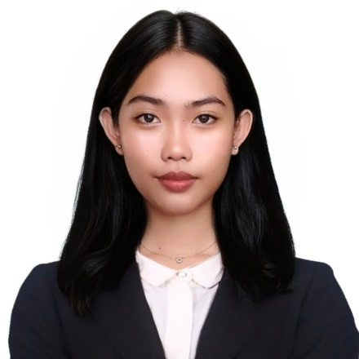**LEVI DELA CRUZ MARBELLA**

Mobile no.: 09915346922

Email: [levidcmarbella@gmail.com](mailto:levidcmarbella@gmail.com)

Address: #326 Brgy. Sawat, Urbiztondo, Pangasinan

**OBJECTIVES**

**OBJECTIVE**

To create a positive and inclusive classroom environment as a first-time teacher, supporting the academic and personal development of students through innovative and compassionate teaching practices.

**PERSONAL INFORMATION**

**PERSONAL INFORMATION**

Date of Birth **:** August 28, 2002

Age **:** 22

Place of Birth **:** Urbiztondo, Pangasinan

Sex **:** Female

Religion **:** Iglesia Ni Cristo

Citizenship **:** Filipino

Civil Status **:** Single

Height **:** 5’4

Weight **:** 40 kgs.

Father’s Name **:** Anthony L. Marbella

Occupation **:** Sales Agent

Mother’s Name **:** Arlene D. Marbella

Occupation **:** Housewife

Languages **:** Filipino, English, Pangasinan

**EDUCATIONAL ATTAINMENT**

**EDUCATIONAL ATTAINMENT**

*Primary* Sawat Elementary School

Brgy. Sawat Urbiztondo, Pangasinan

2008 – 2014

*Secondary* Urbiztondo Integrated School

Brgy. Poblacion Urbiztondo, Pangasinan

2014 – 2021

*Tertiary* Mystical Rose College of Science and Technology

Pogonlomboy Mangatarem, Pangasinan

2021 – Present

**QUALIFICATIONS**

**QUALIFICATIONS**

• **Educational Background**

* Bachelor of Elementary Education undergraduate with foundational training in child-centered teaching methodologies.

• **Core Skills**

* Proficient in classroom management, lesson planning, and fostering an inclusive learning environment.
* Skilled in adapting teaching strategies to accommodate diverse learning styles.

• **Practical Experience**

* Completed observation hours in elementary classrooms, gaining insights into effective teaching practices.

• **Soft Skills**

* Strong interpersonal and communication skills for building positive relationships with students, parents, and colleagues.
* Passionate about nurturing students' academic growth and overall development.

**CHARACTER REFERENCE**

**CHARACTER REFERENCE**

Richele P. Gelido

Private School Teacher

Mystical Rose College of Science and Technology

09774970159

I hereby certify that the above information is true and correct to the best of my knowledge and belief.

LEVI DELA CRUZ MARBELLA

Applicant