**The History and Impact of Concentration Camps: A Reflection on the Past**

Concentration camps were dark and tragic places in history where millions of people were imprisoned under inhumane conditions. These camps appeared in different parts of the world, but they became widely known during World War II, when Nazi Germany established a large system of camps to detain and persecute Jews, political prisoners, Romani people, and others.

Origins and Purpose  
The concept of concentration camps began earlier, with some of the first camps used by the British during the Boer War in South Africa. However, the most infamous camps were built during the 1930s and 1940s by the Nazis. Their purpose was to isolate, exploit, and exterminate people who were considered enemies or threats.

Life Inside the Camps  
Prisoners were brought to the camps in overcrowded trains. Many arrived tired, hungry, and scared. Upon arrival, the Nazis separated families and assigned prisoners to forced labor or immediate execution.

Conditions inside the camps were horrific. People lived in cramped barracks without enough food or clean water. Disease spread quickly, and medical care was almost nonexistent. Thousands died every day from starvation, exhaustion, or abuse.

Acts of Resistance and Survival  
Despite the cruelty, some prisoners managed to resist. They organized secret groups, planned escapes, and supported one another emotionally. Some brave individuals escaped and alerted the world about the atrocities happening inside the camps.

Survivors carried the memory of these experiences for the rest of their lives. They shared their testimonies through books, interviews, and speeches, ensuring the world would never forget what happened.

Liberation and Aftermath  
In 1945, Allied forces liberated many camps. Soldiers found thousands of emaciated prisoners and witnessed the horrors firsthand. After liberation, the survivors began the long journey of recovery, while the world tried to understand the full scale of the tragedy.

The Nuremberg Trials held many Nazi leaders accountable for war crimes. The history of concentration camps became a crucial lesson on the dangers of hatred, discrimination, and totalitarian regimes.

Why Remember?  
Remembering concentration camps helps us honor the victims and prevent history from repeating itself. We learned that silence and indifference allowed such cruelty to grow. Education and awareness promote peace, tolerance, and human rights worldwide.

**1. Train transports of prisoners arriving at Auschwitz**  
 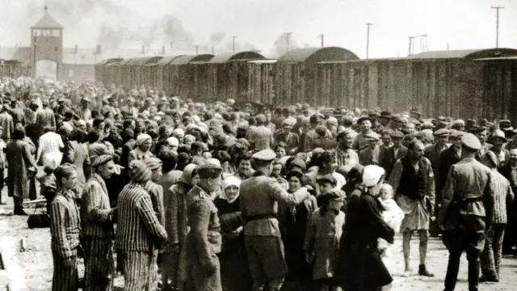

**2. Barracks inside a concentration camp**  
 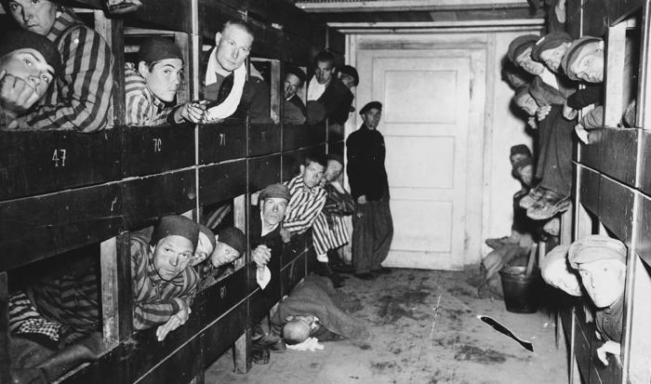

**3. Prisoners during forced labor**  
 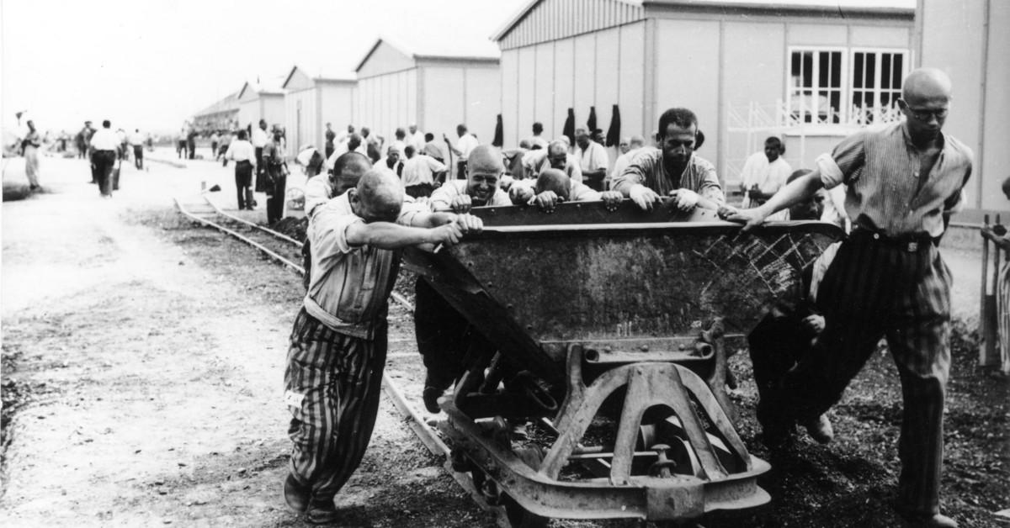

**4. Liberation of prisoners by Allied soldiers** 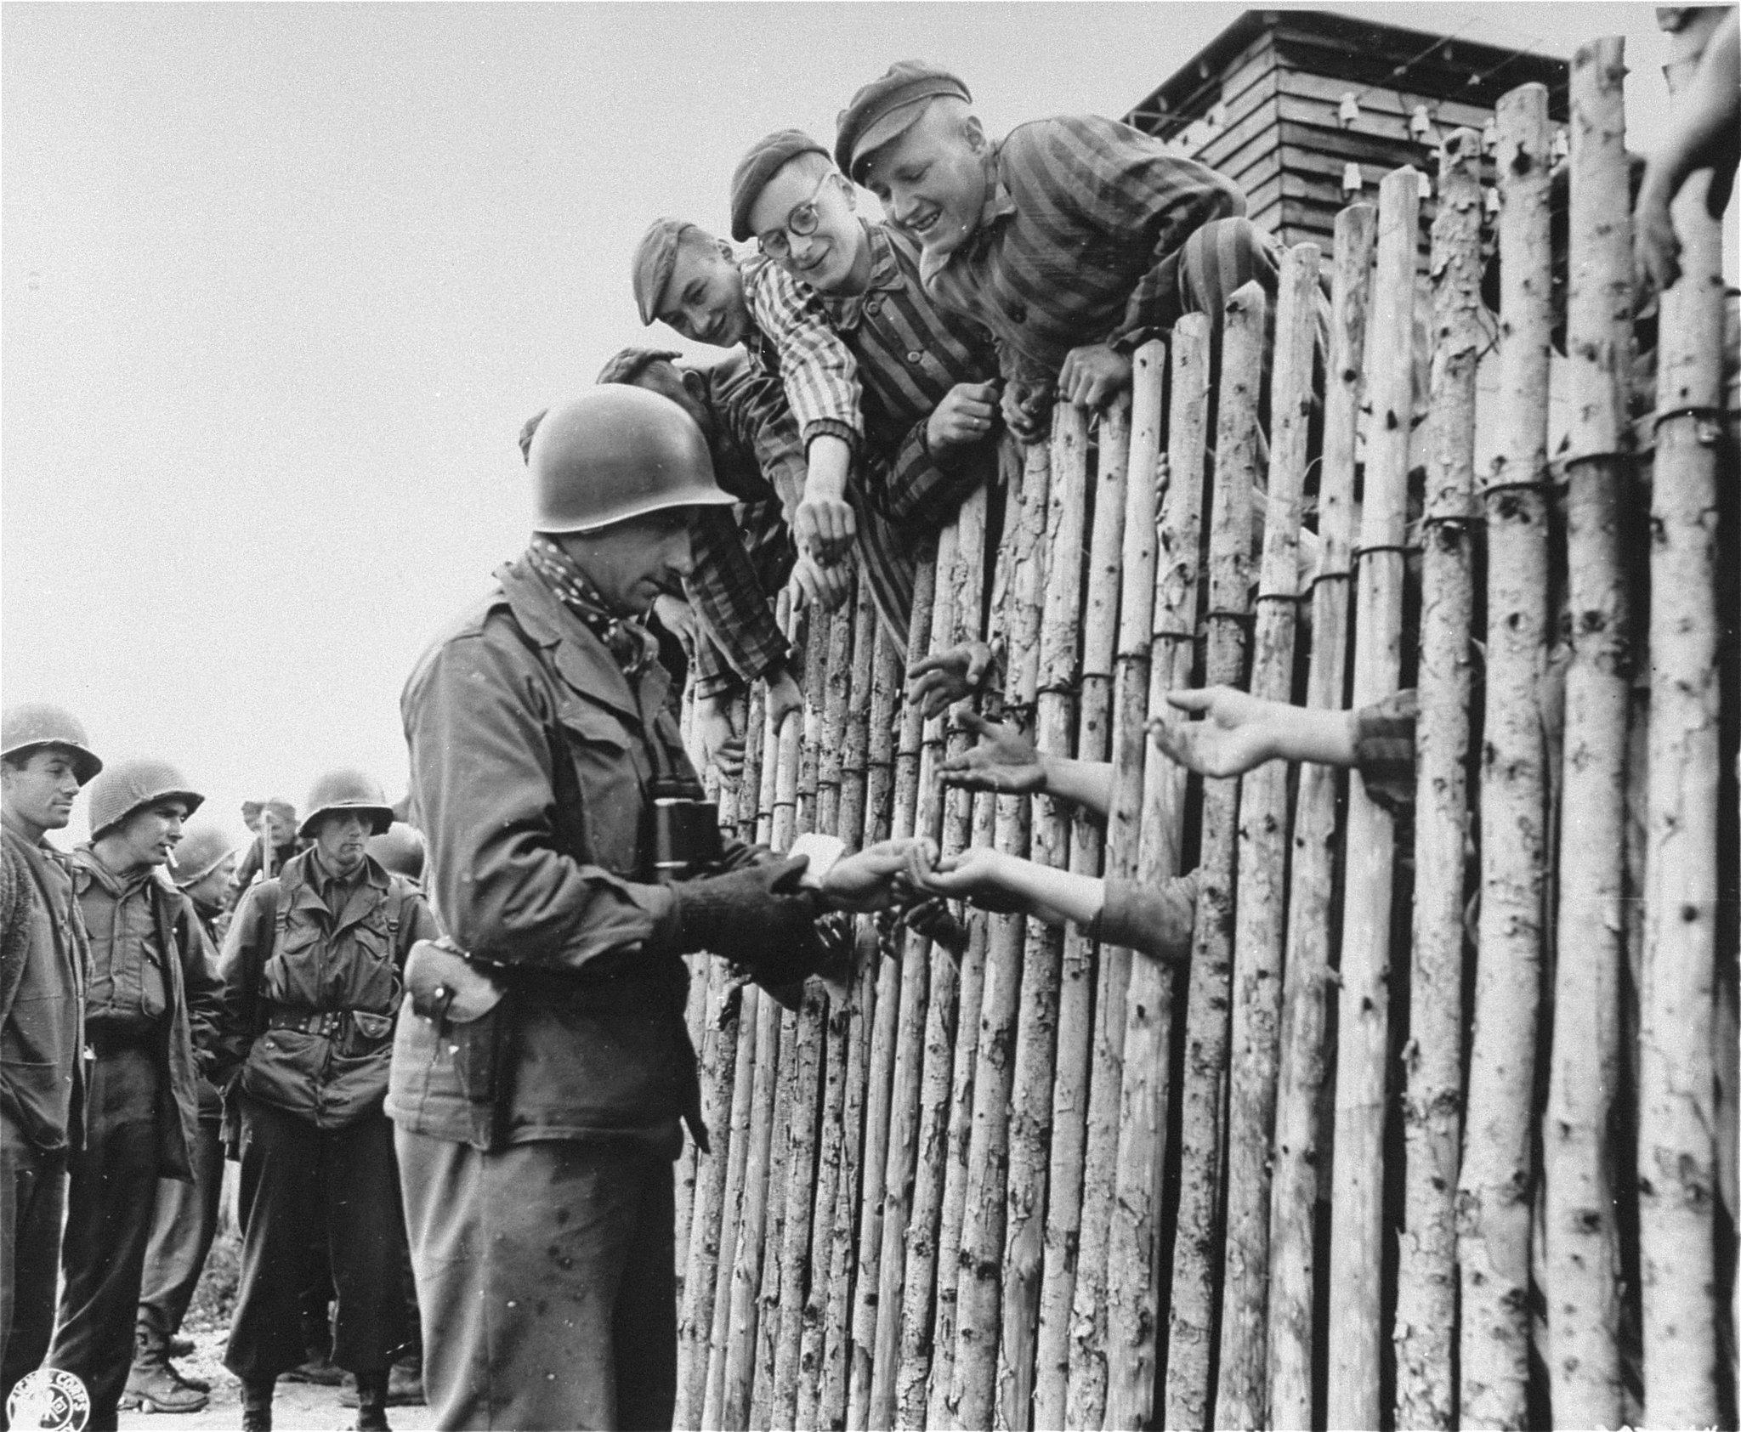

**5. Nuremberg Trials courtroom**  
 