**How to Train a GAN? Tips and tricks to make GANs work**

While research in Generative Adversarial Networks (GANs) continues to improve the fundamental stability of these models, we use a bunch of tricks to train them and make them stable day to day.

Here are a summary of some of the tricks.

[Here's a link to the authors of this document](https://github.com/soumith/ganhacks" \l "authors)

If you find a trick that is particularly useful in practice, please open a Pull Request to add it to the document. If we find it to be reasonable and verified, we will merge it in.

**1. Normalize the inputs**

* normalize the images between -1 and 1
* Tanh as the last layer of the generator output

**2: A modified loss function**

In GAN papers, the loss function to optimize G is min (log 1-D), but in practice folks practically use max log D

* because the first formulation has vanishing gradients early on
* Goodfellow et. al (2014)

In practice, works well:

* Flip labels when training generator: real = fake, fake = real

**3: Use a spherical Z**

* Dont sample from a Uniform distribution

[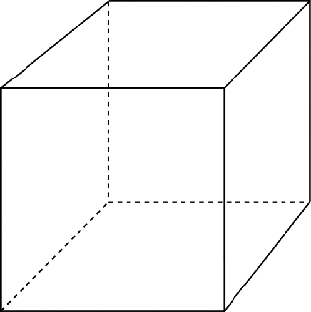](https://github.com/soumith/ganhacks/blob/master/images/cube.png)

* Sample from a gaussian distribution

[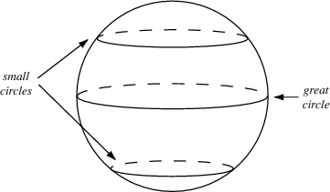](https://github.com/soumith/ganhacks/blob/master/images/sphere.png)

* When doing interpolations, do the interpolation via a great circle, rather than a straight line from point A to point B
* Tom White's [Sampling Generative Networks](https://arxiv.org/abs/1609.04468) ref code <https://github.com/dribnet/plat> has more details

**4: BatchNorm**

* Construct different mini-batches for real and fake, i.e. each mini-batch needs to contain only all real images or all generated images.
* when batchnorm is not an option use instance normalization (for each sample, subtract mean and divide by standard deviation).

[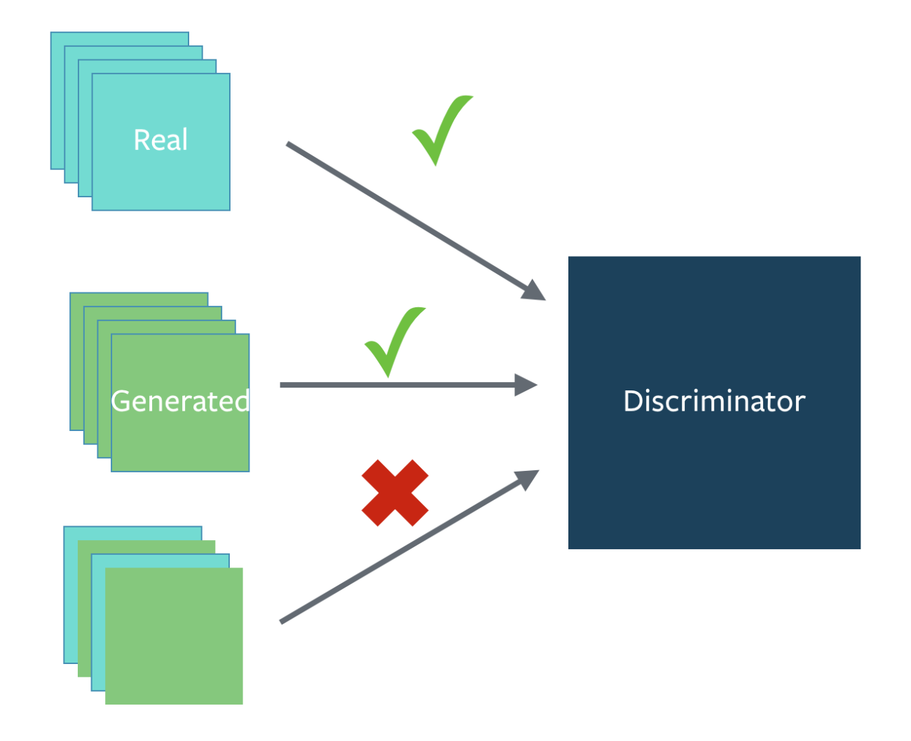](https://github.com/soumith/ganhacks/blob/master/images/batchmix.png)

**5: Avoid Sparse Gradients: ReLU, MaxPool**

* the stability of the GAN game suffers if you have sparse gradients
* LeakyReLU = good (in both G and D)
* For Downsampling, use: Average Pooling, Conv2d + stride
* For Upsampling, use: PixelShuffle, ConvTranspose2d + stride
  + PixelShuffle: <https://arxiv.org/abs/1609.05158>

**6: Use Soft and Noisy Labels**

* Label Smoothing, i.e. if you have two target labels: Real=1 and Fake=0, then for each incoming sample, if it is real, then replace the label with a random number between 0.7 and 1.2, and if it is a fake sample, replace it with 0.0 and 0.3 (for example).
  + Salimans et. al. 2016
* make the labels the noisy for the discriminator: occasionally flip the labels when training the discriminator

**7: DCGAN / Hybrid Models**

* Use DCGAN when you can. It works!
* if you cant use DCGANs and no model is stable, use a hybrid model : KL + GAN or VAE + GAN

**8: Use stability tricks from RL**

* Experience Replay
  + Keep a replay buffer of past generations and occassionally show them
  + Keep checkpoints from the past of G and D and occassionaly swap them out for a few iterations
* All stability tricks that work for deep deterministic policy gradients
* See Pfau & Vinyals (2016)

**9: Use the ADAM Optimizer**

* optim.Adam rules!
  + See Radford et. al. 2015
* Use SGD for discriminator and ADAM for generator

**10: Track failures early**

* D loss goes to 0: failure mode
* check norms of gradients: if they are over 100 things are screwing up
* when things are working, D loss has low variance and goes down over time vs having huge variance and spiking
* if loss of generator steadily decreases, then it's fooling D with garbage (says martin)

**11: Dont balance loss via statistics (unless you have a good reason to)**

* Dont try to find a (number of G / number of D) schedule to uncollapse training
* It's hard and we've all tried it.
* If you do try it, have a principled approach to it, rather than intuition

For example

while lossD > A:

train D

while lossG > B:

train G

**12: If you have labels, use them**

* if you have labels available, training the discriminator to also classify the samples: auxillary GANs

**13: Add noise to inputs, decay over time**

* Add some artificial noise to inputs to D (Arjovsky et. al., Huszar, 2016)
  + <http://www.inference.vc/instance-noise-a-trick-for-stabilising-gan-training/>
  + <https://openreview.net/forum?id=Hk4_qw5xe>
* adding gaussian noise to every layer of generator (Zhao et. al. EBGAN)
  + Improved GANs: OpenAI code also has it (commented out)

**14: [notsure] Train discriminator more (sometimes)**

* especially when you have noise
* hard to find a schedule of number of D iterations vs G iterations

**15: [notsure] Batch Discrimination**

* Mixed results

**16: Discrete variables in Conditional GANs**

* Use an Embedding layer
* Add as additional channels to images
* Keep embedding dimensionality low and upsample to match image channel size

**17: Use Dropouts in G in both train and test phase**

* Provide noise in the form of dropout (50%).
* Apply on several layers of our generator at both training and test time
* <https://arxiv.org/pdf/1611.07004v1.pdf>