HW2

a) Tuple is a built-in data type in python used to store an ordered and unchangeable collection of data. Duplicates are allowed and elements are indexed from 0 to n-1.

b)



c)

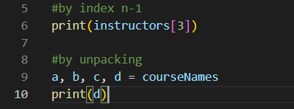

d)

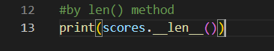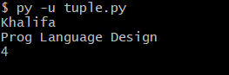

e)

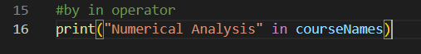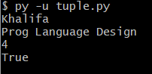

f) No, new elements cannot be added to an existing tuple because tuples are immutable, their contents cannot be changed.

g) Yes, two tuples can be concatenated into a single new tuple using the + operator.

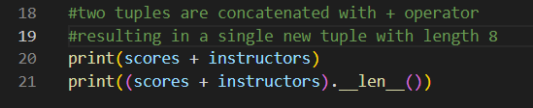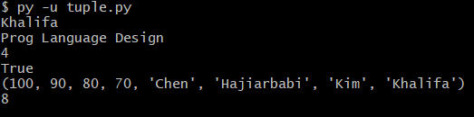

h)

