rasa shell: load a model
rasa train: train a new model

rasa -h : help

https://forum.rasa.com/t/rasa-and-camembert/31882/13
https://santiagopinzond.medium.com/how-to-make-an-integration-of-rasa-bert-in-spanish-2523212aee75
https://www.youtube.com/watch?v=vWStcJDuOUk&list=PL75e0qA87dlG-za8eLI6t0_Pbxafk-cxb&index=2

https://rasa.com/docs/rasa/components#dietclassifier

https://rasa.com/blog/introducing-dual-intent-and-entity-transformer-diet-state-of-the-art-performance-on-a-lightweight-architecture/

https://rasa.com/docs/rasa/tuning-your-model/

https://kavindasenarathne94.medium.com/rasa-architecture-for-clever-chatbots-4a36b0b0ffcc

BERT
recipe: default.v1
language: en
pipeline:
- name: LanguageModelFeaturizer
model_name: "bert"
model_weights: "rasa/LaBSE"

SPACY
language: en
pipeline:
- name: SpacyNLP
model: en_core_web_md
- name: SpacyTokenizer
- name: SpacyFeaturizer
pooling: mean
- name: LexicalSyntacticFeaturizer
- name: CountVectorsFeaturizer
- name: CountVectorsFeaturizer
analyzer: char_wb
min_ngram: 1
max_ngram: 4
- name: DIETClassifier
epochs: 100
- name: SpacyEntityExtractor

https://botfront.io/blog/better-intent-classification-and-entity-extraction-with-diet-classifier-pipeline-optimization

instalar modelo spacy
python3 -m spacy download en_core_web_md

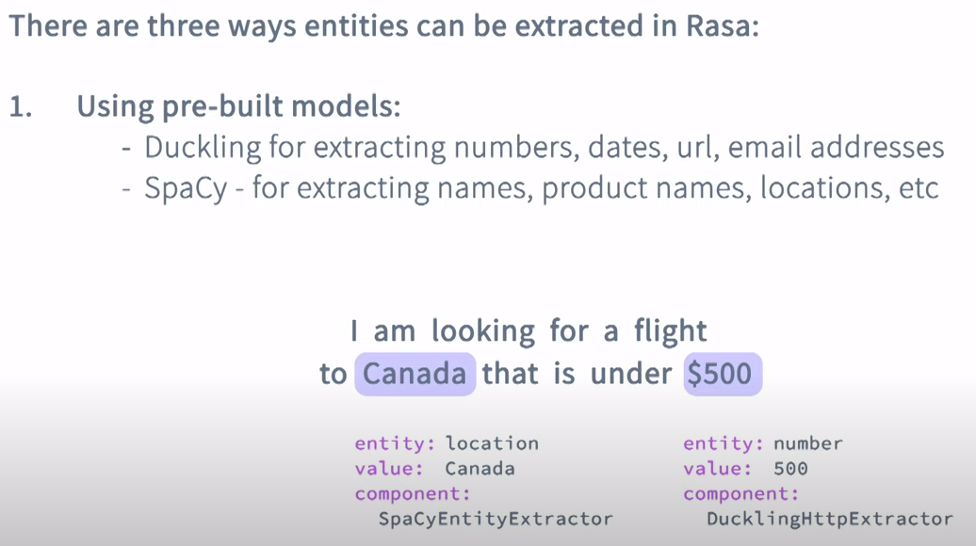
https://blog.knoldus.com/understanding-the-rasa-nlu-pipeline/

