

SQL Installer.NET Guide

Table of Contents

SQL Installer.NET Guide 1
Table of Contents 2
Introduction 3
Chapter 1 – Development 4
Database Version Management 4
Script Folder Layout 4
Script Extensions 4
Continuous Integration 5
CruiseControl.NET using exec task 5
Team Foundation Server with custom build task 5
Setup Project Development 6
Custom Action using WIX 6
Call Method Directly from Code 7
Chapter 2 – Deployment 8
Installing Database 8
Using the Command Line Interface (CLI) 8
Using the Wizard (WIZ) 8

Introduction

SQL Installer.NET is a toolset which assists in the development, deployment, and maintenance of applications which interface with a relational database management system (RDBMS). It is written for Microsoft SQL Server 2005 or above, but can be adapted to other RDMBS products fairly easily.

The installed product exists of two executables: SQLInstaller.exe and SQLInstallerWin.exe. SQLInstaller.exe is the ‘command line’ version and SQLInstallerWin.exe is a more user-friendly ‘wizard’ type Windows application. There is also an assembly, SQLInstaller.Core.dll, which contains public classes which can be used either to develop your own application; or, referenced directly from third party applications which have the ability to load assemblies dynamically. SQL Installer.NET is currently targeted at the 2.0 version of the .Net Framework and uses SMO (SQL Server Management Objects) for most of the ‘heavy lifting’.

I developed a similar toolset years ago at my own company. However, during the past several years of consulting work I have written variations of the same thing for other clients. I recently set out to write a new set of tools from scratch which incorporates many of the concepts and/or ‘best practices’ I’ve learned throughout the years and can continue to evolve as I learn new things. I have therefore made it available as ‘open source’ on Microsoft’s CodePlex site (www.codeplex.com/sqlinstaller). I hope you find it useful.

Brian Schloz
JHOB Technologies, LLC
www.jobtechnologies.com

Chapter 1 – Development

Database Version Management

It has been my observation that developers, in general, treat databases differently than they do source code. I’ve seen several cases of development teams scheduling nightly backup/restore operations as the sole means to carry changes forward during a development cycle; or, where test teams restore a production database into the test environment in order to test the latest code drop. And the coup de grace is where a development team will restore the latest production release into their dev environment to begin development of the next release. These are all symptoms of the underlying problem: databases aren’t being treated as source code.

What that means in real terms is first you should break down your database into its component pieces (tables, views, etc.) and place them into your source code repository. Most development teams get that part. But that’s not good enough. You should also have a method of building out your databases using the component pieces which now reside in your source control repository. The goal is to make the creation of your databases consistent, deterministic, and repeatable. The SQL Installer.NET toolset employs a fairly straightforward ‘file structure’ based processing algorithm to ensure that you meet these goals.

There’s nothing special about the structure. It simply establishes the convention by which SQL Installer.NET will operate.

Script Folder Layout
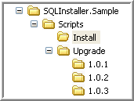
There are two root folders required: Install and Upgrade. The Install folder contains all of the SQL scripts to install the database ‘from scratch’. The Upgrade folder will contain the scripts necessary to upgrade a database from version to version. The Upgrade folder must also contain at least one subfolder to establish the initial version information (1.0.1 in the sample shown).

SQL Installer.NET also enforces a particular naming convention to differentiate between the different types of SQL objects:

Script Extensions
1 | PreInstall.sql | Prerequisites
2 | Table.sql | Tables
3 | UserDefinedFunction.sql | UDF
4 | View.sql | Views
5 | StoredProcedure.sql | Stored Procedures
6 | Trigger.sql | Triggers
7 | PostInstall.sql | Data
8 | ForeignKey.sql | Foreign Key constraints

Once the database is broken down into these eight (8) component pieces and into the hierarchy as illustrated, you would need to check these into source control. Just remember that the latest ‘clean’ version of the database scripts will always live in the ‘Install’ folder. The ‘Upgrade’ folder will only contain subfolders which establish the release number. And each release subfolder under the Upgrade folder will only contain scripts which upgrade the database from the previous release (e.g. 1.0.2 will only contain scripts to migrate from 1.0.1). In the example above, the 1.0.1 subfolder would be empty since it is the initial release. In Chapter 2, a more in-depth explanation is given as to how these folders are used during the installation/upgrade process.

Continuous Integration

Another important feature of SQL Installer.NET is the ability to automate the task of building out databases and keeping the development instances in synchronization with each other. Automation is important because if the process for team members to distribute their changes is cumbersome, they will be less likely to keep on top of it more time is spent later in the development cycle incorporating each others changes.

The ideal setup is for each developer to work on their own special instance of the database (perhaps on their own workstation). As database objects are created on the developer’s instance, they are scripted out and checked into the source code repository (using the layout described in the previous section). Once checked into the repository, a continuous integration (CI) build is done to update the CI database. This is accomplished by adding a build task to the CI server (e.g. CC.NET, NAnt, TFS) which calls the command line utility SQLInstaller.exe passing in the relevant parameters. In the case of TFS, you can also use a custom build task called SqlBuild directly within the build project. Here are some examples:

CruiseControl.NET using exec task
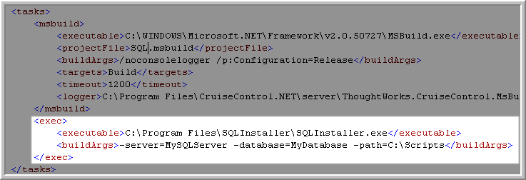

Team Foundation Server with custom build task
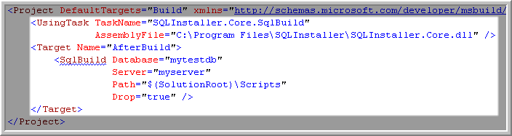

We could have put a Post-Build event directly in the project settings and that would work too. However, by putting it as a special task in the CI server we can evaluate the return code and make sure to fail the build if the SQL scripts fail. A case where you might want to use the project’s Post-Build commands is to execute SQLInstaller.exe to refresh your own database instance. I like to create a special Build Configuration for this. Then all I have to do to refresh my local copy of the database is to Get Latest version and rebuild.

Setup Project Development

In preparation for deployment (Chapter 2), I would typically evaluate the need for an installer project (one that would generate an MSI). If the product is being consumed internally it may or may not be necessary to create one. However, it does make it easier to just hand off an MSI to your operations team. In any case, the SQL Installer.NET toolset allows for a fairly straightforward integration with the various installer technologies out there. The most basic integration is to include the command line executable in an installer Custom Action (CA). For tighter integration, you could reference the library assembly (SQLInstaller.Core.dll) directly in your application and this will give you some flexibility on where/when you would execute the database scripts. You could opt, for example, to implement auto-update functionality in your application which would be responsible for database installation/upgrades. I would lean towards the latter as a strategy given that the Windows Installer development team is trying to steer folks away from custom actions.

Custom Action using WIX
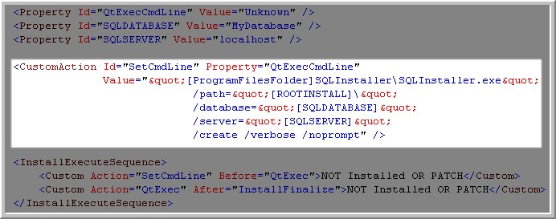

Call Method Directly from Code
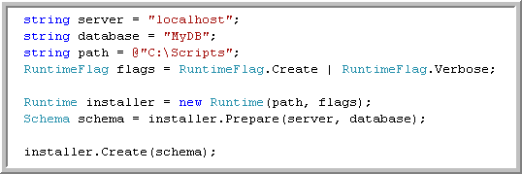

This is a basic example of how to call the Runtime methods directly in your code. For a more complete example including version detection and error checking, you can download the source code.

Chapter 2 – Deployment

Installing Database

SQL Installer.NET gives you two utilities to manually install and/or upgrade your database. You will begin by packaging your database installation scripts using the two folders as described in Chapter 1: Database Version Management. You can use the command line interface (CLI), or the wizard interface (WIZ).

Using the Command Line Interface (CLI)

If you opt to use the CLI, then you simply copy the installation scripts to the machine you’ve installed SQL Installer.NET and run SQLInstaller.exe cmd providing the correct parameters. Here is a screenshot of the parameters:

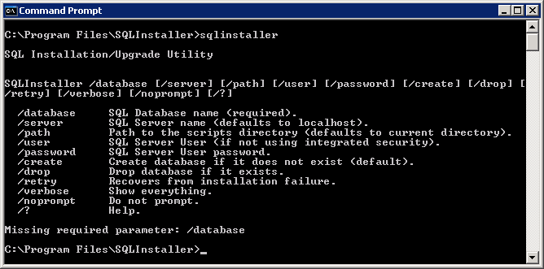

Example: SQLInstaller.exe /database Northwind /server qa-data1 /path C:\Scripts /create /verbose

The example command above will create the database Northwind on the SQL Server qa-data1 using the scripts located under C:\Scripts. A detailed output will be sent to the console (/verbose).

Using the Wizard (WIZ)

The WIZ interface is a slightly more convenient way to package database installations/upgrades for users, operations teams, or administrators. It is a wizard-based GUI application which guides the user step-by-step through the process. Using the WIZ interface, you also have the option of packaging the script folders as a compressed zip file and locate it on a common web server for deployment. Here is a walkthrough of a typical upgrade process:
Step 1 – Welcome to SQL Installer.NET

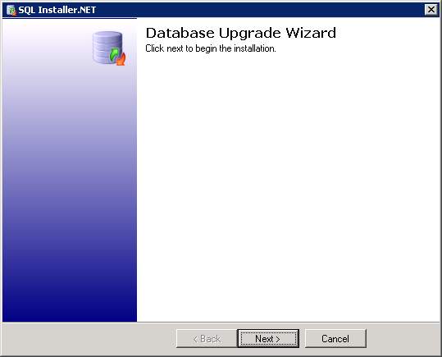

Click next to continue.
Step 2 – Choose Database Settings

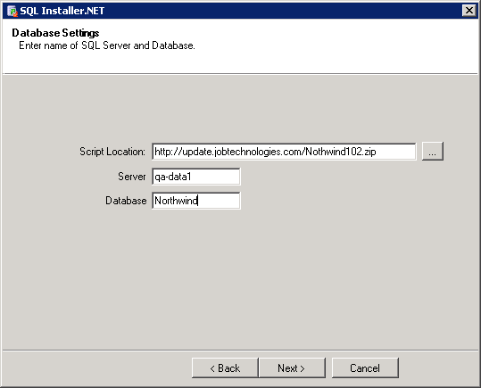

Script Location: can be either a local path (select ellipses button to navigate to local folder containing the Install and Upgrade folders). Or, in the example above this can be a pre-packaged zip file located on a web server.

Server: name of SQL Server machine (note: the wizard version only supports integrated authentication to the SQL Server). If you need to use SQL Server credentials, you must use the CLI.

Database: name of the SQL Server database to install/upgrade.

Step 3 – Database Summary

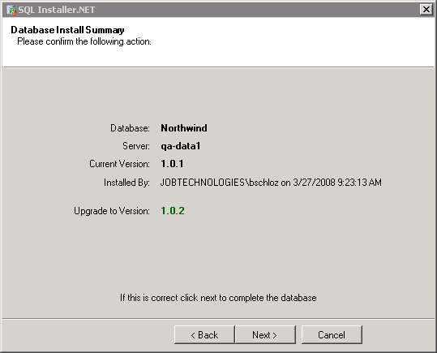

Verify the information provided on this screen. This is the last step before the upgrade occurs.

Step 4 – Congratulations

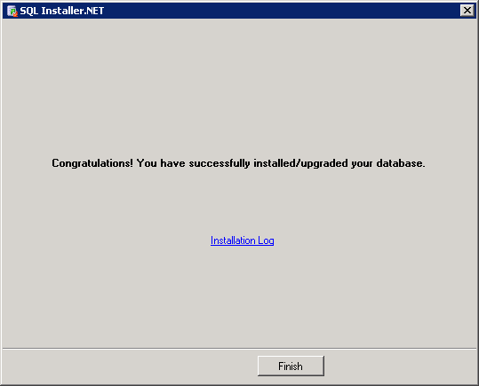

If the install/upgrade was successful or unsuccessful you will be notified here on the final page. You can click on the ‘Installation Log’ link to get a detailed list of actions take during the install/upgrade. Also, if there is a failure you can use this link to view any detailed errors.

Be aware that this assembly has a dependency on SQL Server Management Objects (SMO). Those assemblies must also be installed and/or available on the installation machine. The SQL Installer.NET install packages SMO for you.

