

Table of Contents

Detailed Description..................................................................................................................................1

Wire Frames...............................................................................................................................................2

Screen Captures..........................................................................................................................................3

Potential Future Functionality....................................................................................................................4

Detailed Description 1

This site allows a user to log in and create a blog. It also allows them to see all the blogs that have already been posted by other users. People are allowed to register new accounts. When logged on a user can log off. (very detailed Erik...)

Wire Frames

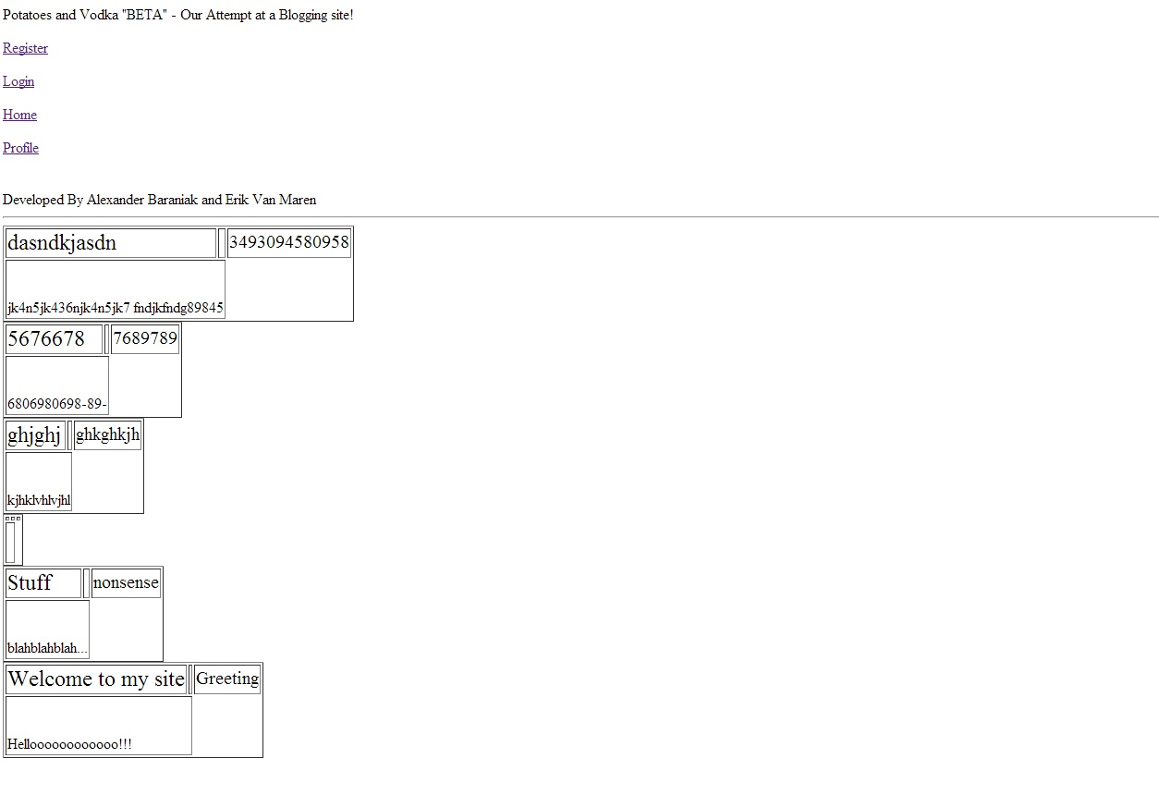
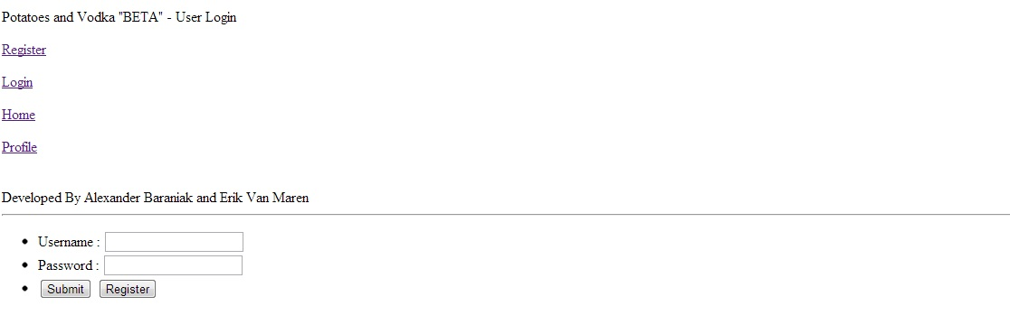

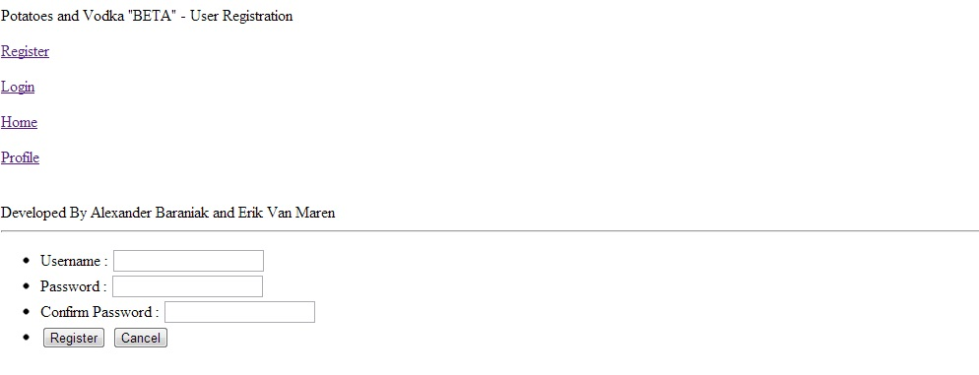

Screen Shots

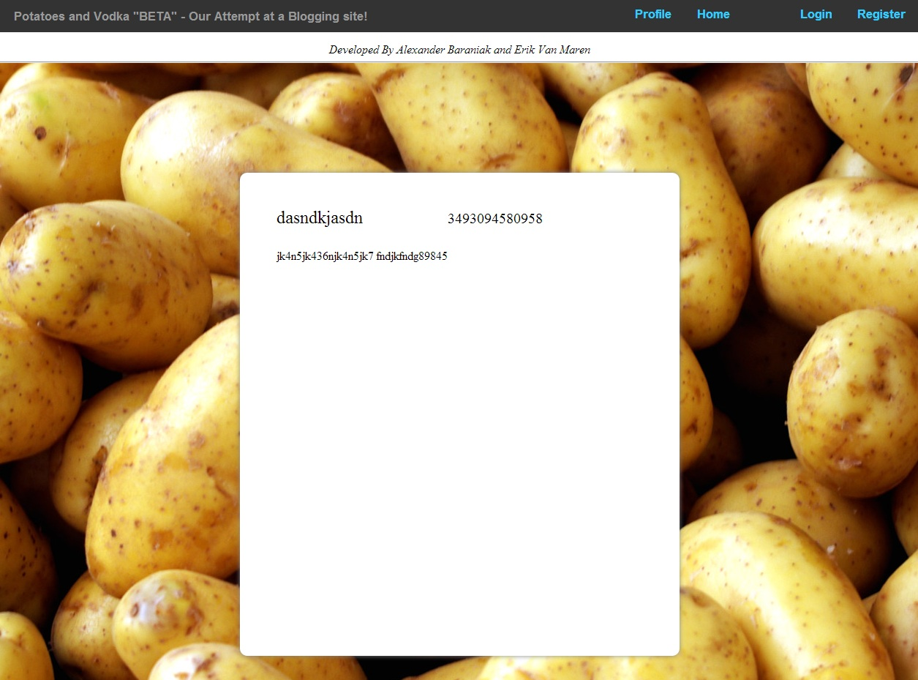

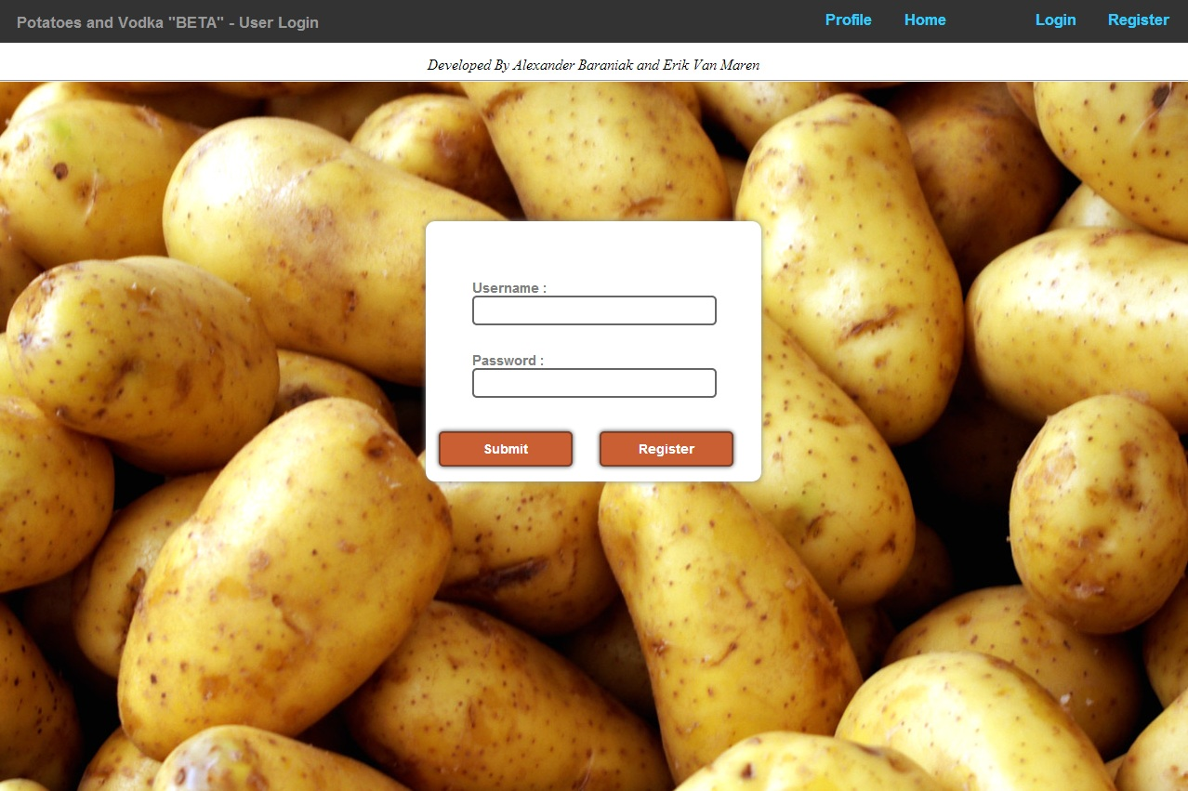

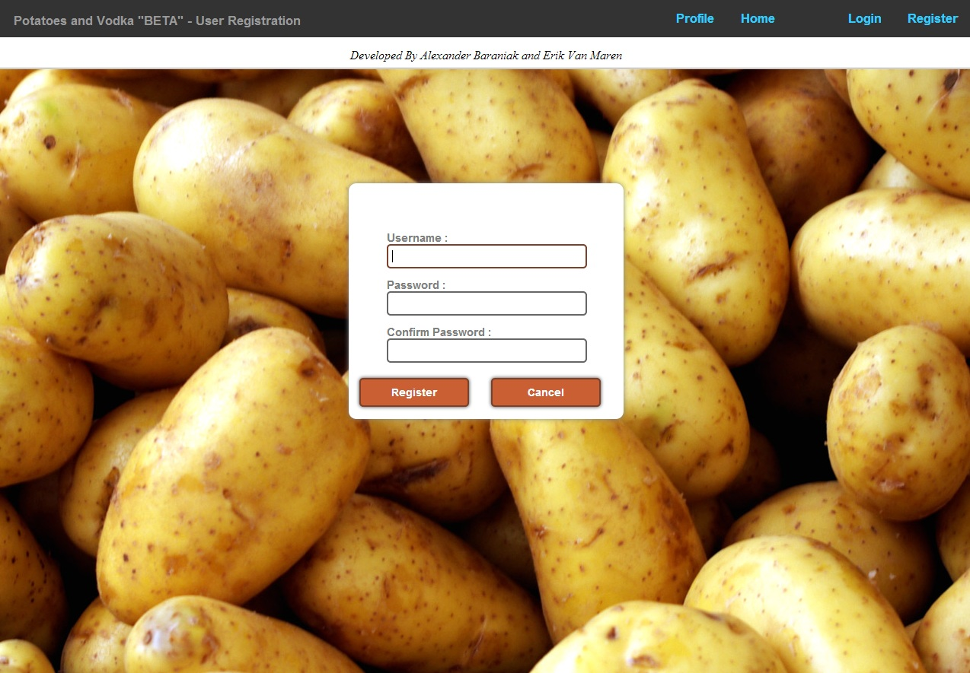

Potential Future Functionality 4

- Profile management features. Edit password, etc
- Ability to comment on blogs
- Mobile support
- Have administrator powers
- Have profile avatars/pictures
- Have a blog search engine

