Unit 1 Hello

Lesson 1
1. Look, listen and repeat.
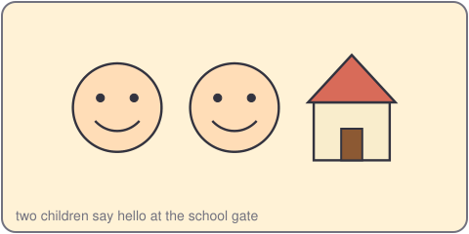
Duc: Hello! I'm Duc.
Lan: Hi, Duc. I'm Lan.
2. Listen, point and say.
Hello, I'm ___.
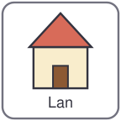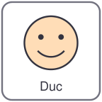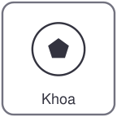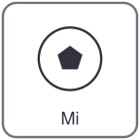
Lan Duc Khoa Mi
Hello, I'm Khoa.
Hi, Khoa. I'm Mi.
3. Let's talk.
Say hello to your partner.
Say your name.

Unit 1 Hello
4. Listen and tick.
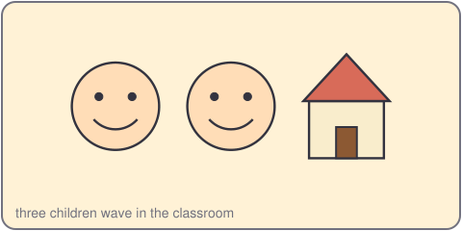
a. Hello, I'm Vy. b. Hi, I'm Quang. c. Hello, I'm An.
5. Look, complete and read.
Hello, I'm _____.
Hi, _____. I'm Thu.
6. Let's sing.
Hello, hello, I'm Mi.
Hi, hi, hi, I'm Vy.
Hello, hello, hello to you!
Hi, hi, hi, hello to you!

Unit 1 Hello

Lesson 2
1. Look, listen and repeat.
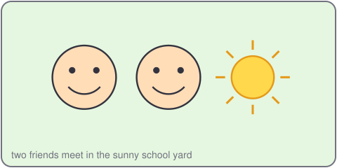
Khoa: Hello, I'm Khoa.
Mi: Hi, Khoa. I'm Mi.
Khoa: Nice to meet you, Mi.
Mi: Nice to meet you, Khoa.
2. Listen, point and say.
Nice to meet you.
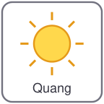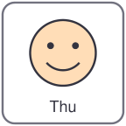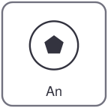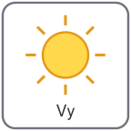
Quang Thu An Vy
Hello, I'm Quang.
Nice to meet you, Thu.
3. Let's talk.
Say hello. Say your name.
Say: Nice to meet you.

Unit 1 Hello
4. Listen and number.
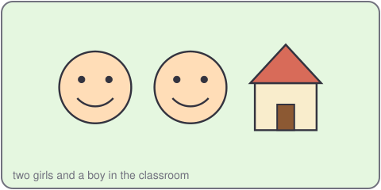
a. Hello, I'm Duc. Nice to meet you. b. Hi, I'm Lan. Nice to meet you.
5. Look, complete and read.
Hello, I'm _____.
Nice to meet you, _____.
6. Let's play.
Stand up. Walk and say hello.
Say your name. Say: Nice to meet you.
Find a friend. Swap.
Sit down. Good job!

Unit 1 Hello

Lesson 3
1. Listen and repeat.
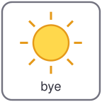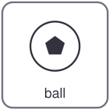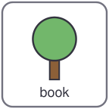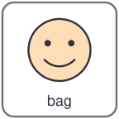
bye ball book bag
b /b/
h /h/ hello hi hand head
2. Listen and circle.
a. bye b. hi c. ball
3. Let's chant.
Hi, hi, hi, my hand, my head.
Hello, hello, a book and a bag.
Bye, bye, bye, a big blue ball.
Bye, bye, bye, hello and hi!

Unit 1 Hello
4. Read and match.
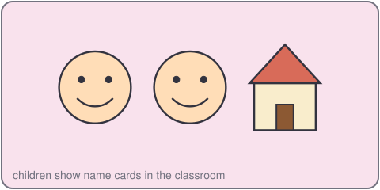
a. Hello, I'm Lan. Hi, nice to meet you.
b. Nice to meet you. Bye, Lan.
c. Goodbye, Duc. Hi, Lan. I'm Duc.
5. Let's write.
Write: Hello, I'm _____.
Write: Bye, _____.
6. Project.
Make a name card. Write your name. Say hello to a friend.

