Unit 2 Our names

Lesson 1
1. Look, listen and repeat.
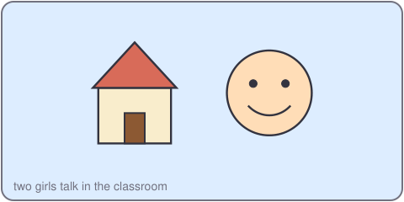
Vy: Hello. What's your name?
An: My name's An. What's your name?
Vy: My name's Vy.
2. Listen, point and say.
My name's ___.
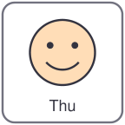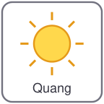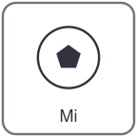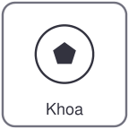
Thu Quang Mi Khoa
What's your name?
My name's Thu.
3. Let's talk.
Ask your partner: What's your name?
Say: My name's ___.

Unit 2 Our names
4. Listen and tick.
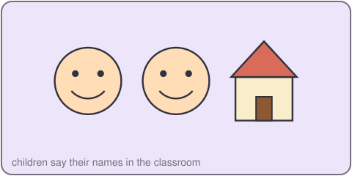
a. My name's Thu. b. My name's Mi. c. My name's Lan.
5. Look, complete and read.
What's your name?
My name's _____.
Hello, _____. Nice to meet you.
6. Let's sing.
What's your name? What's your name?
My name's Lan, my name's Lan.
Hello, Lan! Hello, Lan!
Nice to meet you, Lan.

Unit 2 Our names

Lesson 2
1. Look, listen and repeat.
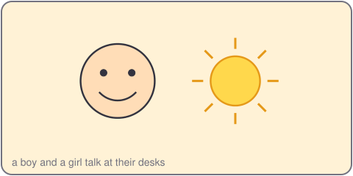
Duc: What's your name?
Mi: My name's Mi.
Duc: How do you spell your name?
Mi: M-I.
2. Listen, point and say.
How do you spell your name?
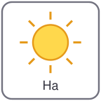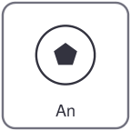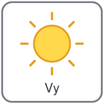
Ha An Vy Mi
How do you spell your name?
A-N.
3. Let's talk.
Ask your partner. How do you spell your name?
Spell it. Write it.

Unit 2 Our names
4. Listen and number.
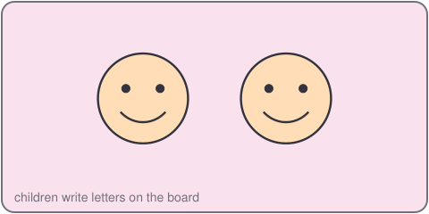
a. M-I b. A-N c. V-Y
5. Look, complete and read.
My name's Lan. L-A-N.
My name's Tien. _-_-_-_.
6. Let's play.
Play a spelling game.
Spell a name. Your partner writes the letters.
Check the name.
Swap.

Unit 2 Our names

Lesson 3
1. Listen and repeat.
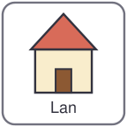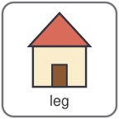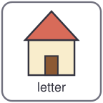
Lan leg look letter
l /l/
n /n/ name nice nose nine
2. Listen and circle.
a. name b. letter c. look
3. Let's chant.
L, l, l, look and listen.
Leg, leg, letter, Lan.
N, n, n, my name, my name.
Nose, nine, nice, name.

Unit 2 Our names
4. Read and match.
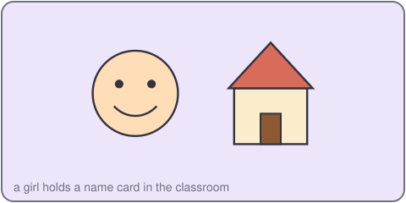
a. What's your name? D-U-C.
b. How do you spell it? Hi, Mi. Nice to meet you.
c. Hello, I'm Mi. My name's Duc.
5. Let's write.
Write: My name's _____.
Write the letters: _ _ _ _.
6. Project.
Make a name card. Write the letters of your name.

