Unit 3 Our friends

Lesson 1
1. Look, listen and repeat.
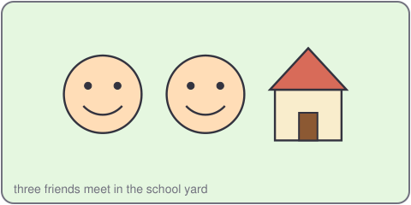
Thu: Hello, Mi. This is my friend, Quang.
Mi: Hi, Quang. Nice to meet you.
Quang: Nice to meet you, Mi.
2. Listen, point and say.
This is ___.
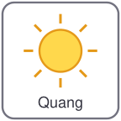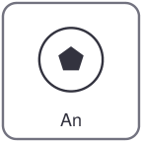
Quang Vy An Khoa
This is Quang.
This is my friend, Vy.
3. Let's talk.
Show a picture of a friend.
Say: This is my friend.

Unit 3 Our friends
4. Listen and tick.
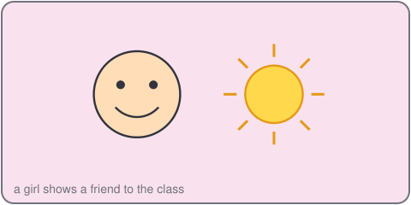
a. This is Duc. b. This is Khoa. c. This is Tien.
5. Look, complete and read.
This is my friend, _____.
This is _____.
6. Let's sing.
This is my friend, this is my friend.
Hello, hello, hello, friend!
This is Mi, this is Mi.
Hello, hello, hello, Mi!

Unit 3 Our friends

Lesson 2
1. Look, listen and repeat.
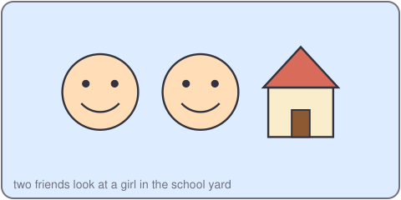
Duc: Is that Lan?
Thu: Yes, it is. That is Lan.
Duc: Is that Tien?
Thu: No, it isn't. That is Khoa.
2. Listen, point and say.
Is that ___?
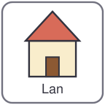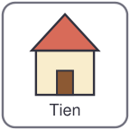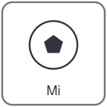
Lan Tien Khoa Mi
Is that Lan? Yes, it is.
Is that Mi? No, it isn't.
3. Let's talk.
Point to a friend. Ask: Is that ___?
Answer: Yes, it is. / No, it isn't.

Unit 3 Our friends
4. Listen and tick.
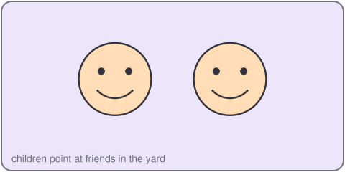
a. Is that Vy? Yes, it is. b. Is that Vy? No, it isn't. c. Is that An? Yes, it is.
5. Look, complete and read.
Is that Duc? _____, it is.
Is that Mi? _____, it isn't.
6. Let's play.
Stand in two teams.
Show a picture card.
Ask: Is that ___?
Answer: Yes, it is. / No, it isn't.

Unit 3 Our friends

Lesson 3
1. Listen and repeat.
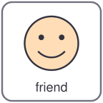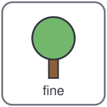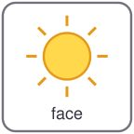
friend fine fish face
f /f/
t /t/ ten two toy touch
2. Listen and circle.
a. friend b. fish c. ten
3. Let's chant.
F, f, f, friend and fish.
T, t, t, ten and two.
This is my friend, nice and fine.
That is my friend, one, two, three.

Unit 3 Our friends
4. Read and match.
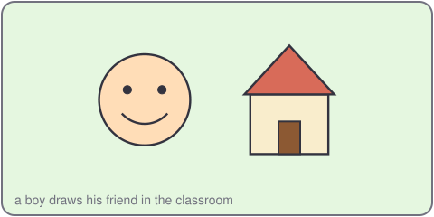
a. This is Quang. Yes, it is.
b. Is that Thu? No, it isn't.
c. Is that Duc? Hi, Quang.
5. Let's write.
This is my friend, _____.
Is that _____? Yes, it is.
6. Project.
Draw a friend. Write the name. Say: This is my friend.

