Unit 4 Our bodies

Lesson 1
1. Look, listen and repeat.
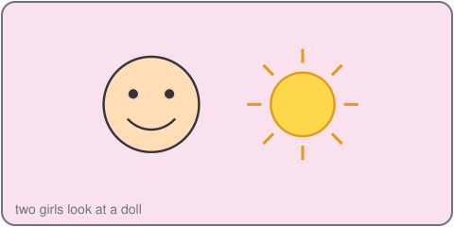
Vy: Hello. This is my doll.
An: Hi! This is her face.
Vy: This is her nose. This is her mouth.
2. Listen, point and say.
This is my ___.
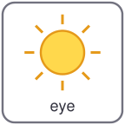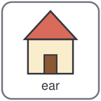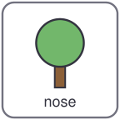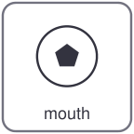
eye ear nose mouth
This is my nose.
This is my mouth.
3. Let's talk.
Point to your face.
Say: This is my nose.

Unit 4 Our bodies
4. Listen and tick.
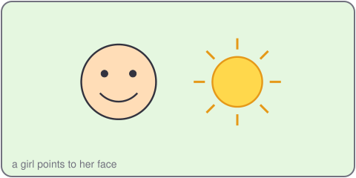
a. This is my nose. b. This is my ear. c. This is my mouth.
5. Look, complete and read.
This is my _____.
This is my _____.
I have two _____.
6. Let's sing.
Eyes, eyes, I have two eyes.
Ears, ears, I have two ears.
Nose, nose, I have one nose.
Mouth, mouth, one mouth, hello!

Unit 4 Our bodies

Lesson 2
1. Look, listen and repeat.
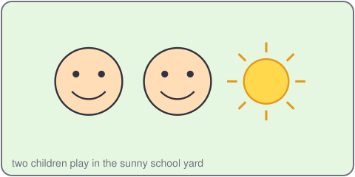
Khoa: Touch your hand.
Mi: OK. Touch your leg.
Khoa: Good! I have two legs.
2. Listen, point and say.
Touch your ___.
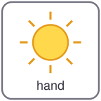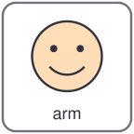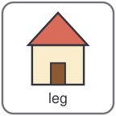
hand arm leg ear
Touch your hand.
Touch your arm.
3. Let's talk.
Tell your partner what to do.
Say: Touch your ___.

Unit 4 Our bodies
4. Listen and number.
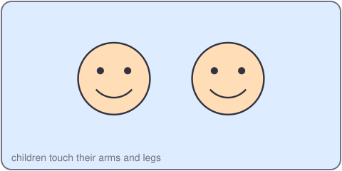
a. Touch your leg. b. Touch your arm. c. Touch your hand.
5. Look, complete and read.
Touch your _____.
I have two _____.
6. Let's play.
Stand up. Listen.
Touch your hand. Touch your ear.
Touch your arm. Touch your leg.
Sit down. Good job!

Unit 4 Our bodies

Lesson 3
1. Listen and repeat.
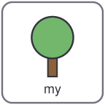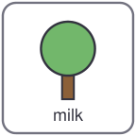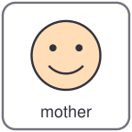
my mouth milk mother
m /m/
n /n/ nose nine name nice
2. Listen and circle.
a. mouth b. mother c. nose
3. Let's chant.
M, m, m, my mouth, my mouth.
N, n, n, my nose, my nose.
Eyes, ears, hands and legs,
I have two, I have two!

Unit 4 Our bodies
4. Read and match.
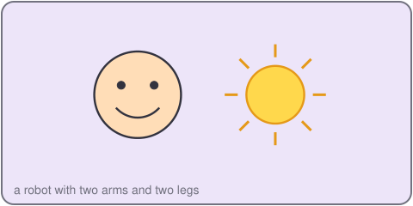
a. How many ears? I have one mouth.
b. How many mouths? I have two hands.
c. How many hands? I have two ears.
5. Let's write.
I have two _____.
This is my _____.
6. Project.
Draw a robot. Say: I have two arms. I have two legs.

