Unit 5 My hobbies

Lesson 1
1. Look, listen and repeat.
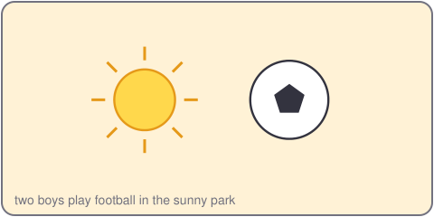
Quang: I like football.
Vy: Hi, Quang. I like chess.
Quang: Nice to meet you, Vy.
2. Listen, point and say.
I like ___.
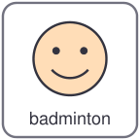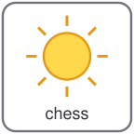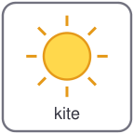
football badminton chess kite
I like football.
I like chess.
3. Let's talk.
Tell your partner your hobby.
Say: I like ___.

Unit 5 My hobbies
4. Listen and tick.
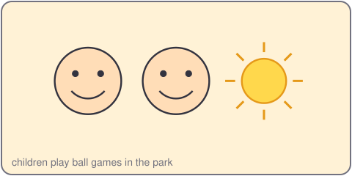
a. I like football. b. I like chess. c. I like badminton.
5. Look, complete and read.
I like _____.
My hobby is _____.
6. Let's sing.
I like football, football, football.
I like chess, chess, chess.
I like badminton, I like kites.
I like my hobbies, yes, yes, yes!

Unit 5 My hobbies

Lesson 2
1. Look, listen and repeat.
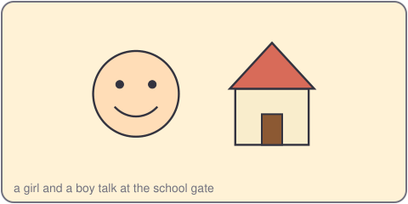
An: Do you like football?
Thu: No, I don't.
An: Do you like chess?
Thu: Yes, I do. I like chess.
2. Listen, point and say.
Do you like ___?
football badminton chess kite
Do you like football? No, I don't.
Do you like chess? Yes, I do.
3. Let's talk.
Ask your partner: Do you like ___?
Answer: Yes, I do. / No, I don't.

Unit 5 My hobbies
4. Listen and tick.
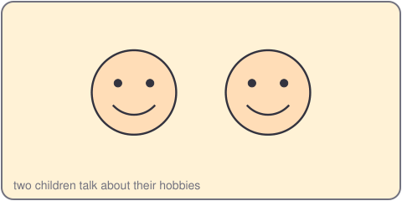
a. Do you like chess? Yes, I do.
b. Do you like football? No, I don't.
c. Do you like chess? No, I don't.
5. Look, complete and read.
Do you like _____? Yes, I _____.
Do you like kites? No, I _____.
6. Let's play.
Stand in two lines.
Ask a friend: Do you like chess?
Say: Yes, I do. Or: No, I don't.
Swap.

Unit 5 My hobbies

Lesson 3
1. Listen and repeat.
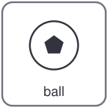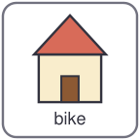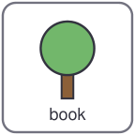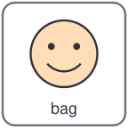
ball bike book bag
b /b/
ch /ch/ chess chair check
2. Listen and circle.
a. ball b. chair c. chess
3. Let's chant.
B, b, b, ball and bike.
Ch, ch, ch, chess and chair.
I like football, I like chess.
Do you like it? Yes, yes, yes!

Unit 5 My hobbies
4. Read and match.
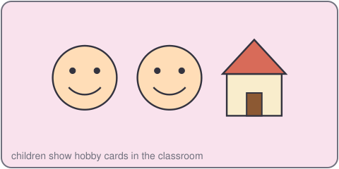
a. Do you like chess? Do you like badminton?
b. I like badminton. No, I don't.
c. Do you like kites? Yes, I do.
5. Let's write.
I like _____.
I like _____ and _____.
6. Project.
Make a hobby card. Draw your hobby. Write: I like ___.

