Unit 1 My friends and me

Lesson 1
1. Look, listen and repeat.
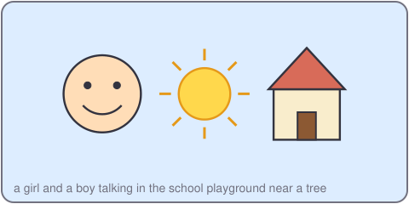
Hi, Mi. Can you swim?
Yes, I can. Can you swim?
No, I can't. But I can ride a bike.
2. Listen, point and say.
I can ___.
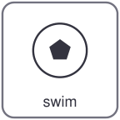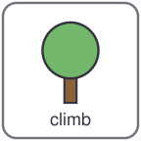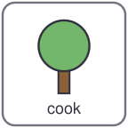
swim ride climb cook
Can you ___? Yes, I can. / No, I can't.
3. Let's talk.
Can you swim? Can you cook?
Yes, I can. / No, I can't.

Unit 1 My friends and me
4. Listen and tick.

a. Khoa can swim. b. Khoa can ride a bike. c. Khoa can climb.
5. Look, complete and read.
Mi can _____.
Khoa can _____ a bike.
Can you climb? Yes, I _____.
6. Let's sing.
I can swim, swim, swim.
I can climb, climb, climb.
Can you swim? Can you climb?
Yes, I can! Yes, I can!

Unit 1 My friends and me

Lesson 2
1. Look, listen and repeat.
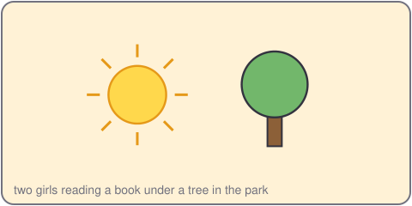
This is my friend Vy. She is kind.
Hello! I like drawing. Do you like drawing?
No, I like singing.
2. Listen, point and say.
She likes ___.
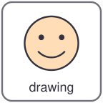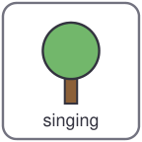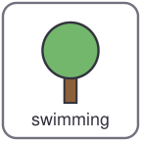
drawing singing reading swimming
I like ___. He likes ___.
3. Let's talk.
What do you like doing?
I like ___. My friend likes ___.

Unit 1 My friends and me
4. Listen and number.

a. Vy likes drawing. b. Tien likes singing. c. Duc likes swimming.
5. Look, complete and read.
Vy is kind. She likes _____.
Tien is funny. He likes _____.
I like _____.
6. Let's play.
Pick a friend. Do not say the name.
She is tall. She likes singing.
Your team guesses: Is it Vy?
Yes, it is. / No, it isn't.

Unit 1 My friends and me

Lesson 3
1. Listen and repeat.
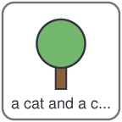
c /k/
can cook cat
2. Listen and circle.
a. can / cat b. cook / book c. sing / sit
3. Let's chant.
Can, can, I can!
I can cook and I can climb.
Can, can, you can!
You can swim and you can sing.

Unit 1 My friends and me
4. Read and match.
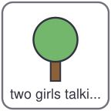
a. Can you swim? She likes drawing.
b. What does Vy like doing? No, he isn't.
c. Is Khoa tall? Yes, I can.
5. Let's write.
I can _____ and _____.
I like _____.
6. Project.
Draw your friend and write two sentences with can and likes.

