Unit 2 My week

Lesson 1
1. Look, listen and repeat.
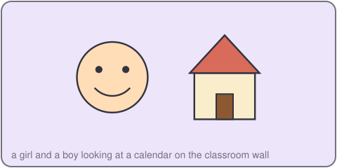
What day is it today, Quang?
It's Monday.
Great! We have music today.
2. Listen, point and say.
It's ___.
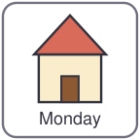
Monday Tuesday Wednesday Thursday Friday
What day is it today?
3. Let's talk.
What day is it today?
What day is it tomorrow?

Unit 2 My week
4. Listen and tick.
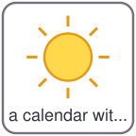
a. Today is Monday. b. Today is Tuesday. c. Today is Friday.
5. Look, complete and read.
Today is _____. Tomorrow is _____.
Saturday and _____ are the weekend.
6. Let's sing.
Monday, Tuesday, Wednesday,
Thursday, Friday, too.
Saturday and Sunday,
What do we do? Let's play!

Unit 2 My week

Lesson 2
1. Look, listen and repeat.
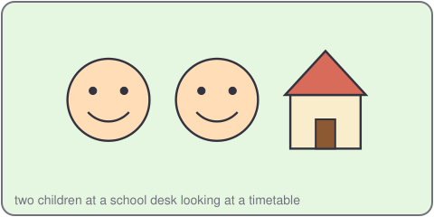
What do you have on Tuesday?
I have English and music.
When do you have art?
I have art on Friday.
2. Listen, point and say.
I have ___ on ___.
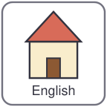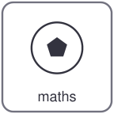
English maths music art science
What do you have on Monday?
3. Let's talk.
When do you have science?
I have it on ___.

Unit 2 My week
4. Listen and number.
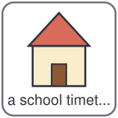
a. I have maths on Monday. b. I have music on Wednesday. c. I have art on Friday.
5. Look, complete and read.
I have _____ on Tuesday.
She has art on _____.
He has English on _____.
6. Let's play.
Draw a timetable. Write five subjects.
Listen to your teacher.
Tick the subject and the day.
Five ticks? Say bingo!

Unit 2 My week

Lesson 3
1. Listen and repeat.

m /m/
Monday music maths
2. Listen and circle.
a. week / weekend b. Monday / Sunday c. music / maths
3. Let's chant.
Monday, Monday, music day!
Tuesday, Tuesday, time to play!
Wednesday, Wednesday, maths for me!
Thursday, Friday, one, two, three!

Unit 2 My week
4. Read and match.

a. What day is it today? I have it on Monday.
b. When do you have music? I have English and art.
c. What do you have on Friday? It's Thursday.
5. Let's write.
My favourite day is _____.
I have _____ on _____.
6. Project.
Make a timetable for your week and show it to your class.

