Unit 1 Where I live

Lesson 1
1. Look, listen and repeat.
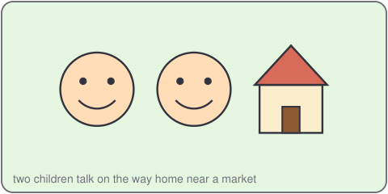
Vy: Where do you live, Quang?
Quang: I live in a village. It is quiet.
Vy: I live in a city. It is busy.
2. Listen, point and say.
I live in a ___.
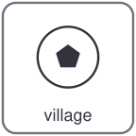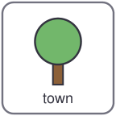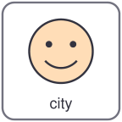
village town city
Where do you live?
I live in a ___.
3. Let's talk.
Where do you live?
I live in a ___. It is ___.

Unit 1 Where I live
4. Listen and tick.
a. I live in a village. b. I live in a city. c. I live in a town.
5. Look, complete and read.
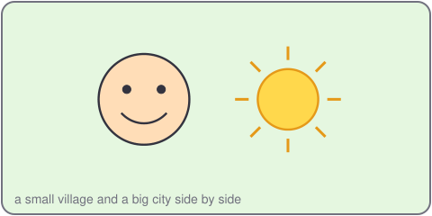
Vy lives in a _____. It is busy.
Quang lives in a _____. It is quiet.
6. Let's sing.
I live in a village, quiet and small.
I live in a town, and I like it all.
I live in a city, busy and tall.
Where do you live? Tell us all!

Unit 1 Where I live

Lesson 2
1. Look, listen and repeat.
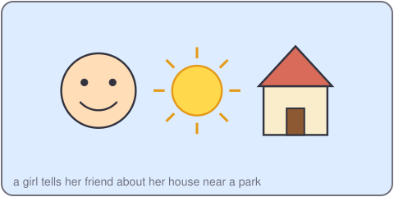
Thu: What is your address, Vy?
Vy: It is 12 Lake Road. My house is near the park.
Thu: Nice! I live at 5 Hill Street.
2. Listen, point and say.
My house is near the ___.
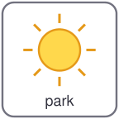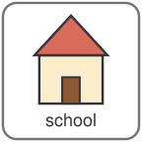
park market school shop
What is your address?
My house is near the ___.
3. Let's talk.
What is your address?
It is ___. My house is near the ___.

Unit 1 Where I live
4. Listen and number.
a. My house is near the park.
b. My house is near the market.
c. My house is near the school.
5. Look, complete and read.
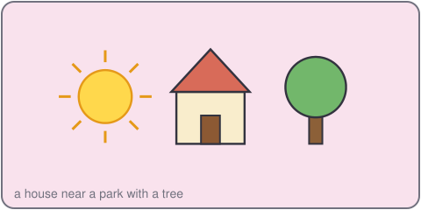
Her house is near the _____.
His house is near the _____.
6. Let's play.
Think of a place near your house.
Your partner asks: Is it a park?
Say: Yes, it is. / No, it is not.
Swap roles. Play again.

Unit 1 Where I live

Lesson 3
1. Listen and repeat.
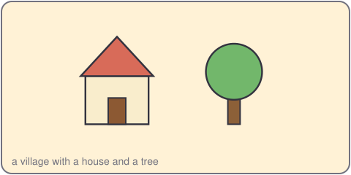
v /v/
village very live
2. Listen and circle.
a. village / town b. quiet / busy c. near / far
3. Let's chant.
Vy lives in a village, very, very quiet.
Quang lives in a city, very, very busy.
Live, live, live in a village!
Live, live, live in a city!

Unit 1 Where I live
4. Read and match.
a. Where do you live? It is 12 Lake Road.
b. What is your address? Yes, it is.
c. Is your house near the park? I live in a village.
5. Let's write.
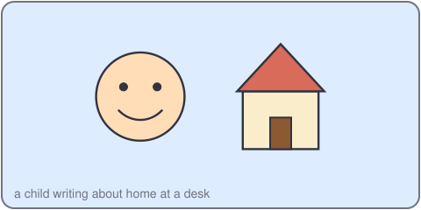
I live in a _____.
My house is near the _____.
It is _____.
6. Project.
Draw a map of your street. Write three sentences.

