Unit 2 Last weekend

Lesson 1
1. Look, listen and repeat.
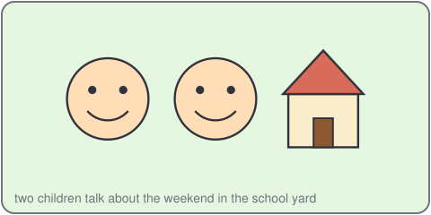
An: What did you do last weekend, Khoa?
Khoa: I visited my grandmother. We cooked fish.
An: I watched TV and played football.
2. Listen, point and say.
I ___ last weekend.
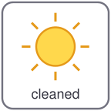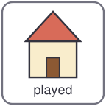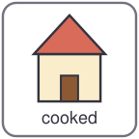
watched TV cleaned played cooked
What did you do last weekend?
I ___ last weekend.
3. Let's talk.
What did you do last weekend?
I visited my ___.

Unit 2 Last weekend
4. Listen and tick.
a. I cleaned my room. b. I visited a farm. c. I played football.
5. Look, complete and read.
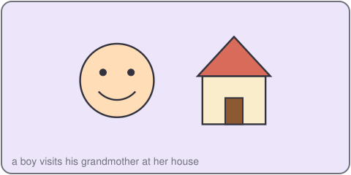
Khoa visited his _____.
An cleaned her _____.
6. Let's sing.
Last weekend, last weekend, what did you do?
I watched TV, and I cleaned too!
Last weekend, last weekend, what did you see?
I saw a big cat in a tall green tree!

Unit 2 Last weekend

Lesson 2
1. Look, listen and repeat.
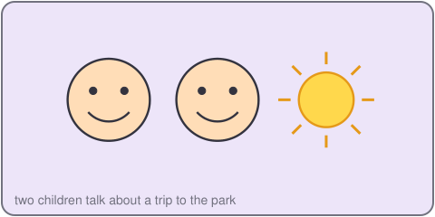
Mi: Did you go to the park, An?
An: Yes, I did. I went with my cousin.
Mi: Did you play football?
An: No, I did not. We flew a kite.
2. Listen, point and say.
I went to the ___.
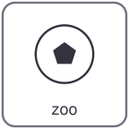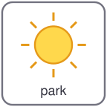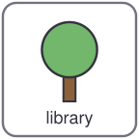
zoo park market library
Did you go to the ___?
Yes, I did. / No, I did not.
3. Let's talk.
Did you go to the zoo last weekend?
Yes, I did. / No, I did not.

Unit 2 Last weekend
4. Listen and number.
a. Khoa went to the zoo. b. Khoa saw a big bird. c. Khoa ate noodles.
5. Look, complete and read.
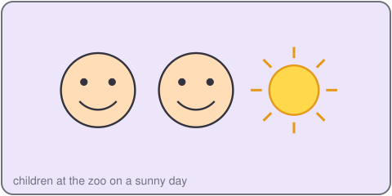
_____ you visit your aunt?
Yes, I _____. / No, I _____ not.
6. Let's play.
Ask three friends.
Did you play football last weekend?
Tick yes or no.
Tell the class.

Unit 2 Last weekend

Lesson 3
1. Listen and repeat.
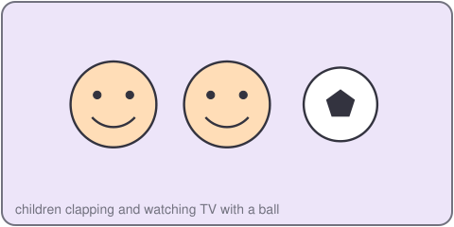
ed /t/
watched cooked jumped
2. Listen and circle.
a. played / plays b. went / go c. watched / watch
3. Let's chant.
Watched, watched, I watched TV.
Cooked, cooked, I cooked for you.
Played, played, I played all day.
Jumped, jumped, I jumped up and down.

Unit 2 Last weekend
4. Read and match.
a. What did you do? Yes, I did.
b. Did you go to the zoo? I went to the market.
c. Where did you go? I cleaned my room.
5. Let's write.
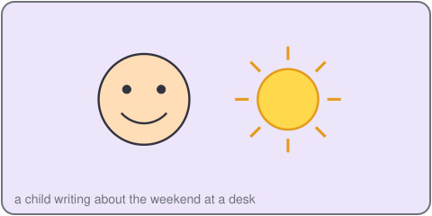
Last weekend, I _____.
I did not _____.
My friend _____.
6. Project.
Make a weekend poster. Draw three pictures and write a sentence for each.

