Unit 1 Hello
1. Look, listen and repeat.
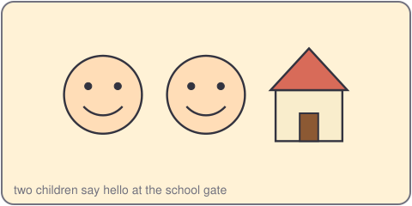
Hello, I'm Ha.
Hi, Ha. I'm Tien.
2. Listen, point and say.
Hello, I'm ___.
Hi, ___. I'm ___.
3. Let's talk.
Hello. / Hi. / I'm (name).

Unit 1 Hello (Lesson 1, Period 2)
4. Listen and tick.
a. Hello, I'm Duc. b. Hi, I'm Lan.
5. Look, complete and read.
Hello, I'm _____. Hi, _____. I'm _____.
6. Let's sing.
Hello, hello, hello! I'm Ha. Hello, hello, hello! I'm Tien.

