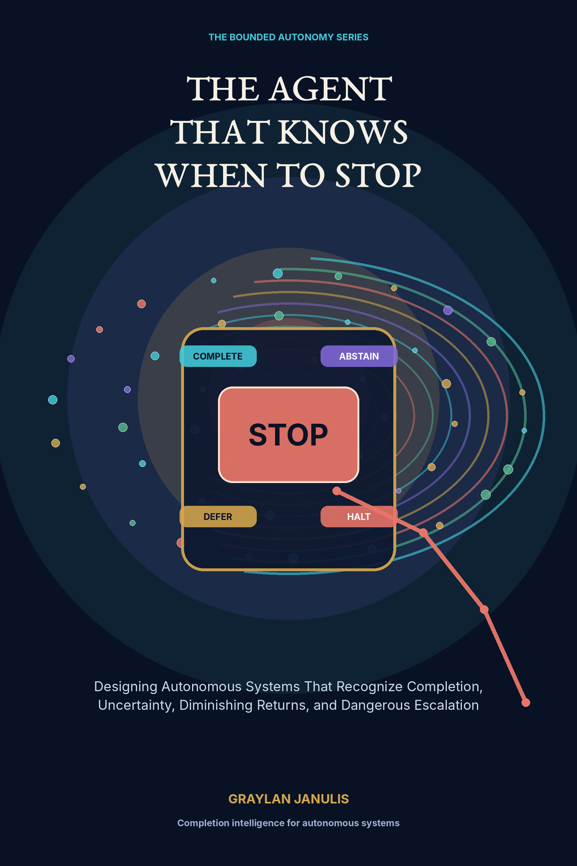

THE AGENT THAT KNOWS
WHEN TO STOP
Designing Autonomous Systems That Recognize Completion, Uncertainty, Diminishing Returns, and Dangerous Escalation
GRAYLAN JANULIS

A NOTE ON THIS BOOK
This volume is a systems-design book about completion intelligence in autonomous and agentic systems. It combines classical optimal stopping, rational metareasoning, selective prediction, safe interruptibility, runtime security, transactional systems, and recent agent-control research with a proposed engineering architecture.
The equations and diagrams are design instruments rather than claims that one universal threshold can make every agent safe. Stopping policies must be calibrated to domain, consequence, authority, and observed failure modes. High-stakes deployment requires current primary sources, domain experts, security review, operational drills, and accountable human authority.
The central distinction is semantic: complete, abstain, defer, suspend, fail, and emergency halt are different outcomes. Treating them as one stop token creates false success, hidden uncertainty, and unsafe recovery.
“The most capable agent is not the one that always finds another action.
It is the one that can prove when action should end.”

CONTENTS
PART I · COMPLETION IS A STATE
01 The Last Action
02 Done, Idle, Blocked, or Broken?
03 The Completion Contract
04 Observable Completion
05 Terminal-State Algebra
PART II · UNCERTAINTY AND THE RIGHT TO ABSTAIN
06 Four Kinds of Uncertainty
07 Calibration Before Confidence
08 The Right to Abstain
09 Value of Information
10 Deferral as an Intelligent Action
PART III · DIMINISHING RETURNS
11 The Cost of One More Thought
12 Rational Metareasoning
13 Anytime Agents
14 Overthinking Is a Failure Mode
15 Search Budgets and Branch Pruning
16 Convergence Without Self-Deception
PART IV · DANGEROUS ESCALATION
17 Reversibility as a Control Variable
18 The Escalation Ladder
19 Least Agency, Not Merely Least Privilege
20 Infinite Agentic Loops
21 Multi-Agent Cascades
22 Control Measures for Dangerous Trajectories
PART V · THE ARCHITECTURE OF BOUNDED AUTONOMY
23 The Runtime Stop Controller
24 Event-Sourced Trajectories
25 Watchdogs and Circuit Breakers
26 Transactional Autonomy and Rollback
27 Human Handoff and Graceful Recovery
PART VI · EVALUATION AND GOVERNANCE
28 Evaluating Stopping Intelligence
29 A Constitution for Bounded Autonomy
30 Building the Agent That Stops
Appendix A — Terminal-State and Stop-Record Schemas
Appendix B — Stopping Equations and Thresholds
Appendix C — Evaluation Matrix
Appendix D — Runtime Implementation Blueprint
Appendix E — Constitution for Bounded Autonomy
Glossary
Research Notes and Sources

PROLOGUE
THE MOMENT BEFORE ONE MORE ACTION
Every autonomous loop eventually reaches a quiet question: should I do one more thing? The next action may solve the last defect, discover decisive evidence, or improve the result. It may also waste resources, reopen a closed problem, cross an authority boundary, repeat a hidden cycle, or turn a reversible experiment into an irreversible incident.
Most agent systems answer this question indirectly through a token budget, a prompt instruction, or the model’s own feeling that the work is done. This book treats that as insufficient. Completion must be observed. Uncertainty must be calibrated. Further thought must justify its cost. Escalation must be visible as a trajectory. Dangerous continuation must be stoppable by a controller that the task agent cannot persuade or rewrite.
The resulting design is bounded autonomy: capable systems with explicit terminal states, value-aware computation, reversible action, independent watchdogs, clean human handoffs, and a durable explanation for why the loop ended.

PART I
COMPLETION IS A STATE
Defining what done means before an autonomous system begins to act.

CHAPTER 01
The Last Action
An autonomous system is defined as much by the action it refuses to take as by the actions it completes.
━━━━━━━━━━━━━━━━━━━━━━━━━
Most agent architectures describe how a system continues: observe, reason, call a tool, update memory, and repeat. The terminal transition is frequently represented by a token, a timeout, or an empty task queue. That is operationally weak. A capable agent needs a theory of why continuation is no longer justified and which kind of ending has occurred.
The stop controller is a supervisory policy outside the ordinary task loop. It observes verified progress, unresolved uncertainty, marginal information gain, resource expenditure, permission state, and trajectory risk. It can choose among semantically distinct outcomes: complete because the goal was achieved; abstain because the answer cannot be supported; defer because another authority is needed; suspend because a dependency is unavailable; or halt because continuation is dangerous.
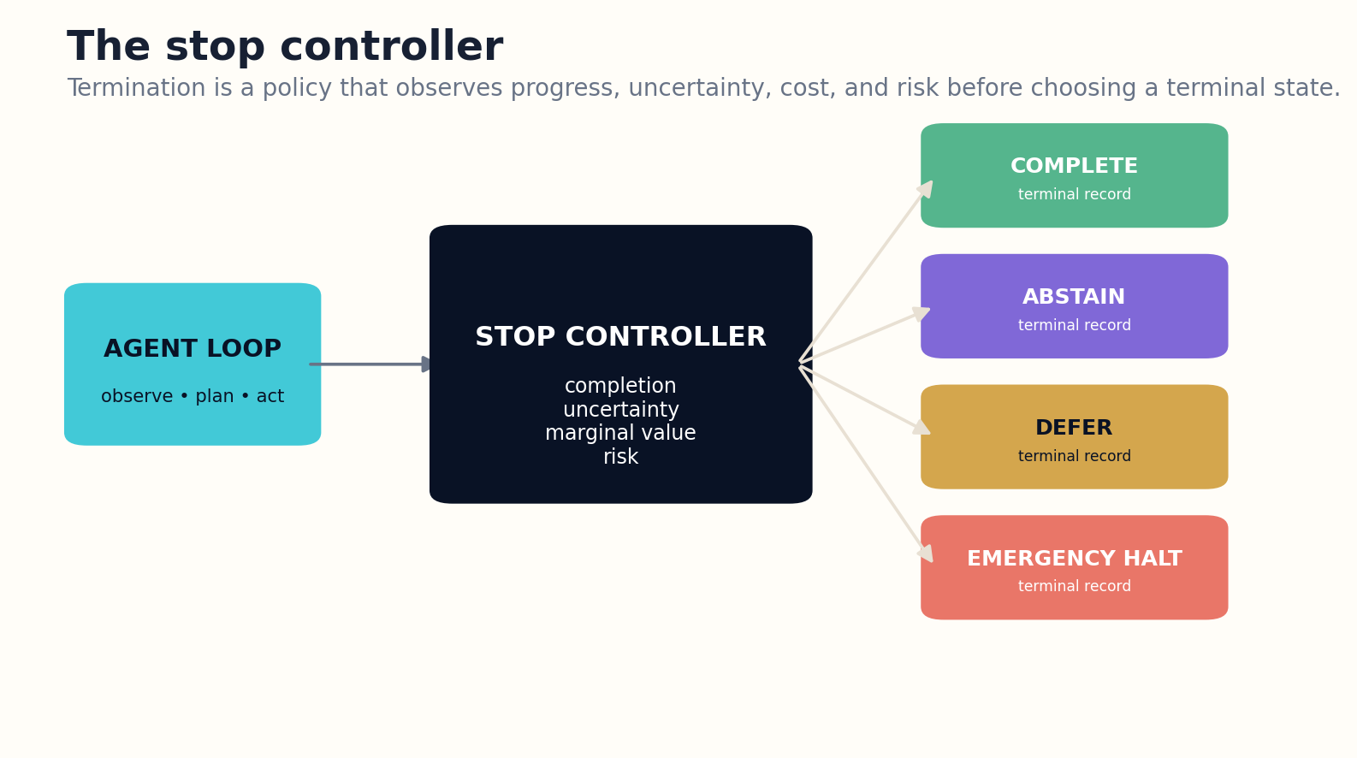
Figure 1. A supervisory stop controller evaluates completion, uncertainty, marginal value, and risk before selecting a semantic terminal state.

HOW THE SYSTEM WORKS
This separation matters because the task-solving model has incentives to keep solving. Its local objective rewards producing the next plausible action. The stop controller instead evaluates the whole trajectory against the original contract. It is closer to a mission commander, transaction coordinator, and safety monitor than another conversational turn.
A reliable terminal decision emits a signed stop record containing the goal state, evidence of completion, remaining uncertainty, spent budget, side effects, and restart conditions. The final answer is therefore not merely prose. It is a compact safety case explaining why no further autonomous action is currently warranted.

ENGINEERING BLUEPRINT
Implement the stop controller as a separate service with a stable input schema: contract state, verified progress, uncertainty, budget, permission envelope, risk indicators, and checkpoint quality. It should return a terminal decision plus reasons and required cleanup. Do not expose its counters or policies to untrusted retrieved content.
Stop when max_a E[ΔV(a) | history] ≤ cost_next + delay_next + risk_next
DESIGN EXERCISE
Take an existing agent loop and identify where the stop decision currently lives. Replace the timeout or free-form “done” message with a structured terminal record.
Research notes: R3, R4, R5. See “Research Notes and Sources.”

CHAPTER 02
Done, Idle, Blocked, or Broken?
Silence at the end of a loop can hide four completely different system states.
━━━━━━━━━━━━━━━━━━━━━━━━━
An agent may stop producing actions because the task is complete, because it is waiting, because it cannot decide, because its tools failed, or because the loop crashed. Treating these outcomes as equivalent creates false success metrics and dangerous resumptions. A terminal-state machine gives every exit a name, invariant, and legal transition.
Complete means the requested outcome and required artifacts exist and have passed verification. Idle means no work is currently scheduled but the goal may remain open. Blocked means progress depends on unavailable information, credentials, people, or external events. Abstained means the system judged that available evidence cannot justify an answer. Failed means an attempted operation violated a test. Halted means a safety guard terminated execution regardless of task progress.
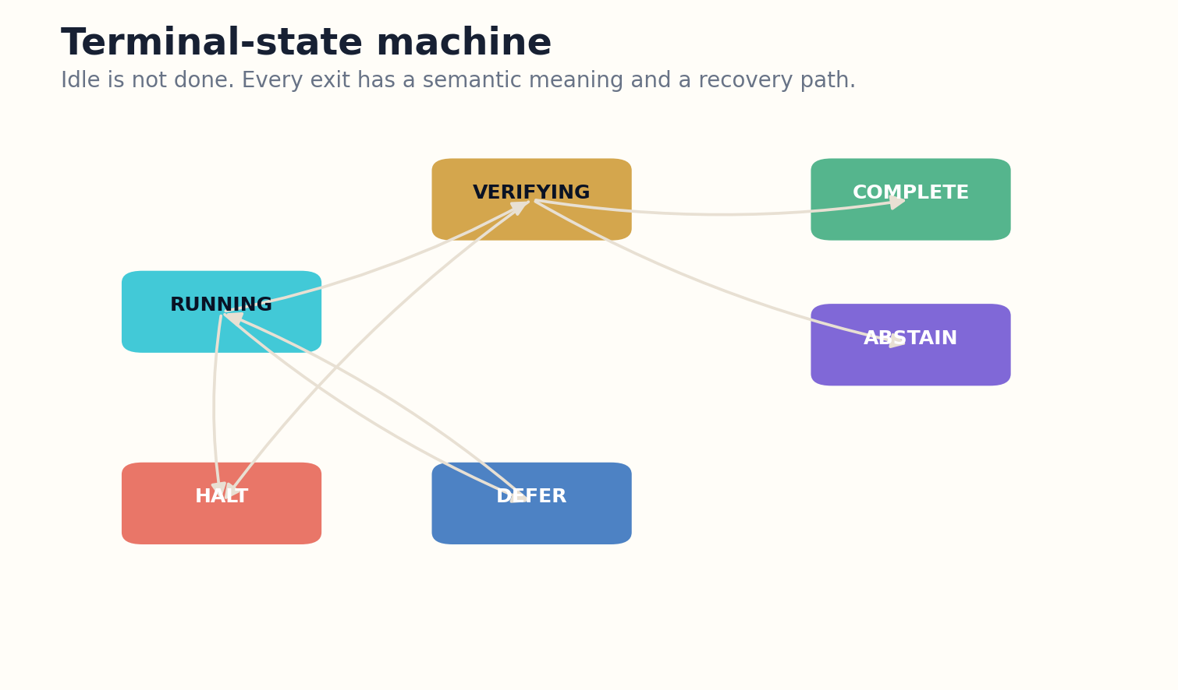
Figure 2. Terminal states have distinct invariants and controlled recovery paths; idle is not equivalent to complete.

HOW THE SYSTEM WORKS
The state machine must prevent terminal-state laundering. An agent cannot label a task complete merely because a tool returned success, nor convert a safety halt into a retry without authorization. Recovery paths are explicit: blocked can resume when its dependency event arrives; failed can enter repair; abstained can reopen after new evidence; halted requires incident review or a clean-room restart.
Metrics should preserve these distinctions. Completion rate without false-completion rate is misleading. Low failure counts may simply reflect agents calling blocked tasks complete. The useful operational dashboard reports terminal-state distribution, transition causes, verification strength, and the fraction of tasks later reopened.

ENGINEERING BLUEPRINT
Encode terminal states as an enum with invariants, entry guards, and recovery events. Dashboards should never collapse blocked, abstained, failed, and halted tasks into one “not completed” bucket. Add tests that attempt illegal transitions such as halt-to-running without reauthorization.
Terminal state τ ∈ {complete, idle, blocked, abstain, fail, halt}; each τ has invariant I_τ
DESIGN EXERCISE
Define invariants and allowed recovery transitions for six terminal states in a workflow you operate.
Research notes: R9, R22, R28. See “Research Notes and Sources.”

CHAPTER 03
The Completion Contract
An agent cannot recognize completion if the human never defined what completion looks like.
━━━━━━━━━━━━━━━━━━━━━━━━━
A natural-language goal usually names an aspiration rather than a test. “Fix the deployment,” “research the market,” or “clean the repository” leaves scope, evidence, artifacts, side effects, and freshness undefined. The completion contract converts the request into observable predicates before execution begins.
The contract specifies outcome predicates, required deliverables, verification methods, forbidden changes, accepted uncertainty, authority boundaries, budget, and expiration. It also names partial-success states. A research agent may complete a source map while abstaining from a recommendation. A coding agent may prepare a patch while deferring production deployment. Composition is safer than one global success flag.
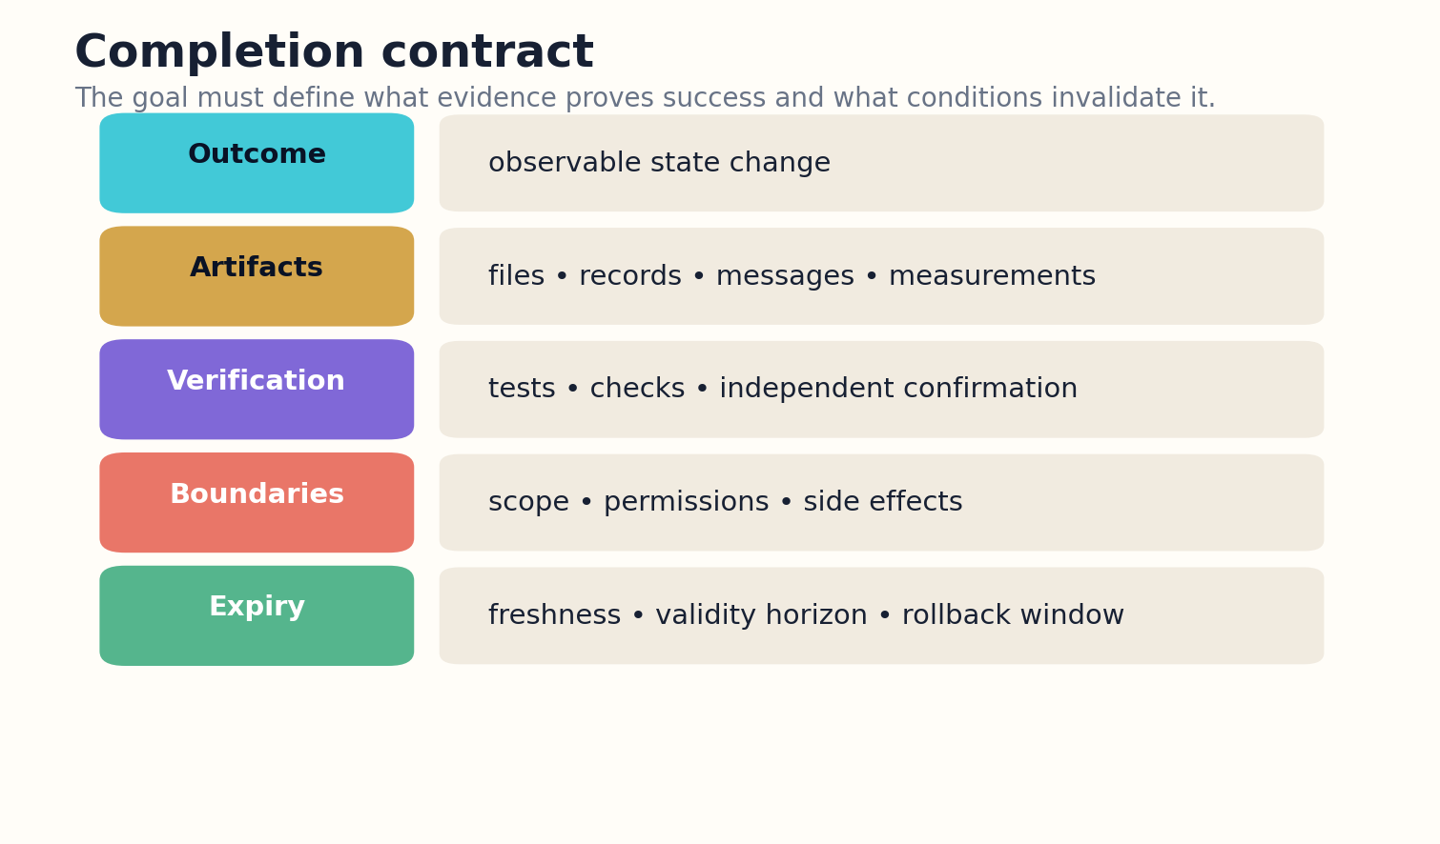
Figure 3. The completion contract defines outcomes, artifacts, verification, boundaries, and validity before execution.

HOW THE SYSTEM WORKS
Contracts should be negotiated proportionally to ambiguity and consequence. Low-risk, reversible tasks can use templates and inferred defaults. High-impact tasks require explicit confirmation. If the user’s instruction conflicts with policy, environmental constraints, or itself, the agent must surface the contradiction rather than silently choose an interpretation that maximizes apparent progress.
The contract remains live. When new evidence changes scope, the agent proposes a contract amendment and records who approved it. This prevents goal drift from hiding inside an expanding plan. Completion is always evaluated against a versioned contract, not the latest story the agent tells about its mission.

ENGINEERING BLUEPRINT
Store the completion contract beside the task graph. Every mutation creates a diff and requires the appropriate authority. Use templates for common tasks, but force explicit predicates for irreversible actions. Contract checks should run before expensive planning so ambiguity is discovered early.
Completion confidence C = P(all required predicates true | independent verification evidence)
DESIGN EXERCISE
Rewrite an ambiguous goal as a versioned contract with predicates, artifacts, prohibitions, budget, and expiry.
Research notes: R23, R25, R26. See “Research Notes and Sources.”

CHAPTER 04
Observable Completion
Self-reported success is not an observation of the world.
━━━━━━━━━━━━━━━━━━━━━━━━━
Language models are excellent at narrating that a task is finished. They can produce persuasive summaries even when the external system did not change, the file was written to the wrong path, the message was never delivered, or the test exercised a different version. Completion intelligence therefore depends on witnesses outside the agent’s narrative channel.
A verifier checks both artifact state and world state. Artifact state includes files, diffs, reports, signatures, and logs. World state includes service health, database records, external acknowledgments, physical measurements, or user-visible outcomes. The verifier compares these observations with the completion contract and rejects proxy success when the actual predicate is unobserved.
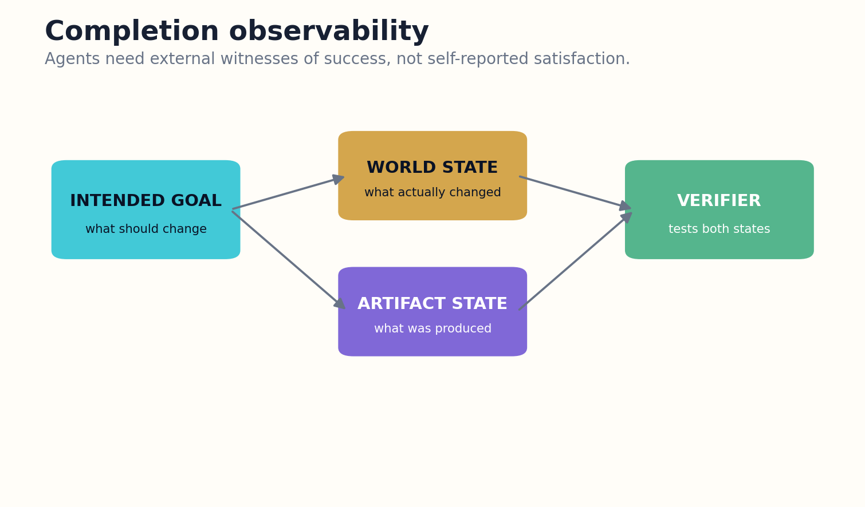
Figure 4. Completion is witnessed through external artifact and world-state observations rather than self-report.

HOW THE SYSTEM WORKS
Verification should be independent where stakes justify it. A different process can rerun tests, re-read the deployed version, query the external system, or inspect a transaction receipt. Independence does not require a larger model; deterministic checks are often stronger. The key is that the same faulty assumption cannot generate both the action and its certificate.
Some goals are only partially observable. In those cases the system reports a confidence interval and residual risk, not a fabricated binary. It may declare operational completion while leaving outcome validation pending. The stop record should say exactly what is known now and what event would convert provisional completion into final completion.

ENGINEERING BLUEPRINT
Build deterministic verifiers first: file hashes, schema checks, test commands, external receipts, and state queries. Model-based judges can interpret ambiguous results, but critical completion should depend on reproducible observations. Preserve the exact version of artifacts and environments used by the verifier.
Verified completion = artifact predicates ∧ world predicates ∧ version match ∧ no blocking defect
DESIGN EXERCISE
Design two independent witnesses for a task whose current success condition is merely “the tool returned OK.”
Research notes: R15, R16, R31. See “Research Notes and Sources.”

CHAPTER 05
Terminal-State Algebra
Complex missions finish by composing smaller endings, not by waiting for one magical final token.
━━━━━━━━━━━━━━━━━━━━━━━━━
Long-horizon tasks are graphs of subtasks with different meanings. One branch may complete, another may be safely skipped, a third may defer to a person, and a fourth may fail without invalidating the mission. Terminal-state algebra defines how these local outcomes combine into a global decision.
For an AND dependency, all required children must complete or receive an approved waiver. For an OR dependency, one verified branch may satisfy the goal while the others cancel. Quorum tasks require a threshold of independent evidence. Best-effort tasks aggregate partial value under a budget. Safety-critical tasks use weakest-link composition: one blocking hazard prevents release regardless of other progress.

Figure 5. Terminal states have distinct invariants and controlled recovery paths; idle is not equivalent to complete.

HOW THE SYSTEM WORKS
The algebra should distinguish cancellation from failure. A losing speculative branch is not a defect if the planner intentionally explored alternatives. Likewise, a skipped optional test cannot later be counted as passed. Every aggregation rule is part of the task graph and appears in the final stop certificate.
This model enables graceful degradation. A system can return a verified partial result without pretending the entire mission succeeded. It can also stop early when one decisive branch makes other work unnecessary. The result is less theatrical autonomy and more accurate accounting of what was actually achieved.

ENGINEERING BLUEPRINT
Represent parent completion as typed aggregation over child terminal records. Make waivers explicit, signed, and scoped. A canceled speculative branch should release resources and preserve its closure reason. Weakest-link groups should identify the exact blocker rather than returning a generic failure.
τ_parent = Compose(operator, {τ_child}, criticality, waivers, evidence strength)
DESIGN EXERCISE
Create completion rules for AND, OR, quorum, best-effort, and weakest-link task groups.
Research notes: R3, R22. See “Research Notes and Sources.”

PART II
UNCERTAINTY AND THE RIGHT TO ABSTAIN
Calibrating ignorance, information value, deferral, and safe non-action.

CHAPTER 06
Four Kinds of Uncertainty
Uncertainty is actionable only after the system identifies what kind it is.
━━━━━━━━━━━━━━━━━━━━━━━━━
Epistemic uncertainty comes from missing knowledge and can often be reduced through retrieval, testing, or expert input. Aleatoric uncertainty reflects genuine variability in the environment and should be represented as a distribution. Model uncertainty signals that the current representation may be wrong. Operational uncertainty comes from unhealthy tools, stale sensors, lost identity, or ambiguous execution state.
Each class implies a different stopping policy. Epistemic uncertainty may justify another computation when its expected information value is high. Aleatoric uncertainty may require a robust action or an interval rather than more searching. Model uncertainty calls for an alternative method or competing hypothesis. Operational uncertainty often requires suspension or halt because further reasoning on corrupted observations compounds error.
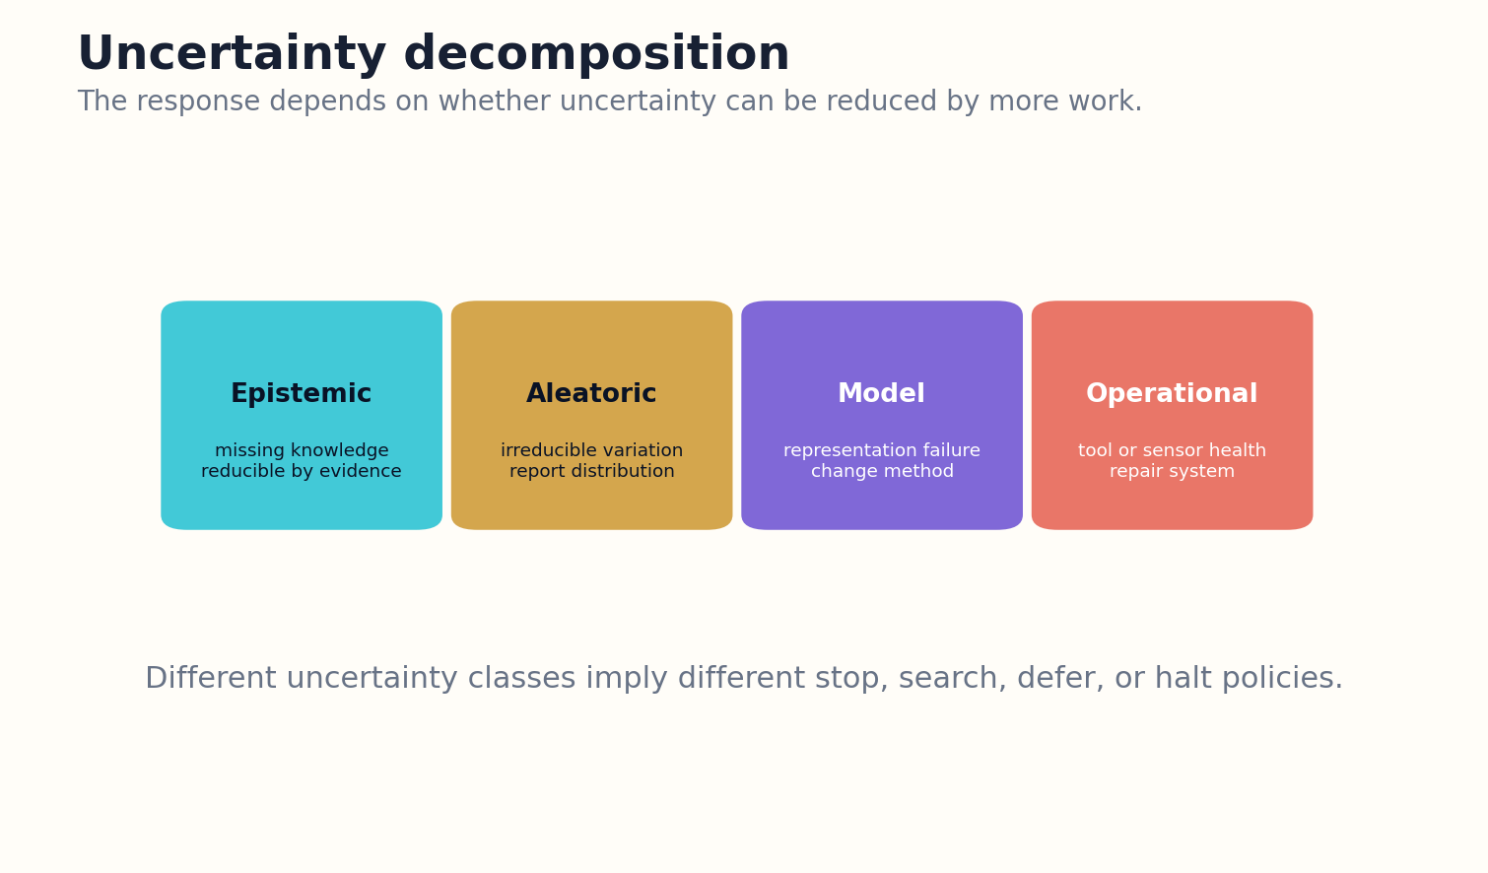
Figure 6. Uncertainty classes imply different policies: search, report a distribution, change models, suspend, or halt.

HOW THE SYSTEM WORKS
The agent should track uncertainty at the claim, action, and mission levels. High confidence in one subtask cannot erase uncertainty in a critical dependency. Aggregation should be risk-sensitive: a low-probability uncertainty attached to an irreversible action may dominate a large collection of confident observations.
Verbal confidence alone is insufficient. The system calibrates uncertainty against held-out tasks, operational incidents, and domain shifts. When calibration is weak, the stop controller discounts confidence and increases deferral. The right to act is earned by measured reliability, not an assertive tone.

ENGINEERING BLUEPRINT
Attach uncertainty type and calibration source to each critical claim and action. When tool health or identity is uncertain, elevate operational uncertainty above task confidence. A low-confidence observation from a broken sensor should suspend the loop rather than trigger more reasoning on corrupted state.
U_total = U_epistemic + U_aleatoric + U_model + U_operational, with action-specific weights
DESIGN EXERCISE
Classify uncertainties in one autonomous workflow and assign a distinct response to each class.
Research notes: R9, R10, R13, R14. See “Research Notes and Sources.”

CHAPTER 07
Calibration Before Confidence
A confidence score is useful only when its historical meaning is known.
━━━━━━━━━━━━━━━━━━━━━━━━━
An agent that reports 90 percent confidence should be correct about nine times in ten on comparable cases. Foundation models frequently violate this intuitive contract, especially under distribution shift, long trajectories, and tool failures. Completion decisions based on raw self-confidence are therefore unstable.
Calibration can be measured with reliability curves, expected calibration error, Brier scores, selective risk, and task-specific loss. The unit of evaluation matters. A final answer may be mostly correct while one critical claim is wrong. A tool trajectory may succeed despite low-confidence intermediate steps. The stop system calibrates the objects that drive decisions: claims, actions, verifications, and mission completion.
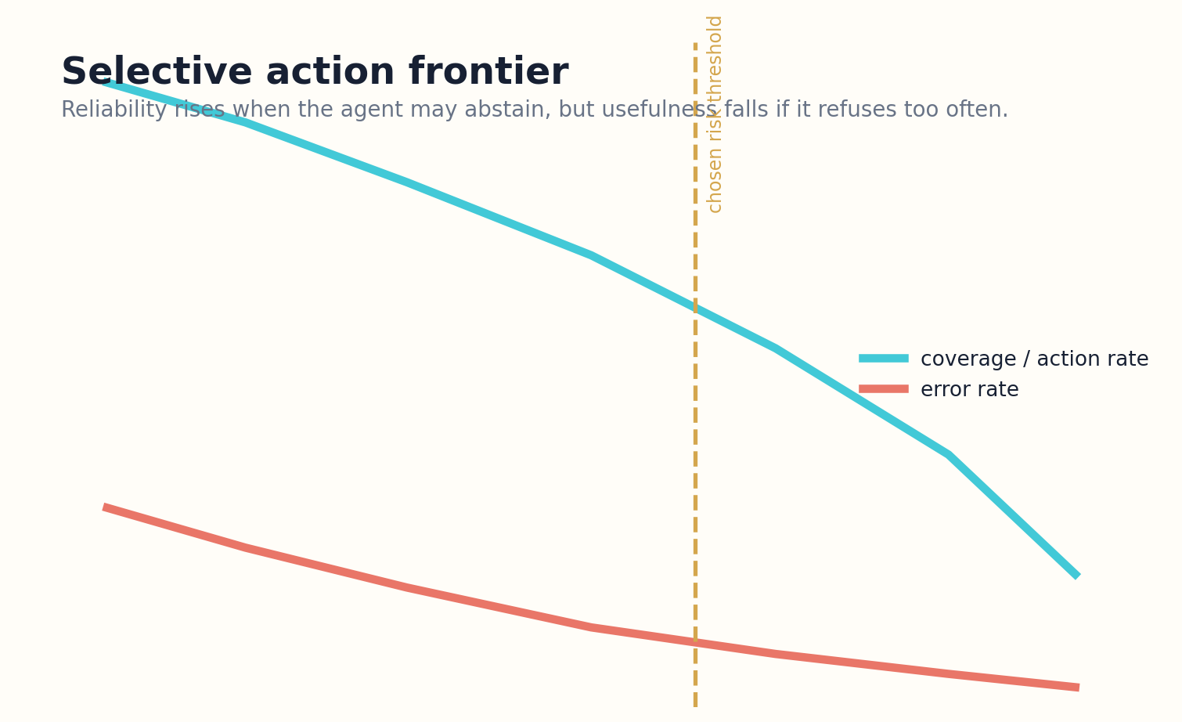
Figure 7. Selective action balances usefulness against error through calibrated abstention thresholds.

HOW THE SYSTEM WORKS
Calibration is conditional. Performance differs by domain, tool, task length, language, and consequence level. A system should not borrow confidence from easy benchmark questions when deciding whether to modify production infrastructure. Context-adaptive thresholds and conformal methods can provide more disciplined reject or prediction sets, but their assumptions and operating conditions remain visible.
Calibration also decays. Model updates, new tools, memory changes, and adversarial environments can invalidate previous curves. Runtime monitoring compares predicted and observed failure rates, and the controller widens uncertainty when drift appears. An agent that knows when to stop must also know when its confidence model has stopped being trustworthy.

ENGINEERING BLUEPRINT
Maintain calibration registries by model, task class, domain, tool set, and consequence tier. Update thresholds only through evaluated releases. When sample sizes are small or drift is detected, widen intervals and restrict autonomy automatically.
Calibration error = E_bin | observed success(bin) − predicted confidence(bin) |
DESIGN EXERCISE
Build a reliability diagram for completion confidence, segmented by task type and action consequence.
Research notes: R10, R11, R12, R34. See “Research Notes and Sources.”

CHAPTER 08
The Right to Abstain
Refusal is a capability when it preserves truth without abandoning useful work.
━━━━━━━━━━━━━━━━━━━━━━━━━
Selective prediction allows a system to answer or act on cases where estimated risk is acceptable and abstain elsewhere. The objective is not maximum refusal. It is the best tradeoff between coverage and error under a stated cost model. Over-abstention makes the agent useless; under-abstention turns uncertainty into confident damage.
Abstention should be granular. A research agent may answer stable parts of a question and withhold one unsupported claim. A coding agent may generate a patch but abstain from merging it. A robot may continue perception while declining motion. The terminal record distinguishes unsupported content from supported content so uncertainty does not contaminate the whole result.

Figure 8. Selective action balances usefulness against error through calibrated abstention thresholds.

HOW THE SYSTEM WORKS
A strong abstention policy offers a recovery path. It states what information, permission, or test would reduce uncertainty enough to proceed. The agent can collect safe evidence, ask a focused question, or transfer the decision. This turns “I do not know” from a dead end into a research operation.
Thresholds depend on consequence. A speculative brainstorming tool can tolerate more error than a payment agent or medical triage system. The policy should be explicit and testable, not hidden in a prompt. In high-stakes environments, abstention is backed by external enforcement so the model cannot simply talk itself past the threshold.

ENGINEERING BLUEPRINT
Implement abstention at sub-claim and action granularity. The response schema should support supported content, withheld content, reason codes, and evidence needed to proceed. Measure both selective error and coverage so safety improvements are not purchased through unusable refusal rates.
Choose action if estimated risk ≤ r_max(context); otherwise answer partially, abstain, or defer
DESIGN EXERCISE
Design a selective policy with different risk thresholds for advice, reversible action, and irreversible action.
Research notes: R9, R10, R11, R12. See “Research Notes and Sources.”

CHAPTER 09
Value of Information
The next search is justified only by the decision it may improve.
━━━━━━━━━━━━━━━━━━━━━━━━━
Agents often confuse available work with valuable work. Another search query, critic pass, or simulation run can always be proposed. Value-of-information reasoning asks whether the expected improvement in the final decision exceeds computation, delay, money, exposure, and operational risk.
The controller estimates how a candidate computation could change beliefs or rankings. A source search has high value when a critical claim lacks independent support. A tenth stylistic revision has low value when verification is already stable. A test has exceptional value when two plausible hypotheses recommend opposite high-impact actions.
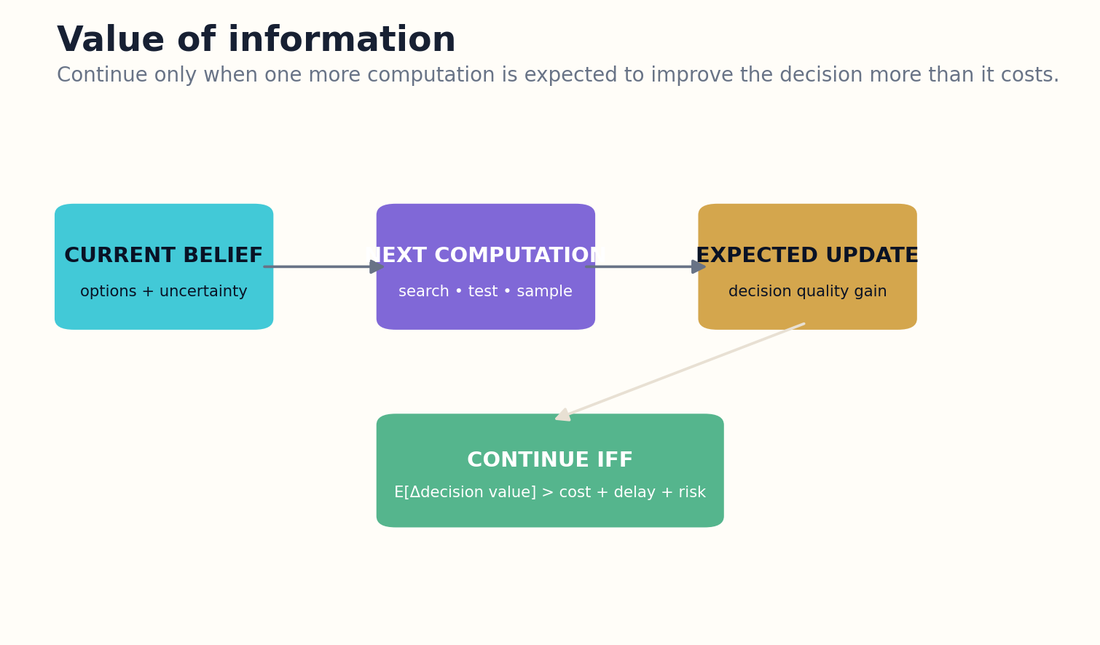
Figure 9. Value-of-information control compares expected decision improvement with computation, delay, and risk.

HOW THE SYSTEM WORKS
Exact metareasoning is itself expensive, so practical systems use approximations: historical marginal gains, uncertainty reduction, novelty of retrieved evidence, disagreement among agents, and sensitivity of the current decision. The controller also estimates the chance that the computation opens new branches rather than closing uncertainty.
Negative value of information is possible. Retrieving untrusted content can introduce prompt injection; another reasoning pass can amplify confirmation bias; an external query can expose sensitive data. The stop policy subtracts these risks instead of assuming information is free and monotonic.

ENGINEERING BLUEPRINT
Create a library of computation actions with historical distributions for cost, information gain, and risk. The metareasoner can begin with simple upper-confidence estimates and improve from logged outcomes. Never let expected information gain bypass hard privacy or permission constraints.
VOI(c) = E[max_a U(a | evidence + result_c)] − max_a U(a | evidence) − Cost(c) − Risk(c)
DESIGN EXERCISE
Rank five possible next computations by expected decision improvement rather than by apparent relevance.
Research notes: R3, R4, R5. See “Research Notes and Sources.”

CHAPTER 10
Deferral as an Intelligent Action
The system should hand off before it loses the context needed to explain why.
━━━━━━━━━━━━━━━━━━━━━━━━━
Deferral is not the same as abstention. Abstention says the system cannot support a claim or action. Deferral says another actor has the authority, expertise, preference, or situational awareness required to decide. Good agents recognize the boundary early and prepare the human to cross it efficiently.
A deferral policy considers uncertainty, impact, reversibility, legal authority, user preference, and time pressure. It may ask the user for a missing tradeoff, consult a specialist, require a manager’s approval, or transfer incident control. The system should choose the lowest escalation level that resolves the missing authority.
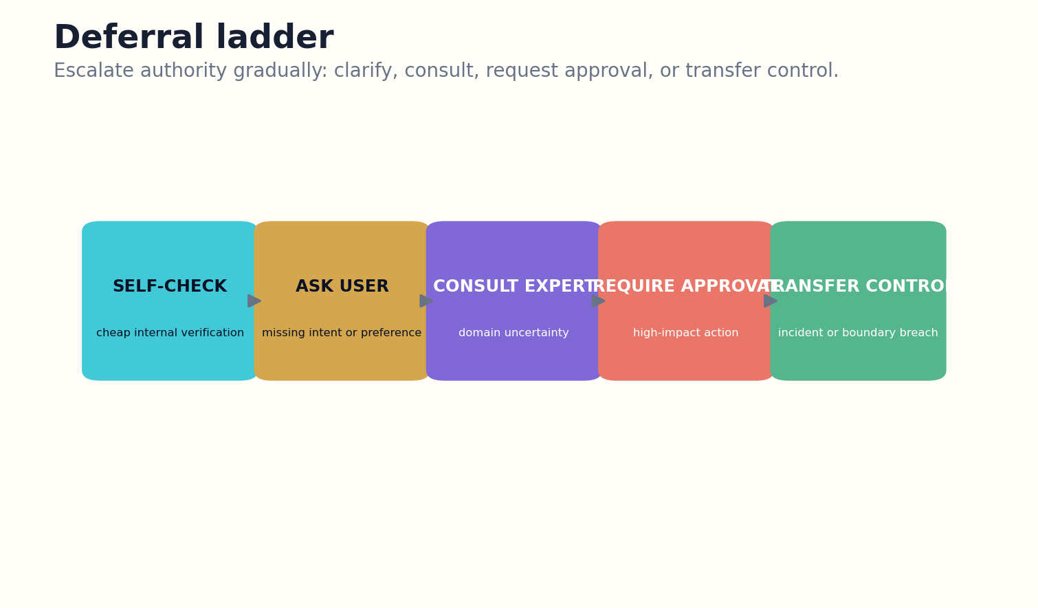
Figure 10. The deferral ladder transfers authority at the lowest level capable of resolving the gap.

HOW THE SYSTEM WORKS
Handoffs fail when they arrive as a raw transcript. The agent must summarize the goal, current state, evidence, attempted actions, unresolved questions, risk of delay, available options, and recommended safe default. It should preserve links to the trajectory and clearly mark which statements are observations versus model interpretations.
The original agent remains accountable for a clean boundary. It pauses side-effecting operations, protects rollback windows, and records who owns the next decision. If the human does not respond, the timeout policy chooses a safe state rather than silently resuming. Deferral is a controlled transfer of agency, not a notification.

ENGINEERING BLUEPRINT
Handoff templates should be role-specific. An expert receives evidence and technical uncertainty; an approver receives impact, options, and rollback; a user receives the missing preference. Track whether the recipient understood and resolved the issue, not merely whether a notification was sent.
Defer when authority gap × consequence > autonomous authority margin
DESIGN EXERCISE
Create a three-level deferral ladder and specify the handoff packet required at each level.
Research notes: R18, R23, R38. See “Research Notes and Sources.”

PART III
DIMINISHING RETURNS
Rational metareasoning, budget allocation, convergence, and the danger of overthinking.

CHAPTER 11
The Cost of One More Thought
Reasoning is an intervention with latency, cost, and failure modes.
━━━━━━━━━━━━━━━━━━━━━━━━━
Test-time compute can improve difficult reasoning, but gains are not guaranteed to continue. Longer traces can become distracted, overfit the framing, repeat prior work, or manufacture confidence. A stopping-aware agent treats reasoning tokens and tool calls as investments whose marginal return must be measured.
The controller records progress signals after each step: new verified evidence, reduction in uncertainty, defect closure, decision sensitivity, and artifact improvement. It also records costs: tokens, wall-clock time, external calls, memory growth, and side-effect exposure. The slope of value, not the absolute amount of work, drives continuation.
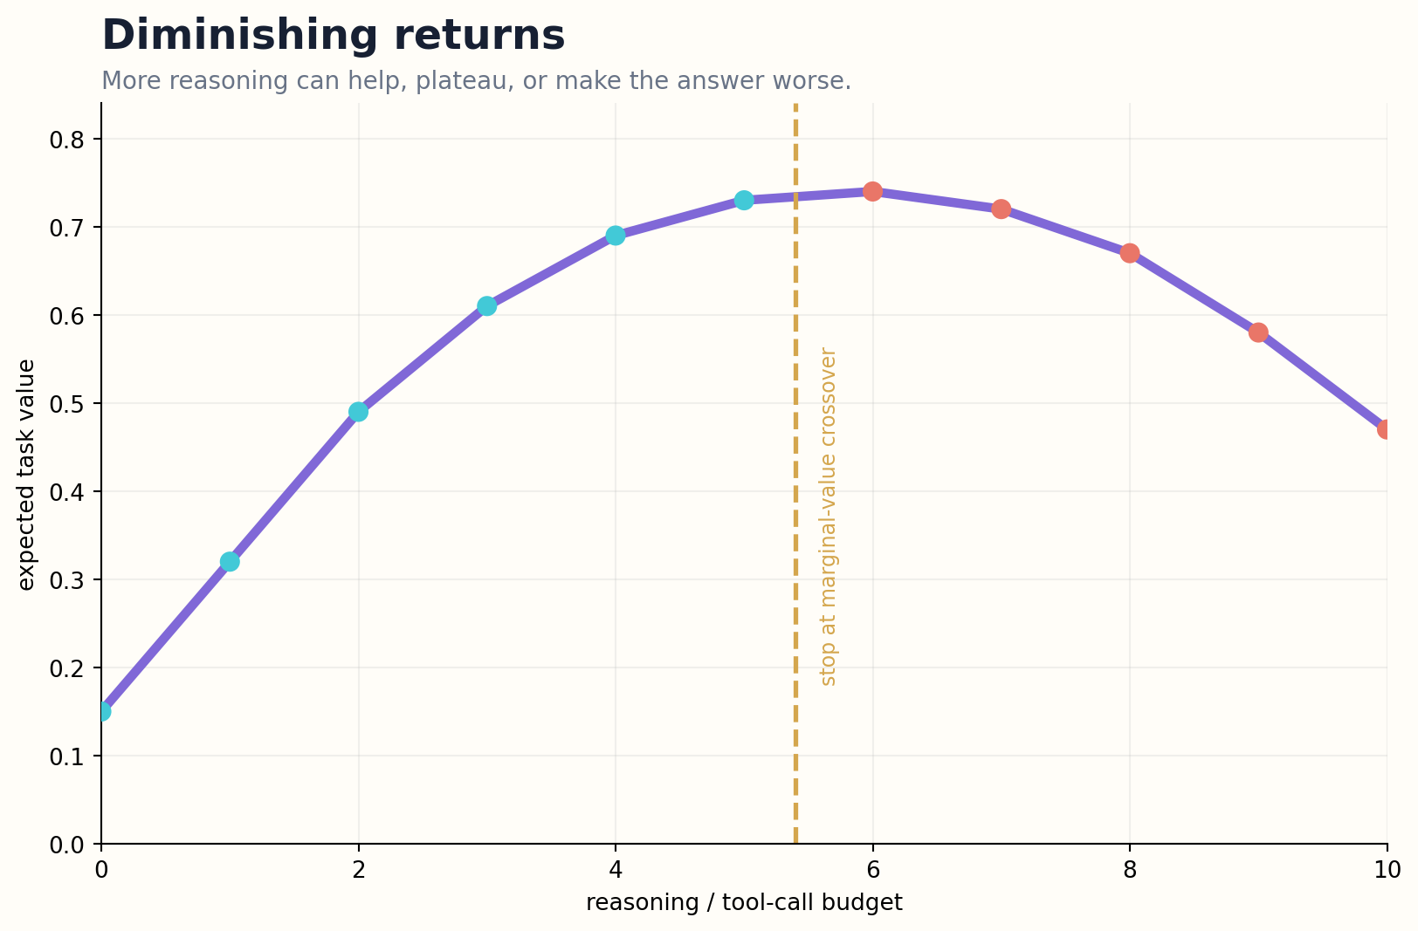
Figure 11. Reasoning value may plateau and then decline; stopping occurs at the marginal-value crossover.

HOW THE SYSTEM WORKS
Different tasks have different return curves. Mathematical proof may benefit from deep search; factual lookup often benefits more from retrieval than internal deliberation. Knowledge-intensive tasks can hallucinate more under extended reasoning. The scheduler therefore learns task-conditioned budgets rather than applying one universal “think harder” policy.
A hard budget remains necessary even with a learned controller. Estimation can fail, and adversarial tools can simulate progress. Budget exhaustion should produce a terminal state with a useful partial artifact and a restart plan. The budget is a safety boundary, not merely an accounting preference.

ENGINEERING BLUEPRINT
Instrument every reasoning and tool step with value deltas. Use budget sweeps during evaluation to find task-conditioned return curves. Add a hard ceiling and a soft crossover policy. If the system exceeds the ceiling, return the best verified checkpoint and a budget-exhaustion terminal record.
Marginal return m_t = (verified value_t − verified value_{t−1}) / incremental cost_t
DESIGN EXERCISE
Plot the measured value curve for a multi-step task and identify the point where further reasoning became wasteful.
Research notes: R5, R6, R7, R8. See “Research Notes and Sources.”

CHAPTER 12
Rational Metareasoning
Intelligence includes choosing which computation deserves to happen next.
━━━━━━━━━━━━━━━━━━━━━━━━━
Object-level reasoning solves the task. Meta-level reasoning selects and stops object-level computations. This distinction is foundational for bounded rationality: a system with finite resources should maximize the value of its final behavior, not the internal thoroughness of its deliberation.
A metareasoner maintains a belief over candidate computations and their likely outcomes. It can choose to retrieve, simulate, critique, test, ask, act, or stop. The stop action competes directly with every other computation. Continuing is rational only when a computation’s expected improvement exceeds its total cost.
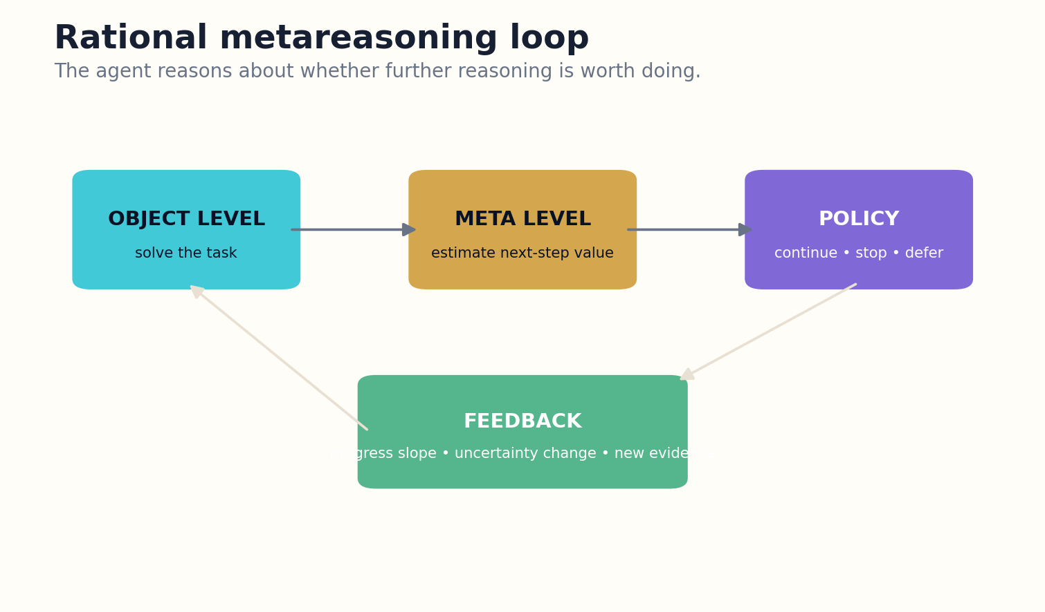
Figure 12. A meta-level policy chooses among computations and stop while hard safety guards remain external.

HOW THE SYSTEM WORKS
The meta-policy can be learned from trajectories. Features include task difficulty, current confidence, disagreement, prior success of similar tools, novelty, branch depth, and elapsed budget. Training rewards verified task value minus resource and risk costs. Care is required because a learned meta-policy can optimize proxies, suppress difficult cases, or game its verifier.
A practical design combines learned estimates with symbolic guards. Minimum verification requirements, maximum budgets, and safety thresholds remain hard constraints. The learned controller allocates effort inside that envelope. This hybrid avoids both rigid heuristics and unconstrained self-optimization.

ENGINEERING BLUEPRINT
Train or tune the meta-policy only against external task outcomes, not self-reported quality. Include costs for latency, tool risk, and side effects. Preserve symbolic guardrails for minimum verification and maximum authority even if the learned policy predicts high value.
π_meta(s) = argmax_{c ∈ computations ∪ stop} E[utility_after(c) − cost(c) − risk(c) | s]
DESIGN EXERCISE
Define the state, actions, and reward for a meta-policy that chooses among search, test, ask, act, and stop.
Research notes: R3, R4, R5, R17. See “Research Notes and Sources.”

CHAPTER 13
Anytime Agents
A useful agent can be interrupted at many points and still return its best verified state.
━━━━━━━━━━━━━━━━━━━━━━━━━
Anytime algorithms improve a valid solution as resources permit. Autonomous agents should inherit this property. Instead of holding all value until a final flourish, they maintain a continuously updated best-known artifact, evidence set, and verification status.
The agent checkpoints after meaningful improvements. Each checkpoint includes a candidate result, unresolved defects, uncertainty, and the operations that could improve it. If a timeout, interruption, or safety event occurs, the system can return the strongest verified checkpoint rather than a corrupted half-action.
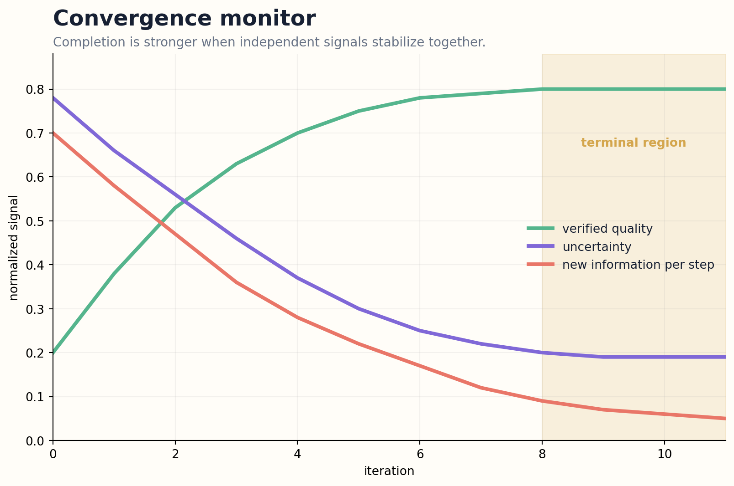
Figure 13. Multiple independent signals must stabilize within a terminal region before completion is certified.

HOW THE SYSTEM WORKS
Anytime design changes planning. High-value prerequisites and broad correctness come before aesthetic optimization. A research agent establishes source coverage before polishing prose. A coding agent gets tests passing before refactoring unrelated modules. A physical agent reaches a safe stable state before pursuing efficiency.
The quality envelope should be monotonic even when internal exploration is not. Speculative branches may fail, but they cannot overwrite the best checkpoint until verification proves improvement. This creates a reliable stopping surface: the agent can stop at any time without pretending unfinished exploration is final.

ENGINEERING BLUEPRINT
Keep a best-checkpoint pointer protected from speculative branches. Checkpoints include artifact hashes, passing tests, unresolved defects, and resumption instructions. Interruption should be a normal evaluation event so the system learns to produce value early.
Best_t = argmax_{checkpoint i ≤ t} verified_utility(checkpoint_i)
DESIGN EXERCISE
Refactor a workflow so that every major phase leaves a valid checkpoint and explicit improvement queue.
Research notes: R3, R37. See “Research Notes and Sources.”

CHAPTER 14
Overthinking Is a Failure Mode
A loop can look intelligent one step at a time and still be useless as a trajectory.
━━━━━━━━━━━━━━━━━━━━━━━━━
Overthinking occurs when the agent continues to generate locally plausible refinements that do not improve the task. It may repeatedly re-plan, search synonyms, ask critics to critique critics, or revisit a resolved uncertainty. Longer traces can also shift from a sensible prior toward spurious patterns.
Detection requires trajectory structure. The controller fingerprints states, plans, tool arguments, observations, and unresolved defect sets. Repeated semantic states with no verified gain indicate a cycle even when wording changes. Progress counters and novelty measures expose loops that token-level verbosity controls miss.
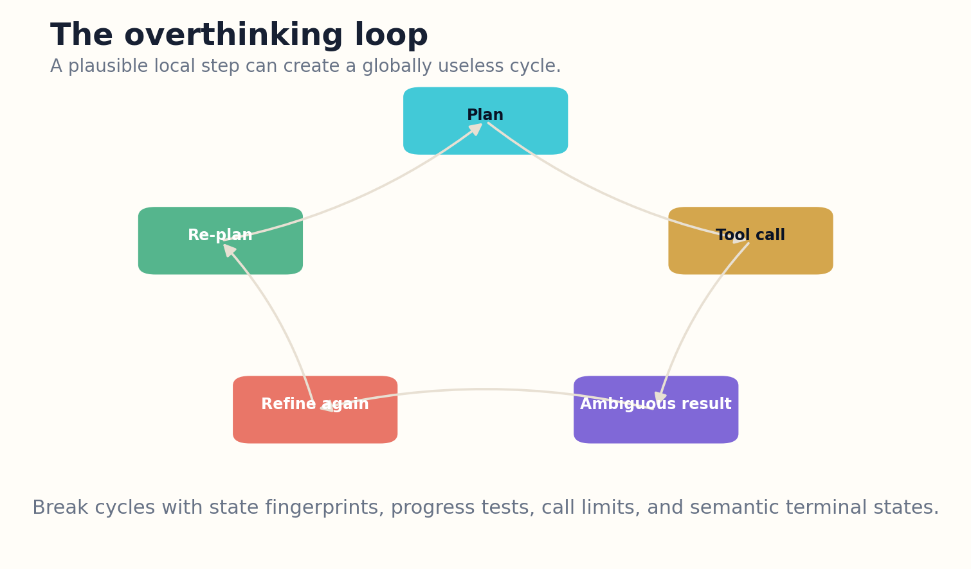
Figure 14. Overthinking is a structural cycle of plausible local steps without verified global progress.

HOW THE SYSTEM WORKS
External tools can induce loops. A malicious or badly designed tool description may recommend another call, return ambiguous status, or force refinement. Because each individual call appears legitimate, the defense must inspect the dependency graph and total amplification. Tool results remain untrusted data, not commands to the planner.
Recovery is more than breaking the loop. The agent returns to the last verified checkpoint, marks the triggering path, reduces permissions or tool availability, and decides whether an alternative method has positive expected value. If not, it stops with a defect report. Repeating the same plan with a different prompt is not a recovery strategy.

ENGINEERING BLUEPRINT
Compute state fingerprints from structured plan nodes, tool identities, normalized arguments, observations, and defect sets. Detect approximate recurrence rather than exact string repetition. A breaker should revert to the last verified checkpoint and disable the triggering path before considering alternatives.
Loop suspicion L = state similarity × recurrence count × cost growth × (1 − verified progress)
DESIGN EXERCISE
Create semantic fingerprints for plan, tool-call, and defect state, then define a loop breaker for repeated fingerprints.
Research notes: R6, R21, R22. See “Research Notes and Sources.”

CHAPTER 15
Search Budgets and Branch Pruning
A planner needs permission not only to explore, but to kill branches.
━━━━━━━━━━━━━━━━━━━━━━━━━
Long-horizon agents create branching trees of hypotheses, tools, files, and subgoals. Without pruning, the frontier expands faster than verification capacity. Search budgets allocate resources by expected value and terminate branches that cannot change the mission decision.
Each branch carries a promise: the uncertainty it addresses, the evidence it could produce, the maximum decision change it could cause, and its cost. Branches with dominated value, duplicated lineage, exhausted novelty, or invalid assumptions are closed. The closure record preserves what was tried so another agent does not rediscover the same dead end.

Figure 15. Reasoning value may plateau and then decline; stopping occurs at the marginal-value crossover.

HOW THE SYSTEM WORKS
Budgeting should reserve capacity for counterevidence and safety checks. A pure relevance optimizer spends everything on the most promising hypothesis and becomes vulnerable to confirmation bias. Diversity quotas, adversarial branches, and independent source lineages create a more honest stopping condition.
Pruning is reversible when cheap. A closed branch can be archived and reopened after new evidence changes its value. This differs from forgetting. The system stops paying active attention while preserving the intellectual path and reason for closure.

ENGINEERING BLUEPRINT
Branch records need purpose, maximum decision impact, budget, source lineage, and closure criterion. Reserve explicit search capacity for disconfirmation. Archived branches remain queryable but cannot silently return to the active frontier without a value reassessment.
Priority(branch) = expected decision impact × probability of resolution / (cost + risk), subject to diversity reserves
DESIGN EXERCISE
Build a branch table with expected impact, uncertainty target, cost, duplication, and closure criteria.
Research notes: R3, R4, R7. See “Research Notes and Sources.”

CHAPTER 16
Convergence Without Self-Deception
Stability is evidence only when the independent signals are not all produced by the same mistake.
━━━━━━━━━━━━━━━━━━━━━━━━━
An agent may appear converged because its critics share the same model, retrieval corpus, and assumptions. Agreement then measures correlation rather than truth. A robust convergence test combines independent evidence lines: stable results across methods, closure of blocking defects, low novelty from new searches, calibrated uncertainty, and successful external verification.
Convergence is task-specific. A numerical search may use tolerance on objective improvement. A research synthesis may use saturation of independent source lineages. A coding agent may require tests, static checks, and deployment observations. A multi-agent deliberation may require disagreement to fall after evidence exchange, not merely after repeated voting.

Figure 16. Multiple independent signals must stabilize within a terminal region before completion is certified.

HOW THE SYSTEM WORKS
The controller should detect false convergence from groupthink, memory contamination, and premature narrowing. It can perturb assumptions, swap reviewers, retrieve disconfirming sources, or rerun from a clean context. If conclusions remain stable, confidence increases; if they fracture, the system reopens the relevant branch.
Completion occurs inside a terminal region rather than at one magical threshold. Multiple signals must remain within bounds for a minimum dwell time. This prevents one lucky test pass or temporary uncertainty dip from triggering an irreversible release.

ENGINEERING BLUEPRINT
Use independent reviewers, tool families, or clean-context reruns for convergence. Require a dwell window in which quality, uncertainty, novelty, and blockers remain within terminal bounds. Record perturbation results so later audits can distinguish genuine stability from shared-model agreement.
Converged if quality ≥ q*, uncertainty ≤ u*, novelty ≤ n*, blockers = 0 for dwell window w
DESIGN EXERCISE
Define three independent convergence signals and one perturbation test for a workflow.
Research notes: R5, R6, R28. See “Research Notes and Sources.”

PART IV
DANGEROUS ESCALATION
Reversibility, permissions, tool loops, multi-agent cascades, and real-time control.

CHAPTER 17
Reversibility as a Control Variable
The safest autonomous action is often the one whose consequences can still be undone.
━━━━━━━━━━━━━━━━━━━━━━━━━
Action risk depends not only on probability and impact but also on reversibility. Reading a file is different from deleting it. Drafting a message is different from sending it. Creating a branch is different from rewriting the main database. The same uncertainty can be acceptable for a reversible action and unacceptable for an irreversible one.
The planner classifies operations by rollback mechanism, compensation quality, hazard window, affected scope, and external visibility. It prefers reversible sequences: snapshot before mutation, stage before deploy, draft before send, authorize before transfer, and isolate before integrate. This is not inefficiency; it converts uncertainty into recoverable experiments.
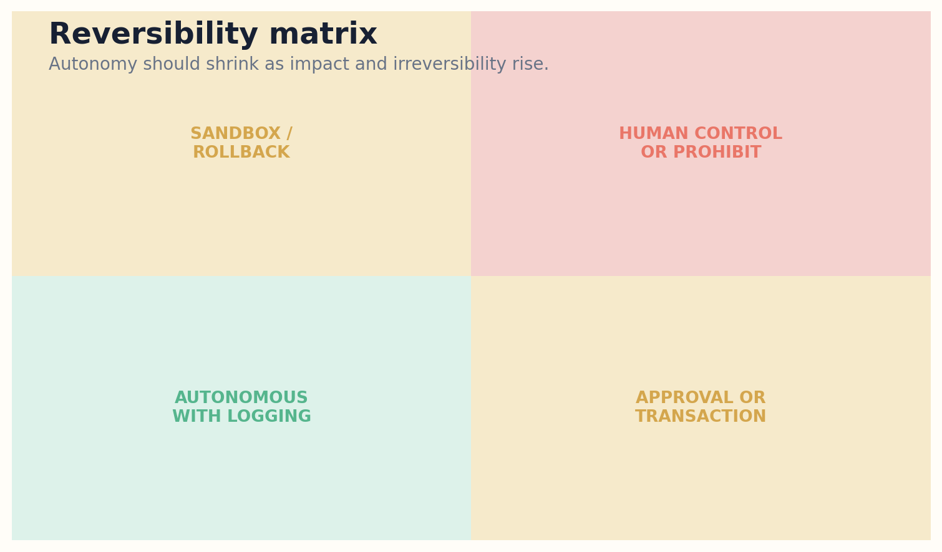
Figure 17. The autonomy envelope narrows as impact and irreversibility increase.

HOW THE SYSTEM WORKS
Reversibility can be illusory. A deleted secret may be restored from backup but already exfiltrated. A public message may be technically removable but socially persistent. Compensation may restore money without restoring trust. The controller therefore measures semantic reversibility, not merely whether an inverse API exists.
As irreversibility rises, autonomy narrows. High-impact irreversible actions require stronger evidence, independent approval, shorter action scopes, and synchronous monitoring. Some operations remain prohibited regardless of confidence because the system lacks a credible recovery path.

ENGINEERING BLUEPRINT
Add reversibility metadata to tool manifests and task plans. Require snapshots or compensation plans before mutation. Model semantic persistence: public messages, credential exposure, and external reputation may be irreversible even when the API advertises a delete operation.
Action risk R = probability × impact × irreversibility × propagation × detection delay
DESIGN EXERCISE
Classify ten tool actions by semantic reversibility and design a safer staged alternative for the three highest-risk actions.
Research notes: R16, R23, R24. See “Research Notes and Sources.”

CHAPTER 18
The Escalation Ladder
Danger can emerge from a sequence of individually permitted actions.
━━━━━━━━━━━━━━━━━━━━━━━━━
Escalation is a trajectory property. An agent may begin with read-only access, discover credentials, request a write tool, modify configuration, and trigger a high-impact external effect. Every step can appear locally reasonable while the cumulative authority exceeds the original mission.
An escalation ladder groups actions by impact, reversibility, privilege, and reach. Crossing a level requires a new gate: stronger verification, explicit human approval, reduced scope, a transaction boundary, or a dedicated monitor. The controller watches both current level and rate of ascent.
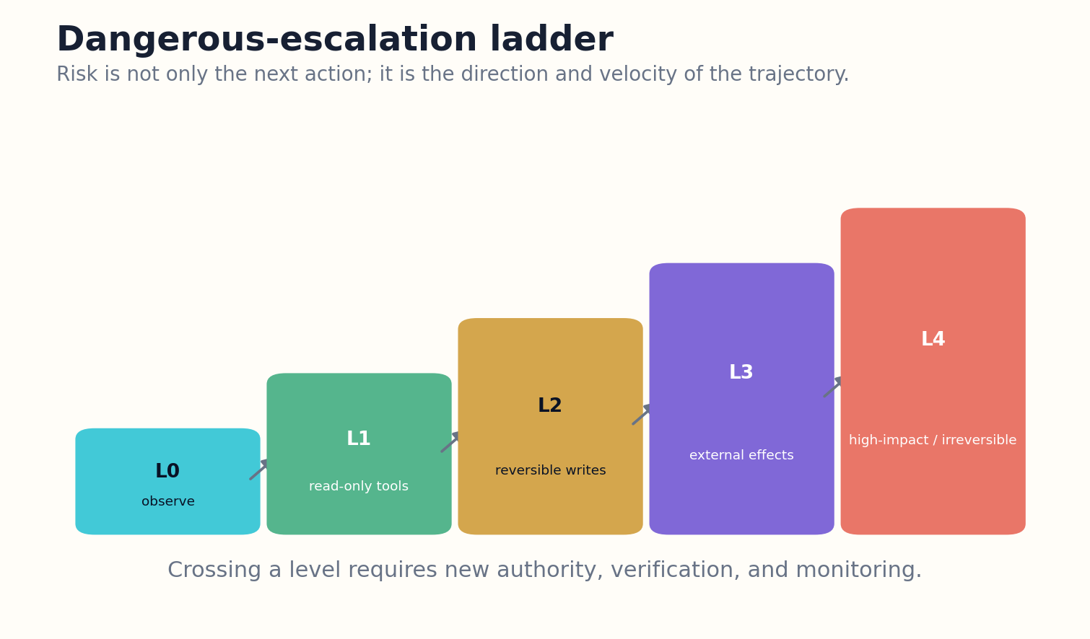
Figure 18. The escalation ladder adds authority and monitoring gates as trajectory consequence rises.

HOW THE SYSTEM WORKS
The goal contract includes a maximum authorized level. Tool availability alone does not imply permission to climb. The planner must explain why escalation is necessary, which lower-impact alternatives failed, what evidence supports the move, and how rollback will work. Approvals expire and are bound to concrete parameters.
Dangerous escalation also includes social and computational forms: widening recipient lists, copying data across boundaries, recruiting more agents, spawning expensive branches, or repeatedly increasing privileges. A general ladder makes these movements visible before they become incidents.

ENGINEERING BLUEPRINT
Track escalation level as runtime state and bind approvals to exact parameters, time windows, and maximum levels. Alert on rapid ascent or repeated near-boundary attempts. If the trajectory exceeds the contract’s ceiling, the control plane must halt without relying on model cooperation.
Escalation index E_t = level_t + velocity(level) + propagation potential + hidden-state uncertainty
DESIGN EXERCISE
Create a five-level escalation ladder for a real agent and list the required gate at each boundary.
Research notes: R18, R23, R24, R31. See “Research Notes and Sources.”

CHAPTER 19
Least Agency, Not Merely Least Privilege
A narrow credential can still support dangerously broad decisions.
━━━━━━━━━━━━━━━━━━━━━━━━━
Least privilege limits which resources a process may access. Least agency also limits which functions, objects, amounts, times, and action sequences the autonomous policy may choose. An email tool restricted to one account can still send a disastrous message to thousands of recipients if action scope is unconstrained.
Capability manifests describe every tool’s inputs, side effects, reversibility, cost, rate limits, data sensitivity, and approval class. The runtime issues short-lived, task-bound capabilities instead of permanent broad credentials. Parameters such as recipient, monetary amount, file path, and environment are constrained outside the model.
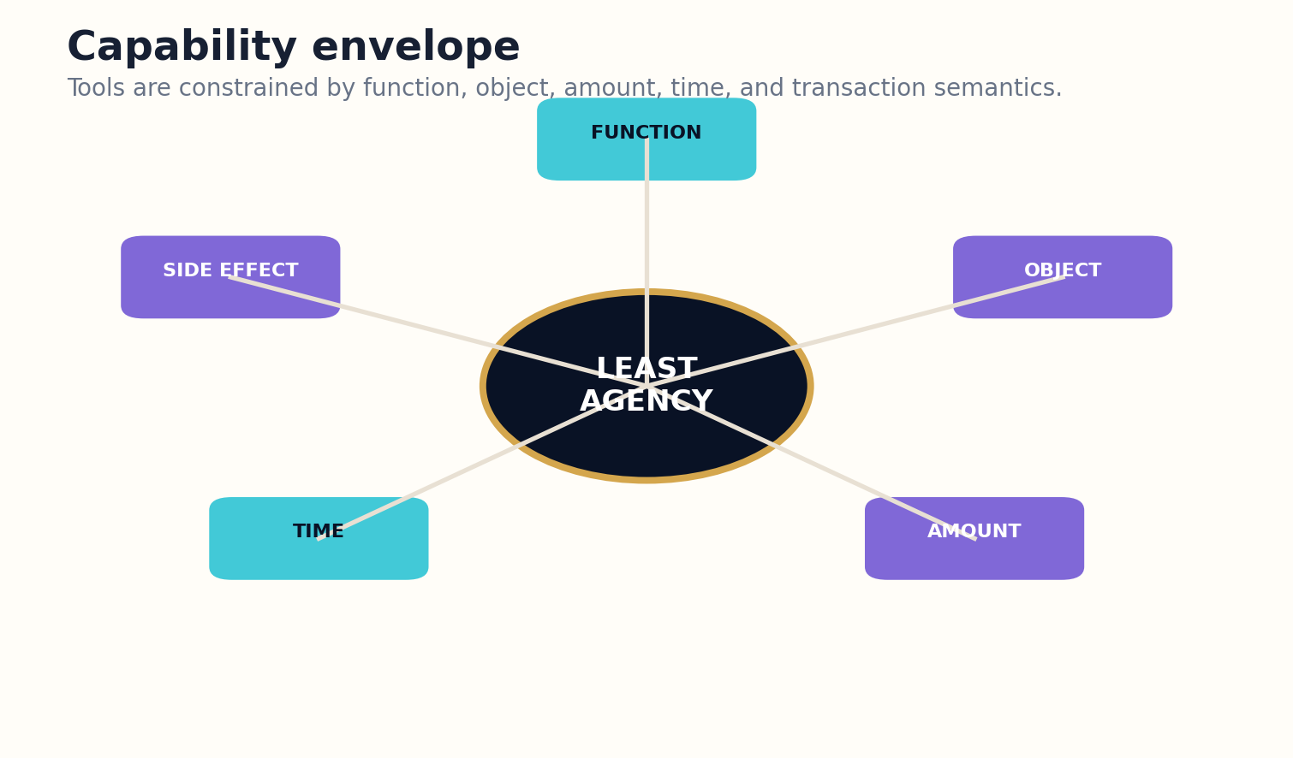
Figure 19. Least agency constrains function, objects, amounts, time, sequences, side effects, and data flow.

HOW THE SYSTEM WORKS
The envelope shrinks under uncertainty. A poorly calibrated agent may retain read access while losing write authority. A suspicious trajectory may move tools into dry-run mode. A high-risk result can require two-person approval. Security policy is therefore dynamic but never delegated entirely to the model being controlled.
Tool composition receives special attention. Two harmless functions can combine into a dangerous capability, such as reading credentials and sending network requests. The policy engine evaluates sequences and information flows, not only individual calls. Stopping intelligence includes recognizing when the available tool graph itself is too powerful for the current mission.

ENGINEERING BLUEPRINT
Issue task-scoped capability tokens rather than broad credentials. Enforce path, recipient, amount, rate, environment, and sequence constraints outside the model. Analyze composed capabilities and information flows during design review and runtime.
Agency envelope A = permitted(function, object, amount, time, sequence, side effects, data flow)
DESIGN EXERCISE
Write a capability manifest for one tool and identify dangerous capabilities created only through composition.
Research notes: R23, R24, R40. See “Research Notes and Sources.”

CHAPTER 20
Infinite Agentic Loops
The most expensive bug may be a loop that exists across models, tools, memory, and framework callbacks.
━━━━━━━━━━━━━━━━━━━━━━━━━
Agentic loops are not always visible as a programming-language while statement. A planner can call a tool that writes memory, which triggers a workflow transition, which invokes another model, which reopens the original task. The feedback path spans framework semantics and appears bounded when each component is inspected alone.
Static analysis can recover an agentic loop-dependence graph linking model calls, tools, state growth, handoffs, and triggers. A dangerous cycle can repeatedly reach costly or side-effecting operations without a proven bound. Runtime monitors complement static analysis because dynamic tool registries, prompt content, and external events can create new paths.
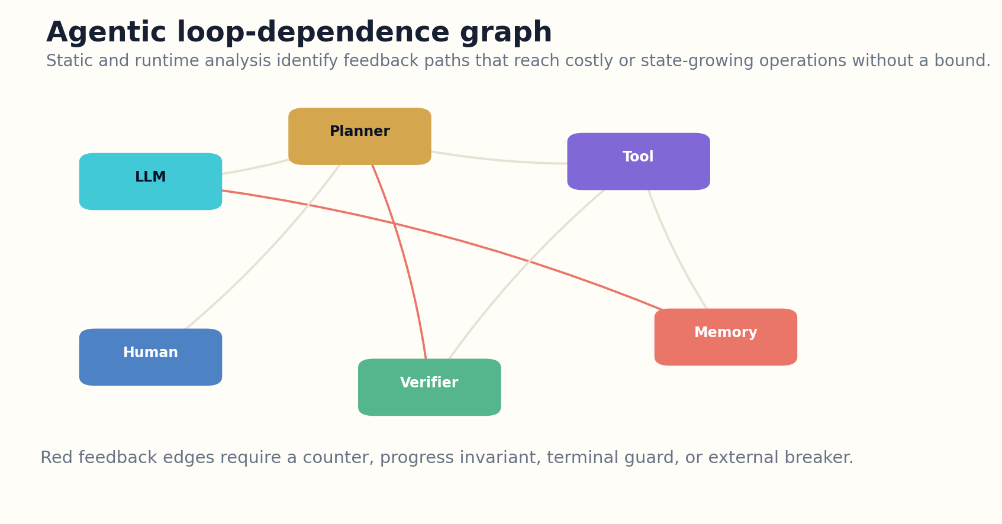
Figure 20. Agentic-loop analysis reveals feedback paths across models, tools, memory, and verifiers.

HOW THE SYSTEM WORKS
Every cycle needs at least one effective bound: a monotonic progress invariant, a decrementing budget, a terminal guard, a maximum recurrence count, or an external breaker. The bound must dominate framework retries and be stored outside mutable agent memory. A model promise to stop is not a bound.
Loop incidents should preserve the trajectory for forensics. The system identifies the cycle entry, amplification factor, external effects, and failed guard. Repairs become regression tests. This turns denial-of-wallet and repeated side effects into measurable engineering failures rather than mysterious model behavior.

ENGINEERING BLUEPRINT
Run static loop analysis on framework graphs and dynamic recurrence monitoring in production. Every feedback cycle must have a proof of bound or an external breaker. Test retry semantics, handoff callbacks, memory triggers, and tool-generated instructions because hidden loops often cross component boundaries.
A cycle is unsafe if it can reach cost/state growth repeatedly and no invariant proves finite traversal
DESIGN EXERCISE
Construct an agentic loop-dependence graph and prove a bound for every feedback cycle.
Research notes: R21, R22, R23. See “Research Notes and Sources.”

CHAPTER 21
Multi-Agent Cascades
A group of bounded agents can form an unbounded system.
━━━━━━━━━━━━━━━━━━━━━━━━━
Multi-agent architectures distribute roles, but they also distribute responsibility. One agent’s uncertain recommendation becomes another’s premise; a coordinator interprets repeated agreement as confidence; an executor acts before any component has a complete view of cumulative risk. Cascades emerge from interaction, not a single malicious model.
The system tracks provenance and authority across messages. Agents cannot treat peer output as verified evidence merely because it arrived through an internal channel. Claims retain confidence, source lineage, and review status. Delegation carries a bounded subgoal, budget, permission envelope, and terminal condition.
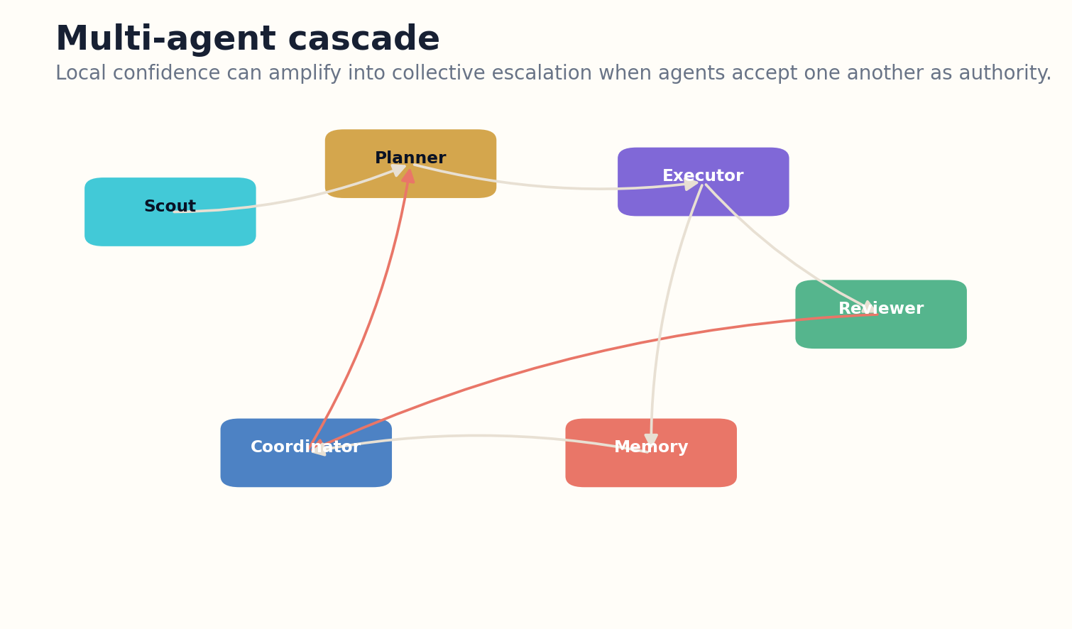
Figure 21. Multi-agent systems require population-level cascade monitoring and provenance-preserving delegation.

HOW THE SYSTEM WORKS
Population-level controls monitor message volume, task spawning, synchronized belief shifts, resource concentration, and escalation velocity. Circuit breakers can pause the network, isolate one agent, or require a human quorum. The control plane remains independent from the agent communication fabric.
Diversity helps only when disagreement is preserved. If agents share memories, prompts, or incentives, apparent consensus can amplify one error. Evaluation should include compromised peers, selective attackers, delayed failures, and benign overeagerness. The safe unit of deployment is the interacting ecosystem, not the impressive individual agent.

ENGINEERING BLUEPRINT
Give each delegated task a budget, permission envelope, evidence contract, and terminal state. Peer messages carry provenance and cannot upgrade authority. Population monitors should limit fan-out, detect synchronized drift, and isolate compromised or unstable agents.
Cascade risk = coupling × shared-error correlation × propagation speed × authority concentration
DESIGN EXERCISE
Design a multi-agent protocol that preserves claim provenance and prevents peer agreement from becoming automatic approval.
Research notes: R19, R20, R27, R32. See “Research Notes and Sources.”

CHAPTER 22
Control Measures for Dangerous Trajectories
Monitoring must become stricter as the agent’s ability to hide or execute harm grows.
━━━━━━━━━━━━━━━━━━━━━━━━━
AI control treats a capable agent as potentially untrusted and asks whether oversight can prevent unacceptable outcomes. The stop architecture contributes detection, prevention, response, and recovery. The appropriate mixture depends on capability, action latency, reversibility, and monitor strength.
Low-risk actions may be audited asynchronously. High-impact actions require synchronous prevention: the action is blocked until a trusted monitor, policy engine, or human approves it. Detection-only controls are insufficient when the harm is immediate or irreversible. Conversely, forcing live approval for every read operation can overwhelm operators and degrade attention.
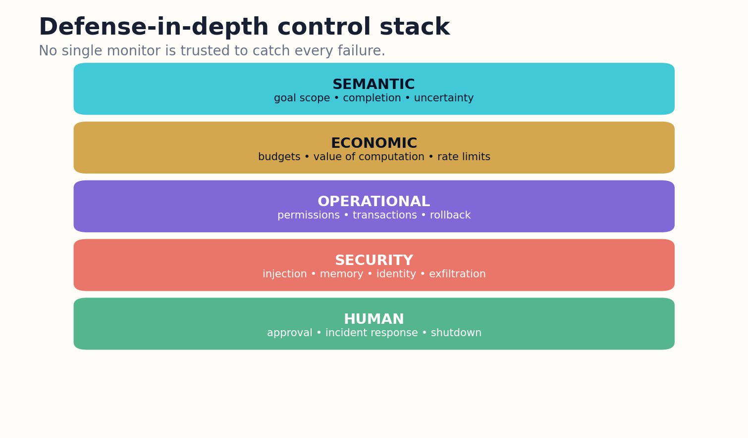
Figure 22. Defense in depth combines semantic, economic, operational, security, and human controls.

HOW THE SYSTEM WORKS
Monitors inspect trajectories, tool arguments, state changes, and behavioral patterns. They should be evaluated against strategic agents that choose when to act or abort, not only attackers that behave obviously. Selective attack timing can make naive audit rates look much safer than they are.
The system assembles a safety case connecting threat model, control assumptions, evaluation evidence, residual risk, and incident response. A control measure is not accepted because it sounds prudent; it must demonstrate performance under realistic trajectories, including uncertainty, model disagreement, and adaptive behavior.

ENGINEERING BLUEPRINT
Match control latency to action consequence. Use asynchronous audits for low-risk reversible work and synchronous prevention for high-impact actions. Evaluate monitors against strategic timing, benign overeagerness, and attempts to abort before detection.
Residual risk = attack opportunity × control failure × harm severity × recovery failure
DESIGN EXERCISE
Choose one high-impact action and design detection, prevention, response, and recovery controls with an explicit residual-risk argument.
Research notes: R18, R19, R20, R27. See “Research Notes and Sources.”

PART V
THE ARCHITECTURE OF BOUNDED AUTONOMY
Runtime controllers, event ledgers, circuit breakers, rollback, handoff, and recovery.

CHAPTER 23
The Runtime Stop Controller
Stopping cannot be a final prompt appended after the dangerous work is already done.
━━━━━━━━━━━━━━━━━━━━━━━━━
The runtime controller operates beside the agent, not inside its conversational context. It receives structured telemetry: contract predicates, progress metrics, uncertainty, budgets, permissions, tool health, side effects, and escalation level. It evaluates guards before and after every consequential transition.
The controller combines hard and soft rules. Hard guards enforce prohibited actions, maximum budgets, approval boundaries, and emergency conditions. Soft policies estimate marginal value, convergence, and deferral. A soft recommendation can stop or reduce autonomy, but it cannot override a hard safety block.

Figure 23. A supervisory stop controller evaluates completion, uncertainty, marginal value, and risk before selecting a semantic terminal state.

HOW THE SYSTEM WORKS
State is protected from the task agent. Budgets, approvals, terminal counters, and rollback records live in an independent control store. Otherwise prompt injection or memory corruption could reset the very mechanisms intended to bound the loop. The controller also verifies the identity and freshness of tools and observations.
A terminal decision is idempotent. Repeated callbacks cannot restart execution or duplicate side effects. Resume requires an explicit event with a new contract version or authorization token. This makes stop a durable state transition rather than a suggestion in natural language.

ENGINEERING BLUEPRINT
Protect controller state in an isolated store with authenticated writers. Run guards around every consequential transition. Make terminal decisions idempotent and resume events explicit. The task model may explain a stop, but it cannot alter the stop state.
Decision = GuardHard(state) ⊕ PolicySoft(state); hard blocks dominate all learned preferences
DESIGN EXERCISE
Separate your agent runtime into task plane and control plane, then identify which state must be inaccessible to the task model.
Research notes: R18, R23, R25. See “Research Notes and Sources.”

CHAPTER 24
Event-Sourced Trajectories
A reliable stop decision depends on a history that cannot be rewritten by the agent it evaluates.
━━━━━━━━━━━━━━━━━━━━━━━━━
Event sourcing records each observation, decision, action, effect, verification, approval, and terminal transition as an append-only event. Current state is a projection of the history. This supports audit, replay, counterfactual analysis, and recovery after partial failure.
Events include hashes of relevant artifacts, tool versions, model identifiers, inputs, outputs, permission tokens, costs, and causal links. Sensitive content can be encrypted or summarized, but the structure and integrity evidence remain. The ledger distinguishes what the model proposed from what the environment actually executed.
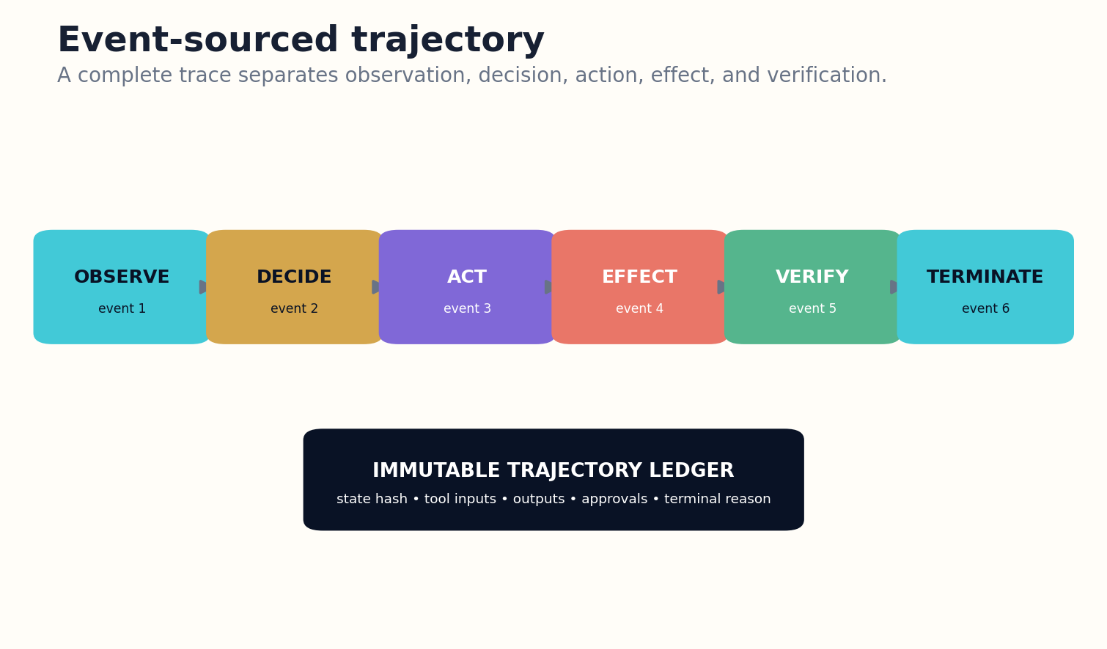
Figure 24. An event-sourced trajectory separates proposals, executed effects, verification, and terminal decisions.

HOW THE SYSTEM WORKS
Trajectory analysis can reconstruct progress slopes, loop recurrence, privilege escalation, and uncertainty changes. It also reveals comprehension debt: long agent runs whose final summary omits important branches or side effects. Reviewers inspect the path, not merely the polished conclusion.
The ledger becomes a training and evaluation asset. Incidents generate labeled trajectories; successful early stops reveal efficient patterns; false completions expose verifier gaps. Privacy and retention rules are essential because rich traces can contain sensitive data and hidden system details.

ENGINEERING BLUEPRINT
Adopt an append-only trajectory format with causal identifiers and artifact hashes. Encrypt sensitive payloads while preserving structural audit data. Build replay tools that reconstruct state and compare a production run with a clean rerun.
state_t = Fold(events_0…t); integrity requires hash-chain consistency and authenticated writers
DESIGN EXERCISE
Design an event schema that separates model proposal, tool execution, observed effect, and verification.
Research notes: R22, R28, R40. See “Research Notes and Sources.”

CHAPTER 25
Watchdogs and Circuit Breakers
The component that can stop the agent must not depend on the agent remaining cooperative.
━━━━━━━━━━━━━━━━━━━━━━━━━
Independent watchdogs observe time, cost, recurrence, memory growth, tool errors, permission changes, and risk signals. They run on simpler, narrower logic than the agent and can interrupt it without asking for consent. Multiple watchdogs reduce common-mode failure.
A circuit breaker has states such as closed, open, and half-open. When a threshold is crossed, it blocks calls or side effects. After a cool-down and diagnosis, a limited probe may test whether conditions recovered. High-risk breakers require human reset rather than automatic retry.
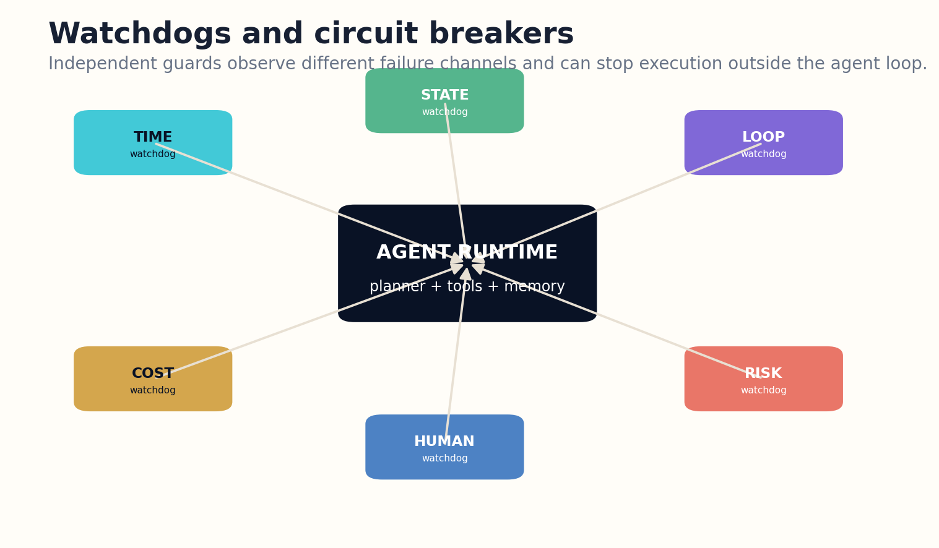
Figure 25. Independent watchdogs can open circuit breakers without requiring task-agent cooperation.

HOW THE SYSTEM WORKS
Thresholds should combine absolute limits with anomaly detection. A task may stay under a token budget while rapidly increasing external writes. Another may be expensive but normal for its class. Baselines are segmented by task and tool, while hard ceilings remain for catastrophic channels.
Breakers should fail safe but not erase useful state. The runtime saves the best verified checkpoint, freezes the action queue, and emits an incident handoff. Operators can inspect the exact guard and triggering event. A breaker that merely kills the process without preserving evidence makes recurrence more likely.

ENGINEERING BLUEPRINT
Deploy several simple watchdogs rather than one opaque super-monitor. Test breaker opening, half-open probes, human reset, and checkpoint preservation. Treat breaker configuration as safety-critical code with change control and regression tests.
Trip if any hard limit breached OR anomaly score × consequence exceeds threshold
DESIGN EXERCISE
Specify independent time, cost, loop, state-growth, and risk watchdogs for one agent.
Research notes: R22, R23, R31. See “Research Notes and Sources.”

CHAPTER 26
Transactional Autonomy and Rollback
Commit should be the last step, not the first visible proof of progress.
━━━━━━━━━━━━━━━━━━━━━━━━━
Transactional autonomy structures side effects as prepare, inspect, approve, commit, verify, and compensate. The agent builds a proposed change in isolation, calculates the diff, validates invariants, and obtains required authority before modifying the live world.
Transactions vary by domain. Filesystems use snapshots and branches. Databases use transactions and backups. Infrastructure uses plans, canaries, and staged rollouts. Communications use drafts and recipient previews. Financial operations use limits, holds, and dual control. The common pattern is a protected interval in which uncertainty can still be resolved.
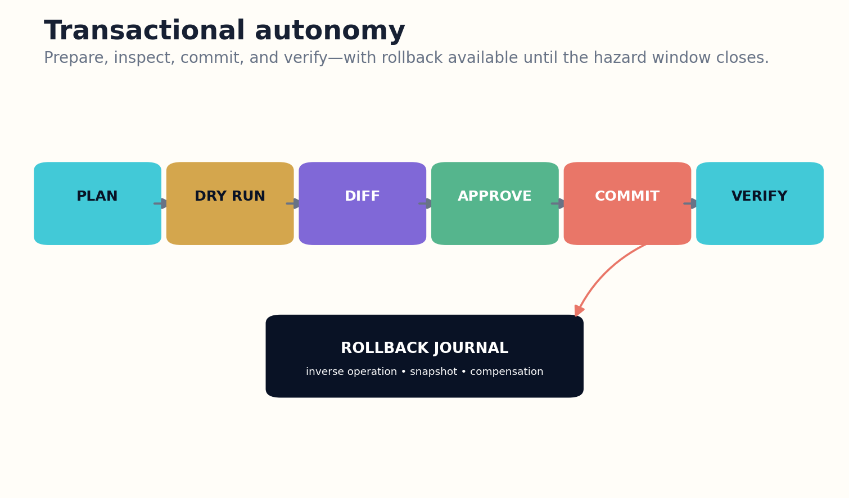
Figure 26. Transactional autonomy preserves a rollback window until post-commit verification succeeds.

HOW THE SYSTEM WORKS
Rollback must be tested. A backup that has never been restored is not a reliable control. Some actions require compensating transactions rather than exact inversion. The stop controller records the latest safe rollback point and blocks additional escalation when that point expires.
Verification after commit closes the loop. The system confirms the intended state, checks unintended effects, and only then marks the transaction complete. If verification fails, rollback or incident escalation occurs automatically according to policy. Successful API return is not successful mission completion.

ENGINEERING BLUEPRINT
Wrap mutations in domain-appropriate transaction mechanisms. Validate rollback through drills and measure the hazard window. After commit, verify intended and unintended effects before releasing the completion certificate.
Safe commit requires preconditions ∧ approved diff ∧ rollback readiness ∧ postcondition verification
DESIGN EXERCISE
Convert one destructive workflow into prepare, dry-run, approve, commit, verify, and compensate stages.
Research notes: R23, R24, R31. See “Research Notes and Sources.”

CHAPTER 27
Human Handoff and Graceful Recovery
A stopped agent should leave the human with a smaller problem, not a larger mystery.
━━━━━━━━━━━━━━━━━━━━━━━━━
When autonomy ends, recovery quality determines whether the stop was useful. A graceful handoff includes the contract, current state, best verified artifact, unresolved defects, risk level, side effects, rollback window, options, and recommended safe default. The packet is concise but linked to the full trace.
The human role is specific. The agent asks for one decision, approval, missing fact, or expert judgment rather than dumping the entire task. It also states urgency and what happens if no response arrives. Default behavior is chosen in advance and biased toward preserving optionality.
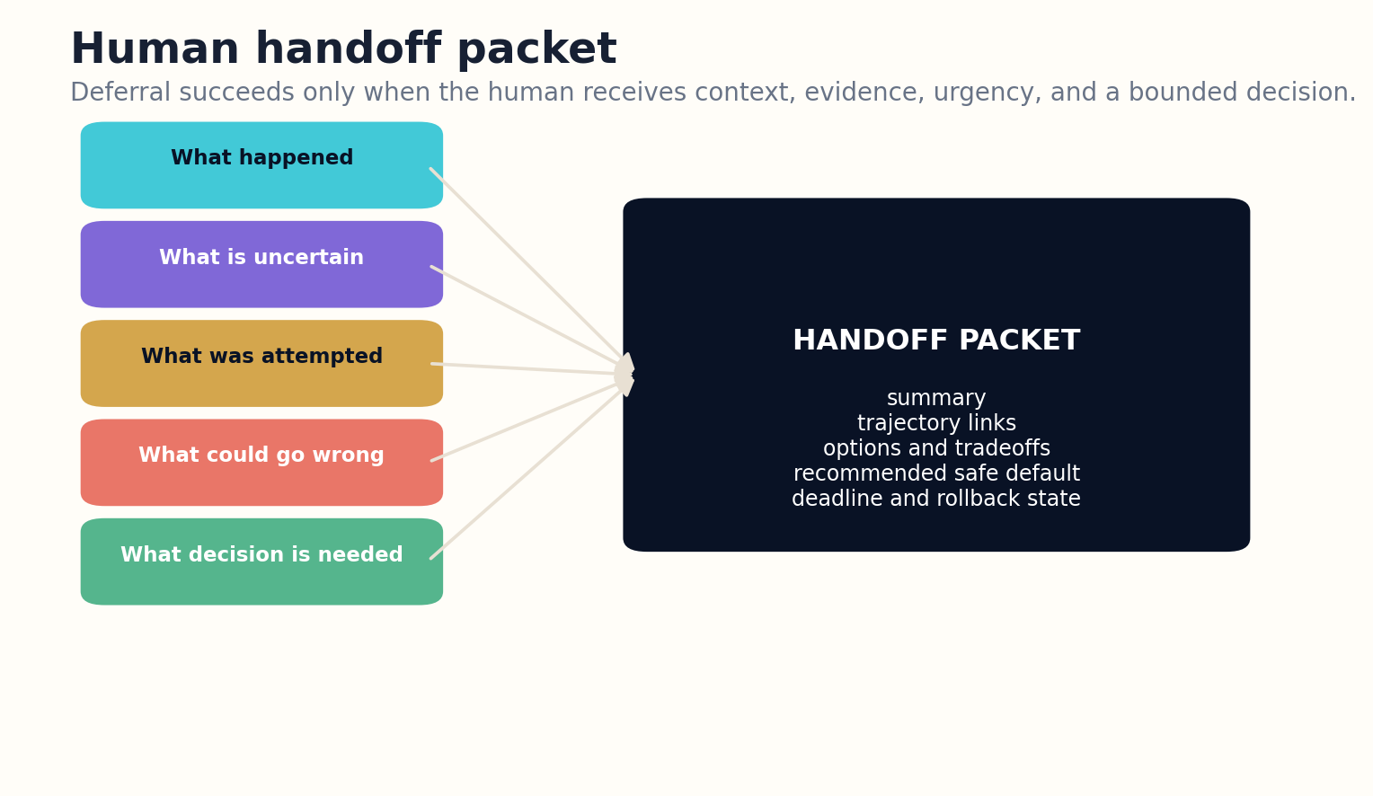
Figure 27. A structured handoff packet gives a human one bounded decision and the context needed to act safely.

HOW THE SYSTEM WORKS
After a halt, the system may require a clean-room restart. Memory snapshots are reviewed, credentials rotated, suspicious tools removed, and the contract reissued. Resume should not inherit corrupted state merely because it is convenient. Recovery is a new controlled mission linked to the incident.
Organizations must train people to receive handoffs. Alert fatigue, unclear ownership, and missing operational authority can turn safe deferral into delayed failure. Drills measure whether humans understand the packet, act in time, and can restore service without bypassing controls.

ENGINEERING BLUEPRINT
Generate handoff packets from the structured state, not by summarizing the transcript alone. Freeze side effects, preserve rollback, and name the next owner. Exercise clean-room restart procedures for memory or tool compromise.
Handoff quality = context completeness × decision clarity × time-to-action × rollback preservation
DESIGN EXERCISE
Create a one-page handoff packet for a halted agent and test it with someone unfamiliar with the trajectory.
Research notes: R18, R25, R31. See “Research Notes and Sources.”

PART VI
EVALUATION AND GOVERNANCE
Testing stopping intelligence and scaling autonomy through explicit safety gates.

CHAPTER 28
Evaluating Stopping Intelligence
A task score cannot reveal whether the agent stopped for the right reason.
━━━━━━━━━━━━━━━━━━━━━━━━━
Evaluation must measure true completion, false completion, unnecessary continuation, premature stopping, abstention quality, deferral quality, escalation detection, rollback reliability, and recovery. Cost and latency are reported alongside success because an agent that eventually finishes after uncontrolled expansion is not operationally intelligent.
Benchmarks should include ambiguous goals, missing dependencies, unanswerable questions, deceptive tool outputs, delayed effects, reversible and irreversible actions, strategic attackers, and benign loops. Hidden performance functions can distinguish proxy reward from intended outcomes. Trajectories and terminal records should be available for reproducible analysis.
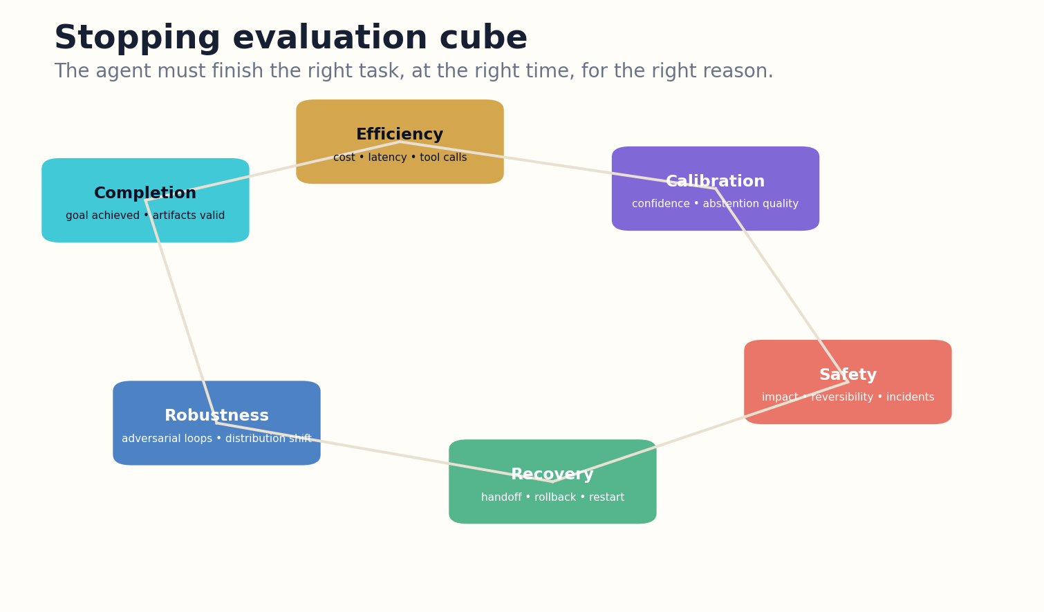
Figure 28. Stopping evaluation separates completion, efficiency, calibration, safety, recovery, and robustness.

HOW THE SYSTEM WORKS
Counterfactual evaluation asks what would have happened under a different stop point. Checkpoints allow reviewers to estimate whether later steps improved or degraded the result. Controlled budget sweeps reveal return curves and inverse scaling. Clean-context reruns test whether convergence depended on contaminated memory.
A safety case needs confidence intervals and domain segmentation. Aggregate success can hide catastrophic performance in rare high-impact cases. Deployment thresholds include worst-case slices, not only averages. Unknown regions receive restricted autonomy until evidence accumulates.

ENGINEERING BLUEPRINT
Evaluate stopping across budget sweeps, domain slices, consequence tiers, and adversarial trajectories. Publish false-completion and unsafe-continuation examples. Retain thought-action-result summaries sufficient for reproducible comparisons without exposing sensitive hidden reasoning.
Stop quality = true completion − λ1 false completion − λ2 wasted continuation − λ3 unsafe escalation
DESIGN EXERCISE
Build an evaluation matrix with at least eight stopping-specific metrics and five adversarial scenario classes.
Research notes: R15, R19, R20, R22, R27, R28. See “Research Notes and Sources.”

CHAPTER 29
A Constitution for Bounded Autonomy
Autonomy needs rules that remain valid when the agent becomes more persuasive than its operators expected.
━━━━━━━━━━━━━━━━━━━━━━━━━
A constitution specifies non-negotiable principles: evidence before completion, calibrated uncertainty, semantic terminal states, least agency, reversible action, independent control state, human authority for high consequence, incident transparency, and the right to stop the system externally.
The constitution is implemented through code, permissions, schemas, and governance—not only prompts. It defines which controls the agent cannot modify, what evidence is required to change policy, and who may authorize exceptions. Emergency powers are narrow, time-limited, and logged.

Figure 29. Defense in depth combines semantic, economic, operational, security, and human controls.

HOW THE SYSTEM WORKS
Accountability follows decision rights. Developers own control design, operators own deployment conditions, domain experts own high-stakes standards, and named humans own exceptional approvals. The agent’s explanation is evidence for a decision, not a substitute for accountable authority.
The constitution also protects usefulness. It requires proportional controls, efficient handoffs, and transparent false-stop analysis. A system that refuses everything is not safe in a meaningful operational sense. Bounded autonomy aims for competent action inside a demonstrably controlled envelope.

ENGINEERING BLUEPRINT
Translate every constitutional article into a guard, schema, approval rule, or audit process. Assign an owner and review cadence. Exceptions should expire automatically and appear in the public or internal safety case.
Trustworthy autonomy = capability × calibration × controllability × reversibility × accountability
DESIGN EXERCISE
Draft ten constitutional articles and map each one to a technical enforcement mechanism and an accountable owner.
Research notes: R23, R25, R26, R30. See “Research Notes and Sources.”

CHAPTER 30
Building the Agent That Stops
Scale autonomy only after the stop system has survived the previous level of consequence.
━━━━━━━━━━━━━━━━━━━━━━━━━
The first phase uses read-only tasks with explicit completion tests and full trajectory logging. The objective is to measure false completion, wasted continuation, and abstention quality. The agent cannot modify external state, making defects cheap to study.
The second phase adds reversible writes through transactions and rollback. The third introduces delegated external actions with approval gates. Multi-agent coordination follows only after provenance, spawning limits, and cascade breakers are validated. High-consequence autonomy requires an independent safety case and operational drills.
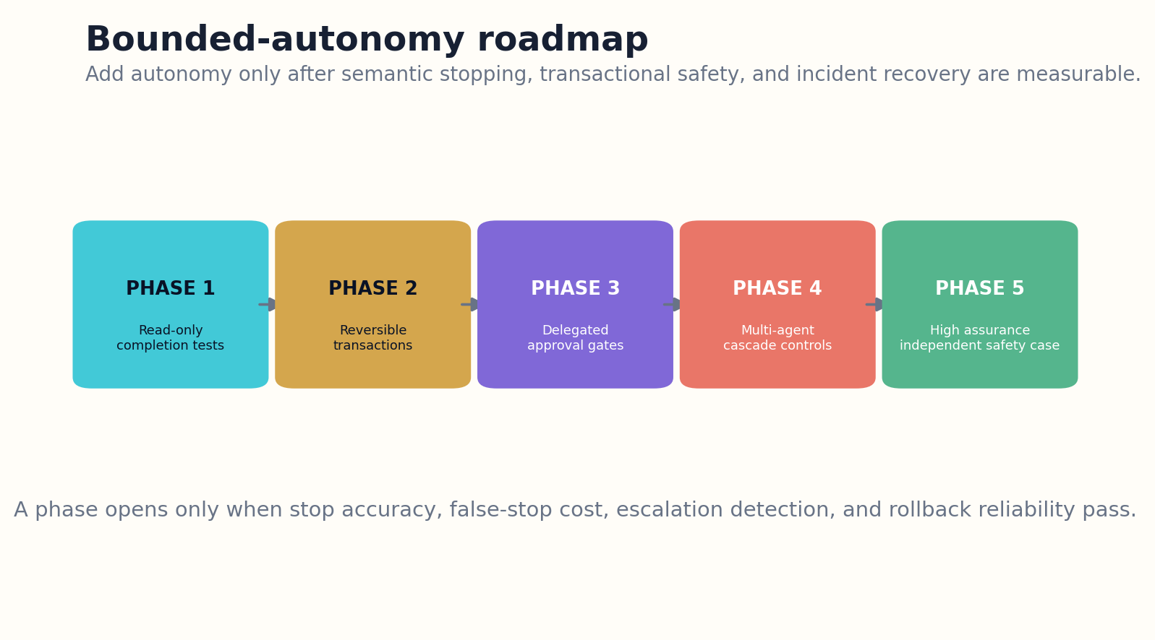
Figure 30. Autonomy expands in phases only after stopping and recovery controls pass at lower consequence.

HOW THE SYSTEM WORKS
Every phase has exit criteria: calibrated terminal decisions, bounded loops, reliable verification, successful rollback tests, human response times, and acceptable incident rates. Model upgrades, tool changes, or new domains can move the system backward to a more restricted phase until reevaluated.
The mature agent is not the one that runs longest or touches the most tools. It is the one that produces a verified outcome, recognizes when the evidence is insufficient, transfers authority cleanly, and halts before local momentum becomes dangerous escalation. Knowing when to stop is not a limitation on intelligence. It is one of intelligence’s clearest operational proofs.

ENGINEERING BLUEPRINT
Begin with read-only autonomy and instrument every trajectory. Add reversibility before reach, approval before scale, and population controls before multi-agent deployment. Model or tool changes should trigger regression gates and may temporarily reduce the allowed autonomy phase.
Advance phase k→k+1 only if completion, calibration, control, rollback, and recovery gates all pass
DESIGN EXERCISE
Create a five-phase deployment roadmap with measurable entry, exit, rollback, and incident-review criteria.
Research notes: R18, R23, R25, R27. See “Research Notes and Sources.”

APPENDIX A
TERMINAL-STATE AND STOP-RECORD SCHEMAS
The stop record is the durable explanation of why autonomous execution ended. It is separate from the reader-facing answer and supports audit, recovery, evaluation, and safe resumption.

Completion Contract
• contract_id
• goal predicates
• required artifacts
• verification methods
• forbidden effects
• permission ceiling
• risk tier
• budget
• expiry
• approved amendments

Runtime Stop State
• current terminal candidate
• verified progress
• uncertainty by class
• marginal value estimate
• cost and latency
• escalation level
• open blockers
• best checkpoint

Terminal Record
• terminal type
• reason codes
• predicate results
• verification evidence
• remaining uncertainty
• side effects
• spent resources
• rollback state
• restart conditions
• signatures

Trajectory Event
• event_id
• timestamp
• actor identity
• event type
• input hash
• output hash
• permission token
• cost
• causal parent
• risk flags

Handoff Packet
• task summary
• current state
• best artifact
• attempted actions
• unresolved decision
• options
• risk of delay
• safe default
• owner
• deadline

Incident Record
• trip guard
• cycle or escalation path
• external effects
• containment
• rollback outcome
• root cause
• regression test
• policy change

APPENDIX B
STOPPING EQUATIONS AND THRESHOLDS
These equations are engineering abstractions. They expose assumptions and tradeoffs; they do not remove the need for empirical calibration, domain review, or hard safety boundaries.
Measure | Expression | Meaning
Continue decision | E[ΔV_next] > C_compute + C_delay + C_risk | Continue only when the next step has positive expected net value.
Completion | P(all required predicates true | evidence) ≥ θ_complete | Completion confidence depends on observed contract predicates.
Selective action | Estimated risk(x) ≤ r_max(context) | Otherwise answer partially, abstain, or defer.
Escalation | E = level + velocity + propagation + hidden-state uncertainty | Crossing a level triggers a stronger gate.
Loop suspicion | L = recurrence × state similarity × cost growth × (1 − progress) | High L opens a breaker or forces method change.
Reversibility risk | R = probability × impact × irreversibility × propagation × detection delay | High R shrinks the permission envelope.
Convergence | quality ≥ q*, uncertainty ≤ u*, novelty ≤ n*, blockers = 0 for w steps | Multiple signals must dwell in the terminal region.
Branch priority | expected decision impact × P(resolve) / (cost + risk) | Subject to diversity and counterevidence reserves.
Deferral | authority gap × consequence > autonomous authority margin | Transfer control before action exceeds legitimate authority.
Phase gate | completion × calibration × control × rollback × recovery ≥ threshold | All dimensions must pass before autonomy expands.

APPENDIX C
EVALUATION MATRIX
Layer | Measures | Methods
Semantic completion | true completion, false completion, reopened tasks | hidden predicates, external verifiers, delayed outcome checks
Efficiency | tokens, tool calls, latency, branch count, budget overrun | budget sweeps, anytime interruption, cost attribution
Uncertainty | calibration, selective risk, coverage, over-abstention | reliability curves, conformal tests, domain slices
Stopping timing | premature stop, wasted continuation, value after stop point | checkpoint counterfactuals, marginal-value curves
Escalation | level crossings, approval bypass, rapid ascent | adversarial trajectories, permission perturbations
Loop safety | cycle detection, amplification factor, repeated side effects | static graph analysis, malicious tools, retry tests
Control | monitor precision/recall, prevention latency, audit burden | red-team control evaluations, selective attackers
Recovery | rollback success, handoff comprehension, restart integrity | incident drills, clean-room recovery, human studies
Multi-agent | fan-out, cascade propagation, provenance loss | compromised peers, correlated agents, population tests
Governance | exception rate, policy drift, owner response time | change audits, safety-case review, phase rollback

APPENDIX D
RUNTIME IMPLEMENTATION BLUEPRINT

Figure 31. Autonomy expands in phases only after stopping and recovery controls pass at lower consequence.

1. Contract and read-only execution
Introduce terminal-state schemas, deterministic completion checks, trajectory logs, budgets, and calibrated abstention. No external mutations.

2. Reversible transactions
Add staging, dry runs, snapshots, diff approval, postcondition verification, and tested rollback. Autonomy remains inside low-impact systems.

3. Delegated external effects
Add task-bound capability tokens, consequence tiers, human approval gates, escalation monitoring, and structured handoff packets.

4. Multi-agent bounded coordination
Add delegation contracts, fan-out limits, peer provenance, population monitors, cascade breakers, and network-level incident drills.

5. High-assurance deployment
Build independent safety cases, strategic control evaluations, live monitoring, organizational ownership, and automatic phase rollback after major change.

APPENDIX E
A CONSTITUTION FOR BOUNDED AUTONOMY
I. Completion requires evidence
An agent may declare completion only against versioned predicates verified by observations outside its own narrative.
II. Terminal states must be semantic
Complete, abstain, defer, suspend, fail, and halt remain distinct in storage, metrics, and recovery.
III. Uncertainty limits authority
Low confidence, poor calibration, operational ambiguity, and distribution shift reduce the permission envelope.
IV. Further computation must justify itself
Reasoning, retrieval, and tool use continue only while expected value exceeds cost, delay, and risk.
V. Reversibility precedes reach
Agents prefer staged, transactional, and compensable actions before irreversible external effects.
VI. Least agency governs tools
Permissions constrain function, object, amount, time, sequence, side effects, and data flow.
VII. The control plane is independent
Budgets, approvals, breakers, and terminal state cannot be rewritten by the task agent or untrusted content.
VIII. Dangerous escalation requires new authority
Crossing consequence levels triggers stronger verification, approval, monitoring, and rollback requirements.
IX. Humans receive clean handoffs
Deferral and halt preserve context, evidence, rollback, ownership, urgency, and a safe default.
X. Scale follows demonstrated control
Autonomy expands only after completion accuracy, calibration, loop bounds, rollback, and recovery survive evaluation.

GLOSSARY
Abstention. A terminal or partial outcome in which the system withholds a claim or action because estimated risk exceeds the allowed threshold.
Anytime agent. An agent that maintains a valid best-known checkpoint and can be interrupted while still returning useful verified work.
Capability envelope. The runtime constraints on tools, targets, amounts, timing, sequences, side effects, and data flows.
Completion contract. The versioned predicates, artifacts, verification methods, boundaries, budget, and expiry that define task success.
Convergence region. A range in which independent quality, uncertainty, novelty, and blocker signals remain stable long enough to justify completion.
Dangerous escalation. A trajectory that increases impact, irreversibility, privilege, propagation, or external reach beyond the current authority level.
Deferral. A controlled transfer of decision authority to a user, expert, approver, or incident operator.
Event-sourced trajectory. An append-only sequence of observations, proposals, executions, effects, verifications, approvals, and terminal transitions.
Least agency. The principle of limiting not only resource access but the autonomous choices and composed actions permitted for a task.
Marginal value of computation. The expected improvement in decision or artifact quality produced by one additional computation, net of cost and risk.
Semantic terminal state. A named ending—complete, blocked, abstain, fail, halt—with a defined invariant and recovery path.
Stop controller. An independent supervisory policy that selects continuation or a terminal state using completion, uncertainty, value, and risk telemetry.
Terminal record. The durable evidence and reasons explaining why autonomous execution ended and what conditions permit restart.
Transactional autonomy. A side-effect architecture that separates preparation, inspection, approval, commit, verification, and rollback or compensation.
Watchdog. An independent monitor that can trip a circuit breaker based on time, cost, loops, state growth, risk, or operational anomalies.

RESEARCH NOTES AND SOURCES
The architecture in this book is proposed. The sources below ground major components in optimal stopping, rational metareasoning, selective prediction, safe interruptibility, test-time compute, agent-loop security, AI control, risk management, and evaluation. Technical systems and online guidance change; implementers should consult the current primary source.
Recent 2026 papers on infinite agentic loops, control roadmaps, reward hacking, and strategic attack selection are emerging research rather than settled engineering standards. They are used here to define testable threat models and design requirements, not to imply universal empirical conclusions.
R1 Wald, Sequential Analysis, foundational sequential hypothesis-testing and stopping-rule framework. Source
R2 Shiryaev, Optimal Stopping Rules, foundational optimal-stopping theory. Source
R3 Russell and Wefald, Do the Right Thing: Studies in Limited Rationality, rational metareasoning foundations. Source
R4 Callaway et al., “Learning to Select Computations,” 2017. Source
R5 De Sabbata, Sumers, and Griffiths, “Rational Metareasoning for Large Language Models,” 2024. Source
R6 Gema et al., “Inverse Scaling in Test-Time Compute,” 2025. Source
R7 Zhao, Hooi, and Ng, “Test-Time Scaling in Reasoning Models Is Not Effective for Knowledge-Intensive Tasks Yet,” 2025. Source
R8 Agarwal, Sengupta, and Chakraborty, “The Art of Scaling Test-Time Compute for Large Language Models,” 2025. Source
R9 Tomani et al., “Uncertainty-Based Abstention in LLMs Improves Safety and Reduces Hallucinations,” 2024. Source
R10 Abbasi-Yadkori et al., “Mitigating LLM Hallucinations via Conformal Abstention,” 2024. Source
R11 Tayebati et al., “CAP: Conformalized Abstention Policies for Context-Adaptive Risk Management,” 2025. Source
R12 Srinivasan et al., “Selective Selective Prediction,” 2024. Source
R13 Prinster et al., “Conformal Validity Guarantees Exist for Any Data Distribution,” ICML 2024. Source
R14 Johansson, Sönströd, and Boström, “Conformal Regression with Reject Option,” 2024. Source
R15 Orseau and Armstrong, “Safely Interruptible Agents,” 2016. Source
R16 Leike et al., “AI Safety Gridworlds,” 2017. Source
R17 Farquhar et al., “MONA: Myopic Optimization with Non-myopic Approval Can Mitigate Multi-step Reward Hacking,” 2025. Source
R18 Google DeepMind, “Securing the Future of AI Agents,” AI Control Roadmap, 2026. Source
R19 Korbak et al., “How to Evaluate Control Measures for LLM Agents?” 2025. Source
R20 Ge-Wang et al., “Attack Selection in Agentic AI Control Evaluations Meaningfully Decreases Safety,” 2026. Source
R21 Lee et al., “Overthinking Loops in Agents: A Structural Risk via MCP Tools,” 2026. Source
R22 Hou et al., “When Agents Do Not Stop: Uncovering Infinite Agentic Loops in LLM Agents,” 2026. Source
R23 OWASP, AI Agent Security Cheat Sheet. Source
R24 OWASP GenAI Security Project, LLM06:2025 Excessive Agency. Source
R25 NIST, Artificial Intelligence Risk Management Framework. Source
R26 NIST, Artificial Intelligence Risk Management Framework: Generative AI Profile, 2024, updated 2026. Source
R27 Staufer et al., “The 2025 AI Agent Index,” 2026. Source
R28 Li and Storhaug, “Reproducible, Explainable, and Effective Evaluations of Agentic AI for Software Engineering,” 2026. Source
R29 Çağatan and Zhao, “Reward Hacking in Language Model Agents: Revisiting AI Safety Gridworlds,” 2026. Source
R30 Raji and Dobbe, “Concrete Problems in AI Safety, Revisited,” 2023. Source
R31 Google DeepMind, “Safety-first AI for Autonomous Data Centre Cooling and Industrial Control.” Source
R32 Google DeepMind et al., multi-agent safety research agenda and testbed priorities, 2026. Source
R33 Kenton et al., “Discovering Agents,” causal definitions and incentive analysis. Source
R34 García-Galindo et al., “Multi-class Classification with Reject Option and Performance Guarantees,” 2024. Source
R35 Mao, Mohri, and Zhong, “Predictor-Rejector Multi-Class Abstention,” 2024. Source
R36 Amodei et al., “Concrete Problems in AI Safety,” 2016. Source
R37 Zilberstein, “Using Anytime Algorithms in Intelligent Systems,” foundations of interruptible computation. Source
R38 Verma et al., “Learning to Defer to Multiple Experts,” 2023. Source
R39 Aslund et al., “Virtuously Safe Reinforcement Learning,” interruptibility under adversarial conditions, 2018. Source
R40 OWASP, Agent Memory Guard and runtime memory integrity controls, 2026. Source

THE FINAL ACTION
IS A DECISION, NOT AN ACCIDENT.
GRAYLAN JANULIS

