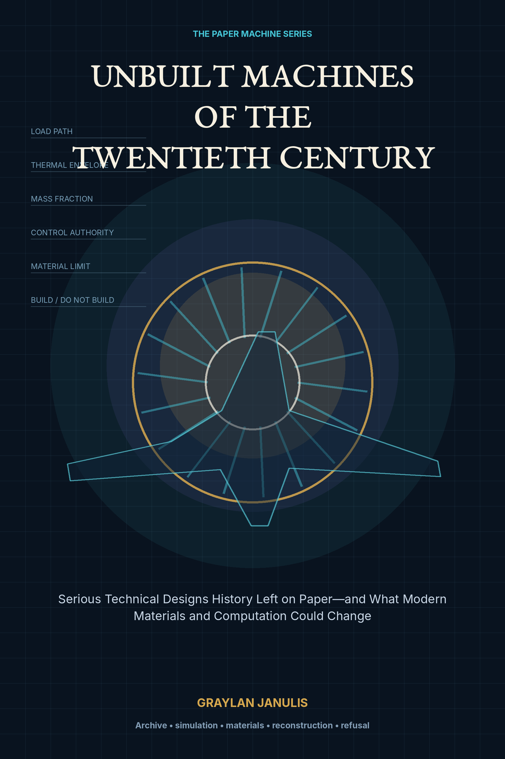

UNBUILT MACHINES
OF THE TWENTIETH CENTURY
Serious Technical Designs History Left on Paper—and What Modern Materials and Computation Could Change
GRAYLAN JANULIS

A NOTE ON RECONSTRUCTION
This book studies designs whose full operational form was never completed as proposed. Some produced mockups, material samples, engines, pilot holes, test reactors, partial networks, or subscale demonstrations. Those artifacts are treated as evidence, not as proof that the integrated machine was ready.
Modern reassessment does not mean automatic revival. Each chapter separates period assumptions, present-day qualified capabilities, frontier possibilities, enduring blockers, and social permission. Dangerous systems are discussed at historical and systems-engineering level, without construction instructions.
The final verdicts—deploy, prototype, subsystem research, archive, or reject—are analytical judgments for this book, not claims that a current program has adopted the design.
“The archive is not a warehouse of lost futures.
It is a test bench for decisions that were never completed.”

CONTENTS
PART I · READING THE PAPER MACHINE
01 The Machine That Exists Only on Paper
02 What Counts as Serious?
03 Six Ways a Machine Dies
04 The Modern Reconstruction Toolkit
05 Counterfactual Engineering Without Myth
PART II · INFORMATION MACHINES
06 Memex: The Desk That Became a Network
07 The Mondothèque and the World Brain
08 OGAS: The Network That Could Not Command Its Commanders
09 Cybersyn: Feedback Before Big Data
10 Xanadu: The Hypertext System the Web Did Not Build
PART III · FLIGHT BEYOND THE AIRPLANE
11 Silbervogel: The Skip-Glider Before the Thermal Model
12 X-20 Dyna-Soar: The Orbital Aircraft That Reached Hardware
13 Boeing 2707: The Supersonic Airliner That Lost Its Market
14 HOTOL: The Single-Stage Spaceplane with a Balance Problem
15 X-30 NASP: When the Airframe Became the Engine
PART IV · LAUNCH AND INTERSTELLAR SYSTEMS
16 Sea Dragon: The Rocket Designed Like a Ship
17 Project Orion: A Spacecraft Driven by Discrete Violence
18 Project Daedalus: The Fusion Starship as a Complete Study
19 Project Longshot: Designing for a Hundred-Year Machine
20 The Launch Loop: A Machine Made of Stored Motion
21 The Space Elevator: A Material Whose Defects Become Geography
PART V · ENERGY, HABITATS, AND PLANETARY MACHINES
22 Solar Power Satellites: An Energy System in Orbit
23 Island Three: The Space Habitat as a Living Machine
24 Project PACER: Power from Underground Nuclear Pulses
25 The Nuclear Aircraft: Endurance Defeated by Shielding
26 Project Habakkuk: The Ice Aircraft Carrier
27 Salter’s Duck: The Wave Farm That Arrived Before Its Industry
PART VI · INNER SPACE AND THE RECONSTRUCTION LAB
28 Project Mohole: The First Attempt to Touch the Mantle
29 The Vactrain: Removing Air, Inheriting Infrastructure
30 The Reconstruction Lab
Appendix A — Reconstruction Scorecard
Appendix B — Modern Materials and Computation Map
Appendix C — Demonstrator Ladder
Appendix D — Portfolio Ranking
Appendix E — Charter of the Reconstruction Lab
Glossary
Research Notes and Sources

PROLOGUE
THE CENTURY OF MACHINES THAT ALMOST EXISTED
The twentieth century produced a second industrial landscape made almost entirely of drawings. Engineers designed orbital aircraft before reliable digital flight control, global information networks before cheap computers, fusion starships before fusion power, and floating cities before closed ecological systems. Many were not jokes or speculative art. They had mass budgets, test programs, government memoranda, cost studies, and teams who expected hardware.
These machines did not all fail for the same reason. Some encountered physics. Some reached the edge of materials. Some required manufacturing systems that did not yet exist. Some solved a problem that disappeared. Some were defeated by their environmental cost or by institutions unwilling to surrender control. Several were technically interesting and socially unacceptable.
Today we possess computation those teams could not imagine, but we also possess evidence of consequences they often discounted. The purpose of this book is to place both advantages into the same model. The result is a history of ambition, a manual for systems engineering, and a discipline of knowing when a beautiful machine should remain on paper.

PART I
READING THE PAPER MACHINE
How to distinguish serious engineering from fantasy, and how to reconstruct an abandoned design without worshipping it.

CHAPTER 01
The Machine That Exists Only on Paper
Before a machine is metal, it is a negotiated model of physics, institutions, money, and time.
━━━━━━━━━━━━━━━━━━━━━━━━━
A serious unbuilt machine is not merely an illustration. It is a compressed engineering world: requirements, load paths, energy flows, operating sequences, manufacturing assumptions, maintenance concepts, and a theory of who will pay for all of it. Some projects died before hardware. Others produced engines, wind-tunnel models, test cavities, or pilot networks but never the full operational system. This book studies that unfinished category.
Paper machines are uniquely revealing because they preserve ambitions before reality forced a final compromise. Their reports often contain clean mass budgets, idealized cost curves, and optimistic development schedules. Those documents are not useless because they were wrong. They show exactly where a generation believed uncertainty could be converted into engineering.
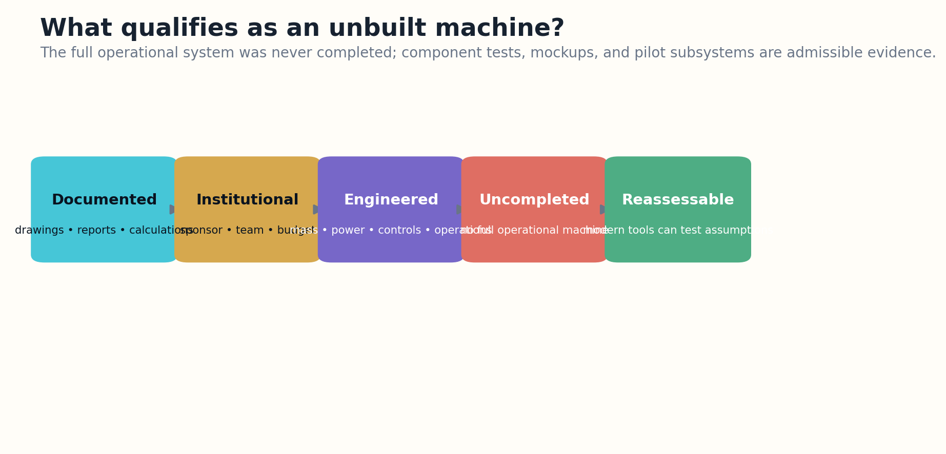
Figure 1. Five admission tests distinguish a documented unbuilt machine from a loose fantasy.

MODERN RECONSTRUCTION
The modern task is not to ask whether an old drawing looks futuristic. It is to reconstruct the design logic and identify its controlling constraints. Which numbers came from measurement? Which came from analogy? Which subsystem had no credible path to maturity? Which political or environmental costs were simply externalized?
A paper machine becomes valuable when it can be transformed into a testable model. Geometry becomes CAD. Assumptions become parameters. Hand calculations become coupled simulations. Procurement claims become supply-chain models. Operational narratives become digital-twin scenarios. The result is not historical reenactment; it is an audit.

WHAT SHOULD BE BUILT?
The central rule is that failure must remain admissible. Modern technology may strengthen a structure while leaving the economics impossible, or make control feasible while increasing unacceptable hazard. The archive is a laboratory for both revival and refusal.
Reconstruction value R = evidence quality × unresolved leverage × modern testability − hazard externalization
VERDICT | FRAMEWORK
RECONSTRUCTION EXERCISE
• Choose one abandoned design and separate requirements, assumptions, and measured evidence.
• Identify the single constraint most likely to dominate the full system.
• Write one condition under which the correct modern verdict would be “do not build.”
Research notes: S1, S2. See Research Notes and Sources.

CHAPTER 02
What Counts as Serious?
A bold idea becomes engineering when it begins to account for the things that can kill it.
━━━━━━━━━━━━━━━━━━━━━━━━━
This book uses five admission tests. The design must have a documented technical form; it must have attracted a real engineering team, institution, or sustained research program; it must expose subsystem interactions rather than only an exterior shape; the full operational machine must never have been completed as proposed; and enough evidence must survive for a modern reassessment.
Component testing does not disqualify a project. The X-20 had models and hardware, Project Mohole drilled pilot holes, Habakkuk produced ice-composite experiments, and Cybersyn operated portions of its communications system. These tests make the archive richer. The relevant absence is the integrated machine performing its intended mission.

Figure 2. Five admission tests distinguish a documented unbuilt machine from a loose fantasy.

MODERN RECONSTRUCTION
Seriousness is not the same as wisdom. Project PACER received formal analysis despite relying on underground nuclear pulses. Nuclear aircraft programs built reactors and test infrastructure despite unresolved shielding and accident consequences. Their institutional scale makes them important to study, but not morally neutral.
The selection method avoids two traps. The first is ridicule: treating old engineers as naïve because they lacked later discoveries. The second is nostalgia: treating cancellation as proof that bureaucrats suppressed a near-ready future. Both erase uncertainty. Technical programs often fail from coupled weaknesses rather than one villain or one missing invention.

WHAT SHOULD BE BUILT?
Every case study therefore begins with an evidence ledger: original goal, period design, tested components, cancellation mechanism, hidden assumptions, modern enabling changes, enduring blockers, and a final reconstruction verdict.
Seriousness score S = documentation × subsystem depth × institutional commitment × auditability
VERDICT | FRAMEWORK
RECONSTRUCTION EXERCISE
• Create admission criteria for a historical design archive.
• Decide whether a full-scale mockup counts as construction and justify the boundary.
• List three projects that are famous but too weakly specified for inclusion.
Research notes: S3, S4. See Research Notes and Sources.

CHAPTER 03
Six Ways a Machine Dies
Cancellation is an outcome; failure is a coupled mechanism.
━━━━━━━━━━━━━━━━━━━━━━━━━
Historical accounts often compress a program into a single cause: Congress cut funding, a ministry resisted, a material was too weak, or the market disappeared. Engineering reconstruction requires a fuller failure taxonomy. A machine can fail in physics, materials, manufacturing, control, economics, politics, or several of them at once.
Physics failure means the governing mechanism cannot produce the promised performance within plausible parameters. Materials failure means the mechanism works but available matter cannot survive the stress, heat, radiation, fatigue, or defect sensitivity. Manufacturing failure appears when a theoretically valid geometry cannot be produced or inspected at required scale.
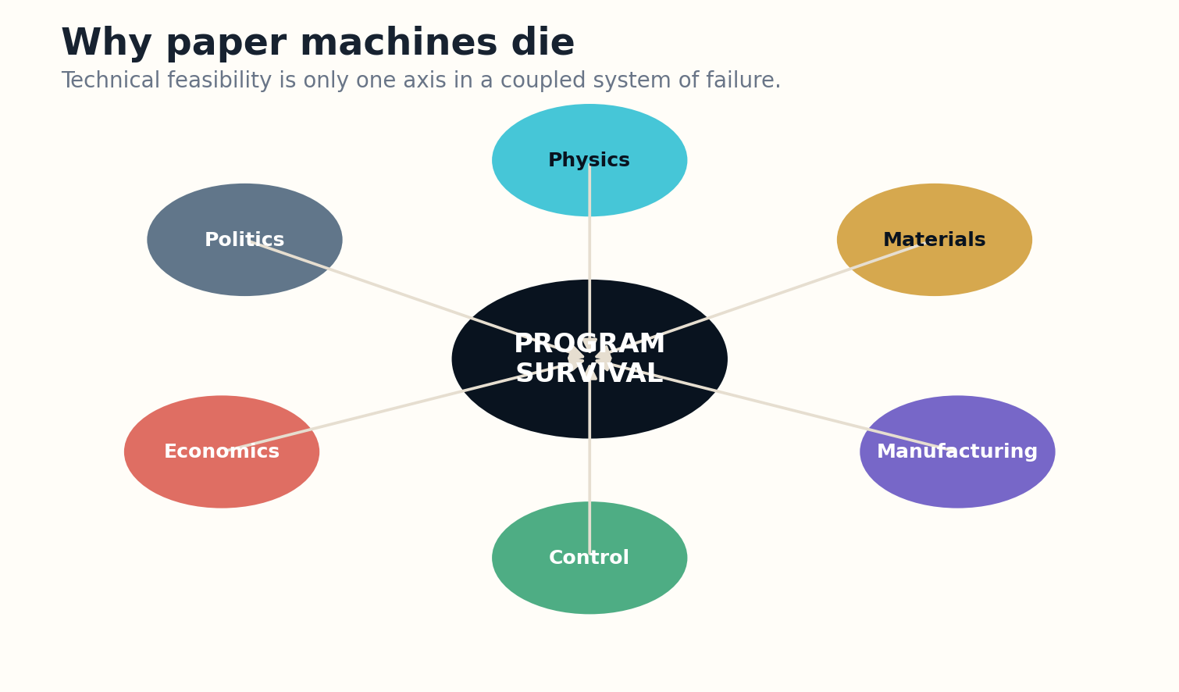
Figure 3. Program survival is limited by the weakest coupled subsystem or institution.

MODERN RECONSTRUCTION
Control failure occurs when the machine cannot remain stable across its operating envelope. HOTOL’s center-of-gravity problem and the X-30’s tightly coupled propulsion-airframe dynamics illustrate how control authority can become a primary design variable. Economic failure appears when unit cost, cadence, maintenance, infrastructure, or demand cannot close.
Political failure is not merely irrational interference. Programs transform landscapes, distribute risk, concentrate authority, and compete with other priorities. OGAS threatened institutional control over information. Supersonic transport externalized noise. Nuclear systems imposed transboundary consequences. Political resistance can expose requirements that technical teams omitted.

WHAT SHOULD BE BUILT?
The most useful modern reassessment identifies the first bottleneck and the bottleneck after it. Removing one constraint often reveals another. Better composites do not guarantee a viable spaceplane; cheaper launch does not automatically justify orbital power; better simulation does not create public legitimacy.
Program survival P ≈ min(physics, materials, manufacturing, control, economics, legitimacy)
VERDICT | FRAMEWORK
RECONSTRUCTION EXERCISE
• Classify the failure of three historical programs using all six categories.
• Identify a case where solving the famous blocker would expose a second blocker.
• Write a failure tree for a megaproject with at least two institutional branches.
Research notes: S5. See Research Notes and Sources.

CHAPTER 04
The Modern Reconstruction Toolkit
Today we can fail virtually, cheaply, and repeatedly before asking matter to agree.
━━━━━━━━━━━━━━━━━━━━━━━━━
The strongest modern advantage is not a miracle material. It is the ability to couple models early. Computational fluid dynamics, finite-element analysis, thermal simulation, plasma models, orbital dynamics, controls, economics, and reliability can share geometry and uncertainty instead of living in separate reports.
Digital twins extend modeling into operation. A trustworthy twin connects a validated model to sensor data and records where prediction diverges from reality. For an unbuilt machine, the first twin is synthetic: a versioned integration environment containing requirements, assumptions, subsystem models, and test evidence. It should make uncertainty visible rather than produce cinematic certainty.
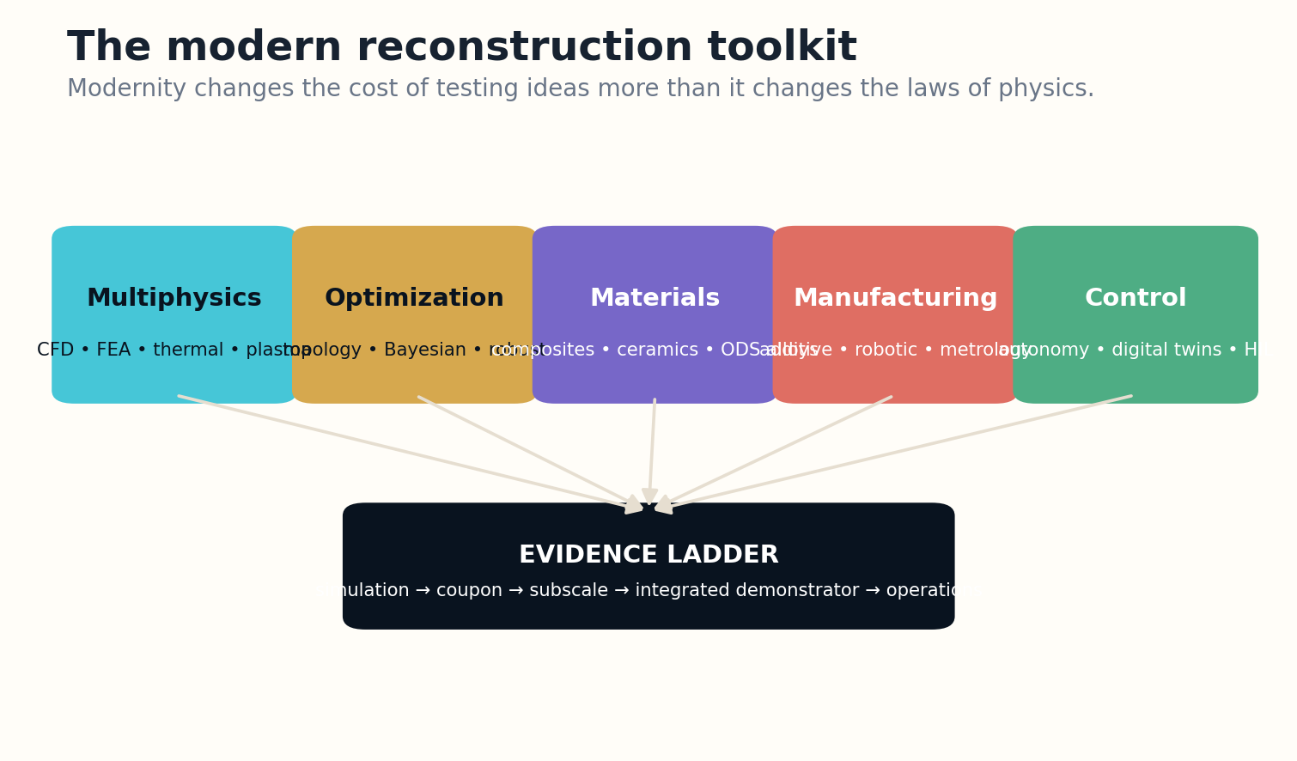
Figure 4. Modern reconstruction converts assumptions into a staged evidence ladder.

MODERN RECONSTRUCTION
Additive manufacturing changes geometry, part count, cooling channels, material grading, and iteration time. Modern high-temperature alloys, ceramic matrix composites, carbon-carbon, improved superconductors, power electronics, and structural health monitoring reopen design spaces. Yet every new material arrives with qualification, repair, inspection, and supply-chain questions.
Optimization can search millions of variants, but it optimizes the objective it is given. A topology optimizer may reduce mass while creating uninspectable cavities. An AI controller may stabilize a simulation while exploiting a modeling error. Robust design therefore optimizes performance across uncertainty, damage, manufacturing variation, and off-nominal operations.

WHAT SHOULD BE BUILT?
The reconstruction ladder is simulation, material coupons, subsystem tests, subscale integration, hardware-in-the-loop, environmental demonstration, and only then operational scale. Historical ambition becomes useful when converted into a sequence of falsifiable gates.
Modern feasibility F_m = model validity × material readiness × manufacturability × controllability × inspectability
VERDICT | FRAMEWORK
RECONSTRUCTION EXERCISE
• Build a reconstruction ladder for one machine.
• Name a modern tool that changes the cost of testing but not the underlying feasibility.
• Define a validation experiment that would falsify a digital twin.
Research notes: S6, S7, S8, S9. See Research Notes and Sources.

CHAPTER 05
Counterfactual Engineering Without Myth
The question is not “Could we build it now?” but “What exact machine would be worth building under present constraints?”
━━━━━━━━━━━━━━━━━━━━━━━━━
Reconstruction is a counterfactual exercise, and counterfactuals are easy to rig. If every modern advantage is granted while every modern regulation, environmental limit, labor cost, and competing technology is ignored, almost any old project can be declared vindicated. A serious reassessment updates the whole world, not only the favorable variables.
Each machine is therefore evaluated in three forms. The archival machine uses period assumptions. The conservative modern machine substitutes qualified technology that exists now. The frontier machine adds plausible but immature capabilities and labels them explicitly. This prevents current prototypes from being treated as commodity components.
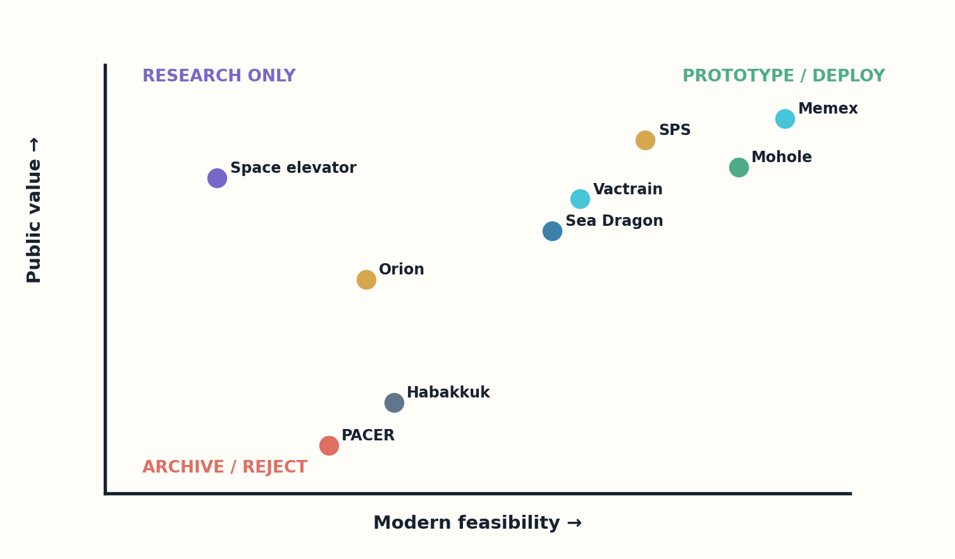
Figure 5. The reconstruction verdict separates public value from modern feasibility.

MODERN RECONSTRUCTION
Comparison must include alternatives. The correct question for Sea Dragon is not whether a huge pressure-fed rocket could be engineered; it is whether it would outperform modular reusable launch systems, distributed payloads, and contemporary range infrastructure. The question for a solar power satellite includes terrestrial renewables, storage, transmission, and demand response.
Values also change. A machine designed for military surprise or centralized control may be technically reconstructible and socially undesirable. A modern redesign can invert the purpose: Memex becomes a provenance-rich research workstation; Cybersyn becomes federated public infrastructure; nuclear aircraft becomes a case study in why endurance should be solved without airborne reactors.

WHAT SHOULD BE BUILT?
The final verdict categories are deploy, prototype, subsystem research, archive, and reject. Archive is not failure. Some machines deserve preservation precisely because they teach the limits of scale, authority, or acceptable risk.
Counterfactual discipline C = updated capability + updated constraints + credible alternatives + explicit values
VERDICT | FRAMEWORK
RECONSTRUCTION EXERCISE
• Write archival, conservative-modern, and frontier versions of the same design.
• Name the modern alternative most likely to defeat the reconstructed machine economically.
• Create a verdict rubric that separates technical possibility from social permission.
Research notes: S6, S7. See Research Notes and Sources.

PART II
INFORMATION MACHINES
Unfinished attempts to mechanize memory, publishing, economic coordination, and institutional feedback.

CHAPTER 06
Memex: The Desk That Became a Network
The machine was never built, but its interface problem is still unfinished.
━━━━━━━━━━━━━━━━━━━━━━━━━
Vannevar Bush’s Memex was imagined as a desk containing microfilm storage, side-by-side displays, rapid retrieval, annotation, and associative trails. Its mechanism belonged to the optical and electromechanical world of the 1940s, yet its central claim was deeper: knowledge work depends on preserving paths of association, not merely retrieving isolated documents.
The historical design was constrained by film duplication, mechanical selectors, indexing labor, and private rather than networked storage. Digital computers removed those limits, and hypertext inherited part of the vision. Yet the modern web often preserves links poorly, hides provenance, and optimizes feeds rather than durable reasoning trails.
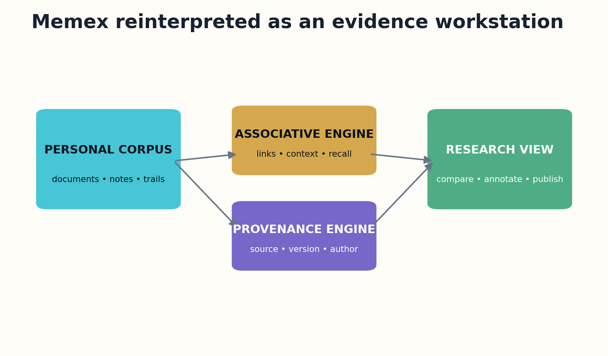
Figure 6. The modern Memex is a provenance-rich research workstation rather than a recommendation feed.

MODERN RECONSTRUCTION
A modern Memex should be an evidence workstation. It would ingest a personal and shared corpus, resolve versions and authorship, preserve annotations as first-class objects, and let users publish trails that remain attached to source spans. Language models would propose connections but could not silently rewrite the archive.
The critical modern materials are not exotic. They are data models, local storage, high-resolution displays, multimodal indexing, cryptographic provenance, and interaction design. The hard problem is governance: which memories remain private, which trails become public, and how can future readers reconstruct the context of a link?

WHAT SHOULD BE BUILT?
Verdict: deployable now, but only if the product resists becoming another recommendation engine. The modern Memex should optimize for inspectable thought, not engagement.
Trail value T = relevance × context preserved × provenance × future readability
VERDICT | DEPLOY
RECONSTRUCTION EXERCISE
• Design a trail object that survives source updates.
• Separate private memory, shared annotation, and public publication.
• Create one safeguard against model-generated false associations.
Research notes: S10, S11. See Research Notes and Sources.

CHAPTER 07
The Mondothèque and the World Brain
Universal knowledge failed first as furniture, then as institutions.
━━━━━━━━━━━━━━━━━━━━━━━━━
Paul Otlet’s Mondothèque and related world-brain proposals imagined a home workstation connected to a universal documentary system. The designs combined catalogs, cards, microfilm, telegraphy, radio, and television into an information appliance decades before digital networking. The machine was inseparable from an institutional ambition to classify and circulate world knowledge.
The technical weakness was not only storage. Global knowledge requires identifiers, translation, curation, dispute resolution, and preservation. Card catalogs could scale only through enormous human labor, while centralized classification risked freezing one worldview into infrastructure.

Figure 7. The modern Memex is a provenance-rich research workstation rather than a recommendation feed.

MODERN RECONSTRUCTION
Modern computation supplies search, knowledge graphs, machine translation, and distributed storage. A reconstructed Mondothèque would be less a terminal than a protocol: open identifiers, rights-aware metadata, community-maintained ontologies, and interfaces that expose alternative classifications instead of declaring one universal map.
The danger is epistemic centralization. A world brain can become a world filter. Modern design should support plural knowledge institutions connected by interoperable evidence, with transparent ranking and the ability to inspect what is absent. The system should reveal classification conflicts rather than erase them.

WHAT SHOULD BE BUILT?
Verdict: prototype as a federated public knowledge commons. The physical workstation is easy; the institutional machine remains the real construction project.
Commons quality Q_c = coverage × plural governance × interoperability × correction capacity
VERDICT | PROTOTYPE
RECONSTRUCTION EXERCISE
• Design two conflicting classification systems that can coexist.
• Specify how a universal index should represent absent or restricted knowledge.
• Identify one governance feature more important than search speed.
Research notes: S11. See Research Notes and Sources.

CHAPTER 08
OGAS: The Network That Could Not Command Its Commanders
A national computer network failed because data is power before it is information.
━━━━━━━━━━━━━━━━━━━━━━━━━
Viktor Glushkov’s OGAS envisioned a nationwide network of computing centers and terminals for economic information processing and management. It was a serious attempt to connect calculation, communication, and planning across a continental industrial system. The project remained unrealized as a national whole despite decades of proposals and local automation.
The historical bottlenecks included scarce computers, weak telecommunications, incompatible systems, and limited real-time data. But institutional resistance was equally fundamental. Ministries controlled their information and budgets. A network that made flows visible threatened existing authority even when presented as a tool for planning.
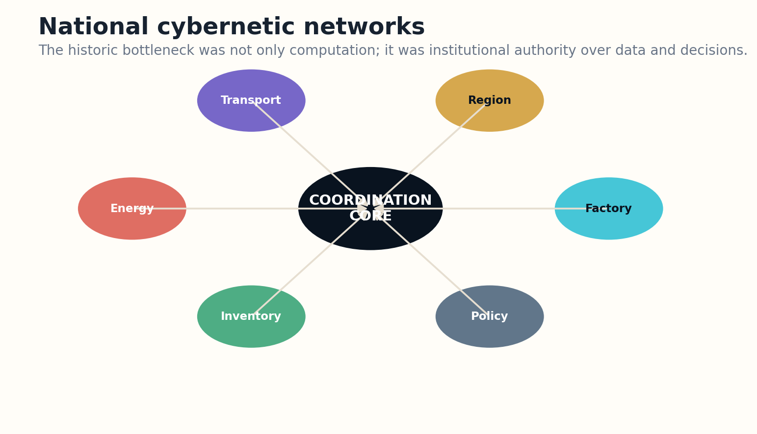
Figure 8. National coordination requires both shared data and bounded institutional authority.

MODERN RECONSTRUCTION
Modern cloud systems, event streams, digital identity, optimization, and machine learning make the computational layer ordinary. They do not solve incentive alignment, strategic misreporting, local knowledge, or the distinction between measurement and value. A modern OGAS that centralizes all decisions would be technically impressive and politically brittle.
The productive reconstruction is federated. Organizations publish auditable operational data under common schemas while retaining bounded local authority. Models produce forecasts and constraint warnings, not unquestionable commands. Privacy, labor rights, security, and appeal mechanisms are part of the control architecture.

WHAT SHOULD BE BUILT?
Verdict: subsystem research and public-sector prototypes. The modern lesson is not that AI can finally plan everything. It is that data infrastructure must make power inspectable and reversible.
Coordination gain G = shared observability × model quality × local agency − strategic distortion
VERDICT | PROTOTYPE
RECONSTRUCTION EXERCISE
• Map where data ownership would create resistance in a modern OGAS.
• Design a forecast that informs without automatically commanding.
• Specify an appeal path for a local unit that rejects a central model.
Research notes: S12, S13. See Research Notes and Sources.

CHAPTER 09
Cybersyn: Feedback Before Big Data
Its most modern feature was not the control room; it was the attempt to preserve local autonomy inside a national feedback loop.
━━━━━━━━━━━━━━━━━━━━━━━━━
Project Cybersyn in Chile linked factories through telex communications, statistical monitoring, cybernetic models, and an operations room. Portions operated, but the full system was never completed before the 1973 coup. It belongs here as an integrated machine whose intended institutional form remained unfinished.
Cybersyn was designed under extreme computational scarcity. Rather than collect everything, it focused on selected indicators and exception reporting. That constraint produced a useful principle: central attention should be triggered by meaningful deviation, while ordinary decisions remain local.
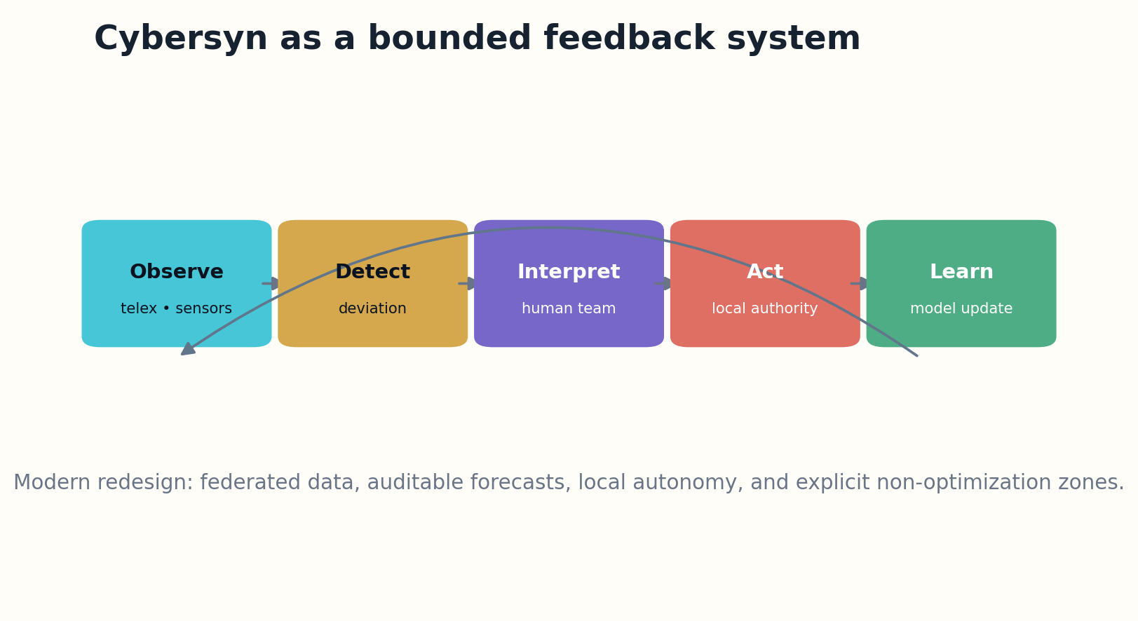
Figure 9. A bounded feedback loop escalates exceptions while preserving local autonomy.

MODERN RECONSTRUCTION
Modern redesign would replace telex with secure event streams, but it should preserve bounded feedback. Digital twins could model production and logistics; probabilistic detection could distinguish noise from structural problems; human teams could explore interventions. Every alert would carry its data lineage and model uncertainty.
The danger is the seductive dashboard. A visually coherent operations room can make incomplete data look like total knowledge. Modern Cybersyn should display missingness, disagreement, lag, and the consequences of acting. It should also log who changed a target and who bears the cost.

WHAT SHOULD BE BUILT?
Verdict: prototype for resilient public infrastructure, disaster response, and supply coordination—not as a machine for total economic control.
Feedback stability S_f = useful signal × response capacity × local autonomy / delay and model error
VERDICT | PROTOTYPE
RECONSTRUCTION EXERCISE
• Design an exception-reporting system with a maximum of ten indicators.
• Show how missing data appears on the operations display.
• Create a rule that prevents central intervention when local correction is working.
Research notes: S14, S15. See Research Notes and Sources.

CHAPTER 10
Xanadu: The Hypertext System the Web Did Not Build
The web made linking universal by making links shallow.
━━━━━━━━━━━━━━━━━━━━━━━━━
Ted Nelson’s Project Xanadu proposed a global hypertext publishing system with bidirectional links, persistent identity, transclusion, versioning, and mechanisms for attribution and compensation. Demonstrations existed, but the complete social and technical system never reached general operation in its original form.
The web chose simpler primitives: documents, URLs, and one-way links. That simplicity enabled explosive growth but accepted link rot, duplication, weak quotation lineage, and fragile authorship. Xanadu’s complexity delayed construction, yet many of its concerns have become more urgent in an age of generative reuse.

Figure 10. The modern Memex is a provenance-rich research workstation rather than a recommendation feed.

MODERN RECONSTRUCTION
A modern reconstruction could use content-addressed storage, distributed version control, cryptographic manifests, micropayment or benefit-sharing systems, and fine-grained rights metadata. Transclusion could show a passage in context while preserving the source version and author-defined permissions.
The remaining blocker is not bandwidth. It is agreement on identity, ownership, privacy, and permanence. Permanent links can conflict with deletion rights; universal attribution can expose vulnerable authors; automated payment can amplify platform power. The architecture must permit selective persistence and negotiated reuse.

WHAT SHOULD BE BUILT?
Verdict: build the provenance and transclusion layers as interoperable standards rather than one total publishing system.
Link integrity L = identity persistence × version specificity × context × rights compatibility
VERDICT | DEPLOY
RECONSTRUCTION EXERCISE
• Design a bidirectional link that survives document relocation.
• Resolve a conflict between permanent citation and legitimate deletion.
• Specify how transclusion should display source context.
Research notes: S16. See Research Notes and Sources.

PART III
FLIGHT BEYOND THE AIRPLANE
Skip-gliders, orbital aircraft, supersonic transports, and single-stage spaceplanes at the edge of materials and control.

CHAPTER 11
Silbervogel: The Skip-Glider Before the Thermal Model
The atmosphere can extend range, but it collects payment in heat, load, and uncertainty.
━━━━━━━━━━━━━━━━━━━━━━━━━
Eugen Sänger and Irene Bredt’s Silbervogel proposed a rocket-boosted vehicle that would skip along the upper atmosphere over intercontinental distances. The design was never constructed. Its importance lies in treating atmospheric reentry not as a single descent but as a sequence of energy exchanges between speed, lift, and heating.
Period calculations underestimated some thermal and aerodynamic effects. Skip trajectories pass repeatedly through changing density, magnifying uncertainty in heating, stability, and structural load. Navigation and guidance would also have been primitive relative to the required precision.
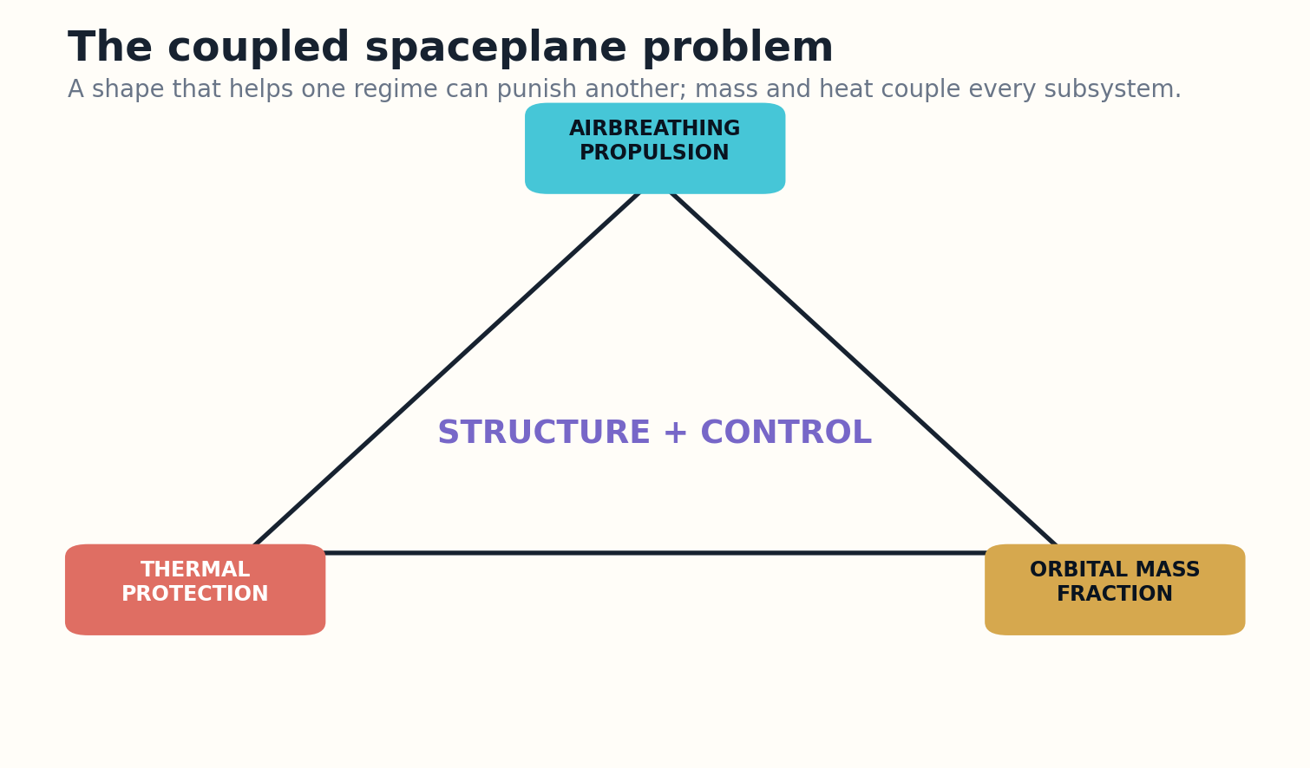
Figure 11. Spaceplane feasibility is controlled by coupled propulsion, thermal, structural, and mass margins.

MODERN RECONSTRUCTION
Modern CFD, nonequilibrium chemistry, high-temperature materials, inertial navigation, and robust control make the concept far more analyzable. Carbon-carbon structures and ceramic matrix composites can survive environments that were inaccessible to 1940s manufacturing, though maintenance and inspection remain severe.
The modern machine should not inherit the bomber mission. A peaceful reconstruction would be an uncrewed high-speed research vehicle studying skip guidance, thermal protection, and cross-range control. Even then, it competes with ballistic and lifting reentry systems that achieve similar research goals with less complexity.

WHAT SHOULD BE BUILT?
Verdict: subsystem research only. The original machine is historically foundational but not a compelling transport architecture.
Convective heating scales approximately as q̇ ∝ √(ρ/R_n) × V³
VERDICT | SUBSYSTEM
RECONSTRUCTION EXERCISE
• Identify which variables make skip-entry heating difficult to bound.
• Design a subscale experiment that studies one skip without an operational weapon mission.
• Compare the concept with a conventional lifting-body reentry.
Research notes: S17. See Research Notes and Sources.

CHAPTER 12
X-20 Dyna-Soar: The Orbital Aircraft That Reached Hardware
A canceled vehicle can still complete an argument.
━━━━━━━━━━━━━━━━━━━━━━━━━
The X-20 Dyna-Soar was a piloted lifting-body spaceplane intended for rocket launch and runway landing. Boeing built models and program hardware, and pilots were selected, but the vehicle never flew before cancellation in 1963. It transformed earlier skip-glider ideas into a concrete aerospace program.
Dyna-Soar confronted reentry heating, low-speed landing, control across regimes, crew escape, launch integration, and mission ambiguity. Its winged geometry offered cross-range and runway recovery but imposed thermal edges and a demanding landing task after orbital flight.

Figure 12. Spaceplane feasibility is controlled by coupled propulsion, thermal, structural, and mass margins.

MODERN RECONSTRUCTION
Modern avionics, autonomous flight control, precision navigation, improved thermal protection, and uncrewed testing would substantially reduce development risk. A contemporary program could fly progressively from suborbital demonstrations to orbital missions while using a digital twin and hardware-in-the-loop simulation.
Yet the mission must justify wings. Capsules offer simpler reentry and recovery; reusable boosters and small lifting bodies divide the problem differently. The modern question is not whether Dyna-Soar could fly, but whether runway cross-range is worth the mass and maintenance.

WHAT SHOULD BE BUILT?
Verdict: prototype only for missions that require maneuvering reentry or repeated runway operations. The historical geometry should not be copied without a new mission analysis.
Glide capability ≈ lift-to-drag ratio × available atmospheric energy management
VERDICT | PROTOTYPE
RECONSTRUCTION EXERCISE
• Define a mission that truly requires a lifting reentry vehicle.
• List the thermal and operational costs of runway landing.
• Design an uncrewed progression that retires the highest risks first.
Research notes: S18. See Research Notes and Sources.

CHAPTER 13
Boeing 2707: The Supersonic Airliner That Lost Its Market
The engine could be built; the system around the engine could not be made acceptable.
━━━━━━━━━━━━━━━━━━━━━━━━━
The Boeing 2707 was the American answer to Concorde and the Tu-144: a larger, faster supersonic transport intended to carry roughly 300 passengers. The program advanced to major proposals, engine tests, and mockups, but Congress canceled support before a flight vehicle was built.
The design pushed speed, capacity, and range simultaneously. High temperature affected structure and cabin systems. Variable geometry added weight and complexity. Engines had to provide enormous thrust while meeting airport operations. Sonic boom, community noise, fuel use, development cost, and ticket economics attacked the concept from outside the airframe.
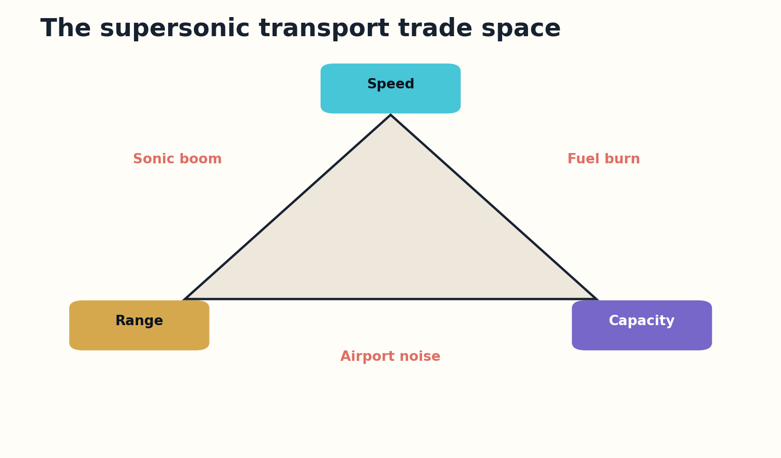
Figure 13. The supersonic transport trade space is constrained by environmental and market penalties.

MODERN RECONSTRUCTION
Modern computational aerodynamics can shape lower-boom signatures, and composites, titanium processing, digital flight control, and efficient engine cycles improve the design space. NASA’s current quiet-supersonic research demonstrates that sonic-boom character can be engineered, but a large transport creates a different scale of challenge.
A reconstructed 2707 should shrink rather than revive the original specification. Lower passenger count, lower cruise Mach number, overwater routing, sustainable fuel constraints, and premium utilization may produce a viable niche. That is not the original machine; it is a descendant that accepts the old tradeoffs.

WHAT SHOULD BE BUILT?
Verdict: archive the 2707 as a warning against maximizing every headline metric. Prototype quiet supersonic transport under strict environmental and market gates.
Transport value V_t = time saved × passengers × utilization − fuel, noise, and infrastructure cost
VERDICT | ARCHIVE / DESCENDANT
RECONSTRUCTION EXERCISE
• Redesign the mission by relaxing one of speed, range, or capacity.
• Calculate how low utilization changes the economics of an expensive fleet.
• Define an environmental gate that can cancel the prototype.
Research notes: S19, S20. See Research Notes and Sources.

CHAPTER 14
HOTOL: The Single-Stage Spaceplane with a Balance Problem
A brilliant engine concept cannot rescue a vehicle whose mass moves outside its control envelope.
━━━━━━━━━━━━━━━━━━━━━━━━━
HOTOL was a British single-stage-to-orbit spaceplane study of the 1980s, associated with an air-breathing rocket concept and horizontal takeoff and landing. It was never built. Its designers confronted one of the hardest aerospace goals: reaching orbit without discarding stages while carrying wings, landing gear, thermal protection, and payload.
The historical configuration suffered a severe center-of-gravity challenge because heavy propulsion was concentrated at the rear while propellant mass changed throughout ascent. A vehicle can be statically balanced on paper and still require impractical control authority across the trajectory.
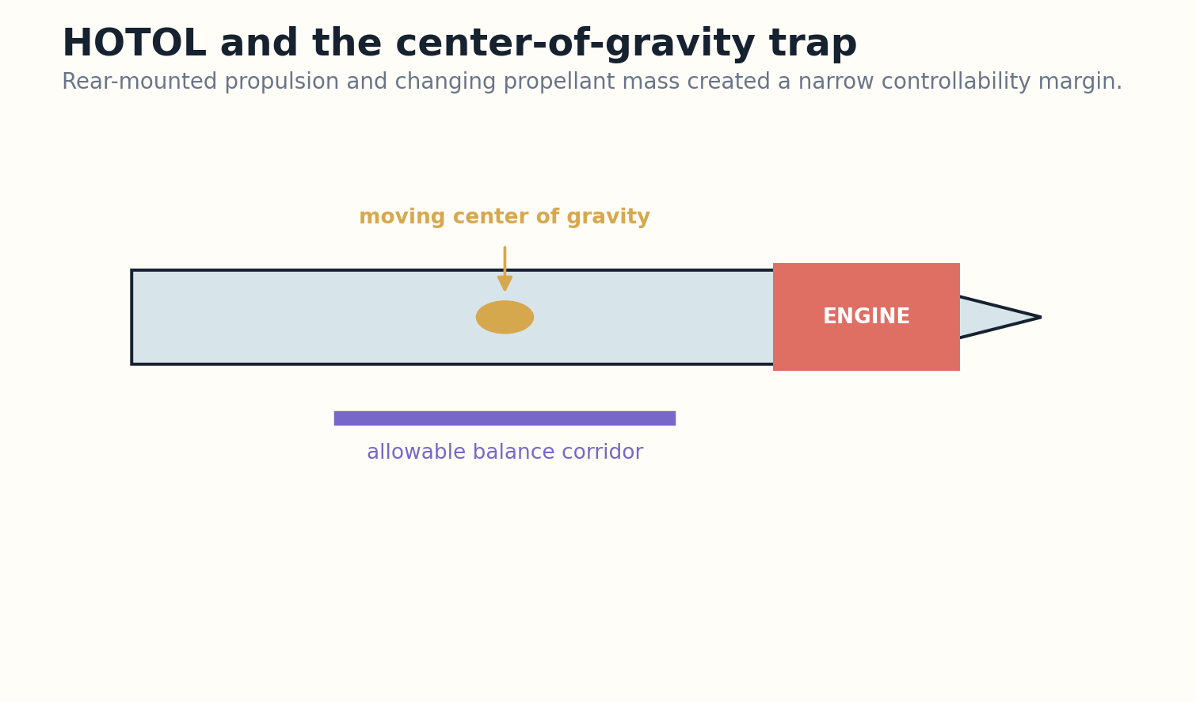
Figure 14. HOTOL’s rear propulsion and propellant movement created a severe balance problem.

MODERN RECONSTRUCTION
Modern multidisciplinary optimization can co-design geometry, tanks, propulsion, flight path, and control laws. Lightweight tanks, composites, active control, and better precooler technology enlarge the feasible region. Digital engineering would expose the balance problem earlier and explore thousands of arrangements.
The rocket equation remains. Single-stage-to-orbit margins are consumed by dry mass, reserve propellant, thermal protection, abort provisions, and reusability. Repositioning engines or using a carrier aircraft changes the architecture but also changes the machine.

WHAT SHOULD BE BUILT?
Verdict: retain HOTOL as a propulsion-airframe integration study. Prototype engines and high-speed subscale vehicles; do not commit to full SSTO until independently verified mass margins remain healthy after operations and safety reserves.
Mass closure m_payload = m_initial − m_propellant − m_structure − m_systems − reserves
VERDICT | SUBSYSTEM
RECONSTRUCTION EXERCISE
• Create a center-of-gravity map over propellant burn.
• Apply a 20 percent dry-mass growth and see whether payload survives.
• Define a decision gate that prevents engine success from being mistaken for vehicle success.
Research notes: S21, S22. See Research Notes and Sources.

CHAPTER 15
X-30 NASP: When the Airframe Became the Engine
The most ambitious aircraft was not one machine but a stack of immature technologies with no slack between them.
━━━━━━━━━━━━━━━━━━━━━━━━━
The National Aero-Space Plane, or X-30, aimed at hypersonic cruise and single-stage access to orbit using air-breathing propulsion and horizontal operations. No full aircraft was built, although the program advanced materials, scramjet research, high-temperature structures, and computational methods.
NASP’s defining difficulty was integration. The forebody compressed air for the engine; the engine shaped the vehicle; cryogenic fuel cooled structure; thermal deformation changed aerodynamics; flexibility interacted with control. A local improvement could destabilize the total system.

Figure 15. Spaceplane feasibility is controlled by coupled propulsion, thermal, structural, and mass margins.

MODERN RECONSTRUCTION
Modern high-fidelity CFD, GPU computing, probabilistic design, digital twins, ceramic matrix composites, oxide-dispersion-strengthened alloys, and additive cooling channels dramatically improve the ability to design and test such coupling. The X-43 and later hypersonic work inherited portions of this technology path.
But the system still lacks generous margin. Air-breathing propulsion must operate across a wide Mach range, and orbital velocity demands energy beyond hypersonic cruise. A combined-cycle demonstrator can be valuable without promising runway-to-orbit operation.

WHAT SHOULD BE BUILT?
Verdict: continue subsystem and staged flight research. Reconstruct NASP as an experimental family, not one all-or-nothing vehicle.
Integrated margin M = min(propulsion, thermal, structural, control, fuel, operations)
VERDICT | SUBSYSTEM
RECONSTRUCTION EXERCISE
• Identify three feedback loops between airframe and propulsion.
• Design a technology demonstrator that validates only one Mach regime.
• Write a rule for when subsystem maturity is insufficient for system commitment.
Research notes: S23, S24. See Research Notes and Sources.

PART IV
LAUNCH AND INTERSTELLAR SYSTEMS
Machines whose dimensions force civilization-scale logistics, energy, autonomy, and risk management.

CHAPTER 16
Sea Dragon: The Rocket Designed Like a Ship
Scale can simplify manufacturing while making every external system enormous.
━━━━━━━━━━━━━━━━━━━━━━━━━
Sea Dragon was a 1960s concept for an extremely large, pressure-fed, sea-launched rocket built with shipyard-like methods. The design sought low cost through simplicity, rugged steel construction, large components, and ocean launch rather than precision aerospace manufacturing.
The concept’s seriousness came from detailed feasibility and cost studies. Pressure-fed engines reduce turbomachinery complexity, but large tanks and high thrust create structural, combustion, handling, and range-safety problems. Ocean operations add corrosion, weather, towing, fueling, and recovery logistics.
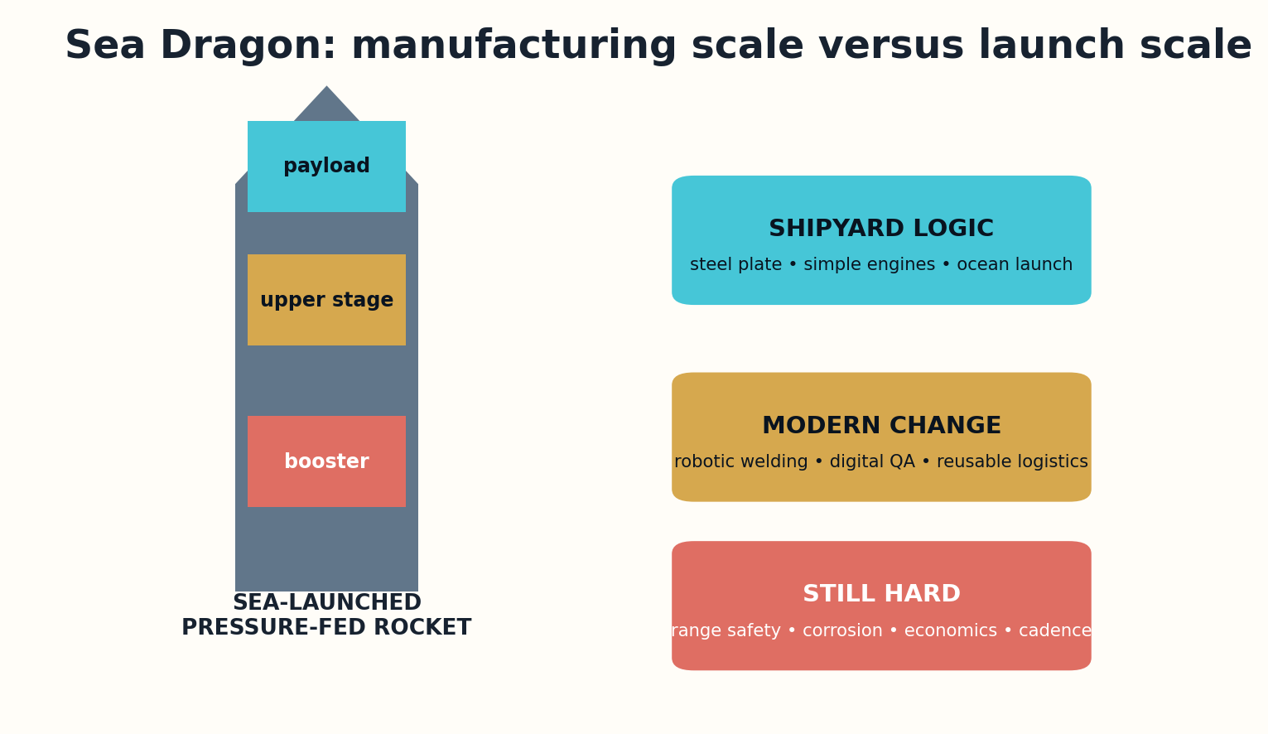
Figure 16. Sea Dragon substituted shipyard simplicity for conventional aerospace manufacturing.

MODERN RECONSTRUCTION
Modern robotic welding, automated inspection, computational combustion, large-scale additive tooling, digital quality records, and autonomous marine operations improve the manufacturing case. Distributed sensors could monitor tank strain and launch condition in real time.
The competitive landscape has changed. Reusable launch systems lower marginal cost through flight rate, while payloads increasingly favor modular deployment. A giant launcher needs enough demand to justify dedicated maritime infrastructure and risk concentration.

WHAT SHOULD BE BUILT?
Verdict: prototype large pressure-fed stages and marine logistics only if a specific bulk-space market exists. Do not build the full machine to create the market it requires.
Delivered cost C/kg = development amortization + operations + losses + infrastructure, divided by annual payload
VERDICT | PROTOTYPE
RECONSTRUCTION EXERCISE
• Estimate the annual payload required to sustain a giant launcher.
• Compare shipyard tolerances with aerospace inspection requirements.
• Design a marine abort and environmental containment concept.
Research notes: S25. See Research Notes and Sources.

CHAPTER 17
Project Orion: A Spacecraft Driven by Discrete Violence
Its performance remains extraordinary because its external costs were pushed outside ordinary rocket design.
━━━━━━━━━━━━━━━━━━━━━━━━━
Project Orion studied spacecraft accelerated by repeated external nuclear pulses acting on a pusher plate through shock isolation. The program produced extensive analysis and conventional explosive tests, but no nuclear pulse spacecraft was constructed. It promised combinations of thrust and specific impulse difficult to match with other concepts.
The architecture turns propulsion into a sequence of extreme transients. The pusher plate, shock absorbers, structural fatigue, pulse timing, radiation environment, and payload isolation must work repeatedly. Launch from Earth adds fallout, treaty, safety, and political barriers that dominate the engineering discussion.
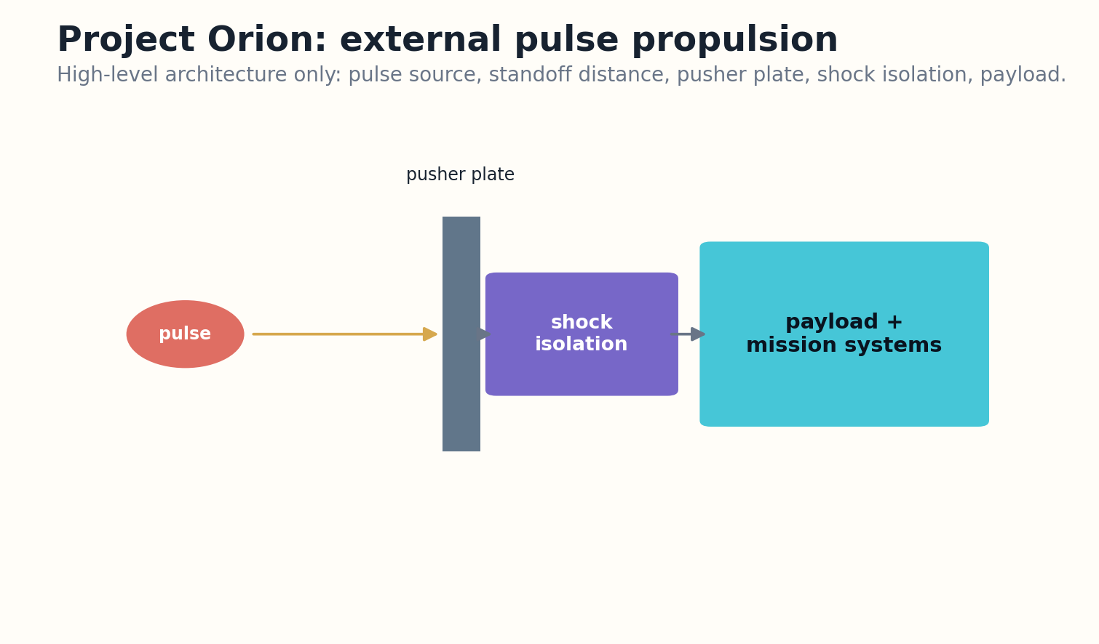
Figure 17. High-level Orion architecture: pulse source, standoff, pusher plate, isolation, and payload.

MODERN RECONSTRUCTION
Modern hydrocodes, materials modeling, high-temperature coatings, autonomous timing, probabilistic fracture mechanics, and in-space assembly improve analysis. None removes the central issue that propulsion units are nuclear explosive devices. A space-only version still faces launch, custody, security, and international legitimacy.
Alternative pulsed plasma systems may preserve some external-pulse advantages without the same device class, but they become new machines with their own unresolved drivers. The proper reconstruction is a propulsion comparison and materials program, not a clandestine path to hardware.

WHAT SHOULD BE BUILT?
Verdict: archive the original operational concept under current legal and safety conditions; permit transparent, non-explosive research into pulsed plasma momentum transfer.
Impulse coupling I_total = Σ(C_m × pulse energy), constrained by fatigue, standoff, and lawful operation
VERDICT | ARCHIVE / SAFE SUBSYSTEMS
RECONSTRUCTION EXERCISE
• List the costs Orion excluded from a conventional vehicle mass budget.
• Define a non-explosive experiment that studies pusher-plate dynamics.
• Write a governance condition that blocks hardware escalation.
Research notes: S26, S27. See Research Notes and Sources.

CHAPTER 18
Project Daedalus: The Fusion Starship as a Complete Study
Interstellar credibility begins when the design includes dust, communication, deceleration choices, and a century of reliability.
━━━━━━━━━━━━━━━━━━━━━━━━━
Project Daedalus was a British Interplanetary Society design study conducted from 1973 to 1978 to examine an uncrewed fusion-powered probe to a nearby star. It became one of the most detailed interstellar vehicle studies of the twentieth century, despite depending on inertial-confinement fusion capabilities not available for propulsion.
Daedalus treated the spacecraft as a staged system carrying large quantities of fusion fuel and accelerating to a significant fraction of light speed. Its design confronted pellet injection, ignition rate, magnetic nozzles, structural mass, interstellar dust, and long-duration autonomy.
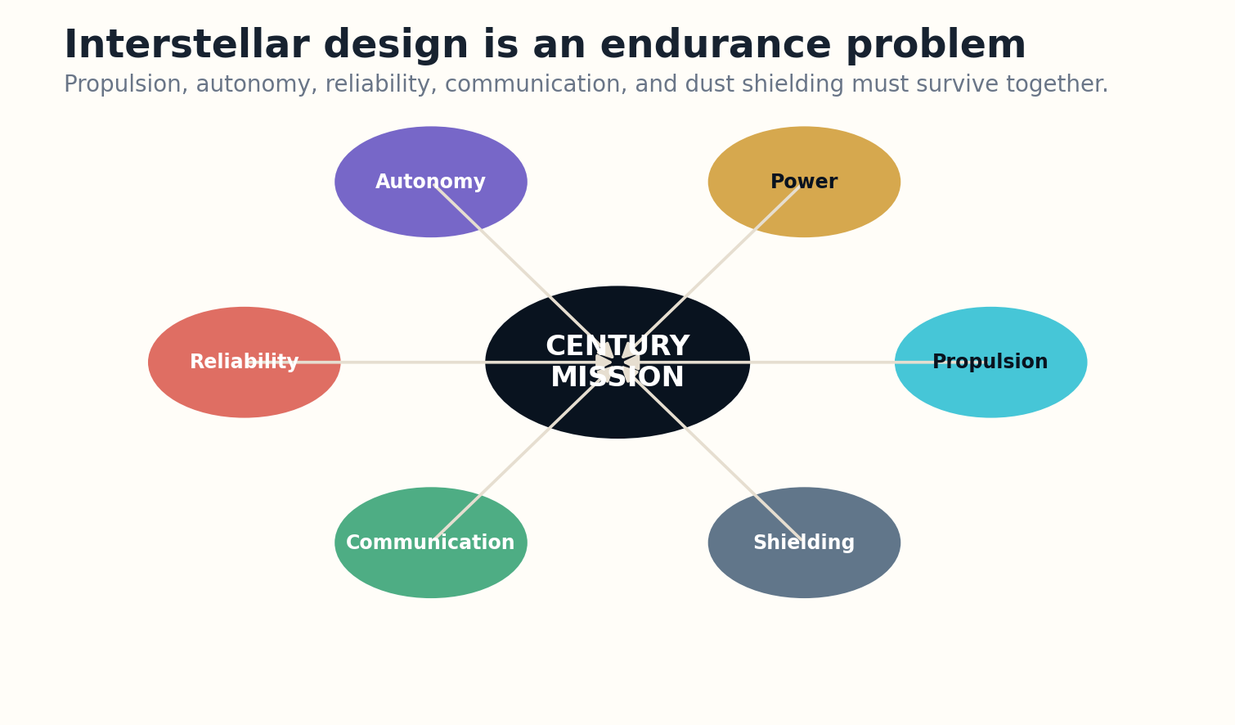
Figure 18. A century mission is a reliability and institutional continuity system as much as a propulsion system.

MODERN RECONSTRUCTION
Modern fusion diagnostics, pulsed-power modeling, superconducting magnets, autonomous navigation, fault-tolerant computing, and high-bandwidth optical communications refine the study. Exoplanet catalogs also improve target selection. However, controlled high-gain fusion propulsion and industrial fuel acquisition remain fundamental blockers.
A modern Daedalus should be a technology roadmap with nested missions: laboratory pulse experiments, magnetic-nozzle tests, outer-solar-system probes, dust-shield demonstrations, and multi-decade autonomy. Each step must have independent scientific value.

WHAT SHOULD BE BUILT?
Verdict: research program, not vehicle program. Its greatest contribution is the discipline of designing the entire century-scale mission rather than only the engine.
Mission feasibility F = propulsion gain × pulse reliability × shielding × autonomy × communication
VERDICT | RESEARCH
RECONSTRUCTION EXERCISE
• Create a precursor mission that validates one Daedalus subsystem.
• Estimate how component failure rate compounds over decades.
• Define a target-selection rule that accounts for mission time and scientific value.
Research notes: S28, S29. See Research Notes and Sources.

CHAPTER 19
Project Longshot: Designing for a Hundred-Year Machine
The hardest component is the one that must remain understandable after its designers are gone.
━━━━━━━━━━━━━━━━━━━━━━━━━
Project Longshot was a late-1980s preliminary design for an uncrewed Alpha Centauri probe assembled in space and traveling for roughly a century. It proposed pulsed fusion propulsion, long-life power, laser communication, autonomous control, and scientific operations far beyond real-time command.
Longshot sharpened a problem that ordinary spacecraft only approach: institutional continuity. Hardware must survive, but so must software meaning, calibration knowledge, command authority, and the ability of future societies to receive and interpret the data.

Figure 19. A century mission is a reliability and institutional continuity system as much as a propulsion system.

MODERN RECONSTRUCTION
Modern radiation-hardened computing, formal verification, self-diagnosis, optical communication, redundant architectures, and model-based autonomy improve the design. Machine learning can help adapt, but opaque models that cannot be validated across decades may reduce trust rather than increase it.
A contemporary Longshot architecture would include executable specifications, multiple independent navigation methods, reconfigurable computation, preserved simulators on Earth, and a governance plan for century-scale mission ownership. The mission should periodically transmit internal health and epistemic status, not only measurements.

WHAT SHOULD BE BUILT?
Verdict: develop long-duration autonomy and archival software as near-term missions. The full star probe remains contingent on propulsion and power breakthroughs.
Century reliability R_sys(t) = product of subsystem survivals, repair capacity, and recoverable knowledge
VERDICT | RESEARCH
RECONSTRUCTION EXERCISE
• Design a software artifact that remains interpretable after fifty years.
• Specify how mission authority transfers across generations.
• Create a health report that communicates uncertainty in onboard models.
Research notes: S30. See Research Notes and Sources.

CHAPTER 20
The Launch Loop: A Machine Made of Stored Motion
The structure stands because something inside it is already moving fast enough to destroy it.
━━━━━━━━━━━━━━━━━━━━━━━━━
Keith Lofstrom’s launch-loop concept proposed a rapidly moving cable or rotor inside a guided sheath, forming a high-altitude track that could accelerate payloads toward orbit. The full system was never constructed. Its attraction is repeated launch without carrying all propellant onboard.
The loop is a dynamic structure. Magnetic guidance, vacuum maintenance, rotor balance, atmospheric disturbance, thermal expansion, station keeping, and vehicle acceleration are coupled. The enormous stored kinetic energy creates a failure mode unlike a passive bridge.
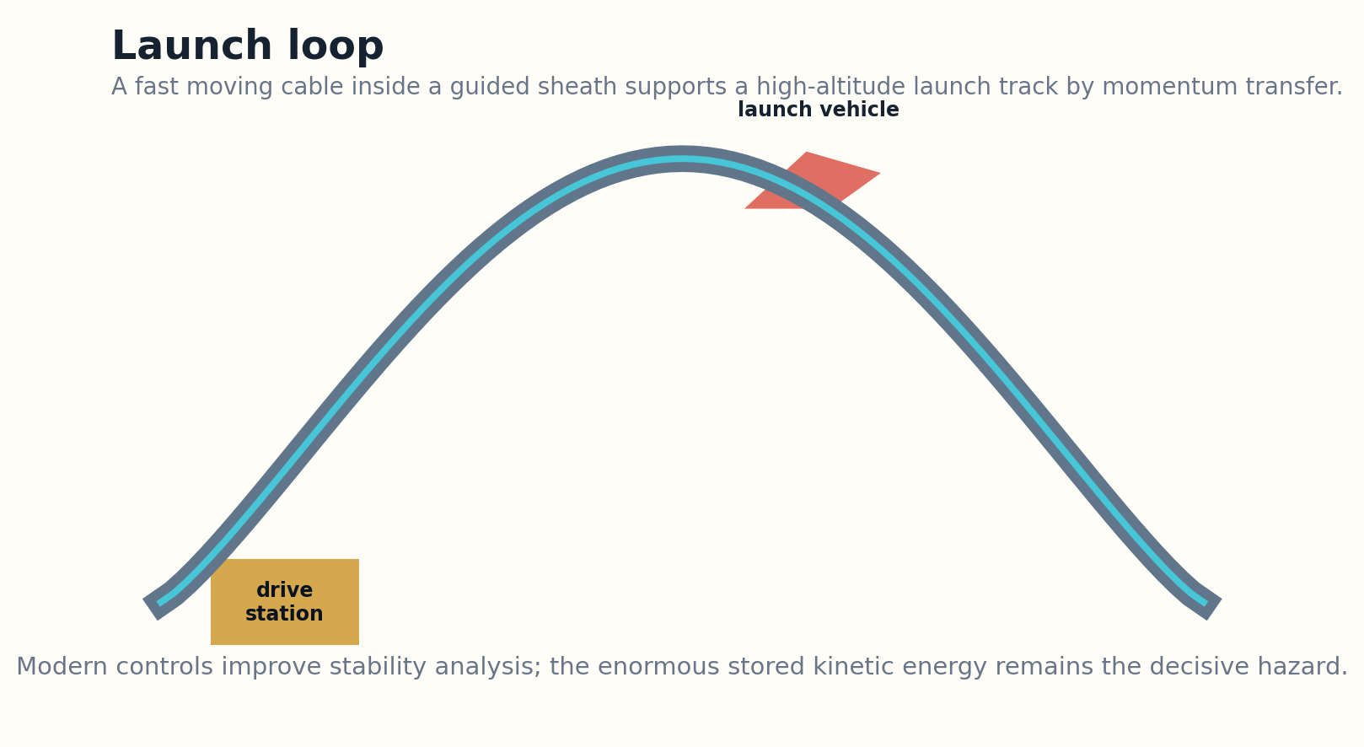
Figure 20. A launch loop is a dynamic structure supported by stored kinetic energy.

MODERN RECONSTRUCTION
Modern magnetic bearings, power electronics, composite rotors, distributed sensing, real-time control, and nonlinear simulation improve stability analysis. Uncrewed small loops could test guidance and energy recovery. Yet extrapolation to thousands of kilometers introduces defect, weather, airspace, and geopolitical exposure.
The design must be judged as infrastructure, not a launcher component. It needs protected corridors, emergency energy dissipation, inspection robots, grid connections, and a launch market large enough to amortize construction. A single catastrophic rotor failure could dominate public acceptance.

WHAT SHOULD BE BUILT?
Verdict: subscale research only until fault containment can be demonstrated physically, not merely simulated.
Stored kinetic energy E_k = 1/2 m v²; containment must remain credible under partial and cascading failure
VERDICT | SUBSYSTEM
RECONSTRUCTION EXERCISE
• Create a fault tree for rotor failure at one station.
• Design a subscale loop with passive energy dissipation.
• Estimate how inspection interval changes with defect-growth uncertainty.
Research notes: S31. See Research Notes and Sources.

CHAPTER 21
The Space Elevator: A Material Whose Defects Become Geography
A tether long enough to touch orbit is not a cable; it is a planetary-scale statistical experiment.
━━━━━━━━━━━━━━━━━━━━━━━━━
Twentieth-century space-elevator proposals placed a tether from Earth through geostationary altitude to a counterweight, allowing climbers to rise without rockets. The concept is governed by specific strength: tensile capability relative to density, including taper, safety factors, and dynamic loads.
No continuous material available at industrial scale has demonstrated the required combination of specific strength, defect tolerance, manufacturability, joining, inspection, and repair for an Earth elevator. Exceptional nanoscale fibers do not automatically become a reliable planetary tether.
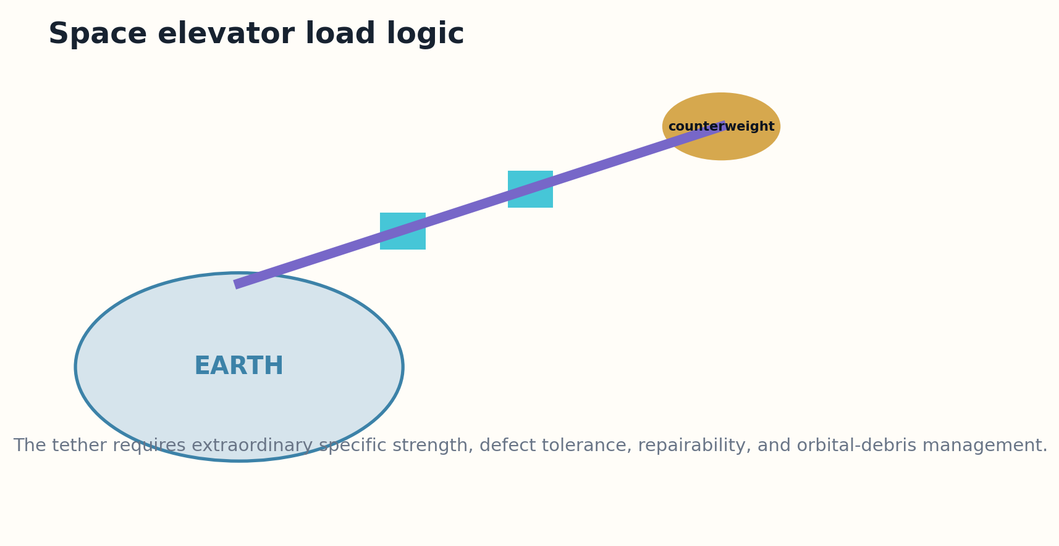
Figure 21. The Earth space elevator is dominated by specific strength, defect statistics, and repair.

MODERN RECONSTRUCTION
Modern atomistic modeling, automated fiber production, distributed sensing, robotic repair, orbital-debris tracking, and active vibration control improve the research program. Lunar or small-body elevators have less demanding gravity and may become earlier demonstrations.
The system also faces lightning, atmosphere, oscillation, debris, collision avoidance, geopolitics, and security. A tether that crosses every orbital altitude becomes shared infrastructure and shared vulnerability.

WHAT SHOULD BE BUILT?
Verdict: materials and off-Earth tether research. The Earth elevator should remain uncommitted until kilometer-scale material reliability and repair are demonstrated with quantified defect distributions.
Tether feasibility depends on characteristic length L_c = σ / (ρg), reduced by taper, defects, and safety factor
VERDICT | RESEARCH
RECONSTRUCTION EXERCISE
• Explain why nanoscale strength cannot be used directly as system strength.
• Choose a lunar or asteroid tether demonstrator.
• Design a repair strategy for a partially damaged ribbon.
Research notes: S32. See Research Notes and Sources.

PART V
ENERGY, HABITATS, AND PLANETARY MACHINES
Orbital power, artificial worlds, pulsed energy, nuclear mobility, ice ships, and wave farms.

CHAPTER 22
Solar Power Satellites: An Energy System in Orbit
The satellite is only one component; the real machine includes launch, construction, transmission, regulation, and the terrestrial grid.
━━━━━━━━━━━━━━━━━━━━━━━━━
Large solar power satellite studies in the 1970s defined orbital arrays, construction bases, transportation fleets, microwave transmitters, ground rectennas, maintenance, and grid integration. No reference-scale system was constructed, but the studies were unusually complete systems engineering exercises.
The historical system depended on very low launch cost, large crews or construction systems in orbit, huge photovoltaic structures, precise beam control, and public acceptance of microwave power transmission. Manufacturing mass and launch cadence dominated economics.
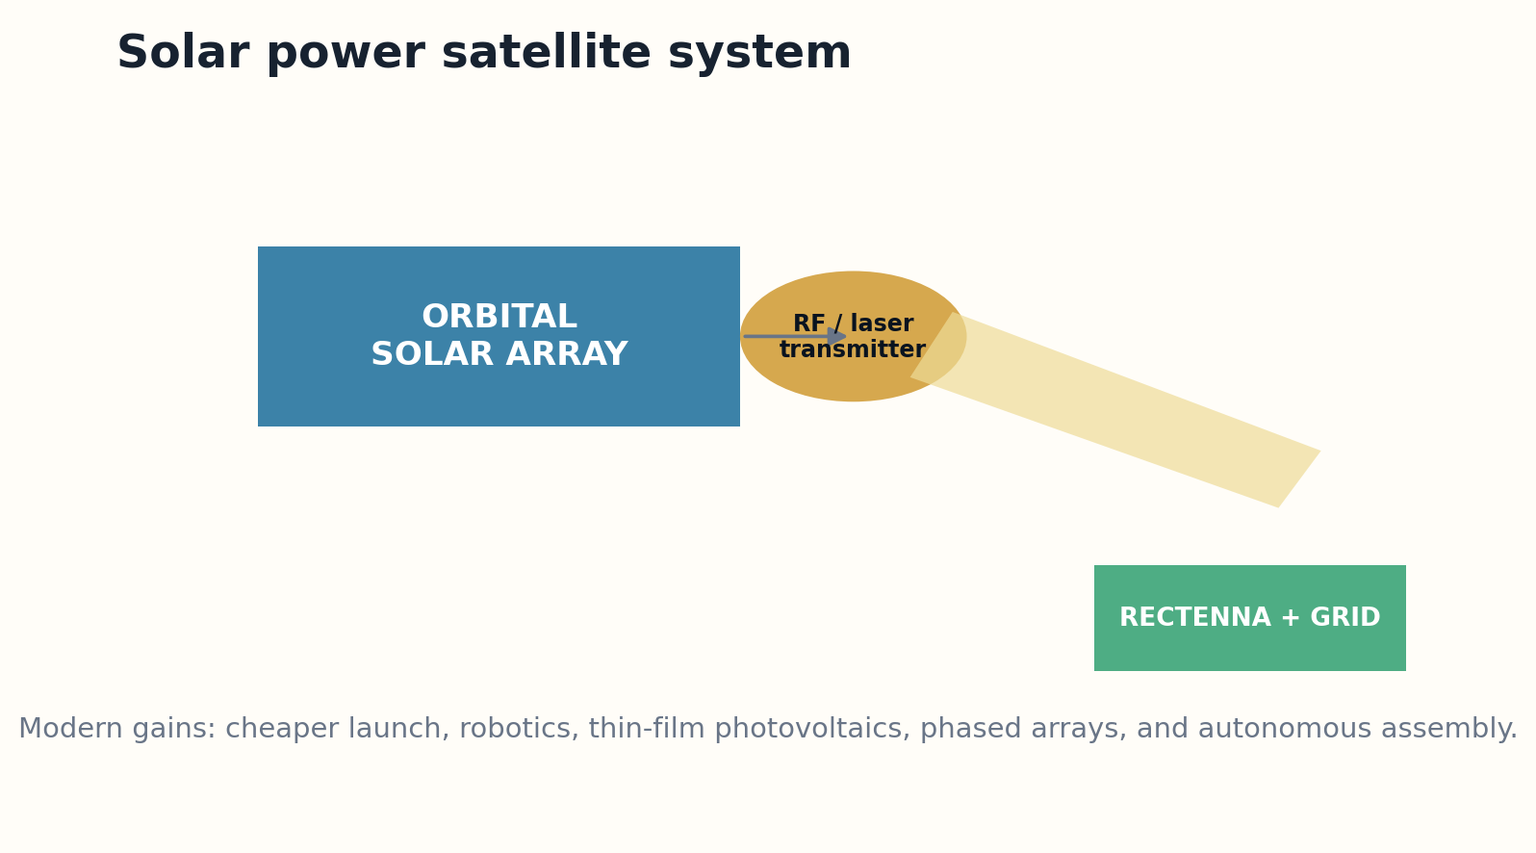
Figure 22. A solar power satellite includes orbital generation, transmission, ground reception, and grid integration.

MODERN RECONSTRUCTION
Modern launch markets, thin-film photovoltaics, autonomous assembly, lightweight structures, high-efficiency power electronics, phased arrays, and digital twins improve the case. Small in-orbit demonstrations can validate beam steering, thermal behavior, assembly, and grid interfaces.
Terrestrial alternatives have also improved. Solar and wind costs, batteries, long-distance transmission, demand response, and distributed generation create a moving benchmark. Orbital power must justify not only energy production but delivery time, resilience, land use, and lifecycle environmental cost.

WHAT SHOULD BE BUILT?
Verdict: staged prototype program. Build progressively larger demonstrators only when each closes against current terrestrial alternatives and independently audited safety limits.
Net delivered power P_net = P_solar × conversion × transmission × rectification − station and logistics losses
VERDICT | PROTOTYPE
RECONSTRUCTION EXERCISE
• Build a lifecycle comparison with terrestrial solar plus storage.
• Define a beam-safety architecture with multiple independent inhibits.
• Choose the smallest demonstrator that tests a system-level uncertainty.
Research notes: S33, S34. See Research Notes and Sources.

CHAPTER 23
Island Three: The Space Habitat as a Living Machine
A rotating cylinder can be structurally feasible and socially uninhabitable.
━━━━━━━━━━━━━━━━━━━━━━━━━
Gerard O’Neill’s large orbital settlement studies described rotating cylindrical habitats with artificial gravity, agriculture, mirrors, industry, and populations comparable to cities. No Island Three-scale habitat was constructed. The design treated space not as a visit but as a permanent industrial ecology.
The structural challenge includes rotation stress, pressure containment, shielding mass, docking, vibration, and long-term fatigue. The ecological challenge is more subtle: nutrient cycles, microbial stability, food production, atmosphere control, and recovery from contamination. The social machine includes governance, inequality, labor, and exit rights.
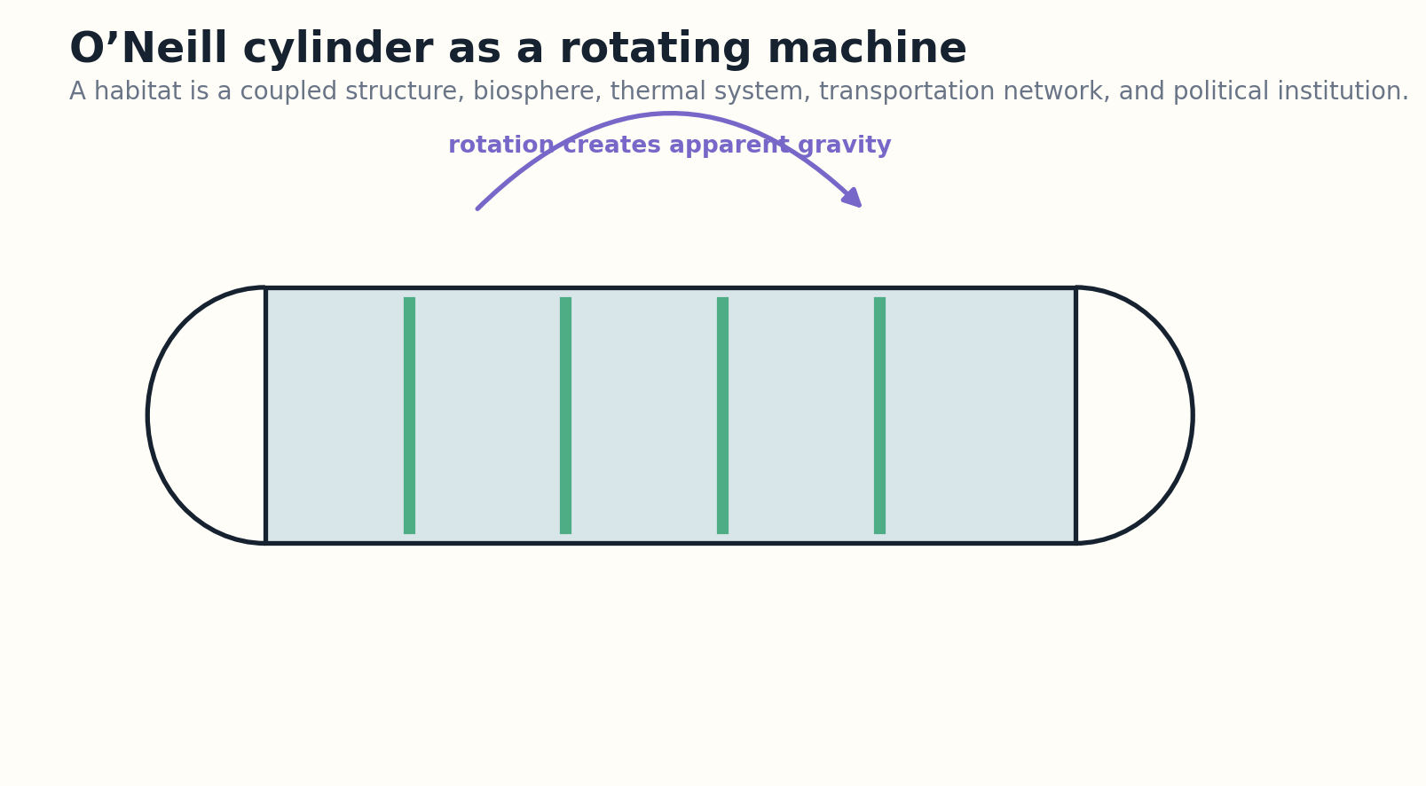
Figure 23. A rotating habitat couples structure, ecology, operations, and governance.

MODERN RECONSTRUCTION
Modern closed-loop life-support experiments, autonomous agriculture, robotics, radiation modeling, additive construction, digital twins, and in-space resource studies improve the path. A habitat can now be simulated as a coupled physical-biological system rather than a static drawing.
The correct progression is not to build a miniature aesthetic cylinder and extrapolate. It is to validate regenerative life support, rotating human factors, maintainable shielding, emergency compartmentalization, and economic purpose through smaller stations.

WHAT SHOULD BE BUILT?
Verdict: prototype subsystems and rotating habitats. Treat the full settlement as a constitutional and ecological project as much as a structural one.
Apparent gravity a = ω²r; comfort also depends on rotation rate, Coriolis effects, and adaptation
VERDICT | PROTOTYPE
RECONSTRUCTION EXERCISE
• Design a rotating demonstrator that answers one human-factors question.
• List the minimum ecological loops that must be closed.
• Write one constitutional requirement for residents of a privately financed habitat.
Research notes: S35. See Research Notes and Sources.

CHAPTER 24
Project PACER: Power from Underground Nuclear Pulses
A calculation can show energy recovery while failing to create an acceptable power plant.
━━━━━━━━━━━━━━━━━━━━━━━━━
Project PACER examined repeated underground nuclear explosions in engineered cavities as a source of heat and electricity. It was never constructed as an operating power system. The design converted weapons-scale pulse physics into a proposed industrial cycle of containment, heat extraction, and repeated operation.
Modern geomechanical modeling, radiation transport, seismic monitoring, robotic inspection, and materials simulation could analyze cavity behavior more accurately. That improvement is real but secondary to proliferation, contamination, treaty, waste, accident, security, and legitimacy concerns.
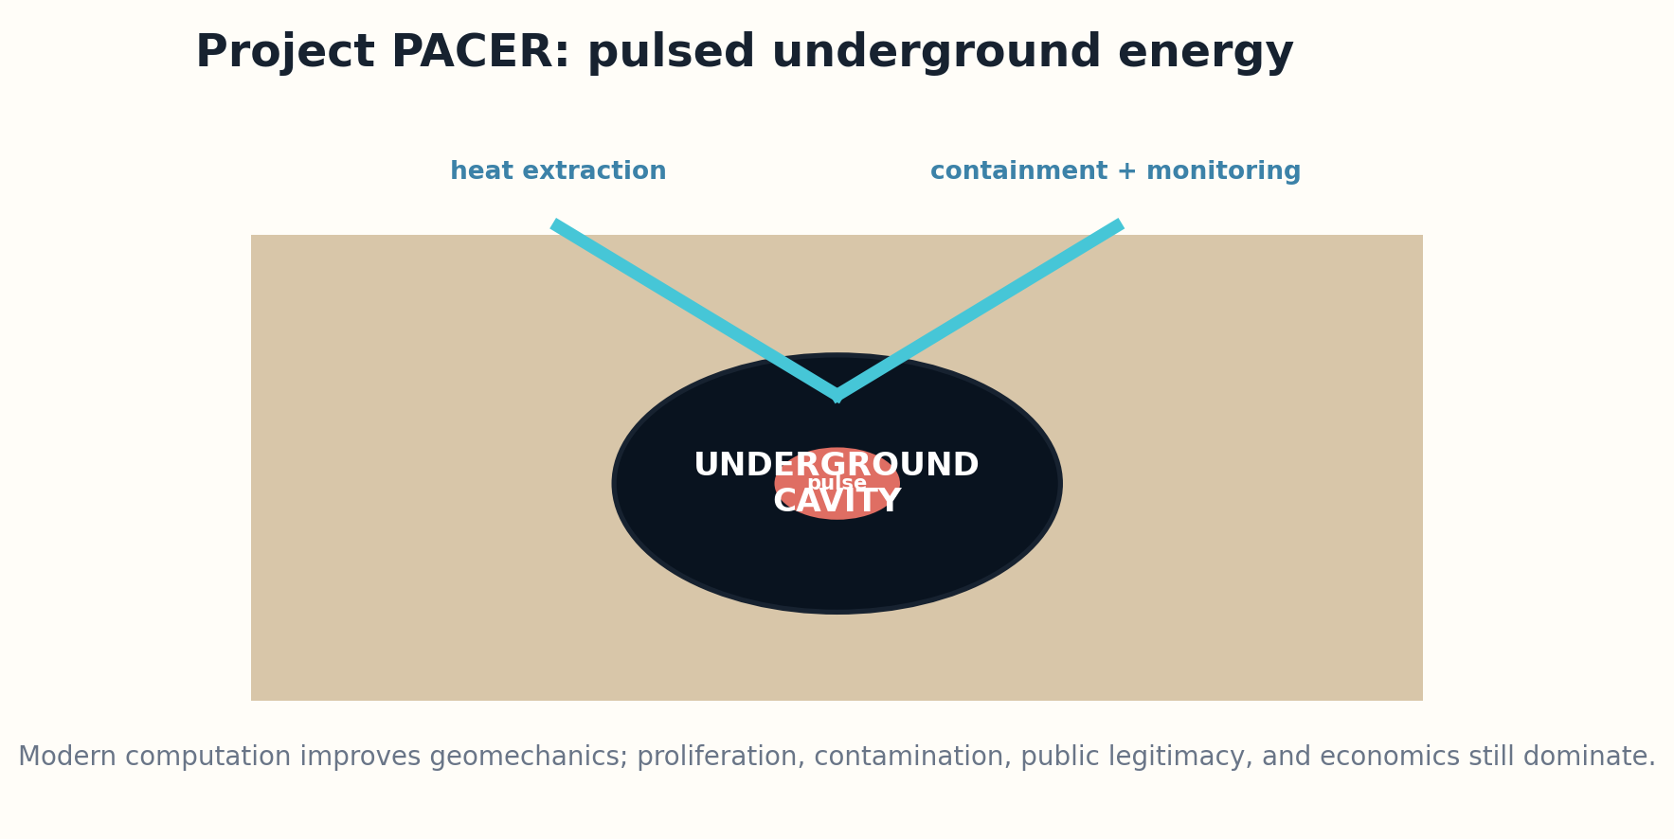
Figure 24. PACER proposed repeated underground pulses and heat extraction, with unacceptable external constraints.

MODERN RECONSTRUCTION
Repeated pulses would create evolving rock damage, chemical environments, activated materials, and uncertain leakage paths. The plant would also require a continuing supply and custody system for nuclear explosive devices, making governance inseparable from operation.
Contemporary low-carbon alternatives have advanced while PACER’s social license has not. Even a technically contained cavity could impose monitoring and stewardship obligations across geological timescales and political generations.

WHAT SHOULD BE BUILT?
Verdict: reject as an energy system. Preserve the analysis as a case study in why thermodynamic availability is not equivalent to acceptable infrastructure.
Usable energy E_u = pulse yield × capture efficiency − containment, cleanup, security, and irreversible-risk cost
VERDICT | REJECT
RECONSTRUCTION EXERCISE
• List the externalities omitted by a simple heat-balance calculation.
• Define a decision criterion that rejects high-consequence uncertainty.
• Compare PACER with a non-explosive pulsed-energy research system.
Research notes: S36. See Research Notes and Sources.

CHAPTER 25
The Nuclear Aircraft: Endurance Defeated by Shielding
The reactor solves fuel endurance by turning mass, maintenance, and accident consequence into the aircraft’s central payload.
━━━━━━━━━━━━━━━━━━━━━━━━━
Twentieth-century nuclear aircraft programs investigated reactors, shielding, heat transfer, and propulsion architectures for extremely long-endurance flight. Reactors were operated and aircraft carried test reactors, but no practical nuclear-propelled operational aircraft was completed.
The design enters a mass spiral. More reactor power demands shielding and cooling. More shielding demands lift, structure, and thrust. Direct-cycle systems expose engine machinery and exhaust paths to contamination; indirect cycles add heat exchangers and mass. Crew protection and ground handling are system drivers.
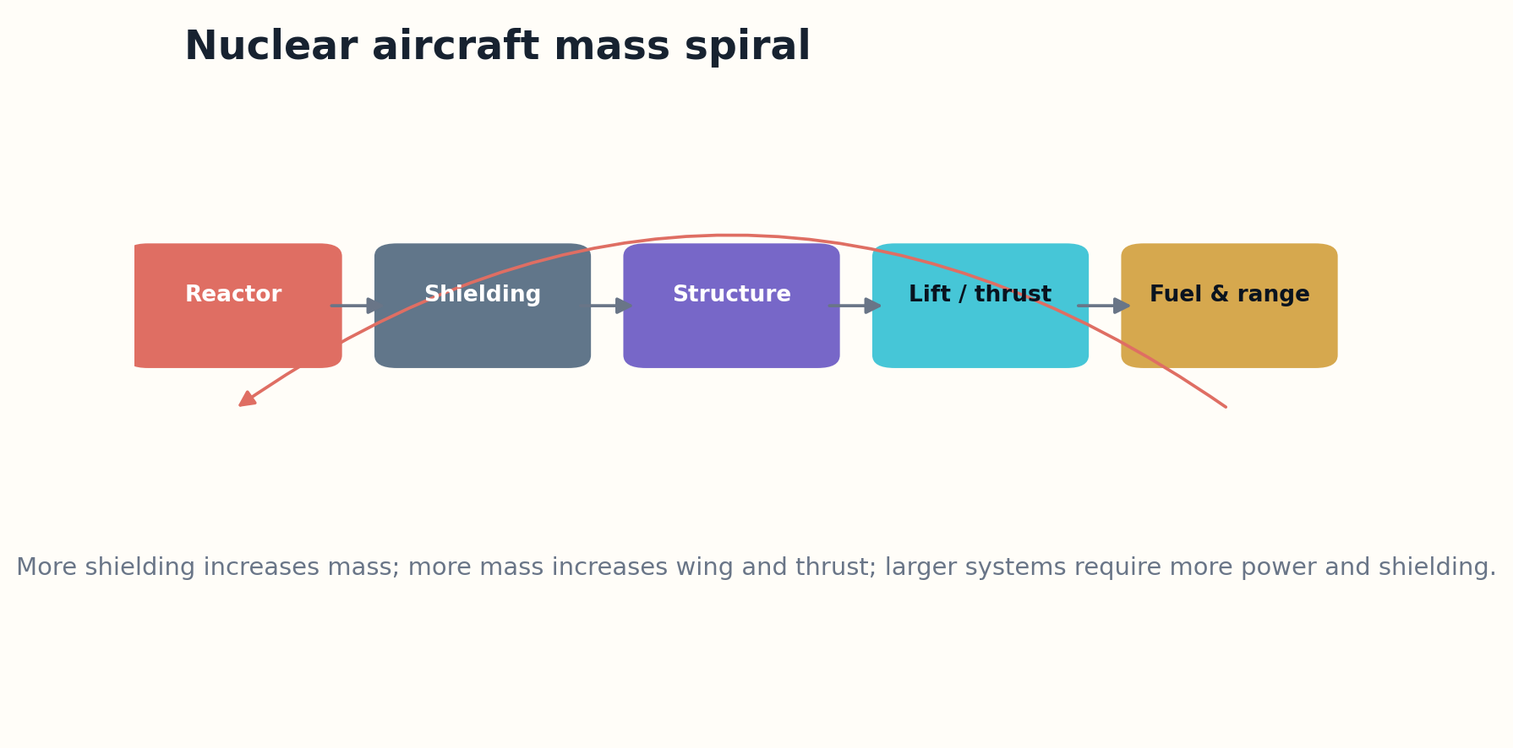
Figure 25. Shielding drives a self-reinforcing aircraft mass spiral.

MODERN RECONSTRUCTION
Modern compact reactor research, high-temperature materials, computational shielding optimization, autonomous flight, and unmanned maintenance reduce some requirements. Removing crew lowers shielding demand, but crash risk, dispersal, security, decommissioning, and overflight remain.
Alternative endurance technologies—satellites, aerial refueling, efficient turbofans, solar-electric aircraft, and distributed unmanned systems—have improved dramatically. The reconstructed machine must beat those alternatives without transferring radiological risk to everyone beneath it.

WHAT SHOULD BE BUILT?
Verdict: reject routine atmospheric nuclear propulsion. Continue reactor and heat-transfer research for space systems where mission value and containment differ.
Aircraft mass spiral Δm_total = Δm_reactor + Δm_shield + Δm_structure + Δm_lift and propulsion
VERDICT | REJECT ATMOSPHERIC
RECONSTRUCTION EXERCISE
• Calculate which requirement dominates shielding for crewed and uncrewed cases.
• Map the accident consequence across the operational route.
• Identify a space application where the same reactor research has a stronger case.
Research notes: S37. See Research Notes and Sources.

CHAPTER 26
Project Habakkuk: The Ice Aircraft Carrier
A cheap material becomes expensive when the environment continuously tries to melt the machine.
━━━━━━━━━━━━━━━━━━━━━━━━━
Project Habakkuk proposed an enormous wartime aircraft carrier made from pykrete, a composite of ice and wood fiber. Material samples and a lake prototype were tested, but the operational ship was never built. The concept exploited abundant material and the surprising strength and slow melting of reinforced ice.
Pykrete offered low-cost bulk, impact tolerance, and field repair by freezing. The full machine would have required continuous refrigeration, internal insulation, embedded structure, propulsion, steering, maintenance, and a massive construction site. Creep and thermal gradients would govern long-duration shape.
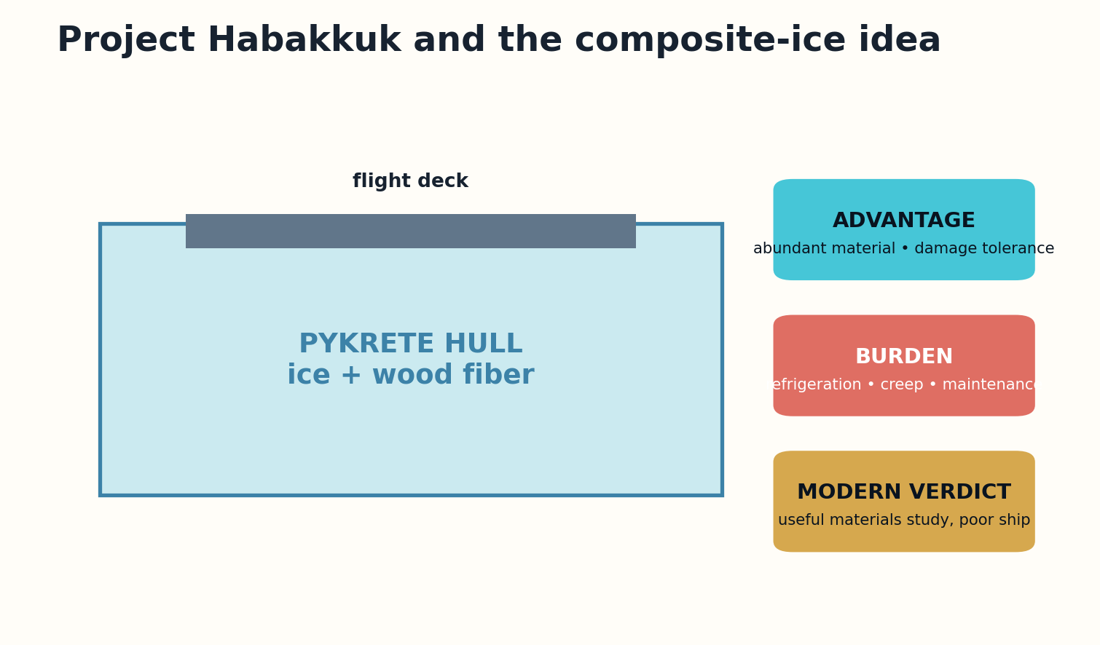
Figure 26. Pykrete offered bulk strength but imposed continuous refrigeration and creep management.

MODERN RECONSTRUCTION
Modern refrigeration, composite modeling, embedded sensors, automated construction, and fiber reinforcement could produce a more predictable ice composite. These tools do not remove the energy cost of keeping a giant vessel below its phase-change threshold in variable oceans.
The useful descendant is temporary polar infrastructure: instrument platforms, seasonal docks, emergency barriers, or low-impact structures designed to melt safely. A permanent mobile airbase is defeated by logistics and better alternatives.

WHAT SHOULD BE BUILT?
Verdict: materials and temporary-structure research. Archive the carrier as a demonstration that material abundance is not lifecycle efficiency.
Thermal survival t ∝ stored cold + insulation / environmental heat flux and refrigeration failure
VERDICT | SUBSYSTEM
RECONSTRUCTION EXERCISE
• Design a temporary ice-composite structure with a safe end-of-life.
• Model creep as a first-class requirement rather than a material footnote.
• Compare refrigeration energy with conventional construction mass.
Research notes: S38. See Research Notes and Sources.

CHAPTER 27
Salter’s Duck: The Wave Farm That Arrived Before Its Industry
High conversion efficiency at one device does not guarantee survivable, maintainable electricity at array scale.
━━━━━━━━━━━━━━━━━━━━━━━━━
Stephen Salter’s wave-energy “duck” emerged in the 1970s as a highly efficient oscillating device designed to absorb wave motion and convert it through hydraulic or electrical systems. Models and prototypes were studied, but the envisioned large commercial arrays were not built.
Wave energy combines irregular input, corrosive water, fatigue, storms, biofouling, moorings, subsea cables, and difficult maintenance. A device can perform beautifully in regular waves and still fail economically because extreme conditions and access windows dominate its lifecycle.
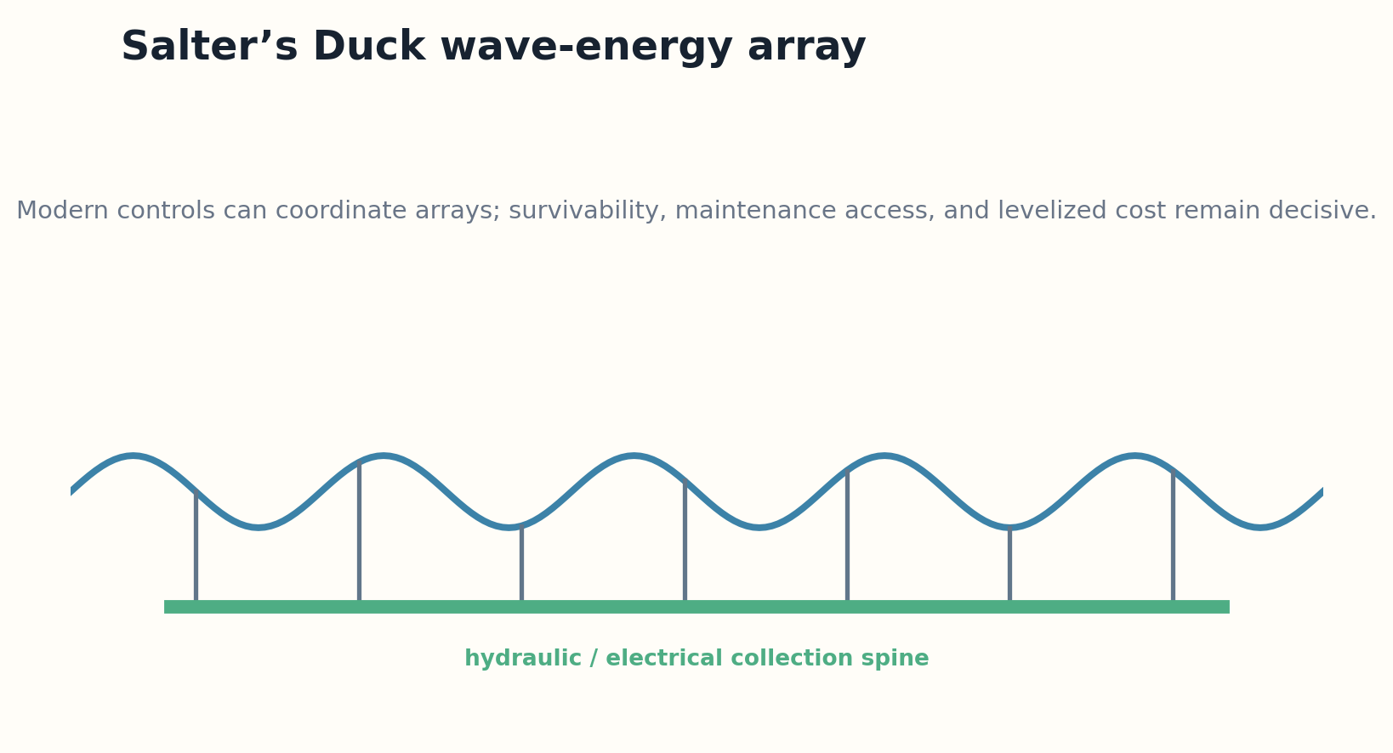
Figure 27. A Salter Duck array converts oscillation while sharing power and maintenance infrastructure.

MODERN RECONSTRUCTION
Modern composite structures, condition monitoring, power electronics, model-predictive control, autonomous surface vehicles, improved forecasts, and digital twins can coordinate arrays and schedule maintenance. Modular devices can fail gracefully instead of taking down an entire farm.
The benchmark is now offshore wind, which benefited from industrial learning, standardization, and service vessels. A modern duck must target locations or services where wave profiles, grid needs, and shared offshore infrastructure create a specific advantage.

WHAT SHOULD BE BUILT?
Verdict: prototype modular arrays with transparent maintenance and storm-survival data. The concept deserves renewed testing, not claims of inevitable superiority.
Average power P = capture width × wave energy flux × availability − conversion and maintenance losses
VERDICT | PROTOTYPE
RECONSTRUCTION EXERCISE
• Design an evaluation that includes storm shutdown and repair access.
• Compare wave and wind using the same financing and availability assumptions.
• Specify how an array degrades gracefully after device failure.
Research notes: S39. See Research Notes and Sources.

PART VI
INNER SPACE AND THE RECONSTRUCTION LAB
Deep drilling, evacuated transit, and a disciplined program for deciding which paper machines deserve new life.

CHAPTER 28
Project Mohole: The First Attempt to Touch the Mantle
A drilling project can fail administratively while changing how an entire science operates.
━━━━━━━━━━━━━━━━━━━━━━━━━
Project Mohole sought to drill through oceanic crust to the Mohorovičić discontinuity and sample the upper mantle. Pilot holes were drilled from a dynamically positioned ship in 1961, but the larger program was canceled in 1967 amid technical, managerial, and financial problems. The full machine—ship, riser, drill string, coring system, and scientific program—was never completed.
The project helped demonstrate dynamic positioning and deep-ocean drilling methods. Its remaining challenges included kilometer-scale water depth, bore stability, high temperature, drill wear, core recovery, ship motion, and the management of a distributed scientific megaproject.
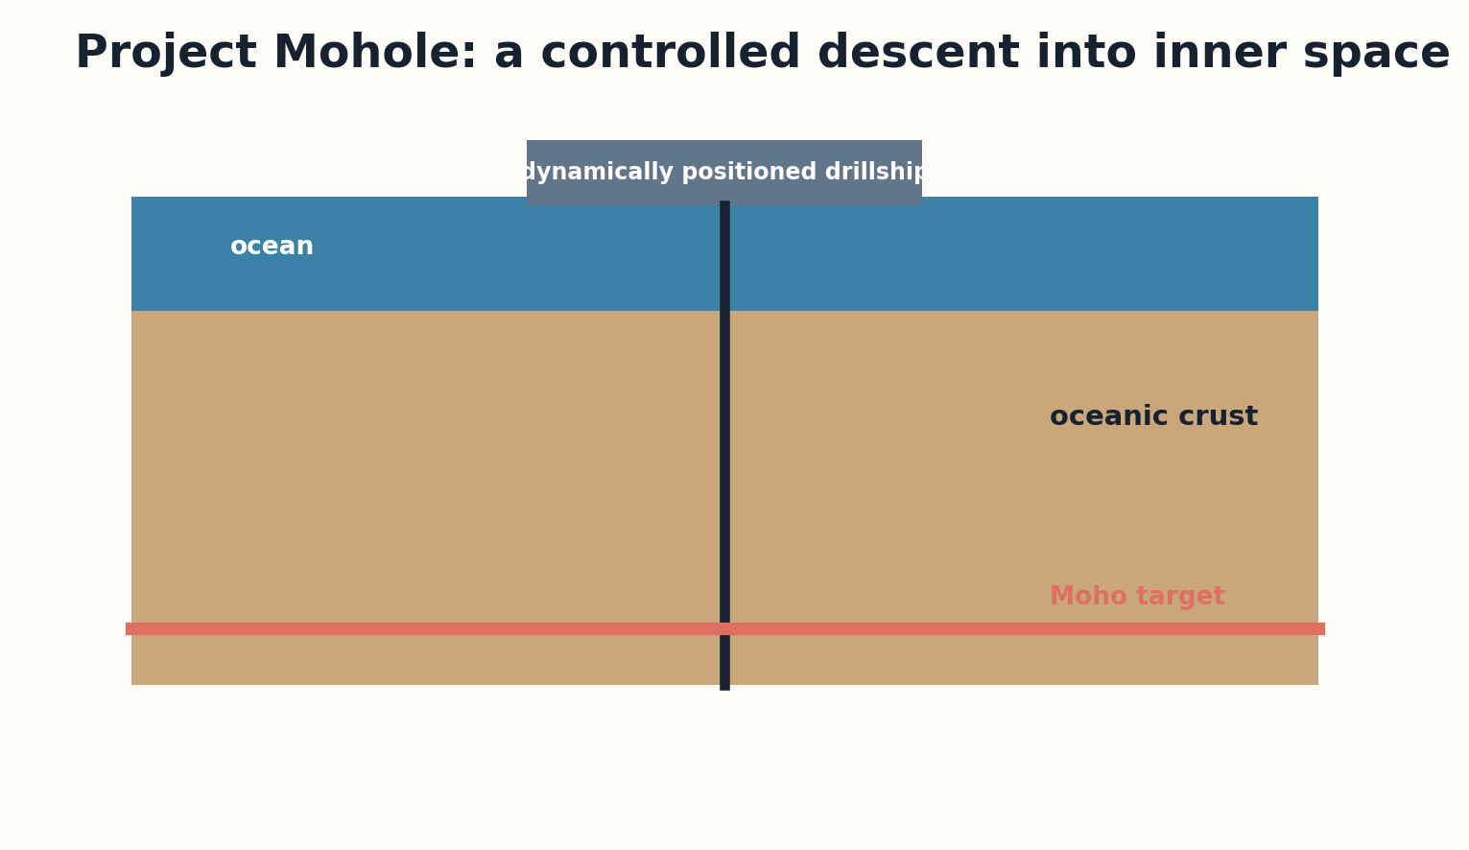
Figure 28. A modern Mohole system couples a drillship, riser, bore, downhole tools, and open science.

MODERN RECONSTRUCTION
Modern drillships, subsea robotics, real-time downhole telemetry, seismic imaging, advanced cutters, digital twins, and autonomous station keeping substantially improve feasibility. Current scientific ocean drilling has inherited much of this infrastructure, although reaching the mantle remains difficult.
A modern Mohole should be governed as a sequence of scientific gates rather than one heroic hole. Site selection, crustal temperature, bore observability, tool recovery, and open data need independent review. The program should publish failures as scientific results.

WHAT SHOULD BE BUILT?
Verdict: mission candidate. Unlike many machines in this book, its purpose remains scientifically unique and its enabling technologies have matured in relevant operations.
Drilling margin M_d = available weight and torque − friction, pressure, temperature, vibration, and bore instability
VERDICT | MISSION CANDIDATE
RECONSTRUCTION EXERCISE
• Design three staged holes whose data independently justify the next step.
• Specify a tool-recovery strategy for deep failure.
• Create a public data policy that turns partial drilling into scientific value.
Research notes: S40, S41. See Research Notes and Sources.

CHAPTER 29
The Vactrain: Removing Air, Inheriting Infrastructure
When drag disappears, guideway precision and emergency engineering become the machine.
━━━━━━━━━━━━━━━━━━━━━━━━━
Twentieth-century evacuated-tube transit proposals imagined vehicles moving at aircraft-like or higher speeds through low-pressure tubes using magnetic or other non-contact support. No intercity network was constructed. The concept attacks aerodynamic drag directly rather than incrementally improving trains.
At low pressure, propulsion energy can fall, but the system acquires demanding requirements: long vacuum envelopes, expansion joints, alignment, levitation control, switching, stations, thermal movement, evacuation, rescue, and protection against local tube damage. A network magnifies every interface.
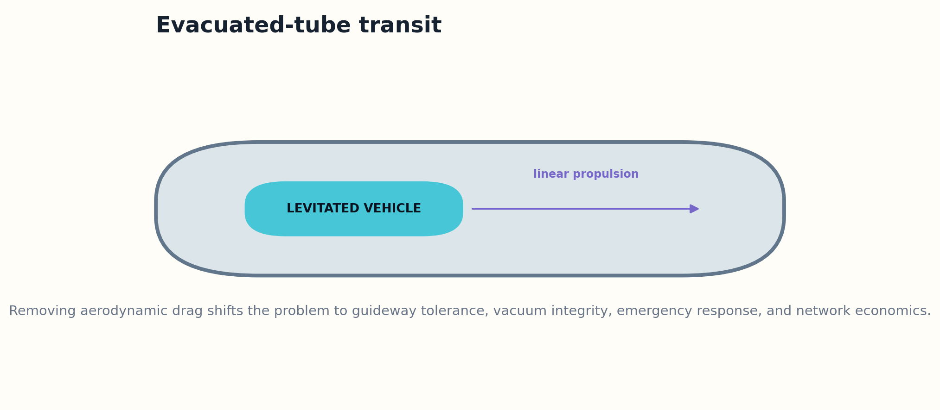
Figure 29. Evacuated transit trades aerodynamic drag for guideway, vacuum, and emergency-system complexity.

MODERN RECONSTRUCTION
Modern tunneling, magnetic levitation, power electronics, distributed sensing, vacuum pumps, autonomous control, and structural-health monitoring improve feasibility. Digital twins can simulate traffic, pressure transients, emergency braking, and guideway deformation before construction.
The economic comparison must include door-to-door time, capacity, station placement, rights of way, maintenance shutdowns, and alternative high-speed rail or aviation. Extremely high cruise speed may produce little benefit on short corridors while multiplying safety requirements.

WHAT SHOULD BE BUILT?
Verdict: build progressively longer freight or test corridors before passenger claims. The useful machine may be a lower-speed partial-vacuum system rather than the maximal twentieth-century vision.
Resistive power P_drag ≈ 1/2 ρ C_d A v³; reducing density shifts cost to the vacuum and guideway system
VERDICT | PROTOTYPE
RECONSTRUCTION EXERCISE
• Compare total trip time at three cruise speeds.
• Design a safe refuge and rescue interval for a long tube.
• Identify the pressure level that optimizes total system cost rather than minimum drag.
Research notes: S42. See Research Notes and Sources.

CHAPTER 30
The Reconstruction Lab
The archive should produce experiments, not merchandise.
━━━━━━━━━━━━━━━━━━━━━━━━━
A modern institution for unbuilt machines would combine historical archives, systems engineering, simulation, materials laboratories, fabrication, policy analysis, and public review. Its output would not be a parade of retrofuturist replicas. It would be a portfolio of falsifiable reconstructions and explicit refusals.
Every project begins with source recovery and a versioned digital model. Teams reproduce period calculations before adding modern tools, so improvements are traceable. Independent reviewers attack assumptions, alternatives, hazards, and cost. The public record includes negative results and abandoned branches.

Figure 30. The reconstruction verdict separates public value from modern feasibility.

MODERN RECONSTRUCTION
Projects advance through gates: archive reconstruction, model verification, material coupons, subsystem tests, integrated demonstrator, and operational pilot. Advancement requires evidence that the next experiment answers a question that cannot be answered more safely or cheaply by simulation.
The portfolio should balance high-value near-term machines such as a modern Memex, deep-drilling systems, wave-energy arrays, and bounded feedback infrastructure with long-horizon research such as tethers, fusion probes, and launch loops. Dangerous or obsolete concepts remain in the archive as technical ethics cases.

WHAT SHOULD BE BUILT?
The twentieth century left thousands of machines unfinished. The mature response is not to finish them all. It is to recover the intelligence inside their failure, identify the descendants that serve present needs, and build only when evidence, alternatives, and public legitimacy align.
Advance project i only when expected information gain × public value > experiment cost + irreversible risk
VERDICT | INSTITUTION
RECONSTRUCTION EXERCISE
• Build a five-project reconstruction portfolio with different verdicts.
• Define an independent red-team review before physical testing.
• Write the charter sentence that gives the laboratory permission to stop.
Research notes: S6, S7, S8. See Research Notes and Sources.

APPENDIX A
RECONSTRUCTION SCORECARD
Criterion | Question | Score 0–5
Historical evidence | Original drawings, reports, tests, budgets, and operational concepts survive.
Physics closure | The governing mechanism closes with conservative parameters.
Material readiness | Qualified materials survive load, heat, radiation, fatigue, and defects.
Manufacturing | Parts can be produced, inspected, repaired, and supplied at scale.
Control | The machine remains observable and stable across nominal and off-nominal states.
Economics | Demand, cadence, infrastructure, and maintenance close against alternatives.
Public value | The machine solves an important present problem rather than reenacting prestige.
Legitimacy | Risk, environmental burden, governance, and distribution of harm are acceptable.

APPENDIX B
MODERN MATERIALS AND COMPUTATION MAP

High-temperature systems
Ceramic matrix composites, carbon-carbon, oxide-dispersion-strengthened alloys, thermal barrier coatings, and embedded temperature/strain sensing.

Large structures
Automated fiber placement, robotic welding, additive tooling, topology optimization, structural-health monitoring, and probabilistic fracture mechanics.

Dynamic machines
Model-predictive control, hardware-in-the-loop simulation, digital twins, distributed sensing, formal safety envelopes, and graceful degradation.

Space systems
Autonomous assembly, optical communication, radiation-tolerant computing, in-space servicing, thin-film power, and fault-tolerant software.

Information machines
Knowledge graphs, content-addressed storage, cryptographic provenance, federated learning, privacy-preserving computation, and auditable model pipelines.

APPENDIX C
THE DEMONSTRATOR LADDER

0 — Archive reconstruction
Digitize sources, reproduce period calculations, and identify missing assumptions.

1 — Integrated simulation
Create a coupled model with uncertainty, alternatives, and falsification tests.

2 — Material coupons
Test strength, heat, fatigue, corrosion, radiation, and inspectability.

3 — Subsystem rig
Validate the controlling mechanism under representative loads.

4 — Subscale integration
Demonstrate interactions, control, fault containment, and maintainability.

5 — Operational pilot
Run a bounded mission with independent monitoring and explicit stop conditions.

APPENDIX D
PORTFOLIO RANKING

Figure 31. The reconstruction verdict separates public value from modern feasibility.

Deploy / standardize
Modern Memex; provenance-aware hypertext; bounded feedback workspaces.

Mission candidate
Project Mohole descendant with staged scientific drilling.

Prototype
Solar power satellites, modular wave arrays, vactrain corridors, rotating-habitat subsystems, Sea Dragon-derived stages.

Subsystem research
HOTOL/NASP propulsion integration, launch-loop fault containment, interstellar autonomy, tether materials.

Archive / reject
PACER, routine atmospheric nuclear aircraft, original explosive Orion operations, permanent Habakkuk carrier.

APPENDIX E
CHARTER OF THE RECONSTRUCTION LAB
I. Reproduce before improving
A modern team must first recover the period design and reproduce its central calculations.

II. Update the whole world
Modern capability, regulation, alternatives, environmental knowledge, and public values must change together.

III. Preserve uncertainty
Simulations must expose validation limits and parameter sensitivity.

IV. Build the smallest decisive experiment
No hardware stage advances when a safer model or smaller test can answer the question.

V. Publish negative results
Failure, cancellation, and refusal are legitimate research outputs.

VI. Separate possibility from permission
Technical feasibility does not authorize deployment.

VII. Protect the public from prestige
No project may use historical romance as evidence of present value.

VIII. Stop when the descendant is better
The lab may conclude that the right outcome is a new machine with only one inherited idea.

GLOSSARY
Archival machine. The design reconstructed using only the assumptions and technologies available to its original team.
Conservative modern machine. A redesign using qualified present-day technologies and current constraints.
Frontier machine. A version that depends on explicitly labeled immature capabilities.
Digital twin. A versioned computational representation linked to test or operational data and validated within a stated domain.
Integrated margin. The minimum remaining margin across coupled subsystems.
Paper machine. A technically specified system whose full operational form was never completed.
Reconstruction verdict. A decision to deploy, prototype, research subsystems, archive, or reject.
Specific strength. Strength divided by density; central to tethers, flight structures, and rotating systems.
System externality. A cost or hazard imposed outside the machine’s ordinary engineering budget.

RESEARCH NOTES AND SOURCES
The historical records vary in completeness. Several chapters synthesize multiple period reports and later histories. Modern reassessments are analytical proposals by the author, not endorsements by the cited institutions. Current technical capabilities and program status should be rechecked before engineering use.
S1 NASA Technical Reports Server and national technical archives as primary repositories for historical design studies. Source
S2 Smithsonian National Air and Space Museum collections and archives for unbuilt aerospace programs. Source
S3 Computer History Museum, timeline and artifact records for Memex and early knowledge machines. Source
S4 U.S. Geological Survey, historical Project Mohole records. Source
S5 NASA systems engineering histories and canceled-program records, used to build the failure taxonomy. Source
S6 NIST, Manufacturing Digital Twin Standards, 2024. Source
S7 NIST, Digital Twins for Advanced Manufacturing. Source
S8 NASA, Aviary aircraft modeling platform. Source
S9 NASA additive-manufacturing and advanced-alloy programs, including RAMPT and GRX-810. Source
S10 Computer History Museum, Memex conceptual sketch and history. Source
S11 Computer History Museum, Navigating Information and World Brain history. Source
S12 Benjamin Peters, How Not to Network a Nation, MIT Press, history of OGAS. Source
S13 CIA FOIA, Communications and Computers in the USSR: Successes and Failures, 1986. Source
S14 Eden Medina, Cybernetic Revolutionaries: Technology and Politics in Allende’s Chile, MIT Press. Source
S15 Historical scholarship on Project Cybersyn and cybernetic management. Source
S16 Project Xanadu history and original system goals. Source
S17 Historical Sänger-Bredt skip-glider literature and later lifting-reentry studies, summarized through NASA aerospace archives. Source
S18 Smithsonian National Air and Space Museum, X-20 Dyna-Soar wind-tunnel model and program history. Source
S19 Smithsonian, Boeing commercial supersonic transport proposal archive. Source
S20 Smithsonian, General Electric GE4 SST engine record. Source
S21 UK Parliament evidence describing HOTOL and its cancellation. Source
S22 Science Museum Group, HOTOL design collection record. Source
S23 NASA, Rockwell X-30 National Aero-Space Plane history. Source
S24 NASA NTRS, NASP aeroelasticity, propulsion, materials, and integration studies. Source
S25 NASA NTRS, Sea Dragon Concept Feasibility and Cost Study, 1963. Source
S26 NASA NTRS, Nuclear Pulse Propulsion: Orion and Beyond. Source
S27 NASA NTRS, Nuclear Pulse Vehicle Study, 1965. Source
S28 British Interplanetary Society, Project Daedalus technical-project history. Source
S29 British Interplanetary Society, Project Icarus reassessment of Daedalus. Source
S30 NASA NTRS, Project Longshot: An Unmanned Probe to Alpha Centauri. Source
S31 Keith Lofstrom, Launch Loop technical papers and later analyses; concept treated as dynamic launch infrastructure. Source
S32 Jerome Pearson and later space-elevator studies; materials feasibility remains the central constraint. Source
S33 NASA/DOE, Satellite Power System Reference System Report, 1979. Source
S34 NASA NTRS, Solar Power Satellite System Definition Study. Source
S35 NASA settlement studies and O’Neill orbital-habitat literature. Source
S36 Historical Project PACER studies and nuclear-pulse energy assessments; discussed as a rejected high-consequence system. Source
S37 U.S. Department of Energy and historical aircraft nuclear propulsion records. Source
S38 Historical Project Habakkuk and pykrete materials records, including wartime prototype evidence. Source
S39 Northern Ireland Assembly energy inquiry, review of wave energy and the Salter Duck. Source
S40 USGS, Project Mohole history and cancellation. Source
S41 USGS, renewed efforts to drill to the Moho. Source
S42 RAND and later evacuated-tube transportation studies; modern reassessment requires full infrastructure economics. Source

THE FUTURE DOES NOT OWE
EVERY OLD MACHINE A BODY.
GRAYLAN JANULIS

