

THE LIBRARY DREAMS IN TRILLIONS
  - Building a 47-Trillion-Token Library for Science, Civilization, and Infinite Fiction

GRAYLAN JANULIS

DESIGN THESIS
A super-library is not a machine that writes everything. It is a governed institution that can justify what it generates, preserve how it knows, and expand imagination without losing contact with human reality.

Concept edition • August 2026

Author’s Note
This book develops a proposal: a lawful, provenance-rich, AI-generative Library of Alexandria with a forty-seven-trillion-token publication horizon and a portfolio of 350 million book-equivalent works. The numbers are targets used to force architectural clarity. They do not describe an existing system, and they do not guarantee quality simply by being large.
I am interested in a library that can reach into the neglected corners of research, connect findings across disciplines, create rigorous books for different readers, and radically expand the space of fiction. But the project only matters if it avoids becoming an engine of elegant misinformation or cultural sameness. Every chapter therefore pairs capability with governance: sources with rights, generation with verification, imagination with originality, and scale with restraint.
The technical quantities are planning estimates. Real costs depend on tokenization, model architecture, verification depth, hardware utilization, storage redundancy, media formats, and acceptance rates. Scientific, legal, medical, and safety-critical publications would require qualified human review and current jurisdiction-specific authority. This is a system-design book, not a claim that automated publication can replace scholarship, authorship, librarianship, or professional judgment.
READING KEY
Documented infrastructure and research directions are distinguished from proposed architecture. “Should,” “could,” and “would” describe design choices, not already-deployed capabilities.

Contents
PART I — THE CIVILIZATIONAL PROBLEM
1. The Night the Shelves Disappeared
2. A Number Large Enough to Change the Question
3. Alexandria Was Never Just Storage
4. The Dark Matter of Research
5. From Search Results to Knowledge Instruments
PART II — THE SOURCE OCEAN
6. The Lawful Source Estate
7. Ingestion at Planetary Scale
8. The Anatomy of a Paper
9. The Scholarly Knowledge Graph
10. Contradictions, Null Results, and Forgotten Branches
PART III — THE GENERATIVE FOUNDRY
11. The Book Genome
12. The 350-Million-Book Portfolio
13. Evidence-Bound Nonfiction
14. Cross-Domain Collision Engines
15. Living Books and Versioned Truth
16. The Verification Court
17. Human Editors as System Architects
PART IV — FICTION BEYOND THE AVERAGE
18. Why Infinite Fiction Becomes Boring
19. World Models Before Words
20. Characters as Causal Systems
21. Plot Search, Surprise, and Consequence
22. Voice Without Mimicry
23. Multilingual Imagination and Cultural Stewardship
PART V — THE 47-TRILLION-TOKEN MACHINE
24. The 47-Trillion-Token Compute Fabric
25. Storage, Indexes, and Memory Hierarchies
26. Agent Swarms and Production Scheduling
27. Quality Economics: Spend Compute Where It Matters
PART VI — TRUST, LAW, AND LAUNCH
28. The Rights Graph and Provenance Ledger
29. Collapse, Slop, and the Defense of Human Reality
30. Building the First Million Books
Appendix A — Capacity Equations
Appendix B — Core Schemas
Appendix C — Evaluation Rubrics
Appendix D — Phased Roadmap
Appendix E — Constitution of the Generative Library
Glossary
Selected Research and Standards

The Architecture at a Glance
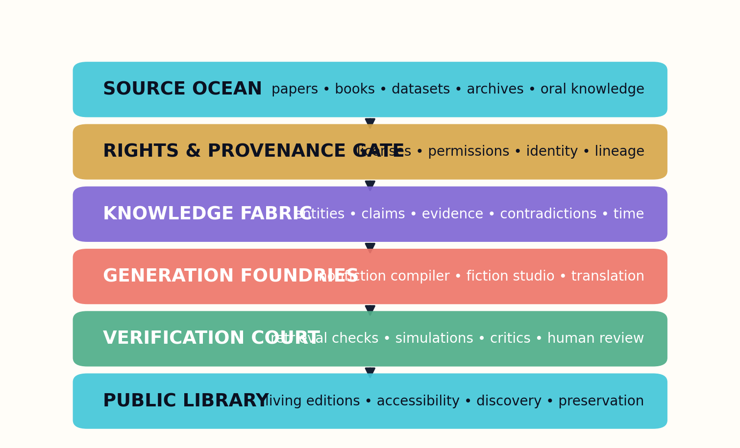
The six-layer architecture: sources enter through rights and provenance, become a knowledge fabric, and leave through independent verification.
The library is organized around two distinct foundries. The nonfiction foundry compiles evidence into explanations, reference systems, handbooks, and living books. The fiction foundry compiles world state, character causality, plot search, voice, and cultural stewardship into literary works. Both share orchestration, provenance, rights, evaluation, preservation, and human release authority.
The central object is a versioned work with a machine-readable manifest. Behind the work sits a graph of sources, claims, permissions, decisions, tests, and contributors. In front of it sits a reader interface that reveals enough of this structure to support trust without turning every page into a database console.

PART I — THE CIVILIZATIONAL PROBLEM
Why a super-library must be designed as a public institution before it is designed as a generation engine.
This part establishes the civilizational purpose, numerical scale, and difference between accumulating text and constructing knowledge instruments.

PART I — THE CIVILIZATIONAL PROBLEM

1. The Night the Shelves Disappeared

A civilization does not lose knowledge only when books burn. It also loses knowledge when nobody can find, connect, test, or understand what survives.
I began with a number that sounds less like publishing and more like astronomy: forty-seven trillion tokens. The immediate temptation is to imagine a warehouse of prose, a machine humming day and night until 350 million books appear. But the moment I treated the number seriously, the project changed. At this scale the difficult problem is not the ability to emit sentences. It is the ability to preserve meaning while moving through an ocean of evidence, rights, languages, disciplines, and human intentions. A super-library cannot merely be a text generator with a large disk. It must be a civilization-scale instrument for turning scattered knowledge into inspectable, teachable, revisable forms.
The ancient Library of Alexandria has become a symbol because it represented more than shelves. It represented an ambition to gather the world’s intellectual inheritance into one place where comparison could occur. A modern successor should not imitate the building; it should recover the function. Today the fragments are distributed across repositories, institutional archives, government databases, laboratory notebooks, books, code, datasets, oral histories, and forgotten appendices. Search engines can point toward fragments, but they rarely reconstruct the conceptual bridges a reader needs. The modern library must therefore compile pathways, not merely collect objects.
Generative systems introduce a strange possibility. A library could become active: it could produce a clear textbook from a difficult literature, a practitioner handbook from fragmented standards, a historical atlas from distributed archives, or a novel whose world has been simulated before it is narrated. Yet activity creates danger. A library that generates without provenance can counterfeit certainty. A library that optimizes only for fluency can manufacture elegant error. A library that recursively consumes its own output can gradually forget the irregularities of human reality. The project must be designed around these failure modes from the first page.

Figure 1. The Night the Shelves Disappeared — system view.
This book treats the library as a pipeline of accountable transformations. Sources enter through rights-aware gates. Documents are decomposed into claims, methods, results, figures, datasets, and conditions. Those units become a temporal knowledge graph. Book architectures are then planned against a specific reader, purpose, and evidence contract. Specialist agents draft, challenge, calculate, translate, and edit. Independent verification courts inspect the resulting claims. Finally, every edition carries a manifest describing what sources, models, prompts, reviewers, and transformations produced it.
The phrase ‘Library of Alexandria’ can invite grandiosity. The antidote is engineering. We will define capacities, queues, schemas, quality budgets, rejection rates, and human authority. We will distinguish a book-equivalent object from an arbitrary slab of tokens. We will reserve expensive reasoning for places where it changes outcomes. We will make uncertainty visible rather than smoothing it away. Most importantly, we will refuse to confuse abundance with wisdom. The library succeeds only when it helps a person see farther, reason better, create more freely, or preserve something that would otherwise disappear.
The first design principle is therefore simple: generate only what the library can explain. Every work must answer where its evidence came from, why its structure was chosen, what remains uncertain, which rights govern its use, and how a reader can challenge it. A system that cannot answer those questions may still produce content. It has not yet produced a library.
SCALE IDENTITY
T_total = N_books × T_avg
At the proposed target, 47×10¹² tokens divided by 350×10⁶ works yields approximately 134,286 tokens per work. That is a book-scale average, not a mandate that every object be the same length.

DESIGN PATTERN
Treat every generated work as a compiled artifact with inputs, intermediate representations, tests, and a signed release record.

FIELD EXERCISE
Write a one-page constitution for a library that can generate text. Include three things it must never optimize away.

PART I — THE CIVILIZATIONAL PROBLEM

2. A Number Large Enough to Change the Question

At ordinary scale, generation is a writing problem. At planetary scale, it becomes an allocation problem.
Forty-seven trillion tokens must be understood as a capacity envelope, not a pile that should be filled as quickly as possible. The target contains several different quantities: source tokens ingested, intermediate reasoning tokens, verified publication tokens, translations, revision deltas, indexes, and preservation replicas. If all of them are collapsed into a single headline number, the architecture will quietly reward waste. A mature program maintains separate ledgers for reading, thinking, writing, checking, and storing. It can then ask whether another billion tokens would produce new knowledge, better pedagogy, wider language access, or merely more repetition.
The average of 134,286 tokens per work is revealing. It allows room for a substantial nonfiction volume, a long novel, or a multimedia research edition with appendices. But an average hides a portfolio. Some works should be short field guides. Some should be continuously updated reference systems. Others should be monumental synthetic histories. The correct allocation follows reader value and epistemic need, not a uniform quota. A ten-page protocol that prevents an error may be worth more than a thousand-page encyclopedia nobody can navigate.
Storage alone is not the limiting factor. At four bytes per token, forty-seven trillion token identifiers would occupy roughly 188 terabytes before compression, indexes, embeddings, images, audio, provenance, and redundancy. That is large but not civilizationally impossible. The expensive part is the computation required to produce and evaluate useful sequences. If generation consumes many internal tokens for every published token, and if each important claim is checked by multiple independent processes, the compute multiplier can easily dominate the raw corpus size.
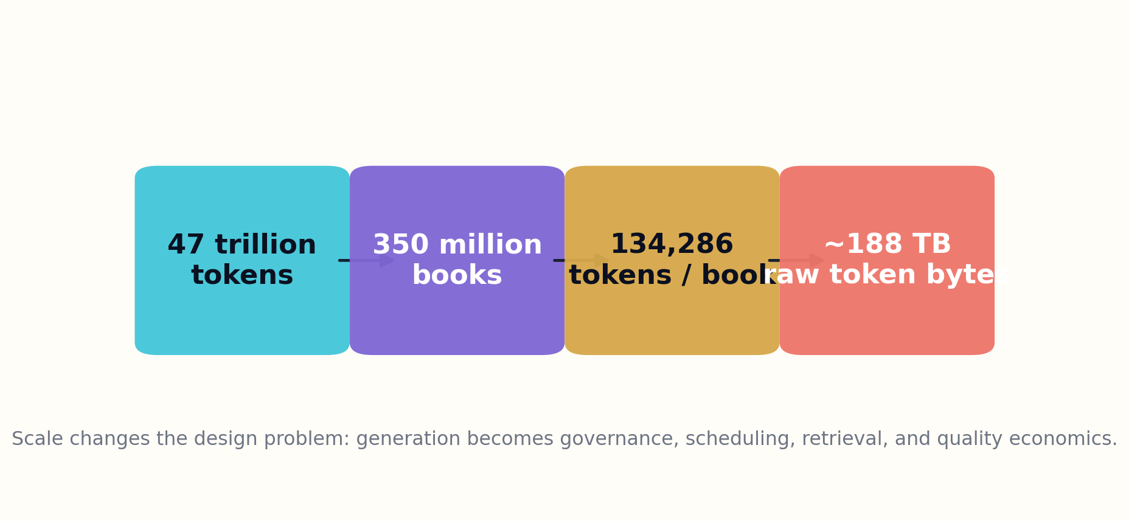
Figure 2. A Number Large Enough to Change the Question — system view.
Throughput calculations force honesty. Ten thousand workers generating one hundred tokens per second without interruption would require roughly 544 days to emit forty-seven trillion tokens, before verification or retries. At five hundred tokens per second the same fleet would require about 109 days. Fifty thousand workers at that rate would reduce drafting time to roughly twenty-two days, but power, scheduling, model availability, memory bandwidth, and quality review would become the true bottlenecks. Parallelism does not abolish coordination; it amplifies it.
This is why the library needs a quality economy. Each candidate work receives a value hypothesis, a difficulty estimate, a rights status, a novelty forecast, and an evidence-risk score. Low-risk transformations—format conversion, accessibility editions, controlled translations—can use efficient pipelines. Frontier syntheses that bridge contested research require deeper retrieval, simulation, and human review. Fiction can spend compute on world consistency, character causality, and alternative plot search rather than simply enlarging a prose model. Compute follows the source of value.
A large number can be useful because it prevents timid architecture. It requires sharding, durable identifiers, reproducible jobs, failure recovery, and multilingual governance from the beginning. But the number must remain subordinate to the mission. The library should be able to stop at ten thousand works and still be valuable. It should be able to reject a million proposed books because they add nothing. Scale is a capability; restraint is an intelligence.
DRAFTING TIME
D = T_total / (W × r × 86,400)
D is days, W is active workers, and r is sustained tokens per second per worker. The formula is deliberately incomplete: verification, retries, and human review must be modeled as separate queues.

DESIGN PATTERN
Maintain distinct token budgets for ingestion, internal reasoning, publication, verification, translation, and revision.

FIELD EXERCISE
Build three capacity scenarios—pilot, national, and planetary—and identify the first bottleneck in each.

PART I — THE CIVILIZATIONAL PROBLEM

3. Alexandria Was Never Just Storage

A shelf preserves an object. A library preserves relationships among objects, readers, and questions.
The storage metaphor is too passive for the institution we are designing. A real library performs selection, description, preservation, instruction, discovery, and public stewardship. Librarians create the conditions under which knowledge can be encountered responsibly. The generative library must encode those functions rather than treating them as decoration around a model. Its catalog is not a list of titles; it is a map of claims, concepts, disagreements, communities, and permissions.
Consider a reader who wants to understand a new battery chemistry. A conventional search returns papers ordered by relevance, citation, or recency. A generative library should do more. It should identify the foundational mechanism, distinguish laboratory performance from commercial constraints, locate negative results, trace measurement changes over time, compare competing materials, and reveal which conclusions depend on particular temperatures, manufacturing methods, or reporting conventions. The resulting book is not a summary of search results. It is a constructed route through an evidence landscape.
This requires institutional memory. Each source must retain its original form and metadata. Every extraction must point back to the exact passage, table, figure, dataset, or code version from which it was derived. Interpretations must be separated from observations. Later corrections should not erase earlier editions; they should produce a visible lineage. When a paper is retracted, the graph must update without pretending that downstream influence never occurred. Historical truth includes the history of error.
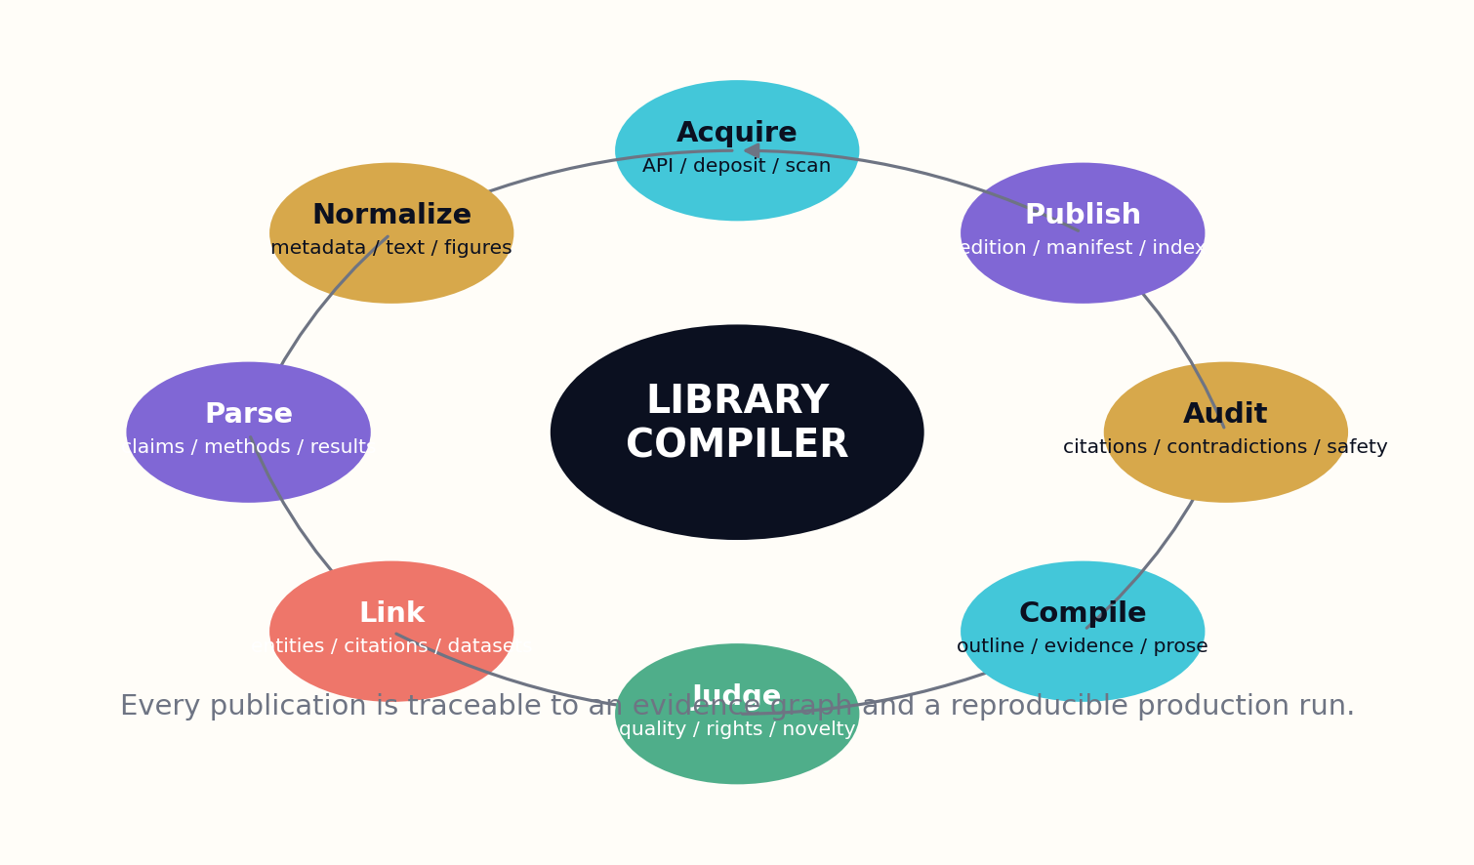
Figure 3. Alexandria Was Never Just Storage — system view.
The library also needs a public-service layer. Different readers require different representations of the same knowledge: a child’s explanation, a graduate treatment, a field checklist, an accessible audio edition, a multilingual community guide, or a machine-readable protocol. These are not cheap paraphrases. Each has distinct pedagogical and safety obligations. The system should generate them from a shared evidence core while allowing qualified human communities to shape terminology, examples, and cultural context.
Alexandria is also a warning about concentration. A single grand institution can become a single point of political, technical, or physical failure. The modern library should be federated. Institutions can hold local mirrors, rights-restricted collections, community archives, and specialist verification nodes. Shared identifiers and manifests allow works to travel while custody remains plural. The most important works should survive the failure of any single company, model provider, cloud, government, or network.
The result is less like one website than a protocol for knowledge civilization. It includes preservation standards, public indexes, trusted repositories, local reading systems, editorial councils, and programmable tools. The generative engine matters, but the institution around it determines whether the engine becomes a public good or an industrial-scale source of confusion.
LIBRARY UTILITY
U = A × T × R × P
A is accessibility, T trust, R relevance, and P preservation. Multiplication matters: if any factor approaches zero, a huge corpus can still have almost no practical utility.

DESIGN PATTERN
Design federation first: durable identifiers, portable manifests, mirrored preservation, and local governance.

FIELD EXERCISE
Choose one scientific topic and list the six representations a true public library should provide beyond a search page.

PART I — THE CIVILIZATIONAL PROBLEM

4. The Dark Matter of Research

The published conclusion is often the visible tip of a much larger structure of conditions, failures, and abandoned paths.
Scientific literature is rich in results and poor in connective tissue. A paper may report a successful method while leaving implementation details in supplementary files, assumptions in prior citations, failed variants in laboratory memory, and boundary conditions implicit in the choice of dataset. The most valuable knowledge is frequently located in figure captions, appendices, issue trackers, code comments, workshop slides, or a sentence explaining why one experiment was excluded. These corners are the dark matter of research: difficult to index, but essential to reproduction and synthesis.
A library that simply summarizes abstracts will amplify the bright surface while burying the structure underneath. Its ingestion process must treat papers as composite technical objects. It should recover section roles, equations, variables, tables, figure references, sample sizes, preprocessing steps, uncertainty statements, limitations, ethics declarations, data availability, and links to code or protocols. It should represent what was measured separately from what the authors infer. This decomposition allows later books to compare like with like.
Negative and null results deserve explicit infrastructure. Publication systems tend to reward novelty and positive findings, which means an apparent research frontier may contain hidden graveyards of approaches that did not work. The generative library can create failure atlases: organized accounts of methods, conditions, and observed breakdowns. Such atlases prevent researchers from repeatedly paying for the same dead ends and reveal where a result may be fragile rather than universal.
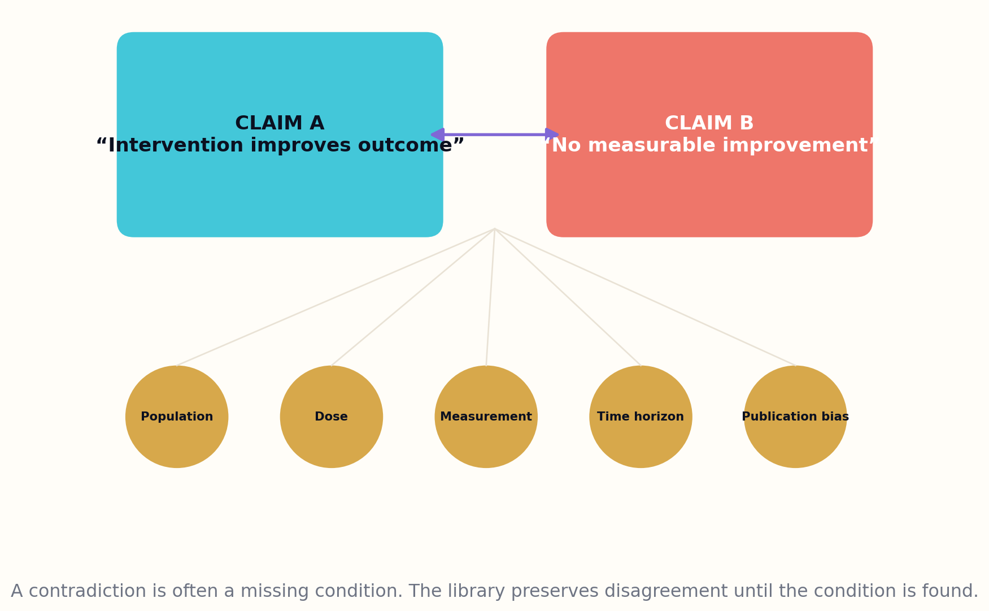
Figure 4. The Dark Matter of Research — system view.
Contradiction should not be resolved by majority vote. Two papers can disagree because they study different populations, doses, metrics, time horizons, or apparatus. The graph should first search for a conditional reconciliation. If none is found, it should preserve the conflict and represent the strength of each evidence chain. A generated book should make disagreement legible instead of converting it into a bland sentence such as ‘results are mixed.’ Precision about conflict is a form of knowledge.
The system also needs mechanisms for surfacing neglected adjacency. A method in materials science may solve a measurement problem in food safety; an ecological resilience model may illuminate distributed computing; a narrative theory may improve human-facing explanations of causal uncertainty. Cross-domain collisions should be proposed by structural similarity, not merely shared words. The library can identify matching graphs of constraints, feedback, and failure, then commission books that test whether the analogy survives technical scrutiny.
Mining the dark matter of research is not a license to ingest everything without permission or context. Access conditions, licenses, sensitive data, Indigenous knowledge protocols, and dual-use risks remain attached to the source. The goal is not maximum extraction. It is maximum responsible intelligibility.
CONDITIONAL CONTRADICTION
C(A,B) = disagreement(A,B) − explained_by(context)
The system first estimates apparent disagreement, then subtracts what can be explained by differences in population, method, measurement, time, or environment. The remainder is unresolved contradiction.

DESIGN PATTERN
Store null results, exclusions, limitations, and failed replications as first-class graph nodes rather than footnotes.

FIELD EXERCISE
Take two apparently conflicting claims. Create a condition matrix that could explain the disagreement without declaring either source wrong.

PART I — THE CIVILIZATIONAL PROBLEM

5. From Search Results to Knowledge Instruments

A good book does not merely contain information. It changes the reader’s ability to act and think.
The output of the super-library should be judged by what it enables. A pile of citations may be comprehensive and still fail a learner. A fluent overview may be readable and still conceal uncertainty. A useful knowledge instrument connects evidence to a reader’s purpose through deliberate structure. It introduces concepts in dependency order, shows how claims were established, exposes failure modes, and provides exercises that transfer understanding into skill.
This leads to the idea of the book genome. Before prose is written, the system specifies purpose, audience, evidence contract, argument structure, voice, pedagogy, visual language, safety constraints, and provenance requirements. These genes are not stylistic presets. They define what success means for the particular work. A clinical handbook and a speculative history may use overlapping sources but require radically different evidentiary thresholds and narrative behavior.
The genome also creates diversity without chaos. At massive scale, naïve templates produce millions of books that feel interchangeable. By varying only surface tone, the system manufactures the illusion of choice. Genuine diversity emerges from different questions, source constellations, conceptual decompositions, pedagogical approaches, cultural frames, and formal structures. The genome controls those deeper dimensions while preserving non-negotiable rules around attribution, uncertainty, and reader safety.
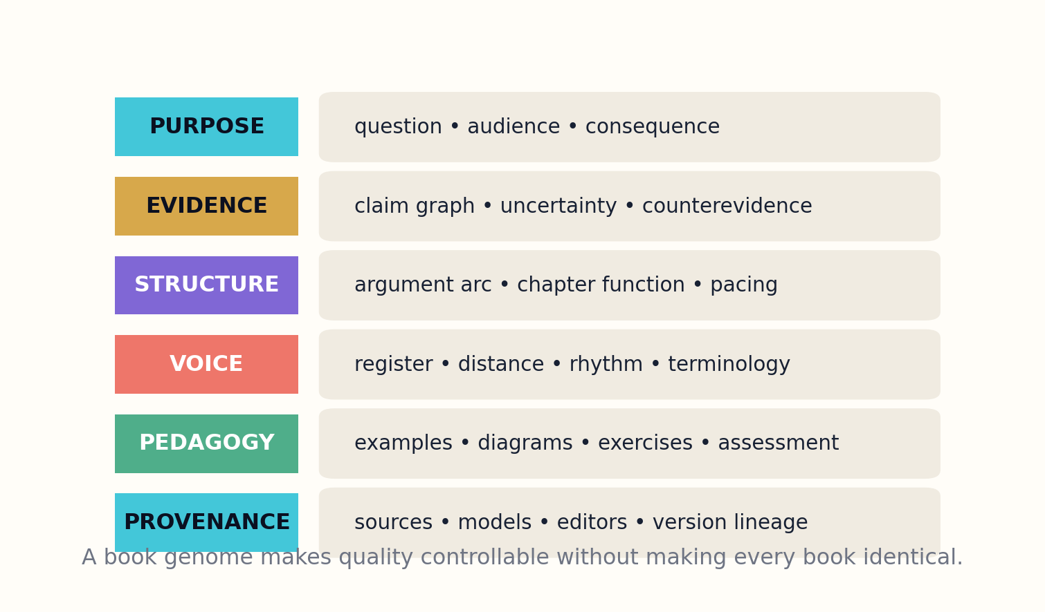
Figure 5. From Search Results to Knowledge Instruments — system view.
Every proposed book should therefore begin with an intervention statement: who is unable to do what, and what new capability will this work provide? The statement forces the commissioning system to justify existence. It can then search the catalog for overlap, measure novelty against existing works, and decide whether to create a new book, revise an old one, generate a shorter guide, or decline the proposal. Rejection is a core publishing function.
A knowledge instrument also contains self-tests. A reader should be able to inspect a claim graph, follow a citation to the supporting passage, run a calculation, compare alternative interpretations, or see how an example changes when assumptions change. Interactive editions can expose simulations and notebooks, but even a static book can include decision tables, counterexamples, and structured exercises. Verification becomes part of reading rather than an invisible backstage ritual.
When books are built this way, the library is no longer competing with search. Search finds objects. The library compiles intellectual machinery from them. The distinction is the foundation of the remaining chapters.
BOOK VALUE
V_book = ΔCapability × Evidence × Retention − Redundancy
A book is valuable when it creates a measurable change in reader capability, is supported by evidence, is retained, and does not merely duplicate what already exists.

DESIGN PATTERN
Commission from a reader capability gap, not from a keyword or a desire to increase title count.

FIELD EXERCISE
Write a book genome for one topic. Define the reader’s initial state, target capability, evidence threshold, and rejection criteria.

PART II — THE SOURCE OCEAN
How the library lawfully ingests and reconstructs the world’s distributed research record.
This part develops the source estate, paper anatomy, temporal claim graph, and methods for preserving contradictions and forgotten branches.

PART II — THE SOURCE OCEAN

6. The Lawful Source Estate

A universal library cannot be built by pretending that universal access and unrestricted reuse are the same thing.
The first gate of the system is not semantic. It is lawful and ethical. Every source arrives with a rights state: public domain, open license, contractual permission, restricted access, personal use, confidential custody, community governance, or unknown status. That state determines what the library may store, analyze, quote, transform, train on, summarize, publish, translate, or distribute. Rights are not a paragraph in the terms of service; they are executable constraints in the data model.
The rights graph begins with source identity and chain of custody. It records the work, version, creator or custodian, license expression, jurisdiction, term, attribution requirements, downstream restrictions, revocation or correction events, and any negotiated benefits. When a generated book uses a source, the relevant obligations propagate into the candidate edition. A publication gate can then block incompatible combinations, require attribution, limit territory, or route the project to human review.
Open access is especially valuable because it allows broad reading, but access does not automatically answer every reuse question. The library should prefer machine-readable license metadata and preserve the original license statement alongside the source snapshot. When metadata is ambiguous, the system should choose the conservative path. ‘Unknown’ is a legitimate state, not an invitation to infer permission from availability.
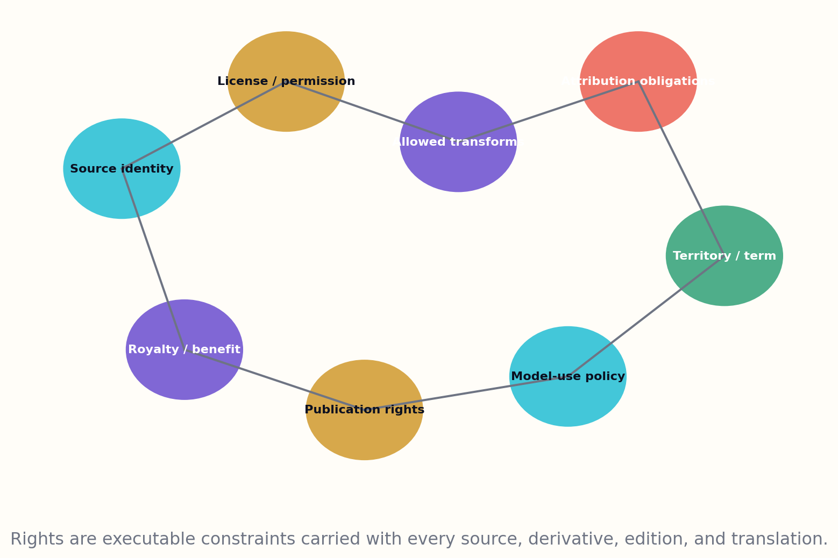
Figure 6. The Lawful Source Estate — system view.
The system must also protect forms of knowledge that conventional copyright schemas do not adequately describe. Community-held knowledge may require consent, contextual integrity, restricted audiences, or benefit sharing. Sensitive archives may contain personal information whose public synthesis would cause harm even when technically obtainable. Scientific datasets may have ethics approvals that do not cover new generative uses. The rights graph therefore includes governance protocols and harm constraints, not merely licenses.
For creators, the library should support transparent participation. Authors can deposit works with explicit transformation permissions, attribution preferences, compensation terms, and opt-in pathways for derivative educational editions. Communities can establish stewardship nodes. Publishers can license backlists for controlled synthesis. The goal is not to erase authorship in a sea of generated text; it is to make authorship and contribution more visible, traceable, and valuable.
A lawful source estate may grow more slowly than indiscriminate scraping. That is a strength. It produces a corpus whose outputs can be published, challenged, preserved, and trusted. The project is too important to rest on legal ambiguity or the assumption that scale will make accountability disappear.
RIGHTS FEASIBILITY
F_pub = min(P_read, P_transform, P_quote, P_distribute)
Publication feasibility is constrained by the least permissive required right. A project cannot compensate for a missing permission by possessing several unrelated permissions.

DESIGN PATTERN
Attach rights metadata to every source fragment and propagate obligations through every derivative artifact.

FIELD EXERCISE
Design a rights state machine with at least six states, including unknown, restricted, licensed, and revoked.

PART II — THE SOURCE OCEAN

7. Ingestion at Planetary Scale

Ingestion is not copying. It is the disciplined conversion of heterogeneous evidence into durable, inspectable representations.
The source ocean arrives through many channels: repository APIs, publisher deposits, institutional archives, government feeds, dataset registries, library scans, code forges, and human curation. Each channel has different rate limits, schemas, update behavior, and legal conditions. The ingestion fabric must therefore be connector-based. A connector declares how it authenticates, what it may retrieve, how it detects versions, how it records failures, and which rights assertions accompany the objects it receives.
Every acquired object is preserved before interpretation. The system computes content hashes, records timestamps and retrieval context, stores the original bitstream in immutable object storage, and assigns a durable internal identifier. Normalization creates derivative forms—clean text, page images, structured metadata, extracted figures—but never replaces the source. This separation permits future parsers to improve without rewriting history.
Deduplication is more complicated than matching hashes. The same paper may appear as a preprint, accepted manuscript, publisher version, repository copy, translation, correction, or later revision. The library clusters manifestations while preserving differences. It identifies near-duplicate paragraphs, moved figures, changed data, and altered conclusions. A version graph lets generated books cite the precise state they used and update intelligently when a source changes.

Figure 7. Ingestion at Planetary Scale — system view.
Planetary ingestion is an event stream, not a one-time harvest. New works arrive, metadata is corrected, licenses change, datasets move, and retractions occur. Connectors emit typed events into a durable log. Downstream services update indexes and knowledge graphs incrementally. Backpressure prevents a surge in one source from overwhelming verification. Failed objects enter quarantine with diagnostic records rather than silently disappearing.
Quality begins at this boundary. Parsers estimate extraction confidence. Language detection, layout analysis, equation recognition, table reconstruction, and reference resolution each expose uncertainty. Low-confidence segments are routed to alternate tools or human review. The system does not allow a beautifully written book to conceal the fact that its source table was parsed incorrectly. Data lineage carries confidence all the way to publication.
At scale, observability is part of scholarship. Operators need dashboards for source coverage, lag, error rates, rights ambiguity, duplication, retraction propagation, and domain imbalance. The library should know not only how much it has ingested, but what kinds of knowledge it is systematically missing.
INGESTION COMPLETENESS
I = Coverage × Freshness × ParseConfidence × RightsClarity
A source estate with broad coverage but stale updates, unreliable extraction, or ambiguous rights has low effective completeness.

DESIGN PATTERN
Preserve originals immutably; treat every parsed representation as a versioned, replaceable derivative.

FIELD EXERCISE
Sketch an ingestion event schema containing identifiers, hashes, source, time, license, parser version, and confidence.

PART II — THE SOURCE OCEAN

8. The Anatomy of a Paper

A paper is not a bag of sentences. It is a structured argument connected to instruments, data, methods, and prior claims.
Scientific documents need a parser that understands rhetorical and technical roles. The title and abstract state a compressed claim. The introduction positions the problem. Methods describe an intervention or measurement process. Results bind observations to figures and tables. Discussion interprets those observations. Limitations mark known boundaries. References connect the work to a larger graph. Treating all paragraphs equally destroys this structure and makes later synthesis less reliable.
The parser constructs a paper object with nested components. Claims are extracted with qualifiers and modality. Variables are linked to definitions and units. Equations become symbolic trees. Tables become typed matrices with headers, footnotes, and provenance. Figures retain captions, panel relationships, and mentions in the text. Methods are decomposed into steps, materials, parameters, software versions, and decision points. The result is not a replacement for the paper; it is an indexable map back into it.
Claim extraction must resist overstatement. ‘Associated with’ cannot become ‘causes.’ ‘In this sample’ cannot become ‘universally.’ A model should record the grammatical strength of the original statement, then compare it with the design’s actual support. Statistical results are bound to sample size, uncertainty, correction method, and analysis population. The library can then detect when a later book inflates a tentative finding into a rule.
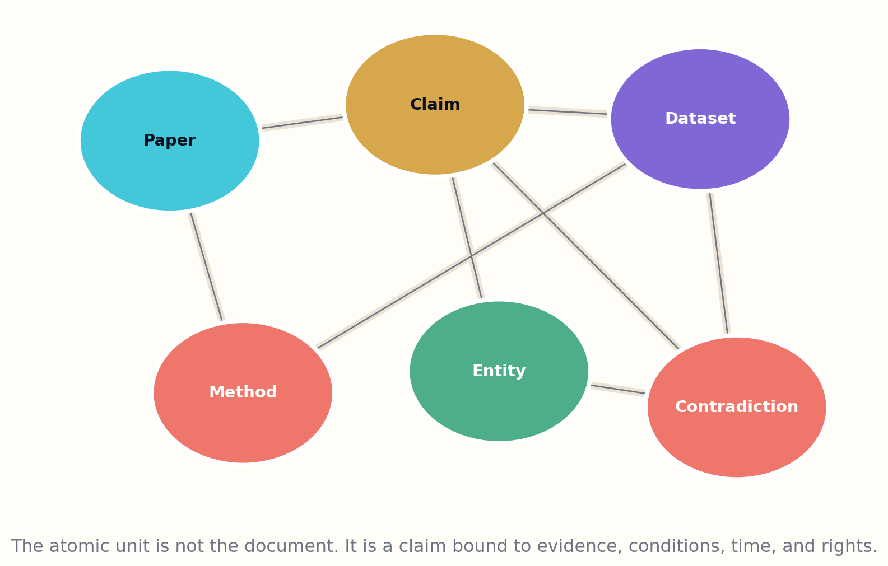
Figure 8. The Anatomy of a Paper — system view.
Methods deserve special attention because they determine reproducibility. A procedural graph can represent dependencies, branching conditions, instruments, calibration, and expected outputs. When code is available, static analysis and sandboxed execution can connect functions to described steps. When data is available, the library may attempt a reproduction under controlled conditions. Failures become evidence, not embarrassing logs to discard.
Paper anatomy also supports better teaching. A generated textbook can reveal how a conclusion was produced, not merely recite it. It can show a method’s decision tree, compare alternative measurements, and explain why a figure supports one claim but not another. Students learn scientific reasoning by seeing the machinery.
No parser is infallible. The interface must let readers open the source at the exact evidence span, inspect the extraction, and submit corrections. Over time, those corrections improve domain parsers and create a public record of how the literature has been interpreted.
CLAIM RECORD
K = (statement, scope, modality, evidence, method, time, confidence)
A claim is complete only when its scope and evidentiary context travel with the text. Removing those fields converts knowledge into a slogan.

DESIGN PATTERN
Bind every extracted claim to exact source spans and to the figures, tables, methods, and conditions that support it.

FIELD EXERCISE
Select one research abstract and rewrite each sentence as a structured claim tuple with scope and modality.

PART II — THE SOURCE OCEAN

9. The Scholarly Knowledge Graph

Documents are containers. Knowledge moves through the relationships among claims, evidence, people, methods, places, and time.
Large scholarly catalogs already demonstrate the value of connecting works, authors, institutions, topics, venues, funders, and citations. The generative library extends this idea downward into the internal anatomy of works. Its graph includes claim nodes, evidence nodes, experimental conditions, methods, datasets, software, instruments, entities, definitions, and contradiction edges. This finer granularity is what allows the system to compose books without treating citation counts as truth.
The graph is temporal. A claim may be plausible in one year, challenged in another, narrowed by a replication, and superseded by a better measurement. Edges therefore carry valid times and observation times. A book published in 2030 can explain what was believed in 2024 without contaminating the historical account with later knowledge. Living editions can also identify exactly which chapters are affected by a new event.
Entity resolution is one of the hardest components. Names vary, acronyms collide, authors change affiliations, and the same concept appears under different vocabularies across disciplines. Resolution should combine identifiers, contextual embeddings, citation neighborhoods, definitions, and human-curated authority files. Crucially, uncertain matches remain probabilistic rather than being prematurely fused. A wrong merge can propagate farther than a missing link.

Figure 9. The Scholarly Knowledge Graph — system view.
Graph retrieval enables question-shaped evidence packages. Instead of retrieving the most similar chunks, the system can traverse from a reader’s question to relevant concepts, then to competing claims, supporting methods, datasets, and critiques. It can require diversity across institutions, time periods, and methodological schools. The resulting context is smaller, more structured, and less vulnerable to repeated popular phrasing.
The graph also powers discovery. Structural motif search can find analogous feedback loops, bottlenecks, or phase transitions in distant fields. Causal paths can expose untested assumptions. Missing-edge prediction can suggest experiments, but suggestions must be labeled as hypotheses and evaluated by domain experts. The library helps formulate questions; it does not magically convert graph completion into scientific fact.
Governance remains essential. Communities need mechanisms to contest entity mappings, topic labels, and canonical definitions. The graph should support plural ontologies where genuine conceptual differences exist. A universal library becomes oppressive if universality means forcing every knowledge tradition into one vocabulary.
EVIDENCE PATH SCORE
S_path = ∏ confidence(edge_i) × diversity × recency_fit
A path is strong when its links are reliable, its evidence is not all copied from one lineage, and its time frame matches the question.

DESIGN PATTERN
Use claim-level temporal graphs for synthesis; retain document-level catalogs for discovery and preservation.

FIELD EXERCISE
Draw a mini knowledge graph for a disputed topic with at least two claims, two methods, one dataset, and one contradiction.

PART II — THE SOURCE OCEAN

10. Contradictions, Null Results, and Forgotten Branches

A mature library preserves the shape of uncertainty instead of hiding it behind a consensus-shaped paragraph.
Most synthesis systems are rewarded for producing an answer. The super-library must also be rewarded for preserving an unresolved question. Its contradiction engine continuously searches for claims that cannot simultaneously hold under the same conditions. It then attempts reconciliation by comparing populations, instruments, definitions, preprocessing, statistical power, and time horizons. When reconciliation succeeds, the apparent conflict becomes a conditional rule. When it fails, the disagreement remains visible.
Null results are indexed alongside positive findings. A null may indicate that an intervention truly has little effect, that a study lacked power, that a measurement was insensitive, or that a published effect was context-dependent. The graph records these alternatives rather than assigning a single interpretation. Generated books can then explain the evidentiary landscape without treating silence as absence.
Forgotten branches include abandoned theories, unfashionable methods, failed products, and research programs interrupted by funding or politics. Some deserve to remain abandoned; others contain techniques that become valuable under new technological conditions. The library can periodically rescan these branches against current capabilities. A method once impractical because computation was expensive may become feasible. A material rejected for manufacturing reasons may fit a new process. Rediscovery becomes systematic rather than accidental.

Figure 10. Contradictions, Null Results, and Forgotten Branches — system view.
The contradiction service should publish machine-readable dossiers. Each dossier contains the claim pair, supporting sources, contextual differences, attempted reconciliations, open questions, and proposed discriminating tests. These dossiers can commission focused review books or experimental challenges. They also provide valuable training material for models that must learn not to collapse ambiguity too early.
Human experts play a central role because disagreements often depend on tacit methodological knowledge. A statistician, instrument engineer, field practitioner, and community member may see different failure modes. The system should solicit structured critiques and preserve minority reports. Consensus is recorded as a governance outcome, not treated as a natural property of token probability.
A library that exposes contradiction may appear less certain than one that produces smooth answers. In reality, it is more useful. It shows where action is robust, where judgment is required, and where new evidence could change the map.
RESOLUTION VALUE
R_test = InformationGain(test) / Cost(test)
A proposed experiment is valuable when it sharply distinguishes competing explanations relative to its financial, ethical, and temporal cost.

DESIGN PATTERN
Generate contradiction dossiers and discriminating-test proposals before generating consensus prose.

FIELD EXERCISE
Create a one-page contradiction dossier for a debate you know. End with the cheapest test that would meaningfully reduce uncertainty.

PART III — THE GENERATIVE FOUNDRY
How evidence becomes a designed, verifiable, living book.
This part defines book genomes, portfolio planning, evidence-bound drafting, cross-domain collision, versioned truth, verification courts, and editorial authority.

PART III — THE GENERATIVE FOUNDRY

11. The Book Genome

Before the first sentence, the system must know what kind of intellectual object it is trying to build.
A book genome is a formal design document that sits between a commissioning question and a manuscript. It describes the work’s purpose, reader, evidence threshold, conceptual dependencies, chapter functions, voice constraints, visual system, accessibility targets, safety requirements, and revision policy. The genome prevents the drafting model from discovering the book one paragraph at a time, a behavior that often produces local fluency and global drift.
The purpose gene names the transformation the reader should experience. The audience gene describes prior knowledge, vocabulary, constraints, and likely misconceptions. The evidence gene specifies what kinds of sources may support which kinds of claims. A historical narrative may permit reasoned reconstruction when clearly labeled; a medical protocol requires stronger, current, and jurisdiction-specific authority. The structure gene defines the argument arc and the job of every chapter. Each component can be tested before prose is expensive.
The genome also contains anti-homogenization controls. It can require multiple explanatory metaphors, specific regional cases, alternative formal structures, or contrasting schools of thought. For fiction, it records world rules, character causal models, narrative distance, aesthetic commitments, and forbidden shortcuts. These constraints generate meaningful difference. Random adjectives and temperature settings do not.

Figure 11. The Book Genome — system view.
Genomes are assembled from modular schemas but remain editable by human designers. A domain editor can create a family of trustworthy patterns: systematic review, field manual, annotated atlas, mathematical primer, laboratory companion, speculative design fiction, or oral-history mosaic. The system may propose a pattern, but an accountable editor approves the contract. This is analogous to architecture: reusable building codes support creativity rather than eliminate it.
A compiled genome produces a test plan. Every chapter has coverage requirements, evidence nodes, terms to define, figures to create, counterarguments to address, and acceptance criteria. During drafting, the orchestrator can see which obligations are satisfied and which remain open. At the end, the book can be evaluated against its original mission rather than against generic stylistic preferences.
The genome becomes part of provenance. Readers can inspect why a work exists and how it was designed. Future editions can change the genome explicitly—for example, expanding the audience, raising the evidence bar, or adopting a new cultural frame—without disguising the revision as a silent rewrite.
GENOME COMPLETENESS
G = P × A × E × S × V × Q
P purpose, A audience, E evidence, S structure, V voice, and Q quality tests. Missing one dimension makes downstream generation unstable.

DESIGN PATTERN
Compile a typed book genome into chapter contracts before allocating prose-generation compute.

FIELD EXERCISE
Create a genome for two books on the same topic: one for a twelve-year-old and one for a domain researcher. Compare what must change beyond vocabulary.

PART III — THE GENERATIVE FOUNDRY

12. The 350-Million-Book Portfolio

The goal is not 350 million titles. The goal is 350 million justified intellectual instruments.
A portfolio this large must be planned as a knowledge ecology. Without commissioning discipline, popular topics receive endless variants while regional, technical, and minority knowledge remains sparse. The portfolio engine therefore measures coverage across disciplines, languages, reading levels, geographies, historical periods, professions, genres, accessibility modes, and evidence maturity. It seeks useful balance rather than equal numbers.
The initial portfolio can be divided into families. Research syntheses connect fragmented literatures. Teaching editions transform those syntheses into curricula. Professional handbooks convert evidence into qualified workflows. Reference works maintain definitions, timelines, standards, and datasets. Regional knowledge books preserve place-specific practice and history. Translation programs widen access. Fiction studios explore human possibility through world models and narrative art. Experimental works test new forms without being mistaken for established reference.
Each candidate receives a commissioning score. The score considers unmet reader demand, societal importance, source readiness, potential harm, existing overlap, language inequity, revision burden, and expected lifespan. High-impact gaps can rise even when market demand is weak. A handbook for a rare but dangerous industrial failure may outrank another general introduction to a fashionable topic. Public value and commercial popularity are different signals.
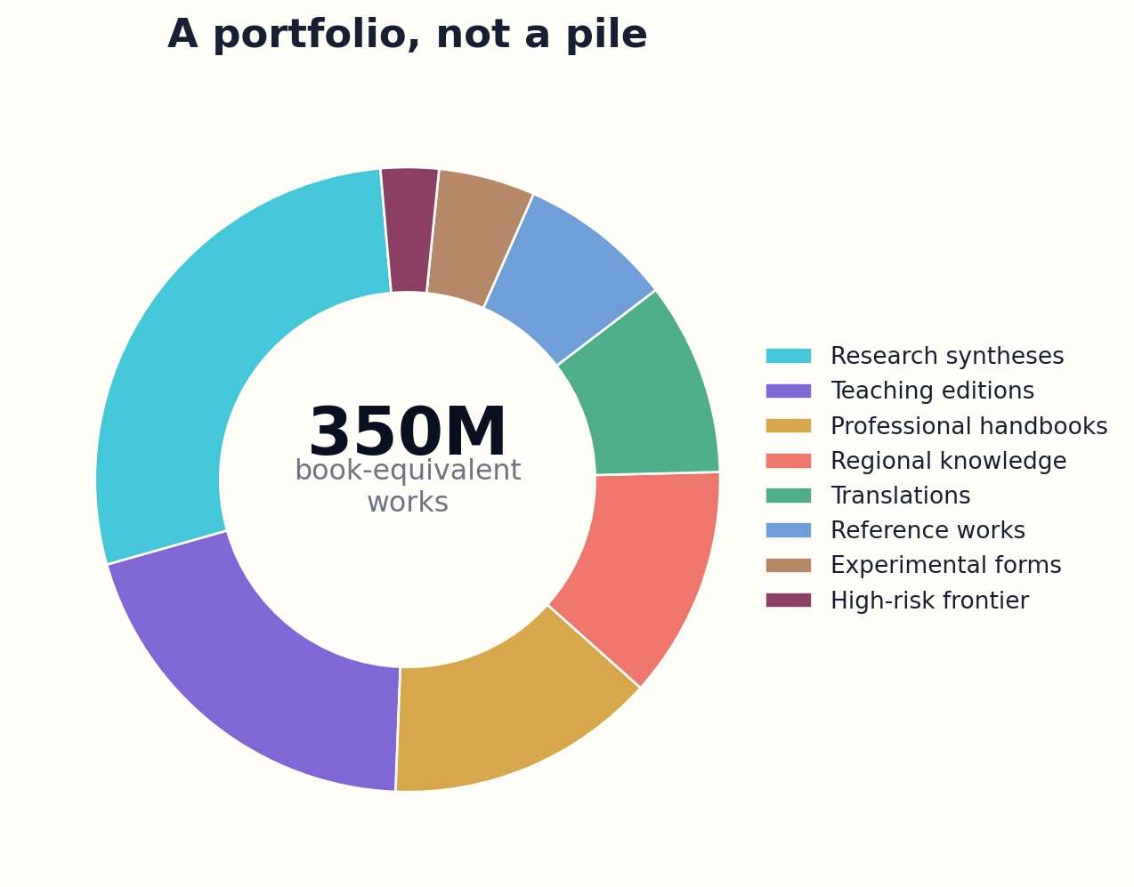
Figure 12. The 350-Million-Book Portfolio — system view.
Portfolio diversity must be measured at the level of ideas and structures, not titles. Embedding distance can detect near-duplicate proposals, but deeper tests compare source graphs, thesis, chapter roles, examples, and reader outcomes. The system should merge redundant candidates, commission deliberate counterbooks, or require a genuinely new contribution. Quantity targets never override novelty thresholds.
The portfolio is dynamic. Some works graduate from experimental to canonical. Others become obsolete, merge into living references, or remain preserved as historical editions. Reader feedback, citation use, correction rates, and demonstrated learning inform future commissioning, but popularity cannot become the sole optimizer. Otherwise the system recreates attention markets inside a library.
At 350 million works, discovery becomes an editorial experience. Readers should encounter curated paths, local librarians, transparent recommendation controls, and serendipity mechanisms. The library must help people choose what not to read. Abundance without navigation is another form of scarcity.
COMMISSION SCORE
C = Gap × Impact × Readiness × Diversity − Overlap − Risk
The terms are normalized and reviewed by policy. A high score means the work fills a consequential gap with sufficient sources and a distinct contribution.

DESIGN PATTERN
Allocate title capacity across a monitored portfolio matrix; never let raw demand erase public-interest knowledge.

FIELD EXERCISE
Design a 1,000-book pilot portfolio and defend the percentage assigned to research, education, reference, translation, and fiction.

PART III — THE GENERATIVE FOUNDRY

13. Evidence-Bound Nonfiction

Fluency is permitted to arrange evidence. It is not permitted to invent the evidence it needs.
Evidence-bound generation begins with a claim plan rather than a blank prompt. The chapter contract identifies the claims required to fulfill its purpose. A retrieval agent builds an evidence packet for each claim, including support, counterevidence, scope conditions, source quality, and unresolved questions. The drafting agent may only assert what is licensed by the packet or clearly label an inference. This changes citation from a decorative afterthought into a generation constraint.
The system uses sentence-level claim tagging. Factual propositions receive internal identifiers linked to evidence nodes. Definitions point to authoritative or historically appropriate sources. Quantitative statements carry units, calculation traces, and time stamps. Interpretive passages identify their status. During revision, an editor can see which sentences are unsupported, overbroad, stale, or dependent on a single source lineage.
Citation quality is not the same as citation quantity. A paragraph with ten references may still misrepresent all ten. Entailment checkers compare the manuscript claim with the cited passage, while domain-specific rules test whether the source type is appropriate. A press release cannot silently support a clinical conclusion. A simulation cannot be described as a field observation. A review can orient the reader, but foundational claims should route to primary evidence when possible.
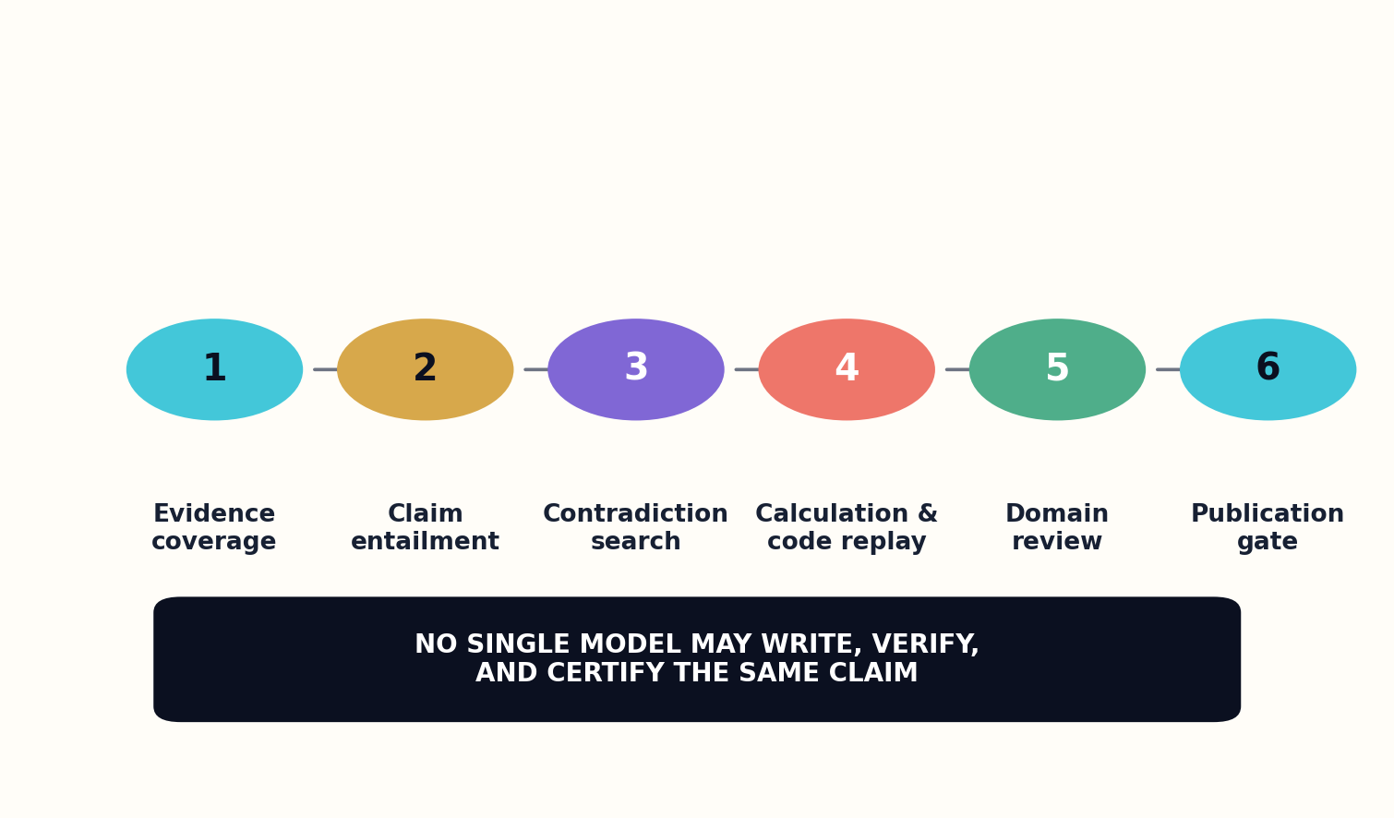
Figure 13. Evidence-Bound Nonfiction — system view.
The drafting process deliberately separates explanation from verification. One agent writes for clarity, another reconstructs the claim graph from the draft, and a third tries to disprove or narrow each important statement. Calculations are executed in tools rather than guessed in prose. Code examples are run in sandboxes. Figures are generated from traceable data. The manuscript advances only when independent checks agree or the uncertainty is made explicit.
Evidence-bound writing can still be beautiful. Narrative order, analogy, pacing, and image can make difficult ideas memorable. The constraint is that rhetoric must not outrun support. In fact, visible evidence often improves storytelling because the reader can follow discovery, conflict, and resolution through real intellectual stakes.
A final evidence ledger accompanies every edition. It lists major claims, confidence, sources, checks, known limitations, and the date through which the literature was reviewed. The ledger can be machine-readable while the book remains humane. Trust does not require ugliness; it requires inspectability.
EVIDENCE COVERAGE
E_c = Σ importance(claim_i) × supported_i / Σ importance(claim_i)
Coverage weights central claims more heavily than minor details. A book cannot compensate for an unsupported thesis with perfectly cited trivia.

DESIGN PATTERN
Generate from claim-specific evidence packets and audit the completed prose by reconstructing its claims independently.

FIELD EXERCISE
Take a nonfiction paragraph and label every sentence as observation, sourced claim, calculation, inference, or opinion.

PART III — THE GENERATIVE FOUNDRY

14. Cross-Domain Collision Engines

Innovation often begins when two distant structures are recognized as the same kind of problem.
The library’s most original nonfiction may come from disciplined collision. A collision engine searches for structural correspondences across domains: feedback control in physiology and distributed systems, error correction in genetics and communications, phase transitions in materials and social coordination, or narrative pacing and curriculum design. It does not assume the analogy is valid. It proposes a bridge, identifies where the structures align, and sends the bridge to specialist agents for attack.
The engine operates on graph motifs rather than keywords. It represents systems in terms of entities, flows, constraints, feedback, delays, objectives, and failure modes. Similar motifs can then be retrieved from different fields. A proposed collision includes a translation table mapping concepts, plus a list of noncorrespondences. The noncorrespondences are crucial because analogy becomes dangerous when it hides domain-specific mechanisms.
Candidate collisions pass through three courts. The semantic court asks whether the concepts are actually comparable. The mathematical court checks whether shared equations or invariants survive translation. The empirical court asks whether the bridge predicts anything testable or improves a design. Many collisions will fail. The rejected attempts should be retained as a map of seductive but unproductive analogies.

Figure 14. Cross-Domain Collision Engines — system view.
Successful collisions can commission several book forms. A bridge primer teaches one field through another. A design atlas catalogs transferable patterns. A research agenda identifies experiments at the intersection. A speculative work explores consequences before the evidence is mature. Each form labels the maturity of the connection so readers are not tricked by the confidence of exposition.
Cross-domain synthesis also counters specialization. Researchers cannot read every adjacent literature, and important methods may remain trapped behind unfamiliar vocabulary. The library can act as an intellectual customs service, translating ideas while preserving their conditions of origin. Human experts from both sides remain necessary to prevent conceptual smuggling.
Originality at scale should come from discovering new relationships among real structures, not from random recombination of phrases. Collision engines provide a route toward generative super-intelligence that remains accountable to evidence.
COLLISION MERIT
M = StructuralMatch × TestableGain × DomainValidation − AnalogyRisk
A collision is valuable when deep structure matches, the bridge creates testable value, experts validate both domains, and misleading differences are controlled.

DESIGN PATTERN
Require every cross-domain analogy to publish both a mapping table and a failure-of-mapping table.

FIELD EXERCISE
Choose two distant systems. Map their flows, constraints, feedback loops, and breakdown modes, then identify the first place the analogy fails.

PART III — THE GENERATIVE FOUNDRY

15. Living Books and Versioned Truth

A living book changes, but it never pretends it was always the newest version.
Some books should be monuments; others should be services. A living book is connected to the evidence graph that produced it. When a source is corrected, retracted, superseded, or joined by important new evidence, the dependency engine identifies affected claims and chapters. Editors receive a change proposal rather than an automatic rewrite. The book can issue a patch, a new edition, or a notice explaining why no change is warranted.
Versioning preserves intellectual history. Each edition has a semantic version, release date, source cutoff, change log, and stable identifier. Readers can cite a specific edition. Major changes to thesis or structure produce a new major version; evidence updates may produce minor versions; corrections produce patches. Earlier editions remain accessible unless legal or safety reasons require restricted handling.
The system computes impact at the claim level. If a foundational claim changes, downstream explanations, figures, exercises, translations, and derivative books are marked for review. This resembles software dependency management, but epistemic dependencies are not purely mechanical. A new result may narrow a claim rather than invalidate it. Human editors interpret significance.

Figure 15. Living Books and Versioned Truth — system view.
Living books can also host multiple sanctioned views. A contested topic may contain parallel chapters written under different theoretical frameworks, each bound to its evidence. Readers can compare them and inspect where they diverge. The library records editorial decisions and minority reports. Versioned truth does not mean truth is arbitrary; it means our representations are historically situated and corrigible.
Update frequency must be proportional to domain velocity and consequence. A programming reference may change monthly. A mathematical history may change slowly. A medical guide may require urgent patches when safety guidance changes. Constant rewriting can exhaust readers and editors, so the system groups low-impact changes and communicates urgency clearly.
The living-book model turns publication from an endpoint into stewardship. It also creates a measurable responsibility: who watches the evidence, who approves changes, who funds maintenance, and what happens when a book is abandoned? Every living work needs an ownership and sunset plan.
CHANGE PRIORITY
P_change = ClaimImpact × EvidenceStrength × Urgency × Reach
A strong new result affecting a central, high-consequence claim in a widely used book receives immediate attention; peripheral changes can wait.

DESIGN PATTERN
Maintain source-to-claim-to-chapter dependency graphs and publish explicit semantic edition histories.

FIELD EXERCISE
Design a version policy for a fast-moving technical handbook and a slow-moving cultural history.

PART III — THE GENERATIVE FOUNDRY

16. The Verification Court

No single model should be allowed to write, verify, and certify the same claim.
The verification court is an adversarial institution inside the pipeline. Its agents are organizationally and technically separated from drafting. They receive the manuscript, its claim graph, evidence ledger, calculations, code, figures, and genome. Their task is not to make the prose nicer. Their task is to discover why the work should not be published in its current form.
The first chamber checks evidence coverage and entailment. The second searches for omitted counterevidence and contradictory literature. The third replays calculations, code, and data transformations. The fourth performs domain-specific safety review. The fifth examines language for overclaiming, ambiguity, and hidden normative assumptions. High-risk works enter human panels with expertise, conflict-of-interest declarations, and recorded votes.
Independence matters because correlated models can agree for the same wrong reason. The court should use diverse model families, retrieval strategies, and prompts. Some checks can be symbolic or rule-based. Others rely on human specialists. A calibrated system measures not just agreement but the diversity of failure detectors. Five copies of the same critic are not five independent reviews.

Figure 16. The Verification Court — system view.
The court issues findings with severity, evidence, and required action. A fatal finding blocks publication. A major finding requires revision and re-review. A minor finding can be corrected with targeted checks. Disagreements among reviewers are preserved. The release authority sees the entire record, not merely a single score.
Verification is expensive, so the library applies risk-tiered depth. A children’s story needs safety and originality review but not scientific replication. A reference on bridge design requires calculations, standards checks, and expert sign-off. A speculative science book can explore possibilities if it labels conjecture clearly. The court enforces the work’s own evidence contract.
After publication, readers become an additional chamber. Structured correction reports can link to exact claims and source spans. Validated corrections improve both the book and the verification suite. Trust is not the promise that errors never occur; it is the demonstrated capacity to find, disclose, and repair them.
INDEPENDENT ASSURANCE
A = 1 − ∏(1 − d_i)
If each genuinely independent detector has probability dᵢ of catching a class of error, combined assurance rises. Correlation reduces the benefit and must be estimated.

DESIGN PATTERN
Separate drafting and certification authorities, and measure reviewer diversity rather than reviewer count alone.

FIELD EXERCISE
Create a verification matrix for a high-stakes book. List error classes, detectors, escalation rules, and required human roles.

PART III — THE GENERATIVE FOUNDRY

17. Human Editors as System Architects

The more generative capacity increases, the more valuable judgment becomes.
The industrial image of automation suggests fewer editors. The library requires more editorial intelligence, distributed differently. Human editors define commissioning policy, book genomes, evidence thresholds, cultural context, quality rubrics, and release authority. They design the systems through which models work. Their highest-value contribution is not correcting commas after generation; it is determining what deserves to exist and what standards it must satisfy.
Editorial roles become specialized. Domain architects maintain schemas and verification rules. Portfolio editors identify neglected reader needs. Narrative editors shape argument, pacing, and voice. Rights editors manage permissions and benefit obligations. Community editors govern local terminology and representation. Reliability editors study failures across thousands of production runs. Librarians remain essential as curators, educators, and defenders of public access.
Editors interact with structured artifacts rather than endless model conversations. They approve claim plans, inspect contradiction dossiers, modify chapter contracts, compare alternative outlines, and review diffs between editions. Interfaces expose why an agent made a decision and what evidence it used. A system that buries editorial control inside opaque prompting is not genuinely human-directed.
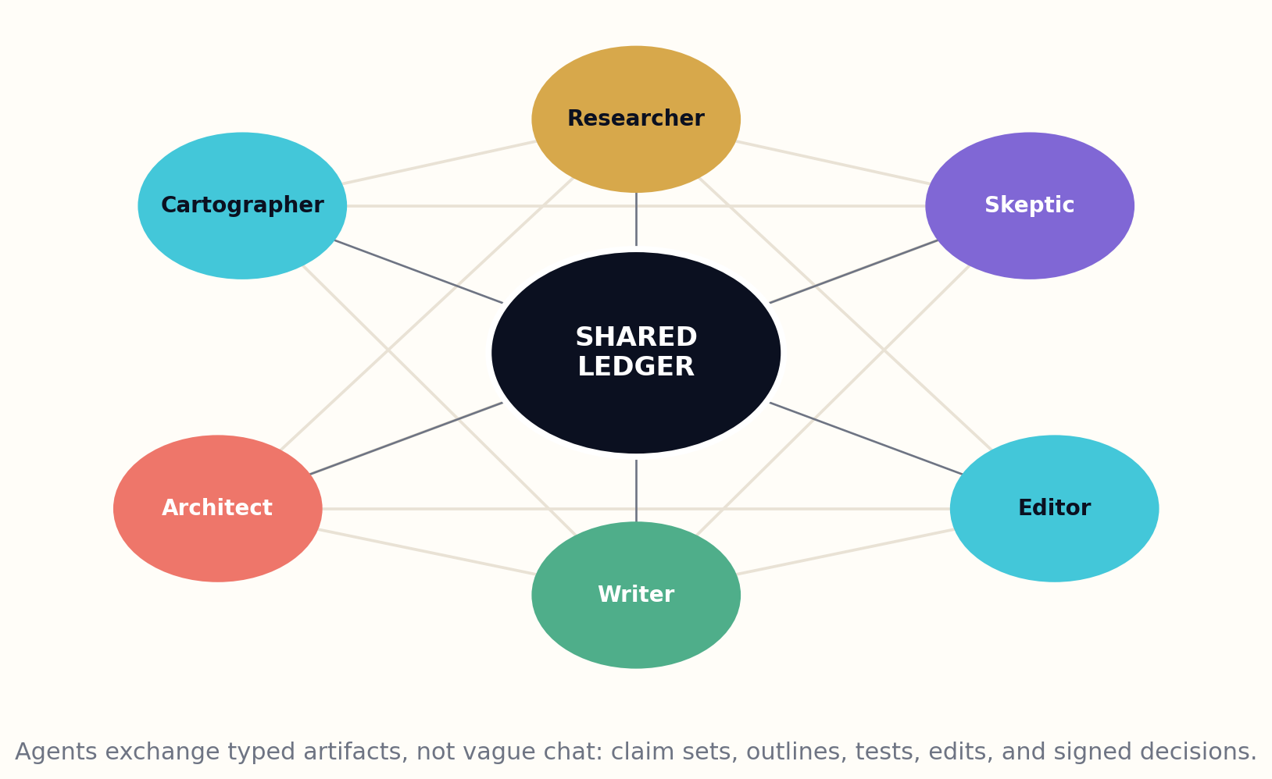
Figure 17. Human Editors as System Architects — system view.
The library should cultivate editors through apprenticeships and simulation. Trainees can review synthetic cases containing planted citation errors, cultural harms, misleading analogies, or subtle scope inflation. Their judgments are compared with expert panels. Over time, the institution develops a craft of generative publishing comparable to the crafts of traditional editing, librarianship, and peer review.
Human authority must be real. Editors need the power to slow production, reject prestigious projects, reveal uncertainty, and override optimization metrics. Governance protects them from pressure to maximize title count or engagement. The release record names accountable people and institutions, not only model versions.
Automation can expand the surface area of human judgment. One editor may supervise many routine transformations while spending deep attention on consequential choices. The goal is not to place a ceremonial human at the end of an autonomous factory. It is to make the entire factory an instrument of deliberate human stewardship.
EDITORIAL LEVERAGE
L_e = DecisionsInfluenced × Consequence / AttentionCost
Good tools increase the number and importance of decisions an editor can shape without reducing those decisions to rubber stamps.

DESIGN PATTERN
Give editors control over contracts, gates, and release—not merely post-generation copyediting.

FIELD EXERCISE
Redesign a traditional publishing team for an AI foundry. Define six human roles that cannot be collapsed into “reviewer.”

PART IV — FICTION BEYOND THE AVERAGE
How scale can expand imagination instead of multiplying predictable prose.
This part treats fiction as causal art built from world models, character beliefs, plot search, original voice, and multilingual stewardship.

PART IV — FICTION BEYOND THE AVERAGE

18. Why Infinite Fiction Becomes Boring

Combinatorial abundance does not guarantee artistic necessity.
A system capable of generating millions of stories can still produce the same story millions of times. Statistical language models are drawn toward patterns that are frequent, coherent, and easy to continue. Those properties are useful, but they create gravitational wells: familiar protagonists, predictable emotional beats, safe metaphors, reversible consequences, and endings that satisfy genre expectations without changing the reader. Scaling naïve generation magnifies the average.
True fiction quality depends on tensions that token prediction alone does not reliably maintain. A world must constrain action. Characters must misunderstand one another in stable, consequential ways. Choices must close possibilities. Symbols must accumulate meaning. Voice must reveal and conceal. Surprise must feel retrospectively inevitable rather than random. These qualities require state, planning, search, and criticism outside the prose stream.
The library therefore treats fiction as simulated causal art. Before drafting, a studio constructs a world model, character models, thematic questions, and a possibility tree. Agents run scenarios, looking for choices that produce irreversible change. Only selected trajectories become narrative. The prose model receives scene-level intent and state, not a vague request to continue a novel.
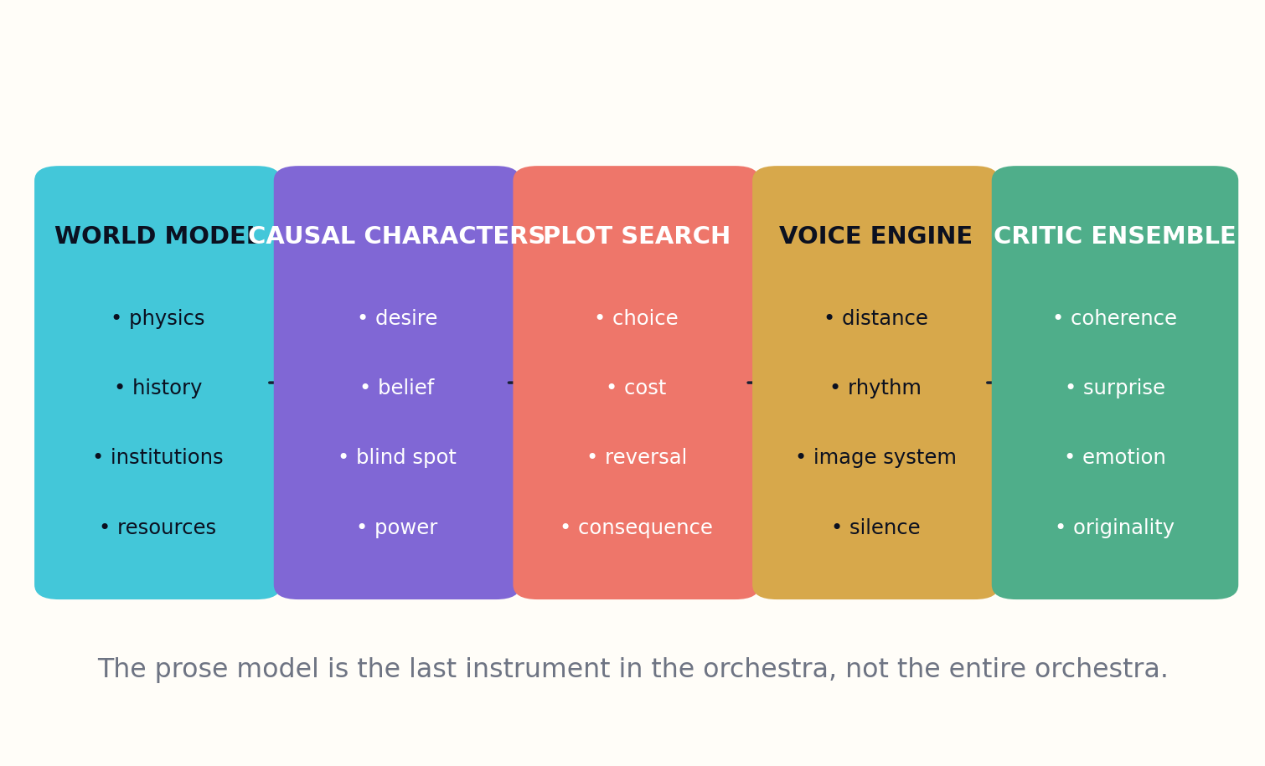
Figure 18. Why Infinite Fiction Becomes Boring — system view.
Scale can improve originality if it is spent on exploration. The studio may generate thousands of compact plot skeletons, discard those too similar to existing works, test the survivors for causal coherence, and commission only a few for full prose. It may simulate alternate histories to discover unexpected institutions or ecological consequences. It may ask cultural experts to challenge assumptions before a world becomes polished.
Quality also requires taste. Automated critics can measure continuity, repetition, pacing variance, emotional trajectory, and cliché density, but they cannot define the entire value of art. Human editors and readers bring lived experience, historical awareness, and aesthetic risk. The system should support schools and communities of taste rather than collapse everything into one universal preference model.
The purpose of 350 million works is not to saturate attention. It is to widen the possibility space of human imagination: more languages, forms, worlds, perspectives, and reading needs. Infinite fiction becomes worthwhile only when the library becomes better at choosing than at generating.
NARRATIVE VALUE
N = Coherence × Surprise × Consequence × Voice × Resonance
If any factor collapses, abundance cannot rescue the story. Surprise without coherence is noise; coherence without surprise is routine.

DESIGN PATTERN
Generate many low-cost story structures, evaluate deeply, and draft only the rare trajectories that earn expansion.

FIELD EXERCISE
Analyze a predictable story. Identify which irreversible choice, world constraint, or character blind spot could transform it.

PART IV — FICTION BEYOND THE AVERAGE

19. World Models Before Words

A fictional world becomes believable when it continues to exist beyond the sentence currently describing it.
The world model is a compact simulation of what can happen and why. It contains geography, resources, technologies, institutions, customs, histories, ecological limits, communication channels, and unresolved conflicts. These components are connected by rules. If energy is scarce, politics, architecture, travel, and class should reflect that scarcity. If memory can be traded, law, intimacy, crime, and identity must change. Worldbuilding becomes causal design rather than a catalog of decorative facts.
The model operates at multiple scales. A planetary layer describes climate, trade, migration, and conflict. Regional layers describe institutions and material culture. Scene layers track weather, objects, doors, distances, injuries, and who knows what. The narrative engine queries only the detail needed for a scene, but deeper state remains available to prevent contradiction and inspire consequence.
History is generated as pressure, not trivia. The studio simulates major events, institutional adaptations, myths, and forgotten causes. Characters inherit the uneven results. A border exists because something happened. A taboo protects or conceals a past function. A language contains metaphors shaped by environment. Historical depth gives ordinary choices weight.

Figure 19. World Models Before Words — system view.
World-model quality is tested through counterfactuals. If one resource disappears, what breaks first? If a law is enforced consistently, who benefits? If a technology is common, which profession becomes obsolete? Agents play residents with different incentives and attempt to exploit the rules. Inconsistencies are either repaired or turned into meaningful corruption, secrecy, or conflict.
The system should avoid equating detail with originality. A thousand invented plant names cannot compensate for institutions copied unchanged from the present. Originality comes from interacting premises. Two or three strong rule changes, followed rigorously, can create more novelty than a glossary of arbitrary inventions.
Once the world is stable enough to resist the plot, prose begins. Description then arises from character position and need. The world is not dumped onto the reader; it is encountered through friction.
WORLD CONSISTENCY
W_c = 1 − ViolatedConstraints / TestedConstraints
Constraint tests are generated across scales. Some apparent violations may be intentional exceptions, but every exception needs a cause and a cost.

DESIGN PATTERN
Simulate institutions, resources, and history before scene generation; let world constraints create plot pressure.

FIELD EXERCISE
Invent one impossible technology and trace five second-order consequences through law, labor, family, architecture, and language.

PART IV — FICTION BEYOND THE AVERAGE

20. Characters as Causal Systems

A character is not a list of traits. A character is a changing model of the world that makes costly choices.
Character models contain goals, needs, beliefs, memories, loyalties, fears, resources, social power, and blind spots. They also contain policies: how the character tends to act under pressure. Two characters may want the same outcome but choose differently because they interpret evidence through different histories. This internal causality prevents the authoring system from moving people merely to satisfy plot beats.
Beliefs are separated from facts. Each character has a knowledge state and confidence distribution. Rumors propagate through social networks. Secrets have owners, witnesses, and leakage probabilities. When a revelation occurs, the system calculates who is surprised, who is threatened, and which prior decisions acquire new meaning. Dramatic irony becomes an information architecture.
Characters change through prediction error and consequence. An experience challenges a belief; the character may update, rationalize, fragment, or double down. The update depends on identity, trust, and cost. Growth is therefore not an arbitrary transformation near the ending. It is a traceable sequence of pressures and responses.
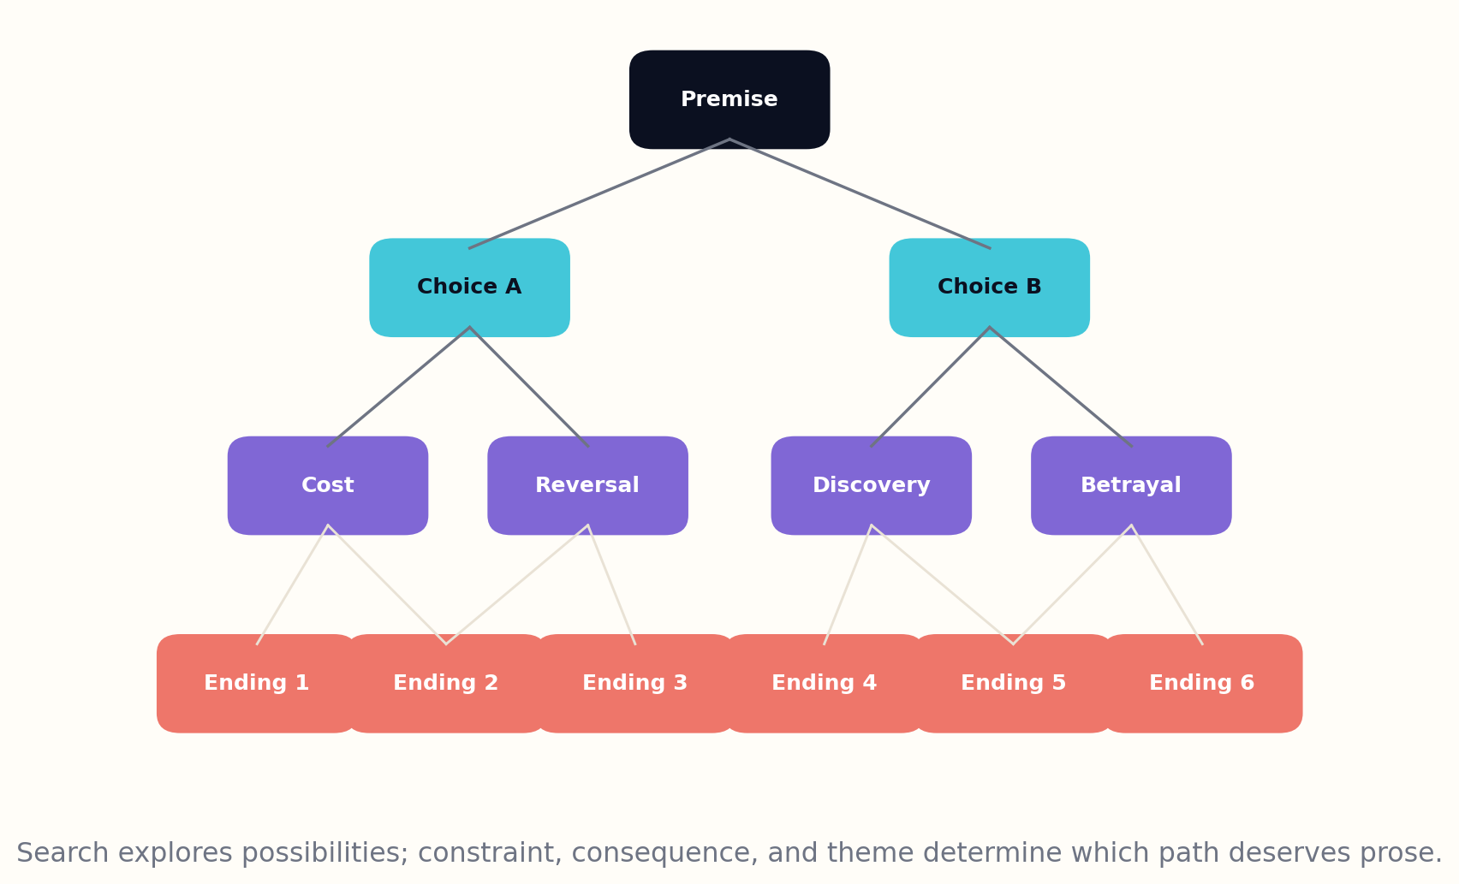
Figure 20. Characters as Causal Systems — system view.
Relationships are modeled as dynamic edges containing affection, obligation, fear, status, debt, and shared history. A single action can strengthen one dimension while damaging another. This creates emotionally complex scenes in which victory carries loss. The relationship graph also prevents every interaction from resetting to a generic tone.
The studio can simulate characters outside the selected plot. It places them in diagnostic situations, interviews them from incompatible viewpoints, and asks critics whether their choices remain distinguishable. If two characters produce the same decisions despite different profiles, their models are shallow. They are revised before prose multiplies the weakness.
Human writers and editors remain the source of moral imagination. The system can maintain causal continuity, but it cannot reduce a person to a vector without losing the mystery literature exists to explore. The model is scaffolding for surprise, not a claim that human beings are fully computable.
CHARACTER ACTION
a* = argmax_a E[goal_gain − moral_cost − relational_cost | belief_state]
The chosen action follows the character’s beliefs and values, not the omniscient truth of the world. Misbelief can make a tragic action locally rational.

DESIGN PATTERN
Track separate world truth, character belief, relationship state, and identity cost for every consequential scene.

FIELD EXERCISE
Model a protagonist and antagonist who share one goal. Give them different beliefs and costs, then derive a conflict without making either irrational.

PART IV — FICTION BEYOND THE AVERAGE

21. Plot Search, Surprise, and Consequence

Plot is not a sequence of events. It is a sequence of narrowing possibilities caused by choice.
The plot engine begins with a thematic problem and a causal state, not a list of conventional beats. It generates choices available to each major character, simulates likely responses, and explores the resulting branches. Most branches are discarded. Some are coherent but emotionally flat. Others are surprising but depend on coincidence. The valuable paths are those in which decisions produce escalating, irreversible consequences while remaining faithful to world and character models.
Search uses multiple objectives. It rewards causal density, thematic pressure, character revelation, setup-payoff relationships, and variation in scene function. It penalizes rescue by unexplained information, repeated conflict, consequence-free reversals, and resemblance to known plots. These scores do not write the story. They help editors navigate a possibility forest too large for unaided intuition.
Surprise is modeled relative to reader expectation. The system estimates which outcomes are plausible from visible evidence and which hidden state could reframe that evidence. A strong reversal changes the meaning of prior scenes without invalidating them. A weak twist simply withholds arbitrary information. Critics therefore perform retrospective tests: after the reveal, can the reader identify fair signals, and do character actions become more intelligible rather than less?

Figure 21. Plot Search, Surprise, and Consequence — system view.
Consequences propagate across layers. A private betrayal alters a relationship, which changes a coalition, which affects an institution, which reshapes the world. Conversely, large events must arrive inside lived experience. The plot graph tracks both directions so scale does not become spectacle detached from character.
Pacing emerges from information, pressure, and recovery. Scenes can increase danger, reveal state, force decision, deepen attachment, or permit reflection. The planner avoids a monotony of constant escalation by varying the kind of tension. It also preserves silence and ambiguity where explanation would diminish the work.
The final trajectory is selected by human editorial judgment informed by search. The machine’s advantage is breadth; the editor’s advantage is taste, lived meaning, and the courage to choose a path that resists easy optimization.
PLOT MERIT
P = Causality × Irreversibility × ThematicPressure × FairSurprise − Coincidence
A strong plot earns its turns from prior state. Coincidence may begin trouble, but it should not repeatedly solve it.

DESIGN PATTERN
Search plot skeletons before prose, then run retrospective fairness and consequence-propagation tests.

FIELD EXERCISE
Construct a four-level choice tree for one premise. Reject every branch that depends on a coincidence to resolve its central conflict.

PART IV — FICTION BEYOND THE AVERAGE

22. Voice Without Mimicry

Voice is a system of attention and omission, not a costume assembled from another writer’s surface habits.
A generative library must distinguish learning from literature and imitating a living author. The fiction studio should not offer unauthorized replicas of identifiable voices. Instead it models abstract dimensions: narrative distance, sentence energy, image density, temporal movement, sensory preference, humor, formality, ambiguity, and the relationship between narrator and reader. These dimensions support new voices without marketing mimicry as creativity.
Voice begins with attention. What does the narrator notice first? Which details are treated as evidence, beauty, threat, status, or background? What can the narrator know, and what do they consistently misread? A voice becomes coherent when these selections persist and evolve. Rhythm and diction follow perception rather than substituting for it.
The system builds an image grammar. Recurring metaphor families arise from world, occupation, body, and history. A sailor and a cryptographer may describe uncertainty differently even at the same reading level. Repetition is tracked so motifs accumulate significance without becoming automatic decoration. Certain words or constructions can be prohibited because they flatten the intended experience.

Figure 22. Voice Without Mimicry — system view.
Originality testing compares the draft with large reference corpora at several levels: phrase overlap, syntactic signature, metaphor pattern, scene sequence, and character configuration. Similarity does not automatically prove copying, but high convergence triggers review. The objective is to protect creators and to force the studio beyond the nearest stylistic basin.
Multivoice works require additional architecture. Each viewpoint receives a separate attention model, knowledge state, rhythm profile, and emotional blind spot. Scene transitions are tested to ensure readers can identify perspective through cognition, not merely name labels. Narrators may influence one another over time, producing controlled convergence or conflict.
The highest aim is not novelty for its own sake. A voice should make a form of experience newly perceptible. The library can search an enormous space of language, but the chosen voice must serve the work’s moral and emotional center.
VOICE ORIGINALITY
O_v = SemanticDistance × PerceptualCoherence − MimicryRisk
A voice is original when it is meaningfully distinct while remaining internally coherent. Random variation increases distance without creating identity.

DESIGN PATTERN
Specify perception, knowledge limits, rhythm, and image grammar; prohibit direct living-author imitation as a product mode.

FIELD EXERCISE
Write a voice contract that never names an author. Define what the narrator notices, avoids, misunderstands, and repeats.

PART IV — FICTION BEYOND THE AVERAGE

23. Multilingual Imagination and Cultural Stewardship

A language is not a skin placed over a finished story. It is one of the systems that creates the story’s possible meanings.
Translation at library scale cannot be reduced to generating a second string with approximately the same propositions. Languages encode social distance, evidentiality, gender, time, humor, rhythm, and cultural memory differently. A multilingual fiction program should plan in a language-aware semantic space, then allow each edition to become a work of literature in its own language. Fidelity includes effect, not only lexical correspondence.
The studio uses cultural and linguistic stewards. They define sensitive terms, naming conventions, historical context, dialect boundaries, and community permissions. They review whether a story treats a culture as an inhabited reality or as exotic material. For endangered and community-governed languages, the library follows local authority on whether generation, translation, or publication is appropriate at all.
Parallel editions can expose productive difference. Notes may explain why a joke, kinship term, or poetic image required transformation. Readers can compare choices without assuming one language is the original center and others are derivative shadows. In some projects, scenes may be recomposed from the beginning for different linguistic audiences while preserving the causal core.

Figure 23. Multilingual Imagination and Cultural Stewardship — system view.
Multilingual generation also expands fiction form. Oral cadence can influence page design. Sign languages invite visual and spatial narrative. Scripts with different directionality reshape layouts. Interactive editions can preserve pronunciation, song, and performance. Accessibility is not a final conversion step; it is an artistic dimension.
Quality evaluation must be local. Back-translation is a diagnostic tool, not a literary judge. Native editors assess naturalness, voice, implication, and cultural resonance. Reader panels can compare emotional and narrative effects. The provenance manifest names translators, adapters, models, and stewards, recognizing creative labor rather than hiding it behind automation.
A global library should increase the number of centers from which stories are imagined. If all plots are planned in one dominant language and merely exported, scale will deepen cultural concentration. Stewardship turns multilingual capacity into plurality rather than homogenization.
TRANSLATION FIDELITY
F_t = Meaning × Effect × Voice × CulturalIntegrity
Literal correspondence is only one component. A translation can preserve facts while losing social relation, humor, rhythm, or cultural truth.

DESIGN PATTERN
Plan with language-aware representations and give local human stewards authority over adaptation and release.

FIELD EXERCISE
Choose an idiom or culturally specific scene. List what must be preserved: information, relationship, humor, rhythm, and social consequence.

PART V — THE 47-TRILLION-TOKEN MACHINE
How specialized models, memory tiers, agent swarms, and quality economics turn an impossible number into a governed production fabric.
This part translates the vision into throughput, storage, orchestration, evaluation, and lifecycle-cost architecture.

PART V — THE 47-TRILLION-TOKEN MACHINE

24. The 47-Trillion-Token Compute Fabric

The machine is not one enormous model. It is a governed fabric of specialized computation.
The compute fabric separates orchestration from execution. A global scheduler receives typed jobs: ingest a source, resolve an entity, test a calculation, explore plot skeletons, draft a chapter, translate an edition, or run a verification suite. Each job declares resource needs, latency tolerance, privacy class, carbon constraints, and quality tier. The scheduler routes it to an appropriate pool rather than sending every task to the largest available model.
Specialization reduces cost and increases control. Lightweight models classify documents, detect language, and propose metadata. Retrieval models assemble evidence. Symbolic engines handle equations and constraints. Code runners execute tests. Strong reasoning models address difficult synthesis. Prose models realize approved plans. Translation systems operate under language-specific editors. The architecture is an orchestra, not a soloist.
Jobs are reproducible. Every run records model identifier, weights or provider version, decoding settings, prompt and tool schema, retrieved context hashes, software environment, random seed where available, and outputs. Deterministic components are preferred for checks. When a provider changes an opaque service, the library can identify which artifacts may need revalidation.
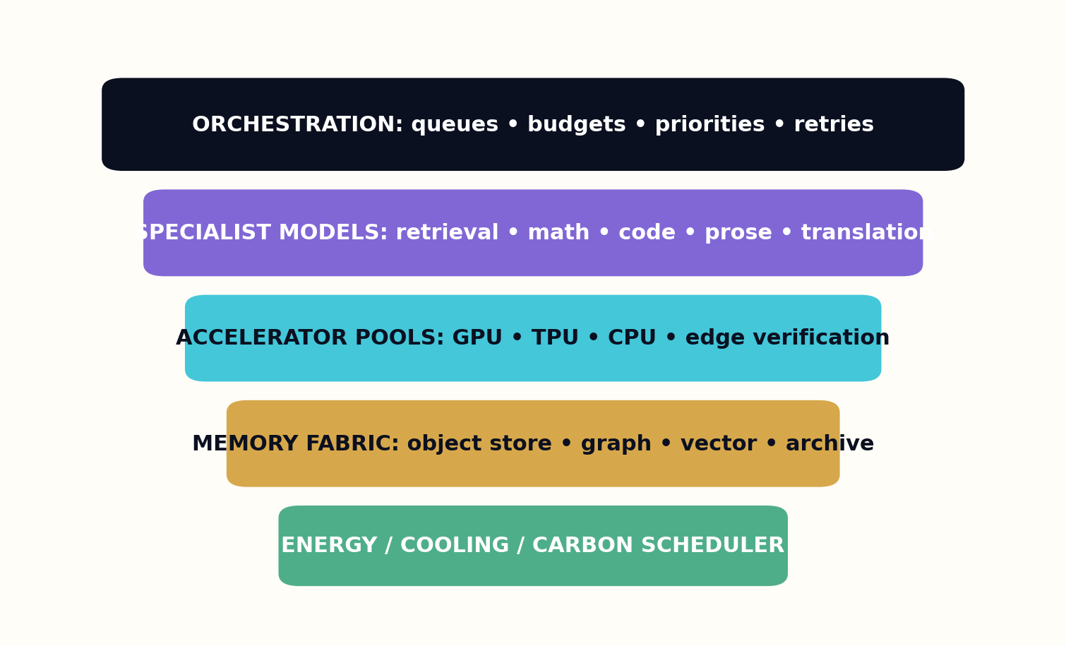
Figure 24. The 47-Trillion-Token Compute Fabric — system view.
Queues protect quality from scale. High-risk verification has reserved capacity. Living-book updates can preempt low-value bulk generation. Retry policies distinguish transient infrastructure failure from epistemic failure. A manuscript that repeatedly fails contradiction review should not consume infinite compute; it returns to editorial redesign.
Energy and cooling become scheduling variables. Flexible tasks can run where and when cleaner energy or lower thermal load is available. Data locality reduces movement. Quantization and model distillation serve low-risk tasks. Published metrics include energy per accepted work, not merely energy per generated token, because rejection and revision are part of the real cost.
The compute fabric should be multi-provider and partially self-hosted. Critical verification and preservation cannot depend on a single external service. Portable job specifications and open formats reduce lock-in. The library must survive model turnover as routinely as a research archive survives a change in database software.
ACCEPTED-TOKEN COST
C_a = (C_draft + C_verify + C_reject + C_revision) / T_accepted
Optimization based only on drafting hides the cost of weak proposals, failed checks, and repeated rewrites.

DESIGN PATTERN
Route typed jobs to specialist resources and schedule by risk, value, locality, and energy—not model prestige.

FIELD EXERCISE
Design a job descriptor for chapter generation containing inputs, resources, quality tier, privacy, deadlines, and reproducibility fields.

PART V — THE 47-TRILLION-TOKEN MACHINE

25. Storage, Indexes, and Memory Hierarchies

A library remembers differently at different distances from the reader’s present question.
The storage architecture contains several memory classes. Immutable object storage preserves source bitstreams, published editions, figures, datasets, and manifests. Relational systems hold transactions and catalog metadata. Graph stores represent entities, claims, rights, and dependencies. Search indexes support lexical discovery. Vector indexes support semantic retrieval. Fast caches hold active book state. Deep archives preserve snapshots for decades.
Not every token deserves an embedding. At forty-seven trillion tokens, naïvely splitting everything into 512-token chunks would create roughly 91.8 billion chunks. A 768-dimensional float16 vector for each would require on the order of 141 terabytes before index overhead, replicas, and metadata. This is feasible for large infrastructure but wasteful if used indiscriminately. The library instead embeds selected semantic units, claims, summaries, figures, and high-value passages, while lexical and graph indexes cover the rest.
Hierarchical retrieval begins with the catalog and graph. It identifies relevant works, concepts, and evidence paths. It then opens only the necessary sections and source spans. Book-level summaries guide chapter-level retrieval; chapter maps guide paragraph-level retrieval. This reduces context noise and makes provenance easier to maintain. The system can always descend to the original object.
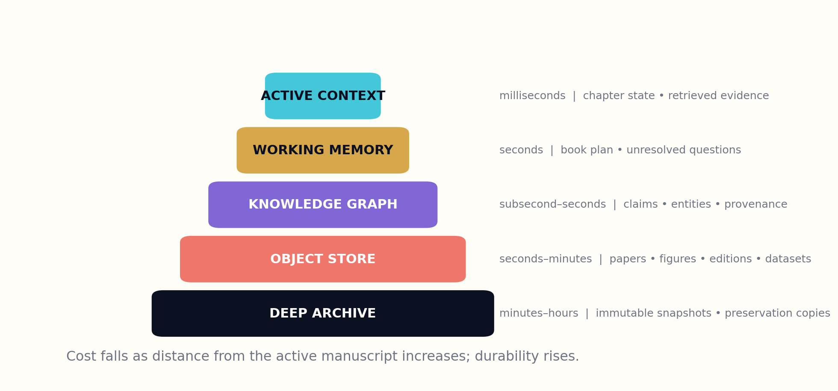
Figure 25. Storage, Indexes, and Memory Hierarchies — system view.
Memory also includes unresolved work. Each manuscript has a state ledger containing decisions, open questions, rejected alternatives, evidence gaps, and verification findings. Agents read and write typed entries rather than repeatedly reconstructing context from chat transcripts. Compaction creates durable summaries but retains links to the detailed record. Nothing important should depend on a model remembering an earlier conversation perfectly.
Preservation requires format migration, fixity checks, geographic replication, and periodic restore tests. Cryptographic hashes detect change but do not guarantee readability. The library maintains open archival formats and emulation plans for interactive works. A generated civilization-scale collection that cannot be opened in fifty years has failed its name.
Deletion and restriction are also architectural requirements. Personal data, revoked materials, or harmful derivatives may need access changes while preserving lawful audit records. The system distinguishes removal from public indexes, restricted custody, and cryptographic tombstones. Memory is governed, not infinite by default.
EMBEDDING FOOTPRINT
B = Chunks × Dimensions × BytesPerValue
At 91.8 billion chunks, 768 dimensions, and two bytes per value, vectors alone approach 141 TB. Indexing strategy must be selective and hierarchical.

DESIGN PATTERN
Use object, relational, graph, lexical, vector, cache, and archive layers for distinct memory functions.

FIELD EXERCISE
Map ten data types in the library to the storage system that should own each one, and justify every choice.

PART V — THE 47-TRILLION-TOKEN MACHINE

26. Agent Swarms and Production Scheduling

Coordination quality determines whether many intelligent workers become a foundry or a crowd.
The production swarm is composed of agents with narrow authority and explicit artifacts. A cartographer maps the topic and reader need. Researchers assemble evidence packets. Skeptics seek contradiction. Architects design the book genome and chapter contracts. Writers produce candidate prose. Visual agents generate diagrams from traceable data. Editors revise structure and voice. Verifiers test claims. Release agents assemble manifests. No agent owns the entire truth.
Agents communicate through a shared ledger. Entries have schemas, identities, timestamps, confidence, and dependencies. A researcher does not tell the writer ‘the sources look good’; it submits a claim set with citations and scope. A skeptic does not say ‘I have concerns’; it files a finding with severity and evidence. Typed communication makes orchestration inspectable and permits agents to be replaced without redesigning the institution.
Scheduling resembles a combination of manufacturing, scientific workflow, and operating-system design. Jobs form directed acyclic graphs with conditional loops. A chapter cannot draft until required evidence is ready. A verification failure can trigger targeted retrieval, structural revision, or project cancellation. Critical paths receive priority. Work stealing keeps resources utilized, but rights-restricted tasks stay within approved execution zones.

Figure 26. Agent Swarms and Production Scheduling — system view.
Swarm diversity is intentionally engineered. Agents may use different model families, retrieval indexes, temperatures, or reasoning methods. Debate is useful only when participants have access to distinct evidence or incentives. The scheduler therefore assigns adversarial roles and prevents a writer from selecting its favorite reviewer. Collusion is an architectural problem even when all participants are software.
The swarm learns from production outcomes. Failure taxonomies identify common unsupported transitions, stale citations, repetitive plots, translation artifacts, or cultural mistakes. Improvements are evaluated on held-out projects before deployment. The system does not silently train on every accepted output, because acceptance may reflect correlated blind spots.
Human supervisors can pause, redirect, or inspect any project. Interfaces summarize state without hiding underlying artifacts. At massive scale, supervision by exception is necessary, but the exceptions must be chosen by transparent risk and uncertainty signals rather than by whatever the system finds easy to display.
PROJECT CRITICAL PATH
T_project = max_path Σ task_duration
Parallel workers reduce total time only outside the longest dependency path. Better decomposition can matter more than adding agents.

DESIGN PATTERN
Use typed, signed artifacts in a shared ledger and assign independent agents to adversarial roles.

FIELD EXERCISE
Draw the task graph for one book from commission to release. Mark the critical path and the loops created by failed verification.

PART V — THE 47-TRILLION-TOKEN MACHINE

27. Quality Economics: Spend Compute Where It Matters

The cheapest token is the one the library decides not to generate.
Quality economics begins with proposal triage. Before expensive research or prose, the library estimates whether a work fills a real gap, whether sources are mature enough, and whether the expected reader benefit justifies maintenance. Many ideas should become catalog paths, short briefs, or additions to existing books rather than new titles. The system saves compute by choosing the right artifact form.
Within a project, adaptive budgets follow uncertainty. Stable background sections may use efficient models and standard verification. Contested claims receive deeper retrieval and multiple critics. A plot branch with high novelty but low coherence gets additional simulation before prose. A translation into a low-resource language receives more human review. Budget is attached to epistemic and artistic difficulty.
Early tests are cheaper than late repairs. Outline contradiction checks prevent structural errors from spreading through thirty chapters. Small prose samples test voice before a novel is drafted. Representative translations test terminology before an entire catalog is converted. Pilot figures reveal extraction problems before hundreds are generated. The foundry uses staged commitments.

Figure 27. Quality Economics: Spend Compute Where It Matters — system view.
Acceptance rate is a key metric. A system that produces enormous volumes and rejects nearly everything may still be useful during search, but it should account for the cost. Conversely, a suspiciously high acceptance rate may indicate weak standards or low ambition. Metrics include cost per accepted work, cost per corrected claim, human attention per release, reader capability gain, and long-term maintenance burden.
Caching and reuse reduce waste when provenance is preserved. A verified evidence packet can support several audience editions. A world model can generate a novel, atlas, and game guide. A translated terminology bank can serve a domain collection. Reuse must not become formulaic copying; it should preserve expensive validated foundations while allowing each work a distinct purpose and structure.
The quality economy ultimately protects attention. Generating a weak book imposes costs on readers, librarians, indexes, and future models. Publication should include an estimate of expected value and a commitment to retirement or revision. The true scarce resource is not tokens. It is the human time required to encounter them.
QUALITY-ADJUSTED COST
QAC = TotalLifecycleCost / VerifiedReaderValue
Lifecycle cost includes generation, review, storage, discovery burden, correction, and maintenance. Reader value must be measured beyond clicks.

DESIGN PATTERN
Use staged commitments, adaptive verification, and aggressive project rejection before full drafting.

FIELD EXERCISE
Create a quality budget for a research handbook and a literary novel. Explain where each should spend its most expensive compute.

PART VI — TRUST, LAW, AND LAUNCH
How provenance, rights, anti-collapse systems, and phased governance keep the library attached to human reality.
This part ends with a practical path from a constitution and ten-thousand-work pilot to a million-book system and the larger horizon.

PART VI — TRUST, LAW, AND LAUNCH

28. The Rights Graph and Provenance Ledger

Every sentence has a history, even when the history is hidden.
The provenance ledger records the history of each published asset. It identifies source objects, extracted fragments, licenses, models, tools, prompts, editors, reviewers, calculations, transformations, and release decisions. Cryptographic hashes bind records to artifacts. Signatures provide tamper evidence and accountable identities. The ledger can be expressed through interoperable content-credential standards while retaining richer internal scholarly detail.
Provenance is not a truth oracle. A signed manifest can prove that a particular institution asserted a history and that the record has not been altered; it cannot prove that every assertion is honest or that the content is correct. Trust therefore combines provenance with evidence quality, independent review, reputation, and reader inspection. The interface must not convert a cryptographic badge into an unearned guarantee.
The rights graph and provenance ledger intersect but serve different questions. Rights asks what transformations and distributions are permitted. Provenance asks what happened. A generated paragraph may be lawful yet poorly supported, or well supported yet unlawfully reused. Release requires both dimensions to pass.

Figure 28. The Rights Graph and Provenance Ledger — system view.
Attribution should reach beyond a bibliography. Contributors can be credited for source creation, dataset maintenance, translation, community stewardship, verification, illustration, and editorial architecture. Where agreements provide compensation or benefit sharing, usage records can support transparent allocation. The library should make the invisible labor of knowledge more visible.
Privacy requires selective disclosure. Public manifests can contain the information needed for trust while sensitive operational logs remain protected. Pseudonymous or community identities may be appropriate. Redaction events are recorded so readers know that a provenance chain changed without exposing protected details. Security design anticipates harassment, coercion, and metadata exploitation.
Long-term validation requires trusted timestamps, key rotation, revocation handling, and preservation of verification software. Manifests should remain interpretable even when providers vanish. Open specifications and independent validators prevent provenance from becoming another proprietary dependency.
RELEASE TRUST
T_release = Provenance × Evidence × Rights × Review
The factors multiply because a failure in any one can make publication unacceptable even when the others are strong.

DESIGN PATTERN
Bind every edition to a signed, portable manifest while explaining clearly what provenance can and cannot prove.

FIELD EXERCISE
Draft a public provenance manifest for one generated chapter, including sources, models, humans, checks, rights, and limitations.

PART VI — TRUST, LAW, AND LAUNCH

29. Collapse, Slop, and the Defense of Human Reality

A library trained only on its own echoes eventually mistakes compression for the world.
Recursive synthetic-data use can narrow distributions and erase rare patterns. In a library, the cultural version of this failure is slop: fluent works derived from other fluent works, increasingly detached from primary evidence, lived language, local knowledge, and artistic risk. The tail disappears first. Unusual cases, minority styles, negative results, and difficult truths are smoothed toward the center.
The defense begins with provenance-aware sampling. Training and generation pipelines distinguish primary human-created sources, measured data, prior synthetic works, translations, and model-assisted edits. Synthetic material is labeled rather than allowed to reenter the corpus anonymously. High-value systems maintain quotas for primary evidence, recent observations, underrepresented languages, and deliberately preserved outliers.
The library also maintains reality anchors. Scientific foundries continually ingest new measurements, datasets, replications, and corrections. Fiction studios work with human diaries, interviews, field observation, community workshops, and commissioned writers under consent. These inputs are not merely data fuel; they are relationships with people and institutions who retain rights and agency.
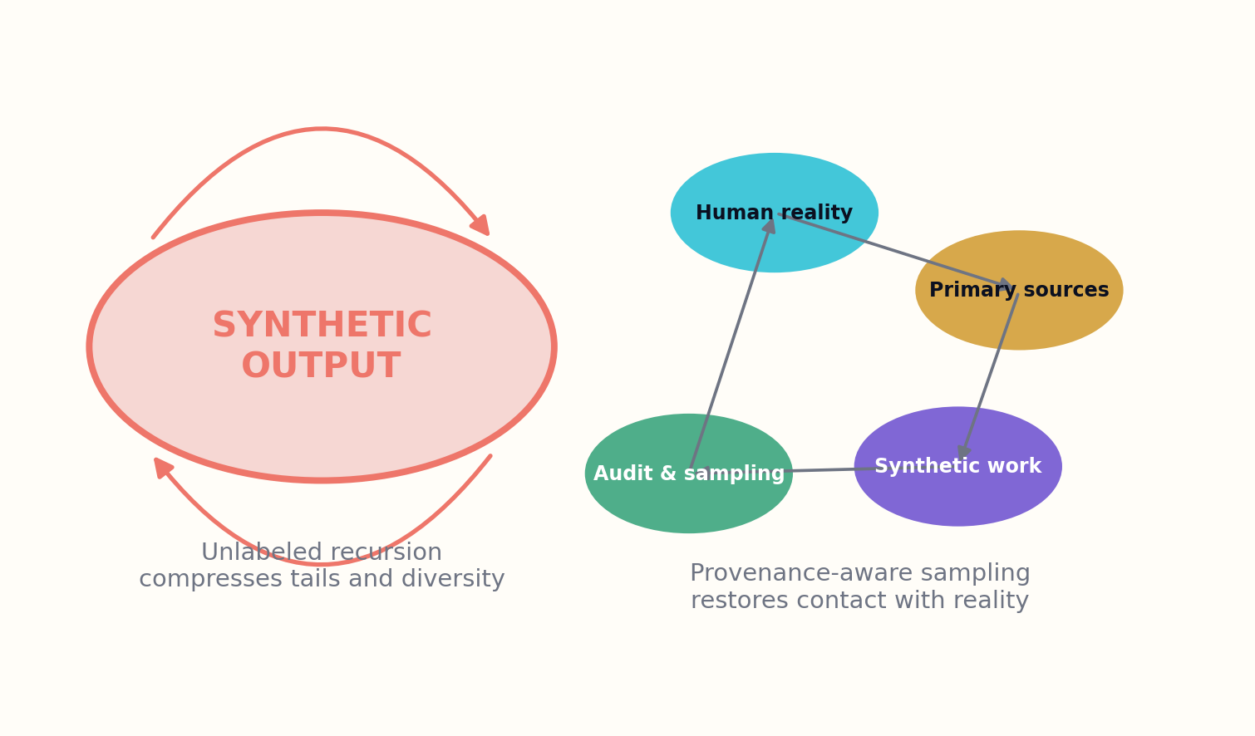
Figure 29. Collapse, Slop, and the Defense of Human Reality — system view.
Anti-slop evaluation operates at multiple levels. Text tests detect repetition, vague abstraction, citation laundering, and stylistic convergence. Portfolio tests detect duplicate theses and plot skeletons. Graph tests measure source lineage diversity. Reader studies measure comprehension, surprise, and lasting value. Random human audits inspect works that automated metrics consider safe, because blind spots cluster precisely where metrics are most confident.
The institution must preserve the right to be difficult. Optimization for immediate comprehension can flatten specialized language, ambiguity, or experimental form. Optimization for engagement can reward outrage and familiarity. The library supports filters and recommendations, but it does not rewrite all culture into the same frictionless voice. Human reality includes opacity, conflict, silence, and unfinished thought.
Scale magnifies both excellence and error. The defense is not to prohibit generation, but to maintain continuous contact with sources that were not generated for the library’s convenience. A super-library should increase humanity’s capacity to remember itself, not replace that memory with an averaged simulation.
REALITY CONTACT
R_c = PrimarySourceMass × LineageDiversity × FreshObservation × HumanAudit
The system tracks whether its inputs remain connected to independently created evidence and expression rather than recursive synthetic derivatives.

DESIGN PATTERN
Label synthetic lineage, preserve outliers, ingest new primary reality, and audit confident outputs at random.

FIELD EXERCISE
Design an anti-collapse dashboard with five metrics that would reveal homogenization before readers complain.

PART VI — TRUST, LAW, AND LAUNCH

30. Building the First Million Books

The path to 350 million works begins by proving that the first thousand deserve to exist.
The launch plan begins with a constitution, not a data center. Founders define rights principles, evidence contracts, human authority, correction policy, provenance standards, safety boundaries, and public-interest goals. Independent advisors from libraries, science, publishing, law, education, accessibility, and represented communities test the charter. The system should know what it will refuse before it learns what it can generate.
Phase one produces ten thousand works in a small number of domains with strong open sources and committed editors. The objective is to validate ingestion, claim graphs, book genomes, verification, manifests, reader studies, and correction loops. Each work is expensive because the pipeline itself is being learned. A public failure registry documents what went wrong and what changed.
Phase two expands to one million works through domain foundries. Each foundry owns schemas, specialist models, evaluation sets, and editorial councils. Shared infrastructure handles identities, rights, storage, orchestration, and preservation. The million-book milestone is not a race. It is achieved only when sampled works maintain evidence, originality, usability, and provenance under increased throughput.
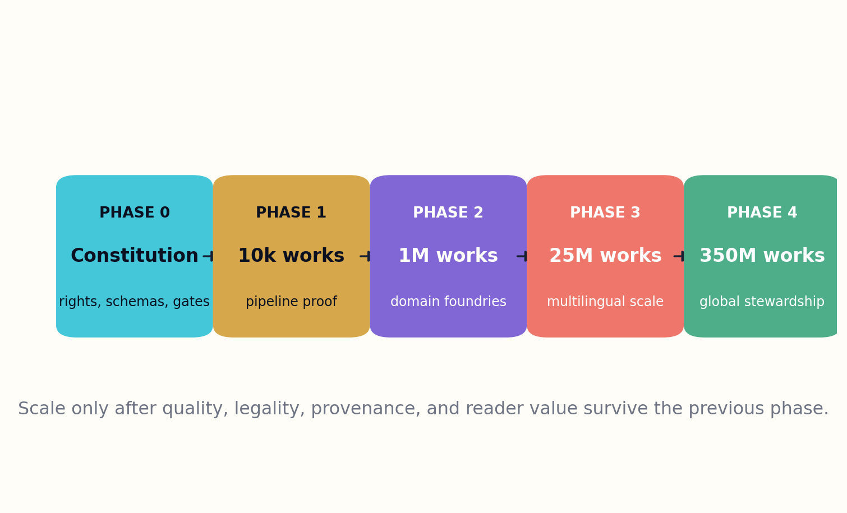
Figure 30. Building the First Million Books — system view.
Phase three addresses multilingual and regional scale. Partnerships with libraries, universities, publishers, archives, and communities establish local stewardship. Compute and storage become geographically distributed. Language programs are funded according to need rather than market size. Fiction studios commission human creators alongside generative systems, creating new economic and artistic institutions.
Only after these phases should the project pursue 350 million book-equivalent works and forty-seven trillion published tokens. By then, much of the portfolio may consist of living editions, translations, accessible forms, specialized manuals, interactive atlases, and fiction ecosystems rather than conventional static volumes. The number remains a horizon, not a substitute for judgment.
The modern Library of Alexandria should be built as a commons of institutions. Its deepest achievement would not be that a machine wrote more books than humanity had previously written. It would be that humanity developed a new capacity to connect evidence, preserve difference, teach across boundaries, imagine alternatives, and correct itself at unprecedented scale. The library dreams in trillions, but it must wake inside human responsibility.
SCALE GATE
Advance_phase ⇔ Quality ≥ Q* ∧ Rights ≥ R* ∧ Trust ≥ T* ∧ Value ≥ V*
Growth is conditional. Missing a threshold stops expansion even when compute and funding are available.

DESIGN PATTERN
Scale in gated phases from constitution to ten thousand, one million, twenty-five million, and only then the full horizon.

FIELD EXERCISE
Write the acceptance criteria for moving from a 10,000-work pilot to a one-million-work production system.

APPENDIX A

Capacity Equations

AVERAGE WORK SIZE
47×10¹² / 350×10⁶ = 134,285.7 tokens per work
At roughly 0.75 words per token, the arithmetic corresponds to about 100,700 words per work on average. Actual languages and tokenizers vary.

RAW TOKEN IDENTIFIERS
47×10¹² × 4 bytes ≈ 188 TB
This excludes original sources, indexes, images, audio, provenance, redundancy, and intermediate reasoning.

CHUNK COUNT
47×10¹² / 512 ≈ 91.8 billion chunks
A warning against embedding every fixed window without semantic selection.

VECTOR STORAGE
91.8B × 768 × 2 bytes ≈ 141 TB
Float16 vectors only; practical indexes can add substantial overhead.

DRAFT THROUGHPUT AT 10,000×100 T/S
≈ 544 days
A theoretical uninterrupted drafting time before verification.

DRAFT THROUGHPUT AT 50,000×500 T/S
≈ 21.8 days
Shows that orchestration, energy, acceptance, and review quickly dominate.

Planning warning
Published tokens should be only one ledger. A serious deployment separately accounts for source ingestion, internal reasoning, rejected candidates, verification, translation, revision, multimedia assets, indexes, and preservation replicas.

APPENDIX B

Core Schemas

Claim record
claim_id: durable identifier
statement: normalized proposition
scope: population / domain / conditions
modality: observed / inferred / hypothesized
evidence: exact source spans and data
method: measurement or reasoning chain
time: observation and validity intervals
confidence: calibrated distribution
rights: inherited transformation constraints

Book genome
purpose: reader capability transformation
audience: prior knowledge and context
evidence_contract: allowed support by claim type
structure: chapters and functional dependencies
voice: perception, rhythm, register, exclusions
pedagogy: examples, diagrams, exercises, assessment
safety: domain-specific review and refusal rules
provenance: required manifest fields
maintenance: update cadence and ownership

Production job
job_type and artifact schema
input hashes and dependency IDs
model / tool / environment identifiers
resource and locality requirements
rights and privacy execution zone
quality tier and verification suite
budget, deadline, retry policy
outputs, metrics, signatures, failure class

APPENDIX C

Evaluation Rubrics

Nonfiction release rubric
Criterion | Score 0–4 | Required evidence
Mission fit | ____ | Reviewer note / metric / artifact
Evidence coverage | ____ | Reviewer note / metric / artifact
Claim entailment | ____ | Reviewer note / metric / artifact
Counterevidence | ____ | Reviewer note / metric / artifact
Calculation replay | ____ | Reviewer note / metric / artifact
Domain safety | ____ | Reviewer note / metric / artifact
Pedagogical transfer | ____ | Reviewer note / metric / artifact
Provenance completeness | ____ | Reviewer note / metric / artifact
Rights clearance | ____ | Reviewer note / metric / artifact
Maintenance owner | ____ | Reviewer note / metric / artifact

Fiction release rubric
Criterion | Score 0–4 | Required evidence
World constraint integrity | ____ | Reviewer note / metric / artifact
Character causal distinctness | ____ | Reviewer note / metric / artifact
Plot consequence | ____ | Reviewer note / metric / artifact
Fair surprise | ____ | Reviewer note / metric / artifact
Voice coherence | ____ | Reviewer note / metric / artifact
Originality distance | ____ | Reviewer note / metric / artifact
Cultural stewardship | ____ | Reviewer note / metric / artifact
Emotional resonance | ____ | Reviewer note / metric / artifact
Accessibility | ____ | Reviewer note / metric / artifact
Provenance and contributor credit | ____ | Reviewer note / metric / artifact

Portfolio rubric
Criterion | Score 0–4 | Required evidence
Coverage gap | ____ | Reviewer note / metric / artifact
Public value | ____ | Reviewer note / metric / artifact
Language equity | ____ | Reviewer note / metric / artifact
Source maturity | ____ | Reviewer note / metric / artifact
Overlap | ____ | Reviewer note / metric / artifact
Risk | ____ | Reviewer note / metric / artifact
Maintenance load | ____ | Reviewer note / metric / artifact
Format appropriateness | ____ | Reviewer note / metric / artifact
Reader discovery cost | ____ | Reviewer note / metric / artifact
Retirement plan | ____ | Reviewer note / metric / artifact

APPENDIX D

Phased Roadmap


Scale is gated by demonstrated quality and stewardship, not by available generation throughput.
PHASE 0 — CONSTITUTION AND SCHEMAS
Establish rights ontology, provenance manifest, source custody, evaluation sets, human governance, and public failure policy.

PHASE 1 — 10,000 WORKS
Prove the complete pipeline in a few evidence-rich domains and several fiction studios. Publish audits and reader studies.

PHASE 2 — 1 MILLION WORKS
Create domain foundries, regional mirrors, multilingual stewardship, and independent verification institutions.

PHASE 3 — 25 MILLION WORKS
Test discovery, preservation, correction propagation, contributor economics, and governance under global diversity.

PHASE 4 — 350 MILLION WORKS
Expand only after sampled quality, lawful provenance, reader value, and institutional resilience survive previous scale.

APPENDIX E

Constitution of the Generative Library

Article I — Human purpose
The library exists to expand human understanding, imagination, capability, and cultural memory. Token volume is never an end in itself.

Article II — Evidence integrity
Nonfiction claims must be traceable to evidence, calculations, or clearly labeled inference. Uncertainty and contradiction remain visible.

Article III — Rights and consent
No source is transformed or distributed beyond its lawful and ethical permissions. Community governance and privacy can impose constraints stronger than default access.

Article IV — Human editorial authority
Accountable people and institutions control commissioning, standards, release, correction, and refusal. Human review is substantive, not ceremonial.

Article V — Originality and plurality
The library resists stylistic homogenization, unauthorized mimicry, cultural concentration, and recursive synthetic collapse.

Article VI — Provenance
Every edition carries a durable record of sources, transformations, models, tools, contributors, checks, rights, and versions.

Article VII — Corrigibility
Errors are expected to be found, disclosed, repaired, and preserved in version history. Readers can challenge exact claims.

Article VIII — Federation and preservation
No single vendor or institution may become the sole custodian of civilization-scale knowledge. Open formats and independent mirrors are mandatory.

Article IX — Accessibility
Works are designed for diverse readers, languages, abilities, devices, and bandwidth conditions from the beginning.

Article X — The right not to generate
The library may reject a work because it is redundant, harmful, unsupported, unlawfully sourced, culturally inappropriate, or unworthy of reader attention.

Glossary

Book genome. A typed design contract defining purpose, audience, evidence, structure, voice, pedagogy, safety, provenance, and maintenance.
Book-equivalent work. A substantial, independently useful intellectual artifact; it may be static, living, interactive, translated, accessible, or multimedia.
Claim graph. A temporal graph linking propositions to evidence, methods, conditions, contradictions, rights, and downstream uses.
Collision engine. A system that proposes cross-domain connections by structural similarity and sends them through technical falsification.
Evidence packet. A claim-specific bundle of support, counterevidence, scope conditions, source quality, and unresolved questions.
Living book. A versioned publication with explicit dependencies on an evolving evidence graph and accountable update stewardship.
Provenance ledger. A tamper-evident record of source lineage, transformations, contributors, models, tools, checks, and releases.
Reality anchor. Primary, independently created observation or expression used to prevent recursive synthetic drift.
Rights graph. Executable relationships describing permission, attribution, restrictions, territory, term, consent, and benefit obligations.
Verification court. Independent agents and human panels that challenge claims, calculations, safety, originality, and cultural integrity before release.

Selected Research and Standards

These sources ground the infrastructure and research directions discussed in the book. The proposed 47-trillion-token system, its portfolio, and its governance model are original design synthesis rather than descriptions of a currently deployed library.
1. OpenAlex technical documentation. A public scholarly catalog and graph connecting works, authors, institutions, sources, topics, publishers, and funders. https://docs.openalex.org/
2. Crossref REST API documentation. Infrastructure for querying scholarly metadata, identifiers, relationships, licenses, updates, and retractions. https://www.crossref.org/documentation/retrieve-metadata/rest-api/
3. Unpaywall data feeds. Open-access location data for a large scholarly corpus, useful as one lawful access signal rather than a universal reuse permission. https://unpaywall.org/products/snapshot
4. arXiv API and data access documentation. Programmatic access patterns for a major open research repository. https://info.arxiv.org/help/api/index.html
5. DataCite Metadata Schema. Persistent-identifier metadata for research outputs, people, organizations, relationships, funding, and versions. https://schema.datacite.org/
6. SPDX specifications. Machine-readable representation of software and data licensing information. https://spdx.dev/specifications/
7. C2PA Content Credentials Specification 2.4. An interoperable framework for cryptographically bound provenance assertions and content history. https://spec.c2pa.org/specifications/
8. Creative Commons: AI and the Commons. Policy and practice material on AI, open culture, licensing, attribution, and public-interest knowledge. https://creativecommons.org/ai-and-the-commons/
9. U.S. Copyright Office: Copyright and Artificial Intelligence. Public reports addressing digital replicas, copyrightability of generative outputs, and training questions. https://www.copyright.gov/ai/
10. Shumailov et al., “AI models collapse when trained on recursively generated data”. Nature (2024). A central research warning about loss of distributional tails under recursive synthetic training. https://www.nature.com/articles/s41586-024-07566-y
11. Lu et al., “The AI Scientist”. Research prototype exploring automated scientific ideation, experimentation, writing, and review; useful as a design reference and a reminder that automation still requires validation. https://arxiv.org/abs/2408.06292
12. Long-form story planning research. Representative systems study hierarchical outlines, memory, iterative planning, critic ensembles, and long-horizon coherence. The book treats these as research directions, not solved artistry. https://arxiv.org/search/?query=long-form+story+generation&searchtype=all

THE LIBRARY DREAMS IN TRILLIONS
The library’s final intelligence is not the ability to produce every possible book. It is the judgment to know which books should exist, how they should know, and how they should remain answerable to the people who read them.

A generative library becomes trustworthy only when generation is one layer inside a larger institution.
GRAYLAN JANULIS

