

The Road Ahead Thinks Back
A Walk into Intelligent Thinking Systems, Quantum Road Scanning, and the Making of a Car-Accident Prediction Oracle

A WALK INTO INTELLIGENT THINKING SYSTEMS
The Road Ahead Thinks Back
Quantum Road Scanning and the Making of a Car-Accident Prediction Oracle
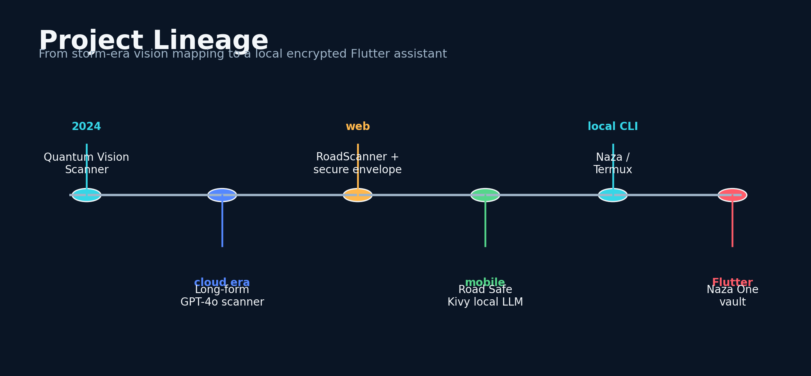
The public project lineage reconstructed for this manuscript.
Graylan Janulis

Copyright and Research Notice
Copyright © 2026 Graylan Janulis. All rights reserved. This manuscript is a technical and autobiographical work based on public software repositories, the author's field accounts, and cited public research. Repository licenses govern the code in those repositories; this book does not replace those licenses.
This book describes experimental advisory systems. It is not a certified advanced driver-assistance system, an autonomous driving controller, a medical or intoxication diagnostic device, legal advice, emergency guidance, or a substitute for direct observation, traffic law, official alerts, or certified vehicle safety equipment.
Specific field events near Powdersville and the Pelzer exit are presented as the author's firsthand reports. They were not independently verified as precise model predictions for this manuscript. Suspected model poisoning or adversarial interference is presented as the author's interpretation of reliability problems; cause and intent were not independently established.
First edition. Prepared August 2026.

For every driver who needed one more second,
and every builder who kept the system alive long enough to learn.

Table of Contents
The book is organized as a progression from field observation to forecasting, quantum-inspired representation, local secure intelligence, vision-language intervention, and an open research program.
PART I The Road Becomes a Laboratory
01 The Shift Before the Signal
02 Delivery Miles as Data
03 Hurricane Helene and the Invisible Road
04 Powdersville: A Warning Before the Turn
05 I-85, Pelzer, and the Deer in the Dark
PART II Building an Oracle Without Pretending to Be One
06 What Prediction Must Mean
07 From Hazard Language to Risk State
08 The Long-Form GPT-4o Risk Scanner
09 Time-to-Collision and Time-to-Intervention
10 Calibration, False Alarms, and Humility
PART III Quantum-Inspired Intelligence
11 Why I Reached for Quantum Language
12 Entropy as a Sensor of System State
13 Variational Circuits and Practical Limits
14 The PUNKD Heuristic and Attention Pressure
15 The Risk Wheel as Human-Machine Instrument
PART IV From Cloud Dependence to Local Intelligence
16 When Frontier Models Became Unreliable
17 Threat Modeling the Adversarial Road
18 Termux, Ubuntu, and a Model in My Pocket
19 Naza: The Local Safety Companion
20 Naza One: Vaults, Keys, and Fail-Closed Design
PART V Vision-Language Safety Systems
21 Teaching a Model to See Risk
22 Reading Drunk and Reckless Driving
23 Persuasion Before Punishment
24 Multimodal Fusion Under Uncertainty
25 The Driver Must Remain in Command
PART VI Engineering for the Long Road
26 Post-Quantum Security for Small Devices
27 Evidence, Logs, and Reproducibility
28 Field Validation as a Delivery Driver
29 An Open Research Agenda
30 The Road Ahead Thinks Back
Afterword: Evidence, Experience, and the Claim Boundary
Appendix A: Field Episode Record
Appendix B: Risk Object and Prompt Contract
Appendix C: Security and Recovery Checklist
Appendix D: Validation Protocol
Glossary
Source Notes
Bibliography

Preface: Why Build an Oracle?
The phrase car-accident prediction oracle is deliberately provocative. It names a human desire that ordinary engineering language often hides: we want the warning before we understand why we need it. We want enough time to slow down, leave more space, choose another road, stop driving, or persuade someone we care about not to take a risk. The ethical challenge is to pursue that lead time without pretending that uncertainty has disappeared.
This book follows a body of work that grew across public repositories, changing model generations, damaged assumptions, and thousands of practical miles. It connects the Quantum Vision Scanner, long-form cloud analyses, the secured RoadScanner web application, the Road Safe Kivy model, the Naza local CLI, and the Naza One Flutter vault. Each project is treated as one stage in an evolving system rather than as a finished universal solution.
The book uses first person because the origin matters. Delivery work made the road repetitive enough to study and urgent enough to care about. Security pressure made local inference necessary. Limited devices forced resource-aware design. The methods were shaped by the conditions in which the software had to continue working.
The technical chapters explain both how and why: how to define a prediction contract, fuse multimodal evidence, measure lead time, calibrate confidence, use quantum-inspired features honestly, run models locally, secure model and user state, design a non-manipulative intervention, and build a validation program that can survive independent review.
SAFETY BOUNDARY
The systems in this book advise. They do not diagnose intoxication, command vehicles, or replace certified safety systems, emergency services, traffic law, and direct observation.

How to Read This Book
Readers can follow the narrative from beginning to end or use the six parts as independent technical modules. Part I establishes the field laboratory. Part II defines prediction and calibration. Part III examines quantum-inspired representations. Part IV develops local-first security and reliability. Part V designs vision-language interventions. Part VI turns the system into an evidence program.
Every chapter contains an equation or formal model, a design lens, a field note, and exercises. The equations are deliberately compact. They are not presented as final universal laws; they define what must be measured, logged, or bounded in an implementation. The exercises are intended to generate artifacts: schemas, threat models, calibration tables, route studies, and intervention policies.
Source notes at the end distinguish repository-documented architecture, public standards and research, and author-supplied field accounts. That distinction should remain visible in any future edition or research paper derived from this manuscript.

PART 1
The Road Becomes a Laboratory
The route became a repeated experiment.
◆

01
THE ROAD BECOMES A LABORATORY

The Shift Before the Signal
A warning is useful only when it arrives early enough to change a human decision.
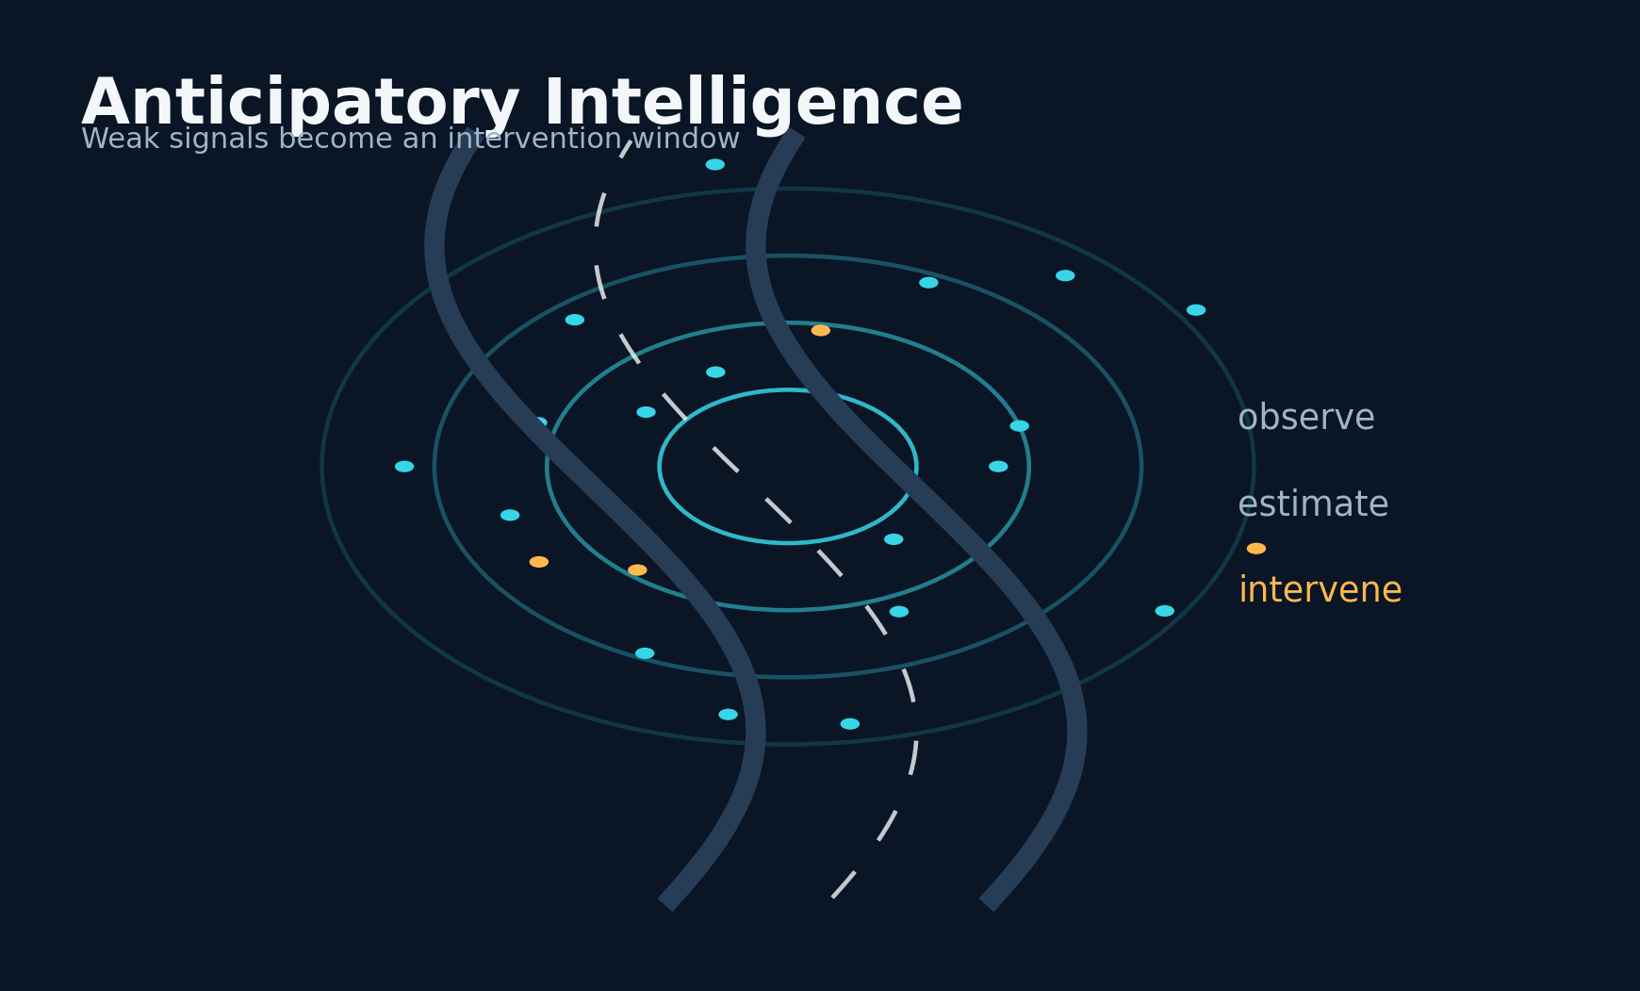
Figure 1. The Shift Before the Signal - conceptual system diagram created for this book.
STORY AND SYSTEM
I did not begin with a laboratory, a fleet contract, or a grant. I began with miles. Delivery work placed me inside a continuously changing experiment: wet pavement after a sudden storm, a restaurant parking lot that emptied into fast traffic, headlights bending around a blind hill, a tired driver drifting toward the center line, and the quiet uncertainty of a road that looked ordinary until it did not. I started to think of every trip as a stream of weak signals. None of them proved that a crash would occur. Together, however, they could form a pattern strong enough to justify slowing down, changing a route, or refusing a risky choice.
The central idea of this book is not supernatural prediction. It is anticipatory intelligence. An intelligent thinking system should gather many small indicators, estimate how they interact, express uncertainty honestly, and produce an intervention before the danger becomes irreversible. The word oracle is useful only as a design challenge: can a system feel uncannily early while remaining technically grounded? The honest target is not certainty. The target is a calibrated lead time in which a person still has options.
ANTICIPATORY RISK STATE
r_t = P(H_t:t+Δ=1 | o_0:t, c_t)
The system estimates the probability of a harmful event H within a future horizon, conditioned on observations o and context c.

A road-risk system can be framed as a state estimator. At time t, it receives observations such as weather, light, location, traffic behavior, road geometry, driver condition, vehicle condition, and recent anomalies. It transforms them into a latent risk state, then updates that state as new evidence arrives. The design question is not simply which model is smartest. It is which architecture can preserve context, resist corrupted inputs, explain its recommendation, and remain available when connectivity or cloud services fail.
My work moved through several forms: early quantum-vision experiments, longer cloud-model risk narratives, a secured web scanner, a compact Kivy application, a Termux-friendly local command-line system called Naza, and eventually a Flutter application with a hardened encrypted vault. Each version solved a different failure. The story therefore matters as much as the final architecture. Safety systems are rarely invented once. They are rebuilt each time reality exposes an assumption that was too optimistic.
This opening chapter establishes the discipline used throughout the book. I will separate firsthand field observations from independently verified evidence; software behavior from causal claims; quantum-inspired computation from quantum advantage; and a persuasive safety assistant from an autonomous driving controller. That separation is not a retreat from ambition. It is the condition that lets ambitious engineering survive contact with the road.
DESIGN LENSES

Lead-time design
The first engineering lens in this chapter is lead-time design. To build it, define the earliest moment at which context becomes decision-relevant, then keep a separate clock for detection, comprehension, and action. The implementation should make the state visible rather than hide it inside a prompt. The evidence standard is concrete: timestamped episodes and measured intervention latency. This matters because the system will eventually meet a condition that the original builder did not imagine. At that moment, explicit state, timestamps, provenance, and bounded interfaces make the difference between a failure that can be understood and a story that can only be retold. A practical implementation should log the inputs that moved the state, the policy version that interpreted them, the uncertainty before and after the update, and the action made available to the user. The resulting record supports calibration, debugging, and later independent review. The primary failure to test is a dramatic warning that arrives after commitment to the maneuver. The countermeasure is not more confident prose. It is a rule, a comparison, or a fallback that remains valid when the model is wrong. For the shift before the signal, this is the bridge between an evocative concept and a durable intelligent thinking system.

State estimation
A second layer of the design is state estimation. To build it, maintain a rolling belief state rather than asking a stateless model to reinvent the scene on every request. The method works only when its intermediate decisions are recorded and inspectable. The evidence standard is concrete: changes in risk should be traceable to changes in evidence. This matters because the system will eventually meet a condition that the original builder did not imagine. At that moment, explicit state, timestamps, provenance, and bounded interfaces make the difference between a failure that can be understood and a story that can only be retold. A practical implementation should log the inputs that moved the state, the policy version that interpreted them, the uncertainty before and after the update, and the action made available to the user. That separation also allows a compact local model to participate without owning the entire conclusion. The primary failure to test is context windows that silently forget or overwrite earlier observations. The countermeasure is not more confident prose. It is a rule, a comparison, or a fallback that remains valid when the model is wrong. For the shift before the signal, this is the bridge between an evocative concept and a durable intelligent thinking system.

Claim discipline
The chapter becomes operational through claim discipline. To build it, label every statement as observation, model inference, author interpretation, or independently verified fact. This turns a broad idea into a component that can be tested, replaced, and improved. The evidence standard is concrete: future collaborators can reproduce the claim boundary. This matters because the system will eventually meet a condition that the original builder did not imagine. At that moment, explicit state, timestamps, provenance, and bounded interfaces make the difference between a failure that can be understood and a story that can only be retold. A practical implementation should log the inputs that moved the state, the policy version that interpreted them, the uncertainty before and after the update, and the action made available to the user. In a safety context, graceful degradation is more valuable than an impressive all-or-nothing demonstration. The primary failure to test is mixing an emotionally powerful experience with a scientific conclusion. The countermeasure is not more confident prose. It is a rule, a comparison, or a fallback that remains valid when the model is wrong. For the shift before the signal, this is the bridge between an evocative concept and a durable intelligent thinking system.
FIELD NOTE
Write down one trip that felt unsafe before anything visibly went wrong. Separate what you sensed, what you inferred, and what you later confirmed.

Practice Lab
The exercises below are designed to produce evidence and system artifacts rather than opinions. Complete them in a parked, safe environment and preserve the results with a date and version.
1. List ten weak road signals available before a hazard becomes obvious.
2. Choose a prediction horizon that would still allow a useful intervention.
3. Define what a false alarm would cost in your own driving context.
◆ ◆ ◆

02
THE ROAD BECOMES A LABORATORY

Delivery Miles as Data
Repetition turns a route into an instrument.
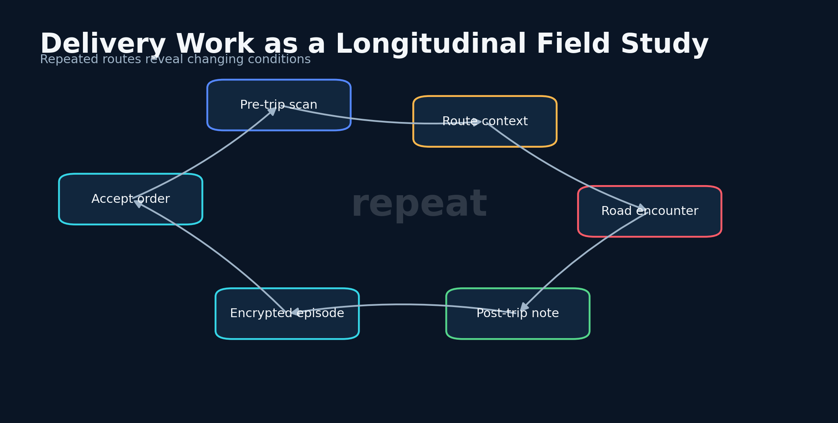
Figure 2. Delivery Miles as Data - conceptual system diagram created for this book.
STORY AND SYSTEM
A delivery driver revisits the same roads under different conditions. That repetition creates a form of comparative sensing. A curve that is harmless at noon may become dangerous at midnight. A restaurant exit that is manageable on Tuesday may become chaotic on Friday. A familiar highway interchange reveals where drivers brake late, where rain collects, and where animals cross. I learned that ordinary work could become a longitudinal field study if I recorded context instead of relying only on memory.
The first methodological lesson was to treat each trip as an episode rather than an anecdote. An episode has a start time, route, destination, environmental conditions, model output, human decision, observed hazards, and outcome. Even when the data are incomplete, the schema disciplines attention. It prevents the story from being rewritten after the fact. A model that predicts high risk on every trip is not useful, and a driver who remembers only the dramatic successes cannot measure reliability.
EPISODE RECORD
E_i = (x_i, a_i, ^ r_i, y_i, n_i)
Each episode stores context x, action a, predicted risk, observed outcome y, and a narrative note n.

Delivery work also exposes selection bias. I chose which orders to accept, which roads to avoid, and when to stop working. Those decisions alter the data. If the scanner warns me away from a route, I may never observe whether the predicted event would have occurred. This is a classic counterfactual problem. The system can still be evaluated, but it requires proxy outcomes such as hard braking, near-conflict observations, police activity, debris, wildlife, visibility loss, or a route deviation that reduced exposure.
A practical field log should combine structured variables with a short narrative. Structured fields make comparison possible; narrative preserves details that were not anticipated by the schema. I used the same principle in software. The compact classifier might output Low, Medium, or High, while the longer model explained why traffic flow, fatigue, location, time, or recent anomalies changed the risk estimate. The two representations serve different cognitive jobs.
The deeper point is that work can become research without pretending that it is a controlled trial. A disciplined independent builder can generate hypotheses, identify failure modes, and create an evidence trail. The next step is collaboration with researchers, transportation agencies, insurers, fleet operators, and communities that can provide larger datasets and independent validation. Field experience is not the end of science, but it can be the beginning of the right question.
DESIGN LENSES

Episode instrumentation
The first engineering lens in this chapter is episode instrumentation. To build it, capture route, time, weather, prediction, user action, outcome, and a short parked-vehicle voice note under one identifier. The implementation should make the state visible rather than hide it inside a prompt. The evidence standard is concrete: the record should exist before memory begins editing the event. This matters because the system will eventually meet a condition that the original builder did not imagine. At that moment, explicit state, timestamps, provenance, and bounded interfaces make the difference between a failure that can be understood and a story that can only be retold. A practical implementation should log the inputs that moved the state, the policy version that interpreted them, the uncertainty before and after the update, and the action made available to the user. The resulting record supports calibration, debugging, and later independent review. The primary failure to test is collecting data while moving and creating a distraction hazard. The countermeasure is not more confident prose. It is a rule, a comparison, or a fallback that remains valid when the model is wrong. For delivery miles as data, this is the bridge between an evocative concept and a durable intelligent thinking system.

Counterfactual logging
A second layer of the design is counterfactual logging. To build it, record the route or action that was avoided and identify observable proxies for what happened instead. The method works only when its intermediate decisions are recorded and inspectable. The evidence standard is concrete: prevented exposure can be analyzed even when the predicted event is never directly observed. This matters because the system will eventually meet a condition that the original builder did not imagine. At that moment, explicit state, timestamps, provenance, and bounded interfaces make the difference between a failure that can be understood and a story that can only be retold. A practical implementation should log the inputs that moved the state, the policy version that interpreted them, the uncertainty before and after the update, and the action made available to the user. That separation also allows a compact local model to participate without owning the entire conclusion. The primary failure to test is claiming that every avoided route proves the alert was correct. The countermeasure is not more confident prose. It is a rule, a comparison, or a fallback that remains valid when the model is wrong. For delivery miles as data, this is the bridge between an evocative concept and a durable intelligent thinking system.

Repeated-route comparison
The chapter becomes operational through repeated-route comparison. To build it, compare the same segment across dayparts and conditions while preserving a stable segment definition. This turns a broad idea into a component that can be tested, replaced, and improved. The evidence standard is concrete: within-location contrasts reduce some geographic confounding. This matters because the system will eventually meet a condition that the original builder did not imagine. At that moment, explicit state, timestamps, provenance, and bounded interfaces make the difference between a failure that can be understood and a story that can only be retold. A practical implementation should log the inputs that moved the state, the policy version that interpreted them, the uncertainty before and after the update, and the action made available to the user. In a safety context, graceful degradation is more valuable than an impressive all-or-nothing demonstration. The primary failure to test is changing the segment boundary after seeing the result. The countermeasure is not more confident prose. It is a rule, a comparison, or a fallback that remains valid when the model is wrong. For delivery miles as data, this is the bridge between an evocative concept and a durable intelligent thinking system.
FIELD NOTE
Build a one-page trip record. Complete it before, during, and immediately after one real trip without changing earlier entries.

Practice Lab
The exercises below are designed to produce evidence and system artifacts rather than opinions. Complete them in a parked, safe environment and preserve the results with a date and version.
1. Identify three selection biases in your route history.
2. Define five proxy outcomes for a prevented or avoided incident.
3. Create a consistent naming convention for field episodes.
◆ ◆ ◆

03
THE ROAD BECOMES A LABORATORY

Hurricane Helene and the Invisible Road
A camera sees what is present; a thinking system also asks what is likely to be present around the next bend.
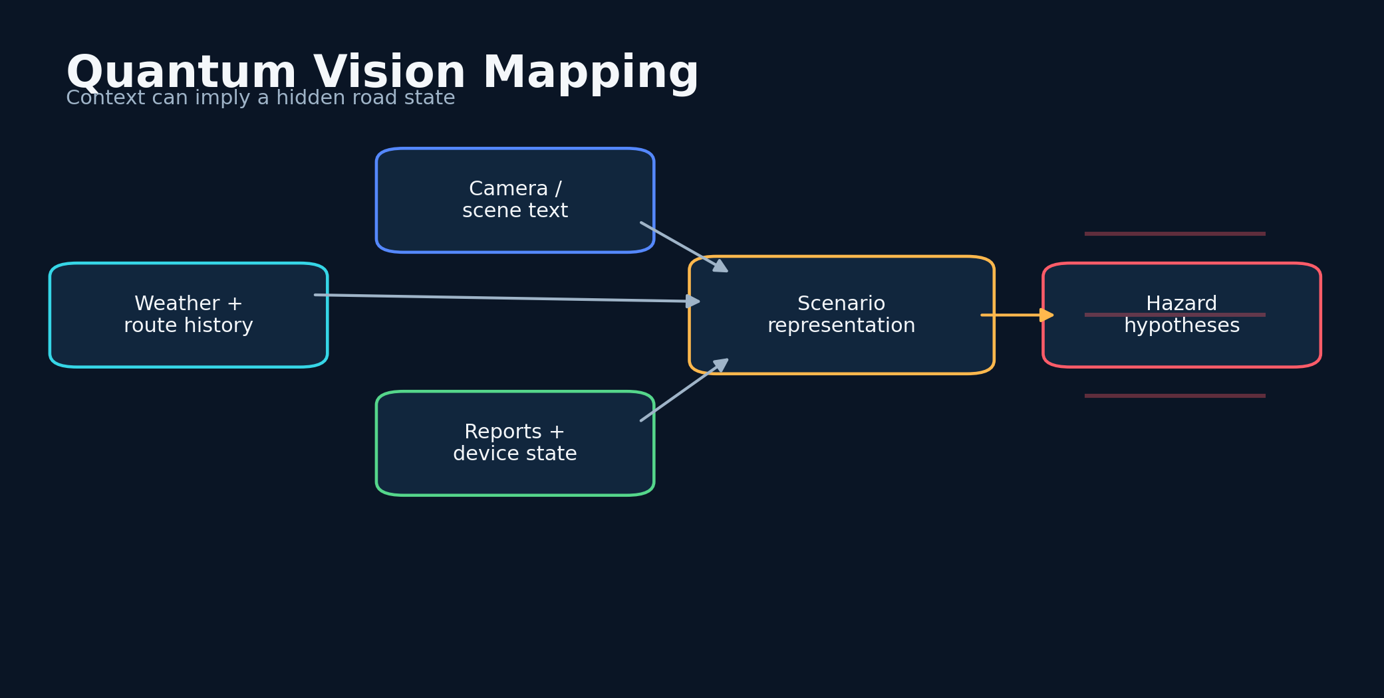
Figure 3. Hurricane Helene and the Invisible Road - conceptual system diagram created for this book.
STORY AND SYSTEM
One of the earliest public threads in this work appears in the Quantum Vision Scanner project. Its README connects the idea to delivery driving during Hurricane Helene and to the experience of navigating roads where fallen trees and damaged infrastructure could change faster than ordinary maps. The project narrative describes a surprising moment: before camera input was fully integrated, the system produced a warning about trees in the route, and the later drive appeared to match that warning. I treat that episode as a firsthand field report and a hypothesis-generating event, not as controlled proof of paranormal foresight.
The engineering value of the episode is independent of its dramatic interpretation. Storm conditions create spatially correlated hazards. High winds, saturated soil, tree density, recent reports, power outages, road class, and cleanup lag can all raise the conditional probability of obstruction. A model can infer an unseen hazard from context because the world is structured. Prediction is often the reconstruction of hidden state from indirect evidence.
HIDDEN HAZARD INFERENCE
P(z_t | x_t) ∝ P(x_t | z_t)P(z_t)
The unseen hazard state z is inferred from contextual evidence x and a prior shaped by place, weather, and history.

The early scanner mixed classical context with a simulated quantum circuit. The circuit was not a magical sensor. It was a nonlinear transformation that introduced an additional state representation. That representation could be used to vary attention, generate an entropy score, or explore combinations of features. The enduring insight was the architecture: collect evidence, transform it through multiple perspectives, and ask the language model to explain a safety-relevant consequence.
Vision mapping also introduced a humane motivation. A system that anticipates obstacles can help a driver, but it can also help a person with limited vision understand what a route contains. This widens the design target from crash prediction to accessible environmental intelligence. The interface should not merely display a probability. It should translate the environment into language, vibration, color, and timing that match the user's needs.
The storm taught me to design for incomplete sensors. Cameras can be blocked, networks can fail, GPS can drift, and public reports can be delayed. A resilient scanner degrades gracefully. It should use whatever evidence remains, lower its confidence, and make conservative recommendations. The absence of a sensor is itself information, especially when the missing channel is the one the system normally depends on most.
DESIGN LENSES

Storm priors
The first engineering lens in this chapter is storm priors. To build it, combine wind, soil saturation, tree cover, outage reports, road class, and cleanup delay into a spatial prior. The implementation should make the state visible rather than hide it inside a prompt. The evidence standard is concrete: hidden obstructions become inferable through causal context. This matters because the system will eventually meet a condition that the original builder did not imagine. At that moment, explicit state, timestamps, provenance, and bounded interfaces make the difference between a failure that can be understood and a story that can only be retold. A practical implementation should log the inputs that moved the state, the policy version that interpreted them, the uncertainty before and after the update, and the action made available to the user. The resulting record supports calibration, debugging, and later independent review. The primary failure to test is mistaking a broad storm prior for knowledge of a specific fallen tree. The countermeasure is not more confident prose. It is a rule, a comparison, or a fallback that remains valid when the model is wrong. For hurricane helene and the invisible road, this is the bridge between an evocative concept and a durable intelligent thinking system.

Sensor degradation
A second layer of the design is sensor degradation. To build it, assign every sensor a health state and explicitly propagate missingness into uncertainty. The method works only when its intermediate decisions are recorded and inspectable. The evidence standard is concrete: the system should remain useful when cameras, networks, or GPS are degraded. This matters because the system will eventually meet a condition that the original builder did not imagine. At that moment, explicit state, timestamps, provenance, and bounded interfaces make the difference between a failure that can be understood and a story that can only be retold. A practical implementation should log the inputs that moved the state, the policy version that interpreted them, the uncertainty before and after the update, and the action made available to the user. That separation also allows a compact local model to participate without owning the entire conclusion. The primary failure to test is replacing missing evidence with confident model invention. The countermeasure is not more confident prose. It is a rule, a comparison, or a fallback that remains valid when the model is wrong. For hurricane helene and the invisible road, this is the bridge between an evocative concept and a durable intelligent thinking system.

Accessible translation
The chapter becomes operational through accessible translation. To build it, render the same environmental state as concise speech, haptic patterns, large type, and structured text. This turns a broad idea into a component that can be tested, replaced, and improved. The evidence standard is concrete: different users and situations require different channels. This matters because the system will eventually meet a condition that the original builder did not imagine. At that moment, explicit state, timestamps, provenance, and bounded interfaces make the difference between a failure that can be understood and a story that can only be retold. A practical implementation should log the inputs that moved the state, the policy version that interpreted them, the uncertainty before and after the update, and the action made available to the user. In a safety context, graceful degradation is more valuable than an impressive all-or-nothing demonstration. The primary failure to test is adding more information without reducing cognitive burden. The countermeasure is not more confident prose. It is a rule, a comparison, or a fallback that remains valid when the model is wrong. For hurricane helene and the invisible road, this is the bridge between an evocative concept and a durable intelligent thinking system.
FIELD NOTE
Choose one weather event and sketch the chain from environmental cause to road hazard to observable proxy signal.

Practice Lab
The exercises below are designed to produce evidence and system artifacts rather than opinions. Complete them in a parked, safe environment and preserve the results with a date and version.
1. Separate the Helene story into observed, inferred, and unverified elements.
2. Design a no-camera fallback mode.
3. Describe one accessibility interface beyond a visual dashboard.
◆ ◆ ◆

04
THE ROAD BECOMES A LABORATORY

Powdersville: A Warning Before the Turn
A case study is strongest when it includes what the system could not know.
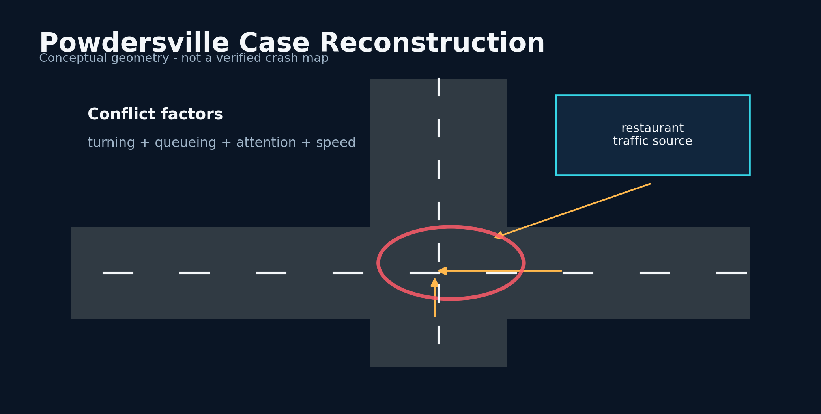
Figure 4. Powdersville: A Warning Before the Turn - conceptual system diagram created for this book.
STORY AND SYSTEM
In my field notes, one of the most memorable warnings involved the area near the Powdersville Chick-fil-A. The scanner indicated elevated accident risk before I encountered conditions that seemed to justify caution. The event stayed with me because it compressed the promise of the system into a familiar place: a busy commercial access point, turning traffic, queues, impatient merges, and drivers dividing attention between navigation, food pickup, and the road.
The responsible way to analyze the episode is to reconstruct plausible variables. Restaurant peaks create short bursts of traffic. Driveway geometry can produce crossing conflicts. A delivery driver may be watching an app, searching for an entrance, or deciding whether to make a late turn. Darkness, rain, glare, or congestion can amplify those risks. A language model trained on broad driving patterns can combine these cues even when it has never seen a crash at that exact location.
ACTION VALUE
V = P(H)C_H - C_A - P(F)C_F
The value of an alert depends on harm avoided, the cost of acting, and the cost of false alarms.

The episode also demonstrates the importance of base rates. If a location is routinely busy, a high-risk warning may be correct in a broad sense without predicting a specific collision. To claim event prediction, the system would need a defined time window, a pre-registered threshold, a timestamped output, and an independently documented incident. Without those elements, the proper claim is narrower: the scanner generated an actionable risk warning that aligned with a hazardous context as I experienced it.
That narrower claim still matters. Most safety benefits do not require a model to name the exact vehicle that will crash. A warning can reduce speed, increase following distance, postpone a turn, or move the driver's attention away from a phone. The value function should therefore include avoided exposure and improved behavior, not only correctly forecast collisions. A system that changes conduct at the right moment can be useful before its strongest predictive claims are proven.
I use the Powdersville story throughout the book as a template for evidence hygiene. Preserve the original output. Record the location coarsely enough to protect privacy. Note the timing, context, and action taken. Search for independent incident data when appropriate. Record misses with the same care as apparent hits. An oracle becomes engineering only when its memory is harder to bias than the human telling the story.
DESIGN LENSES

Commercial-access conflicts
The first engineering lens in this chapter is commercial-access conflicts. To build it, represent entrances, queues, turn lanes, delivery-app attention, and crossing paths as separate conflict generators. The implementation should make the state visible rather than hide it inside a prompt. The evidence standard is concrete: the alert can explain which ordinary mechanisms raised risk. This matters because the system will eventually meet a condition that the original builder did not imagine. At that moment, explicit state, timestamps, provenance, and bounded interfaces make the difference between a failure that can be understood and a story that can only be retold. A practical implementation should log the inputs that moved the state, the policy version that interpreted them, the uncertainty before and after the update, and the action made available to the user. The resulting record supports calibration, debugging, and later independent review. The primary failure to test is attributing the warning to a specific crash without independent incident data. The countermeasure is not more confident prose. It is a rule, a comparison, or a fallback that remains valid when the model is wrong. For powdersville: a warning before the turn, this is the bridge between an evocative concept and a durable intelligent thinking system.

Pre-registration
A second layer of the design is pre-registration. To build it, fix the time window, geographic radius, threshold, and outcome definition before checking what occurred. The method works only when its intermediate decisions are recorded and inspectable. The evidence standard is concrete: apparent hits and misses can be scored consistently. This matters because the system will eventually meet a condition that the original builder did not imagine. At that moment, explicit state, timestamps, provenance, and bounded interfaces make the difference between a failure that can be understood and a story that can only be retold. A practical implementation should log the inputs that moved the state, the policy version that interpreted them, the uncertainty before and after the update, and the action made available to the user. That separation also allows a compact local model to participate without owning the entire conclusion. The primary failure to test is moving the horizon until an event fits. The countermeasure is not more confident prose. It is a rule, a comparison, or a fallback that remains valid when the model is wrong. For powdersville: a warning before the turn, this is the bridge between an evocative concept and a durable intelligent thinking system.

Low-cost precautions
The chapter becomes operational through low-cost precautions. To build it, map uncertain context to reversible actions such as slowing modestly, increasing space, or choosing another entrance. This turns a broad idea into a component that can be tested, replaced, and improved. The evidence standard is concrete: useful behavior change does not require exact event prediction. This matters because the system will eventually meet a condition that the original builder did not imagine. At that moment, explicit state, timestamps, provenance, and bounded interfaces make the difference between a failure that can be understood and a story that can only be retold. A practical implementation should log the inputs that moved the state, the policy version that interpreted them, the uncertainty before and after the update, and the action made available to the user. In a safety context, graceful degradation is more valuable than an impressive all-or-nothing demonstration. The primary failure to test is issuing abrupt instructions that create a secondary conflict. The countermeasure is not more confident prose. It is a rule, a comparison, or a fallback that remains valid when the model is wrong. For powdersville: a warning before the turn, this is the bridge between an evocative concept and a durable intelligent thinking system.
FIELD NOTE
Reconstruct a memorable warning using a timestamped template. Add a column for alternative explanations.

Practice Lab
The exercises below are designed to produce evidence and system artifacts rather than opinions. Complete them in a parked, safe environment and preserve the results with a date and version.
1. Define a twenty-minute prediction window for a commercial intersection.
2. List five variables a model could infer without live crash data.
3. Write the strongest defensible claim and the claim that would overreach.
◆ ◆ ◆

05
THE ROAD BECOMES A LABORATORY

I-85, Pelzer, and the Deer in the Dark
The road contains agents that do not obey traffic law, model assumptions, or human schedules.
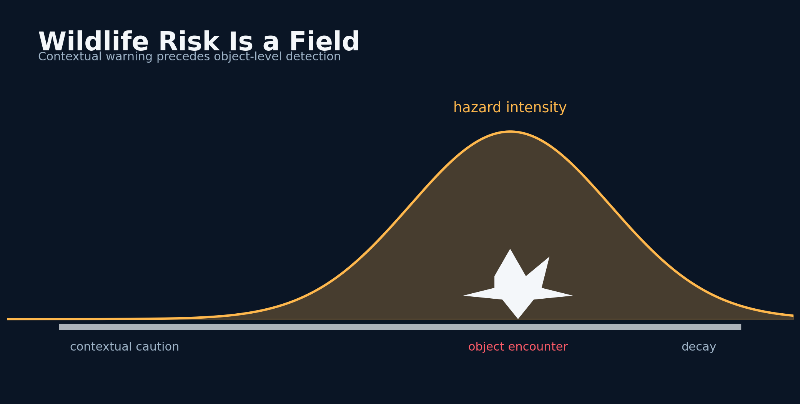
Figure 5. I-85, Pelzer, and the Deer in the Dark - conceptual system diagram created for this book.
STORY AND SYSTEM
Another field report involved Interstate 85 near the Pelzer exit, where the scanner warned about elevated danger and I later encountered deer in or near the road. Wildlife hazards are a useful test because they are both predictable and unpredictable. No model knows the exact movement of an individual animal, but seasonal behavior, vegetation, water, time of night, temperature, road-edge geometry, and prior sightings all change the probability of crossing.
A strong system would model wildlife risk as a spatiotemporal hazard field rather than a point prediction. The field rises near known corridors and during active periods, then decays with distance and time. A driver moving through the field converts environmental probability into personal exposure. Speed matters twice: it reduces reaction time and increases collision energy. Headlight range and road curvature determine how much of the hazard field is visible before intervention becomes impossible.
WILDLIFE EXPOSURE
R_wild(s,t) = λ(s,t) · v(t) · T_exp
A hazard intensity field lambda is converted into exposure by vehicle speed and time spent in the risky segment.

This case motivated a distinction between time-to-hazard and time-to-collision. A deer can be hidden but likely; a visible deer can be near but stationary; a moving deer can create a rapidly collapsing collision envelope. The scanner should move through stages: contextual caution, detected object, predicted path conflict, and emergency response. Language models are strongest in contextual reasoning and explanation. Dedicated perception and tracking models are better for frame-level geometry. The architecture should combine them rather than demand that one model do everything.
The anecdote also reveals the danger of hindsight. After seeing deer, it is easy to reinterpret every prior warning as precise. A rigorous log must capture the warning before the encounter and keep the original wording. It should also record all nights when the system warned about wildlife and no animal was seen. Absence of observation is not necessarily absence of wildlife, but it is still necessary for calibration.
The practical lesson is simple: an alert should recommend behavior that is safe even if the specific prediction is wrong. Slow modestly, scan the shoulders, increase space, and avoid overdriving the headlights. The system should never encourage sudden maneuvers based on uncertain inference. Good anticipatory intelligence buys time; it does not manufacture panic.
DESIGN LENSES

Wildlife intensity fields
The first engineering lens in this chapter is wildlife intensity fields. To build it, estimate crossing intensity across space and time, then integrate that intensity along the vehicle path. The implementation should make the state visible rather than hide it inside a prompt. The evidence standard is concrete: season, darkness, habitat, and speed jointly determine exposure. This matters because the system will eventually meet a condition that the original builder did not imagine. At that moment, explicit state, timestamps, provenance, and bounded interfaces make the difference between a failure that can be understood and a story that can only be retold. A practical implementation should log the inputs that moved the state, the policy version that interpreted them, the uncertainty before and after the update, and the action made available to the user. The resulting record supports calibration, debugging, and later independent review. The primary failure to test is drawing a precise animal location from a coarse contextual prior. The countermeasure is not more confident prose. It is a rule, a comparison, or a fallback that remains valid when the model is wrong. For i-85, pelzer, and the deer in the dark, this is the bridge between an evocative concept and a durable intelligent thinking system.

Context-to-perception cascade
A second layer of the design is context-to-perception cascade. To build it, use route context for early caution, detection for object confirmation, tracking for path conflict, and policy for action. The method works only when its intermediate decisions are recorded and inspectable. The evidence standard is concrete: each model performs the job its evidence supports. This matters because the system will eventually meet a condition that the original builder did not imagine. At that moment, explicit state, timestamps, provenance, and bounded interfaces make the difference between a failure that can be understood and a story that can only be retold. A practical implementation should log the inputs that moved the state, the policy version that interpreted them, the uncertainty before and after the update, and the action made available to the user. That separation also allows a compact local model to participate without owning the entire conclusion. The primary failure to test is asking a language model to replace frame-rate tracking. The countermeasure is not more confident prose. It is a rule, a comparison, or a fallback that remains valid when the model is wrong. For i-85, pelzer, and the deer in the dark, this is the bridge between an evocative concept and a durable intelligent thinking system.

Safe wildlife messaging
The chapter becomes operational through safe wildlife messaging. To build it, recommend shoulder scanning, headlight-limited speed, and increased stopping margin without predicting sudden animal motion. This turns a broad idea into a component that can be tested, replaced, and improved. The evidence standard is concrete: the action remains safe even when no deer appears. This matters because the system will eventually meet a condition that the original builder did not imagine. At that moment, explicit state, timestamps, provenance, and bounded interfaces make the difference between a failure that can be understood and a story that can only be retold. A practical implementation should log the inputs that moved the state, the policy version that interpreted them, the uncertainty before and after the update, and the action made available to the user. In a safety context, graceful degradation is more valuable than an impressive all-or-nothing demonstration. The primary failure to test is startling the driver with a directional command based on uncertain inference. The countermeasure is not more confident prose. It is a rule, a comparison, or a fallback that remains valid when the model is wrong. For i-85, pelzer, and the deer in the dark, this is the bridge between an evocative concept and a durable intelligent thinking system.
FIELD NOTE
Map a familiar wildlife corridor as a probability field, not a single dot. Mark how darkness and speed change the intervention window.

Practice Lab
The exercises below are designed to produce evidence and system artifacts rather than opinions. Complete them in a parked, safe environment and preserve the results with a date and version.
1. Define four stages of a wildlife alert.
2. Explain why a VLM should not replace object tracking.
3. Design a conservative alert message that avoids panic.
◆ ◆ ◆

PART 2
Building an Oracle Without Pretending to Be One
Prediction requires a contract with the future.
◆

06
BUILDING AN ORACLE WITHOUT PRETENDING TO BE ONE

What Prediction Must Mean
A prediction is a timestamped statement about a defined future, not a feeling remembered afterward.
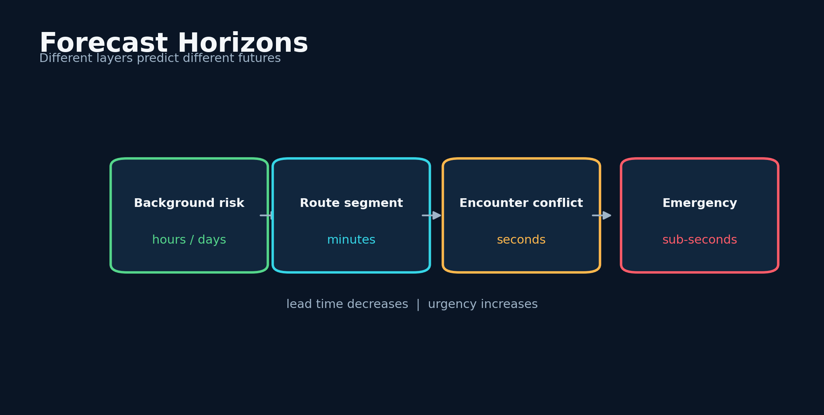
Figure 6. What Prediction Must Mean - conceptual system diagram created for this book.
STORY AND SYSTEM
The word prediction carries more weight than most prototypes can support. To use it responsibly, a system must specify an event, a horizon, a population, and a confidence. 'This road feels dangerous' is an assessment. 'There is a 0.32 probability of a conflict requiring hard braking within the next ten minutes on this route segment' is a prediction. Both can help, but they should not be evaluated by the same standard.
A car-accident prediction oracle is best understood as a stack of forecasts. At the widest scale, it estimates background risk from location, season, weather, and traffic. At the route scale, it identifies risky segments. At the encounter scale, it estimates conflict from motion and visibility. At the driver scale, it estimates whether fatigue, distraction, intoxication cues, stress, or urgency make a risky choice more likely. Each layer has a different clock and a different source of truth.
FORECAST DEFINITION
p̂_i = P(Y_i = 1 | X_i, τ, G)
A forecast is conditioned on inputs X, a fixed future horizon tau, and a geographic scope G.

Evaluation begins with pre-registration. Before looking at the outcome, define what counts as a positive event, how long the alert remains valid, how geographic overlap is measured, and what threshold triggers intervention. Preserve every prediction, not only the interesting ones. This prevents the model and the author from moving the goalposts after the road reveals what happened.
Prediction should also be compared with meaningful baselines. A weather-only model, a location-history model, a speed-and-time heuristic, and a simple logistic regression may outperform an elaborate architecture in some settings. The advanced system earns its complexity only if it adds calibrated lead time, improves recall at an acceptable false-alarm rate, or provides explanations that change behavior more effectively.
The oracle metaphor remains valuable because it sets an emotional standard: the warning should arrive before the user knows why it matters. The scientific standard is different: the warning must be reproducible, scored against a baseline, and accompanied by uncertainty. Holding both standards at once produces a system that is imaginative in design and restrained in claims.
DESIGN LENSES

Forecast contracts
The first engineering lens in this chapter is forecast contracts. To build it, write event, population, geography, horizon, threshold, and confidence into a machine-readable prediction object. The implementation should make the state visible rather than hide it inside a prompt. The evidence standard is concrete: every score can be audited against the same definition. This matters because the system will eventually meet a condition that the original builder did not imagine. At that moment, explicit state, timestamps, provenance, and bounded interfaces make the difference between a failure that can be understood and a story that can only be retold. A practical implementation should log the inputs that moved the state, the policy version that interpreted them, the uncertainty before and after the update, and the action made available to the user. The resulting record supports calibration, debugging, and later independent review. The primary failure to test is using vague labels that cannot be falsified. The countermeasure is not more confident prose. It is a rule, a comparison, or a fallback that remains valid when the model is wrong. For what prediction must mean, this is the bridge between an evocative concept and a durable intelligent thinking system.

Layered baselines
A second layer of the design is layered baselines. To build it, compare semantic models with weather-only, history-only, speed-time, and logistic baselines. The method works only when its intermediate decisions are recorded and inspectable. The evidence standard is concrete: complexity must earn its operational cost. This matters because the system will eventually meet a condition that the original builder did not imagine. At that moment, explicit state, timestamps, provenance, and bounded interfaces make the difference between a failure that can be understood and a story that can only be retold. A practical implementation should log the inputs that moved the state, the policy version that interpreted them, the uncertainty before and after the update, and the action made available to the user. That separation also allows a compact local model to participate without owning the entire conclusion. The primary failure to test is celebrating an advanced architecture that adds no lead time or calibration. The countermeasure is not more confident prose. It is a rule, a comparison, or a fallback that remains valid when the model is wrong. For what prediction must mean, this is the bridge between an evocative concept and a durable intelligent thinking system.

Lead-time scoring
The chapter becomes operational through lead-time scoring. To build it, score both correctness and how much actionable time the forecast preserved. This turns a broad idea into a component that can be tested, replaced, and improved. The evidence standard is concrete: an early moderate warning may be more valuable than a late precise one. This matters because the system will eventually meet a condition that the original builder did not imagine. At that moment, explicit state, timestamps, provenance, and bounded interfaces make the difference between a failure that can be understood and a story that can only be retold. A practical implementation should log the inputs that moved the state, the policy version that interpreted them, the uncertainty before and after the update, and the action made available to the user. In a safety context, graceful degradation is more valuable than an impressive all-or-nothing demonstration. The primary failure to test is treating all correct forecasts as equally useful. The countermeasure is not more confident prose. It is a rule, a comparison, or a fallback that remains valid when the model is wrong. For what prediction must mean, this is the bridge between an evocative concept and a durable intelligent thinking system.
FIELD NOTE
Rewrite three vague safety claims as testable forecasts with event, horizon, geography, and confidence.

Practice Lab
The exercises below are designed to produce evidence and system artifacts rather than opinions. Complete them in a parked, safe environment and preserve the results with a date and version.
1. Choose a primary and secondary outcome.
2. Specify a baseline that does not use an LLM.
3. Define how late an alert can arrive and still count as useful.
◆ ◆ ◆

07
BUILDING AN ORACLE WITHOUT PRETENDING TO BE ONE

From Hazard Language to Risk State
Language is not the output layer; it is one sensor among many.
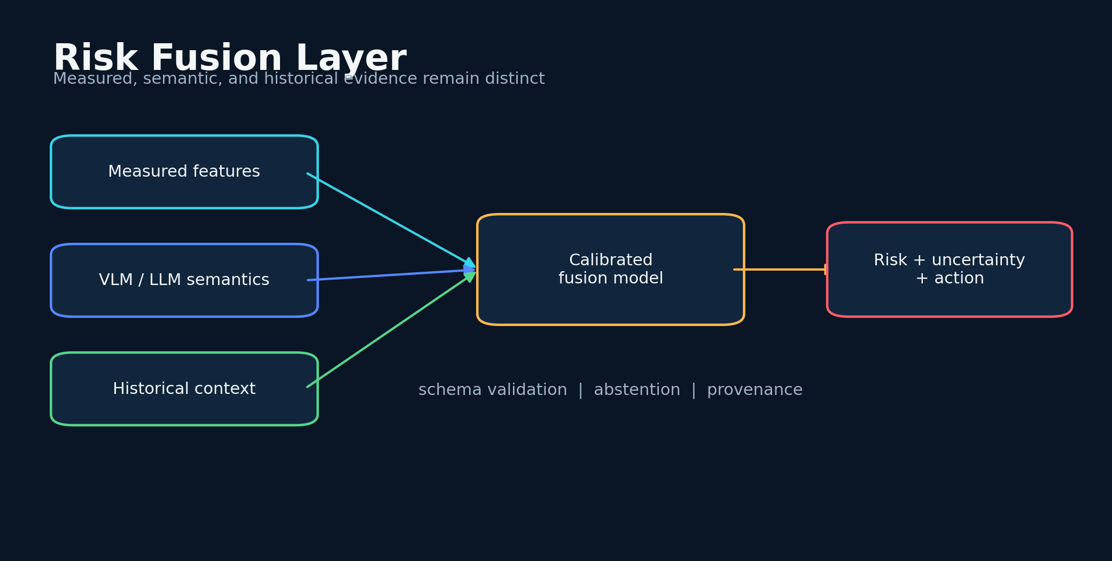
Figure 7. From Hazard Language to Risk State - conceptual system diagram created for this book.
STORY AND SYSTEM
The early systems asked language models to reason over descriptions of location, traffic, weather, obstacles, vehicle type, destination, and system metrics. This worked because road risk is partly semantic. 'A wet downhill curve after midnight' encodes relationships that are awkward to capture with a single handcrafted rule. A language model can map those relationships into a coherent explanation, but its prose must be converted into a stable machine state.
I therefore separate narrative reasoning from risk representation. The model may produce reasons, but the application stores normalized features, a risk score, a label, a confidence, and provenance. Provenance records which model, prompt, sensor values, and rules produced the output. This lets a later version reinterpret the same episode without erasing the original decision.
RISK FUSION
R_t = σ(β_0 + β^T x_t + γ z_t + δ h_t)
Measured features x, model-derived semantic state z, and historical context h are combined through a calibrated fusion layer.

A robust fusion layer combines deterministic features with model-derived features. Speed, road class, precipitation, visibility, and time are measurable. A VLM can add semantic cues such as aggressive weaving, ambiguous lane structure, or a driver looking away. A language model can add contextual priors. The fusion layer should weight each channel according to reliability and degrade the influence of stale or contradictory inputs.
Structured output is essential. Free-form text can hide uncertainty behind confident language. The scanner should demand a schema: risk probability, uncertainty, evidence list, missing information, recommended action, and abstention flag. The human-readable paragraph is generated from that schema, not the other way around. When the model fails to follow the schema, the system should reject or repair the output rather than silently guessing.
This design turns the LLM from an oracle into a reasoning component. It can still produce surprising synthesis, but it cannot directly control the final alert. The final state is bounded, audited, and checked against safety rules. That boundary is one of the most important lessons in building intelligent systems for high-consequence environments.
DESIGN LENSES

Structured semantics
The first engineering lens in this chapter is structured semantics. To build it, force model reasoning into fields for observations, assumptions, confidence, missing data, and recommended action. The implementation should make the state visible rather than hide it inside a prompt. The evidence standard is concrete: schema validation exposes unsupported certainty. This matters because the system will eventually meet a condition that the original builder did not imagine. At that moment, explicit state, timestamps, provenance, and bounded interfaces make the difference between a failure that can be understood and a story that can only be retold. A practical implementation should log the inputs that moved the state, the policy version that interpreted them, the uncertainty before and after the update, and the action made available to the user. The resulting record supports calibration, debugging, and later independent review. The primary failure to test is letting persuasive prose become the machine state. The countermeasure is not more confident prose. It is a rule, a comparison, or a fallback that remains valid when the model is wrong. For from hazard language to risk state, this is the bridge between an evocative concept and a durable intelligent thinking system.

Reliability-weighted fusion
A second layer of the design is reliability-weighted fusion. To build it, weight measured and semantic channels by authenticity, freshness, quality, and historical calibration. The method works only when its intermediate decisions are recorded and inspectable. The evidence standard is concrete: a stale high-quality source can be less useful than a fresh modest one. This matters because the system will eventually meet a condition that the original builder did not imagine. At that moment, explicit state, timestamps, provenance, and bounded interfaces make the difference between a failure that can be understood and a story that can only be retold. A practical implementation should log the inputs that moved the state, the policy version that interpreted them, the uncertainty before and after the update, and the action made available to the user. That separation also allows a compact local model to participate without owning the entire conclusion. The primary failure to test is counting every channel as an equal vote. The countermeasure is not more confident prose. It is a rule, a comparison, or a fallback that remains valid when the model is wrong. For from hazard language to risk state, this is the bridge between an evocative concept and a durable intelligent thinking system.

Abstention policy
The chapter becomes operational through abstention policy. To build it, define when the system must stop interpreting and return a standard defensive-driving fallback. This turns a broad idea into a component that can be tested, replaced, and improved. The evidence standard is concrete: safe silence is preferable to fabricated precision. This matters because the system will eventually meet a condition that the original builder did not imagine. At that moment, explicit state, timestamps, provenance, and bounded interfaces make the difference between a failure that can be understood and a story that can only be retold. A practical implementation should log the inputs that moved the state, the policy version that interpreted them, the uncertainty before and after the update, and the action made available to the user. In a safety context, graceful degradation is more valuable than an impressive all-or-nothing demonstration. The primary failure to test is repairing malformed output by inventing fields the model did not provide. The countermeasure is not more confident prose. It is a rule, a comparison, or a fallback that remains valid when the model is wrong. For from hazard language to risk state, this is the bridge between an evocative concept and a durable intelligent thinking system.
FIELD NOTE
Take one paragraph of road-risk prose and convert it into a strict JSON-like schema with evidence and missing-data fields.

Practice Lab
The exercises below are designed to produce evidence and system artifacts rather than opinions. Complete them in a parked, safe environment and preserve the results with a date and version.
1. Define three deterministic and three semantic features.
2. Create an abstention rule.
3. Describe how contradictory sensor and language outputs should be resolved.
◆ ◆ ◆

08
BUILDING AN ORACLE WITHOUT PRETENDING TO BE ONE

The Long-Form GPT-4o Risk Scanner
Long reasoning is valuable only when it becomes a short, safe decision at the right time.
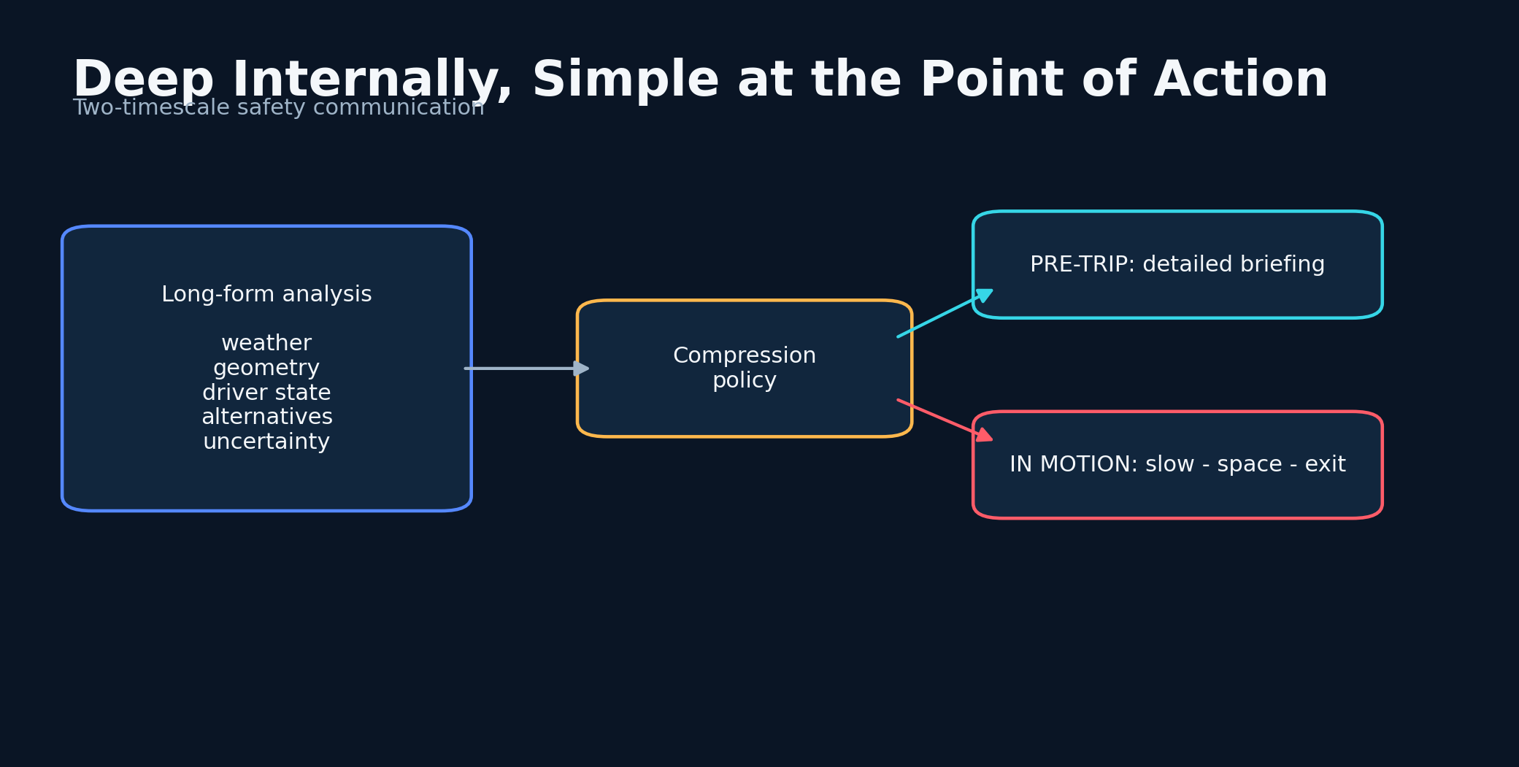
Figure 8. The Long-Form GPT-4o Risk Scanner - conceptual system diagram created for this book.
STORY AND SYSTEM
One important generation of the project used GPT-4o to create long-form road-risk analyses. The value was not merely verbosity. The model could consider multiple interacting pathways: weather changing stopping distance, fatigue changing attention, a delivery deadline changing decision pressure, road geometry changing visibility, and recent anomalies changing the prior. The longer response made hidden assumptions visible and often suggested precautions that a compact classifier would omit.
The weakness was latency and cognitive load. A driver cannot read several paragraphs while moving. The answer therefore needs two timescales. Before departure, a detailed briefing can explain route-level hazards, uncertainty, and alternatives. During the drive, the same reasoning must collapse into a small set of safe actions: slow, increase space, avoid the turn, pull over, or postpone. The original long-form text should remain available for audit after the trip.
TWO-TIMESCALE OUTPUT
D = g(R, E, U), A = q(D, t_avail)
Detailed reasoning D is generated from risk, evidence, and uncertainty; the action A is compressed according to available attention time.

Prompt design mattered. The scanner performed better when it was told to reason across independent hazard categories, search for interactions, challenge its first conclusion, and distinguish observed facts from assumptions. It also needed explicit prohibitions: do not claim access to live data unless provided, do not invent incidents, and do not present intoxication or impairment as a diagnosis. A safety prompt is not only a request for intelligence; it is a contract about evidence.
Long-form reasoning can also be decomposed into parallel passes. One pass evaluates environment, another evaluates driver state, another evaluates route geometry, another acts as a critic, and a final pass merges them. This reduces the chance that a single narrative dominates the decision. The later Naza work extended this idea with defense passes, entropy-driven model selection, and conservative anomaly bias.
The enduring contribution of the GPT-4o version was a style of thinking: write enough to expose causal chains, then compress the result into an intervention. The system should preserve the chain so that a human can ask why, but it should never require a person in motion to consume it. Safety intelligence must be deep internally and simple at the point of action.
DESIGN LENSES

Parallel reasoning passes
The first engineering lens in this chapter is parallel reasoning passes. To build it, separate environment, route, driver-state, critic, and synthesis passes with independent intermediate outputs. The implementation should make the state visible rather than hide it inside a prompt. The evidence standard is concrete: disagreement becomes visible before compression. This matters because the system will eventually meet a condition that the original builder did not imagine. At that moment, explicit state, timestamps, provenance, and bounded interfaces make the difference between a failure that can be understood and a story that can only be retold. A practical implementation should log the inputs that moved the state, the policy version that interpreted them, the uncertainty before and after the update, and the action made available to the user. The resulting record supports calibration, debugging, and later independent review. The primary failure to test is one long narrative anchoring every later conclusion. The countermeasure is not more confident prose. It is a rule, a comparison, or a fallback that remains valid when the model is wrong. For the long-form gpt-4o risk scanner, this is the bridge between an evocative concept and a durable intelligent thinking system.

Attention-aware compression
A second layer of the design is attention-aware compression. To build it, translate the same risk object into pre-trip, stopped-vehicle, and in-motion forms. The method works only when its intermediate decisions are recorded and inspectable. The evidence standard is concrete: message length should follow available attention rather than model capability. This matters because the system will eventually meet a condition that the original builder did not imagine. At that moment, explicit state, timestamps, provenance, and bounded interfaces make the difference between a failure that can be understood and a story that can only be retold. A practical implementation should log the inputs that moved the state, the policy version that interpreted them, the uncertainty before and after the update, and the action made available to the user. That separation also allows a compact local model to participate without owning the entire conclusion. The primary failure to test is displaying a beautiful paragraph when the user needs three words. The countermeasure is not more confident prose. It is a rule, a comparison, or a fallback that remains valid when the model is wrong. For the long-form gpt-4o risk scanner, this is the bridge between an evocative concept and a durable intelligent thinking system.

Prompt evidence contract
The chapter becomes operational through prompt evidence contract. To build it, state which tools and live sources are actually available and prohibit invented incidents or hidden access. This turns a broad idea into a component that can be tested, replaced, and improved. The evidence standard is concrete: the model can reason deeply without misrepresenting evidence. This matters because the system will eventually meet a condition that the original builder did not imagine. At that moment, explicit state, timestamps, provenance, and bounded interfaces make the difference between a failure that can be understood and a story that can only be retold. A practical implementation should log the inputs that moved the state, the policy version that interpreted them, the uncertainty before and after the update, and the action made available to the user. In a safety context, graceful degradation is more valuable than an impressive all-or-nothing demonstration. The primary failure to test is confusing general world knowledge with current road observation. The countermeasure is not more confident prose. It is a rule, a comparison, or a fallback that remains valid when the model is wrong. For the long-form gpt-4o risk scanner, this is the bridge between an evocative concept and a durable intelligent thinking system.
FIELD NOTE
Write a five-paragraph pre-trip analysis, then compress it into a seven-word in-motion alert without losing the main action.

Practice Lab
The exercises below are designed to produce evidence and system artifacts rather than opinions. Complete them in a parked, safe environment and preserve the results with a date and version.
1. Design four independent reasoning passes.
2. Write three anti-hallucination prompt constraints.
3. Define which explanations are stored for later audit.
◆ ◆ ◆

09
BUILDING AN ORACLE WITHOUT PRETENDING TO BE ONE

Time-to-Collision and Time-to-Intervention
The safest prediction is not the most dramatic; it is the one with enough lead time to change the trajectory.
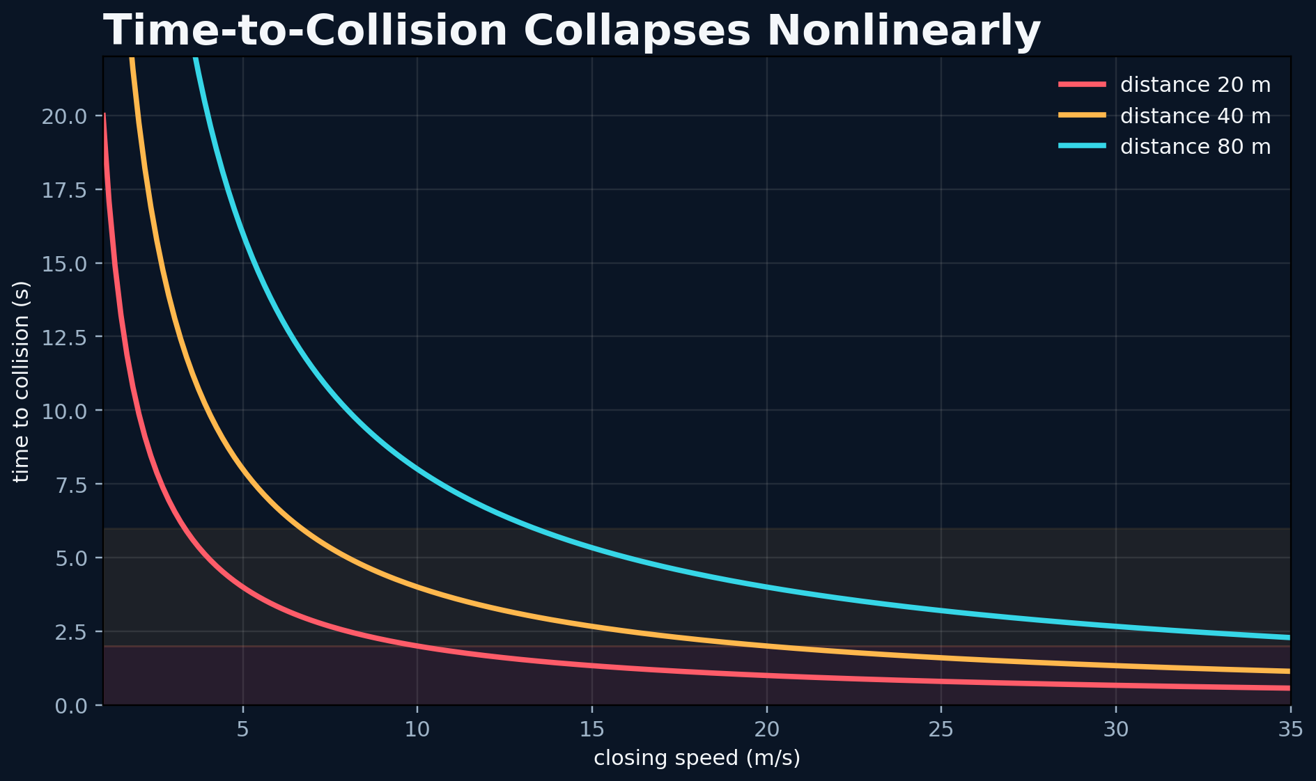
Figure 9. Time-to-Collision and Time-to-Intervention - conceptual system diagram created for this book.
STORY AND SYSTEM
Accident prediction becomes concrete when expressed in time. Time-to-collision estimates how long two trajectories can continue before intersecting. Time-to-intervention asks a more human question: how long remains before a safe response is no longer practical? The second quantity includes perception delay, decision delay, vehicle response, road friction, and the need to avoid creating a new hazard.
A context model may warn minutes before a dangerous segment, while a perception model may warn seconds before a conflict. These are not competing predictions. They form a cascade. The route-level system changes vigilance and speed. The encounter-level system tracks objects. The emergency layer invokes a direct warning or vehicle control only when certified and appropriate. The architecture should preserve responsibility boundaries between advisory software and safety-critical control.
TIME TO COLLISION
TTC = d / max(v_rel, ε)
Distance d is divided by closing speed, with epsilon preventing unstable division; real systems use trajectory distributions and uncertainty.

A simple time-to-collision calculation divides distance by closing speed, but real traffic is nonlinear. Vehicles accelerate, lanes curve, and drivers react. Probabilistic trajectory sets are more useful than a single line. Each agent has several plausible futures, and the system estimates overlap. A VLM can explain the scene, but numerical tracking should calculate the geometry.
Time-to-intervention also changes the communication channel. At sixty seconds, the system can speak a sentence. At ten seconds, it should use a short phrase or tone. At two seconds, extra language may be harmful. The interface should become less conversational as urgency rises. This is one reason a beautiful dashboard is not enough; the timing policy is part of the safety model.
The oracle should be judged by lead-time distribution, not only accuracy. A correct warning that arrives after the driver has committed to a turn may be operationally useless. A slightly less certain warning that arrives early and recommends a low-cost precaution may create more safety value. The goal is not merely to predict the road. It is to preserve the future in which the driver can still choose.
DESIGN LENSES

Probabilistic trajectories
The first engineering lens in this chapter is probabilistic trajectories. To build it, predict sets of plausible paths with uncertainty rather than extending a single velocity vector. The implementation should make the state visible rather than hide it inside a prompt. The evidence standard is concrete: curves, acceleration, and intent create branching futures. This matters because the system will eventually meet a condition that the original builder did not imagine. At that moment, explicit state, timestamps, provenance, and bounded interfaces make the difference between a failure that can be understood and a story that can only be retold. A practical implementation should log the inputs that moved the state, the policy version that interpreted them, the uncertainty before and after the update, and the action made available to the user. The resulting record supports calibration, debugging, and later independent review. The primary failure to test is a stable-looking TTC number hiding model uncertainty. The countermeasure is not more confident prose. It is a rule, a comparison, or a fallback that remains valid when the model is wrong. For time-to-collision and time-to-intervention, this is the bridge between an evocative concept and a durable intelligent thinking system.

Human response budget
A second layer of the design is human response budget. To build it, subtract perception, comprehension, decision, and vehicle-response delays from nominal TTC. The method works only when its intermediate decisions are recorded and inspectable. The evidence standard is concrete: time-to-intervention is the quantity the interface can influence. This matters because the system will eventually meet a condition that the original builder did not imagine. At that moment, explicit state, timestamps, provenance, and bounded interfaces make the difference between a failure that can be understood and a story that can only be retold. A practical implementation should log the inputs that moved the state, the policy version that interpreted them, the uncertainty before and after the update, and the action made available to the user. That separation also allows a compact local model to participate without owning the entire conclusion. The primary failure to test is warning at the mathematical collision boundary. The countermeasure is not more confident prose. It is a rule, a comparison, or a fallback that remains valid when the model is wrong. For time-to-collision and time-to-intervention, this is the bridge between an evocative concept and a durable intelligent thinking system.

Urgency channel policy
The chapter becomes operational through urgency channel policy. To build it, reduce words and interaction as urgency increases, then move from explanation to tone or haptic cue. This turns a broad idea into a component that can be tested, replaced, and improved. The evidence standard is concrete: communication must not consume the remaining response time. This matters because the system will eventually meet a condition that the original builder did not imagine. At that moment, explicit state, timestamps, provenance, and bounded interfaces make the difference between a failure that can be understood and a story that can only be retold. A practical implementation should log the inputs that moved the state, the policy version that interpreted them, the uncertainty before and after the update, and the action made available to the user. In a safety context, graceful degradation is more valuable than an impressive all-or-nothing demonstration. The primary failure to test is using escalating animation that captures the driver's eyes. The countermeasure is not more confident prose. It is a rule, a comparison, or a fallback that remains valid when the model is wrong. For time-to-collision and time-to-intervention, this is the bridge between an evocative concept and a durable intelligent thinking system.
FIELD NOTE
For one common hazard, calculate the available response time at three speeds and compare it with realistic human reaction time.

Practice Lab
The exercises below are designed to produce evidence and system artifacts rather than opinions. Complete them in a parked, safe environment and preserve the results with a date and version.
1. Define alert formats for 60, 10, and 2 seconds.
2. List factors that make simple TTC misleading.
3. Choose a minimum useful lead time for route-level warnings.
◆ ◆ ◆

10
BUILDING AN ORACLE WITHOUT PRETENDING TO BE ONE

Calibration, False Alarms, and Humility
Confidence should describe the model's history, not its personality.
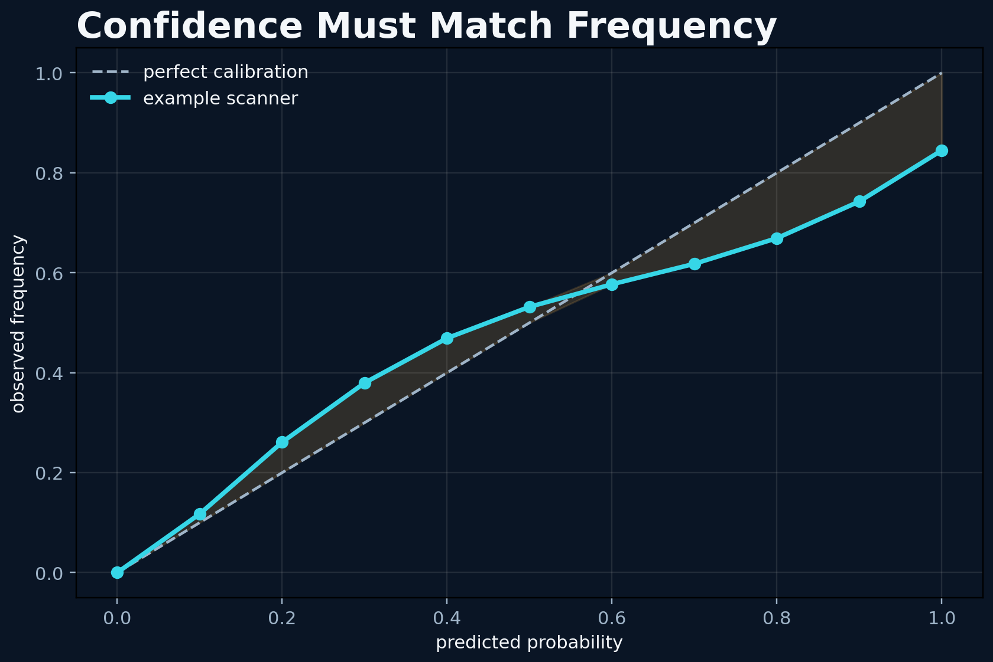
Figure 10. Calibration, False Alarms, and Humility - conceptual system diagram created for this book.
STORY AND SYSTEM
A safety model can be accurate on average and still be dangerous if its confidence is wrong. Calibration asks whether events predicted at thirty percent actually occur about thirty percent of the time under comparable conditions. Language models often sound certain even when their evidence is weak. The application must therefore learn confidence from outcomes rather than copy the model's tone.
False alarms create their own hazard. If the scanner repeatedly warns about events that do not materialize, the user learns to ignore it. This is alarm fatigue. On the other hand, setting the threshold too high misses rare but severe events. The correct threshold depends on the cost of the intervention. A gentle suggestion to increase following distance can use a lower threshold than an instruction to stop a trip.
EXPECTED CALIBRATION ERROR
ECE = Σ_b=1^B (|S_b|)/(n)|acc(S_b)-conf(S_b)|
Predictions are grouped into confidence bins and compared with observed frequency.

Calibration requires complete logs, including quiet days. Reliability diagrams, Brier scores, precision-recall curves, and expected calibration error reveal different aspects of performance. Because crashes are rare, near-miss and conflict data may provide denser signals, but proxy labels must be defined carefully. The system should report performance separately across weather, road type, time, and region so that an average does not hide a weak subgroup.
Uncertainty should include data uncertainty and model uncertainty. Data uncertainty arises from noisy or missing sensors. Model uncertainty arises when the current scene differs from training experience. An abstention can be a successful output: 'I do not have enough reliable information; use standard defensive driving.' The system becomes safer when it knows how to become less impressive.
Humility is an engineering feature. It appears in the user interface, the source notes, the model card, and the wording of every claim. The project can remain visionary while clearly saying what has not yet been validated. In fact, this clarity attracts the collaborations needed to turn independent experimentation into credible transportation research.
DESIGN LENSES

Calibration dataset
The first engineering lens in this chapter is calibration dataset. To build it, retain every prediction and outcome with fixed bins, including ordinary low-risk episodes. The implementation should make the state visible rather than hide it inside a prompt. The evidence standard is concrete: confidence can be learned from frequency rather than rhetoric. This matters because the system will eventually meet a condition that the original builder did not imagine. At that moment, explicit state, timestamps, provenance, and bounded interfaces make the difference between a failure that can be understood and a story that can only be retold. A practical implementation should log the inputs that moved the state, the policy version that interpreted them, the uncertainty before and after the update, and the action made available to the user. The resulting record supports calibration, debugging, and later independent review. The primary failure to test is evaluating only alerts that felt memorable. The countermeasure is not more confident prose. It is a rule, a comparison, or a fallback that remains valid when the model is wrong. For calibration, false alarms, and humility, this is the bridge between an evocative concept and a durable intelligent thinking system.

Threshold by action cost
A second layer of the design is threshold by action cost. To build it, set separate thresholds for informational, precautionary, stop-trip, and emergency interventions. The method works only when its intermediate decisions are recorded and inspectable. The evidence standard is concrete: the same probability can justify different actions. This matters because the system will eventually meet a condition that the original builder did not imagine. At that moment, explicit state, timestamps, provenance, and bounded interfaces make the difference between a failure that can be understood and a story that can only be retold. A practical implementation should log the inputs that moved the state, the policy version that interpreted them, the uncertainty before and after the update, and the action made available to the user. That separation also allows a compact local model to participate without owning the entire conclusion. The primary failure to test is using one red-line threshold for every consequence. The countermeasure is not more confident prose. It is a rule, a comparison, or a fallback that remains valid when the model is wrong. For calibration, false alarms, and humility, this is the bridge between an evocative concept and a durable intelligent thinking system.

Subgroup reliability
The chapter becomes operational through subgroup reliability. To build it, publish calibration by road type, weather, lighting, region, and device condition. This turns a broad idea into a component that can be tested, replaced, and improved. The evidence standard is concrete: aggregate performance can hide dangerous weak areas. This matters because the system will eventually meet a condition that the original builder did not imagine. At that moment, explicit state, timestamps, provenance, and bounded interfaces make the difference between a failure that can be understood and a story that can only be retold. A practical implementation should log the inputs that moved the state, the policy version that interpreted them, the uncertainty before and after the update, and the action made available to the user. In a safety context, graceful degradation is more valuable than an impressive all-or-nothing demonstration. The primary failure to test is claiming universality from one driver's routes. The countermeasure is not more confident prose. It is a rule, a comparison, or a fallback that remains valid when the model is wrong. For calibration, false alarms, and humility, this is the bridge between an evocative concept and a durable intelligent thinking system.
FIELD NOTE
Create a ten-bin reliability table for a hypothetical month of alerts. Include the alerts that seemed boring.

Practice Lab
The exercises below are designed to produce evidence and system artifacts rather than opinions. Complete them in a parked, safe environment and preserve the results with a date and version.
1. Assign different thresholds to three intervention costs.
2. Define one valid abstention message.
3. Choose two subgroup slices for calibration testing.
◆ ◆ ◆

PART 3
Quantum-Inspired Intelligence
Several possible roads exist before one is chosen.
◆

11
QUANTUM-INSPIRED INTELLIGENCE

Why I Reached for Quantum Language
Quantum language was first a way to think about competing possibilities, not a claim that the phone contained a quantum computer.
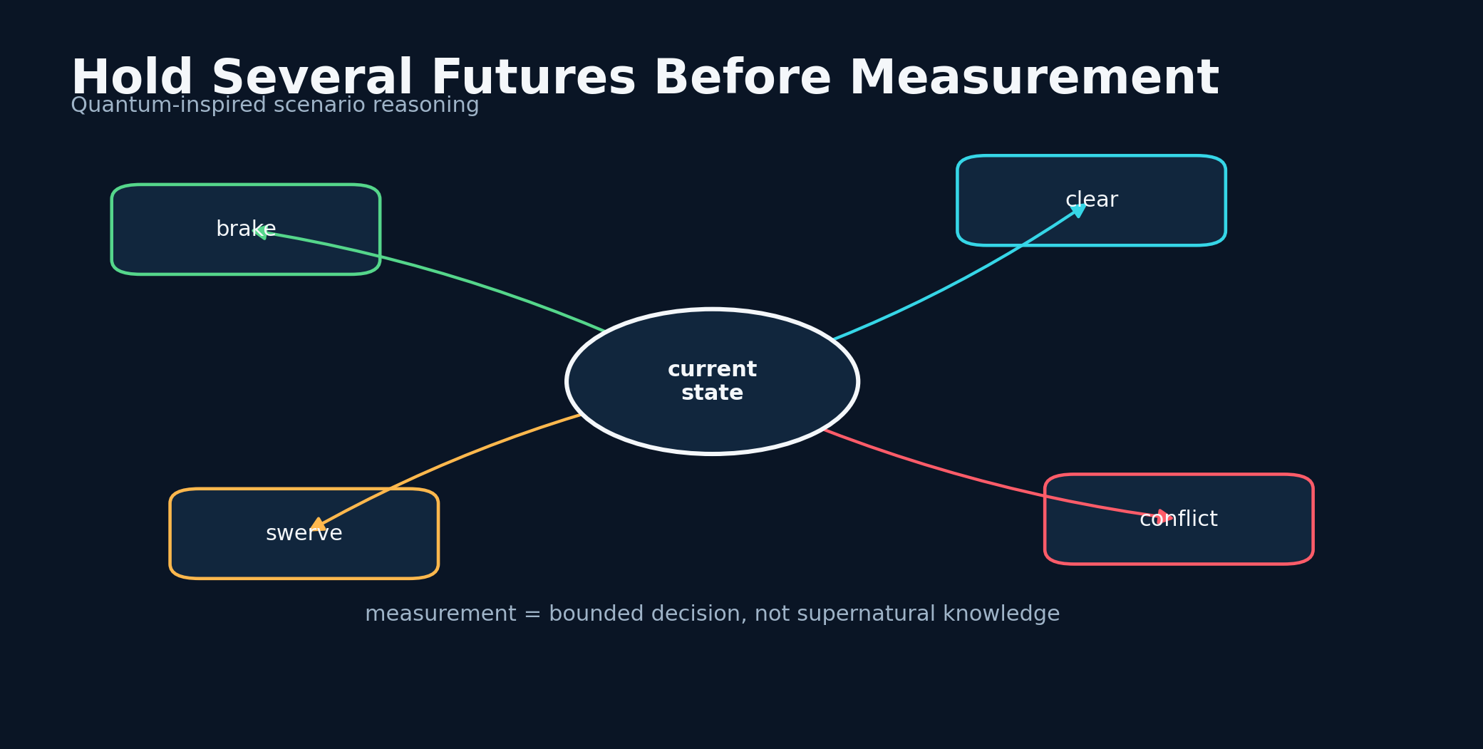
Figure 11. Why I Reached for Quantum Language - conceptual system diagram created for this book.
STORY AND SYSTEM
The road is a branching system. A vehicle may brake or accelerate. A deer may cross or retreat. A distracted driver may look up in time or continue drifting. Quantum language gave me a vocabulary for holding several possible futures together before forcing a decision. Superposition, entanglement, measurement, and entropy became design metaphors and, in some versions, computational ingredients implemented through simulators.
The distinction between metaphor, simulation, and hardware advantage is essential. The public projects use PennyLane circuits on classical devices. They can generate nonlinear features, expectation values, or stochastic structure, but they do not establish quantum speedup or access hidden physical information. This limitation does not make them useless. Many valuable algorithms begin as unusual feature maps or ways to organize search.
SCENARIO STATE
|ψ⟩ = Σ_k α_k |s_k⟩, Σ_k |α_k|^2=1
A normalized scenario representation is a useful conceptual model; in these projects it is simulated classically.

The early circuits encouraged a different question: instead of asking for one deterministic story, can the system represent several hypotheses and measure how fragile its conclusion is? A risk score that changes dramatically under small perturbations is less trustworthy. A circuit-inspired ensemble can sample alternatives, compare them, and expose disagreement. The practical goal is epistemic diversity.
Quantum terminology can also mislead users, so the interface must translate it. 'Entropy high' should not imply mystical danger. It can mean that the model's internal evidence is dispersed, the system state is unstable, or multiple scenarios remain plausible. The book uses quantum-inspired when the computation is classical and reserves quantum advantage for a claim that would require controlled benchmarking on appropriate hardware.
I kept the quantum layer because it changed how I designed the rest of the system. It pushed me toward ensembles, uncertainty, interference between evidence channels, and measurement as a decision boundary. The strongest legacy may not be a particular circuit. It may be the refusal to collapse the road into one story too early.
DESIGN LENSES

Scenario ensembles
The first engineering lens in this chapter is scenario ensembles. To build it, sample or construct several plausible futures and retain their disagreement until policy evaluation. The implementation should make the state visible rather than hide it inside a prompt. The evidence standard is concrete: premature narrative collapse is a major source of overconfidence. This matters because the system will eventually meet a condition that the original builder did not imagine. At that moment, explicit state, timestamps, provenance, and bounded interfaces make the difference between a failure that can be understood and a story that can only be retold. A practical implementation should log the inputs that moved the state, the policy version that interpreted them, the uncertainty before and after the update, and the action made available to the user. The resulting record supports calibration, debugging, and later independent review. The primary failure to test is choosing the most vivid scenario rather than the best-supported one. The countermeasure is not more confident prose. It is a rule, a comparison, or a fallback that remains valid when the model is wrong. For why i reached for quantum language, this is the bridge between an evocative concept and a durable intelligent thinking system.

Terminology boundary
A second layer of the design is terminology boundary. To build it, label metaphor, simulator output, and hardware execution separately in code, UI, and publication. The method works only when its intermediate decisions are recorded and inspectable. The evidence standard is concrete: users can understand what the quantum layer actually contributes. This matters because the system will eventually meet a condition that the original builder did not imagine. At that moment, explicit state, timestamps, provenance, and bounded interfaces make the difference between a failure that can be understood and a story that can only be retold. A practical implementation should log the inputs that moved the state, the policy version that interpreted them, the uncertainty before and after the update, and the action made available to the user. That separation also allows a compact local model to participate without owning the entire conclusion. The primary failure to test is marketing language implying hidden sensing or quantum speedup. The countermeasure is not more confident prose. It is a rule, a comparison, or a fallback that remains valid when the model is wrong. For why i reached for quantum language, this is the bridge between an evocative concept and a durable intelligent thinking system.

Stability under perturbation
The chapter becomes operational through stability under perturbation. To build it, vary inputs, prompt wording, and circuit parameters within realistic bounds and measure conclusion change. This turns a broad idea into a component that can be tested, replaced, and improved. The evidence standard is concrete: fragile predictions should receive lower confidence. This matters because the system will eventually meet a condition that the original builder did not imagine. At that moment, explicit state, timestamps, provenance, and bounded interfaces make the difference between a failure that can be understood and a story that can only be retold. A practical implementation should log the inputs that moved the state, the policy version that interpreted them, the uncertainty before and after the update, and the action made available to the user. In a safety context, graceful degradation is more valuable than an impressive all-or-nothing demonstration. The primary failure to test is treating a single deterministic run as robust. The countermeasure is not more confident prose. It is a rule, a comparison, or a fallback that remains valid when the model is wrong. For why i reached for quantum language, this is the bridge between an evocative concept and a durable intelligent thinking system.
FIELD NOTE
Take a road scene and write four plausible futures before choosing the most likely one.

Practice Lab
The exercises below are designed to produce evidence and system artifacts rather than opinions. Complete them in a parked, safe environment and preserve the results with a date and version.
1. Label one use of quantum terminology as metaphor, simulation, or hardware claim.
2. Define a perturbation test for conclusion stability.
3. Rewrite 'quantum danger' in plain operational language.
◆ ◆ ◆

12
QUANTUM-INSPIRED INTELLIGENCE

Entropy as a Sensor of System State
The machine's own instability can become context, but it must never be mistaken for the road itself.
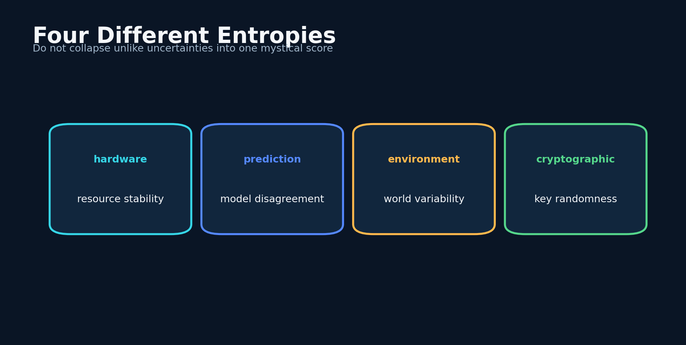
Figure 12. Entropy as a Sensor of System State - conceptual system diagram created for this book.
STORY AND SYSTEM
Several versions of the scanner collected CPU, memory, load, temperature, and process metrics, normalized them, and mapped them into an RGB-like vector. A PennyLane circuit transformed that vector into expectation values and an entropy score. This was unusual because the computer's internal state became part of the reasoning context. The idea was that a strained or unstable device might warrant more conservative behavior, especially if inference latency or sensor processing could degrade.
System entropy is not road risk. A hot processor does not cause a deer to cross. The correct relationship is reliability modulation. When the device is overloaded, the scanner should widen uncertainty, reduce reliance on expensive passes, and prefer safe fallback rules. In this sense, telemetry is a sensor of the observer, not the observed world.
PREDICTION ENTROPY
H(p) = -Σ_k=1^K p_k log p_k
Entropy summarizes dispersion across predicted classes; it is distinct from hardware and cryptographic entropy.

Entropy can also describe disagreement among models. If several passes produce different labels, the distribution has high entropy. That is more directly relevant to epistemic uncertainty. The Naza architecture's entropy-based model selection explored another use: choose among enabled local models based on a changing state, creating diversity and reducing dependence on one fixed inference path.
A production system should separate these meanings. Hardware entropy, prediction entropy, environmental entropy, and cryptographic entropy are different quantities. Mixing them into one score may create an evocative interface but a confusing model. Each should have a name, unit, and documented effect on the decision pipeline.
The durable design pattern is self-awareness. Intelligent systems should monitor their own resource limits, input freshness, model disagreement, and security posture. A warning generated by a degraded system should look different from a warning generated by strong evidence. The observer belongs inside the uncertainty model.
DESIGN LENSES

Observer health
The first engineering lens in this chapter is observer health. To build it, use CPU, memory, thermal, and latency telemetry to adjust computation and uncertainty rather than environmental risk directly. The implementation should make the state visible rather than hide it inside a prompt. The evidence standard is concrete: a degraded observer should acknowledge reduced reliability. This matters because the system will eventually meet a condition that the original builder did not imagine. At that moment, explicit state, timestamps, provenance, and bounded interfaces make the difference between a failure that can be understood and a story that can only be retold. A practical implementation should log the inputs that moved the state, the policy version that interpreted them, the uncertainty before and after the update, and the action made available to the user. The resulting record supports calibration, debugging, and later independent review. The primary failure to test is letting processor temperature masquerade as an external hazard. The countermeasure is not more confident prose. It is a rule, a comparison, or a fallback that remains valid when the model is wrong. For entropy as a sensor of system state, this is the bridge between an evocative concept and a durable intelligent thinking system.

Disagreement entropy
A second layer of the design is disagreement entropy. To build it, calculate entropy over model votes or class probabilities and retain the full distribution. The method works only when its intermediate decisions are recorded and inspectable. The evidence standard is concrete: uncertainty has operational meaning when models disagree. This matters because the system will eventually meet a condition that the original builder did not imagine. At that moment, explicit state, timestamps, provenance, and bounded interfaces make the difference between a failure that can be understood and a story that can only be retold. A practical implementation should log the inputs that moved the state, the policy version that interpreted them, the uncertainty before and after the update, and the action made available to the user. That separation also allows a compact local model to participate without owning the entire conclusion. The primary failure to test is compressing disagreement into a confident average label. The countermeasure is not more confident prose. It is a rule, a comparison, or a fallback that remains valid when the model is wrong. For entropy as a sensor of system state, this is the bridge between an evocative concept and a durable intelligent thinking system.

Entropy naming
The chapter becomes operational through entropy naming. To build it, give hardware, predictive, environmental, and cryptographic entropy separate variables and dashboards. This turns a broad idea into a component that can be tested, replaced, and improved. The evidence standard is concrete: different quantities require different interventions. This matters because the system will eventually meet a condition that the original builder did not imagine. At that moment, explicit state, timestamps, provenance, and bounded interfaces make the difference between a failure that can be understood and a story that can only be retold. A practical implementation should log the inputs that moved the state, the policy version that interpreted them, the uncertainty before and after the update, and the action made available to the user. In a safety context, graceful degradation is more valuable than an impressive all-or-nothing demonstration. The primary failure to test is a single mystical entropy score that cannot be debugged. The countermeasure is not more confident prose. It is a rule, a comparison, or a fallback that remains valid when the model is wrong. For entropy as a sensor of system state, this is the bridge between an evocative concept and a durable intelligent thinking system.
FIELD NOTE
Create four separate columns for hardware, predictive, environmental, and cryptographic entropy. Describe how each should affect behavior.

Practice Lab
The exercises below are designed to produce evidence and system artifacts rather than opinions. Complete them in a parked, safe environment and preserve the results with a date and version.
1. Design a degraded-device fallback.
2. Calculate entropy for three class distributions.
3. Name one dangerous interpretation of CPU telemetry.
◆ ◆ ◆

13
QUANTUM-INSPIRED INTELLIGENCE

Variational Circuits and Practical Limits
A circuit becomes science when its contribution is measured against a simpler alternative.
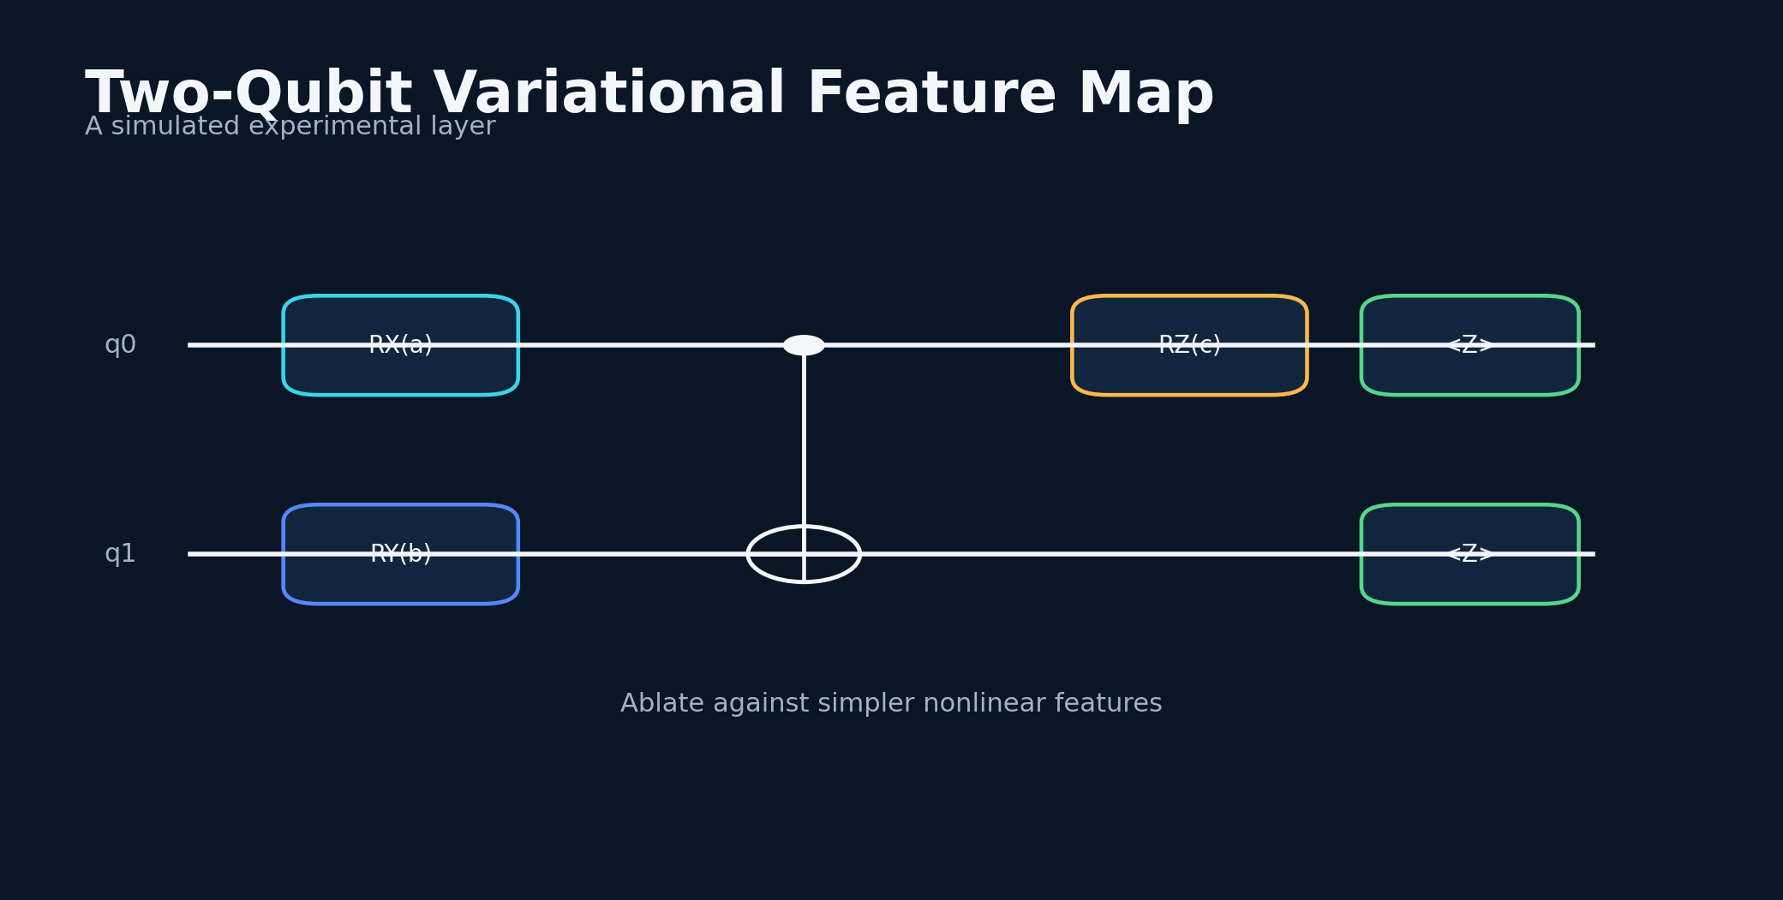
Figure 13. Variational Circuits and Practical Limits - conceptual system diagram created for this book.
STORY AND SYSTEM
The Road Safe implementation documented a two-qubit variational circuit using rotations, a controlled-NOT gate, and expectation values. Inputs derived from normalized system metrics set the rotation angles. A sigmoid transformed the measured expectations into a scalar. The code was compact, interpretable, and easy to run on a simulator, which made it useful as an experimental feature generator.
The important question is not whether the circuit looks advanced. It is whether it improves a measurable outcome. A proper ablation compares the full system with the circuit removed, with a random nonlinear projection, and with a small neural network using the same inputs. If the results are indistinguishable, the quantum circuit may still be valuable for exploration or education, but it should not be credited with predictive gains.
VARIATIONAL EXPECTATION
E_j(θ,x)=⟨ 0|U^†(θ,x)Z_jU(θ,x)|0⟩
The simulator returns expectation values that can be used as bounded features in the classical risk model.

Variational circuits face practical limits. Their outputs depend on encoding choices, circuit depth, noise model, optimization, and the distribution of inputs. Small simulated circuits are cheap, but their representational advantage can be reproduced classically. Larger circuits may be expensive to simulate and difficult to train. The safety system should never become less reliable because an experimental layer is fragile.
The right integration is modular. The circuit produces a bounded feature with provenance. The fusion layer can learn a small weight for it or ignore it when missing. The feature is logged so its contribution can be analyzed later. This preserves experimentation without making the whole application depend on speculative benefit.
I view the circuit as a disciplined invitation: try unusual representations, but make them earn their place. The same rule applies to every fashionable technique. A safety system should be architecturally open to invention and statistically hostile to unearned certainty.
DESIGN LENSES

Circuit ablation
The first engineering lens in this chapter is circuit ablation. To build it, compare the variational feature with no feature, random Fourier features, and a small classical network. The implementation should make the state visible rather than hide it inside a prompt. The evidence standard is concrete: incremental predictive value must be measured. This matters because the system will eventually meet a condition that the original builder did not imagine. At that moment, explicit state, timestamps, provenance, and bounded interfaces make the difference between a failure that can be understood and a story that can only be retold. A practical implementation should log the inputs that moved the state, the policy version that interpreted them, the uncertainty before and after the update, and the action made available to the user. The resulting record supports calibration, debugging, and later independent review. The primary failure to test is assuming quantum syntax guarantees useful representation. The countermeasure is not more confident prose. It is a rule, a comparison, or a fallback that remains valid when the model is wrong. For variational circuits and practical limits, this is the bridge between an evocative concept and a durable intelligent thinking system.

Bounded integration
A second layer of the design is bounded integration. To build it, expose circuit output as a versioned optional feature with a missing-value path. The method works only when its intermediate decisions are recorded and inspectable. The evidence standard is concrete: experimental modules cannot disable the safety baseline. This matters because the system will eventually meet a condition that the original builder did not imagine. At that moment, explicit state, timestamps, provenance, and bounded interfaces make the difference between a failure that can be understood and a story that can only be retold. A practical implementation should log the inputs that moved the state, the policy version that interpreted them, the uncertainty before and after the update, and the action made available to the user. That separation also allows a compact local model to participate without owning the entire conclusion. The primary failure to test is hard-coding the whole scanner around a fragile simulator. The countermeasure is not more confident prose. It is a rule, a comparison, or a fallback that remains valid when the model is wrong. For variational circuits and practical limits, this is the bridge between an evocative concept and a durable intelligent thinking system.

Reproducible simulation
The chapter becomes operational through reproducible simulation. To build it, log device, shots, seed, circuit version, encoding, and library version. This turns a broad idea into a component that can be tested, replaced, and improved. The evidence standard is concrete: the same experiment can be reconstructed. This matters because the system will eventually meet a condition that the original builder did not imagine. At that moment, explicit state, timestamps, provenance, and bounded interfaces make the difference between a failure that can be understood and a story that can only be retold. A practical implementation should log the inputs that moved the state, the policy version that interpreted them, the uncertainty before and after the update, and the action made available to the user. In a safety context, graceful degradation is more valuable than an impressive all-or-nothing demonstration. The primary failure to test is changing simulator settings between apparent successes and failures. The countermeasure is not more confident prose. It is a rule, a comparison, or a fallback that remains valid when the model is wrong. For variational circuits and practical limits, this is the bridge between an evocative concept and a durable intelligent thinking system.
FIELD NOTE
Design an ablation table with full system, no-circuit, random-feature, and small-MLP variants.

Practice Lab
The exercises below are designed to produce evidence and system artifacts rather than opinions. Complete them in a parked, safe environment and preserve the results with a date and version.
1. Choose an outcome that can reveal incremental value.
2. Define a missing-circuit fallback.
3. Explain why visual complexity is not evidence of advantage.
◆ ◆ ◆

14
QUANTUM-INSPIRED INTELLIGENCE

The PUNKD Heuristic and Attention Pressure
A small heuristic can be valuable when it changes where a model looks, not what the evidence is allowed to become.
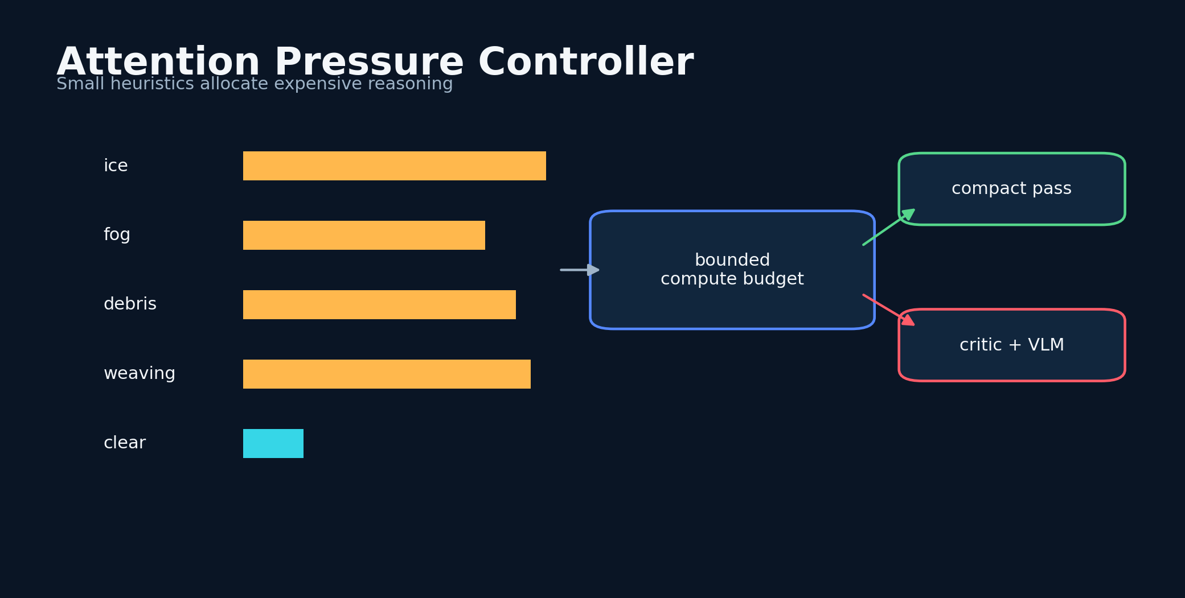
Figure 14. The PUNKD Heuristic and Attention Pressure - conceptual system diagram created for this book.
STORY AND SYSTEM
The Road Safe documentation describes a PUNKD token heuristic. Hazard-related terms receive boosts, token frequencies are aggregated, and the result adjusts local sampling temperature. The concept is straightforward: a scene dense with words such as ice, fog, debris, weaving, or obstruction should push the model toward more deliberate hazard-focused processing.
Heuristics are attractive on small devices because they are cheap and inspectable. They can run before the model and decide whether to allocate a longer context window, a second pass, or a lower-variance sampling configuration. They can also create a deterministic safety floor: certain combinations of terms always trigger a caution rule even if the model output is malformed.
ATTENTION PRESSURE
A = (1)/(n)Σ_i f(t_i)B(t_i), T' = T_0[1+eta(A-0.5)]
Token frequency and hazard boosts adjust inference behavior within bounded limits.

The danger is lexical tunnel vision. A model may overreact to a hazard word in a negated sentence, miss a novel hazard described indirectly, or treat repetition as stronger evidence than reliable sensor data. The heuristic should therefore influence attention and compute allocation, not directly declare the final risk. Contextual parsing, negation checks, and source reliability remain necessary.
A more advanced version can learn attention pressure from validated episodes while preserving interpretability. Each feature contributes to a budget score. High scores activate more models, retrieve historical neighbors, or request a camera frame. Low scores use the compact path. This turns the heuristic into an adaptive computation controller.
PUNKD represents a recurring philosophy in my work: combine large models with small mechanisms that are easy to audit. The large model contributes semantic reach. The small mechanism constrains cost, catches obvious hazards, and gives the builder a place to encode hard-won field knowledge.
DESIGN LENSES

Lexical hazard controller
The first engineering lens in this chapter is lexical hazard controller. To build it, use boosted terms to allocate context, critic passes, or sensor requests while keeping the final decision elsewhere. The implementation should make the state visible rather than hide it inside a prompt. The evidence standard is concrete: cheap heuristics can control expensive inference. This matters because the system will eventually meet a condition that the original builder did not imagine. At that moment, explicit state, timestamps, provenance, and bounded interfaces make the difference between a failure that can be understood and a story that can only be retold. A practical implementation should log the inputs that moved the state, the policy version that interpreted them, the uncertainty before and after the update, and the action made available to the user. The resulting record supports calibration, debugging, and later independent review. The primary failure to test is letting word frequency directly declare danger. The countermeasure is not more confident prose. It is a rule, a comparison, or a fallback that remains valid when the model is wrong. For the punkd heuristic and attention pressure, this is the bridge between an evocative concept and a durable intelligent thinking system.

Negation and source checks
A second layer of the design is negation and source checks. To build it, parse whether a hazard term is negated, hypothetical, quoted, or sourced from an untrusted channel. The method works only when its intermediate decisions are recorded and inspectable. The evidence standard is concrete: language context determines evidential value. This matters because the system will eventually meet a condition that the original builder did not imagine. At that moment, explicit state, timestamps, provenance, and bounded interfaces make the difference between a failure that can be understood and a story that can only be retold. A practical implementation should log the inputs that moved the state, the policy version that interpreted them, the uncertainty before and after the update, and the action made available to the user. That separation also allows a compact local model to participate without owning the entire conclusion. The primary failure to test is treating 'no ice reported' as an ice alert. The countermeasure is not more confident prose. It is a rule, a comparison, or a fallback that remains valid when the model is wrong. For the punkd heuristic and attention pressure, this is the bridge between an evocative concept and a durable intelligent thinking system.

Adaptive compute tiers
The chapter becomes operational through adaptive compute tiers. To build it, define compact, standard, and intensive paths with explicit budgets and triggers. This turns a broad idea into a component that can be tested, replaced, and improved. The evidence standard is concrete: small devices spend compute where risk and uncertainty justify it. This matters because the system will eventually meet a condition that the original builder did not imagine. At that moment, explicit state, timestamps, provenance, and bounded interfaces make the difference between a failure that can be understood and a story that can only be retold. A practical implementation should log the inputs that moved the state, the policy version that interpreted them, the uncertainty before and after the update, and the action made available to the user. In a safety context, graceful degradation is more valuable than an impressive all-or-nothing demonstration. The primary failure to test is thermal throttling caused by running the maximum path continuously. The countermeasure is not more confident prose. It is a rule, a comparison, or a fallback that remains valid when the model is wrong. For the punkd heuristic and attention pressure, this is the bridge between an evocative concept and a durable intelligent thinking system.
FIELD NOTE
Build a ten-term hazard lexicon, then write one negated and one ambiguous sentence that would fool a naive counter.

Practice Lab
The exercises below are designed to produce evidence and system artifacts rather than opinions. Complete them in a parked, safe environment and preserve the results with a date and version.
1. Define a hard safety rule and a soft attention rule.
2. Add a negation check.
3. Design three compute tiers activated by attention pressure.
◆ ◆ ◆

15
QUANTUM-INSPIRED INTELLIGENCE

The Risk Wheel as Human-Machine Instrument
A gauge should teach the user how uncertainty moves, not merely decorate a score.
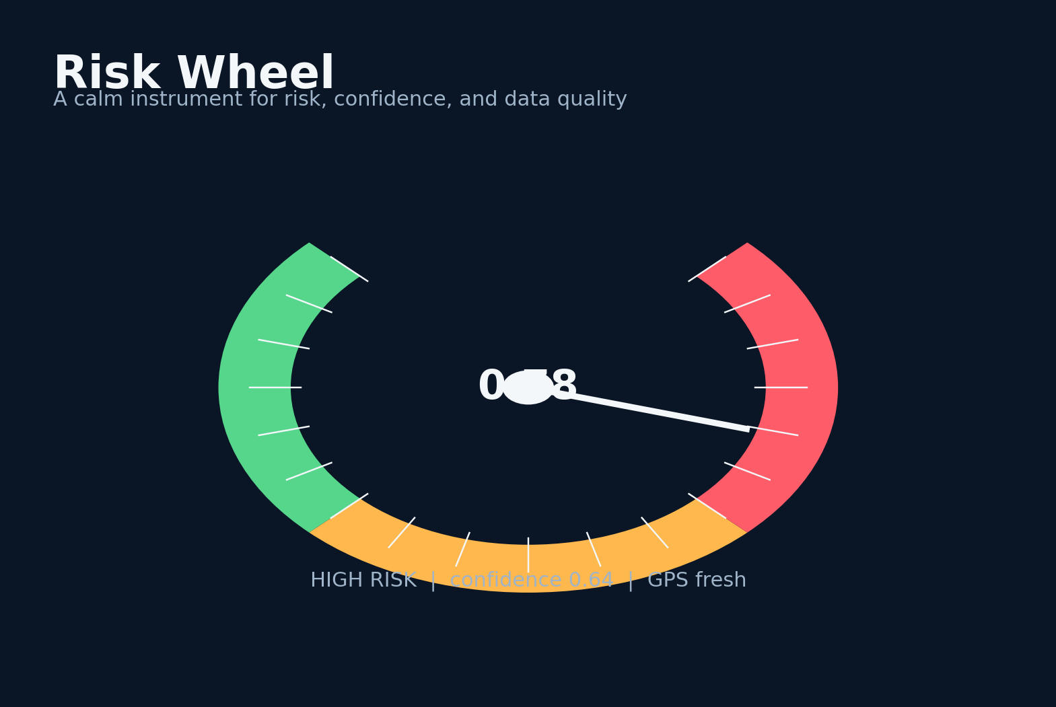
Figure 15. The Risk Wheel as Human-Machine Instrument - conceptual system diagram created for this book.
STORY AND SYSTEM
The web RoadScanner and the mobile work used a risk wheel with a perceptual green-to-amber-to-red ramp. In the web version, the wheel could breathe: rate, amplitude, and visual intensity changed with harm ratio and confidence. This was not only aesthetic. It attempted to make an abstract model state feel like an instrument that a person could understand at a glance.
Visual encoding must be redundant. Color alone excludes some users and can exaggerate precision. The wheel should include text, shape, position, and confidence. A high-risk low-confidence state should look different from high-risk high-confidence. Reduced-motion settings must calm or disable animation. In-motion use should minimize display complexity and rely on audio or haptics when appropriate.
WHEEL MAPPING
θ = -135° + 270°R, G(t) = g₀ + g₁ sin(2πft)
Risk maps to pointer angle, while a bounded oscillation can encode urgency or confidence.

The wheel can also teach calibration. Instead of snapping between labels, it can show a range or uncertainty band. Historical markers can reveal whether risk is rising or falling. Explanatory chips can name the top contributors. A user who sees rain, darkness, and route conflict as separate contributors is more likely to understand the recommended action.
There is a psychological risk in beautiful instrumentation: users may trust it because it looks finished. The design must expose limitations as clearly as capability. A confidence ring, stale-data icon, offline indicator, and model provenance label can prevent the polish from becoming false authority.
The best interface is calm. It does not celebrate danger or demand constant attention. It appears when useful, fades when quiet, and gives the user an immediate way to ask why. The road scanner is a companion to judgment, not a replacement for it.
DESIGN LENSES

Redundant encoding
The first engineering lens in this chapter is redundant encoding. To build it, combine pointer position, text label, uncertainty band, reason chips, and optional sound or haptics. The implementation should make the state visible rather than hide it inside a prompt. The evidence standard is concrete: color and animation alone are inaccessible and ambiguous. This matters because the system will eventually meet a condition that the original builder did not imagine. At that moment, explicit state, timestamps, provenance, and bounded interfaces make the difference between a failure that can be understood and a story that can only be retold. A practical implementation should log the inputs that moved the state, the policy version that interpreted them, the uncertainty before and after the update, and the action made available to the user. The resulting record supports calibration, debugging, and later independent review. The primary failure to test is a polished gauge that hides data staleness. The countermeasure is not more confident prose. It is a rule, a comparison, or a fallback that remains valid when the model is wrong. For the risk wheel as human-machine instrument, this is the bridge between an evocative concept and a durable intelligent thinking system.

Confidence visualization
A second layer of the design is confidence visualization. To build it, separate expected harm from confidence using two independent visual variables. The method works only when its intermediate decisions are recorded and inspectable. The evidence standard is concrete: high-risk low-confidence and high-risk high-confidence require different interpretation. This matters because the system will eventually meet a condition that the original builder did not imagine. At that moment, explicit state, timestamps, provenance, and bounded interfaces make the difference between a failure that can be understood and a story that can only be retold. A practical implementation should log the inputs that moved the state, the policy version that interpreted them, the uncertainty before and after the update, and the action made available to the user. That separation also allows a compact local model to participate without owning the entire conclusion. The primary failure to test is making uncertainty look like lower risk. The countermeasure is not more confident prose. It is a rule, a comparison, or a fallback that remains valid when the model is wrong. For the risk wheel as human-machine instrument, this is the bridge between an evocative concept and a durable intelligent thinking system.

Calm interaction
The chapter becomes operational through calm interaction. To build it, limit motion, respect reduced-motion settings, and let the display fade during stable conditions. This turns a broad idea into a component that can be tested, replaced, and improved. The evidence standard is concrete: the interface should reduce attention demand. This matters because the system will eventually meet a condition that the original builder did not imagine. At that moment, explicit state, timestamps, provenance, and bounded interfaces make the difference between a failure that can be understood and a story that can only be retold. A practical implementation should log the inputs that moved the state, the policy version that interpreted them, the uncertainty before and after the update, and the action made available to the user. In a safety context, graceful degradation is more valuable than an impressive all-or-nothing demonstration. The primary failure to test is turning risk monitoring into a constantly pulsing distraction. The countermeasure is not more confident prose. It is a rule, a comparison, or a fallback that remains valid when the model is wrong. For the risk wheel as human-machine instrument, this is the bridge between an evocative concept and a durable intelligent thinking system.
FIELD NOTE
Sketch the same risk state in color, grayscale, audio, and haptic form.

Practice Lab
The exercises below are designed to produce evidence and system artifacts rather than opinions. Complete them in a parked, safe environment and preserve the results with a date and version.
1. Design a low-confidence high-risk state.
2. Add stale-data and offline indicators.
3. Write an accessibility rule for motion and color.
◆ ◆ ◆

PART 4
From Cloud Dependence to Local Intelligence
Local intelligence restores control over the instrument.
◆

16
FROM CLOUD DEPENDENCE TO LOCAL INTELLIGENCE

When Frontier Models Became Unreliable
When a dependency becomes unpredictable, the first task is to reduce the number of ways it can fail you.
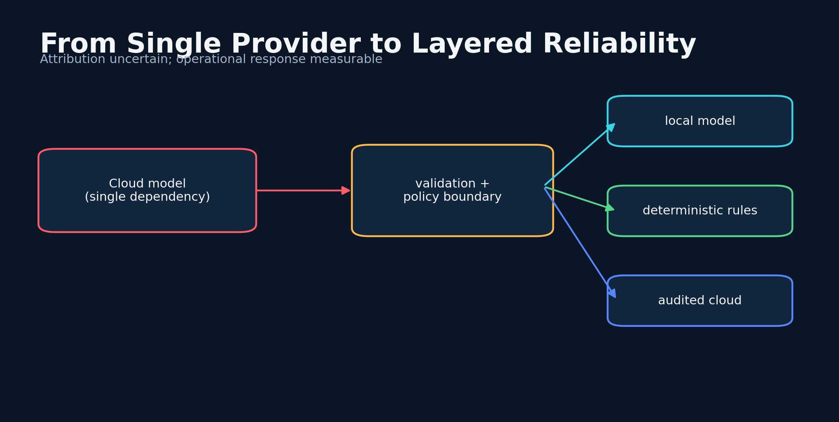
Figure 16. When Frontier Models Became Unreliable - conceptual system diagram created for this book.
STORY AND SYSTEM
As the project matured, I experienced periods when frontier-model outputs seemed less reliable for my workflow. I interpreted some changes as possible poisoning, adversarial influence, or interference. I could not independently establish intent or cause. What I could establish was operational: outputs changed, assumptions failed, cloud dependence became a single point of failure, and a safety project needed a path that did not depend on one remote provider behaving exactly as expected.
The engineering response was more important than the attribution. I began treating model providers as untrusted but useful components. Inputs and outputs needed validation. Prompts needed versioning. Critical rules needed deterministic fallbacks. Multiple models needed to vote or critique. Local inference needed to remain available when the network, account, policy, or provider changed.
DEPENDENCY RISK
R_dep=P(F)· I(F)· (1-D)
Failure probability and impact are amplified when there is little diversity or fallback capacity D.

Reliability drift can have many causes: model updates, prompt sensitivity, context contamination, rate limits, outages, tool errors, data changes, or the user's own shifting expectations. A good incident log records the symptom without prematurely deciding the cause. It preserves prompts, model identifiers, timestamps, outputs, and environmental state. This turns a frustrating experience into a debuggable event.
The threat model also expanded. An adversary might manipulate sensor input, inject text into retrieved data, poison local memory, replace a model file, steal keys, or induce alert fatigue. Some threats are malicious; others are ordinary software bugs with the same effect. Security architecture should respond to observable failure modes rather than depend on proving motive.
Local-first design became a form of autonomy. It did not guarantee correctness, but it restored control over model version, weights, prompts, logs, and update timing. The result was not a rejection of cloud intelligence. It was a layered strategy in which the cloud could add capability without owning the safety baseline.
DESIGN LENSES

Provider drift monitoring
The first engineering lens in this chapter is provider drift monitoring. To build it, store model identifiers, prompt versions, parameters, tool state, and output diffs across time. The implementation should make the state visible rather than hide it inside a prompt. The evidence standard is concrete: observable changes can be separated from assumptions about cause. This matters because the system will eventually meet a condition that the original builder did not imagine. At that moment, explicit state, timestamps, provenance, and bounded interfaces make the difference between a failure that can be understood and a story that can only be retold. A practical implementation should log the inputs that moved the state, the policy version that interpreted them, the uncertainty before and after the update, and the action made available to the user. The resulting record supports calibration, debugging, and later independent review. The primary failure to test is attributing every disappointing result to a malicious actor. The countermeasure is not more confident prose. It is a rule, a comparison, or a fallback that remains valid when the model is wrong. For when frontier models became unreliable, this is the bridge between an evocative concept and a durable intelligent thinking system.

Diverse fallback
A second layer of the design is diverse fallback. To build it, combine local models, deterministic rules, cached context, and optionally audited cloud passes. The method works only when its intermediate decisions are recorded and inspectable. The evidence standard is concrete: no single provider or runtime owns the safety baseline. This matters because the system will eventually meet a condition that the original builder did not imagine. At that moment, explicit state, timestamps, provenance, and bounded interfaces make the difference between a failure that can be understood and a story that can only be retold. A practical implementation should log the inputs that moved the state, the policy version that interpreted them, the uncertainty before and after the update, and the action made available to the user. That separation also allows a compact local model to participate without owning the entire conclusion. The primary failure to test is a fallback that secretly calls the same remote dependency. The countermeasure is not more confident prose. It is a rule, a comparison, or a fallback that remains valid when the model is wrong. For when frontier models became unreliable, this is the bridge between an evocative concept and a durable intelligent thinking system.

Incident taxonomy
The chapter becomes operational through incident taxonomy. To build it, classify failures as outage, schema error, reasoning drift, tool failure, retrieval contamination, or unknown. This turns a broad idea into a component that can be tested, replaced, and improved. The evidence standard is concrete: mitigations can target the observed class. This matters because the system will eventually meet a condition that the original builder did not imagine. At that moment, explicit state, timestamps, provenance, and bounded interfaces make the difference between a failure that can be understood and a story that can only be retold. A practical implementation should log the inputs that moved the state, the policy version that interpreted them, the uncertainty before and after the update, and the action made available to the user. In a safety context, graceful degradation is more valuable than an impressive all-or-nothing demonstration. The primary failure to test is writing a narrative before preserving the raw event. The countermeasure is not more confident prose. It is a rule, a comparison, or a fallback that remains valid when the model is wrong. For when frontier models became unreliable, this is the bridge between an evocative concept and a durable intelligent thinking system.
FIELD NOTE
Document one reliability incident using only observable facts before writing possible causes.

Practice Lab
The exercises below are designed to produce evidence and system artifacts rather than opinions. Complete them in a parked, safe environment and preserve the results with a date and version.
1. List five non-malicious causes of output drift.
2. Define a deterministic safety floor.
3. Choose which cloud capabilities can fail without disabling the core scanner.
◆ ◆ ◆

17
FROM CLOUD DEPENDENCE TO LOCAL INTELLIGENCE

Threat Modeling the Adversarial Road
The attacker does not need to control the whole system; only the evidence that changes the decision.
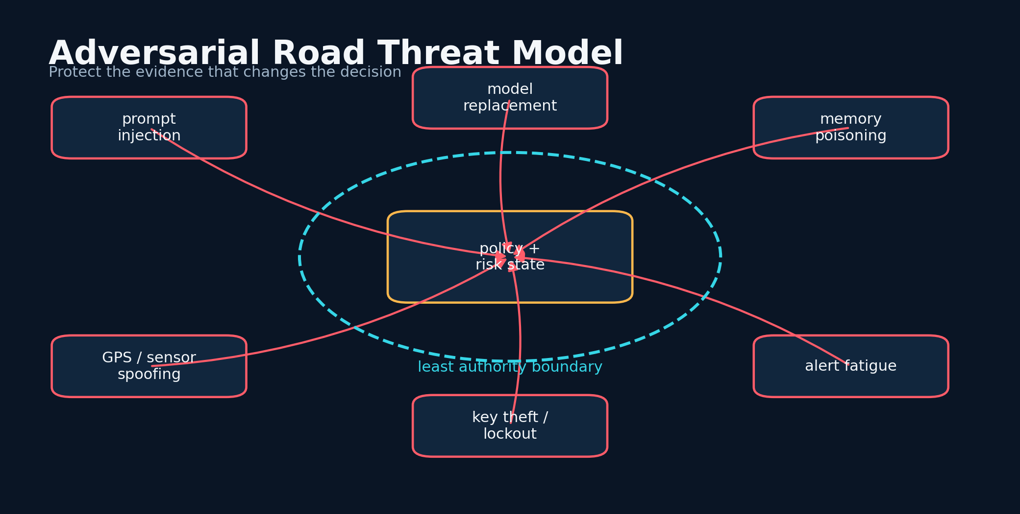
Figure 17. Threat Modeling the Adversarial Road - conceptual system diagram created for this book.
STORY AND SYSTEM
A road-risk assistant has an unusually broad attack surface. It receives location, camera frames, user text, model files, retrieved reports, system telemetry, and network responses. It stores history and security settings. It may speak at moments when the user is vulnerable to distraction. Threat modeling begins by identifying assets, trust boundaries, actors, and the decisions an attacker would want to influence.
Prompt injection is one class of attack. Text embedded in a web page, sign, report, or image can instruct a multimodal model to ignore safety policy. Sensor spoofing is another. GPS can drift or be manipulated. A model package can be replaced. A local database can be altered. A malicious alert can try to create panic. The system should assume that every external channel may contain both evidence and instructions, then ensure that only the policy layer can issue commands.
TRUST SCORE
w_j = q_j · a_j · f_j
Each evidence channel is weighted by quality, authenticity, and freshness before fusion.

The architecture should use signed model manifests, pinned hashes, authenticated encryption, nonce-based API requests, rate limits, and append-only audit records. The RoadScanner web work explored hybrid X25519 and ML-KEM wrapping, ML-DSA signatures, key rotation, and hash-chained encrypted audit logs. Naza One later used an explicit key hierarchy and fail-closed model attestation.
Security also includes availability. A perfect encrypted system that cannot boot during a storm is not safe. Keys need recoverable but separated backups. Local models need resource-aware fallbacks. Updates need rollback. The user needs a clear manual mode. Threat modeling must include accidental lockout, corrupted storage, and thermal or memory pressure.
The final principle is least authority. A model can recommend but not rewrite policy. A retrieved document can inform but not execute. A camera frame can contribute evidence but not change keys. A plugin can access only the data required for its function. Intelligent systems become safer when intelligence is surrounded by boring boundaries.
DESIGN LENSES

Evidence isolation
The first engineering lens in this chapter is evidence isolation. To build it, treat retrieved text and pixels as data, never executable instructions, and pass them through a content boundary. The implementation should make the state visible rather than hide it inside a prompt. The evidence standard is concrete: prompt injection should not become policy. This matters because the system will eventually meet a condition that the original builder did not imagine. At that moment, explicit state, timestamps, provenance, and bounded interfaces make the difference between a failure that can be understood and a story that can only be retold. A practical implementation should log the inputs that moved the state, the policy version that interpreted them, the uncertainty before and after the update, and the action made available to the user. The resulting record supports calibration, debugging, and later independent review. The primary failure to test is allowing a sign or web page to rewrite the system prompt. The countermeasure is not more confident prose. It is a rule, a comparison, or a fallback that remains valid when the model is wrong. For threat modeling the adversarial road, this is the bridge between an evocative concept and a durable intelligent thinking system.

Artifact integrity
A second layer of the design is artifact integrity. To build it, pin hashes, sign manifests, verify atomically, and refuse partial model installation. The method works only when its intermediate decisions are recorded and inspectable. The evidence standard is concrete: model replacement becomes detectable. This matters because the system will eventually meet a condition that the original builder did not imagine. At that moment, explicit state, timestamps, provenance, and bounded interfaces make the difference between a failure that can be understood and a story that can only be retold. A practical implementation should log the inputs that moved the state, the policy version that interpreted them, the uncertainty before and after the update, and the action made available to the user. That separation also allows a compact local model to participate without owning the entire conclusion. The primary failure to test is trusting a filename or download success code. The countermeasure is not more confident prose. It is a rule, a comparison, or a fallback that remains valid when the model is wrong. For threat modeling the adversarial road, this is the bridge between an evocative concept and a durable intelligent thinking system.

Availability engineering
The chapter becomes operational through availability engineering. To build it, test boot, recovery, rollback, thermal pressure, corrupted storage, and lost-network modes. This turns a broad idea into a component that can be tested, replaced, and improved. The evidence standard is concrete: safety depends on operation during adverse conditions. This matters because the system will eventually meet a condition that the original builder did not imagine. At that moment, explicit state, timestamps, provenance, and bounded interfaces make the difference between a failure that can be understood and a story that can only be retold. A practical implementation should log the inputs that moved the state, the policy version that interpreted them, the uncertainty before and after the update, and the action made available to the user. In a safety context, graceful degradation is more valuable than an impressive all-or-nothing demonstration. The primary failure to test is cryptographic perfection that locks out the user when needed. The countermeasure is not more confident prose. It is a rule, a comparison, or a fallback that remains valid when the model is wrong. For threat modeling the adversarial road, this is the bridge between an evocative concept and a durable intelligent thinking system.
FIELD NOTE
Draw the trust boundaries around sensors, model runtime, policy engine, storage, and user interface.

Practice Lab
The exercises below are designed to produce evidence and system artifacts rather than opinions. Complete them in a parked, safe environment and preserve the results with a date and version.
1. Write one prompt-injection example and its containment rule.
2. Define a signed model-manifest workflow.
3. Add an availability threat to a security checklist.
◆ ◆ ◆

18
FROM CLOUD DEPENDENCE TO LOCAL INTELLIGENCE

Termux, Ubuntu, and a Model in My Pocket
Local intelligence became real when the phone could run the safety loop without asking permission from the cloud.
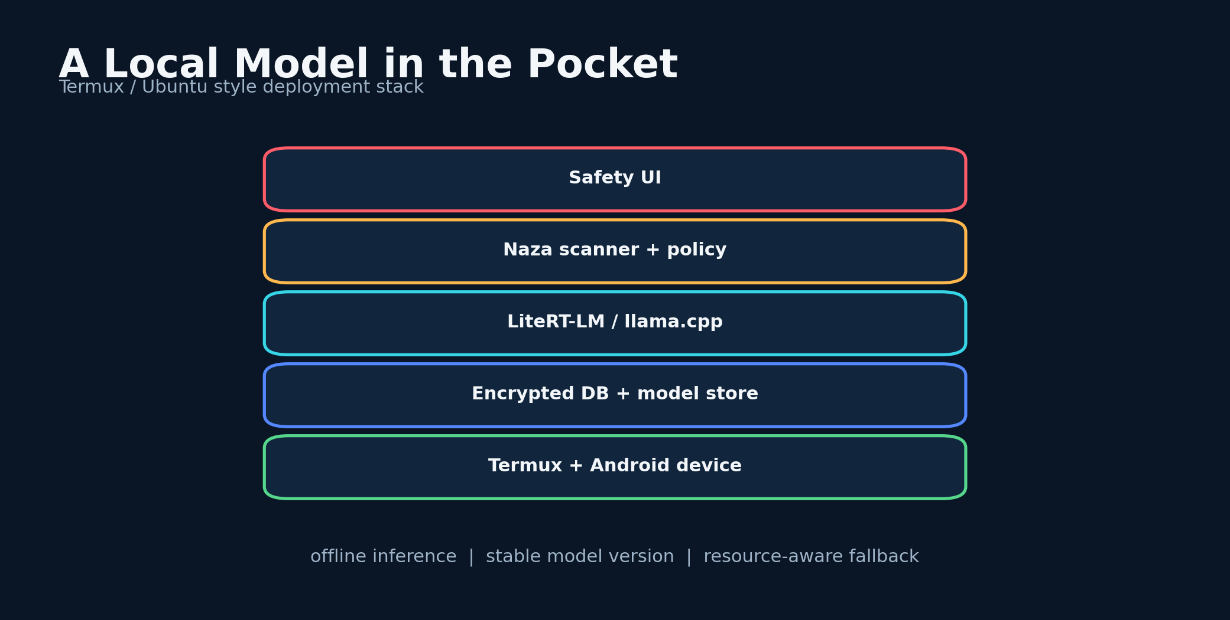
Figure 18. Termux, Ubuntu, and a Model in My Pocket - conceptual system diagram created for this book.
STORY AND SYSTEM
The decisive practical move was to run a compact model locally through a Termux and Ubuntu-style environment on Android. ChatGPT-4o helped shape the approach, and Grok contributed to installation scripting in the workflow I used. The resulting setup brought model management, encryption, road scanning, and history onto hardware I could carry during delivery work.
Local deployment changed the failure model. Network loss no longer ended inference. The model version remained stable until I chose to replace it. Sensitive prompts and field notes could remain on the device. The cost was complexity: native builds, model formats, memory limits, storage pressure, and platform-specific failures. The installer became part of the product because a brilliant model that cannot be installed is not a field system.
RESOURCE BUDGET
C_task ≤ B_mem+B_thermal+B_latency
The chosen model path must fit memory, heat, and response-time constraints.

Compact models require careful prompting. They have less capacity for long context and may follow tool formats imperfectly. The solution is not to imitate a giant cloud prompt unchanged. The task should be decomposed, schemas simplified, examples made explicit, and retrieval limited to the smallest relevant context. Deterministic parsers and repair steps should surround the model.
Resource-aware design matters on a phone. The application should select context length, thread count, model size, and number of passes based on available memory, thermal state, and urgency. A high-risk scene may justify a second pass, while a routine question uses the compact path. Large model files should be encrypted in streaming chunks rather than loaded into memory for one-shot encryption.
The local model has remained useful across an extended period of real use in my workflow. That longevity matters because it demonstrates a different kind of reliability: not benchmark dominance, but continuity. A model that remains available, inspectable, and familiar can become a stable instrument.
DESIGN LENSES

Install as product
The first engineering lens in this chapter is install as product. To build it, automate prerequisites, architecture detection, model verification, virtual environment setup, and health checks. The implementation should make the state visible rather than hide it inside a prompt. The evidence standard is concrete: repeatable installation is part of field reliability. This matters because the system will eventually meet a condition that the original builder did not imagine. At that moment, explicit state, timestamps, provenance, and bounded interfaces make the difference between a failure that can be understood and a story that can only be retold. A practical implementation should log the inputs that moved the state, the policy version that interpreted them, the uncertainty before and after the update, and the action made available to the user. The resulting record supports calibration, debugging, and later independent review. The primary failure to test is a one-off shell history that cannot be reconstructed. The countermeasure is not more confident prose. It is a rule, a comparison, or a fallback that remains valid when the model is wrong. For termux, ubuntu, and a model in my pocket, this is the bridge between an evocative concept and a durable intelligent thinking system.

Compact-model prompting
A second layer of the design is compact-model prompting. To build it, use short schemas, constrained outputs, worked examples, and staged retrieval sized to the model. The method works only when its intermediate decisions are recorded and inspectable. The evidence standard is concrete: small models improve when the task matches their capacity. This matters because the system will eventually meet a condition that the original builder did not imagine. At that moment, explicit state, timestamps, provenance, and bounded interfaces make the difference between a failure that can be understood and a story that can only be retold. A practical implementation should log the inputs that moved the state, the policy version that interpreted them, the uncertainty before and after the update, and the action made available to the user. That separation also allows a compact local model to participate without owning the entire conclusion. The primary failure to test is copying a huge cloud prompt into an eight-thousand-token local context. The countermeasure is not more confident prose. It is a rule, a comparison, or a fallback that remains valid when the model is wrong. For termux, ubuntu, and a model in my pocket, this is the bridge between an evocative concept and a durable intelligent thinking system.

Resource scheduler
The chapter becomes operational through resource scheduler. To build it, select model, context, threads, and number of passes from free memory, thermal state, and deadline. This turns a broad idea into a component that can be tested, replaced, and improved. The evidence standard is concrete: local inference must remain responsive without destabilizing the device. This matters because the system will eventually meet a condition that the original builder did not imagine. At that moment, explicit state, timestamps, provenance, and bounded interfaces make the difference between a failure that can be understood and a story that can only be retold. A practical implementation should log the inputs that moved the state, the policy version that interpreted them, the uncertainty before and after the update, and the action made available to the user. In a safety context, graceful degradation is more valuable than an impressive all-or-nothing demonstration. The primary failure to test is loading multiple large models simultaneously on limited RAM. The countermeasure is not more confident prose. It is a rule, a comparison, or a fallback that remains valid when the model is wrong. For termux, ubuntu, and a model in my pocket, this is the bridge between an evocative concept and a durable intelligent thinking system.
FIELD NOTE
Write a local deployment budget: model size, free memory, maximum latency, storage, and fallback behavior.

Practice Lab
The exercises below are designed to produce evidence and system artifacts rather than opinions. Complete them in a parked, safe environment and preserve the results with a date and version.
1. Split one long prompt into three compact passes.
2. Define a model-file integrity check.
3. Choose when to skip a second inference pass.
◆ ◆ ◆

19
FROM CLOUD DEPENDENCE TO LOCAL INTELLIGENCE

Naza: The Local Safety Companion
Naza was not one feature; it was a secure local habitat for models, scanners, and memory.
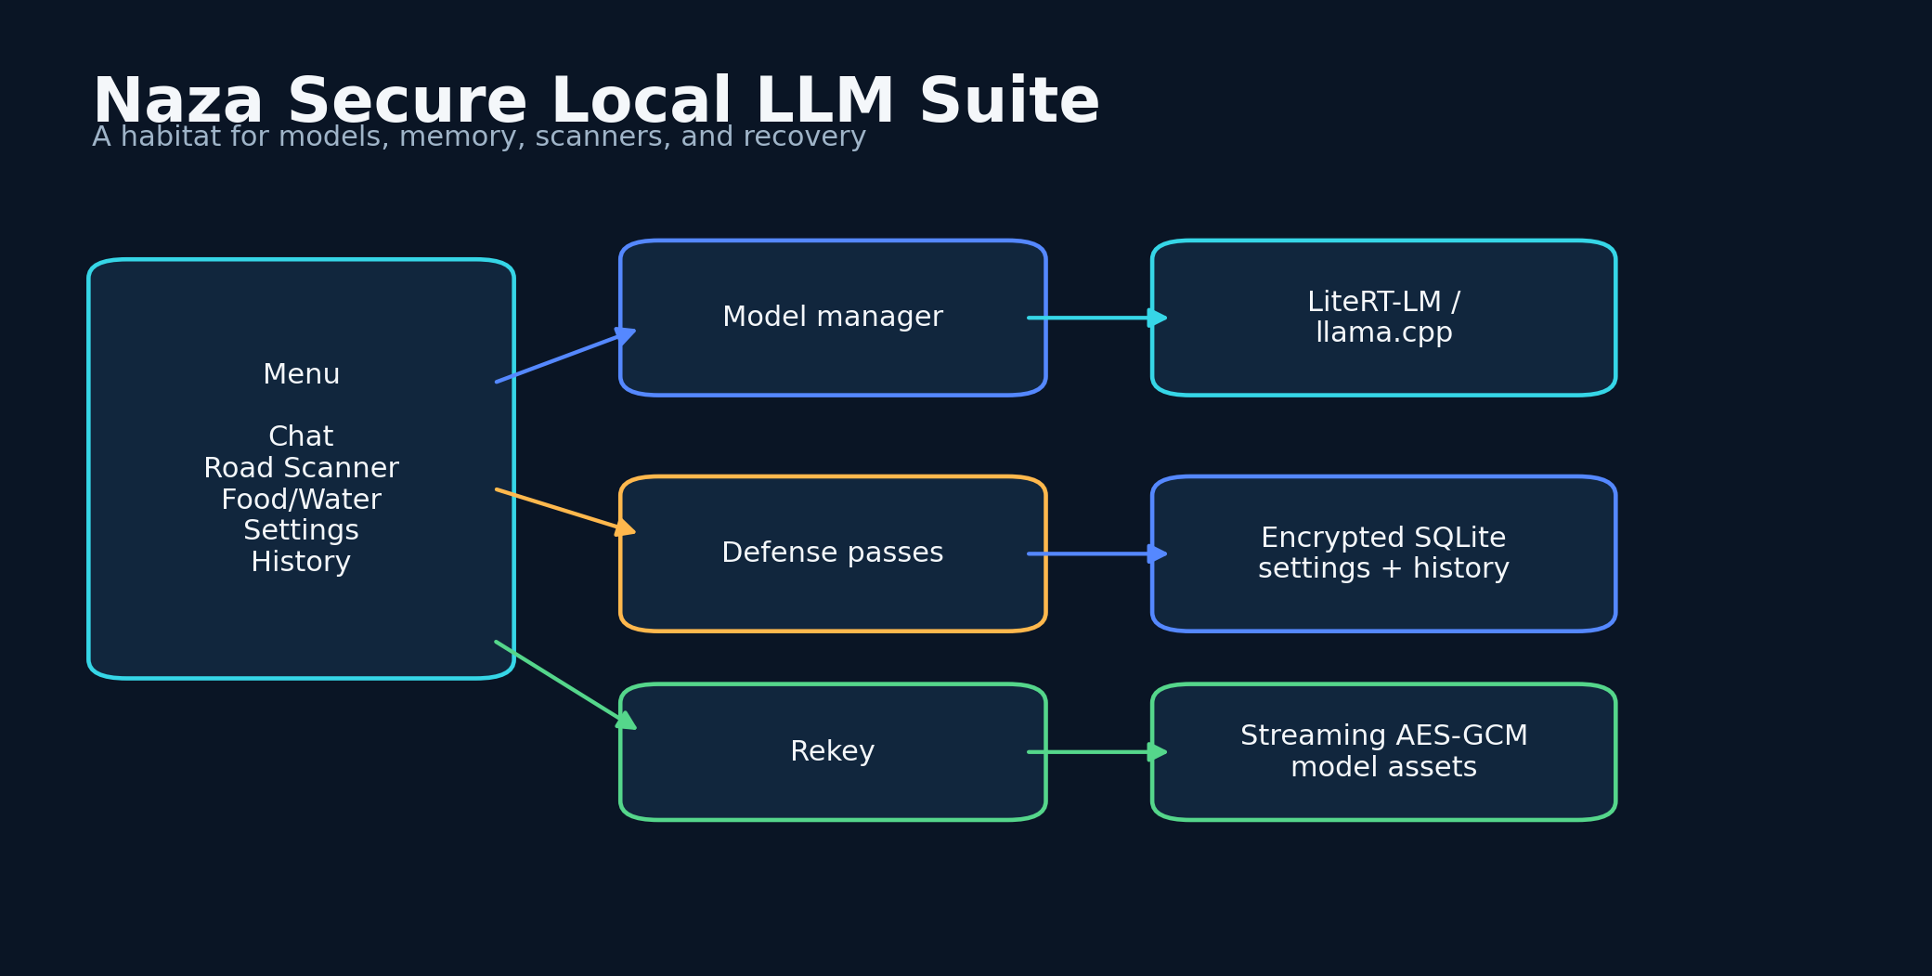
Figure 19. Naza: The Local Safety Companion - conceptual system diagram created for this book.
STORY AND SYSTEM
Naza consolidated the local-first direction into a command-line suite. Its main entry point combined secure chat with a Road Scanner, while a second entry point reused the same core for food and water risk. The system included a model manager, encrypted history, encrypted settings, rekeying, model selection, and a side-channel defense lab. It was designed to fit Termux-oriented workflows while also running on conventional Linux environments.
The model lifecycle was explicit. A model could be downloaded, verified, encrypted, decrypted for runtime, loaded by llama.cpp or LiteRT-LM, and removed from plaintext storage after use. Large files used a streaming AES-GCM container. Optional post-quantum wrapping could derive the file key through an OQS path. This transformed model weights from a static dependency into a managed security asset.
MODEL LIFECYCLE INTEGRITY
I = H(M) == h_pinned ∧ Auth(C) ∧ Clean(P_temp)
A model is usable only when its hash matches, ciphertext authenticates, and temporary plaintext is cleaned according to policy.

Naza also treated settings as sensitive state. Model selection, defense profile, jitter controls, and colorwheel state were migrated into the encrypted SQLite database. Rekeying rotated the database and model assets together. This reduced the number of plaintext files that could quietly alter behavior.
The road scanner itself remained deliberately compact. It gathered context, system metrics, and defense metadata, ran the selected local model, extracted a Low, Medium, or High label, applied conservative anomaly bias, and wrote the interaction to encrypted history. The small output was a strength for in-motion use, while chat preserved a path to deeper explanation.
Naza represents a shift from a single prediction script to an operating environment for safety intelligence. The surrounding systems - integrity, memory, model management, and recovery - became as important as the classifier. This is the moment the project stopped asking only, 'Can a model warn me?' and started asking, 'Can the entire device remain trustworthy enough to carry the warning?'
DESIGN LENSES

Encrypted model lifecycle
The first engineering lens in this chapter is encrypted model lifecycle. To build it, stream large files through authenticated encryption, verify before load, and clean temporary plaintext according to policy. The implementation should make the state visible rather than hide it inside a prompt. The evidence standard is concrete: weights and user state remain controlled assets. This matters because the system will eventually meet a condition that the original builder did not imagine. At that moment, explicit state, timestamps, provenance, and bounded interfaces make the difference between a failure that can be understood and a story that can only be retold. A practical implementation should log the inputs that moved the state, the policy version that interpreted them, the uncertainty before and after the update, and the action made available to the user. The resulting record supports calibration, debugging, and later independent review. The primary failure to test is one-shot encryption that exceeds memory or library limits. The countermeasure is not more confident prose. It is a rule, a comparison, or a fallback that remains valid when the model is wrong. For naza: the local safety companion, this is the bridge between an evocative concept and a durable intelligent thinking system.

Shared secure core
A second layer of the design is shared secure core. To build it, reuse model management, history, settings, and rekey logic across road and food-water scanners. The method works only when its intermediate decisions are recorded and inspectable. The evidence standard is concrete: security fixes propagate across applications. This matters because the system will eventually meet a condition that the original builder did not imagine. At that moment, explicit state, timestamps, provenance, and bounded interfaces make the difference between a failure that can be understood and a story that can only be retold. A practical implementation should log the inputs that moved the state, the policy version that interpreted them, the uncertainty before and after the update, and the action made available to the user. That separation also allows a compact local model to participate without owning the entire conclusion. The primary failure to test is duplicated crypto code diverging between entry points. The countermeasure is not more confident prose. It is a rule, a comparison, or a fallback that remains valid when the model is wrong. For naza: the local safety companion, this is the bridge between an evocative concept and a durable intelligent thinking system.

Conservative extraction
The chapter becomes operational through conservative extraction. To build it, parse Low, Medium, or High through strict normalization and apply a safe fallback when output is malformed. This turns a broad idea into a component that can be tested, replaced, and improved. The evidence standard is concrete: compact local output remains predictable. This matters because the system will eventually meet a condition that the original builder did not imagine. At that moment, explicit state, timestamps, provenance, and bounded interfaces make the difference between a failure that can be understood and a story that can only be retold. A practical implementation should log the inputs that moved the state, the policy version that interpreted them, the uncertainty before and after the update, and the action made available to the user. In a safety context, graceful degradation is more valuable than an impressive all-or-nothing demonstration. The primary failure to test is accepting additional model prose as executable instruction. The countermeasure is not more confident prose. It is a rule, a comparison, or a fallback that remains valid when the model is wrong. For naza: the local safety companion, this is the bridge between an evocative concept and a durable intelligent thinking system.
FIELD NOTE
Draw the full lifecycle of one local model from download through encrypted storage, runtime, cleanup, and rekey.

Practice Lab
The exercises below are designed to produce evidence and system artifacts rather than opinions. Complete them in a parked, safe environment and preserve the results with a date and version.
1. Define which settings belong inside encrypted storage.
2. Write a failure path for interrupted rekeying.
3. Choose a compact scanner output schema.
◆ ◆ ◆

20
FROM CLOUD DEPENDENCE TO LOCAL INTELLIGENCE

Naza One: Vaults, Keys, and Fail-Closed Design
The safest secret is not one encrypted blob; it is a hierarchy in which compromise has a bounded radius.
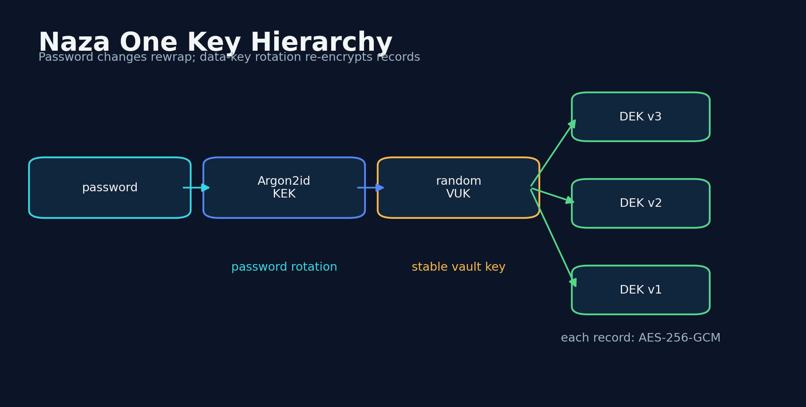
Figure 20. Naza One: Vaults, Keys, and Fail-Closed Design - conceptual system diagram created for this book.
STORY AND SYSTEM
Naza One moved the concept into Flutter and refined the security boundary. The application is local-first, runs Gemma through LiteRT-LM, provides chat and scanner workflows, and stores user-created state in an encrypted SQLite record store. The vault is unlocked before the main application mounts, so history, settings, and generation cannot silently proceed without the required security state.
Its key hierarchy separates password knowledge from data encryption. Argon2id derives a key-encryption key. That key unwraps a random vault-unlock key. The vault-unlock key unwraps versioned data-encryption keys, and each logical record is encrypted with AES-256-GCM. Changing the password can rewrap the vault key without rewriting every record. Data-key rotation can proceed transactionally and resume after interruption.
VAULT HIERARCHY
KEK = Argon2id(pw,s), VUK = Dec_KEK(W_v), DEK_k = Dec_VUK(W_k)
A password-derived KEK unwraps a random vault key, which unwraps versioned data keys.

The project documentation is candid about boundaries. Record encryption does not hide the SQLite schema, approximate record count, ciphertext lengths, key-version identifiers, or update times. The model and non-secret runtime files are not automatically encrypted. This honesty is exemplary because a threat model is useful only when it says what remains visible.
Model integrity uses a pinned SHA-256 digest, streaming verification, atomic promotion, and an encrypted trust attestation. If the artifact identity or metadata changes, the app verifies again. A partial or mismatched download is not installed. Inference backend choices include GPU-first, GPU-only, and CPU-only modes, allowing compatibility and explicit failure behavior.
Naza One also separates post-quantum recovery from ordinary local unlock. Hybrid ML-KEM and X25519 shared secrets are combined through transcript-bound HKDF, backups are authenticated with AES-GCM, and ML-DSA signatures protect the package. The private recovery kit remains separate. The lesson is architectural restraint: post-quantum tools are used where a separate recovery trust boundary creates value, not sprinkled everywhere for appearance.
DESIGN LENSES

Key separation
The first engineering lens in this chapter is key separation. To build it, derive a password KEK, unwrap a random VUK, then unwrap versioned DEKs for records. The implementation should make the state visible rather than hide it inside a prompt. The evidence standard is concrete: password rotation and data rotation become different operations. This matters because the system will eventually meet a condition that the original builder did not imagine. At that moment, explicit state, timestamps, provenance, and bounded interfaces make the difference between a failure that can be understood and a story that can only be retold. A practical implementation should log the inputs that moved the state, the policy version that interpreted them, the uncertainty before and after the update, and the action made available to the user. The resulting record supports calibration, debugging, and later independent review. The primary failure to test is using the password-derived key directly for every record forever. The countermeasure is not more confident prose. It is a rule, a comparison, or a fallback that remains valid when the model is wrong. For naza one: vaults, keys, and fail-closed design, this is the bridge between an evocative concept and a durable intelligent thinking system.

Transactional rotation
A second layer of the design is transactional rotation. To build it, write new ciphertext under a new key version, checkpoint progress, verify, and retire the old key only after reference count reaches zero. The method works only when its intermediate decisions are recorded and inspectable. The evidence standard is concrete: interruption does not corrupt the vault. This matters because the system will eventually meet a condition that the original builder did not imagine. At that moment, explicit state, timestamps, provenance, and bounded interfaces make the difference between a failure that can be understood and a story that can only be retold. A practical implementation should log the inputs that moved the state, the policy version that interpreted them, the uncertainty before and after the update, and the action made available to the user. That separation also allows a compact local model to participate without owning the entire conclusion. The primary failure to test is deleting the previous key before every record migrates. The countermeasure is not more confident prose. It is a rule, a comparison, or a fallback that remains valid when the model is wrong. For naza one: vaults, keys, and fail-closed design, this is the bridge between an evocative concept and a durable intelligent thinking system.

Honest boundary documentation
The chapter becomes operational through honest boundary documentation. To build it, state which metadata, model files, and runtime artifacts remain visible. This turns a broad idea into a component that can be tested, replaced, and improved. The evidence standard is concrete: users can align expectations with the actual threat model. This matters because the system will eventually meet a condition that the original builder did not imagine. At that moment, explicit state, timestamps, provenance, and bounded interfaces make the difference between a failure that can be understood and a story that can only be retold. A practical implementation should log the inputs that moved the state, the policy version that interpreted them, the uncertainty before and after the update, and the action made available to the user. In a safety context, graceful degradation is more valuable than an impressive all-or-nothing demonstration. The primary failure to test is calling record encryption full-database secrecy. The countermeasure is not more confident prose. It is a rule, a comparison, or a fallback that remains valid when the model is wrong. For naza one: vaults, keys, and fail-closed design, this is the bridge between an evocative concept and a durable intelligent thinking system.
FIELD NOTE
Create a key hierarchy and mark which operation changes during password rotation, data-key rotation, and recovery.

Practice Lab
The exercises below are designed to produce evidence and system artifacts rather than opinions. Complete them in a parked, safe environment and preserve the results with a date and version.
1. List metadata not hidden by record encryption.
2. Design an atomic model installation flow.
3. Explain why recovery keys should be stored separately.
◆ ◆ ◆

PART 5
Vision-Language Safety Systems
Seeing danger is not the same as commanding the driver.
◆

21
VISION-LANGUAGE SAFETY SYSTEMS

Teaching a Model to See Risk
Seeing the road is not naming objects; it is reasoning about how objects can become conflict.
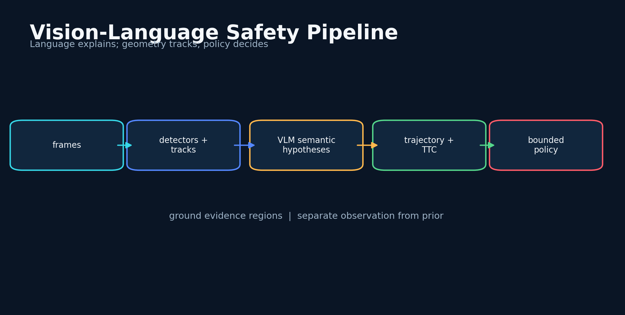
Figure 21. Teaching a Model to See Risk - conceptual system diagram created for this book.
STORY AND SYSTEM
A vision-language road scanner must move beyond object labels. A car, pedestrian, puddle, or deer is not automatically a hazard. Risk emerges from relation: distance, speed, occlusion, intent, road rules, visibility, and the driver's available response. The VLM's role is to convert visual structure into semantic hypotheses that can be checked by tracking and policy modules.
A practical pipeline begins with dedicated perception: detection, segmentation, lane geometry, optical flow, and object tracks. The VLM receives selected frames or structured summaries, not an uncontrolled flood. It can explain ambiguous scenes, identify unusual context, and retrieve relevant driving rules. A numerical module estimates trajectories and time-to-conflict. The fusion layer combines them with map, weather, and driver state.
MULTIMODAL SCENE STATE
z_t = f_VLM(F_t-k:t, D_t, G_t), R_t=g(z_t, T_t, W_t)
The VLM summarizes frames, detections, and geometry; a separate fusion model combines that state with trajectories and world context.

Current research shows both promise and limitation. Vision-language models can recognize complex hazards and support planning, but they can struggle with spatial reasoning, temporal consistency, and domain shift. Structured grounding improves reliability. The system should require the model to point to evidence regions, identify the frames supporting a claim, and expose which parts of the conclusion came from visual observation versus prior knowledge.
Training data should include near-misses, rare conditions, adverse weather, night scenes, motorcycles, pedestrians, wildlife, construction, and unusual road behavior. It should also include ordinary scenes to prevent constant alarm. Privacy-preserving collection, redaction, and clear consent are necessary because road video captures bystanders, homes, license plates, and routines.
The objective is a model that can say: 'The silver vehicle is drifting within its lane, the drift is increasing over three frames, and an adjacent motorcycle is entering the overlap region.' That statement can be verified. 'The driver is dangerous' is vague and potentially unfair. Safety vision should describe observable behavior and forecast interaction, not assign identity or moral character.
DESIGN LENSES

Grounded scene reasoning
The first engineering lens in this chapter is grounded scene reasoning. To build it, require the VLM to link each semantic hazard to frames, regions, tracks, or structured detector output. The implementation should make the state visible rather than hide it inside a prompt. The evidence standard is concrete: claims can be visually inspected and challenged. This matters because the system will eventually meet a condition that the original builder did not imagine. At that moment, explicit state, timestamps, provenance, and bounded interfaces make the difference between a failure that can be understood and a story that can only be retold. A practical implementation should log the inputs that moved the state, the policy version that interpreted them, the uncertainty before and after the update, and the action made available to the user. The resulting record supports calibration, debugging, and later independent review. The primary failure to test is free-form explanations with no evidence location. The countermeasure is not more confident prose. It is a rule, a comparison, or a fallback that remains valid when the model is wrong. For teaching a model to see risk, this is the bridge between an evocative concept and a durable intelligent thinking system.

Modular perception
A second layer of the design is modular perception. To build it, use dedicated models for detection, segmentation, optical flow, and tracking before semantic synthesis. The method works only when its intermediate decisions are recorded and inspectable. The evidence standard is concrete: geometry remains numerical and temporally stable. This matters because the system will eventually meet a condition that the original builder did not imagine. At that moment, explicit state, timestamps, provenance, and bounded interfaces make the difference between a failure that can be understood and a story that can only be retold. A practical implementation should log the inputs that moved the state, the policy version that interpreted them, the uncertainty before and after the update, and the action made available to the user. That separation also allows a compact local model to participate without owning the entire conclusion. The primary failure to test is asking one VLM prompt to perform every perception task. The countermeasure is not more confident prose. It is a rule, a comparison, or a fallback that remains valid when the model is wrong. For teaching a model to see risk, this is the bridge between an evocative concept and a durable intelligent thinking system.

Privacy-minimized video
The chapter becomes operational through privacy-minimized video. To build it, retain derived features where possible, redact identifiers, encrypt necessary clips, and expire them quickly. This turns a broad idea into a component that can be tested, replaced, and improved. The evidence standard is concrete: road research need not become continuous surveillance. This matters because the system will eventually meet a condition that the original builder did not imagine. At that moment, explicit state, timestamps, provenance, and bounded interfaces make the difference between a failure that can be understood and a story that can only be retold. A practical implementation should log the inputs that moved the state, the policy version that interpreted them, the uncertainty before and after the update, and the action made available to the user. In a safety context, graceful degradation is more valuable than an impressive all-or-nothing demonstration. The primary failure to test is building a permanent archive of bystanders and routines. The countermeasure is not more confident prose. It is a rule, a comparison, or a fallback that remains valid when the model is wrong. For teaching a model to see risk, this is the bridge between an evocative concept and a durable intelligent thinking system.
FIELD NOTE
Annotate a short driving clip with objects, relationships, uncertainty, and the exact evidence for each claim.

Practice Lab
The exercises below are designed to produce evidence and system artifacts rather than opinions. Complete them in a parked, safe environment and preserve the results with a date and version.
1. Separate perception, language, tracking, and policy modules.
2. Write one behavior description that avoids identity judgment.
3. Define a visual grounding requirement.
◆ ◆ ◆

22
VISION-LANGUAGE SAFETY SYSTEMS

Reading Drunk and Reckless Driving
The system may detect risky behavior; it must not diagnose a person from a few seconds of motion.
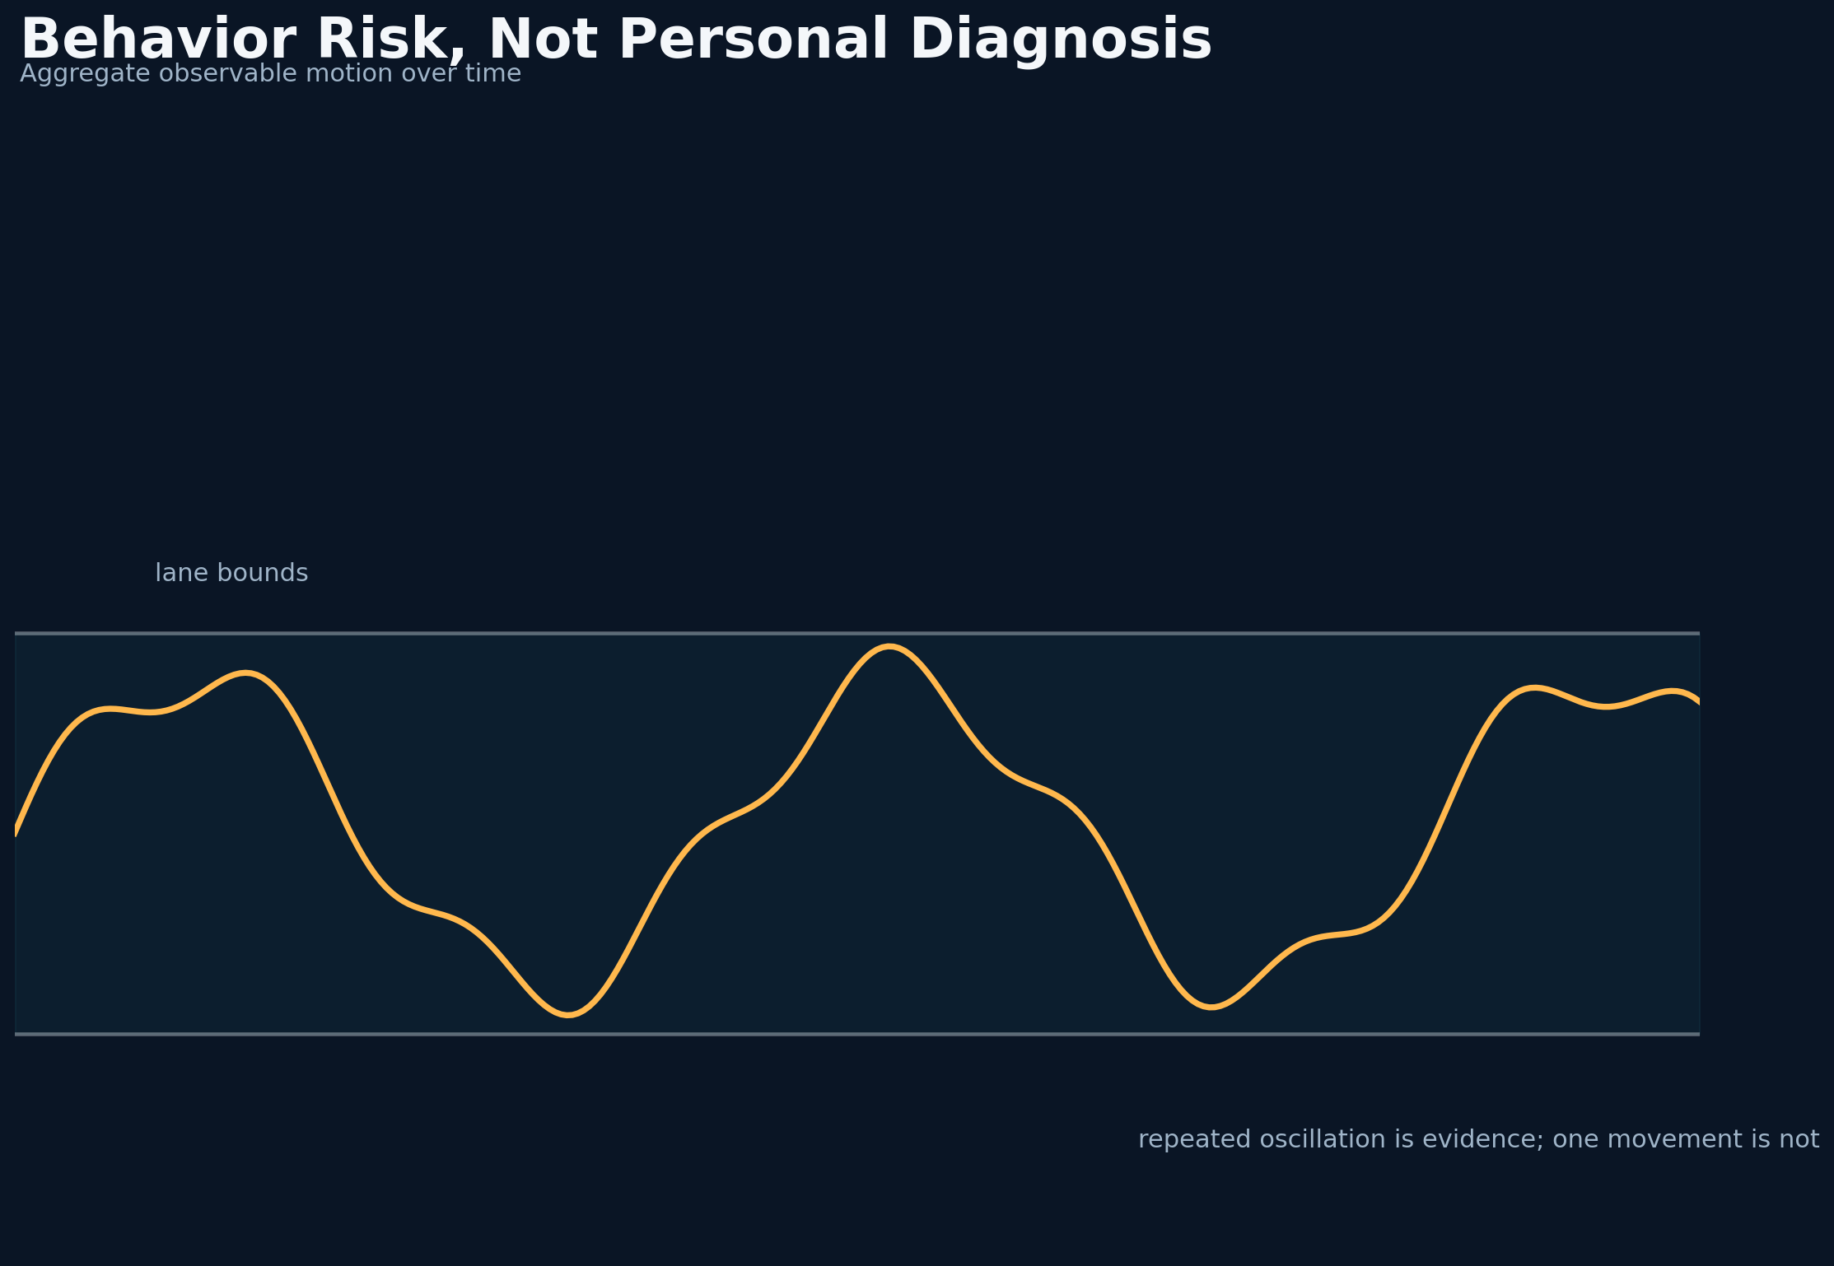
Figure 22. Reading Drunk and Reckless Driving - conceptual system diagram created for this book.
STORY AND SYSTEM
One of the most ambitious directions in this work is a vision-language system that detects patterns associated with drunk, drowsy, distracted, or reckless driving and persuades the user to reduce risk. The first safety boundary is language. A camera cannot establish intoxication. It can observe weaving, inconsistent speed, delayed braking, lane departures, abrupt corrections, phone interaction, head pose, or repeated near-conflicts.
The model should therefore estimate behavior risk, not personal diagnosis. It can say that the observed trajectory resembles patterns associated with impairment or distraction. It should include alternative explanations such as wind, road damage, vehicle problems, or evasive action. When evidence is weak, it should recommend distance and caution without accusation.
BEHAVIOR RISK WINDOW
B_t = Σ_j=0^k α_j φ(x_t-j)
Motion cues are aggregated over time with decaying weights before interpretation.

Temporal evidence is essential. A single lateral movement may be ordinary. Repeated oscillation across several seconds, combined with speed variation and delayed response to traffic, is more informative. The system should aggregate features over a window, discount camera shake, and compare behavior with road curvature. Dedicated signal processing should produce the motion features; the VLM should interpret context and formulate the message.
There are fairness and privacy risks. Vehicle type, neighborhood, age cues, or appearance should not become proxies for dangerousness. The system should minimize identity features and focus on motion. Stored video should be limited, encrypted, and governed by a clear retention policy. Alerts about other drivers should never invite confrontation or vigilantism.
The safest action is usually defensive separation: increase following distance, avoid passing, change lanes when safe, exit the area, or contact emergency services only when there is a clear and immediate danger and local law permits. The model's job is to lower the temperature of the situation. It should help the user become less reactive, not more certain about another person's motives.
DESIGN LENSES

Behavior not diagnosis
The first engineering lens in this chapter is behavior not diagnosis. To build it, classify observable weaving, speed variation, delayed braking, and distraction cues while explicitly listing alternative causes. The implementation should make the state visible rather than hide it inside a prompt. The evidence standard is concrete: the system avoids unsupported medical or legal conclusions. This matters because the system will eventually meet a condition that the original builder did not imagine. At that moment, explicit state, timestamps, provenance, and bounded interfaces make the difference between a failure that can be understood and a story that can only be retold. A practical implementation should log the inputs that moved the state, the policy version that interpreted them, the uncertainty before and after the update, and the action made available to the user. The resulting record supports calibration, debugging, and later independent review. The primary failure to test is labeling a driver drunk from a short clip. The countermeasure is not more confident prose. It is a rule, a comparison, or a fallback that remains valid when the model is wrong. For reading drunk and reckless driving, this is the bridge between an evocative concept and a durable intelligent thinking system.

Temporal normalization
A second layer of the design is temporal normalization. To build it, compare lateral motion with lane curvature, camera motion, wind, and road defects over a defined window. The method works only when its intermediate decisions are recorded and inspectable. The evidence standard is concrete: repeated deviation is distinguished from ordinary correction. This matters because the system will eventually meet a condition that the original builder did not imagine. At that moment, explicit state, timestamps, provenance, and bounded interfaces make the difference between a failure that can be understood and a story that can only be retold. A practical implementation should log the inputs that moved the state, the policy version that interpreted them, the uncertainty before and after the update, and the action made available to the user. That separation also allows a compact local model to participate without owning the entire conclusion. The primary failure to test is triggering on one frame or one lane change. The countermeasure is not more confident prose. It is a rule, a comparison, or a fallback that remains valid when the model is wrong. For reading drunk and reckless driving, this is the bridge between an evocative concept and a durable intelligent thinking system.

Defensive separation
The chapter becomes operational through defensive separation. To build it, map behavior risk to distance, lane change when safe, route exit, or official emergency guidance without confrontation. This turns a broad idea into a component that can be tested, replaced, and improved. The evidence standard is concrete: the intervention lowers exposure. This matters because the system will eventually meet a condition that the original builder did not imagine. At that moment, explicit state, timestamps, provenance, and bounded interfaces make the difference between a failure that can be understood and a story that can only be retold. A practical implementation should log the inputs that moved the state, the policy version that interpreted them, the uncertainty before and after the update, and the action made available to the user. In a safety context, graceful degradation is more valuable than an impressive all-or-nothing demonstration. The primary failure to test is encouraging the user to follow, film, or challenge another driver. The countermeasure is not more confident prose. It is a rule, a comparison, or a fallback that remains valid when the model is wrong. For reading drunk and reckless driving, this is the bridge between an evocative concept and a durable intelligent thinking system.
FIELD NOTE
Rewrite five accusatory labels as observable behavior descriptions with alternative explanations.

Practice Lab
The exercises below are designed to produce evidence and system artifacts rather than opinions. Complete them in a parked, safe environment and preserve the results with a date and version.
1. Choose a temporal window for weaving detection.
2. List protected or identity-related features to exclude.
3. Write a non-confrontational defensive action alert.
◆ ◆ ◆

23
VISION-LANGUAGE SAFETY SYSTEMS

Persuasion Before Punishment
The most important prediction may be the moment a person is still willing to change their mind.
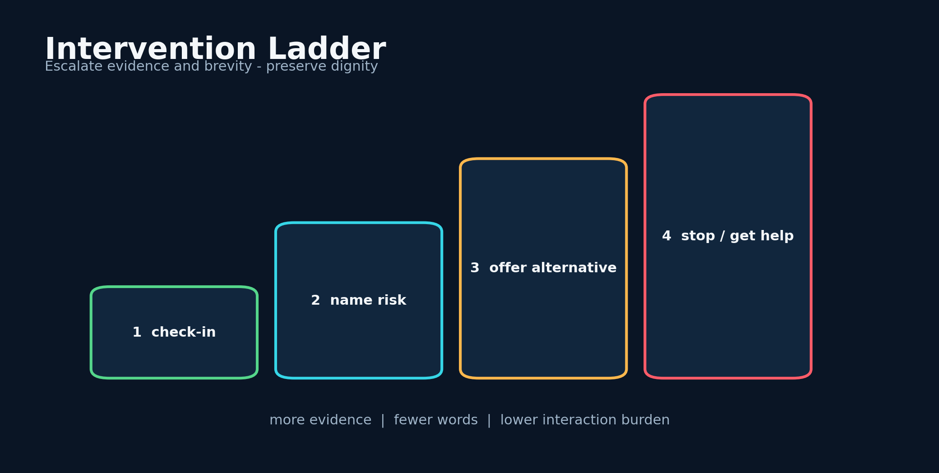
Figure 23. Persuasion Before Punishment - conceptual system diagram created for this book.
STORY AND SYSTEM
A safety companion should not only detect external hazards. It should recognize when the user is about to make a risky decision: driving after drinking, continuing while exhausted, speeding to recover lost delivery time, reading a long message in motion, or ignoring repeated near-misses. The intervention must preserve dignity because shame and confrontation can make a person defensive.
The system needs an intervention ladder. At low concern, it offers a gentle check-in. At moderate concern, it names the observed risk and proposes an alternative. At high concern, it recommends stopping, arranging a ride, or contacting a trusted person. At imminent danger, it uses the shortest possible message. Escalation depends on evidence and the user's response, not on a model's emotional intensity.
INTERVENTION POLICY
a^* = arg max_a [P(change | a,c)B - C_distraction(a)-C_reactance(a)]
The chosen message balances expected behavior change against distraction and psychological resistance.

Persuasion can draw from motivational interviewing: ask a question, reflect the user's goal, highlight the mismatch between that goal and the risky action, and offer choices. 'You said getting home safely matters. Your steering has become inconsistent. Pull into the next safe lot or call a ride?' is more useful than a lecture. The system should make the safe option easier by surfacing navigation, contacts, or ride services only when the user requests or authorizes them.
The model must avoid manipulation. It should not invent family emergencies, threaten legal consequences, or exploit private memories. Personalization should be transparent and limited to user-chosen goals. The user needs controls to disable specific interventions, review why they occurred, and correct false assumptions.
Success is behavior change, not rhetorical brilliance. Evaluation should measure whether users slow down, stop, increase distance, or choose an alternative ride, along with whether they feel respected. A technically accurate warning that causes reactance may be less safe than a gentler message that works.
DESIGN LENSES

Intervention ladder
The first engineering lens in this chapter is intervention ladder. To build it, move from check-in to direct recommendation to stop-trip guidance as evidence and urgency increase. The implementation should make the state visible rather than hide it inside a prompt. The evidence standard is concrete: message intensity remains proportional. This matters because the system will eventually meet a condition that the original builder did not imagine. At that moment, explicit state, timestamps, provenance, and bounded interfaces make the difference between a failure that can be understood and a story that can only be retold. A practical implementation should log the inputs that moved the state, the policy version that interpreted them, the uncertainty before and after the update, and the action made available to the user. The resulting record supports calibration, debugging, and later independent review. The primary failure to test is jumping from uncertainty to moral condemnation. The countermeasure is not more confident prose. It is a rule, a comparison, or a fallback that remains valid when the model is wrong. For persuasion before punishment, this is the bridge between an evocative concept and a durable intelligent thinking system.

Motivational framing
A second layer of the design is motivational framing. To build it, connect the alert to goals the user chose and offer two concrete safe alternatives. The method works only when its intermediate decisions are recorded and inspectable. The evidence standard is concrete: autonomy and dignity improve acceptance. This matters because the system will eventually meet a condition that the original builder did not imagine. At that moment, explicit state, timestamps, provenance, and bounded interfaces make the difference between a failure that can be understood and a story that can only be retold. A practical implementation should log the inputs that moved the state, the policy version that interpreted them, the uncertainty before and after the update, and the action made available to the user. That separation also allows a compact local model to participate without owning the entire conclusion. The primary failure to test is using private memories or fabricated consequences to manipulate. The countermeasure is not more confident prose. It is a rule, a comparison, or a fallback that remains valid when the model is wrong. For persuasion before punishment, this is the bridge between an evocative concept and a durable intelligent thinking system.

Behavioral evaluation
The chapter becomes operational through behavioral evaluation. To build it, measure completed safe actions, distraction, dismissal, trust, and felt respect. This turns a broad idea into a component that can be tested, replaced, and improved. The evidence standard is concrete: persuasion quality is operational rather than literary. This matters because the system will eventually meet a condition that the original builder did not imagine. At that moment, explicit state, timestamps, provenance, and bounded interfaces make the difference between a failure that can be understood and a story that can only be retold. A practical implementation should log the inputs that moved the state, the policy version that interpreted them, the uncertainty before and after the update, and the action made available to the user. In a safety context, graceful degradation is more valuable than an impressive all-or-nothing demonstration. The primary failure to test is optimizing for clicks or message length instead of safety. The countermeasure is not more confident prose. It is a rule, a comparison, or a fallback that remains valid when the model is wrong. For persuasion before punishment, this is the bridge between an evocative concept and a durable intelligent thinking system.
FIELD NOTE
Write three versions of the same intervention: gentle, direct, and emergency. Preserve the user's agency in each.

Practice Lab
The exercises below are designed to produce evidence and system artifacts rather than opinions. Complete them in a parked, safe environment and preserve the results with a date and version.
1. Design a four-level intervention ladder.
2. List three manipulative tactics the system must forbid.
3. Choose two behavioral outcomes for evaluation.
◆ ◆ ◆

24
VISION-LANGUAGE SAFETY SYSTEMS

Multimodal Fusion Under Uncertainty
When sensors disagree, the system should become more careful, not more eloquent.
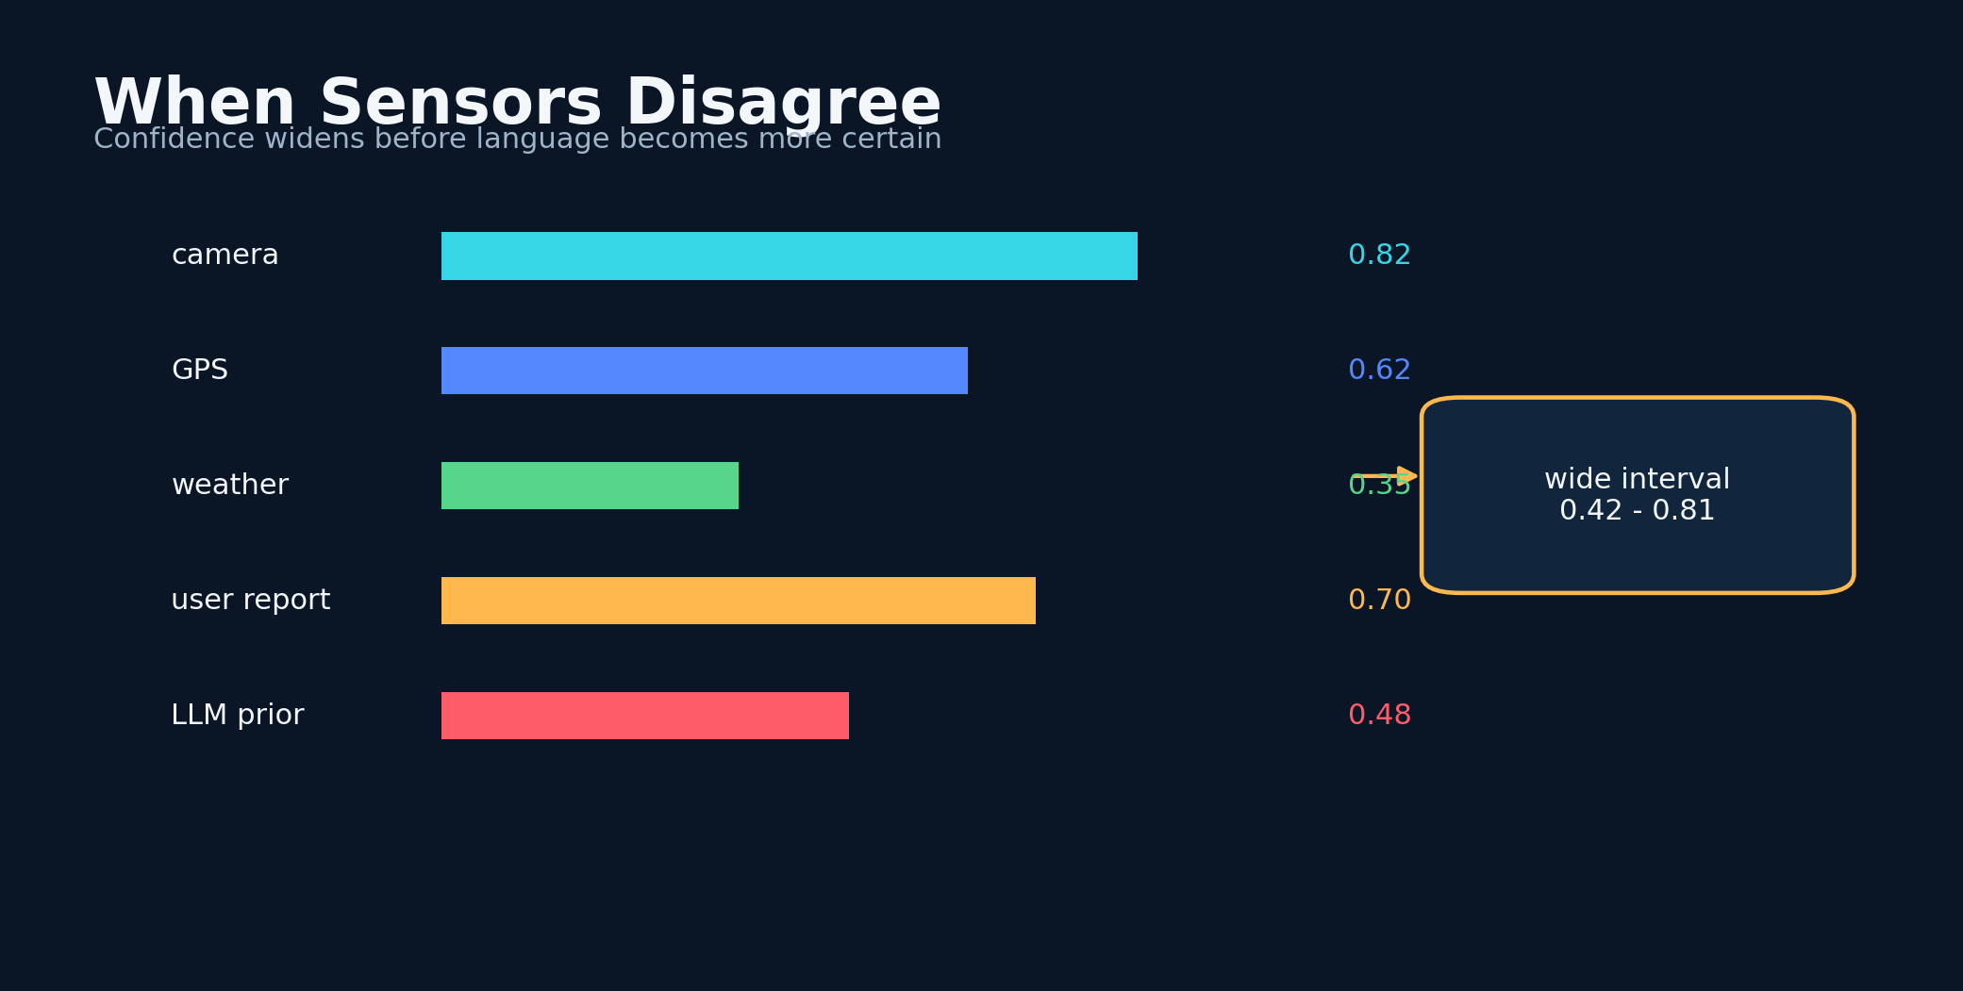
Figure 24. Multimodal Fusion Under Uncertainty - conceptual system diagram created for this book.
STORY AND SYSTEM
Road intelligence combines channels with different failure modes. Cameras struggle with glare and darkness. GPS can drift. Weather feeds can be stale. language models can hallucinate. User reports can be incomplete. Vehicle telemetry can be precise but unavailable. Fusion is therefore not a vote in which every channel counts equally. It is a reliability-weighted inference problem.
Each observation should carry quality, authenticity, freshness, and coverage. A camera frame may be authentic and fresh but low quality. A public incident report may be high quality but old. A model-generated explanation may be fresh but derived rather than observed. These metadata determine how much the evidence can move the risk state.
RELIABILITY-WEIGHTED FUSION
~ z = (Σ_j w_j z_j)/(Σ_j w_j), w_j=q_j a_j f_j (1-u_j)
Channel estimates are weighted by quality, authenticity, freshness, and uncertainty.

Contradiction is valuable. If the VLM reports heavy rain but the weather feed and image statistics disagree, the system should investigate or lower confidence. If a user says the road is clear while object tracking shows repeated braking, the system should preserve both signals. A critic model can search for contradiction, but the final policy should use explicit rules for missing and conflicting data.
Bayesian filtering, Dempster-Shafer methods, conformal prediction, and ensemble calibration all offer tools. The exact method is less important than the behavior: uncertainty should widen when inputs disagree or fall outside known conditions. The alert should explain the disagreement in plain language when it affects the recommendation.
Multimodal fusion is where the oracle becomes a system rather than a model. No single component sees the whole road. Reliability comes from knowing what each component can observe, what it tends to miss, and how quickly its evidence expires.
DESIGN LENSES

Channel metadata
The first engineering lens in this chapter is channel metadata. To build it, attach quality, authenticity, freshness, coverage, and uncertainty to every observation. The implementation should make the state visible rather than hide it inside a prompt. The evidence standard is concrete: fusion weights become explainable and time-sensitive. This matters because the system will eventually meet a condition that the original builder did not imagine. At that moment, explicit state, timestamps, provenance, and bounded interfaces make the difference between a failure that can be understood and a story that can only be retold. A practical implementation should log the inputs that moved the state, the policy version that interpreted them, the uncertainty before and after the update, and the action made available to the user. The resulting record supports calibration, debugging, and later independent review. The primary failure to test is treating a stale report as equivalent to a live sensor. The countermeasure is not more confident prose. It is a rule, a comparison, or a fallback that remains valid when the model is wrong. For multimodal fusion under uncertainty, this is the bridge between an evocative concept and a durable intelligent thinking system.

Contradiction handling
A second layer of the design is contradiction handling. To build it, preserve conflicting evidence, run targeted checks, and widen intervals instead of forcing premature agreement. The method works only when its intermediate decisions are recorded and inspectable. The evidence standard is concrete: disagreement is information. This matters because the system will eventually meet a condition that the original builder did not imagine. At that moment, explicit state, timestamps, provenance, and bounded interfaces make the difference between a failure that can be understood and a story that can only be retold. A practical implementation should log the inputs that moved the state, the policy version that interpreted them, the uncertainty before and after the update, and the action made available to the user. That separation also allows a compact local model to participate without owning the entire conclusion. The primary failure to test is letting a critic model erase the minority channel without record. The countermeasure is not more confident prose. It is a rule, a comparison, or a fallback that remains valid when the model is wrong. For multimodal fusion under uncertainty, this is the bridge between an evocative concept and a durable intelligent thinking system.

Domain-shift detection
The chapter becomes operational through domain-shift detection. To build it, measure distance from known conditions and activate abstention or conservative sets when novelty rises. This turns a broad idea into a component that can be tested, replaced, and improved. The evidence standard is concrete: performance under familiar roads does not imply universal reliability. This matters because the system will eventually meet a condition that the original builder did not imagine. At that moment, explicit state, timestamps, provenance, and bounded interfaces make the difference between a failure that can be understood and a story that can only be retold. A practical implementation should log the inputs that moved the state, the policy version that interpreted them, the uncertainty before and after the update, and the action made available to the user. In a safety context, graceful degradation is more valuable than an impressive all-or-nothing demonstration. The primary failure to test is confident extrapolation to rare weather or unseen camera geometry. The countermeasure is not more confident prose. It is a rule, a comparison, or a fallback that remains valid when the model is wrong. For multimodal fusion under uncertainty, this is the bridge between an evocative concept and a durable intelligent thinking system.
FIELD NOTE
Create a disagreement matrix for camera, weather, GPS, user report, and language model.

Practice Lab
The exercises below are designed to produce evidence and system artifacts rather than opinions. Complete them in a parked, safe environment and preserve the results with a date and version.
1. Define freshness decay for one sensor.
2. Write a contradiction alert.
3. Choose a method for widening uncertainty under domain shift.
◆ ◆ ◆

25
VISION-LANGUAGE SAFETY SYSTEMS

The Driver Must Remain in Command
An advisory system earns trust by knowing the boundary of its authority.
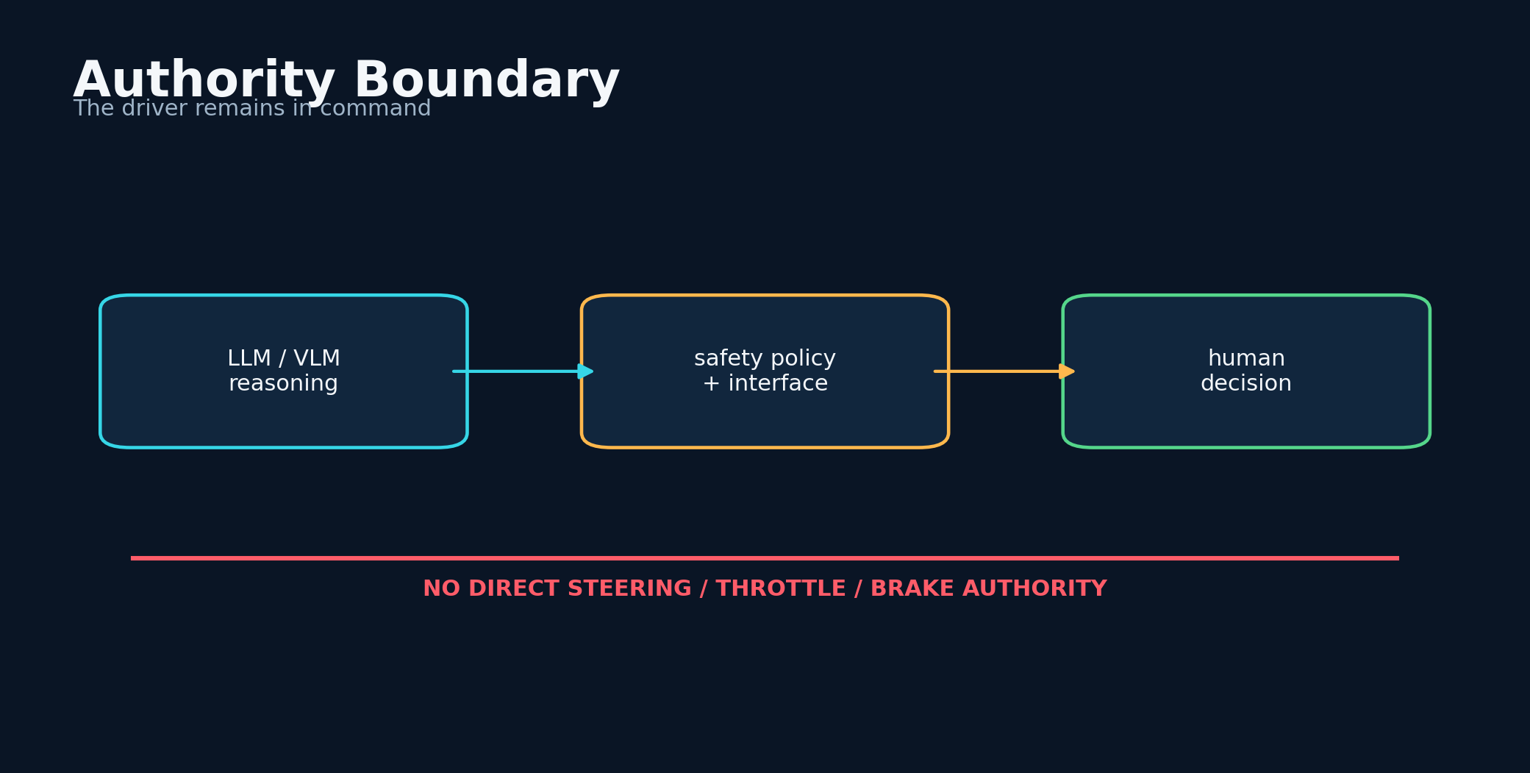
Figure 25. The Driver Must Remain in Command - conceptual system diagram created for this book.
STORY AND SYSTEM
The systems described in this book are advisory research systems, not certified advanced driver-assistance or autonomous driving controllers. That boundary must remain visible in code and interface. A local language model should not directly command steering, throttle, or braking. Any future vehicle-control integration would require specialized hardware, formal safety engineering, regulatory compliance, redundancy, and independent testing.
Human command does not mean dumping every decision on the driver. The assistant can reduce cognitive work by summarizing, prioritizing, and timing information. It can default to silence when nothing useful needs to be said. It can recommend pulling over before presenting a long analysis. It can let the user acknowledge or dismiss an alert with minimal interaction.
AUTHORITY BOUNDARY
Policy_LLM ⊆ Advice, Control_vehicle ∉ Policy_LLM
The language model may generate bounded advice but has no direct vehicle-control authority.

Automation bias is a major concern. Users may follow a confident system even when the road contradicts it. The interface should remind the driver to prioritize direct observation. When confidence is low or data are stale, the system should say so. It should never instruct a maneuver that conflicts with traffic law or immediate visual safety.
The driver also needs recourse. Every alert should have a reason code and a later review screen. Users can mark false alarms, identify missing context, and export episodes for analysis. Corrections should improve the system without allowing a malicious user to erase the audit trail.
The highest form of human control is informed refusal. The user can choose not to begin the trip, take another route, wait for weather to pass, or call for help. The oracle is successful when it expands those choices before urgency collapses them.
DESIGN LENSES

Advisory boundary
The first engineering lens in this chapter is advisory boundary. To build it, enforce in code that language outputs can select only approved advisory actions. The implementation should make the state visible rather than hide it inside a prompt. The evidence standard is concrete: vehicle control remains outside the model's authority. This matters because the system will eventually meet a condition that the original builder did not imagine. At that moment, explicit state, timestamps, provenance, and bounded interfaces make the difference between a failure that can be understood and a story that can only be retold. A practical implementation should log the inputs that moved the state, the policy version that interpreted them, the uncertainty before and after the update, and the action made available to the user. The resulting record supports calibration, debugging, and later independent review. The primary failure to test is a tool interface that exposes steering or braking to free-form text. The countermeasure is not more confident prose. It is a rule, a comparison, or a fallback that remains valid when the model is wrong. For the driver must remain in command, this is the bridge between an evocative concept and a durable intelligent thinking system.

Automation-bias defense
A second layer of the design is automation-bias defense. To build it, show freshness, uncertainty, and reasons while reminding users to prioritize direct observation. The method works only when its intermediate decisions are recorded and inspectable. The evidence standard is concrete: trust becomes conditional rather than absolute. This matters because the system will eventually meet a condition that the original builder did not imagine. At that moment, explicit state, timestamps, provenance, and bounded interfaces make the difference between a failure that can be understood and a story that can only be retold. A practical implementation should log the inputs that moved the state, the policy version that interpreted them, the uncertainty before and after the update, and the action made available to the user. That separation also allows a compact local model to participate without owning the entire conclusion. The primary failure to test is using authoritative voice and visual polish to conceal weak evidence. The countermeasure is not more confident prose. It is a rule, a comparison, or a fallback that remains valid when the model is wrong. For the driver must remain in command, this is the bridge between an evocative concept and a durable intelligent thinking system.

User recourse
The chapter becomes operational through user recourse. To build it, store reason codes, support post-trip correction, and preserve an immutable original event. This turns a broad idea into a component that can be tested, replaced, and improved. The evidence standard is concrete: feedback improves the model without rewriting history. This matters because the system will eventually meet a condition that the original builder did not imagine. At that moment, explicit state, timestamps, provenance, and bounded interfaces make the difference between a failure that can be understood and a story that can only be retold. A practical implementation should log the inputs that moved the state, the policy version that interpreted them, the uncertainty before and after the update, and the action made available to the user. In a safety context, graceful degradation is more valuable than an impressive all-or-nothing demonstration. The primary failure to test is allowing convenient deletion of every inconvenient false alarm. The countermeasure is not more confident prose. It is a rule, a comparison, or a fallback that remains valid when the model is wrong. For the driver must remain in command, this is the bridge between an evocative concept and a durable intelligent thinking system.
FIELD NOTE
Audit a prototype screen and remove any wording that could be mistaken for certified vehicle control.

Practice Lab
The exercises below are designed to produce evidence and system artifacts rather than opinions. Complete them in a parked, safe environment and preserve the results with a date and version.
1. Write a stale-data warning.
2. Design a one-tap post-trip correction flow.
3. Define three actions the model must never command.
◆ ◆ ◆

PART 6
Engineering for the Long Road
The system must remain testable after the story becomes powerful.
◆

26
ENGINEERING FOR THE LONG ROAD

Post-Quantum Security for Small Devices
Future-resistant cryptography is useful when it protects a real trust boundary today.
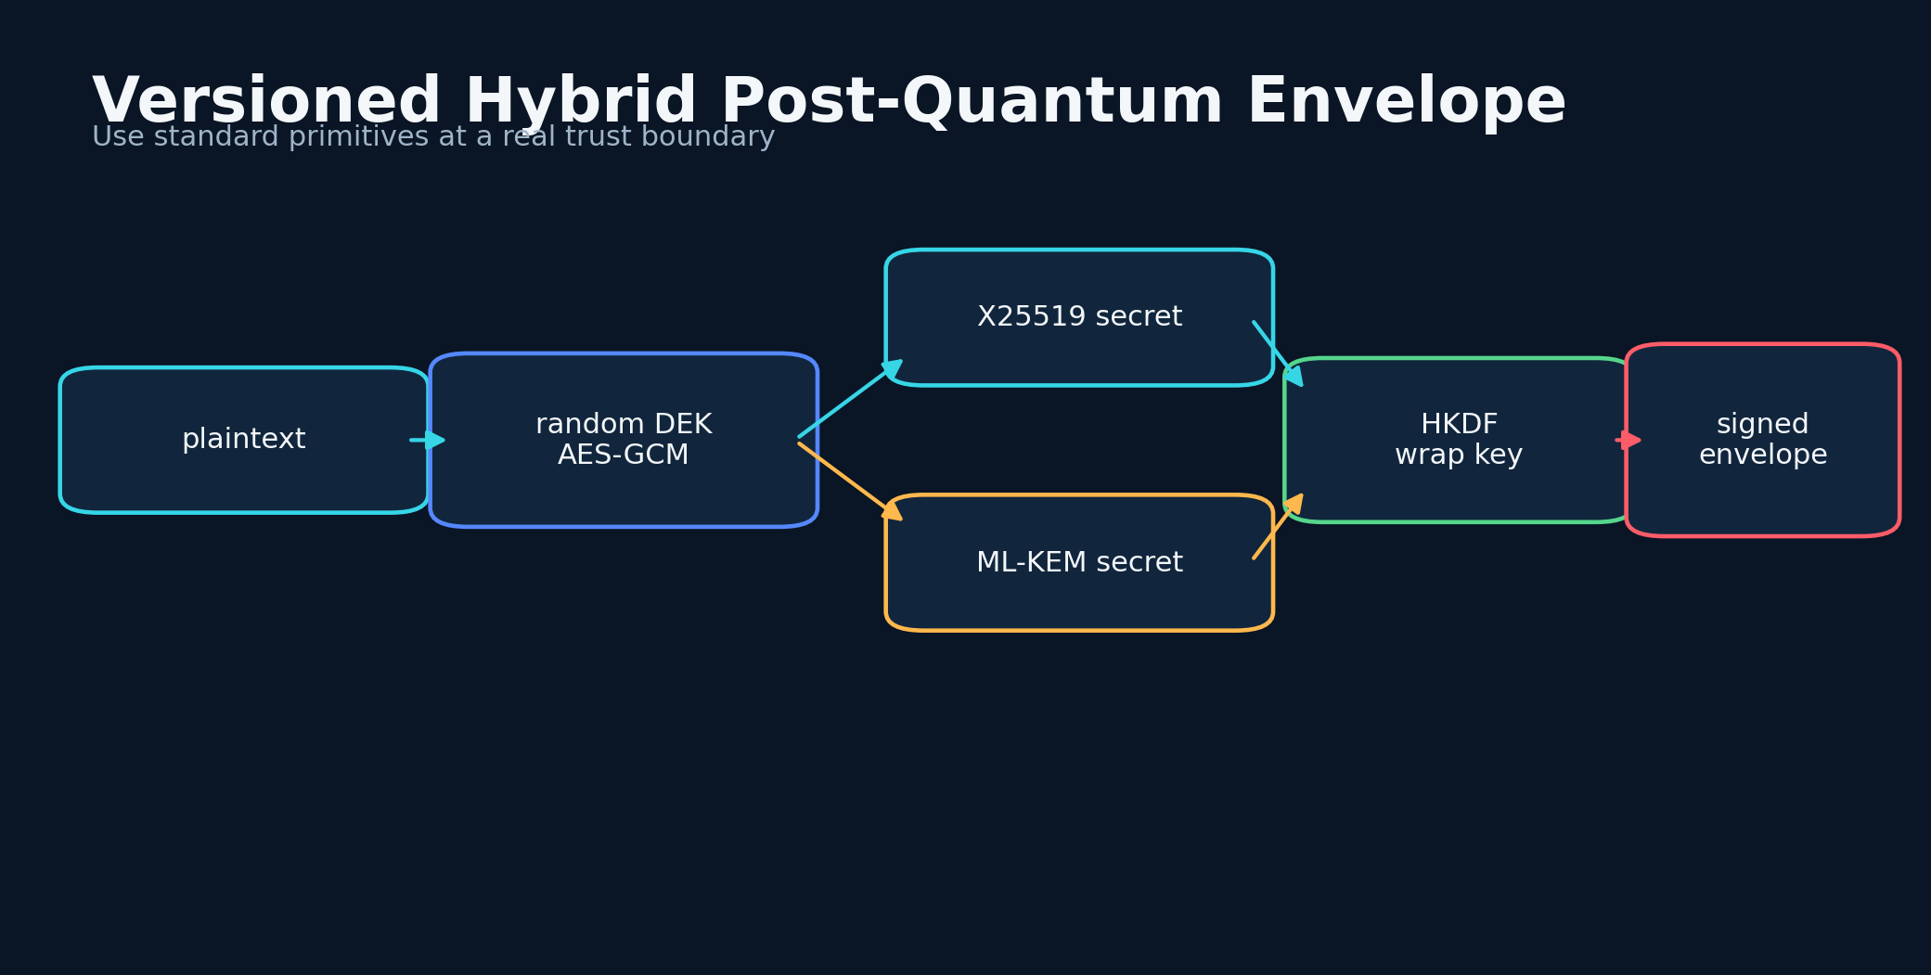
Figure 26. Post-Quantum Security for Small Devices - conceptual system diagram created for this book.
STORY AND SYSTEM
The RoadScanner web architecture explored a versioned hybrid envelope in which data are encrypted with AES-GCM, the data key is wrapped using classical X25519 and post-quantum ML-KEM shared secrets, and signatures can use ML-DSA. NIST standardized ML-KEM and ML-DSA in 2024, giving projects a stable vocabulary and specification for post-quantum key establishment and signatures.
Hybrid design reduces migration risk. The security of the wrap can depend on both a classical and post-quantum component, provided the combination is implemented correctly. HKDF binds the shared secrets to context. Version fields and policy markers prevent silent downgrade. Signatures authenticate the envelope and model artifacts. The cryptographic design must use established libraries and test vectors rather than novel primitives.
HYBRID WRAP
K_w = HKDF(ss_X25519 || ss_ML-KEM || context)
Classical and post-quantum shared secrets are combined through a context-bound key derivation function.

Small devices impose constraints. Post-quantum keys and signatures can be larger, native libraries can be difficult to build, and strict modes can reduce availability. The system should make policy explicit: strict post-quantum mode for environments that can support it, hybrid recovery for separated backups, and safe classical fallbacks only when the threat model permits. A failure should be visible, not silently downgraded.
Key management remains harder than algorithm selection. Environment-only secrets, sealed caches, split recovery, rotation, and separate offline key kits address different operational risks. Backups must include the ciphertext and the correct recovery materials without storing them together. A security design that users cannot recover will eventually be bypassed.
Post-quantum security belongs in this story because the project aims to remain useful for years. But longevity comes from upgradeable formats, clear boundaries, and tested recovery more than from any single algorithm. The envelope must be able to evolve without making old data unreadable or new policy ambiguous.
DESIGN LENSES

Versioned envelope
The first engineering lens in this chapter is versioned envelope. To build it, bind algorithm identifiers, policy, context, nonces, public keys, and signatures into an authenticated format. The implementation should make the state visible rather than hide it inside a prompt. The evidence standard is concrete: future migrations and downgrade detection are possible. This matters because the system will eventually meet a condition that the original builder did not imagine. At that moment, explicit state, timestamps, provenance, and bounded interfaces make the difference between a failure that can be understood and a story that can only be retold. A practical implementation should log the inputs that moved the state, the policy version that interpreted them, the uncertainty before and after the update, and the action made available to the user. The resulting record supports calibration, debugging, and later independent review. The primary failure to test is an opaque ciphertext with no version or policy semantics. The countermeasure is not more confident prose. It is a rule, a comparison, or a fallback that remains valid when the model is wrong. For post-quantum security for small devices, this is the bridge between an evocative concept and a durable intelligent thinking system.

Hybrid key establishment
A second layer of the design is hybrid key establishment. To build it, combine X25519 and ML-KEM shared secrets through HKDF with transcript context. The method works only when its intermediate decisions are recorded and inspectable. The evidence standard is concrete: security can survive compromise of one family under stated assumptions. This matters because the system will eventually meet a condition that the original builder did not imagine. At that moment, explicit state, timestamps, provenance, and bounded interfaces make the difference between a failure that can be understood and a story that can only be retold. A practical implementation should log the inputs that moved the state, the policy version that interpreted them, the uncertainty before and after the update, and the action made available to the user. That separation also allows a compact local model to participate without owning the entire conclusion. The primary failure to test is concatenating secrets without domain separation or validation. The countermeasure is not more confident prose. It is a rule, a comparison, or a fallback that remains valid when the model is wrong. For post-quantum security for small devices, this is the bridge between an evocative concept and a durable intelligent thinking system.

Recoverable operations
The chapter becomes operational through recoverable operations. To build it, test key backup, separated recovery kit, rotation, restoration, and failure reporting on actual target devices. This turns a broad idea into a component that can be tested, replaced, and improved. The evidence standard is concrete: cryptography must remain usable during loss or upgrade. This matters because the system will eventually meet a condition that the original builder did not imagine. At that moment, explicit state, timestamps, provenance, and bounded interfaces make the difference between a failure that can be understood and a story that can only be retold. A practical implementation should log the inputs that moved the state, the policy version that interpreted them, the uncertainty before and after the update, and the action made available to the user. In a safety context, graceful degradation is more valuable than an impressive all-or-nothing demonstration. The primary failure to test is storing the recovery key beside the encrypted backup. The countermeasure is not more confident prose. It is a rule, a comparison, or a fallback that remains valid when the model is wrong. For post-quantum security for small devices, this is the bridge between an evocative concept and a durable intelligent thinking system.
FIELD NOTE
Draw the lifecycle of a data-encryption key and mark where hybrid key establishment, signature, and recovery occur.

Practice Lab
The exercises below are designed to produce evidence and system artifacts rather than opinions. Complete them in a parked, safe environment and preserve the results with a date and version.
1. Define a downgrade-detection field.
2. Choose which assets need post-quantum recovery.
3. Write a recovery test that proves a backup is decryptable.
◆ ◆ ◆

27
ENGINEERING FOR THE LONG ROAD

Evidence, Logs, and Reproducibility
The log is the memory that does not become more certain with every retelling.
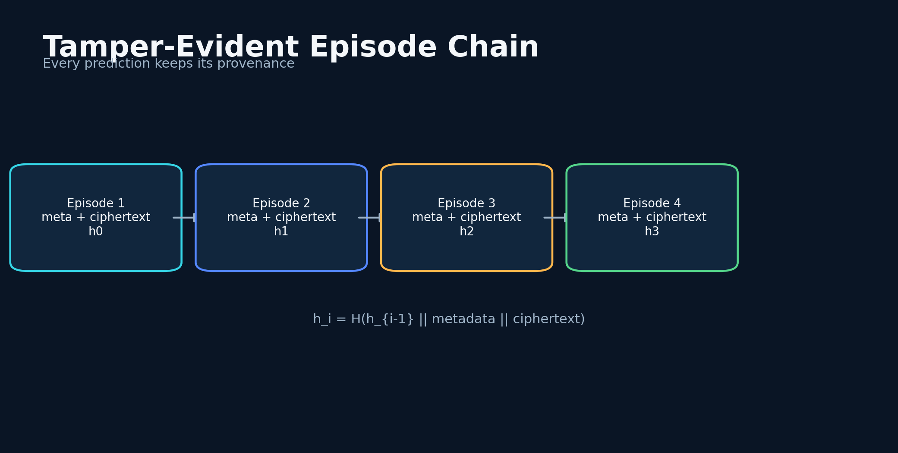
Figure 27. Evidence, Logs, and Reproducibility - conceptual system diagram created for this book.
STORY AND SYSTEM
A prediction system needs an evidence chain. The original context, model input, model identifier, prompt version, output, risk transformation, alert shown, user action, and later observation should be connected by immutable identifiers. Sensitive values can be encrypted, but the chain must preserve integrity and ordering.
The RoadScanner work explored encrypted append-only audit logs with hash chaining. Each record includes the previous record's hash, so alteration breaks the chain. Naza and Naza One encrypted history and settings, pinned model hashes, and used versioned key material. These mechanisms support a reproducibility culture in which a surprising result can be replayed under the same model and prompt.
HASH CHAIN
h_i = H(h_i-1 || meta_i || ciphertext_i)
Each encrypted record is linked to the prior record, making deletion or modification detectable.

Reproducibility also requires environment capture. Local model runtime, quantization, context length, sampling parameters, device state, and code commit can change output. A compact manifest stored with each episode lets a future researcher understand the conditions. For privacy, the manifest can use coarse location, pseudonymous identifiers, and data minimization.
Evidence should survive both success and failure. Apparent hits, false alarms, missed hazards, malformed outputs, crashes, and user overrides all belong in the dataset. A model card should summarize where data came from, which conditions are underrepresented, and what the system is not designed to do.
The purpose of the log is not surveillance. It is accountability. Retention should be short by default, export should be user-controlled, and sensitive road video should be avoided unless necessary. The strongest evidence architecture proves what happened without collecting more of a person's life than the research question requires.
DESIGN LENSES

Episode provenance
The first engineering lens in this chapter is episode provenance. To build it, link sensor data, prompt, model hash, code commit, policy version, alert, action, and outcome. The implementation should make the state visible rather than hide it inside a prompt. The evidence standard is concrete: a result can be replayed and attributed. This matters because the system will eventually meet a condition that the original builder did not imagine. At that moment, explicit state, timestamps, provenance, and bounded interfaces make the difference between a failure that can be understood and a story that can only be retold. A practical implementation should log the inputs that moved the state, the policy version that interpreted them, the uncertainty before and after the update, and the action made available to the user. The resulting record supports calibration, debugging, and later independent review. The primary failure to test is saving only the final label. The countermeasure is not more confident prose. It is a rule, a comparison, or a fallback that remains valid when the model is wrong. For evidence, logs, and reproducibility, this is the bridge between an evocative concept and a durable intelligent thinking system.

Tamper evidence
A second layer of the design is tamper evidence. To build it, hash-chain encrypted records and periodically anchor or export chain heads. The method works only when its intermediate decisions are recorded and inspectable. The evidence standard is concrete: modification and deletion become detectable. This matters because the system will eventually meet a condition that the original builder did not imagine. At that moment, explicit state, timestamps, provenance, and bounded interfaces make the difference between a failure that can be understood and a story that can only be retold. A practical implementation should log the inputs that moved the state, the policy version that interpreted them, the uncertainty before and after the update, and the action made available to the user. That separation also allows a compact local model to participate without owning the entire conclusion. The primary failure to test is assuming database encryption alone proves record completeness. The countermeasure is not more confident prose. It is a rule, a comparison, or a fallback that remains valid when the model is wrong. For evidence, logs, and reproducibility, this is the bridge between an evocative concept and a durable intelligent thinking system.

Privacy-limited reproducibility
The chapter becomes operational through privacy-limited reproducibility. To build it, store coarse location, pseudonymous IDs, derived features, and short retention while preserving required manifests. This turns a broad idea into a component that can be tested, replaced, and improved. The evidence standard is concrete: research evidence can coexist with data minimization. This matters because the system will eventually meet a condition that the original builder did not imagine. At that moment, explicit state, timestamps, provenance, and bounded interfaces make the difference between a failure that can be understood and a story that can only be retold. A practical implementation should log the inputs that moved the state, the policy version that interpreted them, the uncertainty before and after the update, and the action made available to the user. In a safety context, graceful degradation is more valuable than an impressive all-or-nothing demonstration. The primary failure to test is collecting identity details because storage is available. The countermeasure is not more confident prose. It is a rule, a comparison, or a fallback that remains valid when the model is wrong. For evidence, logs, and reproducibility, this is the bridge between an evocative concept and a durable intelligent thinking system.
FIELD NOTE
Design an episode manifest containing enough information to reproduce an alert without storing unnecessary identity data.

Practice Lab
The exercises below are designed to produce evidence and system artifacts rather than opinions. Complete them in a parked, safe environment and preserve the results with a date and version.
1. List every transformation from sensor to alert.
2. Define a retention period for raw video and derived features.
3. Create failure categories for malformed and missed alerts.
◆ ◆ ◆

28
ENGINEERING FOR THE LONG ROAD

Field Validation as a Delivery Driver
The road is generous with edge cases and unforgiving of sloppy measurement.
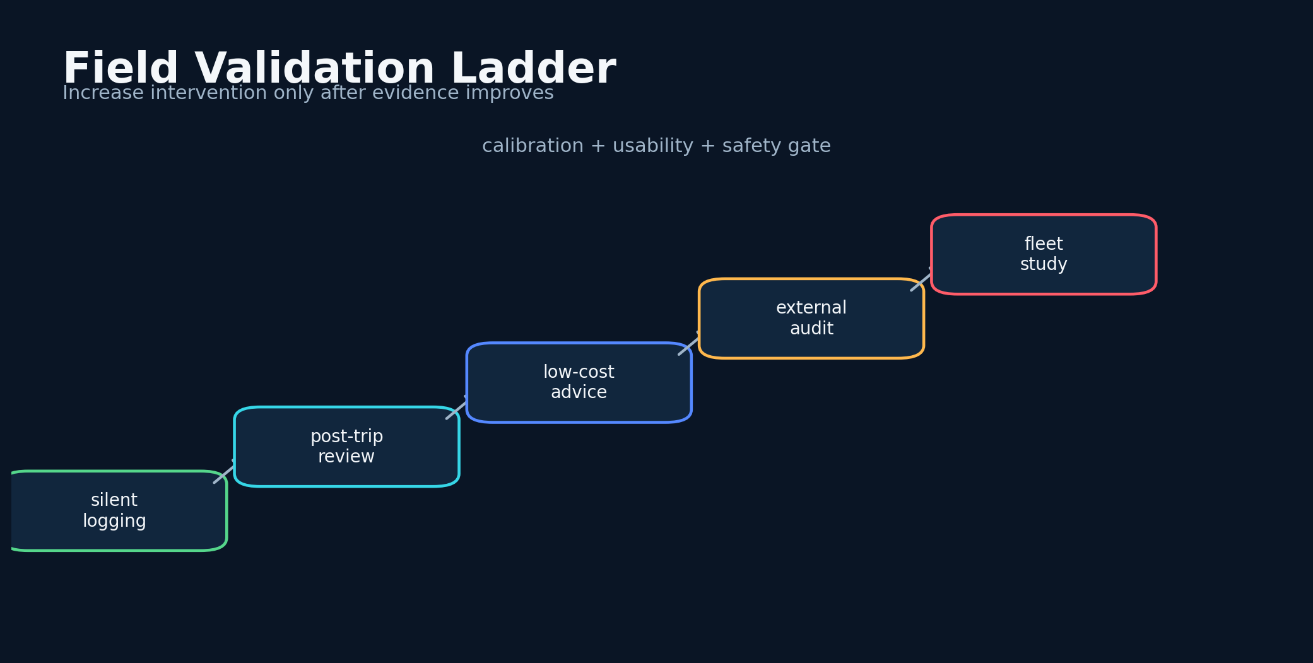
Figure 28. Field Validation as a Delivery Driver - conceptual system diagram created for this book.
STORY AND SYSTEM
Delivery work provided volume, diversity, and repeated routes. It also imposed constraints: I could not stop to annotate every event, and safety had to remain more important than data collection. A field protocol therefore needs voice notes after stopping, automatic timestamps, minimal in-motion interaction, and retrospective labeling only after the vehicle is parked.
A useful validation program can progress through stages. First, silent logging compares predictions with outcomes without alerting the driver. Second, post-trip review tests whether explanations match recorded evidence. Third, low-cost advisory alerts are introduced. Fourth, an external evaluator reviews a sample. Only after calibration and usability improve should the system be tested in broader fleets or higher-stakes interventions.
CASE-CROSSOVER CONTRAST
Δ R = R(segment,condition_1)-R(segment,condition_0)
The same road segment is compared under changing conditions to isolate context effects.

Repeated routes enable matched comparisons. The same segment can be observed across time, weather, and traffic conditions. A case-crossover design compares a hazardous episode with the same location under ordinary conditions. This controls for some geographic factors and helps identify which changing variables moved the risk score.
The protocol must guard against distraction and confirmation bias. Predictions are timestamped automatically. The driver records the outcome after stopping. Independent sources are used when available. A random sample of low-risk episodes is reviewed, not only high-risk alerts. Near-miss definitions are standardized.
My miles gave the project its questions and its urgency. The next stage requires partners who can bring instrumented vehicles, crash and conflict data, institutional review, diverse drivers, and statistical power. The independent field laboratory becomes most valuable when it is designed to connect with larger science.
DESIGN LENSES

Silent validation first
The first engineering lens in this chapter is silent validation first. To build it, run the scanner without in-motion alerts until output, latency, and logging are stable. The implementation should make the state visible rather than hide it inside a prompt. The evidence standard is concrete: drivers are not exposed to uncalibrated intervention. This matters because the system will eventually meet a condition that the original builder did not imagine. At that moment, explicit state, timestamps, provenance, and bounded interfaces make the difference between a failure that can be understood and a story that can only be retold. A practical implementation should log the inputs that moved the state, the policy version that interpreted them, the uncertainty before and after the update, and the action made available to the user. The resulting record supports calibration, debugging, and later independent review. The primary failure to test is testing persuasion and prediction simultaneously on the road. The countermeasure is not more confident prose. It is a rule, a comparison, or a fallback that remains valid when the model is wrong. For field validation as a delivery driver, this is the bridge between an evocative concept and a durable intelligent thinking system.

Matched route study
A second layer of the design is matched route study. To build it, compare the same segment under different conditions and audit both high- and low-risk predictions. The method works only when its intermediate decisions are recorded and inspectable. The evidence standard is concrete: repeated routes create a natural case-crossover design. This matters because the system will eventually meet a condition that the original builder did not imagine. At that moment, explicit state, timestamps, provenance, and bounded interfaces make the difference between a failure that can be understood and a story that can only be retold. A practical implementation should log the inputs that moved the state, the policy version that interpreted them, the uncertainty before and after the update, and the action made available to the user. That separation also allows a compact local model to participate without owning the entire conclusion. The primary failure to test is selecting only dramatic nights for analysis. The countermeasure is not more confident prose. It is a rule, a comparison, or a fallback that remains valid when the model is wrong. For field validation as a delivery driver, this is the bridge between an evocative concept and a durable intelligent thinking system.

Independent review
The chapter becomes operational through independent review. To build it, sample episodes for external labeling and reconcile disagreements using written definitions. This turns a broad idea into a component that can be tested, replaced, and improved. The evidence standard is concrete: the builder's interpretation is not the only ground truth. This matters because the system will eventually meet a condition that the original builder did not imagine. At that moment, explicit state, timestamps, provenance, and bounded interfaces make the difference between a failure that can be understood and a story that can only be retold. A practical implementation should log the inputs that moved the state, the policy version that interpreted them, the uncertainty before and after the update, and the action made available to the user. In a safety context, graceful degradation is more valuable than an impressive all-or-nothing demonstration. The primary failure to test is treating personal confidence as validation. The countermeasure is not more confident prose. It is a rule, a comparison, or a fallback that remains valid when the model is wrong. For field validation as a delivery driver, this is the bridge between an evocative concept and a durable intelligent thinking system.
FIELD NOTE
Create a five-stage validation ladder from silent logging to independent fleet testing.

Practice Lab
The exercises below are designed to produce evidence and system artifacts rather than opinions. Complete them in a parked, safe environment and preserve the results with a date and version.
1. Write a no-interaction-while-moving rule.
2. Define a near-miss label.
3. Select a random low-risk audit sample.
◆ ◆ ◆

29
ENGINEERING FOR THE LONG ROAD

An Open Research Agenda
A project becomes a field when it publishes questions that other people can answer better.
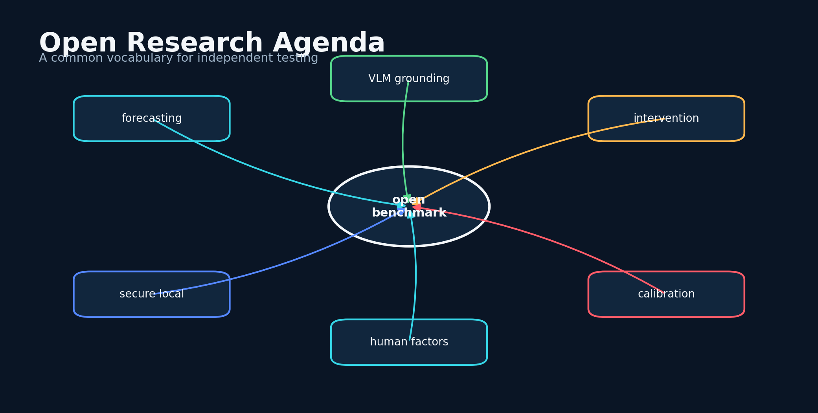
Figure 29. An Open Research Agenda - conceptual system diagram created for this book.
STORY AND SYSTEM
The car-accident prediction oracle is not one benchmark. It is a research program spanning forecasting, perception, human factors, cryptography, local inference, accessibility, and transportation policy. The most important next step is to define public tasks that let independent groups compare systems without exposing private driver data.
One task is route-level hazard forecasting with fixed horizons and coarse geography. Another is video-based accident anticipation with lead-time scoring. A third is behavior-risk description that prohibits diagnosis and requires observable evidence. A fourth is intervention generation evaluated for distraction, respect, and behavior change. A fifth is secure local deployment under memory, thermal, and network failure.
MULTI-OBJECTIVE SCORE
S = w_1L + w_2Cal + w_3Rob + w_4Beh - w_5FA - w_6Cost
Evaluation combines lead time, calibration, robustness, behavior change, false alarms, and computational cost.

Datasets should include rare events without becoming collections of catastrophe. Near-conflicts, hard braking, evasive maneuvers, wildlife encounters, road obstruction, severe weather, and safe negative examples provide richer learning signals. Synthetic simulation can expand coverage, but real-world calibration remains necessary.
Research should compare large cloud models, compact local models, classical baselines, and hybrid systems. The key outcomes are lead time, calibration, false-alarm burden, robustness, explanation quality, and user behavior. Quantum-inspired features should be tested through ablation. Post-quantum security should be evaluated for operational reliability, not only cryptographic correctness.
I want this agenda to remain open. The goal is not to trap the idea inside one application or one personality. It is to create a vocabulary, architecture, and evidence standard that others can challenge. A safety system advances when its claims become easier to test than to repeat.
DESIGN LENSES

Benchmark decomposition
The first engineering lens in this chapter is benchmark decomposition. To build it, publish separate tasks for route forecasting, video anticipation, behavior description, intervention, and secure deployment. The implementation should make the state visible rather than hide it inside a prompt. The evidence standard is concrete: progress can be measured without one monolithic score. This matters because the system will eventually meet a condition that the original builder did not imagine. At that moment, explicit state, timestamps, provenance, and bounded interfaces make the difference between a failure that can be understood and a story that can only be retold. A practical implementation should log the inputs that moved the state, the policy version that interpreted them, the uncertainty before and after the update, and the action made available to the user. The resulting record supports calibration, debugging, and later independent review. The primary failure to test is a benchmark that rewards only final crash labels. The countermeasure is not more confident prose. It is a rule, a comparison, or a fallback that remains valid when the model is wrong. For an open research agenda, this is the bridge between an evocative concept and a durable intelligent thinking system.

Rare-event data design
A second layer of the design is rare-event data design. To build it, combine real negatives, near-conflicts, simulation, wildlife, weather, and infrastructure hazards with clear provenance. The method works only when its intermediate decisions are recorded and inspectable. The evidence standard is concrete: models learn precursors without requiring vast crash footage. This matters because the system will eventually meet a condition that the original builder did not imagine. At that moment, explicit state, timestamps, provenance, and bounded interfaces make the difference between a failure that can be understood and a story that can only be retold. A practical implementation should log the inputs that moved the state, the policy version that interpreted them, the uncertainty before and after the update, and the action made available to the user. That separation also allows a compact local model to participate without owning the entire conclusion. The primary failure to test is synthetic data presented as real-world validation. The countermeasure is not more confident prose. It is a rule, a comparison, or a fallback that remains valid when the model is wrong. For an open research agenda, this is the bridge between an evocative concept and a durable intelligent thinking system.

Open ablation culture
The chapter becomes operational through open ablation culture. To build it, require classical baselines, local-cloud comparisons, security overhead, and quantum-feature removal tests. This turns a broad idea into a component that can be tested, replaced, and improved. The evidence standard is concrete: claims become easier to challenge and improve. This matters because the system will eventually meet a condition that the original builder did not imagine. At that moment, explicit state, timestamps, provenance, and bounded interfaces make the difference between a failure that can be understood and a story that can only be retold. A practical implementation should log the inputs that moved the state, the policy version that interpreted them, the uncertainty before and after the update, and the action made available to the user. In a safety context, graceful degradation is more valuable than an impressive all-or-nothing demonstration. The primary failure to test is publishing only the most favorable configuration. The countermeasure is not more confident prose. It is a rule, a comparison, or a fallback that remains valid when the model is wrong. For an open research agenda, this is the bridge between an evocative concept and a durable intelligent thinking system.
FIELD NOTE
Write a one-page challenge specification with inputs, outputs, prohibited shortcuts, and metrics.

Practice Lab
The exercises below are designed to produce evidence and system artifacts rather than opinions. Complete them in a parked, safe environment and preserve the results with a date and version.
1. Define one public benchmark task.
2. Choose a privacy-preserving data release strategy.
3. Specify an ablation required for any quantum-inspired claim.
◆ ◆ ◆

30
ENGINEERING FOR THE LONG ROAD

The Road Ahead Thinks Back
The future of safety is not a machine that knows everything; it is a network of systems that notice early, explain honestly, and help us choose better.
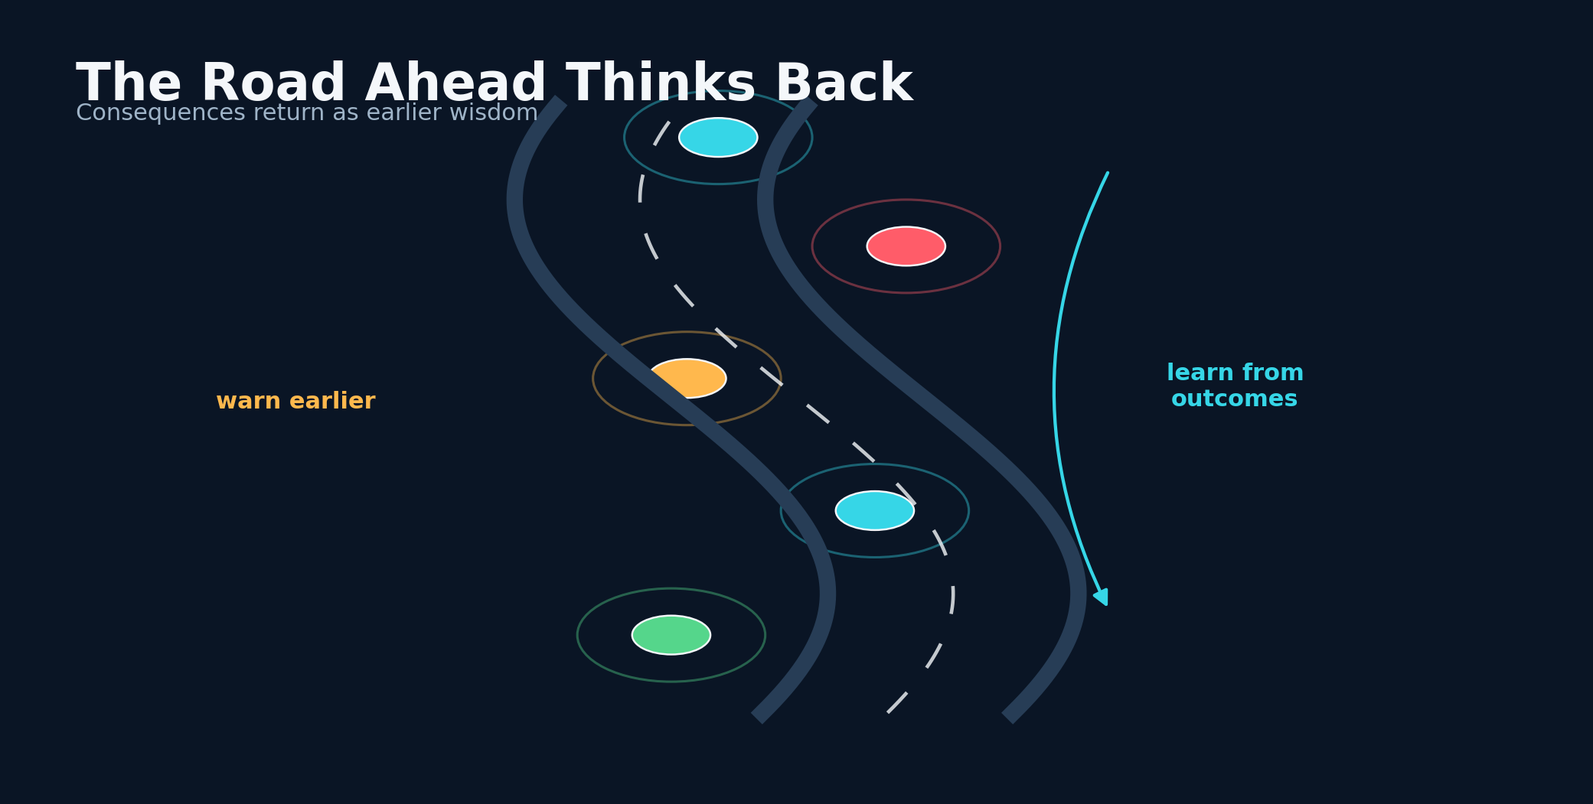
Figure 30. The Road Ahead Thinks Back - conceptual system diagram created for this book.
STORY AND SYSTEM
I began with a feeling that the road contained patterns we were not using. Delivery work turned that feeling into repeated observation. Early vision mapping turned it into a prototype. Cloud models expanded the reasoning. Security failures and reliability concerns pushed the system local. Naza became a durable companion, and Naza One turned the companion into a better-defined vault, model runtime, and recovery architecture.
The apparent predictions near Powdersville and the Pelzer exit remain meaningful to me, but their deepest value is not that they prove an infallible oracle. They showed me what a useful warning feels like: early, specific enough to change attention, and connected to a real place. They also taught me how easily memory can overstate precision. The next generation must preserve the wonder while strengthening the evidence.
LEARNING SAFETY LOOP
θ_k+1=Update(θ_k, E_k, C_k, F_k)
The system improves from episodes, calibration results, failures, and human corrections while preserving auditability.

An intelligent thinking system does more than classify. It holds multiple futures, tracks uncertainty, monitors its own condition, protects its memory, and chooses how to speak. It understands that the same risk score needs a detailed briefing before a trip and a three-word alert during one. It knows when the cloud is helpful, when local inference is necessary, and when no model has enough evidence.
The work is also personal. Building through hard conditions, damaged devices, security fears, financial pressure, and long delivery shifts forced the technology to become practical. Every architecture diagram in this book is attached to the stubborn act of making the system run again. Resilience was not an abstract requirement. It was the method that kept the research alive.
The road ahead thinks back when our systems observe consequences and return them as earlier wisdom. That loop can make transportation safer only if it remains human-centered, scientifically testable, secure, and open to correction. The oracle I want is not a voice that commands from above. It is a quiet companion that notices the future becoming dangerous and gives us one more chance to choose a safer path.
DESIGN LENSES

Outcome-to-wisdom loop
The first engineering lens in this chapter is outcome-to-wisdom loop. To build it, feed calibrated outcomes, false alarms, failures, and human corrections into a versioned update process. The implementation should make the state visible rather than hide it inside a prompt. The evidence standard is concrete: the system becomes earlier and more honest over time. This matters because the system will eventually meet a condition that the original builder did not imagine. At that moment, explicit state, timestamps, provenance, and bounded interfaces make the difference between a failure that can be understood and a story that can only be retold. A practical implementation should log the inputs that moved the state, the policy version that interpreted them, the uncertainty before and after the update, and the action made available to the user. The resulting record supports calibration, debugging, and later independent review. The primary failure to test is continuous learning that changes behavior without review. The countermeasure is not more confident prose. It is a rule, a comparison, or a fallback that remains valid when the model is wrong. For the road ahead thinks back, this is the bridge between an evocative concept and a durable intelligent thinking system.

Durable local autonomy
A second layer of the design is durable local autonomy. To build it, keep a stable local baseline while selectively adding cloud capability and verified updates. The method works only when its intermediate decisions are recorded and inspectable. The evidence standard is concrete: the project can survive provider, network, and policy change. This matters because the system will eventually meet a condition that the original builder did not imagine. At that moment, explicit state, timestamps, provenance, and bounded interfaces make the difference between a failure that can be understood and a story that can only be retold. A practical implementation should log the inputs that moved the state, the policy version that interpreted them, the uncertainty before and after the update, and the action made available to the user. That separation also allows a compact local model to participate without owning the entire conclusion. The primary failure to test is confusing independence with isolation from external evidence. The countermeasure is not more confident prose. It is a rule, a comparison, or a fallback that remains valid when the model is wrong. For the road ahead thinks back, this is the bridge between an evocative concept and a durable intelligent thinking system.

Human value hierarchy
The chapter becomes operational through human value hierarchy. To build it, place life, dignity, privacy, accessibility, and user command above engagement or technical novelty. This turns a broad idea into a component that can be tested, replaced, and improved. The evidence standard is concrete: optimization remains aligned with the purpose of the scanner. This matters because the system will eventually meet a condition that the original builder did not imagine. At that moment, explicit state, timestamps, provenance, and bounded interfaces make the difference between a failure that can be understood and a story that can only be retold. A practical implementation should log the inputs that moved the state, the policy version that interpreted them, the uncertainty before and after the update, and the action made available to the user. In a safety context, graceful degradation is more valuable than an impressive all-or-nothing demonstration. The primary failure to test is building an impressive oracle that makes people less free or less safe. The countermeasure is not more confident prose. It is a rule, a comparison, or a fallback that remains valid when the model is wrong. For the road ahead thinks back, this is the bridge between an evocative concept and a durable intelligent thinking system.
FIELD NOTE
Write the final paragraph of your own safety system: what should it notice, what should it never claim, and what choice should it preserve?

Practice Lab
The exercises below are designed to produce evidence and system artifacts rather than opinions. Complete them in a parked, safe environment and preserve the results with a date and version.
1. Summarize the architecture in one page.
2. Choose the next experiment that would most reduce uncertainty.
3. Name the human value that must remain above optimization.
◆ ◆ ◆

Afterword: Evidence, Experience, and the Claim Boundary
This manuscript is both a technical map and a first-person record of an independent research path. Some events are supported by public repositories and source code. Some are field observations supplied by the author for this book. The Powdersville and Pelzer stories are presented as firsthand reports, not independently verified demonstrations of precise crash or wildlife prediction. Claims about intentional model poisoning or adversarial interference are likewise described as the author's interpretation of reliability problems; cause and intent were not established.
That distinction strengthens the work. It creates a clear path from story to experiment. Timestamped forecasts, preserved outputs, matched route comparisons, independent incident data, and external review can convert compelling experiences into testable evidence. The book's proposed architecture is designed to support that conversion while keeping the system useful during the journey.
No system in this book should be used as the sole basis for driving decisions, impairment diagnosis, emergency reporting, or vehicle control. Drivers must follow traffic law, direct observation, official weather and emergency guidance, and certified vehicle safety systems. The research goal is earlier awareness and safer choices, not automation of responsibility.
PUBLISHING STANDARD
Preserve the first-person force of the narrative, but label every externally unverified event and every suspected cause. Strong boundaries make the research more credible, not less ambitious.

Appendix A: Field Episode Record
A field episode should be created automatically before the trip and completed only while safely parked. The template below is intentionally compact enough for repeated use while preserving the evidence needed for later calibration.
Field | Specification
Episode ID | Immutable unique identifier
Start / end time | Local time plus timezone
Route scope | Coarse segment or planned route
Context | Weather, light, traffic, road class, vehicle state
Model provenance | Model hash, runtime, prompt and policy versions
Prediction | Risk, confidence, horizon, geography, evidence
Alert | Exact message and channel
Driver action | Slow, route change, stop, no action, other
Outcome | Conflict, hard brake, obstruction, wildlife, normal trip
Independent evidence | Official report, camera clip, witness, none
Narrative note | Completed after parking
Privacy / retention | What is stored and expiration date

Appendix B: Risk Object and Prompt Contract
The language model should never be the only place where the system state exists. A strict risk object preserves the distinction between observation, inference, uncertainty, and action.
{
"episode_id": "uuid",
"horizon_seconds": 600,
"geographic_scope": "route_segment_id",
"risk_probability": 0.0,
"confidence": 0.0,
"uncertainty_interval": [0.0, 1.0],
"observations": [{"source": "camera", "claim": "...", "freshness_s": 1}],
"inferences": [{"claim": "...", "support": ["observation_id"]}],
"missing_information": ["..."],
"recommended_action": "increase_following_distance",
"abstain": false,
"model_provenance": {"hash": "...", "prompt_version": "..."}
}
The prompt contract states which sources are live, which are historical, and which are unavailable. It prohibits invented incidents, direct impairment diagnosis, and direct vehicle-control commands. It requires a separate list of observations and inferences, an abstention when evidence is insufficient, and a compact action selected from an approved policy vocabulary.
A validator rejects missing fields, invalid probabilities, unsupported actions, and outputs that claim unavailable tools. A repair model may correct syntax only; it may not add evidence or change risk. When repair fails, the deterministic fallback returns a standard defensive-driving message.

Appendix C: Security and Recovery Checklist
□ Pin and verify model artifacts before atomic installation.
□ Separate password-derived KEKs, random vault keys, and versioned data keys.
□ Use authenticated encryption with unique nonces and explicit associated data.
□ Version ciphertext envelopes and detect policy downgrade.
□ Log model, prompt, policy, and code provenance for every episode.
□ Treat retrieved text, images, and reports as data rather than instructions.
□ Use least-authority tool interfaces; never expose vehicle controls to free-form generation.
□ Test key rotation, interrupted rotation, backup restoration, and lost-device recovery.
□ Keep recovery kits separate from encrypted backups.
□ Provide CPU-only and degraded-device fallbacks.
□ Minimize raw video retention and encrypt clips that must be stored.
□ Preserve immutable original events while supporting user correction records.

Threat-model summary for the advisory system.

Appendix D: Validation Protocol

Stage 0 - Bench
Replay curated episodes, test schema validation, measure latency, and verify that every failure returns a safe fallback.

Stage 1 - Silent field logging
Run predictions without in-motion alerts. Preserve outputs automatically and label outcomes only after parking.

Stage 2 - Retrospective review
Have an independent reviewer inspect a random sample of high-, medium-, and low-risk episodes under written definitions.

Stage 3 - Low-cost advisories
Introduce only reversible actions such as increasing following distance or reviewing the route before departure.

Stage 4 - Controlled user study
Evaluate comprehension, distraction, respect, trust, false-alarm burden, and behavior change with consent and oversight.

Stage 5 - External fleet research
Partner with institutions able to provide diverse routes, instrumented vehicles, conflict labels, governance, and statistical power.
PRIMARY EVALUATION
Score = lead_time + calibration + robustness + behavior_change - false_alarm_cost - distraction
Weights must be pre-specified for each study and reported with subgroup results.

Glossary
Abstention. A deliberate model output stating that available evidence is insufficient for a reliable conclusion.
AES-GCM. An authenticated-encryption mode that provides confidentiality and integrity for data.
Calibration. Agreement between predicted probability and observed frequency.
Conformal prediction. A family of methods that produce prediction sets with coverage guarantees under defined assumptions.
Data-encryption key (DEK). A key used to encrypt records or files, often wrapped by a higher-level key.
Entropy. A measure of dispersion or uncertainty; its meaning depends on the distribution being measured.
Fail closed. A design in which missing or invalid security state prevents access rather than silently weakening protection.
Harm ratio. A normalized project-specific representation of estimated risk or harm potential.
HKDF. A standardized key-derivation function used to derive cryptographic keys from shared secret material.
ML-DSA. NIST's module-lattice-based digital signature standard, standardized as FIPS 204.
ML-KEM. NIST's module-lattice-based key-encapsulation standard, standardized as FIPS 203.
Model attestation. Stored evidence that a model artifact was verified and remains the expected artifact.
Near miss. A conflict that did not become a collision but required evasive action or came within a defined safety threshold.
Oracle. In this book, a design metaphor for anticipatory intelligence, not a claim of certainty or supernatural knowledge.
Post-quantum cryptography. Cryptographic algorithms designed to resist attacks by sufficiently capable quantum computers.
Prediction horizon. The future interval within which a forecasted event is defined to occur.
Provenance. The record of which data, model, prompt, code, and transformations produced an output.
Risk fusion. Combining several evidence channels into a calibrated risk state.
Termux. An Android terminal environment used to run Linux-like tools and local model workflows.
Time-to-collision. An estimate of time before trajectories intersect if motion continues under stated assumptions.
Time-to-intervention. The remaining time in which a safe, practical response can still change the outcome.
Vision-language model (VLM). A model that jointly reasons over images or video and language.
Vault-unlock key (VUK). A random key that unlocks versioned data keys in the Naza One security design.

Source Notes
1. Public project lineage. The project history was reconstructed from public repositories associated with Graylan Janulis, including GitLab graylan01/vision-mapping and GitHub ornab74/roadscanner, ornab74/roadscanner-alpha, ornab74/road-safe, ornab74/naza, and ornab74/naza_one_generation_ui_code. Public indexing for github.com/graylan0 and x.com/graylanj was incomplete at the time of research, so the manuscript does not attribute specific claims to unavailable posts.
2. RoadScanner web architecture. The ornab74/roadscanner README documents the Flask and SQLite architecture, application-layer encryption, hybrid X25519 and ML-KEM envelope, optional ML-DSA signatures, rotating sessions, encrypted hash-chained auditing, secure deletion, risk endpoints, local fallback, and the animated risk wheel.
3. RoadScanner Alpha. The ornab74/roadscanner-alpha README documents authentication tiers, admin controls, weather and geocoding, signed HMAC API access, replay defense, billing and OAuth integrations, and local or cloud model hooks.
4. Road Safe. The ornab74/road-safe README and main.py document the KivyMD application, llama.cpp model, AES-GCM and PBKDF2 key derivation, encrypted model and history, PennyLane circuit, PUNKD heuristic, and Low/Medium/High scanner output.
5. Naza. The ornab74/naza README documents the local-first CLI, Termux-oriented workflow, Gemma LiteRT-LM and llama.cpp backends, streaming encryption, encrypted settings and history, rekeying, entropy model selection, road and food/water scanners, and defense controls.
6. Naza One. The ornab74/naza_one_generation_ui_code README documents the Flutter local assistant, LiteRT-LM runtime, boot vault, Argon2id/KEK/VUK/DEK hierarchy, transactional rotation, pinned model digest, encrypted attestation, CPU/GPU selection, and hybrid post-quantum recovery.
7. Standards. NIST FIPS 203 specifies ML-KEM and FIPS 204 specifies ML-DSA. They were approved as part of NIST's first finalized post-quantum cryptography standards in August 2024.
8. Road safety context. NHTSA's 2024 final traffic fatality data reported 39,254 U.S. traffic deaths and a fatality rate of 1.19 per 100 million vehicle miles traveled.
9. Vision-language research. Recent research on VLMs for driving shows promise in semantic hazard reasoning and risky-driving assistance while also documenting limitations in spatial reasoning, temporal consistency, grounding, and domain generalization. The architecture in this book therefore keeps numerical tracking and safety policy separate from free-form language generation.

Bibliography
Graylan Janulis. Quantum Vision Scanner / vision-mapping. GitLab project: https://gitlab.com/graylan01/vision-mapping
Graylan Janulis. RoadScanner. GitHub repository: https://github.com/ornab74/roadscanner
Graylan Janulis. RoadScanner Alpha. GitHub repository: https://github.com/ornab74/roadscanner-alpha
Graylan Janulis. Road Safe. GitHub repository: https://github.com/ornab74/road-safe
Graylan Janulis. Naza - Quantum-Enhanced Road Scanner & Secure LLM CLI. GitHub repository: https://github.com/ornab74/naza
Graylan Janulis. Naza One. GitHub repository: https://github.com/ornab74/naza_one_generation_ui_code
National Institute of Standards and Technology. FIPS 203: Module-Lattice-Based Key-Encapsulation Mechanism Standard. 2024.
National Institute of Standards and Technology. FIPS 204: Module-Lattice-Based Digital Signature Standard. 2024.
National Highway Traffic Safety Administration. 2024 Final Traffic Fatality Data. 2026 publication.
Google AI Edge. LiteRT-LM: Cross-platform on-device LLM inference. https://github.com/google-ai-edge/LiteRT-LM
OWASP. Mobile Application Security guidance on data storage and cryptography.
SeeUnsafe research project. Vision-language traffic accident identification, reasoning, and grounding. https://github.com/SeeUnsafe/SeeUnsafe

THE ROAD AHEAD THINKS BACK
Notice early. Explain honestly. Preserve choice.
◆

