

INFERENCE AT THE
EDGE OF THE WORLD
A Field Atlas of Local AI for Clinics, Ships, Disaster Zones, Farms, Vehicles, and Disconnected Communities
GRAYLAN JANULIS

FIELD NOTICE
This book is a systems-engineering atlas, not a clinical, navigational, emergency-management, agricultural, or driving instruction manual. Composite field dispatches are fictionalized scenarios used to expose architectural constraints. Safety-critical deployments require domain professionals, local authorities, formal validation, and applicable regulatory approval.
The central design stance is offline-first but not isolationist. Local AI should preserve essential capability during disconnection while maintaining a disciplined path to outside expertise, model updates, accountability, and human control. The system is judged not only by model accuracy, but by power, latency, maintainability, privacy, failure behavior, equity, and the quality of its refusal.
The atlas is organized as expeditions and missions rather than conventional chapters. Each mission contains a dispatch, terrain analysis, architecture doctrine, failure drill, field equation, and build exercise. The reader may follow it linearly or use it as a deployment reference.
THE EDGE DOCTRINE
The cloud may improve the mission.
It may never be the only place the mission can think.

FIELD CONTENTS
EXPEDITION I · LAWS OF THE EDGE
01 The Last Mile Is the First Design Constraint
02 Autonomy Without Isolation
03 The Connectivity Ladder
04 Power Is a Model Parameter
05 Graceful Degradation Is a Product Feature
06 The Human Override Must Work in the Rain
EXPEDITION II · THE RURAL CLINIC
07 Triage on a Solar Tablet
08 Imaging Without a Radiologist On Site
09 Maternal and Child Health Under Interrupted Connectivity
10 Local-Language Clinical Interfaces
11 Federated Learning Across Small Clinics
EXPEDITION III · THE OPEN OCEAN
12 The Ship as a Moving Data Center
13 Navigation and Collision Intelligence
14 Predictive Maintenance Below Deck
15 Medical Support at Sea
16 Remote Operations and the MASS Safety Case
EXPEDITION IV · THE DISASTER ZONE
17 The First Twenty-Four Hours
18 Drone-Borne Mapping and Search
19 Mesh Networks and Delay-Tolerant Intelligence
20 Local Early Warning and Evacuation
21 Humanitarian Data Under Extreme Uncertainty
EXPEDITION V · THE FARM
22 Sensor-to-Soil Intelligence
23 Vision Models for Crops and Livestock
24 Irrigation Under Intermittent Power
25 Local Advisory in the Farmer’s Language
26 Cooperative Learning Without Centralizing the Farm
EXPEDITION VI · THE MOVING VEHICLE
27 Perception When the Network Vanishes
28 Hazard Prediction and Driver Assistance
29 Fleet Memory and Selective Synchronization
30 Edge Vision-Language Models Without Unsafe Authority
31 Maintenance, Energy, and Route Resilience
EXPEDITION VII · THE DISCONNECTED COMMUNITY
32 The Village Knowledge Node
33 Offline Education and Translation
34 Local Governance and Community Data
35 Microgrids, Markets, and Public Services
36 A Right to Intelligence Without Connectivity
ANNEX A Hardware tiers and reference loadouts
ANNEX B Model optimization and compilation
ANNEX C Synchronization and update protocols
ANNEX D Safety-case and failure-drill templates
ANNEX E A 90-day pilot and cost architecture
ANNEX F The Edge Intelligence Constitution
Glossary
Research notes and sources

HOW TO USE THIS ATLAS
A field system is read in two directions. The vertical direction runs from power and sensors through models, memory, interface, policy, and human authority. The horizontal direction runs across failure states: full connectivity, weak connectivity, local mesh, complete isolation, degraded power, damaged sensors, and compromised software. A design is not complete until both directions are explicit.
Each mission begins with a dispatch that describes what the operator experiences. The terrain section converts the scene into technical constraints. The architecture section identifies a reference pattern. The failure drill describes how the system is likely to betray its designers. The field equation is a compact design objective, not a scientific law. The build lab turns the chapter into an experiment.
The recommended reading sequence is to master Expedition I, select one operating theater, and then complete the annexes before a pilot. Teams working across several theaters should compare their assumptions: a ship, clinic, and farm may use similar hardware, but their authority models, evidence standards, acceptable latency, and consequences of error are profoundly different.
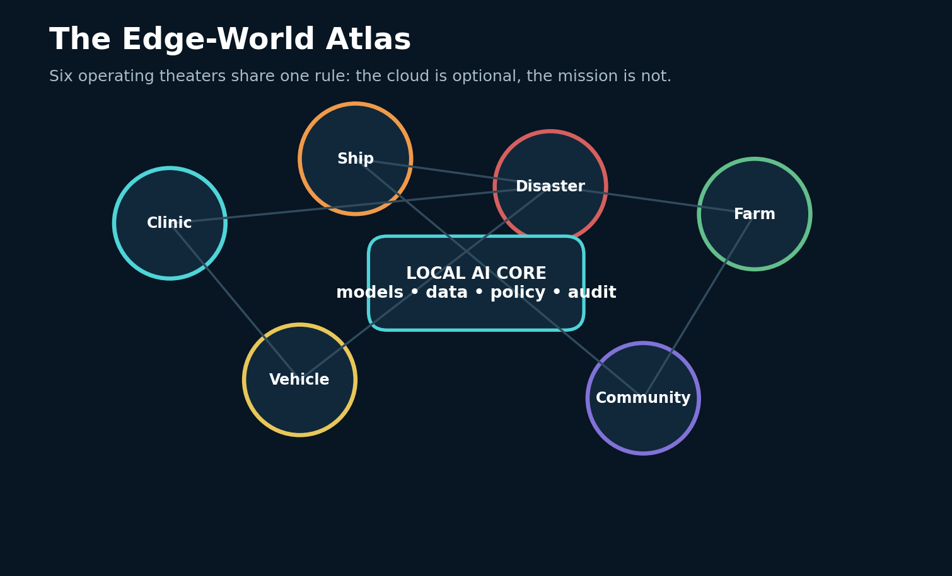
FIELD PLATE 01 — The six theaters of edge intelligence orbit a local core rather than a permanent cloud connection.

EXPEDITION I
LAWS OF THE EDGE
The field doctrine that makes local intelligence survive power loss, weak links, environmental damage, and uncertain authority.

MISSION 01 / LAWS OF THE EDGE
The Last Mile Is the First Design Constraint
A field dispatch, architecture pattern, and failure drill
FIELD DISPATCH
A health worker, mechanic, farmer, or ship officer does not experience “edge computing” as an architecture trend. They experience a decision that must be made before a distant service answers. The mission begins where latency, cost, weather, geography, or politics makes the network uncertain.

THE TERRAIN
The engineering terrain is defined by consequence, not by device class. In this mission the team must decide which observations are trustworthy, how long knowledge remains fresh, who is allowed to act, and what continues when power or connectivity falls away. The architecture must also fit the local workflow: a system that requires extra documentation, unfamiliar terminology, or constant troubleshooting transfers its cost to the very people it was meant to assist.
Design from the local decision outward. Identify the smallest set of sensors, rules, models, memory, and human authority required to finish the mission without a cloud response. Treat remote services as accelerators and update channels, not as the only place where intelligence exists.
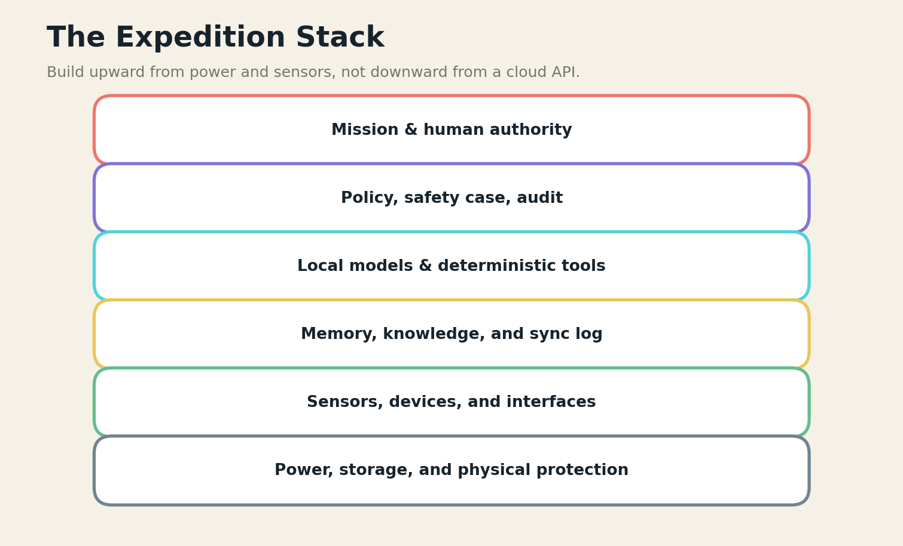
FIELD PLATE 02 — The expedition stack begins with physical survival and ends with accountable mission authority.

THE FAILURE DRILL
A cloud-first prototype often works perfectly in the lab and disappears in the field. The failure is organizational as much as technical: no one owns offline behavior, local storage, stale knowledge, or the handoff from automation to human judgment.
The failure drill should be performed in shadow mode before the system receives authority. Operators must see the degraded state, know which data is stale or missing, and be able to continue with a manual or deterministic process. Every failure produces an artifact: the triggering condition, the system response, the human decision, and the evidence needed to redesign the control.

FIELD LOADOUT
COMPONENT | FIELD REQUIREMENT
Power and thermal budget | Must remain useful without a wide-area link.
Connectivity service ladder | Must expose version, health, and provenance.
Model cascade | Must have a deterministic or manual fallback.
Signed knowledge bundle | Must be replaceable or repairable with available skills.
Human authority matrix | Must produce an auditable event when it changes a decision.
FIELD EQUATION
A = useful decisions completed locally / total required decisions

BUILD LAB
Map one mission minute by minute. Mark every point at which data leaves the site, every hidden dependency, and every action that must remain possible during a seventy-two-hour outage.
Research trail: R7,R24,R25. See Research Notes and Sources.

MISSION 02 / LAWS OF THE EDGE
Autonomy Without Isolation
A field dispatch, architecture pattern, and failure drill
FIELD DISPATCH
Local autonomy is not a declaration that a system should operate alone. It is an agreement about which actions can be completed locally, which require consultation, and which must stop when evidence or authority is missing.

THE TERRAIN
The engineering terrain is defined by consequence, not by device class. In this mission the team must decide which observations are trustworthy, how long knowledge remains fresh, who is allowed to act, and what continues when power or connectivity falls away. The architecture must also fit the local workflow: a system that requires extra documentation, unfamiliar terminology, or constant troubleshooting transfers its cost to the very people it was meant to assist.
Build an authority matrix with four zones: automate, recommend, escalate, and prohibit. Bind each action to evidence freshness, operator identity, sensor health, model confidence, and the availability of a qualified human.
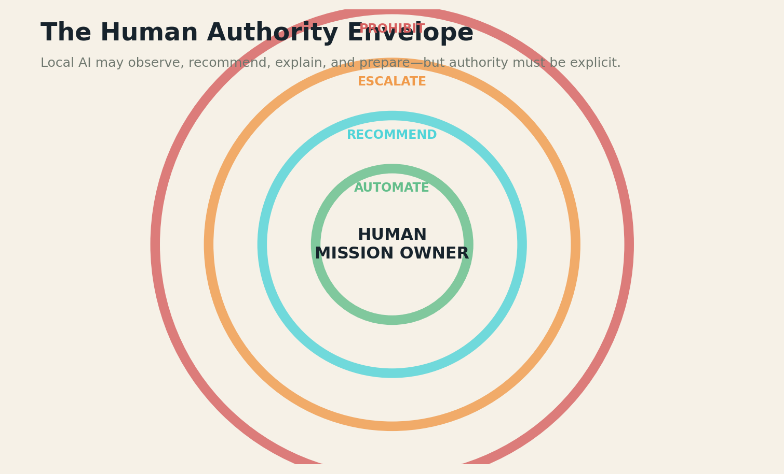
FIELD PLATE 03 — The authority envelope separates automation, recommendation, escalation, and prohibition.

THE FAILURE DRILL
Systems fail dangerously when “offline mode” quietly expands authority. A model that was intended to summarize records can become a triage engine; a navigation aid can become a de facto controller. The interface must make authority visible and technically enforceable.
The failure drill should be performed in shadow mode before the system receives authority. Operators must see the degraded state, know which data is stale or missing, and be able to continue with a manual or deterministic process. Every failure produces an artifact: the triggering condition, the system response, the human decision, and the evidence needed to redesign the control.

FIELD LOADOUT
COMPONENT | FIELD REQUIREMENT
Power and thermal budget | Must remain useful without a wide-area link.
Connectivity service ladder | Must expose version, health, and provenance.
Model cascade | Must have a deterministic or manual fallback.
Signed knowledge bundle | Must be replaceable or repairable with available skills.
Human authority matrix | Must produce an auditable event when it changes a decision.
FIELD EQUATION
U = mission utility - unauthorized action risk

BUILD LAB
Take one feature and write the exact conditions under which it moves from recommendation to escalation. Then simulate a stale model, a missing sensor, and an untrained operator.
Research trail: R1,R5,R11,R25. See Research Notes and Sources.

MISSION 03 / LAWS OF THE EDGE
The Connectivity Ladder
A field dispatch, architecture pattern, and failure drill
FIELD DISPATCH
Connectivity is not binary. A field node may move through full broadband, expensive satellite, brief cellular bursts, peer mesh, radio relays, physical data transfer, and complete isolation during one mission.

THE TERRAIN
The engineering terrain is defined by consequence, not by device class. In this mission the team must decide which observations are trustworthy, how long knowledge remains fresh, who is allowed to act, and what continues when power or connectivity falls away. The architecture must also fit the local workflow: a system that requires extra documentation, unfamiliar terminology, or constant troubleshooting transfers its cost to the very people it was meant to assist.
Define a ladder of service levels. At each rung, specify what synchronizes, what compresses, what queues, what can be reconstructed later, and what user promises change. Exchange manifests and high-priority deltas before bulk media.
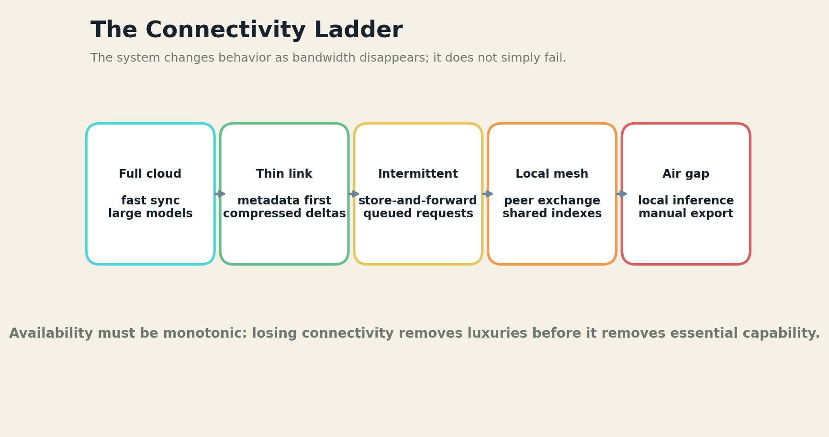
FIELD PLATE 04 — The connectivity ladder defines a different service contract at each rung.

THE FAILURE DRILL
The most common design error is feature collapse: the entire application becomes unusable because a low-value cloud call blocks the interface. The second is conflict erasure, where delayed devices overwrite one another when the link returns.
The failure drill should be performed in shadow mode before the system receives authority. Operators must see the degraded state, know which data is stale or missing, and be able to continue with a manual or deterministic process. Every failure produces an artifact: the triggering condition, the system response, the human decision, and the evidence needed to redesign the control.

FIELD LOADOUT
COMPONENT | FIELD REQUIREMENT
Power and thermal budget | Must remain useful without a wide-area link.
Connectivity service ladder | Must expose version, health, and provenance.
Model cascade | Must have a deterministic or manual fallback.
Signed knowledge bundle | Must be replaceable or repairable with available skills.
Human authority matrix | Must produce an auditable event when it changes a decision.
FIELD EQUATION
C = essential capability retained as bandwidth approaches zero

BUILD LAB
Disconnect the prototype at random times. Measure which workflows finish, which data remains inspectable, and whether reconciliation preserves conflicting clinical, safety, or community records.
Research trail: R7,R8,R20. See Research Notes and Sources.

MISSION 04 / LAWS OF THE EDGE
Power Is a Model Parameter
A field dispatch, architecture pattern, and failure drill
FIELD DISPATCH
In the field, a parameter count is also a heat load, battery schedule, solar-panel area, enclosure problem, and maintenance burden. Accuracy measured without energy and thermal behavior is incomplete.

THE TERRAIN
The engineering terrain is defined by consequence, not by device class. In this mission the team must decide which observations are trustworthy, how long knowledge remains fresh, who is allowed to act, and what continues when power or connectivity falls away. The architecture must also fit the local workflow: a system that requires extra documentation, unfamiliar terminology, or constant troubleshooting transfers its cost to the very people it was meant to assist.
Profile the entire workload: sensing, preprocessing, inference, storage, display, radio transmission, idle listening, and cooling. Use cascades so rules and TinyML handle frequent easy cases while larger local models wake only for difficult events.
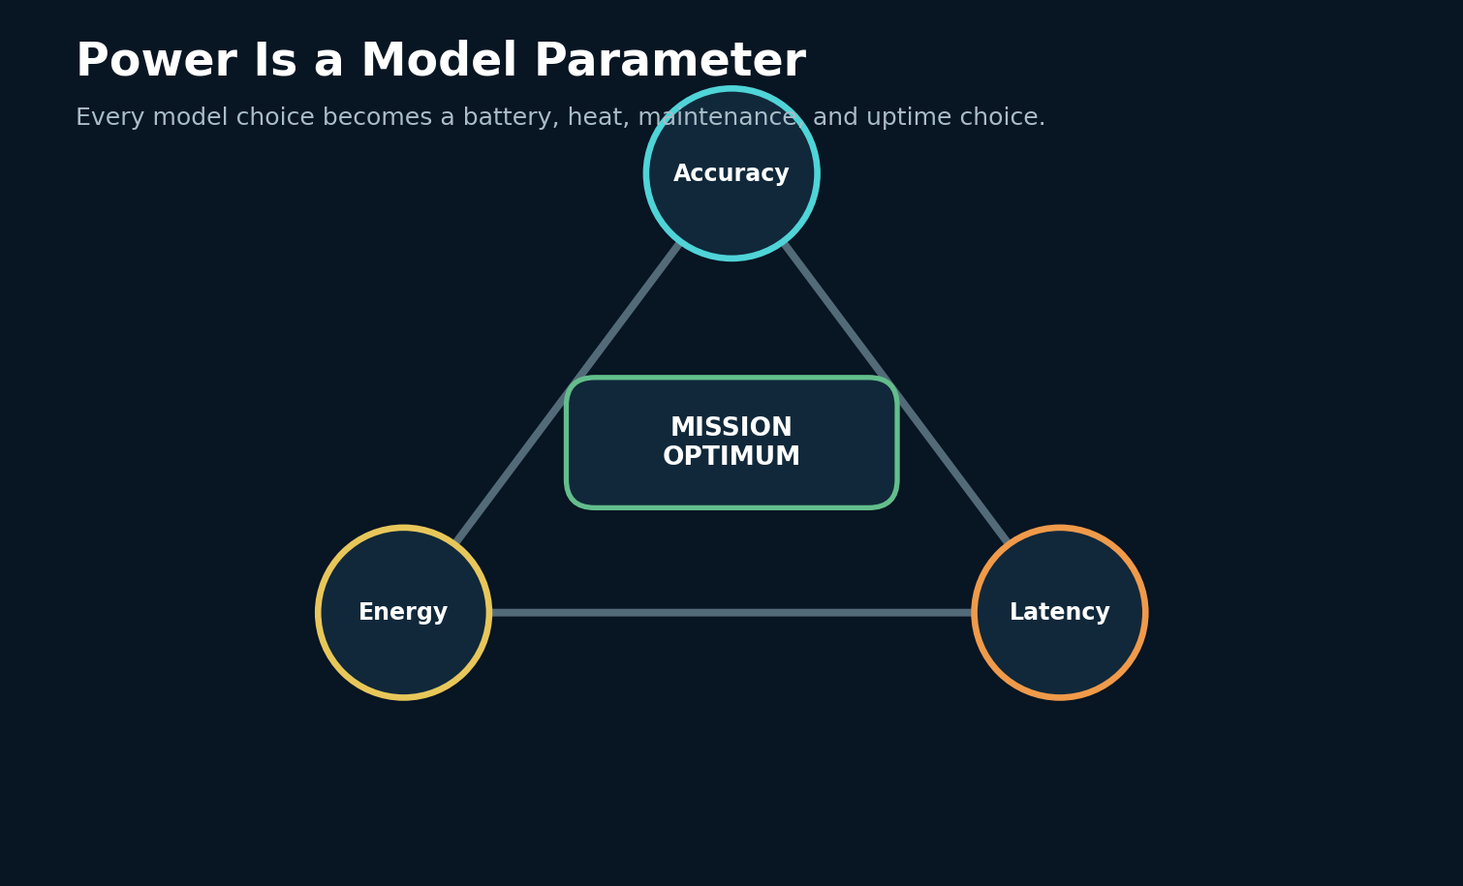
FIELD PLATE 05 — Accuracy, latency, and energy form a mission-specific engineering triangle.

THE FAILURE DRILL
A fast accelerator can still be the wrong choice if it drains batteries, throttles in heat, or requires fans that ingest dust and salt. Wireless transmission may cost more energy than local computation, but only measurement can establish the real budget.
The failure drill should be performed in shadow mode before the system receives authority. Operators must see the degraded state, know which data is stale or missing, and be able to continue with a manual or deterministic process. Every failure produces an artifact: the triggering condition, the system response, the human decision, and the evidence needed to redesign the control.

FIELD LOADOUT
COMPONENT | FIELD REQUIREMENT
Power and thermal budget | Must remain useful without a wide-area link.
Connectivity service ladder | Must expose version, health, and provenance.
Model cascade | Must have a deterministic or manual fallback.
Signed knowledge bundle | Must be replaceable or repairable with available skills.
Human authority matrix | Must produce an auditable event when it changes a decision.
FIELD EQUATION
E_m = useful mission decisions / joule

BUILD LAB
Run a twenty-four-hour power trace using field temperatures and realistic duty cycles. Reserve headroom for battery aging, cloudy days, and emergency operation.
Research trail: R16,R24. See Research Notes and Sources.

MISSION 05 / LAWS OF THE EDGE
Graceful Degradation Is a Product Feature
A field dispatch, architecture pattern, and failure drill
FIELD DISPATCH
A resilient system loses optional capability before it loses essential capability. It may stop generating rich explanations, reduce sensor rates, disable noncritical translation, or delay bulk synchronization while preserving alarms and core decision support.

THE TERRAIN
The engineering terrain is defined by consequence, not by device class. In this mission the team must decide which observations are trustworthy, how long knowledge remains fresh, who is allowed to act, and what continues when power or connectivity falls away. The architecture must also fit the local workflow: a system that requires extra documentation, unfamiliar terminology, or constant troubleshooting transfers its cost to the very people it was meant to assist.
Create explicit degraded modes for network, power, storage, sensor, and model failures. Each mode should have an operator-visible state, bounded authority, deterministic fallback, and a recovery procedure.
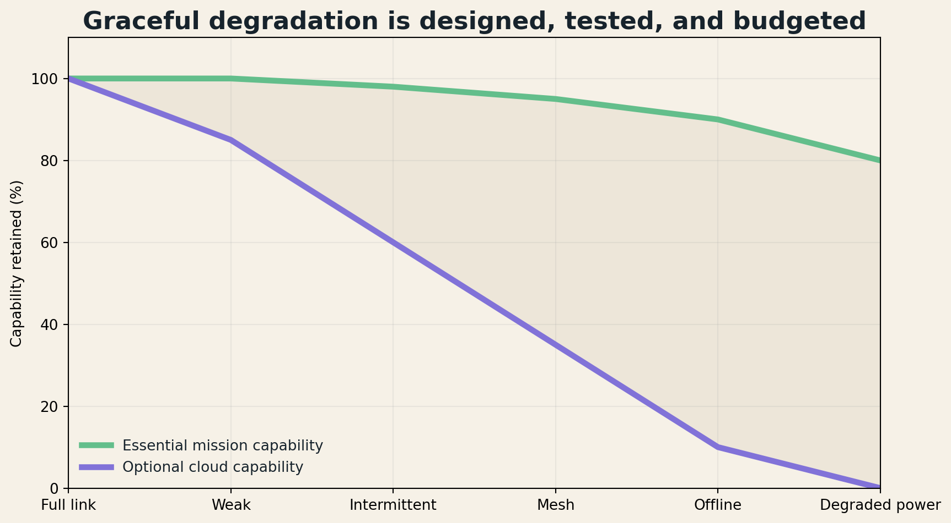
FIELD PLATE 06 — Optional cloud capability should collapse faster than essential local capability.

THE FAILURE DRILL
Silent degradation is worse than visible failure. A camera may fog, a model may run on lower resolution, or an index may become stale while the interface continues to look normal. Health telemetry must travel with every output.
The failure drill should be performed in shadow mode before the system receives authority. Operators must see the degraded state, know which data is stale or missing, and be able to continue with a manual or deterministic process. Every failure produces an artifact: the triggering condition, the system response, the human decision, and the evidence needed to redesign the control.

FIELD LOADOUT
COMPONENT | FIELD REQUIREMENT
Power and thermal budget | Must remain useful without a wide-area link.
Connectivity service ladder | Must expose version, health, and provenance.
Model cascade | Must have a deterministic or manual fallback.
Signed knowledge bundle | Must be replaceable or repairable with available skills.
Human authority matrix | Must produce an auditable event when it changes a decision.
FIELD EQUATION
G = weighted essential functions preserved / total essential functions

BUILD LAB
Build a failure injection harness. Remove one dependency every ten minutes and verify that the system enters the documented mode rather than inventing a new one.
Research trail: R7,R25. See Research Notes and Sources.

MISSION 06 / LAWS OF THE EDGE
The Human Override Must Work in the Rain
A field dispatch, architecture pattern, and failure drill
FIELD DISPATCH
Human oversight is meaningful only if the operator can understand, interrupt, and recover the system under real conditions: gloves, glare, noise, fatigue, language barriers, motion, stress, and scarce time.

THE TERRAIN
The engineering terrain is defined by consequence, not by device class. In this mission the team must decide which observations are trustworthy, how long knowledge remains fresh, who is allowed to act, and what continues when power or connectivity falls away. The architecture must also fit the local workflow: a system that requires extra documentation, unfamiliar terminology, or constant troubleshooting transfers its cost to the very people it was meant to assist.
Design the interface around mission decisions, not model internals. Show the recommendation, evidence, uncertainty, missing inputs, authority level, and next safe action. Provide physical or highly reliable controls for critical stop and reset functions.

FIELD PLATE 07 — The authority envelope separates automation, recommendation, escalation, and prohibition.

THE FAILURE DRILL
A beautiful dashboard can fail when the operator cannot read it in sunlight, cannot authenticate without connectivity, or cannot tell whether an alert is new. Training and drills must include system refusal, contradiction, and manual continuation.
The failure drill should be performed in shadow mode before the system receives authority. Operators must see the degraded state, know which data is stale or missing, and be able to continue with a manual or deterministic process. Every failure produces an artifact: the triggering condition, the system response, the human decision, and the evidence needed to redesign the control.

FIELD LOADOUT
COMPONENT | FIELD REQUIREMENT
Power and thermal budget | Must remain useful without a wide-area link.
Connectivity service ladder | Must expose version, health, and provenance.
Model cascade | Must have a deterministic or manual fallback.
Signed knowledge bundle | Must be replaceable or repairable with available skills.
Human authority matrix | Must produce an auditable event when it changes a decision.
FIELD EQUATION
H = successful safe overrides / attempted overrides

BUILD LAB
Conduct a usability drill outdoors or in a noisy room with the network disabled. Ask a new operator to identify the system state, reject a recommendation, and export the audit record.
Research trail: R1,R25. See Research Notes and Sources.

EXPEDITION II
THE RURAL CLINIC
Decision support that augments health workers while preserving clinical authority, privacy, and referral pathways.

MISSION 07 / THE RURAL CLINIC
Triage on a Solar Tablet
A field dispatch, architecture pattern, and failure drill
FIELD DISPATCH
A community health worker opens a rugged tablet after a storm has isolated the clinic. The device contains current decision logic, local patient summaries, referral criteria, and language support. It does not diagnose independently; it organizes observations and makes escalation requirements difficult to miss.

THE TERRAIN
The engineering terrain is defined by consequence, not by device class. In this mission the team must decide which observations are trustworthy, how long knowledge remains fresh, who is allowed to act, and what continues when power or connectivity falls away. The architecture must also fit the local workflow: a system that requires extra documentation, unfamiliar terminology, or constant troubleshooting transfers its cost to the very people it was meant to assist.
Represent clinical guidance as software-neutral workflows and decision logic rather than hidden prompts. Keep required data elements, contraindications, red flags, and referral actions inspectable. The local model can translate, summarize, and explain, while deterministic logic protects critical pathways.
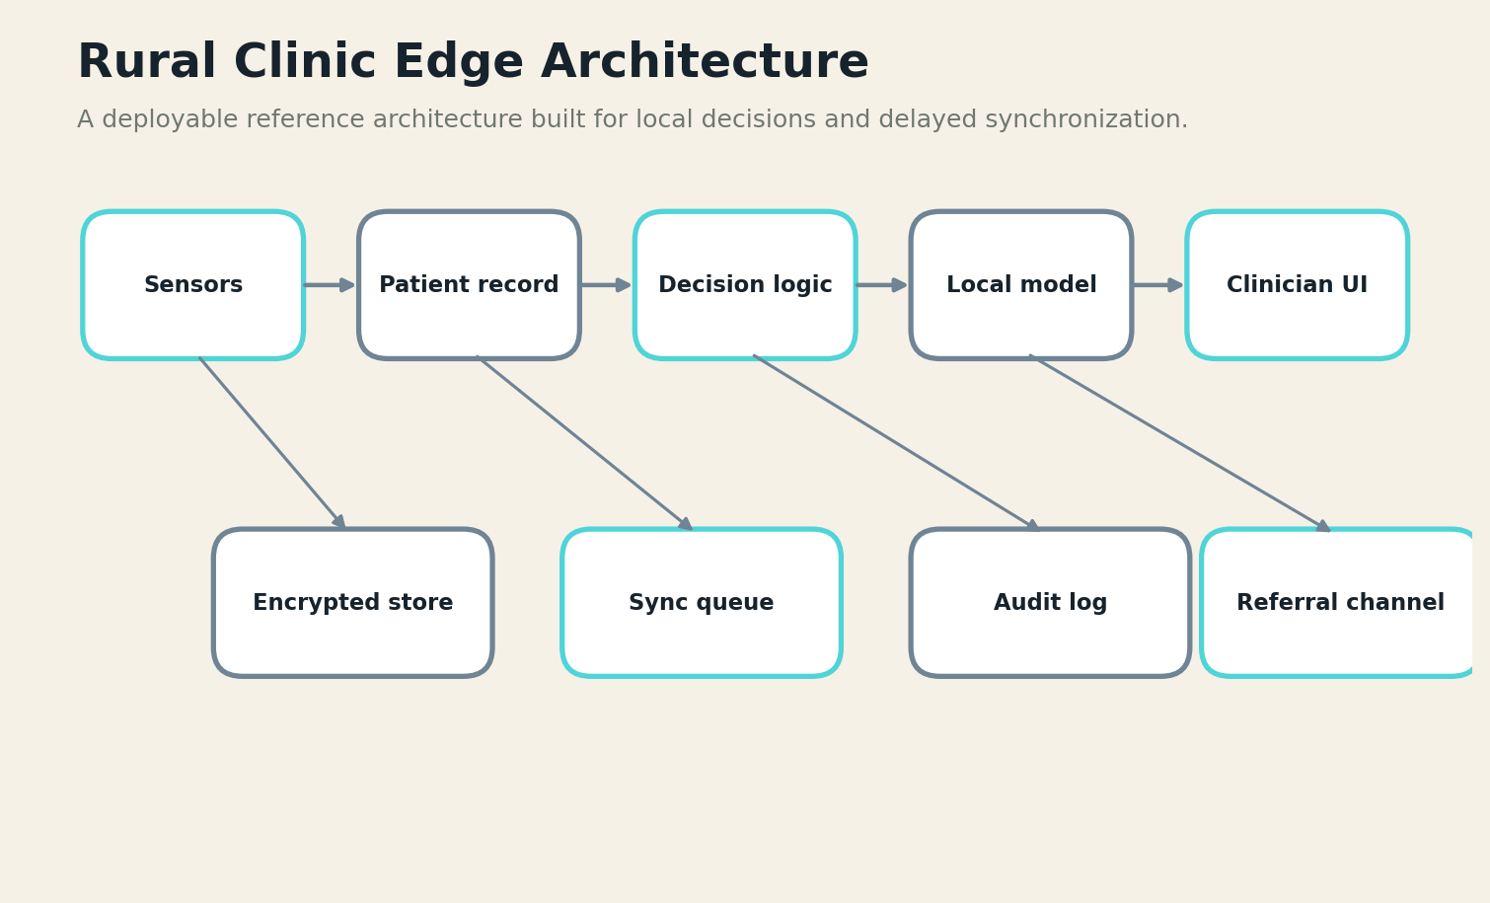
FIELD PLATE 08 — A clinic node combines structured decision logic, local models, encrypted records, and delayed referral channels.

THE FAILURE DRILL
A generative interface can sound clinically complete while omitting a single dangerous condition. The system must show what it asked, what remains unknown, which guideline version it used, and when the case exceeds local authority.
The failure drill should be performed in shadow mode before the system receives authority. Operators must see the degraded state, know which data is stale or missing, and be able to continue with a manual or deterministic process. Every failure produces an artifact: the triggering condition, the system response, the human decision, and the evidence needed to redesign the control.

FIELD LOADOUT
COMPONENT | FIELD REQUIREMENT
Rugged phone or tablet | Must remain useful without a wide-area link.
Encrypted local record | Must expose version, health, and provenance.
Decision-logic package | Must have a deterministic or manual fallback.
Compact language / vision models | Must be replaceable or repairable with available skills.
Referral and audit queue | Must produce an auditable event when it changes a decision.
FIELD EQUATION
T = red flags captured × referral completion / false reassurance

BUILD LAB
Implement one narrowly scoped workflow from a trusted guideline. Test missing data, contradictory answers, pediatric and adult boundaries, and a completely offline referral record.
Research trail: R1,R2,R3,R4. See Research Notes and Sources.

MISSION 08 / THE RURAL CLINIC
Imaging Without a Radiologist On Site
A field dispatch, architecture pattern, and failure drill
FIELD DISPATCH
Portable ultrasound, digital microscopy, retinal cameras, and low-cost radiography can produce data far from specialists. Edge models can assist acquisition quality, flag urgent patterns, and package cases for delayed expert review.

THE TERRAIN
The engineering terrain is defined by consequence, not by device class. In this mission the team must decide which observations are trustworthy, how long knowledge remains fresh, who is allowed to act, and what continues when power or connectivity falls away. The architecture must also fit the local workflow: a system that requires extra documentation, unfamiliar terminology, or constant troubleshooting transfers its cost to the very people it was meant to assist.
Separate acquisition guidance, quality control, candidate finding, and clinical interpretation. Use local models to verify that the image is usable and highlight regions of concern; preserve the original data and provide a path for qualified review.

THE FAILURE DRILL
The danger is automation bias. A low-quality image may receive a confident label, or a rare condition may fall outside the model distribution. The system must know its supported devices, populations, and acquisition protocols.
The failure drill should be performed in shadow mode before the system receives authority. Operators must see the degraded state, know which data is stale or missing, and be able to continue with a manual or deterministic process. Every failure produces an artifact: the triggering condition, the system response, the human decision, and the evidence needed to redesign the control.

FIELD LOADOUT
COMPONENT | FIELD REQUIREMENT
Rugged phone or tablet | Must remain useful without a wide-area link.
Encrypted local record | Must expose version, health, and provenance.
Decision-logic package | Must have a deterministic or manual fallback.
Compact language / vision models | Must be replaceable or repairable with available skills.
Referral and audit queue | Must produce an auditable event when it changes a decision.
FIELD EQUATION
Q_i = usable acquisitions gained - unsafe false confidence

BUILD LAB
Create an out-of-distribution test set using poor lighting, motion, device variation, and unfamiliar anatomy. Measure refusal quality, not only classification accuracy.
Research trail: R1,R17,R18. See Research Notes and Sources.

MISSION 09 / THE RURAL CLINIC
Maternal and Child Health Under Interrupted Connectivity
A field dispatch, architecture pattern, and failure drill
FIELD DISPATCH
Maternal and child health workflows combine schedules, longitudinal records, danger signs, immunization logic, growth measurements, and referrals. Their value depends on continuity across visits even when a national system is unreachable.

THE TERRAIN
The engineering terrain is defined by consequence, not by device class. In this mission the team must decide which observations are trustworthy, how long knowledge remains fresh, who is allowed to act, and what continues when power or connectivity falls away. The architecture must also fit the local workflow: a system that requires extra documentation, unfamiliar terminology, or constant troubleshooting transfers its cost to the very people it was meant to assist.
Store a minimal encrypted longitudinal record locally with explicit consent and role-based access. Use structured decision logic for schedules and danger signs, then synchronize signed deltas when a trusted connection returns.
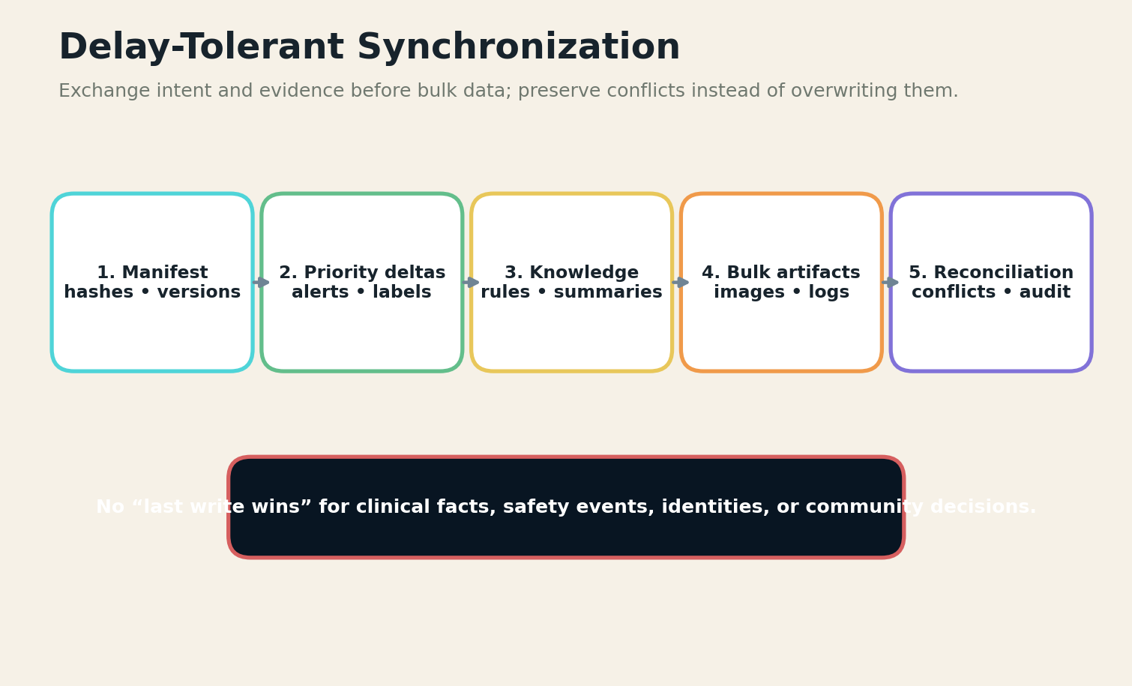
FIELD PLATE 09 — Delay-tolerant synchronization moves high-value deltas before bulk artifacts and preserves conflicts.

THE FAILURE DRILL
Duplicate identities, clock errors, and conflicting records can become clinical risks. Reconciliation must preserve both versions, show provenance, and ask a qualified person to resolve material conflicts.
The failure drill should be performed in shadow mode before the system receives authority. Operators must see the degraded state, know which data is stale or missing, and be able to continue with a manual or deterministic process. Every failure produces an artifact: the triggering condition, the system response, the human decision, and the evidence needed to redesign the control.

FIELD LOADOUT
COMPONENT | FIELD REQUIREMENT
Rugged phone or tablet | Must remain useful without a wide-area link.
Encrypted local record | Must expose version, health, and provenance.
Decision-logic package | Must have a deterministic or manual fallback.
Compact language / vision models | Must be replaceable or repairable with available skills.
Referral and audit queue | Must produce an auditable event when it changes a decision.
FIELD EQUATION
L = clinically relevant history available at point of care / required history

BUILD LAB
Simulate two clinics updating the same patient during a network split. Verify that neither visit disappears and that the merged timeline remains understandable.
Research trail: R2,R3,R6. See Research Notes and Sources.

MISSION 10 / THE RURAL CLINIC
Local-Language Clinical Interfaces
A field dispatch, architecture pattern, and failure drill
FIELD DISPATCH
A model that speaks the dominant national language may still fail the community. Clinical communication includes dialect, code-switching, culturally specific symptom descriptions, low literacy, and the need for private audio interaction.

THE TERRAIN
The engineering terrain is defined by consequence, not by device class. In this mission the team must decide which observations are trustworthy, how long knowledge remains fresh, who is allowed to act, and what continues when power or connectivity falls away. The architecture must also fit the local workflow: a system that requires extra documentation, unfamiliar terminology, or constant troubleshooting transfers its cost to the very people it was meant to assist.
Use local speech, text, and pictorial interfaces that can operate offline. Build terminology packs with local clinicians and community representatives. Preserve the original utterance alongside translations so uncertain interpretations can be reviewed.

THE FAILURE DRILL
Translation errors can change severity, timing, or anatomy. The model should surface uncertain terms, avoid pretending that a culturally specific expression has a single clinical equivalent, and allow the health worker to confirm meaning.
The failure drill should be performed in shadow mode before the system receives authority. Operators must see the degraded state, know which data is stale or missing, and be able to continue with a manual or deterministic process. Every failure produces an artifact: the triggering condition, the system response, the human decision, and the evidence needed to redesign the control.

FIELD LOADOUT
COMPONENT | FIELD REQUIREMENT
Rugged phone or tablet | Must remain useful without a wide-area link.
Encrypted local record | Must expose version, health, and provenance.
Decision-logic package | Must have a deterministic or manual fallback.
Compact language / vision models | Must be replaceable or repairable with available skills.
Referral and audit queue | Must produce an auditable event when it changes a decision.
FIELD EQUATION
M = critical meaning preserved / total critical meaning units

BUILD LAB
Record a consented set of realistic phrases in noisy environments. Evaluate clinical meaning preservation, not only word error rate.
Research trail: R22,R23,R30. See Research Notes and Sources.

MISSION 11 / THE RURAL CLINIC
Federated Learning Across Small Clinics
A field dispatch, architecture pattern, and failure drill
FIELD DISPATCH
Small clinics often see too little local data to train robust models, yet centralizing sensitive health records may be unacceptable or impossible. Federated learning offers a way to exchange updates while keeping records local.

THE TERRAIN
The engineering terrain is defined by consequence, not by device class. In this mission the team must decide which observations are trustworthy, how long knowledge remains fresh, who is allowed to act, and what continues when power or connectivity falls away. The architecture must also fit the local workflow: a system that requires extra documentation, unfamiliar terminology, or constant troubleshooting transfers its cost to the very people it was meant to assist.
Use a coordinator that distributes signed model versions, accepts bounded updates, and records device, data, and evaluation metadata. Aggregate only after screening for poisoning, extreme drift, and demographic imbalance.

THE FAILURE DRILL
Federated learning does not automatically provide privacy, fairness, or security. Gradients can leak information; unreliable devices can drop out; dominant sites can shape the model; and weak labels can spread error.
The failure drill should be performed in shadow mode before the system receives authority. Operators must see the degraded state, know which data is stale or missing, and be able to continue with a manual or deterministic process. Every failure produces an artifact: the triggering condition, the system response, the human decision, and the evidence needed to redesign the control.

FIELD LOADOUT
COMPONENT | FIELD REQUIREMENT
Rugged phone or tablet | Must remain useful without a wide-area link.
Encrypted local record | Must expose version, health, and provenance.
Decision-logic package | Must have a deterministic or manual fallback.
Compact language / vision models | Must be replaceable or repairable with available skills.
Referral and audit queue | Must produce an auditable event when it changes a decision.
FIELD EQUATION
F = generalization gain - privacy leakage - poisoning exposure

BUILD LAB
Run a federation with heterogeneous devices and deliberately skewed sites. Compare local, federated, and centrally trained models, then test secure aggregation and site-level rollback.
Research trail: R17,R18,R25. See Research Notes and Sources.

EXPEDITION III
THE OPEN OCEAN
Ships as moving edge data centers operating under latency, weather, cyber risk, and formal maritime responsibility.

MISSION 12 / THE OPEN OCEAN
The Ship as a Moving Data Center
A field dispatch, architecture pattern, and failure drill
FIELD DISPATCH
A vessel carries navigation systems, machinery telemetry, cargo data, crew records, cameras, weather feeds, and safety procedures through regions where bandwidth, latency, and cyber conditions change by the hour.

THE TERRAIN
The engineering terrain is defined by consequence, not by device class. In this mission the team must decide which observations are trustworthy, how long knowledge remains fresh, who is allowed to act, and what continues when power or connectivity falls away. The architecture must also fit the local workflow: a system that requires extra documentation, unfamiliar terminology, or constant troubleshooting transfers its cost to the very people it was meant to assist.
Partition shipboard networks by mission and consequence. Keep navigation, propulsion, safety, and essential documentation available locally. Use a ship data backbone with signed time, immutable event logs, and controlled bridges to remote operations and enterprise systems.
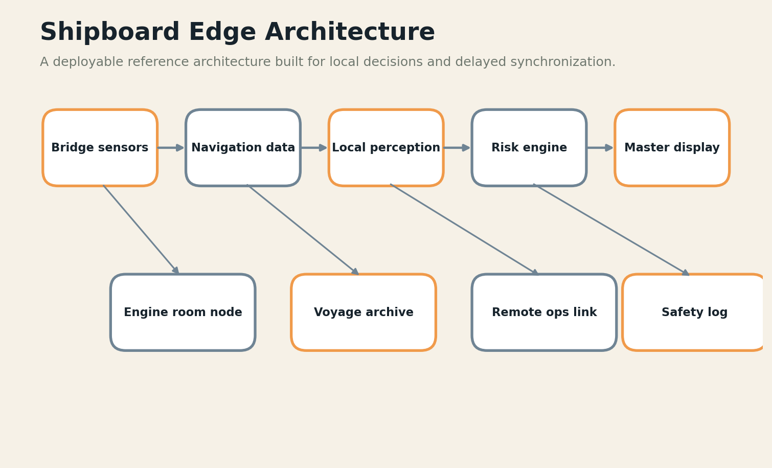
FIELD PLATE 10 — Shipboard intelligence remains partitioned, locally complete, and auditable during link loss.

THE FAILURE DRILL
A flat network lets a convenience service become a path into safety-critical systems. A remote dependency can also leave the crew without procedures or diagnostics during an outage.
The failure drill should be performed in shadow mode before the system receives authority. Operators must see the degraded state, know which data is stale or missing, and be able to continue with a manual or deterministic process. Every failure produces an artifact: the triggering condition, the system response, the human decision, and the evidence needed to redesign the control.

FIELD LOADOUT
COMPONENT | FIELD REQUIREMENT
Partitioned ship node | Must remain useful without a wide-area link.
Bridge and machinery interfaces | Must expose version, health, and provenance.
Signed voyage data | Must have a deterministic or manual fallback.
Local manuals and models | Must be replaceable or repairable with available skills.
Remote-operations gateway | Must produce an auditable event when it changes a decision.
FIELD EQUATION
S = safety-critical functions locally complete / total safety-critical functions

BUILD LAB
Draw the vessel as trust zones. Remove the satellite link and verify that bridge, engine-room, medical, and emergency workflows continue independently.
Research trail: R11,R12,R26. See Research Notes and Sources.

MISSION 13 / THE OPEN OCEAN
Navigation and Collision Intelligence
A field dispatch, architecture pattern, and failure drill
FIELD DISPATCH
Local perception can combine radar, AIS, cameras, charts, weather, and vessel dynamics to detect developing collision risk. The system should improve watchkeeping without hiding uncertainty or replacing formal responsibility.

THE TERRAIN
The engineering terrain is defined by consequence, not by device class. In this mission the team must decide which observations are trustworthy, how long knowledge remains fresh, who is allowed to act, and what continues when power or connectivity falls away. The architecture must also fit the local workflow: a system that requires extra documentation, unfamiliar terminology, or constant troubleshooting transfers its cost to the very people it was meant to assist.
Fuse independent sensors, track their health, and maintain a navigational operating envelope. Recommendations should include time to closest approach, assumptions, conflicting observations, and the maneuver options considered.

THE FAILURE DRILL
Sensor spoofing, rain clutter, missing AIS, chart error, and unfamiliar traffic patterns can create false certainty. The model must degrade to conservative rules and alert the officer when its operating envelope is exceeded.
The failure drill should be performed in shadow mode before the system receives authority. Operators must see the degraded state, know which data is stale or missing, and be able to continue with a manual or deterministic process. Every failure produces an artifact: the triggering condition, the system response, the human decision, and the evidence needed to redesign the control.

FIELD LOADOUT
COMPONENT | FIELD REQUIREMENT
Partitioned ship node | Must remain useful without a wide-area link.
Bridge and machinery interfaces | Must expose version, health, and provenance.
Signed voyage data | Must have a deterministic or manual fallback.
Local manuals and models | Must be replaceable or repairable with available skills.
Remote-operations gateway | Must produce an auditable event when it changes a decision.
FIELD EQUATION
R_nav = hazard detection value - maneuver authority risk

BUILD LAB
Replay dense traffic, sensor dropout, spoofed messages, and adverse weather. Score how early the system recognizes its own uncertainty.
Research trail: R11,R12. See Research Notes and Sources.

MISSION 14 / THE OPEN OCEAN
Predictive Maintenance Below Deck
A field dispatch, architecture pattern, and failure drill
FIELD DISPATCH
Machinery produces vibration, acoustic, thermal, pressure, and electrical signatures long before a failure becomes visible. Local anomaly detection can watch continuously without streaming raw data ashore.

THE TERRAIN
The engineering terrain is defined by consequence, not by device class. In this mission the team must decide which observations are trustworthy, how long knowledge remains fresh, who is allowed to act, and what continues when power or connectivity falls away. The architecture must also fit the local workflow: a system that requires extra documentation, unfamiliar terminology, or constant troubleshooting transfers its cost to the very people it was meant to assist.
Place TinyML near sensors for event detection, a field node for trend analysis, and a larger local model for explanation against manuals and maintenance history. Synchronize compact features and selected evidence rather than every waveform.
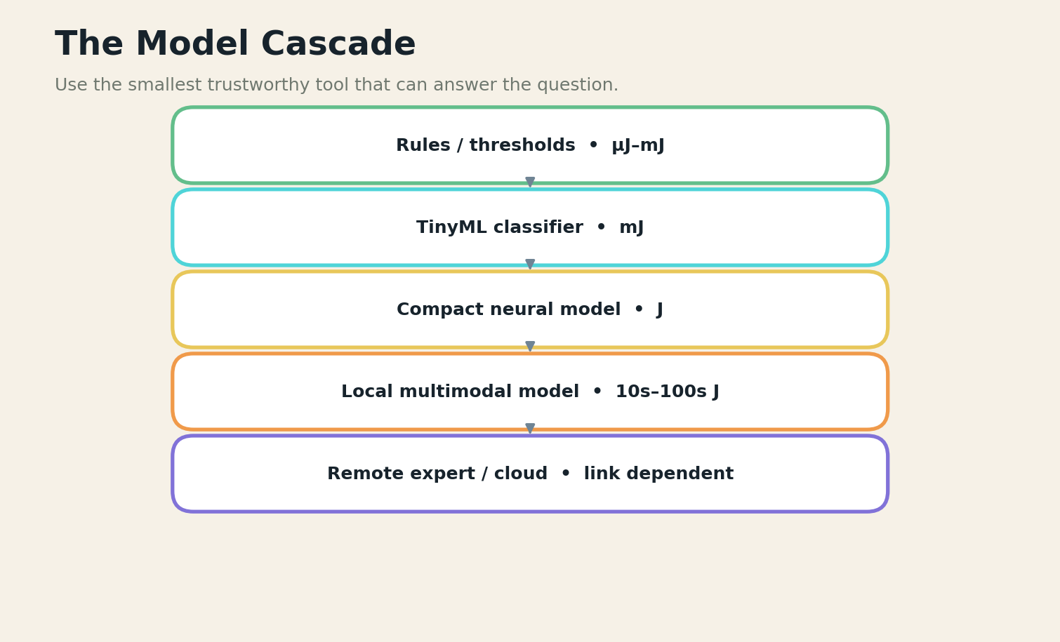
FIELD PLATE 11 — The model cascade uses the least expensive trustworthy component before invoking larger models.

THE FAILURE DRILL
Anomaly systems can drown crews in alerts or normalize slow degradation. Maintenance labels are sparse, operating regimes vary, and sensor replacement changes the signal.
The failure drill should be performed in shadow mode before the system receives authority. Operators must see the degraded state, know which data is stale or missing, and be able to continue with a manual or deterministic process. Every failure produces an artifact: the triggering condition, the system response, the human decision, and the evidence needed to redesign the control.

FIELD LOADOUT
COMPONENT | FIELD REQUIREMENT
Repairable local server | Must remain useful without a wide-area link.
Wi-Fi / mesh access | Must expose version, health, and provenance.
Local language corpus | Must have a deterministic or manual fallback.
Public-service apps | Must be replaceable or repairable with available skills.
Consent and governance ledger | Must produce an auditable event when it changes a decision.
FIELD EQUATION
P_m = avoided downtime value / false alarm burden

BUILD LAB
Create a baseline across load conditions, then inject sensor drift and component changes. Require every alert to include the evidence window and the nearest known operating regime.
Research trail: R24,R26. See Research Notes and Sources.

MISSION 15 / THE OPEN OCEAN
Medical Support at Sea
A field dispatch, architecture pattern, and failure drill
FIELD DISPATCH
A ship may be days from a clinic and temporarily unable to reach telemedicine services. Local tools can organize symptoms, retrieve procedures, translate guidance, and prepare a structured consultation for the next connection.

THE TERRAIN
The engineering terrain is defined by consequence, not by device class. In this mission the team must decide which observations are trustworthy, how long knowledge remains fresh, who is allowed to act, and what continues when power or connectivity falls away. The architecture must also fit the local workflow: a system that requires extra documentation, unfamiliar terminology, or constant troubleshooting transfers its cost to the very people it was meant to assist.
Keep a curated medical knowledge pack, medication inventory, crew allergies, and emergency protocols locally. Restrict the model to support functions that match onboard training and always preserve escalation criteria.

THE FAILURE DRILL
The system must not convert absence of a remote doctor into expanded autonomous practice. Knowledge packs can become stale, drug inventories can differ from assumptions, and privacy is difficult in close quarters.
The failure drill should be performed in shadow mode before the system receives authority. Operators must see the degraded state, know which data is stale or missing, and be able to continue with a manual or deterministic process. Every failure produces an artifact: the triggering condition, the system response, the human decision, and the evidence needed to redesign the control.

FIELD LOADOUT
COMPONENT | FIELD REQUIREMENT
Partitioned ship node | Must remain useful without a wide-area link.
Bridge and machinery interfaces | Must expose version, health, and provenance.
Signed voyage data | Must have a deterministic or manual fallback.
Local manuals and models | Must be replaceable or repairable with available skills.
Remote-operations gateway | Must produce an auditable event when it changes a decision.
FIELD EQUATION
A_med = correct support steps completed - unauthorized clinical action

BUILD LAB
Run a drill with no network, an injured crew member, and an unavailable item. Verify that the system finds the approved alternative procedure or clearly stops.
Research trail: R1,R5,R11. See Research Notes and Sources.

MISSION 16 / THE OPEN OCEAN
Remote Operations and the MASS Safety Case
A field dispatch, architecture pattern, and failure drill
FIELD DISPATCH
Autonomous and remotely operated ships require more than capable models. They require a documented description of modes, operating limits, connectivity, fallback, human roles, and evidence that safety is comparable to conventional operation.

THE TERRAIN
The engineering terrain is defined by consequence, not by device class. In this mission the team must decide which observations are trustworthy, how long knowledge remains fresh, who is allowed to act, and what continues when power or connectivity falls away. The architecture must also fit the local workflow: a system that requires extra documentation, unfamiliar terminology, or constant troubleshooting transfers its cost to the very people it was meant to assist.
Build the AI system into a formal safety case. Trace hazards to controls, tests, operational design domains, remote-operations procedures, cyber protections, and the master’s retained responsibility.

THE FAILURE DRILL
A remote operations center can become a hidden single point of failure. Link loss, ambiguous control transfer, operator workload, or conflicting commands must produce a safe and well-rehearsed state.
The failure drill should be performed in shadow mode before the system receives authority. Operators must see the degraded state, know which data is stale or missing, and be able to continue with a manual or deterministic process. Every failure produces an artifact: the triggering condition, the system response, the human decision, and the evidence needed to redesign the control.

FIELD LOADOUT
COMPONENT | FIELD REQUIREMENT
Partitioned ship node | Must remain useful without a wide-area link.
Bridge and machinery interfaces | Must expose version, health, and provenance.
Signed voyage data | Must have a deterministic or manual fallback.
Local manuals and models | Must be replaceable or repairable with available skills.
Remote-operations gateway | Must produce an auditable event when it changes a decision.
FIELD EQUATION
K = verified safety claims / total safety claims required

BUILD LAB
Write a control-transfer protocol and test it during latency spikes, partial sensor loss, and simultaneous vessel events.
Research trail: R11,R12,R25. See Research Notes and Sources.

EXPEDITION IV
THE DISASTER ZONE
Intelligence that appears before infrastructure returns: mapping, triage, warnings, mesh communication, and evidence discipline.

MISSION 17 / THE DISASTER ZONE
The First Twenty-Four Hours
A field dispatch, architecture pattern, and failure drill
FIELD DISPATCH
The first local AI systems in a disaster should not attempt to reconstruct the entire world. They should help responders answer a few urgent questions: where are people, which routes are open, what hazards are changing, and what information is trustworthy enough to act on?

THE TERRAIN
The engineering terrain is defined by consequence, not by device class. In this mission the team must decide which observations are trustworthy, how long knowledge remains fresh, who is allowed to act, and what continues when power or connectivity falls away. The architecture must also fit the local workflow: a system that requires extra documentation, unfamiliar terminology, or constant troubleshooting transfers its cost to the very people it was meant to assist.
Preposition portable nodes containing maps, language packs, forms, local procedures, and models for damage classification and message triage. Design them to boot without identity servers or external DNS.
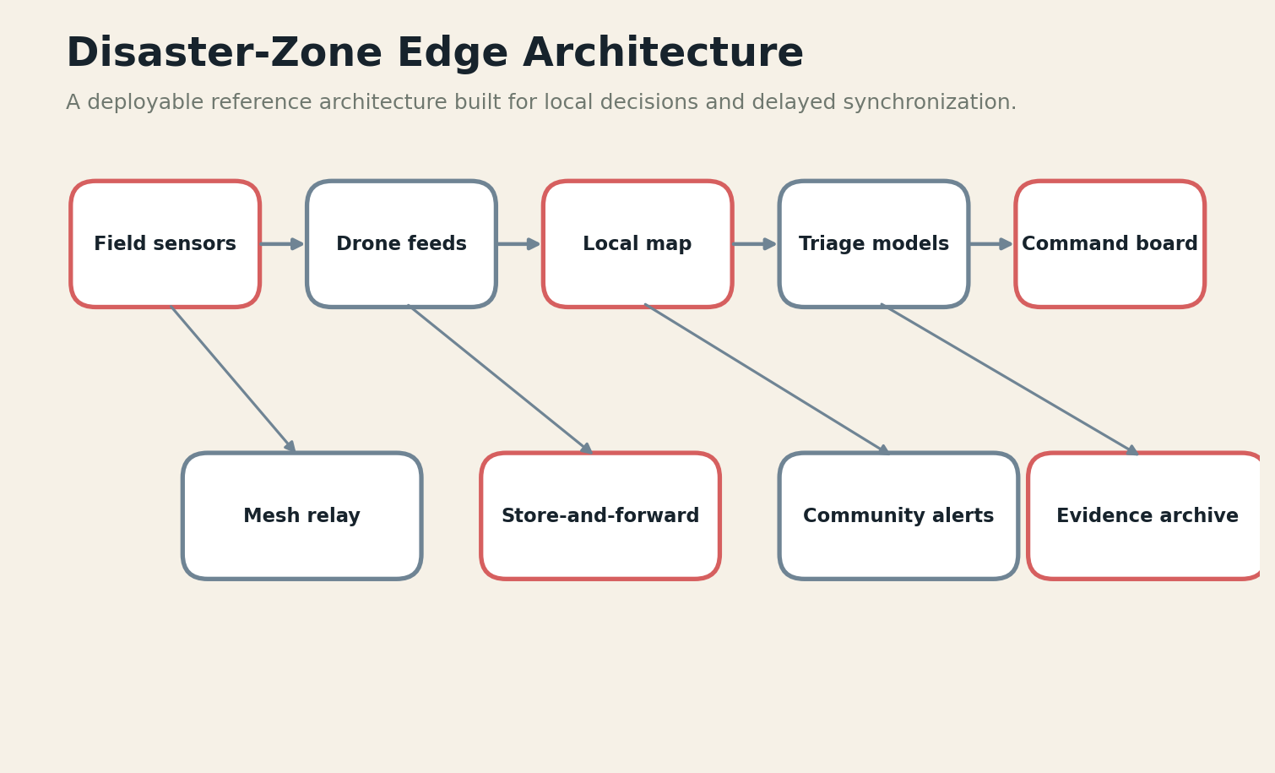
FIELD PLATE 12 — A disaster node turns fragmented sensing and mesh traffic into verified operational facts.

THE FAILURE DRILL
A sophisticated platform can waste the first day on setup, account recovery, and data imports. The field kit must have a paper-compatible workflow and a clear path from raw report to human-confirmed operational fact.
The failure drill should be performed in shadow mode before the system receives authority. Operators must see the degraded state, know which data is stale or missing, and be able to continue with a manual or deterministic process. Every failure produces an artifact: the triggering condition, the system response, the human decision, and the evidence needed to redesign the control.

FIELD LOADOUT
COMPONENT | FIELD REQUIREMENT
Battery field server | Must remain useful without a wide-area link.
Mesh radios | Must expose version, health, and provenance.
Portable map and forms | Must have a deterministic or manual fallback.
Drone / sensor ingestion | Must be replaceable or repairable with available skills.
Store-and-forward queue | Must produce an auditable event when it changes a decision.
FIELD EQUATION
D_24 = verified operational facts delivered in first 24 hours

BUILD LAB
Time the deployment from a sealed case to the first shared map. Repeat with no cellular service and only battery power.
Research trail: R7,R8,R10. See Research Notes and Sources.

MISSION 18 / THE DISASTER ZONE
Drone-Borne Mapping and Search
A field dispatch, architecture pattern, and failure drill
FIELD DISPATCH
Drones can rapidly map damage, inspect roads, detect heat signatures, relay communications, and deliver small supplies. Edge processing reduces the need to transmit every frame over fragile links.

THE TERRAIN
The engineering terrain is defined by consequence, not by device class. In this mission the team must decide which observations are trustworthy, how long knowledge remains fresh, who is allowed to act, and what continues when power or connectivity falls away. The architecture must also fit the local workflow: a system that requires extra documentation, unfamiliar terminology, or constant troubleshooting transfers its cost to the very people it was meant to assist.
Run acquisition-quality checks and first-pass detection onboard. Downlink thumbnails, coordinates, confidence, and selected evidence first; retain full media for later retrieval. Keep flight safety independent from the AI payload.

THE FAILURE DRILL
False detections can divert responders, while missed detections can delay rescue. Wind, smoke, heat, rotor noise, and damaged landscapes differ from training data.
The failure drill should be performed in shadow mode before the system receives authority. Operators must see the degraded state, know which data is stale or missing, and be able to continue with a manual or deterministic process. Every failure produces an artifact: the triggering condition, the system response, the human decision, and the evidence needed to redesign the control.

FIELD LOADOUT
COMPONENT | FIELD REQUIREMENT
Battery field server | Must remain useful without a wide-area link.
Mesh radios | Must expose version, health, and provenance.
Portable map and forms | Must have a deterministic or manual fallback.
Drone / sensor ingestion | Must be replaceable or repairable with available skills.
Store-and-forward queue | Must produce an auditable event when it changes a decision.
FIELD EQUATION
U_d = actionable findings per flight-minute × verification rate

BUILD LAB
Fly a controlled exercise with decoys, occlusion, poor weather, and limited bandwidth. Measure evidence quality at the command post, not only onboard accuracy.
Research trail: R10,R19,R21. See Research Notes and Sources.

MISSION 19 / THE DISASTER ZONE
Mesh Networks and Delay-Tolerant Intelligence
A field dispatch, architecture pattern, and failure drill
FIELD DISPATCH
When infrastructure fragments, nearby devices may still exchange messages, maps, model updates, and requests. A local mesh can create an island of coordination while one or two gateways connect intermittently to the outside world.

THE TERRAIN
The engineering terrain is defined by consequence, not by device class. In this mission the team must decide which observations are trustworthy, how long knowledge remains fresh, who is allowed to act, and what continues when power or connectivity falls away. The architecture must also fit the local workflow: a system that requires extra documentation, unfamiliar terminology, or constant troubleshooting transfers its cost to the very people it was meant to assist.
Use store-carry-forward messaging, signed bundles, explicit expiry, and priority classes. Route small operational facts before media. Allow phones, vehicles, drones, and fixed nodes to participate without granting all devices equal trust.

FIELD PLATE 13 — Delay-tolerant synchronization moves high-value deltas before bulk artifacts and preserves conflicts.

THE FAILURE DRILL
Mesh networks can amplify rumors, malicious data, and clock errors. Routing may favor well-connected areas while isolated communities remain invisible.
The failure drill should be performed in shadow mode before the system receives authority. Operators must see the degraded state, know which data is stale or missing, and be able to continue with a manual or deterministic process. Every failure produces an artifact: the triggering condition, the system response, the human decision, and the evidence needed to redesign the control.

FIELD LOADOUT
COMPONENT | FIELD REQUIREMENT
Battery field server | Must remain useful without a wide-area link.
Mesh radios | Must expose version, health, and provenance.
Portable map and forms | Must have a deterministic or manual fallback.
Drone / sensor ingestion | Must be replaceable or repairable with available skills.
Store-and-forward queue | Must produce an auditable event when it changes a decision.
FIELD EQUATION
M_r = delivered priority information / energy × delay × trust loss

BUILD LAB
Partition the network, move gateways, inject false reports, and verify that provenance and priority survive relaying.
Research trail: R8,R20,R26. See Research Notes and Sources.

MISSION 20 / THE DISASTER ZONE
Local Early Warning and Evacuation
A field dispatch, architecture pattern, and failure drill
FIELD DISPATCH
Early warning is only useful if detection, interpretation, communication, and action remain connected. Local AI can fuse sensors, forecasts, terrain, population, and route conditions to tailor warnings when central systems are delayed.

THE TERRAIN
The engineering terrain is defined by consequence, not by device class. In this mission the team must decide which observations are trustworthy, how long knowledge remains fresh, who is allowed to act, and what continues when power or connectivity falls away. The architecture must also fit the local workflow: a system that requires extra documentation, unfamiliar terminology, or constant troubleshooting transfers its cost to the very people it was meant to assist.
Keep hazard thresholds and evacuation rules inspectable. Use AI to estimate evolving risk and create accessible messages, but require authorized local governance for issuance and route changes.

THE FAILURE DRILL
A warning can be technically accurate and socially unusable. Connectivity gaps, language, disability, trust, and prior false alarms determine whether people act.
The failure drill should be performed in shadow mode before the system receives authority. Operators must see the degraded state, know which data is stale or missing, and be able to continue with a manual or deterministic process. Every failure produces an artifact: the triggering condition, the system response, the human decision, and the evidence needed to redesign the control.

FIELD LOADOUT
COMPONENT | FIELD REQUIREMENT
Battery field server | Must remain useful without a wide-area link.
Mesh radios | Must expose version, health, and provenance.
Portable map and forms | Must have a deterministic or manual fallback.
Drone / sensor ingestion | Must be replaceable or repairable with available skills.
Store-and-forward queue | Must produce an auditable event when it changes a decision.
FIELD EQUATION
W = population reached × comprehension × feasible action / false alarm cost

BUILD LAB
Test the entire chain with community participants: detection, approval, translation, broadcast, acknowledgment, and safe destination capacity.
Research trail: R8,R9,R30. See Research Notes and Sources.

MISSION 21 / THE DISASTER ZONE
Humanitarian Data Under Extreme Uncertainty
A field dispatch, architecture pattern, and failure drill
FIELD DISPATCH
Disaster data arrives as fragments: eyewitness reports, old maps, social posts, drone observations, damaged sensors, and institutional records. The AI system must preserve uncertainty and disagreement rather than forcing a clean but false picture.

THE TERRAIN
The engineering terrain is defined by consequence, not by device class. In this mission the team must decide which observations are trustworthy, how long knowledge remains fresh, who is allowed to act, and what continues when power or connectivity falls away. The architecture must also fit the local workflow: a system that requires extra documentation, unfamiliar terminology, or constant troubleshooting transfers its cost to the very people it was meant to assist.
Represent claims with source, time, location, confidence, sensitivity, and verification status. Separate observed, inferred, predicted, and requested information. Protect personally identifiable and protection-sensitive data by default.
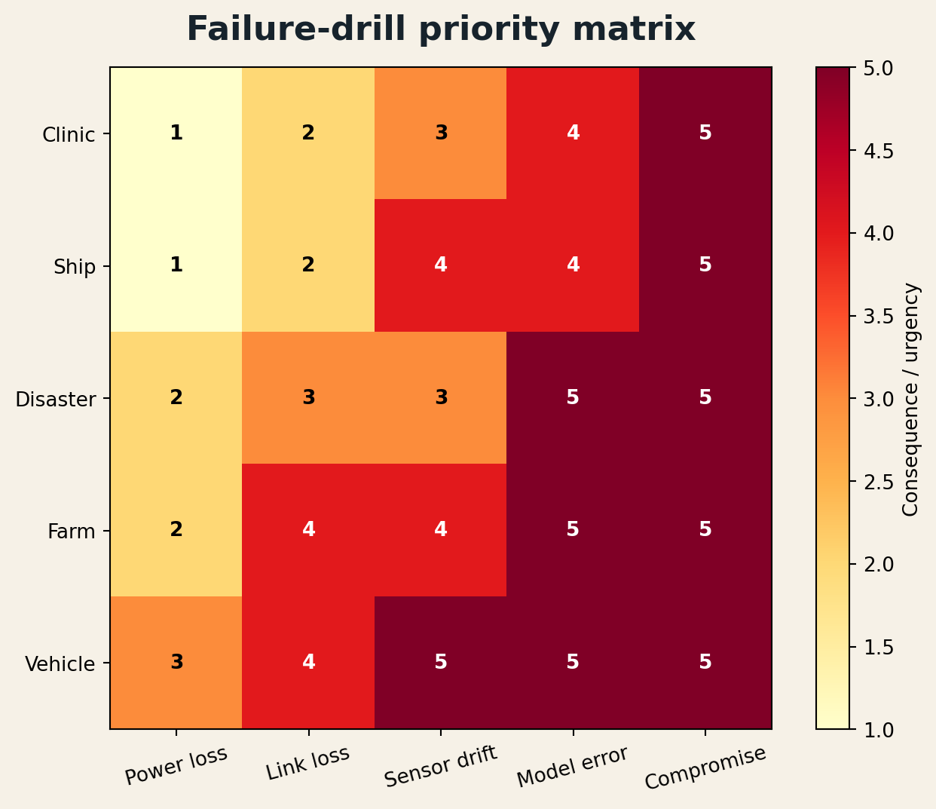
FIELD PLATE 14 — Failure-drill priority changes by operating theater and consequence.

THE FAILURE DRILL
The pressure for a single dashboard encourages premature certainty. Duplicate names, changing locations, and unverified casualty reports can cause harm if circulated without context.
The failure drill should be performed in shadow mode before the system receives authority. Operators must see the degraded state, know which data is stale or missing, and be able to continue with a manual or deterministic process. Every failure produces an artifact: the triggering condition, the system response, the human decision, and the evidence needed to redesign the control.

FIELD LOADOUT
COMPONENT | FIELD REQUIREMENT
Battery field server | Must remain useful without a wide-area link.
Mesh radios | Must expose version, health, and provenance.
Portable map and forms | Must have a deterministic or manual fallback.
Drone / sensor ingestion | Must be replaceable or repairable with available skills.
Store-and-forward queue | Must produce an auditable event when it changes a decision.
FIELD EQUATION
I_q = decision usefulness × provenance completeness × uncertainty visibility

BUILD LAB
Build a contradiction queue and require two independent confirmations for selected high-consequence facts. Verify that sensitive records do not propagate to public mesh nodes.
Research trail: R7,R8,R25. See Research Notes and Sources.

EXPEDITION V
THE FARM
Local sensing and advisory systems that respect smallholder economics, seasonal knowledge, and intermittent power.

MISSION 22 / THE FARM
Sensor-to-Soil Intelligence
A field dispatch, architecture pattern, and failure drill
FIELD DISPATCH
A farm edge system begins with soil moisture, weather, crop stage, water availability, and the farmer’s own observations. The purpose is not to maximize sensor count; it is to improve a decision whose cost and timing matter.

THE TERRAIN
The engineering terrain is defined by consequence, not by device class. In this mission the team must decide which observations are trustworthy, how long knowledge remains fresh, who is allowed to act, and what continues when power or connectivity falls away. The architecture must also fit the local workflow: a system that requires extra documentation, unfamiliar terminology, or constant troubleshooting transfers its cost to the very people it was meant to assist.
Place simple thresholds and anomaly detectors near sensors. Use a local node to combine field zones, forecasts, and crop knowledge. Let the farmer inspect why an irrigation, scouting, or treatment action was recommended.
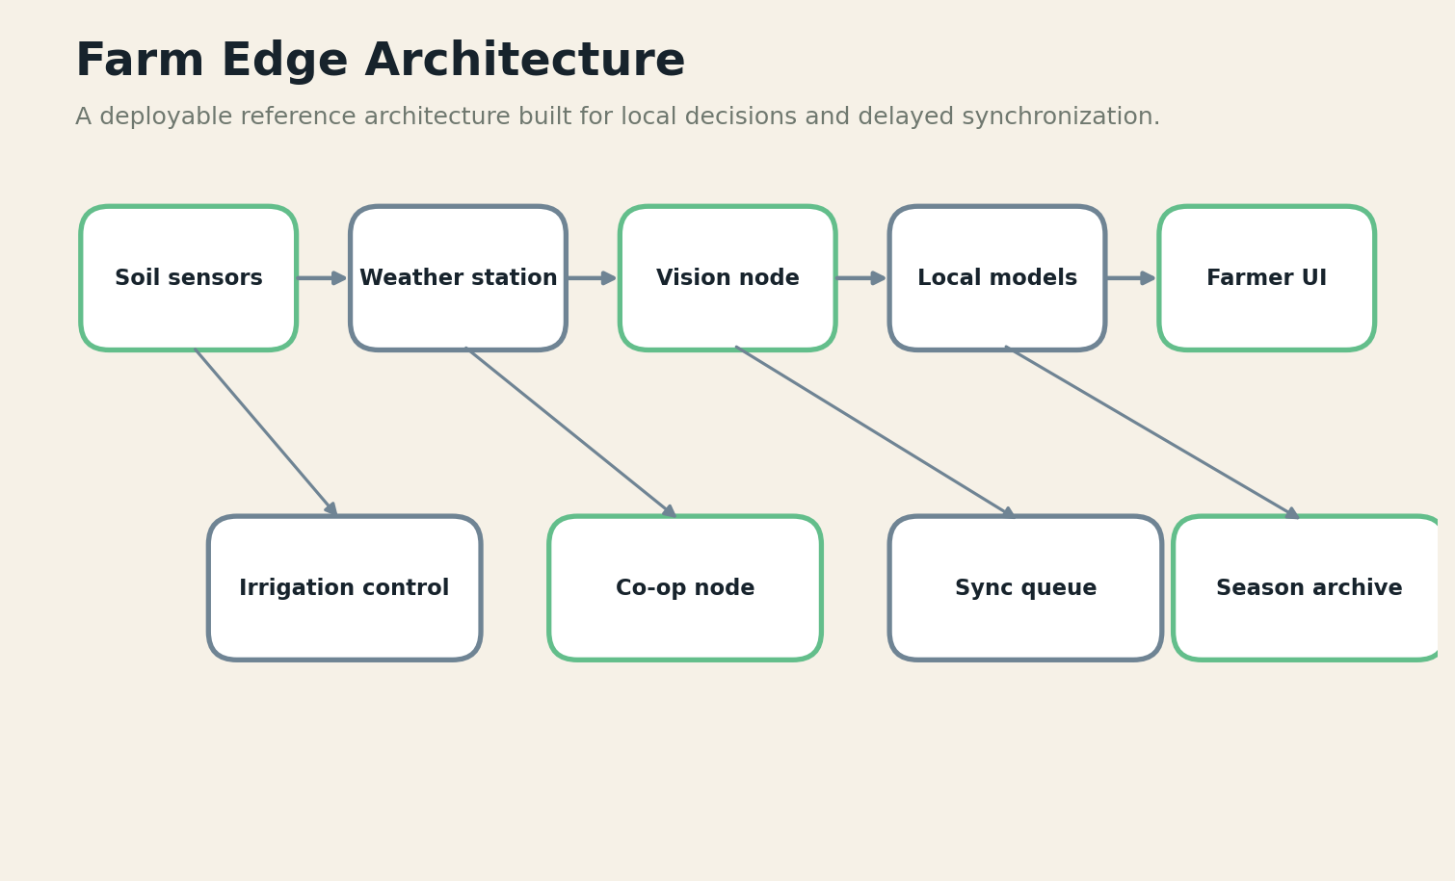
FIELD PLATE 15 — Farm intelligence joins local sensing, farmer knowledge, actuation, and cooperative synchronization.

THE FAILURE DRILL
Sensors drift, animals damage cables, probes represent only a tiny patch, and imported agronomic models may not fit local soils. Local calibration and farmer feedback are part of the model.
The failure drill should be performed in shadow mode before the system receives authority. Operators must see the degraded state, know which data is stale or missing, and be able to continue with a manual or deterministic process. Every failure produces an artifact: the triggering condition, the system response, the human decision, and the evidence needed to redesign the control.

FIELD LOADOUT
COMPONENT | FIELD REQUIREMENT
Low-power sensors | Must remain useful without a wide-area link.
Solar field node | Must expose version, health, and provenance.
Local crop knowledge | Must have a deterministic or manual fallback.
Farmer language interface | Must be replaceable or repairable with available skills.
Actuator safety interlocks | Must produce an auditable event when it changes a decision.
FIELD EQUATION
S_s = avoided input waste + yield protection - sensing burden

BUILD LAB
Compare sensor recommendations with manual field checks across microclimates. Track where the system is consistently early, late, or wrong.
Research trail: R13,R14,R15,R16. See Research Notes and Sources.

MISSION 23 / THE FARM
Vision Models for Crops and Livestock
A field dispatch, architecture pattern, and failure drill
FIELD DISPATCH
Phones, fixed cameras, and drones can support disease scouting, weed detection, fruit counting, body-condition monitoring, and fence inspection without uploading every image.

THE TERRAIN
The engineering terrain is defined by consequence, not by device class. In this mission the team must decide which observations are trustworthy, how long knowledge remains fresh, who is allowed to act, and what continues when power or connectivity falls away. The architecture must also fit the local workflow: a system that requires extra documentation, unfamiliar terminology, or constant troubleshooting transfers its cost to the very people it was meant to assist.
Use acquisition guidance, local classification, and uncertainty-based escalation. Keep examples from local seasons and varieties in a reviewable gallery so extension workers can correct labels.

THE FAILURE DRILL
Models trained on clean benchmark images often fail in mixed crops, dust, shadows, partial symptoms, and unfamiliar breeds. A confident wrong pesticide recommendation can be worse than no model.
The failure drill should be performed in shadow mode before the system receives authority. Operators must see the degraded state, know which data is stale or missing, and be able to continue with a manual or deterministic process. Every failure produces an artifact: the triggering condition, the system response, the human decision, and the evidence needed to redesign the control.

FIELD LOADOUT
COMPONENT | FIELD REQUIREMENT
Low-power sensors | Must remain useful without a wide-area link.
Solar field node | Must expose version, health, and provenance.
Local crop knowledge | Must have a deterministic or manual fallback.
Farmer language interface | Must be replaceable or repairable with available skills.
Actuator safety interlocks | Must produce an auditable event when it changes a decision.
FIELD EQUATION
V_f = useful detections × local validity - harmful treatment suggestions

BUILD LAB
Collect hard negatives from the actual farm and measure the system’s ability to defer to an extension worker.
Research trail: R14,R15,R16. See Research Notes and Sources.

MISSION 24 / THE FARM
Irrigation Under Intermittent Power
A field dispatch, architecture pattern, and failure drill
FIELD DISPATCH
Irrigation intelligence must survive weak power, pump limits, uncertain forecasts, and competition for water. The control system should remain understandable and manually operable.

THE TERRAIN
The engineering terrain is defined by consequence, not by device class. In this mission the team must decide which observations are trustworthy, how long knowledge remains fresh, who is allowed to act, and what continues when power or connectivity falls away. The architecture must also fit the local workflow: a system that requires extra documentation, unfamiliar terminology, or constant troubleshooting transfers its cost to the very people it was meant to assist.
Separate safety interlocks from optimization. Tiny controllers enforce pressure, dry-run, reservoir, and schedule limits. A local optimizer proposes zone timing using soil, weather, crop stage, and energy availability.

FIELD PLATE 16 — Accuracy, latency, and energy form a mission-specific engineering triangle.

THE FAILURE DRILL
An elegant optimizer can issue impossible schedules when valves fail or the pump curve changes. Connectivity loss must not freeze a valve in the last remote state.
The failure drill should be performed in shadow mode before the system receives authority. Operators must see the degraded state, know which data is stale or missing, and be able to continue with a manual or deterministic process. Every failure produces an artifact: the triggering condition, the system response, the human decision, and the evidence needed to redesign the control.

FIELD LOADOUT
COMPONENT | FIELD REQUIREMENT
Low-power sensors | Must remain useful without a wide-area link.
Solar field node | Must expose version, health, and provenance.
Local crop knowledge | Must have a deterministic or manual fallback.
Farmer language interface | Must be replaceable or repairable with available skills.
Actuator safety interlocks | Must produce an auditable event when it changes a decision.
FIELD EQUATION
I_o = crop water benefit / water + energy + failure risk

BUILD LAB
Run the controller through sensor loss, cloudy solar days, blocked lines, and manual override. Measure water saved without increasing crop stress.
Research trail: R13,R15,R16. See Research Notes and Sources.

MISSION 25 / THE FARM
Local Advisory in the Farmer’s Language
A field dispatch, architecture pattern, and failure drill
FIELD DISPATCH
Advisory systems become useful when they understand local crops, units, seasons, market customs, and language. Offline access matters because the question often arises in the field, not beside a reliable connection.

THE TERRAIN
The engineering terrain is defined by consequence, not by device class. In this mission the team must decide which observations are trustworthy, how long knowledge remains fresh, who is allowed to act, and what continues when power or connectivity falls away. The architecture must also fit the local workflow: a system that requires extra documentation, unfamiliar terminology, or constant troubleshooting transfers its cost to the very people it was meant to assist.
Package local extension knowledge, weather summaries, pest alerts, and market information into a searchable node. Provide speech and pictorial modes. Cite the source and date of every agronomic recommendation.

THE FAILURE DRILL
Generic language models can invent treatments, ignore local restrictions, or translate technical words incorrectly. The system should distinguish local approved guidance from general model knowledge.
The failure drill should be performed in shadow mode before the system receives authority. Operators must see the degraded state, know which data is stale or missing, and be able to continue with a manual or deterministic process. Every failure produces an artifact: the triggering condition, the system response, the human decision, and the evidence needed to redesign the control.

FIELD LOADOUT
COMPONENT | FIELD REQUIREMENT
Repairable local server | Must remain useful without a wide-area link.
Wi-Fi / mesh access | Must expose version, health, and provenance.
Local language corpus | Must have a deterministic or manual fallback.
Public-service apps | Must be replaceable or repairable with available skills.
Consent and governance ledger | Must produce an auditable event when it changes a decision.
FIELD EQUATION
A_f = locally valid answers × adoption × outcome improvement

BUILD LAB
Ask farmers to test realistic questions in their own phrasing. Score actionability, trust, and source traceability rather than conversational fluency.
Research trail: R13,R14,R22,R23. See Research Notes and Sources.

MISSION 26 / THE FARM
Cooperative Learning Without Centralizing the Farm
A field dispatch, architecture pattern, and failure drill
FIELD DISPATCH
Neighboring farms can benefit from shared disease signals, weather patterns, equipment faults, and market observations without surrendering all raw data to a distant platform.

THE TERRAIN
The engineering terrain is defined by consequence, not by device class. In this mission the team must decide which observations are trustworthy, how long knowledge remains fresh, who is allowed to act, and what continues when power or connectivity falls away. The architecture must also fit the local workflow: a system that requires extra documentation, unfamiliar terminology, or constant troubleshooting transfers its cost to the very people it was meant to assist.
Create a cooperative edge node that accepts signed summaries, model updates, and consented examples. Define which data belongs to the farmer, cooperative, public authority, or research partner.

THE FAILURE DRILL
Data asymmetry can let larger farms capture the benefit while smaller farms provide the diversity. Poor governance can turn advisory infrastructure into surveillance or price extraction.
The failure drill should be performed in shadow mode before the system receives authority. Operators must see the degraded state, know which data is stale or missing, and be able to continue with a manual or deterministic process. Every failure produces an artifact: the triggering condition, the system response, the human decision, and the evidence needed to redesign the control.

FIELD LOADOUT
COMPONENT | FIELD REQUIREMENT
Low-power sensors | Must remain useful without a wide-area link.
Solar field node | Must expose version, health, and provenance.
Local crop knowledge | Must have a deterministic or manual fallback.
Farmer language interface | Must be replaceable or repairable with available skills.
Actuator safety interlocks | Must produce an auditable event when it changes a decision.
FIELD EQUATION
B_c = shared benefit - extraction risk - exclusion cost

BUILD LAB
Write a data-benefit agreement before training. Test withdrawal, correction, and deletion from the cooperative archive.
Research trail: R14,R15,R25. See Research Notes and Sources.

EXPEDITION VI
THE MOVING VEHICLE
Real-time perception and risk systems that remain useful when networks, maps, and cooperative infrastructure disappear.

MISSION 27 / THE MOVING VEHICLE
Perception When the Network Vanishes
A field dispatch, architecture pattern, and failure drill
FIELD DISPATCH
A vehicle cannot wait for a cloud response to detect a pedestrian, fallen tree, animal, washed-out road, or stopped truck. Safety-critical perception must be local and bounded by known sensor and weather limits.

THE TERRAIN
The engineering terrain is defined by consequence, not by device class. In this mission the team must decide which observations are trustworthy, how long knowledge remains fresh, who is allowed to act, and what continues when power or connectivity falls away. The architecture must also fit the local workflow: a system that requires extra documentation, unfamiliar terminology, or constant troubleshooting transfers its cost to the very people it was meant to assist.
Use redundant sensing, deterministic timing, health monitoring, and a local operational design domain. Cache maps and procedures, but treat them as evidence that can become stale.
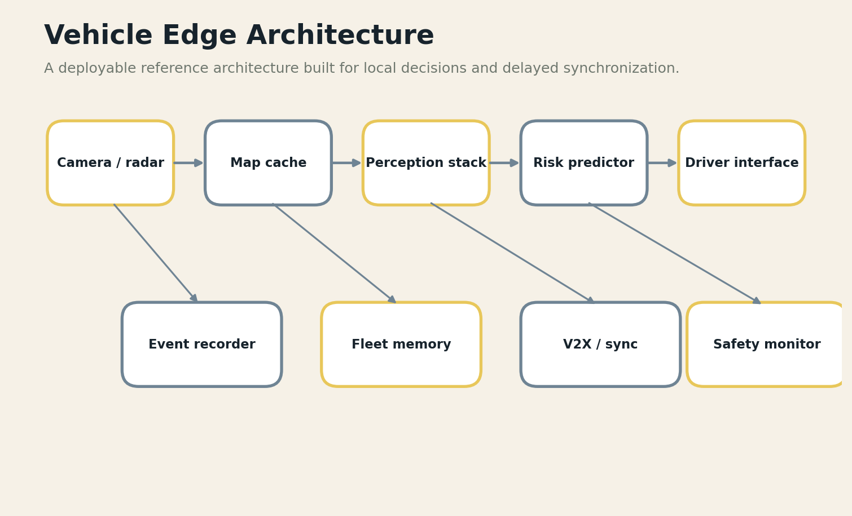
FIELD PLATE 17 — Vehicle intelligence keeps perception and safety local while synchronizing selected fleet evidence.

THE FAILURE DRILL
Adverse weather, glare, mud, vibration, lens obstruction, and unfamiliar roads create distribution shift. The system must recognize degraded perception and reduce authority or request human control.
The failure drill should be performed in shadow mode before the system receives authority. Operators must see the degraded state, know which data is stale or missing, and be able to continue with a manual or deterministic process. Every failure produces an artifact: the triggering condition, the system response, the human decision, and the evidence needed to redesign the control.

FIELD LOADOUT
COMPONENT | FIELD REQUIREMENT
Redundant sensors | Must remain useful without a wide-area link.
Real-time compute | Must expose version, health, and provenance.
Cached maps and rules | Must have a deterministic or manual fallback.
Event recorder | Must be replaceable or repairable with available skills.
Fleet sync gateway | Must produce an auditable event when it changes a decision.
FIELD EQUATION
P_v = hazards detected within deadline × calibrated confidence

BUILD LAB
Drive a closed-course test with sensor contamination, map error, fog, and lost connectivity. Measure time to safe degradation.
Research trail: R27,R28,R29. See Research Notes and Sources.

MISSION 28 / THE MOVING VEHICLE
Hazard Prediction and Driver Assistance
A field dispatch, architecture pattern, and failure drill
FIELD DISPATCH
A compact multimodal model can interpret road context, driver state, map geometry, and object trajectories to identify developing risk before a conventional threshold alarm fires.

THE TERRAIN
The engineering terrain is defined by consequence, not by device class. In this mission the team must decide which observations are trustworthy, how long knowledge remains fresh, who is allowed to act, and what continues when power or connectivity falls away. The architecture must also fit the local workflow: a system that requires extra documentation, unfamiliar terminology, or constant troubleshooting transfers its cost to the very people it was meant to assist.
Keep the system in an advisory envelope unless it is certified for control. Produce short, prioritized warnings with location, time horizon, and recommended risk-reducing action.

THE FAILURE DRILL
Verbose or frequent warnings can distract the driver. Vision-language models can produce persuasive explanations that exceed the evidence in the sensors.
The failure drill should be performed in shadow mode before the system receives authority. Operators must see the degraded state, know which data is stale or missing, and be able to continue with a manual or deterministic process. Every failure produces an artifact: the triggering condition, the system response, the human decision, and the evidence needed to redesign the control.

FIELD LOADOUT
COMPONENT | FIELD REQUIREMENT
Redundant sensors | Must remain useful without a wide-area link.
Real-time compute | Must expose version, health, and provenance.
Cached maps and rules | Must have a deterministic or manual fallback.
Event recorder | Must be replaceable or repairable with available skills.
Fleet sync gateway | Must produce an auditable event when it changes a decision.
FIELD EQUATION
H_p = prevented risk - distraction - false intervention cost

BUILD LAB
Test rare scenarios and measure whether warnings improve driver behavior without increasing workload or false reactions.
Research trail: R27,R28. See Research Notes and Sources.

MISSION 29 / THE MOVING VEHICLE
Fleet Memory and Selective Synchronization
A field dispatch, architecture pattern, and failure drill
FIELD DISPATCH
Vehicles accumulate local maps, near-miss events, mechanical signatures, and route observations. Fleet learning is valuable, but raw continuous upload is expensive and sensitive.

THE TERRAIN
The engineering terrain is defined by consequence, not by device class. In this mission the team must decide which observations are trustworthy, how long knowledge remains fresh, who is allowed to act, and what continues when power or connectivity falls away. The architecture must also fit the local workflow: a system that requires extra documentation, unfamiliar terminology, or constant troubleshooting transfers its cost to the very people it was meant to assist.
Store event windows locally and summarize routine operation. Synchronize safety-relevant anomalies, map deltas, and model diagnostics according to priority and consent. Maintain a signed chain from event to fleet update.

FIELD PLATE 18 — Delay-tolerant synchronization moves high-value deltas before bulk artifacts and preserves conflicts.

THE FAILURE DRILL
A fleet can learn the wrong lesson from correlated sensors or a malicious vehicle. Rare local hazards may be averaged away by global training.
The failure drill should be performed in shadow mode before the system receives authority. Operators must see the degraded state, know which data is stale or missing, and be able to continue with a manual or deterministic process. Every failure produces an artifact: the triggering condition, the system response, the human decision, and the evidence needed to redesign the control.

FIELD LOADOUT
COMPONENT | FIELD REQUIREMENT
Redundant sensors | Must remain useful without a wide-area link.
Real-time compute | Must expose version, health, and provenance.
Cached maps and rules | Must have a deterministic or manual fallback.
Event recorder | Must be replaceable or repairable with available skills.
Fleet sync gateway | Must produce an auditable event when it changes a decision.
FIELD EQUATION
F_m = fleet learning gain × rare-event retention - poisoning risk

BUILD LAB
Introduce one poisoned update and one rare but valid hazard. Confirm that screening blocks the first and preserves the second.
Research trail: R25,R26,R27. See Research Notes and Sources.

MISSION 30 / THE MOVING VEHICLE
Edge Vision-Language Models Without Unsafe Authority
A field dispatch, architecture pattern, and failure drill
FIELD DISPATCH
Vision-language models can connect perception with semantic context: “a child is approaching the road from behind a parked vehicle” rather than only bounding boxes. Their strength is interpretation; their risk is confident narrative.

THE TERRAIN
The engineering terrain is defined by consequence, not by device class. In this mission the team must decide which observations are trustworthy, how long knowledge remains fresh, who is allowed to act, and what continues when power or connectivity falls away. The architecture must also fit the local workflow: a system that requires extra documentation, unfamiliar terminology, or constant troubleshooting transfers its cost to the very people it was meant to assist.
Use VLMs as secondary hazard interpreters and evaluators behind real-time perception. Constrain outputs to a typed hazard vocabulary, evidence references, and time budgets.

FIELD PLATE 19 — The model cascade uses the least expensive trustworthy component before invoking larger models.

THE FAILURE DRILL
A model may hallucinate intent, overlook geometry, or respond too slowly. Language should never be treated as a control signal without deterministic validation.
The failure drill should be performed in shadow mode before the system receives authority. Operators must see the degraded state, know which data is stale or missing, and be able to continue with a manual or deterministic process. Every failure produces an artifact: the triggering condition, the system response, the human decision, and the evidence needed to redesign the control.

FIELD LOADOUT
COMPONENT | FIELD REQUIREMENT
Redundant sensors | Must remain useful without a wide-area link.
Real-time compute | Must expose version, health, and provenance.
Cached maps and rules | Must have a deterministic or manual fallback.
Event recorder | Must be replaceable or repairable with available skills.
Fleet sync gateway | Must produce an auditable event when it changes a decision.
FIELD EQUATION
V_l = contextual hazard gain - unsupported narrative risk

BUILD LAB
Compare VLM hazard descriptions with raw sensor evidence and human annotations. Reject any output that cannot point to visible or measured support.
Research trail: R27,R28,R29. See Research Notes and Sources.

MISSION 31 / THE MOVING VEHICLE
Maintenance, Energy, and Route Resilience
A field dispatch, architecture pattern, and failure drill
FIELD DISPATCH
In rural fleets and emergency vehicles, a minor failure can remove an entire service. Local AI can combine diagnostics, battery health, road condition, spare parts, and mission priority to plan resilient routes and maintenance.

THE TERRAIN
The engineering terrain is defined by consequence, not by device class. In this mission the team must decide which observations are trustworthy, how long knowledge remains fresh, who is allowed to act, and what continues when power or connectivity falls away. The architecture must also fit the local workflow: a system that requires extra documentation, unfamiliar terminology, or constant troubleshooting transfers its cost to the very people it was meant to assist.
Maintain a local digital log of faults, repairs, consumables, and route hazards. Use optimization to recommend actions while exposing assumptions and allowing a mechanic or dispatcher to override.

THE FAILURE DRILL
Maintenance models trained on commercial fleets may not fit improvised repairs, mixed parts, or extreme duty cycles. Optimization can prefer efficiency over service equity.
The failure drill should be performed in shadow mode before the system receives authority. Operators must see the degraded state, know which data is stale or missing, and be able to continue with a manual or deterministic process. Every failure produces an artifact: the triggering condition, the system response, the human decision, and the evidence needed to redesign the control.

FIELD LOADOUT
COMPONENT | FIELD REQUIREMENT
Redundant sensors | Must remain useful without a wide-area link.
Real-time compute | Must expose version, health, and provenance.
Cached maps and rules | Must have a deterministic or manual fallback.
Event recorder | Must be replaceable or repairable with available skills.
Fleet sync gateway | Must produce an auditable event when it changes a decision.
FIELD EQUATION
R_f = missions completed / energy + downtime + inequity penalty

BUILD LAB
Test a scenario with one failing vehicle, blocked road, scarce fuel, and two critical destinations. Audit why the system chose its route.
Research trail: R25,R29. See Research Notes and Sources.

EXPEDITION VII
THE DISCONNECTED COMMUNITY
Community-scale intelligence for language, education, markets, public services, and self-determined data governance.

MISSION 32 / THE DISCONNECTED COMMUNITY
The Village Knowledge Node
A field dispatch, architecture pattern, and failure drill
FIELD DISPATCH
A community node is a small local server or cluster that stores public information, local language resources, educational materials, service workflows, and selected models. It can serve phones and terminals over local Wi-Fi even when the wider internet is absent.

THE TERRAIN
The engineering terrain is defined by consequence, not by device class. In this mission the team must decide which observations are trustworthy, how long knowledge remains fresh, who is allowed to act, and what continues when power or connectivity falls away. The architecture must also fit the local workflow: a system that requires extra documentation, unfamiliar terminology, or constant troubleshooting transfers its cost to the very people it was meant to assist.
Build it as community infrastructure: replaceable hardware, open formats, local backups, clear administration, and a visible content-update process. Separate public knowledge from sensitive records.
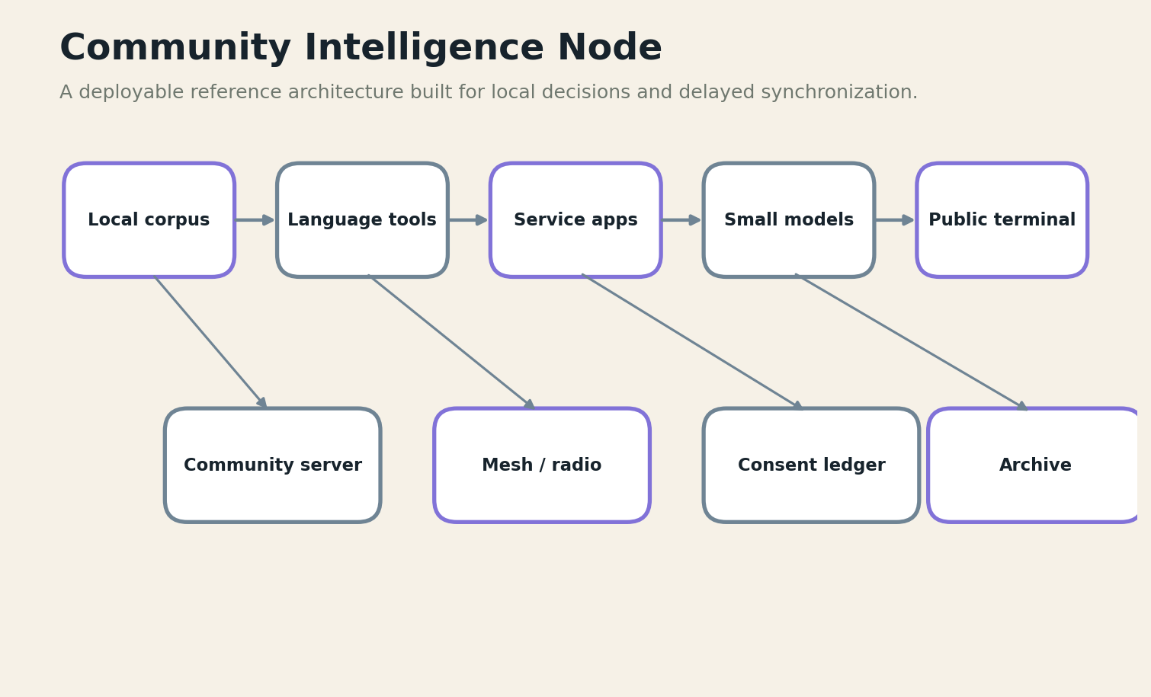
FIELD PLATE 20 — A community node offers local language and public services with community-controlled governance.

THE FAILURE DRILL
A donated server can become an abandoned appliance when storage fills, batteries fail, or no one can update it. Technical ownership must be matched by local training and budget.
The failure drill should be performed in shadow mode before the system receives authority. Operators must see the degraded state, know which data is stale or missing, and be able to continue with a manual or deterministic process. Every failure produces an artifact: the triggering condition, the system response, the human decision, and the evidence needed to redesign the control.

FIELD LOADOUT
COMPONENT | FIELD REQUIREMENT
Repairable local server | Must remain useful without a wide-area link.
Wi-Fi / mesh access | Must expose version, health, and provenance.
Local language corpus | Must have a deterministic or manual fallback.
Public-service apps | Must be replaceable or repairable with available skills.
Consent and governance ledger | Must produce an auditable event when it changes a decision.
FIELD EQUATION
K_n = locally useful services × uptime × local stewardship

BUILD LAB
Operate the node for a month without outside support. Track who can repair it, restore it, explain it, and decide what it contains.
Research trail: R6,R13,R30. See Research Notes and Sources.

MISSION 33 / THE DISCONNECTED COMMUNITY
Offline Education and Translation
A field dispatch, architecture pattern, and failure drill
FIELD DISPATCH
Local AI can provide tutoring, reading support, translation, speech practice, and curriculum search where cloud services are unaffordable or inaccessible. The system should strengthen teachers and local language, not replace them.

THE TERRAIN
The engineering terrain is defined by consequence, not by device class. In this mission the team must decide which observations are trustworthy, how long knowledge remains fresh, who is allowed to act, and what continues when power or connectivity falls away. The architecture must also fit the local workflow: a system that requires extra documentation, unfamiliar terminology, or constant troubleshooting transfers its cost to the very people it was meant to assist.
Use curriculum-bound knowledge packs, offline speech models, and teacher-controlled lesson plans. Store learner progress locally with consent and export only necessary aggregates.

THE FAILURE DRILL
A fluent tutor can teach wrong content, erase local history, or reward students for adapting to model bias. Devices may also concentrate access in a few households.
The failure drill should be performed in shadow mode before the system receives authority. Operators must see the degraded state, know which data is stale or missing, and be able to continue with a manual or deterministic process. Every failure produces an artifact: the triggering condition, the system response, the human decision, and the evidence needed to redesign the control.

FIELD LOADOUT
COMPONENT | FIELD REQUIREMENT
Repairable local server | Must remain useful without a wide-area link.
Wi-Fi / mesh access | Must expose version, health, and provenance.
Local language corpus | Must have a deterministic or manual fallback.
Public-service apps | Must be replaceable or repairable with available skills.
Consent and governance ledger | Must produce an auditable event when it changes a decision.
FIELD EQUATION
L_e = learning gain × inclusion - misinformation - teacher displacement

BUILD LAB
Run lessons with teachers observing. Measure learning, correction burden, language quality, and equitable access across students.
Research trail: R22,R23,R30. See Research Notes and Sources.

MISSION 34 / THE DISCONNECTED COMMUNITY
Local Governance and Community Data
A field dispatch, architecture pattern, and failure drill
FIELD DISPATCH
Community-scale AI affects land, benefits, public safety, health, markets, and identity. Governance cannot be an afterthought added after the node is deployed.

THE TERRAIN
The engineering terrain is defined by consequence, not by device class. In this mission the team must decide which observations are trustworthy, how long knowledge remains fresh, who is allowed to act, and what continues when power or connectivity falls away. The architecture must also fit the local workflow: a system that requires extra documentation, unfamiliar terminology, or constant troubleshooting transfers its cost to the very people it was meant to assist.
Create a local data charter covering collection, consent, access, retention, benefit, redress, and prohibited uses. Use a consent ledger and public audit summaries.

FIELD PLATE 21 — The authority envelope separates automation, recommendation, escalation, and prohibition.

THE FAILURE DRILL
Technically anonymized data can remain socially identifiable in small communities. An outside operator may possess practical control despite formal local ownership.
The failure drill should be performed in shadow mode before the system receives authority. Operators must see the degraded state, know which data is stale or missing, and be able to continue with a manual or deterministic process. Every failure produces an artifact: the triggering condition, the system response, the human decision, and the evidence needed to redesign the control.

FIELD LOADOUT
COMPONENT | FIELD REQUIREMENT
Repairable local server | Must remain useful without a wide-area link.
Wi-Fi / mesh access | Must expose version, health, and provenance.
Local language corpus | Must have a deterministic or manual fallback.
Public-service apps | Must be replaceable or repairable with available skills.
Consent and governance ledger | Must produce an auditable event when it changes a decision.
FIELD EQUATION
D_g = legitimate community benefit × consent quality / reidentification risk

BUILD LAB
Choose one dataset and conduct a community threat model: who could infer what, who benefits, and how a person can challenge the system.
Research trail: R25,R26,R30. See Research Notes and Sources.

MISSION 35 / THE DISCONNECTED COMMUNITY
Microgrids, Markets, and Public Services
A field dispatch, architecture pattern, and failure drill
FIELD DISPATCH
A community node can coordinate solar generation, water pumps, cold storage, transport, local markets, and public notices. These systems become valuable when they share state without sharing unlimited authority.

THE TERRAIN
The engineering terrain is defined by consequence, not by device class. In this mission the team must decide which observations are trustworthy, how long knowledge remains fresh, who is allowed to act, and what continues when power or connectivity falls away. The architecture must also fit the local workflow: a system that requires extra documentation, unfamiliar terminology, or constant troubleshooting transfers its cost to the very people it was meant to assist.
Use event-driven local services with clear priorities for health, water, communications, and food preservation. AI forecasts demand and anomalies; deterministic controllers enforce physical safety and allocation rules approved by governance.

THE FAILURE DRILL
Optimization can hide political choices. A mathematically efficient allocation may disadvantage remote households or informal workers. The system must show tradeoffs and preserve an appeal path.
The failure drill should be performed in shadow mode before the system receives authority. Operators must see the degraded state, know which data is stale or missing, and be able to continue with a manual or deterministic process. Every failure produces an artifact: the triggering condition, the system response, the human decision, and the evidence needed to redesign the control.

FIELD LOADOUT
COMPONENT | FIELD REQUIREMENT
Repairable local server | Must remain useful without a wide-area link.
Wi-Fi / mesh access | Must expose version, health, and provenance.
Local language corpus | Must have a deterministic or manual fallback.
Public-service apps | Must be replaceable or repairable with available skills.
Consent and governance ledger | Must produce an auditable event when it changes a decision.
FIELD EQUATION
P_s = essential service continuity - inequity - opaque control

BUILD LAB
Simulate a power shortage. Ask the system to explain curtailment choices and let community representatives alter the policy.
Research trail: R7,R13,R25. See Research Notes and Sources.

MISSION 36 / THE DISCONNECTED COMMUNITY
A Right to Intelligence Without Connectivity
A field dispatch, architecture pattern, and failure drill
FIELD DISPATCH
The final edge architecture is not a smaller copy of the cloud. It is a different social contract: people should retain useful tools, knowledge, and agency even when they cannot purchase bandwidth or expose their data to a distant platform.

THE TERRAIN
The engineering terrain is defined by consequence, not by device class. In this mission the team must decide which observations are trustworthy, how long knowledge remains fresh, who is allowed to act, and what continues when power or connectivity falls away. The architecture must also fit the local workflow: a system that requires extra documentation, unfamiliar terminology, or constant troubleshooting transfers its cost to the very people it was meant to assist.
Design for local ownership, inspectable models, exportable data, language inclusion, repairability, and a path to outside expertise without permanent dependence. Measure success by capability retained locally.

FIELD PLATE 22 — The edge-world atlas organizes six environments around a local intelligence core.

THE FAILURE DRILL
Edge AI can still reproduce centralized extraction if models, updates, keys, and governance remain controlled elsewhere. Offline operation alone does not create autonomy.
The failure drill should be performed in shadow mode before the system receives authority. Operators must see the degraded state, know which data is stale or missing, and be able to continue with a manual or deterministic process. Every failure produces an artifact: the triggering condition, the system response, the human decision, and the evidence needed to redesign the control.

FIELD LOADOUT
COMPONENT | FIELD REQUIREMENT
Repairable local server | Must remain useful without a wide-area link.
Wi-Fi / mesh access | Must expose version, health, and provenance.
Local language corpus | Must have a deterministic or manual fallback.
Public-service apps | Must be replaceable or repairable with available skills.
Consent and governance ledger | Must produce an auditable event when it changes a decision.
FIELD EQUATION
J = intelligence access × local agency × durability / dependency concentration

BUILD LAB
Write a field constitution for one deployment. Include the right to manual service, the right to explanation, the right to leave, and the right to keep essential capability after a vendor exits.
Research trail: R6,R13,R25,R30. See Research Notes and Sources.

ANNEX A
HARDWARE TIERS AND REFERENCE LOADOUTS
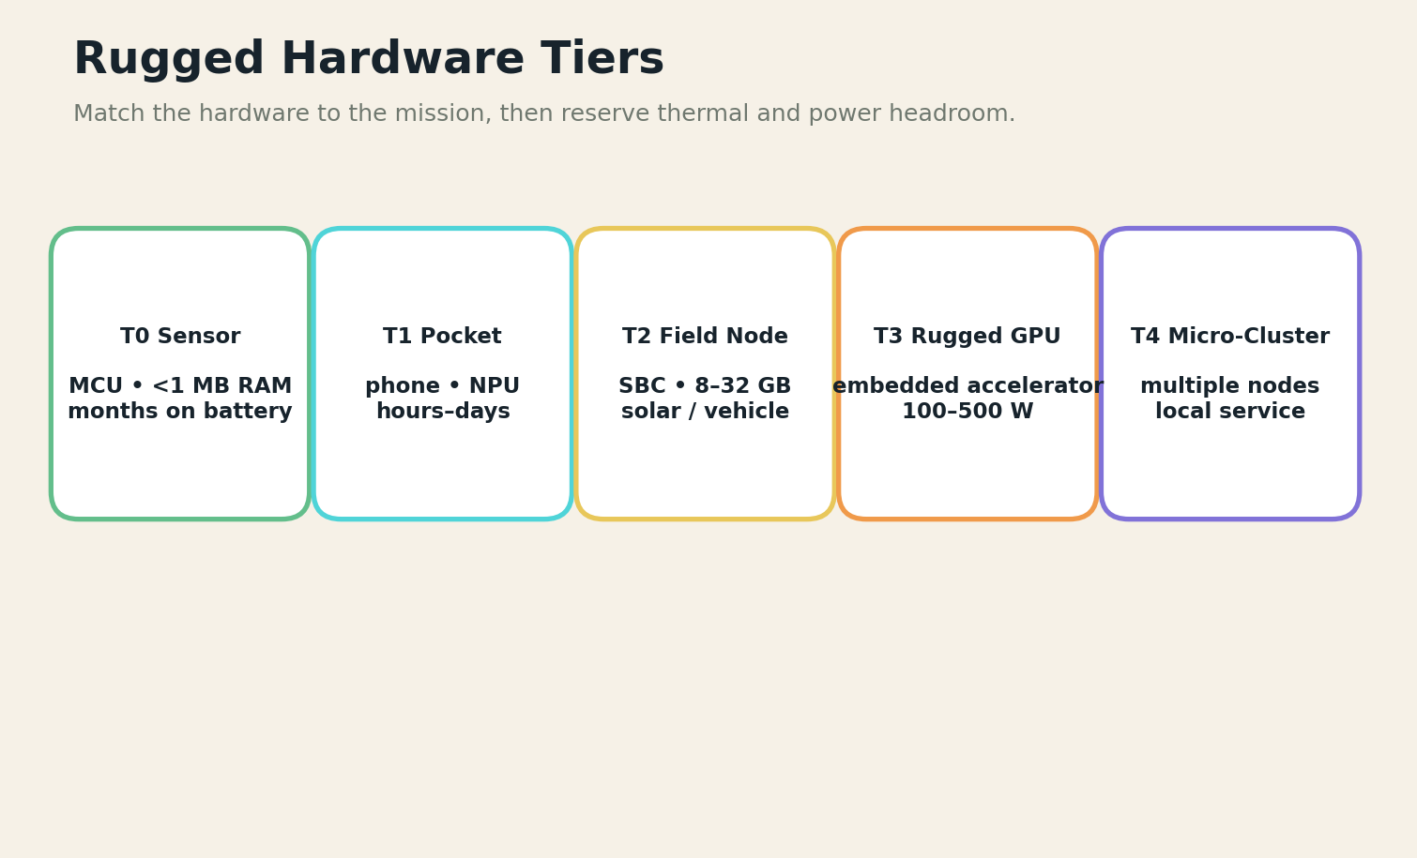
FIELD PLATE 23 — Five hardware tiers span sensor intelligence through local micro-clusters.
Hardware selection begins with the mission deadline, evidence type, power source, ambient temperature, dust or salt exposure, repair skills, and replacement supply. A benchmark score without enclosure, storage, radio, display, and idle-power measurements is not a deployable specification.
Tier 0 sensors perform thresholding, anomaly detection, and wake-up functions with tiny energy budgets. Tier 1 pocket devices support speech, image capture, forms, and compact models. Tier 2 field nodes provide local knowledge, databases, and multi-user service. Tier 3 rugged accelerators run multimodal models or dense perception. Tier 4 micro-clusters serve clinics, ships, bases, cooperatives, and communities.
TIER | PLATFORM | MEMORY | POWER | BEST USE
Tier 0 | MCU / sensor | <1 MB RAM | µW–mW | Wake words, anomaly, threshold
Tier 1 | Phone / tablet | 4–16 GB | 2–15 W | Speech, forms, compact vision
Tier 2 | SBC / mini PC | 8–64 GB | 10–80 W | Local RAG, records, multi-user
Tier 3 | Rugged GPU / NPU | 16–128 GB | 50–500 W | VLM, mapping, perception
Tier 4 | Micro-cluster | 100+ GB | 0.5–5 kW | Community or ship service

ANNEX B
MODEL OPTIMIZATION AND COMPILATION

FIELD PLATE 24 — A model cascade avoids spending large-model energy on every event.

1. Start with task boundaries
Specify input sensors, output schema, deadline, false-positive cost, false-negative cost, operating domain, and refusal behavior before selecting a model.

2. Compress with evidence
Quantization, pruning, distillation, low-rank adaptation, smaller input resolution, and early-exit networks can reduce cost. Every optimization must be reevaluated on field distributions, calibration, and rare cases.

3. Compile for the real target
Use the actual runtime, operators, memory limits, and thermal envelope. Measure cold start, steady-state latency, idle power, radio cost, and recovery after interruption.

4. Separate interpretation from control
Generative or multimodal models may explain and contextualize. Deterministic validators enforce schemas, limits, and safety interlocks.

5. Preserve rollback
Ship signed model bundles with compatibility metadata, known limitations, benchmark results, and a tested rollback path that does not require the failed network.

FIELD RELEASE CHECKLIST
□ Benchmark on the actual target at hot and cold operating temperatures.
□ Measure calibration and rare-case behavior after every compression step.
□ Sign model, tokenizer, policy, runtime, and compatibility metadata as one bundle.
□ Run a no-network install, rollback, and recovery exercise with field operators.
□ Record the authority envelope and refusal conditions beside the performance score.

ANNEX C
SYNCHRONIZATION AND UPDATE PROTOCOLS

FIELD PLATE 25 — The synchronization order protects urgent facts and auditability under brief connections.
Every node maintains an append-only local event log, a content-addressed object store, and a manifest of model, knowledge, policy, and data versions. Synchronization begins by exchanging manifests and clocks. Nodes then transfer safety alerts, revocations, identity corrections, and small knowledge deltas before bulk media.
Conflicts are typed. Routine cache conflicts can use automatic merge rules. Clinical facts, safety events, consent records, and governance decisions remain as parallel versions until an authorized resolver acts. The reconciliation result points to both inputs and the person or policy that selected the outcome.
Updates are staged: download, verify signature, check compatibility, run local self-tests, enter shadow mode, promote, and retain rollback. A node should never discover that an update requires more memory or changes an input schema after replacing the only working version.

ANNEX D
SAFETY-CASE AND FAILURE-DRILL TEMPLATES

FIELD PLATE 26 — A cross-theater matrix helps teams prioritize failure drills by consequence.
SAFETY-CASE FIELD | REQUIRED CONTENT
Mission claim | What capability is being claimed, for whom, in what operating domain?
Evidence | Which tests, field observations, standards, and expert reviews support the claim?
Hazards | What can fail physically, computationally, socially, or procedurally?
Controls | Which independent controls prevent, detect, limit, and recover from each hazard?
Authority | Who may approve, override, stop, and restart the system?
Residual risk | What remains uncertain, and who has accepted that uncertainty?
Monitoring | Which indicators reveal drift, misuse, inequity, or degraded hardware after deployment?

FAILURE-DRILL CYCLE
Inject: Remove or corrupt one dependency without warning the operator.
Observe: Capture system state, human interpretation, workarounds, and unequal service loss.
Recover: Restore service through the documented fallback, then preserve the evidence needed to redesign the system.
Reauthorize: Do not return automated authority until the changed control has been retested in shadow mode.

ANNEX E
A 90-DAY PILOT AND COST ARCHITECTURE
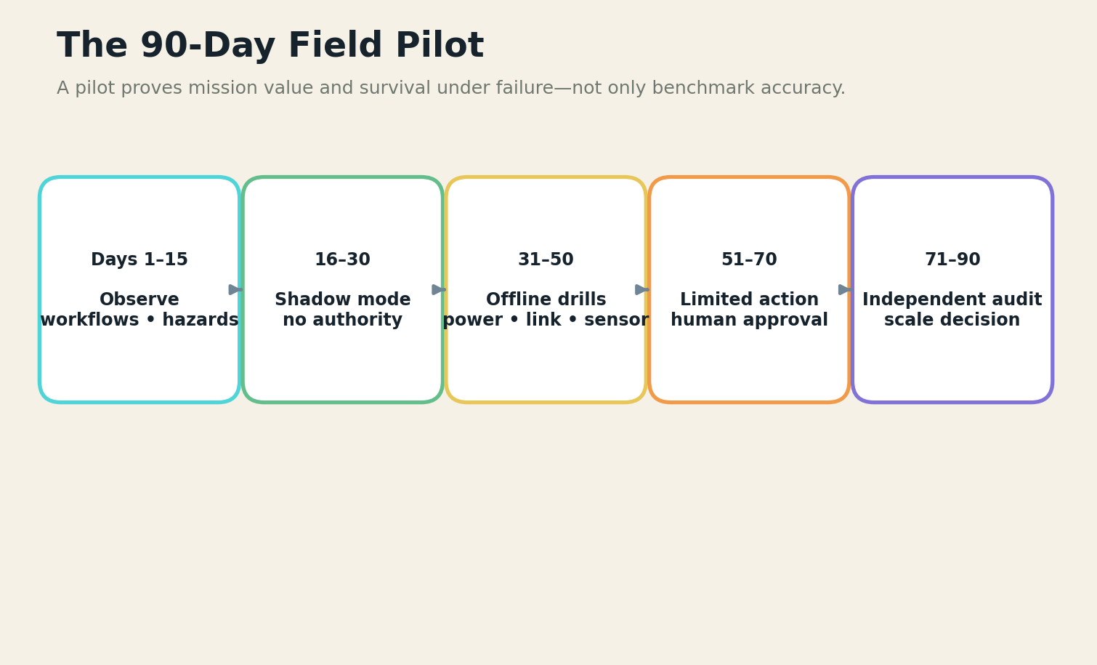
FIELD PLATE 27 — The pilot moves from observation to shadow mode, deliberate failure, limited authority, and independent audit.
A serious pilot budgets for workflow research, local data preparation, hardware spares, enclosure and power engineering, field training, security review, domain validation, travel, repair, and post-pilot maintenance. The model license or accelerator is often not the largest cost.
Days 1–15 document the current service and failure modes. Days 16–30 run the system in shadow mode. Days 31–50 perform power, link, sensor, and compromise drills. Days 51–70 permit narrowly bounded actions with human approval. Days 71–90 commission an independent audit and a community or operator review before deciding whether to scale.
Cost estimates should be expressed as ranges and lifecycle obligations. A pocket pilot may begin with several thousand dollars; a rugged multimodal deployment can require tens or hundreds of thousands once sensing, integration, validation, and support are counted. High-stakes systems should not use consumer prototype costs as deployment forecasts.

ANNEX F
THE EDGE INTELLIGENCE CONSTITUTION
I. Essential capability remains local
A loss of connectivity may reduce convenience and scale, but it must not erase the minimum mission service promised to the community or operator.

II. Authority is explicit
Every automated action belongs to a declared authority zone with a human owner, evidence requirement, and tested override.

III. Refusal is a capability
The system may state that evidence, power, sensor quality, knowledge freshness, or authority is insufficient. It may never hide the refusal behind fluent output.

IV. Data stays proportionate
Collect and retain only what the mission requires. Sensitive records remain local unless a lawful, consented, and technically protected transfer is necessary.

V. Communities are not test environments
Local people participate in requirements, language, evaluation, governance, benefit, and the decision to continue or remove the system.

VI. Repair is part of intelligence
A system that cannot be maintained with available skills, tools, energy, and supply chains is not a successful edge system.

VII. Updates preserve continuity
No update may silently remove offline capability, exceed hardware resources, change authority, or prevent rollback.

VIII. Every decision leaves evidence
High-consequence recommendations and actions retain model, data, sensor, policy, time, operator, and outcome provenance.

IX. Equity is measured under failure
The system is evaluated for who loses service first when bandwidth, power, staff, or hardware becomes scarce.

X. Exit is designed on day one
The operator or community can export data, preserve essential knowledge, replace components, and continue service when a vendor or project leaves.

CONSTITUTION ADOPTION TEST
CONSTITUTION ADOPTION TEST
Can a local operator explain every article, demonstrate the fallback it protects, and preserve essential service after the project team leaves?

GLOSSARY
Air-gapped mode. Operation with no network path to outside systems; updates and exports require controlled physical transfer.
Authority envelope. The explicit boundary between actions that may be automated, recommended, escalated, or prohibited.
Delay-tolerant synchronization. Synchronization designed for long outages, short contacts, reordering, and conflict preservation.
Edge node. A computing system located near users, sensors, or actuators that can complete useful local work.
Graceful degradation. Planned reduction of optional capability while preserving essential service and visible system state.
Knowledge bundle. A signed, versioned package of rules, documents, models, indexes, policies, and limitations for local use.
Local-first. A design in which the local copy and workflow remain primary while remote services synchronize or augment them.
Operational design domain. The environmental, sensor, traffic, population, or workflow conditions in which a capability is validated.
Shadow mode. A deployment stage in which the AI produces outputs for evaluation but does not influence operations.
Store-carry-forward. A networking method in which devices retain bundles and physically or wirelessly relay them when paths appear.
TinyML. Machine learning on highly constrained microcontrollers or low-power devices, often near the sensor.
Zero-trust edge. A security posture that does not grant trust based on network location and continuously verifies identity, device, policy, and action.

RESEARCH NOTES AND SOURCES
The book combines official guidance and primary technical research with proposed architecture. Composite field scenes and equations are authorial design instruments, not claims of specific deployed outcomes. Hardware, regulations, software, and standards change rapidly; implementation teams should consult current primary documentation and qualified domain professionals.
The source trail emphasizes software-neutral clinical logic, emergency telecommunications, disaster drones and mesh networking, smallholder digital services, autonomous-shipping safety, energy-aware TinyML benchmarking, federated learning, offline speech, vehicle hazard reasoning, and risk governance.
R1 World Health Organization. Artificial Intelligence for Health (2024). Source
R2 World Health Organization. Digital adaptation kit for child health in humanitarian emergencies (2024). Source
R3 World Health Organization. Digital adaptation kit for immunizations (2025). Source
R4 World Health Organization. Digital transformation handbook for primary health care (2024). Source
R5 World Health Organization. Recommendations on digital interventions for health system strengthening. Source
R6 UNICEF. HealthConnekt: connected health workers and service-delivery points (2024). Source
R7 International Telecommunication Union. When Digital Systems Fail: The Hidden Risks of Our Digital World (2026). Source
R8 International Telecommunication Union. The use of telecommunications/ICTs for disaster risk reduction and management (2025). Source
R9 International Telecommunication Union. Leveraging AI to Enhance Multi-Hazard Early Warning Systems (2026). Source
R10 World Food Programme. WFP Drones: mapping, response, and emergency connectivity. Source
R11 International Maritime Organization. International Code of Safety for Maritime Autonomous Surface Ships adopted in 2026. Source
R12 International Maritime Organization. Autonomous shipping FAQ and MASS operating principles (2026). Source
R13 Food and Agriculture Organization. Digital Services Portfolio and DSP-in-a-Box for limited-connectivity agriculture. Source
R14 Food and Agriculture Organization. Digital Agriculture and AI Innovation Roadmap. Source
R15 FAO / UNDP. Precision Agriculture for Smallholder Farmers. Source
R16 Batistatos et al.. AGRARIAN: A Hybrid AI-Driven Architecture for Smart Agriculture (2025). Source
R17 Fabila et al.. Democratizing AI in Africa: Federated Learning for Low-Resource Edge Devices (2024). Source
R18 Aminifar et al.. Privacy-Preserving Edge Federated Learning for Intelligent Mobile-Health Systems (2024). Source
R19 Jankovic et al.. UAV-Assisted Real-Time Disaster Detection Using an Optimized Transformer Model (2025). Source
R20 Liu et al.. MapMesh: Scalable Routing in a City-Scale Wi-Fi Network for Disaster Recovery (2025). Source
R21 Papyan et al.. AI-Based Drone Assisted Human Rescue in Disaster Environments (2024). Source
R22 Koneru et al.. KIT Offline Speech Translation and Instruction Following, IWSLT 2025. Source
R23 Mbonimpa et al.. Edge-Based Speech Transcription and Synthesis for Kinyarwanda and Swahili (2025). Source
R24 MLCommons. MLPerf Tiny benchmark and energy-aware edge inference methodology. Source
R25 National Institute of Standards and Technology. AI Risk Management Framework and Generative AI Profile. Source
R26 National Institute of Standards and Technology. Implementing a Zero Trust Architecture. Source
R27 Yang et al.. REACT: Real-Time Edge-AI V2X Framework for Accident Avoidance (2025). Source
R28 Chen et al.. INSIGHT: Vision-Language Models for Context-Aware Hazard Detection (2025). Source
R29 Rahmati. Edge AI Decision-Making for Autonomous Vehicles in Adverse Weather (2025). Source
R30 UNESCO. AI and the Future of Education: Disruptions, Dilemmas and Directions (2025). Source

THE EDGE OF THE WORLD
IS NOT THE EDGE OF INTELLIGENCE.
GRAYLAN JANULIS

