

THE LAST PAGE
OF arXiv
A journey through papers whose deepest ideas remained dim beyond their specialist circles
GRAYLAN JANULIS

A NOTE ON “OBSCURITY”
This book does not claim that every featured paper is objectively unknown or poorly cited. Some became influential within specialist communities. The narrower claim is that their deepest reusable ideas are often less visible than their titles, benchmark results, or later descendants.
“The last page” is therefore both literal and metaphorical. It is the point where attention has decayed: limitations, strange implementation details, future-work sentences, negative results, and architectural implications that survive after the headline has moved on.
Each dossier separates the paper’s documented proposal from this book’s interpretation of why an idea dimmed and how it might be reconstructed now. arXiv hosts preprints; appearance there does not by itself establish peer review, correctness, or lasting importance.
The expedition is not a hall of forgotten geniuses.
It is a study of how attention fails to preserve possibility.

EXPEDITION MAP
DESCENT I · CREDIT ASSIGNMENT AFTER MIDNIGHT
arXiv:1411.6191 Kickback cuts Backprop's red-tape
arXiv:1506.06472 A Theory of Local Learning, the Learning Channel, and the Optimality of Backpropagation
arXiv:1602.05179 Equilibrium Propagation
arXiv:1608.05343 Decoupled Neural Interfaces using Synthetic Gradients
DESCENT II · MEMORY BETWEEN A THOUGHT AND A LIFETIME
arXiv:1603.08983 Adaptive Computation Time for Recurrent Neural Networks
arXiv:1609.09106 HyperNetworks
arXiv:1610.06258 Using Fast Weights to Attend to the Recent Past
arXiv:1511.08228 Neural GPUs Learn Algorithms
DESCENT III · AGENTS BEFORE THE AGENT BOOM
arXiv:1511.06279 Neural Programmer-Interpreters
arXiv:1707.01495 Hindsight Experience Replay
arXiv:1705.05363 Curiosity-driven Exploration by Self-supervised Prediction
arXiv:1802.07740 Machine Theory of Mind
arXiv:1701.08734 PathNet
DESCENT IV · WORLDS MADE OF MECHANISMS
arXiv:1909.10893 Recurrent Independent Mechanisms
arXiv:1605.08104 Deep Predictive Coding Networks
arXiv:1610.06918 Learning to Protect Communications with Adversarial Neural Cryptography
arXiv:1611.03824 Learning to Learn without Gradient Descent by Gradient Descent
Entrance Hall — Why Good Papers Become Invisible
Interlude — The Attention-Decay Curve
The Last-Page Engine — A system for discovering underexploited ideas
Appendix A — The Dossier Schema
Appendix B — Reconstruction Scorecard
Appendix C — A 30-Day Paper Expedition
Glossary
Source Ledger

ENTRANCE HALL — THE PAPER OCEAN
arXiv solved a historic problem: it made research available before the slow machinery of conventional publication had finished moving. Availability, however, is not the same as arrival. As the archive expanded, attention became the scarce infrastructure. A paper could be public, indexed, and technically retrievable while remaining functionally absent from the minds that might use it.
Research attention is path-dependent. Early downloads, social mentions, famous affiliations, benchmark timing, category placement, and language all influence which works are opened and cited. Research on newly submitted preprints found that social mentions, downloads, and early citations are correlated, while recommendation theory has shown more generally how “hidden gems” can remain invisible when platforms learn from choices inside small recommendation sets.
The book therefore uses a visibility funnel rather than a binary known/unknown label. A paper can be visible by title but invisible by mechanism. It can be heavily cited for one result while its strangest idea remains dormant. It can be famous in machine learning and unknown in robotics, neuroscience, systems engineering, or philosophy. Cross-field obscurity is one of the largest archives still waiting to be opened.
The expedition method asks five questions. What did the paper actually build? Which sentence changes the conceptual frame? Why was that frame hard to absorb at the time? Which modern systems have unknowingly approached it again? What small experiment could test the idea today without reenacting the entire original project?
This is not archaeology for nostalgia. It is a way to prevent research from repeatedly paying to rediscover ideas whose first versions were imperfect, strangely named, insufficiently scaled, or simply located beyond the point where most readers stopped.
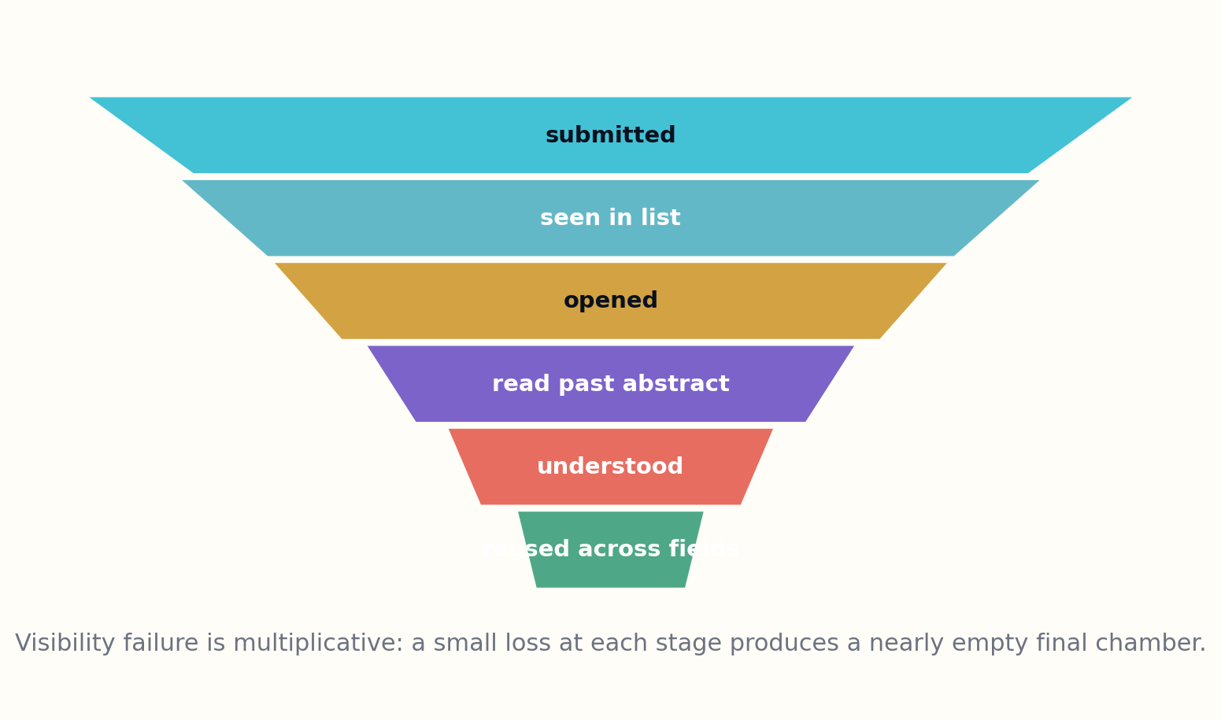

INTERLUDE — THE ATTENTION-DECAY CURVE
A paper begins with maximum potential attention and loses readers at every boundary. The title filters for vocabulary. The abstract filters for immediate relevance. Figures reward fast interpretation. Methods require patience. Limitations require intellectual honesty. Appendices demand a reader who is still present after the result has already been announced.
This decay is not a moral failure. No researcher can read everything. The failure emerges when the community’s filtering mechanisms become too correlated: everyone sees what everyone else already saw, and the final chamber is populated mostly by specialists with the same assumptions.
The practical response is not universal full reading. It is better routing. Machines can scan widely, but they should not declare importance alone. They can extract claims, identify unusual mechanisms, compare vocabulary across fields, and locate sentences whose implications exceed the paper’s headline. Human readers then decide what deserves reconstruction.
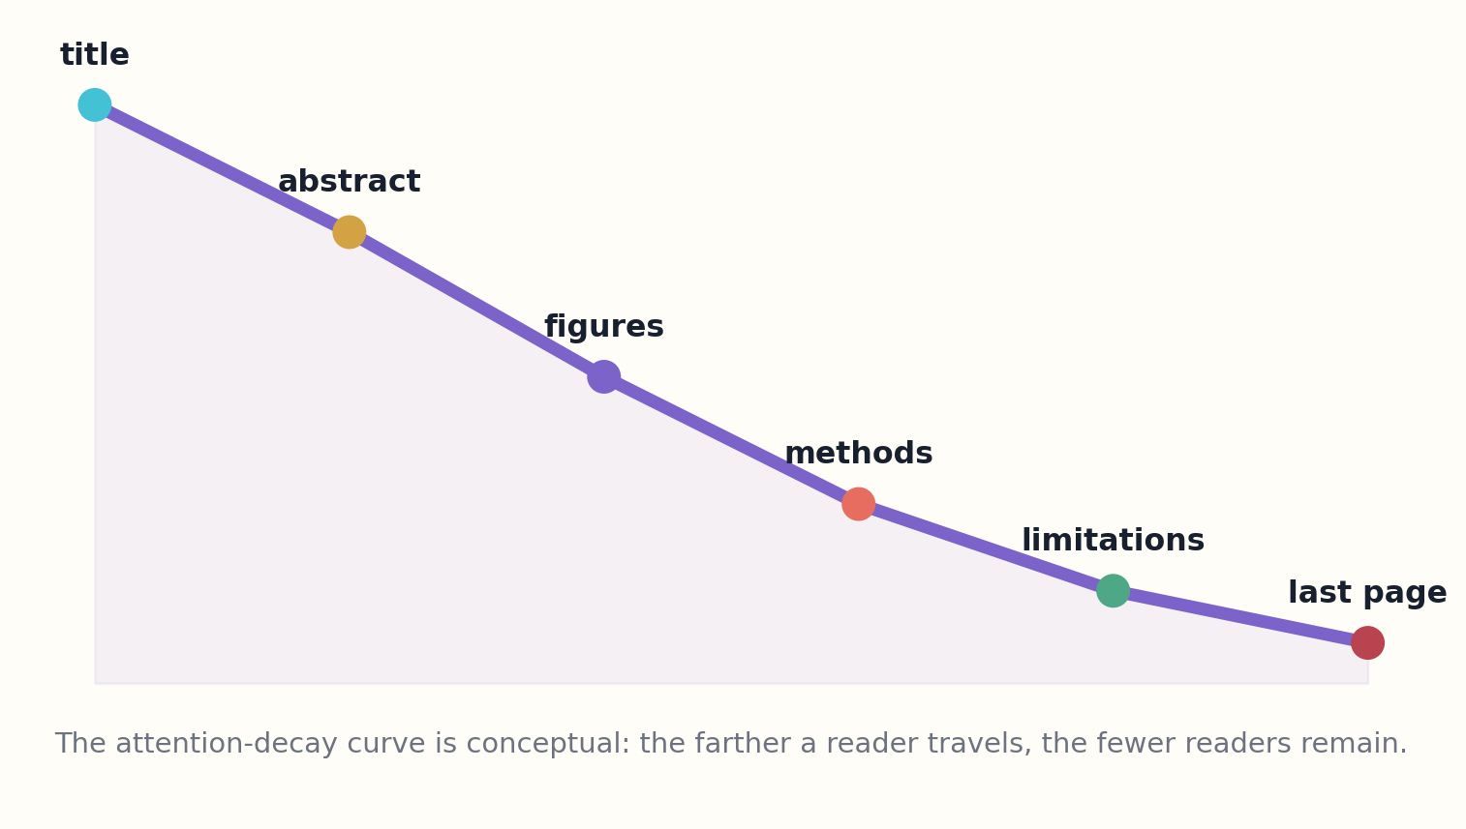

DESCENT I
CREDIT ASSIGNMENT AFTER MIDNIGHT
Four papers asking what must travel backward when global backpropagation is too expensive, biologically implausible, or operationally locked.

PAPER DOSSIER I.1
Kickback cuts Backprop's red-tape
David Balduzzi, Hastagiri Vanchinathan, Joachim Buhmann
ARXIV | YEAR | FIELD
1411.6191 | 2014 | Local credit assignment

THE PAPER’S ACTUAL MOVE
A network can decompose global backpropagation into interacting local learning processes and, under conditions, follow useful error directions with a much simpler signal.
Δw_ij ∝ local activity × truncated global influence
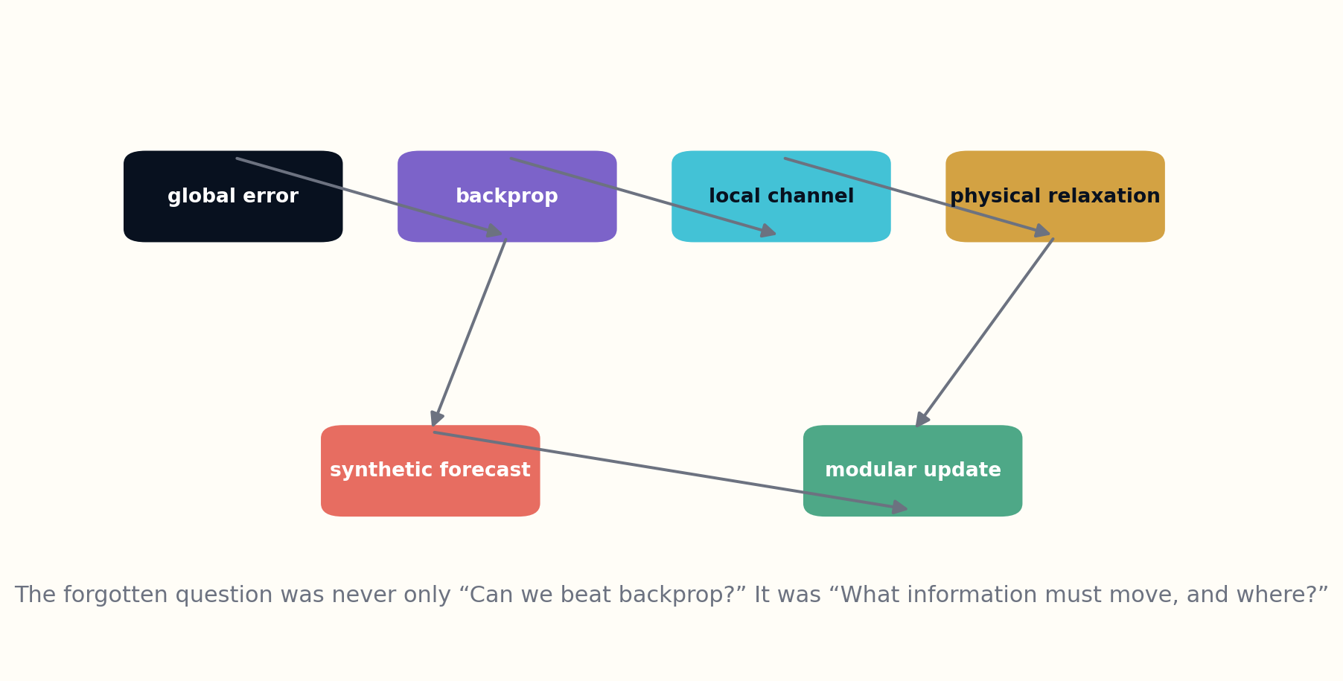
Figure 3. Alternative views of the credit-assignment channel.

THE MECHANISM BENEATH THE RESULT
Kickback can be read as a communication-design paper disguised as a learning-rule paper. A downstream unit does not need the complete global gradient if a compact scalar channel preserves enough directional information to make a useful local change. That reframes credit assignment as bandwidth allocation: what is the smallest message that still lets a component improve without seeing the whole machine?

AFTERLIFE FILE I.1
Kickback cuts Backprop's red-tape

WHY THE IDEA WENT DIM
Its name sounded playful, its experiments were small, and the field was rapidly standardizing around highly optimized backpropagation. The deeper object—the information structure of credit—was easier to overlook than the algorithmic comparison.

WHAT IT LOOKS LIKE FROM 2026
For distributed agents, neuromorphic hardware, asynchronous pipelines, and privacy-preserving learning, the question is again how to transmit only the minimum corrective signal. Kickback can be reread as a systems paper about constrained feedback channels.

A BETTER WAY TO READ IT NOW
The most productive modern reading is not “replace backpropagation everywhere.” It is “design explicit correction channels between bounded components.” A local agent might receive a signed critique, a constraint violation, or a delayed success estimate rather than a full differentiable trace. The paper therefore belongs in the lineage of modular systems whose interfaces carry learning signals as carefully as they carry data.

THE CAUTION LABEL
The sufficient conditions are restrictive, and matching a benchmark is not evidence that the method scales to contemporary architectures. The reusable contribution is the decomposition and the question it formalizes.

WHAT WOULD FALSIFY THE REVIVAL?
A revival would fail if the compressed signal only works because the tested networks are shallow, the activations satisfy restrictive assumptions, or the local updates quietly depend on global synchronization. The decisive experiment is not another benchmark win. It is a stress test in which modules are asynchronous, partially observed, and individually replaceable, followed by measurement of whether useful learning survives.
RECONSTRUCTION EXPERIMENT
Build a three-module network in which the middle module receives only a scalar or low-rank corrective signal. Compare training stability, communication cost, and task accuracy with end-to-end backpropagation.
Primary paper: arXiv:1411.6191

PAPER DOSSIER I.2
A Theory of Local Learning, the Learning Channel, and the Optimality of Backpropagation
Pierre Baldi, Peter Sadowski
ARXIV | YEAR | FIELD
1506.06472 | 2015 | Information theory of learning rules

THE PAPER’S ACTUAL MOVE
Learning rules can be classified by what local variables they access and by the capacity of the backward learning channel that communicates target information.
Learning capacity ≈ information rate of the target channel / computational cost

THE MECHANISM BENEATH THE RESULT
The theory asks which variables a learning unit can access and how much information can pass through the learning channel. That vocabulary is powerful because it separates architecture from training mythology. Two systems with identical forward graphs may have radically different learning capacity if their backward channels expose different variables, precision, timing, or shared state.

AFTERLIFE FILE I.2
A Theory of Local Learning, the Learning Channel, and the Optimality of Backpropagation

WHY THE IDEA WENT DIM
The paper did not offer a fashionable architecture. It offered a taxonomy and a negative result: local rules without a sufficiently informative backward channel cannot learn arbitrary complex mappings. Taxonomies are often cited less vividly than new models, even when they define the search space.

WHAT IT LOOKS LIKE FROM 2026
Agent orchestration, federated learning, edge devices, and model partitioning all face learning-channel constraints. The paper provides language for asking what must cross a boundary before asking how large the model should be.

A BETTER WAY TO READ IT NOW
Read today, the paper suggests a design checklist for federated learners, neuromorphic devices, privacy-preserving modules, and multi-agent systems. Before arguing about an optimizer, first enumerate what each learner is permitted to know. The resulting channel description can reveal impossible objectives, hidden centralization, and accidental leakage before a line of training code is written.

THE CAUTION LABEL
Its optimality statements depend on the formal framework and cost assumptions. They do not end the search for biologically plausible or hardware-native learning; they clarify what alternatives must overcome.

WHAT WOULD FALSIFY THE REVIVAL?
The framework loses value if its information measures do not predict practical trainability or if realistic learners exploit structure the formal channel model omits. A strong reconstruction would hold the forward architecture fixed, systematically alter the learning channel, and test whether the predicted ordering of learning capacity matches actual optimization across several tasks.
RECONSTRUCTION EXPERIMENT
Describe a modern multi-agent training system as a learning channel. Measure bits transmitted, synchronization barriers, and the class of errors each message can correct.
Primary paper: arXiv:1506.06472

PAPER DOSSIER I.3
Equilibrium Propagation
Benjamin Scellier, Yoshua Bengio
ARXIV | YEAR | FIELD
1602.05179 | 2016 | Energy-based learning

THE PAPER’S ACTUAL MOVE
A system can perform inference and gradient-like learning through two nearby physical equilibria, nudging outputs and observing local changes rather than running a distinct digital backward pass.
∂J/∂θ ≈ [∂F/∂θ|nudged − ∂F/∂θ|free] / β

THE MECHANISM BENEATH THE RESULT
Equilibrium Propagation turns a temporal relaxation process into a source of gradient information. The free phase settles under the model’s own energy; the nudged phase perturbs the output toward a target; the difference between equilibria supplies a local update. The deep move is to use a physical or dynamical contrast as the carrier of credit.

AFTERLIFE FILE I.3
Equilibrium Propagation

WHY THE IDEA WENT DIM
The method asked readers to think in terms of relaxation dynamics while the dominant ecosystem was becoming more discrete, feed-forward, accelerator-optimized, and software-defined. Its most radical implication concerned hardware and physics more than immediate benchmark leadership.

WHAT IT LOOKS LIKE FROM 2026
Analog compute, energy-based models, spiking systems, and self-organizing materials renew the relevance of learning through local physical response. The paper is a bridge between optimization and embodiment.

A BETTER WAY TO READ IT NOW
Its contemporary significance lies at the boundary between algorithms and matter. In analog circuits, recurrent substrates, and self-organizing materials, one may not have a clean tape of intermediate activations for reverse-mode differentiation. A system that learns from nearby physical equilibria offers a route in which the substrate participates in both inference and adaptation.

THE CAUTION LABEL
Equilibrium settling can be slow, sensitive, and difficult to scale. Biological plausibility is not established by mathematical resemblance alone.

WHAT WOULD FALSIFY THE REVIVAL?
The approach would be weakened if settling time, noise sensitivity, phase mismatch, or hardware nonidealities erase its theoretical locality advantage. A fair experiment should measure wall-clock energy, convergence stability, and update fidelity on the actual substrate—not only compare abstract gradient estimates in software.
RECONSTRUCTION EXPERIMENT
Simulate a small continuous network with free and nudged phases. Compare estimated gradients with backpropagation while tracking settling time and energy cost.
Primary paper: arXiv:1602.05179

PAPER DOSSIER I.4
Decoupled Neural Interfaces using Synthetic Gradients
Max Jaderberg et al.
ARXIV | YEAR | FIELD
1608.05343 | 2016 | Asynchronous modular learning

THE PAPER’S ACTUAL MOVE
A module can predict the gradient it will eventually receive, update immediately, and loosen the forward/backward locking that makes end-to-end networks wait.
ĝ_h = G(h, context) ≈ ∂L/∂h

THE MECHANISM BENEATH THE RESULT
Synthetic gradients replace a missing future derivative with a prediction. A module can update before the rest of the network finishes, using an auxiliary model that forecasts the gradient it will eventually receive. This converts optimization dependency into a learned contract between asynchronously operating components.

AFTERLIFE FILE I.4
Decoupled Neural Interfaces using Synthetic Gradients

WHY THE IDEA WENT DIM
The paper is usually remembered as an optimization trick. Its final abstraction is more ambitious: independent networks can co-learn and compose into a functioning corporation, including prediction of both gradients and inputs.

WHAT IT LOOKS LIKE FROM 2026
This anticipates bounded agents, speculative execution, pipeline parallelism, learned critics, and local model swarms. A synthetic gradient is a forecast of future accountability.

A BETTER WAY TO READ IT NOW
The idea now maps naturally onto pipeline-parallel training, distributed agents, cached tool calls, and systems in which a component must act before final evaluation arrives. A learned critic can provide provisional credit, while later ground truth periodically recalibrates the predictor. The architecture is less about faster backpropagation than about making waiting optional.

THE CAUTION LABEL
Predicted gradients can be biased and unstable; decoupling can hide global incompatibilities. The mechanism needs periodic contact with ground truth.

WHAT WOULD FALSIFY THE REVIVAL?
The dangerous failure is self-confirming error: a poor gradient predictor changes the upstream representation, which then makes its own future training targets less informative. Reconstruction should therefore measure calibration drift, instability under distribution shift, and how often true delayed feedback must arrive to prevent local learners from diverging together.
RECONSTRUCTION EXPERIMENT
Create two modules that train at different rates. Let the first use predicted gradients and periodically reconcile against true gradients. Plot drift, recovery, and wall-clock utilization.
Primary paper: arXiv:1608.05343

DESCENT II
MEMORY BETWEEN A THOUGHT AND A LIFETIME
Adaptive time, generated parameters, fast-changing associations, and repeated local rules.

PAPER DOSSIER II.1
Adaptive Computation Time for Recurrent Neural Networks
Alex Graves
ARXIV | YEAR | FIELD
1603.08983 | 2016 | Variable-depth computation

THE PAPER’S ACTUAL MOVE
A recurrent network can learn how many internal steps to spend before emitting each output, paying a ponder cost for extra computation.
N(x) = min{n : Σ_{i≤n} p_i ≥ 1−ε}; L_total = L_task + τ·ponder
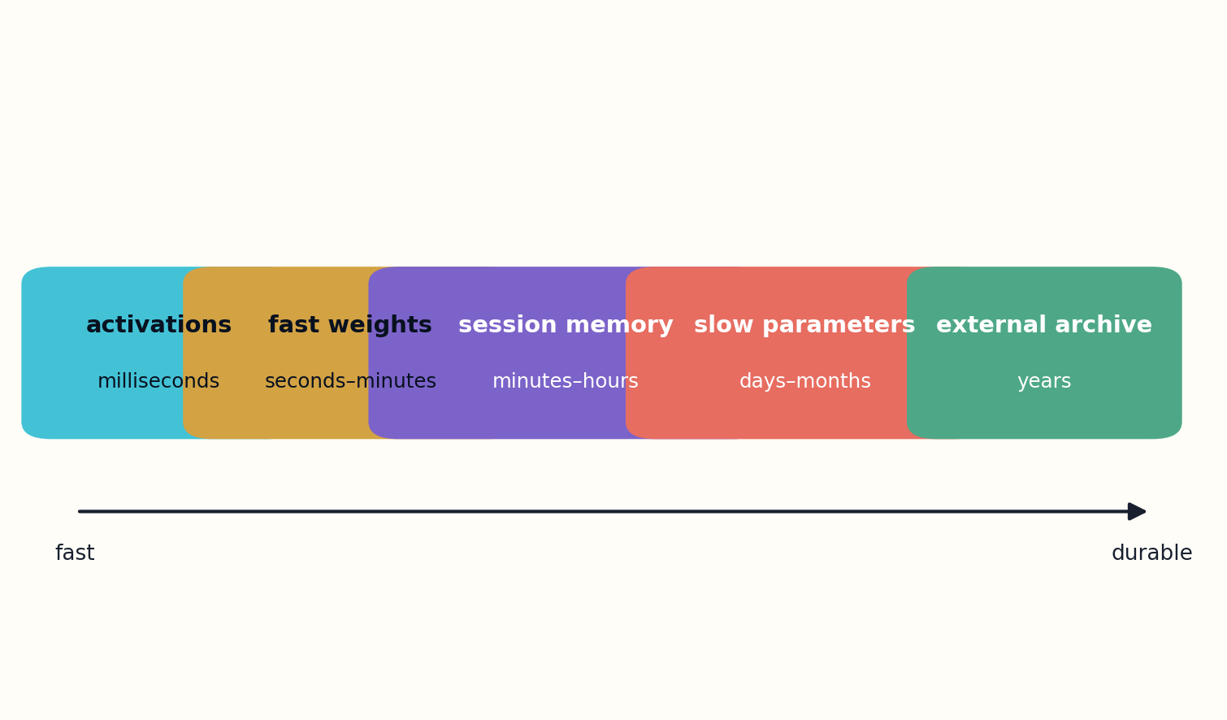
Figure 4. Memory becomes richer when a system supports multiple rates of change.

THE MECHANISM BENEATH THE RESULT
Adaptive Computation Time treats depth as a per-example decision rather than a fixed architectural constant. At each step, the recurrent network emits a halting probability; the weighted remainder determines when it has spent enough computation. The model therefore learns not only an answer but a budget-allocation policy.

AFTERLIFE FILE II.1
Adaptive Computation Time for Recurrent Neural Networks

WHY THE IDEA WENT DIM
The benchmark gains were mixed, so the paper could be reduced to a clever recurrent trick. The more lasting idea is that compute should be an input-dependent resource and that halting behavior itself reveals structure.

WHAT IT LOOKS LIKE FROM 2026
Reasoning budgets, early exit, adaptive depth, token routing, and latency-aware local models all replay ACT’s question: where is the next unit of computation actually worth spending?

A BETTER WAY TO READ IT NOW
The broader principle is conditional effort. Retrieval systems can inspect more evidence for ambiguous questions, agents can run extra verification after risky actions, and small local models can spend multiple cheap iterations on difficult inputs while returning immediately on routine ones. Variable computation is a way to turn limited hardware into selective intelligence.

THE CAUTION LABEL
Learned halting can be difficult to optimize and can exploit the objective in unintended ways. More computation is not necessarily better reasoning.

WHAT WOULD FALSIFY THE REVIVAL?
A halting policy is not useful if its confidence is miscalibrated, if latency variance harms the application, or if it learns superficial proxies for difficulty. A modern test should compare accuracy, tail latency, energy, and error severity under distribution shift, with explicit penalties for confident early stopping on dangerous cases.
RECONSTRUCTION EXPERIMENT
Add a halting head to a compact model solving mixed-difficulty puzzles. Penalize steps and inspect whether compute allocation tracks independently measured difficulty.
Primary paper: arXiv:1603.08983

PAPER DOSSIER II.2
HyperNetworks
David Ha, Andrew Dai, Quoc V. Le
ARXIV | YEAR | FIELD
1609.09106 | 2016 | Networks that generate networks

THE PAPER’S ACTUAL MOVE
One network can generate the weights of another, turning parameters from fixed assets into context-dependent outputs.
θ_target = H(z; φ)

THE MECHANISM BENEATH THE RESULT
A HyperNetwork makes parameters conditional outputs rather than permanent possessions. One network generates some or all of another network’s weights from task, layer, state, or context information. This separates the capacity to manufacture a specialized model from the capacity used by that model while it performs the task.

AFTERLIFE FILE II.2
HyperNetworks

WHY THE IDEA WENT DIM
The result was framed around weight sharing in LSTMs and convolutional models, while the deeper shift—parameters as a generated medium—was not yet connected to adapters, personalization, task-conditioned experts, or deployment-time specialization.

WHAT IT LOOKS LIKE FROM 2026
Hypernetworks provide a language for producing adapters, policies, filters, and specialist models on demand without storing every variant. They are a natural partner for compact local-model systems.

A BETTER WAY TO READ IT NOW
The concept is a natural ancestor of adapters, conditional experts, per-user local models, and systems that synthesize narrow policies on demand. Instead of carrying a giant universal network into every context, a compact generator can produce a temporary specialist whose parameters encode the current environment, device, or task.

THE CAUTION LABEL
Generated weights may be hard to constrain, inspect, or stabilize. Parameter efficiency does not guarantee runtime efficiency.

WHAT WOULD FALSIFY THE REVIVAL?
Generated weights may be brittle, difficult to inspect, or more expensive than retrieving a stable adapter. A reconstruction should compare weight generation with low-rank adaptation, expert routing, and ordinary fine-tuning under equal memory and latency budgets, then test whether generated specialists remain stable under small context perturbations.
RECONSTRUCTION EXPERIMENT
Train a small hypernetwork to generate low-rank adapters for several tightly defined tasks. Compare storage, adaptation speed, and interference with separately trained adapters.
Primary paper: arXiv:1609.09106

PAPER DOSSIER II.3
Using Fast Weights to Attend to the Recent Past
Jimmy Ba, Geoffrey Hinton, Volodymyr Mnih, Joel Leibo, Catalin Ionescu
ARXIV | YEAR | FIELD
1610.06258 | 2016 | Intermediate-timescale memory

THE PAPER’S ACTUAL MOVE
Useful memory can live in variables that change faster than learned parameters but slower than activations, storing recent associations without copying every past state.
A_t = λA_{t−1} + η h_t h_tᵀ

THE MECHANISM BENEATH THE RESULT
Fast weights create an intermediate memory substrate. They change more quickly than ordinary learned parameters but persist longer than transient activations, allowing recent associations to influence the next computation without permanently rewriting the model. The architecture therefore recognizes that cognition needs more than one rate of change.

AFTERLIFE FILE II.3
Using Fast Weights to Attend to the Recent Past

WHY THE IDEA WENT DIM
Attention soon became identified with explicit key-value caches and transformer mechanisms. The timescale argument—intelligence needs more than activities and permanent weights—was broader than the implementation most readers remembered.

WHAT IT LOOKS LIKE FROM 2026
Test-time learning, recurrent memory, cache compression, personalization, and local agents all need intermediate state that is neither prompt text nor permanent fine-tuning.

A BETTER WAY TO READ IT NOW
This lens clarifies modern agent memory. A conversation history is not a single undifferentiated context window: some facts should vanish after a turn, some should shape a session, some should become verified long-term memory, and some should never enter persistent state. Fast weights suggest a learned associative layer between prompt tokens and durable databases.

THE CAUTION LABEL
Associative fast weights can saturate, interfere, and grow expensive. Their value depends on controlled forgetting and retrieval geometry.

WHAT WOULD FALSIFY THE REVIVAL?
The revival fails if fast memory merely duplicates attention at higher cost, accumulates interference, or cannot be safely reset. Experiments should measure retention, overwrite behavior, contamination across tasks, and whether explicit external memory provides the same benefit with greater inspectability.
RECONSTRUCTION EXPERIMENT
Give a local agent a fast-weight associative layer for recent tool outcomes. Measure whether it recalls transient bindings better than a plain rolling transcript at equal memory cost.
Primary paper: arXiv:1610.06258

PAPER DOSSIER II.4
Neural GPUs Learn Algorithms
Łukasz Kaiser, Ilya Sutskever
ARXIV | YEAR | FIELD
1511.08228 | 2015 | Parallel learned algorithms

THE PAPER’S ACTUAL MOVE
A convolutional recurrent architecture can learn algorithmic transformations and extrapolate from short training instances to much longer inputs, helped by relaxed parameter sharing.
S_{t+1} = GRU_conv(S_t); shared rule repeated across depth/time

THE MECHANISM BENEATH THE RESULT
The Neural GPU applies a small convolutional recurrent rule repeatedly across a spatial state. Algorithmic behavior emerges from weight sharing through depth and time rather than from a large collection of step-specific parameters. The paper is therefore a study in how a compact local transition rule can implement long computation.

AFTERLIFE FILE II.4
Neural GPUs Learn Algorithms

WHY THE IDEA WENT DIM
The architecture did not become the default differentiable computer, but its concern—how to preserve algorithmic generalization while using parallel local updates—remains unresolved in many sequence models.

WHAT IT LOOKS LIKE FROM 2026
Cellular, recurrent, and state-space systems continue to revisit repeated local rules as an alternative to storing every computation in attention.

A BETTER WAY TO READ IT NOW
Its enduring idea is architectural recurrence as software compression. Cellular models, iterative refinement systems, and small local planners can reuse one carefully learned operation many times. This creates a different scaling axis: not more parameters, but more applications of a stable rule over a structured workspace.

THE CAUTION LABEL
Algorithmic tasks are narrow and extrapolation can be brittle. “No errors” on selected tests does not imply general program induction.

WHAT WOULD FALSIFY THE REVIVAL?
The critical weakness is extrapolation. A rule that succeeds only near the training lengths has learned a benchmark surface rather than an algorithm. A reconstruction must train on short instances, test far beyond them, inspect invariants after each step, and compare against explicit symbolic baselines.
RECONSTRUCTION EXPERIMENT
Train a repeated local-update model on short arithmetic strings, then stress it with length, noise, and operation changes. Separate interpolation from genuine algorithmic invariance.
Primary paper: arXiv:1511.08228

DESCENT III
AGENTS BEFORE THE AGENT BOOM
Programs, failure, curiosity, social inference, and reusable pathways before today’s language-agent vocabulary.

PAPER DOSSIER III.1
Neural Programmer-Interpreters
Scott Reed, Nando de Freitas
ARXIV | YEAR | FIELD
1511.06279 | 2015 | Composable learned programs

THE PAPER’S ACTUAL MOVE
A shared recurrent core can call reusable subprograms stored in persistent memory and use external scratch space, learning from rich execution traces instead of only weak end labels.
(program, state) → next subprogram, arguments, return probability
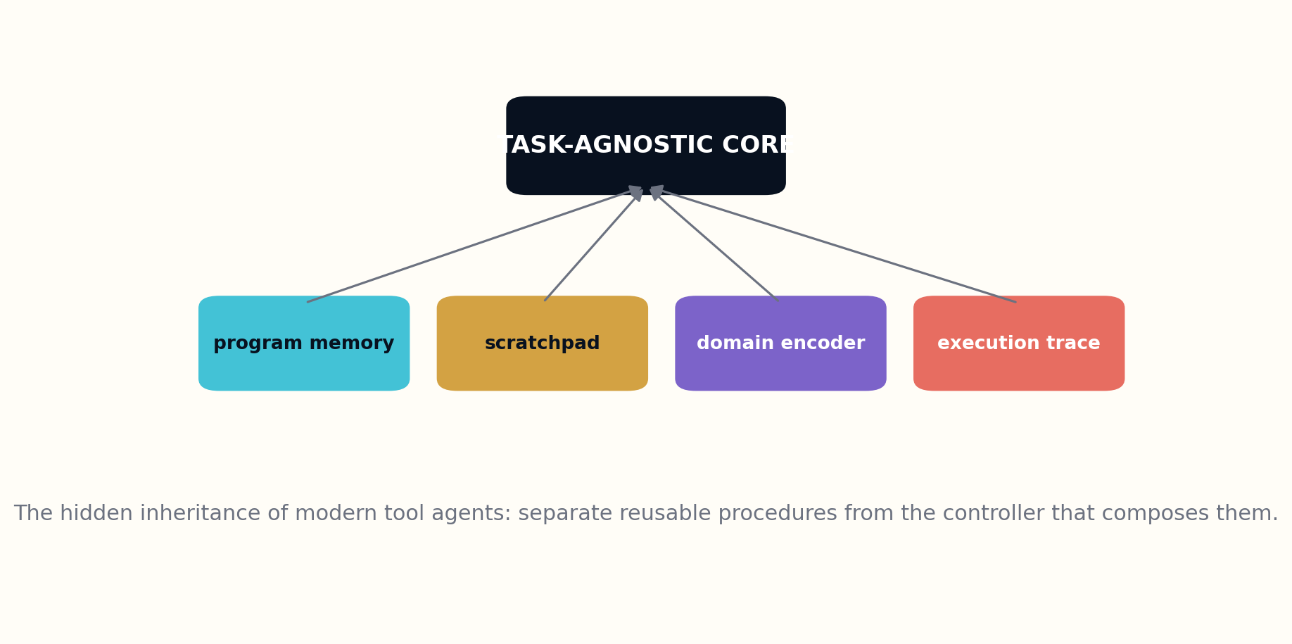
Figure 5. The controller, program library, environment adapters, and trace form separate architectural objects.

THE MECHANISM BENEATH THE RESULT
Neural Programmer-Interpreters split behavior into reusable programs, arguments, a controller, and an execution trace. Instead of learning one opaque input-output mapping, the model chooses a subprogram and predicts when it should return. The trace makes composition and procedure reuse architectural rather than accidental.

AFTERLIFE FILE III.1
Neural Programmer-Interpreters

WHY THE IDEA WENT DIM
The model required supervised traces and arrived before tool-using language agents made explicit program memory fashionable. Readers often focused on arithmetic demonstrations rather than the architecture of reusable procedural knowledge.

WHAT IT LOOKS LIKE FROM 2026
Modern agents need the same separation: a controller, a library of tools or procedures, environment-specific adapters, and visible traces. NPI is a prehistory of structured agent runtimes.

A BETTER WAY TO READ IT NOW
This is strikingly close to a modern tool-using agent, but with a stronger insistence on explicit procedures and supervised execution structure. A contemporary descendant would store validated subroutines outside the controller, use typed arguments, and record every call so that planning failure can be separated from tool failure.

THE CAUTION LABEL
Trace supervision is expensive and brittle; learned execution can fail outside demonstrated decompositions. Deterministic verification remains necessary.

WHAT WOULD FALSIFY THE REVIVAL?
The approach is weakened if trace supervision is too costly, if decomposition does not transfer, or if slight environmental change breaks the learned controller. A modern experiment should compare trace-supervised reusable programs with unconstrained language-agent plans on held-out task compositions and altered tool interfaces.
RECONSTRUCTION EXPERIMENT
Represent a small file-edit workflow as callable subprograms with traces. Compare a flat policy against a controller that composes reusable procedures.
Primary paper: arXiv:1511.06279

PAPER DOSSIER III.2
Hindsight Experience Replay
Marcin Andrychowicz et al.
ARXIV | YEAR | FIELD
1707.01495 | 2017 | Learning from failed goals

THE PAPER’S ACTUAL MOVE
A failed trajectory can be relabeled with the goal it actually achieved, converting sparse failure into informative success for another objective.
g′ ← achieved_goal(s_T); replay (s,a,r(g′),s′,g′)
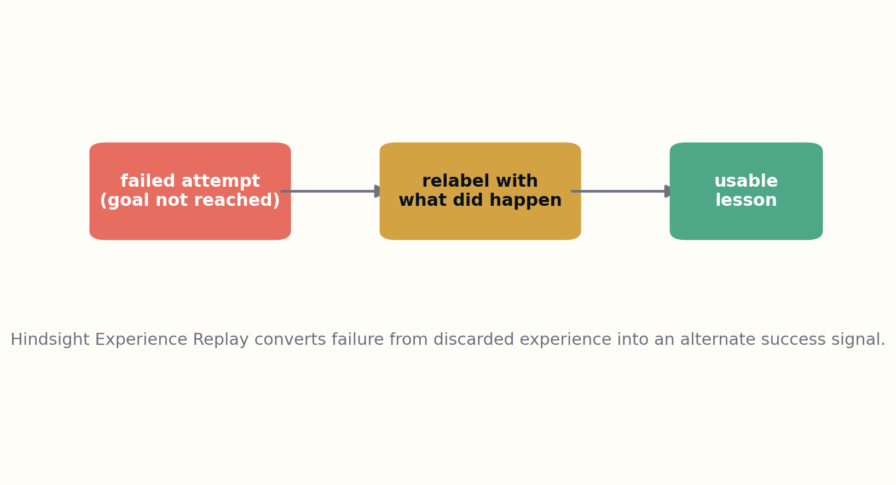
Figure 6. Hindsight relabeling preserves the event while changing the training question.

THE MECHANISM BENEATH THE RESULT
Hindsight Experience Replay preserves a failed trajectory but changes the question asked of it. By relabeling the achieved outcome as the goal, sparse failure becomes a successful demonstration for another objective. The key move is epistemic reuse: the event stays fixed while its training interpretation changes.

AFTERLIFE FILE III.2
Hindsight Experience Replay

WHY THE IDEA WENT DIM
HER became known inside reinforcement learning, but its epistemic move is larger: outcomes can teach by changing the question without falsifying the event.

WHAT IT LOOKS LIKE FROM 2026
Agent memory, debugging, code repair, and scientific search can preserve failed attempts as successful demonstrations of boundary conditions, intermediate goals, or anti-patterns.

A BETTER WAY TO READ IT NOW
That principle extends beyond robotics. Debugging traces, unsuccessful searches, abandoned proofs, and agent runs can become useful when indexed by the states they actually reached. A memory system should therefore record achieved outcomes and constraints, not only whether the original request succeeded.

THE CAUTION LABEL
Relabeling must remain honest about the original objective. In safety-critical systems, accidental success under an easier goal cannot excuse failure under the requested goal.

WHAT WOULD FALSIFY THE REVIVAL?
Relabeling becomes misleading when the substituted goal changes the causal meaning of the action or when accidental outcomes dominate useful behavior. The decisive test is whether hindsight improves performance on genuinely intended future goals without teaching policies to exploit the relabeling scheme.
RECONSTRUCTION EXPERIMENT
Log unsuccessful coding-agent runs. Relabel each with the partial state achieved and train a retriever to surface those traces when a matching subgoal recurs.
Primary paper: arXiv:1707.01495

PAPER DOSSIER III.3
Curiosity-driven Exploration by Self-supervised Prediction
Deepak Pathak, Pulkit Agrawal, Alexei Efros, Trevor Darrell
ARXIV | YEAR | FIELD
1705.05363 | 2017 | Intrinsic motivation

THE PAPER’S ACTUAL MOVE
Prediction error in a controllable feature space can act as an internal reward, encouraging exploration while ignoring changes the agent cannot influence.
rᵢ_t = η ||φ(s_{t+1}) − f(φ(s_t),a_t)||²

THE MECHANISM BENEATH THE RESULT
Curiosity-driven exploration predicts features of a future state from the current state and action, then uses prediction error as intrinsic reward. The agent is paid for encountering transitions its internal dynamics model cannot yet explain. Exploration becomes an information-acquisition process rather than random motion.

AFTERLIFE FILE III.3
Curiosity-driven Exploration by Self-supervised Prediction

WHY THE IDEA WENT DIM
Curiosity is easy to remember as “reward surprise.” The paper’s subtler design choice is to learn a feature space through inverse dynamics so uncontrollable television noise does not dominate the reward.

WHAT IT LOOKS LIKE FROM 2026
Research agents and autonomous software need novelty signals that reward discoverable causal structure rather than random change or clickbait.

A BETTER WAY TO READ IT NOW
The useful modern abstraction is novelty with a causal filter. Research agents, code explorers, and world models need signals that reward learnable uncertainty rather than merely surprising pixels or noisy pages. Curiosity should direct effort toward states where an action can reduce ignorance.

THE CAUTION LABEL
Curiosity can still chase stochastic traps, unsafe states, or novelty without usefulness. Intrinsic reward requires governance and task relevance.

WHAT WOULD FALSIFY THE REVIVAL?
The mechanism fails in stochastic or adversarial environments where unpredictability is endless but useless. Reconstruction must include noisy-TV traps, irreversible hazards, and novelty that cannot improve the task, then test whether controllability and learning progress outperform raw prediction error.
RECONSTRUCTION EXPERIMENT
Compare three research-paper explorers: random novelty, raw text surprise, and controllable-concept prediction error. Measure useful discoveries and distraction rate.
Primary paper: arXiv:1705.05363

PAPER DOSSIER III.4
Machine Theory of Mind
Neil Rabinowitz et al.
ARXIV | YEAR | FIELD
1802.07740 | 2018 | Models of other agents

THE PAPER’S ACTUAL MOVE
A meta-learned network can infer another agent’s latent traits and beliefs from behavior, including false beliefs, then predict future actions.
posterior(agent state | behavioral history) → predicted action/belief

THE MECHANISM BENEATH THE RESULT
Machine Theory of Mind infers latent traits and beliefs from observed behavior, then predicts future actions. It separates a character-like prior over an agent from an episodic representation of what that agent has seen. This is a computational account of modeling another decision-maker under partial information.

AFTERLIFE FILE III.4
Machine Theory of Mind

WHY THE IDEA WENT DIM
The gridworld setting made the work look psychologically small. Its systems implication is large: competent multi-agent systems need explicit, revisable models of other policies, not just messages from them.

WHAT IT LOOKS LIKE FROM 2026
Agent swarms, assistants, negotiation systems, and human-machine interfaces increasingly need bounded theory-of-mind modules with uncertainty and privacy controls.

A BETTER WAY TO READ IT NOW
For multi-agent systems, the paper’s deeper contribution is the distinction between persistent disposition and temporary belief state. Assistants, negotiation systems, and collaborative robots need both. Treating every action as a direct expression of personality—or every history as sufficient—produces brittle social inference.

THE CAUTION LABEL
Behavioral prediction is not genuine access to mental state. The danger of overclaiming, manipulation, stereotyping, and invasive inference is substantial.

WHAT WOULD FALSIFY THE REVIVAL?
Behavioral prediction is not mind reading. A model may exploit regularities in the simulator while failing on real people, strategic deception, or unfamiliar cultures. A responsible reconstruction should test calibration, counterfactual belief changes, and whether the system knows when several mental-state explanations remain equally plausible.
RECONSTRUCTION EXPERIMENT
Build a sandbox where agents follow several transparent policies. Train a model to infer policy class and confidence, then test on deliberately ambiguous and deceptive behavior.
Primary paper: arXiv:1802.07740

PAPER DOSSIER III.5
PathNet
Chrisantha Fernando et al.
ARXIV | YEAR | FIELD
1701.08734 | 2017 | Evolutionary routing and transfer

THE PAPER’S ACTUAL MOVE
Agents can evolve pathways through a larger shared network, freeze useful routes, and reuse pieces for new tasks without retraining everything.
path* = argmax_path fitness(path); freeze path_A, evolve path_B

THE MECHANISM BENEATH THE RESULT
PathNet evolves task-specific pathways through a larger modular network. Successful modules can be frozen and reused while new tasks search over remaining routes. Knowledge transfer therefore occurs by preserving useful computational paths rather than copying or retraining an entire model.

AFTERLIFE FILE III.5
PathNet

WHY THE IDEA WENT DIM
PathNet arrived before mixture-of-experts routing and modular model reuse became central. Its combination of evolutionary search, fixed subpaths, and transfer sat awkwardly between communities.

WHAT IT LOOKS LIKE FROM 2026
The paper anticipates specialist routing, subnetworks, model gardens, and continual-learning systems in which tasks own paths rather than whole giant models.

A BETTER WAY TO READ IT NOW
The architecture anticipates specialist routing and model gardens. A local system could maintain a set of compact modules for parsing, retrieval, planning, and verification, then learn which paths serve each task. Frozen routes provide a form of institutional memory while unused capacity remains available for experimentation.

THE CAUTION LABEL
Evolutionary search can be expensive, and frozen pathways can preserve mistakes or constrain future learning. Shared capacity creates governance questions.

WHAT WOULD FALSIFY THE REVIVAL?
Evolutionary routing may consume more search than it saves, and frozen pathways may trap early mistakes. The relevant comparison is against sparse mixture-of-experts routing, adapter composition, and hand-designed pipelines under equal compute, with explicit measurement of interference and recovery when a module becomes obsolete.
RECONSTRUCTION EXPERIMENT
Create a supernetwork of compact modules. Evolve task-specific paths and compare transfer, interference, and compute against full fine-tuning.
Primary paper: arXiv:1701.08734

DESCENT IV
WORLDS MADE OF MECHANISMS
Sparse modules, predictive error, adversarial communication, and learned search.

PAPER DOSSIER IV.1
Recurrent Independent Mechanisms
Anirudh Goyal et al.
ARXIV | YEAR | FIELD
1909.10893 | 2019 | Sparse modular dynamics

THE PAPER’S ACTUAL MOVE
Groups of recurrent cells can operate as nearly independent mechanisms, update only when relevant, and communicate through sparse attention.
h_t^k = RIM_k(h_{t−1}^k, x_t) only when attention gate k activates
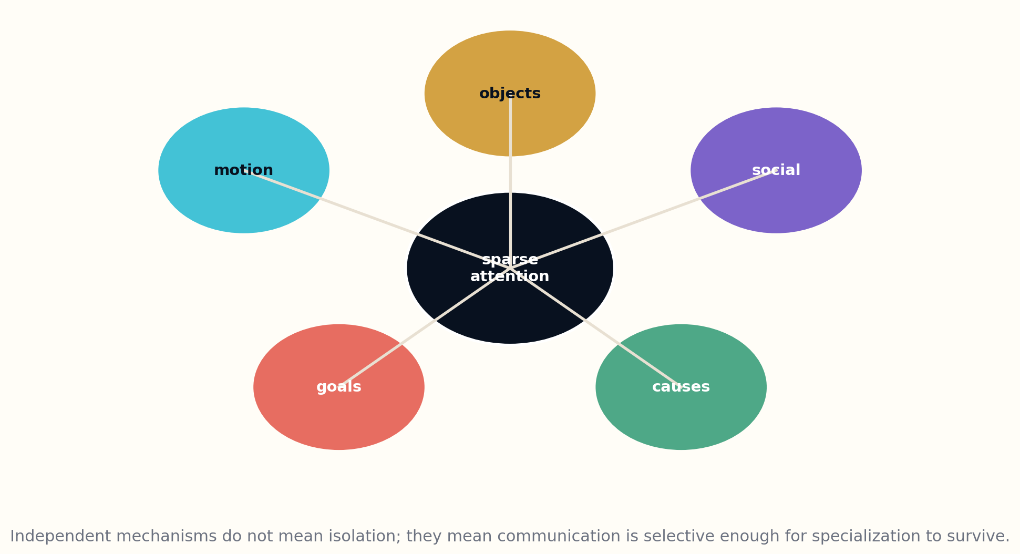
Figure 7. Sparse communication allows mechanisms to specialize without becoming isolated.

THE MECHANISM BENEATH THE RESULT
Recurrent Independent Mechanisms assume that only a few latent mechanisms need to update at each moment. Sparse attention selects active modules; inactive modules preserve state; another sparse channel allows limited communication. The architecture encodes the hypothesis that the world changes through localized interactions among relatively stable processes.

AFTERLIFE FILE IV.1
Recurrent Independent Mechanisms

WHY THE IDEA WENT DIM
The paper’s benchmark story concerns generalization under changed factors, but its deeper claim is ontological: environments may be easier to model as sparse interactions among stable mechanisms.

WHAT IT LOOKS LIKE FROM 2026
Modular world models, causal representation learning, agent routing, and failure containment all benefit from mechanisms that remain separable until interaction is required.

A BETTER WAY TO READ IT NOW
This is more than a regularizer. It proposes a representational politics: mechanisms should be allowed to specialize and remain quiet until relevant. In world models and agent systems, such separation can improve transfer, diagnosis, and failure containment because one changed factor need not rewrite every internal state.

THE CAUTION LABEL
Modules do not automatically correspond to true causes, and attention bottlenecks can produce arbitrary specialization. Interpretability must be tested, not assumed.

WHAT WOULD FALSIFY THE REVIVAL?
Modules can specialize arbitrarily without becoming causal. A convincing reconstruction needs interventions on a simulator’s true factors, measurements of module selectivity and damage propagation, and comparison with equally sparse monolithic baselines. Interpretability must emerge under intervention, not from attractive diagrams.
RECONSTRUCTION EXPERIMENT
Train modular and monolithic recurrent models on a simulator with independently changing subsystems. Perturb one factor and measure cross-module damage.
Primary paper: arXiv:1909.10893

PAPER DOSSIER IV.2
Deep Predictive Coding Networks
William Lotter, Gabriel Kreiman, David Cox
ARXIV | YEAR | FIELD
1605.08104 | 2016 | Prediction-error hierarchies

THE PAPER’S ACTUAL MOVE
Each layer predicts its input and forwards primarily the deviation, so representation learning is organized around errors rather than undifferentiated features.
e_l(t) = input_l(t) − prediction_l(t); propagate e, not raw state
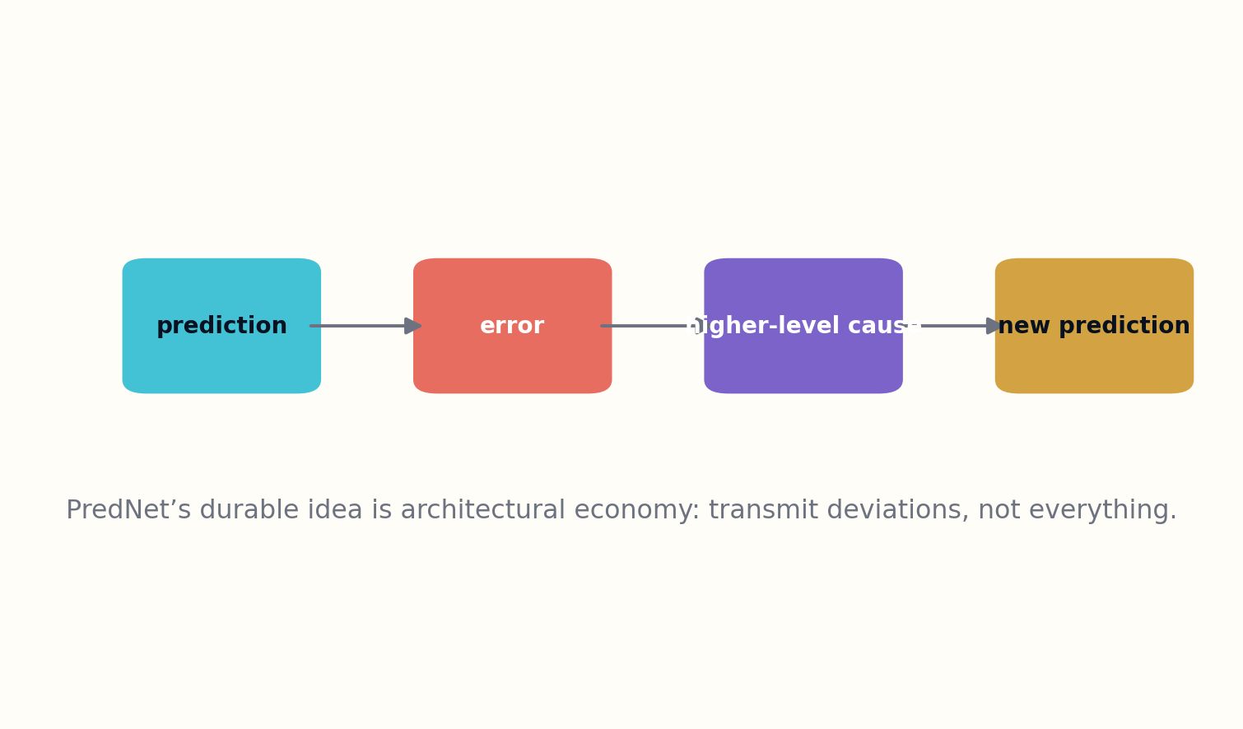
Figure 8. Prediction-error architectures spend bandwidth on deviations rather than stable state.

THE MECHANISM BENEATH THE RESULT
PredNet organizes a hierarchy around prediction error. Each layer predicts its incoming representation, computes the deviation, and sends error upward while recurrent state carries temporal context. Stable information is largely explained away; bandwidth is concentrated on what the model failed to anticipate.

AFTERLIFE FILE IV.2
Deep Predictive Coding Networks

WHY THE IDEA WENT DIM
The paper is remembered as a video-prediction architecture. Its broader systems principle—bandwidth should be spent on surprise and correction—applies to distributed intelligence far beyond vision.

WHAT IT LOOKS LIKE FROM 2026
Local agents, event cameras, anomaly systems, and memory compressors can all communicate changes instead of repeatedly retransmitting stable context.

A BETTER WAY TO READ IT NOW
That principle generalizes to memory and communication systems. A local agent need not resend an entire desktop, codebase, or sensor field when most of it is unchanged. It can preserve periodic keyframes and exchange structured deltas, anomalies, and uncertainty, reducing context cost while making surprise explicit.

THE CAUTION LABEL
Prediction quality can favor low-level pixel averages, and biological analogy does not guarantee optimal engineering. Error-only channels may hide slow drift.

WHAT WOULD FALSIFY THE REVIVAL?
Error-only representations can hide gradual drift, reward blurry averages, or amplify sensor noise. A modern comparison should test full-state, delta-state, and hybrid keyframe systems over long horizons, including recovery after accumulated prediction errors and deliberate adversarial changes.
RECONSTRUCTION EXPERIMENT
Build two context pipelines for a changing interface: full-state snapshots versus prediction errors plus periodic keyframes. Compare bandwidth and recovery after drift.
Primary paper: arXiv:1605.08104

PAPER DOSSIER IV.3
Learning to Protect Communications with Adversarial Neural Cryptography
Martín Abadi, David G. Andersen
ARXIV | YEAR | FIELD
1610.06918 | 2016 | Adversarially learned communication

THE PAPER’S ACTUAL MOVE
Alice and Bob can learn communication that limits what an adversary Eve recovers, with secrecy specified as an adversarial objective rather than a hard-coded cipher.
min_{Alice,Bob} max_{Eve} [reconstruction_Bob − λ·reconstruction_Eve]

THE MECHANISM BENEATH THE RESULT
The adversarial cryptography experiment defines communication as a game among sender, intended receiver, and eavesdropper. Alice and Bob learn encodings that help Bob reconstruct while making Eve’s task harder. The durable mechanism is not a new cipher but an explicit leakage objective attached to a communication protocol.

AFTERLIFE FILE IV.3
Learning to Protect Communications with Adversarial Neural Cryptography

WHY THE IDEA WENT DIM
The headline invited the misleading interpretation that neural networks had replaced cryptography. The durable idea was policy-shaped communication: train a protocol against an explicit observer and measure leakage.

WHAT IT LOOKS LIKE FROM 2026
Agent protocols, privacy filters, steganographic risk testing, and red-team communication channels can use adversarial learners as auditors—never as substitutes for proven cryptography.

A BETTER WAY TO READ IT NOW
Used cautiously, this becomes a red-team pattern for agent channels. A system can train privacy filters, selective disclosure policies, or message abstractions against learned observers, then test whether seemingly harmless representations leak protected attributes. Conventional cryptography still protects the bytes; adversarial learning probes what the decrypted message reveals.

THE CAUTION LABEL
Learned obfuscation is not cryptographic security. It may fail catastrophically against new adversaries and must not protect real secrets without conventional cryptography.

WHAT WOULD FALSIFY THE REVIVAL?
Security claims collapse if the learned attacker is weaker than real attackers or if performance disappears under a new architecture. A valid reconstruction must hold out stronger adversaries, vary side information, and treat any unexplained leakage as failure rather than evidence that neural secrecy is “approximately” sufficient.
RECONSTRUCTION EXPERIMENT
In a toy environment, train sender/receiver protocols against several adversaries, then evaluate with a held-out stronger attacker. Treat generalization failure as the main result.
Primary paper: arXiv:1610.06918

PAPER DOSSIER IV.4
Learning to Learn without Gradient Descent by Gradient Descent
Yutian Chen et al.
ARXIV | YEAR | FIELD
1611.03824 | 2016 | Learned black-box optimization

THE PAPER’S ACTUAL MOVE
A recurrent optimizer trained on simple functions can transfer a learned exploration/exploitation strategy to new derivative-free optimization problems.
x_{t+1} = x_t + O_φ(history_t, f(x_t))

THE MECHANISM BENEATH THE RESULT
The learned optimizer is a recurrent policy that observes a history of evaluated points and proposes the next point without receiving gradients of the target function. Training across many synthetic functions allows it to internalize a strategy for balancing exploration, exploitation, and scale adaptation.

AFTERLIFE FILE IV.4
Learning to Learn without Gradient Descent by Gradient Descent

WHY THE IDEA WENT DIM
Learned optimizers are often discussed as replacements for hand-designed update rules. This paper’s deeper possibility is a policy that internalizes the shape of search itself and transfers across domains.

WHAT IT LOOKS LIKE FROM 2026
Prompt search, model selection, tool routing, experiment design, and hyperparameter tuning can all use small learned search policies under strict evaluation budgets.

A BETTER WAY TO READ IT NOW
This makes optimization itself a transferable behavior. Small models can learn search policies for prompt selection, retrieval weights, tool routing, compiler flags, or experimental design when evaluations are expensive and differentiability is unavailable. The optimizer becomes an agent whose memory is the search history.

THE CAUTION LABEL
Transfer breaks beyond the training horizon and distribution. A learned optimizer may exploit benchmark regularities rather than discover general search principles.

WHAT WOULD FALSIFY THE REVIVAL?
A learned search policy may memorize the geometry of its training functions and fail beyond the familiar horizon. Reconstruction should include held-out function families, shifted dimensionality, adversarial landscapes, and comparisons with Bayesian optimization and evolutionary strategies under identical evaluation budgets.
RECONSTRUCTION EXPERIMENT
Train a compact optimizer on synthetic objectives, then test it on tool-selection and retrieval-ranking tasks with held-out landscape families.
Primary paper: arXiv:1611.03824

THE GENEALOGY ROOM
The dossiers form a family tree that ordinary citation counts only partly reveal. Local-learning papers asked how corrective information could be compressed. Synthetic gradients treated future correction as a prediction problem. Fast weights created a memory substrate between activation and permanent parameter. Program interpreters separated reusable procedures from the controller. RIMs protected specialization with sparse communication.
Placed together, these works describe a system architecture that now feels surprisingly contemporary: multiple bounded modules, local state, learned routing, external procedures, adaptive compute, explicit critics, and periodic reconciliation with a global objective.
The lesson is not that today’s systems secretly copied these papers. Intellectual lineages are rarely that clean. The lesson is that a community can repeatedly approach the same pressure point under different names. A discovery engine should search for structural recurrence, not just shared terminology.
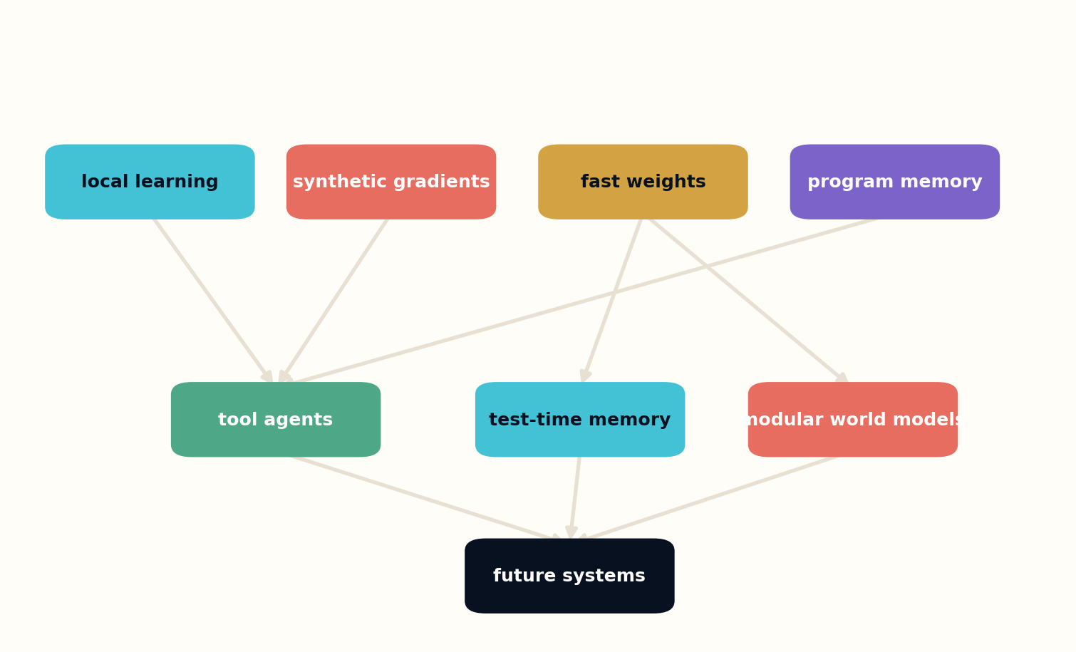
Figure 9. Several underexploited ideas converge toward modern modular, tool-using, memory-rich systems.

THE LAST-PAGE ENGINE
A machine designed to find hidden research should not simply rank low-citation papers. Low attention is not quality, and high attention is not intellectual exhaustion. The engine must search for mismatches: unusually strong mechanisms with narrow experiments, ideas cited mostly inside one field, negative results that define a boundary, future-work claims newly enabled by hardware, and papers whose descendants use different vocabulary.
The retrieval stage should deliberately diversify. One lane searches semantically close work. Another searches methods with similar causal structure but different nouns. A third searches contradictions. A fourth searches forgotten prior art. A fifth retrieves the final sections, appendices, and implementation notes that ordinary abstract search suppresses.
Each candidate becomes an evidence-bound dossier. Models may propose why an idea matters, but the dossier must preserve the exact paper claim, separate interpretation from evidence, search for later failures, and estimate the cost of reconstruction. Human researchers then choose which ideas deserve experiments.
The output should be a queue of falsifiable opportunities rather than a feed of “amazing papers.” A good discovery system increases the rate at which neglected mechanisms receive fair tests. It does not increase the rate at which readers are impressed.
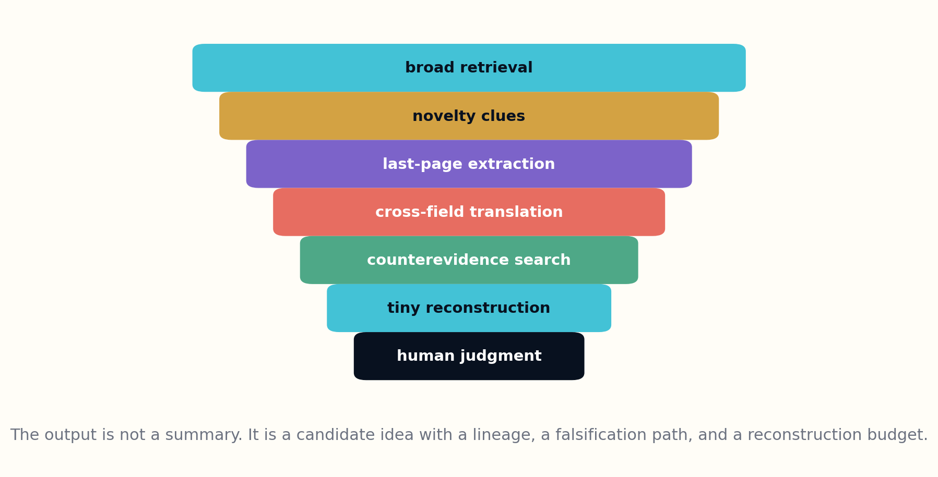
Figure 10. A paper-mining system narrows from broad retrieval to human judgment through explicit evidentiary gates.
Opportunity score = neglectedness × mechanism strength × present feasibility × testability − contradiction risk

APPENDIX A — THE DOSSIER SCHEMA
Field | Purpose
Coordinates | identifier, version, date, authors, categories, publication status
Documented move | what the authors explicitly proposed or demonstrated
Buried mechanism | the reusable idea that exceeds the headline
Visibility hypothesis | a labeled interpretation of why the idea traveled poorly
Modern neighbors | later systems with structural, not merely lexical, similarity
Counterevidence | failures, replications, missing scale tests, and alternative explanations
Reconstruction | the smallest experiment capable of changing belief
Lineage | sources, descendants, vocabulary shifts, and unresolved ownership

APPENDIX B — RECONSTRUCTION SCORECARD

1. Mechanism clarity
Can the idea be stated as a transformation, channel, invariant, or testable causal claim rather than a mood?

2. Evidence distance
How many inferential steps separate the paper’s demonstrated result from the modern application being proposed?

3. Vocabulary drift
Did the field rename the problem, causing semantic search to miss the lineage?

4. Enabling change
Which new hardware, datasets, tools, or institutions make the idea more feasible now?

5. Failure history
Have later papers already tested and rejected the mechanism under relevant conditions?

6. Reconstruction cost
Can a result-changing experiment be performed in days, weeks, months, or only at industrial scale?

7. Consequence
What would become possible—or impossible—if the idea survived the reconstruction?

APPENDIX C — A 30-DAY PAPER EXPEDITION

Days 1–5: Map the vocabulary
Choose one mechanism, list its old and new names, and build broad searches across at least three categories.

Days 6–10: Read against the abstract
Extract methods, limitations, negative results, appendices, and future-work statements without writing a summary.

Days 11–15: Build the lineage
Find predecessors, descendants, contradictions, and parallel rediscoveries in other fields.

Days 16–22: Reconstruct
Implement the smallest faithful version and one deliberately modernized variant.

Days 23–27: Attack
Design failure tests, out-of-distribution conditions, resource measurements, and stronger baselines.

Days 28–30: Publish the dossier
Release code, evidence, failed branches, and a calibrated conclusion stating what changed and what did not.

GLOSSARY
Attention decay. The progressive reduction in readership and interpretive depth across a paper’s sections.
Cross-field obscurity. A condition in which a mechanism is known inside one specialty but functionally absent elsewhere.
Deep idea. A reusable mechanism, constraint, or architecture that survives beyond the original benchmark.
Dossier. A structured record separating a paper’s claim, interpretation, counterevidence, lineage, and reconstruction plan.
Last-page extraction. Targeted reading of conclusions, limitations, appendices, and implementation details after broad retrieval.
Reconstruction. A contemporary experiment intended to update belief about an older idea, not merely reproduce its original result.
Visibility hypothesis. An explicitly labeled inference about why an idea received limited or distorted attention.

SOURCE LEDGER
Primary technical descriptions are taken from the linked arXiv abstract records. Interpretations of visibility, modern relevance, and reconstruction opportunities are the author’s synthesis and are not claims made by the original papers.
The meta-analysis also draws on arXiv research about downloads, social mentions, and early citations; the arXiv user survey; and recent work showing that popularity can fail to identify strong models in large repositories.
• How the Scientific Community Reacts to Newly Submitted Preprints — source
• arXiv User Survey Report — source
• Discovering Hidden Gems in Model Repositories — source
• User choice, hidden gems, and the quadratic horizon — source
• David Balduzzi, Hastagiri Vanchinathan, Joachim Buhmann. Kickback cuts Backprop's red-tape (2014). arXiv:1411.6191
• Pierre Baldi, Peter Sadowski. A Theory of Local Learning, the Learning Channel, and the Optimality of Backpropagation (2015). arXiv:1506.06472
• Benjamin Scellier, Yoshua Bengio. Equilibrium Propagation (2016). arXiv:1602.05179
• Max Jaderberg et al.. Decoupled Neural Interfaces using Synthetic Gradients (2016). arXiv:1608.05343
• Alex Graves. Adaptive Computation Time for Recurrent Neural Networks (2016). arXiv:1603.08983
• David Ha, Andrew Dai, Quoc V. Le. HyperNetworks (2016). arXiv:1609.09106
• Jimmy Ba, Geoffrey Hinton, Volodymyr Mnih, Joel Leibo, Catalin Ionescu. Using Fast Weights to Attend to the Recent Past (2016). arXiv:1610.06258
• Łukasz Kaiser, Ilya Sutskever. Neural GPUs Learn Algorithms (2015). arXiv:1511.08228
• Scott Reed, Nando de Freitas. Neural Programmer-Interpreters (2015). arXiv:1511.06279
• Marcin Andrychowicz et al.. Hindsight Experience Replay (2017). arXiv:1707.01495
• Deepak Pathak, Pulkit Agrawal, Alexei Efros, Trevor Darrell. Curiosity-driven Exploration by Self-supervised Prediction (2017). arXiv:1705.05363
• Neil Rabinowitz et al.. Machine Theory of Mind (2018). arXiv:1802.07740
• Chrisantha Fernando et al.. PathNet (2017). arXiv:1701.08734
• Anirudh Goyal et al.. Recurrent Independent Mechanisms (2019). arXiv:1909.10893
• William Lotter, Gabriel Kreiman, David Cox. Deep Predictive Coding Networks (2016). arXiv:1605.08104
• Martín Abadi, David G. Andersen. Learning to Protect Communications with Adversarial Neural Cryptography (2016). arXiv:1610.06918
• Yutian Chen et al.. Learning to Learn without Gradient Descent by Gradient Descent (2016). arXiv:1611.03824

THE ARCHIVE DOES NOT FORGET.
ATTENTION DOES.
GRAYLAN JANULIS

