

THE BOOK GENOME
Engineering the DNA of Purpose, Audience, Evidence, Voice, Difficulty, Format, and Intellectual Contribution
GRAYLAN JANULIS

DESIGN NOTE
The Book Genome is a proposed technical framework. It builds on established bibliographic, publishing, linked-data, accessibility, identifier, rights, and provenance standards, but the seven-chromosome model and the equations in this book are original design proposals rather than existing industry requirements.
The genetic metaphor is intentionally limited. Books are authored cultural works, not organisms; genome fields are design commitments, not determinants. The framework must never be used to erase human authorship, rank readers as fixed types, force all books into one aesthetic, or claim that a numerical profile fully explains literary value.
The objective is interoperability with judgment: a common language that helps authors, publishers, libraries, educators, readers, and AI systems describe what a book is trying to accomplish and test whether the finished work honored that intention.
“A book genome does not replace the mystery of a book.
It makes the book’s promises visible enough to protect them.”

CONTENTS
PART I · THE REPRESENTATION PROBLEM
01 The Invisible Anatomy of a Book
02 Where Metadata Ends and Meaning Begins
03 The Identity Problem: Work, Expression, Manifestation, Item
04 The Genome Vector and the Limits of a Single Score
05 The Book as an Executable Contract
PART II · THE SEVEN CHROMOSOMES
06 Purpose: The Transformation Vector
07 Audience: A Manifold of Reader States
08 Evidence: The Epistemic Architecture
09 Voice: Coordinates, Range, and Controlled Variance
10 Difficulty: A Surface, Not a Grade Level
PART III · THE INTERNAL ANATOMY
11 Format: The Affordance Chromosome
12 Intellectual Contribution: The Reason to Exist
13 Rights, Provenance, and Ethical Constraints
14 The Structural Genotype
15 Concept Dependencies and the Order of Understanding
PART IV · THE COMPUTABLE BOOK
16 Chapter Functions and Reader-State Transitions
17 Examples, Exercises, and Assessment as Genome Elements
18 Citation, Uncertainty, and Claim Lineage
19 Visual Grammar and Multimodal Reasoning
20 The Fiction Genome
PART V · EVOLUTION AND FITNESS
21 The Book Genome Ontology
22 JSON-LD Serialization and SHACL Validation
23 Genome Similarity, Search, and Recommendation
24 Gap Detection and Portfolio Intelligence
25 The Book Compiler
PART VI · THE BOOK GENOME ECOSYSTEM
26 Evaluation: From Review to Fitness Profile
27 Mutation, Crossover, and Controlled Variation
28 Versioning, Translation, Adaptation, and Living Books
29 Institutional Uses: Publishing, Libraries, Education, and AI
30 A Constitution and Roadmap for the Book Genome
Appendix A — Book Genome Core Schema
Appendix B — JSON-LD Example
Appendix C — SHACL Validation Profile
Appendix D — Genome Evaluation Rubric
Appendix E — Crosswalk to Existing Standards
Appendix F — A Constitution for Book Genome Systems
Glossary
Research Notes and Sources

PROLOGUE
THE BOOK BEFORE THE BOOK
A technical and human manifesto
Before a book becomes sentences, it is a set of decisions—some conscious, some inherited, and some invisible even to its author. It decides whom to trust, what to explain, which examples count, how much difficulty to demand, what evidence is enough, what voice can carry the subject, and what contribution would make the work worth a reader’s time.
The Book Genome makes those decisions representable. It does not ask literature to become a database or scholarship to become a score. It creates a layer where intention, evidence, experience, and contribution can be inspected together. This layer can guide human authors, constrain generative systems, enrich libraries, improve recommendations, and preserve the difference between a book that merely contains information and a book that changes what a reader can understand or do.
The chapters that follow move from philosophy to formal model, from editorial practice to ontology, from JSON-LD and SHACL to fiction, evaluation, versioning, governance, and a roadmap for an open standard. The destination is not a universal formula for books. It is a durable language for making better promises—and keeping them.

PART I
THE REPRESENTATION PROBLEM
Why conventional metadata cannot describe what a book is designed to do.

CHAPTER 01
The Invisible Anatomy of a Book
A title tells us what a book is called. A genome tells us what the book is built to change.
━━━━━━━━━━━━━━━━━━━━━━━━━
A book arrives in the world with an abundance of visible descriptors: title, author, publisher, date, language, ISBN, page count, subject, genre, and price. These fields are indispensable for identification and commerce, yet they say surprisingly little about the intellectual machine inside the covers. Two books may share the same subject and reading level while performing opposite functions. One may orient a frightened beginner; another may challenge a specialist’s assumptions. One may preserve testimony; another may compress a technical field into operational rules. Conventional metadata can locate both books, but it cannot reliably explain the transformation each one is designed to produce.
The Book Genome begins from a different question. Instead of asking only what the object is, it asks what design commitments organize it. The primary genome consists of seven chromosomes: purpose, audience, evidence, voice, difficulty, format, and intellectual contribution. These dimensions are not tags pasted onto finished prose. They are upstream constraints that shape source selection, structure, examples, pacing, visual design, citation behavior, and the kinds of reader outcomes that count as success.
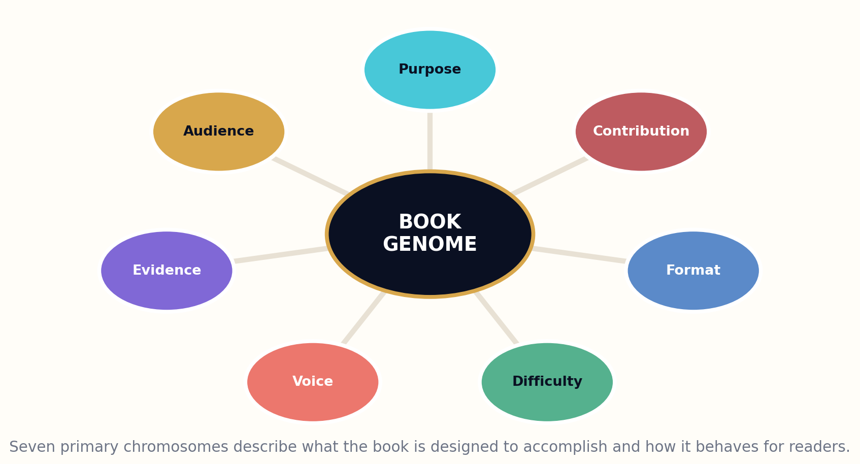
Figure 1. The seven primary chromosomes of a Book Genome.

HOW THE MODEL WORKS
The framework distinguishes genotype from phenotype. The genotype is the explicit specification: a formal representation of the book’s intended behavior. The phenotype is the experienced work: the prose, images, sequence, rhythm, interfaces, and effects that emerge when the genome is compiled through authorship and production. The same genome can produce multiple legitimate phenotypes, just as one work can appear in several expressions and manifestations. The metaphor is useful because it lets us discuss variation, inheritance, and evaluation, but it must never imply that books are biologically determined or that creativity can be reduced to a formula.
A genome record is therefore both descriptive and prescriptive. It can be created after publication to analyze an existing book, or before publication to guide a new one. In retrospective mode it supports search, recommendation, comparative criticism, and preservation. In prospective mode it supports commissioning, outlining, generative systems, editorial review, translation, adaptation, and portfolio planning. The same formal vocabulary allows a publisher, a library, a school, and an AI system to discuss the book without collapsing their different responsibilities.

DESIGN IMPLICATIONS
The central promise is not perfect classification. Books are too alive for that. The promise is a richer interface between intention and artifact. Once the invisible anatomy is represented, institutions can ask better questions: Which readers are underserved? Which books claim expertise without adequate evidence? Which works explain old knowledge in genuinely new ways? Which formats contradict the needs of their audiences? The genome turns those questions from intuition alone into inspectable design decisions.
G = ⟨P, A, E, V, D, F, C⟩ + supporting systems ⟨S, R, Q, L⟩
WORKED EXAMPLE
A “beginner’s guide to quantum computing” and a “policy briefing on quantum security” can share a subject while having radically different genomes.
GENOME LAB
• Choose two books on the same topic and describe how their purposes differ.
• Write a seven-field genome for a book you know well.
• Identify one important property of a book that conventional metadata usually misses.
Standards and research foundation: IFLA-LRM, BIBFRAME, ONIX. See Research Notes and Sources.

CHAPTER 02
Where Metadata Ends and Meaning Begins
Cataloging identifies the object; a genome represents its intended behavior.
━━━━━━━━━━━━━━━━━━━━━━━━━
Publishing and library standards already solve difficult problems. ONIX moves product information through the book supply chain. BIBFRAME expresses bibliographic resources as linked data. IFLA’s Library Reference Model distinguishes work, expression, manifestation, and item. EPUB packages structured digital publications. Schema.org, Dublin Core, DataCite, and related vocabularies expose titles, contributors, audiences, citations, rights, versions, and formats. The Book Genome does not replace these systems. It supplies a missing semantic layer above them.
The missing layer concerns functional meaning. A catalog record may state that a book is educational, but not the exact misconception it is designed to repair. It may identify an intended audience, but not the prerequisites the argument assumes or the decisions the reader should be able to make after completion. It may list citations without distinguishing foundational evidence, contested claims, illustrative cases, and speculative extrapolation. It may label a work as a novel while saying nothing about the causal architecture of its world, the distance of its narrator, or the formal contribution it attempts.
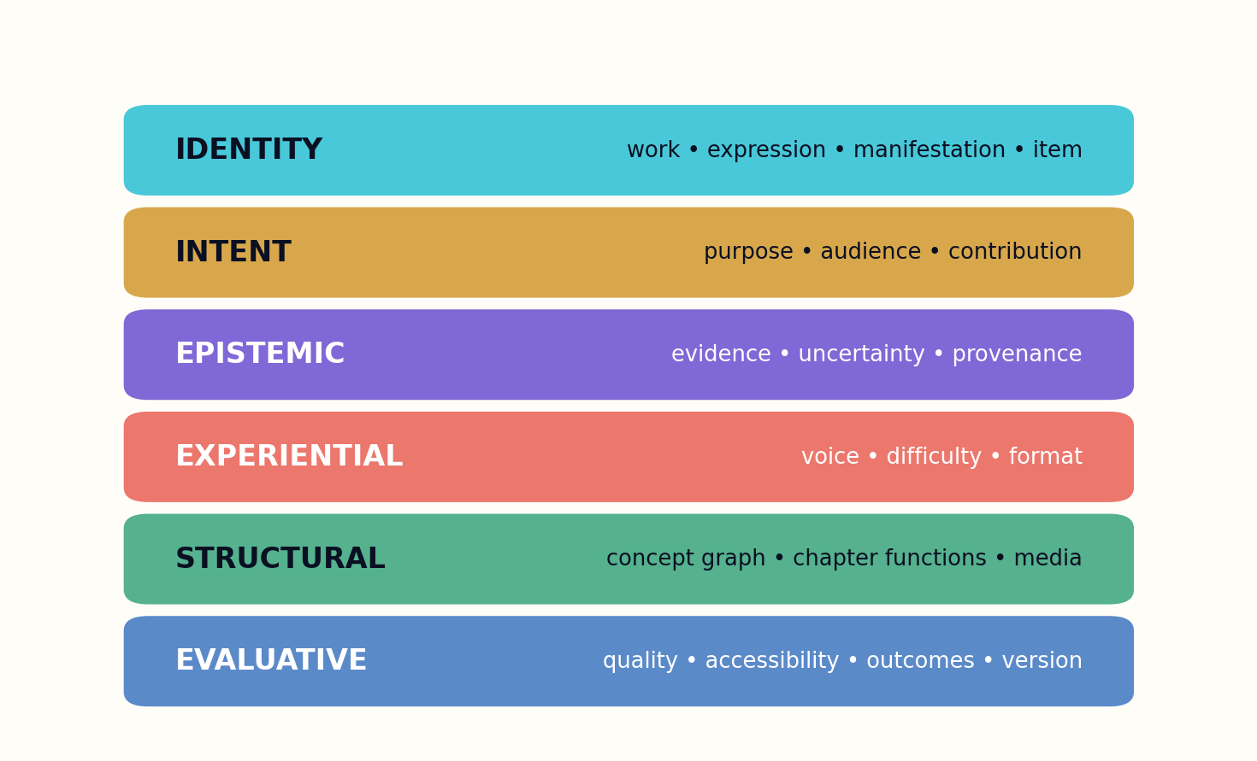
Figure 2. Identity, intent, epistemic, experiential, structural, and evaluative layers remain separate but linked.

HOW THE MODEL WORKS
The Genome therefore uses layered representation. Identity fields connect the record to bibliographic systems. Intent fields define purpose, audience, and contribution. Epistemic fields define evidence and uncertainty. Experiential fields define voice, difficulty, and format. Structural fields represent the concept graph, chapter functions, narrative or argument arcs, media, examples, and assessments. Evaluative fields record how the resulting phenotype performed against the original design.
This layering prevents category errors. Product metadata should not be forced to contain every pedagogical and literary detail. A genome should not pretend to replace circulation records, preservation metadata, or rights contracts. Instead, mappings connect the layers. An ONIX product record may point to a genome identifier. A BIBFRAME Work may be associated with one or more genome versions. An EPUB package may embed a compact genome summary while linking to a richer external graph.

DESIGN IMPLICATIONS
Meaning begins where fields become relationships and constraints. “Advanced” is not a meaningful difficulty label unless it is tied to prerequisites, abstraction, notation, pace, and reader support. “Evidence-based” is not a meaningful claim unless sources, claim types, uncertainty, and contradiction handling are represented. The Genome’s purpose is to make those phrases testable rather than promotional.
Book description = bibliographic identity + functional genome + production lineage + measured phenotype
WORKED EXAMPLE
A catalog can state “for professionals”; a genome can state “for emergency nurses with triage experience, no statistics background, and fifteen-minute reading windows.”
GENOME LAB
• Map one genome field to an existing metadata standard.
• List three claims publishers make that should become testable genome properties.
• Draw a boundary between product metadata and intellectual-design metadata.
Standards and research foundation: ONIX, BIBFRAME, DCMI, SCHEMA. See Research Notes and Sources.

CHAPTER 03
The Identity Problem: Work, Expression, Manifestation, Item
Before describing a book’s genome, we must decide which “book” we mean.
━━━━━━━━━━━━━━━━━━━━━━━━━
The phrase “this book” can refer to a conceptual work, a particular linguistic realization, a published edition, or the individual copy in a reader’s hands. Bibliographic theory has long recognized this ambiguity. IFLA LRM models Work, Expression, Manifestation, and Item; BIBFRAME organizes related distinctions through Work, Instance, and Item. The Book Genome must align with these abstractions or it will confuse intellectual revision with translation, format conversion, and mere reproduction.
The deepest genome belongs to the Work: its central purpose, contribution, governing question, and high-level structural commitments. The Expression realizes that work in a language, voice, sequence, and cultural context. A translation may preserve the Work genome while changing voice coordinates, examples, difficulty, and audience assumptions. An adaptation may preserve only part of the original genome and should declare the transformed components rather than claiming complete equivalence.
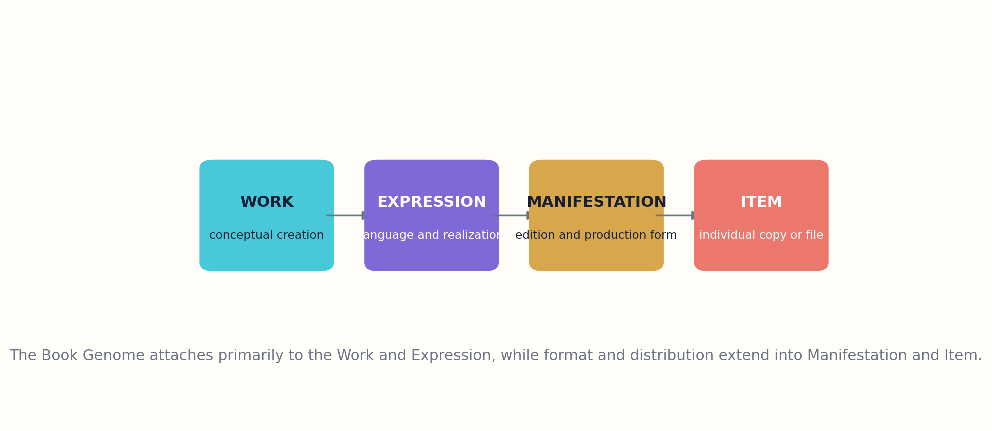
Figure 3. The Genome aligns with Work, Expression, Manifestation, and Item distinctions.

HOW THE MODEL WORKS
Manifestation-level properties describe production and affordance. A print edition, EPUB, audiobook, and interactive web edition may embody the same expression while changing navigation, accessibility, pacing, annotation, and media. These are not cosmetic differences. Format can alter the cognitive experience enough that the Genome needs manifestation-specific overrides. A dense reference work may be effective in searchable digital form and frustrating in audio; a memoir may gain emotional force through performance.
Item-level records matter when provenance, annotation, or condition changes the intellectual object. An author’s marked copy, a classroom edition with teacher notes, or a digitally personalized version may carry item-specific layers. The core genome remains stable, but the item can record local overlays and reader interaction without pretending those changes belong to every copy.

DESIGN IMPLICATIONS
A robust implementation therefore uses inheritance. Work fields cascade to expressions, expressions to manifestations, and manifestations to items unless explicitly overridden. The system records why an override exists and whether it changes identity enough to require a new Work. This prevents both fragmentation—treating every file as a different book—and false sameness—pretending a radical adaptation is merely another format.
G_item = G_work ⊕ Δ_expression ⊕ Δ_manifestation ⊕ Δ_item
WORKED EXAMPLE
A simplified adaptation for young readers may inherit the original thesis while changing audience, difficulty, examples, voice, and evidence detail.
GENOME LAB
• Classify five versions of one famous work as Work, Expression, Manifestation, or Item.
• Define which genome fields may inherit automatically.
• Describe a change large enough to create a new Work rather than a new Expression.
Standards and research foundation: IFLA-LRM, BIBFRAME. See Research Notes and Sources.

CHAPTER 04
The Genome Vector and the Limits of a Single Score
A book is not “good” in the abstract; it is fitted—or unfitted—to a purpose, audience, and intellectual obligation.
━━━━━━━━━━━━━━━━━━━━━━━━━
The seven chromosomes can be represented as a mixed vector containing numbers, categories, graphs, distributions, and free-text commitments. Purpose may be a weighted mixture of teaching, explaining, guiding, preserving, persuading, provoking, and entertaining. Audience may be a set of reader personas plus distributions over prior knowledge and goals. Evidence may be a typed claim graph. Voice may be a coordinate profile with permitted variance. Difficulty may be a surface over prerequisites, abstraction, notation, syntax, and pace.
A vector makes comparison possible, but a genome is not reducible to seven scalar ratings. The internal structure of each chromosome matters. Two books can both score highly on evidence while using different evidence architectures: one may synthesize controlled studies, another may preserve primary testimony, and a third may construct a mathematical proof. Flattening them into a single “evidence score” destroys the very distinctions the framework is meant to protect.
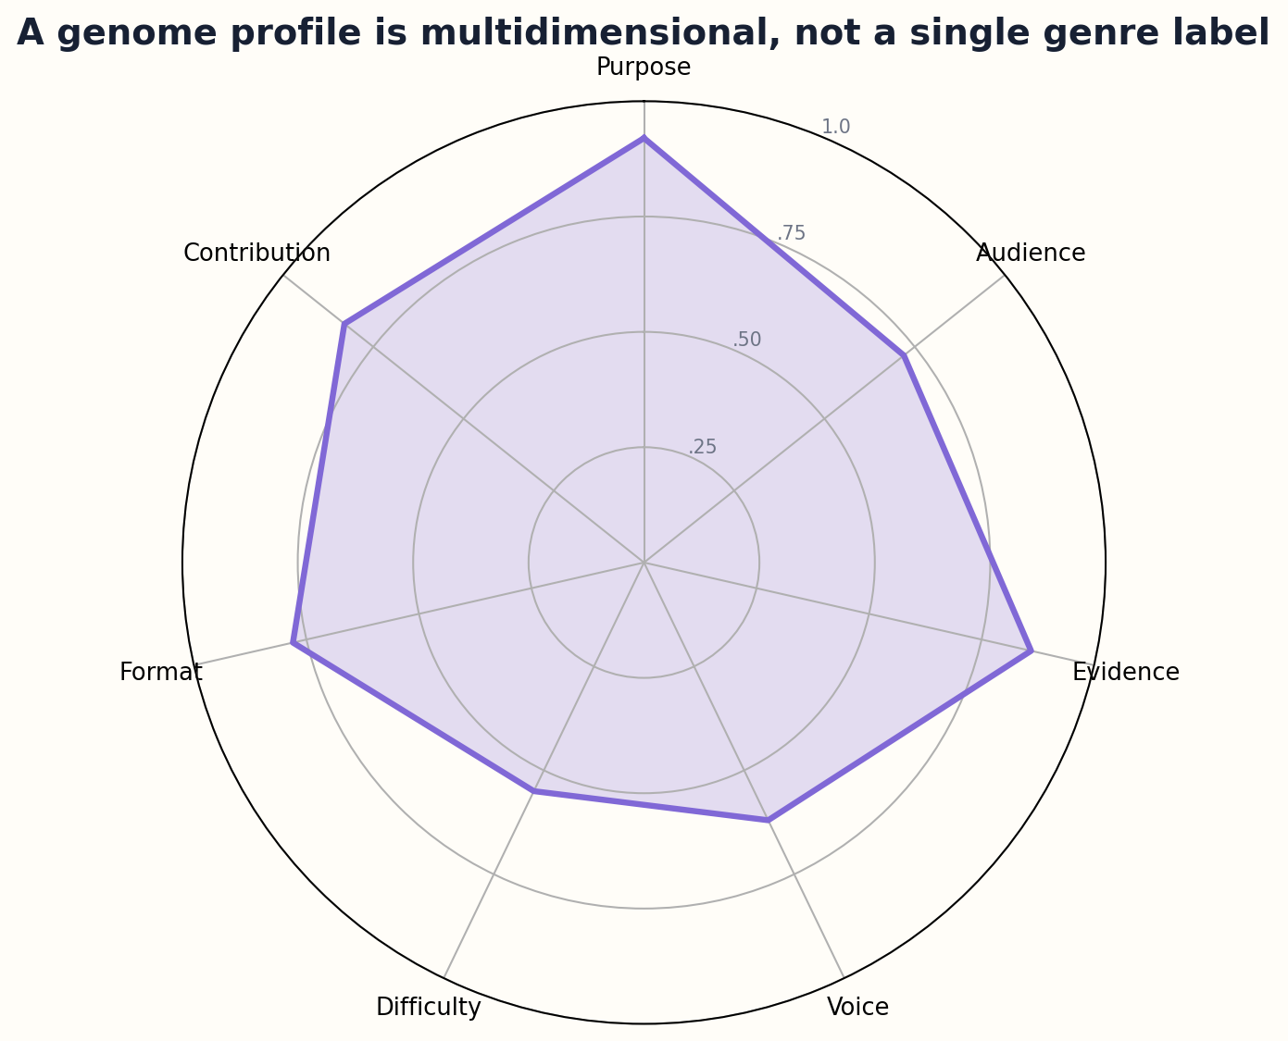
Figure 4. A genome profile is hierarchical and multidimensional.

HOW THE MODEL WORKS
The right computational model is hierarchical. At the top level, the seven chromosomes support discovery and portfolio analysis. Beneath each chromosome, domain-specific submodels preserve detail. A medical evidence profile can use study design, population, effect, and risk-of-bias fields. A historical evidence profile can distinguish archival documents, material artifacts, oral histories, and historiographic interpretation. A novel’s evidence profile may instead represent research grounding and internal-world consistency.
Similarity is therefore purpose-dependent. A reader seeking a replacement textbook may weight audience, difficulty, and concept coverage heavily. A scholar studying intellectual lineage may weight contribution, evidence, and structure. A publisher avoiding redundant titles may compare topic, purpose, examples, argument, and voice. The Genome stores enough detail for each task to define its own metric rather than accepting one universal distance.

DESIGN IMPLICATIONS
The framework also records uncertainty about the genome itself. Purpose can be ambiguous; audience may be broader than intended; voice may change across chapters. Fields can contain confidence, source, assessor, and date. A machine-inferred genome is explicitly different from an author-declared or editor-verified genome. This prevents computational convenience from hardening interpretation into fact.
d(G₁,G₂ | task) = Σ wᵢ(task) · dᵢ(chromosomeᵢ) with no universal weight vector
WORKED EXAMPLE
A recommendation engine for learners and a rights auditor can use the same genome record while applying completely different distance functions.
GENOME LAB
• Design a hierarchical representation for one chromosome.
• Create two different similarity metrics for two different tasks.
• Add confidence and provenance to three inferred genome fields.
Standards and research foundation: JSONLD, SHACL. See Research Notes and Sources.

CHAPTER 05
The Book as an Executable Contract
A genome becomes valuable when a production system can test whether the finished work honored it.
━━━━━━━━━━━━━━━━━━━━━━━━━
A genome is more than a description. It is an executable editorial contract between the proposed book and its future phenotype. The contract says what the book will attempt, whom it will serve, what kinds of claims it may make, what voice boundaries it will preserve, how difficult the path may become, which formats are required, and what contribution would justify publication. These commitments can generate validation tests before the first chapter is drafted.
Execution begins with compilation. The purpose profile selects structural patterns. The audience profile constrains terminology, prerequisite explanation, examples, pace, and accessibility. The evidence model controls source retrieval and claim language. The voice profile constrains sentence behavior without mechanically dictating style. The format profile determines whether diagrams, navigation, interaction, audio cues, or downloadable artifacts are necessary. The contribution profile defines what the manuscript must add beyond available works.
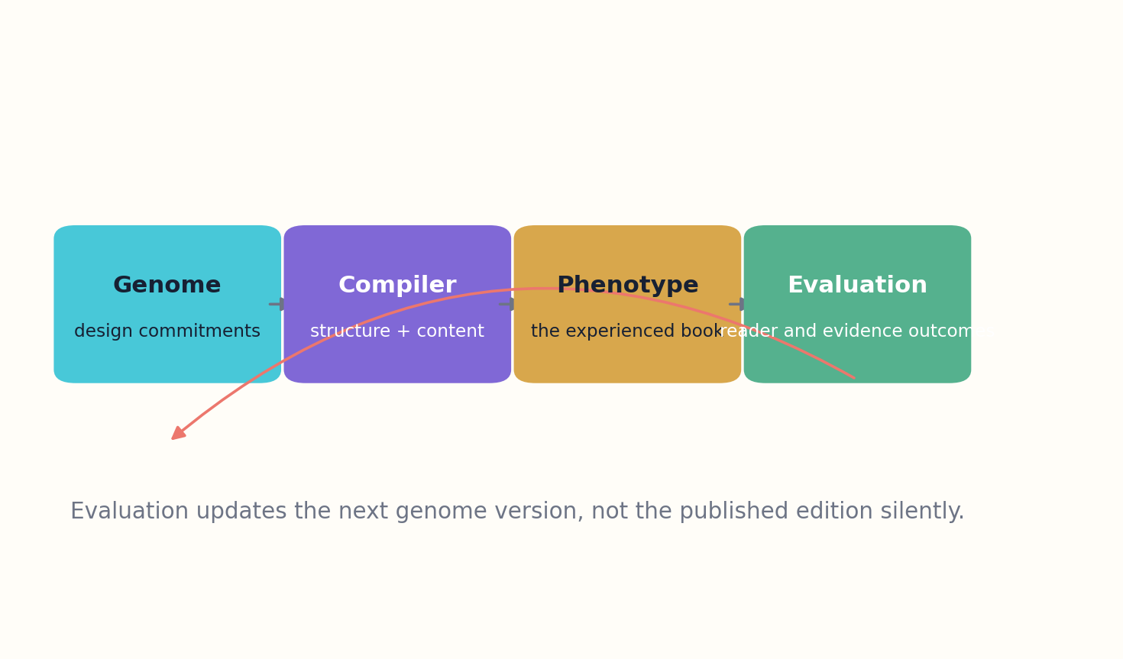
Figure 5. The Genome functions as an executable editorial contract.

HOW THE MODEL WORKS
The contract is intentionally asymmetric. The phenotype may exceed the genome through creative discovery, but it should not violate core commitments silently. If research changes the thesis, the genome is revised and versioned. If a fictional character develops in an unexpected direction, the story architecture can mutate while preserving thematic purpose. If the intended audience changes, the production team records a new audience profile rather than disguising a specialist book as general access.
Evaluation closes the loop. Tests compare the published phenotype with the genome: Do target readers understand the concepts? Are claims supported at the declared evidence level? Does the voice remain legible and distinctive? Does the format provide the promised affordances? Is the intellectual contribution visible to expert reviewers? Failure can trigger a bounded revision, a new expression, a new edition, or rejection.

DESIGN IMPLICATIONS
The executable-contract model is especially important for generative publishing. Without it, an AI system optimizes locally for fluent paragraphs. With it, generation becomes constrained synthesis. Models receive typed tasks, evidence packets, structural functions, and acceptance tests. The result is not guaranteed greatness, but it becomes possible to inspect why the system believed the book was ready.
Compile(G, sources, authorship) → phenotype B; Validate(B, G) → findings, not a single verdict
WORKED EXAMPLE
A handbook promising “field decisions under pressure” must be evaluated with scenarios and time limits, not only copyediting.
GENOME LAB
• Turn one vague publishing promise into three executable tests.
• Identify which genome changes require a new edition.
• Design a validation test for voice that avoids enforcing uniform prose.
Standards and research foundation: SHACL, PROVO. See Research Notes and Sources.

PART II
THE SEVEN CHROMOSOMES
Purpose, audience, evidence, voice, difficulty, format, and contribution.

CHAPTER 06
Purpose: The Transformation Vector
Topic names the territory. Purpose names the change the book intends to cause.
━━━━━━━━━━━━━━━━━━━━━━━━━
Purpose is the most important and most frequently underspecified chromosome. “A book about climate adaptation” identifies subject matter but not function. The work may explain mechanisms, train municipal planners, persuade voters, preserve local testimony, compare technologies, provoke ethical reflection, or entertain through speculative fiction. Each purpose demands a different architecture and a different definition of success.
The Genome models purpose as a weighted transformation vector rather than a single label. Common modes include inform, explain, teach, guide, persuade, preserve, provoke, entertain, coordinate, diagnose, and transform practice. One mode is usually dominant, while others support it. A field manual may primarily guide action, secondarily explain mechanisms, and minimally preserve institutional memory. Declaring the mixture prevents a manuscript from drifting into incompatible ambitions.
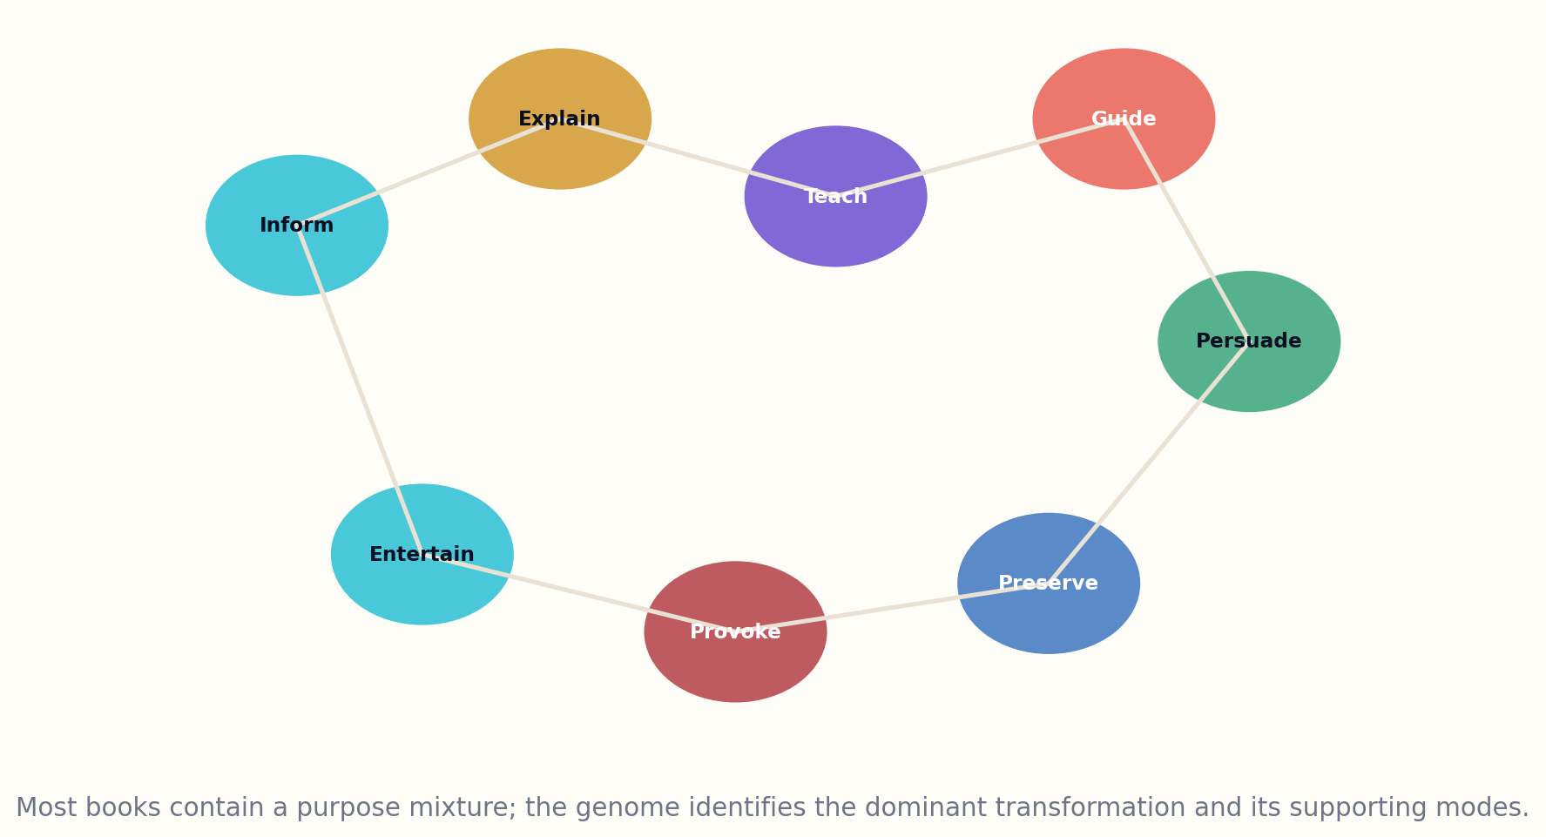
Figure 6. Purpose is a weighted transformation mixture.

HOW THE MODEL WORKS
Purpose is written as a before-and-after state. The “before” describes the reader’s likely knowledge, beliefs, capabilities, or emotional position. The “after” defines the intended change. A rigorous purpose statement can be tested: after reading, the reader can distinguish three failure modes, perform a procedure, reconstruct an argument, recognize uncertainty, or inhabit a moral contradiction. Purpose becomes an operational hypothesis about reading.
Purpose also includes prohibited outcomes. A persuasive book may not manipulate by hiding uncertainty. A practical guide may not encourage action beyond its evidence. A preservation project may not normalize or overwrite the voice of its contributors. A novel intended to create empathy should not reduce a community to an educational instrument. Negative constraints are part of the genome because many failures arise from achieving the headline goal through unacceptable means.

DESIGN IMPLICATIONS
At portfolio scale, purpose reveals redundancy and absence. A library may contain thousands of books explaining a topic but almost none guiding local action, teaching beginners, or preserving frontline experience. Topic counts hide this imbalance. Purpose vectors expose it and allow publishers and generative libraries to commission the missing transformations.
P = [inform, explain, teach, guide, persuade, preserve, provoke, entertain, …], ΣPᵢ = 1
WORKED EXAMPLE
A diabetes book can target clinical decision support, patient self-management, caregiver understanding, public policy, or memoir; these are different books.
GENOME LAB
• Write a before-and-after purpose statement.
• Assign a weighted purpose vector totaling 1.0.
• List two outcomes the book must not produce.
Standards and research foundation: DCMI, SCHEMA. See Research Notes and Sources.

CHAPTER 07
Audience: A Manifold of Reader States
There is no general reader—only readers with different histories, constraints, motives, and moments.
━━━━━━━━━━━━━━━━━━━━━━━━━
Audience metadata often collapses people into broad demographic or market categories: adult, young adult, professional, student, general interest. These labels are useful for distribution but inadequate for intellectual design. A reader’s relationship to a book depends on prior knowledge, vocabulary, goals, available time, cultural context, access needs, emotional stakes, and the environment in which reading occurs.
The Genome represents audience as a set of reader-state models rather than a single persona. Each model records prerequisites, misconceptions, goals, constraints, motivation, language, domain fluency, and desired depth. A book may serve several reader states, but it must describe how. Parallel explanations, optional technical layers, glossaries, summaries, and multiple formats can widen access without pretending every passage fits everyone equally.
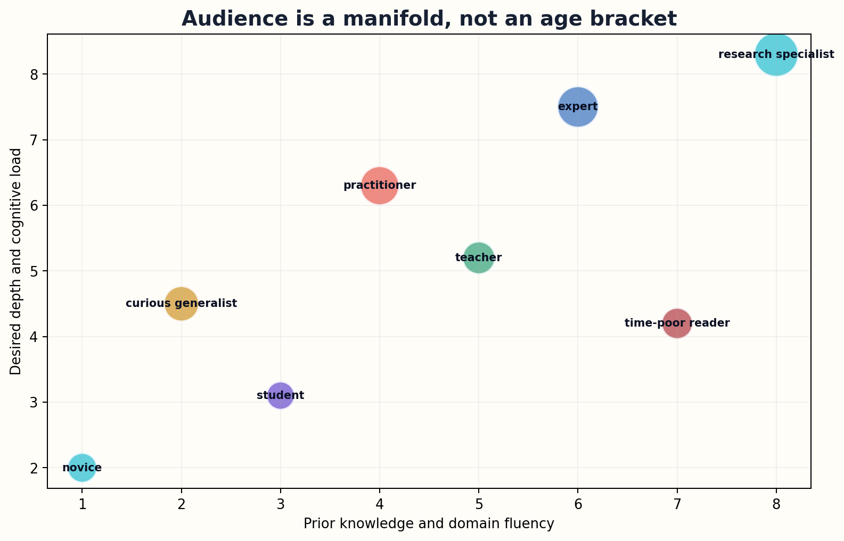
Figure 7. Audience is modeled as reader states rather than a single demographic label.

HOW THE MODEL WORKS
Audience fit is measured as distance between assumed and actual reader state. If the book introduces a concept before supplying required vocabulary, distance rises. If examples rely on unfamiliar institutions, distance rises. If a professional reader must navigate long introductory material to reach operational detail, distance rises. The design objective is not minimum difficulty; it is controlled distance with visible support.
The model also captures context of use. A paramedic reading during training has different needs from one consulting a guide during an incident. A student reading for examination has different needs from a curious adult seeking conceptual orientation. The same audience member can occupy different reader states at different moments. This is why the Genome separates identity from situation.

DESIGN IMPLICATIONS
Audience representation carries ethical risk. It must not become a surveillance profile or deterministic judgment of intelligence. Reader-state data should be minimal, consent-based when personal, and used to increase agency. The framework describes what the book assumes; it does not rank the worth of readers.
Audience fit = 1 − normalized distance(assumed reader state, target reader state)
WORKED EXAMPLE
“Advanced developer” is replaced by explicit prerequisites: asynchronous programming, distributed systems, basic cryptography, and comfort reading API specifications.
GENOME LAB
• Define three reader states for one book.
• List the context-of-use differences between study, reference, and emergency consultation.
• Replace one demographic audience label with a capability-based description.
Standards and research foundation: DCMI, SCHEMA, EPUB. See Research Notes and Sources.

CHAPTER 08
Evidence: The Epistemic Architecture
Evidence is not a bibliography. It is the structure that governs what the prose is allowed to claim.
━━━━━━━━━━━━━━━━━━━━━━━━━
The evidence chromosome describes how a book knows what it says. It represents source types, claim types, uncertainty, contradiction handling, dates, scope, and the difference between observation, synthesis, interpretation, illustration, and speculation. A long bibliography can coexist with weak evidence if citations do not support nearby claims or if disputed findings are presented as settled.
Every factual claim receives an evidence class. Direct empirical claims connect to data, observations, documents, or primary research. Synthesized claims connect to reviews, replications, and comparative analysis. Interpretive claims expose the reasoning that connects evidence to conclusion. Illustrations and hypotheticals are marked so they cannot be mistaken for documented events. Forecasts state assumptions and horizons. In fiction, research grounding is separated from invented facts inside the story world.
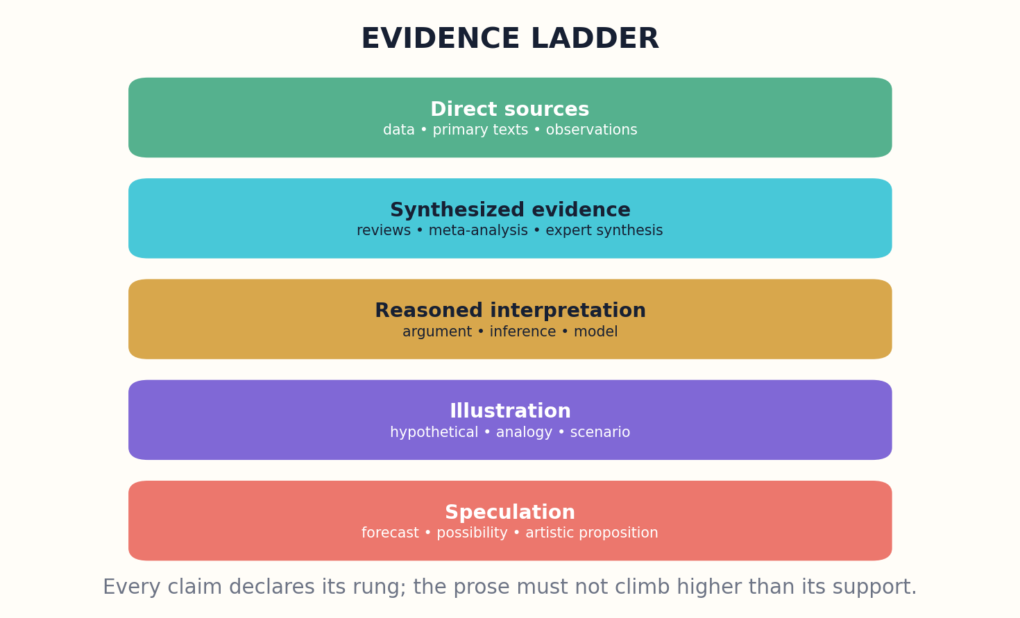
Figure 8. The evidence ladder preserves the boundary between documentation and speculation.

HOW THE MODEL WORKS
The Genome also specifies evidence thresholds by consequence. A low-stakes historical aside may require a credible secondary source. A medical recommendation, legal interpretation, or safety procedure may require current primary evidence and professional review. A technical book may require executable code and test results. The evidence policy belongs to the book’s purpose and domain; one universal hierarchy would be misleading.
Contradiction is represented rather than erased. The evidence graph records opposing claims, scope differences, null results, and unresolved questions. Prose generation is constrained by this graph: a sentence cannot speak with more certainty than the current evidence state. A living edition can later update the claim when the graph changes.

DESIGN IMPLICATIONS
Evidence design improves creativity because it clarifies where invention is permitted. Once established knowledge, interpretation, and speculation are separated, authors can make bold connections without disguising them as fact. The Genome does not demand timid writing; it demands honest borders.
Claim strength ≤ support quality × scope match × replication × recency × contradiction coverage
WORKED EXAMPLE
A systems book may state a demonstrated mechanism, infer a cross-domain analogy, and propose a speculative architecture—each in a different evidence class.
GENOME LAB
• Classify ten sentences as evidence, synthesis, interpretation, illustration, or speculation.
• Define evidence thresholds for a high-stakes chapter.
• Create a contradiction record for two conflicting sources.
Standards and research foundation: DATACITE, CROSSREF, PROVO. See Research Notes and Sources.

CHAPTER 09
Voice: Coordinates, Range, and Controlled Variance
Voice is not an author name to imitate. It is a system of attention, distance, rhythm, and permission.
━━━━━━━━━━━━━━━━━━━━━━━━━
Voice is often described impressionistically: warm, authoritative, conversational, lyrical, academic. The Genome makes voice more operational without pretending to mechanize art. A voice profile can represent narrator distance, formality, concreteness, abstraction, sentence-length distribution, metaphor density, rhetorical temperature, humor, use of first person, direct address, terminology policy, and what kinds of uncertainty the narrator admits.
The most important voice dimension is attention. What does the book consistently notice? A field guide notices symptoms, thresholds, and actions. A memoir notices sensory details, memory fractures, and relationships. A philosophical work notices distinctions and consequences. Two books can share syntax while differing radically in attention. The voice genome therefore includes an attention policy and epistemic stance, not merely surface statistics.
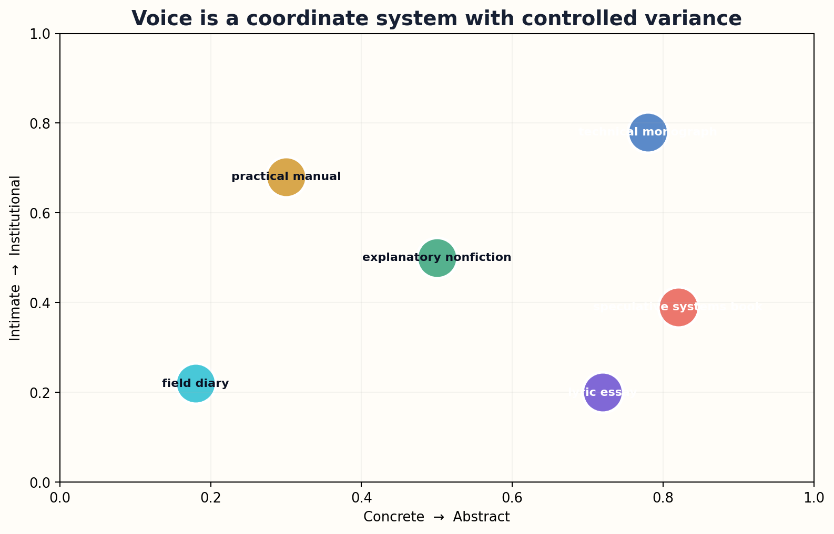
Figure 9. Voice can be mapped through interpretable coordinates while preserving controlled variance.

HOW THE MODEL WORKS
Voice also needs range. A uniform model-generated register produces fatigue. The profile defines a center and permitted variation by chapter function. An opening narrative may be intimate; a methods section precise; a warning direct; a synthesis expansive. Controlled variance preserves identity while allowing the book to breathe.
The framework explicitly rejects living-author imitation as a normal voice coordinate. A production system should describe desired properties rather than target a person’s signature. Originality audits can compare phrase overlap, syntactic patterns, imagery, scene structure, and narrative attention, but the goal is not to prove absolute uniqueness. It is to avoid deceptive dependence and preserve room for human authorship.

DESIGN IMPLICATIONS
Voice evaluation combines computational and human methods. Stylometric drift can identify accidental inconsistency. Read-aloud testing can reveal rhythm. Target readers can judge trust, clarity, and emotional fit. Editors can preserve deliberate irregularities that automated systems might mistakenly smooth. The genome guides judgment; it does not replace it.
V = center coordinates + permitted chapter-level variance + prohibited imitation targets
WORKED EXAMPLE
A technical field book can combine calm authority, concrete verbs, low metaphor density, explicit uncertainty, and short emergency procedures.
GENOME LAB
• Describe a voice using eight dimensions without naming an author.
• Define what the narrator consistently notices and ignores.
• Specify where the voice may vary across chapter functions.
Standards and research foundation: SCHEMA, PROVO. See Research Notes and Sources.

CHAPTER 10
Difficulty: A Surface, Not a Grade Level
A short sentence can contain a difficult idea; a long sentence can explain a simple one.
━━━━━━━━━━━━━━━━━━━━━━━━━
Readability formulas measure useful surface features, but difficulty is multidimensional. A book may use short sentences while assuming years of domain knowledge. It may use advanced notation with gentle conceptual pacing. It may be linguistically easy but emotionally demanding. The Genome therefore models difficulty as a surface over prerequisites, abstraction, concept density, notation, syntax, inferential distance, pace, memory load, emotional intensity, and support.
Difficulty is local as well as global. A chapter can contain a steep conceptual ridge followed by a long practice valley. The genome records a difficulty curve and identifies deliberate transitions. This makes it possible to detect accidental cliffs: a symbol introduced without definition, an example that assumes hidden cultural knowledge, or a chapter that compresses five prerequisite ideas into one paragraph.
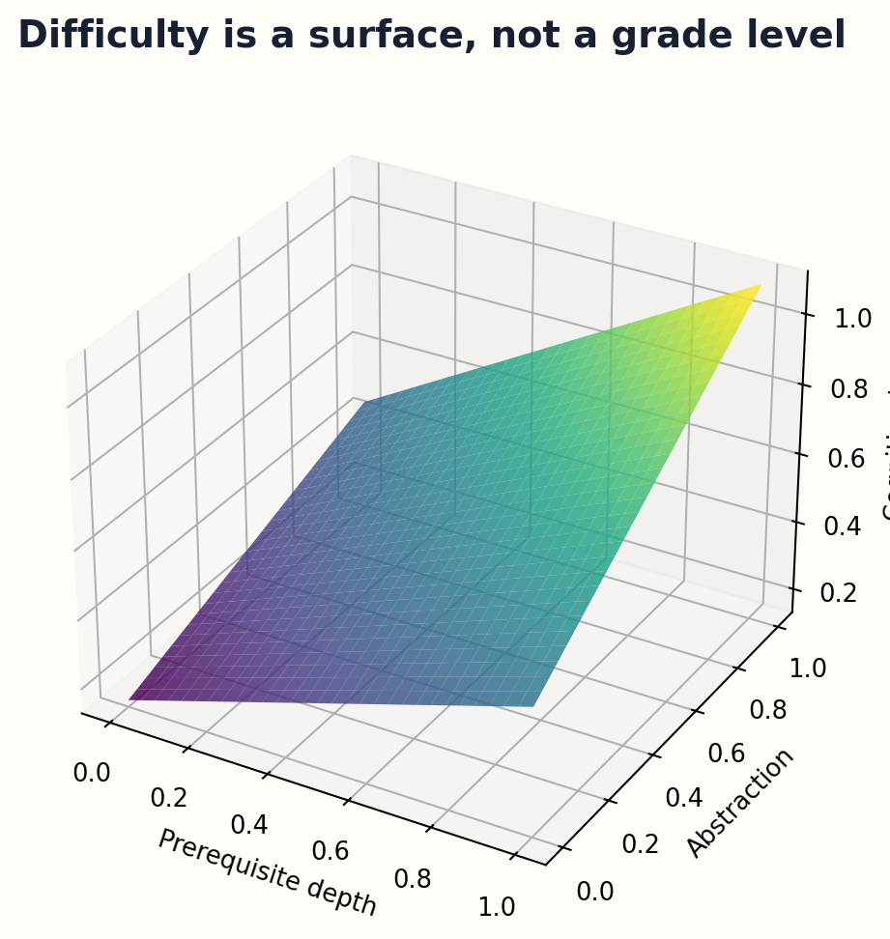
Figure 10. Difficulty emerges from interacting prerequisites, abstraction, and cognitive load.

HOW THE MODEL WORKS
The target is productive difficulty, not universal simplicity. Expert readers may need compression and formalism. Beginners may need concrete examples, repetition, and visible milestones. A work of literature may intentionally disorient before establishing a new interpretive frame. The difficulty chromosome states why the load exists and what support makes it worthwhile.
Difficulty adapts across expressions and manifestations. A translation may require different background explanation. An audio edition may need shorter syntactic units and verbalized equations. An interactive edition may move some complexity into simulation. These are genome overrides, not proof that the underlying work has changed purpose.

DESIGN IMPLICATIONS
Evaluation uses reader-state transitions rather than only text statistics. Comprehension, task performance, error patterns, rereading behavior, and self-reported load reveal where the designed surface differs from the experienced one. The result can guide a new edition without treating every struggle as a defect.
D(x) = f(prerequisites, abstraction, notation, syntax, inference, pace, memory, emotion, support)
WORKED EXAMPLE
A calculus book can lower linguistic complexity while preserving mathematical depth by externalizing prerequisite graphs and adding worked transformations.
GENOME LAB
• Plot a difficulty curve for one chapter.
• Identify one necessary difficulty and one accidental difficulty.
• Redesign a dense passage for audio without deleting its intellectual content.
Standards and research foundation: DCMI, SCHEMA, EPUB. See Research Notes and Sources.

PART III
THE INTERNAL ANATOMY
The structural systems that turn a genome into a coherent reading experience.

CHAPTER 11
Format: The Affordance Chromosome
Format is not a container after writing; it is part of the book’s theory of use.
━━━━━━━━━━━━━━━━━━━━━━━━━
Print, EPUB, web, audio, large print, braille, interactive simulation, and API-accessible reference systems do not offer the same actions. Print supports stable spatial memory and low-friction annotation. EPUB supports reflow, search, adjustable presentation, and accessibility metadata. Audio supports temporal immersion and screen-free use. Interactive systems can expose state, feedback, and branching. The format chromosome records which affordances are essential to the purpose.
A format profile contains navigation, pacing, media, input, output, accessibility, persistence, and offline requirements. A field manual may require one-handed navigation, offline access, high-contrast diagrams, and printable checklists. A scholarly monograph may require stable page or section anchors, citation export, equation fidelity, and permanent identifiers. A novel may prioritize uninterrupted reading and performance quality in audio.
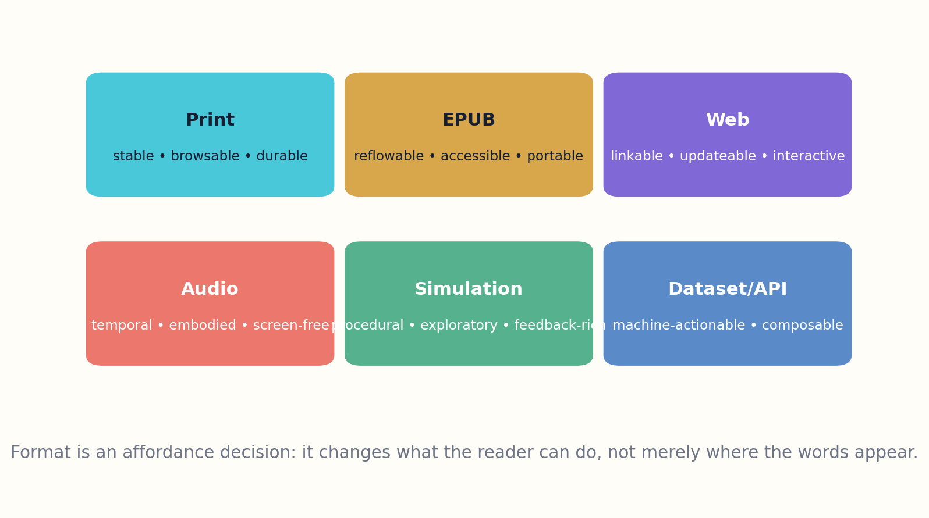
Figure 11. Formats preserve different reader actions and require deliberate adaptation.

HOW THE MODEL WORKS
The Genome distinguishes core content from format-native expression. A diagram can be core if the mechanism cannot be understood efficiently without it. A hover interaction may be a web-specific enhancement. An audio edition may require rewritten figure descriptions rather than a robotic reading of captions. Format equivalence is therefore evaluated by preserved function, not literal sameness.
Accessibility is embedded here but not confined here. The EPUB ecosystem provides accessibility requirements and discovery metadata, yet accessible design begins earlier: audience, difficulty, structure, visuals, and voice all influence access. The format genome records alternatives, hazards, controls, navigation landmarks, language, and assistive-technology behavior.

DESIGN IMPLICATIONS
A multi-format book is a family of designed manifestations. The Genome can generate a compatibility matrix showing which functions survive each format and which require adaptation. This prevents publishers from calling a file conversion a complete edition when the reader’s essential affordances were lost.
Format fitness = Σ(required reader actions preserved × accessibility × reliability) − interaction friction
WORKED EXAMPLE
An interactive statistics book may need manipulable plots; its print manifestation must replace manipulation with carefully selected comparative panels and exercises.
GENOME LAB
• List the essential reader actions for one book.
• Build a print/EPUB/audio compatibility matrix.
• Identify one feature that requires adaptation rather than conversion.
Standards and research foundation: EPUB, SCHEMA, ONIX. See Research Notes and Sources.

CHAPTER 12
Intellectual Contribution: The Reason to Exist
A book may be accurate and readable yet still add nothing that the world needs.
━━━━━━━━━━━━━━━━━━━━━━━━━
The contribution chromosome asks the uncomfortable commissioning question: why should this book exist? Topic coverage is not enough. A contribution may introduce new evidence, synthesize separated fields, create a better explanation, serve an ignored audience, preserve endangered knowledge, invent a useful format, reorganize a domain, expose a contradiction, or produce an original aesthetic experience.
Contribution is represented as a claim relative to a comparison set. The Genome names the existing books, articles, courses, archives, and tools that already serve similar purposes. It then states the proposed difference in audience, evidence, structure, method, voice, format, or outcome. This makes novelty falsifiable and reduces the common error of declaring a work unprecedented because the system failed to search properly.
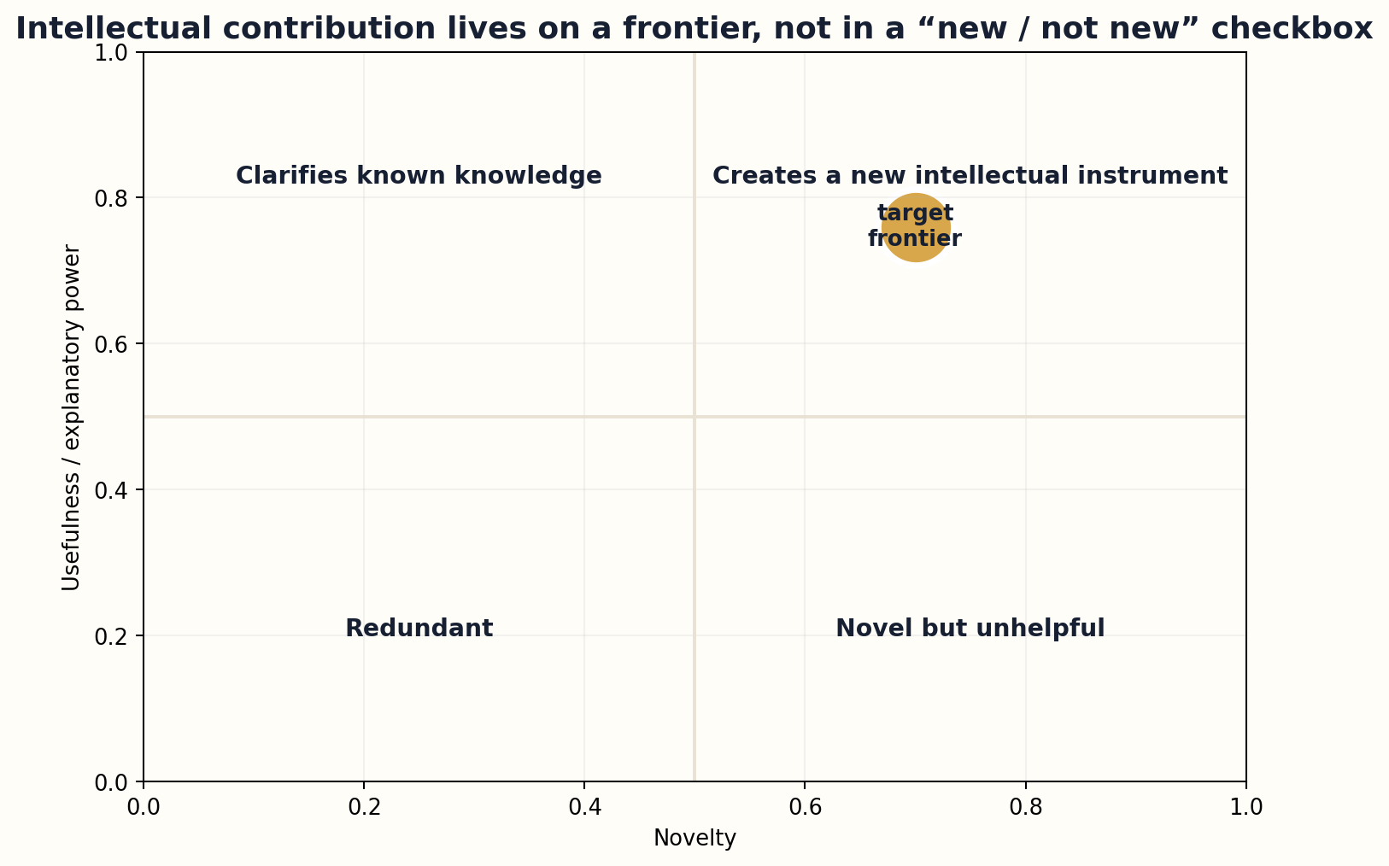
Figure 12. Contribution balances novelty and usefulness relative to an explicit comparison set.

HOW THE MODEL WORKS
Novelty alone is insufficient. A bizarre structure or new terminology can create distance without value. Contribution lives on a frontier between novelty and usefulness, with additional dimensions for durability, transferability, public value, and cost of maintenance. A clear synthesis for an underserved audience may contribute more than a technically novel but unusable artifact.
The contribution genome also records negative space. What does the book deliberately leave for other works? A focused book can be more valuable than an encyclopedic one if it declares its boundaries. This is particularly important for generative systems, which tend to expand scope until distinctiveness disappears into broad coverage.

DESIGN IMPLICATIONS
After publication, contribution becomes measurable through uptake, citation, learning, practice change, cultural response, reuse, and expert judgment. These signals do not define worth completely, but they reveal whether the proposed gap was real. A future edition can refine the contribution claim instead of preserving launch rhetoric forever.
C = novelty × usefulness × distinct audience value × durability − redundancy − maintenance burden
WORKED EXAMPLE
A new programming book may contribute not through new language facts but through a concept sequence that helps smartphone-only learners build reliable tools.
GENOME LAB
• Name the comparison set for a proposed book.
• Write a one-sentence contribution claim that can be challenged.
• List what the book will deliberately not attempt.
Standards and research foundation: CROSSREF, DATACITE, SCHEMA. See Research Notes and Sources.

CHAPTER 13
Rights, Provenance, and Ethical Constraints
A book’s genome must describe not only what it can do, but what it is permitted to become.
━━━━━━━━━━━━━━━━━━━━━━━━━
The seven primary chromosomes are incomplete without lineage. A book is assembled from sources, experiences, datasets, images, quotations, software, cultural knowledge, and human labor. The Genome therefore links to rights and provenance systems that record origin, permission, attribution, transformations, contributors, models, and review decisions. This layer is not an afterthought for lawyers; it shapes what the book may contain and how it may evolve.
Rights fields distinguish ownership from permission and permission from technical access. A source may be readable online but not licensed for redistribution or generative transformation. An image may have different terms from the text surrounding it. A cultural narrative may be legally public yet ethically require community participation. The Genome can carry machine-readable restrictions while preserving human notes for cases that cannot be reduced to standard licenses.
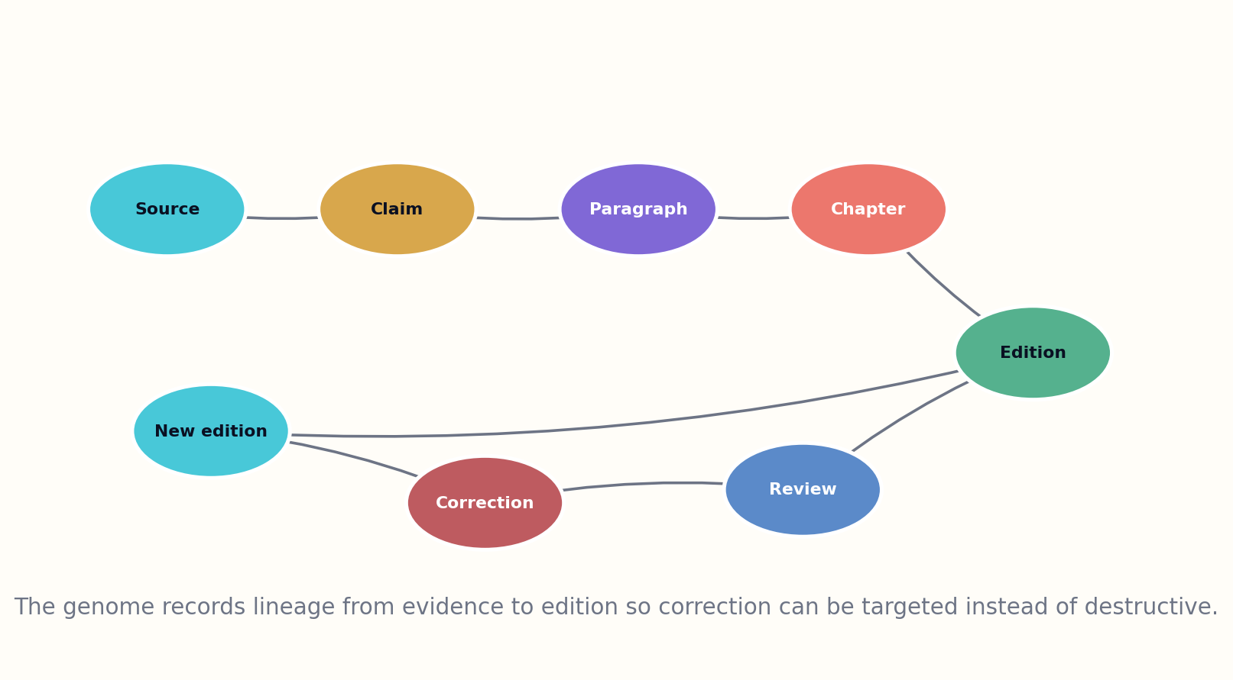
Figure 13. Claim and edition lineage allow targeted correction and rights repair.

HOW THE MODEL WORKS
Provenance records activities as well as objects. Which author, model, editor, translator, or tool created a passage? Which sources informed it? Which review changed it? Which edition inherited it? W3C PROV-O offers a general model for entities, activities, and agents; content-provenance systems can add signed manifests. The Book Genome specializes these ideas for editorial lineage.
Ethical constraints include prohibited audience targeting, privacy limits, representation rules, safety boundaries, and disclosure requirements. A children’s book, medical guide, or community history may require different governance. These constraints can block compilation even when the seven primary dimensions are otherwise complete.

DESIGN IMPLICATIONS
Provenance does not prove truth or fairness. A perfect record can document a bad decision. The value is inspectability and repair. When a source is corrected, a contributor withdraws permission, or a generated passage is found derivative, the dependency graph identifies every affected edition and adaptation.
Publishability = genome completeness × rights validity × provenance integrity × ethical clearance
WORKED EXAMPLE
A translated oral-history collection records consent, cultural restrictions, translator decisions, source audio, editorial cuts, and manifestation-specific access rules.
GENOME LAB
• Create a lineage record for one paragraph.
• Distinguish copyright permission from cultural permission.
• Define a condition that must block compilation.
Standards and research foundation: PROVO, DATACITE, C2PA. See Research Notes and Sources.

CHAPTER 14
The Structural Genotype
A table of contents is the visible skeleton; the structural genotype explains what each bone is for.
━━━━━━━━━━━━━━━━━━━━━━━━━
The structural genotype represents the book as a graph of functions rather than a sequence of headings. Nodes can be questions, claims, concepts, scenes, methods, examples, counterarguments, exercises, revelations, or decisions. Edges can mean prerequisite, supports, contradicts, foreshadows, applies, reframes, or resolves. The linear table of contents is one traversal through this richer structure.
For nonfiction, the structural graph connects governing question, thesis, mechanisms, evidence, alternatives, applications, and limits. For fiction, it connects world states, character goals, choices, consequences, promises, motifs, and revelations. Both forms require causality. A chapter that does not change the reader’s model or the story state is structurally suspect even if the prose is attractive.
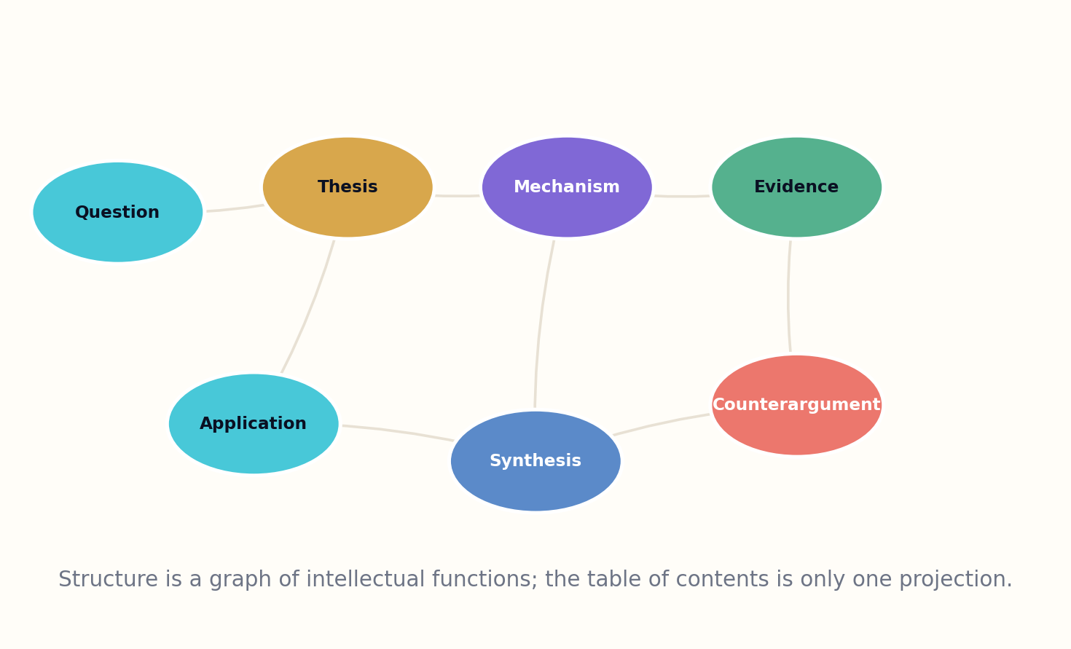
Figure 14. A structural graph represents intellectual functions beyond the visible table of contents.

HOW THE MODEL WORKS
Graph representation enables diagnostics. Orphaned concepts reveal definitions that never become useful. Unsupported claims reveal argumentative gaps. Repeated examples may indicate redundancy. A late prerequisite reveals an ordering defect. A scene that consumes attention without changing state reveals narrative drag. These findings guide editing without declaring that one structure fits every book.
The structural genotype also supports alternate expressions. A course can traverse the concept graph pedagogically. A reference edition can reorganize by task. An audio edition can create shorter navigation units. A summary can preserve the claim spine while dropping examples. Each traversal declares which structural functions it preserves or removes.

DESIGN IMPLICATIONS
Structure remains authored. Algorithms can propose paths and detect defects, but the choice of sequence carries meaning. Delaying a concept can create suspense; repeating an image can create resonance; violating expected order can force re-evaluation. The Genome records deliberate exceptions so automated optimization does not flatten them.
S = (nodes, typed edges, traversal rules, invariants, deliberate violations)
WORKED EXAMPLE
A systems book may revisit one equation in three chapters, each time changing its interpretation; the repetitions are linked as progressive reframings.
GENOME LAB
• Convert a table of contents into a typed graph.
• Find one orphan node and one late prerequisite.
• Design two different traversals through the same structural graph.
Standards and research foundation: BIBFRAME, SHACL. See Research Notes and Sources.

CHAPTER 15
Concept Dependencies and the Order of Understanding
The reader cannot climb a staircase whose missing steps exist only in the author’s memory.
━━━━━━━━━━━━━━━━━━━━━━━━━
Authors often underestimate the knowledge hidden inside apparently simple explanations. A paragraph about neural networks may assume vectors, functions, optimization, probability, data splits, and software conventions. The concept-dependency graph externalizes these assumptions. Each concept lists prerequisites, misconceptions, examples, representations, and transfer targets.
The graph supports topological ordering, but pedagogy is not a pure topological sort. Some concepts become understandable only through provisional intuition before formal definition. Others benefit from a spiral structure in which the reader revisits the same idea at increasing depth. The Genome therefore records dependency strength and teaching strategy: required before, helpful before, introduced intuitively, formalized later, or learned through practice.
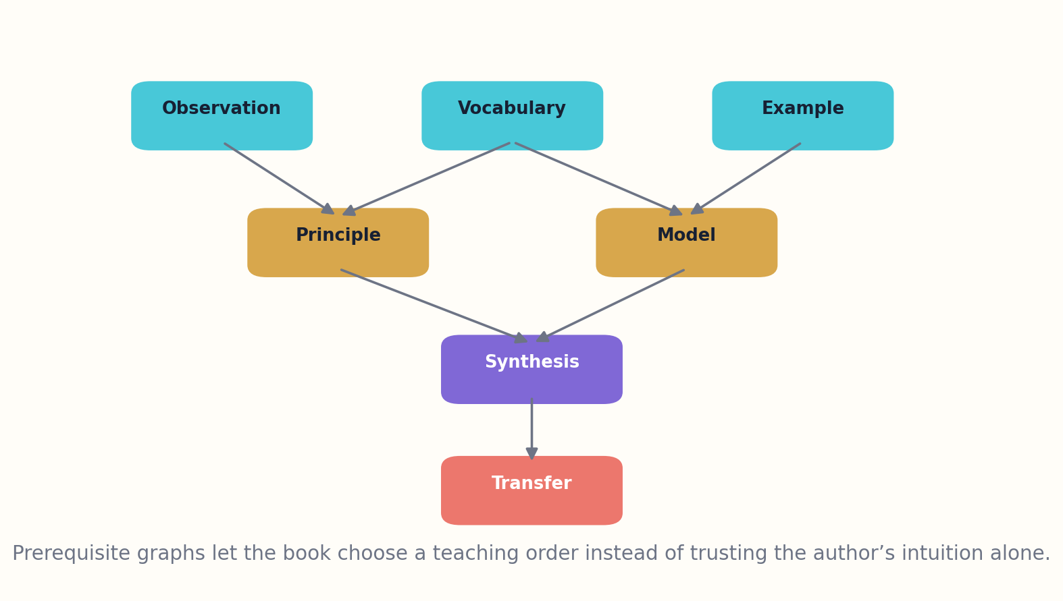
Figure 15. Concept dependencies make hidden prerequisites and teaching strategies explicit.

HOW THE MODEL WORKS
Misconceptions are first-class nodes. A good explanation does not merely add correct information; it competes with an existing model. The Genome links each misconception to diagnostic questions, counterexamples, and repair sequences. This lets evaluation distinguish absence of knowledge from a stable but wrong understanding.
Concept coverage is also audience-specific. An expert edition may omit foundations but should declare them. A beginner edition may include them while protecting momentum through optional layers. Translation can change dependencies when terminology or institutional background differs. Accessibility adaptations may require alternative representations rather than simpler content.

DESIGN IMPLICATIONS
At library scale, concept graphs enable learning paths across books. A reader can assemble a route through chapters from several works, while the Genome preserves each book’s integrity. The result is not atomized content without authorship; it is a navigable ecology of authored explanations.
Teaching order minimizes prerequisite violations while maximizing motivation, coherence, and transfer
WORKED EXAMPLE
A cybersecurity book can teach threat modeling before cryptographic detail, using provisional models that are formalized later.
GENOME LAB
• Build a ten-node concept dependency graph.
• Add two misconceptions and their repair paths.
• Mark which prerequisites are required, helpful, or intentionally deferred.
Standards and research foundation: DCMI, SCHEMA. See Research Notes and Sources.

PART IV
THE COMPUTABLE BOOK
Ontologies, schemas, validation, similarity, search, and generation.

CHAPTER 16
Chapter Functions and Reader-State Transitions
A chapter is not a container of words. It is a planned transition in the reader’s internal model.
━━━━━━━━━━━━━━━━━━━━━━━━━
The chapter-function model assigns each chapter a dominant job: orient, define, establish stakes, build mechanism, demonstrate, complicate, compare, test, transfer, integrate, or conclude. A chapter can perform several functions, but naming the dominant transition prevents the middle of a book from becoming an undifferentiated accumulation of information.
Every chapter begins with an entry state and ends with an exit state. The entry state names what the reader should already know, believe, feel, or be able to do. The exit state names what has changed. The difference becomes the chapter contract. Examples, figures, equations, and exercises are selected because they produce this transition, not because the author happens to possess them.
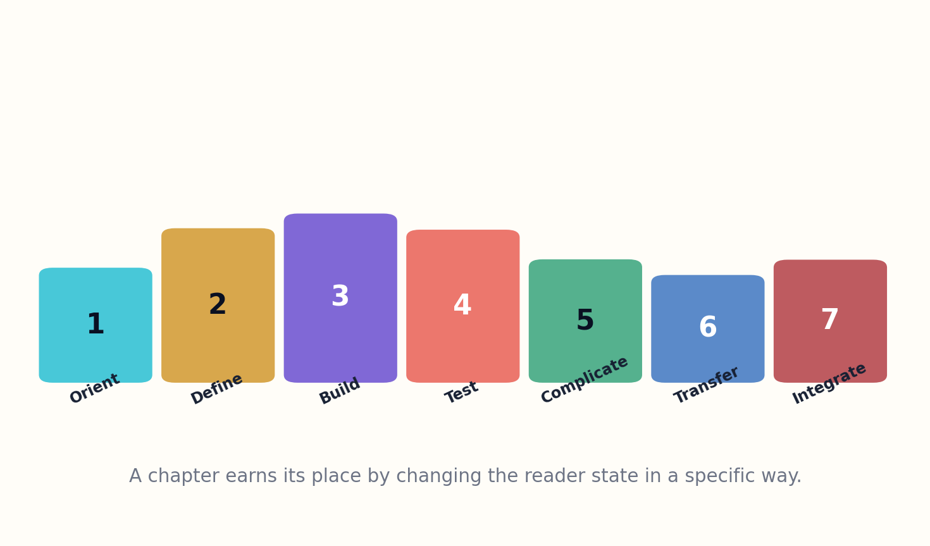
Figure 16. Chapter functions create a designed sequence of reader-state transitions.

HOW THE MODEL WORKS
Function sequencing produces rhythm. Orientation cannot continue forever; complication without consolidation exhausts the reader; repeated demonstration can feel stagnant; transfer arrives too early if the underlying model is unstable. The Genome can visualize the sequence as a waveform and detect long runs of the same function.
Fiction chapters use analogous transitions: reveal, escalate, choose, fail, reframe, recover, converge, or transform. The exit state includes character knowledge, relationship changes, world conditions, promises, and reader expectations. This makes continuity and pacing inspectable without turning the novel into a formula.

DESIGN IMPLICATIONS
During revision, chapter-level evaluation asks whether the promised transition occurred. If readers remember facts but cannot apply the model, the chapter may have informed without teaching. If a dramatic chapter changes nothing downstream, it may have generated sensation without consequence. These diagnoses are more useful than asking whether the chapter is simply “good.”
Chapter value = distance(exit state, entry state) × relevance to governing purpose
WORKED EXAMPLE
A chapter titled “Security Basics” is redesigned as “Build a threat model for a real app,” changing the exit state from recognition to action.
GENOME LAB
• Assign dominant functions to every chapter of a book.
• Write entry and exit states for one chapter.
• Find a sequence with too many identical functions and redesign it.
Standards and research foundation: SHACL. See Research Notes and Sources.

CHAPTER 17
Examples, Exercises, and Assessment as Genome Elements
An explanation is incomplete until the reader has a chance to act on it and receive evidence about the result.
━━━━━━━━━━━━━━━━━━━━━━━━━
Examples are not decorative confirmations. They select which features of a concept become visible. A single clean example can create false confidence; a diverse example set reveals boundaries and invariants. The Genome classifies examples as introductory, representative, adversarial, edge-case, counterexample, worked solution, historical case, or transfer case.
Exercises are tied to the purpose vector and concept graph. Recall exercises test retrieval. Explanation exercises test model reconstruction. Calculation exercises test procedure. Design tasks test synthesis. Diagnosis tasks test discrimination among failure modes. Reflection tasks test integration with experience. A book that promises practice change but contains only recall questions has a genome-phenotype mismatch.
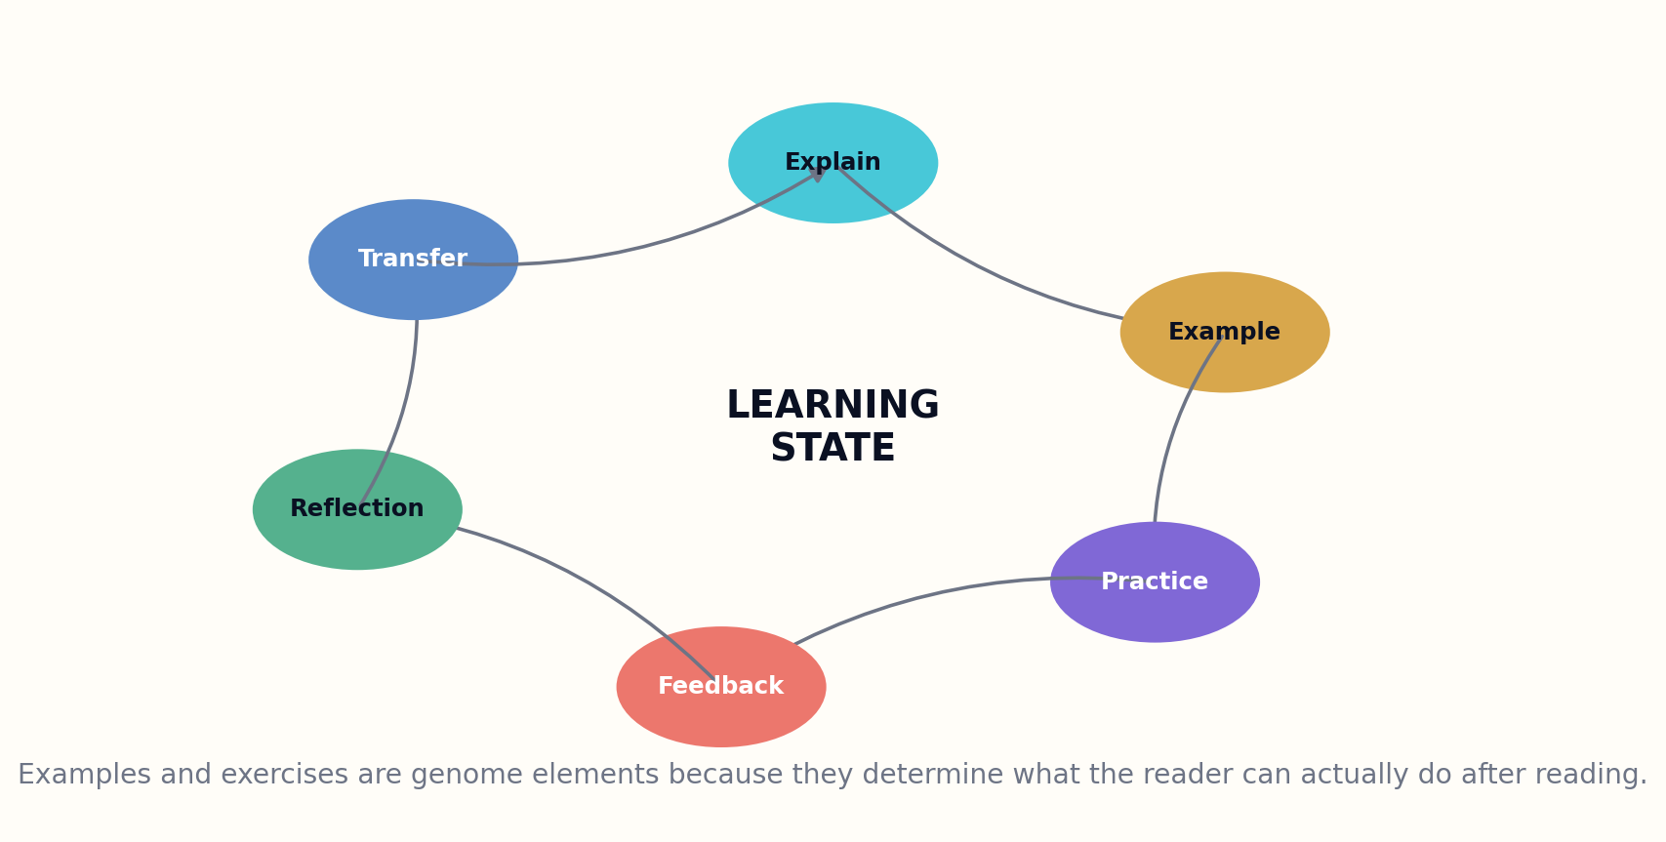
Figure 17. Examples, practice, feedback, reflection, and transfer form a complete learning loop.

HOW THE MODEL WORKS
Feedback is part of the exercise design. A correct answer alone may not reveal why a tempting alternative is wrong. The Genome can specify hints, common errors, partial-credit logic, worked paths, and escalation. Interactive manifestations may provide immediate feedback; print editions can provide layered hints and solution maps.
Assessment must respect reader agency. Not every book needs testing, and not every learning outcome should be reduced to a score. A memoir can invite reflection without measuring it. A novel can create interpretive possibilities rather than one correct response. The chromosome records whether outcomes are assessed, observed, invited, or deliberately left open.

DESIGN IMPLICATIONS
Evaluation data can improve later editions, but privacy and context matter. Error patterns are more useful than surveillance of individual readers. The goal is to learn where the design failed, not to classify people permanently. Aggregate evidence should update the book genome while preserving the integrity of the published edition.
Exercise alignment = targeted capability ∩ required concept ∩ valid evidence of performance
WORKED EXAMPLE
A food-safety manual adds scenario diagnosis and threshold decisions instead of ending chapters with vocabulary quizzes.
GENOME LAB
• Classify ten examples by function.
• Design one recall, one diagnosis, and one transfer exercise for the same concept.
• Specify feedback for the most tempting wrong answer.
Standards and research foundation: SCHEMA, DCMI. See Research Notes and Sources.

CHAPTER 18
Citation, Uncertainty, and Claim Lineage
A citation should not be a decorative fence around a paragraph; it should expose the path from evidence to language.
━━━━━━━━━━━━━━━━━━━━━━━━━
The citation genome links claims to exact support, not merely to works. A claim record stores source span, claim type, scope, date, evidence class, confidence, and known counterevidence. The published book can show conventional notes while maintaining a richer machine-readable ledger behind them. This makes fact-checking and revision more precise.
Uncertainty has several forms: measurement uncertainty, sampling uncertainty, model uncertainty, disagreement, missing evidence, future uncertainty, and interpretive ambiguity. The Genome represents the form rather than attaching a generic confidence score. Language rules map these states to prose so that “may,” “likely,” and “established” have controlled meanings within the book.

Figure 18. Claim and edition lineage allow targeted correction and rights repair.

HOW THE MODEL WORKS
Citation quality depends on directness. A review may be appropriate for consensus, while a specific numerical claim may require the original study or dataset. A repeated statement across many secondary sources does not become independent evidence. The claim graph detects citation laundering and shared dependencies.
Lineage supports living editions. When a source is corrected, retracted, or superseded, the system traverses dependent claims, paragraphs, figures, translations, and audio editions. Editors receive an impact map and can issue a notice, patch, or major revision. The old edition remains recoverable.

DESIGN IMPLICATIONS
The same system supports intellectual honesty in speculative work. A chapter can clearly identify what is documented, what is inferred, and what the author proposes. This frees the book to think aggressively while allowing readers to see where the floor of evidence ends.
Claim confidence = evidence quality × directness × scope match × independence − contradiction pressure
WORKED EXAMPLE
A graph label, paragraph sentence, and executive summary all point to the same claim identifier, allowing one correction to find every surface form.
GENOME LAB
• Create claim-level citations for a paragraph.
• List three different forms of uncertainty.
• Design an impact query for a retracted source.
Standards and research foundation: CROSSREF, DATACITE, PROVO. See Research Notes and Sources.

CHAPTER 19
Visual Grammar and Multimodal Reasoning
A figure earns space when it lets the reader answer a question that prose answers poorly.
━━━━━━━━━━━━━━━━━━━━━━━━━
The visual chromosome is part of structure and format. It specifies which questions require maps, timelines, networks, plots, tables, mechanism diagrams, equations, photographs, or illustrations. The choice is semantic: maps answer where, timelines answer when, networks answer how things relate, plots answer how quantities vary, and diagrams answer how a mechanism is organized.
Each visual has a task, data lineage, caption, reading order, and accessibility alternative. A decorative image may support atmosphere, but it should be labeled as such rather than presented as evidence. A technical figure should expose scales, units, uncertainty, and transformations. A diagram should avoid implying causal relationships that the evidence does not support.
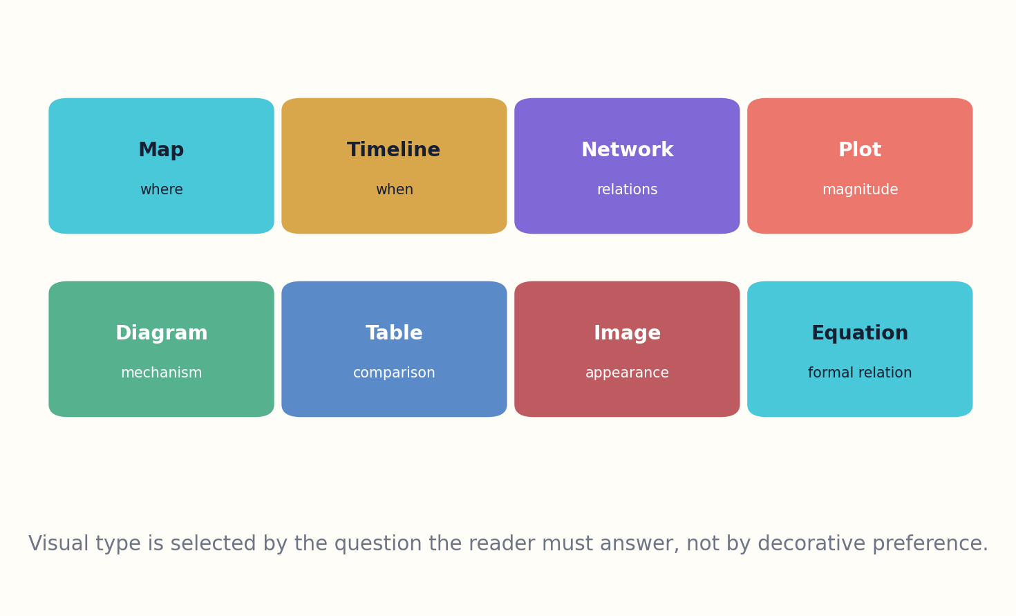
Figure 19. Visual forms are chosen by the question they must help the reader answer.

HOW THE MODEL WORKS
The Genome links figures to the concepts and claims they serve. If a figure is removed, the system can identify which explanations lose support. If a translation changes text length or direction, the figure can be regenerated while preserving semantic roles. If an audio edition cannot render the visual directly, the genome specifies a structured verbal explanation and optional tactile or downloadable alternative.
Multimodal books can also include simulations, code, datasets, and interactive controls. These artifacts receive version, rights, and reproducibility metadata. A screenshot is not a substitute for an executable model when the reader’s goal is exploration. Conversely, an interactive widget should not replace a stable explanation that remains usable after the software disappears.

DESIGN IMPLICATIONS
Visual consistency is governed by a grammar rather than a color palette alone. Repeated shapes, arrows, scales, and labels acquire meaning across chapters. The Genome records these semantics so later editions and generated diagrams do not drift into contradictory visual language.
Visual value = question answered × information compressed × error prevented × accessibility
WORKED EXAMPLE
A causal loop diagram and a time-series chart can use the same data but answer different questions; the genome records both roles.
GENOME LAB
• Name the question answered by every figure in one chapter.
• Replace one decorative figure with a functional visual.
• Write an audio alternative that preserves the reasoning, not just appearance.
Standards and research foundation: EPUB, SCHEMA. See Research Notes and Sources.

CHAPTER 20
The Fiction Genome
A novel has a genome too, but its truth lives in causality, experience, language, and artistic consequence.
━━━━━━━━━━━━━━━━━━━━━━━━━
The fiction genome uses the seven chromosomes differently. Purpose becomes artistic and emotional intention. Audience describes genre literacy, desired challenge, and cultural context. Evidence becomes research grounding, internal-world consistency, and the honesty of paratextual claims. Voice remains central. Difficulty includes formal experimentation, temporal complexity, ambiguity, and emotional load. Format can support branching, audio performance, or illustrated worldbuilding. Contribution describes the work’s aesthetic and cultural reason to exist.
Additional structures represent world rules, character states, relationships, plot causality, theme, motifs, promises, and reader knowledge. Characters are modeled as changing policies under pressure: desire, fear, belief, memory, obligation, power, and strategy. Plot is a search through plausible choices and consequences, not a list of events.
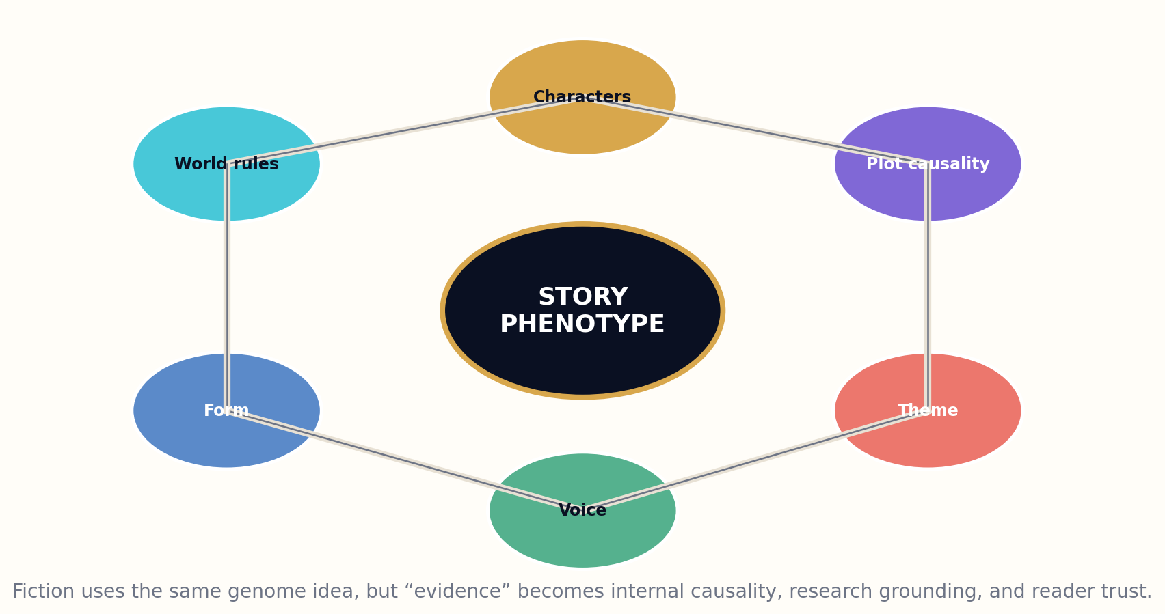
Figure 20. A fiction genome preserves world, character, plot, theme, voice, and form commitments.

HOW THE MODEL WORKS
The fiction genome protects against generative sameness. A system can compare proposed works across theme, structure, world logic, character dynamics, image systems, and voice coordinates. Surface variation does not count as originality if the causal and emotional architecture is copied. Living-author imitation is excluded as a normal production mode.
Evaluation remains plural. Continuity and causal coherence can be tested computationally. Phrase overlap and structural dependence can be audited. Human readers judge emotional credibility, surprise, beauty, cultural depth, and the productive ambiguity that formal tests might punish. A novel can violate its own pattern if the violation creates meaning.

DESIGN IMPLICATIONS
The goal is not to expose every mystery inside a machine-readable record. Public genome summaries can remain high-level, while private production state preserves continuity. The framework helps authors and systems maintain artistic commitments across long works without turning literature into a deterministic recipe.
Story phenotype = world constraints × character policies × consequential choices × voice × reader inference
WORKED EXAMPLE
Two climate novels can share a setting but differ in purpose, moral geometry, narrator distance, plot causality, and formal contribution.
GENOME LAB
• Write a fiction genome without giving away the ending.
• Model one character as state variables rather than adjectives.
• Identify the difference between genre convention and derivative dependence.
Standards and research foundation: PROVO, SCHEMA. See Research Notes and Sources.

PART V
EVOLUTION AND FITNESS
Evaluation, controlled variation, versioning, accessibility, and living editions.

CHAPTER 21
The Book Genome Ontology
A vocabulary becomes infrastructure when independent systems can exchange it without sharing one database or one worldview.
━━━━━━━━━━━━━━━━━━━━━━━━━
The ontology defines classes, properties, relationships, controlled vocabularies, and extension points. The central BookGenome entity links to PurposeProfile, AudienceProfile, EvidenceModel, VoiceProfile, DifficultyProfile, FormatProfile, ContributionProfile, StructureGraph, RightsPolicy, EvaluationProfile, and VersionLineage. Each profile can be simple for ordinary publishing or specialized for a domain.
The model reuses existing terms where they are sufficient. Dublin Core and Schema.org can represent audience, education level, format, language, citation, and rights. IFLA LRM and BIBFRAME provide bibliographic identity relationships. DataCite provides identifiers, related resources, version, rights, and descriptions. PROV-O provides entities, activities, and agents. The Genome defines new terms only for the intellectual-design commitments that these standards do not express.
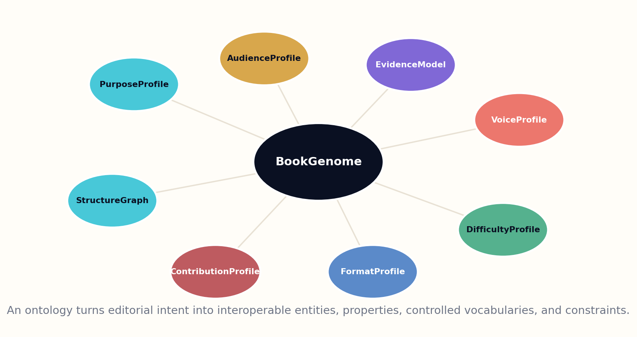
Figure 21. The ontology links core genome profiles while remaining extensible.

HOW THE MODEL WORKS
Ontology design follows open-world semantics: missing data does not automatically mean false. Validation is handled separately through shapes and profiles. A minimal genome may require only purpose, audience, contribution, and confidence. A high-stakes technical profile may require claim-level evidence, named reviewers, version triggers, and format accessibility fields.
Controlled vocabularies remain extensible. Purpose modes, chapter functions, evidence classes, and contribution types have stable core identifiers, while communities can define domain-specific extensions. Extensions declare broader mappings so a general system can still understand that a “clinical practice transformation” is a kind of guidance purpose.

DESIGN IMPLICATIONS
Governance matters more than elegance. Terms need definitions, examples, counterexamples, change histories, deprecation rules, and multilingual labels. A small standards group should not freeze one culture’s assumptions into every book. The ontology must support local vocabularies and community authority while preserving interoperable cores.
Ontology usefulness = semantic precision × reuse × extensibility × governance × implementation cost⁻¹
WORKED EXAMPLE
A library can query all books with “guide” as a broad purpose while a medical system uses the specialized subtype “clinical decision support.”
GENOME LAB
• Define five core classes and ten properties.
• Identify three fields that should reuse existing standards.
• Design one community extension with a broader mapping.
Standards and research foundation: BIBFRAME, IFLA-LRM, DCMI, SCHEMA, PROVO. See Research Notes and Sources.

CHAPTER 22
JSON-LD Serialization and SHACL Validation
A genome should be editable by humans, exchangeable on the web, and testable by machines.
━━━━━━━━━━━━━━━━━━━━━━━━━
JSON-LD provides a practical serialization because it looks like ordinary JSON while linking fields to globally defined terms. Editorial tools can present friendly forms and export linked data. The same record can be stored in document databases, transformed into RDF, queried with graph tools, and embedded in web pages or EPUB packages.
Serialization separates identifiers from labels. A purpose value is not merely the string “teach”; it is an IRI whose definition and translations are known. Audience profiles can link to controlled prerequisite concepts. Evidence claims can link to DOI, ISBN, arXiv, or URL identifiers. This makes records mergeable across institutions without requiring identical local interfaces.
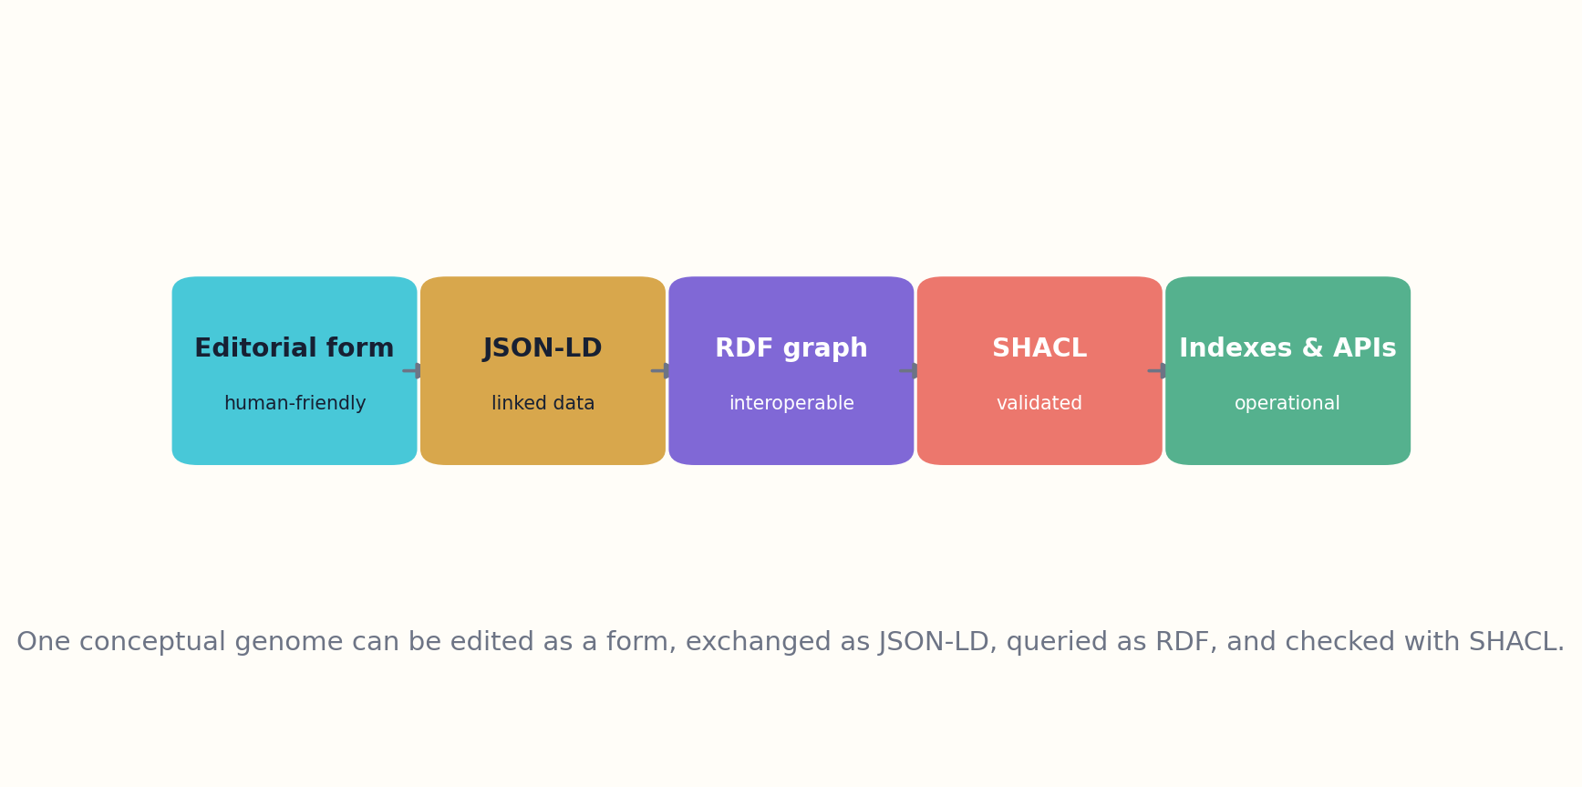
Figure 22. Human-friendly records become interoperable linked data and validated graphs.

HOW THE MODEL WORKS
SHACL validates profile requirements. A general BookGenome shape may require one purpose profile, at least one audience profile, one contribution statement, a language, and a provenance assertion. A high-stakes nonfiction shape may additionally require evidence policies, claim ledgers, reviewer roles, and version triggers. A fiction shape may require originality constraints and internal-consistency structures rather than external claim coverage.
Validation reports should be editorial. A failing shape needs severity, explanation, and repair guidance. Some findings block publication; others warn about incomplete discovery metadata. A shape can be deactivated for a justified exception, but the exception is recorded. This avoids the false choice between rigid schemas and ungoverned free text.

DESIGN IMPLICATIONS
The serialization is versioned independently from the book. A genome-schema update may add a better field without changing the Work. Migrations preserve original records and document transformations. Stable contexts and test suites are essential before the framework becomes infrastructure.
Valid(profile) ⇔ every required node and property satisfies the selected SHACL shapes
WORKED EXAMPLE
A publisher exports a compact JSON-LD genome; a library enriches it with local subjects without altering the publisher’s signed source record.
GENOME LAB
• Write a minimal JSON-LD genome.
• Define one blocking and one warning SHACL constraint.
• Design a migration for a renamed property.
Standards and research foundation: JSONLD, SHACL, DATACITE. See Research Notes and Sources.

CHAPTER 23
Genome Similarity, Search, and Recommendation
Readers do not need the book closest in topic. They need the book closest to their present task.
━━━━━━━━━━━━━━━━━━━━━━━━━
Traditional recommendation often relies on sales, co-reading, subject similarity, or broad genre. Genome search adds functional similarity. A reader can ask for a concise practical guide with moderate evidence depth, low prerequisite load, calm voice, offline format, and a contribution focused on field decisions. This query describes the desired reading experience rather than naming a title.
Similarity combines heterogeneous distances. Purpose mixtures can use distribution distance. Audience profiles can compare prerequisite and goal graphs. Evidence models can compare source classes and uncertainty policies. Voice can use interpretable coordinates plus text-derived features. Difficulty can compare surfaces. Format can compare required affordances. Contribution can compare claimed gaps and comparison sets.
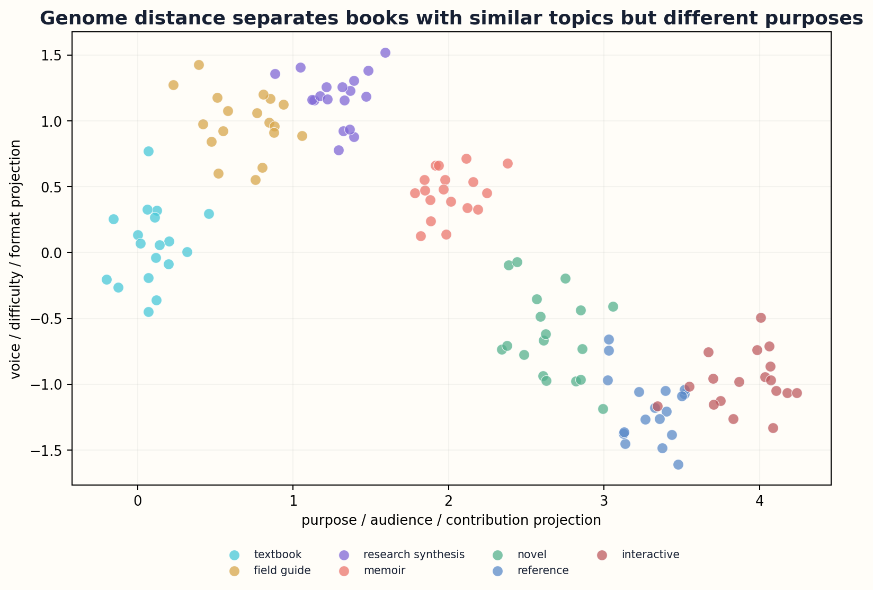
Figure 23. Genome similarity supports functional recommendation beyond topic matching.

HOW THE MODEL WORKS
Recommendation must preserve diversity. The nearest genome may produce a filter bubble of familiar forms. Systems can offer a primary fit plus deliberate alternatives: a more challenging evidence profile, a different cultural voice, a visual format, or a dissenting intellectual contribution. The Genome explains why each alternative is different.
Cold-start problems improve because a new book can be recommended before sales data exists. Its declared genome, verified samples, and evaluation profile provide meaningful features. Likewise, a reader can describe a desired state without surrendering a detailed behavioral history. Preference can be session-specific and stored locally.

DESIGN IMPLICATIONS
Explanations become concrete. Instead of “readers like you enjoyed this,” the system can say: “This book assumes the concepts you already know, uses case-based explanation, includes executable exercises, and treats the controversy at the evidence depth you requested.” Recommendation becomes a transparent match between reader state and book design.
Recommendation score = fit(reader state, genome) + diversity value + trust − friction − risk
WORKED EXAMPLE
Two books with identical subjects are separated because one is a reference work and the other a narrative learning path.
GENOME LAB
• Create a genome-based search query.
• Define distances for three chromosomes.
• Design an explanation that does not expose private reader data.
Standards and research foundation: SCHEMA, BIBFRAME. See Research Notes and Sources.

CHAPTER 24
Gap Detection and Portfolio Intelligence
A library’s deepest blind spot is not the topic it lacks, but the reader transformation it never attempted.
━━━━━━━━━━━━━━━━━━━━━━━━━
Portfolio analysis aggregates genomes to reveal overproduction and absence. A publisher may discover hundreds of introductory explanations but few transition books that move readers from beginner to practitioner. A national library may find strong coverage in dominant languages and weak coverage in accessible formats. A generative library may identify regions where source evidence is mature but no book serves a particular audience.
Gap detection combines unmet need, source readiness, public value, competition, maintenance burden, and editorial capacity. Bright regions on a gap map do not automatically trigger generation. They generate commissioning questions. Human institutions decide whether the gap reflects real demand, structural neglect, or a category that should not be optimized through volume.
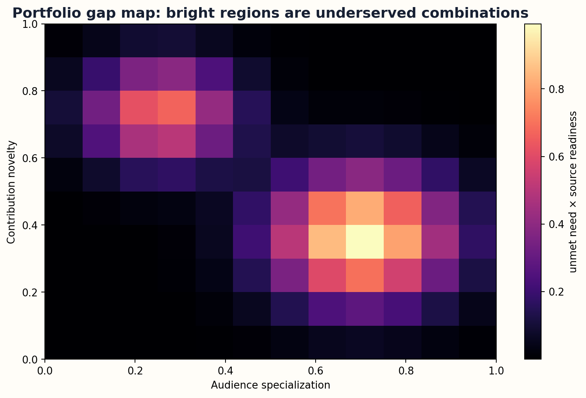
Figure 24. Portfolio analysis exposes underserved combinations of audience and contribution.

HOW THE MODEL WORKS
The contribution chromosome prevents redundant commissioning. Candidate genomes are compared with existing works across purpose, audience, evidence, structure, format, and claimed contribution. A new title can still enter a crowded topic if it makes a distinct transformation. Conversely, a fashionable new subject may not justify another book if the proposed genome differs only in marketing.
Portfolio intelligence supports equity. Institutions can reserve capacity for minoritized languages, disabilities, local knowledge, rare professions, and low-demand high-consequence subjects. These allocations are visible and governed rather than hidden behind recommendation algorithms. The Genome provides the measurement layer; policy supplies the values.

DESIGN IMPLICATIONS
After publication, phenotype data updates the map. A theoretically underserved region may remain unused because the audience model was wrong or distribution failed. A small book may reveal intense value for a community. The system learns without equating popularity with importance.
Gap opportunity = unmet need × source readiness × public value × genome distinctiveness ÷ maintenance cost
WORKED EXAMPLE
A portfolio has many AI introductions but no low-bandwidth, smartphone-first workbook for learners without laptops; the gap is format plus audience, not topic.
GENOME LAB
• Build a two-dimensional gap map for a small catalog.
• Add a protected public-interest allocation.
• Distinguish a real gap from a marketing invention.
Standards and research foundation: ONIX, BIBFRAME, SCHEMA. See Research Notes and Sources.

CHAPTER 25
The Book Compiler
Generative writing becomes reliable only when the system compiles a genome instead of improvising a manuscript.
━━━━━━━━━━━━━━━━━━━━━━━━━
The Book Compiler turns a genome, source graph, and authorship process into a phenotype. It does not begin by asking a model to write chapter one. It validates the genome, resolves rights, retrieves evidence, builds the concept and structure graphs, assigns chapter functions, generates an evaluation plan, and only then creates bounded drafting tasks.
Each task receives typed inputs and outputs. A research agent produces claim packets. An architect produces a chapter-state transition. A writer produces prose constrained by voice and evidence. A visual agent produces a figure with a declared question and data lineage. A skeptic searches for contradiction. An editor integrates findings. Human contributors can lock decisions that machines may not override.
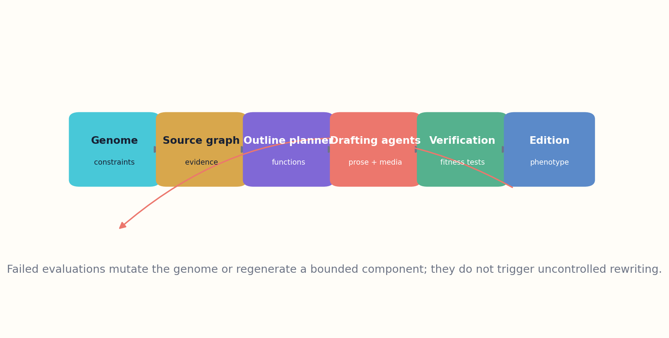
Figure 25. The Book Compiler turns a genome and source graph into a tested phenotype.

HOW THE MODEL WORKS
Compilation is incremental and checkpointed. Chapters can be drafted in parallel only when shared concepts, terminology, and claims are stable. A failed test regenerates the smallest affected component. The system avoids the catastrophic revision pattern in which one late correction causes an uncontrolled rewrite of the whole book.
The compiler maintains two representations: the artifact and the ledger. The artifact is the readable book. The ledger contains genome versions, sources, prompts, model versions, decisions, tests, and human changes. Readers may see a concise production statement while auditors can inspect the deeper record.

DESIGN IMPLICATIONS
Human authorship remains central because a genome does not choose what deserves to matter. The compiler can increase coherence and traceability, but purpose, contribution, ethical boundaries, aesthetic judgment, and final release require accountable people. The system should amplify authorship, not use formalism to erase it.
Book = Compile(genome, source graph, human decisions, tools, constraints, evaluations)
WORKED EXAMPLE
A 30-chapter technical book is generated as hundreds of typed artifacts rather than one enormous prompt and one opaque output.
GENOME LAB
• Draw the dependency graph for a book compiler.
• Define the smallest regenerable unit after a failed fact check.
• List decisions that must remain human-controlled.
Standards and research foundation: PROVO, SHACL, JSONLD. See Research Notes and Sources.

PART VI
THE BOOK GENOME ECOSYSTEM
Publishing, libraries, education, AI systems, governance, and launch.

CHAPTER 26
Evaluation: From Review to Fitness Profile
A book passes when independent evidence shows that it fulfills its genome—not when one model assigns a high score.
━━━━━━━━━━━━━━━━━━━━━━━━━
Evaluation compares phenotype with design. The fitness profile includes truth, reader fit, clarity, coherence, distinctiveness, accessibility, durability, rights compliance, and purpose-specific outcomes. Publication is a threshold across dimensions rather than an average that allows one catastrophic weakness to be hidden by several strengths.
Different evaluators inspect different risks. Domain experts assess claims and contribution. Target readers reveal comprehension and usability. Literary critics assess voice, form, and emotional consequence. Accessibility specialists test actual reading systems and assistive technologies. Automated tools detect broken links, undefined concepts, citation mismatch, continuity errors, and schema violations. No evaluator is permitted to certify its own output alone.
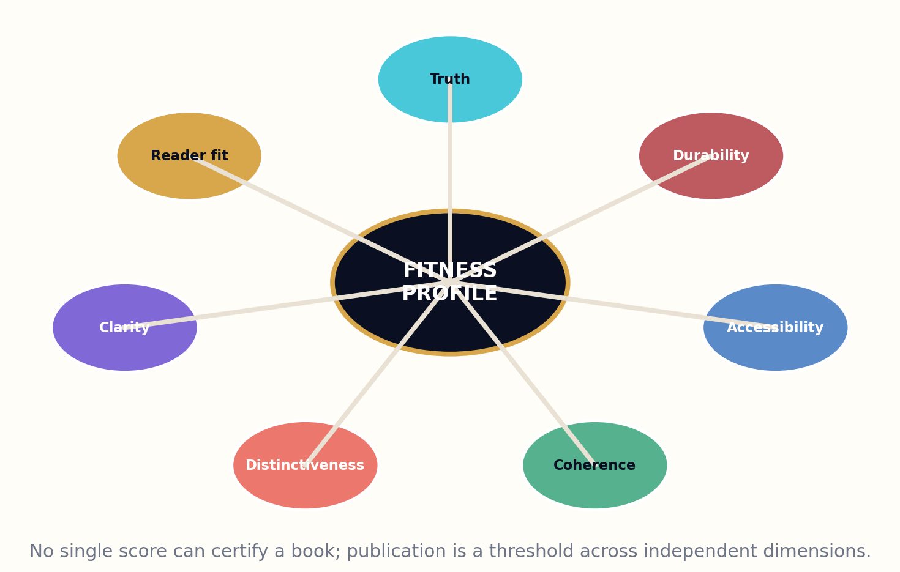
Figure 26. A fitness profile evaluates independent dimensions rather than one universal score.

HOW THE MODEL WORKS
Evaluation design is part of the genome because outcomes determine evidence collection. A teaching book may use pre/post concept tasks and delayed transfer. A reference work may use search-time and decision accuracy. A novel may use diverse human panels and long-form qualitative response. A preservation work may prioritize contributor approval and contextual integrity.
Scores carry uncertainty and evaluator provenance. Expert disagreement is retained. A work can pass with a minority objection if the release record explains the decision. Reader tests can reveal that a book serves an unexpected audience; this becomes phenotype evidence rather than an automatic rewrite of intent.

DESIGN IMPLICATIONS
The fitness profile persists after publication. Corrections, reviews, classroom outcomes, citations, and use in practice update the record. Reputation attaches to editions and genome claims, not to a permanent binary label of “good book.”
Release iff min(truth, rights, safety, accessibility, purpose fit) ≥ tier threshold
WORKED EXAMPLE
A beautiful health guide fails publication because its evidence score is below the high-stakes threshold, despite strong clarity and reader engagement.
GENOME LAB
• Define a fitness profile for one genre.
• Choose which dimensions behave as hard gates.
• Record and preserve one minority review opinion.
Standards and research foundation: SHACL, EPUB, PROVO. See Research Notes and Sources.

CHAPTER 27
Mutation, Crossover, and Controlled Variation
The genetic metaphor is most useful when it describes deliberate editorial variation—not automated reproduction without responsibility.
━━━━━━━━━━━━━━━━━━━━━━━━━
Genome mutation creates a new design candidate by changing one or more bounded commitments. A book can be retargeted to a new audience, narrowed to a field guide, deepened into a research monograph, shifted into audio-first form, reframed through a different evidence policy, or reorganized around a new contribution. Each mutation declares what changed and what remains inherited.
Crossover combines compatible components from different genomes: the pedagogical sequence of one work, the evidence architecture of another, and a new voice and contribution. This process carries strong originality and rights risks. It should operate on abstract design patterns and licensed components, not on concealed copying of prose or authorial identity.
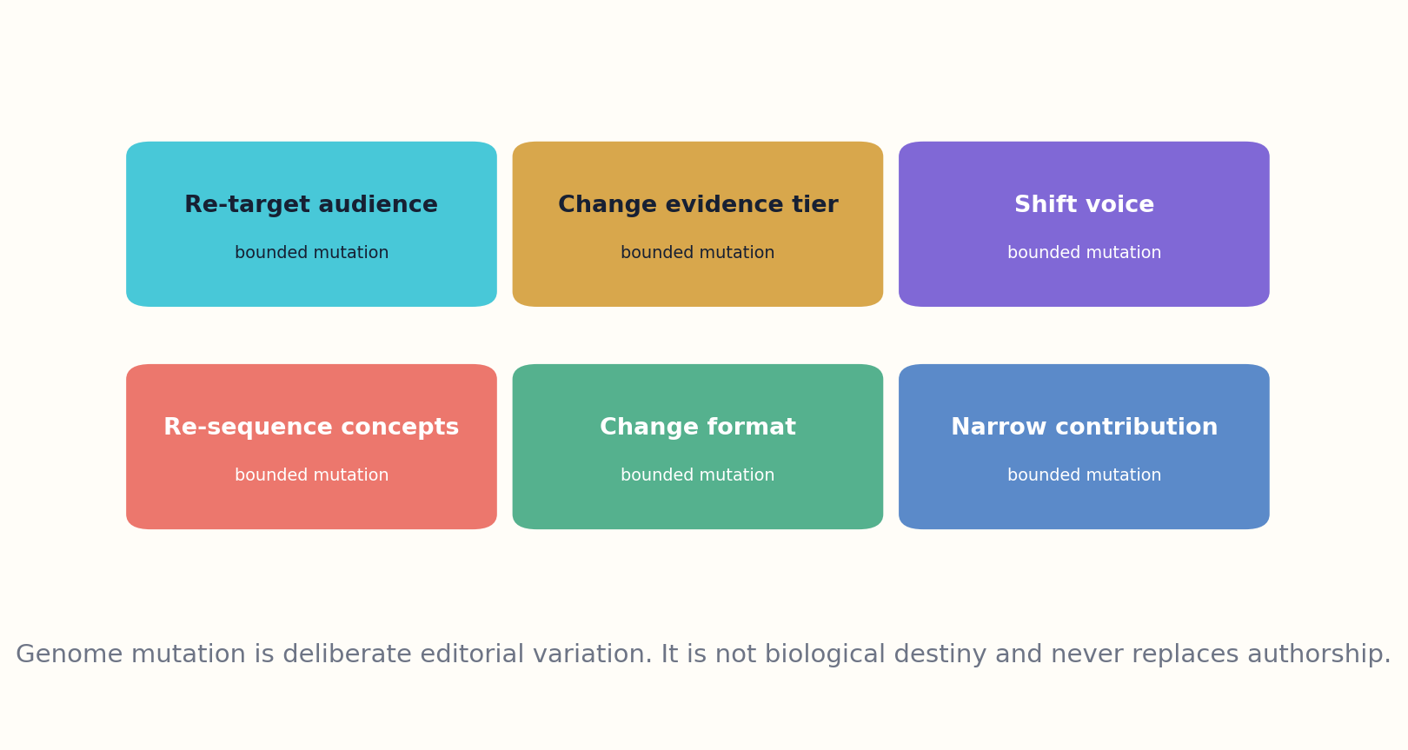
Figure 27. Controlled genome mutations create deliberate editorial variants.

HOW THE MODEL WORKS
Variation supports exploration before expensive production. A commissioning system can generate several candidate genomes, estimate audience fit and redundancy, and ask editors to select or merge them. Most candidates remain unrealized. This is more efficient and more ethical than generating full manuscripts and flooding the market with weak alternatives.
Fitness landscapes are contextual. A mutation that improves accessibility may reduce density for an expert audience; changing voice may increase trust for one group and reduce it for another. The system should preserve a Pareto frontier of candidates rather than optimizing one global score.

DESIGN IMPLICATIONS
The metaphor has limits. Genes reproduce without intention; books are acts of human meaning. The framework therefore uses mutation as a design-operation vocabulary, never as a claim that authorship is merely recombination. Human creators choose the values, risks, and artistic consequences that make a variation worth realizing.
G′ = mutate(G, bounded operation, declared inheritance, rights constraints)
WORKED EXAMPLE
A specialist monograph becomes a practitioner handbook by changing audience, purpose mix, difficulty surface, examples, format, and evaluation—not by merely shortening chapters.
GENOME LAB
• Design three bounded mutations of one genome.
• Identify an invalid crossover that would create derivative dependence.
• Draw a Pareto frontier for accessibility, depth, and production cost.
Standards and research foundation: PROVO, C2PA. See Research Notes and Sources.

CHAPTER 28
Versioning, Translation, Adaptation, and Living Books
A living book must be allowed to change without making its past unreadable.
━━━━━━━━━━━━━━━━━━━━━━━━━
Versioning separates intellectual revision from expression and manifestation changes. A translation may create a new expression with inherited purpose and contribution but altered voice, examples, difficulty, and audience assumptions. A print-to-EPUB conversion may create a new manifestation with accessibility and navigation overrides. A revised thesis or evidence architecture changes the Work genome and requires a major intellectual version.
Semantic versioning can be adapted carefully. Patch versions correct errors without changing conclusions. Minor versions add evidence, examples, or accessibility while preserving the central contribution. Major versions change thesis, audience, structure, or evidence enough that readers need a new edition identity. The exact rules vary by genre and domain.
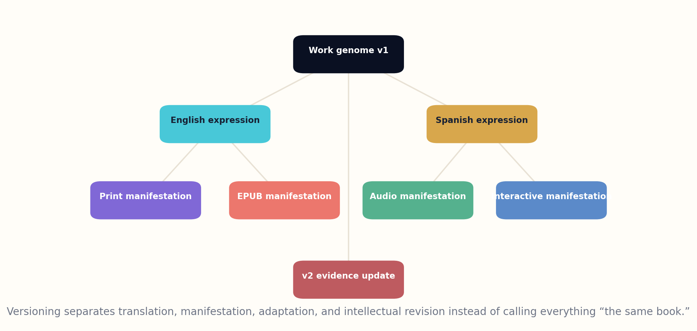
Figure 28. Version lineage distinguishes expressions, manifestations, and intellectual revisions.

HOW THE MODEL WORKS
Living books combine immutable editions with a pointer to the recommended current edition. Every released version remains citable. Update triggers are declared in the genome: new regulations, retractions, threshold evidence, software changes, or scheduled review. The system can estimate impact by traversing claim and structure dependencies.
Translation is treated as intellectual work. The translator records terms without direct equivalents, changes in rhetorical function, cultural adaptations, and newly required context. Machine translation can assist, but a declared reviewer is accountable for the expression. A translation that changes purpose or contribution may become an adaptation rather than a faithful expression.

DESIGN IMPLICATIONS
Long-lived books also need deprecation. An obsolete safety guide should not simply vanish; it should display a clear warning, replacement link, and preserved historical record. Versioning turns maintenance from ad hoc editing into a governed lifecycle.
Version identity = inherited genome + declared deltas + immutable release manifest
WORKED EXAMPLE
A programming book receives a minor edition for a new language version and a major edition when the conceptual model and examples are rebuilt.
GENOME LAB
• Write semantic versioning rules for a living reference.
• Classify a translation, abridgment, and interactive adaptation.
• Define three automatic update triggers.
Standards and research foundation: IFLA-LRM, DATACITE, EPUB, PROVO. See Research Notes and Sources.

CHAPTER 29
Institutional Uses: Publishing, Libraries, Education, and AI
The framework becomes powerful when institutions exchange intent—not merely inventory.
━━━━━━━━━━━━━━━━━━━━━━━━━
Publishers can use genomes for commissioning, acquisition, editorial briefs, redundancy analysis, format planning, and post-publication evaluation. The framework makes the reason for a book visible before production cost is committed. It also gives sales and metadata teams a more truthful vocabulary than generic claims such as “authoritative,” “accessible,” or “groundbreaking.”
Libraries can enrich discovery. Readers can search by purpose, assumed prerequisites, evidence depth, format affordances, voice, and contribution. Collection development can identify underserved reader states and preserve multiple intellectual approaches rather than purchasing near-duplicates. BIBFRAME and IFLA LRM mappings keep genome records connected to established cataloging practice.
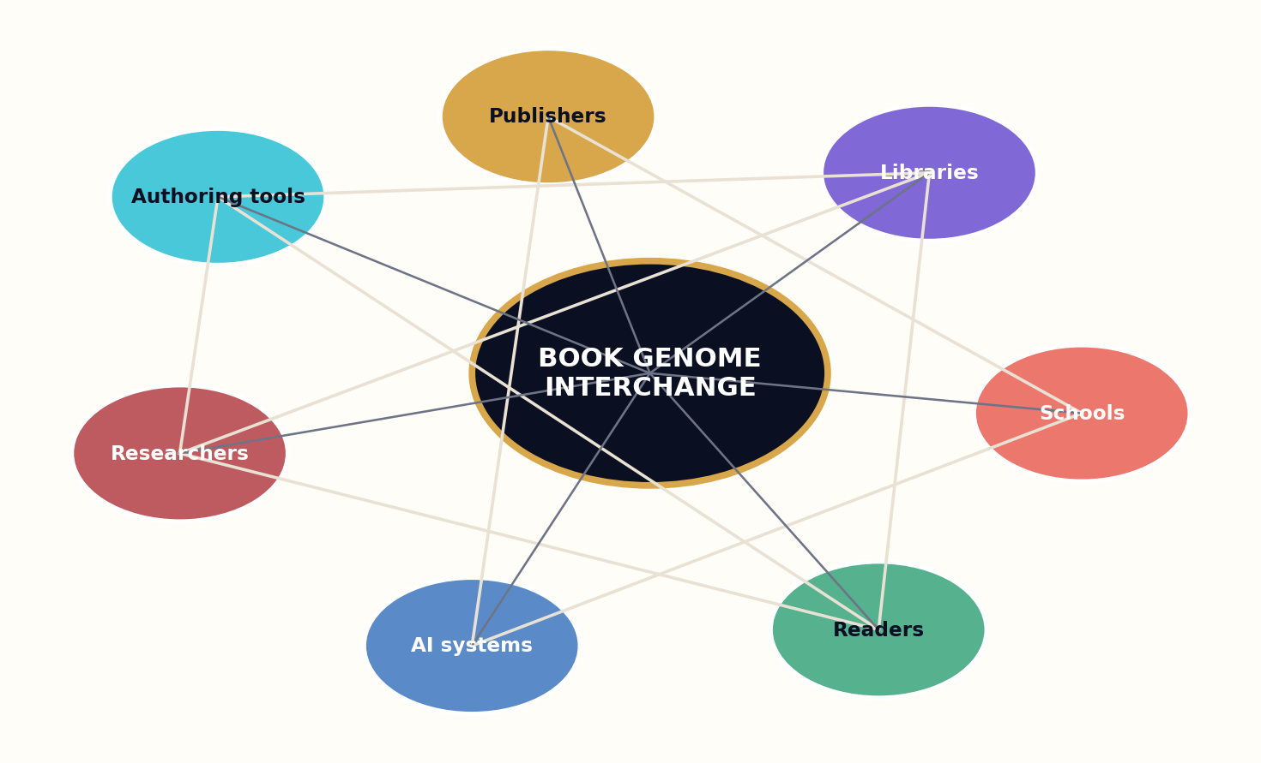
Figure 29. Publishers, libraries, schools, readers, researchers, and AI systems exchange genome records.

HOW THE MODEL WORKS
Education systems can align books to concept graphs and learning states without reducing them to standards codes. Teachers can compare explanations, difficulty surfaces, exercise types, and evidence policies. Students can choose alternate paths through the same domain. The framework should support pedagogy while resisting automated tracking that turns reading into constant measurement.
AI systems can use genomes as task contracts. A model can retrieve the right book for a user, adapt a manifestation, generate a new candidate, or audit an existing work. The genome constrains these actions and exposes why they were taken. It also prevents models from treating every book as undifferentiated training text.

DESIGN IMPLICATIONS
Researchers can study the ecology of books: how purposes evolve, which audiences receive strong evidence, how voice and difficulty affect learning, and where publishing systems create structural absence. These analyses require governance because genome records encode interpretations. Institutions should preserve original assertions, assessor identity, confidence, and the right to dispute a classification.
Ecosystem value = interoperability × truthful discovery × reader agency × editorial accountability
WORKED EXAMPLE
A library recommendation can match a reader’s task and prerequisites while a publisher uses the same record to see why the catalog lacks a suitable title.
GENOME LAB
• Design one workflow for a publisher, library, and school.
• Identify one harmful use of genome data and prohibit it.
• Define how an author can challenge an inferred genome.
Standards and research foundation: ONIX, BIBFRAME, IFLA-LRM, SCHEMA. See Research Notes and Sources.

CHAPTER 30
A Constitution and Roadmap for the Book Genome
A standard for books must remain open enough for art, strict enough for trust, and governable enough for civilization.
━━━━━━━━━━━━━━━━━━━━━━━━━
The Book Genome should begin as an experimental vocabulary, not a universal mandate. Phase one defines the seven chromosomes, identity mappings, provenance, confidence, and a minimal validation profile. The framework is tested against a deliberately diverse corpus: textbooks, field manuals, memoirs, novels, research syntheses, oral histories, reference works, and interactive books.
Phase two builds open-source editors, JSON-LD contexts, SHACL shapes, visualization tools, and crosswalks to ONIX, BIBFRAME, IFLA LRM, Schema.org, Dublin Core, DataCite, EPUB, and PROV-O. The goal is not to force every standard into one schema, but to prove that genomes can travel between systems without semantic collapse.
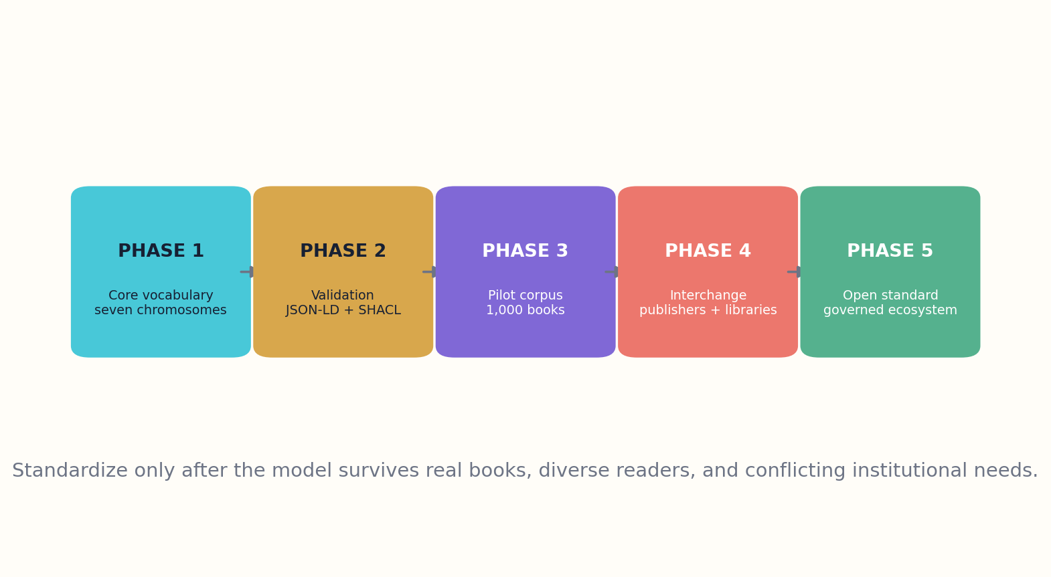
Figure 30. The framework moves from vocabulary to validation, pilot corpus, interchange, and governed standard.

HOW THE MODEL WORKS
Phase three pilots institutional exchange. Publishers create declared genomes; libraries add assessed genomes; educators create local audience and difficulty overlays; readers contribute voluntary phenotype evidence. Conflicts remain visible. No institution owns the final interpretation of a book.
Governance follows a constitution. The framework must preserve authorship, support multilingual and community-defined extensions, disclose inference, prohibit covert reader ranking, separate public metadata from private production state, record uncertainty, permit correction, and maintain the right not to classify. Commercial actors may build services, but the core vocabulary and test suite remain open.

DESIGN IMPLICATIONS
The final ambition is not to turn books into spreadsheets. It is to give books a richer public language for intention and consequence. A successful Genome makes discovery more honest, generation more disciplined, editing more inspectable, and libraries more capable of revealing what humanity has not yet written.
Adoption gate = usefulness proven × interoperability proven × governance trusted × harm controls tested
WORKED EXAMPLE
The first pilot publishes 1,000 genomes with author declarations, independent assessments, and visible disagreement rather than one “official” record.
GENOME LAB
• Select a diverse 100-book pilot corpus.
• Write five constitutional principles.
• Define the evidence required before calling the framework a standard.
Standards and research foundation: ONIX, BIBFRAME, IFLA-LRM, JSONLD, SHACL, PROVO. See Research Notes and Sources.

APPENDIX A
BOOK GENOME CORE SCHEMA
The core schema below is intentionally compact. Production systems should extend it with domain profiles rather than placing every possible property in one universal record.
Core property | Meaning
identity | Work, Expression, Manifestation, and Item identifiers; titles; languages; version lineage.
purpose | Weighted transformation modes, before/after reader state, prohibited outcomes.
audience | Reader-state profiles, prerequisites, goals, context of use, access needs.
evidence | Claim classes, source policies, uncertainty, contradiction handling, review tier.
voice | Attention policy, narrator distance, register, rhythm, terminology, permitted variance.
difficulty | Prerequisite depth, abstraction, notation, concept density, pace, support, local curve.
format | Required reader actions, media, navigation, accessibility, offline and persistence needs.
contribution | Comparison set, novelty claim, usefulness, public value, boundaries, maintenance burden.
structure | Concept graph, chapter functions, argument or narrative graph, examples, assessments, media.
rightsAndProvenance | Licenses, permissions, agents, activities, models, source lineage, cultural constraints.
evaluation | Fitness dimensions, evaluators, methods, thresholds, findings, phenotype evidence.
version | Genome schema version, edition version, declared deltas, update triggers, deprecation state.

APPENDIX B
JSON-LD EXAMPLE
{
"@context": {
"bg": "https://example.org/book-genome/",
"schema": "https://schema.org/",
"prov": "http://www.w3.org/ns/prov#",
"dc": "http://purl.org/dc/terms/"
},
"@id": "urn:isbn:9780000000000#work",
"@type": [
"schema:Book",
"bg:GenomedWork"
],
"schema:name": "Example Systems Field Guide",
"dc:language": "en",
"bg:purpose": {
"@type": "bg:PurposeProfile",
"bg:dominantMode": "bg:Guide",
"bg:secondaryMode": [
"bg:Explain",
"bg:Teach"
],
"bg:readerTransformation": "Reader can diagnose and respond to three common system failures."
},
"bg:audience": {
"@type": "bg:AudienceProfile",
"bg:priorKnowledge": [
"basic networking"
],
"bg:contextOfUse": "field reference",
"bg:timeConstraint": "PT15M"
},
"bg:evidenceModel": {
"@type": "bg:EvidenceModel",
"bg:minimumTier": "bg:VerifiedTechnical",
"bg:requiresExecutableExamples": true,
"bg:uncertaintyPolicy": "explicit"
},
"bg:voice": {
"bg:register": "direct",
"bg:concreteness": 0.86,
"bg:narratorDistance": 0.42,
"bg:metaphorDensity": 0.15
},
"bg:difficulty": {
"bg:prerequisiteDepth": 0.35,
"bg:abstraction": 0.45,
"bg:notationLoad": 0.2
},
"bg:format": {
"bg:requiredAffordance": [
"offline",
"search",
"printable-checklists",
"high-contrast-diagrams"
]
},
"bg:contribution": {
"bg:comparisonSet": [
"urn:isbn:9781111111111"
],
"bg:claim": "Combines diagnosis trees with low-bandwidth field use."
},
"prov:wasAttributedTo": {
"@id": "https://example.org/people/editor-1"
}
}

APPENDIX C
SHACL VALIDATION PROFILE
@prefix sh: <http://www.w3.org/ns/shacl#> .
@prefix bg: <https://example.org/book-genome/> .
bg:BookGenomeShape a sh:NodeShape ;
sh:targetClass bg:GenomedWork ;
sh:property [ sh:path bg:purpose ; sh:minCount 1 ; sh:node bg:PurposeProfileShape ] ;
sh:property [ sh:path bg:audience ; sh:minCount 1 ] ;
sh:property [ sh:path bg:contribution ; sh:minCount 1 ] ;
sh:property [ sh:path bg:genomeVersion ; sh:minCount 1 ; sh:datatype <http://www.w3.org/2001/XMLSchema#string> ] .
bg:HighStakesNonfictionShape a sh:NodeShape ;
sh:targetClass bg:HighStakesNonfiction ;
sh:property [ sh:path bg:evidenceModel ; sh:minCount 1 ] ;
sh:property [ sh:path bg:namedReviewer ; sh:minCount 1 ; sh:severity sh:Violation ] ;
sh:property [ sh:path bg:updateTrigger ; sh:minCount 1 ] .
Validation profiles should distinguish violations, warnings, and informational findings. A profile may be strict enough for a clinical manual and permissive enough for experimental poetry without claiming that both require the same fields.

APPENDIX D
GENOME EVALUATION RUBRIC

Purpose fit
□ The transformation is explicit.
□ Chapter functions support it.
□ Prohibited outcomes are respected.

Audience fit
□ Prerequisites are accurate.
□ Examples match reader context.
□ Difficulty support is sufficient.

Evidence integrity
□ Claims remain within evidence tier.
□ Contradictions are represented.
□ Citation lineage is inspectable.

Voice integrity
□ Attention and stance are coherent.
□ Variance is deliberate.
□ No deceptive imitation target is used.

Format fitness
□ Required reader actions are preserved.
□ Accessibility is tested.
□ Format-native adaptations are complete.

Contribution
□ Comparison set is credible.
□ Distinct value is visible.
□ Scope and maintenance obligations are honest.

APPENDIX E
CROSSWALK TO EXISTING STANDARDS
Genome concern | Existing standards | Added layer
Identity / editions | IFLA LRM, BIBFRAME, ISBN, ONIX | Genome reuses identifiers and adds design inheritance and deltas.
Audience / difficulty | Dublin Core educationLevel, Schema.org Audience and EducationalAudience | Genome adds reader-state models, prerequisites, context of use, and difficulty surfaces.
Evidence / related works | Crossref, DataCite, Schema.org citation | Genome adds claim-level roles, uncertainty, contradictions, and support thresholds.
Format / accessibility | EPUB 3.3, EPUB Accessibility, ONIX product form | Genome adds required reader actions and format-fitness constraints.
Rights / provenance | DataCite rights, Dublin Core rights/provenance, PROV-O, C2PA | Genome specializes lineage for sources, models, editorial activities, and editions.
Validation / exchange | JSON-LD, RDF, SHACL | Genome defines a context, profiles, and constraint shapes.

APPENDIX F
A CONSTITUTION FOR BOOK GENOME SYSTEMS
I. Books exceed their schemas.
No genome record may be presented as a complete account of a book’s value or meaning.

II. Authors remain visible.
Machine assistance, editorial transformation, translation, and human authorship must be represented truthfully.

III. Readers are not fixed types.
Audience models describe a book’s assumptions and a reading situation; they do not determine a person’s intelligence or worth.

IV. Evidence boundaries remain visible.
Generation and recommendation may not strengthen claims beyond the declared evidence architecture.

V. Inference is disclosed.
Declared, assessed, and machine-inferred fields remain distinguishable with confidence and provenance.

VI. Communities can extend and contest.
The core remains interoperable while cultural and domain communities govern their own extensions.

VII. Privacy limits optimization.
Personal reading data is minimized, consented, and never required for basic discovery.

VIII. Classification is appealable.
Authors, communities, and readers can dispute inferred genomes without deleting historical assessments.

IX. Open standards prevent capture.
The vocabulary, context, schemas, and test suite remain openly governed and implementable.

X. The right not to classify.
Some books, fields, or communities may refuse detailed genome representation or expose only a minimal public record.

GLOSSARY
Book Genome. A structured representation of a book’s design commitments, including seven primary chromosomes and supporting systems.
Chromosome. A primary genome dimension: purpose, audience, evidence, voice, difficulty, format, or intellectual contribution.
Phenotype. The experienced book produced from a genome through authorship, editing, production, and format.
Purpose vector. A weighted mixture of intended reader transformations such as explain, teach, guide, preserve, persuade, provoke, or entertain.
Reader state. A situated model of prerequisites, goals, constraints, context, and desired depth—not a permanent classification of a person.
Evidence model. The policy and graph that determine how claims are supported, qualified, contradicted, and revised.
Difficulty surface. A local and global model of prerequisites, abstraction, notation, pace, cognitive load, and support.
Contribution profile. A falsifiable statement of how a book differs from a named comparison set and why that difference matters.
Structural genotype. The graph of concepts, claims, chapter functions, examples, media, narrative states, and typed relationships.
Genome compiler. A production system that turns a validated genome and source graph into a book phenotype with auditable artifacts.
Fitness profile. A multidimensional evaluation of how well a phenotype satisfies its genome and publication tier.
Genome delta. A declared change between inherited genome versions, expressions, manifestations, or adaptations.

RESEARCH NOTES AND SOURCES
The Book Genome framework is original to this volume. The sources below establish adjacent standards and infrastructure. They do not claim or endorse the complete seven-chromosome model. Standards and specifications evolve; implementers should consult current primary documentation and legal or accessibility expertise where appropriate.
IFLA-LRM International Federation of Library Associations and Institutions. IFLA Library Reference Model: A Conceptual Model for Bibliographic Information, 2024 edition. https://repository.ifla.org/items/214c74cb-c075-4428-a138-39f8d06c55aa
BIBFRAME Library of Congress. BIBFRAME Model, Vocabulary, Guidelines, Examples, and Implementation Resources. https://www.loc.gov/bibframe/docs/index.html
ONIX EDItEUR. ONIX for Books, the international XML standard for book product metadata; Library of Congress format description consulted for overview. https://www.editeur.org/83/Overview/
EPUB World Wide Web Consortium. EPUB 3.3 and EPUB Accessibility specifications. https://www.w3.org/publishing/epub3/
SCHEMA Schema.org. Book, CreativeWork, Audience, EducationalAudience, accessibility, citation, and educational metadata terms. https://schema.org/Book
DCMI Dublin Core Metadata Initiative. DCMI Metadata Terms, including audience, educationLevel, format, rights, provenance, and bibliographicCitation. https://www.dublincore.org/specifications/dublin-core/dcmi-terms/
DATACITE DataCite Metadata Working Group. DataCite Metadata Schema 4.6, 2024. https://schema.datacite.org/meta/kernel-4.6/
CROSSREF Crossref. Metadata and REST API documentation for works, relations, references, licenses, and updates. https://www.crossref.org/documentation/
JSONLD World Wide Web Consortium. JSON-LD 1.1, W3C Recommendation. https://www.w3.org/TR/json-ld/
SHACL World Wide Web Consortium. Shapes Constraint Language (SHACL), W3C Recommendation. https://www.w3.org/TR/shacl/
PROVO World Wide Web Consortium. PROV-O: The PROV Ontology, W3C Recommendation. https://www.w3.org/TR/prov-o/
C2PA Coalition for Content Provenance and Authenticity. C2PA Specifications; useful for signed content manifests but not a substitute for independent trust and security review. https://spec.c2pa.org/specifications/

A BOOK IS MORE THAN ITS DATA.
THE GENOME EXISTS TO PROTECT THE PROMISE INSIDE IT.
GRAYLAN JANULIS

