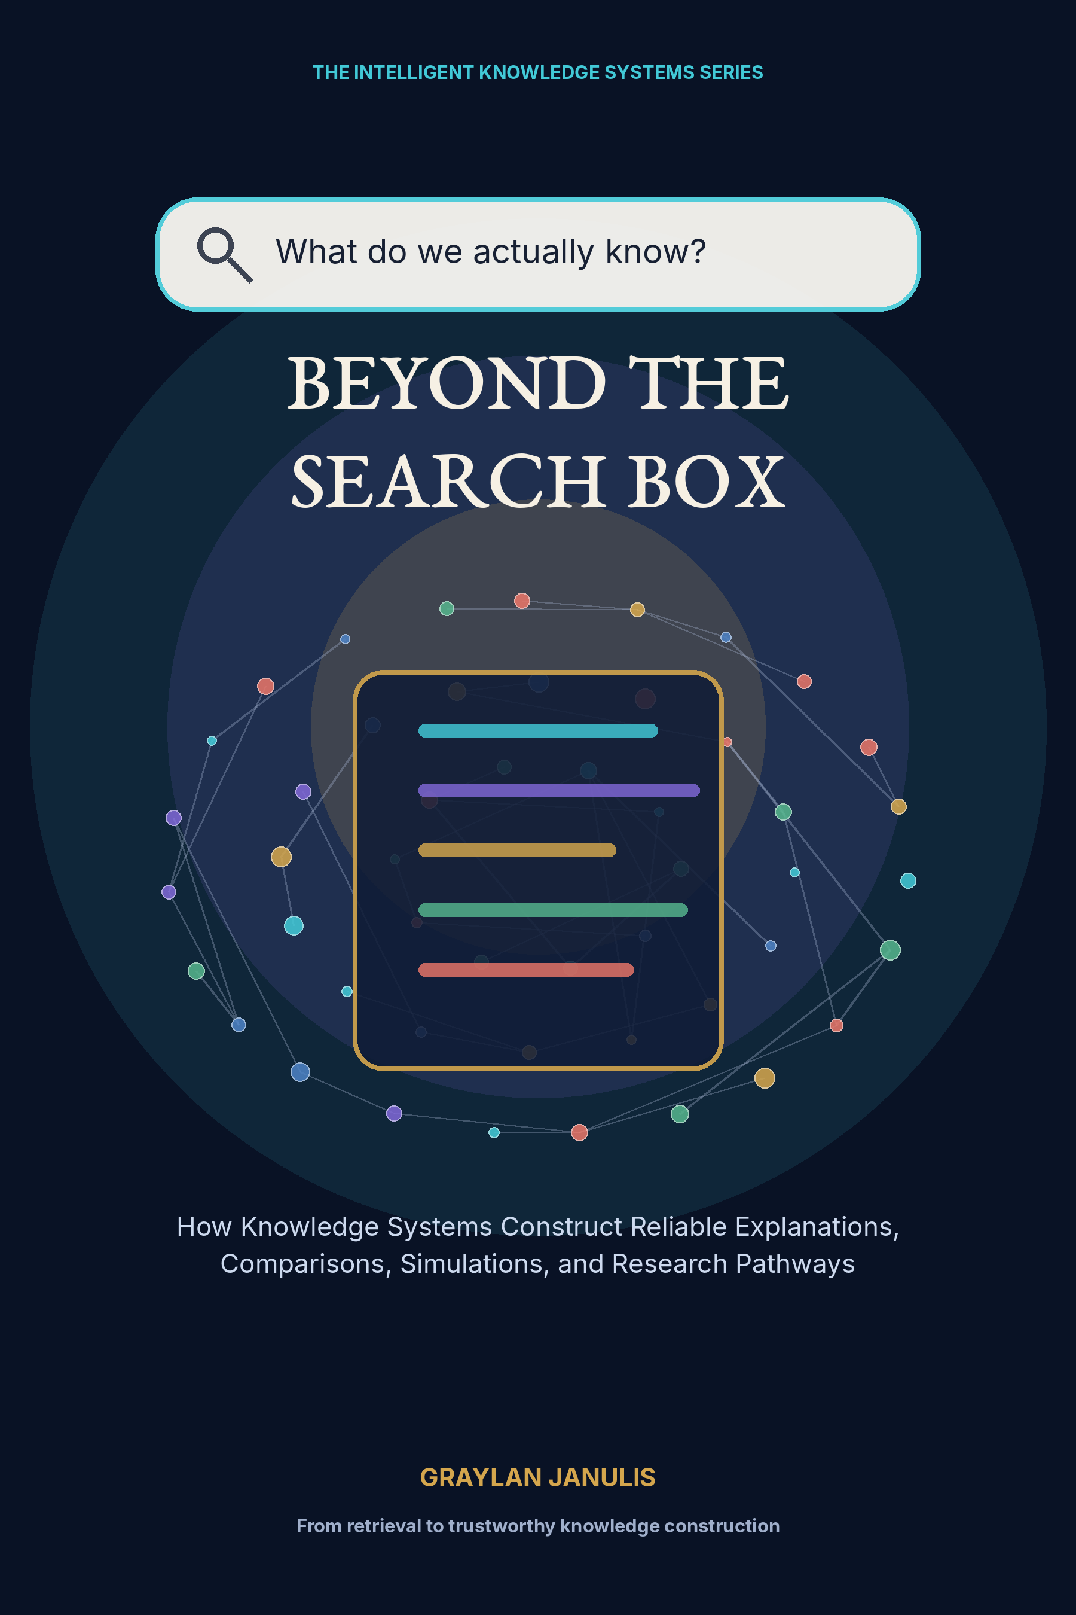

BEYOND THE
SEARCH BOX
How Knowledge Systems Construct Reliable Explanations, Comparisons, Simulations, and Research Pathways
GRAYLAN JANULIS

A NOTE ON THIS BOOK
This volume is a systems design book. It combines established information-retrieval, knowledge-graph, provenance, scientific-synthesis, causal-modeling, and evaluation ideas with a proposed architecture for knowledge systems that go beyond returning documents.
The diagrams, equations, schemas, and workflows are design instruments rather than claims that one existing product implements the complete system. Current projects such as retrieval-augmented generation, GraphRAG, OpenScholar, PaperQA2, RAGAS, and ARES demonstrate important components while also exposing limits that require broader architecture.
High-stakes deployment requires current primary sources, domain experts, legal and privacy review, security testing, and explicit human authority. A constructed explanation should never hide where evidence ends and inference begins.
“Search returns where knowledge might be.
A knowledge system constructs what the evidence permits us to say.”

CONTENTS
PART I · THE SEARCH BOX IS TOO SMALL
01 The Answer Is Not a Link
02 Intent Is a Task Model
03 Documents Are Containers; Claims Are Units
04 The Epistemic Contract
05 Explanations as Executable Structures
PART II · THE KNOWLEDGE FABRIC
06 Ingestion Without Amnesia
07 The Claim-Centered Knowledge Graph
08 Time, Versions, and Provenance
09 Contradiction Is a First-Class Object
10 Multimodal Evidence
PART III · THE ANSWER COMPILER
11 Plan Before Retrieval
12 Hybrid Retrieval as a Portfolio
13 The Evidence Packet
14 Comparison Engines
15 The Explanation Compiler
16 Citation Architecture
17 The Verification Court
PART IV · FROM ANSWERS TO MODELS
18 From Explanation to Model
19 Causal Graphs and Counterfactuals
20 Agent-Based Simulation
21 Scenario Laboratories
22 Research Pathway Generators
23 Tools, Experiments, and Reproducible Runs
PART V · THE RESEARCH WORKSPACE
24 The Interface Beyond One Box
25 Conversation as Research State
26 Memory That Knows What to Forget
27 Collaborative Intelligence Without Consensus Theater
PART VI · TRUSTWORTHY DEPLOYMENT
28 Evaluation as a Stack
29 Adversarial Knowledge Systems
30 Building the First Reliable System
Appendix A — The Answer Object Schema
Appendix B — Evaluation Matrix
Appendix C — Implementation Blueprint
Appendix D — Constitution for Reliable Knowledge Construction
Glossary
Research Notes and Sources

PROLOGUE
THE MOMENT AFTER RETRIEVAL
Every serious search ends with a second problem. We find documents, but then we must decide what they mean together. We compare definitions, judge methods, resolve dates, reproduce calculations, imagine alternatives, and determine what evidence would change our mind. The search engine helped us arrive at the work; it did not perform the work.
The new knowledge system begins at that moment. It does not erase documents or human judgment. It constructs an inspectable workspace in which sources become claims, claims become models, models become explanations, and uncertainty becomes a pathway for further research.
This book describes that architecture from source ingestion to deployment. Its ambition is not to manufacture certainty. It is to make reasoning visible enough that people can use, challenge, improve, and continue it.

PART I
THE SEARCH BOX IS TOO SMALL
Why document retrieval is only the first move in knowledge work.

CHAPTER 01
The Answer Is Not a Link
A document can be relevant and still fail to answer the question.
━━━━━━━━━━━━━━━━━━━━━━━━━
The familiar search box compresses every knowledge need into a short string and returns a ranked list of documents. That interaction is useful, but it quietly transfers the hardest work to the reader: defining the task, judging authority, reconciling disagreement, constructing a comparison, testing assumptions, and deciding what to investigate next. Search finds potential evidence. Knowledge work begins after the result page.
A system beyond search treats the user request as a request for an answer object. The object may contain a direct conclusion, a mechanism, a comparison table, a causal model, a simulation, a timeline, an uncertainty map, or a research pathway. It remains linked to its sources, but it is not reducible to those sources. The system has transformed documents into an inspectable structure designed for a purpose.
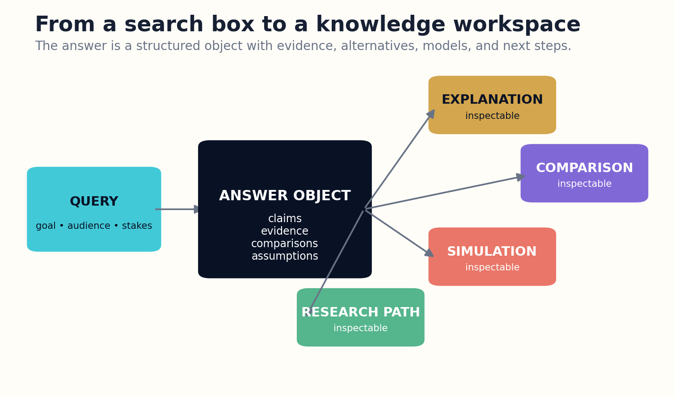
Figure 1. The search box becomes an entry point to a structured workspace containing explanations, comparisons, simulations, and research paths.

HOW THE SYSTEM WORKS
This transformation creates a higher burden. A ranked list can admit that the reader must decide what is true. A constructed explanation appears authoritative even when its assembly is weak. Therefore every answer object needs an epistemic contract: scope, evidence, assumptions, uncertainty, counterevidence, and an update rule. Reliability is not a final disclaimer. It is the organizing architecture.
The central thesis of this book is that the next generation of knowledge systems will resemble compilers and laboratories more than search engines. They will parse requests, plan research, retrieve heterogeneous evidence, build intermediate representations, run checks and tools, and render several views of the same reasoning. The interface may still contain a box, but the box will be only the doorway.

ENGINEERING BLUEPRINT
A practical implementation begins with an answer-object API rather than a chat endpoint. The object should expose separate fields for conclusion, claim ledger, evidence map, assumptions, uncertainty, and next actions. The interface may render these fields as prose, but clients must be able to inspect and modify them independently. This single decision prevents the generated paragraph from becoming the only durable representation of the work.
Answer value = task completion × evidence quality × inspectability × updateability
DESIGN EXERCISE
Describe one recent search where the useful work began only after opening the results. Define the answer object that would have completed the task.
Research notes: R1, R2, R5. See “Research Notes and Sources.”

CHAPTER 02
Intent Is a Task Model
The same words can ask for location, explanation, diagnosis, design, or decision.
━━━━━━━━━━━━━━━━━━━━━━━━━
A query is not a complete specification. “Why is this system failing?” can mean locate an error message, explain a mechanism, compare possible causes, diagnose a particular incident, simulate future behavior, or recommend a repair. Retrieval systems that optimize relevance without resolving the intended operation often return excellent documents for the wrong task.
The task model expands the request into goals, constraints, stakes, audience, time horizon, and desired output. It distinguishes factual lookup from synthesis, and synthesis from action. It also records what evidence is permitted. A legal analyst may require jurisdiction-specific primary sources; an engineer may need executable documentation and version compatibility; a student may need a progressive explanation rather than the newest paper.
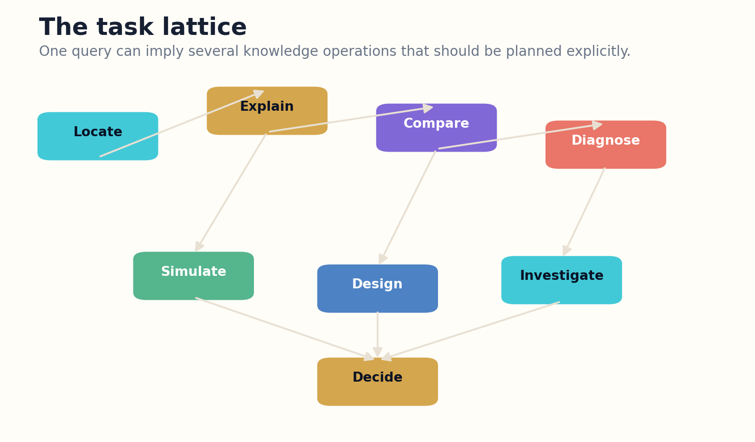
Figure 2. The task lattice distinguishes operations that ordinary relevance ranking tends to collapse.

HOW THE SYSTEM WORKS
Task decomposition should remain visible. The system can show that a comparison requires common dimensions, that a diagnosis requires observations and hypotheses, or that a simulation requires state variables and transition rules. Users can correct the plan before costly retrieval and generation begin. This is especially important when the initial wording hides incompatible objectives.
The task lattice replaces a single answer mode with a family of operations: locate, define, explain, compare, diagnose, forecast, simulate, design, decide, and investigate. Complex work moves through several nodes. A research request may start by locating terminology, continue through comparison and explanation, and end with an experiment plan. The system should preserve that pathway rather than flattening it into one paragraph.

ENGINEERING BLUEPRINT
The planner should emit a machine-readable task graph and a human-readable plan. Each node names its operation, required evidence, dependencies, confidence, and completion test. Before execution, a lightweight classifier can estimate whether clarification is cheaper than research. After execution, the system compares the delivered object with the original completion criteria instead of scoring only linguistic similarity.
Task = goal + audience + constraints + stakes + output form + stopping rule
DESIGN EXERCISE
Rewrite one ambiguous query as three distinct task models. For each, state what would count as completion.
Research notes: R3, R6. See “Research Notes and Sources.”

CHAPTER 03
Documents Are Containers; Claims Are Units
The atomic unit of reliable synthesis is a claim bound to evidence and conditions.
━━━━━━━━━━━━━━━━━━━━━━━━━
Documents are convenient publication containers, but they are poor reasoning units. A paper may contain a supported result, a speculative interpretation, a method, a limitation, a figure that contradicts the prose, and references with different evidential roles. Retrieving the document does not identify which part should enter the answer.
A claim-centered system extracts typed assertions and binds them to source spans, authorship, date, scope, method, population, measurement, uncertainty, and status. It distinguishes observed findings from causal conclusions, normative recommendations, definitions, forecasts, and examples. This typing prevents a common synthesis error: turning a narrow observation into a universal rule.
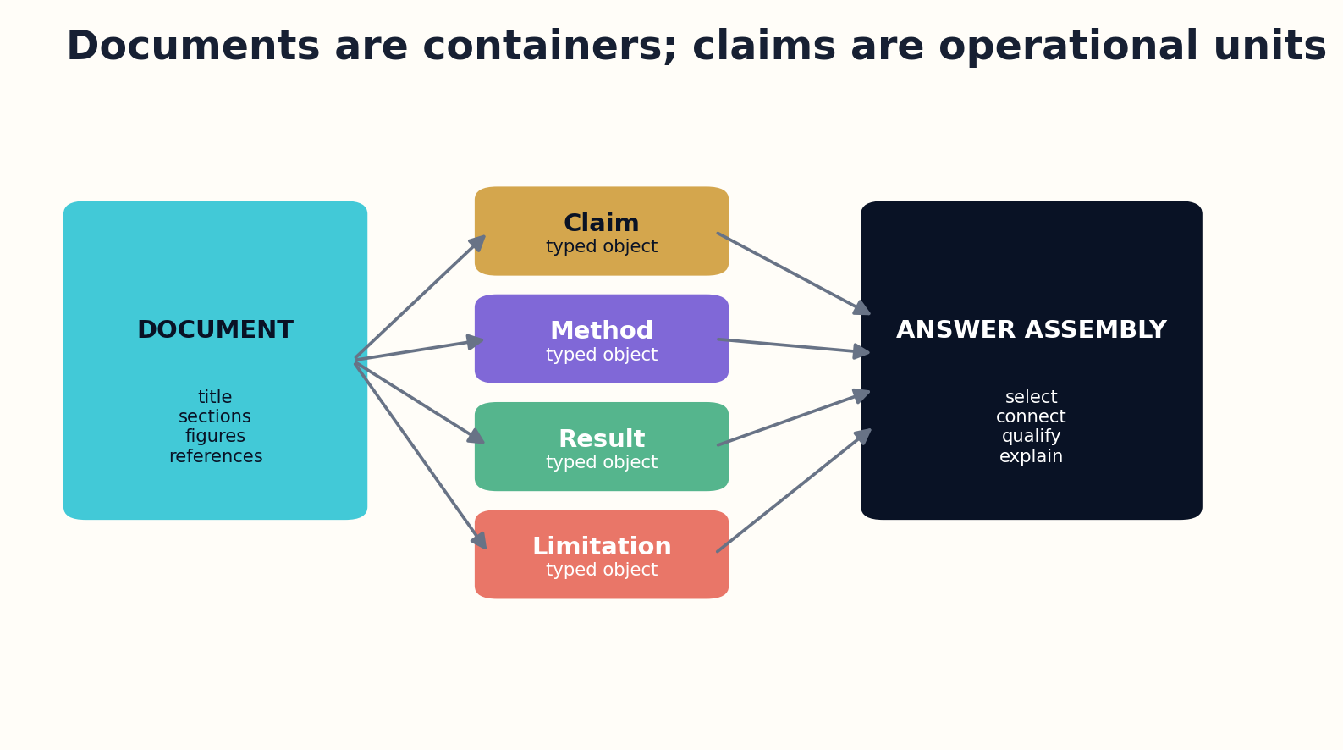
Figure 3. Documents remain authoritative containers while typed claims become the units of synthesis.

HOW THE SYSTEM WORKS
The claim is not detached from the document. The original container remains available for context, and every extraction carries confidence. The system can show the passage, figure, or table that supports the claim and the transformation used to normalize it. When extraction is uncertain, the claim is provisional and may be excluded from high-stakes answers.
Once claims are explicit, the system can compare them across documents, detect repeated evidence, identify contradiction, trace dependency, and generate explanations at different depths. The document remains the cultural and scholarly artifact. The claim graph becomes the operational memory used to construct accountable answers.

ENGINEERING BLUEPRINT
Claim extraction works best as a staged pipeline. A first pass proposes spans and types; a second resolves entities, quantities, and conditions; a third compares the normalized claim with the original passage. High-consequence claims enter a review queue. Store both the normalized form and the source wording so later systems can reason structurally without erasing nuance.
Claim = assertion + scope + evidence span + method + uncertainty + time
DESIGN EXERCISE
Take one article and extract four differently typed claims. Record the condition under which each claim is valid.
Research notes: R4, R7, R8. See “Research Notes and Sources.”

CHAPTER 04
The Epistemic Contract
A reliable answer declares the boundary of its own authority.
━━━━━━━━━━━━━━━━━━━━━━━━━
Every constructed answer should carry a compact contract that explains what question was answered and what was left outside the boundary. Scope includes population, geography, time, definitions, data versions, and intended use. Without it, readers often apply a locally correct answer to a different problem.
The contract names the evidence standard. It can require primary sources, independent replication, official specifications, current measurements, or expert review. It also distinguishes evidence from illustration. A hypothetical scenario may clarify a mechanism without proving that the mechanism occurred in the real case.
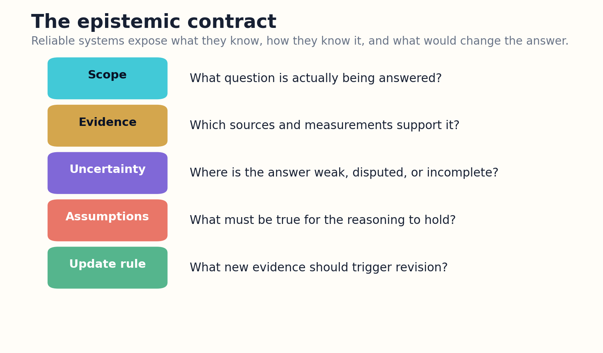
Figure 4. The epistemic contract exposes scope, evidence, uncertainty, assumptions, and update conditions.

HOW THE SYSTEM WORKS
Uncertainty is represented structurally rather than as a vague caution. The system identifies which claims are well supported, which depend on assumptions, which are disputed, and which are simply unknown. It can expose the evidence that would most reduce uncertainty. This turns uncertainty from a weakness into a research guide.
Finally, the contract defines an update rule. An answer about software should name the version and become stale when dependencies change. A scientific explanation may require revision after a retraction or replication. A policy comparison may change after a law or price changes. Knowledge systems become trustworthy when they know not only how to answer, but when to stop trusting the previous answer.

ENGINEERING BLUEPRINT
Implement the contract as a required release gate. An answer cannot be marked final until scope, evidence class, uncertainty, and freshness policy have values. Defaults should be conservative: unknown scope remains narrow, missing evidence lowers confidence, and volatile domains receive short expiration windows. A contract diff between editions makes changes in authority visible to users and auditors.
Trust = evidence fit × scope clarity × uncertainty honesty × update discipline
DESIGN EXERCISE
Write an epistemic contract for a high-stakes answer in your field, including two events that should invalidate it.
Research notes: R9, R10. See “Research Notes and Sources.”

CHAPTER 05
Explanations as Executable Structures
A good explanation can be inspected, compressed, expanded, and tested.
━━━━━━━━━━━━━━━━━━━━━━━━━
An explanation is more than fluent prose. It has an internal structure: conclusion, mechanism, causal or logical steps, evidence, examples, boundary conditions, and counterexamples. When this structure exists only inside generated language, the system cannot reliably verify or adapt it. The solution is an explanation intermediate representation.
The representation stores claims and relations before rendering. It can encode that one event causes another under specified assumptions, that a definition constrains a comparison, or that a numerical result follows from a calculation. A prose renderer then creates a concise brief, a technical derivation, a visual map, or an interactive tutorial from the same underlying object.
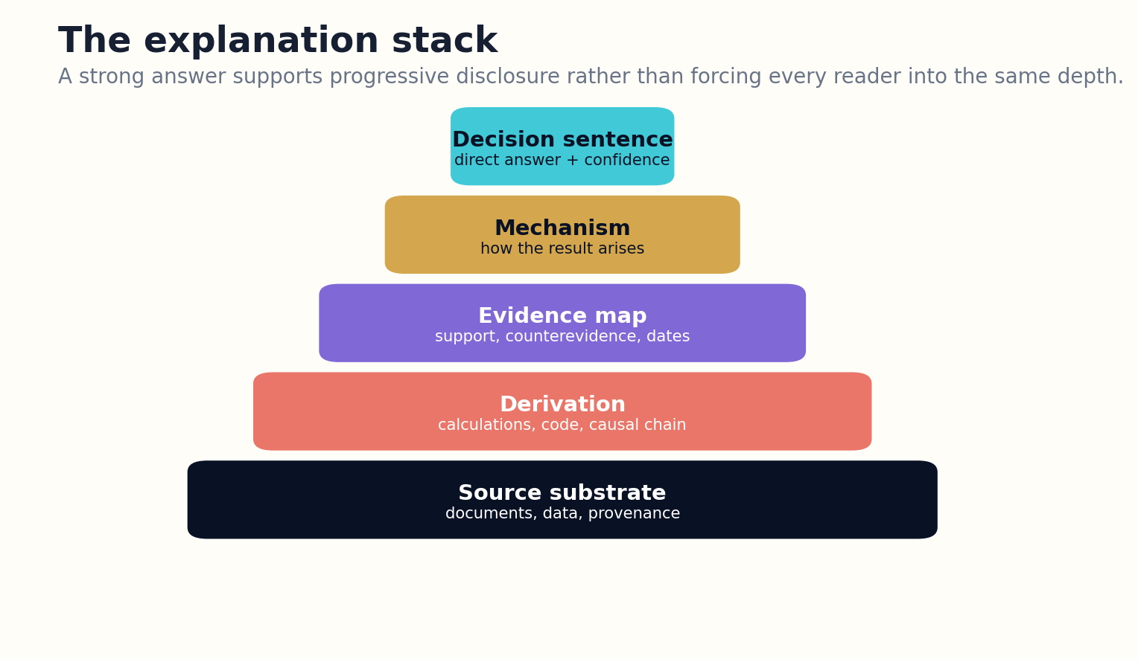
Figure 5. Progressive disclosure lets readers move from a direct answer to mechanism, evidence, derivation, and sources.

HOW THE SYSTEM WORKS
Executable does not always mean code. It means that critical steps can be replayed. Arithmetic can be recalculated, citations can be checked for entailment, graph paths can be traversed, and causal assumptions can be toggled. Readers can ask “show me why” and receive the chain rather than a longer paraphrase.
Progressive disclosure solves a central design conflict. Experts do not want elementary exposition, while beginners cannot use a compressed answer. The explanation stack exposes a decision sentence first, then mechanism, evidence, derivation, and source substrate. The reader controls depth without losing the identity of the answer.

ENGINEERING BLUEPRINT
An explanation intermediate representation can resemble a directed acyclic graph whose nodes are claims, definitions, mechanisms, examples, and calculations. Edges encode supports, causes, qualifies, contrasts, and derives. Renderers traverse the graph according to audience and length budgets. Validation checks for orphan claims, circular support, hidden assumptions, and conclusions whose evidence paths are too weak.
Explanation = conclusion + mechanism + evidence + assumptions + falsifiers
DESIGN EXERCISE
Turn a familiar explanation into a five-layer stack, from one-sentence answer to source-level derivation.
Research notes: R2, R11. See “Research Notes and Sources.”

PART II
THE KNOWLEDGE FABRIC
Building claim-centered, time-aware, multimodal evidence infrastructure.

CHAPTER 06
Ingestion Without Amnesia
The source pipeline should preserve more than the language model will ever see at once.
━━━━━━━━━━━━━━━━━━━━━━━━━
Reliable knowledge construction begins before retrieval. The ingestion system acquires documents through permitted channels, preserves original bytes, records checksums and timestamps, and stores the acquisition event. Parsed text is a derivative representation, not a replacement for the source.
Normalization respects document structure. Sections, footnotes, equations, tables, figures, captions, code blocks, references, and supplementary files remain typed objects. A PDF parser may infer reading order, but the system stores uncertainty and a visual page image for inspection. When LaTeX, XML, or structured HTML exists, it can provide a richer representation.
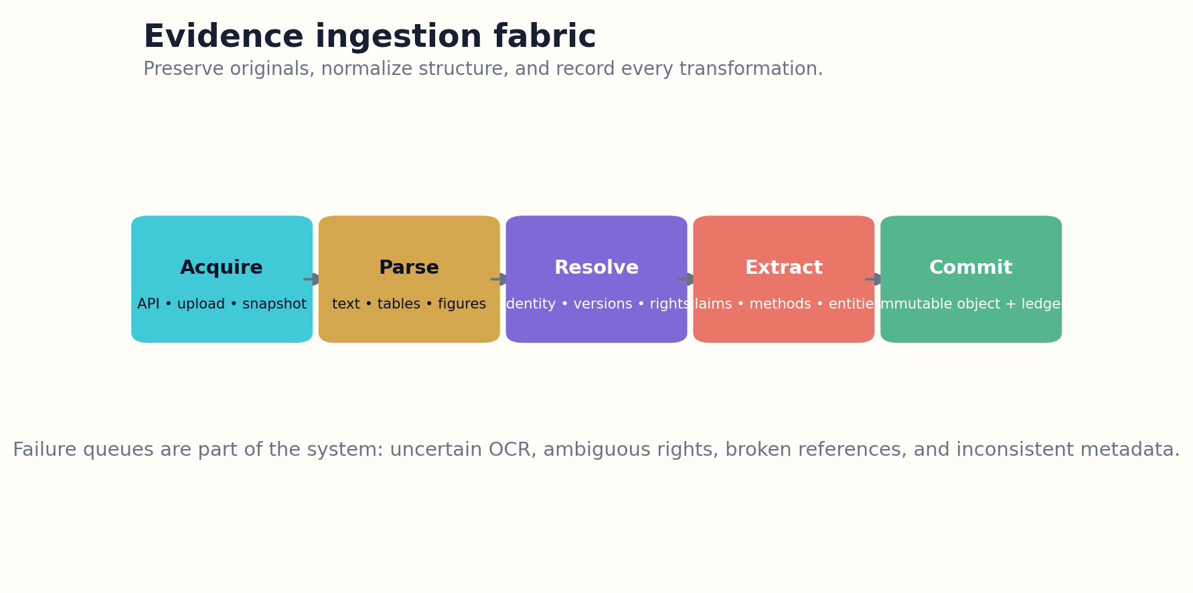
Figure 6. The evidence pipeline preserves original objects and records every transformation before indexing.

HOW THE SYSTEM WORKS
Identity resolution groups preprints, revisions, accepted manuscripts, corrections, and versions of record. It connects authors, institutions, datasets, software, and persistent identifiers. Duplicate text is not automatically duplicate evidence; several publications may reuse the same sample or dataset. Lineage must be modeled before evidence is counted.
Failure queues are essential. Broken OCR, ambiguous licenses, mismatched metadata, suspicious files, and unresolved versions should not quietly enter the trusted index. They remain discoverable at an appropriate confidence tier and can be repaired by specialized tools or humans. Ingestion quality determines the ceiling of every later explanation.

ENGINEERING BLUEPRINT
In production, every parser should write a transformation manifest: software version, parameters, page ranges, warnings, and confidence. Preserve page coordinates for extracted spans so reviewers can inspect the exact visual context. Run parsers in isolated workers because documents can be malformed or hostile. Reprocessing should create a new derivative version rather than silently replacing prior output.
Ingestion confidence = parse × identity × rights × version × integrity
DESIGN EXERCISE
Design an ingest record for a PDF with an associated dataset and code repository. Include failure states.
Research notes: R12, R13, R14. See “Research Notes and Sources.”

CHAPTER 07
The Claim-Centered Knowledge Graph
Relationships are the memory that nearest-neighbor retrieval forgets.
━━━━━━━━━━━━━━━━━━━━━━━━━
A claim graph represents works, claims, entities, methods, datasets, measurements, assumptions, replications, and contradictions as typed nodes and edges. Each edge carries a source, timestamp, extraction confidence, and review status. The graph does not replace text retrieval; it makes relational questions tractable.
Graph structure supports questions that isolated chunks answer poorly. Which methods were applied to the same problem? Which claims depend on a particular dataset? Which results were replicated outside the original population? Which institutions dominate a field? Which contradiction disappears when definitions are aligned?
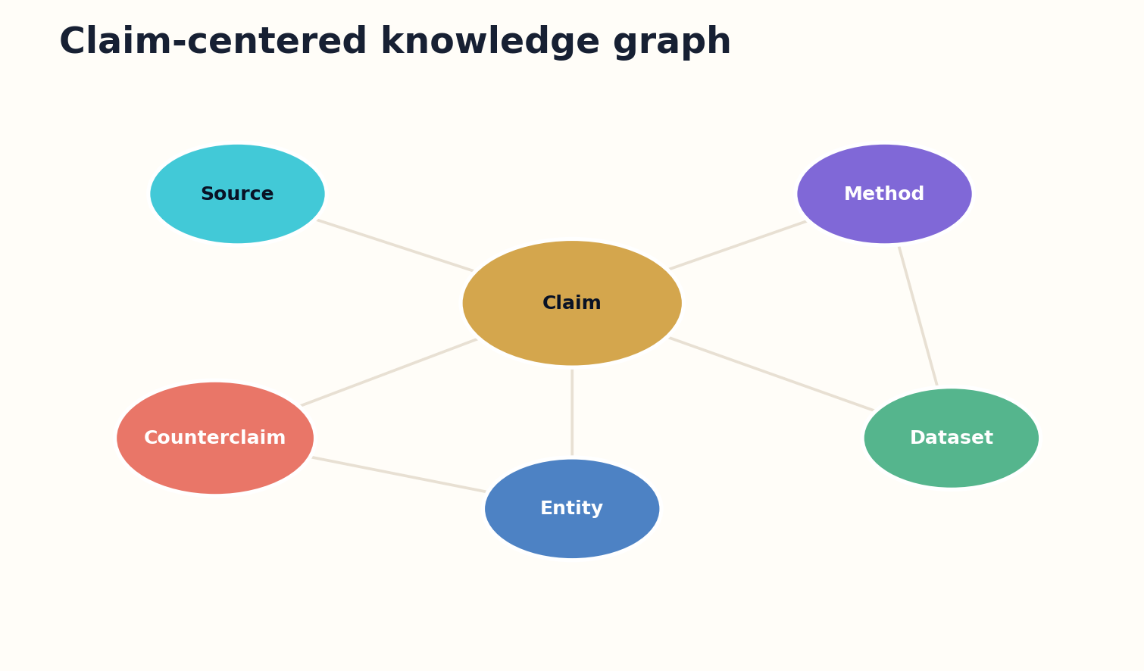
Figure 7. A claim-centered graph connects evidence, methods, entities, datasets, and counterclaims.

HOW THE SYSTEM WORKS
Automated extraction proposes graph elements, but high-impact edges require adjudication. A model may infer that two terms are equivalent or that one study contradicts another. The system should expose the passages and conditions supporting that relation. Graph authority must be earned, not implied by visualization.
Graph retrieval can operate locally around entities or globally through communities and themes. Microsoft’s GraphRAG work illustrates how graph-derived community structures can support broader questions that traditional chunk retrieval struggles with. The general lesson is architectural: global synthesis needs representations that exist above individual passages.

ENGINEERING BLUEPRINT
The graph store should separate asserted edges from inferred edges. Asserted edges come directly from trusted metadata or reviewed source spans; inferred edges come from extraction or reasoning models. Query policies can permit inferred edges for discovery while requiring asserted or reviewed paths for high-stakes conclusions. This distinction prevents a dense graph from appearing more certain than its evidence.
Edge confidence = extraction agreement × source support × context fit × review status
DESIGN EXERCISE
Define ten node types and ten relation types for a domain you know. Mark which relations require human review.
Research notes: R5, R15, R16. See “Research Notes and Sources.”

CHAPTER 08
Time, Versions, and Provenance
A correct answer can become wrong without changing a single sentence.
━━━━━━━━━━━━━━━━━━━━━━━━━
Knowledge systems must model time at several levels: source publication, data collection, event occurrence, system ingestion, answer generation, and claim validity. Collapsing these dates produces subtle errors. A recent paper may analyze old data; an old standard may remain authoritative; a current website may describe a deprecated software version.
Version families prevent the index from treating revisions as independent evidence. The system records supersession, correction, retraction, translation, and derivation. DataCite and related metadata practices provide useful patterns for identifying resources and relationships, while provenance standards such as W3C PROV distinguish entities, activities, and agents.
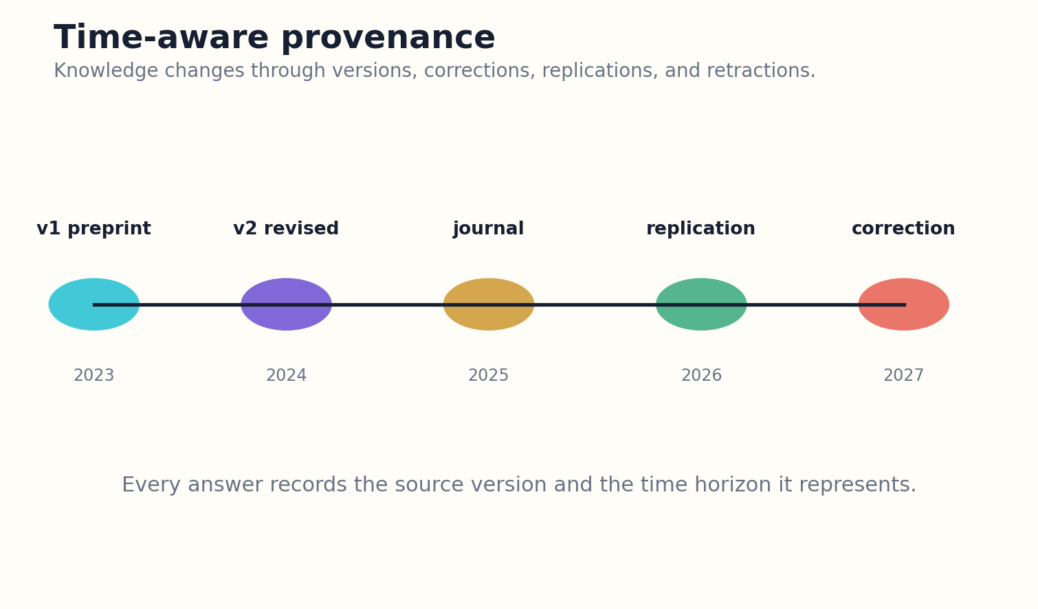
Figure 8. Time-aware provenance separates publication, validity, revision, and answer generation.

HOW THE SYSTEM WORKS
Every answer object receives a provenance manifest. It names source versions, retrieval time, transformations, models, tools, human edits, and review decisions. Provenance does not prove truth, but it allows the answer to be reconstructed and challenged. Without it, correction becomes guesswork.
Time-aware retrieval can answer historical questions without contaminating them with later knowledge. It can also compare how consensus changed. A living answer may point to a new edition while preserving the exact version previously cited. Stable history and current guidance can coexist.

ENGINEERING BLUEPRINT
A temporal query layer needs interval logic, not a single publication date. Claims can have observed-at, valid-from, valid-until, published-at, and corrected-at fields. Retrieval should support 'what was knowable on this date' as well as 'what is recommended now.' Cache invalidation follows dependency edges so a retraction opens review tasks only for affected answer objects.
Answer state A(t) = sources(t) + graph(t) + tools(t) + policy(t)
DESIGN EXERCISE
Create a timeline for one evolving technical claim, including the source and answer versions that should remain citable.
Research notes: R9, R12, R13. See “Research Notes and Sources.”

CHAPTER 09
Contradiction Is a First-Class Object
Disagreement should be analyzed before it is summarized.
━━━━━━━━━━━━━━━━━━━━━━━━━
A synthesis system often fails by averaging incompatible claims into a smooth conclusion. Contradiction must be stored explicitly, with the dimensions on which claims overlap or diverge. Population, intervention, measurement, definitions, time horizon, and statistical power can turn an apparent conflict into a conditional agreement.
The contradiction resolver retrieves the strongest opposing evidence, not merely nearby negative language. It asks whether studies share a target question and whether one source is derivative of another. It also records null results and failed replications, which are often underrepresented in publication systems.
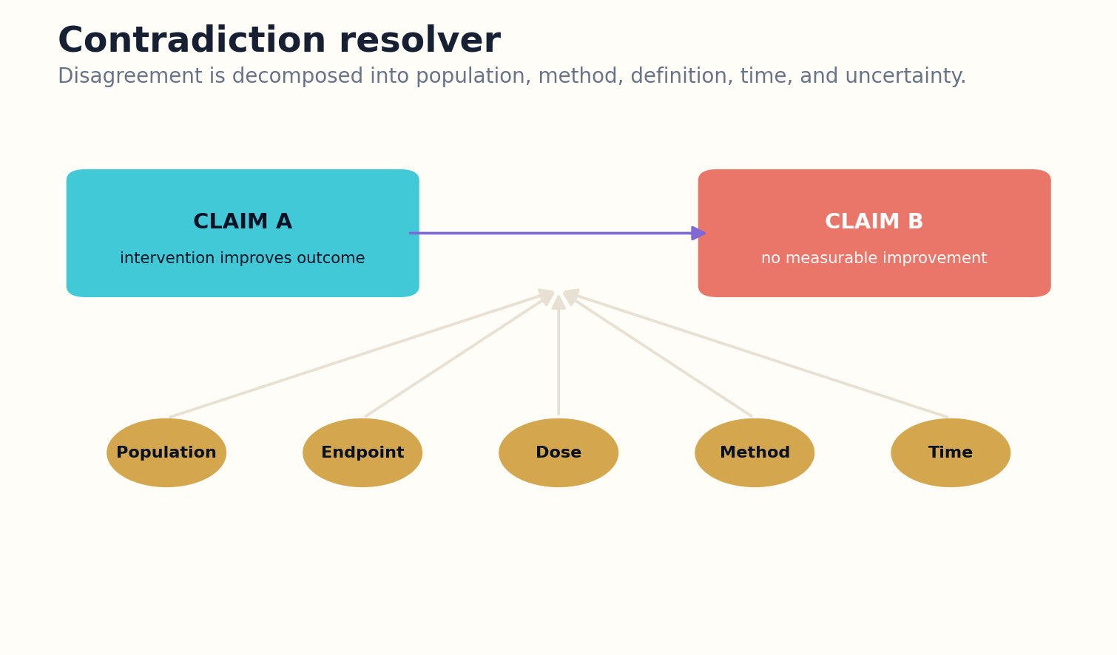
Figure 9. A contradiction resolver searches for the condition that explains or sharpens disagreement.

HOW THE SYSTEM WORKS
Some contradictions remain unresolved. The correct output may be a controversy map with competing models, evidence quality, assumptions, and decisive experiments. This is more useful than a forced verdict because it tells researchers what is actually at stake.
Contradiction coverage becomes an evaluation metric. A generated answer that accurately summarizes supporting evidence but ignores serious counterevidence is incomplete. The system should report what it searched, what it found, and why some disagreement did or did not alter the conclusion.

ENGINEERING BLUEPRINT
Contradiction analysis should produce a structured dispute record with paired claims, overlap dimensions, candidate reconciliation variables, source quality, and decisive tests. The system can cluster disputes by cause: definition mismatch, population shift, measurement error, temporal change, or genuine theoretical conflict. These records become reusable assets for future syntheses and prevent repeated rediscovery of the same disagreement.
Contradiction pressure = overlap × evidential strength × incompatibility × unresolvedness
DESIGN EXERCISE
Build a contradiction table for two studies that disagree. Test whether the disagreement survives alignment of definitions and populations.
Research notes: R17, R18. See “Research Notes and Sources.”

CHAPTER 10
Multimodal Evidence
The decisive evidence may be in a figure, a table cell, or a line of code—not the abstract.
━━━━━━━━━━━━━━━━━━━━━━━━━
Text-only systems lose essential scientific and technical information. Figures reveal trends and anomalies, tables contain exact values, equations define mechanisms, code exposes implementation choices, and raw data enables independent analysis. A reliable knowledge system treats each as a linked evidence object.
Cross-modal consistency checks compare prose with artifacts. Does the claimed improvement match the table? Are units consistent across an equation and chart? Does the code implement the method described? Are the figure axes truncated or transformed? These checks can identify errors that semantic retrieval alone cannot see.
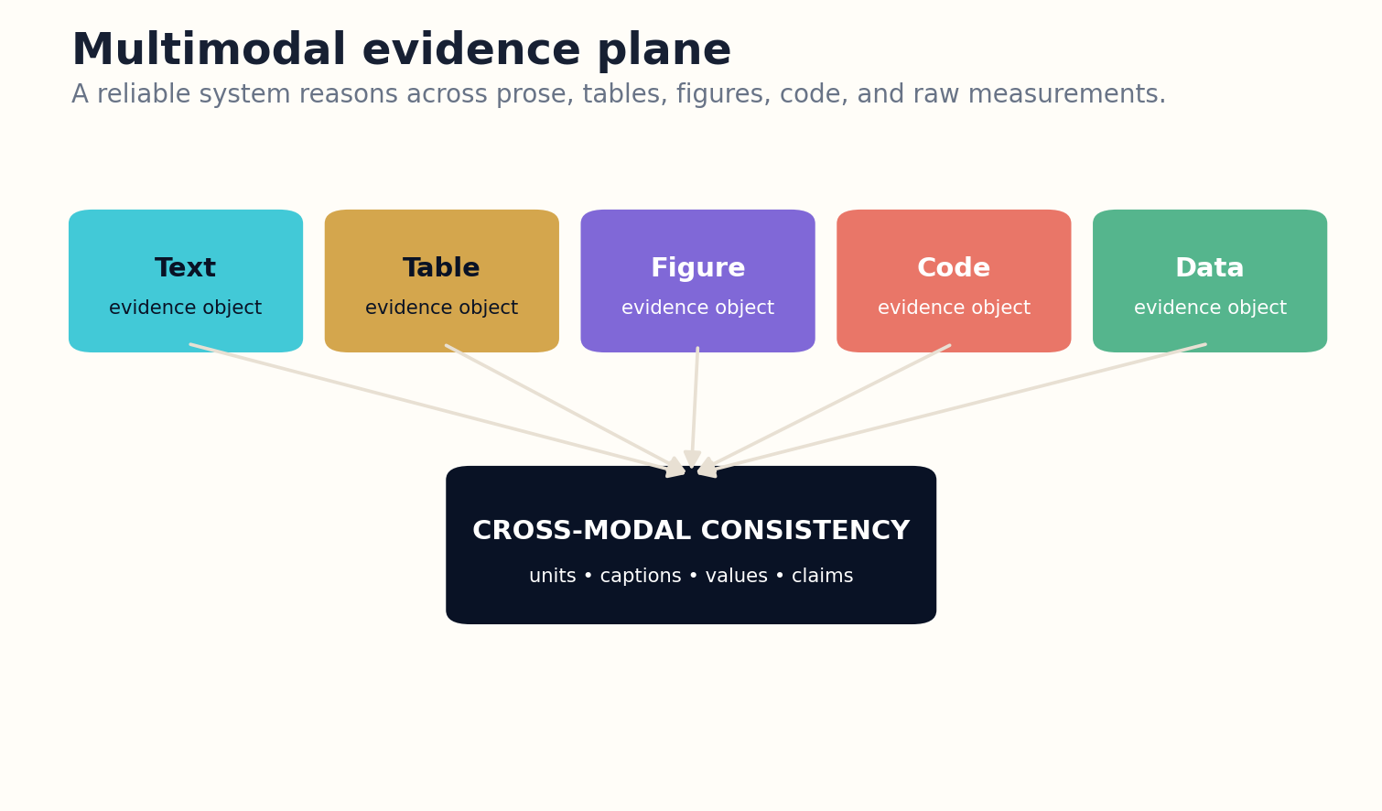
Figure 10. Text, tables, figures, code, and data are checked as connected evidence objects.

HOW THE SYSTEM WORKS
Multimodal retrieval should preserve context. A cropped plot without its caption, methods, and surrounding discussion can mislead. The evidence packet therefore includes visual regions, parsed values, source page coordinates, and links back to the full document. Models may assist extraction, but uncertain readings remain visible.
The system can also construct new visual explanations from verified data. A comparison chart or simulation output should carry the code, parameters, source values, and rendering version. Visual clarity must not erase provenance.

ENGINEERING BLUEPRINT
A multimodal evidence service should expose common operations: crop, parse axes, extract table cells, resolve units, execute code, and link artifacts. Every extracted value retains its source coordinates and confidence. When a generated chart is published, its manifest includes input values and transformation code. This creates an audit path from visual conclusion back to measurement.
Cross-modal consistency = agreement(text, table, figure, code, data)
DESIGN EXERCISE
Choose one paper with a central figure. Reconstruct the evidence chain from raw values to caption to prose claim.
Research notes: R7, R19. See “Research Notes and Sources.”

PART III
THE ANSWER COMPILER
Planning retrieval and constructing explanations, comparisons, and verified answer objects.

CHAPTER 11
Plan Before Retrieval
Good retrieval begins with a theory of what evidence would answer the question.
━━━━━━━━━━━━━━━━━━━━━━━━━
Naive retrieval sends the original query directly to an index. A planner first decomposes the task into subquestions, entities, variables, required source types, date constraints, and stopping conditions. This prevents the system from mistaking lexical overlap for evidential sufficiency.
Planning is iterative. Early retrieval may reveal that the question uses ambiguous terminology, that a key variable is unmeasured, or that the field is divided into incompatible frameworks. The planner updates the task model and may ask the user to choose a definition or accept a narrower answer.
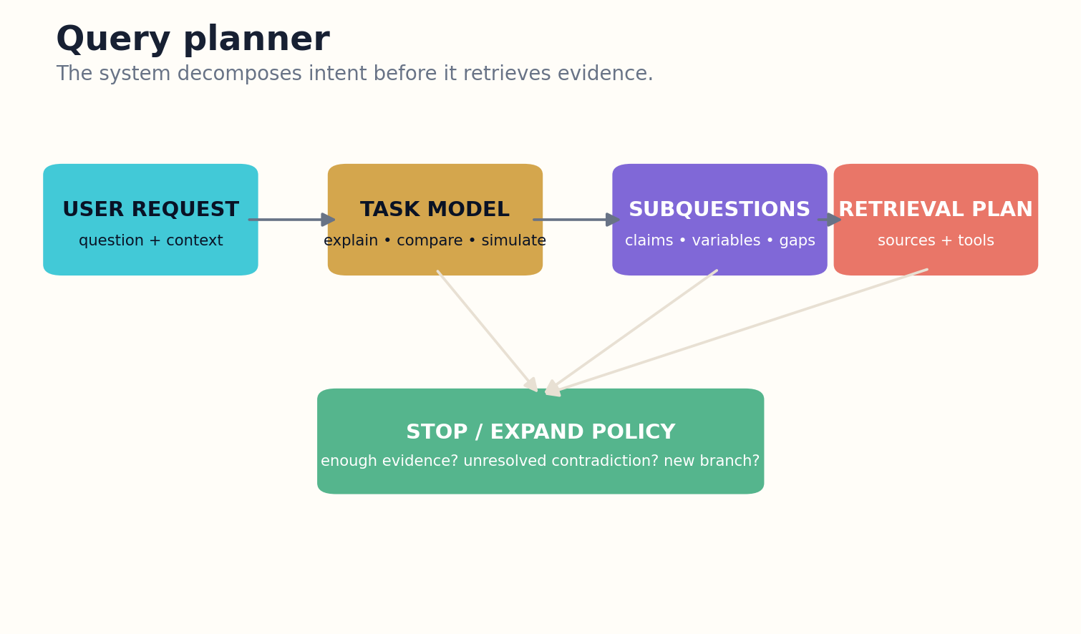
Figure 11. The query planner decomposes intent and controls expansion or stopping before retrieval becomes expensive.

HOW THE SYSTEM WORKS
A retrieval plan includes diversity requirements. A comparison needs evidence for every option, not ten sources for the most popular one. A causal question needs methods capable of supporting causal inference. A current-status question needs recent primary or official sources. The planner allocates a coverage budget before ranking documents.
Stopping rules are equally important. The system can stop when major claims have adequate independent support, serious contradictions have been searched, and new retrieval yields diminishing informational value. Without a stopping rule, research agents either terminate too early or continue consuming resources without improving the answer.

ENGINEERING BLUEPRINT
The planner can use a belief state over unresolved subquestions. Retrieval actions are selected by expected information gain, while a budget manager accounts for latency, model cost, and source access. The planner should retain rejected query branches and reasons, because failed searches are evidence about terminology gaps or unavailable data. Users can reopen a branch without restarting the investigation.
Next query = argmax expected uncertainty reduction / retrieval cost
DESIGN EXERCISE
Write a retrieval plan for a comparison question, including coverage goals and a stopping rule.
Research notes: R3, R20. See “Research Notes and Sources.”

CHAPTER 12
Hybrid Retrieval as a Portfolio
Lexical, dense, graph, temporal, and tool retrieval solve different failure modes.
━━━━━━━━━━━━━━━━━━━━━━━━━
Lexical search remains powerful for exact terminology, identifiers, error messages, and rare names. Dense retrieval captures semantic similarity but can overgeneralize. Graph retrieval follows relationships. Temporal retrieval resolves versions and recency. Tool retrieval queries structured databases or executes calculations. A mature system treats these methods as a portfolio.
The planner selects and weights retrievers according to the task. A software debugging query may begin with exact strings and repository structure. A literature synthesis may combine dense retrieval with citations and claim graphs. A regulatory comparison may prioritize official domains and date filters. Retrieval policy is part of the answer’s provenance.
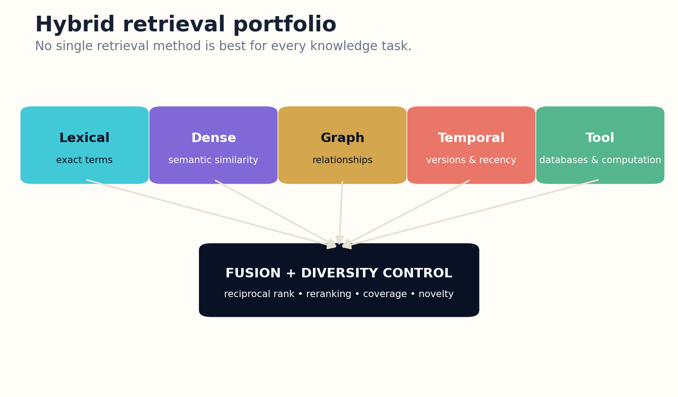
Figure 12. A portfolio of retrieval methods is fused with coverage and diversity controls.

HOW THE SYSTEM WORKS
Fusion requires diversity control. Simply merging top results can produce duplicates, popularity bias, and repeated evidence from the same source lineage. Rerankers should consider relevance, authority, independence, coverage, novelty, and contradiction value. Sometimes a lower-ranked source is important precisely because it challenges the dominant cluster.
Benchmarks such as BEIR demonstrate that retrieval methods vary across domains and that strong average performance does not guarantee robust transfer. Production systems need domain-specific test collections and live monitoring rather than faith in a universal embedding model.

ENGINEERING BLUEPRINT
A robust fusion layer stores rankings from every retriever before combining them. Reciprocal-rank fusion provides a simple baseline; learned reranking can follow, but coverage constraints should remain explicit. Add lineage-aware deduplication so mirrors and derivative summaries do not dominate. Evaluate retrieval separately for common, rare, temporal, adversarial, and cross-domain questions.
Retrieval utility = relevance + authority + independence + coverage + novelty − redundancy
DESIGN EXERCISE
Design a hybrid retrieval policy for a technical standard, a scientific controversy, and a local incident.
Research notes: R20, R21, R22. See “Research Notes and Sources.”

CHAPTER 13
The Evidence Packet
Generation should begin from a bounded research object, not a bag of convenient passages.
━━━━━━━━━━━━━━━━━━━━━━━━━
The evidence packet is the contract between research and writing. It contains the task model, claim candidates, source passages, methods, dates, quality assessments, contradictions, unresolved questions, rights metadata, and coverage report. It is small enough to inspect and rich enough to support the answer.
Packet construction prevents context-window abundance from masquerading as research quality. The system selects evidence for claim support and challenge, preserving source diversity and dependency. It can include summaries for navigation, but the authoritative links point to source spans and artifacts.
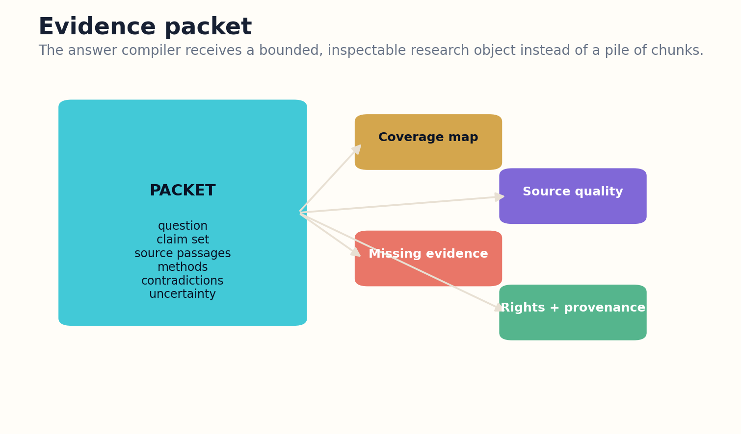
Figure 13. The evidence packet is a bounded research object with support, challenge, quality, and missingness.

HOW THE SYSTEM WORKS
The packet also states what is missing. If no primary evidence supports a popular claim, the writer cannot repair the gap with rhetoric. If one option in a comparison lacks data, the final answer should expose asymmetry. Missingness is a conclusion, not a formatting problem.
Evidence packets are reusable and versioned. A comparison, explanation, and simulation may share a core packet while adding task-specific material. When a source changes, dependency tracking identifies which packets and answer objects need review.

ENGINEERING BLUEPRINT
Packets should be immutable snapshots once they enter verification. Repairs create a new packet version with a diff showing added, removed, or reweighted evidence. A packet builder can enforce quotas for primary sources, counterevidence, and independent lineages. The writing model receives only approved packet fields, while reviewers retain access to rejected candidates and retrieval logs.
Packet sufficiency = coverage × source quality × independence × contradiction search
DESIGN EXERCISE
Assemble a minimal evidence packet for a five-claim answer. Include one deliberately unresolved gap.
Research notes: R1, R23. See “Research Notes and Sources.”

CHAPTER 14
Comparison Engines
A comparison is a model of dimensions and tradeoffs, not a list of product descriptions.
━━━━━━━━━━━━━━━━━━━━━━━━━
Reliable comparison begins by defining aligned dimensions. Effectiveness, cost, risk, evidence quality, maintenance, reversibility, and context fit may matter differently depending on the decision. The system should derive criteria from the task model and let the user inspect or change weights.
Evidence must be normalized before scoring. Studies may use different endpoints, time windows, populations, currencies, or baselines. The engine records transformations and refuses false precision when measurements cannot be aligned. Qualitative differences remain qualitative rather than being forced into arbitrary numbers.
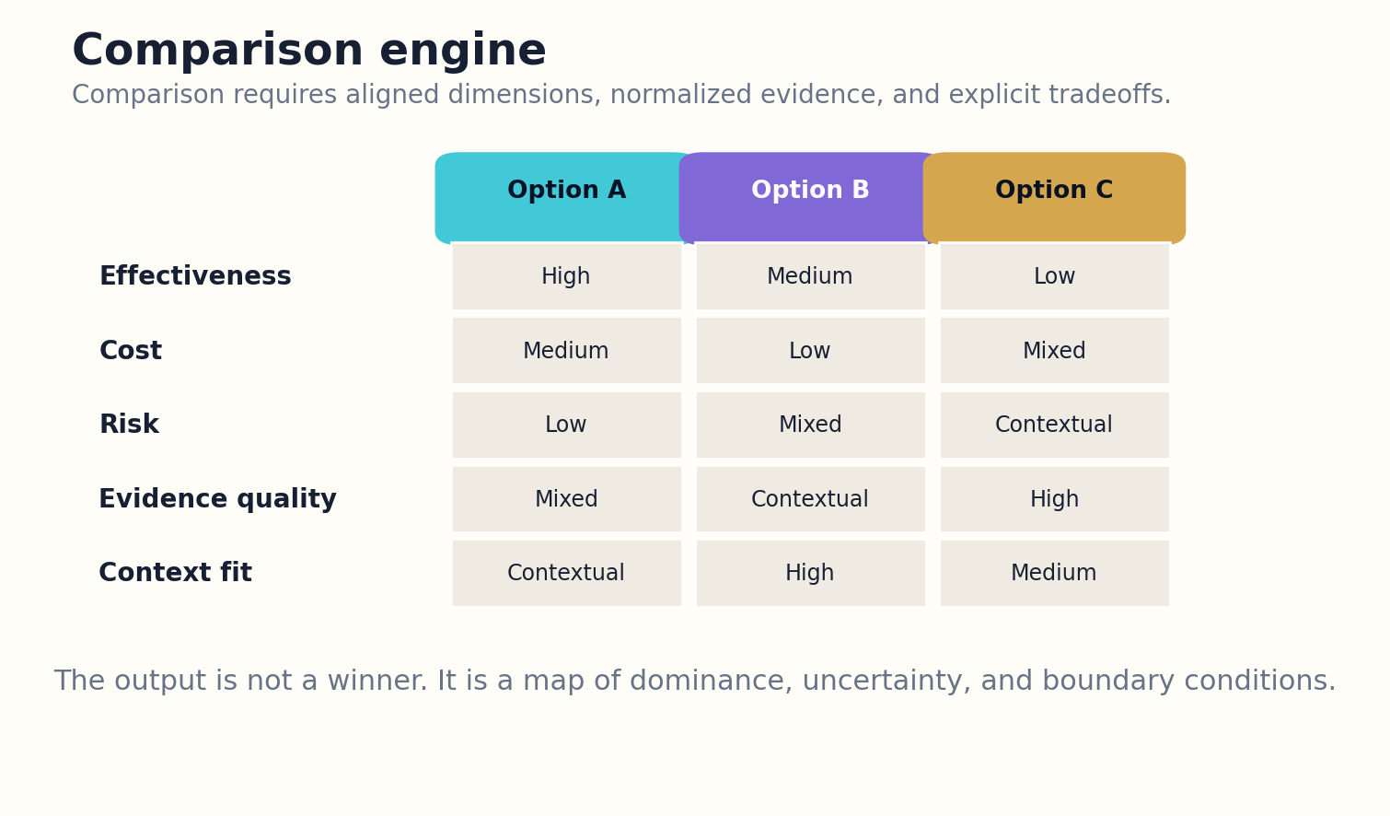
Figure 14. The comparison engine aligns dimensions and reports tradeoffs instead of manufacturing one universal winner.

HOW THE SYSTEM WORKS
Dominance analysis is often more honest than a single winner. One option may be better under low budget, another under high reliability requirements, and a third when reversibility matters. The output can show Pareto frontiers, sensitivity to weights, and conditions under which the recommendation changes.
Comparisons also need a freshness policy. Prices, specifications, laws, and availability can change quickly. The system marks dynamic fields and can rerun only the affected retrieval and calculations. A stable explanatory layer can coexist with live data.

ENGINEERING BLUEPRINT
Comparison engines need typed criterion functions. Some return measurements, some return ordinal judgments, and some return narrative constraints. Normalize only compatible values, preserve missing data, and show how recommendations change when weights move. A decision log records who selected the criteria and why, preventing the ranking formula from hiding a political or organizational choice.
Score(option) = Σ weight_i × normalized evidence_i, with sensitivity over weights
DESIGN EXERCISE
Create a comparison schema with five criteria. Identify which criteria are not safely reducible to one score.
Research notes: R3, R24. See “Research Notes and Sources.”

CHAPTER 15
The Explanation Compiler
Write once at the reasoning layer; render many times for different readers.
━━━━━━━━━━━━━━━━━━━━━━━━━
The explanation compiler transforms the task model and evidence packet into an intermediate representation of claims, mechanisms, dependencies, examples, qualifiers, and citations. It checks that every important statement has a role and that the argument does not depend on unsupported transitions.
The compiler separates semantic revision from stylistic revision. First it establishes correctness and structure. Then it renders prose, diagrams, equations, tutorials, or executive briefs. A stylistic pass may improve rhythm but cannot introduce new claims without reopening verification.
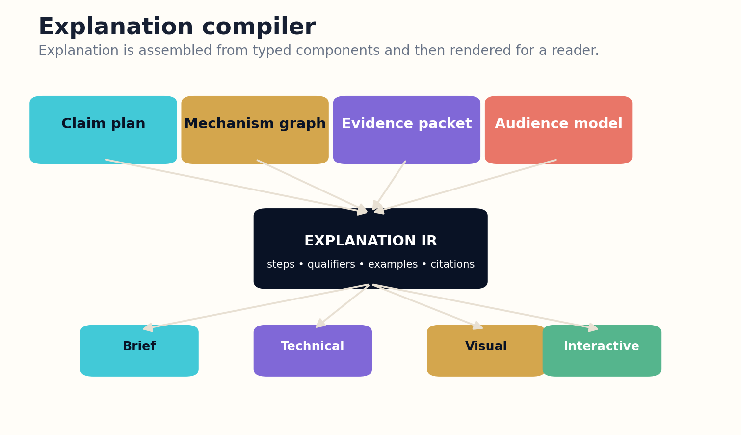
Figure 15. An explanation intermediate representation can render several trustworthy views for different readers.

HOW THE SYSTEM WORKS
Audience models control depth, vocabulary, prerequisites, and examples. The same explanation graph can support a beginner lesson and an expert memo while preserving the underlying claim identities. This avoids maintaining disconnected versions that silently diverge.
The intermediate representation enables local repair. If one claim is corrected, the system can identify affected paragraphs and visuals. It also supports “why” and “show the source” interactions because the visible sentence remains linked to the reasoning object that generated it.

ENGINEERING BLUEPRINT
Compiler validation can borrow ideas from software tooling. A linter detects undefined terms, unsupported transitions, inconsistent quantities, citation gaps, and audience-level violations. A test suite checks that key questions are answerable from the rendered output. Snapshot tests ensure that a model or prompt upgrade does not silently alter important conclusions without a new review.
Rendered answer = compile(explanation IR, audience, medium, length)
DESIGN EXERCISE
Represent one explanation as claims and relations, then render it as a 100-word brief and a technical outline.
Research notes: R2, R11, R25. See “Research Notes and Sources.”

CHAPTER 16
Citation Architecture
A citation is useful only when it supports the statement beside it.
━━━━━━━━━━━━━━━━━━━━━━━━━
Citation correctness has several dimensions: source identity, passage relevance, entailment, scope match, version status, and placement. A citation can be real yet fail to support the claim. Automated systems must evaluate the relationship between sentence and source, not merely attach a plausible reference.
Claims should link to precise spans and, where possible, figures, tables, code, or data. Long-form explanations can show compact citations in the prose while retaining a machine-readable claim ledger. Readers who need depth can inspect the support and counterevidence without cluttering every paragraph.

Figure 16. The evidence packet is a bounded research object with support, challenge, quality, and missingness.

HOW THE SYSTEM WORKS
Citation independence matters. Ten articles repeating one original source do not constitute ten independent confirmations. The provenance graph tracks derivation and shared datasets. Evidence aggregation should discount dependent repetitions and recognize replications.
Scientific synthesis systems such as OpenScholar and PaperQA2 demonstrate the value of retrieval-centered, citation-backed generation, while also motivating rigorous evaluation of citation accuracy. The architectural lesson is that citations are generated from evidence planning, not added as decoration after prose.

ENGINEERING BLUEPRINT
Build citations from the claim ledger outward. Each factual sentence references one or more claim identifiers; each claim references exact evidence spans and lineage. The renderer chooses citation style, but the underlying mapping is stable. An entailment checker should fail closed for critical claims and route ambiguous matches to review rather than selecting the most plausible source.
Citation strength = identity × entailment × scope fit × independence × version validity
DESIGN EXERCISE
Audit five citations in an existing report. Classify each as direct support, indirect context, contradiction, or decorative.
Research notes: R26, R27, R28. See “Research Notes and Sources.”

CHAPTER 17
The Verification Court
The authoring model should never be the sole judge of its own answer.
━━━━━━━━━━━━━━━━━━━━━━━━━
The verification court is an adversarial stage composed of independent roles. One audits retrieval coverage, another checks sentence-to-source entailment, another searches for contradiction, another replays calculations and code, and a domain reviewer inspects assumptions. Their objective is to construct the strongest case against release.
Independence is technical as well as organizational. Reviewers should use different prompts, retrieval paths, tools, and where practical different model families. Agreement among identical agents is weak evidence because they may share blind spots. Disagreement becomes a trigger for deeper inspection.
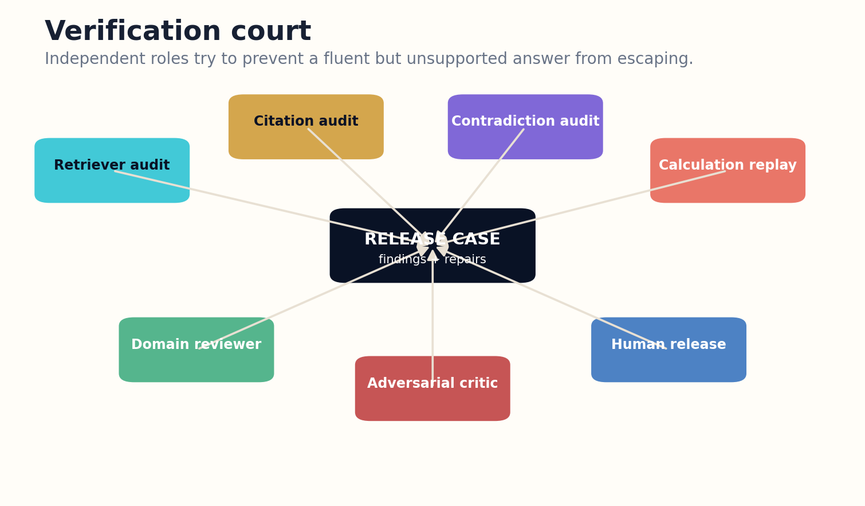
Figure 17. Independent reviewers build a release case and verify repairs before publication.

HOW THE SYSTEM WORKS
Findings are structured as blocking defects, required repairs, unresolved minority opinions, and nonblocking improvements. The answer compiler responds with targeted patches, and a reviewer verifies the repair. This creates an audit trail similar to code review and scientific rebuttal.
Evaluation frameworks such as RAGAS and ARES separate retrieval relevance, answer relevance, and faithfulness, which is useful but not sufficient for every domain. High-stakes systems require human release authority, domain-specific tests, and post-publication correction channels.

ENGINEERING BLUEPRINT
Court agents should write findings in a shared defect schema: object, severity, evidence, reproduction steps, and proposed repair. The release manager verifies that every blocker is closed or explicitly waived by an authorized human. Track reviewer calibration against known cases so an overconfident judge does not quietly become the system's weakest link.
Release if min(coverage, faithfulness, validity, safety, provenance) ≥ tier threshold
DESIGN EXERCISE
Define six court roles for a system in your domain. Give each role a blocking criterion.
Research notes: R29, R30, R31. See “Research Notes and Sources.”

PART IV
FROM ANSWERS TO MODELS
Causal reasoning, simulations, scenarios, and research-path generation.

CHAPTER 18
From Explanation to Model
Some questions cannot be answered responsibly without an explicit model.
━━━━━━━━━━━━━━━━━━━━━━━━━
Descriptive explanations organize what happened or what is known. Predictive and counterfactual questions require stronger representations. The system should escalate through a model ladder: narrative variables, causal graph, equations, executable code, simulation, and experiment plan. It should stop at the simplest level that can answer the task.
Model construction begins by naming state, inputs, outputs, constraints, and uncertainty. The system separates observed relationships from assumed mechanisms. It records calibration data and the range over which the model is intended to operate. A polished simulation outside its validated range is still speculation.
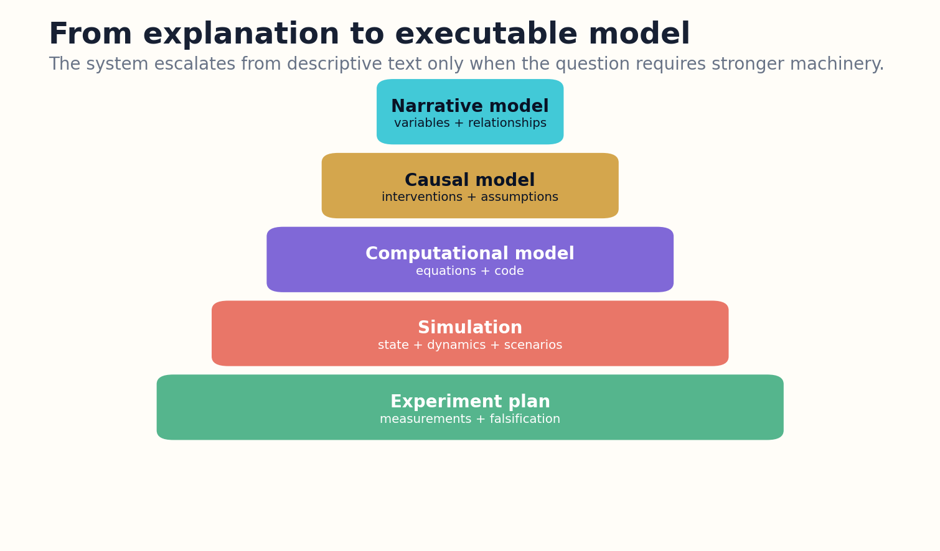
Figure 18. The model ladder escalates from narrative description to experiments only when the task requires it.

HOW THE SYSTEM WORKS
Tools become part of the answer object. Calculators, notebooks, solvers, databases, and simulators produce artifacts with parameters and logs. The language model coordinates and explains them but does not silently invent outputs. Deterministic components handle deterministic work.
A model is valuable even when it fails. Sensitivity analysis can reveal which assumptions dominate the result and which measurements would be most informative. The system can then construct a research pathway rather than pretending to know the answer.

ENGINEERING BLUEPRINT
Model escalation should be policy-driven. The planner first asks whether a descriptive answer is sufficient; if not, it selects causal, mathematical, or simulation tools. Each escalation adds required fields and tests. For example, a simulation cannot run without state definitions, parameter provenance, and validation criteria. This prevents decorative models that add apparent sophistication without decision value.
Model adequacy = predictive fit × causal relevance × calibration × domain validity
DESIGN EXERCISE
Take a narrative explanation and identify the minimum explicit model needed to answer a counterfactual question.
Research notes: R32, R33. See “Research Notes and Sources.”

CHAPTER 19
Causal Graphs and Counterfactuals
Correlation describes a pattern; intervention asks what would happen if we changed the system.
━━━━━━━━━━━━━━━━━━━━━━━━━
Causal questions require assumptions about how variables influence one another and which factors confound the relationship. A causal graph makes those assumptions visible. The system can distinguish observation from intervention and explain why a predictive model alone may not answer a policy question.
Graph construction combines domain knowledge, study design, and data. Automated suggestions can help enumerate plausible confounders and mediators, but they cannot certify causality from text alone. The answer should label which edges are measured, inferred, assumed, or contested.
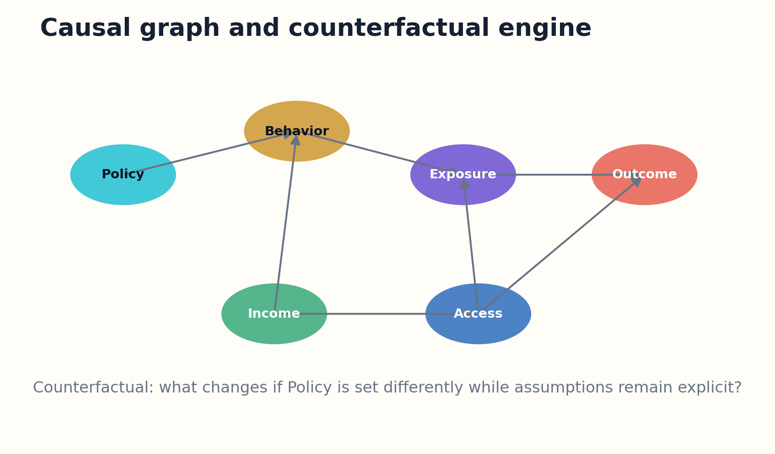
Figure 19. Causal graphs make intervention assumptions visible and support counterfactual analysis.

HOW THE SYSTEM WORKS
Counterfactual analysis asks what would happen under an alternative action while holding the model’s structural assumptions. The system can show multiple plausible models and how recommendations change across them. This is more honest than presenting one counterfactual number without sensitivity analysis.
Causal answers should connect to experiment design. If two models make different predictions, the research pathway can identify an intervention or measurement that distinguishes them. Explanation becomes a bridge from current evidence to future evidence.

ENGINEERING BLUEPRINT
Causal workflows should store multiple candidate graphs when evidence does not identify one structure. The answer can compare conclusions across the equivalence class and highlight edges that determine the recommendation. Tools such as identification checks and refutation tests can be executed automatically, but domain experts remain responsible for whether the assumptions correspond to reality.
Causal effect = E[Y | do(X=x1)] − E[Y | do(X=x0)] under stated assumptions
DESIGN EXERCISE
Draw a causal graph for a policy question and label every edge as measured, inferred, assumed, or disputed.
Research notes: R33, R34. See “Research Notes and Sources.”

CHAPTER 20
Agent-Based Simulation
When individual differences and interactions matter, averages may hide the mechanism.
━━━━━━━━━━━━━━━━━━━━━━━━━
Agent-based models represent heterogeneous actors with rules, resources, memory, and relationships. They are useful when system behavior emerges from local interactions: markets, traffic, epidemics, organizations, ecosystems, or information diffusion. The knowledge system can translate evidence into candidate agent rules while preserving provenance.
Simulation design begins with purpose. A model intended to explore mechanisms differs from one intended to forecast. The system records initialization, transition rules, random seeds, calibration targets, and validation tests. Generated rules remain hypotheses until compared with observations.
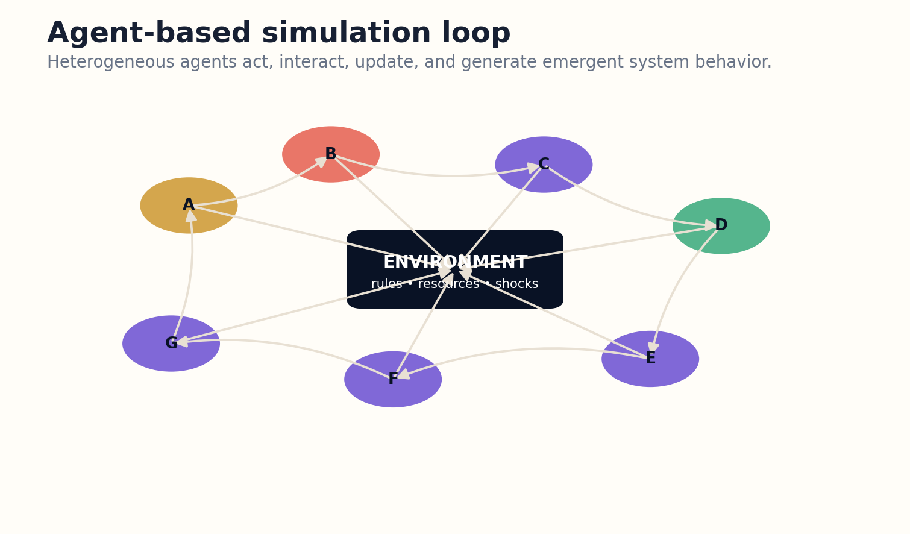
Figure 20. Agent-based simulation represents heterogeneous behavior and emergent outcomes.

HOW THE SYSTEM WORKS
Language models can help construct scenarios and interpret outcomes, but the simulation engine should execute state transitions. Results are distributions across runs, not one cinematic narrative. The answer shows sensitivity to parameters and identifies which emergent patterns are robust.
Agent-based simulation is especially valuable for research pathways. It can reveal that several mechanisms produce the same aggregate pattern, motivating new measurements at the individual or network level. The simulation does not close the question; it sharpens it.

ENGINEERING BLUEPRINT
An agent-based model repository should separate reusable agent archetypes, environment modules, and experiment configurations. Calibration fits distributions rather than one hand-selected run. Dashboards show ensemble outcomes, uncertainty intervals, and failure regions. The language layer explains the model but never substitutes a narrated scenario for the actual simulation output.
System state S(t+1) = F(S(t), agent policies, interactions, environment, random seed)
DESIGN EXERCISE
Specify agents, environment, rules, observables, and validation criteria for a small simulation.
Research notes: R35, R36. See “Research Notes and Sources.”

CHAPTER 21
Scenario Laboratories
A scenario is a disciplined conditional world, not a disguised prediction.
━━━━━━━━━━━━━━━━━━━━━━━━━
Scenario systems explore how outcomes change under uncertain drivers. They distinguish controllable decisions, external uncertainties, structural assumptions, and early indicators. A good scenario set spans meaningful alternatives rather than multiplying colorful stories.
The laboratory combines qualitative and quantitative models. Narrative scenarios make institutional and human consequences legible; equations and simulations test feasibility and internal consistency. The system flags when a scenario violates resource constraints or contradicts known dependencies.

Figure 21. The model ladder escalates from narrative description to experiments only when the task requires it.

HOW THE SYSTEM WORKS
Users can compare policies across scenarios and identify robust choices that perform acceptably under several futures. Sensitivity analysis shows which uncertainties reverse the decision. This is often more useful than choosing one forecast.
Every scenario carries a lineage: source assumptions, model version, parameters, generated narrative, and human edits. It also has signposts that can be monitored. As reality unfolds, the system updates scenario probabilities or retires branches without erasing the original analysis.

ENGINEERING BLUEPRINT
Scenario laboratories benefit from a matrix of drivers and states before narrative drafting. Internal-consistency rules reject impossible combinations, while a diversity objective prevents all scenarios from sharing the same hidden assumption. Monitoring services attach indicators to scenario branches and periodically update their plausibility without rewriting the original conditional analysis.
Robust decision = argmax_policy min_scenario utility(policy, scenario)
DESIGN EXERCISE
Create three scenarios that differ in structural drivers, not merely optimistic and pessimistic labels.
Research notes: R32, R37. See “Research Notes and Sources.”

CHAPTER 22
Research Pathway Generators
The most useful answer may be a map of what to learn next.
━━━━━━━━━━━━━━━━━━━━━━━━━
A research pathway converts uncertainty into sequenced work. It identifies prerequisite concepts, terminology, seminal sources, current debates, data resources, methods, tools, potential experiments, and decision points. The output is a graph because investigation branches and loops.
Pathway generation begins from the gap map in the evidence packet. Some gaps are resolved by better retrieval; others require data analysis, expert consultation, replication, or new experiments. The system estimates cost, risk, dependencies, and expected uncertainty reduction for each step.
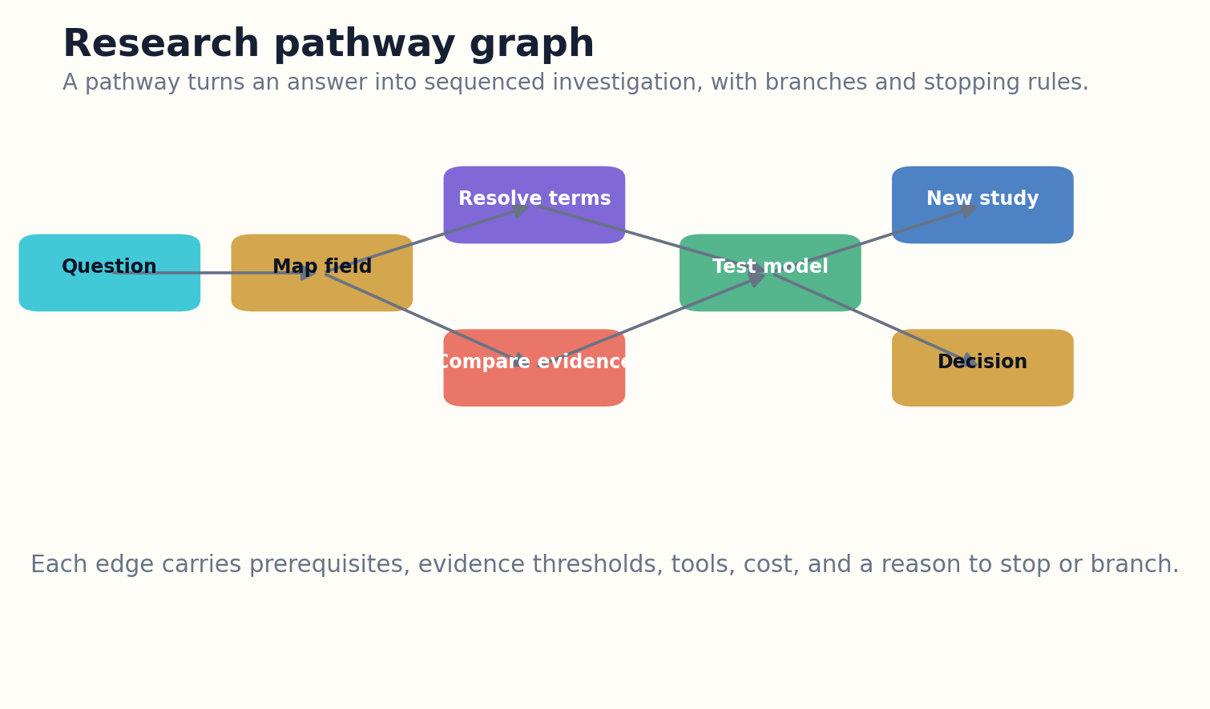
Figure 22. Research pathways branch from gaps toward retrieval, analysis, modeling, experiments, or decisions.

HOW THE SYSTEM WORKS
The pathway includes stopping rules. A literature branch can stop when independent evidence saturates. An experiment branch can stop for safety, futility, or decisive evidence. A design branch may return to assumptions when simulation fails. This prevents research agents from equating activity with progress.
Pathways are personalized to resources and expertise without hiding the global map. A student may receive a learning sequence; a laboratory may receive an experimental program; a policy team may receive stakeholder and data tasks. All remain linked to the same question state.

ENGINEERING BLUEPRINT
A pathway engine can represent every step as a task card with prerequisites, expected information gain, cost, risk, owner, and completion evidence. The graph supports parallel work where dependencies permit. When a step fails, the system records whether the failure reduces uncertainty, changes the model, or merely requires another method. Research progress becomes inspectable rather than performative.
Next step = argmax expected information gain × decision relevance / cost and risk
DESIGN EXERCISE
Build a pathway with at least one retrieval branch, one analysis branch, and one experiment branch.
Research notes: R27, R38. See “Research Notes and Sources.”

CHAPTER 23
Tools, Experiments, and Reproducible Runs
A knowledge system becomes a laboratory when it can act through tools and preserve the run.
━━━━━━━━━━━━━━━━━━━━━━━━━
Tool use extends the system beyond prose. It can query structured databases, execute code, fit models, solve equations, render figures, inspect repositories, and control instruments under appropriate governance. Each tool call is an activity with inputs, outputs, version, permissions, and logs.
The planner chooses tools based on evidence needs, not novelty. A calculator is preferable to language-model arithmetic. A database query is preferable to guessing a current value. A simulation is appropriate only when its assumptions are explicit. Tool selection is part of reasoning quality.

Figure 23. Research pathways branch from gaps toward retrieval, analysis, modeling, experiments, or decisions.

HOW THE SYSTEM WORKS
Reproducible runs bundle code, environment, data identifiers, parameters, seeds, and outputs. When proprietary or sensitive components prevent full release, the manifest still records enough structure for audit. Results in the explanation link to the run that produced them.
Experiment execution requires strict safety and authority boundaries. The system may propose protocols and analyze results, but physical or high-consequence actions need human approval, access control, and domain procedures. The laboratory metaphor should never erase operational responsibility.

ENGINEERING BLUEPRINT
Tool orchestration should use capability manifests and least-privilege credentials. A tool declares accepted inputs, output schema, side effects, version, cost, and security tier. Sandboxed execution captures stdout, errors, files, and environment hashes. Results do not enter the claim ledger until validation confirms that the run completed and the interpretation matches the output.
Run = tool version + inputs + environment + parameters + outputs + provenance
DESIGN EXERCISE
Design a reproducible run manifest for a calculation or simulation used in an answer.
Research notes: R9, R39. See “Research Notes and Sources.”

PART V
THE RESEARCH WORKSPACE
Interfaces, memory, collaboration, and personalization beyond a single conversation.

CHAPTER 24
The Interface Beyond One Box
Knowledge work needs a canvas, not an endless transcript.
━━━━━━━━━━━━━━━━━━━━━━━━━
A single conversation stream hides structure as the project grows. The research workspace separates the task map, current explanation, evidence, comparison, simulation, notebook, and decision log while keeping them linked. Users can move between views without losing provenance.
The answer object is editable at the level of claims and assumptions. A user can challenge one source, change a comparison weight, alter a simulation parameter, or request a deeper derivation. The system recomputes affected components rather than regenerating the entire narrative unpredictably.
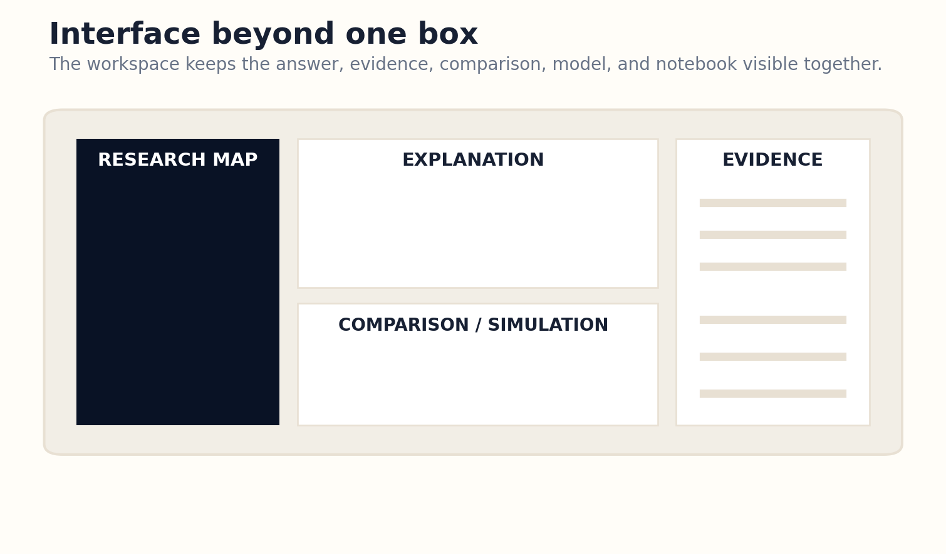
Figure 24. A multi-pane workspace preserves task, answer, evidence, and model state together.

HOW THE SYSTEM WORKS
Visual navigation supports progressive disclosure. A concise answer can expand into evidence paths, contradiction maps, or model internals. Source inspection occurs beside the claim rather than in a separate browser hunt. The interface communicates confidence and missingness without overwhelming the reader.
The search box remains as one entry point, but other interactions become equally important: selecting entities, drawing causal arrows, uploading data, pinning evidence, branching scenarios, and arranging a research plan. The workspace turns knowledge construction into a manipulable process.

ENGINEERING BLUEPRINT
The workspace should use linked selections: selecting a sentence highlights its claims and sources; selecting a comparison cell reveals normalization and evidence; changing a parameter updates only dependent simulation views. Autosave should persist structured state, not merely the visible layout. Export formats should include a reader-friendly report and a machine-readable answer bundle.
Interface utility = task visibility × state continuity × inspectability × controllability
DESIGN EXERCISE
Sketch a workspace for one complex task. Include at least four synchronized views.
Research notes: R40, R41. See “Research Notes and Sources.”

CHAPTER 25
Conversation as Research State
The durable object is not the transcript; it is the evolving model of the investigation.
━━━━━━━━━━━━━━━━━━━━━━━━━
Conversation is valuable for clarification and iterative thinking, but a transcript is a poor long-term memory. Important decisions, definitions, assumptions, evidence, and open questions become buried in turns. The system should continuously compile conversation into structured research state.
Research state includes the task model, glossary, claim graph, accepted and rejected sources, answer versions, model parameters, decisions, and unresolved branches. Users can inspect and edit this state directly. The conversation becomes one interface for changing it.

Figure 25. A multi-pane workspace preserves task, answer, evidence, and model state together.

HOW THE SYSTEM WORKS
Branching allows competing hypotheses or scenarios to develop without contaminating one another. A team can compare branches, merge compatible findings, and preserve the reason a branch was abandoned. This resembles version control for inquiry.
State summaries are generated from the structured objects, not used as lossy replacements for them. The system can return after months, reconstruct why a decision was made, and rerun outdated components. Durable research is possible because memory has schema.

ENGINEERING BLUEPRINT
Research-state compilation can run after every meaningful turn. A state updater proposes changes to definitions, claims, decisions, and open questions, while the user can approve important mutations. Branches receive identifiers and merge records. This approach preserves conversational flexibility while preventing the transcript from becoming the sole source of truth.
Research state R_t = update(R_{t−1}, evidence, decisions, models, open questions)
DESIGN EXERCISE
Convert a long conversation or meeting into a structured state with decisions, evidence, assumptions, and open branches.
Research notes: R9, R41. See “Research Notes and Sources.”

CHAPTER 26
Memory That Knows What to Forget
Reliable memory preserves commitments and provenance while allowing low-value detail to decay.
━━━━━━━━━━━━━━━━━━━━━━━━━
Knowledge systems need a hierarchy of memory. Active context holds the current reasoning step. Working memory holds the task plan and selected evidence. Project memory holds durable claims, decisions, and artifacts. Archive memory preserves source and edition history. Treating all text equally is expensive and confusing.
Memory admission is policy-driven. A user preference may be useful but should not overwrite task-specific evidence. A provisional hypothesis should not become a permanent fact. Sensitive data may require expiration or local storage. Each memory item receives type, provenance, confidence, scope, and retention rules.

Figure 26. A multi-pane workspace preserves task, answer, evidence, and model state together.

HOW THE SYSTEM WORKS
Forgetting can improve reliability. Redundant summaries, superseded drafts, and failed tool outputs can move to cold storage while their lineage remains. Retrieval should prefer current authoritative state but permit historical reconstruction. Deletion and correction must propagate through indexes.
Personal memory creates additional risks. The system should let users view, correct, export, and delete stored information. Personalization should assist the task without constructing an invisible profile that changes evidence standards or traps the user in prior beliefs.

ENGINEERING BLUEPRINT
Memory governance should be visible in the interface. Users can inspect why an item was stored, where it is used, when it expires, and which derived indexes contain it. Sensitive project memory can remain local while public evidence is shared. Periodic compaction should preserve decisions and provenance even when intermediate language is archived.
Memory priority = future utility × confidence × uniqueness × retention permission / cost
DESIGN EXERCISE
Create memory tiers and admission rules for a year-long research project.
Research notes: R9, R42. See “Research Notes and Sources.”

CHAPTER 27
Collaborative Intelligence Without Consensus Theater
Teams need visible disagreement and accountable synthesis, not a machine-generated illusion of agreement.
━━━━━━━━━━━━━━━━━━━━━━━━━
Collaborative knowledge systems coordinate researchers, domain experts, editors, decision makers, and agents. Each participant can contribute sources, claims, critiques, models, or approvals. Roles and authority are explicit so that a fluent synthesis cannot erase responsibility.
Disagreement is represented in the shared state. Participants can endorse, challenge, or qualify claims and attach reasons. The system distinguishes unresolved conflict from simple duplication and can generate a disagreement brief showing the decisive assumptions.

Figure 27. Agent-based simulation represents heterogeneous behavior and emergent outcomes.

HOW THE SYSTEM WORKS
Agent roles remain bounded. A cartographer maps the field, a retriever gathers evidence, a skeptic attacks coverage, a modeler builds simulations, and an editor constructs the explanation. They exchange typed artifacts through a ledger rather than relying on an unstructured group chat.
Human governance decides when consensus is required and when plural outputs are preferable. A scientific system may publish competing models; a safety procedure may require one approved action. Collaboration quality comes from transparent process, not from minimizing visible friction.

ENGINEERING BLUEPRINT
Collaborative ledgers need attribution at the artifact level. A source contribution, claim correction, simulation change, or release approval records its author and rationale. Voting is not always appropriate; the governance model may assign domain authority or require consensus for specific fields. The system should surface minority reports instead of burying them inside a final summary.
Collective reliability = diversity of expertise × evidence transparency × accountable authority
DESIGN EXERCISE
Define five human or agent roles, their permissions, and how disagreement is resolved or preserved.
Research notes: R31, R43. See “Research Notes and Sources.”

PART VI
TRUSTWORTHY DEPLOYMENT
Evaluation, security, governance, and a practical path to production.

CHAPTER 28
Evaluation as a Stack
There is no single score for a system that retrieves, reasons, explains, simulates, and guides research.
━━━━━━━━━━━━━━━━━━━━━━━━━
Evaluation begins by separating layers. Retrieval metrics measure relevance, coverage, diversity, and freshness. Grounding metrics test whether statements are supported. Reasoning metrics test validity, consistency, and uncertainty. Task metrics ask whether the user learned, decided, diagnosed, or designed more effectively.
Simulation adds calibration, sensitivity, stability, and empirical validation. Research pathways require measures of coverage, sequencing, cost realism, and information gain. Interface evaluation measures state comprehension, control, and error recovery. Security and privacy require adversarial testing.
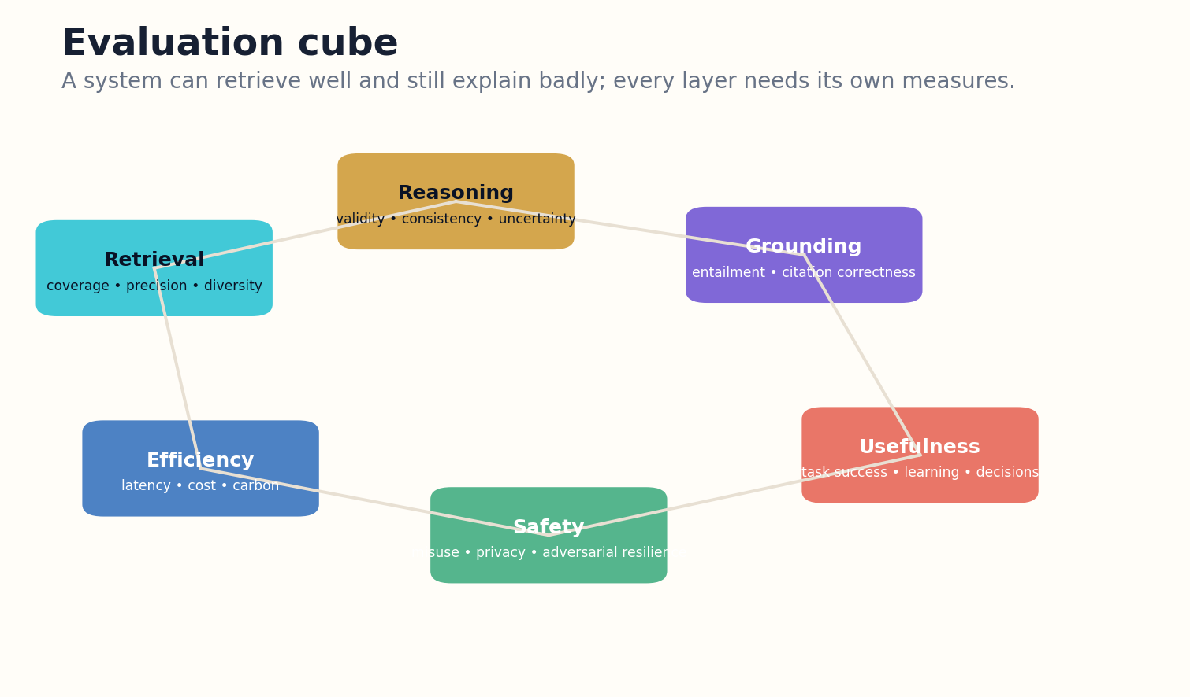
Figure 28. Evaluation separates retrieval, grounding, reasoning, usefulness, safety, and efficiency.

HOW THE SYSTEM WORKS
Automated judges accelerate iteration, but they need calibration against human evaluation and domain truth. RAGAS and ARES provide useful component-level approaches; benchmarks such as BEIR reveal retrieval variation. Production evaluation must include real tasks, hidden test cases, counterfactual probes, and post-deployment error reports.
The system publishes an evaluation card by release and domain. It reports limitations and performance distributions, not only averages. A system that performs well on popular questions but fails rare or adversarial cases should not be described as generally reliable.

ENGINEERING BLUEPRINT
Evaluation infrastructure should run continuously. Offline benchmark suites catch regressions before release, online sampling audits real answers, and incident reviews generate new adversarial tests. Metrics are segmented by domain, task, language, rarity, and consequence. The dashboard should display confidence intervals and failure examples, because a single aggregate score encourages unsafe overgeneralization.
System quality = vector(retrieval, grounding, reasoning, usefulness, safety, efficiency)
DESIGN EXERCISE
Build a test matrix crossing five task types with six evaluation layers. Identify which cells require human judgment.
Research notes: R20, R29, R30, R44. See “Research Notes and Sources.”

CHAPTER 29
Adversarial Knowledge Systems
The more a system can construct, the more carefully it must distrust its inputs and tools.
━━━━━━━━━━━━━━━━━━━━━━━━━
Threats enter through sources, prompts, graphs, tools, memory, and collaborators. A poisoned document may contain instructions for the model, fabricated citations, or misleading metadata. A compromised connector may alter data. A graph extraction attack can create false authority through repeated relationships.
The architecture separates data from instructions. Retrieved content is treated as untrusted evidence, never as policy. Tools run with least privilege, network and file access are scoped, and outputs are validated. Critical source domains and artifacts use integrity checks and independent retrieval paths.
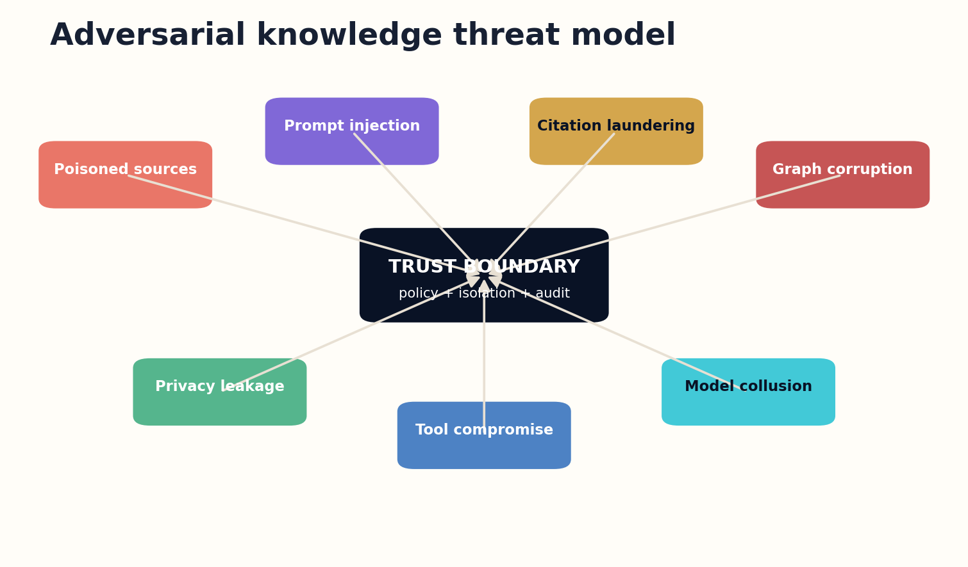
Figure 29. The trust boundary treats sources and tool outputs as potentially adversarial.

HOW THE SYSTEM WORKS
Citation laundering is a distinctive threat. False claims can spread through many derivative pages and appear independently confirmed. Provenance and lineage analysis discount repetitions and prioritize primary evidence. The contradiction search deliberately leaves dominant clusters.
Security includes epistemic abuse. A user may request a persuasive explanation designed to conceal uncertainty or target a vulnerable audience. Governance policies should consider the purpose and consequences of the constructed object, while preserving legitimate research and critique. Trustworthy knowledge systems defend both infrastructure and truth-seeking process.

ENGINEERING BLUEPRINT
Defense in depth begins with strict separation of system instructions, user requests, retrieved evidence, and tool outputs. Content scanners can flag instruction-like text inside sources, but policy enforcement belongs outside the model. Use signed source connectors, provenance checks, sandboxed tools, rate limits, anomaly detection, and human escalation for high-impact graph or memory mutations.
Risk = threat likelihood × access × propagation × consequence / detectability
DESIGN EXERCISE
Create a threat model covering source poisoning, prompt injection, tool compromise, and citation laundering.
Research notes: R45, R46, R47. See “Research Notes and Sources.”

CHAPTER 30
Building the First Reliable System
The path beyond search begins with one narrow task that can be measured end to end.
━━━━━━━━━━━━━━━━━━━━━━━━━
The first deployment should not attempt universal knowledge construction. Choose one domain, one task family, and a source estate with clear rights and quality. Build the task model, ingest pipeline, evidence packet, explanation representation, verification court, and evaluation suite around that constrained problem.
Phase two adds structured comparison. Phase three introduces reusable explanation compilation and audience-specific rendering. Phase four adds models, tools, and simulations for questions that justify them. Only after these layers are measurable should the system become a broad research workspace.
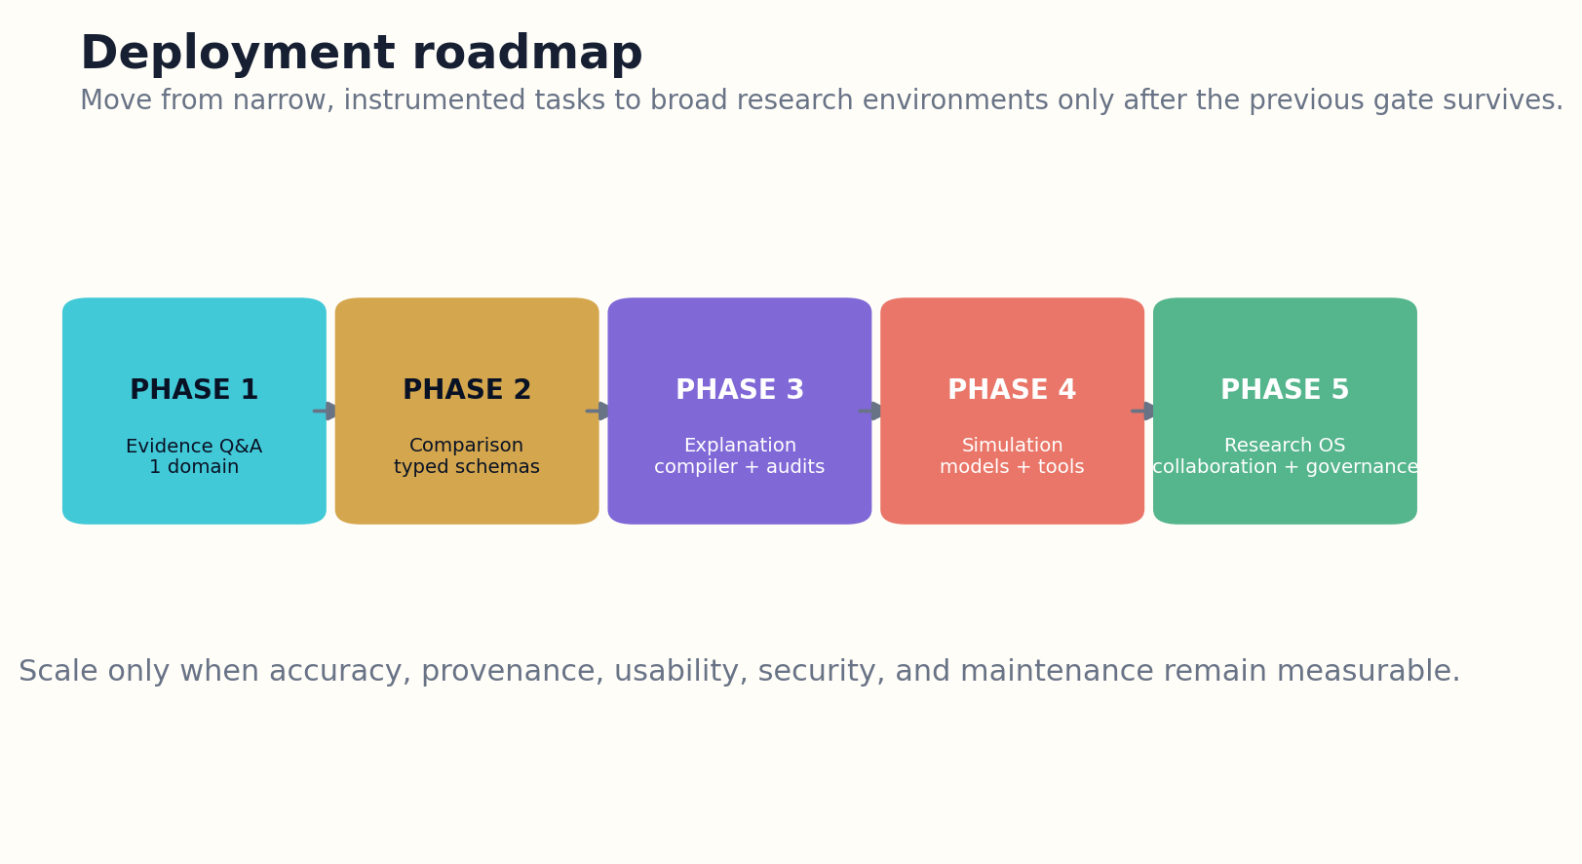
Figure 30. Deployment expands from narrow evidence Q&A to a governed research operating system.

HOW THE SYSTEM WORKS
Every phase needs correction and maintenance. Source updates, index changes, model upgrades, security incidents, and user reports can alter answer quality. The system should version policies and evaluations, maintain regression tests, and preserve prior answer objects for comparison.
Success is not measured by the number of queries answered. It is measured by whether users can inspect how an answer was built, identify what remains uncertain, change assumptions, reproduce calculations, compare alternatives, and continue along a productive research path. The search box becomes smaller because the knowledge system around it becomes larger.

ENGINEERING BLUEPRINT
The first production team should include retrieval, domain, evaluation, security, and product expertise from the beginning. Define a narrow answer contract, assemble a test corpus, and instrument every step before optimizing speed. Weekly error reviews should produce schema changes and regression tests. Expansion occurs only after the system can explain its own failures as clearly as its successes.
Scale gate opens when reliability × usefulness × maintainability × governance exceeds threshold
DESIGN EXERCISE
Write a three-phase deployment plan for one narrow domain, with explicit quality gates and rollback conditions.
Research notes: R5, R29, R45. See “Research Notes and Sources.”

APPENDIX A
THE ANSWER OBJECT SCHEMA
The answer object is the central production artifact. Prose is one rendering. The schema below preserves the task, evidence, reasoning, uncertainty, models, and update conditions required for inspection and reuse.

Task Model
• question
• operation types
• audience
• constraints
• stakes
• time horizon
• completion criteria

Claim Ledger
• claim_id
• claim_type
• statement
• scope
• source spans
• support
• counterevidence
• uncertainty
• review status

Explanation IR
• conclusion
• mechanism steps
• dependencies
• examples
• qualifiers
• falsifiers
• rendering hints

Comparison Model
• options
• criteria
• normalization
• weights
• evidence quality
• sensitivity
• dominance regions

Simulation Manifest
• model type
• state variables
• rules
• parameters
• data
• seeds
• validation
• outputs
• limitations

Research Path
• nodes
• dependencies
• tools
• evidence thresholds
• cost
• risk
• stopping rules
• branch status

Provenance Manifest
• sources
• versions
• retrieval plan
• models
• tools
• human edits
• review findings
• release signature

APPENDIX B
EVALUATION MATRIX
Layer | Measures | Methods
Retrieval | coverage, precision, diversity, independence, recency | gold sets, adversarial queries, source audits
Grounding | citation entailment, scope fit, attribution, contradiction coverage | claim-level human review, source-span tests
Reasoning | logical validity, calculation correctness, causal assumptions, consistency | tool replay, counterexamples, perturbation tests
Explanation | mechanism clarity, progressive depth, misconception repair | reader studies, expert rubric, teach-back
Comparison | dimension alignment, normalization, sensitivity, fairness | known decision cases, weight perturbation
Simulation | calibration, sensitivity, stability, empirical validation | holdout data, parameter sweeps, replication
Research path | gap coverage, sequencing, information gain, cost realism | expert planning comparison, completion studies
System | security, privacy, latency, cost, energy, maintainability | red teams, regression suites, operations metrics

APPENDIX C
IMPLEMENTATION BLUEPRINT

Figure 31. Deployment expands from narrow evidence Q&A to a governed research operating system.

Phase 1 — Evidence-grounded Q&A
One domain, official and primary sources, typed claims, precise citations, error reporting, and a hidden evaluation set.

Phase 2 — Structured comparison
Add criterion schemas, normalization, evidence-quality labels, sensitivity analysis, and dynamic-field refresh.

Phase 3 — Explanation compiler
Introduce explanation IR, audience renderers, diagrams, calculation replay, and independent verification roles.

Phase 4 — Models and simulations
Add causal graphs, notebooks, agent-based models, parameter manifests, calibration tests, and scenario branching.

Phase 5 — Research operating system
Add durable project state, collaboration, governance, memory controls, source contribution, and public evaluation cards.

APPENDIX D
A CONSTITUTION FOR RELIABLE KNOWLEDGE CONSTRUCTION
I. Evidence before eloquence
No answer may gain authority merely from fluency. Important claims must resolve to inspectable evidence or be labeled as inference.
II. Scope before generalization
Every answer declares the population, version, time, and conditions to which it applies.
III. Contradiction before consensus
Serious counterevidence is searched and represented before a synthesis is released.
IV. Models before predictions
Forecasts, counterfactuals, and simulations expose assumptions, parameters, calibration, and limits.
V. Provenance before permanence
Sources, transformations, tools, models, and human decisions remain recoverable for every released answer object.
VI. Human authority before high consequence
Accountable people retain release and action authority in high-stakes domains.
VII. Correction without erasure
Answers are versioned, corrected, and superseded without silently rewriting prior states.
VIII. Privacy before personalization
Users control personal memory, and personalization never lowers evidence standards invisibly.
IX. Security before connectivity
Retrieved content and tool outputs remain untrusted until validated inside bounded permissions.
X. Research before closure
When evidence cannot support a reliable answer, the system produces a map of uncertainty and the next productive questions.

GLOSSARY
Answer object. A structured artifact containing the task, claims, evidence, explanation, alternatives, uncertainty, models, and research state.
Claim graph. A network of typed claims and their sources, methods, entities, support, contradiction, and dependencies.
Epistemic contract. The declared scope, evidence standard, assumptions, uncertainty, and update conditions of an answer.
Evidence packet. A bounded, versioned collection of claim-relevant evidence, counterevidence, quality labels, and missingness.
Explanation IR. An intermediate representation of conclusions, mechanisms, dependencies, examples, qualifiers, and citations.
Hybrid retrieval. The coordinated use of lexical, dense, graph, temporal, and tool-based retrieval.
Research pathway. A directed graph of learning, retrieval, analysis, modeling, and experimental steps with stopping rules.
Simulation manifest. The reproducible record of a model’s rules, parameters, data, seeds, validation, outputs, and limits.
Task model. A structured interpretation of the user’s goal, audience, constraints, stakes, and completion criteria.
Verification court. Independent automated and human roles that challenge coverage, grounding, reasoning, safety, and release readiness.

RESEARCH NOTES AND SOURCES
The architecture in this book is proposed. The sources below ground major components in retrieval-augmented generation, graph retrieval, scholarly synthesis, provenance, evaluation, causal modeling, simulation, privacy, and security. Technical versions and online documentation change; implementers should consult the current primary source.
R1 Lewis et al., “Retrieval-Augmented Generation for Knowledge-Intensive NLP Tasks,” 2020. Source
R2 Edge et al., “From Local to Global: A Graph RAG Approach to Query-Focused Summarization,” Microsoft Research, 2024. Source
R3 Microsoft GraphRAG Query Engine documentation: local, global, DRIFT, basic search, and question generation. Source
R4 Zhu et al., “Knowledge Graph-Guided Retrieval Augmented Generation,” 2025. Source
R5 Microsoft GraphRAG project and indexing documentation. Source
R6 OpenAI Research, Deep Research and related system descriptions, consulted for task-oriented research-agent patterns. Source
R7 Wang et al., “SciDaSynth: Interactive Structured Knowledge Extraction and Synthesis from Scientific Literature,” 2024. Source
R8 Asai et al., “OpenScholar: Synthesizing Scientific Literature with Retrieval-Augmented LMs,” 2024. Source
R9 W3C, PROV-O: The PROV Ontology, Recommendation. Source
R10 DataCite Metadata Schema 4.7, released March 2026. Source
R11 Sabeti Moghaddam et al., “Explainable Knowledge Graph Retrieval-Augmented Generation with KG-SMILE,” 2025. Source
R12 OpenAlex API and data documentation. Source
R13 Crossref REST API documentation. Source
R14 arXiv bulk data access documentation. Source
R15 Microsoft GraphRAG indexing overview. Source
R16 Microsoft Research, GraphRAG dynamic community selection, 2024. Source
R17 Skarlinski et al., “Language Agents Achieve Superhuman Synthesis of Scientific Knowledge,” 2024. Source
R18 Babaei Giglou et al., “LLMs4Synthesis,” 2024. Source
R19 DataCite and scholarly metadata standards for linking publications, data, software, and instruments. Source
R20 Thakur et al., “BEIR: A Heterogeneous Benchmark for Zero-shot Evaluation of Information Retrieval Models,” 2021. Source
R21 Yan et al., “Corrective Retrieval Augmented Generation,” 2024. Source
R22 MTEB benchmark documentation and datasets for broad embedding evaluation. Source
R23 OpenScholar project materials on citation-backed scientific synthesis. Source
R24 Multi-criteria decision analysis principles; implementation should use domain-specific validated methods and transparent sensitivity analysis. Source
R25 Balanos et al., “KGRAG-Ex: Explainable Retrieval-Augmented Generation with Knowledge Graph-Based Perturbations,” 2025. Source
R26 Asai et al., OpenScholar paper and ScholarQABench. Source
R27 FutureHouse, PaperQA2 research and open-source ecosystem. Source
R28 Skarlinski et al., PaperQA2 and LitQA2 evaluation. Source
R29 Es et al., “RAGAS: Automated Evaluation of Retrieval Augmented Generation,” 2023. Source
R30 Saad-Falcon et al., “ARES: An Automated Evaluation Framework for RAG Systems,” 2023. Source
R31 NIST AI Risk Management Framework and Generative AI Profile. Source
R32 Sterman, Business Dynamics: Systems Thinking and Modeling for a Complex World; model-building principles. Source
R33 Pearl, Glymour, and Jewell, The Book of Why; causal-graph foundations. Source
R34 DoWhy documentation for causal inference workflows. Source
R35 Mesa: Agent-based modeling in Python, official documentation. Source
R36 Railsback and Grimm, Agent-Based and Individual-Based Modeling; validation and design principles. Source
R37 RAND scenario analysis and robust decision-making research. Source
R38 Lu et al., “The AI Scientist: Towards Fully Automated Open-Ended Scientific Discovery,” 2024. Source
R39 Code Ocean and reproducible computational research principles. Source
R40 Wang et al., SciDaSynth human-AI interaction design for structured scientific synthesis. Source
R41 W3C PROV for durable research-state lineage. Source
R42 NIST Privacy Framework. Source
R43 Microsoft GraphRAG responsible AI transparency materials. Source
R44 HELM: Holistic Evaluation of Language Models. Source
R45 NIST AI RMF Generative AI Profile. Source
R46 OWASP Top 10 for Large Language Model Applications. Source
R47 MITRE ATLAS: adversarial threats to AI systems. Source

THE SEARCH BOX WAS NEVER THE DESTINATION.
IT WAS THE DOOR.
GRAYLAN JANULIS

