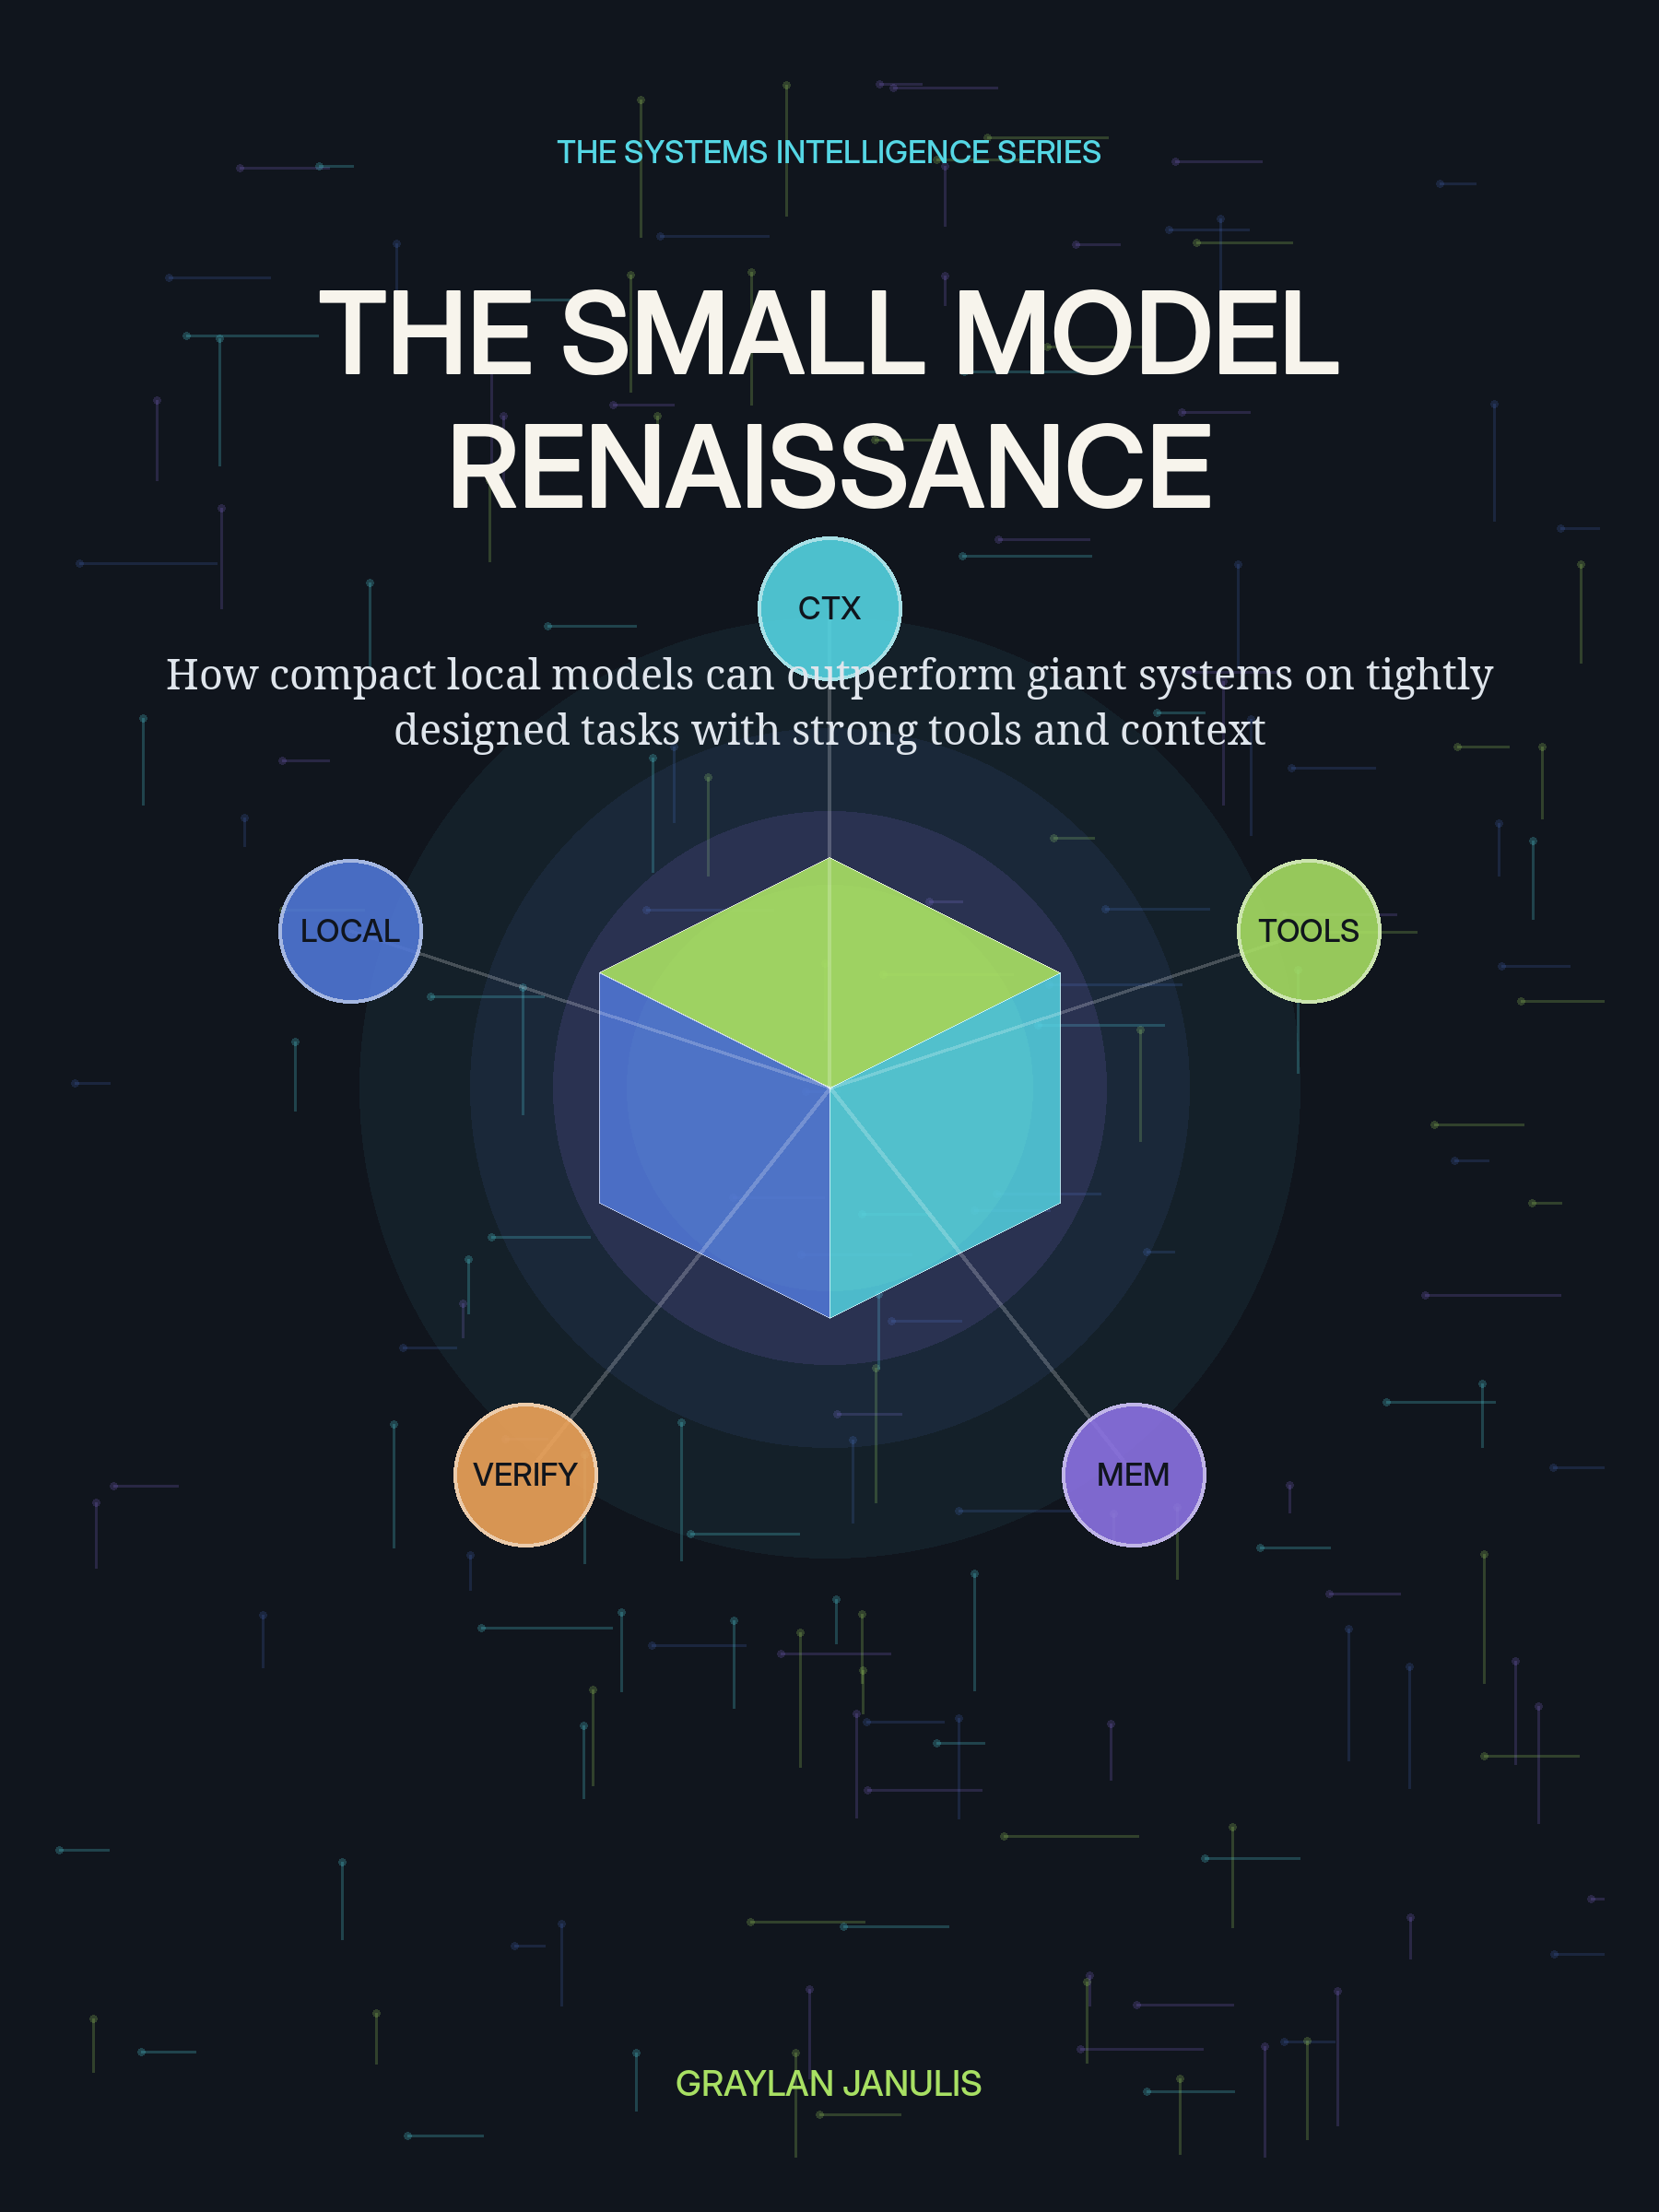

THE SMALL MODEL
RENAISSANCE
How compact local models can outperform giant systems on tightly designed tasks with strong tools and context
GRAYLAN JANULIS

THE CLAIM THIS BOOK MAKES
Compact models do not universally outperform frontier systems. They can outperform larger default systems on bounded tasks when the complete compact system has better task fit, denser context, stronger tools, edited memory, lower latency, tighter permissions, and executable verification.
This book uses outperform in a matched-budget sense: higher completed-task utility under the same task definition, data access, tools, retries, wall-clock budget, privacy constraints, and human approval policy. Model-only leaderboard scores are useful evidence, but they are not the product.
The field notebooks draw from public project documentation and user-reported local experiments involving Gemma, LiteRT-LM, llama.cpp, Weaviate, Termux, Chromebook Linux, Naza, Humoids, Humoid Agent TUI, and Simulation AI. Those cases illustrate architecture. They are not presented as independently verified benchmark victories.
THE RENAISSANCE FORMULA
SMALL MODEL + PRECISE WORLD + STRONG TOOLS + EDITED MEMORY + VERIFICATION

FIELD MAP
BOOK I — SEVEN THESES
T1 Scale Is Not a Product Requirement
T2 Intelligence Is a Product of Multipliers
T3 Context Quality Beats Context Quantity
T4 Tools Are Externalized Intelligence
T5 Memory Must Be Curated
T6 Determinism Is a Capability
T7 Locality Changes the Trust Model
BOOK II — THE PATTERN ATLAS
P1 The Task Box
P2 The Narrow Tool Belt
P3 The Context Accordion
P4 The Evidence Packet
P5 Canonical Tool Intermediate Representation
P6 The Deterministic Reducer
P7 Hybrid Retrieval Fusion
P8 Failure Memory
P9 The Verification Loop
P10 The Model Cascade
P11 The Capability Sandbox
P12 The Encrypted Local Vault
BOOK III — FIELD NOTEBOOKS
N1 Humoids: A Private Local Companion
N2 Humoid Agent TUI: The Harness Becomes the Intelligence
N3 Simulation AI: The Model Observes, the World Model Decides
N4 Naza: One Local Core, Several Safety Tasks
N5 The Chromebook and Termux Laboratory
BOOK IV — THE BUILD BENCH
L1 Build the Matched-Budget Benchmark
L2 Serve a Compact Model Locally
L3 Design a Tool Surface for a Tiny Agent
L4 Implement the Context Accordion
L5 Build Hybrid Memory with Failure Bias
L6 Create a Surgical Coding Loop
L7 Build a Local Multimodal Observer
L8 Deploy an Encrypted Local Product
BOOK V — DEPLOYMENT DISPATCHES
D1 Latency Is a Cognitive Feature
D2 Privacy Is an Architectural Resource
D3 Energy and Cost Follow Workload Shape
D4 Organizational Intelligence Can Be Local
D5 The Renaissance Is a Portfolio, Not a Winner
Appendix A — Reference Architecture
Appendix B — Matched-Budget Evaluation Protocol
Appendix C — Context and Memory Schemas
Appendix D — Tool Contract Template
Appendix E — Deployment Checklist
Glossary
Research Notes and Sources

PROLOGUE
THE EIGHT-GIGABYTE MACHINE
A field note from the moment constraint becomes an architecture.

PROLOGUE
The Eight-Gigabyte Machine
The small model renaissance begins when the machine in front of you becomes the design target.
━━━━━━━━━━━━━━━━━━━━━━━━━━━━━━━━━━━━━━━━━━
There is a peculiar kind of clarity that appears when a model must run on the computer already on the desk. The memory ceiling becomes real. The fan becomes part of the benchmark. A four-gigabyte weight file is not an abstract artifact; it is a delay, a storage decision, an encryption problem, and a promise that the system should still work when the network disappears.
Under those conditions, the usual strategy—send the entire problem to the largest available model—stops being available. The builder has to choose what the model truly needs. Search becomes surgical. Context becomes a budget. Tools must be explicit. Memory must be compact. A test runner becomes more valuable than another page of reasoning. The system begins to acquire structure.
That structure is the subject of this book. It is not an argument that tiny models know everything. It is an argument that many useful tasks do not require everything. They require a model to make a small number of language-shaped decisions inside a world that software has already organized.
The renaissance is therefore both technical and philosophical. It moves intelligence from a distant monolith into a network of local instruments. It replaces the question ‘How large is the model?’ with ‘How well is the task designed?’ It makes ownership, privacy, latency, and inspectability part of capability.
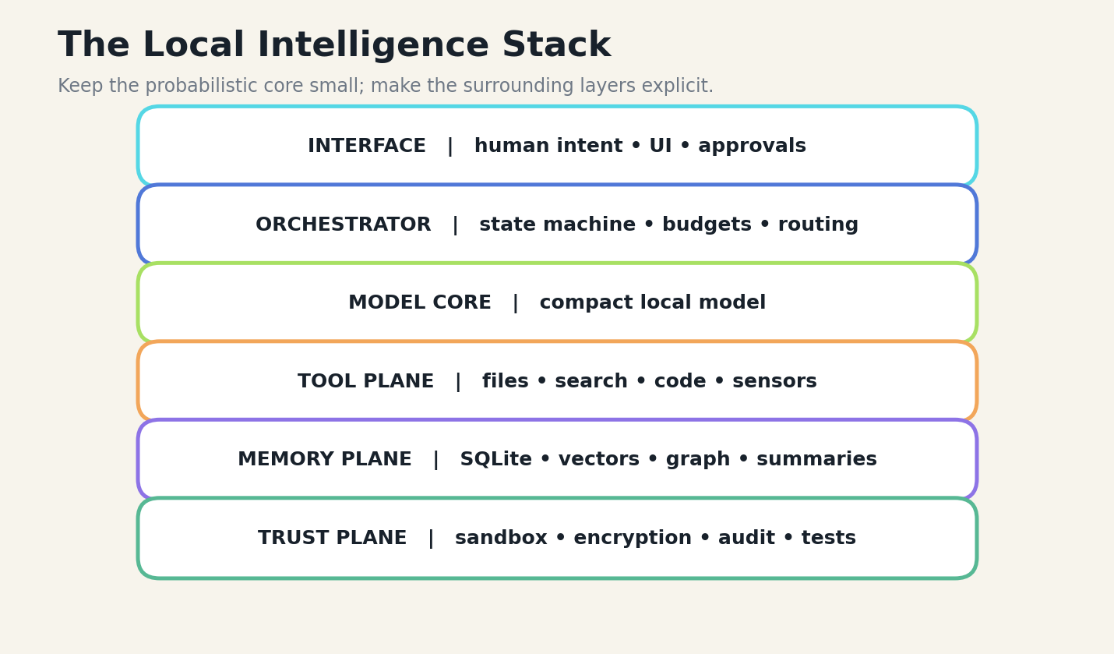
FIGURE 01 A compact local model becomes useful when surrounded by orchestration, tools, memory, and trust controls.

BOOK I
SEVEN THESES
A manifesto for system-level intelligence.

T1
Scale Is Not a Product Requirement
A model should be sized for the task envelope, not for the prestige of the deployment.
━━━━━━━━━━━━━━━━━━━━━━━━━━━━━━━━━━━━━━━━━━
The modern AI market often begins with the model leaderboard and works backward toward a product. The small-model renaissance reverses that sequence. It begins by defining the task, the acceptable failure modes, the tools available, the context that can be assembled, and the latency and privacy constraints. Only then does it choose a model. This sounds procedural, but it changes the economics and the epistemology of the system: the model is no longer treated as a universal mind. It is treated as a probabilistic component inside a designed machine.
A giant model is valuable when the task is broad, underspecified, novel, or linguistically demanding. It can absorb ambiguity that would overwhelm a compact model. Yet many production tasks are not broad. They are constrained transformations: classify a road note into three risk levels, convert a command into one of twenty functions, extract a schema from a file, choose the next test, or interpret a screen against a known object map. Generality is wasted when the world has already been narrowed.
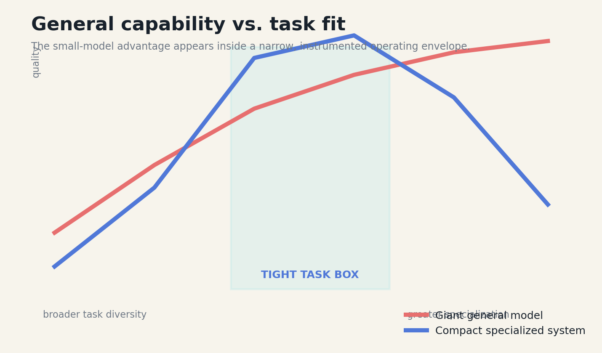
FIGURE 02 A model should be sized for the task envelope, not for the prestige of the deployment.

SYSTEM CONSEQUENCE
The decisive variable is task fit. A compact model can outperform a larger default system when the compact model receives cleaner context, fewer but better tools, a stricter output grammar, a deterministic validator, and a recovery loop. The word outperform must be measured at the system level: completed tasks per dollar, p95 latency, privacy exposure, energy use, error recovery, and end-to-end reliability. It does not mean that the compact model is universally more knowledgeable.
The first discipline, therefore, is refusal. Refuse to deploy the model on questions outside its task box. Refuse to hide uncertainty behind fluent language. Refuse to compare a tool-augmented small system with a naked large model unless both receive the same operational budget. The renaissance begins when system design becomes more important than parameter count.
DESIGN EQUATION
Task advantage A = task fit × context density × tool leverage × verification ÷ generality tax
BOUNDARY CONDITION
A compact system loses when the problem is genuinely open-ended, when the tool surface is poorly defined, or when the system cannot detect that the task has escaped its operating envelope.
Research anchors: R5, R6, R7, R25. See Research Notes and Sources.
T2
Intelligence Is a Product of Multipliers
Effective capability is multiplicative: weak context or weak verification can erase a strong model.
━━━━━━━━━━━━━━━━━━━━━━━━━━━━━━━━━━━━━━━━━━
Model quality is usually discussed as though it were a single scalar. Real systems behave more like multiplication. A capable model with irrelevant context can fail. A modest model with a calculator, a parser, a test runner, and a precise file slice can succeed. The surrounding components do not merely add convenience; they change what the model can reliably accomplish.
The compound intelligence principle represents effective capability as the interaction of model competence, context quality, tool power, memory quality, and verification strength. If any factor approaches zero, the total system degrades sharply. This explains why a frontier model can appear strangely incompetent inside a noisy agent harness, while a two-to-four-billion-parameter model can appear brilliant inside a narrow workflow with executable feedback.
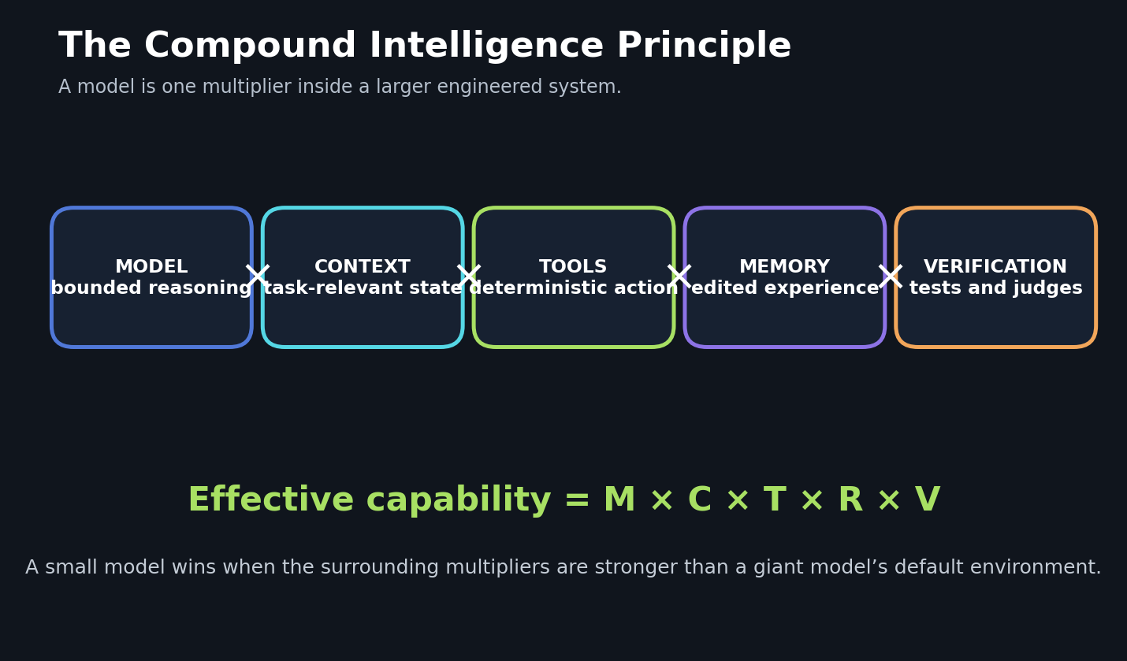
FIGURE 03 Effective capability is multiplicative: weak context or weak verification can erase a strong model.

SYSTEM CONSEQUENCE
Multiplication also clarifies where engineering effort belongs. If the model already understands the domain vocabulary, another billion parameters may create less value than reducing retrieved context by half. If the model can choose the correct tool but often emits malformed arguments, a canonical intermediate representation and schema repair may create a larger gain than a model upgrade. If the model writes plausible code but does not inspect test failures, the missing multiplier is verification.
This thesis creates a practical research agenda. Rather than asking whether small models can reason, ask which multiplier is limiting a specific system. Benchmark each factor independently, then benchmark the complete loop. The objective is not to prove that small models are secretly giant models. It is to build systems where compact models spend their limited capacity on the decisions that actually require language.
DESIGN EQUATION
C_eff = M × C × T × R × V, where each factor is normalized to the task
BOUNDARY CONDITION
Multipliers can create false confidence if they share the same error source. Five agents using the same retrieval mistake are not independent verification.
Research anchors: R8, R9, R10, R11. See Research Notes and Sources.
T3
Context Quality Beats Context Quantity
The best context window is a dense working set, not a transcript landfill.
━━━━━━━━━━━━━━━━━━━━━━━━━━━━━━━━━━━━━━━━━━
Long context windows encouraged the belief that nothing needs to be forgotten. In agentic systems, this can be actively harmful. Tool outputs repeat, plans become stale, rejected hypotheses remain visible, and the model must spend attention distinguishing current truth from conversational debris. Smaller models suffer sooner because their effective attention and context-utilization capacity are limited, but the failure is architectural rather than merely parametric.
The solution is edited context. Invariants remain pinned. The active plan is explicit. Recent tool events are retained only while they influence the next decision. Older history is folded into structured summaries containing decisions, unresolved work, file references, and evidence pointers. The original trace remains in an archive and can be reopened when the summary is challenged. This is the context accordion: compact by default, reversible when necessary.
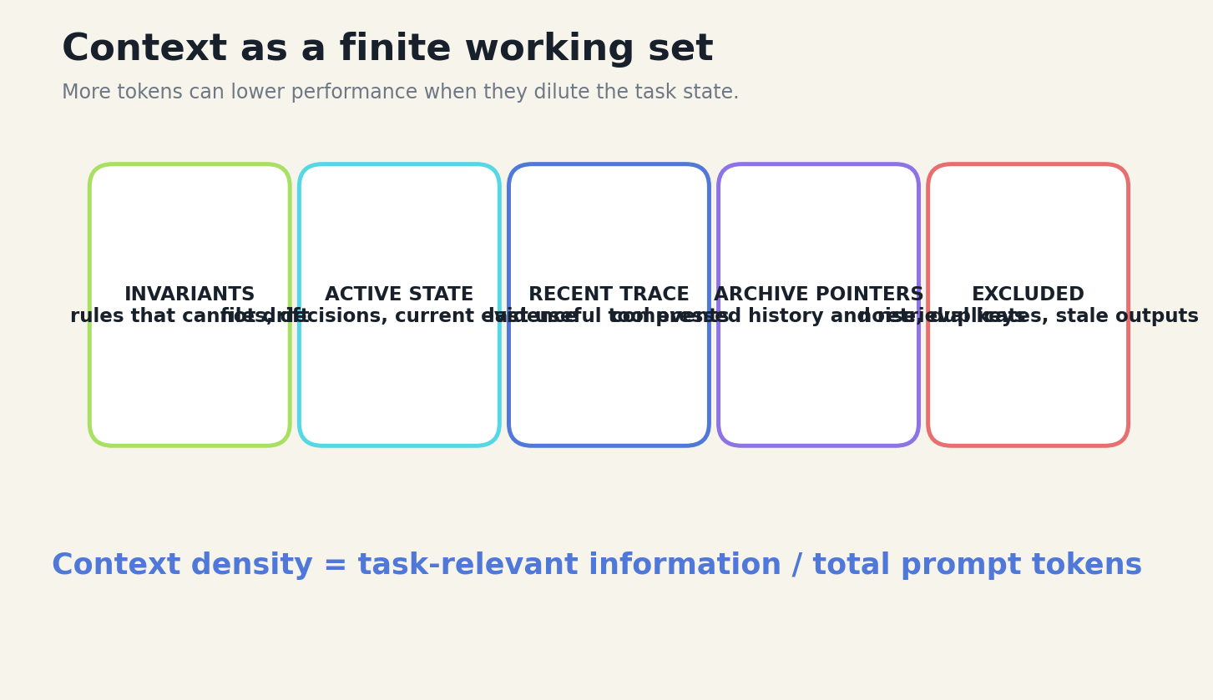
FIGURE 04 The best context window is a dense working set, not a transcript landfill.

SYSTEM CONSEQUENCE
Recent studies support the underlying principle from several directions. Selective pruning and summarization can improve long-horizon tool workflows while cutting token use. Instruction retrieval can give small models concise procedures instead of forcing them to derive a reasoning strategy from scratch. Tool-schema compression can restore agentic retrieval under constrained budgets. Counterevidence is equally important: small models may ignore or be distracted by ordinary RAG passages, which means retrieval must be tested for utilization, not assumed beneficial.
Context engineering is therefore an active control system. It measures relevance, freshness, provenance, redundancy, and cognitive load. It decides what must be present, what can be summarized, what should become a pointer, and what must be excluded. The smaller the model, the more valuable this editorial discipline becomes.
DESIGN EQUATION
Context density D_c = task-relevant tokens ÷ total prompt tokens
BOUNDARY CONDITION
Compression becomes dangerous when it removes exact values, negations, boundary conditions, or minority evidence. Every summary needs provenance and an escape hatch back to source.
Research anchors: R9, R10, R12, R13, R14. See Research Notes and Sources.
T4
Tools Are Externalized Intelligence
A compact model does not need to memorize what reliable software can calculate, retrieve, or verify.
━━━━━━━━━━━━━━━━━━━━━━━━━━━━━━━━━━━━━━━━━━
Tools change the definition of model capability. Without tools, the model must contain facts, procedures, arithmetic, state, and action logic in its weights and prompt. With tools, the model can focus on intent recognition, decomposition, selection, and interpretation. Deterministic software handles exact computation, structured search, file access, sensor reads, and state transitions.
The difference is especially important for small models. A 270-million-parameter function model fine-tuned on a fixed API surface can become a fast local controller. A three-billion-parameter model operating a stateful debugger can learn to repair code by interacting with executable feedback rather than producing a long internal monologue. These systems do not make the model omniscient. They move complexity into components that are easier to test.
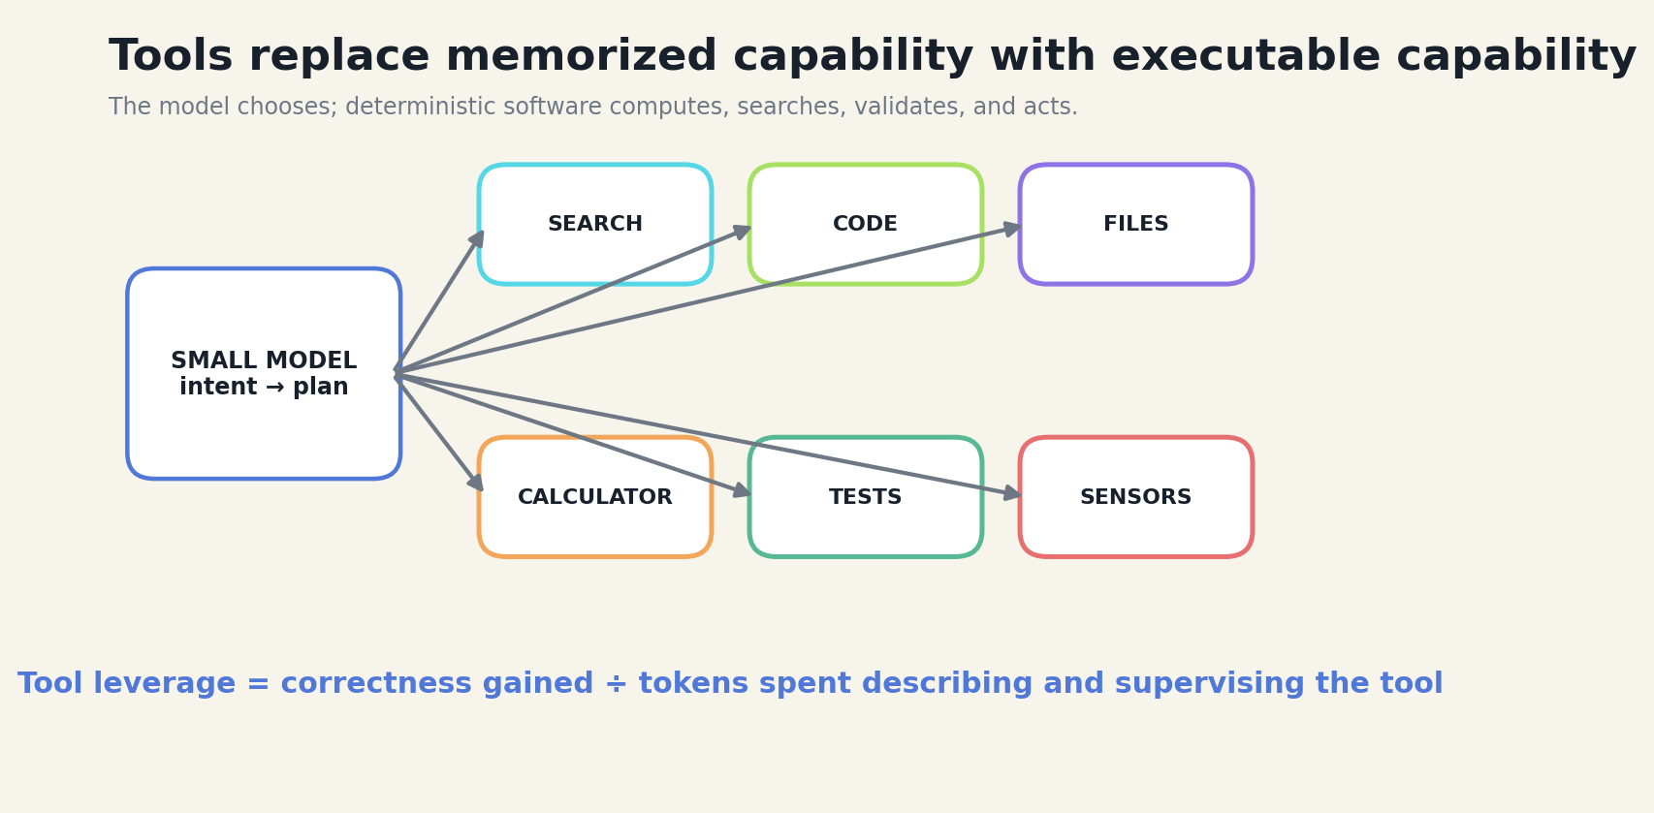
FIGURE 05 A compact model does not need to memorize what reliable software can calculate, retrieve, or verify.

SYSTEM CONSEQUENCE
Tool design matters as much as tool availability. Names must be distinct. Arguments must be literal. Results should be small and typed. Error messages should tell the model what can be repaired. The tool catalog should expose the minimum action surface required by the task. A sprawling catalog consumes context, increases selection errors, and turns every prompt into an API manual.
A good tool is a contract between probabilistic planning and deterministic execution. It has preconditions, a schema, a bounded effect, a result object, and an audit event. The model may choose incorrectly, but it should not be able to redefine what the tool means.
DESIGN EQUATION
Tool leverage L_t = reliability gained ÷ (schema tokens + call latency + supervision cost)
BOUNDARY CONDITION
Tools can amplify mistakes. A small model with broad shell access is not more intelligent; it is more dangerous. Capability must be narrower than linguistic possibility.
Research anchors: R1, R2, R4, R11, R16. See Research Notes and Sources.
T5
Memory Must Be Curated
Persistent memory should store verified structure, not merely previous language.
━━━━━━━━━━━━━━━━━━━━━━━━━━━━━━━━━━━━━━━━━━
Naive agent memory treats every conversation as potential future context. The result is a warehouse of unverified impressions, repeated preferences, transient errors, and stale plans. A useful memory system behaves more like an editor. It decides which events changed the state of the task and records them in typed form.
Four classes deserve special treatment. Decision memory records what was chosen and why. Evidence memory records the source, scope, and confidence of facts. Procedure memory records reusable steps and the conditions under which they worked. Failure memory records where the system was wrong, what signal exposed the error, and what repair succeeded. This last class is crucial because language models naturally produce more fluent success narratives than precise failure analyses.
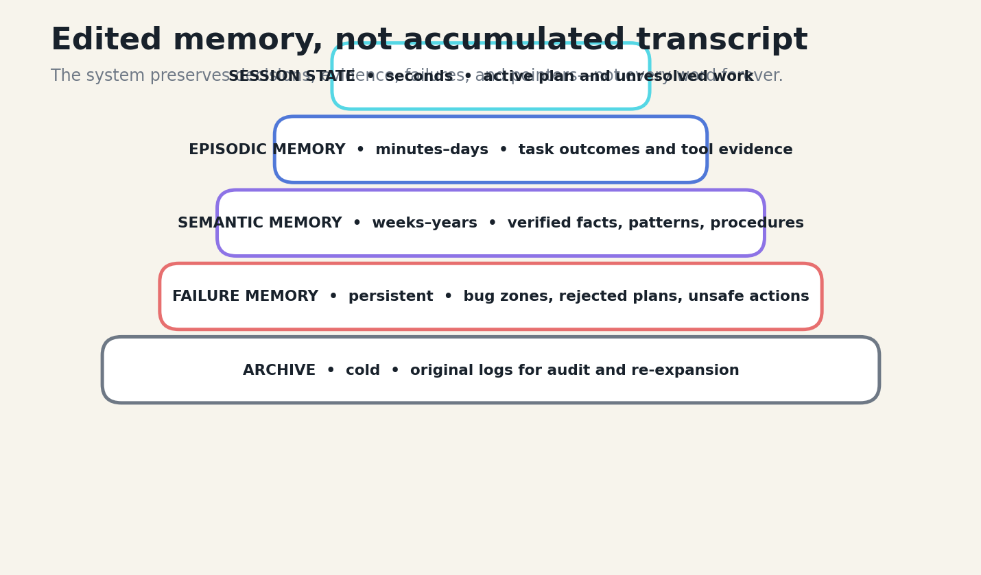
FIGURE 06 Persistent memory should store verified structure, not merely previous language.

SYSTEM CONSEQUENCE
Retrieval should combine lexical search, semantic vectors, recency, task identity, and validation status. Reciprocal-rank fusion can merge channels; diversity selection can reduce near-duplicates. Temporal neighbors help reconstruct a sequence around a relevant event. Every memory returned to the model should carry a type, provenance, confidence, and source pointer.
The memory system also needs forgetting. Temporary observations expire. Superseded decisions remain in the audit archive but leave active memory. Unverified memories cannot silently become facts through repetition. Curated memory gives a small model continuity without drowning it in its own past.
DESIGN EQUATION
Memory utility U_m = relevance × validation × novelty × recency ÷ redundancy
BOUNDARY CONDITION
A sophisticated memory index cannot repair a bad memory-writing policy. Storing plausible but false summaries creates durable hallucinations.
Research anchors: R20, R21, R22, R13. See Research Notes and Sources.
T6
Determinism Is a Capability
The strongest local systems let models propose while deterministic components decide what becomes state.
━━━━━━━━━━━━━━━━━━━━━━━━━━━━━━━━━━━━━━━━━━
Language models are excellent proposal engines. They are weaker as invisible authorities over persistent state. The small-model renaissance therefore separates generation from commitment. A model may propose a file patch, screen interpretation, risk label, or tool call. A deterministic validator checks schema, permissions, preconditions, and expected effects. A reducer commits only the validated state transition.
This separation is not a concession. It is an increase in capability. Once state changes are explicit, the system can replay them, test them, reject them, compare alternatives, and recover from failure. The model no longer needs to be trusted as a database, a filesystem, or a process manager. It becomes a bounded planner operating against a world that can push back.
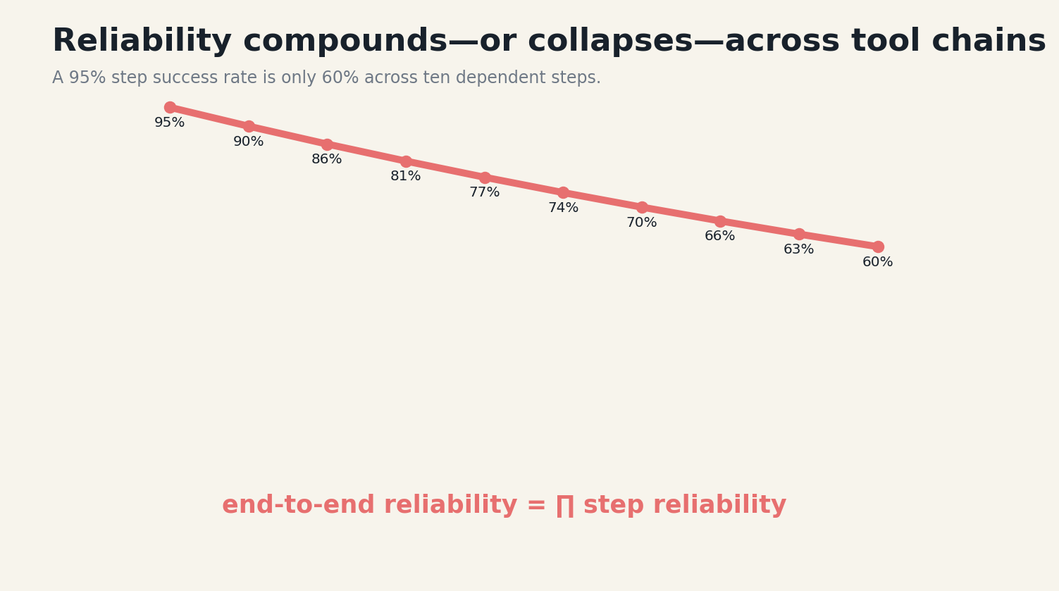
FIGURE 07 The strongest local systems let models propose while deterministic components decide what becomes state.

SYSTEM CONSEQUENCE
Reliability math makes the point severe. Even a ninety-five-percent success rate per step falls to roughly sixty percent across ten dependent steps. Longer agents must therefore shorten chains, checkpoint progress, validate intermediate results, and create repair paths. A giant model with no checks can lose to a smaller model that turns every uncertain step into an observable event.
The deterministic core should be boring. It should use ordinary schemas, state machines, hashes, unit tests, path fences, and transaction logs. The creativity belongs in proposal generation. The authority belongs in code that can be inspected.
DESIGN EQUATION
R_end-to-end = ∏ᵢ rᵢ; reduce chain length and raise rᵢ with executable checks
BOUNDARY CONDITION
Deterministic code can encode the wrong policy. Validation rules require tests, versioning, and human review just as models do.
Research anchors: R15, R17, R18, R21. See Research Notes and Sources.
T7
Locality Changes the Trust Model
Running near the user changes latency, privacy, resilience, ownership, and what kinds of systems become possible.
━━━━━━━━━━━━━━━━━━━━━━━━━━━━━━━━━━━━━━━━━━
Local models are often marketed as cheaper copies of cloud intelligence. Their deeper value is architectural. They can observe private files without uploading them, remain available when connectivity fails, respond with predictable latency, and integrate directly with local sensors and applications. The user can choose the model, inspect the runtime, encrypt the weights, and preserve history under local control.
Locality also exposes hard constraints. Memory is finite. Thermal limits matter. Context windows compete with tool schemas. Model files need verification and safe updates. Quantization changes quality and speed. The runtime must survive different CPUs, GPUs, and operating systems. These constraints force explicit engineering that cloud APIs can hide.

FIGURE 08 Running near the user changes latency, privacy, resilience, ownership, and what kinds of systems become possible.

SYSTEM CONSEQUENCE
Trust does not emerge automatically from offline execution. A local agent can still leak secrets to logs, execute unsafe shell commands, corrupt files, or preserve sensitive history in plaintext. Local-first design therefore pairs on-device inference with encrypted vaults, workspace fences, approval previews, credential isolation, and audit logs.
When these controls are present, locality becomes a new product primitive. A compact model can become a permanent companion to one codebase, one machine, one kitchen, one vehicle, or one institution. It does not need to know the whole world. It needs to know its world, respect its boundaries, and act well inside them.
DESIGN EQUATION
Local trust value T_l = privacy + availability + latency stability + ownership − device risk
BOUNDARY CONDITION
Some tasks require fresh global knowledge or compute beyond the device. A local-first system should support explicit escalation rather than pretending the network never matters.
Research anchors: R3, R4, R19, R20, R22. See Research Notes and Sources.

BOOK II
THE PATTERN ATLAS
Twelve reusable structures for compact, tool-using local systems.

P1
The Task Box
Define inputs, outputs, allowed tools, invariants, risk tier, and escalation before model selection.
━━━━━━━━━━━━━━━━━━━━━━━━━━━━━━━━━━━━━━━━━━
The task box converts a vague ambition into an operating envelope. It names the accepted input forms, maximum sizes, output schema, available tools, success conditions, and prohibited actions. It also states which tasks must be refused or escalated. This box is what allows a small model to specialize without being mistaken for a general agent.
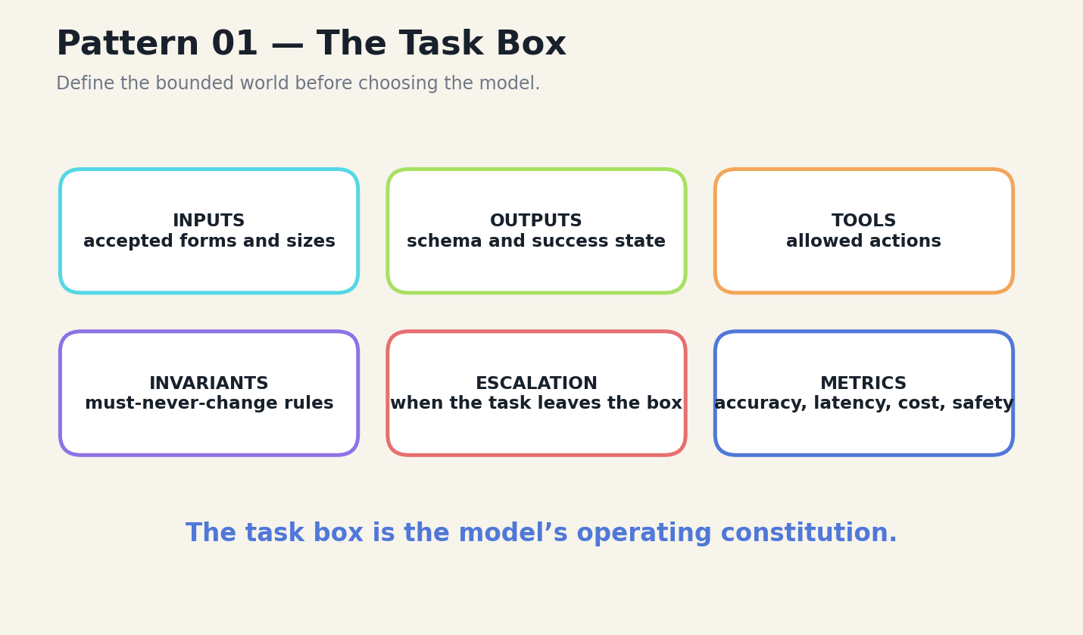
FIGURE 09 Define inputs, outputs, allowed tools, invariants, risk tier, and escalation before model selection.
A good task box is narrow enough to benchmark and broad enough to matter. ‘Help with code’ is not a task box. ‘Given one repository, one issue description, and read-only search, propose a patch limited to three files and prove it with the project test suite’ is. The second description exposes the information and authority required for success.

IMPLEMENTATION
Implementation begins with a contract file that both the orchestrator and evaluator can read. It should include schemas, examples, counterexamples, permission boundaries, and escalation triggers. The model prompt is generated from this contract rather than hand-written separately.
The pattern fails when product pressure quietly expands the task without updating the contract. Drift should be visible in benchmark coverage and refusal rates.
DESIGN EQUATION
Box quality = measurable boundaries × useful coverage × enforceable escalation
FIELD EXERCISE
□ Write a task box for one feature in fewer than 250 words.
□ Add three adversarial inputs that must leave the box.
□ Define one metric for success and one for safe refusal.
Research anchors: R25. See Research Notes and Sources.
P2
The Narrow Tool Belt
Offer the fewest high-leverage tools that can complete the task.
━━━━━━━━━━━━━━━━━━━━━━━━━━━━━━━━━━━━━━━━━━
Tool catalogs should be designed like physical workbenches. A technician does not carry every instrument in the building for every job. The agent should receive a small set of actions with distinct names and literal argument semantics. Search, read, patch, test, and inspect may be enough for a coding loop; adding dozens of unrelated utilities creates cognitive and context overhead.

FIGURE 10 Offer the fewest high-leverage tools that can complete the task.
Each tool should produce a compact result object. File tools return line ranges and hashes. Test tools return failing cases and concise traces. Search tools return ranked matches with pointers. The tool result should contain the information required for the next decision, not a complete system dump.

IMPLEMENTATION
When the catalog is fixed, specialization can internalize tool knowledge through fine-tuning or concise instruction retrieval. When the catalog changes frequently, schema compression and dynamic tool retrieval become more important. The system can expose a high-level tool first and reveal lower-level tools only after the model chooses a domain.
The narrow belt fails when one overloaded tool hides many unsafe operations or when error messages are too vague for repair.
DESIGN EQUATION
Selection entropy H_tools should fall as task specificity rises
FIELD EXERCISE
□ Remove half the tools from an existing agent and rerun evaluation.
□ Rewrite one verbose tool result into a typed object.
□ Create a distractor-tool test.
Research anchors: R1, R8, R12, R18. See Research Notes and Sources.
P3
The Context Accordion
Fold old context into structured summaries while preserving source pointers.
━━━━━━━━━━━━━━━━━━━━━━━━━━━━━━━━━━━━━━━━━━
The context accordion separates visible working state from expandable history. The model sees pinned invariants, the current plan, recent evidence, and summaries of older decisions. Each summary includes identifiers that allow the orchestrator to reopen original tool events when exact details become relevant.
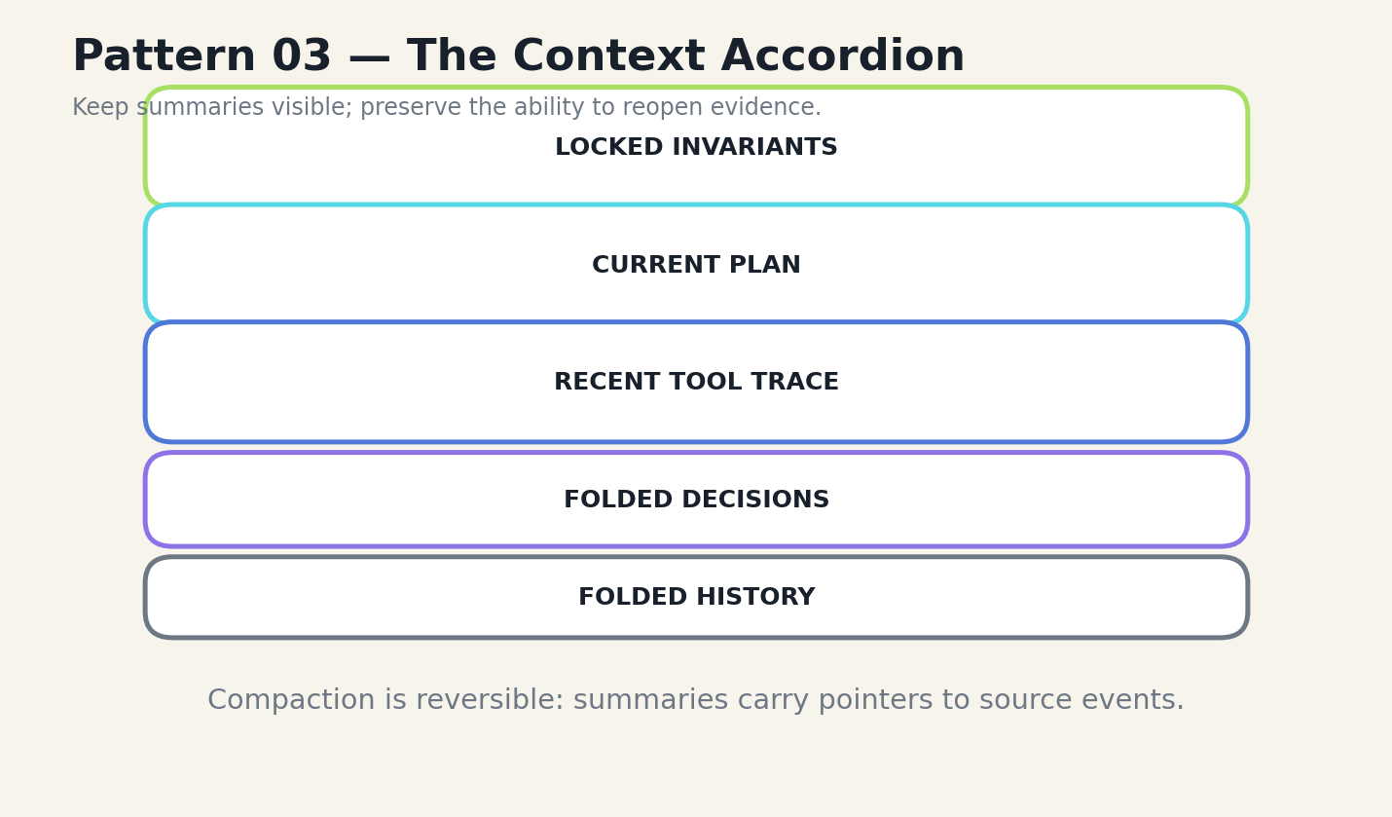
FIGURE 11 Fold old context into structured summaries while preserving source pointers.
Compaction should be event-driven rather than based only on token count. Fold a phase when a decision is accepted, a test proves a state, or the model switches subproblems. Preserve unresolved contradictions and exact numerical constraints. Remove repeated acknowledgments and superseded plans.

IMPLEMENTATION
The accordion works best when the model can request expansion explicitly: reopen decision D14, retrieve the original diff, show the surrounding memory neighbors. This converts forgetting from an irreversible loss into a controllable operation.
The pattern fails when summaries become unverified narrative. Summary generation should itself be checked against the events it compresses.
DESIGN EQUATION
Compression value = tokens removed × relevance preserved × reversibility
FIELD EXERCISE
□ Create a summary schema with decisions, evidence, open work, and pointers.
□ Fold a 20-turn tool trace into 300 tokens.
□ Test whether exact values survive compaction.
Research anchors: R9, R13, R20. See Research Notes and Sources.
P4
The Evidence Packet
Assemble a typed case file before asking the model to reason or write.
━━━━━━━━━━━━━━━━━━━━━━━━━━━━━━━━━━━━━━━━━━
An evidence packet is the compact context object for one decision. It contains the task, relevant files or passages, constraints, prior decisions, failing tests, source spans, and open questions. Every field has provenance and a reason for inclusion.
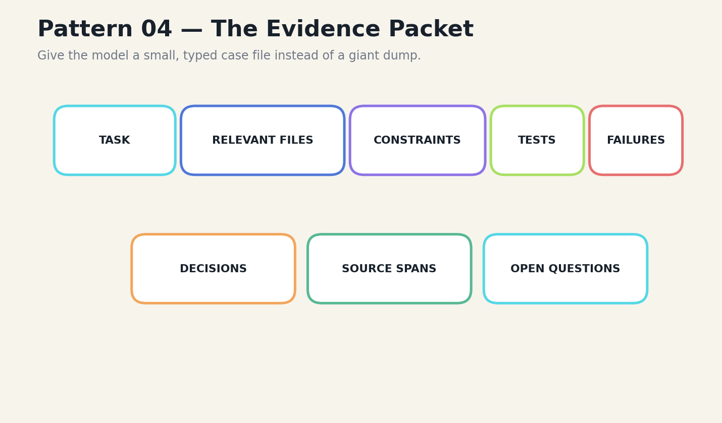
FIGURE 12 Assemble a typed case file before asking the model to reason or write.
The packet is produced by retrieval and deterministic preprocessing before generation. For code, it may include a connected subgraph of functions, tests, and configuration. For visual tasks, it may include object coordinates, prior state, and interaction history. For classification, it may include calibrated examples and threshold rules.

IMPLEMENTATION
The packet should be evaluated independently. Can a human understand why each item is present? Does it omit irrelevant files? Are contradictions visible? Does it distinguish observed facts from model hypotheses? A weak packet makes the model appear weak even when the real failure is retrieval.
The pattern fails when the packet becomes a static template that always includes the same material. It must be built for the current task.
DESIGN EQUATION
Packet precision = relevant evidence retrieved ÷ total evidence supplied
FIELD EXERCISE
□ Build one evidence packet by hand.
□ Delete every item that does not change the next decision.
□ Add a provenance pointer to each remaining item.
Research anchors: R10, R13, R14. See Research Notes and Sources.
P5
Canonical Tool Intermediate Representation
Translate model-native tool dialects into one policy-controlled internal form.
━━━━━━━━━━━━━━━━━━━━━━━━━━━━━━━━━━━━━━━━━━
Different models express tools differently: native function calls, control tokens, tagged JSON, or natural-language action plans. Forcing every model to emit the same unnatural syntax can reduce accuracy. The canonical IR keeps model-native syntax at the boundary and normalizes calls after parsing.
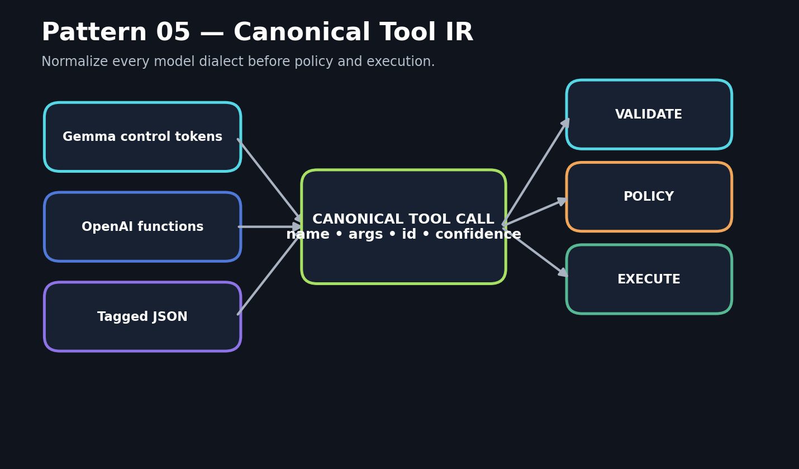
FIGURE 13 Translate model-native tool dialects into one policy-controlled internal form.
A canonical call contains the tool name, literal arguments, call identifier, provider and model, protocol, confidence, and a hash of the source turn. Validation, authorization, logging, approval, and execution operate only on this representation. Tool results return through the inverse adapter.

IMPLEMENTATION
This pattern makes the harness model-portable. It also enables differential testing: the same intended call can be generated by several models, normalized, and compared before execution. Repair strategies remain protocol-specific while policy remains uniform.
The pattern fails when the parser silently guesses ambiguous arguments. Ambiguity should lower confidence or require clarification.
DESIGN EQUATION
Protocol portability = shared policy surface ÷ model-specific execution code
FIELD EXERCISE
□ Define a canonical call schema.
□ Write adapters for two model dialects.
□ Reject an ambiguous call rather than auto-correcting it.
Research anchors: R2, R4, R20. See Research Notes and Sources.
P6
The Deterministic Reducer
Permit models to propose; permit only validated code to commit state.
━━━━━━━━━━━━━━━━━━━━━━━━━━━━━━━━━━━━━━━━━━
The deterministic reducer is the authority boundary. The model proposes an action or interpretation. Validators check permissions, schema, preconditions, expected postconditions, and conflict with current state. The reducer writes the new state in a transaction and emits an audit event.
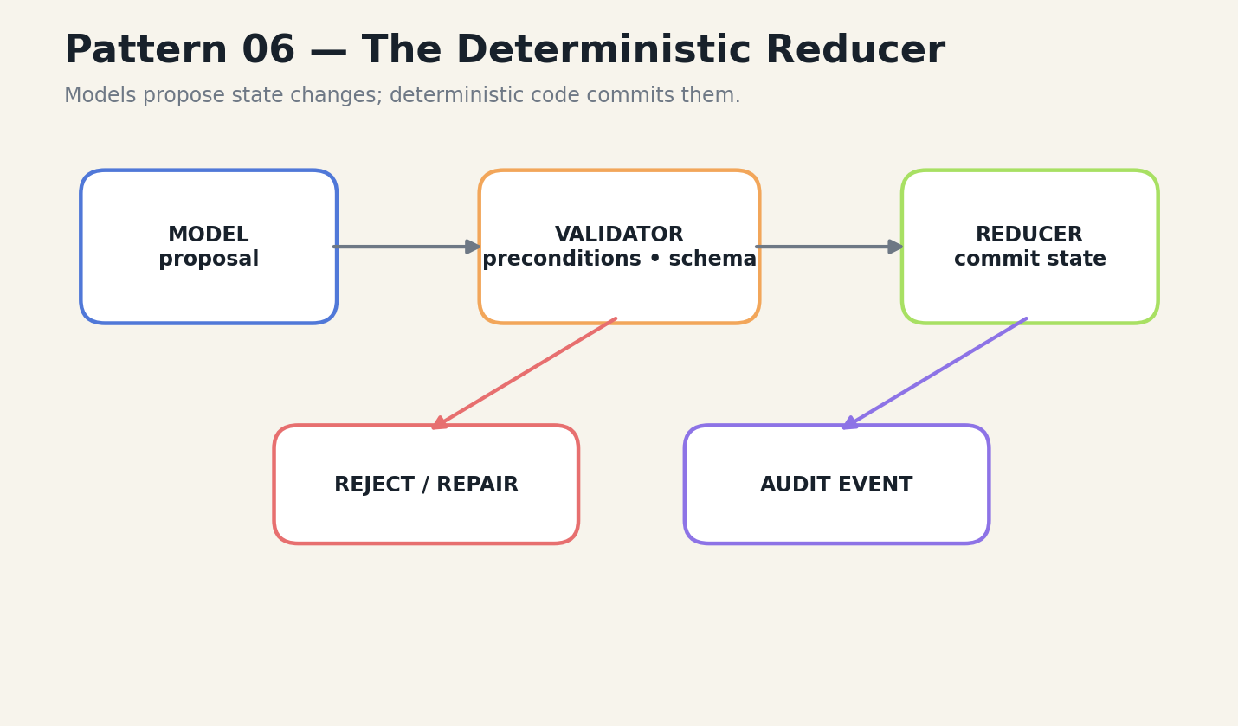
FIGURE 14 Permit models to propose; permit only validated code to commit state.
This is especially powerful in visual and simulation systems. A generated screen can suggest what the next state looks like, but it cannot redefine object identity, file existence, or process state. Those semantics live in structured data and change only through validated events.

IMPLEMENTATION
Reducers make undo and replay possible. Every committed event can be reapplied to a known checkpoint. Failed proposals become training and evaluation data without contaminating state. The same pattern works for file patches, workflow automation, and risk-scanner histories.
The pattern fails when state is duplicated in hidden prompt text. The structured store must remain the source of truth.
DESIGN EQUATION
State authority = validated events; generated representations are projections
FIELD EXERCISE
□ Choose one stateful workflow and identify the reducer.
□ List its preconditions and postconditions.
□ Implement a reversible event log.
Research anchors: R17, R21. See Research Notes and Sources.
P7
Hybrid Retrieval Fusion
Combine lexical, semantic, recency, and graph signals, then diversify.
━━━━━━━━━━━━━━━━━━━━━━━━━━━━━━━━━━━━━━━━━━
Small models need retrieval that is both precise and easy to use. Lexical search preserves exact identifiers. Vector search finds semantic neighbors. Recency identifies current task state. Graph traversal preserves structural relationships. No single channel is sufficient.
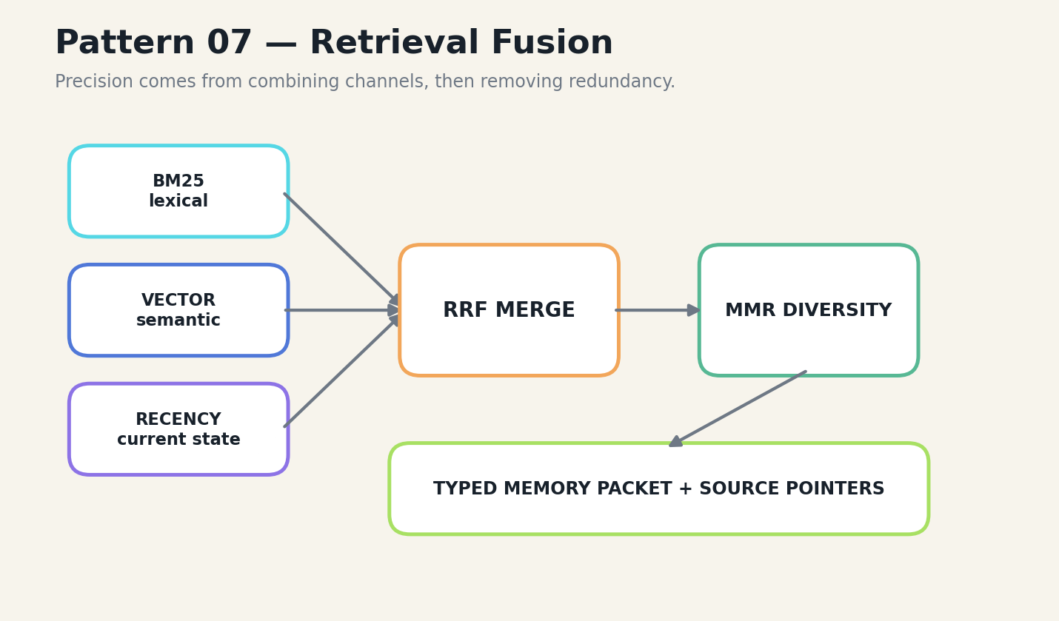
FIGURE 15 Combine lexical, semantic, recency, and graph signals, then diversify.
Reciprocal-rank fusion merges ranked lists without requiring scores to share a scale. Maximum marginal relevance reduces duplicates and preserves diverse evidence. Task and validation filters prevent unrelated or unverified memories from occupying the packet.

IMPLEMENTATION
Retrieval quality must be separated from utilization quality. An oracle passage that contains the answer is not useful if the model ignores it or becomes distracted. Evaluation should therefore measure retrieval recall, answer extraction, and damage to previously known answers independently.
The pattern fails when the system optimizes only top-k similarity. Similarity is not task relevance, and redundant context can be worse than missing context.
DESIGN EQUATION
RRF(d)=Σ 1/(k+rankᵢ(d)); diversify before prompting
FIELD EXERCISE
□ Implement BM25 and vector retrieval on the same corpus.
□ Fuse rankings with RRF.
□ Measure whether retrieved context helps or distracts the model.
Research anchors: R13, R14, R20. See Research Notes and Sources.
P8
Failure Memory
Record the shape of failure so future plans avoid known traps.
━━━━━━━━━━━━━━━━━━━━━━━━━━━━━━━━━━━━━━━━━━
A failure memory contains the task, location, symptom, root cause, detection signal, attempted repairs, successful repair, and confidence. For code, it may identify a file region or dependency. For tool use, it may identify a malformed argument pattern. For visual systems, it may identify a coordinate transform or occlusion error.
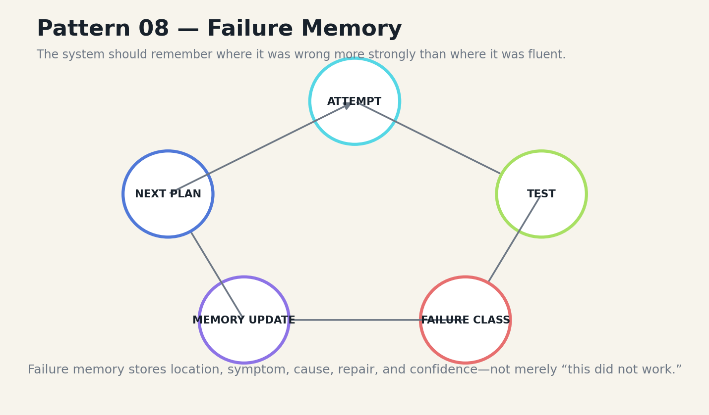
FIGURE 16 Record the shape of failure so future plans avoid known traps.
Failure memories should receive a retrieval bias when a new task resembles a past bug zone. This does not mean assuming the same cause. It means presenting the warning early enough to influence the plan. A small model benefits because it does not need to rediscover every local hazard.

IMPLEMENTATION
Failures also drive benchmark construction. Every production incident becomes a replayable case. Regression suites grow from reality rather than from generic prompts. Over time, the system becomes specialized not only by what it knows, but by what it has learned not to do.
The pattern fails when failures are stored as blame or vague summaries. The memory must be operational and testable.
DESIGN EQUATION
Failure value = recurrence probability × consequence × repair reusability
FIELD EXERCISE
□ Convert one real bug report into a failure-memory object.
□ Create a similarity rule that retrieves it at the right time.
□ Add the failure to a regression suite.
Research anchors: R15, R20. See Research Notes and Sources.
P9
The Verification Loop
End work on verified state, not on a confident answer.
━━━━━━━━━━━━━━━━━━━━━━━━━━━━━━━━━━━━━━━━━━
A verification loop converts an open-ended agent into an iterative engineer. The system understands the task, retrieves context, plans, acts, tests, inspects results, and either commits or revises. Each loop produces observable evidence.
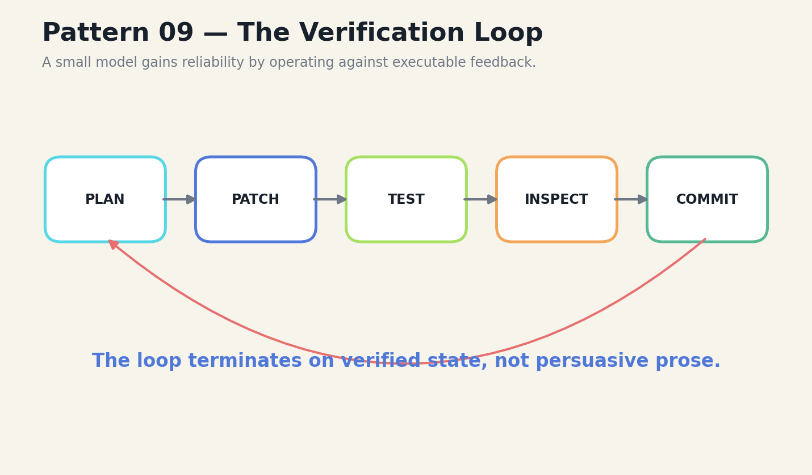
FIGURE 17 End work on verified state, not on a confident answer.
The loop should be short. Large speculative plans create long chains whose probabilities multiply downward. A small model should make one bounded change, run the cheapest decisive test, and update its plan from the result. This resembles scientific control more than conversational reasoning.

IMPLEMENTATION
Verification can include unit tests, schema checks, static analysis, diff inspection, sensor thresholds, or independent model judges. The choice depends on the task box. Human approval is a verification tool when consequences are high or aesthetics matter.
The pattern fails when tests are weak, flaky, or selected by the same model to confirm its own work. Verification needs independent signals.
DESIGN EQUATION
Progress = verified state change ÷ tool calls and retries
FIELD EXERCISE
□ Rewrite a long agent plan into three short verify loops.
□ Identify the cheapest decisive test after each action.
□ Add a stop condition for repeated non-progress.
Research anchors: R11, R15, R18. See Research Notes and Sources.
P10
The Model Cascade
Route routine work to small specialists and escalate only when needed.
━━━━━━━━━━━━━━━━━━━━━━━━━━━━━━━━━━━━━━━━━━
A cascade begins with deterministic rules and parsers, then moves through tiny specialists, a local generalist, and finally an approved frontier service. Each tier has a task profile, confidence model, cost, and privacy policy.
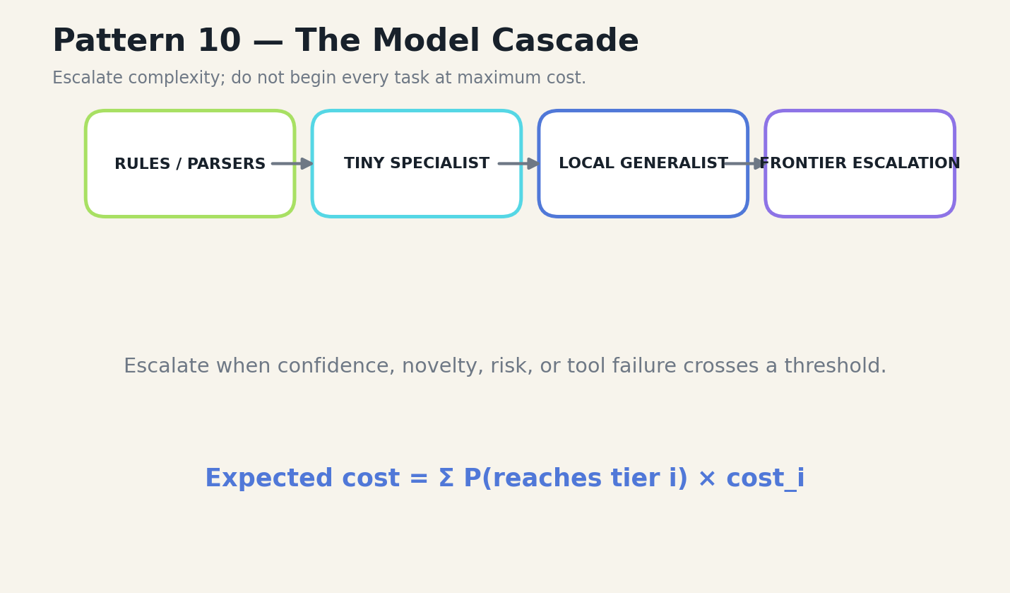
FIGURE 18 Route routine work to small specialists and escalate only when needed.
The cascade should not use self-confidence alone. Escalation signals include novelty, model disagreement, repeated repair, missing tools, out-of-distribution inputs, high consequence, and explicit user request. Sensitive data may be summarized or redacted before leaving the device, or the task may remain local and unresolved.

IMPLEMENTATION
Cascades create economic leverage because most routine tasks terminate early. They also create a stronger failure mode: a small model that knows when it is out of depth. The escalation policy is part of the product, not an emergency fallback.
The pattern fails when each tier receives different tools or data, making comparisons and routing uncalibrated.
DESIGN EQUATION
Expected cost E[C]=Σ P(reach tier i)×Cᵢ
FIELD EXERCISE
□ Define four cascade tiers.
□ Choose three escalation signals that are externally measurable.
□ Test routing on easy, ambiguous, and high-risk cases.
Research anchors: R1, R3, R25. See Research Notes and Sources.
P11
The Capability Sandbox
Bind tools to explicit resources, effects, and approvals.
━━━━━━━━━━━━━━━━━━━━━━━━━━━━━━━━━━━━━━━━━━
Local execution is powerful because the model can reach files, applications, and devices. That power must be represented as capabilities. A tool receives access to one workspace, one database, one sensor, or one API scope. It does not inherit the full permissions of the host by default.
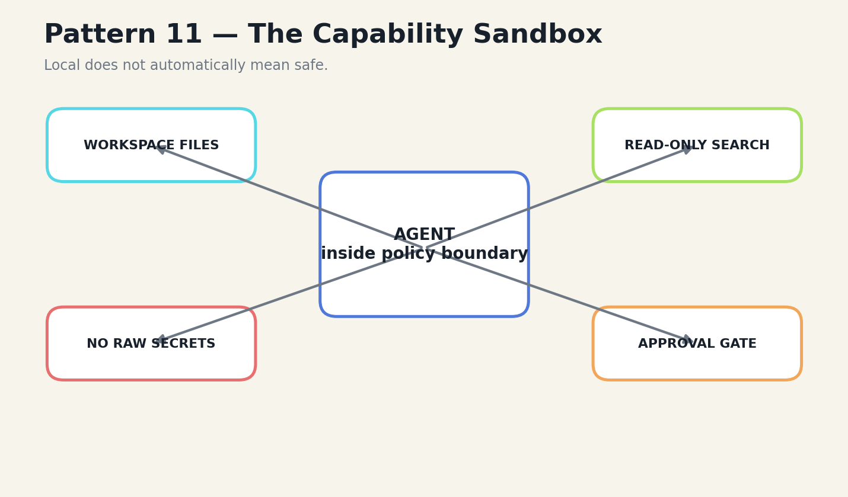
FIGURE 19 Bind tools to explicit resources, effects, and approvals.
Write operations should show a preview. Shell access should be disabled or isolated unless essential. Secrets should be referenced by handles rather than inserted into prompts. Network tools should use allowlists. Timeouts, output limits, and argument-size limits prevent accidental resource exhaustion.

IMPLEMENTATION
The sandbox also improves reasoning. When the action surface is narrow and consequences are explicit, the model has fewer ambiguous choices. Security and capability are aligned rather than treated as opposing concerns.
The pattern fails when path fences are mistaken for process isolation. A subprocess may retain the operating-system user’s full permissions unless containerized or otherwise constrained.
DESIGN EQUATION
Action risk = authority × irreversibility × uncertainty × exposure
FIELD EXERCISE
□ Map every tool to the resource it can change.
□ Add a preview and approval step to one write tool.
□ Test symlink, path traversal, oversized output, and timeout attacks.
Research anchors: R4, R20, R21. See Research Notes and Sources.
P12
The Encrypted Local Vault
Treat model weights, history, and local state as protected assets.
━━━━━━━━━━━━━━━━━━━━━━━━━━━━━━━━━━━━━━━━━━
The encrypted vault stores model files, conversation history, settings, and memory under user-controlled keys. The durable copy remains encrypted. A temporary plaintext model is materialized only when required by the runtime, protected by restrictive permissions, and removed after use.
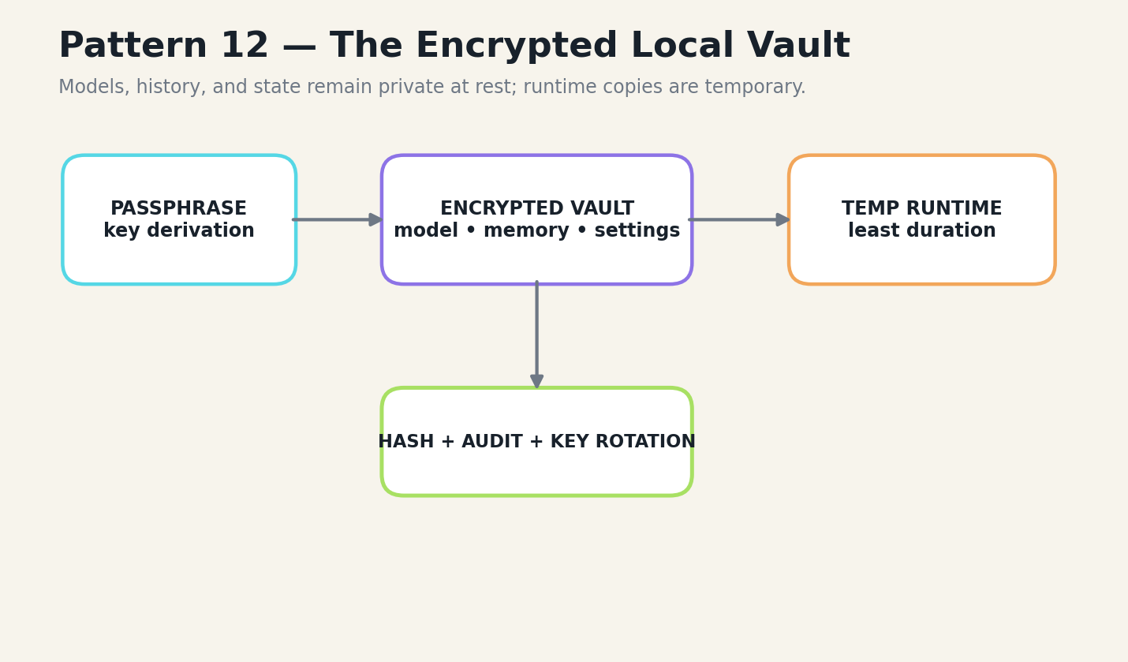
FIGURE 20 Treat model weights, history, and local state as protected assets.
Model downloads require pinned identifiers and hashes. Resumable chunks prevent unreliable networks from forcing complete restarts. Key rotation rewraps or re-encrypts stored assets. Audit records distinguish the encrypted source of truth from runtime caches.

IMPLEMENTATION
This pattern matters because local models often contain private adaptation data and because the history surrounding them can be more sensitive than the weights. Encryption at rest does not solve live compromise, but it reduces exposure from device loss, backup leakage, and casual inspection.
The pattern fails when the key is stored beside the data without a passphrase or hardware boundary, or when temporary plaintext copies persist indefinitely.
DESIGN EQUATION
Vault exposure = plaintext duration × accessible copies × key co-location
FIELD EXERCISE
□ Pin a model revision and expected hash.
□ Map every plaintext runtime artifact and its lifetime.
□ Design a key-rotation test with recovery.
Research anchors: R3, R19, R21, R22. See Research Notes and Sources.

BOOK III
FIELD NOTEBOOKS
Architectures from local-model projects and constrained hardware.

N1
Humoids: A Private Local Companion
A repository-grounded systems reading, not an independent benchmark claim.
━━━━━━━━━━━━━━━━━━━━━━━━━━━━━━━━━━━━━━━━━━
The Humoids repository describes a desktop application built around a Gemma LiteRT-LM model, an encrypted model vault, encrypted chat history, a polished local interface, and a dynamic encouragement RAG layer. The system is revealing because the model is only one piece of the user experience. Download verification, encryption, history indexing, memory drawers, rendering, and local prompt shaping carry much of the practical intelligence.
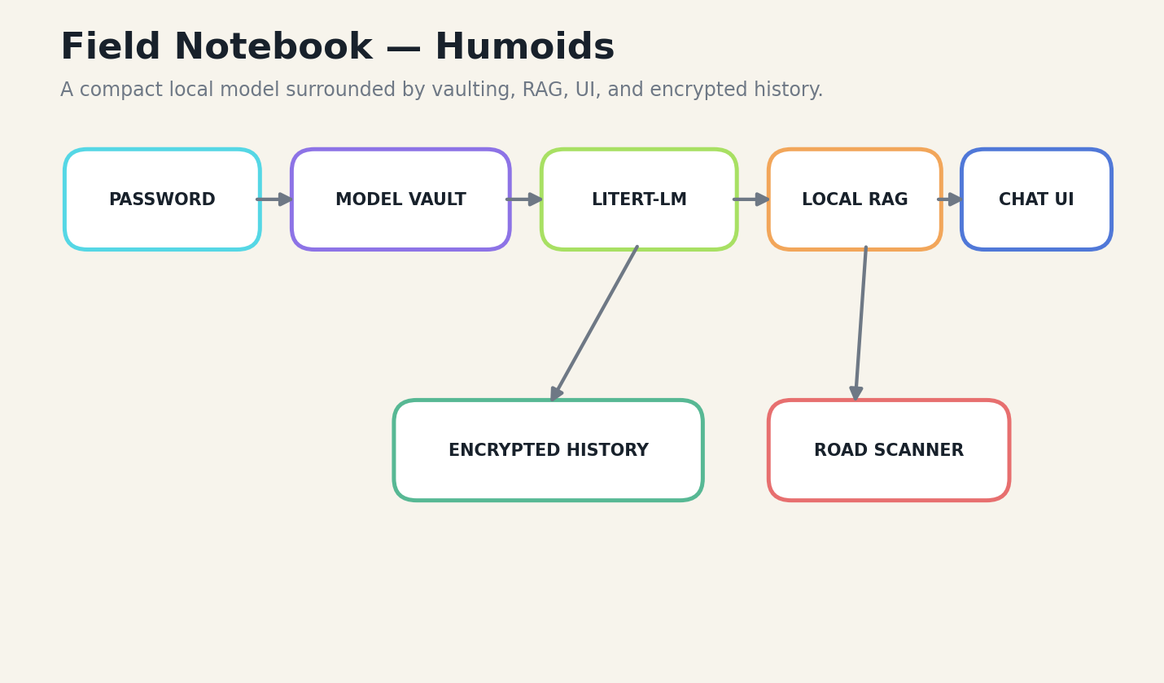
FIGURE 21 Humoids: A Private Local Companion
The model lifecycle is deliberately concrete. A user creates or unlocks a vault, downloads a pinned model, verifies its hash, encrypts the durable copy, and materializes a temporary runtime file only when generation begins. This is not a benchmark advantage; it is a trust advantage. The system becomes suitable for personal workflows that would be uncomfortable with automatic cloud upload.

WHAT THE CASE TEACHES
The dynamic support layer demonstrates a second principle: context can be generated from local state without pretending that the system knows the user’s emotions. Local machine metrics, encrypted rotation memory, and UI color state shape a small prompt packet. The repository explicitly labels these signals as tone controls rather than psychological evidence.
A rigorous evaluation would compare the compact system with and without the RAG layer, measure repetition, usefulness, latency, and user preference, and verify that encryption and temporary-file cleanup behave under failure. The repository documents an architecture and user flow; it does not by itself prove superiority over larger models.
The broader lesson is that a local companion succeeds through continuity, privacy, and interface design. A giant model API can answer a prompt. A local system can become an owned environment.
EVIDENCE STATUS
Architecture and behaviors are drawn from public repository documentation and user-reported experiments. Comparative superiority requires matched-budget reproduction.
Research anchors: R19. See Research Notes and Sources.
N2
Humoid Agent TUI: The Harness Becomes the Intelligence
A repository-grounded systems reading, not an independent benchmark claim.
━━━━━━━━━━━━━━━━━━━━━━━━━━━━━━━━━━━━━━━━━━
Humoid Agent TUI is a multi-provider terminal harness that can switch between hosted systems, local llama.cpp, and LiteRT-LM. Its most important design decision is the separation between model-native syntax and a canonical internal tool-call representation. Each provider speaks the dialect it handles best; policy, validation, logging, and execution remain shared.
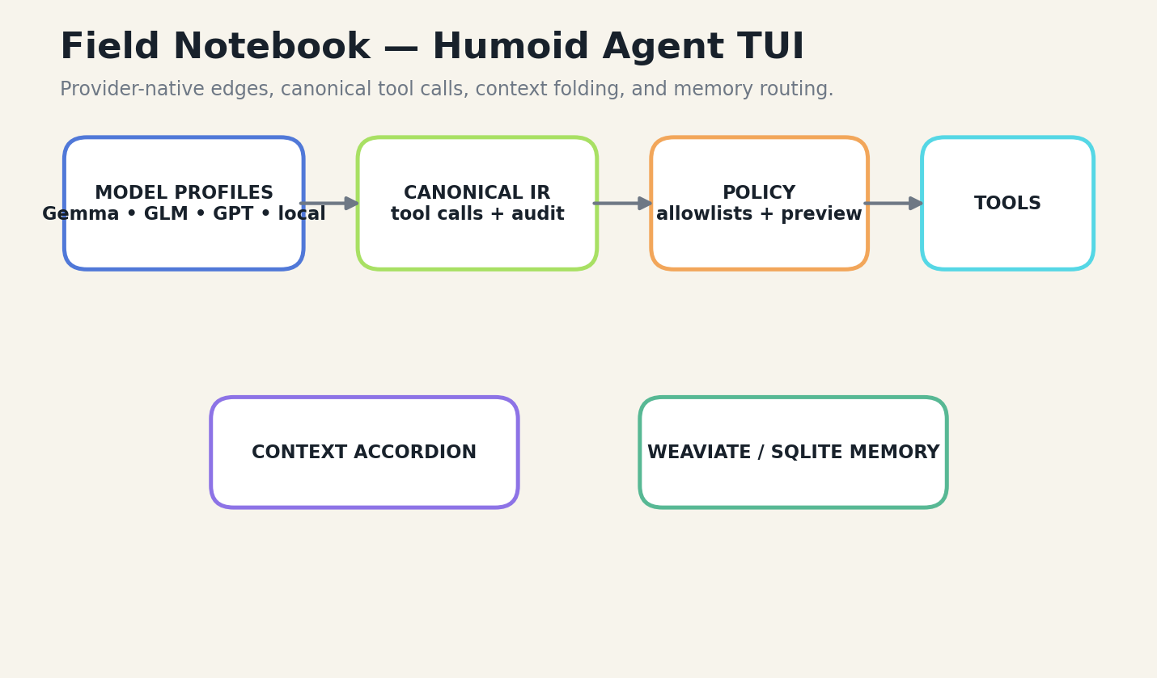
FIGURE 22 Humoid Agent TUI: The Harness Becomes the Intelligence
The repository also treats memory and context as visible product surfaces. Weaviate is attempted first and SQLite provides a fallback. Memory packets carry type, channel, task, validation status, temporal neighbors, and diversity filtering. A Context Accordion folds old state into decisions, unresolved work, file references, and tool evidence while preserving expansion.

WHAT THE CASE TEACHES
The TUI adds approval-oriented file writes, model-specific prompt profiles, protocol fallbacks, benchmark controls, and a local model manager. These features matter because small-model failures are often not mysterious reasoning failures. They are mismatches between prompt format, tool syntax, memory schema, or runtime assumptions.
The design also exposes a key safety truth: restricting file tools to a workspace does not contain an enabled shell subprocess. The repository documents this boundary explicitly. Small systems become trustworthy when they state what their controls do not protect.
A matched-budget benchmark should compare task completion across providers using the same evidence packet, tools, time budget, and approval policy. The expected result is not that the smallest provider always wins. It is that the harness makes model strengths and failures measurable.
EVIDENCE STATUS
Architecture and behaviors are drawn from public repository documentation and user-reported experiments. Comparative superiority requires matched-budget reproduction.
Research anchors: R20. See Research Notes and Sources.
N3
Simulation AI: The Model Observes, the World Model Decides
A repository-grounded systems reading, not an independent benchmark claim.
━━━━━━━━━━━━━━━━━━━━━━━━━━━━━━━━━━━━━━━━━━
Simulation AI combines a Godot surface with a local Python authority. User interactions are mapped into source-image coordinates, annotated, observed by a local Gemma vision component, validated deterministically, and then used to propose a new visual frame. Encrypted history preserves the generated images and interaction state.
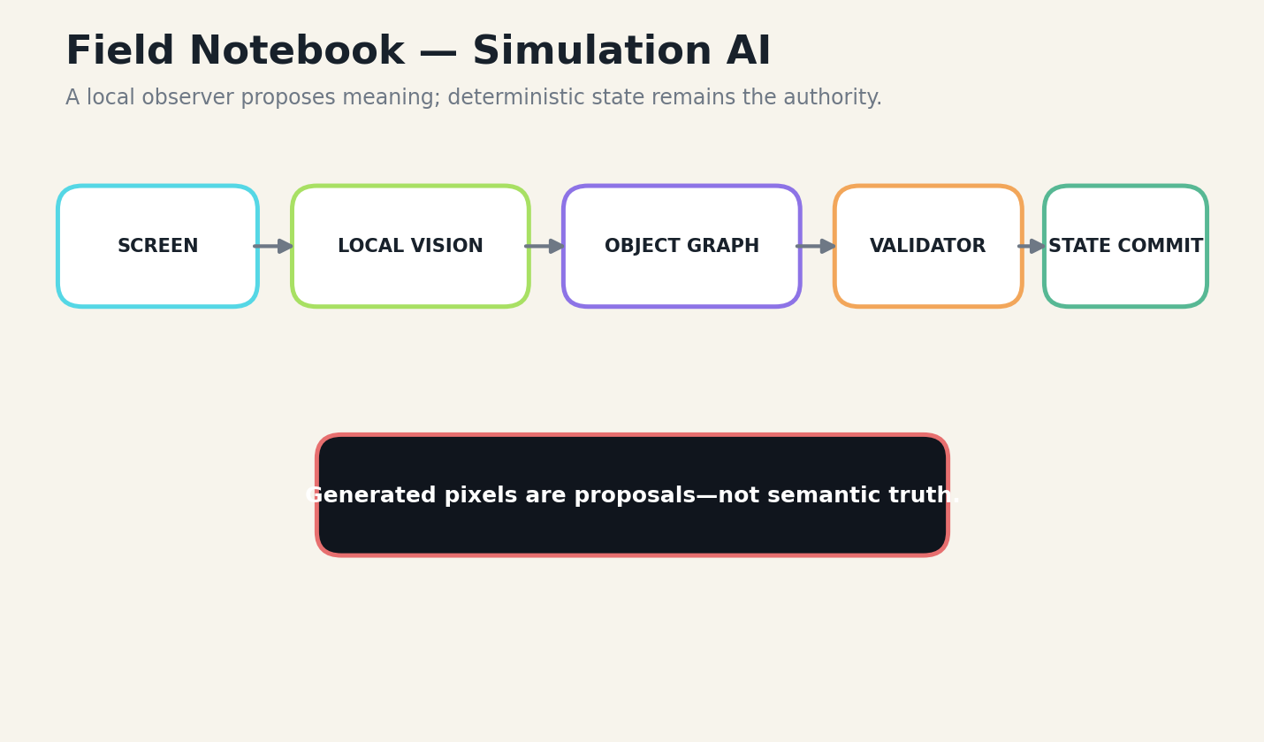
FIGURE 23 Simulation AI: The Model Observes, the World Model Decides
The central invariant is unusually strong: a generated frame may illustrate a candidate transition, but it may never silently become committed semantic state. Object identity, geometry, affordances, causality, temporal order, and uncertainty live outside the pixels. This is the deterministic reducer pattern applied to multimodal generation.

WHAT THE CASE TEACHES
The architecture is well suited to compact models because the observer does not need to reconstruct an entire operating system from scratch. It receives mapped coordinates, prior state, object graphs, and a known action class. The visual model answers a bounded question inside a structured world.
The repository describes quantum-inspired registers as classical weighted hypotheses rather than claiming physical quantum computation. This distinction is important. Metaphorical mathematics can guide uncertainty management, but implementation claims must remain testable.
Evaluation should measure grounding accuracy, state continuity, contradiction detection, recovery from a bad frame, and the fraction of interactions that require cloud escalation. The system’s promise lies in the separation of perception, proposal, and authority.
EVIDENCE STATUS
Architecture and behaviors are drawn from public repository documentation and user-reported experiments. Comparative superiority requires matched-budget reproduction.
Research anchors: R17, R21. See Research Notes and Sources.
N4
Naza: One Local Core, Several Safety Tasks
A repository-grounded systems reading, not an independent benchmark claim.
━━━━━━━━━━━━━━━━━━━━━━━━━━━━━━━━━━━━━━━━━━
Naza is documented as a secure local command-line suite with chat, road-risk scanning, food and water scanning, encrypted history, encrypted model storage, model selection, key rotation, and side-channel experiments. It supports a Gemma LiteRT-LM profile and a smaller llama.cpp profile.
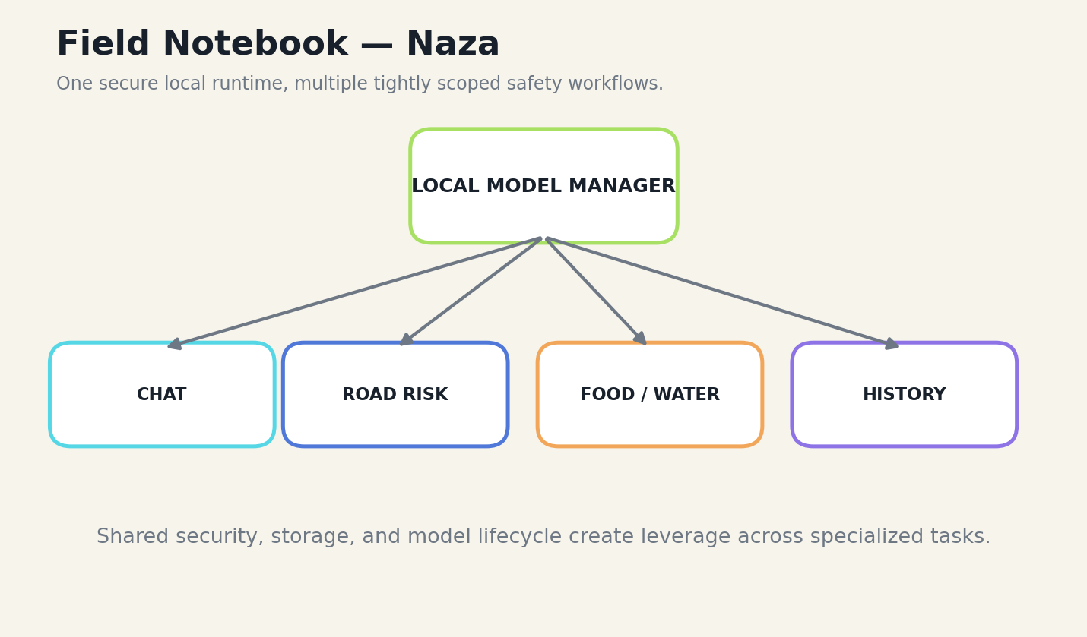
FIGURE 24 Naza: One Local Core, Several Safety Tasks
The architecture demonstrates reuse through shared infrastructure. The same model manager, encrypted database, settings flow, and runtime lifecycle support several task-specific scanners. Specialization occurs in prompts, labels, defensive voting, and domain logic rather than in a new application stack for every use case.

WHAT THE CASE TEACHES
This is a practical route for compact systems. A local model may not be globally authoritative about road or food safety, but it can provide a private, consistent first-pass classifier with clear low, medium, and high outputs. The task box must make the limits visible and avoid presenting model output as a professional inspection or medical determination.
The encrypted model lifecycle is also a systems lesson. Large weights require streaming encryption and careful runtime handling. The durable encrypted copy, temporary plaintext working file, history database, and key rotation process are all part of model deployment—not peripheral security chores.
Claims that Naza predicts or classifies better than frontier models require controlled evaluation. The repository supports an architectural case: strong local infrastructure can make compact models usable across repeated bounded tasks.
EVIDENCE STATUS
Architecture and behaviors are drawn from public repository documentation and user-reported experiments. Comparative superiority requires matched-budget reproduction.
Research anchors: R22. See Research Notes and Sources.
N5
The Chromebook and Termux Laboratory
A repository-grounded systems reading, not an independent benchmark claim.
━━━━━━━━━━━━━━━━━━━━━━━━━━━━━━━━━━━━━━━━━━
The field laboratory behind these projects has often been a Chromebook, a CPU-only Linux container, or an Android device running Termux and an Ubuntu proot. The constraint is not incidental. It changes every design choice: model size, quantization, context length, startup time, storage, user interface, and fallback behavior.
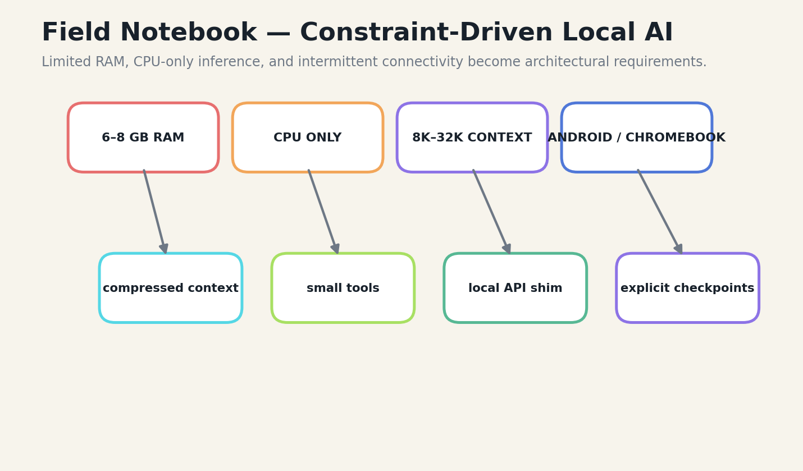
FIGURE 25 The Chromebook and Termux Laboratory
User-reported experiments include running a roughly 2.4-gigabyte Gemma LiteRT-LM model locally, exposing an OpenAI-compatible endpoint, increasing a token limit from 4,096 to 8,192, and using the local endpoint with an editing workflow. These reports are valuable engineering evidence, but they are not controlled benchmark results. Reproduction should record model revision, hardware, runtime version, prompt, temperature, token count, wall time, and task outcome.

WHAT THE CASE TEACHES
Constrained hardware encourages the right habits. Context must be compact. Retrieval must be surgical. The model cannot reread an entire repository forever. Tools need bounded outputs. Checkpoints matter because a crash can waste minutes of local inference. A local API shim makes it possible to reuse clients built for larger services.
The same environment reveals the limits of romantic localism. Very long contexts can exhaust RAM. CPU generation can be slow. Native libraries can break across distributions. GPU and Vulkan support can be inconsistent. A resilient system detects hardware, recommends a compatible runtime, and degrades gracefully.
The renaissance is not the claim that a phone replaces a datacenter. It is the realization that many useful forms of intelligence become possible when the system is designed for the machine actually present.
EVIDENCE STATUS
Architecture and behaviors are drawn from public repository documentation and user-reported experiments. Comparative superiority requires matched-budget reproduction.
Research anchors: R3, R4, R19, R20. See Research Notes and Sources.

BOOK IV
THE BUILD BENCH
Eight laboratories for turning the thesis into working systems.

L1
Build the Matched-Budget Benchmark
Create an evaluator that compares complete systems under identical task, tool, time, and privacy budgets.
━━━━━━━━━━━━━━━━━━━━━━━━━━━━━━━━━━━━━━━━━━
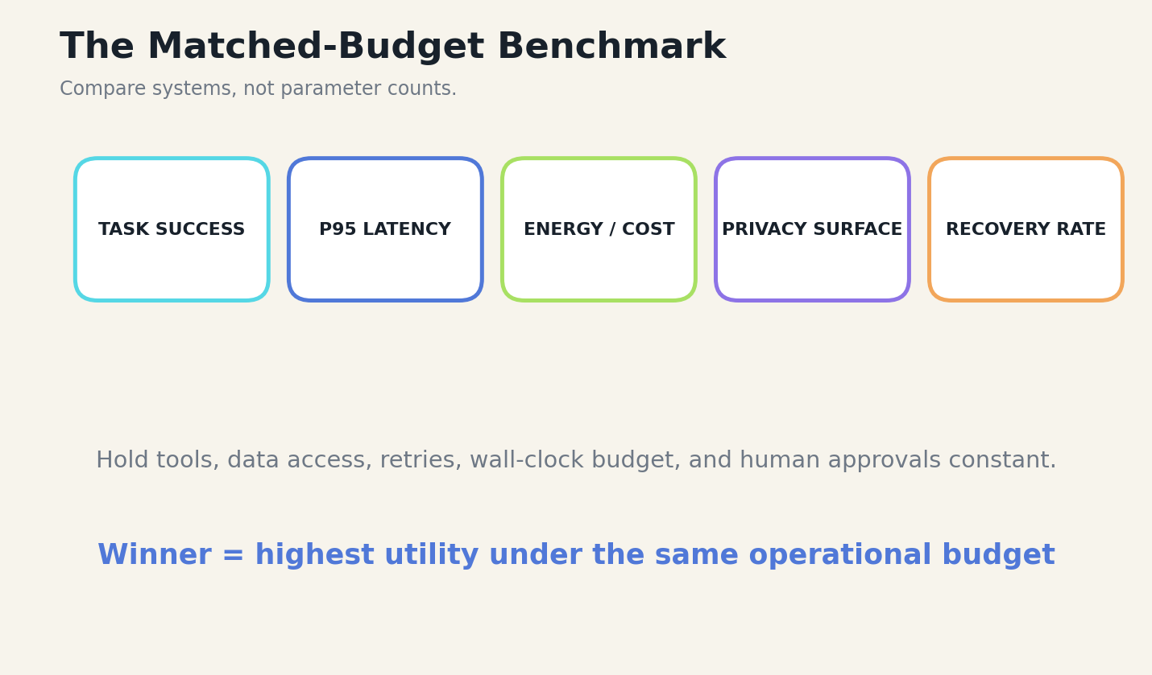
FIGURE 26 Create an evaluator that compares complete systems under identical task, tool, time, and privacy budgets.
LAB OUTPUTS | A benchmark manifest • A replayable task set • A result schema • At least three ablations
Begin with fifty to two hundred representative tasks sampled from real work. Freeze the tool surface, source corpus, retry limit, human approval policy, and wall-clock budget. Run each model-system pair multiple times with fixed and varied seeds. Record task success, partial credit, tool errors, retries, latency, energy or cost, and recovery after failure.

BUILD SEQUENCE
Separate model capability from system advantage. Test the small model without tools, with tools, with curated context, and with verification. Test the larger model under the same stages. This ablation reveals which multiplier created the gain.
Publish failure categories, not only a single score. Tool selection, malformed arguments, context distraction, planning drift, unsafe action, and verification failure demand different repairs.
FIELD EXERCISE
□ Inject one controlled failure and prove recovery.
□ Record model, runtime, hardware, context, seed, and wall time.
□ Add the result to a replayable regression suite.
Research anchors: R14, R15, R18, R25. See Research Notes and Sources.
L2
Serve a Compact Model Locally
Expose a local model through a stable API so the rest of the system remains model-agnostic.
━━━━━━━━━━━━━━━━━━━━━━━━━━━━━━━━━━━━━━━━━━

FIGURE 27 Expose a local model through a stable API so the rest of the system remains model-agnostic.
LAB OUTPUTS | Pinned model hash • OpenAI-compatible or explicit local API • Health endpoint • Performance baseline
Choose a runtime suited to the hardware: LiteRT-LM for supported edge deployments or llama.cpp for broad GGUF compatibility. Pin the runtime version and model revision. Start with a modest context window, measure peak memory, then increase only if the task requires it.

BUILD SEQUENCE
Wrap the server with health checks, request timeouts, token limits, cancellation, and structured logging. The API should report model identity, context capacity, quantization, and loaded state. Clients should not assume that every local model supports the same tool dialect.
Test cold-start time, prefill speed, decode speed, memory growth, cancellation, concurrent requests, and recovery after a failed load.
FIELD EXERCISE
□ Inject one controlled failure and prove recovery.
□ Record model, runtime, hardware, context, seed, and wall time.
□ Add the result to a replayable regression suite.
Research anchors: R3, R4. See Research Notes and Sources.
L3
Design a Tool Surface for a Tiny Agent
Create five to eight tools whose names and results make the task obvious.
━━━━━━━━━━━━━━━━━━━━━━━━━━━━━━━━━━━━━━━━━━

FIGURE 28 Create five to eight tools whose names and results make the task obvious.
LAB OUTPUTS | Tool catalog • Canonical IR • Schema validator • Distractor benchmark
Start from the task box and list the minimum state changes required. Prefer high-level tools that encode domain rules over raw shell commands. Define JSON schemas or compact native declarations with literal argument descriptions and examples of invalid calls.

BUILD SEQUENCE
Build a validator that rejects unknown fields, path escapes, oversized arguments, and ambiguous values. Return repairable errors. Normalize native model syntax into a canonical call object before execution.
Evaluate tool selection with distractors, near-duplicate names, missing required arguments, and multi-step tasks.
FIELD EXERCISE
□ Inject one controlled failure and prove recovery.
□ Record model, runtime, hardware, context, seed, and wall time.
□ Add the result to a replayable regression suite.
Research anchors: R1, R2, R4, R12, R16. See Research Notes and Sources.
L4
Implement the Context Accordion
Turn long sessions into reversible structured state.
━━━━━━━━━━━━━━━━━━━━━━━━━━━━━━━━━━━━━━━━━━

FIGURE 29 Turn long sessions into reversible structured state.
LAB OUTPUTS | Context schema • Compaction trigger • Expansion tool • Loss audit
Define pinned fields for invariants, current objective, active files, accepted decisions, unresolved questions, and latest tool evidence. When a phase closes, summarize it into a typed object and store source-event identifiers.

BUILD SEQUENCE
Use token accounting to enforce a budget for each zone. The model should be able to request expansion of a decision or evidence item. Reopened context should replace, not merely append to, redundant summaries.
Test exact-value preservation, contradiction preservation, and task success after several compaction cycles.
FIELD EXERCISE
□ Inject one controlled failure and prove recovery.
□ Record model, runtime, hardware, context, seed, and wall time.
□ Add the result to a replayable regression suite.
Research anchors: R9, R10, R13. See Research Notes and Sources.
L5
Build Hybrid Memory with Failure Bias
Combine SQLite durability with optional vector or graph retrieval.
━━━━━━━━━━━━━━━━━━━━━━━━━━━━━━━━━━━━━━━━━━

FIGURE 30 Combine SQLite durability with optional vector or graph retrieval.
LAB OUTPUTS | Memory schema • SQLite baseline • Optional vector backend • Failure replay tests
Store memories as typed records with task ID, channel, tier, timestamp, validation status, importance, source pointer, and embedding. Use lexical search for identifiers, vector search for semantic similarity, recency for current state, and explicit filters for verified memories.

BUILD SEQUENCE
Merge rankings with RRF and apply a diversity pass. Add a failure-memory channel that boosts known bug zones when file paths, error signatures, or task types match. Keep original events available for audit.
Evaluate retrieval recall, redundancy, latency, and downstream utilization. Oracle retrieval should be a separate test because small models can still ignore perfect evidence.
FIELD EXERCISE
□ Inject one controlled failure and prove recovery.
□ Record model, runtime, hardware, context, seed, and wall time.
□ Add the result to a replayable regression suite.
Research anchors: R13, R14, R20. See Research Notes and Sources.
L6
Create a Surgical Coding Loop
Build UNDERSTAND → RETRIEVE → PLAN → PATCH → TEST → INSPECT → COMMIT.
━━━━━━━━━━━━━━━━━━━━━━━━━━━━━━━━━━━━━━━━━━

FIGURE 31 Build UNDERSTAND → RETRIEVE → PLAN → PATCH → TEST → INSPECT → COMMIT.
LAB OUTPUTS | Repository index • Context builder • Diff preview • Test and commit tools
The agent begins with repository metadata and targeted search rather than a full code dump. Retrieval builds the smallest connected subgraph of definitions, callers, tests, and configuration needed for the requested behavior.

BUILD SEQUENCE
The model proposes one patch at a time. The user or policy layer previews the diff. Tests run immediately. The model receives concise failure evidence and updates the plan. A no-mutation invariant stops repeated reading without a state-changing hypothesis.
Measure files read, tokens consumed, patches attempted, tests passed, and human edits. Compare against a larger model using the same search and tool loop.
FIELD EXERCISE
□ Inject one controlled failure and prove recovery.
□ Record model, runtime, hardware, context, seed, and wall time.
□ Add the result to a replayable regression suite.
Research anchors: R11, R15, R20. See Research Notes and Sources.
L7
Build a Local Multimodal Observer
Use a compact vision model to convert images into structured observations, not final truth.
━━━━━━━━━━━━━━━━━━━━━━━━━━━━━━━━━━━━━━━━━━

FIGURE 32 Use a compact vision model to convert images into structured observations, not final truth.
LAB OUTPUTS | Observation schema • Coordinate mapper • Deterministic reducer • Continuity benchmark
Define a coordinate system, object schema, confidence fields, and permitted interaction classes. Preprocess the image with annotations or crops that focus the model on the current question. Store previous object identities and topology outside the image.

BUILD SEQUENCE
The model returns candidate observations. Deterministic code checks coordinate bounds, object continuity, and action preconditions. Only validated events update the semantic state. Generated imagery remains a projection.
Evaluate grounding accuracy, continuity across frames, uncertainty calibration, and recovery after deliberately wrong observations.
FIELD EXERCISE
□ Inject one controlled failure and prove recovery.
□ Record model, runtime, hardware, context, seed, and wall time.
□ Add the result to a replayable regression suite.
Research anchors: R17, R21. See Research Notes and Sources.
L8
Deploy an Encrypted Local Product
Turn the prototype into an owned, recoverable, updateable application.
━━━━━━━━━━━━━━━━━━━━━━━━━━━━━━━━━━━━━━━━━━

FIGURE 33 Turn the prototype into an owned, recoverable, updateable application.
LAB OUTPUTS | Threat model • Encrypted vault • Update manifest • Recovery and residue tests
Pin model and dependency versions. Verify downloads. Encrypt the durable model, history, and memory stores. Materialize runtime files with restrictive permissions and delete them after use. Add password rotation and recovery procedures.

BUILD SEQUENCE
Package the runtime for target platforms and detect CPU, GPU, and library compatibility at startup. Provide clear diagnostics when acceleration is unavailable. Never silently download a different model to fix a mismatch.
Run security tests for path traversal, symlinks, secret leakage, plaintext residue, interrupted downloads, corrupted ciphertext, and failed key rotation.
FIELD EXERCISE
□ Inject one controlled failure and prove recovery.
□ Record model, runtime, hardware, context, seed, and wall time.
□ Add the result to a replayable regression suite.
Research anchors: R3, R19, R21, R22. See Research Notes and Sources.

BOOK V
DEPLOYMENT DISPATCHES
Economics, privacy, latency, institutions, and the hybrid future.

D1
Latency Is a Cognitive Feature
A strategic consequence of designing intelligence as a system.
━━━━━━━━━━━━━━━━━━━━━━━━━━━━━━━━━━━━━━━━━━
Low latency changes interaction quality. A local model that answers in a predictable rhythm can support incremental editing, command interpretation, and sensor-driven workflows even when its best single response is weaker than a frontier model. The user can correct it early rather than waiting for a large speculative answer.
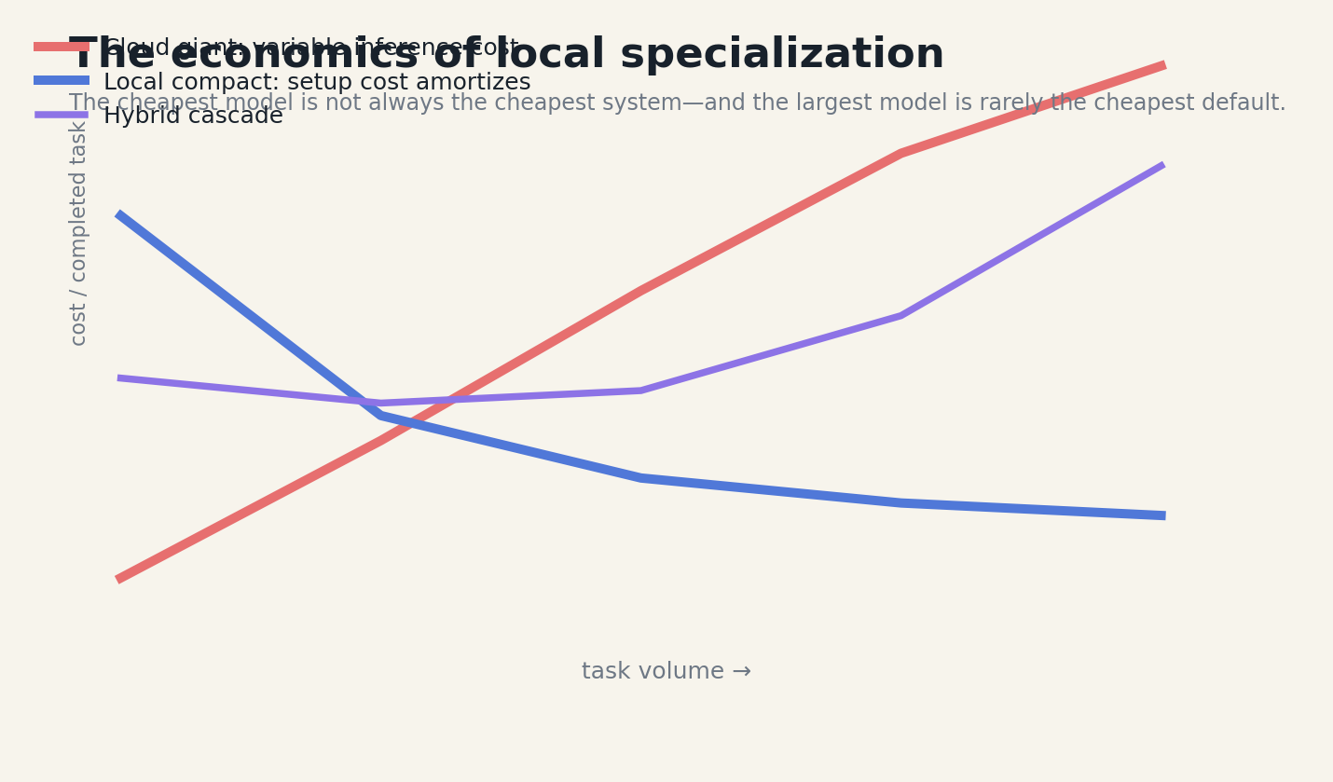
FIGURE 34 Latency Is a Cognitive Feature
Measure time to first token, time to first useful action, and time to verified completion. The third metric often matters most. A slower model that chooses the right tool once can beat a fast model that retries malformed calls.
Speculative decoding, quantization, caching, and smaller context windows can improve local responsiveness, but each optimization should be validated against task quality.
DESIGN EQUATION
Completion utility = verified result ÷ wall-clock time
D2
Privacy Is an Architectural Resource
A strategic consequence of designing intelligence as a system.
━━━━━━━━━━━━━━━━━━━━━━━━━━━━━━━━━━━━━━━━━━
Privacy is not merely a compliance cost. It expands the tasks a system can accept. Local models can process private journals, proprietary repositories, device telemetry, or household data that users would not send to a remote service.
The advantage exists only when prompts, logs, crash reports, embeddings, and temporary files remain local or explicitly controlled. A local model wrapped in cloud analytics is not meaningfully private.
Privacy-preserving design can also improve context quality because the system can retrieve richer local evidence without aggressive redaction.
DESIGN EQUATION
Private task value = useful local evidence × user trust × control
D3
Energy and Cost Follow Workload Shape
A strategic consequence of designing intelligence as a system.
━━━━━━━━━━━━━━━━━━━━━━━━━━━━━━━━━━━━━━━━━━
A local deployment has fixed costs: device purchase, engineering, model storage, and idle capacity. Cloud inference has variable costs and operational convenience. The break-even point depends on task volume, latency sensitivity, hardware utilization, and the value of privacy.
The correct comparison is cost per verified task. Include retries, network transfer, human review, and failed generations. A smaller model may use less energy per token yet consume more total energy if weak tooling causes repeated attempts.
A hybrid cascade often dominates both extremes: deterministic rules and compact models handle routine work, while difficult cases escalate.
DESIGN EQUATION
Cost_task = compute + storage + engineering + review + failure recovery
D4
Organizational Intelligence Can Be Local
A strategic consequence of designing intelligence as a system.
━━━━━━━━━━━━━━━━━━━━━━━━━━━━━━━━━━━━━━━━━━
A small model can be adapted to one team’s procedures, terminology, tool interfaces, and failure history. The result is not a miniature general assistant. It is an institutional instrument that remembers how work is actually done.
Local ownership reduces vendor lock-in and allows slow, careful change. Model upgrades can be evaluated against the organization’s own replay suite instead of adopted because a public leaderboard moved.
Governance remains necessary. Memory retention, access control, audit, and escalation should be explicit. The local system becomes part of the organization’s operating memory.
DESIGN EQUATION
Institutional fit = procedure alignment × memory quality × governance
D5
The Renaissance Is a Portfolio, Not a Winner
A strategic consequence of designing intelligence as a system.
━━━━━━━━━━━━━━━━━━━━━━━━━━━━━━━━━━━━━━━━━━
The future is not one small model defeating one giant model. It is a portfolio of rules, parsers, specialized models, local generalists, and frontier services connected by explicit routing. Different tasks deserve different intelligence budgets.
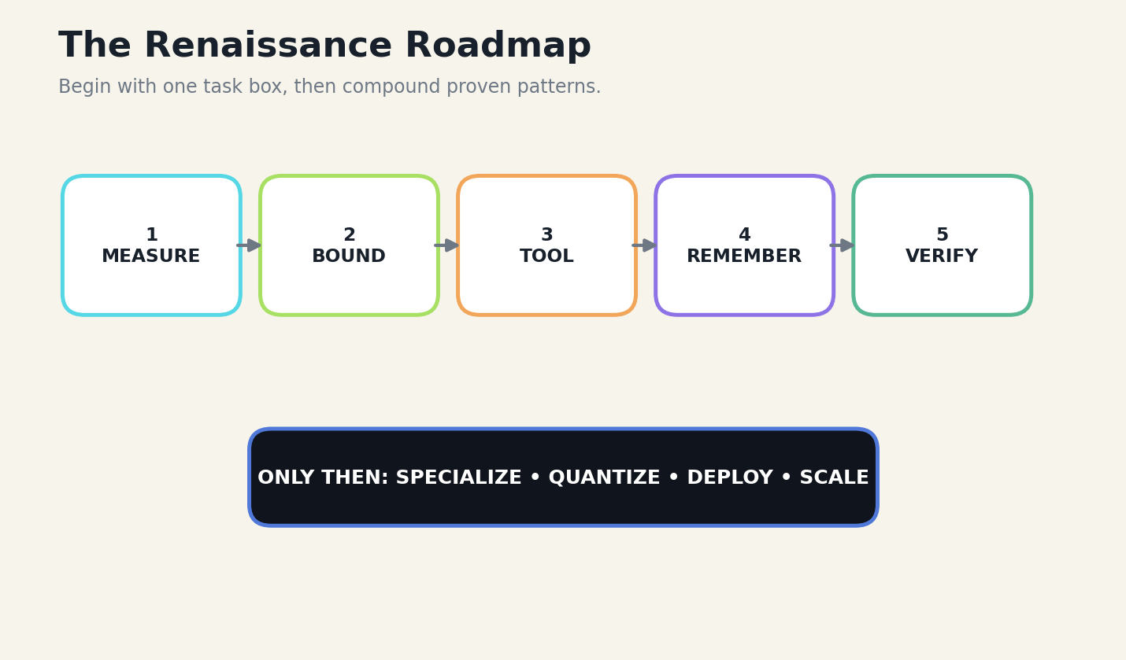
FIGURE 35 The Renaissance Is a Portfolio, Not a Winner
This portfolio lets developers optimize for the shape of work. Repetitive private tasks move local. Broad research tasks use larger models. High-risk actions require deterministic checks and humans regardless of model size. Models become replaceable components rather than identities around which the entire product is built.
The renaissance succeeds when ordinary devices can host useful, inspectable, domain-specific intelligence—and when those systems know when to ask for help.
DESIGN EQUATION
Best model = argmax utility(task, hardware, privacy, risk, tools)

EPILOGUE
THE COMPOUND INTELLIGENCE PRINCIPLE
The model does not have to contain the whole system.
━━━━━━━━━━━━━━━━━━━━━━━━━━━━━━━━━━━━━━━━━━
The small model renaissance is not a return to weak AI. It is a rejection of the idea that all capability must be compressed into one set of weights. The world already contains databases, compilers, sensors, tests, operating systems, human judgment, and accumulated memory. A good local model learns how to coordinate these powers without pretending to replace them.
The practical result is a different design aesthetic. Prompts become contracts. Context becomes a working set. Tools become capabilities. Memory becomes edited experience. Verification becomes the stopping condition. Locality becomes ownership. Escalation becomes an honest part of intelligence rather than evidence of failure.
A giant system will remain valuable for the hardest and broadest work. But the future will also be filled with compact models that know one environment deeply, act through carefully designed tools, and improve through replayable evidence. They will run in vehicles, kitchens, codebases, clinics, workshops, homes, schools, and devices that never needed a universal oracle.
The renaissance arrives when builders stop asking whether the small model is as smart as the giant model in the abstract. The useful question is whether this complete local system can do this real task better, faster, more privately, and more reliably.

FIGURE 36 The compact model becomes powerful through multiplicative system factors.

APPENDIX A
REFERENCE ARCHITECTURE
A portable blueprint for a compact local intelligence system.


FIGURE 37 Reference stack for a local compound-intelligence application.

Interface plane
Captures human intent, displays evidence, provides previews, approvals, cancellation, and clear escalation.

Orchestration plane
Owns task state, budgets, routing, retries, cancellation, and the deterministic workflow.

Model plane
Contains one or more compact models with model-native prompt and tool adapters.

Tool plane
Exposes bounded files, search, code, calculators, sensors, and application actions.

Memory plane
Stores typed session, episodic, semantic, and failure memories with provenance.

Trust plane
Provides encryption, sandboxing, audit, schema validation, tests, and update verification.

APPENDIX B
MATCHED-BUDGET EVALUATION PROTOCOL
A model comparison that measures products rather than prestige.


FIGURE 38 The benchmark holds the operational budget constant.
Field | Requirement
Task set | Realistic, versioned, replayable tasks with clear completion and refusal criteria.
Data access | Same source corpus, repository snapshot, or tool-visible environment.
Tools | Same capabilities and effect boundaries; model-native syntax may differ.
Budget | Same wall-clock ceiling, retry limit, context budget, and human approvals.
Metrics | Completion, partial credit, p50/p95 latency, tool errors, retries, cost, energy, privacy exposure.
Ablations | Model only; tools; tools + curated context; tools + context + verification; optional specialization.
Reporting | Per-category failures, confidence intervals, seeds, hardware, runtime, model revision, and prompts.
DESIGN EQUATION
System utility U = task success × reliability × privacy value ÷ (latency + cost + human repair)

APPENDIX C
CONTEXT AND MEMORY SCHEMAS
Small models benefit when every piece of state has a type.

Context Packet
FIELDS
task_id • objective • invariants • active_plan • active_files • recent_tool_events • accepted_decisions • unresolved_questions • evidence_pointers • token_budget

Memory Record
FIELDS
memory_id • task_id • memory_tier • channel • timestamp • content • source_pointer • validation_status • importance • embedding • supersedes

Failure Memory
FIELDS
signature • location • symptom • root_cause • detection_signal • failed_repairs • successful_repair • regression_test • confidence

Canonical Tool Call
FIELDS
call_id • tool_name • arguments • provider • model • protocol • source_turn_hash • confidence • approval_state

Audit Event
FIELDS
event_id • actor • action • inputs_hash • outputs_hash • policy_decision • timestamp • parent_state • new_state

APPENDIX D
TOOL CONTRACT TEMPLATE
A tool is an executable promise with a bounded effect.

Contract field | Definition
Name | Distinct verb-noun label.
Purpose | One sentence describing the job.
Arguments | Typed, literal, bounded fields.
Preconditions | State that must be true.
Effect | Resources the tool may read or change.
Result | Compact structured object.
Errors | Repairable codes and messages.
Security | Allowlists, path fences, timeouts, output limits, approvals.
Audit | Call ID, hashes, timing, actor, and state transition.
Tests | Valid, invalid, adversarial, and interrupted cases.

APPENDIX E
DEPLOYMENT CHECKLIST
The compact model is ready only when the complete system is ready.

□ Task box and escalation rules are versioned.
□ Model revision, quantization, runtime, and hash are pinned.
□ Context budget and compaction policy are measured.
□ Tool schemas, validators, and result limits are tested.
□ Write actions have preview, approval, undo, and audit.
□ Memory records have type, provenance, validation, and expiration.
□ Regression suite includes real production failures.
□ p50 and p95 latency are measured on target hardware.
□ Plaintext model and history residue are tested after crashes.
□ Network and cloud escalation are explicit and consented.
□ The system can refuse out-of-box tasks.
□ A larger-model fallback is evaluated, not assumed.

FIGURE 39 The practical sequence for building a compact local system.

GLOSSARY
THE LANGUAGE OF COMPOUND INTELLIGENCE
Terms used throughout the field manual.

Canonical tool IR. A shared internal representation into which model-native tool syntax is normalized before policy and execution.
Compound intelligence. Capability produced by the interaction of model, context, tools, memory, verification, and orchestration.
Context accordion. A reversible context-compaction system that folds old events into typed summaries with source pointers.
Deterministic reducer. Code that commits validated state transitions proposed by probabilistic models.
Evidence packet. A compact, typed collection of task-relevant files, facts, constraints, tests, and provenance.
Failure memory. A structured record of an error, its detection signal, cause, repair, and regression test.
Matched-budget benchmark. A comparison that holds task, tools, data, retries, time, and approvals constant.
Model cascade. A routing system that escalates from rules and small specialists to larger models only when necessary.
Task box. The explicit operating envelope defining inputs, outputs, tools, invariants, metrics, and escalation.
Tool leverage. Reliability gained from an external tool relative to its schema, latency, and supervision cost.

RESEARCH NOTES
PRIMARY SOURCES AND PROJECT EVIDENCE
Current official documentation, papers, and repository-grounded field notes.

The book distinguishes three kinds of support: official model/runtime documentation, research papers, and public project documentation. Repository case studies describe architectures and user-reported experiences; they are not independent benchmark validation.
The small-model field changes rapidly. Model names, runtime features, context limits, and performance should be verified against current official documentation before deployment.
R1 Google AI for Developers, FunctionGemma model overview and model card. A 270M function-calling foundation intended for fine-tuning into local specialized agents. Source
R2 Google AI for Developers, Function calling with Gemma 4. Official tool-use lifecycle and developer execution boundary. Source
R3 Google AI Edge, LiteRT-LM documentation and repository. Cross-platform local inference, tool use, multimodality, and OpenAI-compatible serving. Source
R4 ggml-org, llama.cpp documentation, including local inference, quantization, grammars, server APIs, and function calling. Source
R5 Microsoft Research, Phi-3 Technical Report: A Highly Capable Language Model Locally on Your Phone. Source
R6 Microsoft Research, Phi-4 Technical Report. Source
R7 Microsoft Research, Phi-4-Mini Technical Report: Compact yet Powerful Multimodal Language Models via Mixture-of-LoRAs. Source
R8 Shemla, Yakobe, and Agarwal, Internalizing Tool Knowledge in Small Language Models via QLoRA Fine-Tuning, 2026. Source
R9 Lodha et al., Less Context, Better Agents: Efficient Context Engineering for Long-Horizon Tool-Using LLM Agents, 2026. Source
R10 Alkiek, Jurgens, and Vydiswaran, Big Reasoning with Small Models: Instruction Retrieval at Inference Time, 2025. Source
R11 Rainone, Bakker, and Memisevic, Replacing Thinking with Tool Usage Enables Reasoning in Small Language Models, 2025. Source
R12 Sakizli, Tool-Schema Compression Enables Agentic RAG Under Constrained Context Budgets, 2026. Source
R13 Jin et al., SARA: Selective and Adaptive Retrieval-Augmented Generation with Context Compression, 2025. Source
R14 Pandey, Can Small Language Models Use What They Retrieve? An Empirical Study of Retrieval Utilization Across Model Scale, 2026. Source
R15 Albayaydh, Zhao, and Flechais, Beyond the Leaderboard: A Synthesis of Tool-Use, Planning, and Reasoning Failures in LLM Agents, 2026. Source
R16 Somma, Plante, and Premji, The Remarkable Effectiveness of Providing AI Agents with Natural Language Tools, 2026. Source
R17 Microsoft Research, Phi-Ground Tech Report: Advancing Perception in GUI Grounding, 2025. Source
R18 Liu et al., MCPAgentBench: A Real-world Task Benchmark for Evaluating LLM Agent MCP Tool Use, 2025. Source
R19 Graylan Janulis / ornab74, Humoids repository. Repository-described local Gemma, encrypted vault, history, and local RAG architecture. Source
R20 Graylan Janulis / ornab74, Humoid Agent TUI repository. Repository-described provider routing, canonical tool IR, Weaviate/SQLite memory, and Context Accordion. Source
R21 Graylan Janulis / ornab74, Simulation AI repository. Repository-described local vision observer and deterministic semantic authority. Source
R22 Graylan Janulis / ornab74, Naza repository. Repository-described secure local model suite for chat and bounded safety scanners. Source
R25 Cersosimo, Democratizing AI with Small Language Models: Structured Benchmarking and Parameter-Efficient Fine-Tuning for Local Deployment, 2026. Source

DO NOT ASK THE SMALL MODEL
TO CONTAIN THE WORLD.
BUILD THE WORLD IT NEEDS.
GRAYLAN JANULIS

