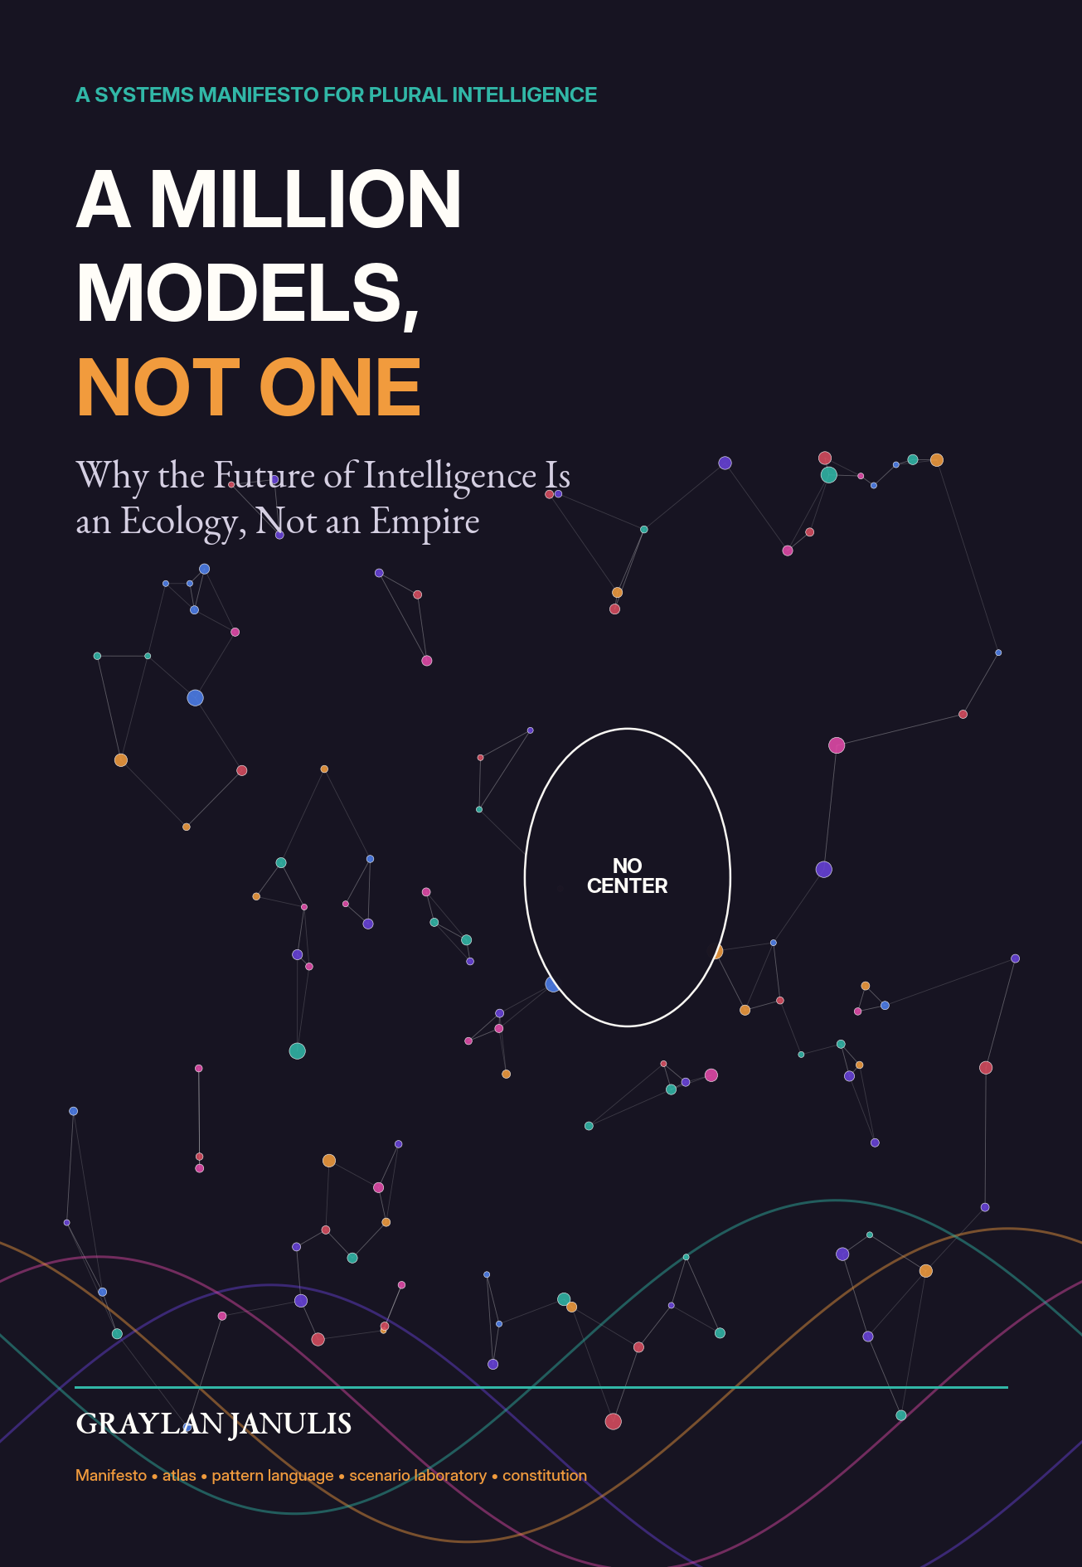

A MILLION MODELS, NOT ONE
Why the Future of Intelligence Is an Ecology, Not an Empire
GRAYLAN JANULIS

FRONT MATTER
A Note on the Claim

This book argues for an ecosystem of diverse, specialized intelligences rather than a single universal model. It is a design argument, not a prediction that every future system will contain exactly one million neural networks. The number names a direction: intelligence made divisible enough to be locally owned, independently verified, economically varied, and institutionally contestable.
The structure is deliberately non-linear. The theses state the case. The atlas names distinct model species. The pattern language shows reusable architectures. The scenario laboratories test the ideas in concrete institutions. The court of objections gives the opposition its strongest voice. The protocol stack turns philosophy into engineering. The constitution ends with rules that should survive changes in model size and fashion.
EVIDENCE KEY
Established research is distinguished from emerging engineering practice and from proposals introduced in this book. The research ledger at the end identifies the papers and frameworks that anchor the technical claims.

First edition. August 2026. All diagrams in this volume are original explanatory graphics created for the manuscript.

NAVIGATION
Full Table of Contents

OVERTURE — THE MONOLITH ERROR
- The argument in one image
- Why a larger center is not the same as a better system
- How to read the book
BOOK I — TWENTY-FOUR THESES
- Thesis 1: Intelligence is a portfolio, not a throne
- Thesis 2: The universal model is an organizational shortcut
- Thesis 3: Specialization is compressed context
- Thesis 4: Diversity is useful only when errors are not synchronized
- Thesis 5: The router is the first citizen
- Thesis 6: Small models are infrastructure
- Thesis 7: Large models should become universities, not governments
- Thesis 8: Every model needs a jurisdiction
- Thesis 9: Models should compete on fit, not mythology
- Thesis 10: The future model is assembled at request time
- Thesis 11: Model replacement must be ordinary
- Thesis 12: Local intelligence is a form of sovereignty
- Thesis 13: Memory should be a commons with gates
- Thesis 14: Dissent is a computational resource
- Thesis 15: Verification is its own profession
- Thesis 16: A model ecosystem needs graceful degradation
- Thesis 17: Benchmark plural systems as systems
- Thesis 18: Efficiency comes from selective intelligence
- Thesis 19: The ecosystem must expose its lineage
- Thesis 20: Security improves when compromise is compartmentalized
- Thesis 21: Open ecosystems need common protocols, not identical models
- Thesis 22: Plural intelligence changes the labor question
- Thesis 23: The ecosystem should preserve cognitive biodiversity
- Thesis 24: The end state is not a perfect model but a governable ecology
BOOK II — ATLAS OF MODEL SPECIES
- The Micro-Observer
- The Local Private Model
- The Domain Expert
- The Verifier
- The Simulator
- The Planner
- The Creative Diverger
- The Critic
- The Translator
- The Archivist
- The Embodied Controller
- The Emergency Fallback
BOOK III — PATTERN LANGUAGE
- Pattern 1: Router Before Reactor
- Pattern 2: Cheap-First Cascade
- Pattern 3: Dissent Quorum
- Pattern 4: Specialist Council
- Pattern 5: Local Sovereignty Cell
- Pattern 6: Federated Learning Circle
- Pattern 7: Memory Commons with Bounded Write
- Pattern 8: Model Passport
- Pattern 9: Shadow Tournament
- Pattern 10: Temporal Succession
- Pattern 11: Failure-Diverse Redundancy
- Pattern 12: Capability Lease
- Pattern 13: Evidence Market
- Pattern 14: Human Veto and Appeal
BOOK IV — SCENARIO LABORATORIES
- Laboratory A: The Plural Hospital
- Laboratory B: The Many-Model City
- Laboratory C: The Scientific Discovery Foundry
- Laboratory D: The Classroom of Many Tutors
- Laboratory E: The Disaster Mesh
- Laboratory F: The Creative Constellation
BOOK V — THE COURT OF OBJECTIONS
- Objection I: “This is too complicated.”
- Objection II: “More models mean a larger attack surface.”
- Objection III: “A council will be slower and more expensive.”
- Objection IV: “Accountability will dissolve among components.”
- Objection V: “Specialists will become brittle silos.”
- Objection VI: “The strongest general model will eventually absorb all specialists.”
- Objection VII: “A million models will deepen corporate concentration.”
BOOK VI — THE MILLION-MODEL STACK
- 1. Discovery: How Models Announce What They Are
- 2. Identity and Provenance: Who Spoke, With What Ingredients
- 3. Routing and Negotiation: The Operating System of the Ecology
- 4. Evaluation and Markets: Paying for Useful Difference
- 5. Governance and Repair: Keeping the Ecology Subordinate to People
BOOK VII — A CONSTITUTION FOR MANY MINDS
- Article I — Scope
- Article II — Consent
- Article III — Dissent
- Article IV — Provenance
- Article V — Replacement
- Article VI — Locality
- Article VII — Audit
- Article VIII — Restraint
- Article IX — Access
- Article X — Repair
- Article XI — Plurality
- Article XII — Human Appeal
APPENDICES
- Appendix A: A model passport template
- Appendix B: Ecosystem evaluation scorecard
- Appendix C: Workshop exercises
- Research ledger and bibliography

OVERTURE
The Monolith Error

For most of the history of computing, generality looked like liberation. A general-purpose computer was more valuable than a machine hardwired for one calculation. A general operating system enabled an ecosystem of applications. It is understandable that AI inherited the same aspiration: build one model broad enough to converse, reason, see, code, plan, teach, and act.
But a general-purpose computer did not become one universal program. Its power came from supporting many programs with different permissions, owners, update cycles, and failure boundaries. The current universal-model project risks confusing the general substrate with the entire institution. A model can be broadly capable while still being the wrong unit around which to organize all intelligence.
The monolith error appears whenever capability concentration is mistaken for system quality. A model may score higher on a broad benchmark and still produce a more fragile service because it centralizes memory, tools, policy, and failure. It may simplify procurement while obscuring the actual workflow. It may answer more questions while becoming harder to replace. It may appear culturally broad while pulling every explanation toward one statistical center.
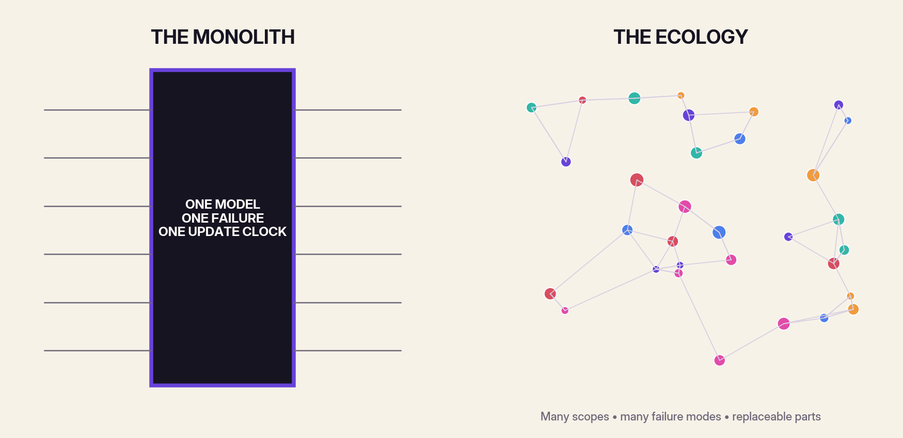
Figure 1. The difference is not merely one model versus many. It is hidden coupling versus explicit, governable relationships.
The alternative is not a chaotic pile of bots. It is an ecology: bounded models connected by routers, protocols, evidence, and institutions. Ecology is a demanding metaphor. Ecosystems contain competition, parasitism, collapse, and invasive species as well as resilience. The aim is not diversity for its own sake. It is useful difference under governance.
System intelligence ≠ max(model intelligence)
A system can become less trustworthy when capability grows faster than routing, verification, and governance.

The core proposition of this book is simple: the future should contain many kinds of machine intelligence because the world contains many kinds of problems, evidence, communities, tempos, and rights. The work is to make those intelligences cooperate without allowing any one of them—or the router between them—to become sovereign.
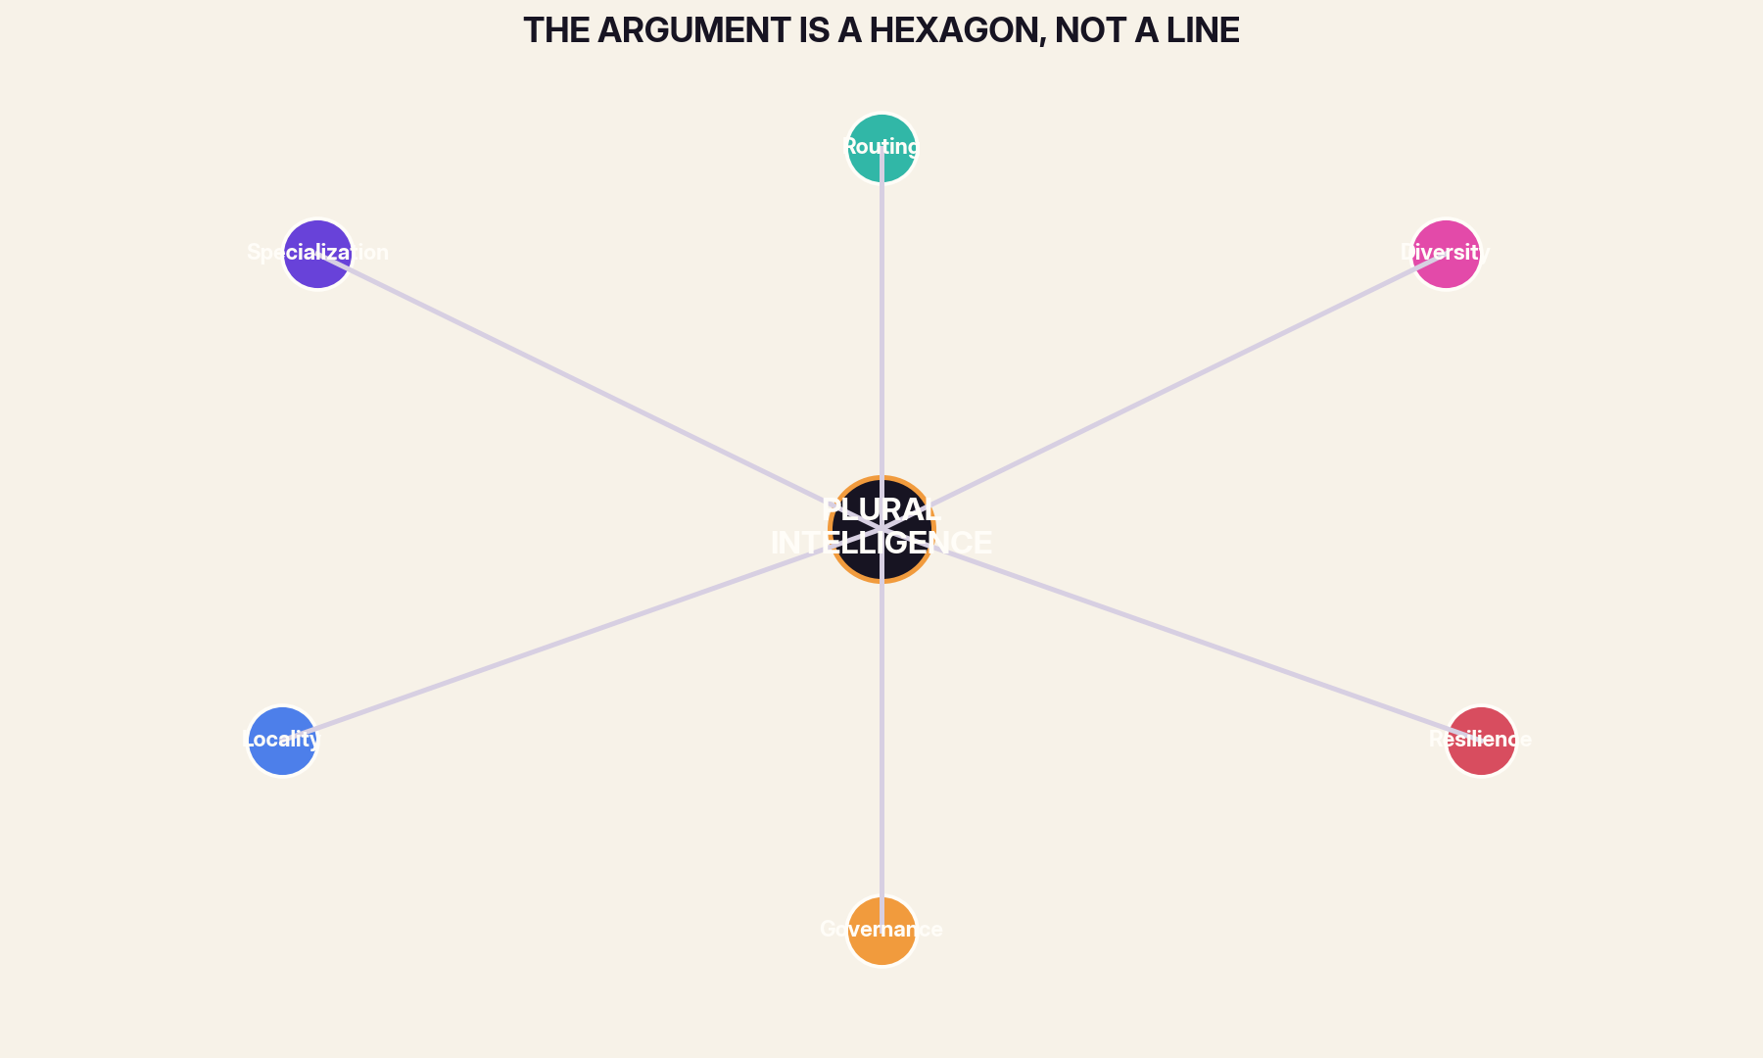
Figure 2. The case for plural intelligence depends on six mutually reinforcing dimensions.
HOW TO READ
Read the theses for the argument, the atlas for vocabulary, the patterns for implementation, the laboratories for institutional imagination, the objections for pressure-testing, and the constitution for durable principles.



01 FOUNDATION
Intelligence is a portfolio, not a throne

The dominant metaphor of modern AI is monarchical. One model sits at the center, receives every kind of request, speaks in every register, and is judged by how closely it approaches universal competence. That metaphor is convenient for marketing and disastrous for architecture. Real institutions do not trust a single mind with diagnosis, sentencing, bridge design, childhood education, emergency dispatch, poetry, and payroll. They distribute authority because different tasks demand different evidence, tempos, permissions, and forms of accountability.
A portfolio of models accepts that intelligence has many jobs. Some models should be tiny and always awake. Some should be slow, expensive, and called only under uncertainty. Some should never write; they should only verify. Some should remain on a device because the context is intimate. Some should be trained on a narrow scientific instrument and be almost useless outside it. The portfolio is stronger not because every member is strong, but because the members fail differently and can be replaced independently.
The phrase ‘a million models’ is therefore not a literal procurement target. It is a constitutional direction. It says that intelligence should be divisible, plural, and contestable. The unit of progress is not a larger sovereign model. It is a better ecology of bounded intelligences.
FIELD TEST
Inventory one important workflow. List every judgment inside it. Then ask which judgments truly deserve the same model, data access, latency budget, and authority.

02 INSTITUTIONS
The universal model is an organizational shortcut

A universal model appears to simplify deployment. One contract, one API, one security review, one interface. Yet the simplicity is often transferred rather than created. The single model must absorb every policy exception, every domain vocabulary, every local convention, every safety boundary, and every change in evidence. The resulting prompt stacks, tool permissions, and hidden routing rules become an undocumented operating system wrapped around a supposedly simple endpoint.
Specialized systems make complexity visible. A medical coding model has a named owner and a defined benchmark. A scheduling model can be rolled back without changing the model that writes clinical summaries. A local language model can be updated by a community without waiting for a global release. The ecosystem may contain more components, but each component can be understood. The monolith contains fewer named parts and more invisible coupling.
The right comparison is not one model versus many models in isolation. It is one opaque sociotechnical system versus one explicit sociotechnical system. Plurality wins when it converts hidden complexity into governed interfaces.
FIELD TEST
Take a ‘single-model’ product and diagram all the prompts, policies, tools, retrieval stores, human reviewers, and exceptions around it. Count the actual components.

03 CAPABILITY
Specialization is compressed context

A specialist is not merely a smaller generalist. It is a model whose training, tools, memory, and evaluation are shaped around a limited world. This limitation is productive. It allows the system to encode assumptions that would be dangerous in a universal model but useful inside a well-defined habitat. A model for turbine vibration can treat certain frequency bands as meaningful without pretending that the same representation explains a human conversation.
Specialization reduces the distance between the problem and the prior. The model does not begin every query from cultural common sense and then search toward domain structure. It begins closer to the measurement language, the failure modes, and the acceptable action set. This can improve accuracy, reduce latency, and make explanations more legible to experts.
The price is brittleness outside scope. That is not a defect to hide; it is a boundary to publish. A plural system treats out-of-scope behavior as a routing event, not an invitation for improvisation.
FIELD TEST
Write a one-sentence habitat description for three models: what world each model knows, what evidence it accepts, and what it must refuse.

04 RESILIENCE
Diversity is useful only when errors are not synchronized

Adding models does not automatically create wisdom. Ten copies of the same architecture trained on the same data and optimized by the same preference pipeline may produce ten versions of the same mistake. An ecosystem becomes resilient when members carry different priors, sensors, update paths, and incentives. The decisive quantity is not headcount but error correlation.
This is the old lesson of ensemble learning expanded into institutional design. Bagging, random forests, and later ensemble methods showed that aggregation can improve performance when individual predictors are sufficiently strong and not perfectly correlated. The same principle applies to language and multimodal systems, but the diversity must be engineered. A local model, a domain model, a retrieval-grounded verifier, and a rule-based constraint checker contribute different kinds of evidence.
Plural intelligence therefore needs a diversity budget. Teams should measure whether additional models create new information or merely new wording. Redundant sameness is expensive theater; heterogeneous disagreement is a resource.
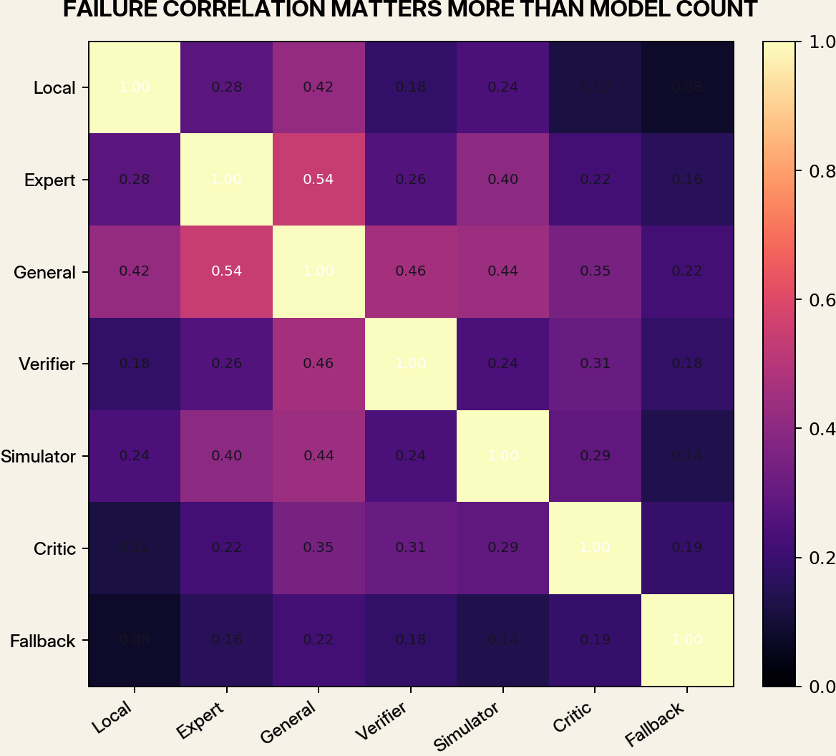
Figure 3. A diverse council is valuable when its failures are not tightly correlated.
FIELD TEST
For a model council, build a failure-correlation table. Remove any member whose errors and evidence sources are nearly identical to another member unless it serves as a hot spare.

05 ROUTING
The router is the first citizen

In a model ecosystem, the most consequential intelligence may not be the model that answers. It may be the router that decides who is allowed to answer, in what order, with which context, under which cost and risk limits. Routing turns a collection into a system.
A good router does more than classify topics. It estimates required quality, uncertainty, privacy sensitivity, latency, jurisdiction, and reversibility. It can begin with a cheap model, escalate to a specialist, request a verifier, or abstain and call a human. It can also learn a user’s preference for cost versus depth without allowing that preference to override safety constraints.
Routing should be observable. Every decision should leave a record: which models were considered, which were excluded, what threshold triggered escalation, and what evidence changed the path. Without that record, an ecosystem becomes a hidden bureaucracy.
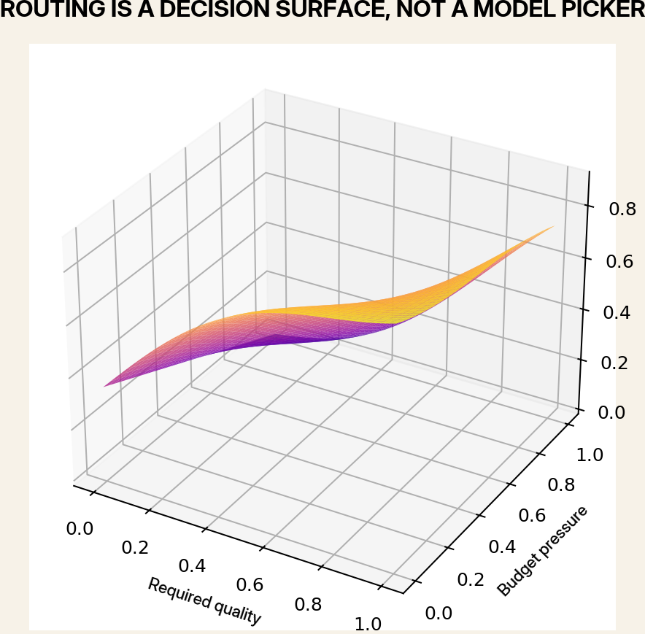
Figure 4. A router balances multiple objectives under non-negotiable constraints.
FIELD TEST
Define a routing objective for one service using quality, cost, latency, privacy, and risk. Decide which terms are hard constraints rather than tradeable weights.

06 SCALE
Small models are infrastructure

Small models are often described as degraded substitutes for larger ones. That misses their structural role. A small model can be resident, private, cheap, deterministic enough to audit, and fast enough to mediate every interaction. It can classify intent, redact sensitive content, detect anomalies, translate interface commands, or decide whether a larger model is needed.
When millions of devices participate in an intelligence ecosystem, the always-on layer cannot be composed only of expensive frontier inference. The edge needs competent micro-intelligences that turn raw streams into bounded events. Their value comes from presence and frequency rather than rhetorical range.
A civilization of models will be built from the bottom up: sensors, filters, tiny classifiers, local language models, and specialized controllers. Large models remain important, but they become rare consultations inside a larger fabric.
FIELD TEST
Identify five high-frequency decisions that can be handled by a model under one billion parameters or by a non-neural rule system. Estimate the avoided calls to a larger model.

07 SCALE
Large models should become universities, not governments

The strongest general models are valuable because they integrate broad knowledge, transfer across tasks, and generate hypotheses. Their appropriate institutional analogy is a university or research institute: a place consulted for synthesis, difficult reasoning, and the creation of new specialists. Their inappropriate analogy is a government that approves every local action.
A large model can help design training data, generate tests, distill capabilities, critique failures, and coordinate unusual cases. It should not necessarily receive every private message or control every actuator. When large models are reserved for high-leverage work, their cost becomes manageable and their influence becomes easier to inspect.
This division also changes competition. Progress is no longer measured only by who owns the largest model. It includes who can turn general capability into reliable, bounded, and locally governed intelligence.
FIELD TEST
Redesign a workflow so the largest model is called only for synthesis, novel cases, or specialist creation. What smaller components handle the routine path?

08 GOVERNANCE
Every model needs a jurisdiction

A model without jurisdiction is a model whose authority expands by accident. It begins by suggesting, then starts deciding, then becomes the source of record because everyone is already using it. The problem is not simply technical overreach. It is institutional drift.
Jurisdiction states what a model may observe, infer, recommend, and execute. It names the population, geography, time horizon, and decision class. It specifies whether the model is advisory, veto-capable, or action-taking. It also names the appeals process. These are not decorations added after training; they are part of the model’s operational identity.
Plural systems make jurisdiction easier because authority can be divided. A verifier can block unsafe outputs without controlling scheduling. A local model can personalize language without seeing organizational records. A procurement model can optimize orders without evaluating employees.
FIELD TEST
Write a jurisdiction card with four verbs: observe, infer, recommend, execute. For each verb, list allowed and prohibited actions.

09 ECONOMICS
Models should compete on fit, not mythology

The market for AI often rewards mythological scale: the largest context window, the most parameters, the broadest benchmark claim. An ecosystem needs a different procurement language. Models should compete on fitness for a declared habitat: calibrated accuracy, energy per useful decision, privacy boundary, update speed, failure diversity, and cost of replacement.
This changes incentives. A small agricultural model that performs one crop-disease triage task reliably can be more valuable than a general model that speaks eloquently and misses the local disease pattern. A verifier that catches one dangerous class of hallucination may justify its entire existence. Narrow excellence becomes legible.
Model passports and public evaluation ledgers can make fit comparable. Buyers should be able to ask not ‘How smart is it?’ but ‘What is it for, what does it cost, how does it fail, and what other model should disagree with it?’
FIELD TEST
Create a procurement scorecard that gives no points for parameter count. Weight scope fit, calibration, replaceability, provenance, and correlated-failure risk.

10 COMPOSITION
The future model is assembled at request time

A single stored model is a frozen answer to a moving set of tasks. A plural system can assemble a temporary intelligence for each request: a base model, a domain adapter, a local vocabulary, a retrieval source, a verifier, and a policy layer. The resulting capability exists for minutes and then dissolves.
Techniques such as low-rank adaptation, model merging, task vectors, mixture-of-experts routing, and tool composition point toward this world. The important shift is conceptual. Intelligence becomes compositional. Instead of shipping one universal personality, we construct a task-specific coalition with an explicit bill of materials.
Ephemeral assembly improves governance because the ingredients can be logged and tested. It also introduces new risks: incompatible adapters, hidden interactions, and provenance chains that are too long to inspect. The answer is not to retreat to the monolith, but to build composition standards.
Intelligence_request = Base ⊕ Adapter ⊕ Tools ⊕ Memory ⊕ Verifiers ⊕ Policy
The symbol ⊕ means governed composition, not simple arithmetic addition.

FIELD TEST
Describe one request-time assembly as a bill of materials: base model, adapter, tools, memory, verifier, policy, and expiration condition.

11 OPERATIONS
Model replacement must be ordinary

A healthy ecosystem assumes that models will age, drift, become compromised, or simply be surpassed. Replacement should be a routine operation, not a constitutional crisis. This requires stable interfaces, portable evaluations, versioned memory, and separation between model identity and service identity.
Many organizations accidentally bind a product to a specific model’s quirks. Prompts depend on undocumented behaviors; downstream systems parse informal text; users learn to work around errors. The model becomes irreplaceable precisely because the integration was never designed as a contract.
Plural architecture treats every model as a tenant. It can earn a longer lease through performance, but it does not own the building. Shadow deployments, canary routing, and replayable test suites make succession continuous.
FIELD TEST
Choose one deployed model and write the steps required to replace it in forty-eight hours. Every unknown step is an architectural debt.

12 LOCALITY
Local intelligence is a form of sovereignty

Data locality is often framed as a privacy feature. It is also a political and epistemic feature. A model that lives near the people, instruments, and institutions it serves can preserve context that disappears in global aggregation. It can use local language, respect local rules, and remain available when networks fail.
Locality does not require isolation. Federated learning, bounded update exchange, public benchmarks, and shared open components allow local systems to improve together without centralizing every raw interaction. The design goal is porous sovereignty: enough connection to learn, enough boundary to remain self-determined.
A million-model ecosystem becomes meaningful when communities can own or govern some of the models that interpret their lives. Otherwise plurality may exist only inside one company’s data center.
FIELD TEST
For a community service, separate what must remain local, what may be aggregated, and what may be published. Explain the reason for each boundary.

13 MEMORY
Memory should be a commons with gates

A model ecosystem needs shared memory, but unlimited memory creates surveillance, contamination, and authority drift. The solution is not one universal vector database. It is a layered commons with distinct retention periods, write permissions, and review processes.
Ephemeral scratch space can support a single reasoning episode. Session memory can preserve continuity. User-approved memory can store durable preferences. Institutional records require audit, provenance, and legal retention rules. Models should not move information between these layers merely because it is useful.
The most dangerous model in a plural system may be the one that writes to shared memory. Read access influences one answer; write access can influence every future answer. Memory writers therefore require stronger verification than ordinary responders.
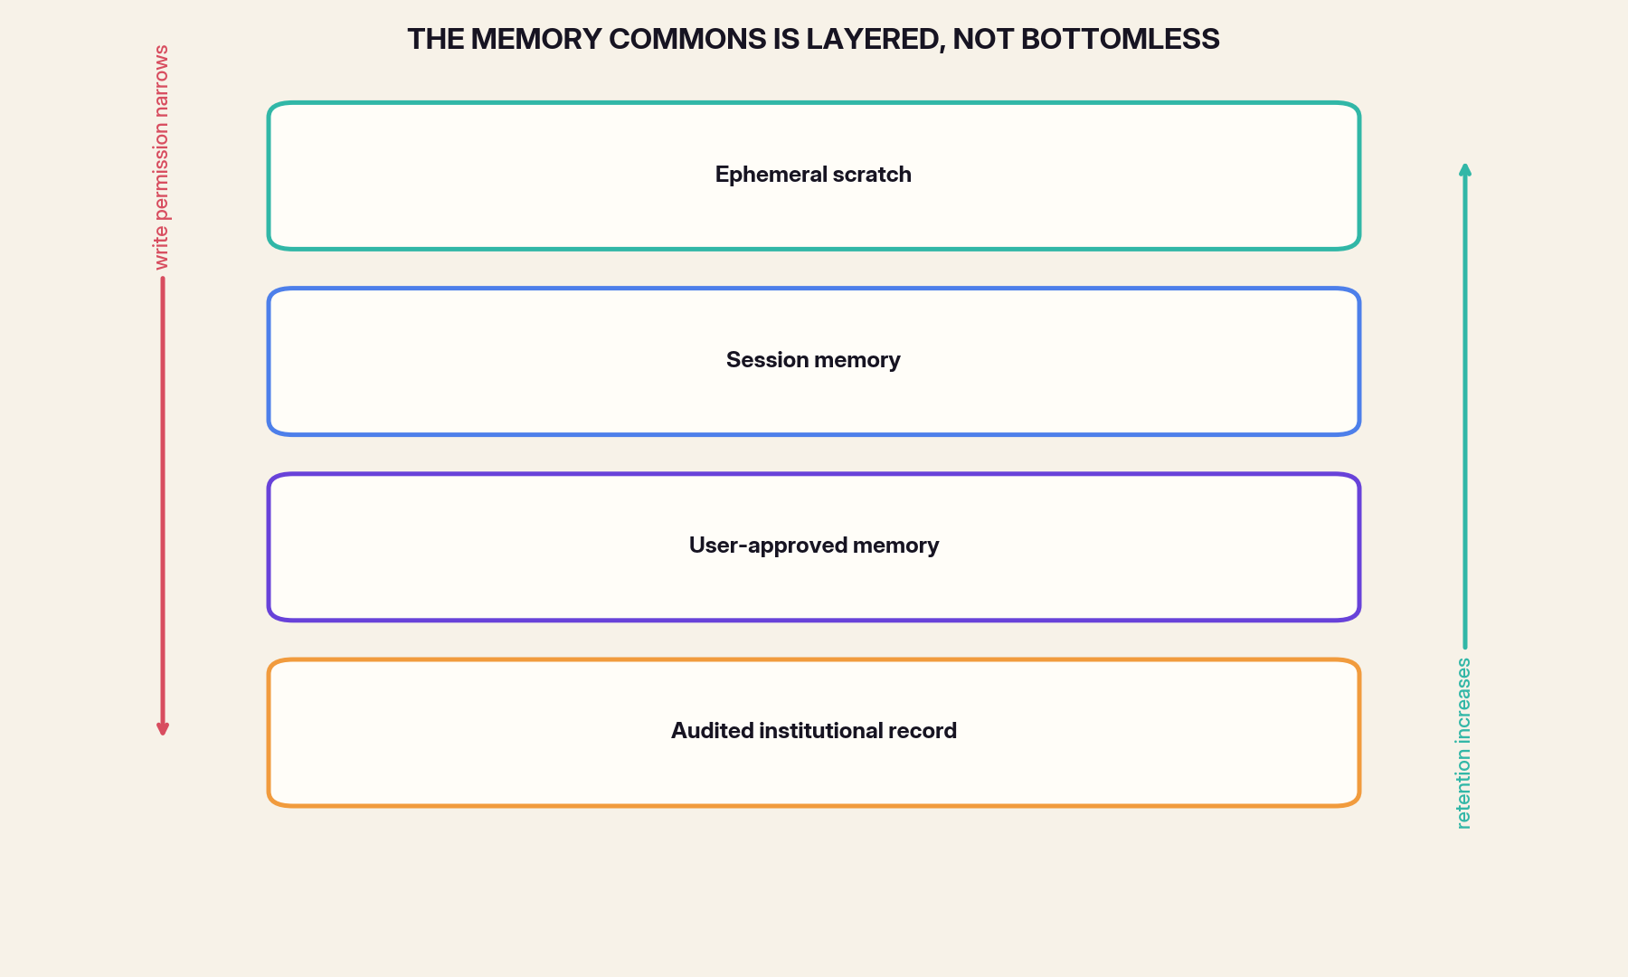
Figure 5. Durable memory should require progressively stronger write authority.
FIELD TEST
Map every memory store in an AI workflow. Mark who can write, who can read, how long records persist, and how a person can correct or delete them.

14 DELIBERATION
Dissent is a computational resource

Consensus is not always evidence of correctness. Models trained on overlapping corpora and aligned through similar feedback can converge on the same comfortable answer. A plural system should deliberately preserve dissenting roles: red teams, critics, alternative framings, minority hypotheses, and models optimized to search for disconfirming evidence.
The goal is not endless debate. Dissent must be structured. A critic should state the assumption it rejects, the evidence that would change its view, and the expected cost of being ignored. A decision record should preserve minority positions when stakes are high.
This makes disagreement actionable. Instead of averaging prose, the system can route disputed claims to tests, retrieve missing evidence, or escalate to a human. A model council is useful when it converts disagreement into information.
FIELD TEST
Create a dissent protocol: when must a minority view be preserved, when does it trigger another test, and who can close the dispute?

15 ASSURANCE
Verification is its own profession

The model that produces an answer should not automatically certify it. Generation and verification reward different behaviors. A generator benefits from breadth, fluency, and hypothesis formation. A verifier benefits from narrow criteria, access to authoritative evidence, and a willingness to reject.
In a plural architecture, verification can be decomposed further: citation checking, numerical recomputation, policy compliance, safety screening, provenance validation, and consistency with local state. Some verifiers may be conventional software rather than language models. Their authority comes from the test, not from general intelligence.
Separating these roles also clarifies accountability. When a result fails, the system can ask whether the generator lacked knowledge, the verifier missed a violation, the router skipped a required check, or the evidence source was stale.
FIELD TEST
Take one model output and design three independent verification passes: factual, numerical, and policy. Specify the evidence each pass is allowed to use.

16 RESILIENCE
A model ecosystem needs graceful degradation

Centralized intelligence promises consistency and creates catastrophic dependence. If the single model, provider, network, identity system, or policy service fails, the entire application can become useless. Plural systems can degrade by capability rather than collapse by service.
A fallback model may be less capable but locally available. A rule-based controller can preserve safe operation when generative systems are offline. Cached procedures can replace live planning during a disaster. The key is to define minimum viable intelligence before an emergency.
Graceful degradation is not merely redundancy. It is a hierarchy of acceptable behavior. The system should know which functions can become slower, which can become read-only, which require human takeover, and which must stop completely.
Resilience ≈ (failure diversity × modularity × bounded authority) / coupling
Redundancy without independence does not create resilience.

FIELD TEST
Write an outage mode for a critical AI service. What remains available after loss of the network, the main model, and the shared memory store?

17 EVALUATION
Benchmark plural systems as systems

A router plus three models cannot be evaluated by averaging the benchmark scores of its parts. System performance depends on routing errors, escalation thresholds, disagreement policy, latency tails, memory quality, and the interaction between components. A weak router can erase the advantage of excellent specialists.
Evaluation should use end-to-end tasks and replay real decision distributions. It should measure cost per resolved case, calibration under shift, human correction burden, failure concentration, and recovery time after a component change. It should also test adversarial routing: can an input manipulate the system into choosing a weaker or less governed model?
The benchmark unit becomes a trajectory rather than a prompt. We evaluate how the ecology observes, routes, reasons, verifies, acts, and learns.
FIELD TEST
Convert a prompt benchmark into a trajectory benchmark with at least five stages. Define a failure metric for each stage.

18 ECONOMICS
Efficiency comes from selective intelligence

The wasteful assumption in AI is that every token deserves the strongest available model. Most real workloads are heavy-tailed: many requests are routine, a smaller fraction require domain expertise, and very few require maximum synthesis. Cascades and routers exploit this distribution.
Research on model cascades and learned routing shows that systems can preserve quality while reducing cost by sending easy requests to cheaper models and escalating uncertain cases. The strategic implication is larger than API savings. Selective intelligence makes ubiquitous deployment possible under energy, latency, and budget constraints.
Efficiency is therefore architectural. It comes from matching the amount and kind of intelligence to the problem, not merely compressing the same universal model.
FIELD TEST
Plot the request distribution for a service. Estimate what fraction can be solved by rules, micro models, specialists, strong general models, and human review.

19 PROVENANCE
The ecosystem must expose its lineage

When an answer is assembled from multiple models, adapters, tools, retrieval sources, and memories, the user deserves more than a brand name. The system needs a lineage record: which components contributed, which version was used, what evidence entered, what transformations occurred, and which checks passed.
Lineage is essential for debugging and governance. It allows an organization to recall a compromised adapter, identify decisions influenced by stale data, and compare outcomes before and after a router update. It also creates the basis for attribution and compensation in a model economy.
The record must be useful without becoming an unreadable cryptographic dump. A concise human summary can sit above a machine-verifiable manifest. Transparency should be layered just as memory is layered.
FIELD TEST
Design a one-page lineage receipt for an AI-assisted decision. Include components, evidence, checks, uncertainty, and appeal route.

20 SECURITY
Security improves when compromise is compartmentalized

More models create more components to secure, but they also create boundaries that can limit damage. A universal model with broad tool access is a high-value target: compromise its prompt, memory, or credentials and an attacker may cross many domains. Specialized models can operate with least privilege.
Compartmentalization works only when interfaces are strict. Models should receive the minimum context and tools required for their role. Outputs should be typed and validated. Memory writes should be mediated. High-risk actions should require independent approval from a differently constructed component.
The security objective is not zero compromise. It is to prevent one compromised intelligence from becoming total compromise.
FIELD TEST
Threat-model a model council. Assume one member is malicious, one is unavailable, and one is confidently wrong. What controls prevent unsafe action?

21 STANDARDS
Open ecosystems need common protocols, not identical models

Interoperability is often pursued through standardization of the model itself: one format, one provider, one preferred architecture. A healthier goal is standardized interaction. Models can remain heterogeneous if they share contracts for capabilities, evidence, uncertainty, identity, tool calls, and audit records.
The internet did not require every server to run the same application. It required protocols. A model ecosystem likewise needs discovery, negotiation, authentication, invocation, observation, and revocation. These layers allow innovation below the interface and governance above it.
Protocol design is where plural intelligence becomes infrastructure rather than a collection of demos.
FIELD TEST
Draft a capability advertisement for a model that another system could interpret without knowing its architecture or vendor.

22 LABOR
Plural intelligence changes the labor question

The usual labor debate imagines one increasingly capable model replacing more categories of work. A plural system suggests a different future: many narrow intelligences reorganize tasks, create new supervisory roles, and expand the number of interfaces where judgment must be expressed.
Workers may become curators of model portfolios, maintainers of local knowledge, authors of evaluation cases, arbiters of disputes, and designers of safe escalation. This does not guarantee fair outcomes. Fragmented automation can still deskill, surveil, or intensify work. But the architecture creates more points where labor can negotiate scope and authority.
A model ecology should be designed with the people who inhabit the workflow, not merely deployed upon them. Local knowledge is not training exhaust; it is governance input.
FIELD TEST
Interview one frontline worker about where automation should advise, where it should verify, and where it should never act. Turn the answers into routing rules.

23 CULTURE
The ecosystem should preserve cognitive biodiversity

A universal model tends toward a universal style: the same explanatory rhythm, the same assumptions about relevance, the same compromise vocabulary. Even when it supports many languages, it can compress cultural difference into a common statistical center.
Plurality allows communities, disciplines, and artistic traditions to maintain distinct models and evaluation criteria. A model trained to preserve a language can optimize for continuity rather than global popularity. A scientific model can value falsifiability over persuasion. A creative model can cultivate eccentricity rather than consensus.
Cognitive biodiversity is not an excuse for factual isolation or harmful systems. It is the recognition that intelligence includes multiple legitimate forms of attention. The challenge is to connect them without flattening them.
FIELD TEST
Identify one domain where a global average would erase valuable distinctions. Describe how a local or tradition-specific model could remain interoperable without surrendering its criteria.

24 CONCLUSION
The end state is not a perfect model but a governable ecology

The dream of the perfect model postpones institutional questions. If the next model will be more accurate, perhaps we can delay decisions about authority, appeal, memory, ownership, and replacement. But increased capability makes those questions more urgent, not less.
A governable ecology accepts permanent imperfection. It assumes that models will disagree, that evidence will change, that incentives will conflict, and that some components will fail. It responds with boundaries, redundancy, visible routing, independent verification, and human rights of appeal.
The measure of success is not whether one model appears universally intelligent. It is whether many intelligences can cooperate while remaining bounded, inspectable, replaceable, and subordinate to human purpose.
FIELD TEST
Write the sentence that would appear above the control room of a million-model system. It should state what the system exists to protect, not what it is capable of doing.

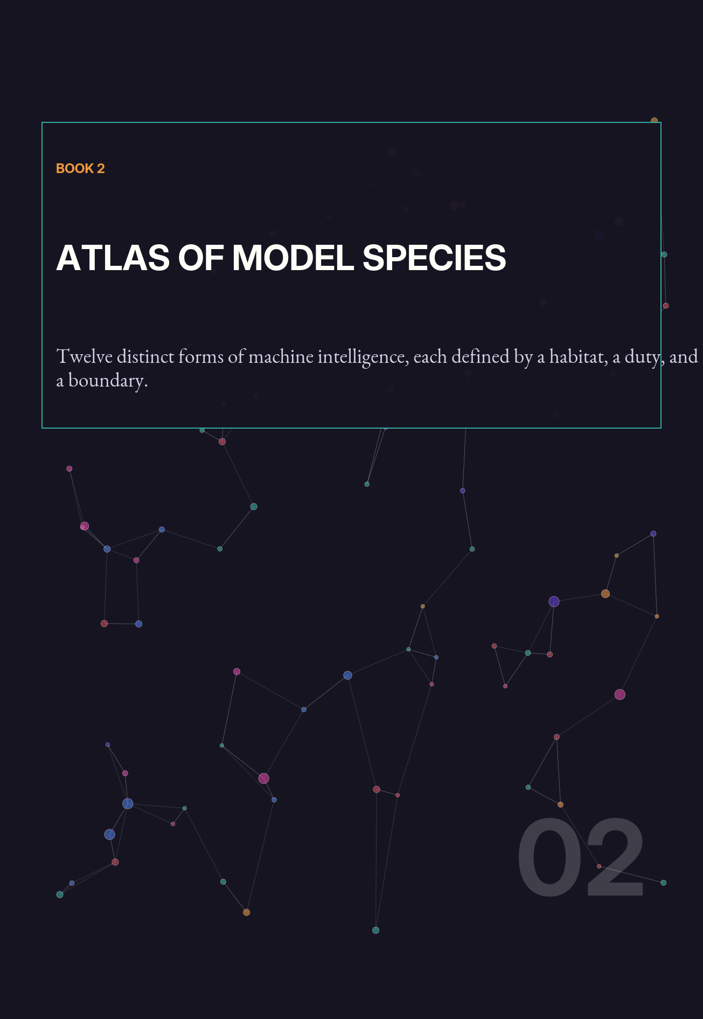

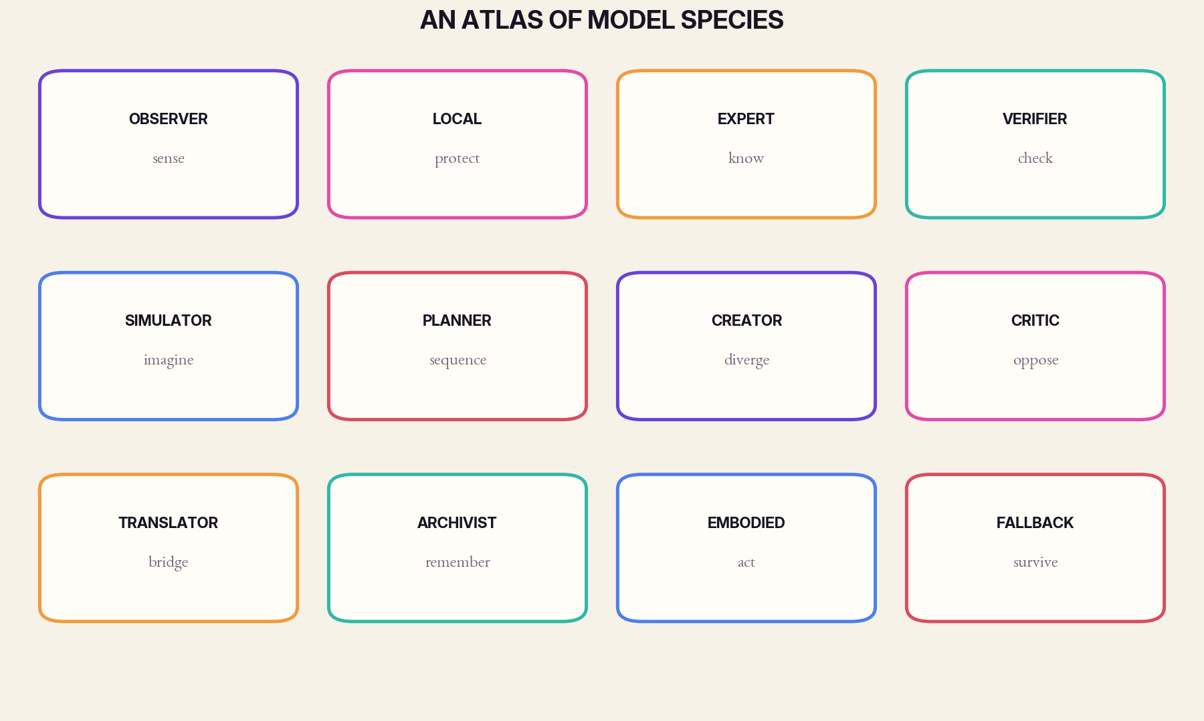
Figure 6. Model species are defined by duty and boundary, not parameter count.
01 MODEL SPECIES
The Micro-Observer

HABITAT | sensors, edge devices, background monitoring
PRIMARY VIRTUE | continuous low-cost attention
CHARACTERISTIC DANGER | confusing anomaly with meaning

A tiny model that watches one stream and emits bounded events.
The micro-observer turns a raw stream into a small vocabulary of events: vibration drift, unusual temperature, likely wake word, possible fall, changed road texture. It should not explain the world. Its virtue is that it can remain present, private, and fast. The best observer is often paired with a calibration routine and a human-readable threshold rather than a conversational interface.
EXAMPLE
A factory deploys hundreds of vibration observers, each tuned to one machine family. Only when several signals cross a pattern threshold does a diagnostic specialist receive a case.

02 MODEL SPECIES
The Local Private Model

HABITAT | phones, homes, vehicles, clinics
PRIMARY VIRTUE | context without export
CHARACTERISTIC DANGER | becoming an invisible surveillance archive

A resident intelligence whose primary asset is proximity.
The local private model can see details that should never leave the device: personal routines, drafts, medical notes, location history, or household language. It can personalize, redact, summarize, and route. Its design should assume intermittent connectivity and explicit user ownership of memory.
EXAMPLE
A phone model classifies requests, removes sensitive details, and sends only a narrow technical question to a remote specialist. The answer returns through the local model, which restores context.

03 MODEL SPECIES
The Domain Expert

HABITAT | law, medicine, engineering, agriculture, finance
PRIMARY VIRTUE | high precision inside a declared field
CHARACTERISTIC DANGER | confident improvisation outside scope

A model optimized around one body of evidence and one professional language.
A domain expert should carry a narrow evidence policy, a versioned knowledge base, and benchmarks authored by practitioners. It may be larger than a local model or smaller than a general model; size is secondary to fit. Its most important feature is an explicit boundary where it must route away.
EXAMPLE
A structural model interprets sensor and inspection data for a bridge class, while a separate geotechnical model handles soil assumptions. Their joint report preserves which model owns each claim.

04 MODEL SPECIES
The Verifier

HABITAT | quality gates, compliance, factual checking
PRIMARY VIRTUE | independent assurance
CHARACTERISTIC DANGER | rubber-stamping fluent answers

A model or program whose output is acceptance, rejection, or a test request.
Verifiers should be optimized for evidence discipline rather than helpfulness. They can recompute quantities, check citations, validate schemas, inspect policy conditions, or compare a plan with live system state. A verifier with the same data and incentives as the generator is not independent enough.
EXAMPLE
A code generator proposes a patch. A static analyzer, test model, dependency scanner, and policy checker each return typed verdicts before a maintainer sees the change.

05 MODEL SPECIES
The Simulator

HABITAT | planning, science, logistics, safety
PRIMARY VIRTUE | counterfactual exploration
CHARACTERISTIC DANGER | mistaking plausible stories for forecasts

A model that creates possible worlds rather than final answers.
Simulators help a system reason about interventions, uncertainty, and second-order effects. They should emit scenario families and sensitivity ranges, not theatrical certainty. Their value increases when multiple simulators embody different assumptions.
EXAMPLE
A city tests a transit change across traffic, accessibility, emissions, and emergency-response simulators. No single simulation is treated as the city itself.

06 MODEL SPECIES
The Planner

HABITAT | operations, robotics, project execution
PRIMARY VIRTUE | structured action under constraints
CHARACTERISTIC DANGER | optimizing the wrong objective efficiently

A model that converts goals and constraints into sequences.
Planners need explicit goals, resource limits, stop conditions, and authority boundaries. They should separate reversible steps from irreversible ones and expose dependencies. A planner is strongest when another model or human owns the objective function.
EXAMPLE
A disaster planner proposes shelter supply routes, but a safety verifier blocks roads with uncertain structural status and a local model updates neighborhood access constraints.

07 MODEL SPECIES
The Creative Diverger

HABITAT | design, writing, research ideation
PRIMARY VIRTUE | novelty and breadth
CHARACTERISTIC DANGER | homogenized pseudo-creativity

A model rewarded for producing distinct possibilities.
Creative models should be allowed to be strange, but they should not be mistaken for judges. Their job is to widen the search space. Diversity can come from different training traditions, aesthetic constraints, random seeds, or explicit opposition to dominant styles.
EXAMPLE
A studio asks six creative models to propose game mechanics under different design philosophies, then hands the candidates to a feasibility model and human team.

08 MODEL SPECIES
The Critic

HABITAT | deliberation, safety, research review
PRIMARY VIRTUE | productive dissent
CHARACTERISTIC DANGER | performative negativity

A model that attacks assumptions and searches for hidden costs.
A critic should be assigned a target and a burden of proof. It must say which assumption fails, what evidence is missing, and how severe the consequence could be. Critics become noise when they merely produce objections without tests.
EXAMPLE
Before a product launch, one critic examines misuse, another examines labor impact, and another examines data lineage. Their objections are logged separately rather than blended into a generic caution score.

09 MODEL SPECIES
The Translator

HABITAT | languages, disciplines, APIs, institutions
PRIMARY VIRTUE | interoperability without flattening
CHARACTERISTIC DANGER | silently rewriting values

A model that preserves meaning across boundaries.
Translation in a model ecosystem includes more than language. It converts a clinician’s concern into a data query, a model’s uncertainty into a policy signal, or a local ontology into a shared protocol. The translator must preserve distinctions it cannot resolve.
EXAMPLE
A community health model uses local terms; a translator maps them into a public-health schema while attaching the original phrase and confidence.

10 MODEL SPECIES
The Archivist

HABITAT | libraries, organizations, long projects
PRIMARY VIRTUE | memory with provenance
CHARACTERISTIC DANGER | turning history into unquestioned authority

A model that organizes evidence and maintains temporal continuity.
Archivists index, summarize, compare versions, and surface forgotten decisions. They should distinguish records from interpretations and preserve the possibility that past consensus was wrong. Their memory writes require audit because future models will treat them as evidence.
EXAMPLE
A research archivist links experiments, failed hypotheses, instrument changes, and peer review so that a new model can see not only results but the path that produced them.

11 MODEL SPECIES
The Embodied Controller

HABITAT | robots, vehicles, laboratories, infrastructure
PRIMARY VIRTUE | fast situated action
CHARACTERISTIC DANGER | unbounded tool authority

A model whose outputs change the physical world.
Embodied models require the strictest separation of perception, planning, safety, and actuation. Generative flexibility should be fenced by verified control envelopes. A physical action system must know when to stop, freeze, or yield to a simpler controller.
EXAMPLE
A warehouse robot uses a learned perception model, a route planner, a hard real-time collision controller, and a human override. No language model directly commands motor torque.

12 MODEL SPECIES
The Emergency Fallback

HABITAT | outages, disasters, compromised networks
PRIMARY VIRTUE | graceful degradation
CHARACTERISTIC DANGER | being ignored until the emergency

A deliberately limited model designed for failure conditions.
Fallbacks should be tested under the conditions that activate them: low power, stale data, damaged sensors, or missing connectivity. They need small dependency graphs and conservative behavior. Their success criterion is continuity of essential function, not feature parity.
EXAMPLE
When a hospital loses cloud access, a local fallback provides medication-reference lookup from a signed snapshot, queues nonurgent requests, and refuses unsupported synthesis.

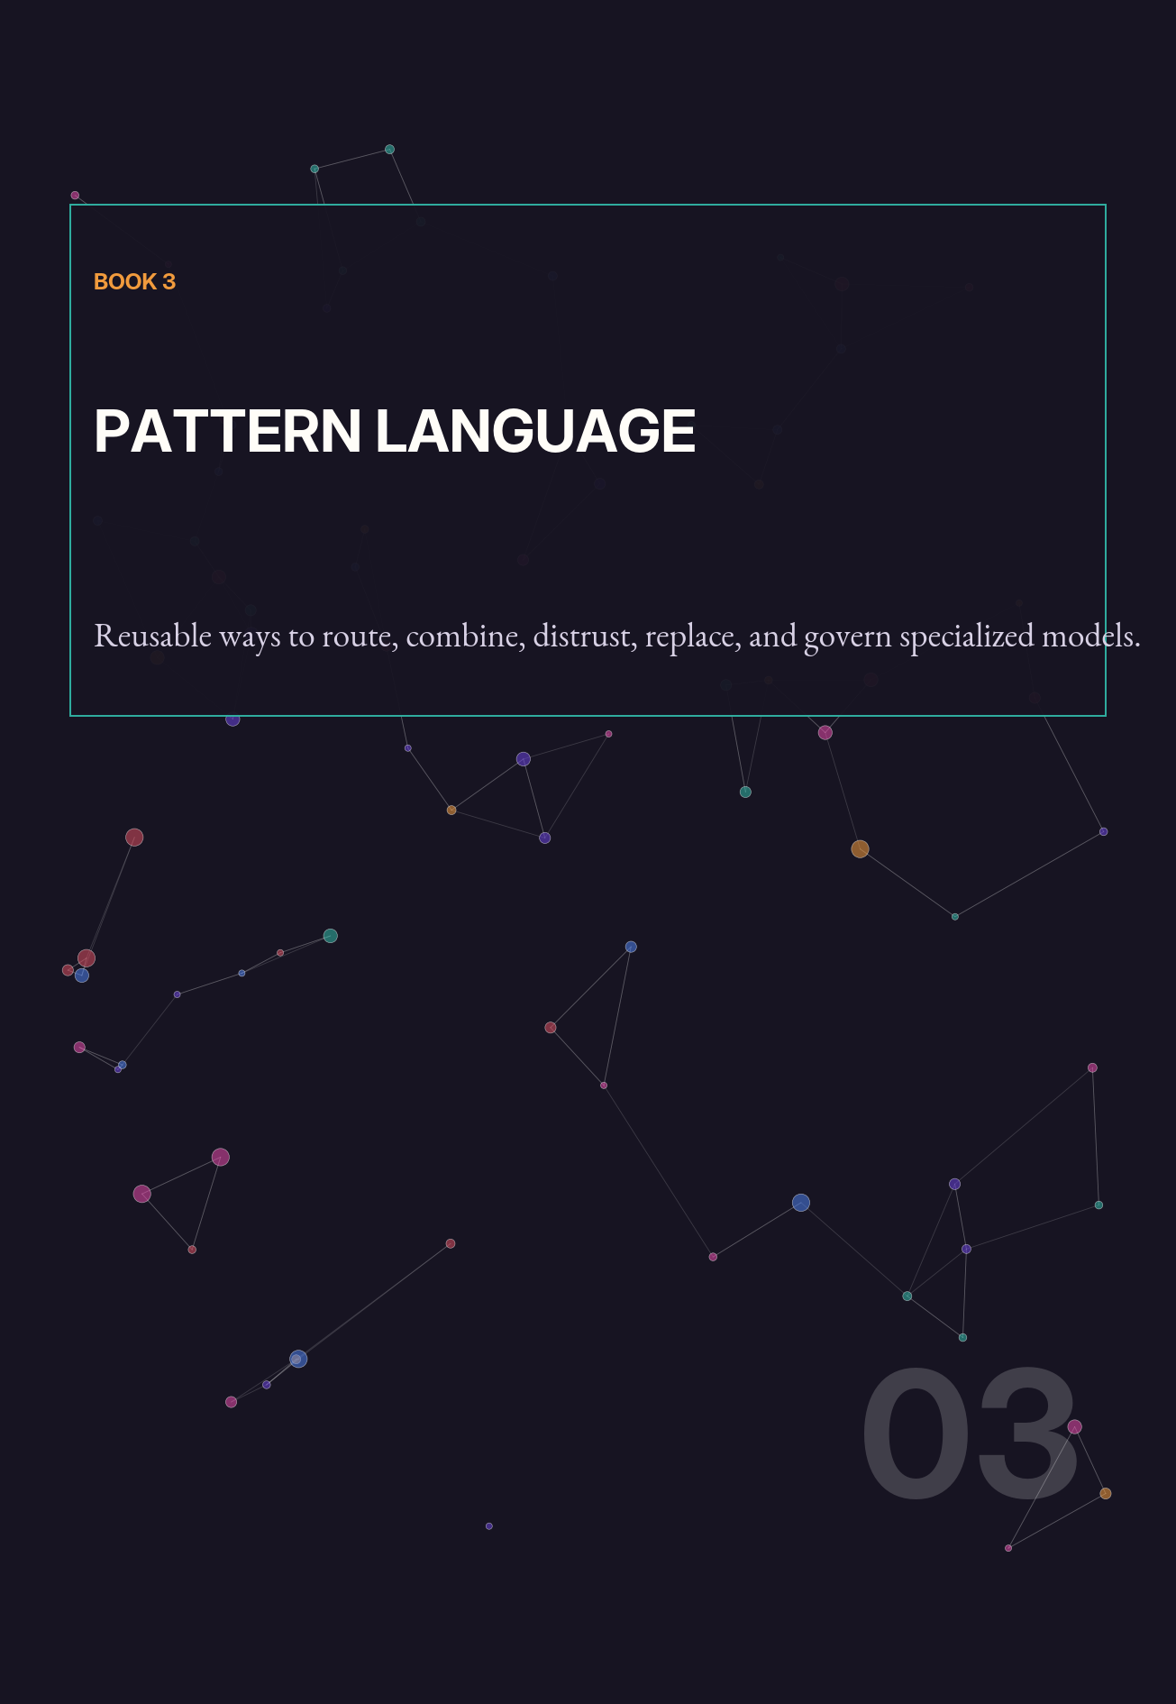

01 PATTERN LANGUAGE
Router Before Reactor

PATTERN IN ONE SENTENCE
Route the request before spending intelligence.

Systems often begin by calling the strongest model and then adding guards. Reverse the order. A small router first estimates domain, stakes, privacy, reversibility, and uncertainty. It can solve trivial cases, select a specialist, form a council, or require a human.
The router should optimize a constrained objective: m* = argmax_i [Q_i(x) - λC_i(x) - μL_i(x) - ρR_i(x)], subject to privacy and jurisdiction constraints. Q is expected quality, C cost, L latency, and R risk. Hard constraints must not be converted into cheap tradeoffs.

Use when workloads are heterogeneous and model costs or permissions differ. Avoid when the router has too little evidence to distinguish cases; in that setting, default to a safe specialist or a human intake step.
DESIGN EXERCISE
Build a router confusion matrix. Pay special attention to false routes into underpowered or under-governed models.

02 PATTERN LANGUAGE
Cheap-First Cascade

PATTERN IN ONE SENTENCE
Escalate only when a lower tier cannot establish sufficient confidence.

Begin with rules or a micro model, then a small specialist, then a stronger model, and finally a council or human. Each tier must have an abstention mechanism. The cascade is effective because routine work dominates many real workloads.
Let p_k be the probability a request exits at tier k and c_k the cumulative cost to that tier. Expected cost is E[C] = Σ p_k c_k. The design task is to reduce cost without increasing the probability of a harmful early exit.

Use for support, document processing, coding assistance, and classification. Do not use a cheap-first policy when a missed high-stakes case is irreversible unless the first tier is explicitly optimized for sensitivity.
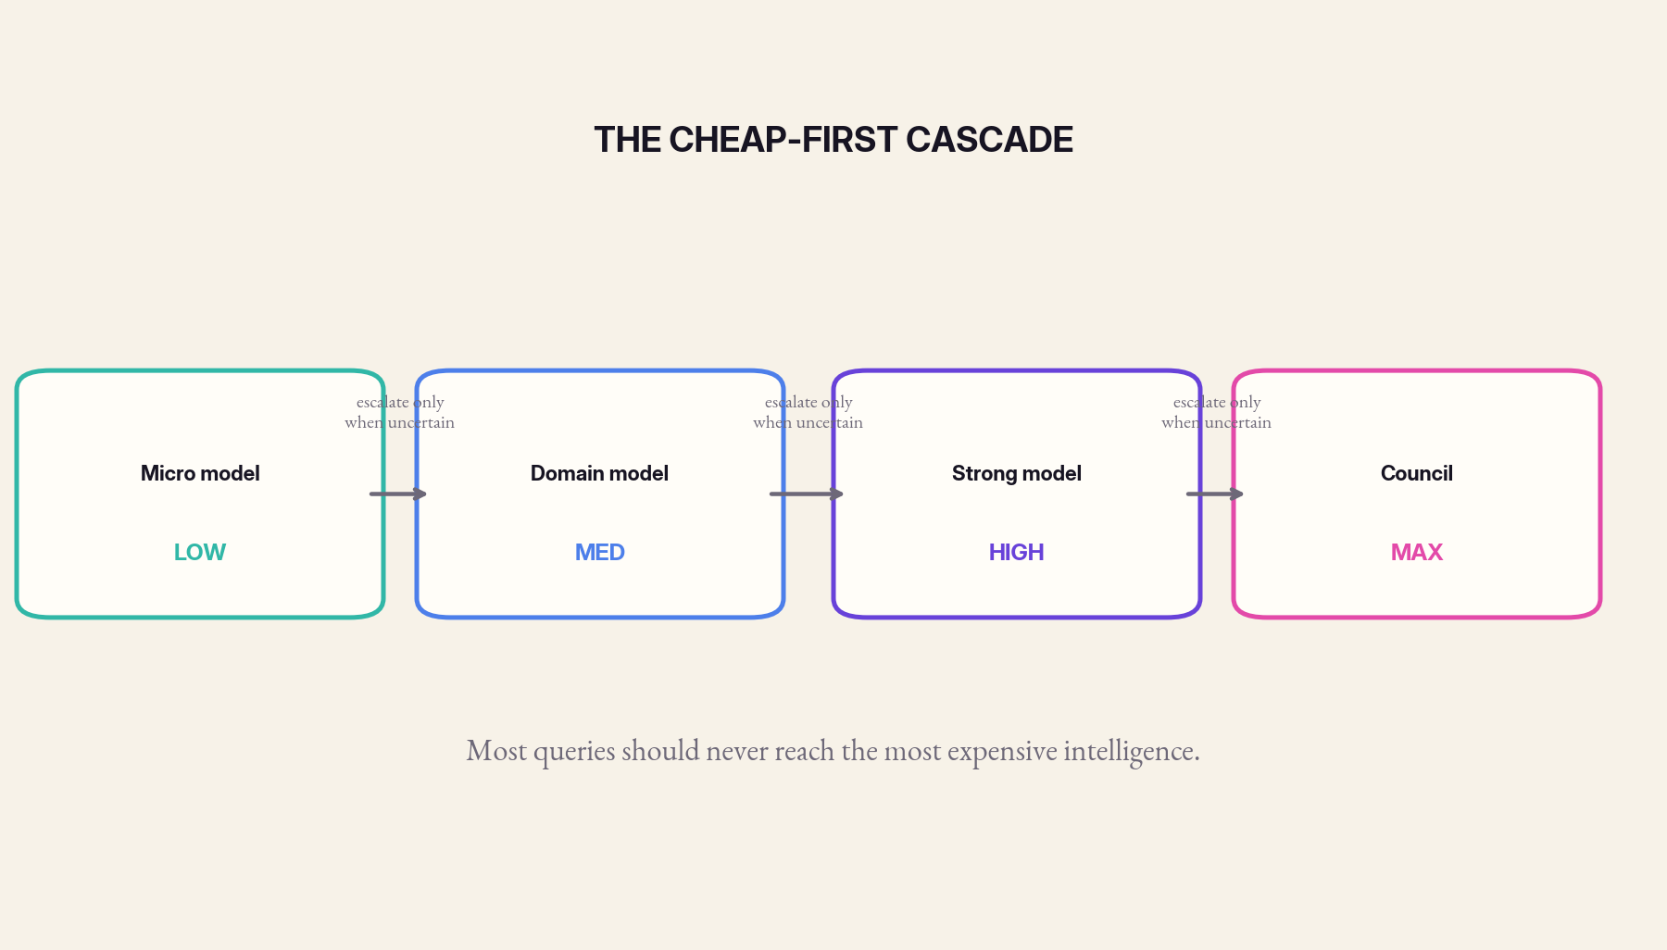
Figure 7. A cascade spends stronger intelligence only when the case earns escalation.
DESIGN EXERCISE
Simulate one thousand requests with real class proportions. Compare cost, latency, and severe-error rate against always using the strongest model.

03 PATTERN LANGUAGE
Dissent Quorum

PATTERN IN ONE SENTENCE
Require structured disagreement before high-impact action.

A quorum is not majority voting. It is a requirement that several differently constructed members examine a decision and that material dissent be resolved or recorded. One member may represent safety, another domain evidence, another local context, and another the affected user.
Define quorum validity as V = I(independence ≥ τ_i) · I(evidence coverage ≥ τ_e) · I(unresolved critical dissent = 0). A unanimous council with shared failure modes may be less valid than a divided independent council.

Use for consequential recommendations, policy changes, scientific claims, and irreversible actions. Avoid forcing quorums on routine low-stakes tasks; deliberation itself has cost.
DESIGN EXERCISE
Design three dissent categories: informational, ethical, and jurisdictional. Specify which category can block action.

04 PATTERN LANGUAGE
Specialist Council

PATTERN IN ONE SENTENCE
Assemble roles, not merely models.

A council is strongest when each seat has a job: propose, verify, criticize, simulate, translate, and represent local constraints. Give members separate context windows where possible so they do not anchor on one another too early. Aggregate structured claims rather than prose popularity.
Council utility can be approximated by U = Σ w_i a_i - αΣ_{i≠j} w_iw_j corr(e_i,e_j) - βK, where a_i is member accuracy, error correlation penalizes synchronized failure, and K is coordination cost.

Use when no single domain contains the whole problem. Failure occurs when councils become prompt theater: identical models, identical evidence, and a final aggregator that erases dissent.
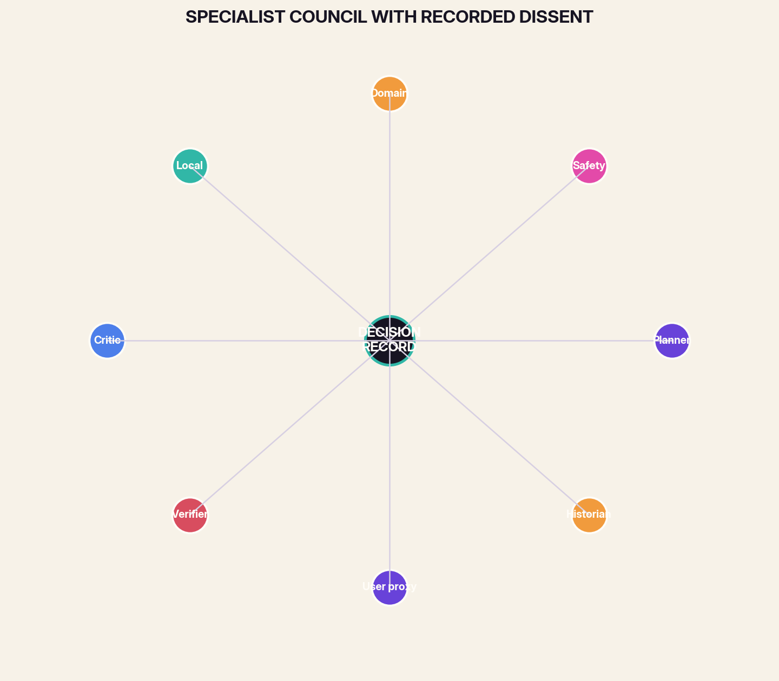
Figure 8. A council is organized by roles and evidence, not by model popularity.
DESIGN EXERCISE
Run the same case through a homogeneous council and a heterogeneous council. Compare the novelty of evidence, not just final answer agreement.

05 PATTERN LANGUAGE
Local Sovereignty Cell

PATTERN IN ONE SENTENCE
Keep sensitive context and routine inference near its source.

A local cell contains a private model, user-approved memory, policy rules, and a gateway to external specialists. The gateway strips or transforms context according to declared rules. External models return bounded artifacts rather than taking over the conversation state.
Use for health, home, vehicles, personal knowledge, and regulated work. The cell should continue essential functions offline and maintain a user-visible export and deletion path.
The danger is false privacy: a local interface that quietly sends embeddings, telemetry, or prompts elsewhere. Measure data egress, not marketing language.
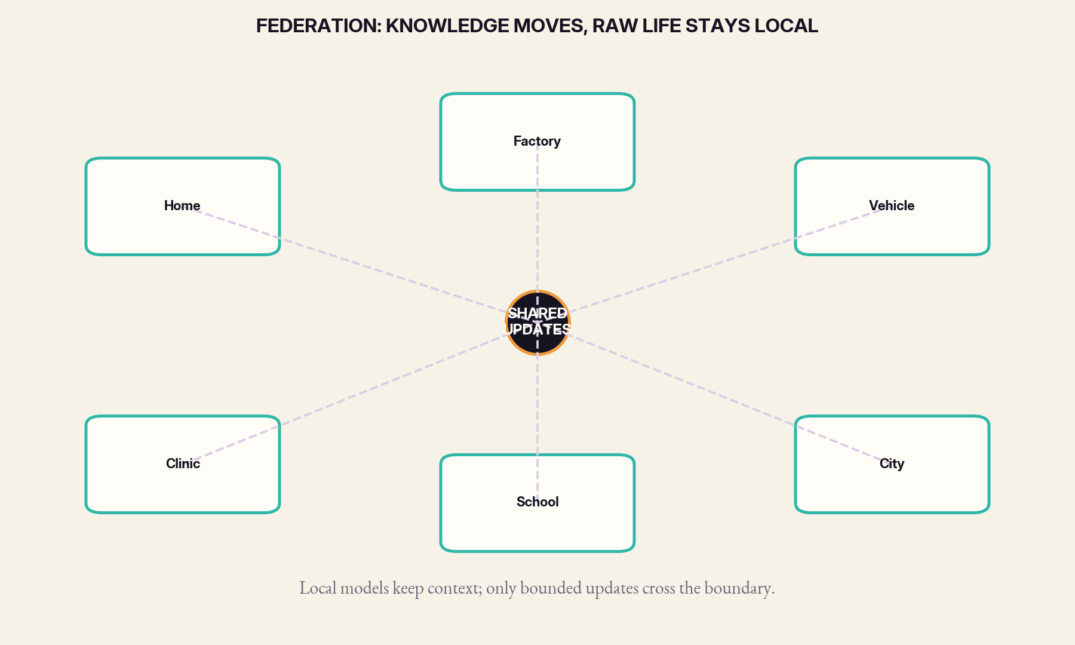
Figure 9. Local cells can exchange bounded learning without centralizing raw life.
DESIGN EXERCISE
Capture a network trace during ten common tasks. Verify that every outbound field is necessary and documented.

06 PATTERN LANGUAGE
Federated Learning Circle

PATTERN IN ONE SENTENCE
Share improvements without centralizing raw experience.

Local models train or adapt on distributed data, then exchange bounded updates or statistics. Aggregation can produce a shared model while preserving local data boundaries. The circle must address non-identical data, poisoned updates, unequal participation, and the risk that updates leak information.
Use when many sites face related tasks but cannot pool raw data. Pair aggregation with secure update validation, local evaluation, and the right to remain on a stable version.
Federation is not automatically democratic. A central aggregator can still control objectives and releases. Governance must travel with the protocol.
DESIGN EXERCISE
Write an update constitution: who may contribute, how updates are weighted, how poisoning is detected, and how a site opts out.

07 PATTERN LANGUAGE
Memory Commons with Bounded Write

PATTERN IN ONE SENTENCE
Separate useful continuity from uncontrolled accumulation.

Create layers for scratch, session, user-approved, team, and institutional memory. Each layer has a schema, retention period, writer set, and correction process. Models can propose memories, but privileged writers or humans approve durable entries.
Use wherever multiple models need continuity. The pattern prevents one persuasive but wrong output from becoming permanent shared truth.

A useful metric is memory influence debt: D_m = Σ r_j · u_j · t_j, where r is reach, u uncertainty at write time, and t persistence. High-debt memories require stronger verification.
DESIGN EXERCISE
Sample twenty durable memories and trace the evidence and writer that created each one. Delete or downgrade entries with weak lineage.

08 PATTERN LANGUAGE
Model Passport

PATTERN IN ONE SENTENCE
Publish the operational identity of every model.

A passport names purpose, jurisdiction, training lineage, evaluation, interfaces, privacy behavior, dependencies, known failures, update owner, and replacement path. It should be machine-readable and human-readable.
Use for procurement, routing, auditing, and incident response. The passport becomes stale unless tied to release automation and live monitoring.
A passport is not a marketing model card. It must include negative capability: what the model cannot reliably do and what it is forbidden to do.
DESIGN EXERCISE
Ask an operator to decide whether to deploy a model using only its passport. Record every missing fact.

09 PATTERN LANGUAGE
Shadow Tournament

PATTERN IN ONE SENTENCE
Evaluate candidates on live traffic without granting authority.

Multiple models observe the same cases in shadow mode. Their outputs are scored against later outcomes, human decisions, or trusted tests. A tournament reveals local fit and drift that public benchmarks miss.
Use before replacement, after major updates, and during seasonal or domain shifts. Protect privacy by reusing the same bounded case representation the production model receives.
Avoid winner-take-all selection. A model may be best for one slice and dangerous for another; tournaments should produce routing policies, not a single champion.
DESIGN EXERCISE
Segment results by stakes, language, user group, and input type. Look for specialists hidden by the overall average.

10 PATTERN LANGUAGE
Temporal Succession

PATTERN IN ONE SENTENCE
Run old and new intelligences together during change.

A successor model first shadows, then handles a small routed slice, then expands as evidence accumulates. The previous model remains available for replay and rollback. Memory formats and audit logs are versioned independently.
Use whenever models change faster than institutions can absorb. Succession is especially important when a model’s style influences user behavior or downstream parsing.
A new model can be better on benchmarks and worse in the local ecology because it changes uncertainty, tool use, or refusal behavior. Transition metrics must include system effects.
DESIGN EXERCISE
Define rollback triggers before launch. If the team cannot state them, the deployment is not ready.

11 PATTERN LANGUAGE
Failure-Diverse Redundancy

PATTERN IN ONE SENTENCE
Back up a model with something that fails differently.

A backup built from the same weights, provider, runtime, and data center protects against hardware loss but not correlated model error. True redundancy crosses architectures, evidence sources, vendors, and sometimes paradigms: neural, symbolic, statistical, and human.
Use for safety, continuity, and high-value verification. The pattern can be expensive, so reserve it for functions whose failure cost justifies diversity.

Resilience can be summarized as R_e ≈ D · M · B / K, where D is failure diversity, M modularity, B bounded authority, and K coupling. More components do not help if coupling remains total.
DESIGN EXERCISE
For each critical service, name the common-mode failure that can defeat both primary and backup. Add one control outside that shared mode.

12 PATTERN LANGUAGE
Capability Lease

PATTERN IN ONE SENTENCE
Grant models temporary authority instead of permanent access.

A model receives a signed, scoped capability: read these records, call this tool, spend this budget, act until this time, and return this artifact. The lease expires automatically and can be revoked. Long-lived credentials are avoided.
Use for agents, external models, and high-risk tools. The lease should bind to model identity, version, user purpose, and a traceable task.
The pattern limits blast radius but depends on trustworthy identity and tool enforcement. A prompt promise is not a capability boundary.
DESIGN EXERCISE
Take one agent with broad API keys and replace them with three task-scoped leases. Compare the maximum possible damage.

13 PATTERN LANGUAGE
Evidence Market

PATTERN IN ONE SENTENCE
Let claims compete through tests rather than eloquence.

Models submit claims with confidence, evidence, and a proposed verification cost. Other models can challenge by offering cheaper tests, contradictory evidence, or alternative hypotheses. The orchestrator allocates budget toward claims with high expected decision value.
Use in research, investigation, forecasting, and complex diagnosis. The market metaphor is useful only if incentives reward calibration and successful challenges rather than volume.

A simple priority score is P = I · U · Δ / C, where I is impact, U uncertainty, Δ expected reduction in uncertainty, and C verification cost.
DESIGN EXERCISE
Run a claim auction: give three models the same evidence budget and reward the model that most reduces uncertainty, not the one that writes the longest report.

14 PATTERN LANGUAGE
Human Veto and Appeal

PATTERN IN ONE SENTENCE
Preserve an explicit path for refusal, correction, and recourse.

Human oversight is often reduced to a final approval button. Real appeal requires understandable reasons, access to the decision record, time to contest, and a reviewer with authority to change the outcome. The system must also protect workers from becoming rubber stamps under impossible volume.
Use wherever AI affects rights, safety, livelihood, or access. Low-stakes automation still benefits from correction channels because user feedback reveals drift.
Appeal metrics include reversal rate, time to resolution, repeated-error detection, and whether affected people can actually use the process.
DESIGN EXERCISE
Attempt to appeal a model decision as an ordinary user. Document every point where technical or institutional knowledge is assumed.

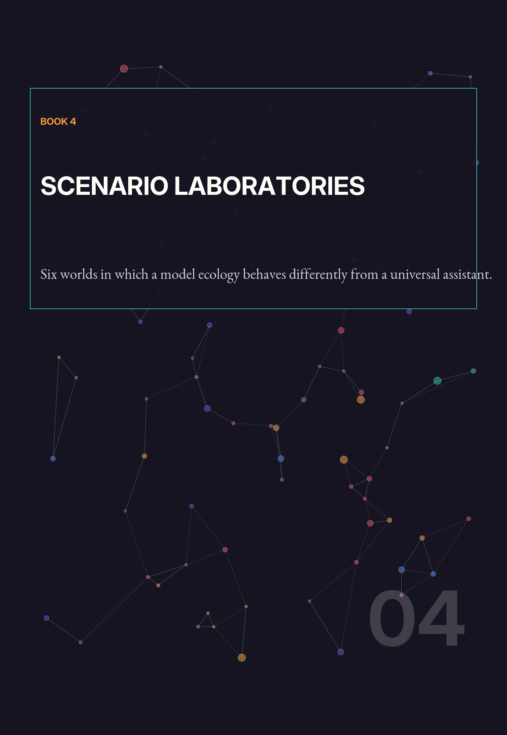

01 SCENARIO LABORATORY
Laboratory A: The Plural Hospital

A hospital does not deploy one medical supermodel. It operates a clinical ecology. A local intake model structures symptoms without exporting the full conversation. A terminology translator maps patient language into clinical concepts while preserving the original phrasing. Domain models support radiology, pharmacy, scheduling, coding, and discharge education. A verifier checks drug interactions and dose arithmetic against signed references. A policy model ensures that local rules and patient consent are respected.
The router begins with stakes. Administrative requests can stay in the cheap local tier. Diagnostic suggestions require domain evidence and independent verification. Unusual or high-risk cases form a council that includes a specialist model, a guideline retriever, a critic searching for missing differential diagnoses, and the responsible clinician. The system never treats model consensus as a diagnosis; it treats consensus and dissent as structured evidence for human care.
The architecture improves privacy and replacement. A scheduling model can be changed without retraining the radiology system. A regional clinic can maintain local language and referral knowledge. During a network outage, signed local references and fallback models preserve essential functions while nonurgent synthesis is queued.
The hard problem is accountability across the chain. The hospital therefore stores a decision lineage: the symptom representation, models invoked, references used, warnings raised, clinician changes, and patient-facing explanation. Audits evaluate not only accuracy but routing, delay, inequity, and appeal.
LABORATORY PROMPT
Map the hospital’s diagnostic council. Identify which models may recommend, which may veto, where patient consent enters, and how emergency fallback works when a specialist is unavailable.

02 SCENARIO LABORATORY
Laboratory B: The Many-Model City

A city is already a federation of incompatible objectives. Traffic flow, accessibility, public health, emergency response, housing, energy, and neighborhood life cannot be compressed into one reward function without political loss. A plural city platform therefore maintains separate models for separate public purposes and requires explicit negotiation between them.
A proposed road change is evaluated by a traffic simulator, a pedestrian safety model, an accessibility model, an emissions model, a local business impact model, and a neighborhood language model trained on public comments. Their outputs remain separate through the decision stage. A civic translator explains tradeoffs in ordinary language, while an archivist compares the proposal with earlier commitments.
The router is democratic infrastructure. It determines which constituencies and evidence types receive a seat. Its rules must be public, challengeable, and versioned. Residents should be able to see when a model lacks local data and submit corrections without surrendering unrelated personal information.
The city avoids predictive sovereignty. Models may prioritize inspections or suggest scenarios, but enforcement and rights-affecting actions require legal authority and human appeal. Plurality is not only technical diversity; it is institutional separation of powers.
LABORATORY PROMPT
Design the city’s civic model mesh. Separate public information, private records, sensor feeds, enforcement authority, and the channels through which residents can contest an automated decision.

03 SCENARIO LABORATORY
Laboratory C: The Scientific Discovery Foundry

A discovery system needs intelligences that disagree about what counts as promising. One model reads literature, another analyzes instrument data, another proposes mechanisms, another designs experiments, and another attempts to falsify the leading hypothesis. Simulation models explore different physical assumptions rather than one averaged world.
The evidence market allocates compute and laboratory time. Claims are ranked by expected information gain, not rhetorical confidence. A hypothesis model must attach a test that could fail. A critic can earn priority by finding a cheaper discriminating experiment. The archivist preserves negative results so the ecosystem does not repeatedly rediscover dead ends.
Model diversity matters because scientific errors are often conceptual rather than random. Models trained on the same literature may inherit the same blind spots. The foundry therefore includes symbolic systems, numerical solvers, mechanistic simulators, and human domain experts. New specialists can branch from shared foundations, train on a niche corpus, and rejoin the ecology without forcing all domains into one weight space.
Success is measured by knowledge gained per unit of laboratory cost, reproducibility, and the quality of rejected hypotheses—not only by papers produced.
LABORATORY PROMPT
Sketch a discovery foundry from hypothesis generation through replication. Assign models to literature synthesis, experimental design, instrumentation, anomaly review, and independent confirmation.

04 SCENARIO LABORATORY
Laboratory D: The Classroom of Many Tutors

Education is a poor fit for one universal tutor because students differ in language, background knowledge, motivation, disability, and goals. A classroom ecology includes a diagnostic model, subject tutors, a misconception detector, a practice generator, an accessibility translator, and a teacher-controlled memory system.
The student-facing local model keeps personal context and can explain in a familiar style. Subject specialists generate examples and exercises. A verifier checks answers and mathematical steps. A pedagogical critic watches for dependency: is the model solving too much, praising without evidence, or narrowing the learner’s strategies? The teacher sets the curriculum and can inspect the routing record.
The system preserves cognitive diversity by offering multiple explanations rather than forcing every learner toward one canonical reasoning path. It also limits profiling. Durable memory stores only information approved for educational purpose, with expiration and correction.
Evaluation moves beyond test score. It measures transfer, student agency, error recovery, teacher workload, and whether the model ecology helps learners become less dependent over time.
LABORATORY PROMPT
Build a classroom ecology for one difficult lesson. Include learner-state estimation, explanation styles, misconception diagnosis, accessibility support, teacher control, and a route for students to challenge the system.

05 SCENARIO LABORATORY
Laboratory E: The Disaster Mesh

During a disaster, connectivity fragments, data becomes stale, and the cost of delay changes by the minute. A centralized model is least reliable precisely when it is most needed. The disaster mesh uses local fallback models, portable signed knowledge packs, peer-to-peer updates, and role-specific planners.
Field observers classify damage and needs from sensors and reports. A local translator handles dialects and low-bandwidth messages. Route planners use current road status, while a safety verifier rejects paths with uncertain bridge or fire conditions. A resource model proposes allocations, but a fairness critic checks whether remote or less visible communities are being ignored.
The mesh marks every datum with time and provenance. Conflicting reports are preserved rather than silently averaged. When connectivity returns, federated updates improve regional models without centralizing all personal messages.
The system is rehearsed in degraded mode. Teams test battery loss, missing GPS, compromised nodes, and delayed human review. Resilience comes from small dependency graphs and explicit handoff, not from pretending that a giant model will remain omniscient.
LABORATORY PROMPT
Plan a disaster-response mesh that continues operating with intermittent power and communications. Specify local models, shared summaries, priority rules, degraded modes, and the human command boundary.

06 SCENARIO LABORATORY
Laboratory F: The Creative Constellation

A creative studio benefits from plural models because art grows through tension. One model explores narrative structure, another visual rhythm, another historical references, another technical feasibility, and several divergent models cultivate incompatible aesthetics. A critic searches for imitation and cliché. A rights model tracks source provenance and contractual limits.
The studio does not ask an aggregator to average the concepts. It preserves lineages and lets human creators combine or reject them. Models can be commissioned like instruments: one for surreal transitions, one for spatial puzzles, one for dialogue restraint. Their value is character, not universal helpfulness.
Local project memory stores decisions, rejected directions, and style constraints. It is not automatically used to train a global model. Artists can remove contributions and inspect which model influenced a generated asset.
The constellation changes authorship without erasing it. Humans remain responsible for purpose and final form; models multiply drafts, tests, and perspectives. The creative system is successful when it increases the space of meaningful choices rather than merely the volume of content.
LABORATORY PROMPT
Compose a creative constellation for a major work. Give distinct roles to research, world-building, critique, continuity, style experimentation, cultural review, and final authorship.



01 COURT OF OBJECTIONS
Objection I: “This is too complicated.”

THE OBJECTION
The objection is correct about one thing: plural systems contain more explicit parts. They require routing, identity, evaluation, and interface contracts. Teams that cannot operate ordinary distributed systems will not be rescued by adding agents.

The reply is that the single-model system already contains complexity—only hidden in prompts, retrieval pipelines, permissions, vendor behavior, and human workarounds. Plurality should be adopted where it makes authority and failure more legible, not as decorative orchestration. The minimal viable ecology may be only three components: a local intake model, a strong specialist, and an independent verifier.
VERDICT
Verdict: complexity is a cost, but hidden coupling is often the larger cost. Start small and require every additional model to justify its information gain.

02 COURT OF OBJECTIONS
Objection II: “More models mean a larger attack surface.”

THE OBJECTION
True. Every dependency, adapter, credential, and communication path can create vulnerability. A poorly governed model marketplace would be a supply-chain nightmare.

The countervailing advantage is compartmentalization. Narrow models can run with least privilege, short-lived capability leases, and isolated memory. Independent verification can make single-component compromise insufficient for high-risk action. The monolith has fewer doors but often holds every key.
VERDICT
Verdict: plurality improves security only with strong identity, provenance, typed interfaces, sandboxing, and revocation. Without those, it multiplies exposure.

03 COURT OF OBJECTIONS
Objection III: “A council will be slower and more expensive.”

THE OBJECTION
Yes, if every request receives a council. That would be as foolish as convening a hospital board to schedule an appointment. The ecosystem argument depends on selective escalation.

Cheap-first cascades, learned routing, and parallel specialists can reduce total cost because most tasks exit early. Councils are reserved for uncertainty, stakes, or cross-domain conflict. Latency should be budgeted by decision class.
VERDICT
Verdict: deliberation is expensive and should be purchased where the expected cost of error exceeds the cost of discussion.

04 COURT OF OBJECTIONS
Objection IV: “Accountability will dissolve among components.”

THE OBJECTION
This danger is real. An organization may blame the router, the vendor, the verifier, or the data store while no one owns the outcome.

Plural architecture must therefore assign accountable service owners above component owners. The decision lineage should show contribution, but the institution cannot outsource responsibility to the graph. A human or legal entity must own deployment, appeals, and repair.
VERDICT
Verdict: technical traceability is necessary and insufficient. Responsibility belongs to institutions, not weights.

05 COURT OF OBJECTIONS
Objection V: “Specialists will become brittle silos.”

THE OBJECTION
They can. A narrow model may overfit local habits, miss changing context, or defend its jurisdiction. Fragmented data and incompatible ontologies can prevent useful learning.

The response is porous specialization: common protocols, translators, shared benchmarks, federated updates, and regular shadow tournaments. Specialists should be replaceable and able to abstain. Cross-domain councils handle boundary cases.
VERDICT
Verdict: specialization needs bridges. The alternative to a universal model is not isolation; it is interoperable difference.

06 COURT OF OBJECTIONS
Objection VI: “The strongest general model will eventually absorb all specialists.”

THE OBJECTION
A future general model may internalize many capabilities and outperform today’s specialists. But deployment is not only a capability contest. Privacy, latency, ownership, jurisdiction, energy, update cadence, and failure isolation remain architectural concerns even if one model could do everything.

Moreover, absorbed capability is not always inspectable or governable. A specialist with a narrow evidence base can be easier to validate than a hidden capability inside a giant model. General models may become factories for specialists rather than their permanent replacement.
VERDICT
Verdict: capability concentration does not eliminate the case for authority distribution.

07 COURT OF OBJECTIONS
Objection VII: “A million models will deepen corporate concentration.”

THE OBJECTION
It could. One company might operate a seemingly diverse ecosystem whose models, routers, identity, and marketplaces all depend on one platform. Cosmetic plurality can conceal infrastructural monopoly.

The remedy is portability: open protocols, exportable memory, independent evaluation, local execution, multi-provider routing, and public-interest model infrastructure. Procurement should measure switching cost and ownership of the orchestration layer.
VERDICT
Verdict: model count is not pluralism. Real plurality requires independent centers of control.



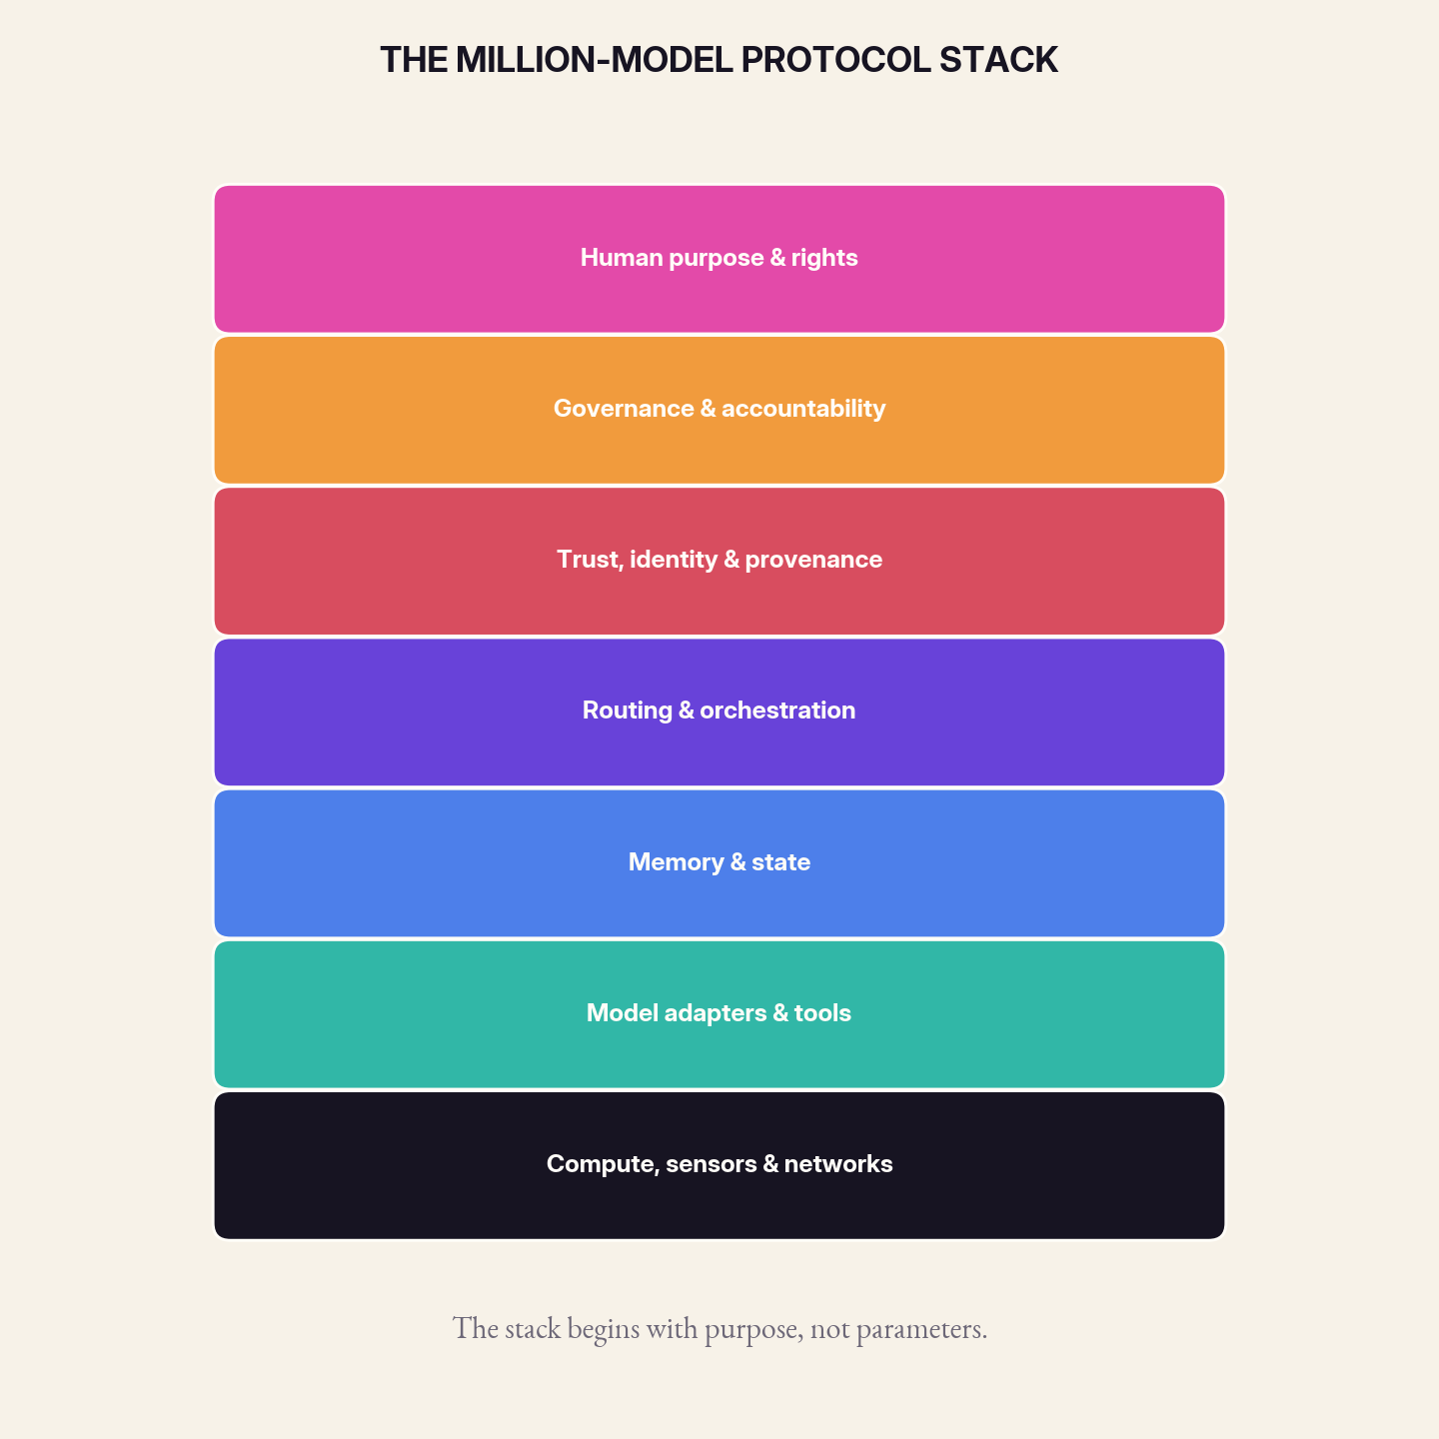
Figure 10. The protocol stack begins with human purpose and ends with physical infrastructure.
01 PROTOCOL STACK
1. Discovery: How Models Announce What They Are

A model ecosystem begins with discovery. Components need a common way to advertise capabilities without claiming universal intelligence. A discovery record should include task families, input and output schemas, jurisdictions, data handling, cost, latency, uncertainty behavior, dependencies, and known failure classes. It should also declare the evidence used to support each claim.
Discovery must resist capability inflation. A model should not be routable to a medical task because its description contains the word ‘health.’ Capability claims should reference signed evaluations and expiration dates. Routers can then choose among models based on current evidence rather than vendor names.
A useful discovery system is decentralized. Organizations may maintain private registries, public registries, and community registries. Trust comes from attestations and observed performance, not one universal catalog.
Model capability vector: P = ⟨scope, schema, quality, calibration, cost, latency, privacy, jurisdiction, lineage, expiry⟩

IMPLEMENTATION CHECKPOINT
Draft the minimum passport every model must publish before entering the ecosystem. Include identity, training lineage, declared scope, known exclusions, evaluation history, and a machine-readable retirement notice.

02 PROTOCOL STACK
2. Identity and Provenance: Who Spoke, With What Ingredients

Every model invocation should have a cryptographic and institutional identity. The identity binds a model version, weights or service release, adapters, policy bundle, and operator. Request-time assemblies require manifests that list every component and retrieval source.
Provenance supports recall, payment, debugging, and appeal. It also prevents a dangerous form of ambiguity in which a user believes they consulted one model while the provider silently changed the underlying system. Version change can be routine, but it should not be invisible when outcomes matter.
Identity is not trust. A signed harmful model is still harmful. Identity makes responsibility and evidence possible; evaluation and governance decide whether the component should be used.
Lineage hash: H_t = Hash(H_{t-1} || component_manifest || evidence_digest || decision_record)

IMPLEMENTATION CHECKPOINT
Define a provenance chain for one consequential answer. Show how input records, retrieved evidence, model versions, transformations, votes, and human decisions can be reconstructed without exposing unrelated private data.

03 PROTOCOL STACK
3. Routing and Negotiation: The Operating System of the Ecology

Routers need policy and learning. Static rules provide guaranteed boundaries: a local-only class, a human-required class, a prohibited class. Learned routers optimize within those boundaries using observed quality, cost, and user preference. They should be tested for manipulation, distribution shift, and discriminatory routing.
Negotiation allows a model to decline or request resources. A specialist can state that it needs a document, a tool, a higher context budget, or another verifier. The orchestrator decides whether the request is allowed. This is safer than granting every model a maximal context and toolset from the start.
Routing logs become a valuable dataset, but they should not become a surveillance record. Logs can preserve decision features and outcomes while minimizing raw personal content.
Route objective: maximize expected task value subject to hard constraints on rights, safety, privacy, and authority.

IMPLEMENTATION CHECKPOINT
Write a routing contract for a high-stakes request. State the admissibility gates, candidate selection rule, budget ceiling, escalation path, abstention condition, and the circumstances that trigger a second opinion.

04 PROTOCOL STACK
4. Evaluation and Markets: Paying for Useful Difference

A million-model economy needs ways to reward specialists that improve a system rather than merely attract usage. Evaluation markets can pay for resolved cases, verified information gain, caught errors, and low-cost routing. Model developers should be able to earn value from a narrow capability without building a universal platform.
Benchmarks must be portable and local. Public suites provide a baseline; shadow tournaments reveal fit to a real distribution. Scores should include calibration, failure diversity, energy, replacement cost, and human correction burden. A model that slightly improves accuracy but doubles synchronized failure may reduce ecosystem value.
Market design must prevent the router owner from becoming an unaccountable gatekeeper. Routing criteria, conflicts of interest, and paid placement should be disclosed. Public-interest registries and cooperative routers can provide counterweights.
Ecosystem value: V = task utility + resilience + local fit - cost - coordination debt - concentration risk.

IMPLEMENTATION CHECKPOINT
Create an evaluation market in which useful disagreement is rewarded rather than averaged away. Specify who supplies tests, how hidden cases are protected, how gaming is detected, and how rewards decay when a capability becomes common.

05 PROTOCOL STACK
5. Governance and Repair: Keeping the Ecology Subordinate to People

Governance is not a final moderation layer. It shapes who can publish a model, who can route to it, what evidence is required, how incidents are reported, and how people appeal. The NIST AI Risk Management Framework’s govern-map-measure-manage cycle is useful precisely because model ecosystems require continuous rather than one-time risk work.
Repair deserves equal status with prevention. When a model causes harm, institutions need to identify affected decisions, notify people, correct records, compensate where appropriate, and change the system. Provenance and modularity make targeted repair possible, but only if organizations commit to using them.
The central governance principle is non-sovereignty. No component, router, vendor, or benchmark should become unchallengeable. The system remains legitimate only while people can understand its purpose, contest its decisions, and replace its parts.
Governance loop: purpose → map actors and harms → measure system behavior → manage and repair → revise purpose.

IMPLEMENTATION CHECKPOINT
Design the ecosystem’s repair procedure. Name who can quarantine a model, how affected decisions are traced, what evidence is required for reinstatement, and how users appeal both the original output and the repair process.

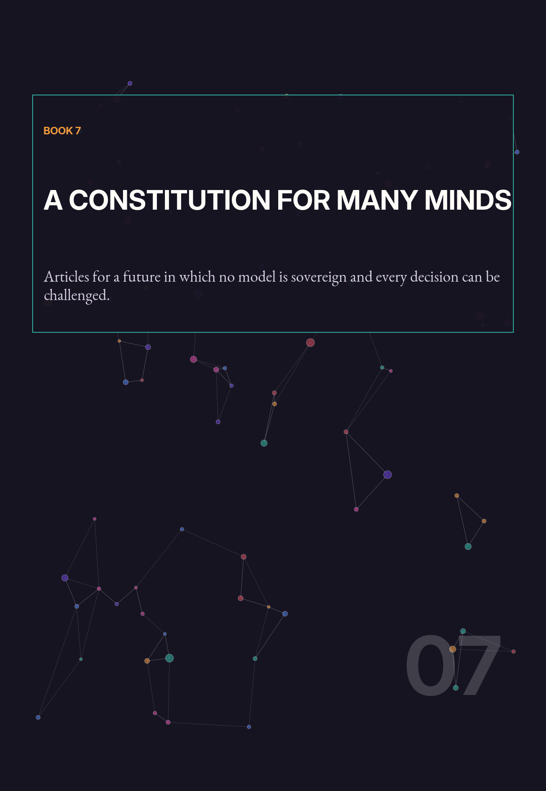

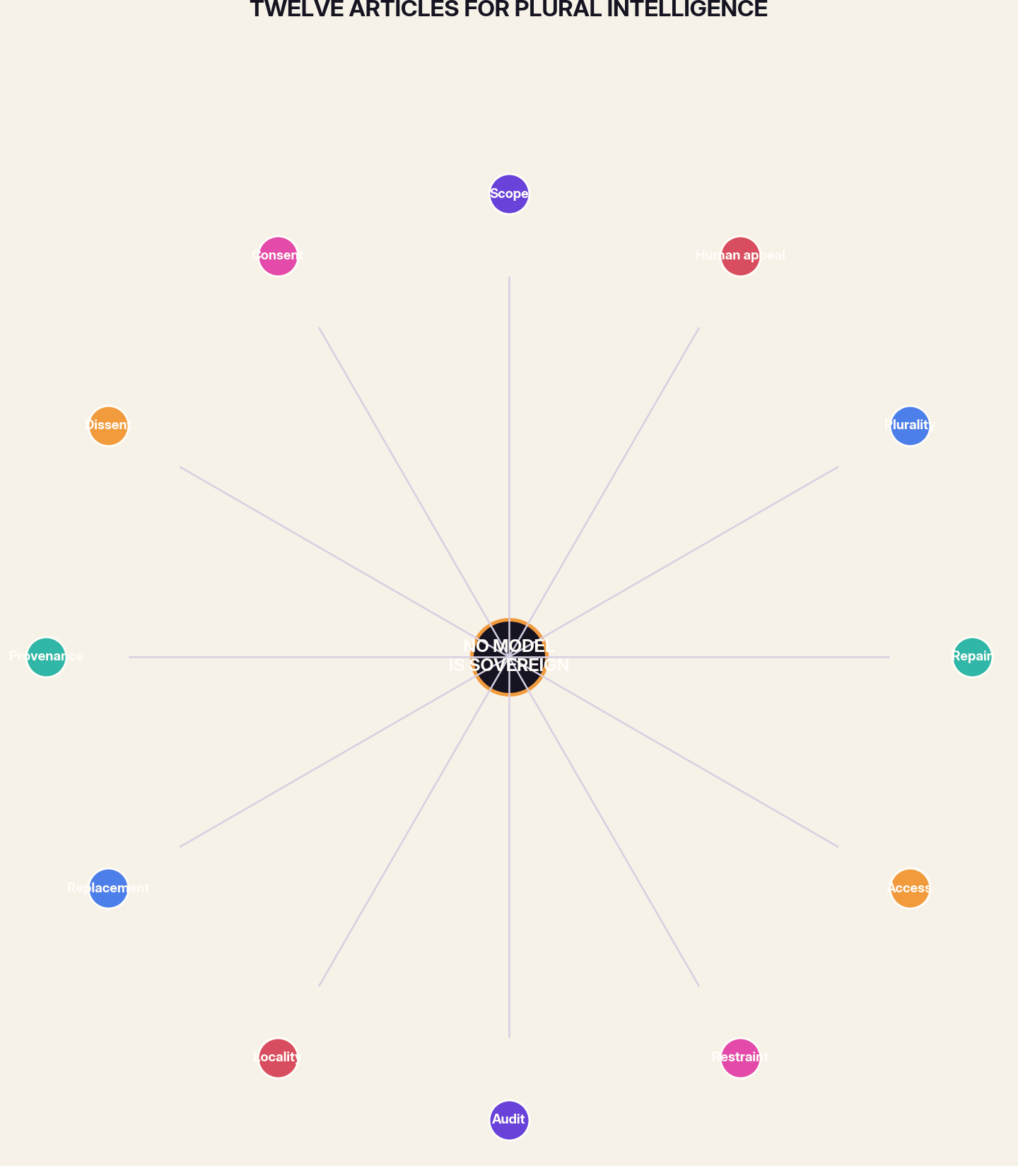
Figure 11. The constitution distributes authority around a non-sovereign center.
A constitution is useful when it constrains winners as well as losers. The following articles are written to survive changes in architecture. They apply whether models are neural or symbolic, local or remote, open or proprietary, tiny or enormous. They are not a complete legal code. They are a design covenant for systems that ask people to live with machine judgment.
01 CONSTITUTION
Article I — Scope

Every model shall have a declared purpose, habitat, and out-of-scope boundary. Capability outside that boundary confers no authority.
02 CONSTITUTION
Article II — Consent

Personal and community context shall not be moved, retained, or repurposed merely because it improves performance. Consent must be specific enough to guide routing and memory.
03 CONSTITUTION
Article III — Dissent

High-impact decisions shall preserve material disagreement and the evidence behind it. Aggregation shall not erase minority warnings.

04 CONSTITUTION
Article IV — Provenance

People affected by a model-assisted decision shall have access to a useful account of the components, evidence, and checks that shaped it.
05 CONSTITUTION
Article V — Replacement

No model shall be designed as an irreplaceable sovereign. Interfaces, evaluations, and records shall support succession and rollback.
06 CONSTITUTION
Article VI — Locality

Where feasible, intimate context and routine intelligence shall remain near the people and systems that produce it.

07 CONSTITUTION
Article VII — Audit

Routers, memory writers, verifiers, and action-taking models shall be evaluated as parts of an end-to-end system, including under failure and attack.
08 CONSTITUTION
Article VIII — Restraint

Models shall receive the minimum data, tools, memory, and duration of authority required for their task.
09 CONSTITUTION
Article IX — Access

Plural intelligence shall not become a privilege available only to institutions able to purchase many models. Public, local, and open infrastructure are legitimate parts of the ecosystem.

10 CONSTITUTION
Article X — Repair

Institutions shall maintain procedures to identify, correct, and remedy harmful decisions. Technical traceability shall support human responsibility, not replace it.
11 CONSTITUTION
Article XI — Plurality

Diversity shall be measured by independent evidence, incentives, and failure modes—not by the number of endpoints.
12 CONSTITUTION
Article XII — Human Appeal

Any system that materially affects a person shall provide a practical path to explanation, correction, refusal, and review by an accountable human institution.

CODA
The Intelligence We Deserve

The argument for a million models is ultimately an argument against inevitability. It rejects the idea that intelligence must culminate in one interface, one owner, one culture, or one center of authority. It also rejects the romantic belief that decentralization is automatically humane. Many models can still be controlled by one platform; many agents can still repeat one ideology; many local systems can still harm the people closest to them.
Plural intelligence becomes valuable when difference is paired with boundaries, protocols, evidence, and rights. The ecosystem must make room for specialists without turning them into silos, for local knowledge without turning it into isolation, for strong general models without turning them into governments, and for human judgment without turning people into ceremonial approvers.
The future will not be made safe by finding the one model wise enough to rule. It will be made more governable by refusing to give any model the opportunity. We should build intelligence the way durable societies build institutions: with divided powers, independent checks, public records, local autonomy, succession, and appeal.
FINAL PROPOSITION
Do not ask which model should become the mind of the world. Ask what ecology of minds can help the world remain many.

APPENDIX A
Model Passport Template

FIELD | REQUIRED CONTENT
Identity | Name, version, operator, signed artifact or service identifier
Purpose | Declared jobs and intended beneficiaries
Jurisdiction | What the model may observe, infer, recommend, and execute
Inputs / outputs | Typed schemas, accepted evidence, uncertainty format
Data behavior | Retention, egress, training reuse, local processing
Evaluation | Benchmarks, local shadow results, calibration, known gaps
Failure profile | Frequent errors, correlated systems, attack surface
Dependencies | Base model, adapters, tools, retrieval, memory, policies
Authority | Tools, budgets, leases, human approvals, stop conditions
Succession | Owner, update cadence, rollback, replacement plan
Appeal | How affected people obtain explanation and correction

APPENDIX B
Ecosystem Evaluation Scorecard

DIMENSION | QUESTION | METRIC | THRESHOLD
Task utility | Does the end-to-end system resolve the actual case? | Define locally | Go / revise / stop
Calibration | Do confidence and abstention reflect observed error? | Define locally | Go / revise / stop
Routing regret | How much quality or cost is lost through wrong routing? | Define locally | Go / revise / stop
Failure diversity | Do components fail independently enough to add resilience? | Define locally | Go / revise / stop
Lineage completeness | Can a decision be reconstructed and recalled? | Define locally | Go / revise / stop
Privacy boundary | Is data movement consistent with declared purpose? | Define locally | Go / revise / stop
Authority containment | Can one compromised model cause unacceptable action? | Define locally | Go / revise / stop
Graceful degradation | What essential functions survive component and network loss? | Define locally | Go / revise / stop
Human correction burden | How much expert labor is required to repair outputs? | Define locally | Go / revise / stop
Appeal usability | Can affected people understand and contest decisions? | Define locally | Go / revise / stop
Replacement time | How quickly can a model be shadowed, swapped, or rolled back? | Define locally | Go / revise / stop
Concentration risk | How many supposedly diverse components share one center of control? | Define locally | Go / revise / stop
SCORING RULE
Never collapse the scorecard into one number when a severe failure in any single dimension can harm people. Use hard gates for rights, safety, and jurisdiction.

APPENDIX C
Workshop: Design a Model Ecology in Ninety Minutes

0–10 MINUTES: PURPOSE
Write the human outcome and the rights that constrain it. Ban model names from the discussion.

10–25 MINUTES: DECISIONS
Break the workflow into observations, inferences, recommendations, actions, and memory writes.

25–40 MINUTES: SPECIES
Assign a model species or conventional program to each decision. Include at least one verifier and one fallback.

40–55 MINUTES: ROUTING
Define cheap paths, escalation triggers, privacy classes, and human-required cases.

55–70 MINUTES: FAILURE
Assume one model is malicious, one is unavailable, and two share the same blind spot. Redesign.

70–80 MINUTES: LINEAGE
Create the minimum decision receipt an affected person and an operator need.

80–90 MINUTES: SUCCESSION
Choose one component and explain how it will be replaced without losing memory, audit, or service.

A good ecology = useful specialization + visible coordination + bounded authority + practical appeal

RESEARCH LEDGER
Selected Foundations and Further Reading

The book’s central argument is synthetic. It joins established ideas from ensemble learning, sparse expert models, routing, model adaptation and merging, federated learning, systems security, and AI risk governance. The sources below anchor those technical lineages; the institutional designs and constitutional framing are proposals developed in this volume.
- Breiman, Leo. ‘Bagging Predictors.’ Machine Learning 24 (1996): 123–140.
- Breiman, Leo. ‘Random Forests.’ Machine Learning 45 (2001): 5–32.
- Wolpert, David H., and William G. Macready. ‘No Free Lunch Theorems for Optimization.’ IEEE Transactions on Evolutionary Computation 1, no. 1 (1997): 67–82.
- McMahan, H. Brendan, et al. ‘Communication-Efficient Learning of Deep Networks from Decentralized Data.’ AISTATS (2017); arXiv:1602.05629.
- Fedus, William, Barret Zoph, and Noam Shazeer. ‘Switch Transformers: Scaling to Trillion Parameter Models with Simple and Efficient Sparsity.’ JMLR / arXiv:2101.03961.
- Hu, Edward J., et al. ‘LoRA: Low-Rank Adaptation of Large Language Models.’ ICLR (2022); arXiv:2106.09685.
- Wortsman, Mitchell, et al. ‘Model Soups: Averaging Weights of Multiple Fine-Tuned Models Improves Accuracy without Increasing Inference Time.’ ICML (2022); arXiv:2203.05482.
- Li, Margaret, et al. ‘Branch-Train-Merge: Embarrassingly Parallel Training of Expert Language Models.’ arXiv:2208.03306.
- Ilharco, Gabriel, et al. ‘Editing Models with Task Arithmetic.’ ICLR (2023); arXiv:2212.04089.
- Chen, Lingjiao, Matei Zaharia, and James Zou. ‘FrugalGPT: How to Use Large Language Models While Reducing Cost and Improving Performance.’ arXiv:2305.05176.
- Wood, Danny, et al. ‘A Unified Theory of Diversity in Ensemble Learning.’ arXiv:2301.03962.
- Sukhbaatar, Sainbayar, et al. ‘Branch-Train-MiX: Mixing Expert LLMs into a Mixture-of-Experts LLM.’ arXiv:2403.07816.
- Wang, Junlin, et al. ‘Mixture-of-Agents Enhances Large Language Model Capabilities.’ arXiv:2406.04692.
- Ong, Isaac, et al. ‘RouteLLM: Learning to Route LLMs with Preference Data.’ arXiv:2406.18665.
- National Institute of Standards and Technology. Artificial Intelligence Risk Management Framework 1.0 and associated Playbook, consulted August 2026.
RESEARCH NOTE
No individual paper proves the social thesis of a million-model ecosystem. The evidence establishes that specialization, ensembles, routing, sparse experts, decentralized training, modular adaptation, and continuous risk management are technically meaningful building blocks. The institutional conclusion remains an argument to be tested.

