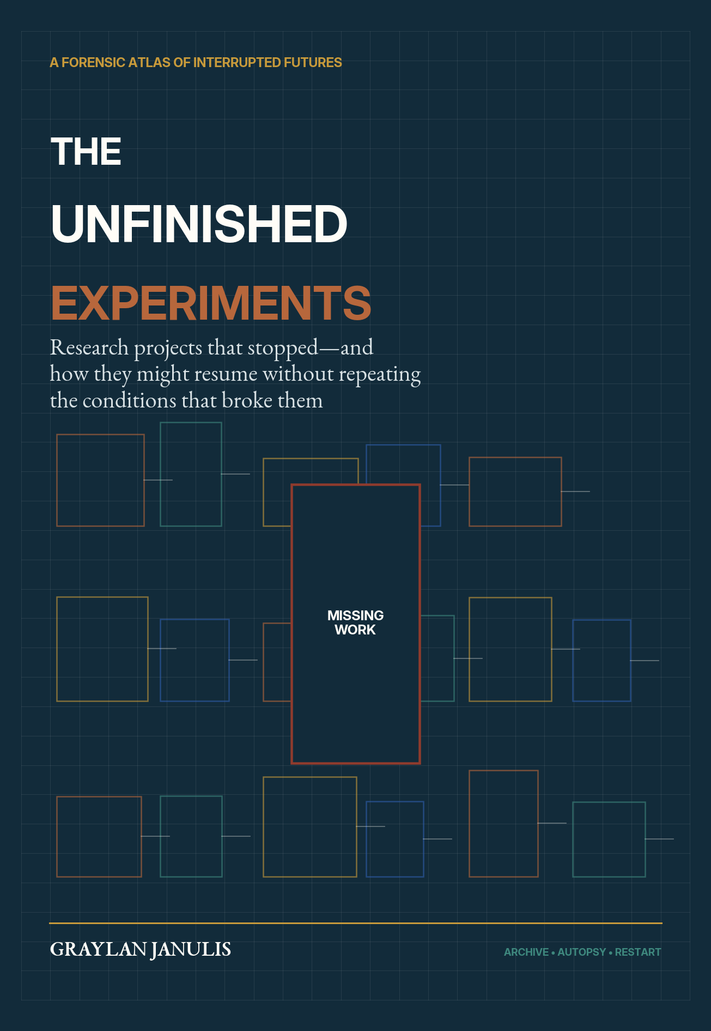

THE UNFINISHED EXPERIMENTS
An Atlas of Interrupted Futures and the Engineering of Return
GRAYLAN JANULIS

FRONT MATTER
What This Book Means by Unfinished

An unfinished experiment is not simply a failed project. It is a research lineage in which a consequential question outlived the institution, instrument, political settlement, or technology created to answer it. Some projects stopped after proving a crucial subsystem. Some died before their first decisive test. Some survived under another name. Others were halted because the social world correctly refused the conditions under which they were proposed.
This book is organized as an archive rather than a chronology. The opening autopsy examines how research stops. Six cabinets then hold case files grouped by the force of interruption, not by academic discipline. The final workshop presents a method for deciding what recovery means: reconstruct the old machine, continue its scientific question, preserve only its data, or decline to restart at all.
EVIDENCE POLICY
Historical statements are based on institutional archives, government reports, museum records, and peer-reviewed histories listed in the research ledger. Restart protocols are proposals developed for this volume. Their scores are structured prompts for debate, not objective rankings.

First edition. August 2026. All diagrams are original explanatory graphics created for this manuscript.

NAVIGATION
Archive Catalogue

PROLOGUE
- The museum after closing
- What interruption destroys
- Why a restart is never a rewind
BLACK ARCHIVE — SEVEN AUTOPSIES
- The Funding Cliff
- Political Veto
- Technical Prematurity
- Personnel Loss
- Institutional Amnesia
- Historical Accident
- The Ethical Stop
CABINET 1: BLUEPRINTS WITHOUT THEIR MACHINES
- The Analytical Engine
- Wardenclyffe and Wireless Power
- Setun and Balanced-Ternary Computing
- The Fifth Generation Computer Systems Project
- Thinking Machines and the Connection Machine
CABINET 2: THE ABANDONED MEGASTRUCTURES
- Project Mohole
- The Superconducting Super Collider
- Arecibo Observatory
- Terrestrial Planet Finder
CABINET 3: STATES, SYSTEMS, AND CONTESTED CONTROL
- OGAS: A Networked Economy That Never Arrived
- Project Cybersyn
- Biosphere 2 and the Closed-World Promise
- SPICE, SCoPEx, and the Experiments That Governance Stopped

NAVIGATION
Archive Catalogue — continued

CABINET 4: MEDICINE’S BROKEN CONTINUITIES
- The Interrupted Science of Psychedelic Medicine
- Phage Therapy Beyond the Antibiotic Century
CABINET 5: VEHICLES THAT LOST THEIR MISSION
- Project Orion
- NERVA and Nuclear Thermal Propulsion
- X-33 and VentureStar
- Energia–Buran
- The Venera Lineage
- Quiet Supersonic Flight: A Resumption in Progress
CABINET 6: ENERGY BRANCHES LEFT UNCHOSEN
- The Molten-Salt Reactor Experiment
- The Integral Fast Reactor
THE RESTART WORKSHOP
- Resumption Readiness Index
- Knowledge half-life and archive triage
- Tacit-knowledge recovery
- Simulation-first reconstruction
- Governance before apparatus
- Funding ladders and off-ramps
- When not to resume
- Restart charter and scorecard
- Research ledger

PROLOGUE
The Museum After Closing

Walk through a research museum after the public has left and the objects become quieter but more demanding. A reactor vessel, a fragment of accelerator magnet, a punched card, a heat shield, or a photograph of an operations room no longer performs its intended function. It asks a counterfactual question. Was this an evolutionary dead end, a future delayed, a warning, or a path abandoned for reasons that no longer apply?
The temptation is to answer with romance. History seems full of stolen futures: machines too advanced for their century, discoveries suppressed by politics, programs canceled just before success. The opposite temptation is equally simplistic. Winners write technical history as though the surviving architecture was always inevitable and every discarded branch was irrational. Neither view is useful to researchers deciding where to spend the next decade.
An interrupted project contains at least four different things: a scientific question, an apparatus, an institution, and a public bargain. These can survive separately. Project Mohole’s original hole was never drilled, yet ocean drilling transformed Earth science. Terrestrial Planet Finder never flew, yet its methods and mission logic flow into a new observatory program. Arecibo’s dish cannot be repaired, but its capabilities can be redistributed. Project Orion’s engineering can be studied while its original operation remains unacceptable.
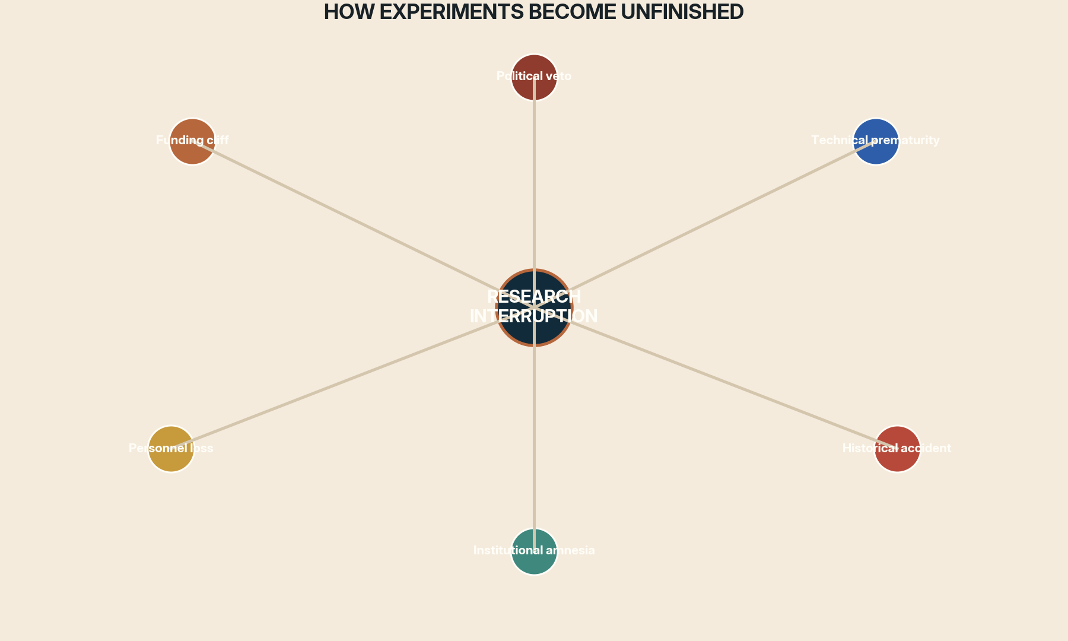
Figure 1. The stopping force is part of the experiment’s technical history, not an external footnote.
Unfinishedness = unanswered question + broken continuity + recoverable evidence
A project is worth forensic study when all three terms remain nonzero.

The central discipline of this book is therefore separation. We separate the question from the hardware, the insight from the mythology, the prototype from the promised system, and technical feasibility from legitimacy. Resumption is not a demand to complete the past. It is a method for asking whether a past question can be reformulated under better evidence, better tools, and better institutions.
ARCHIVE RULE
Never ask, “How do we finish it?” before asking, “Which part is still scientifically alive, and which part depended on conditions we should not recreate?”

BLACK ARCHIVE
Seven Autopsies of Research Interruption

Projects rarely die from one cause. A funding cut can reveal technical fragility; technical delay can weaken political support; political conflict can scatter personnel; scattered personnel can turn a recoverable design into an unreadable archive. The seven autopsies below are analytical lenses. Each case file later combines several of them.
01 AUTOPSY
The Funding Cliff

Research budgets rarely end at a scientifically meaningful boundary. They end at fiscal years, elections, contract disputes, currency crises, or a sponsor’s change of taste. The most destructive cliff arrives after a project has become too specialized to disperse but before it has created a stable successor institution. Hardware is mothballed, calibration chains break, and skilled teams leave in an order no recovery plan anticipated.
A restart budget must therefore purchase continuity, not only milestones. Every major experiment should reserve resources for archiving, decommissioning, personnel transition, and a restart package. Funding that cannot afford an orderly stop cannot honestly afford the experiment.
02 AUTOPSY
Political Veto

Some projects are halted because they threaten authority, symbolize an opponent, or become attached to a political order that collapses. Their technical record may be deliberately discredited, hidden, or destroyed. Later advocates often commit the opposite error: they romanticize the interrupted project because its enemies were unjust.
Responsible resumption separates the validity of the question from loyalty to the original regime. It reconstructs who benefited, who lacked consent, what decisions were centralized, and which governance failures were already visible before the interruption.

03 AUTOPSY
Technical Prematurity

An experiment can be conceptually correct and operationally impossible. Missing materials, sensors, computation, manufacturing, or theory may force teams to hide uncertainty inside heroic engineering. Prematurity is not shameful. The mistake is scaling before the missing dependency has been isolated.
Restart by rebuilding the dependency graph. Identify which old bottleneck is genuinely solved and which has merely been renamed. Use simulation and subsystem demonstrations to prove the change before reconstructing the complete machine.
04 AUTOPSY
Personnel Loss

The deepest project knowledge is often not in reports. It lives in choices experts no longer remember making: which instrument drift is normal, which drawing is obsolete, which supplier process matters, which result was distrusted, and which workaround became routine. When a team disperses, the archive loses its interpreter.
Resumption should treat oral history and executable reconstruction as engineering. Interview operators, recreate analysis environments, preserve failed procedures, and record disagreements before memory becomes a polished legend.

05 AUTOPSY
Institutional Amnesia

Organizations often continue after the experiment but forget why it was stopped. A successor team sees the surviving artifacts, not the meetings, informal warnings, political bargains, or opportunity costs. The project is then proposed again as if history merely lacked courage.
The cure is a decision archive: not only what was built, but what alternatives were rejected, which assumptions failed, and which stopping criteria were crossed. Memory must be queryable by future designers.
06 AUTOPSY
Historical Accident

War, coup, state collapse, disaster, and market shock can terminate work unrelated to its scientific quality. These cases tempt a simple conclusion: history stole a future that would otherwise have arrived. But the counterfactual is never clean. The same institutions that enabled a project may also have made it brittle.
Resume the capability through a more plural institution. Build international or distributed ownership, preserve independent replicas, and avoid one site, patron, or political settlement as the project’s single point of failure.

07 AUTOPSY
The Ethical Stop

Not every unfinished experiment is a tragedy. Some stop because participants lack consent, environmental risks are externalized, military use overwhelms civil benefit, or governance does not exist at the scale of possible harm. In such cases, interruption is evidence of social intelligence.
A restart begins with the ethical institution, not the apparatus. If consent, liability, public legitimacy, or reversibility cannot be designed, the responsible result may be continued non-execution. Knowledge can advance through models, archives, and safer proxies while the dangerous intervention remains unfinished.
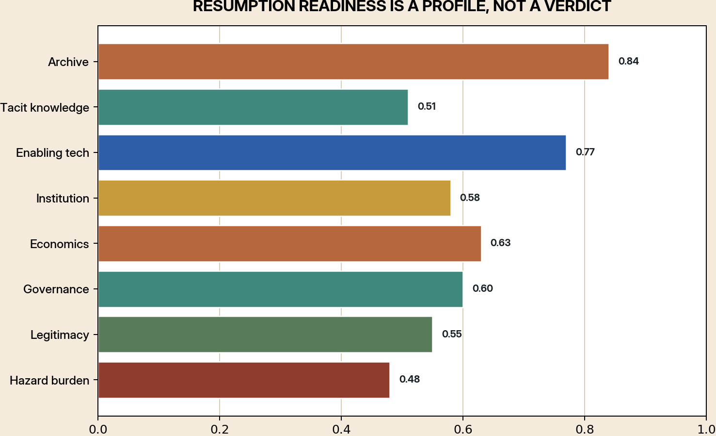
Figure 2. Readiness must be inspected dimension by dimension; a high archive score cannot cancel an unacceptable hazard burden.
RRI = .22A + .16K + .16T + .12I + .10E + .10G + .08L + .06P − .20H
A=archive quality, K=tacit knowledge, T=enabling technology, I=institution, E=economics, G=governance, L=legitimacy, P=public value, H=hazard burden. Hard ethical gates override the sum.

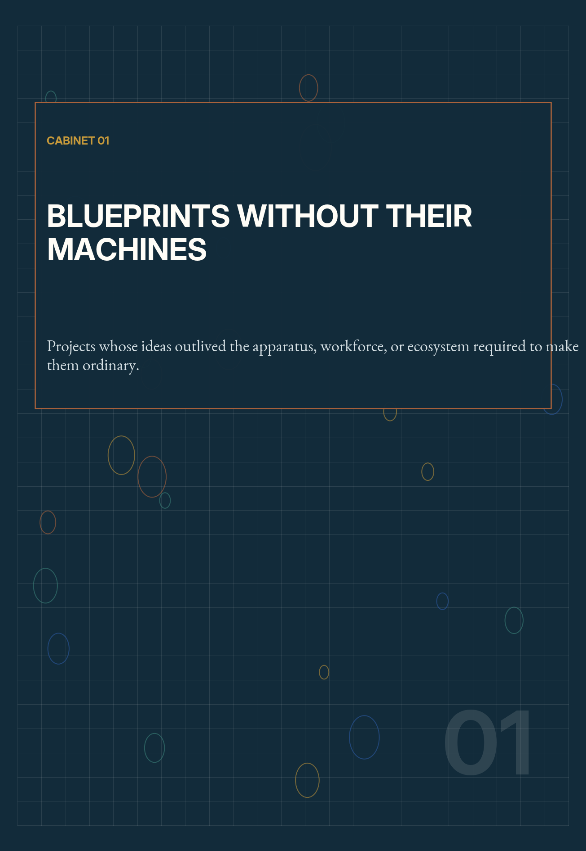

01 FORENSIC DOSSIER
The Analytical Engine

FIELD | Computation
ACTIVE LINE | 1830s–1871 / active reconstruction
STOPPING FORCE | Technical prematurity and personnel loss
RRI | 78 / 100 — provisional
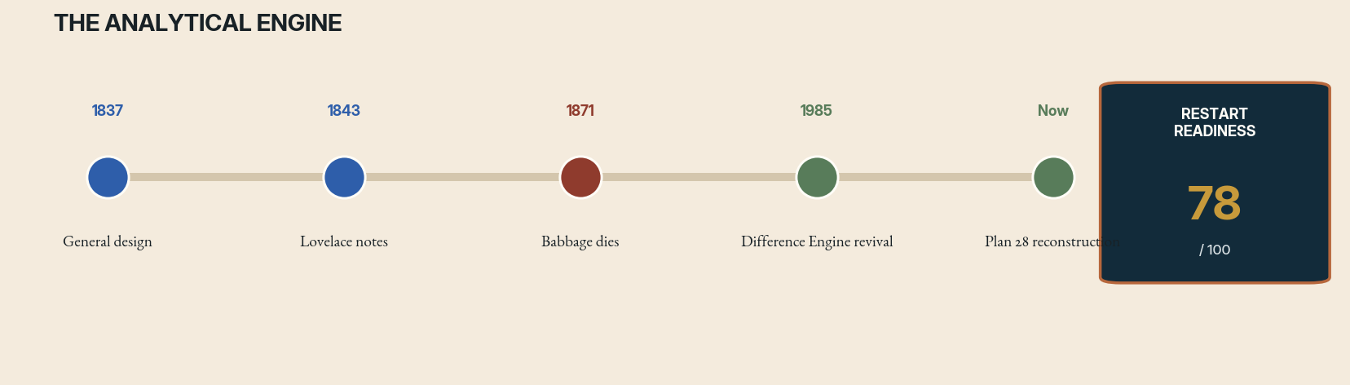
Case file 01 interruption timeline. Rust marks the decisive interruption; green marks successor activity. The readiness score is an editorial diagnostic, not a funding recommendation.
THE ORIGINAL WAGER
Charles Babbage’s Analytical Engine was not merely a faster calculator. Its architecture separated a store from a mill, imagined punched-card control, conditional behavior, repeated operations, and a path toward general symbolic manipulation. Ada Lovelace’s notes grasped that such a machine could operate on relations represented as symbols, not only on quantities. The experiment therefore belongs to the history of programmable thought even though the complete machine was never built.
THE STOPPING FORCE
The project stopped in a peculiar zone between invention and institution. Victorian machining could produce remarkable precision, but the Engine’s scale, cost, changing plans, and dependence on Babbage’s personal direction prevented a stable build program. Government support collapsed after earlier conflict around the Difference Engine. Babbage continued revising instead of freezing a constructible specification, and his death removed the person who carried the densest tacit map of the design.
WHAT SURVIVED
What survived was unusually rich yet incomplete: thousands of drawings, notations, fragments, and explanatory texts distributed across archives. Later reconstruction of Difference Engine No. 2 demonstrated that Babbage’s mechanical designs were more buildable than earlier skeptics assumed. The unresolved question is not whether a nineteenth-century computer can be made to move, but which version of a constantly evolving design should count as the Analytical Engine and how to translate an archive into an executable machine without silently modernizing it.
WHAT HAS CHANGED
Digital modeling, parametric CAD, precision metrology, finite-element analysis, archival imaging, and collaborative version control change the economics of reconstruction. A modern team can model every gear train before metal is cut, compare multiple plan families, expose assumptions, and publish a machine-readable design history. The scientific value is less in proving that computation exists than in studying how complex systems were conceived before electrical abstraction made their mechanisms invisible.
RESTART PROTOCOL
Resume as an open reconstruction laboratory rather than a monument project. First create a versioned digital corpus of all relevant drawings and annotations. Then build subsystem replicas—the mill, carry mechanisms, card readers, and printing apparatus—with period-faithful materials where interpretation is clear and reversible surrogate parts where it is not. Maintain two models: a historical reconstruction and an explicitly modernized demonstrator. Every design choice should cite its archival basis and record dissent.
THE COUNTERFACTUAL FORK
Had Babbage frozen a buildable plan and retained government support, the likely result would have been a singular mechanical installation maintained by a small priesthood of engineers—not a Victorian software industry. Its greatest effect might have been educational: forcing mathematicians to distinguish notation, procedure, memory, and machine state decades earlier. The counterfactual matters because it suggests that general computation can be conceptually mature long before manufacturing, interfaces, and institutions make it socially general.
THE FIRST 365 DAYS
Year one should produce a public concordance of plan numbers, dates, cross-references, and disputed interpretations; a complete parametric simulation of one selected subsystem; oral histories with living reconstruction experts; and two independently fabricated test mechanisms. The go/no-go review would ask whether archival ambiguity has been reduced enough to justify a full mechanical build, not whether a fundraising target has been reached.
RED-TEAM GATE
Do not collapse ambiguous historical variants into a single authoritative machine. The point is to preserve uncertainty, demonstrate engineering reasoning, and reveal the boundary between recovery and invention.

RESEARCH ANCHORS
Science Museum Babbage collections; Plan 28 project; modern analytical reconstructions by computer historians.

02 FORENSIC DOSSIER
Wardenclyffe and Wireless Power

FIELD | Energy / communications
ACTIVE LINE | 1901–1917 / modern beamed-power lineage
STOPPING FORCE | Funding collapse, changing markets, and overextended claims
RRI | 62 / 100 — provisional
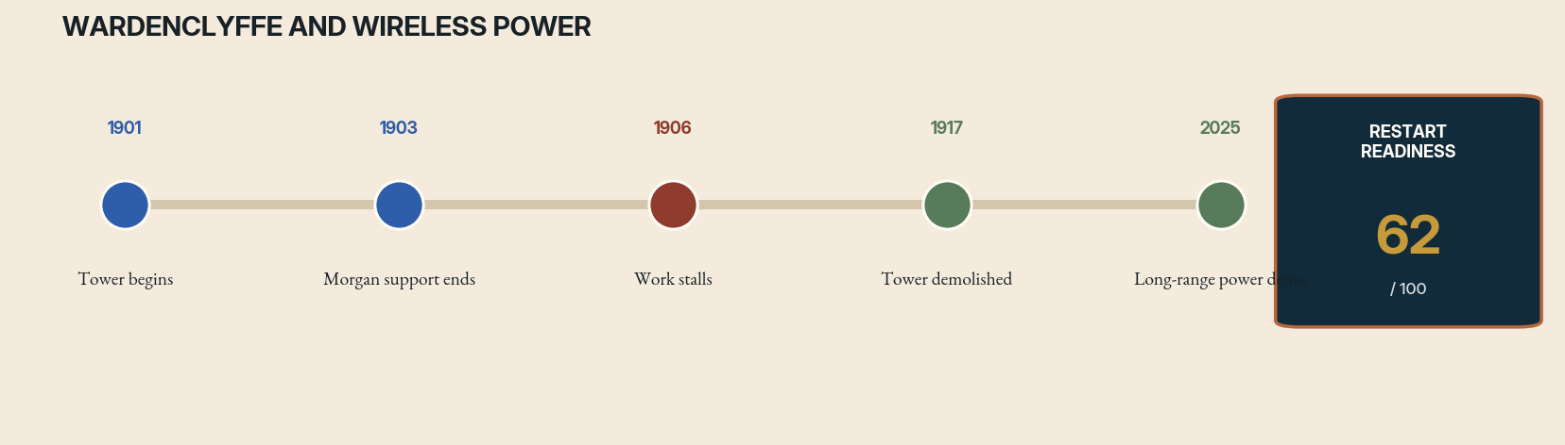
Case file 02 interruption timeline. Rust marks the decisive interruption; green marks successor activity. The readiness score is an editorial diagnostic, not a funding recommendation.
THE ORIGINAL WAGER
Nikola Tesla’s Wardenclyffe project attempted to combine global wireless communication with transmission of electrical power through a resonant terrestrial system. It was a grand synthesis rather than a single laboratory test: tower, underground structures, high-frequency generators, receivers, and a theory of the Earth as an electrical medium. The ambition exceeded radio telegraphy because Tesla wanted energy itself to become mobile and universally accessible.
THE STOPPING FORCE
The project lost financial support as radio competitors achieved more legible milestones with cheaper infrastructure. Tesla’s changing specifications, secrecy, and difficulty separating near-term communications revenue from vast power-transmission claims weakened investor confidence. The tower stood unfinished while equipment and debts accumulated. World War I security concerns and the site’s financial deterioration completed the interruption; the tower was demolished in 1917.
WHAT SURVIVED
Wardenclyffe left an enduring cultural image but an unstable technical inheritance. Resonant inductive coupling and directed energy are real engineering fields, yet they are often confused with Tesla mythology. The useful residue is not a promise of free planetary electricity. It is the question of when power should move without wires, across what distance, at what frequency, with what conversion loss, and under whose control.
WHAT HAS CHANGED
High-efficiency power electronics, phased arrays, adaptive beam steering, rectennas, safety interlocks, and autonomous tracking now permit disciplined experiments that Tesla could not perform. Modern programs have demonstrated meaningful transmission over distance using microwaves or lasers. Better atmospheric models and real-time sensing make it possible to measure where energy goes instead of relying on grand resonance narratives.
RESTART PROTOCOL
Resume the experiment as a ladder of bounded use cases: power to remote sensors, disaster zones, high-altitude platforms, aircraft, and isolated infrastructure. Publish end-to-end efficiency, beam containment, failure response, spectrum impact, and cost against cables, batteries, and fuel delivery. Use independent safety authorities and automatic shutdown zones. A Wardenclyffe successor should look more like a network protocol and less like a single heroic tower.
THE COUNTERFACTUAL FORK
A fully financed Wardenclyffe would probably have succeeded first as a communications station and only later confronted the severe efficiency, safety, and economics of long-range power. The popular counterfactual—a world electrified freely through the ground—ignores generators, receivers, losses, spectrum, and ownership. The more useful alternate history is one in which radio and power engineering remained experimentally linked, perhaps accelerating rectennas and resonant transfer while also producing earlier regulation of invisible energy infrastructure.
THE FIRST 365 DAYS
Year one should select two nonconsumer use cases, construct an end-to-end energy budget, establish independent beam-safety oversight, and reproduce transmission over increasing distances with automatic interruption. Every demonstration would report wall-plug efficiency, receiver aperture, weather sensitivity, stray exposure, and competing wired cost. A public test range should publish failures as prominently as distance records.
RED-TEAM GATE
Reject language that implies limitless or unmetered energy. Wireless transmission redistributes generated power; it does not abolish generation, scarcity, environmental cost, or governance.

RESEARCH ANCHORS
Tesla Science Center at Wardenclyffe historical materials; DARPA POWER program and 2025 long-distance beamed-power demonstrations.

03 FORENSIC DOSSIER
Setun and Balanced-Ternary Computing

FIELD | Computer architecture
ACTIVE LINE | 1958–1970 / contemporary research prototypes
STOPPING FORCE | Institutional preference and ecosystem lock-in
RRI | 56 / 100 — provisional
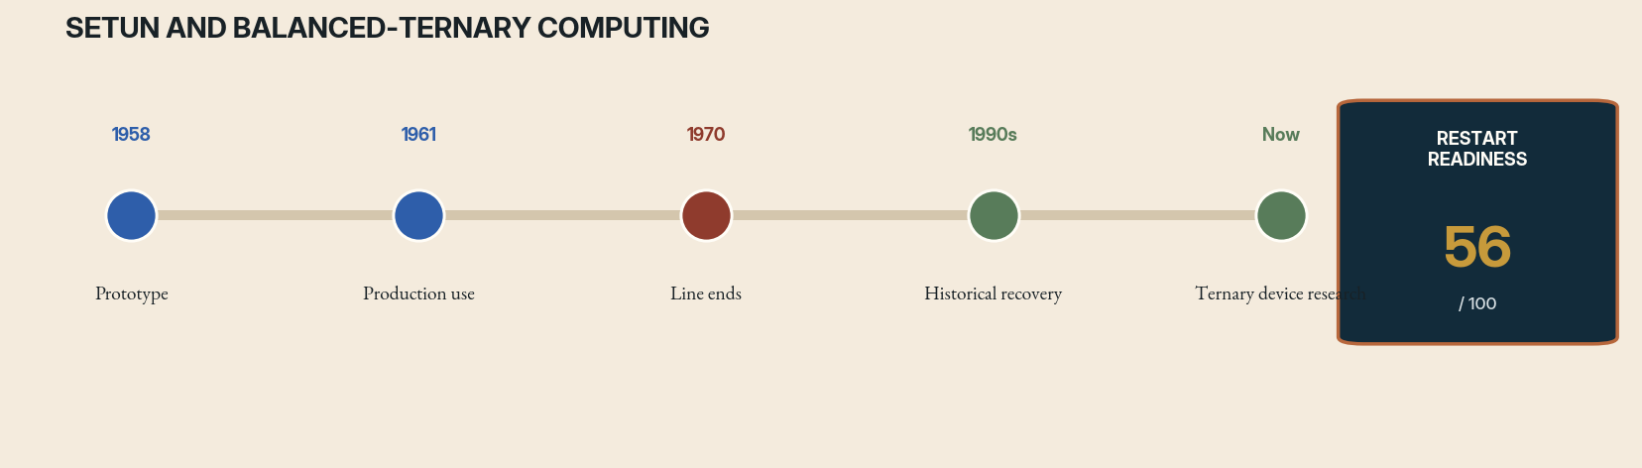
Case file 03 interruption timeline. Rust marks the decisive interruption; green marks successor activity. The readiness score is an editorial diagnostic, not a funding recommendation.
THE ORIGINAL WAGER
The Setun computer, developed at Moscow State University, used balanced ternary digits rather than binary bits. Its arithmetic represented negative, zero, and positive states directly, offering elegant rounding and compact expression of signed quantities. Setun was not an abstract logic puzzle; it was built, programmed, manufactured in limited numbers, and used for education and calculation.
THE STOPPING FORCE
The machine’s end was less a technical failure than an ecosystem decision. Soviet computing institutions standardized around binary architectures, components, training, and procurement. A small ternary lineage could not command the factories, peripherals, operating practices, or political sponsorship required to become a platform. Once binary compatibility became the infrastructure of computing, Setun’s advantages were judged against the cost of being different.
WHAT SURVIVED
Setun left hardware descriptions, software concepts, operator memories, and a demonstration that alternative number systems can support general computing. It also left a caution: an elegant primitive does not become a viable ecosystem merely by reducing a theoretical operation count. Architecture lives inside tools, compilers, memory devices, human habits, and supply chains.
WHAT HAS CHANGED
Modern machine learning, approximate arithmetic, multi-level memory, novel transistors, and specialized accelerators reopen questions that general-purpose binary computing settled for an earlier era. Ternary neural weights and activations can reduce storage or energy under particular workloads. Simulation and FPGA emulation make it inexpensive to compare balanced ternary designs with binary baselines before building exotic devices.
RESTART PROTOCOL
Do not attempt to replace the binary world. Build a ternary research stack for narrow domains: arithmetic libraries, compiler intermediate representations, FPGA cores, error models, and benchmark suites for inference, search, and control. Measure total system cost, including data conversion. Preserve Setun software artifacts as executable emulations so historical design knowledge informs contemporary experiments.
THE COUNTERFACTUAL FORK
If Setun had received sustained production support, it might have created a durable educational and scientific niche without displacing binary computing. Compilers, peripherals, and operator culture could have revealed workloads where balanced ternary reduced instruction complexity or error. Its likely value was pluralism: an alternative architecture strong enough to keep assumptions about representation visible. Standardization erased that comparative laboratory just as the computing ecosystem became powerful enough to learn from it.
THE FIRST 365 DAYS
Year one should deliver a cycle-accurate emulator, an FPGA implementation, a small compiler toolchain, and benchmark translations for control, signal processing, and low-precision inference. Researchers should measure energy, memory traffic, conversion overhead, fault tolerance, and programmer effort against binary systems. The project proceeds to custom devices only if at least one end-to-end workload shows a reproducible advantage.
RED-TEAM GATE
A revival is justified only where ternary representation creates end-to-end benefit. Mathematical beauty is evidence for exploration, not proof of practical superiority.

RESEARCH ANCHORS
IFIP and Russian Virtual Computer Museum histories of Setun; contemporary balanced-ternary arithmetic and ternary neural-hardware research.

04 FORENSIC DOSSIER
The Fifth Generation Computer Systems Project

FIELD | Artificial intelligence
ACTIVE LINE | 1982–1992 / partial lineage in knowledge systems
STOPPING FORCE | Technical mismatch and shifting markets
RRI | 66 / 100 — provisional
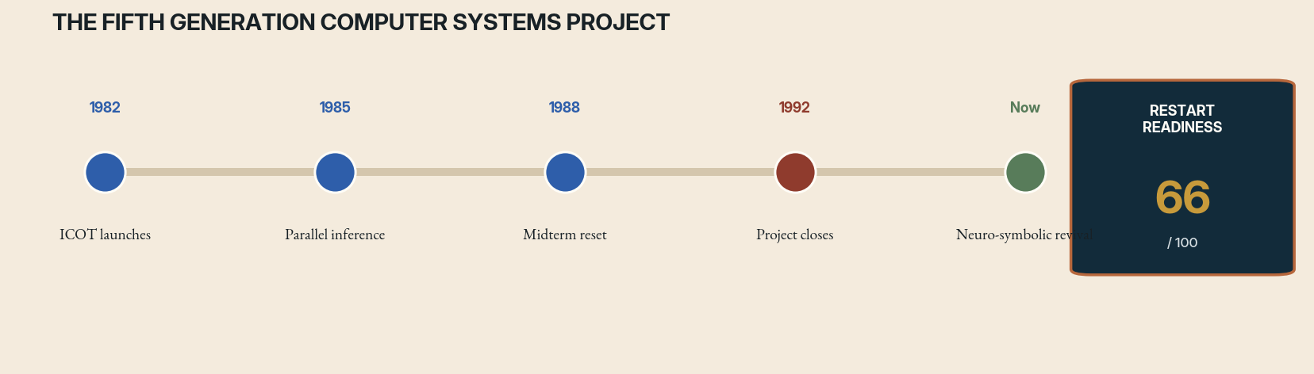
Case file 04 interruption timeline. Rust marks the decisive interruption; green marks successor activity. The readiness score is an editorial diagnostic, not a funding recommendation.
THE ORIGINAL WAGER
Japan’s Fifth Generation Computer Systems project sought a leap beyond conventional computers through massively parallel inference, logic programming, natural-language interfaces, and knowledge processing. The program was national industrial strategy as well as research. It treated intelligence as an architecture requiring new hardware, languages, databases, and development institutions rather than as one software package.
THE STOPPING FORCE
The project delivered machines and software, but its central technical bet did not align with the computing market that emerged. Commodity workstations improved rapidly, procedural and object-oriented software ecosystems expanded, and logic programming struggled with knowledge acquisition, performance, and brittle representations. Expectations framed the program as a race for machine intelligence, making substantial infrastructure work appear like failure when the promised revolution did not arrive.
WHAT SURVIVED
The project trained researchers, advanced parallel logic programming, and left extensive technical evaluations. Its deepest unfinished question remains relevant: how should machines combine declarative knowledge, inference, databases, parallelism, and human explanation? Today’s language models solve some interface problems while reproducing the project’s old tension between fluent output and dependable structured reasoning.
WHAT HAS CHANGED
Foundation models, vector retrieval, differentiable programming, SAT/SMT solvers, probabilistic programming, knowledge graphs, and abundant parallel hardware create a new substrate. The restart opportunity is not to rebuild Prolog machines. It is to design systems in which learned models propose and translate while formal components check constraints, execute rules, and preserve inspectable state.
RESTART PROTOCOL
Establish an open Fifth Generation successor program organized around hybrid proof-carrying intelligence. Fund shared benchmarks where systems must answer, cite, derive, repair, and expose uncertainty. Require multiple architectures—symbolic, neural, probabilistic, and database-native—to cooperate through typed interfaces. Evaluate maintenance cost and knowledge revision, not only one-shot task scores.
THE COUNTERFACTUAL FORK
If the Fifth Generation project had met its original ambitions, it still would not have produced a disembodied general intelligence. More plausibly, it would have created a mature industrial market for knowledge servers, parallel rule engines, and declarative business systems before the web. The central lost opportunity may have been a deeper fusion of databases and reasoning. Today’s AI stack often rebuilds that integration informally through prompts, retrieval, and tools without the project’s insistence on explicit inference structures.
THE FIRST 365 DAYS
Year one should create three challenge environments—scientific reasoning, public benefits, and software verification—in which language models must hand claims to formal solvers and databases. Each answer would carry a derivation graph, mutable knowledge entries, and a repair procedure. Success is defined by maintainability after facts change, not by a benchmark score captured before deployment.
RED-TEAM GATE
Avoid declaring a new national race to general intelligence. Competitive spectacle distorted the original program and can again favor demonstrations over durable public infrastructure.

RESEARCH ANCHORS
Japan National Diet Library and ICOT archival records, including final evaluations of the Fifth Generation project.

05 FORENSIC DOSSIER
Thinking Machines and the Connection Machine

FIELD | Parallel computing
ACTIVE LINE | 1983–1994 / lineage in accelerators and HPC
STOPPING FORCE | Business collapse and market timing
RRI | 71 / 100 — provisional
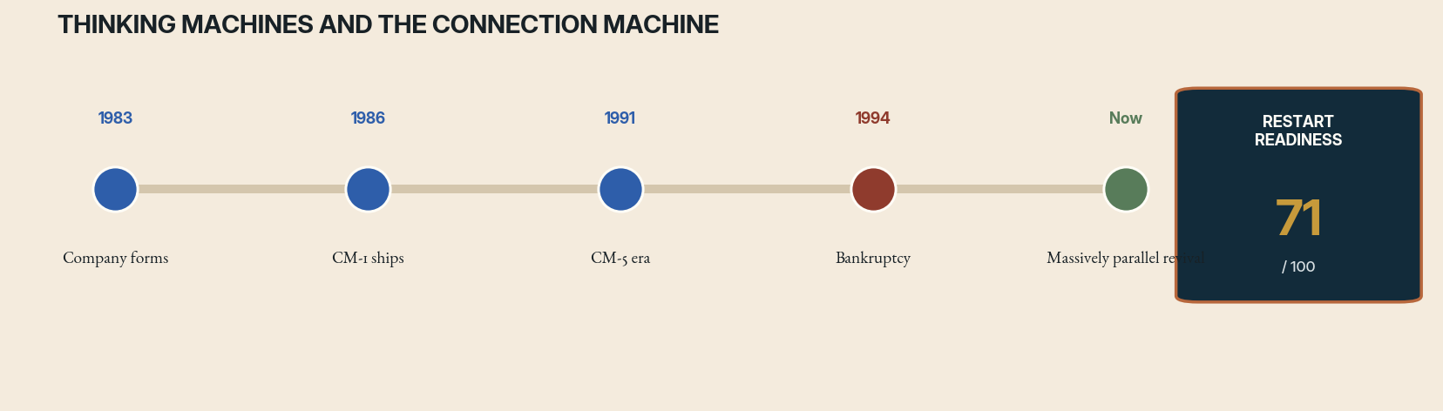
Case file 05 interruption timeline. Rust marks the decisive interruption; green marks successor activity. The readiness score is an editorial diagnostic, not a funding recommendation.
THE ORIGINAL WAGER
Thinking Machines Corporation built the Connection Machine around a radical proposition: useful intelligence and scientific computation would emerge from vast numbers of simple processors operating in parallel. Its machines were visually iconic, technically ambitious, and associated with research in physics, graphics, databases, and early artificial intelligence. The company tried to turn an experimental architecture into a commercial computing platform.
THE STOPPING FORCE
The business depended heavily on government customers and expensive bespoke systems. Competition intensified, procurement shifted, and the market rewarded more conventional massively parallel machines assembled from commodity processors. Technical complexity, uneven software maturity, and aggressive growth made the company fragile. Bankruptcy ended the integrated product line even though many researchers and ideas migrated elsewhere.
WHAT SURVIVED
The Connection Machine’s afterlife is everywhere: parallel programming, data-parallel languages, distributed scientific workloads, graphics processors, and accelerator-rich supercomputers. What disappeared was not parallelism but a distinctive attempt to make it the organizing principle of an entire computing environment. The unfinished experiment concerns programmability: can a machine expose enormous concurrency without forcing every user to become a hardware specialist?
WHAT HAS CHANGED
GPU computing, tensor compilers, automatic differentiation, distributed runtimes, high-bandwidth interconnects, and cloud-scale orchestration have normalized massive parallelism. At the same time, current accelerators recreate old difficulties in memory movement, topology, debugging, and vendor dependence. Historical Connection Machine software can now be studied as a source of interface ideas rather than as obsolete syntax.
RESTART PROTOCOL
Create a public parallel-computing workbench that spans emulated Connection Machine concepts and modern accelerators. Focus on topology-aware programming, visual observability, deterministic replay, and portable intermediate representations. Invite scientific users to compare how the same algorithm is expressed across eras. The goal is not a retro supercomputer; it is a more humane language for parallel machines.
THE COUNTERFACTUAL FORK
A healthier Thinking Machines might have become a specialized scientific-computing company rather than the symbolic home of machine intelligence. Its survival would still have depended on commoditization, software portability, and customer economics. The counterfactual is valuable because it reveals a recurring pattern: exotic hardware companies often understand the future workload correctly but misjudge how quickly general suppliers will absorb the useful idea.
THE FIRST 365 DAYS
Year one should recover executable examples from CM software, document their topology assumptions, and port them through a common intermediate representation to GPUs and modern clusters. A visual debugger should show data movement and synchronization across both historical and modern machines. The test is whether old programming abstractions expose parallel structure more clearly than current frameworks, not whether an emulator can win a speed contest.
RED-TEAM GATE
Separate architectural insight from corporate mythology. A revival should not reproduce dependence on a single exotic vendor or on procurement cycles that only a few institutions can survive.

RESEARCH ANCHORS
MIT Press histories of Thinking Machines; Computer History Museum records of the Connection Machine and the company’s 1990s collapse.

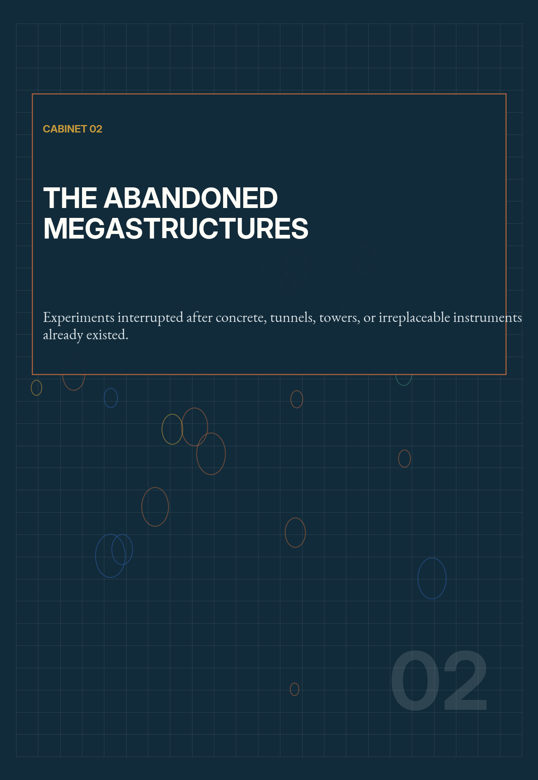

06 FORENSIC DOSSIER
Project Mohole

FIELD | Earth science / ocean engineering
ACTIVE LINE | 1957–1966 / lineage in scientific ocean drilling
STOPPING FORCE | Cost escalation, management conflict, and political withdrawal
RRI | 73 / 100 — provisional
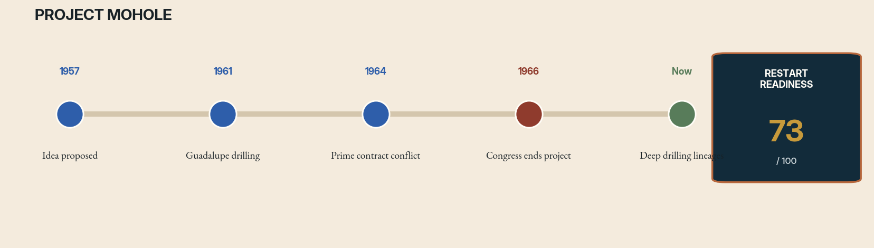
Case file 06 interruption timeline. Rust marks the decisive interruption; green marks successor activity. The readiness score is an editorial diagnostic, not a funding recommendation.
THE ORIGINAL WAGER
Project Mohole aimed to drill through the ocean floor into the Mohorovičić discontinuity, the boundary inferred between Earth’s crust and mantle. Scientists chose the ocean because the crust is thinner there. The preliminary drilling off Guadalupe Island proved dynamic positioning and recovered deep cores, making Mohole a rare case in which a successful pilot preceded cancellation of the full mission.
THE STOPPING FORCE
The next phase became entangled in contractor selection, expanding engineering ambitions, uncertain cost control, and conflict between scientific leadership and program management. The project’s identity shifted from a focused geophysical experiment toward a giant platform program. Congressional confidence collapsed as estimates rose and governance looked unstable. Funding ended in 1966 before the deep hole was attempted.
WHAT SURVIVED
Mohole’s tools and people seeded decades of scientific ocean drilling. Successor programs recovered cores that transformed understanding of plate tectonics, climate, ocean chemistry, and the deep biosphere. Yet the original symbolic objective—directly sampling the mantle through oceanic crust—remains uncompleted. The lineage succeeded scientifically while the headline experiment remained unfinished.
WHAT HAS CHANGED
Modern riser systems, drilling control, seafloor observatories, autonomous vehicles, improved geophysical imaging, and decades of borehole experience reduce some uncertainties. They do not make the mission cheap. The most important change is institutional: a restart can be decomposed into internationally shared science goals rather than defended as a single prestige shot.
RESTART PROTOCOL
Define a mantle-access campaign with staged holes and explicit decision gates. Begin with site characterization and technology demonstrations, then drill progressively deeper while publishing cost, failure, and core-quality data. Treat every stage as valuable science so cancellation does not turn the entire investment into an apparent zero. Maintain independent program management from the scientific priority process.
THE COUNTERFACTUAL FORK
If Mohole had continued, it might have reached the mantle—or it might have become a costly platform that consumed ocean science while chasing a symbolic depth. The successful pilot does not resolve that counterfactual. Its most important alternate future is organizational: scientific drilling could have learned earlier to separate shared infrastructure, site selection, and investigator priorities. Later programs effectively performed that institutional repair while postponing the iconic endpoint.
THE FIRST 365 DAYS
Year one should compare candidate sites using modern seismic data, assess riser and vessel readiness, recover cost and failure lessons from the original program, and define a sequence of holes with independent scientific value. A management simulation should test contractor changes and funding shocks. The final product is a staged international proposal whose first phase is worthwhile even if no mantle sample is ever returned.
RED-TEAM GATE
Do not let the romance of ‘reaching the mantle’ crowd out less dramatic drilling with higher near-term scientific return. The mission must remain an instrument, not a monument.

RESEARCH ANCHORS
International Ocean Discovery Program histories of Project Mohole and later deep-ocean drilling, including Hole 1256D.

07 FORENSIC DOSSIER
The Superconducting Super Collider

FIELD | Particle physics
ACTIVE LINE | 1983–1993 / successor questions in future colliders
STOPPING FORCE | Cost, governance failure, and political reversal
RRI | 48 / 100 — provisional
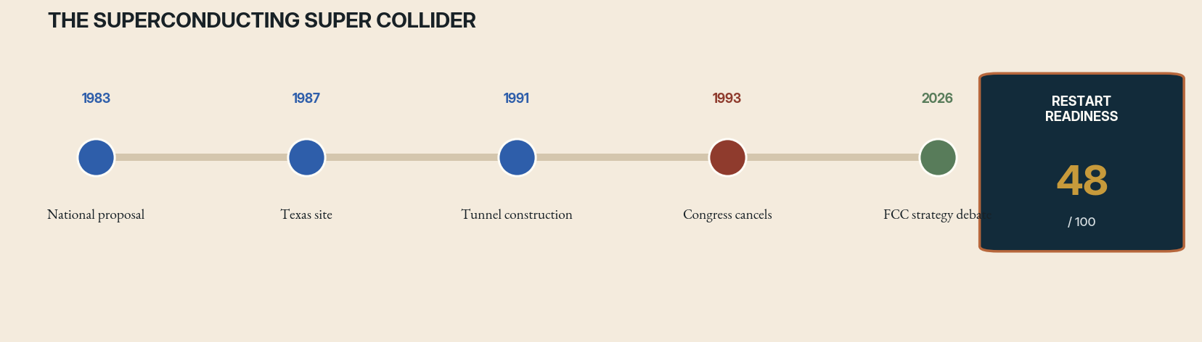
Case file 07 interruption timeline. Rust marks the decisive interruption; green marks successor activity. The readiness score is an editorial diagnostic, not a funding recommendation.
THE ORIGINAL WAGER
The Superconducting Super Collider was planned as an enormous proton collider in Texas, with a ring roughly 87 kilometers around and collision energies beyond any machine then operating. It promised direct access to fundamental physics and a national center for accelerator science. Construction began, tunnels were bored, magnets developed, and a scientific community reorganized around a machine expected to define the field.
THE STOPPING FORCE
Cancellation followed escalating cost estimates, weak financial controls, changing international contributions, managerial conflict, and a post–Cold War political environment less willing to fund a giant domestic science project. The machine became a referendum on federal megaproject competence. In 1993 Congress ended it after substantial construction, leaving tunnels, equipment, dispersed teams, and a durable wound in U.S. high-energy physics.
WHAT SURVIVED
The SSC produced accelerator technology, trained specialists, and clarified how badly governance can damage a scientifically coherent mission. CERN’s Large Hadron Collider later discovered the Higgs boson at lower energy than the SSC design but with international governance and a mature laboratory base. Today the question is not whether to restart the abandoned Texas ring. It is how to pursue post-LHC physics without reproducing the same political and financial structure.
WHAT HAS CHANGED
High-field superconductors, machine learning for controls, improved tunneling, global detector collaborations, and new collider concepts have advanced. At the same time, costs and power requirements remain formidable. CERN’s Future Circular Collider studies and the 2026 European strategy process demonstrate that the original scientific desire persists, but now within a staged international framework beginning with a precision electron–positron machine.
RESTART PROTOCOL
Resume the scientific program, not the artifact. Build a globally governed sequence: precision experiments, accelerator R&D, high-field magnet demonstrations, energy and lifecycle accounting, and transparent off-ramps. Publish independent cost ranges and make regional participation modular. Preserve the SSC archive as mandatory training for leaders of any future collider.
THE COUNTERFACTUAL FORK
Had the SSC survived, it likely would have reshaped the geographic and institutional center of particle physics, but not necessarily protected the United States from later megaproject pressures. Its technical reach might have produced discoveries earlier or explored energies still inaccessible. Yet a successful machine built through fragile governance could also have normalized cost opacity. The counterfactual must include both the physics it might have seen and the institutional precedent it might have set.
THE FIRST 365 DAYS
Year one of any successor should fund independent cost engineering, high-field magnet prototypes, electricity-supply scenarios, detector R&D, and an open comparison of collider and non-collider paths. Governance design must precede site competition. No civil construction begins until international contributions, lifecycle energy, escalation rules, and a credible cancellation archive are contractually defined.
RED-TEAM GATE
No project should be declared inevitable before its energy source, total lifecycle cost, governance, and opportunity cost are credible. Scientific importance does not suspend institutional arithmetic.

RESEARCH ANCHORS
U.S. GAO reports on SSC management and costs; U.S. Department of Energy histories; CERN Future Circular Collider feasibility and strategy materials.

08 FORENSIC DOSSIER
Arecibo Observatory

FIELD | Radio astronomy / planetary radar
ACTIVE LINE | 1963–2020 / educational and archival afterlife
STOPPING FORCE | Structural failure after deferred maintenance and storm damage
RRI | 39 / 100 — provisional
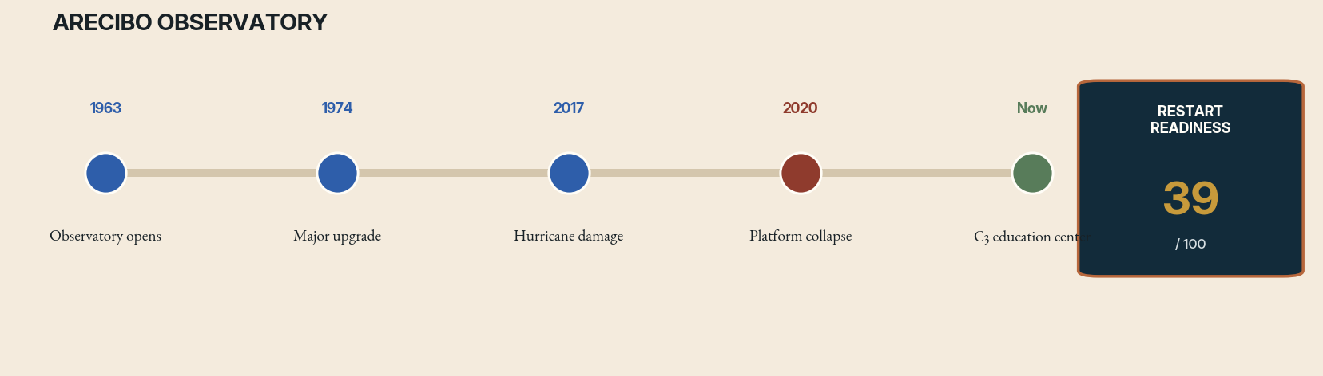
Case file 08 interruption timeline. Rust marks the decisive interruption; green marks successor activity. The readiness score is an editorial diagnostic, not a funding recommendation.
THE ORIGINAL WAGER
Arecibo’s fixed 305-meter dish used the geometry of a natural sinkhole to create an instrument of extraordinary sensitivity. It mapped planets with radar, studied pulsars, probed Earth’s ionosphere, supported searches for near-Earth objects, and became a symbol of large-scale public science. Its architecture was site-specific: immense capability purchased through a structure that could not simply point anywhere or be moved.
THE STOPPING FORCE
A sequence of storms, constrained maintenance budgets, aging cables, and institutional uncertainty narrowed the observatory’s margin. In 2020 two support cables failed. Engineers concluded that repair posed unacceptable danger; before controlled decommissioning could proceed, the suspended platform collapsed into the dish. The interruption was physical, sudden, and irreversible.
WHAT SURVIVED
Arecibo left irreplaceable longitudinal datasets, a trained community, planetary-radar expertise, and a public constituency. It also left a lesson about maintenance as scientific infrastructure rather than overhead. The current site’s educational mission preserves access, but the telescope’s observing role cannot be resumed by repairing the original dish.
WHAT HAS CHANGED
Distributed arrays, digital beamforming, higher-bandwidth receivers, new survey telescopes, and coordinated planetary-defense networks offer different ways to recover functions. None precisely duplicates Arecibo’s combination of collecting area, radar power, latitude, and legacy. A restart must therefore begin with a capability map rather than an architectural replica.
RESTART PROTOCOL
Inventory every scientific function that vanished—planetary radar, pulsar timing, ionospheric experiments, training, and rapid-response observing. Assign each to a portfolio of new or upgraded facilities, including smaller resilient instruments at the site where justified. Fund long-term maintenance reserves as part of construction. Preserve data and operational knowledge in executable pipelines, not only documents.
THE COUNTERFACTUAL FORK
If cable replacement and maintenance funding had arrived earlier, Arecibo might have operated for many more years, but its long-term vulnerability would have remained. The more useful counterfactual is a distributed observatory strategy launched before crisis: preserving the giant dish while training successor facilities and duplicating fragile capabilities. Scientific infrastructure should not wait for structural distress before asking how its functions survive loss.
THE FIRST 365 DAYS
Year one should publish a capability ledger, identify datasets and software at risk, fund planetary-radar workforce transfer, and design complementary instruments with different failure modes. The site’s educational center should host an operations archive in which students can replay historical observations. Decisions about new hardware in Puerto Rico must be co-designed with local scientific and civic institutions.
RED-TEAM GATE
A replica should not be promised merely because the loss is emotionally powerful. Rebuild only where the scientific portfolio, safety case, local community, and maintenance model support it.

RESEARCH ANCHORS
National Science Foundation records on the 2020 collapse, decommissioning, and the current Arecibo C3 education center.

09 FORENSIC DOSSIER
Terrestrial Planet Finder

FIELD | Astronomy / space observatories
ACTIVE LINE | 1990s–2000s / lineage in Habitable Worlds Observatory
STOPPING FORCE | Budget competition and technological immaturity
RRI | 81 / 100 — provisional
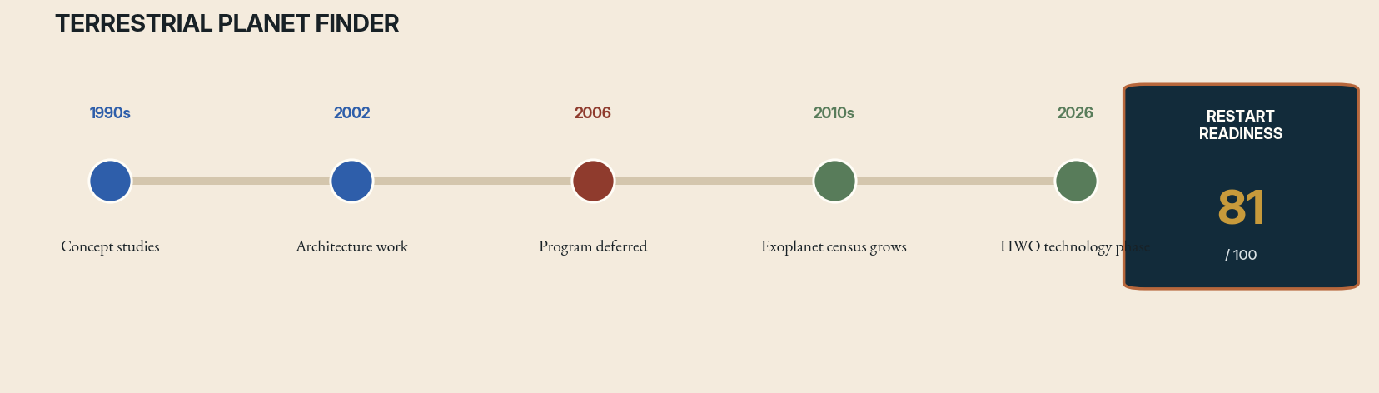
Case file 09 interruption timeline. Rust marks the decisive interruption; green marks successor activity. The readiness score is an editorial diagnostic, not a funding recommendation.
THE ORIGINAL WAGER
NASA’s Terrestrial Planet Finder studies explored space telescopes capable of detecting and characterizing Earth-like planets around nearby stars. Concepts included visible-light coronagraphs and infrared interferometers. The project’s scientific objective was audacious but clear: suppress the overwhelming light of a star, isolate a faint planet, and search its spectrum for atmospheric clues.
THE STOPPING FORCE
TPF encountered a convergence of technical risk and budget competition. Precision formation flying, large deployable optics, ultra-stable wavefront control, and high-performance starlight suppression were not mature enough for a straightforward mission. Other flagship commitments consumed available funding. The program was deferred and never entered full development.
WHAT SURVIVED
TPF did not disappear. Its science case and technology work flowed into coronagraphs, starshades, interferometry research, exoplanet yield modeling, and later decadal-survey priorities. Kepler and subsequent observatories transformed the context by showing that planets are common. The unfinished experiment became more compelling because the target population stopped being hypothetical.
WHAT HAS CHANGED
Wavefront sensing, deformable mirrors, low-noise detectors, segmented telescope control, exoplanet demographics, and high-contrast testbeds have advanced. NASA’s Habitable Worlds Observatory now carries a related goal, with technology programs selected in 2026 and precursor science planning underway. The resumption is already occurring, but under a different institutional name and with a stronger ladder of demonstrations.
RESTART PROTOCOL
Treat HWO as a disciplined continuation rather than a clean-sheet miracle. Preserve explicit traceability from TPF studies to current requirements. Run parallel coronagraph and starshade pathways until evidence supports convergence. Invest in precursor observations, target catalogs, and open yield models so the mission’s science return is robust to launch schedule and design changes.
THE COUNTERFACTUAL FORK
Had TPF entered development in the 2000s, it would have confronted a target catalog and exoplanet population far less mature than today’s. It might have pioneered direct imaging but carried greater yield uncertainty and technology risk. Delay was costly in time yet beneficial in context: later planet surveys transformed mission design. This is a case where interruption allowed the scientific target to become clearer while the enabling technology improved.
THE FIRST 365 DAYS
Year one of the continuation should integrate TPF archives into HWO requirements, publish a traceability matrix for inherited assumptions, and run open coronagraph/starshade yield challenges. Teams should identify discoveries that remain valuable even if Earth analogs are rarer or more difficult than expected. The mission’s public promise should center comparative planetary science, not a guaranteed biosignature.
RED-TEAM GATE
Do not oversell a single spectral detection as proof of life. The system must be designed for repeated, comparative, and context-rich observations with transparent uncertainty.

RESEARCH ANCHORS
NASA/JPL Terrestrial Planet Finder archives; NASA Habitable Worlds Observatory program and 2026 technology selections.

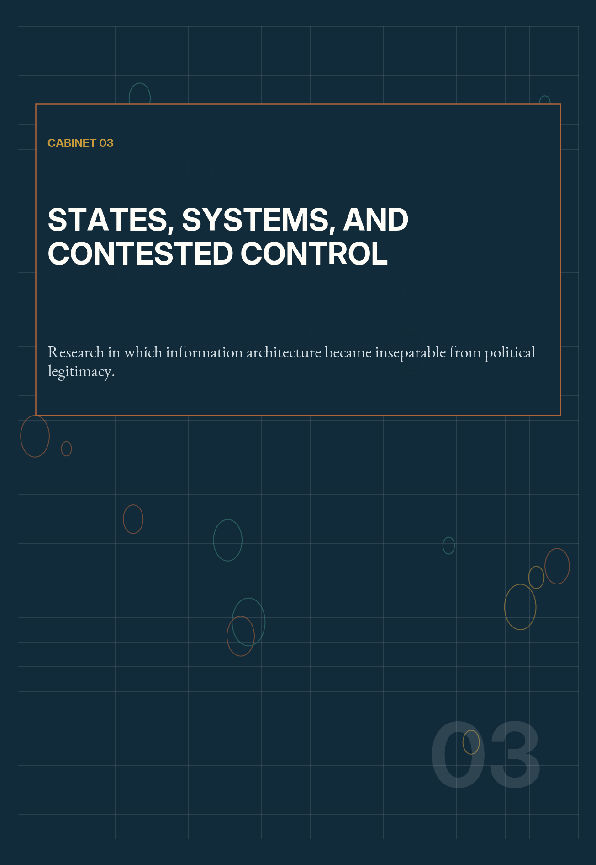

10 FORENSIC DOSSIER
OGAS: A Networked Economy That Never Arrived

FIELD | Cybernetics / public administration
ACTIVE LINE | 1960s–1970s / contemporary digital-governance echoes
STOPPING FORCE | Bureaucratic resistance, politics, and infrastructure limits
RRI | 45 / 100 — provisional
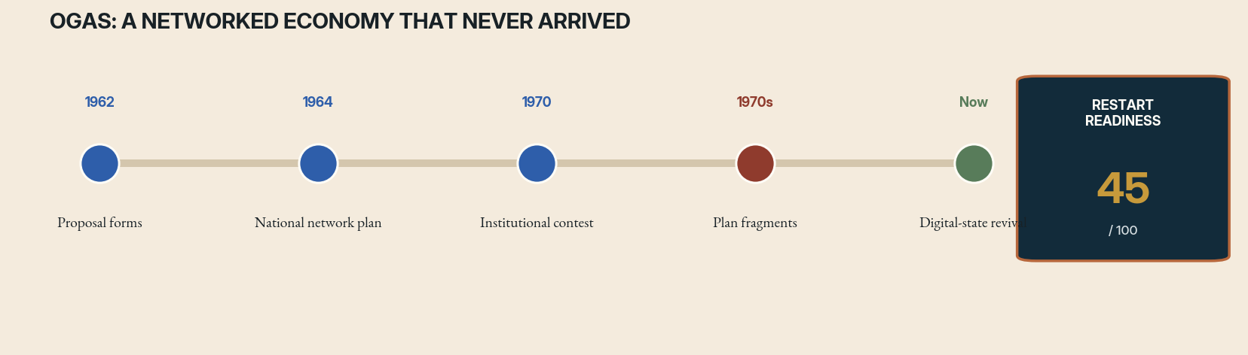
Case file 10 interruption timeline. Rust marks the decisive interruption; green marks successor activity. The readiness score is an editorial diagnostic, not a funding recommendation.
THE ORIGINAL WAGER
Viktor Glushkov’s OGAS proposal imagined a nationwide computer network for economic information, calculation, and coordination across the Soviet Union. It sought to replace slow paper reporting and ministerial opacity with connected computing centers, standardized data, and more responsive planning. The project anticipated elements of networked administration before such infrastructure was common.
THE STOPPING FORCE
OGAS threatened existing bureaucratic authority. Ministries that controlled information had little incentive to expose it to a cross-cutting network. Competing proposals, limited telecommunications, computer shortages, high projected costs, and uncertainty about who would govern the system prevented a decisive national commitment. Pieces of automation appeared, but the integrated network did not.
WHAT SURVIVED
The project left designs and debates that reveal a central problem of digital government: data architecture is power architecture. A network can improve visibility while also concentrating surveillance and control. OGAS failed partly because the state was fragmented, not because it lacked central authority. Its history complicates simplistic claims that authoritarian systems can implement any technology they choose.
WHAT HAS CHANGED
Cloud infrastructure, open standards, event streaming, privacy-preserving analytics, and ubiquitous networks make the technical surface far easier. Yet the political problem remains. Institutions still resist interoperable records, and citizens face risks from centralized data. A credible restart must invert the old premise: begin with public rights and federated services, not total informational capture.
RESTART PROTOCOL
Build a civic information commons with narrow, auditable registries and locally accountable data stewards. Separate statistical planning from case-level enforcement. Use federated queries, purpose limitation, public schemas, and appeal mechanisms. Simulate policy options without treating the model as a command system. Measure whether information actually improves service delivery rather than merely expanding managerial visibility.
THE COUNTERFACTUAL FORK
A politically successful OGAS might have increased planning speed while intensifying contest over who defined truth in the Soviet economy. Better data would not automatically have repaired distorted incentives or ministerial power. Its counterfactual is thus double-edged: networked administration could have reduced waste and delay, yet also extended surveillance and made dissent appear as data error. The institution governing the network would have mattered more than its topology.
THE FIRST 365 DAYS
Year one should choose a low-coercion civic service such as public inventory, maintenance, or emergency logistics. The pilot must use minimal personal data, publish its schema and optimization objectives, and establish local correction rights. Researchers should measure whether frontline workers gain autonomy and information, not only whether central managers receive faster dashboards.
RED-TEAM GATE
Any revival that centralizes personal data or removes political contest would reproduce OGAS’s most dangerous potential while ignoring its administrative insight.

RESEARCH ANCHORS
Slava Gerovitch and Benjamin Peters histories of Soviet networking and the OGAS project.

11 FORENSIC DOSSIER
Project Cybersyn

FIELD | Cybernetics / democratic planning
ACTIVE LINE | 1971–1973 / renewed scholarly and design interest
STOPPING FORCE | Military coup and political destruction
RRI | 59 / 100 — provisional
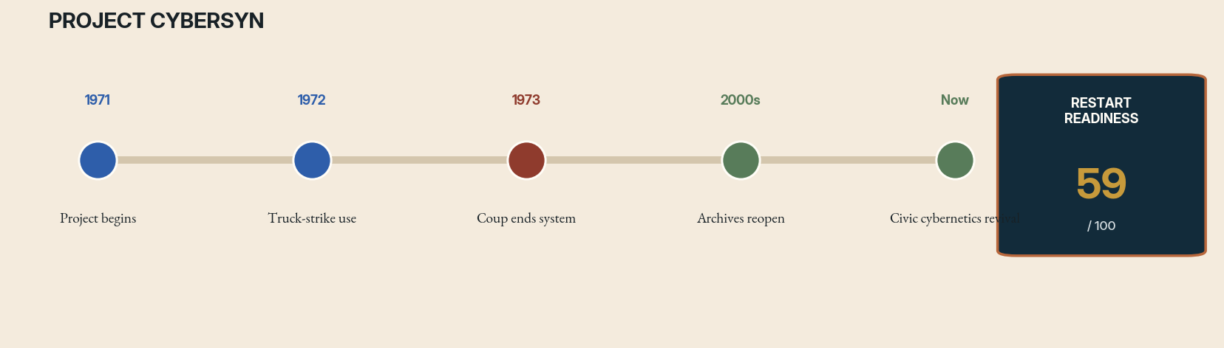
Case file 11 interruption timeline. Rust marks the decisive interruption; green marks successor activity. The readiness score is an editorial diagnostic, not a funding recommendation.
THE ORIGINAL WAGER
Project Cybersyn connected Chilean factories to a small operations network intended to support economic coordination under Salvador Allende’s government. Telex links, statistical filtering, simulation, and an operations room were assembled under severe resource limits. Stafford Beer and Chilean collaborators sought a system that could provide timely signals without requiring every local decision to be centralized.
THE STOPPING FORCE
The project was cut short by the 1973 military coup. Institutions were dismantled, participants dispersed, and the political experiment was violently terminated. Cybersyn therefore never reached a stable operational phase from which its efficacy could be judged. Its iconic control room has often overshadowed the incomplete software, organizational negotiation, and democratic aspirations around it.
WHAT SURVIVED
Cybersyn left a powerful design vocabulary: real-time indicators, exception reporting, local autonomy, feedback, simulation, and interfaces made for collective deliberation. It also left unresolved questions about who selected the indicators, how workers would participate, and whether an operations room could remain advisory under pressure. The project is both a technical ancestor and a political warning.
WHAT HAS CHANGED
Real-time data systems are now commonplace, but the ability to collect data has outpaced democratic governance. Participatory budgeting, cooperative platforms, digital twins, and public-interest technology create possible descendants. The key enabling technology is not faster analytics; it is institutional design that lets communities define goals, inspect models, and refuse extraction.
RESTART PROTOCOL
Create municipal and cooperative Cybersyn laboratories. Select one bounded system—food distribution, energy demand, transit reliability—and co-design its indicators with workers and residents. Use open-source models, public logs, and rotating citizen oversight. Keep optimization advisory and preserve the right of local units to explain deviations rather than being punished by an automated target.
THE COUNTERFACTUAL FORK
Had Chile’s democratic experiment continued, Cybersyn would have faced ordinary problems that the coup prevented it from confronting: model drift, worker distrust, conflicting objectives, maintenance, and turnover. It may have matured into participatory infrastructure or hardened into managerial control. The unfinished value lies in testing whether real-time coordination can preserve local autonomy once scarcity and political pressure make central command tempting.
THE FIRST 365 DAYS
Year one should form a worker-and-resident governance board, choose one transparent logistics problem, rebuild exception-reporting tools with open code, and conduct simulated crises. Every alert should include the local unit’s explanation and right to contest. The primary metric is not optimization accuracy but whether decisions become faster without becoming less democratic.
RED-TEAM GATE
Do not revive the aesthetics of the control room without redistributing control. A dashboard can become a theater of participation while power remains elsewhere.

RESEARCH ANCHORS
MIT Press histories of Project Cybersyn; Chilean archival collections and contemporary scholarship on cybernetic governance.

12 FORENSIC DOSSIER
Biosphere 2 and the Closed-World Promise

FIELD | Ecology / life support
ACTIVE LINE | 1980s–1994 / ongoing research facility
STOPPING FORCE | Scientific controversy, management conflict, and mission collapse
RRI | 64 / 100 — provisional
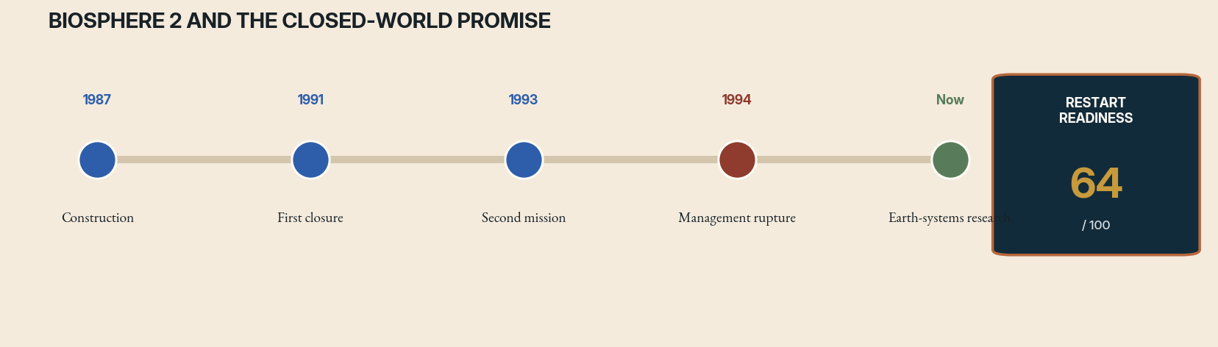
Case file 12 interruption timeline. Rust marks the decisive interruption; green marks successor activity. The readiness score is an editorial diagnostic, not a funding recommendation.
THE ORIGINAL WAGER
Biosphere 2 attempted to sustain people inside a materially closed ecological system containing agriculture, atmosphere, water cycles, and multiple biomes. It was part life-support experiment, part theatrical expedition, and part ecological model. The first crew’s two-year closure generated unprecedented data about oxygen decline, nutrient cycles, species changes, crop production, and human group dynamics.
THE STOPPING FORCE
The project’s scientific credibility suffered from secrecy, unclear controls, undisclosed interventions, and conflict between management, participants, and external scientists. Oxygen had to be added; food was scarce; ecological imbalances emerged. A second mission ended amid organizational and legal turmoil. The original closed-world program lost legitimacy even though the facility remained scientifically valuable.
WHAT SURVIVED
Biosphere 2’s failures were not empty. They demonstrated how quickly small atmospheric and soil processes can dominate a supposedly controlled world. They exposed the difference between a demonstration and a reproducible experiment. The site later became a research facility for climate, water, landscape, and ecological studies, meaning the hardware survived by abandoning the original narrative.
WHAT HAS CHANGED
Continuous sensors, isotope tracing, microbiome analysis, digital twins, automated agriculture, and open data can make closed-ecology research more interpretable. Space agencies and private missions have renewed interest in regenerative life support. The responsible descendant is a network of progressively closed testbeds, not an immediate attempt to seal people inside a miniature planet.
RESTART PROTOCOL
Run nested closure experiments: material loops without humans, short human occupations, then longer missions only after independent replication. Pre-register interventions and publish all gas, water, crop, and microbial data. Separate public spectacle from scientific governance. Use multiple smaller facilities so one ecological accident does not end the entire research line.
THE COUNTERFACTUAL FORK
If Biosphere 2 had maintained transparent science governance, its first closure could have become the beginning of a long experimental sequence rather than a verdict on the concept. Oxygen loss and ecological instability were scientifically valuable. The alternate history is not a perfectly sealed world; it is a facility that treated interventions as normal experimental evidence and allowed external teams to reproduce claims.
THE FIRST 365 DAYS
Year one should map every material and gas pathway, reproduce historical carbon and oxygen budgets with current models, establish independent data custody, and run unoccupied closure trials. Human occupancy resumes only after predefined atmospheric and food thresholds are met. Public communication should show interventions live, eliminating the incentive to hide assistance in order to preserve spectacle.
RED-TEAM GATE
Human participants must never be used to preserve the appearance of closure. Safety interventions should be immediate, disclosed, and treated as data rather than embarrassment.

RESEARCH ANCHORS
University of Arizona Biosphere 2 history and current research program.

13 FORENSIC DOSSIER
SPICE, SCoPEx, and the Experiments That Governance Stopped

FIELD | Climate intervention
ACTIVE LINE | 2010s–2024 / governance debate ongoing
STOPPING FORCE | Legitimacy, governance, and social-license failure
RRI | 22 / 100 — provisional
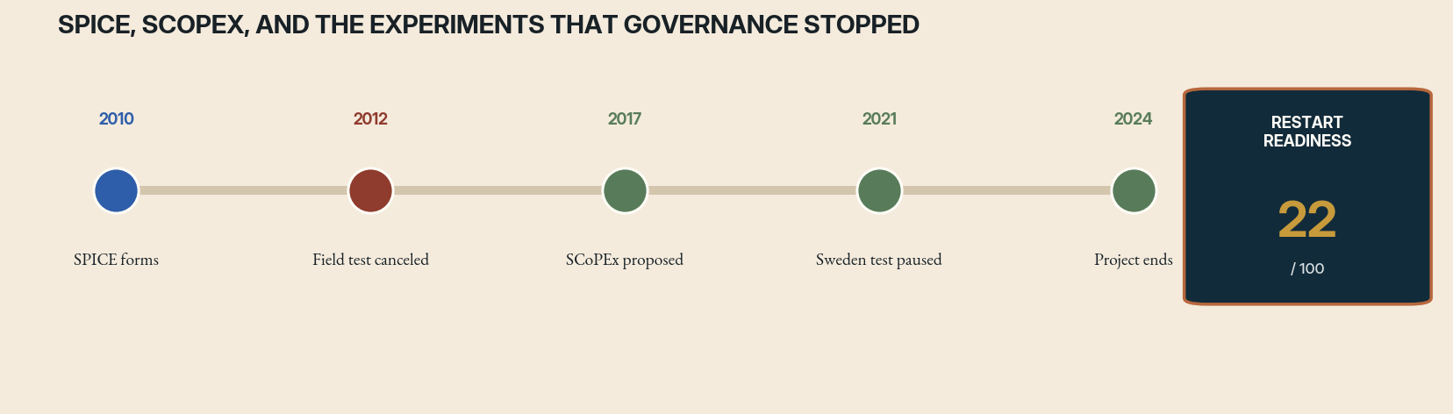
Case file 13 interruption timeline. Rust marks the decisive interruption; green marks successor activity. The readiness score is an editorial diagnostic, not a funding recommendation.
THE ORIGINAL WAGER
Stratospheric aerosol and related solar-geoengineering experiments ask whether reflecting a small fraction of sunlight could temporarily reduce warming. SPICE in the United Kingdom proposed a tethered-balloon test of delivery hardware; SCoPEx at Harvard proposed small-scale atmospheric measurements. Neither field test was intended to alter climate, yet each became a proxy battle over the governance of planetary intervention.
THE STOPPING FORCE
SPICE canceled its hardware test amid intellectual-property concerns and governance criticism. SCoPEx faced opposition from Indigenous and environmental groups, including around a planned platform test in Sweden, and was ultimately terminated. These projects did not stop because the apparatus was impossible. They stopped because technical scale did not erase symbolic, political, and distributive scale.
WHAT SURVIVED
The interruptions generated a governance literature, public-engagement experiments, and clearer recognition that even small tests can create path dependence. They also left a difficult scientific gap: society may need better knowledge of climate interventions while research itself can normalize deployment, redirect funding, or impose decisions on people who did not choose the risk.
WHAT HAS CHANGED
Climate impacts have intensified, modeling has improved, and governments are beginning to examine research governance more formally. The technical ability to conduct tiny outdoor studies is not the limiting factor. The limiting factor is whether any process can establish legitimate questions, international transparency, Indigenous participation, liability, and a credible separation between research and deployment advocacy.
RESTART PROTOCOL
Do not restart with a balloon. Begin with an institution. Establish international registries, public funding disclosure, independent ethics review, transboundary notification, community veto mechanisms for local tests, and clear termination criteria. Prioritize laboratory, observational, and modeling work that reduces uncertainty without environmental release. Outdoor experiments should occur only after governance exists at the scale of their political meaning.
THE COUNTERFACTUAL FORK
Had the SPICE or SCoPEx tests proceeded, the physical measurements might have been modest while the political precedent became large. A successful balloon launch could have been cited as social permission for a research trajectory no public had authorized. Conversely, cancellation without a durable governance system leaves future teams to repeat the same legitimacy conflict. The counterfactual demonstrates that experimental meaning is not proportional to released mass.
THE FIRST 365 DAYS
Year one should contain no outdoor release. It should create an international project registry, funding disclosure rules, Indigenous and community review mechanisms, transboundary notification standards, and a liability study. Independent groups should test whether proposed laboratory or observational research can answer the same questions. Only a governance evaluation—not a technical team—may recommend moving to field design.
RED-TEAM GATE
This is a case where remaining unfinished may be responsible until institutions mature. Scientific curiosity does not create a right to use shared atmosphere as an experimental substrate.

RESEARCH ANCHORS
Nature reporting and governance analyses of SPICE; project records on SCoPEx; 2026 U.S. GAO work on solar-geoengineering governance.



14 FORENSIC DOSSIER
The Interrupted Science of Psychedelic Medicine

FIELD | Medicine / psychiatry
ACTIVE LINE | 1950s–1970s / modern clinical revival
STOPPING FORCE | Prohibition, politicization, and methodological weakness
RRI | 69 / 100 — provisional
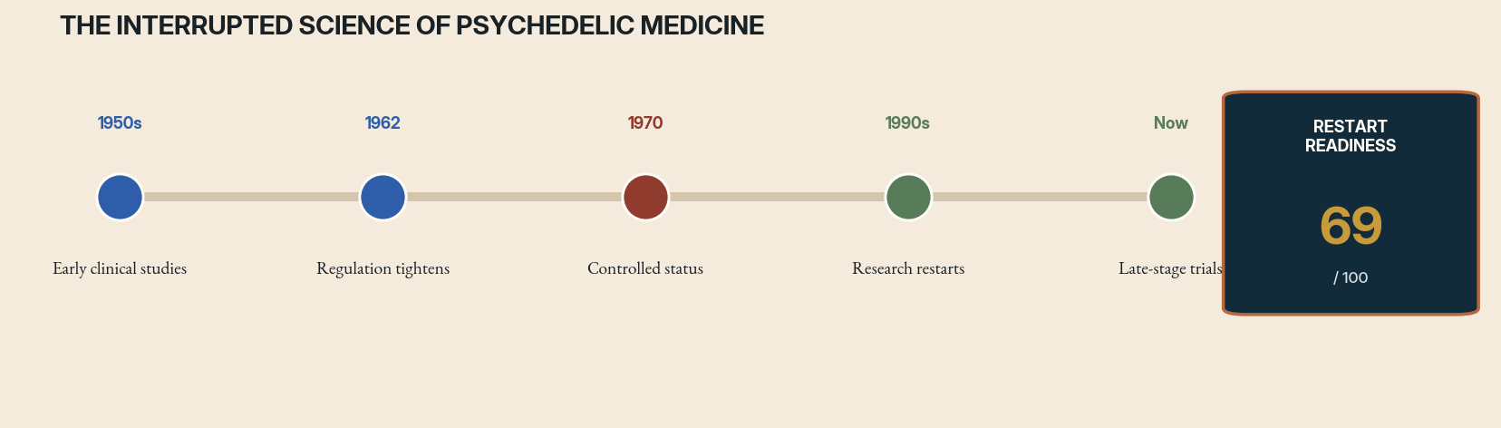
Case file 14 interruption timeline. Rust marks the decisive interruption; green marks successor activity. The readiness score is an editorial diagnostic, not a funding recommendation.
THE ORIGINAL WAGER
Mid-twentieth-century researchers studied psychedelic compounds in alcoholism, depression, trauma, end-of-life distress, and psychotherapy. The work explored not only pharmacology but a treatment form in which preparation, environment, guided experience, and integration mattered. Thousands of participants were involved across many studies, but methods varied widely and modern trial standards were still developing.
THE STOPPING FORCE
Public controversy, association with counterculture, restrictive drug policy, ethical abuses in some government and private experiments, and weakly controlled studies made the field politically radioactive. Access to compounds and funding contracted sharply. Research teams dissolved, clinical knowledge became informal, and a broad class of hypotheses was largely removed from mainstream investigation for decades.
WHAT SURVIVED
The field left suggestive clinical reports, unresolved mechanisms, and a body of therapeutic practice that could not simply be imported as proof. The interruption created both lost opportunity and a methodological debt. Modern researchers must distinguish pharmacological effects, expectancy, psychotherapy, selection, setting, and intense unblinding—problems that early enthusiasm often blurred.
WHAT HAS CHANGED
Contemporary trials use better diagnostics, monitoring, neuroimaging, data standards, and adverse-event reporting. Regulatory pathways exist, and public interest is high. Yet commercialization and media excitement can reproduce the earlier cycle of overclaim followed by backlash. The research restart is therefore as much about institutional restraint as access to substances.
RESTART PROTOCOL
Build multi-site trials with active comparators, long follow-up, transparent therapist training, independent adverse-event registries, and studies of who does not benefit. Compare drug-assisted therapy with excellent non-drug care rather than weak usual-treatment controls. Fund mechanism and service-delivery research alongside pivotal trials. Preserve community and Indigenous knowledge without extracting or romanticizing it.
THE COUNTERFACTUAL FORK
Without prohibition and backlash, psychedelic research might have matured sooner, but it might also have institutionalized weak blinding, charismatic therapists, and broad claims before safeguards developed. The interruption did not preserve a pure science waiting to be reopened. It froze a mixture of promising clinical observations, cultural conflict, ethical failure, and methodological ambiguity that modern work must disentangle.
THE FIRST 365 DAYS
Year one should establish a shared adverse-event registry, harmonize therapist competencies, launch comparative trials against high-quality psychotherapy, and fund studies of expectancy and functional unblinding. Patient advocates should help define outcomes beyond symptom scales. Commercial sponsors must disclose training, site, and facilitator effects so a drug result cannot conceal a treatment-system failure.
RED-TEAM GATE
Revival must not erase histories of coercion, nor treat vulnerable patients as a market. Strong consent, screening, supervision, and post-session care are non-negotiable.

RESEARCH ANCHORS
Peer-reviewed histories of abandoned psychedelic research; current trial reviews and regulatory guidance.

15 FORENSIC DOSSIER
Phage Therapy Beyond the Antibiotic Century

FIELD | Medicine / microbiology
ACTIVE LINE | 1910s–present / uneven continuity and renewed trials
STOPPING FORCE | Western abandonment after antibiotics, standardization problems
RRI | 76 / 100 — provisional
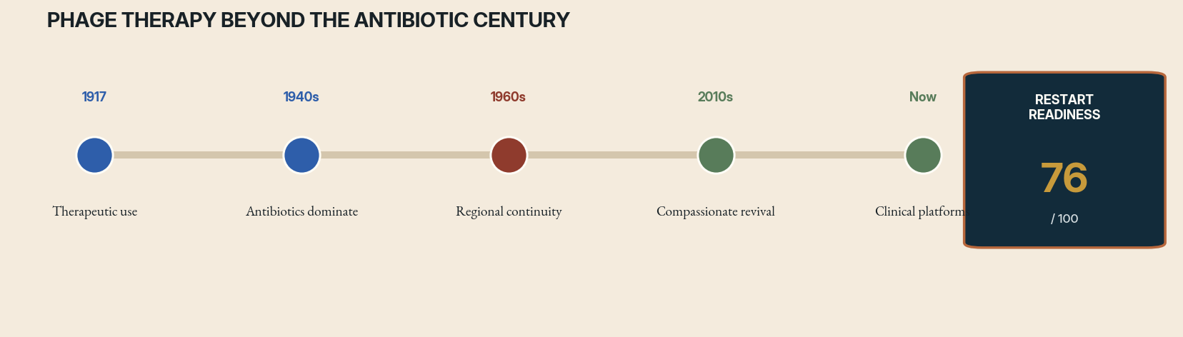
Case file 15 interruption timeline. Rust marks the decisive interruption; green marks successor activity. The readiness score is an editorial diagnostic, not a funding recommendation.
THE ORIGINAL WAGER
Bacteriophages—viruses that infect bacteria—were used therapeutically before antibiotics became dominant. The approach promised targeted killing, self-amplification at infection sites, and adaptation to bacterial resistance. Research continued in parts of Eastern Europe and the former Soviet Union even as Western medicine largely moved away from it.
THE STOPPING FORCE
Early phage preparations varied in purity, identity, host range, and potency. Biological mechanisms were incompletely understood, and results were inconsistent. Antibiotics appeared easier to manufacture, prescribe, and standardize across many infections. Industrial and regulatory systems formed around fixed chemical drugs, while personalized or evolving phage mixtures fit poorly.
WHAT SURVIVED
Phage institutes preserved collections and practical experience. Modern compassionate-use cases showed that tailored phages can sometimes contribute to treatment of resistant infections, while also revealing logistical difficulty: isolate the pathogen, find or engineer active phages, test interactions, manufacture safely, and obtain authorization before the patient deteriorates.
WHAT HAS CHANGED
Rapid sequencing, synthetic biology, cryo-electron microscopy, automated host-range screening, genomic safety checks, and distributed biobanks make the pipeline more tractable. Antimicrobial resistance creates urgent need. Regulators now have investigational pathways, but manufacturing and trial design remain obstacles because a fixed product may be obsolete against a changing bacterial target.
RESTART PROTOCOL
Develop a federated phage commons with standardized metadata, genomic screening, potency assays, manufacturing nodes, and rapid matching. Run platform trials that allow cocktails to evolve under a common protocol. Study combinations with antibiotics and immune status. Create reimbursement and regulatory models for libraries and processes, not only single immutable vials.
THE COUNTERFACTUAL FORK
If antibiotics had not displaced Western phage research, medicine might have developed microbial diagnostics and adaptive biological manufacturing much earlier. It also might have struggled for decades with inconsistent preparations. The counterfactual suggests that pharmaceutical standardization selected not only the best molecule but the easiest regulatory object. Phage therapy asks institutions to regulate a changing library and matching process.
THE FIRST 365 DAYS
Year one should connect biobanks through a common schema, validate rapid host-range assays, establish genomic exclusion rules, and simulate a cross-border matching emergency. A platform trial should enroll one infection class and permit predefined cocktail updates. The program should time every step from patient isolate to administered product, because logistics are part of efficacy.
RED-TEAM GATE
Do not present phages as a universal antibiotic replacement. Host specificity, resistance, immune effects, bacterial toxins, and quality control require infection-specific expertise.

RESEARCH ANCHORS
Historical and current peer-reviewed reviews; U.S. FDA investigational pathways for bacteriophage therapy.

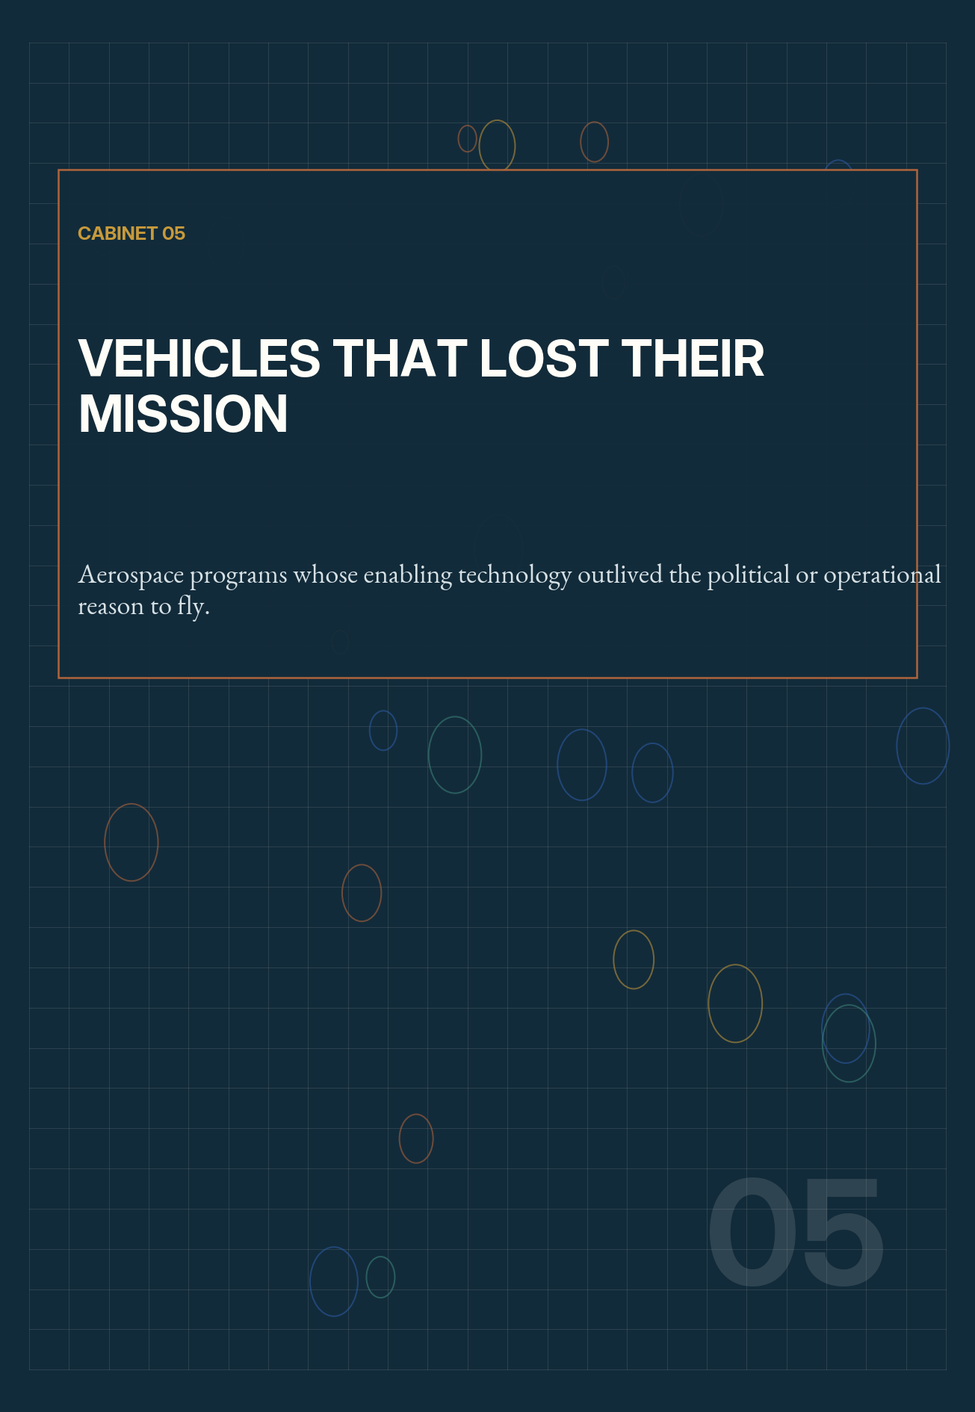

16 FORENSIC DOSSIER
Project Orion

FIELD | Space propulsion
ACTIVE LINE | 1957–1965 / conceptual lineage only
STOPPING FORCE | Nuclear-test politics, treaty limits, and mission loss
RRI | 18 / 100 — provisional
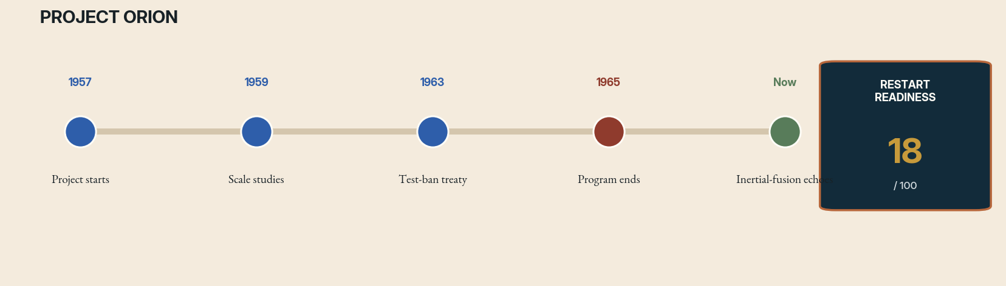
Case file 16 interruption timeline. Rust marks the decisive interruption; green marks successor activity. The readiness score is an editorial diagnostic, not a funding recommendation.
THE ORIGINAL WAGER
Project Orion proposed propelling enormous spacecraft by detonating a sequence of nuclear explosive devices behind a shock-absorbing pusher plate. The physics promised thrust and specific impulse far beyond chemical rockets, potentially moving vast payloads through the solar system. Engineers studied pulse units, plate ablation, shock absorption, vehicle layouts, and missions ranging from planetary expeditions to interstellar precursors.
THE STOPPING FORCE
The concept collided with radioactive fallout, nuclear-test politics, the Partial Test Ban Treaty, weapon-control concerns, and the rise of more conventional space architectures. Orion’s strongest advantage—using nuclear explosives directly—was also its political impossibility. Once no near-term mission required its extraordinary payload capacity, the program lost institutional purpose.
WHAT SURVIVED
Orion left rigorous studies showing that an outrageous idea can contain serious engineering. It influenced pulsed propulsion, impact physics, and later fusion concepts. It also demonstrates that technical feasibility is not social feasibility. A machine whose normal operation resembles weapons testing cannot be treated as an ordinary transport option.
WHAT HAS CHANGED
Fusion research, high-energy-density experiments, advanced materials, numerical shock modeling, and deep-space mission studies have advanced. None removes the treaty, proliferation, launch-accident, or contamination issues of fission pulse units. The plausible descendants use non-weapon pulsed fusion, externally delivered energy, or laboratory-scale plate experiments.
RESTART PROTOCOL
Resume only the transferable science: pulsed plasma coupling, sacrificial surfaces, magnetic nozzles, shock isolation, and mission analysis for high-energy propulsion. Use non-nuclear laboratory pulses and transparent simulations. Any work involving explosive nuclear devices must remain inside international treaty and nonproliferation frameworks and should not be normalized through euphemism.
THE COUNTERFACTUAL FORK
Had Orion received a mission and political exemption, it could have launched extraordinary payloads while embedding nuclear explosive use in space infrastructure. Its technical success would have created new security and treaty pressures rather than resolving them. The counterfactual is therefore not simply a lost road to the planets; it is a world in which spaceflight and nuclear arsenals became more tightly coupled.
THE FIRST 365 DAYS
Year one should explicitly exclude explosive nuclear pulse units. Teams may reproduce plate-ablation experiments with lasers or chemical pulses, validate shock-isolation models, and compare pulsed fusion descendants. A legal and nonproliferation panel should review publications and materials. The deliverable is a map of transferable physics and prohibited implementation paths.
RED-TEAM GATE
The original vehicle should not be revived as an engineering program under current conditions. Its study is valuable precisely because it clarifies where capability must yield to planetary safety and law.

RESEARCH ANCHORS
NASA technical histories of nuclear pulse propulsion and Project Orion.

17 FORENSIC DOSSIER
NERVA and Nuclear Thermal Propulsion

FIELD | Space propulsion
ACTIVE LINE | 1955–1973 / active successor research
STOPPING FORCE | Budget decline and loss of mission
RRI | 74 / 100 — provisional
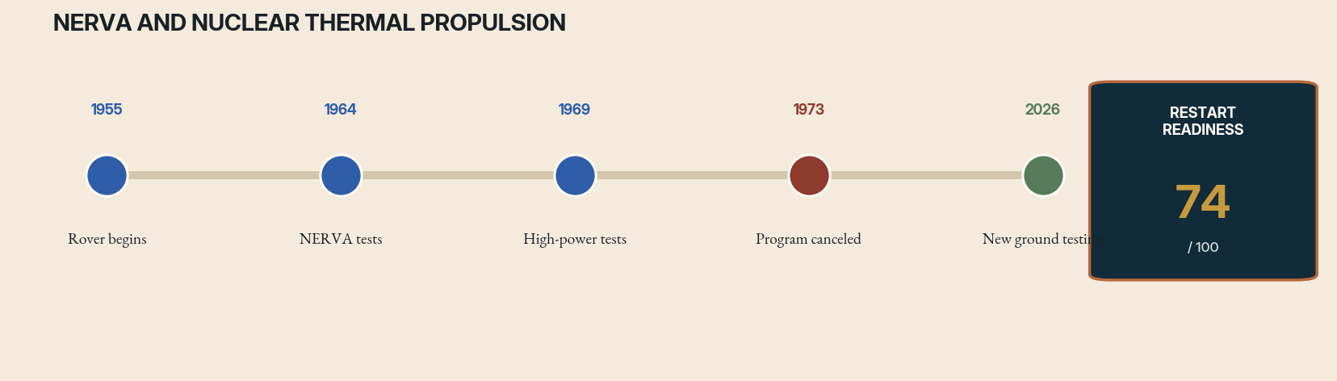
Case file 17 interruption timeline. Rust marks the decisive interruption; green marks successor activity. The readiness score is an editorial diagnostic, not a funding recommendation.
THE ORIGINAL WAGER
Project Rover and NERVA developed nuclear thermal rockets in which a reactor heated hydrogen propellant to produce high exhaust velocity. Ground tests demonstrated reactors and engines at substantial power. The technology was tied to ambitious crewed Mars and upper-stage concepts, offering higher efficiency than chemical propulsion while retaining significant thrust.
THE STOPPING FORCE
As Apollo wound down, the missions that justified nuclear stages disappeared. Budgets contracted, environmental and political concerns rose, and the program was canceled in 1973 before a flight test. The interruption occurred after major technical success but before operational integration—a classic case of an enabling technology losing the mission that made its risk acceptable.
WHAT SURVIVED
NERVA left test data, reactor-fuel experience, facilities, and a demonstrated performance lineage. It also left contamination and testing challenges that modern programs must confront openly. Nuclear thermal propulsion repeatedly returns in architecture studies because the physics advantage remains, but each revival must rebuild workforce, fuel production, and regulatory confidence.
WHAT HAS CHANGED
Advanced fuels, computational multiphysics, additive manufacturing, non-nuclear test methods, and higher-fidelity mission analysis improve development. NASA continues space nuclear propulsion work, while the DARPA–NASA DRACO demonstration program has concluded without an orbital test. In 2026 NASA reported new ground-testing milestones, showing the lineage is active but still preflight.
RESTART PROTOCOL
Create a mission-pulled program with staged fuel-element tests, full environmental accounting, independent safety review, and clear decisions about ground-test containment. Develop reactors and spacecraft operations together. Maintain a non-nuclear propulsion fallback so schedule pressure cannot turn safety exceptions into program doctrine.
THE COUNTERFACTUAL FORK
If NERVA had flown, nuclear propulsion might have become a normal upper-stage option or remained an expensive specialty awaiting Mars missions. A flight would have forced earlier decisions about reactor activation, launch accidents, ground testing, and end-of-life disposal. The technical lineage might be stronger today, but only if those institutions survived the environmental conflicts of the 1970s.
THE FIRST 365 DAYS
Year one should complete fuel-element irradiation plans, validate non-nuclear thermal test rigs, publish mission trades, and conduct a public environmental scoping process before selecting a flight date. An independent team should challenge contamination assumptions and compare chemical and electric alternatives. The program advances only if a real mission benefits enough to justify the nuclear system.
RED-TEAM GATE
Do not use Mars rhetoric to bypass nuclear governance. Launch approval, reactor start conditions, disposal, security, and test emissions are part of the propulsion system, not external paperwork.

RESEARCH ANCHORS
NASA histories of NERVA and current Space Nuclear Propulsion program; NASA 2026 testing updates; DARPA DRACO completion records.

18 FORENSIC DOSSIER
X-33 and VentureStar

FIELD | Reusable launch systems
ACTIVE LINE | 1996–2001 / lineage in reusable spaceflight
STOPPING FORCE | Composite tank failure, schedule, and program economics
RRI | 53 / 100 — provisional
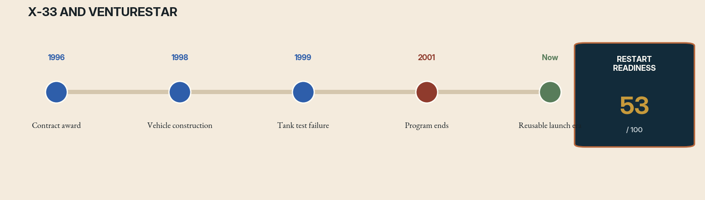
Case file 18 interruption timeline. Rust marks the decisive interruption; green marks successor activity. The readiness score is an editorial diagnostic, not a funding recommendation.
THE ORIGINAL WAGER
The X-33 was a subscale technology demonstrator for VentureStar, a proposed single-stage-to-orbit reusable vehicle. It combined a lifting-body shape, linear aerospike engines, metallic thermal protection, and lightweight composite hydrogen tanks. The program aimed to prove that airline-like operational concepts could radically lower launch cost.
THE STOPPING FORCE
A composite liquid-hydrogen tank failed during testing, and replacement paths threatened schedule and mass targets. The design had coupled several immature technologies so tightly that one failure destabilized the business case. NASA and Lockheed Martin ended the program in 2001 after substantial construction. The vehicle never flew.
WHAT SURVIVED
X-33 left aerospike tests, structures research, thermal-protection work, and a durable lesson about technology stacking. Reusability later succeeded through architectures that accepted staging and focused first on recovering high-value components. The unfinished experiment is not ‘Can launch vehicles be reusable?’ but ‘When does single-stage operation justify its punishing mass fraction?’
WHAT HAS CHANGED
Modern composites, cryogenic manufacturing, digital engineering, reusable boosters, autonomous flight software, and rapid test culture change the design space. Yet orbital energy has not changed. Single-stage-to-orbit remains extraordinarily sensitive to dry mass and operational assumptions. The strongest restart may use X-33 technologies in vehicles that do not inherit its all-or-nothing architecture.
RESTART PROTOCOL
Reconstruct the vehicle as a high-fidelity digital twin and run modern mass, reliability, and operations analyses. Build tank and thermal subscale demonstrators before committing to an integrated craft. Compare single-stage, two-stage, and point-to-point variants under identical lifecycle assumptions. Let the architecture change if the evidence demands it.
THE COUNTERFACTUAL FORK
Had the composite tank passed, X-33 might still have uncovered mass growth, maintenance, or operations barriers later in flight. Conversely, a successful demonstrator could have preserved aerospike and lifting-body development long enough for a different reusable architecture to emerge. The canceled program teaches that a single failed component can become a proxy for an entire tightly coupled vision.
THE FIRST 365 DAYS
Year one should rebuild the mass model from primary records, test contemporary composite and metallic tank candidates, and create an operations simulator using modern turnaround data. Teams must compare a resurrected single-stage vehicle with staged alternatives under identical mission and reliability assumptions. Only subsystem results, not affection for VentureStar, determine the integrated concept.
RED-TEAM GATE
Never let a desired business model dictate the physics inputs. ‘Airline-like’ is an outcome to measure, not a requirement to assume.

RESEARCH ANCHORS
NASA X-33 program records and lessons-learned studies; U.S. GAO reports on program termination.

19 FORENSIC DOSSIER
Energia–Buran

FIELD | Aerospace systems
ACTIVE LINE | 1976–1993 / one orbital flight
STOPPING FORCE | State collapse, cost, and absent mission
RRI | 27 / 100 — provisional
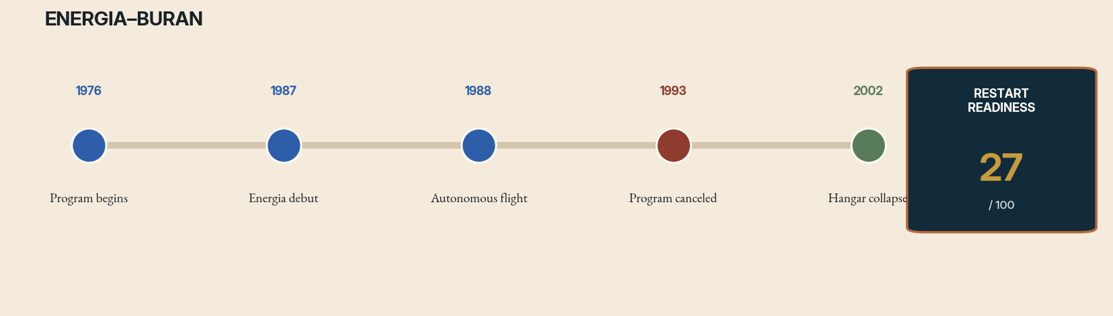
Case file 19 interruption timeline. Rust marks the decisive interruption; green marks successor activity. The readiness score is an editorial diagnostic, not a funding recommendation.
THE ORIGINAL WAGER
The Soviet Energia–Buran system combined a super-heavy launch vehicle with a reusable orbiter. Buran completed a fully automated orbital flight and landing in 1988 without crew aboard. Its launch stack differed from the U.S. Shuttle, and Energia could in principle carry payloads without the orbiter. The program represented a vast industrial effort across propulsion, guidance, thermal protection, and ground infrastructure.
THE STOPPING FORCE
Buran arrived as the Soviet economy and political system disintegrated. The program was extraordinarily expensive, lacked a compelling flight manifest, and had been shaped partly as a strategic response to the U.S. Shuttle. After one mission, funding vanished. Hardware and facilities deteriorated; a hangar collapse in 2002 destroyed the flown orbiter.
WHAT SURVIVED
The autonomous flight remains a major technical accomplishment. Energia’s propulsion lineage, guidance work, and operational records retain historical value. But the program also shows how symmetry with a rival can generate a machine without a durable civil mission. A system can succeed on its only flight and still fail as an institution.
WHAT HAS CHANGED
Autonomous landing is now routine, reusable launch markets are real, and digital manufacturing can reduce some overhead. The geopolitical, industrial, and supply-chain context that produced Energia no longer exists. Rebuilding it would require recreating an ecosystem rather than refurbishing a vehicle.
RESTART PROTOCOL
Do not revive Buran as a national prestige replica. Digitize surviving documentation, reconstruct flight software in emulation, preserve materials knowledge, and extract design patterns for autonomous reentry and heavy-lift operations. Any new reusable spacecraft should begin from contemporary missions and production capacity, not from the obligation to complete history.
THE COUNTERFACTUAL FORK
If the Soviet Union had remained stable, Buran could have flown additional automated missions, but its costs and unclear payload rationale would still have demanded a reckoning. It might have evolved into a cargo system around Energia or been canceled after a short prestige career. The alternate history underscores that technical excellence cannot substitute for a mission economy.
THE FIRST 365 DAYS
Year one should prioritize digital preservation: scan drawings, recover software, interview surviving personnel, and emulate the autonomous flight sequence. Materials specimens and test records should enter international archives. A contemporary mission study may reuse lessons, but no hardware replica proceeds unless it solves a current requirement better than available launch systems.
RED-TEAM GATE
A lost vehicle is not automatically an unfinished mission. The correct resumption may be archival and educational, not operational.

RESEARCH ANCHORS
Smithsonian National Air and Space Museum histories of Buran and scholarly aerospace histories.

20 FORENSIC DOSSIER
The Venera Lineage

FIELD | Planetary exploration
ACTIVE LINE | 1961–1984 / modern Venus revival
STOPPING FORCE | Program end, state priorities, and extreme environment
RRI | 82 / 100 — provisional
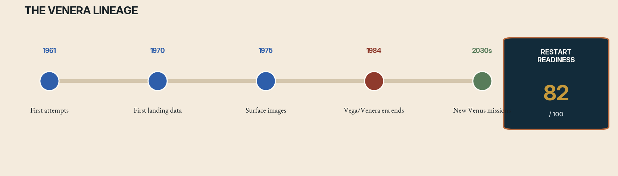
Case file 20 interruption timeline. Rust marks the decisive interruption; green marks successor activity. The readiness score is an editorial diagnostic, not a funding recommendation.
THE ORIGINAL WAGER
The Soviet Venera program repeatedly sent spacecraft into one of the harshest environments in the solar system. Landers survived crushing pressure and extreme heat long enough to return atmospheric measurements, chemical data, and images from the surface. The program advanced through failure, with each mission engineered from the evidence of the last.
THE STOPPING FORCE
The dedicated lineage ended as Soviet priorities and institutions changed. Venus’s environment made long-duration surface operations exceptionally difficult, while Mars and other destinations attracted more international attention. Knowledge remained in aging teams and dispersed records. The experiment of sustained surface science on Venus stopped after brief but historic successes.
WHAT SURVIVED
Venera left unique in-situ data and a model of evolutionary mission design. It also left uncertain calibration details and hardware knowledge difficult to reconstruct decades later. New missions can orbit and descend with modern instruments, but matching the old program’s willingness to learn through repeated probes requires a sustained cadence rather than one flagship event.
WHAT HAS CHANGED
High-temperature electronics, silicon-carbide devices, advanced pressure vessels, compact sensors, radar mapping, and atmospheric platforms improve prospects. NASA and other agencies have renewed Venus missions. The frontier is now duration: moving from minutes or hours toward days, months, and networks across altitude.
RESTART PROTOCOL
Build a Venus ladder: orbital context, balloon and aerial platforms, short-lived instrumented landers, then long-duration high-temperature stations. Recover Venera data and engineering records into an open calibration archive. Design missions as a series so each one carries explicit experiments for its successor.
THE COUNTERFACTUAL FORK
A continuous Venera cadence might have produced long-lived surface stations decades earlier, but only if teams retained the iterative culture that converted every failure into the next mission. The lost element was not one spacecraft design. It was the sequence itself. Interruption allowed expertise, calibration context, and supplier knowledge to decay between generations.
THE FIRST 365 DAYS
Year one should create a unified Venera data and calibration archive, test high-temperature electronics for thousands of hours, and design a family of low-cost atmospheric and surface probes. Mission interfaces should be stable enough that instruments can improve without redesigning the whole vehicle. Every flight includes a technology experiment for the next one.
RED-TEAM GATE
Avoid turning Venus into a one-shot competition. The scientific return depends on continuity, cross-calibration, and preservation of failure data.

RESEARCH ANCHORS
NASA histories of the Venera missions and deep-space exploration firsts.

21 FORENSIC DOSSIER
Quiet Supersonic Flight: A Resumption in Progress

FIELD | Aeronautics
ACTIVE LINE | 1960s–present / X-59 flight research
STOPPING FORCE | Sonic-boom regulation, economics, and public impact
RRI | 88 / 100 — provisional
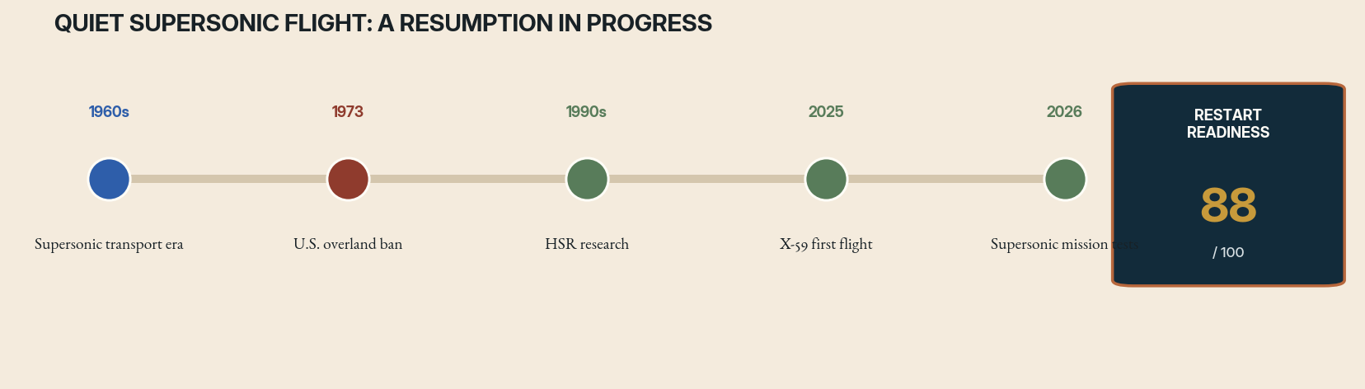
Case file 21 interruption timeline. Rust marks the decisive interruption; green marks successor activity. The readiness score is an editorial diagnostic, not a funding recommendation.
THE ORIGINAL WAGER
Civil supersonic flight promised to compress geography, but conventional aircraft produced disruptive sonic booms across entire flight paths. Environmental concern, noise, cost, and fuel use limited the market. The United States prohibited routine civil supersonic flight over land, turning boom reduction into a prerequisite for any broad revival.
THE STOPPING FORCE
Programs rose and fell as fuel prices, emissions, airline economics, and public acceptance changed. NASA’s High-Speed Research program advanced materials, propulsion, and acoustics but did not produce an operational airliner. The central experiment—whether a shaped vehicle could replace a boom with an acceptable ground thump—remained unfinished at community scale.
WHAT SURVIVED
Decades of wind-tunnel work, computational fluid dynamics, acoustic propagation, and human-response studies accumulated. Unlike many cases in this book, the lineage preserved a public research institution capable of returning to the question when design tools matured. The X-59 QueSST embodies that continuity.
WHAT HAS CHANGED
Precision shaping, simulation, flight control, and acoustic measurement now support a purpose-built research aircraft. The X-59 achieved its first flight in 2025 and NASA reported its first supersonic flight in 2026. The next experiment is social as much as aerodynamic: fly over communities, measure perception, and provide evidence for regulators.
RESTART PROTOCOL
Continue the program as a transparent public experiment. Publish acoustic signatures, route conditions, survey methods, and negative responses. Separate the low-boom question from airline promises about ticket price and emissions. Use the data to define performance-based standards rather than approving a particular manufacturer.
THE COUNTERFACTUAL FORK
Had earlier low-boom research reached a demonstrator, regulators might have received community data sooner. Yet commercial supersonic enthusiasm could also have outrun climate and equity analysis. The X-59 lineage benefits from being explicitly a research aircraft rather than a product prototype. Its counterfactual warns against allowing a successful acoustics experiment to answer unrelated policy questions.
THE FIRST 365 DAYS
Year one of community testing should pre-register survey methods, recruit demographically and geographically varied locations, publish raw acoustic conditions, and include communities that report negative impacts. Regulators should define in advance how results affect standards. Independent climate and airport-noise studies run in parallel but remain analytically separate.
RED-TEAM GATE
A quieter boom does not settle climate impact, airport noise, affordability, or route equity. Resuming one dimension of flight must not silently approve the entire commercial system.

RESEARCH ANCHORS
NASA High-Speed Flight project and 2025–2026 X-59 flight updates.

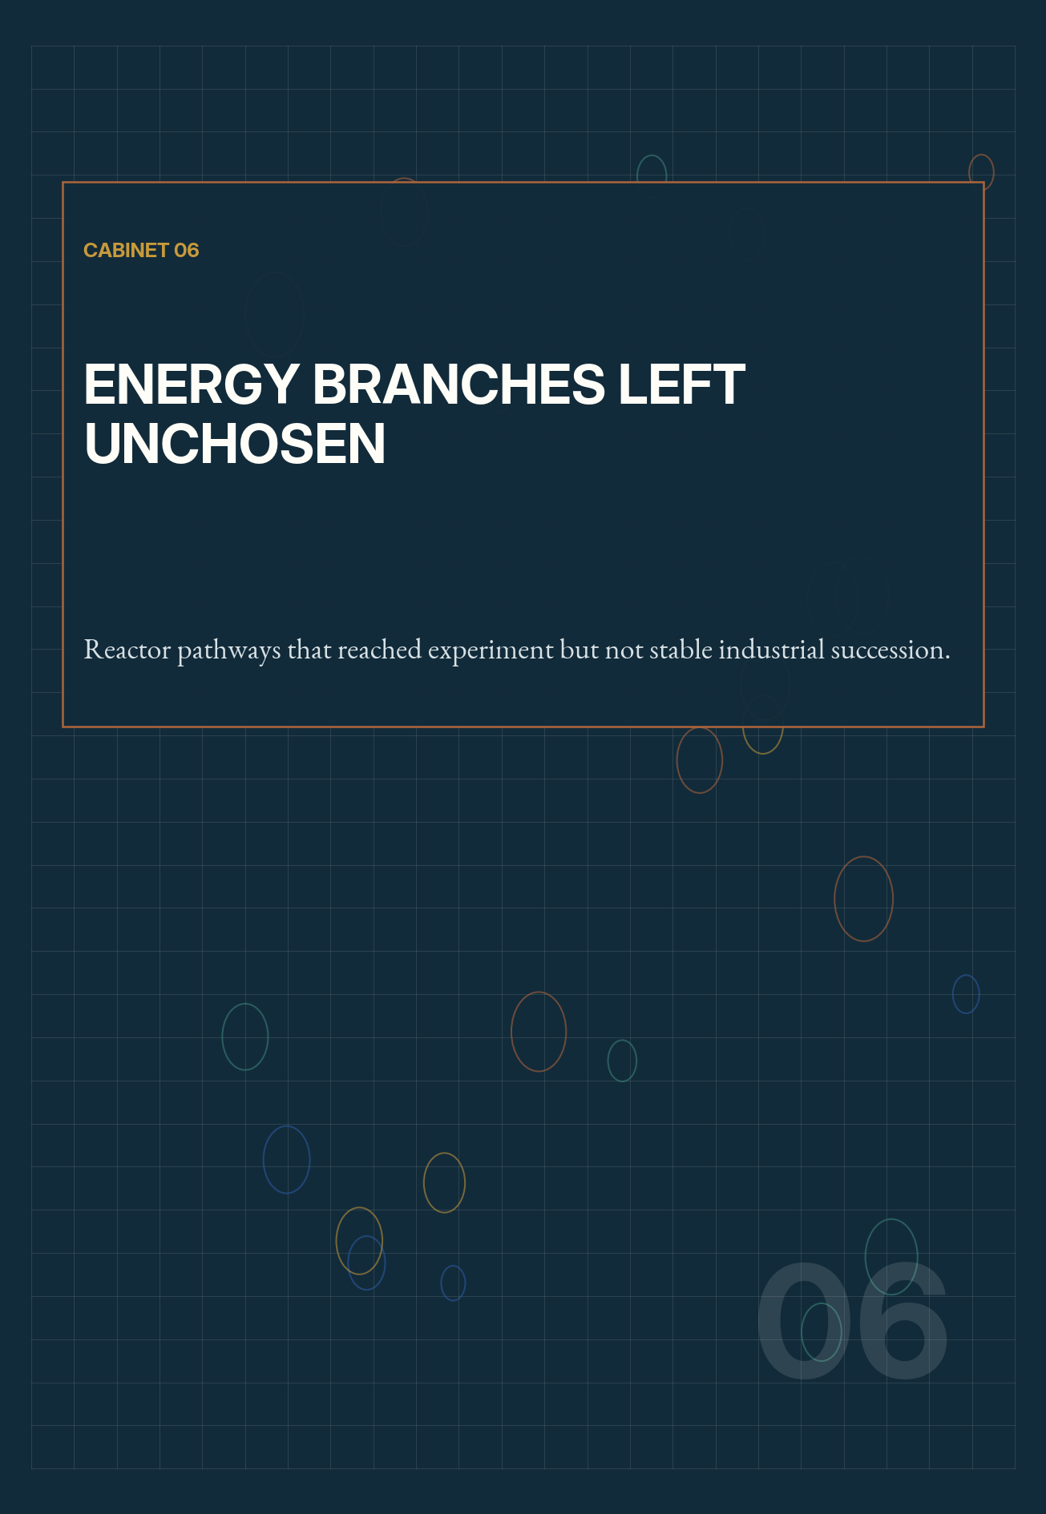

22 FORENSIC DOSSIER
The Molten-Salt Reactor Experiment

FIELD | Nuclear energy
ACTIVE LINE | 1965–1969 / contemporary test loops and demonstrations
STOPPING FORCE | Program priority shift and fuel-cycle politics
RRI | 68 / 100 — provisional
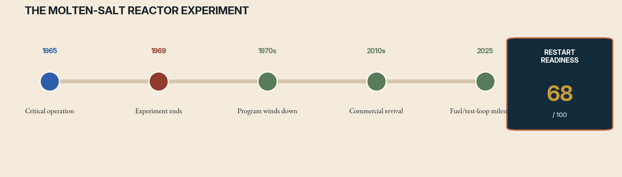
Case file 22 interruption timeline. Rust marks the decisive interruption; green marks successor activity. The readiness score is an editorial diagnostic, not a funding recommendation.
THE ORIGINAL WAGER
Oak Ridge National Laboratory’s Molten-Salt Reactor Experiment demonstrated a reactor in which liquid fuel circulated through the core. It operated with different fissile fuels, provided data on chemistry and materials, and supported a broader vision of high-temperature reactors with online processing and alternative fuel cycles.
THE STOPPING FORCE
The experiment completed its planned operations, but the larger development line lost priority to solid-fuel fast breeders and light-water systems already embedded in institutions and industry. Questions about fuel processing, proliferation, corrosion, tritium, maintenance, and licensing remained unresolved. The technology became an archive rather than a commercial lineage.
WHAT SURVIVED
MSRE left unusually valuable operational records, irradiated materials experience, and a physical cleanup challenge that continued long after shutdown. Its legacy is often simplified into either proof that molten-salt reactors are ready or proof they are impractical. In reality it proved a specific experimental system and exposed a long list of engineering work still required.
WHAT HAS CHANGED
Advanced alloys, chemistry monitoring, computational fluid dynamics, remote handling, safeguards, and modular test facilities improve the research environment. The U.S. Department of Energy has supported molten-salt tools and loops, and in 2025 reported fuel preparation for a molten-chloride reactor experiment. Multiple private designs now force regulators to address diverse salt and fuel configurations.
RESTART PROTOCOL
Resume through shared public infrastructure: corrosion loops, salt purification, off-gas systems, instrumentation, accident experiments, and waste-form research. Require developers to publish comparable materials and chemistry data. Progress from non-nuclear loops to low-power experiments before claiming commercial schedules.
THE COUNTERFACTUAL FORK
If molten-salt development had continued after MSRE, the United States might have resolved corrosion and processing questions earlier—or discovered that integrated maintenance and safeguards made the systems uneconomic. The experiment proved operation, not a commercial fleet. The interrupted years matter because materials and chemical expertise require continuity; enthusiasm cannot instantly recreate irradiated-salt experience.
THE FIRST 365 DAYS
Year one should establish shared salt-characterization standards, operate long-duration non-nuclear loops, recover historical samples and logs, and publish a cross-design hazard taxonomy. Regulators and laboratories should define what evidence transfers between fuel-salt and coolant-salt systems. Developers enter nuclear testing only after materials and off-gas milestones are independently reproduced.
RED-TEAM GATE
Do not treat the word ‘molten salt’ as one technology. Fuel salt, coolant salt, spectrum, processing, and containment choices create different hazards and regulatory cases.

RESEARCH ANCHORS
U.S. Department of Energy and Oak Ridge records on MSRE; current DOE molten-salt test infrastructure and 2025 reactor-experiment fuel milestones.

23 FORENSIC DOSSIER
The Integral Fast Reactor

FIELD | Nuclear energy / fuel cycles
ACTIVE LINE | 1984–1994 / successor fast-reactor research
STOPPING FORCE | Political cancellation for nontechnical reasons
RRI | 61 / 100 — provisional
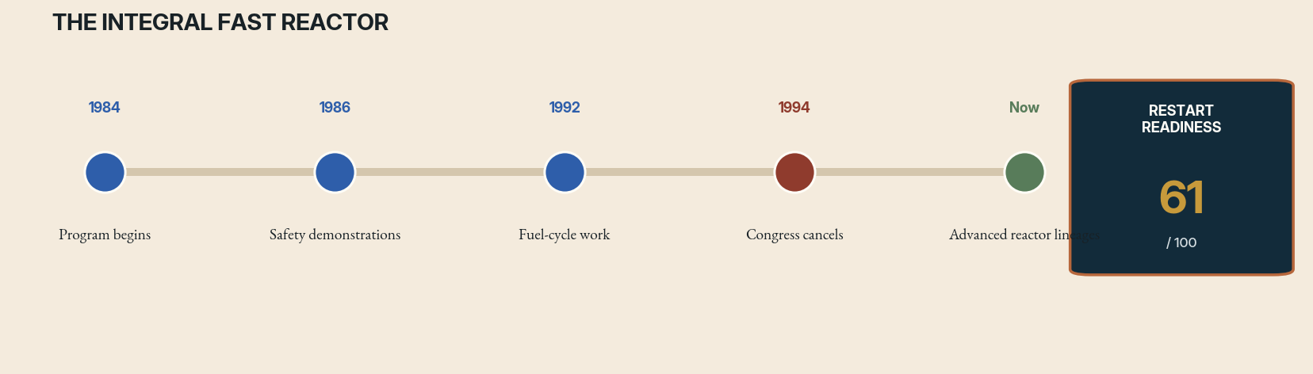
Case file 23 interruption timeline. Rust marks the decisive interruption; green marks successor activity. The readiness score is an editorial diagnostic, not a funding recommendation.
THE ORIGINAL WAGER
Argonne’s Integral Fast Reactor program combined a sodium-cooled fast reactor, metallic fuel, passive safety behavior, and on-site electrochemical recycling. The ‘integral’ claim mattered: reactor physics, fuel fabrication, recycle, waste, and proliferation properties were meant to be evaluated as one system rather than separate technologies.
THE STOPPING FORCE
The program was canceled in 1994 amid changing federal priorities and political opposition, despite significant technical progress. Supporters characterize the end as nontechnical; critics note unresolved economics, safeguards, sodium systems, and scale-up. Cancellation froze an integrated demonstration before the complete fuel-cycle proposition could be tested at operational scale.
WHAT SURVIVED
IFR left Experimental Breeder Reactor-II data, passive safety demonstrations, metallic-fuel knowledge, and pyroprocessing research. It also became a political symbol, making dispassionate assessment difficult. Some components continued in U.S. fast-reactor and fuel-cycle programs, but the original integrated mission did not.
WHAT HAS CHANGED
Advanced sensors, modeling, robotics, safeguards, and new reactor demonstration programs create a path to revisit components. Climate policy and interest in firm low-carbon power change the mission context. Yet construction cost, sodium fire risk, fuel qualification, waste claims, and proliferation analysis remain decisive.
RESTART PROTOCOL
Create a staged integrated test program with independent safeguards and economic teams. Demonstrate metallic fuel and passive response, then closed-loop material accounting, before expanding recycle claims. Compare the system against once-through reactors, renewables-plus-storage, and other firm power using transparent assumptions. Preserve the option to stop after any stage.
THE COUNTERFACTUAL FORK
Had IFR continued, it might have clarified whether integrated recycling improved waste and resource outcomes at acceptable cost. It also might have exposed scale-up, safeguards, or sodium-system problems that advocacy now treats as settled. Cancellation converted an empirical program into a symbolic argument. A restart is valuable precisely because it can force contested claims back into measurement.
THE FIRST 365 DAYS
Year one should reproduce passive-safety and metallic-fuel models against archived tests, establish independent material-accounting requirements, and compare fuel-cycle scenarios with common boundary conditions. A small integrated demonstration should separate reactor operation from recycling decisions so one does not preauthorize the other. Economics and safeguards teams must have authority to stop progression.
RED-TEAM GATE
A technical restart must not become a referendum on nuclear identity. Judge each claimed benefit separately and reject circular assumptions that recycling is valuable because a recycling reactor requires it.

RESEARCH ANCHORS
Argonne National Laboratory and U.S. Department of Energy histories of EBR-II and the Integral Fast Reactor.

RESTART WORKSHOP
How to Resume Without Repeating

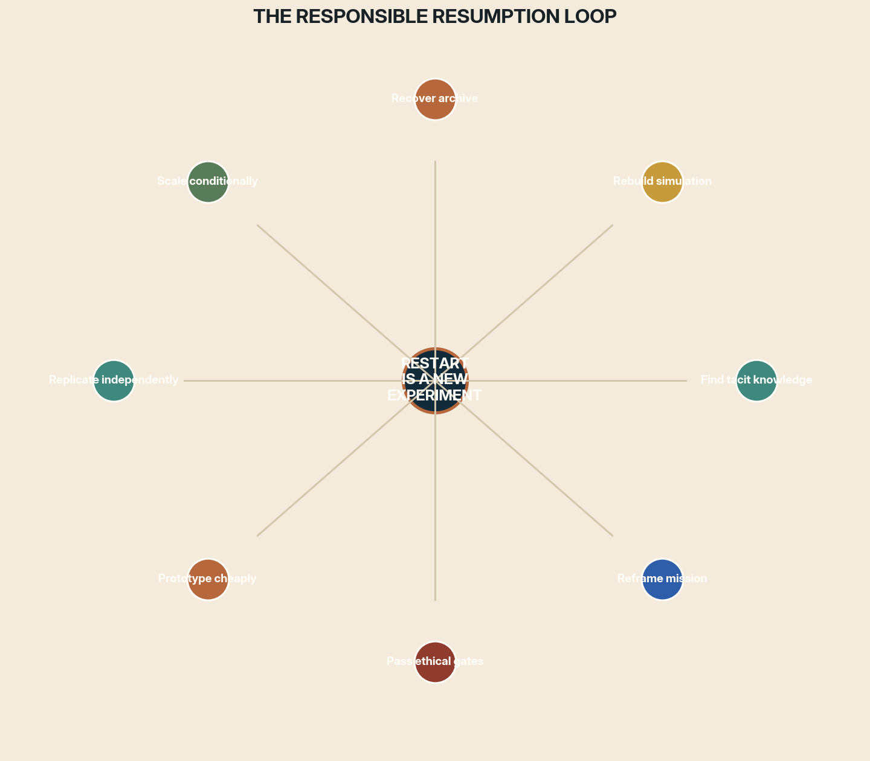
Figure 3. A restart is a new experiment whose first prototype is the recovery process itself.
The workshop begins with a refusal: no team may describe a project as ‘ready to resume’ until it can state what evidence would cause the restart to stop again. A revival without off-ramps is a campaign, not research. The steps below convert historical fascination into a falsifiable program.
01 WORKSHOP STATION
1. Recover the Decision Archive

Collect drawings, code, data, correspondence, cost records, safety reports, oral histories, and rejected alternatives. Preserve original ordering and uncertainty. Build a searchable map that distinguishes contemporary evidence from later recollection. The goal is not a heroic narrative but a record of choices.
Archive completeness = recoverable artifacts × interpretable context × provenance confidence

REQUIRED OUTPUT
Publish a decision-archive index that links every major claim to its source, date, custodian, version, and unresolved contradiction.

02 WORKSHOP STATION
2. Measure Knowledge Half-Life

List every critical capability and identify whether it resides in documents, surviving hardware, an active supplier, a living expert, or an extinct practice. Interview people before designing the restart. Recreate one old analysis or calibration chain to test whether the archive is executable.
K(t) = K₀e^(−λt); recovery investment should begin where λ is highest

REQUIRED OUTPUT
Create a knowledge-decay register ranking endangered skills, living experts, obsolete tools, replacement pathways, and the date by which each recovery action becomes materially harder.

03 WORKSHOP STATION
3. Reframe the Mission

Describe the underlying question without naming the original machine. Then generate at least three contemporary ways to answer it. A project may resume as an observatory network rather than a giant dish, a digital twin rather than a vehicle, or a governance institution rather than an outdoor experiment.
Mission continuity ≠ artifact continuity

REQUIRED OUTPUT
Produce a mission matrix comparing the historical artifact with at least three successor forms, including what each preserves, abandons, newly risks, and can falsify.

04 WORKSHOP STATION
4. Simulate Before Reconstructing

Create a reference model with explicit uncertainty and reproduce historical test results. Use it to identify which old assumptions still govern performance. Simulation should narrow experiments, not replace them. Publish disagreement between models instead of choosing the most favorable one.
Restart value = expected information gain / irreversible cost

REQUIRED OUTPUT
Release a simulation-validation report containing reproduced historical cases, uncertainty bounds, model disagreements, missing parameters, and the physical test most likely to overturn the forecast.

05 WORKSHOP STATION
5. Build the Smallest Decisive Prototype

Do not begin by recreating the integrated system. Build the subsystem whose result most changes the decision. For X-33, that might be a cryogenic tank; for a ternary processor, a compiler and FPGA core; for a mantle mission, a drilling and riser demonstration.
Prototype priority ∝ decision sensitivity × uncertainty × reversibility

REQUIRED OUTPUT
Write a decisive-prototype brief defining one disputed assumption, a reversible apparatus, measurement thresholds, replication plan, disposal plan, and explicit go, revise, or stop outcomes.

06 WORKSHOP STATION
6. Establish Governance Before Scale

Assign owners for safety, data, environmental impact, public engagement, and independent review before hardware commitments become politically irreversible. Projects that affect shared resources require institutions at the scale of their consequences.
No governance, no field release

REQUIRED OUTPUT
Draw a governance map naming rights-holders, decision owners, independent reviewers, appeal routes, liability boundaries, public reporting duties, and the authority empowered to halt the work.

07 WORKSHOP STATION
7. Fund a Ladder, Not a Cliff

Divide the restart into stages that each produce useful knowledge. Precommit review points and archive funding. Protect negative results and staff transition. A stage should be allowed to succeed scientifically while recommending that the next stage not occur.
Program resilience = stage value × off-ramp credibility × archive quality

REQUIRED OUTPUT
Build a staged funding ladder in which every tranche has a knowledge product, review gate, archive budget, workforce transition plan, and credible termination path independent of sunk cost.

08 WORKSHOP STATION
8. Test the Successor Institution

Run tabletop exercises in which a sponsor withdraws, a key engineer leaves, a supplier fails, public opposition rises, or a safety result is unfavorable. The institution should degrade gracefully and preserve the evidence needed for another generation to understand what happened.
Institutional readiness = continuity under loss, not confidence under stability

REQUIRED OUTPUT
Deliver a resilience exercise report showing how the program responds to five losses, which functions fail first, what evidence remains recoverable, and which institutional redesigns are required before launch.

09 WORKSHOP STATION
9. Decide Whether Not to Resume

Some projects are best completed by documenting why they should remain stopped. A formal non-resumption decision can specify what evidence or governance change would reopen the question. This transforms abandonment into an accountable scientific result rather than indefinite limbo.
A responsible stop is a valid research output

REQUIRED OUTPUT
Issue a non-resumption memorandum stating the decisive objection, evidence reviewed, affected publics, conditions that could reopen the question, preservation obligations, and date of mandatory reconsideration.

APPENDIX A
Resumption Readiness Scorecard

DIMENSION | QUESTION | EVIDENCE | GATE
Scientific question | Is the question still important and not already answered elsewhere? | Cite / test / interview | Pass / revise / stop
Archive | Can decisions, data, and versions be reconstructed? | Cite / test / interview | Pass / revise / stop
Tacit knowledge | Are operators or executable procedures still recoverable? | Cite / test / interview | Pass / revise / stop
Enabling technology | Which old bottleneck has demonstrably changed? | Cite / test / interview | Pass / revise / stop
Institution | Who can sustain the work across political and personnel change? | Cite / test / interview | Pass / revise / stop
Economics | Is the staged program affordable relative to alternatives? | Cite / test / interview | Pass / revise / stop
Governance | Can rights, safety, liability, and appeal be established before scale? | Cite / test / interview | Pass / revise / stop
Legitimacy | Are affected communities participants rather than audiences? | Cite / test / interview | Pass / revise / stop
Hazard | Can severe harms be bounded, reversed, or avoided? | Cite / test / interview | Pass / revise / stop
Off-ramp | What result ends or redirects the program? | Cite / test / interview | Pass / revise / stop
SCORING RULE
Never average away a failed ethical or safety gate. The index helps compare recoverability; it does not authorize action.

APPENDIX B
Restart Charter Template

01 — LIVING QUESTION
The precise unanswered question, stated without the historical artifact.

02 — HISTORICAL INHERITANCE
Artifacts, data, teams, patents, sites, and unresolved disputes.

03 — CHANGED CONDITION
The enabling technology or institution that makes a new test rational.

04 — SMALLEST DECISIVE EXPERIMENT
A reversible prototype that changes the go/no-go decision.

05 — AFFECTED PUBLICS
People, communities, ecosystems, and future operators with standing.

06 — ETHICAL HARD GATES
Conditions that cannot be traded against schedule or scientific value.

07 — EVIDENCE PLAN
Measurements, comparators, uncertainty, replication, and publication.

08 — INSTITUTIONAL DESIGN
Ownership, independent review, succession, maintenance, and archives.

09 — OFF-RAMPS
Predeclared results that stop, pause, narrow, or redirect the program.

10 — AFTERLIFE PLAN
How data, hardware, and knowledge remain useful after completion or cancellation.

A restart is complete when its next interruption will be intelligible

CODA
The Future Is Full of Discontinued Lines

Research history is not a staircase. It is a landscape of branches, some cut by evidence, some by power, some by accident, and some by the arrival of a better path. The surviving branch is not always the best imaginable one. The abandoned branch is not automatically the future we were denied.
The mature response to unfinished experiments is neither worship nor dismissal. It is forensic imagination: recover enough of the old world to understand the wager, then design a new experiment that can disagree with it. This may mean building a machine at last. It may mean transferring one subsystem into another program. It may mean preserving an archive, funding a successor question, or establishing that the old intervention should remain unperformed.
A civilization that cannot resume valuable inquiry wastes the sacrifices embedded in its archives. A civilization that cannot refuse a seductive revival repeats the failures embedded there. The work of return is to become capable of both memory and restraint.
FINAL PROPOSITION
The purpose of an archive is not to make the past inevitable. It is to give the future more than one beginning.

RESEARCH LEDGER
Selected Institutional and Scholarly Foundations

The case files synthesize public institutional records and scholarly histories. Dates and current-status claims were checked against official sources available through August 2026. Restart protocols and readiness scores are original analytical proposals for this volume.
- NASA Technical Reports Server: Project Orion and nuclear pulse propulsion histories.
- NASA: NERVA/Rover histories; Space Nuclear Propulsion program; 2026 ground-test updates.
- DARPA and NASA TechPort: DRACO program completion records.
- International Ocean Discovery Program: Project Mohole and later scientific ocean drilling.
- U.S. Government Accountability Office and Department of Energy: Superconducting Super Collider cost and management records.
- CERN: Future Circular Collider feasibility study and 2026 European strategy materials.
- NASA/JPL: Terrestrial Planet Finder archives and Habitable Worlds Observatory program materials.
- National Science Foundation: Arecibo cable failures, collapse, decommissioning, and C3 site transition.
- Slava Gerovitch and Benjamin Peters: histories of Soviet computer networking and OGAS.
- Japan National Diet Library and ICOT archives: Fifth Generation Computer Systems project records.
- MIT Press and Computer History Museum: Thinking Machines and Connection Machine histories.
- Tesla Science Center at Wardenclyffe; DARPA POWER program records.
- IFIP and Russian Virtual Computer Museum: Setun balanced-ternary computer histories.
- Science Museum and Plan 28: Babbage Analytical Engine drawings and reconstruction program.
- University of Arizona: Biosphere 2 history and current research.
- Peer-reviewed histories and contemporary trial reviews of psychedelic medicine.
- Peer-reviewed histories of phage therapy and U.S. FDA investigational guidance.
- Smithsonian National Air and Space Museum: Energia–Buran history.
- NASA: Venera mission histories and Venus exploration records.
- Nature and public project records: SPICE and SCoPEx governance controversies; U.S. GAO geoengineering governance analysis.
- NASA: High-Speed Research and 2025–2026 X-59 mission updates.
- NASA and U.S. GAO: X-33/VentureStar records and lessons learned.
- Oak Ridge National Laboratory and U.S. Department of Energy: MSRE and current molten-salt research.
- Argonne National Laboratory and U.S. Department of Energy: Integral Fast Reactor and EBR-II histories.
METHOD NOTE
Absence from this ledger does not imply that a project had no other participants or interpretations. Each dossier is an entry point for deeper archival work, not a substitute for it.

