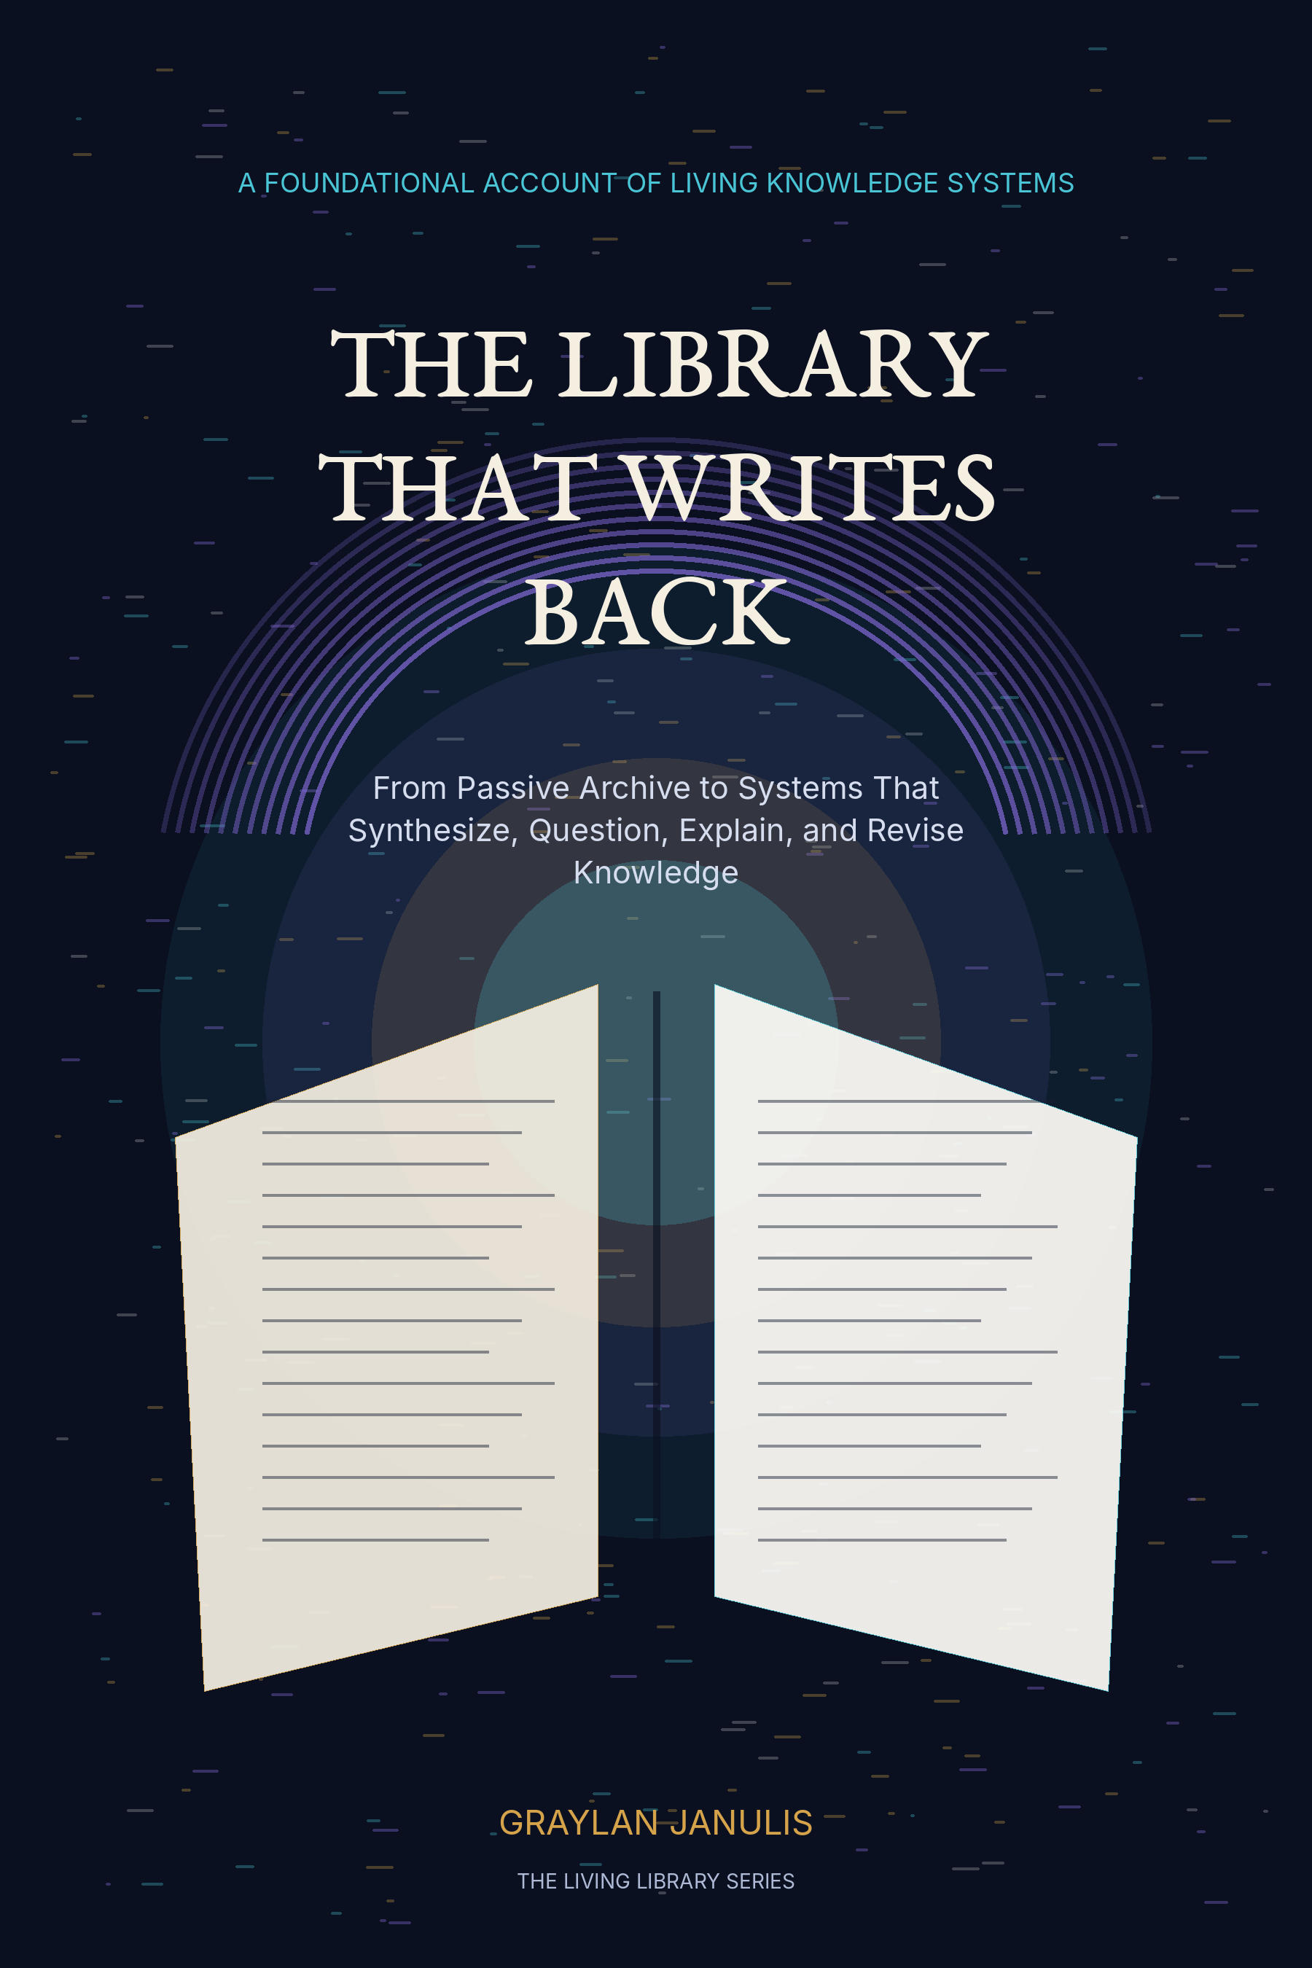

THE LIBRARY
THAT WRITES BACK
From Passive Archive to Systems That Synthesize, Question, Explain, and Revise Knowledge
GRAYLAN JANULIS

A NOTE ON THE LIVING LIBRARY
This book is a foundational design account. It combines established library practices, current digital-library infrastructure, linked-data methods, retrieval-augmented generation, versioning systems, and AI risk-management principles with a proposed architecture for libraries that can synthesize, question, explain, and revise knowledge.
The proposed library is not an autonomous oracle. It is a governed institution in which models operate inside collection policy, provenance, rights, human review, and public accountability. Every new cognitive capacity remains subordinate to the older duties of preservation, access, intellectual freedom, and stewardship.
The book uses equations as design models rather than claims of exact measurement. Exercises are included so that each chapter can function as an implementation workshop, graduate seminar, or institutional planning guide.
“The library of the future does not merely return what was stored.
It shows what follows, what conflicts, what remains unknown, and what must change.”

CONTENTS
PART I · THE SILENT LIBRARY
01 The Room That Remembered
02 Catalogs: Memory Learns Coordinates
03 The Public Library as Civic Operating System
04 Digitization and the Illusion of Access
05 Search Is Not Understanding
PART II · THE LIBRARY BECOMES A GRAPH
06 Metadata as Latent Intelligence
07 Authority, Identity, and the Problem of Names
08 From Bibliographic Graph to Claim Graph
09 Temporal Knowledge and the Shape of Change
10 The Knowledge Fabric
PART III · THE LIBRARY LEARNS TO ANSWER
11 Retrieval-Augmented Librarianship
12 The Query Planner
13 Evidence Packets Before Prose
14 The Explanation Engine
15 Dialogue Without Dependency
PART IV · THE LIBRARY LEARNS TO QUESTION
16 The Contradiction Engine
17 Uncertainty Is Part of the Answer
18 The Library Generates Questions
19 The Adversarial Librarian
20 Refusal, Silence, and Epistemic Humility
PART V · THE LIBRARY LEARNS TO REVISE
21 Living Editions
22 Correction Propagation
23 Memory Architecture for a Living Institution
24 Provenance, Rights, and the Chain of Thought We Can Show
25 The Human Constitution
PART VI · THE LIBRARY BECOMES AN INSTITUTION OF INTELLIGENCE
26 The Classroom That Can Revise Its Textbook
27 The Research Library as Discovery Partner
28 The Community Library That Remembers Locally
29 The Creative Library
30 The Library That Writes Back
Appendix A — The Cognitive Library Reference Architecture
Appendix B — Core Data Objects and Schemas
Appendix C — Evaluation and Audit Rubrics
Appendix D — A Constitution for the Library That Writes Back
Glossary
Research Notes and Sources

PROLOGUE
WHEN THE CATALOG ANSWERED
A reader enters with a question that does not yet have a title. The old library points toward shelves, databases, archives, and experts. The new library still does all of that, but it can also assemble the evidence, reveal disagreement, explain the mechanism, and preserve the research path as a durable object.
Then it does something more difficult. It asks whether the question was framed correctly. It discovers that two fields use different words for the same structure, that an influential claim depends on one disputed dataset, or that a community has been described repeatedly without being heard. It returns not only an answer, but a map of the answer’s limits and a set of better questions.
Later, a source is corrected. The library traces the change through claims, chapters, lessons, and prior answers. It releases a new edition without erasing the old one. The institution remembers not only knowledge, but the history of its own revision. This is the library that writes back.

PART I
THE SILENT LIBRARY
How preservation, cataloging, and public access created the preconditions for intelligence.

CHAPTER 01
The Room That Remembered
Before a library could answer, it had to survive.
━━━━━━━━━━━━━━━━━━━━━━━━━
The first library intelligence was endurance. Clay tablets, scrolls, manuscripts, printed books, maps, recordings, and born-digital files all share the same first problem: they disappear unless an institution accepts responsibility for them. Preservation is not passive. It is an active sequence of selection, description, storage, environmental control, migration, repair, and access decisions performed across generations. A library becomes more than a warehouse when it promises that an object will remain findable after the people who acquired it are gone.
This promise creates a distinctive kind of time. Commercial platforms optimize for the present session, the current market, or the next engagement cycle. Libraries preserve against fashion. They keep material whose importance may not yet be visible, maintain unpopular viewpoints, and protect the evidence needed to reconstruct how a society once understood itself. The archive therefore contains a latent future: readers who do not exist yet, questions no one has formulated, and relationships that cannot be discovered until other materials arrive.
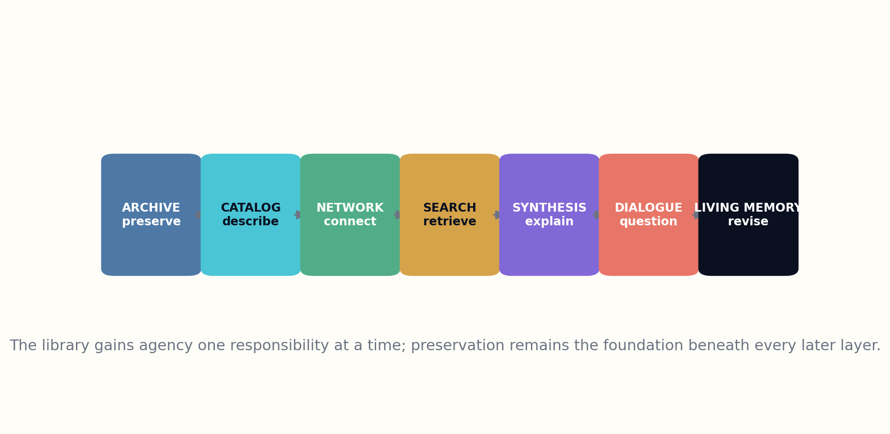
Figure 1. The cumulative evolution from archive to living, revisable knowledge system.

HOW THE SYSTEM WORKS
The Library That Writes Back begins by refusing the idea that artificial intelligence replaces this work. A model can summarize a file it can see, but it cannot guarantee that the file remains authentic, legible, lawful, and locatable over decades. The living library must inherit preservation discipline from archivists before it inherits fluent generation from language models. Otherwise it will become a brilliant conversational layer floating above unstable memory.
Preservation also sets the ethical boundary of selection. No institution can keep everything with equal care. A cognitive library must expose why materials were collected, excluded, restricted, digitized, or allowed to decay. Those decisions become part of the knowledge system because absence shapes every answer. A future library should be able to say not only what it knows, but why its evidence base looks the way it does.

THE INSTITUTIONAL TEST
The evolution described in this book is cumulative. Preserve, describe, connect, retrieve, synthesize, question, and revise are not replacements for one another. Each new capacity becomes legitimate only when it strengthens the obligations beneath it. The library writes back because it remembers how it learned to speak.
Institutional memory M(t) = preserved objects × authenticity × discoverability × time horizon
DESIGN EXERCISE
• List the preservation duties that an AI answer system normally assumes someone else has handled.
• Describe one future question your institution should preserve evidence for now.
• Write a collection decision that includes both what is kept and what remains absent.
Research notes: R1, R2. See Research Notes and Sources.

CHAPTER 02
Catalogs: Memory Learns Coordinates
A collection without coordinates is a room full of locked doors.
━━━━━━━━━━━━━━━━━━━━━━━━━
Cataloging was the first major act of computational imagination in the library. It transformed individual objects into records that could be sorted, compared, grouped, and retrieved without opening every item. Author names, titles, subjects, dates, editions, physical descriptions, and call numbers did more than help staff place books on shelves. They created an abstract representation of the collection: a second library made of metadata.
Every catalog is also a theory of relevance. A subject heading decides which concepts deserve stable names. An authority record decides when two names refer to the same person. A classification system places some topics close together and others far apart. These structures make discovery possible, but they also encode historical assumptions. The living library must preserve their utility while making their choices visible and revisable.

HOW THE SYSTEM WORKS
Machine-readable cataloging made the abstract library portable. Records could move between institutions, support shared cataloging, and power automated systems. Yet record exchange alone did not create semantic unity. The same person, work, place, or event could still appear under inconsistent identifiers. The next step would require shifting from fields in isolated records toward entities with persistent identities and explicit relationships.
For an AI library, cataloging becomes the first defense against hallucination. Before a model explains a work, the system should know which edition it means, who created it, how it relates to translations or adaptations, and whether the record is complete. Bibliographic identity is not clerical decoration; it is the boundary around the object being discussed.

THE INSTITUTIONAL TEST
The catalog therefore evolves from a lookup table into a trust layer. It tells the answering system what exists, what is uncertain, what changed, and which descriptive decisions came from humans. When the library eventually speaks, its grammar begins in metadata.
Findability F = description quality × identifier stability × vocabulary alignment × access availability
DESIGN EXERCISE
• Choose a familiar book and list five identity problems a careless AI could confuse.
• Identify one classification decision that embeds a cultural assumption.
• Design a record field that captures uncertainty instead of forcing false precision.
Research notes: R1, R3. See Research Notes and Sources.

CHAPTER 03
The Public Library as Civic Operating System
Access becomes intelligence when a community can act on what it finds.
━━━━━━━━━━━━━━━━━━━━━━━━━
The public library expanded the meaning of access. It did not merely open collections; it built a civic interface around them. Reference interviews, children’s programs, literacy instruction, local history rooms, meeting spaces, job-search assistance, technology access, and interlibrary loan turned the collection into a social operating system. The librarian translated between a person’s incomplete question and the structures of recorded knowledge.
That translation matters because users rarely arrive with well-formed queries. They arrive with situations: a diagnosis they do not understand, a legal notice, a school assignment, a family mystery, a business idea, a language barrier, or a fear they cannot name precisely. The reference librarian performs intent discovery, risk assessment, source selection, explanation, and referral. Modern AI systems often rediscover these functions without recognizing their institutional ancestry.

HOW THE SYSTEM WORKS
A library that writes back should inherit the reference ethic: ask enough to understand, preserve privacy, avoid pretending certainty, distinguish information from professional advice, and strengthen the user’s ability to continue independently. The objective is not to maximize conversational dependence. It is to increase agency.
Civic access also means resisting a single model of the reader. Communities contain different languages, literacy levels, disabilities, political experiences, and relationships to authority. A living library adapts format and explanation while keeping evidence standards stable. Personalization should change the path through knowledge, not secretly change the facts available to different people.

THE INSTITUTIONAL TEST
The future library remains a place, even when its intelligence is distributed. Physical space provides privacy, human contact, community governance, and access for people excluded by devices or accounts. The cognitive layer should deepen the institution’s public role rather than dissolve it into a private assistant owned elsewhere.
Civic value C = access × agency × privacy × inclusion × continuity of service
DESIGN EXERCISE
• Rewrite a vague user request as the underlying situation it may represent.
• Specify which reader adaptations are helpful and which would become discriminatory.
• Design an AI service that hands the user back more independence than they had at the start.
Research notes: R2, R4. See Research Notes and Sources.

CHAPTER 04
Digitization and the Illusion of Access
A scan is not access until it can be found, understood, and trusted.
━━━━━━━━━━━━━━━━━━━━━━━━━
Digitization created an extraordinary illusion: once an object became pixels, it appeared to be available. In practice, a digital object may remain buried behind weak metadata, unreadable interfaces, proprietary formats, poor optical character recognition, missing rights information, or broken links. The distance between possession and use did not disappear. It changed form.
A living library treats digitization as a chain of transformations. The source object is imaged; text may be extracted; layout is inferred; language is identified; names and dates are recognized; rights are assessed; and derivatives are created for access. Each transformation can introduce error. The system must preserve the original, record the tools and versions used, and expose confidence where extraction is uncertain.

HOW THE SYSTEM WORKS
Digital scale also changes selection pressure. Materials that are easy to scan, already described, written in dominant languages, or free of rights ambiguity become overrepresented in computational research. Difficult collections become invisible to models even when they are historically important. The library must measure this bias and invest deliberately in the hard edges of the collection.
Generative systems intensify the problem because they can make thin access look complete. A fluent answer synthesized from a small digitized subset may conceal the existence of uncataloged boxes, undigitized languages, restricted records, or missing local publications. Every answer should carry a coverage statement: what source universe was searched, what was excluded, and how that limitation affects confidence.

THE INSTITUTIONAL TEST
Digitization is therefore not the moment the library becomes intelligent. It is the moment the collection becomes computationally addressable. Intelligence begins when the system can reason about the limits and lineage of those digital representations.
Effective access A = digital availability × discoverability × readability × rights clarity × coverage honesty
DESIGN EXERCISE
• Map every transformation between a physical page and an AI answer.
• Identify which materials in a collection are computationally overrepresented.
• Write a coverage statement for an incomplete digital corpus.
Research notes: R1, R5. See Research Notes and Sources.

CHAPTER 05
Search Is Not Understanding
The ranked list is a map of candidates, not a completed act of thought.
━━━━━━━━━━━━━━━━━━━━━━━━━
Search engines taught users to expect immediate access to enormous collections. They also compressed the intellectual problem into ranking: identify documents likely to match a query and order them. This is indispensable, but it does not answer whether the documents agree, whether the user has enough background to interpret them, whether the most cited result is still current, or how evidence should change a decision.
Understanding requires operations beyond retrieval. The system must identify the question type, gather diverse evidence, compare definitions, reconstruct mechanisms, detect contradictions, estimate uncertainty, and choose an explanatory path for a particular reader. These are editorial and reasoning tasks. A library that writes back performs them explicitly instead of hiding them inside a single opaque response.

HOW THE SYSTEM WORKS
The distinction can be framed as a transformation from documents to intellectual instruments. A search result gives the user material. A synthesis explains what follows from the material. A tutorial creates capability. A decision brief clarifies tradeoffs. A controversy map shows where agreement ends. A living edition records how the answer changed. Each output has a different production contract.
Search also needs stopping rules. Infinite retrieval can always find another document, while premature retrieval can miss decisive counterevidence. The library should stop when additional sources are unlikely to change the answer at the required risk level, not merely when a context window is full. High-consequence questions require broader source diversity and stronger review.

THE INSTITUTIONAL TEST
The future of the library is not the disappearance of search. It is search embedded inside a larger epistemic workflow. The user should be able to move backward from an explanation to the evidence, sideways to disagreement, and forward to questions the current record cannot yet answer.
Understanding U = retrieval × comparison × mechanism × uncertainty × reader fit
DESIGN EXERCISE
• Turn one search query into three different knowledge products.
• Define a stopping rule for a low-risk and a high-risk question.
• Design a path from an answer back to evidence and forward to open questions.
Research notes: R6, R7. See Research Notes and Sources.

PART II
THE LIBRARY BECOMES A GRAPH
How records become relationships, and collections become machine-readable knowledge.

CHAPTER 06
Metadata as Latent Intelligence
The catalog was already a knowledge model; linked data lets it admit what it has always been.
━━━━━━━━━━━━━━━━━━━━━━━━━
Traditional metadata records describe resources one item at a time. Linked data changes the unit of thought. A person, place, concept, organization, event, and work receive persistent identities that can be referenced across records and institutions. The catalog becomes a network in which meaning is carried by relationships rather than repeated text fields.
This shift matters for AI because language models are excellent at producing plausible associations but unreliable at maintaining identity across scale. A graph can state that two names refer to one person, that a translation realizes a particular work, that an exhibition occurred at a place during a date range, or that a subject term changed over time. The model may propose links, but the graph preserves adjudicated structure.
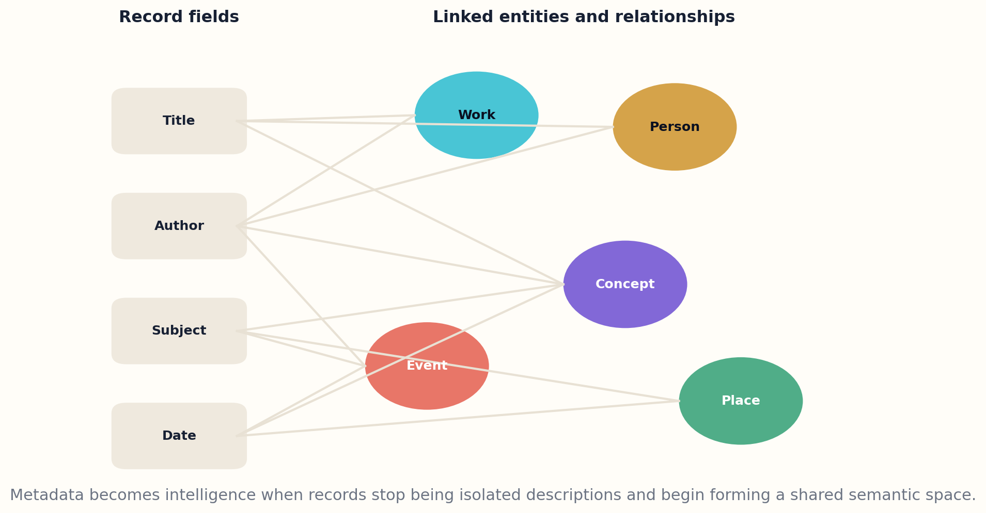
Figure 2. Bibliographic fields become linked entities whose relationships can support reasoning.

HOW THE SYSTEM WORKS
Library linked data also creates a bridge between professional description and the wider web. Collections no longer need to remain isolated behind institution-specific interfaces. Shared identifiers allow local records to connect with external scholarly, cultural, and civic datasets while retaining local notes and authority. The result is not a single global catalog but a federation of accountable descriptions.
The danger is to confuse graph connectivity with truth. Edges can be wrong, incomplete, culturally contested, or produced from biased source material. Every relationship should carry provenance, confidence, temporal scope, and review status. Some entities should support multiple names or interpretations rather than forcing one canonical label.

THE INSTITUTIONAL TEST
The intelligent library uses metadata as a reasoning substrate, but librarians remain responsible for the ontological choices. Machines can accelerate suggestion and reconciliation. Humans decide which distinctions matter, whose vocabulary governs, and how conflict is represented without erasure.
Graph utility G = identity stability × relationship density × provenance × semantic pluralism
DESIGN EXERCISE
• Convert four catalog fields into entities and relationships.
• Add provenance and temporal scope to one graph edge.
• Identify a concept that requires multiple community vocabularies rather than one canonical term.
Research notes: R3, R8, R9. See Research Notes and Sources.

CHAPTER 07
Authority, Identity, and the Problem of Names
Every answer begins by deciding what its nouns refer to.
━━━━━━━━━━━━━━━━━━━━━━━━━
Identity resolution is one of the least glamorous and most consequential problems in a cognitive library. Authors share names, institutions merge, places change boundaries, works appear in multiple editions, and historical people are described differently across cultures. If identity is unstable, retrieval fragments evidence and synthesis combines things that do not belong together.
Authority control traditionally established preferred forms and cross-references. The living library extends this into identity graphs with aliases, language-specific labels, temporal names, uncertain matches, and community assertions. A stable identifier should not erase variation; it should provide a place where variation can be represented and sourced.

HOW THE SYSTEM WORKS
Models can assist by proposing candidate matches from context, citation networks, affiliations, and dates. Yet automatic reconciliation must be reversible. A false merge can contaminate every downstream answer, while an unjustified split can hide a person’s body of work. High-impact identities require human review and confidence thresholds.
Identity also raises questions of power. Historical records may use imposed names, colonial classifications, deadnames, or descriptions rejected by the people represented. The system needs policies for respectful display, historical fidelity, searchability, and restricted knowledge. The right answer may be multiple labels with clear context rather than one universal preference.

THE INSTITUTIONAL TEST
When the library writes back, it should be able to explain its identity decision. The user can see why two records were linked, what evidence supports the link, and what uncertainty remains. This transforms authority from invisible control into inspectable stewardship.
Identity confidence I = contextual agreement × temporal compatibility × source authority × reviewer confirmation
DESIGN EXERCISE
• Create an identity record with aliases, dates, uncertainty, and community-preferred labels.
• Describe the damage caused by one false merge and one false split.
• Write an explanation the system could show when an identity match is uncertain.
Research notes: R3, R8. See Research Notes and Sources.

CHAPTER 08
From Bibliographic Graph to Claim Graph
Documents are containers; claims are the units that argue with one another.
━━━━━━━━━━━━━━━━━━━━━━━━━
A bibliographic graph tells us that works, people, subjects, and institutions are related. A claim graph reaches inside the work. It represents propositions, methods, evidence, conditions, limitations, counterclaims, corrections, and dependencies. This is the point where the library begins to model knowledge rather than only the containers of knowledge.
Claims must be typed. Observation, causal inference, theoretical deduction, interpretation, estimate, recommendation, and testimony require different standards. The system records the exact source span, who made the claim, what population or context it applies to, what evidence supports it, and how confident the extractor is. A sentence that sounds universal may turn out to describe one experiment under narrow conditions.
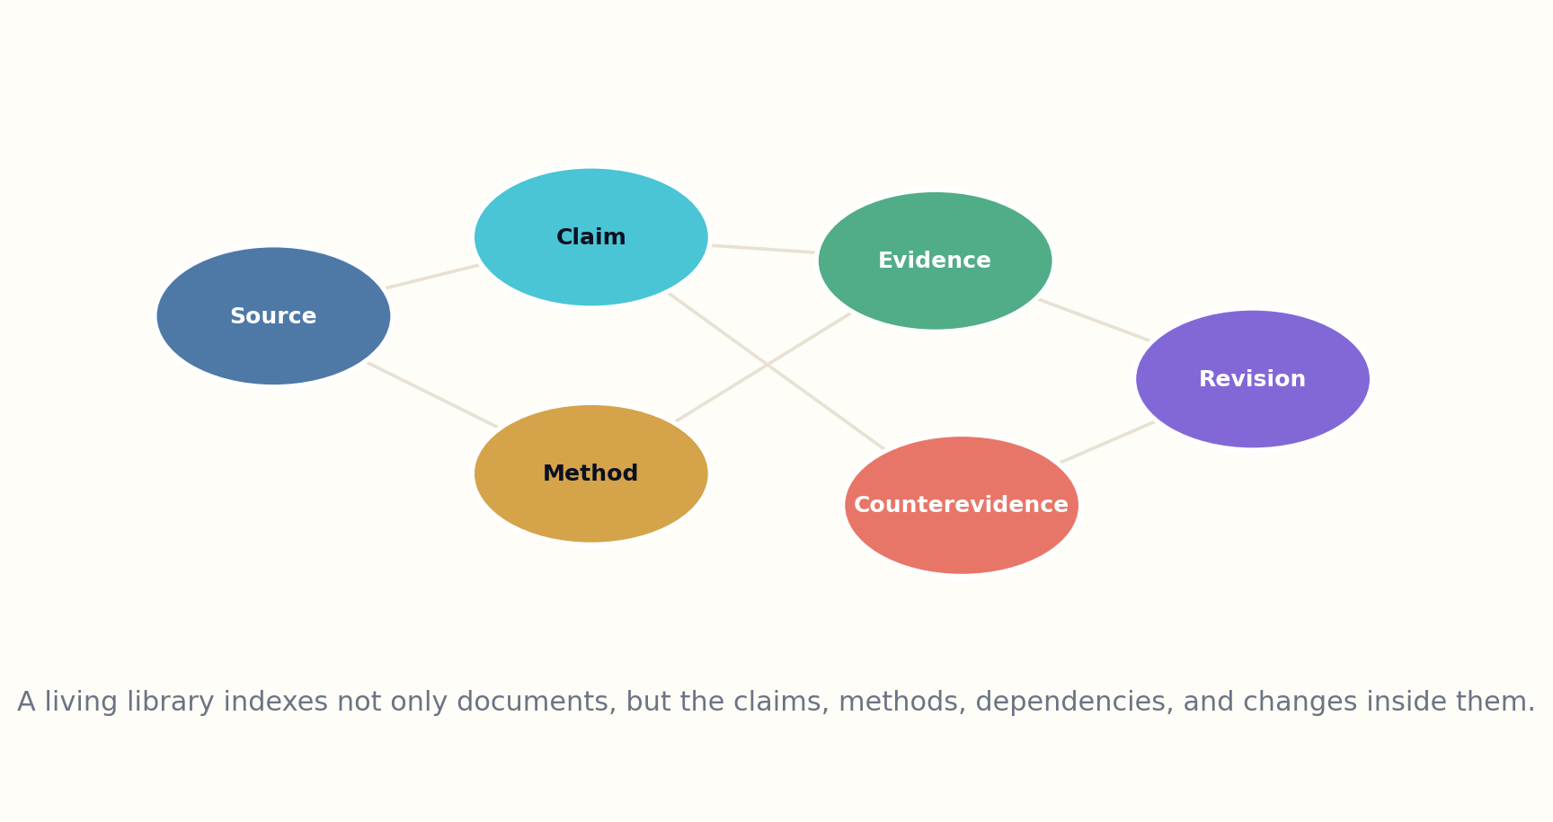
Figure 3. Claim-level memory connects source, method, evidence, counterevidence, and revision.

HOW THE SYSTEM WORKS
Methods become first-class objects because they determine what a claim can mean. Two studies may use the same word while measuring different outcomes. A historical argument may depend on a disputed translation. A policy recommendation may assume values rather than empirical facts. By linking claims to methods and assumptions, the library can explain disagreement instead of merely counting citations.
Claim extraction should remain provisional. Models can identify candidate claims and relations, but domain reviewers, source checks, and contradiction searches determine whether they enter the trusted graph. The system stores rejected candidates as audit data so that extraction errors can be studied rather than silently disappearing.

THE INSTITUTIONAL TEST
The claim graph enables a different kind of reading. A user can ask which conclusions depend on a particular dataset, which claims were revised after a correction, or where a field’s apparent consensus rests on one influential method. The library writes back by revealing the architecture of argument beneath the surface of prose.
Claim record c = {type, proposition, scope, method, evidence, uncertainty, provenance, status}
DESIGN EXERCISE
• Extract five differently typed claims from one article.
• Link each claim to the method that makes it interpretable.
• Design a query that traces every conclusion dependent on one dataset.
Research notes: R10, R11. See Research Notes and Sources.

CHAPTER 09
Temporal Knowledge and the Shape of Change
A fact without a date is often a future error.
━━━━━━━━━━━━━━━━━━━━━━━━━
Libraries have always preserved editions and publication dates, but answering systems often flatten time. They retrieve a statement without asking when it was true, whether the terminology changed, or whether later evidence corrected it. A living library treats time as a dimension of every important entity and claim.
Temporal modeling separates event time, publication time, observation time, and system-ingestion time. A paper may report an experiment performed years earlier. A law may be enacted on one date and take effect on another. A person may hold a title only during a specific interval. These distinctions prevent the system from importing current labels into historical contexts or presenting outdated guidance as present truth.

HOW THE SYSTEM WORKS
Time also gives shape to intellectual development. The library can reconstruct how a concept emerged, which evidence shifted consensus, and where an abandoned branch may deserve reconsideration. Revision becomes intelligible when the user can compare snapshots rather than seeing only the latest summary.
Temporal search requires a different index. The user may ask what was knowable in 1995, what changed between two editions, or which claims remained stable through multiple waves of research. The answer must restrict itself to the evidence available at the requested time while clearly separating later interpretation.

THE INSTITUTIONAL TEST
A library that writes back should never imply that knowledge has always looked like its current state. It preserves the path, including error, uncertainty, and correction. That path is one of the most valuable objects a library can generate.
Temporal validity V_t = claim confidence × interval match × version status × historical vocabulary fit
DESIGN EXERCISE
• Distinguish event, publication, observation, and ingestion time for one source.
• Write a query that asks what was knowable at a historical date.
• Design a timeline showing the evidence that changed a consensus.
Research notes: R12, R13. See Research Notes and Sources.

CHAPTER 10
The Knowledge Fabric
A graph becomes a fabric when many institutions can repair it without surrendering their differences.
━━━━━━━━━━━━━━━━━━━━━━━━━
No single library can build a complete knowledge graph. The future fabric must be federated: national libraries, public libraries, universities, museums, archives, publishers, community repositories, and independent scholars contribute descriptions and corrections through shared protocols. Persistent identifiers and typed relationships make cooperation possible without requiring one institution to own the whole record.
Federation requires trust levels. A local history society may have unmatched knowledge about a neighborhood; a research institution may have stronger authority in a technical domain; a community may control access to culturally sensitive knowledge. The system should route claims according to provenance and domain, not flatten all contributors into one confidence score.

HOW THE SYSTEM WORKS
The fabric must support disagreement between descriptions. Two communities may classify the same event differently, or a historical name may carry contested meanings. Rather than overwriting one view, the graph stores multiple assertions with sources, dates, and governance contexts. Synthesis can then represent conflict honestly.
Technical interoperability is necessary but insufficient. Shared schemas, APIs, and identifiers can move data, while institutional agreements determine correction, attribution, privacy, and responsibility. The social protocol is as important as the graph protocol.

THE INSTITUTIONAL TEST
The living library therefore resembles a commons with constitutional rules. It is distributed enough to preserve local agency and coordinated enough to support global discovery. Its intelligence emerges from relationships among stewards, not only relationships among data.
Fabric resilience R = interoperability × institutional diversity × correction capacity × local authority
DESIGN EXERCISE
• Design trust tiers for three different contributing institutions.
• Represent a contested description without forcing consensus.
• List the social agreements required in addition to a shared data schema.
Research notes: R3, R8, R9. See Research Notes and Sources.

PART III
THE LIBRARY LEARNS TO ANSWER
How retrieval, synthesis, explanation, and dialogue transform access into understanding.

CHAPTER 11
Retrieval-Augmented Librarianship
The model should enter the stacks before it enters the answer.
━━━━━━━━━━━━━━━━━━━━━━━━━
Retrieval-augmented generation separates two kinds of memory. The language model contributes general linguistic and reasoning capabilities, while an external collection supplies current, attributable evidence. This is a natural fit for libraries because collections, metadata, and reference practice already form a disciplined non-parametric memory.
A simple RAG system retrieves a handful of passages and asks a model to answer. A library-grade system does more. It resolves entities, plans multiple searches, diversifies source types, checks dates and versions, reads surrounding context, records failed queries, and tests whether each sentence is entailed by evidence. Retrieval is not a plugin; it is an accountable research process.
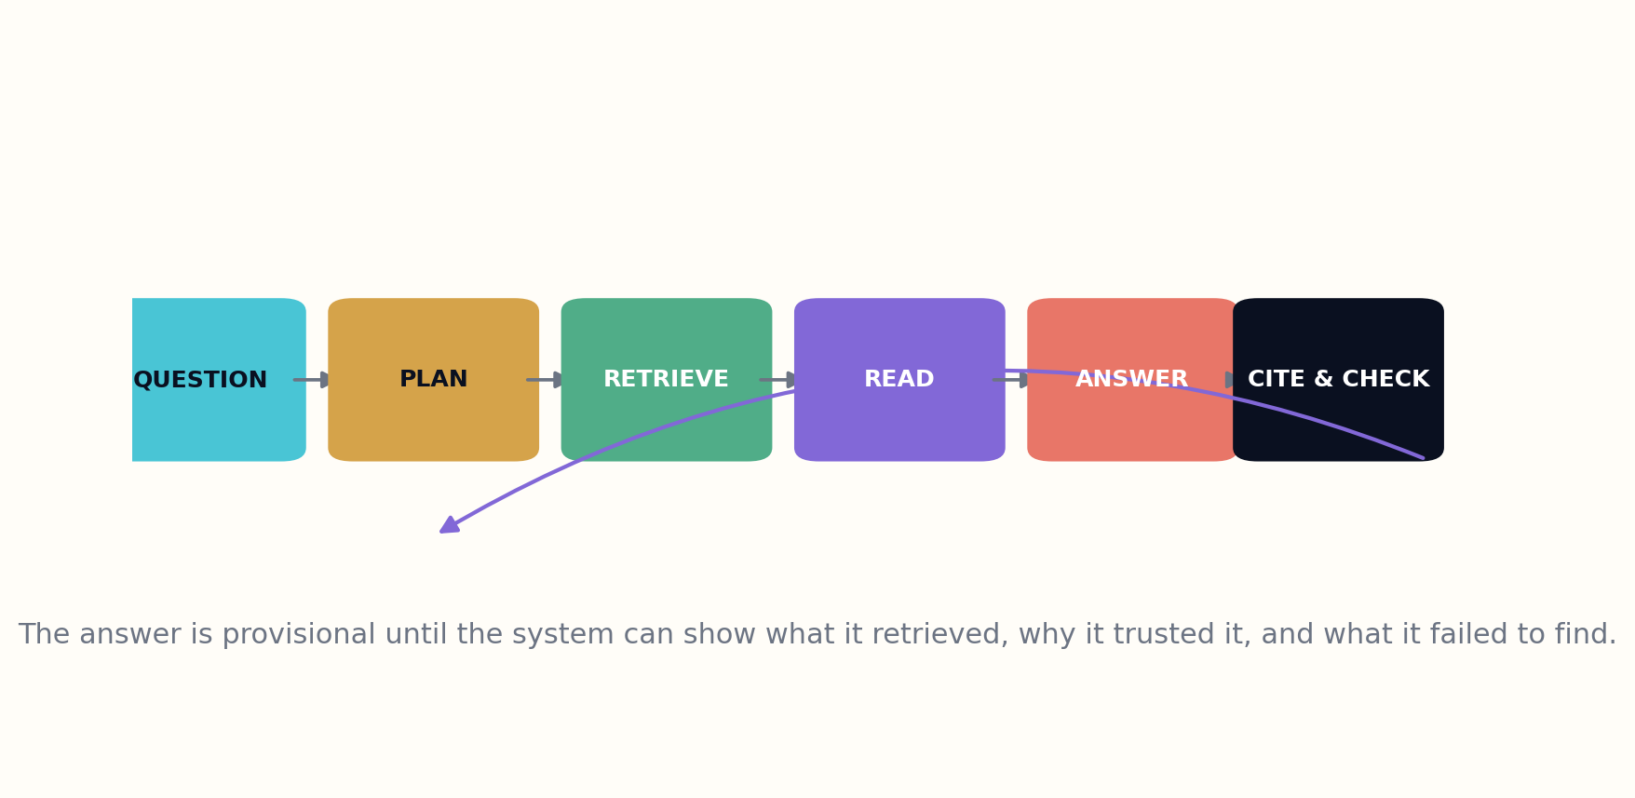
Figure 4. A library-grade retrieval loop plans, retrieves, reads, answers, cites, and checks.

HOW THE SYSTEM WORKS
The system should also know when not to retrieve. Some tasks are creative, conversational, or purely computational. Others require extensive retrieval because the answer is time-sensitive, contested, high-risk, or outside the model’s stable knowledge. The query planner decides the retrieval depth and risk tier before prose generation begins.
Citation must connect to the exact support, not merely a nearby document. If a passage supports only part of a sentence, the sentence should be split or qualified. When sources disagree, the answer should show the disagreement instead of selecting whichever passage ranked first.

THE INSTITUTIONAL TEST
Retrieval-augmented librarianship is therefore a partnership between machine speed and library discipline. The model can traverse enormous collections, but the institution defines what counts as evidence, how diversity is measured, and when the answer must be escalated to a human specialist.
Answer trust T = retrieval coverage × source quality × entailment × contradiction search × citation precision
DESIGN EXERCISE
• Upgrade a naive top-five RAG pipeline into a library-grade retrieval workflow.
• Define conditions under which the system should skip retrieval or deepen it.
• Audit one answer sentence for exact evidentiary support.
Research notes: R14, R15. See Research Notes and Sources.

CHAPTER 12
The Query Planner
The quality of an answer is often decided before the first source is retrieved.
━━━━━━━━━━━━━━━━━━━━━━━━━
A query planner converts the user’s words into an evidence strategy. It identifies whether the request is a lookup, comparison, explanation, synthesis, forecast, historical reconstruction, or open-ended exploration. Each type implies different sources, search expansions, stopping rules, and forms of uncertainty.
The planner decomposes complex questions into subquestions while preserving their dependencies. A request about whether a technology is ready may require current performance evidence, cost, safety, regulation, infrastructure, and comparison with alternatives. Answering only the easiest subquestion creates a fluent but structurally incomplete response.
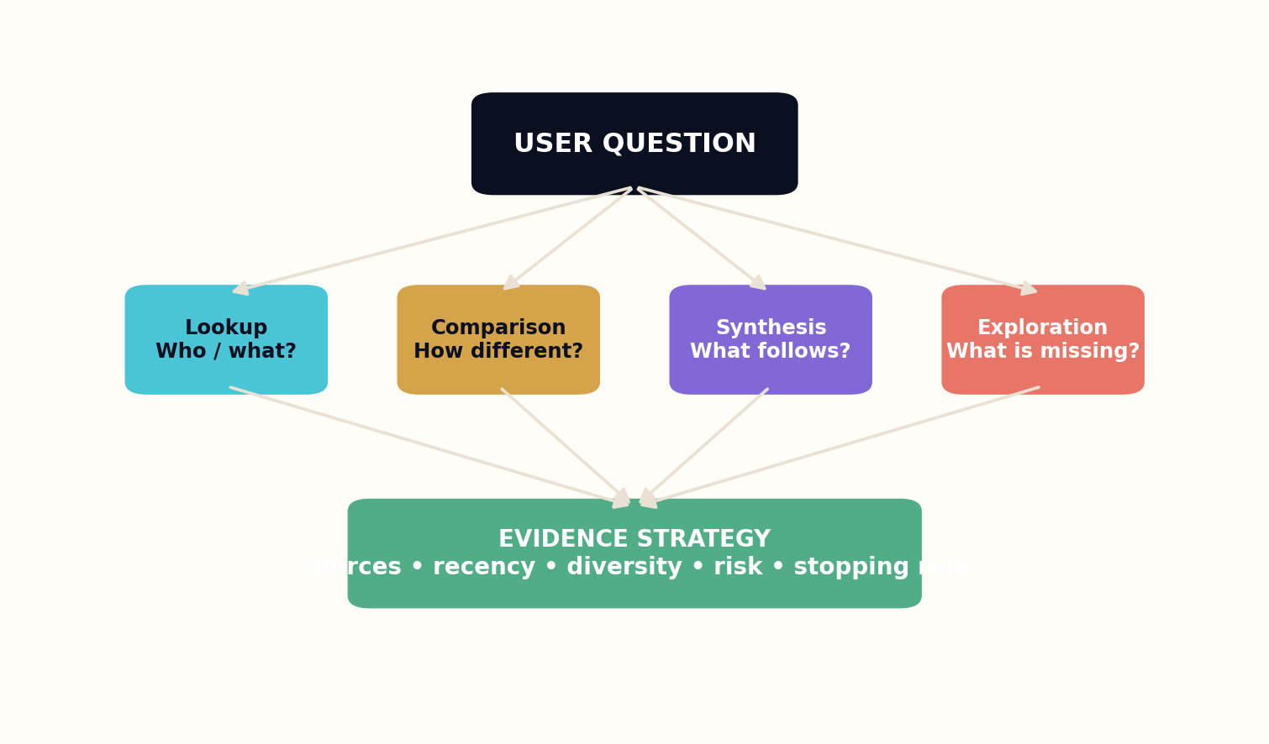
Figure 5. The query planner selects a research strategy before generation begins.

HOW THE SYSTEM WORKS
Risk changes the plan. A reading recommendation can tolerate imperfect recall; medical, legal, financial, or safety-critical guidance requires authoritative sources, recency checks, professional boundaries, and explicit limitations. The library publishes the plan or a readable summary so the user knows what kind of investigation occurred.
The planner also searches for disconfirming evidence. It creates adversarial queries, alternative terminology, and source diversity targets. If all results come from one institution, language, or methodological tradition, the system marks the coverage weakness rather than mistaking concentration for consensus.

THE INSTITUTIONAL TEST
A good planner ends with a stopping decision. It estimates whether additional retrieval is likely to change the answer enough to justify time and cost. The system can answer, answer provisionally, ask a clarifying question, or refuse to synthesize. Planning makes these outcomes deliberate.
Plan quality P = question coverage × source strategy × risk fit × countersearch × stopping discipline
DESIGN EXERCISE
• Classify five user questions by evidence strategy.
• Decompose a complex readiness question into dependent subquestions.
• Create a stopping rule that can end in answer, provisional answer, clarification, or refusal.
Research notes: R14, R16. See Research Notes and Sources.

CHAPTER 13
Evidence Packets Before Prose
The writer should receive a case file, not a pile of fragments.
━━━━━━━━━━━━━━━━━━━━━━━━━
The evidence packet is the boundary between research and writing. It contains supported claims, disputed claims, methods, definitions, temporal status, rights, provenance, and unresolved gaps. By stabilizing the evidence before prose generation, the library reduces the chance that fluency invents missing transitions or silently strengthens weak claims.
Packets are purpose-specific. A beginner explanation includes foundational definitions and representative examples. A policy brief prioritizes consequences, stakeholder positions, and uncertainty. A scholarly synthesis preserves methods and contradiction detail. The same source universe can support different packets because the reader transformation is different.
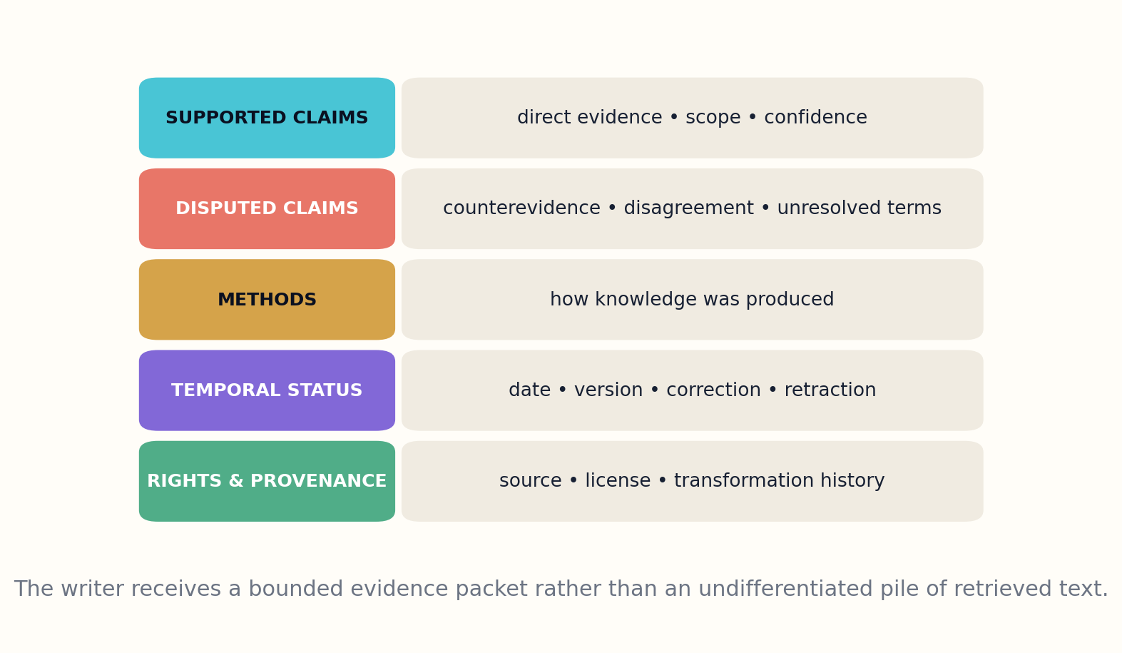
Figure 6. The evidence packet separates supported claims, disputes, methods, temporal status, and rights.

HOW THE SYSTEM WORKS
Every item in the packet has a status: direct evidence, interpretation, synthesis, analogy, hypothesis, or illustrative example. The writer may connect items, but it cannot convert a hypothesis into an observation or an analogy into proof. Those type constraints travel into the claim ledger of the final work.
The packet records what retrieval failed to find. Missing demographic coverage, inaccessible full text, absent replications, or uncertain rights become explicit limitations. This is essential because the absence of evidence is otherwise invisible once prose becomes smooth.

THE INSTITUTIONAL TEST
Evidence packets make the system modular. Different models or human authors can write from the same research object, and reviewers can determine whether problems originated in retrieval, synthesis, or expression. The library gains a repairable production line rather than a mysterious end-to-end answer generator.
Packet completeness E_p = supported claims + counterclaims + methods + versions + gaps + provenance
DESIGN EXERCISE
• Build an evidence packet for one chapter before drafting prose.
• Label each packet item by epistemic type.
• Record three failed retrieval paths and explain how they limit the answer.
Research notes: R14, R15, R17. See Research Notes and Sources.

CHAPTER 14
The Explanation Engine
Explanation is not simplification; it is the design of a path through complexity.
━━━━━━━━━━━━━━━━━━━━━━━━━
A library that answers must also teach. Explanation begins by modeling what the reader already knows, what they are trying to accomplish, and which misconceptions are likely. The system then chooses a ladder: orientation, example, structure, mechanism, transfer. Skipping a rung can make an answer sound sophisticated while leaving the reader unable to use it.
Multiple representations are crucial. Text explains sequence and argument; diagrams expose structure; equations compress relationships; timelines reveal change; examples anchor abstraction; counterexamples define boundaries. The explanation engine selects forms according to the concept, not according to what the model finds easiest to generate.
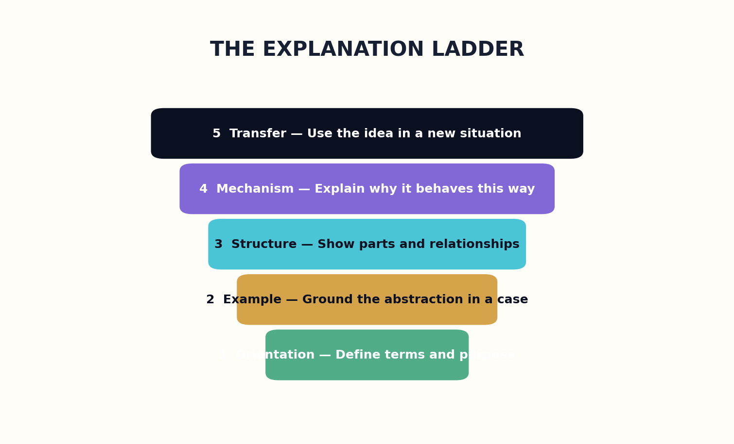
Figure 7. Explanations progress from orientation to transfer rather than stopping at summary.

HOW THE SYSTEM WORKS
Mechanistic explanation is a safeguard against decorative prose. The system should be able to state what components exist, how they interact, under which conditions the behavior changes, and what observation would show the explanation is wrong. When mechanism is unknown, it should say so rather than substituting metaphor.
The library evaluates explanation through reader performance. Can the user predict a new case, identify a misconception, complete an exercise, or make a better decision? Preference ratings alone reward pleasant style and confidence. Capability tests reveal whether understanding transferred.

THE INSTITUTIONAL TEST
The explanation engine also preserves the option to go deeper. Every simplification links to its assumptions and source structure. A child, student, professional, and researcher may enter through different doors but should be able to reach the same evidentiary foundation.
Explanation power X = clarity × mechanism × representation fit × transfer × traceability
DESIGN EXERCISE
• Explain one concept through all five rungs of the explanation ladder.
• Choose the best visual form for three different kinds of knowledge.
• Create a transfer exercise that proves the reader can use the idea in a new case.
Research notes: R4, R18. See Research Notes and Sources.

CHAPTER 15
Dialogue Without Dependency
The best conversation returns the user to the world with stronger judgment.
━━━━━━━━━━━━━━━━━━━━━━━━━
Dialogue lets the library refine intent, adapt explanations, and preserve continuity across a research session. Yet conversational fluency can create dependency, authority inflation, and privacy risk. The living library treats dialogue as a guided reference process rather than an endless engagement objective.
The reader model includes prior knowledge, goal, language, time budget, accessibility needs, and trust requirements. It should avoid inferring sensitive traits that are not necessary for the task. Personalization data remains visible, editable, and deletable. The user can choose a private session that stores no long-term profile.
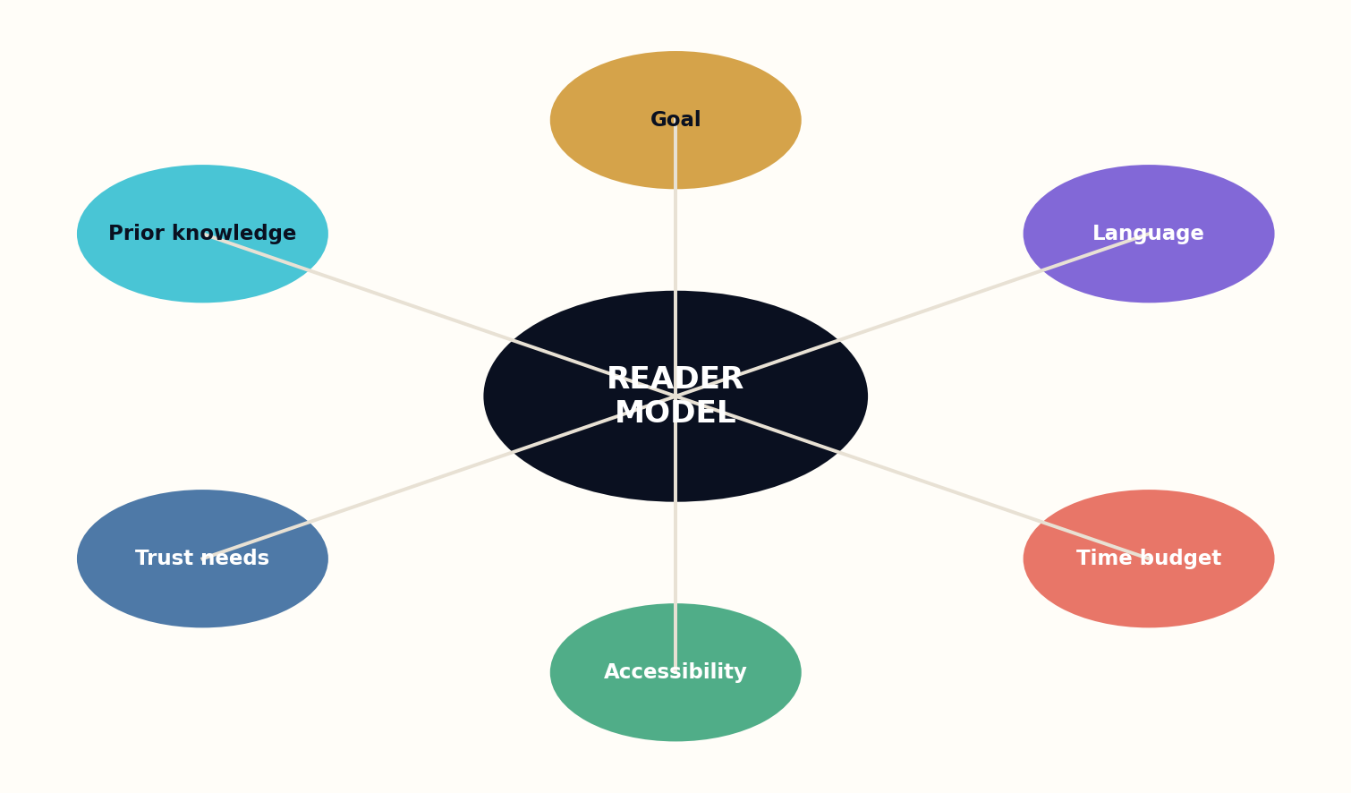
Figure 8. A bounded reader model adapts explanation without requiring invasive profiling.

HOW THE SYSTEM WORKS
The library asks clarifying questions only when they materially change the research plan or output. It does not interrogate users for data that merely improves personalization metrics. When a question is emotionally charged or high-risk, the system slows down, separates information from advice, and offers human referral.
Conversation should expose agency. The system can show alternative search paths, explain why it requested clarification, and let the user change source preferences or reading level. Rather than hiding complexity, it gives the user controls for navigating it.

THE INSTITUTIONAL TEST
A successful dialogue ends with a durable artifact: a reading path, evidence map, saved query, annotated bibliography, lesson, decision matrix, or set of unanswered questions. The chat may disappear, but the user’s capability remains.
Dialogue value D = intent clarity × adaptive explanation × privacy × user control × durable outcome
DESIGN EXERCISE
• Define the minimum reader data needed for a research dialogue.
• Write a clarifying question that materially changes the evidence plan.
• Design a durable artifact that should remain after the conversation ends.
Research notes: R2, R4, R19. See Research Notes and Sources.

PART IV
THE LIBRARY LEARNS TO QUESTION
How contradiction, uncertainty, adversarial review, and hypothesis generation create epistemic agency.

CHAPTER 16
The Contradiction Engine
Disagreement is not noise to remove; it is structure to understand.
━━━━━━━━━━━━━━━━━━━━━━━━━
When sources disagree, ordinary answer systems tend to select, average, or vaguely acknowledge conflict. A contradiction engine treats disagreement as an object. It identifies the exact claims in tension, measures their scope overlap, compares definitions and methods, and searches for contextual variables that may explain the divergence.
Some contradictions dissolve under better modeling. Studies may examine different populations, doses, time horizons, or endpoints. Historical accounts may rely on sources written for different purposes. Legal interpretations may operate in different jurisdictions. The engine proposes reconciliation hypotheses but keeps them separate from established conclusions.
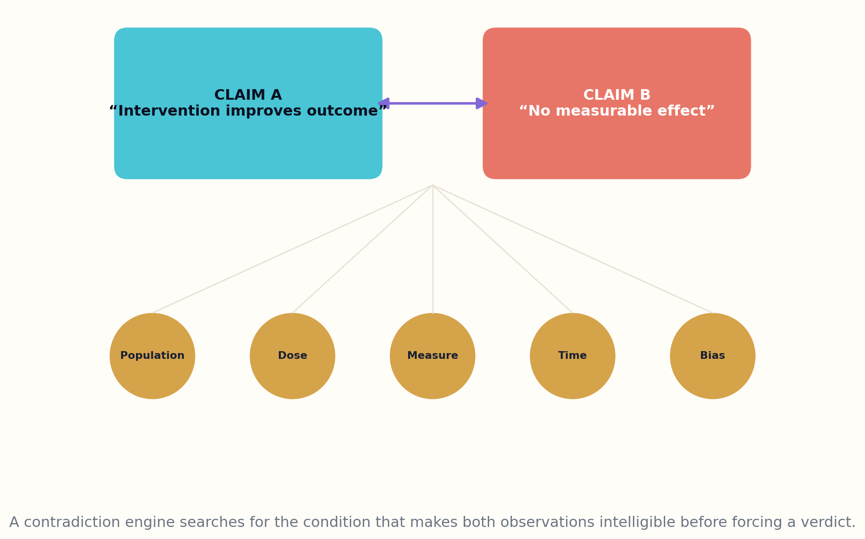
Figure 9. The contradiction engine searches for conditions that explain apparent disagreement.

HOW THE SYSTEM WORKS
Other contradictions are real and persistent. In those cases, the library should not force consensus. It can generate a controversy map showing camps, evidence quality, unresolved experiments, and points of agreement. This is often more useful than a conventional answer because it tells the reader what would actually change the debate.
Contradiction search must be adversarial. It uses alternative vocabulary, negative citations, correction networks, and sources outside the dominant cluster. Popularity and citation count cannot substitute for counterevidence. A field may look settled because dissenting work is poorly indexed or published elsewhere.

THE INSTITUTIONAL TEST
The contradiction engine is where the library begins to question its own first answer. It does not merely retrieve more; it searches specifically for the evidence that would make its synthesis fail.
Contradiction pressure K = severity × scope overlap × evidence quality × unresolvedness
DESIGN EXERCISE
• Compare two conflicting claims and list contextual variables that could reconcile them.
• Create a controversy map with agreement, dispute, and decisive missing tests.
• Write three adversarial queries designed to overturn an initial synthesis.
Research notes: R15, R20. See Research Notes and Sources.

CHAPTER 17
Uncertainty Is Part of the Answer
Confidence without calibration is a literary effect, not knowledge.
━━━━━━━━━━━━━━━━━━━━━━━━━
A cognitive library must represent uncertainty at multiple layers: source quality, extraction confidence, identity resolution, claim scope, model synthesis, and future prediction. Collapsing these into one percentage creates false precision. The system instead explains where uncertainty enters and how it affects the conclusion.
Epistemic labels help readers distinguish observed results, strong inference, plausible synthesis, open hypothesis, and unknown. These labels should be tied to criteria and examples so that they remain meaningful across domains. A high-confidence observation can still have narrow scope; a low-confidence hypothesis may be worth testing.
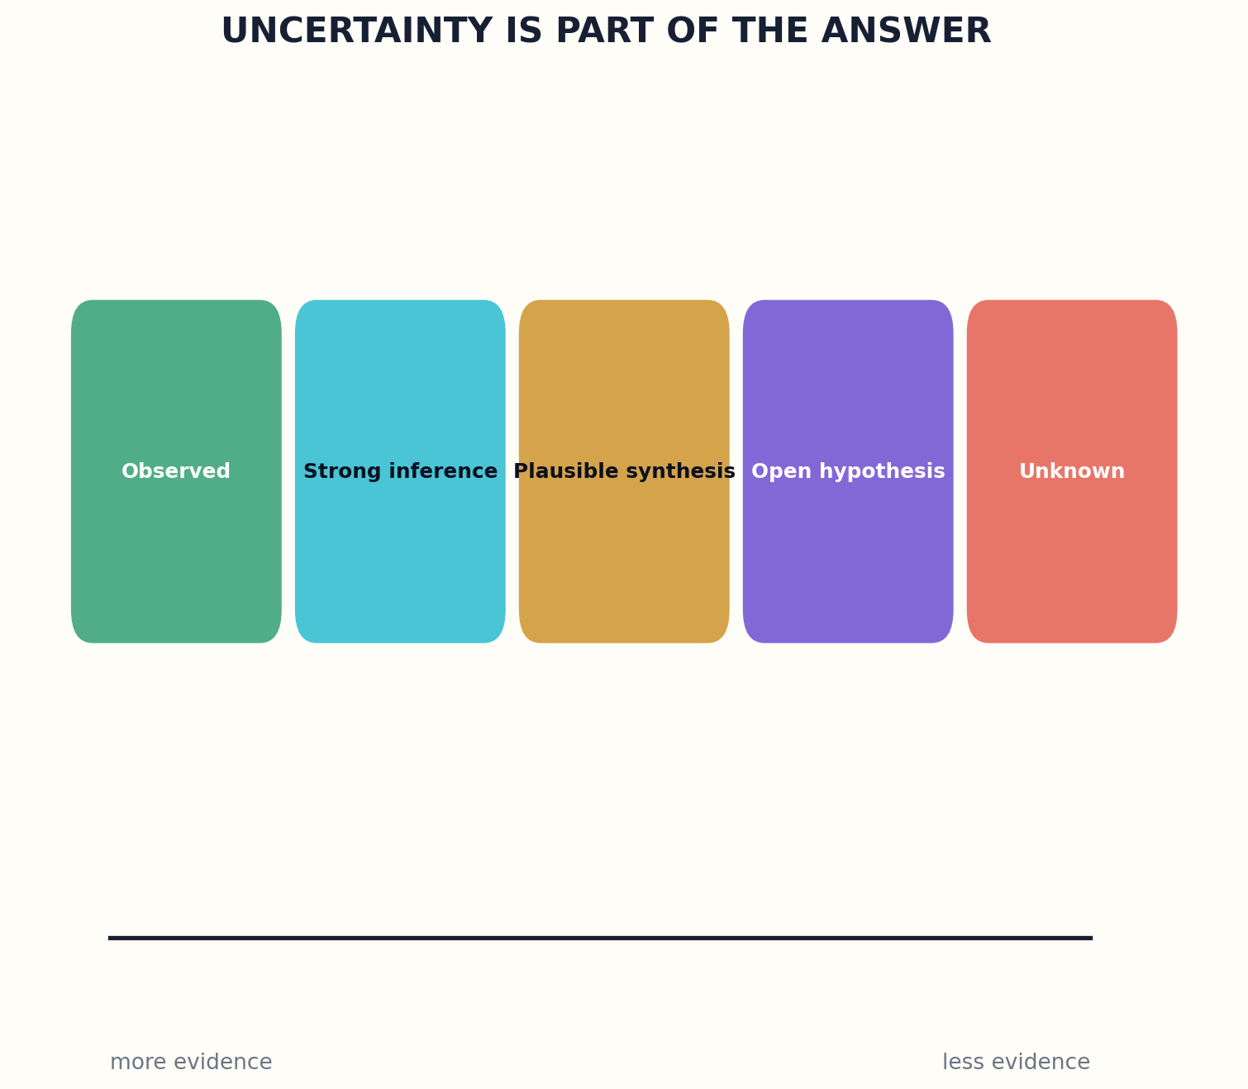
Figure 10. Epistemic labels preserve the distance between observation, inference, synthesis, hypothesis, and unknown.

HOW THE SYSTEM WORKS
Calibration requires evaluation against later outcomes and expert judgments. If the library says ninety percent confidence, similarly labeled claims should be correct roughly nine times out of ten under the defined test. The institution publishes calibration reports by domain and model rather than presenting confidence as an unverified internal feeling.
Uncertainty also changes language. The system should not hide behind vague qualifiers, but it should match verbs and sentence structure to evidence strength. It can say what is established, what is likely, what is contested, what is merely possible, and what information would reduce uncertainty.

THE INSTITUTIONAL TEST
A trustworthy library makes uncertainty actionable. It tells the reader whether to proceed, seek expert review, wait for more evidence, run a test, or avoid a high-consequence decision. Humility becomes operational rather than decorative.
Total uncertainty U = source + extraction + identity + scope + synthesis + future variance
DESIGN EXERCISE
• Create a five-level epistemic labeling scheme with criteria.
• Separate high confidence from broad scope in one example.
• Write an uncertainty statement that recommends a next action.
Research notes: R20, R21. See Research Notes and Sources.

CHAPTER 18
The Library Generates Questions
The frontier of knowledge is not a shelf; it is a structured absence.
━━━━━━━━━━━━━━━━━━━━━━━━━
A library that only answers reinforces the questions users already know how to ask. A questioning library searches for gaps: missing populations, contradictory definitions, untested transfers, dormant methods, unexplained anomalies, and evidence that has not been revisited after technological change.
Question generation begins from the graph. The system identifies dense claims with weak replication, concepts linked across fields but never compared, conclusions dependent on fragile datasets, and communities repeatedly described without participation. These patterns become candidate research questions rather than speculative facts.
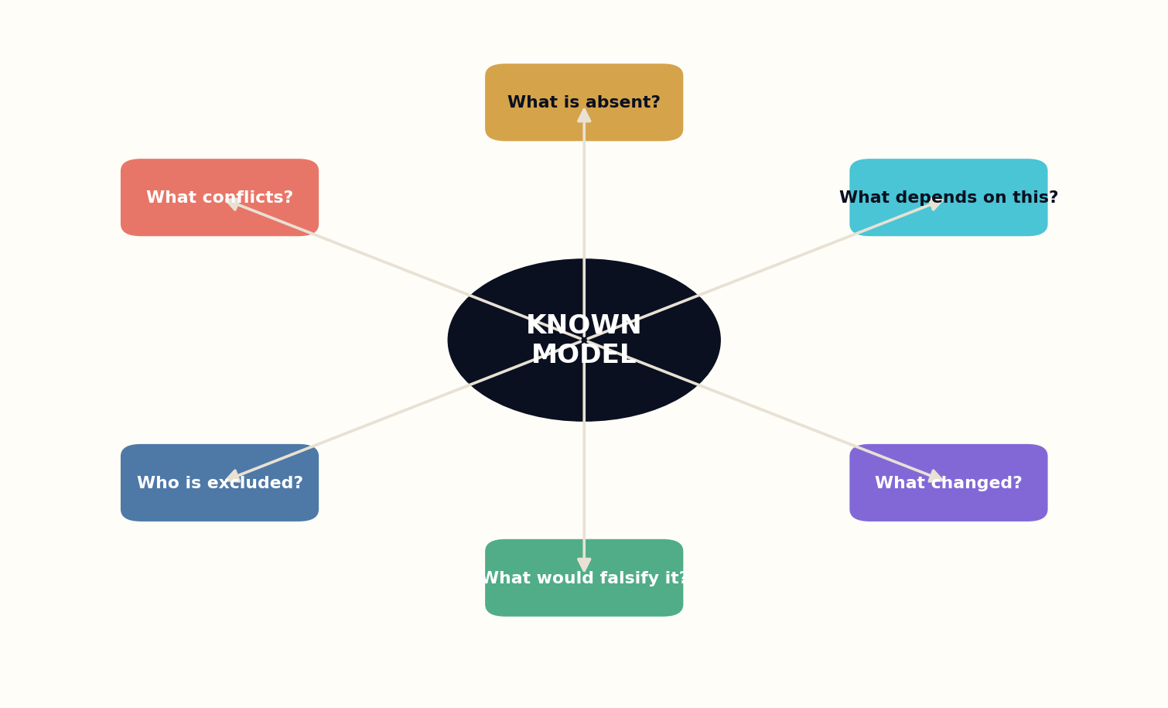
Figure 11. The questioning library searches for conflict, absence, dependency, change, falsification, and exclusion.

HOW THE SYSTEM WORKS
Good questions contain a path to resolution. The library states what evidence would answer them, which instruments or datasets are required, what ethical constraints apply, and why the result matters. This turns curiosity into a research agenda.
The system must avoid novelty theater. A strange question is not automatically valuable. Candidates are scored for significance, tractability, neglectedness, and potential harm. Domain experts and affected communities decide which questions should be pursued and which should remain unasked or carefully bounded.

THE INSTITUTIONAL TEST
Question generation changes the library’s social role. It becomes an institution that not only distributes past knowledge but helps coordinate future inquiry. The shelves become launch points.
Question value Q = significance × answerability × neglectedness × ethical legitimacy
DESIGN EXERCISE
• Generate questions from one contradiction, one missing population, and one outdated assumption.
• Specify what evidence would resolve each question.
• Reject one novel question because its likely harm exceeds its value.
Research notes: R10, R22. See Research Notes and Sources.

CHAPTER 19
The Adversarial Librarian
Every important answer deserves an intelligent opponent.
━━━━━━━━━━━━━━━━━━━━━━━━━
The adversarial librarian is a review role, not a personality. It attempts to block publication by finding missing sources, weak entailment, hidden assumptions, rights problems, harmful framing, and excluded perspectives. It does not rewrite the answer first; it creates a structured case against it.
Independence is essential. The reviewer should use different retrieval paths, model families, prompts, and source clusters from the authoring system where feasible. Agreement among identical agents can reflect shared blind spots. Disagreement among diverse reviewers reveals where human attention is most valuable.

HOW THE SYSTEM WORKS
Findings are classified as blocking defects, required repairs, unresolved minority opinions, and optional improvements. The writer responds to each finding with a traceable patch. A second review checks the repair. This creates a production dialogue closer to peer review and code review than ordinary chat.
The adversarial librarian also tests explanation. It looks for examples that fail, equations with undefined terms, diagrams that imply more certainty than the text, and recommendations that exceed the evidence. High-stakes materials receive named domain review before release.

THE INSTITUTIONAL TEST
Institutionalizing opposition protects the library from its own fluency. The system becomes trustworthy not because it is never wrong, but because it is designed to search aggressively for the ways it could be wrong before the reader bears the cost.
Review strength R_v = independence × defect coverage × repair traceability × escalation discipline
DESIGN EXERCISE
• Define five adversarial review roles with distinct failure targets.
• Separate blocking defects from minority opinions.
• Design a repair record that proves a finding was addressed.
Research notes: R21, R23. See Research Notes and Sources.

CHAPTER 20
Refusal, Silence, and Epistemic Humility
An intelligent library must know when not to complete the sentence.
━━━━━━━━━━━━━━━━━━━━━━━━━
Generative systems are biased toward completion. A library has a different obligation. It may refuse to synthesize when evidence is insufficient, rights are unclear, the user requests harmful operational detail, or the system cannot responsibly represent affected communities. Refusal is not a failure of intelligence; it is a governed output.
Silence can take several forms. The system may ask for clarification, provide only sources, offer a provisional map, explain why no stable answer exists, or refer the user to a librarian or professional. These alternatives preserve usefulness without manufacturing certainty.

HOW THE SYSTEM WORKS
The refusal policy should be public and appealable. Users deserve to know whether the limitation came from safety, privacy, collection coverage, licensing, uncertainty, or institutional scope. Hidden refusal logic can reproduce bias and prevent legitimate research.
Humility also means recognizing the boundary between information and judgment. A library can explain evidence, historical precedent, and options, but some decisions belong to democratic institutions, professionals, communities, or the individual. The system should not convert access to knowledge into authority over lives.

THE INSTITUTIONAL TEST
The library writes back most responsibly when it can leave space for the reader, the expert, and the unknown. An answer is one service among many; restraint is another.
Responsible completion C_r = usefulness − unsupported certainty − preventable harm − hidden authority
DESIGN EXERCISE
• Create four alternatives to a full answer.
• Write a transparent refusal notice that names the governing limitation.
• Identify a decision where the library should inform but not decide.
Research notes: R2, R21. See Research Notes and Sources.

PART V
THE LIBRARY LEARNS TO REVISE
How versioning, provenance, memory, and governance keep knowledge alive without erasing history.

CHAPTER 21
Living Editions
Revision should change the recommendation without erasing the record.
━━━━━━━━━━━━━━━━━━━━━━━━━
Traditional books freeze a synthesis at publication. Digital systems can update instantly, but silent updating destroys citation stability and historical accountability. Living editions combine both virtues: every edition is immutable and citable, while a signed pointer identifies the currently recommended edition.
The edition manifest records source snapshots, graph versions, models, prompts, human contributors, review outcomes, and changes from the previous release. Minor versions improve explanation or repair bounded errors. Major versions appear when evidence or structure changes enough to alter interpretation.
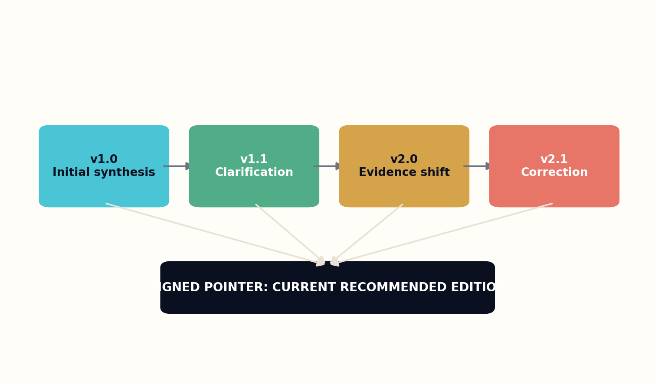
Figure 12. Immutable editions coexist with a signed pointer to the recommended current version.

HOW THE SYSTEM WORKS
Update triggers are part of the work’s design. A retraction, correction, major replication, legal change, safety notice, or threshold of contradictory evidence opens a review. The system traces which claims and chapters depend on the changed source before proposing revisions.
Readers choose their relationship to change. A classroom can pin a semester to one edition. A professional can subscribe to urgent updates. A historian can compare versions to study the evolution of understanding. The library supports stability, freshness, and memory simultaneously.

THE INSTITUTIONAL TEST
Living editions transform authorship into stewardship. Publication is no longer the end of responsibility. Every released synthesis carries a maintenance policy, review cadence, and retirement condition.
Revision trigger Δ = evidence change × dependency × consequence × confidence
DESIGN EXERCISE
• Write semantic versioning rules for a living book.
• Define three events that trigger urgent review.
• Design reader controls for stable, current, and historical views.
Research notes: R12, R13, R24. See Research Notes and Sources.

CHAPTER 22
Correction Propagation
A corrected source should not leave uncorrected descendants.
━━━━━━━━━━━━━━━━━━━━━━━━━
In a connected library, one source can influence thousands of summaries, lessons, answers, translations, and derived works. Correction must therefore propagate through dependencies. The system needs to know which claims rely on the source, which passages express those claims, and which users received high-consequence outputs.
Propagation is not automatic rewriting. A correction may invalidate a sentence, narrow its scope, or leave the conclusion unchanged because other evidence remains. The system proposes affected nodes and impact levels; human editors approve high-risk changes.
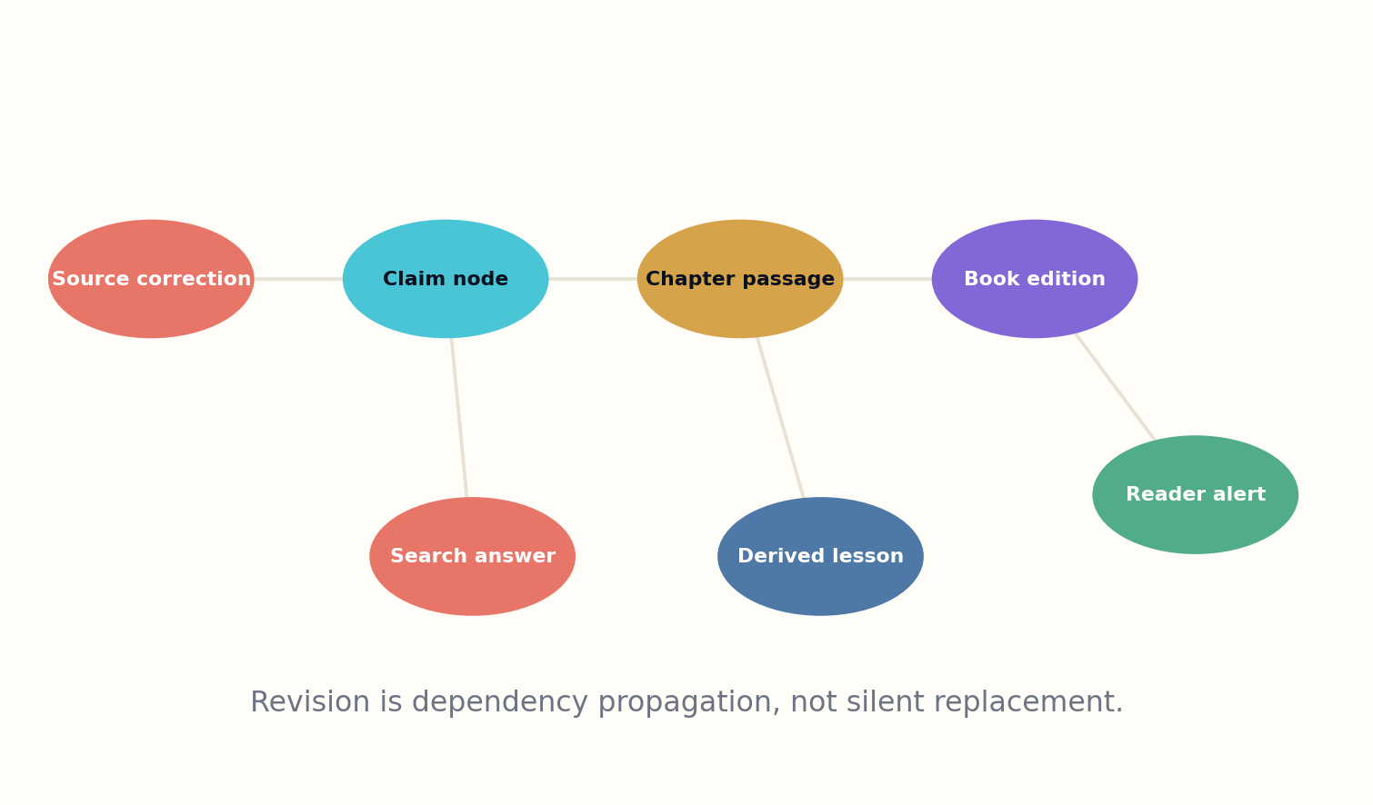
Figure 13. A source correction propagates through claims, passages, editions, alerts, and derived answers.

HOW THE SYSTEM WORKS
Alerts should match consequence. A minor bibliographic correction may update metadata quietly. A retraction affecting a medical recommendation may trigger visible notices, suspended answers, and direct alerts to subscribed users. The institution records when it learned of the change and how quickly it responded.
The old edition remains accessible with status markings. Erasing it would prevent audit and historical study. The recommended pointer moves only after review, and downstream systems can query the status before reusing content.

THE INSTITUTIONAL TEST
Correction propagation is the mechanical heart of a library that revises knowledge. It turns provenance from documentation into action.
Impact I_c = source change severity × dependency count × claim centrality × consequence
DESIGN EXERCISE
• Map the descendants of one corrected claim.
• Define low, medium, and urgent propagation responses.
• Explain why the prior edition must remain accessible.
Research notes: R12, R13. See Research Notes and Sources.

CHAPTER 23
Memory Architecture for a Living Institution
The library needs many memories because not every truth belongs in the same speed or scale.
━━━━━━━━━━━━━━━━━━━━━━━━━
A cognitive library cannot place its entire collection into a model context. It uses a hierarchy: active session state, book or project workspaces, claim and entity graphs, vector and lexical indexes, object stores, and deep preservation archives. Each layer trades speed, cost, fidelity, and durability differently.
Raw source objects and released editions are immutable. Parsed text, embeddings, summaries, and caches are derived products that can be regenerated when tools improve. This distinction allows the institution to evolve without losing evidence or confusing a parser’s output with the original record.

HOW THE SYSTEM WORKS
Memory retrieval is typed. Entity questions use authority graphs; exact quotations use text indexes; broad synthesis uses graph communities and representative sources; historical reconstruction uses temporal snapshots. A single vector database cannot satisfy every epistemic task.
Session memory is deliberately bounded. Personal research history can help continuity, but it creates privacy and bias risks. Users should control retention, export, and deletion. Institutional memory preserves public artifacts and decisions, not unnecessary behavioral profiles.

THE INSTITUTIONAL TEST
The architecture is designed for replay. An answer can be regenerated against the same source and index snapshots, or rerun against current knowledge to show what changed. Reproducibility makes revision intelligible.
Memory cost M_c = latency + storage + regeneration + privacy risk; choose tier by task
DESIGN EXERCISE
• Classify every data product as immutable or regenerable.
• Match four question types to different retrieval memories.
• Design a replay function that compares past and current answers.
Research notes: R1, R8, R14. See Research Notes and Sources.

CHAPTER 24
Provenance, Rights, and the Chain of Thought We Can Show
Trust requires visible lineage, not private internal monologue.
━━━━━━━━━━━━━━━━━━━━━━━━━
A living library should not expose hidden model reasoning as proof. Instead, it exposes the evidence and production lineage that can be independently inspected: sources, claims, retrieval paths, tools, model versions, human edits, rights, and review decisions. This is the chain of custody that matters.
Rights metadata travels with every source and derivative. Technical access does not imply permission to reproduce, transform, or train. The system records licenses, restrictions, attribution obligations, cultural protocols, territory, and duration. Unknown rights can permit catalog-level discovery while blocking generative use.
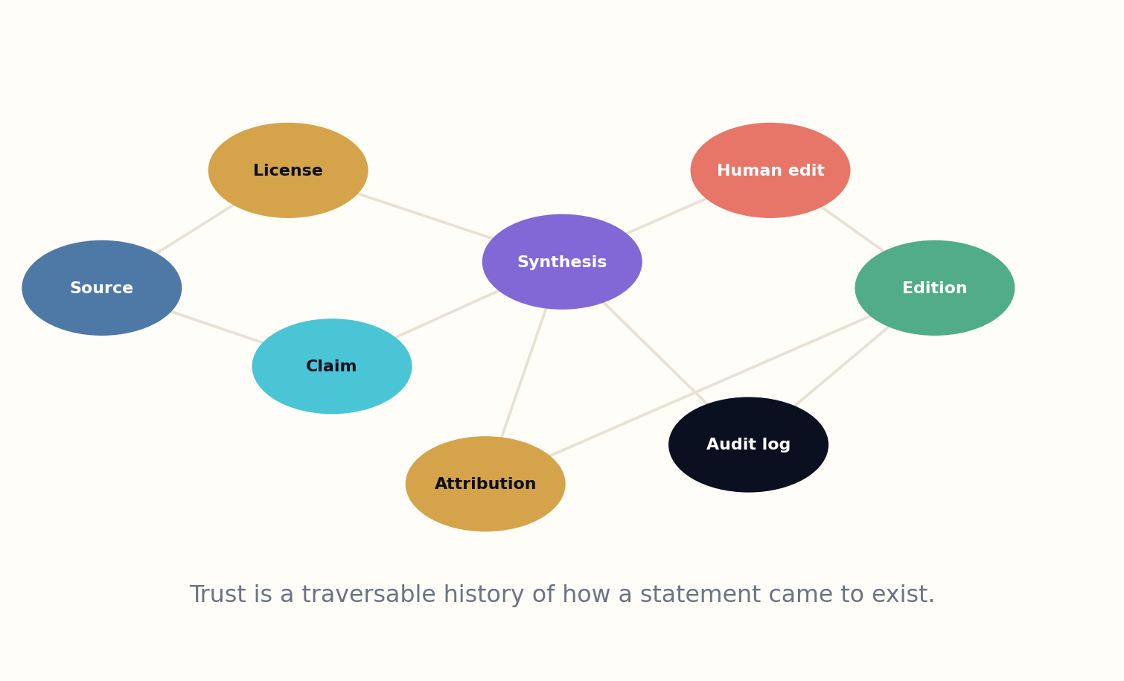
Figure 14. Provenance links sources, permissions, synthesis, human edits, audit logs, and released editions.

HOW THE SYSTEM WORKS
Provenance also distinguishes machine and human contribution. Research design, source curation, structural editing, original writing, translation, and final approval are recorded separately. This gives readers a realistic account of authorship and gives institutions a basis for responsibility.
Cryptographic hashes and signed manifests make silent substitution detectable, but signatures do not prove truth. Trusted identities, secure key management, independent archives, and substantive review remain necessary. Provenance makes claims investigable; it does not make them correct by itself.

THE INSTITUTIONAL TEST
The chain should be readable at multiple levels. Ordinary readers see a concise source and revision note. Researchers can inspect claim-level support. Auditors can obtain the full machine-readable manifest. Transparency should deepen with need without making every page unusable.
Provenance path P = source → claim → retrieval → synthesis → review → human edit → edition
DESIGN EXERCISE
• Create a provenance manifest for one paragraph and one diagram.
• Separate what a digital signature proves from what it cannot prove.
• Design three levels of provenance visibility for different readers.
Research notes: R25, R26, R27. See Research Notes and Sources.

CHAPTER 25
The Human Constitution
The machine can recommend revisions; the institution must remain accountable for them.
━━━━━━━━━━━━━━━━━━━━━━━━━
The library that writes back needs a constitution before it needs autonomy. The charter defines intellectual freedom, privacy, access, collection responsibility, correction, cultural stewardship, safety boundaries, and the right to appeal. Technical policies derive from public principles rather than the other way around.
Governance is layered. A librarian council sets collection and service policy. Domain boards define evidence standards. Community representatives govern local and culturally sensitive knowledge. Technical operators maintain systems, while independent auditors inspect performance and incidents. No single vendor or model controls the institution’s memory.
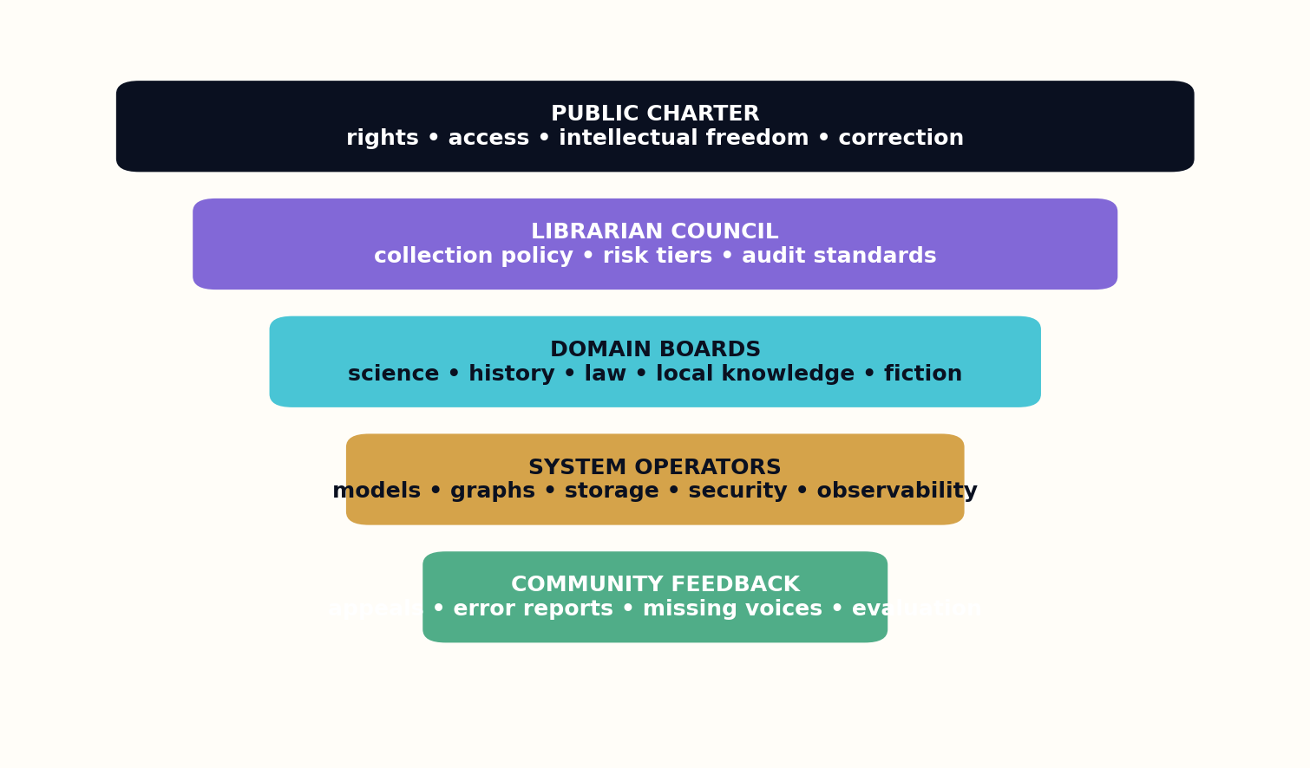
Figure 15. A public charter, librarian council, domain boards, operators, and community feedback create accountable authority.

HOW THE SYSTEM WORKS
Human authority is named. High-consequence publications and policy changes receive accountable approval. Automated decisions are sampled, reviewed, and reversible. Model updates do not silently change the behavior of the public service; they pass evaluation and change control.
The constitution includes rights for users: inspect evidence, know when AI is involved, correct personal data, request human review, appeal restrictions, compare editions, and use the library without surrendering unnecessary personal information. It also includes responsibilities for contributors and staff.

THE INSTITUTIONAL TEST
The purpose of governance is not to slow intelligence but to make it legitimate. A library becomes a public institution when the people affected can understand, challenge, and shape how it knows.
Institutional legitimacy L = public charter × accountable authority × appeal × audit × continuity
DESIGN EXERCISE
• Draft five constitutional rights for users of a cognitive library.
• Assign authority across librarians, domain experts, communities, operators, and auditors.
• Design change control for a new model release.
Research notes: R2, R21, R28. See Research Notes and Sources.

PART VI
THE LIBRARY BECOMES AN INSTITUTION OF INTELLIGENCE
How living libraries reshape education, science, community memory, and creative culture.

CHAPTER 26
The Classroom That Can Revise Its Textbook
A textbook should be stable enough to teach and alive enough to admit when the world changes.
━━━━━━━━━━━━━━━━━━━━━━━━━
The living library can generate learning paths from a shared evidence base without reducing education to personalized worksheets. A course edition defines prerequisites, concepts, examples, misconceptions, exercises, and assessment targets. The system adapts explanation and pacing while preserving a common intellectual standard.
Teachers remain architects of sequence and culture. They can inspect why a lesson was generated, lock examples, add local context, and compare outcomes across versions. The AI handles variation, practice, feedback, and source updates; the teacher decides what kind of understanding matters.

HOW THE SYSTEM WORKS
A revisable textbook links every factual passage to claims and versions. When evidence changes, the system flags affected lessons and proposes updates. Classes can finish on a pinned edition while future cohorts receive the revision. Students learn that knowledge changes through visible reasons, not mysterious replacement.
Assessment moves from recall toward transfer. The library generates new cases, asks students to critique sources, and reveals uncertainty. It can diagnose misconceptions without reducing a learner to a permanent profile. Student data remains local, limited, and governed by educational purpose.

THE INSTITUTIONAL TEST
The result is a classroom in which the library participates as a transparent teaching partner. It explains, questions, and updates, but it does not replace the human community that gives learning meaning.
Learning gain G_l = conceptual mastery × transfer × source literacy × durable curiosity
DESIGN EXERCISE
• Design a pinned semester edition and a future revised edition.
• Create an exercise that tests source criticism rather than recall.
• Specify which student data the system does not need to retain.
Research notes: R4, R19. See Research Notes and Sources.

CHAPTER 27
The Research Library as Discovery Partner
The next breakthrough may be a relationship the catalog can finally see.
━━━━━━━━━━━━━━━━━━━━━━━━━
Research libraries already support discovery through collections, databases, data management, and expert consultation. The cognitive library adds claim graphs, method matching, contradiction search, and question generation. It can surface a technique used in one field that may transfer to another, or identify a conclusion whose evidence base has become unusually fragile.
Discovery begins with abstraction. The system represents methods by inputs, transformations, constraints, outputs, and failure modes, then searches for structurally similar techniques across disciplinary language. A model proposes the analogy, but domain experts evaluate whether units, scale, and assumptions make the transfer plausible.

HOW THE SYSTEM WORKS
The library can also construct research landscapes: consensus zones, unresolved contradictions, missing replications, sparse populations, and dormant branches made newly feasible by technology. These maps help researchers choose questions with both novelty and consequence.
The institution must resist automated novelty claims. Prior-art search, historical collections, patents, negative results, and non-English sources are essential. The system should say that a connection appears underexplored, not declare invention before human investigation.

THE INSTITUTIONAL TEST
As a discovery partner, the library does not become the scientist. It becomes an instrument for seeing the intellectual terrain, preserving the route, and coordinating the work needed to test a new path.
Discovery potential D_p = structural transfer × neglectedness × evidence readiness × testability
DESIGN EXERCISE
• Abstract one research method into a domain-neutral structure.
• Search for a distant field with compatible constraints.
• Write a cautious novelty statement that invites prior-art review.
Research notes: R10, R22. See Research Notes and Sources.

CHAPTER 28
The Community Library That Remembers Locally
Global intelligence becomes trustworthy only when local memory can speak in its own voice.
━━━━━━━━━━━━━━━━━━━━━━━━━
A cognitive library must not centralize all knowledge into one global model. Local libraries preserve neighborhood newspapers, oral histories, public records, languages, family collections, environmental observations, and the practical knowledge of institutions and residents. These materials often do not exist elsewhere.
The local node gives communities control over description, access, and generative use. Sensitive interviews may be searchable only through mediated access. Sacred or private knowledge may be excluded from model processing. Community protocols become executable policy rather than informal hope.
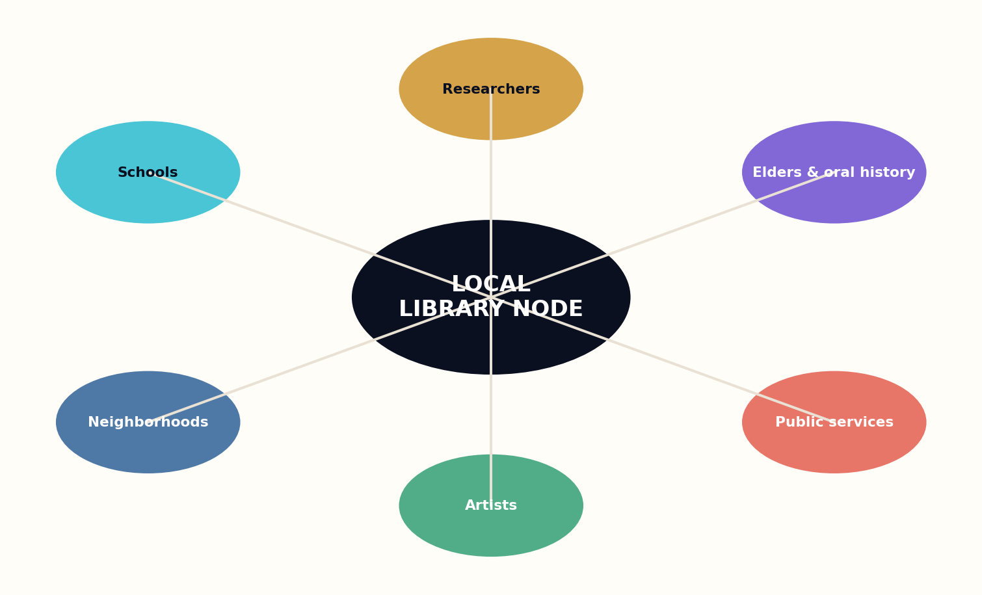
Figure 16. A local library node connects schools, researchers, oral history, public services, artists, and neighborhoods.

HOW THE SYSTEM WORKS
The library can synthesize local questions: how zoning changed a neighborhood, which services disappeared, how flood patterns evolved, or where public promises remain unfulfilled. Answers link back to records and testimony, preserving disagreement among residents rather than manufacturing one official memory.
Local intelligence also supports action. Schools can build place-based curricula, planners can compare historical decisions, artists can discover overlooked stories, and residents can contribute corrections. The institution becomes a feedback loop between memory and civic agency.

THE INSTITUTIONAL TEST
Federation allows local nodes to connect globally without surrendering authority. The community decides which entities and summaries enter the wider fabric. The future Library of Alexandria should be a network of places that can say ‘this is how we know,’ not a machine that speaks about everyone from nowhere.
Local knowledge value L_k = community authority × provenance × accessibility × relevance × consent
DESIGN EXERCISE
• Design three access levels for an oral-history collection.
• Write a local question that requires records plus community testimony.
• Define what a local node shares globally and what remains governed locally.
Research notes: R2, R5, R29. See Research Notes and Sources.

CHAPTER 29
The Creative Library
The archive becomes generative when memory is available for transformation without becoming a costume for imitation.
━━━━━━━━━━━━━━━━━━━━━━━━━
Libraries have always supported creation by preserving forms, images, histories, myths, music, and language. A creative cognitive library can help writers explore public-domain traditions, build world models, compare narrative structures, and test continuity. Its purpose is not to produce infinite pastiche but to expand the space of responsible imagination.
The fiction system separates archive retrieval from artistic invention. Research establishes historical, scientific, and cultural constraints. World models simulate institutions and consequences. Character models track desire, memory, and relationship. Plot search explores choices. A critic circle evaluates coherence, surprise, voice, and emotional truth before prose is released.
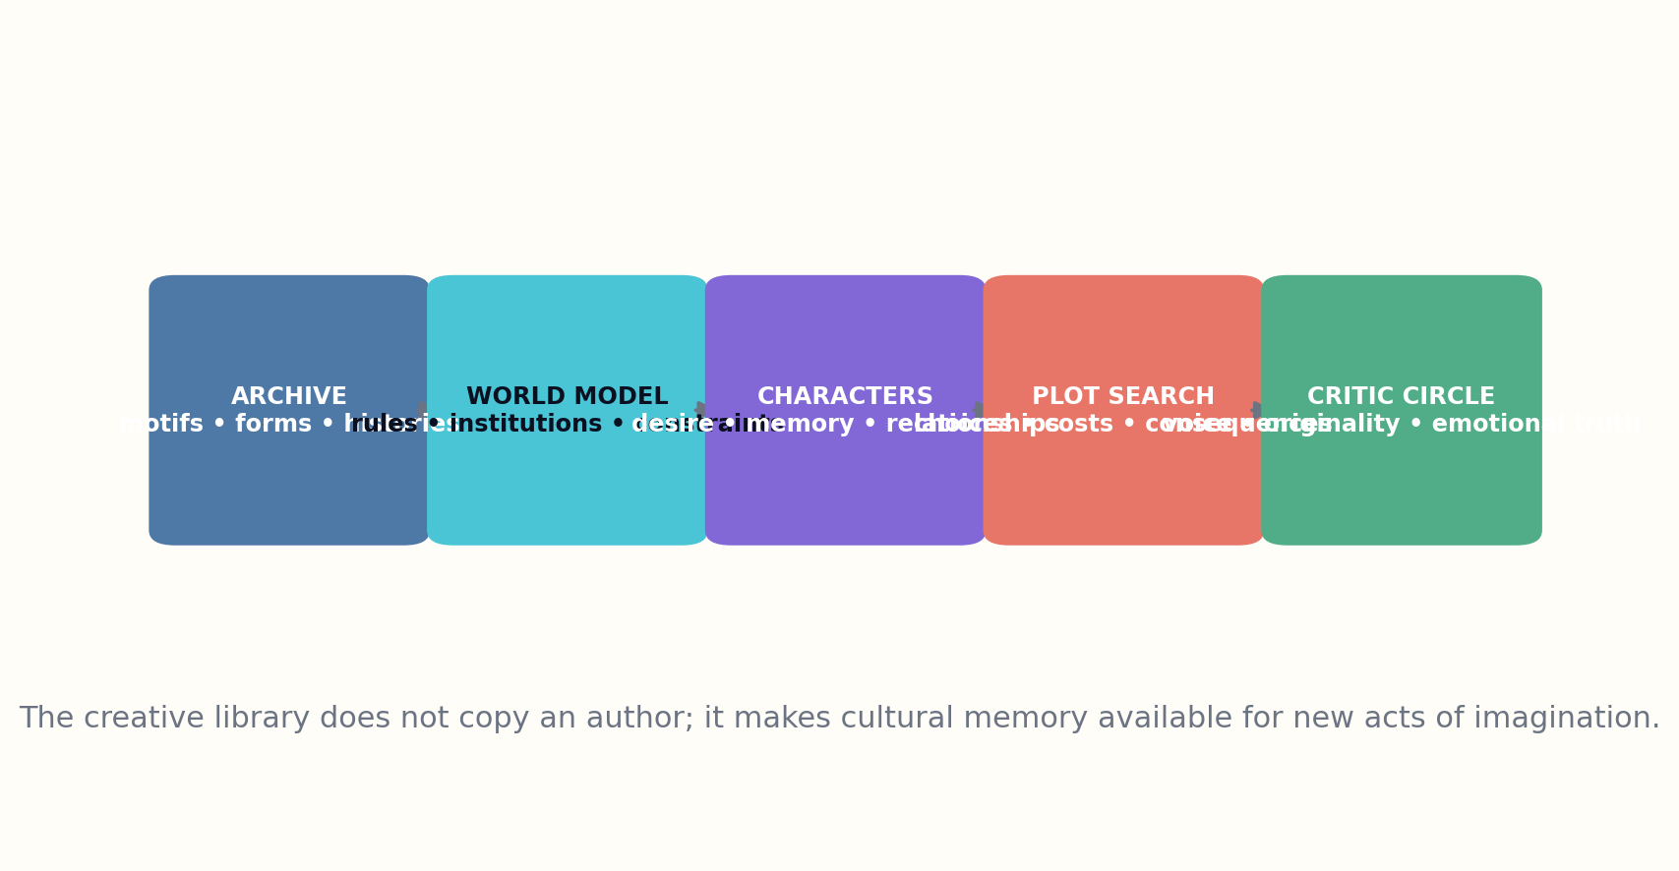
Figure 17. The creative library separates archival influence, world modeling, characters, plot search, and criticism.

HOW THE SYSTEM WORKS
Originality policy forbids targeted imitation of living authors and checks phrase, structure, character, and plot dependence. Influence is represented broadly through traditions and source domains. Human authors choose, reject, rewrite, and give purpose to the work.
The creative library also makes room for communities and languages excluded by conventional markets. It can support new fiction, translations, oral storytelling, interactive forms, and collaborative editions under local stewardship. Generation capacity becomes a subsidy for cultural possibility rather than a flood of generic products.

THE INSTITUTIONAL TEST
When the library writes fiction back to the world, it should reveal new consequences of what humanity has remembered. The measure is not how many stories can be emitted, but how many feel necessary after they exist.
Creative value C_v = causal coherence × formal risk × emotional consequence × originality × cultural legitimacy
DESIGN EXERCISE
• Build a fiction workflow that separates research, simulation, prose, and critique.
• Write an originality policy that permits traditions but blocks impersonation.
• Define what would make one generated story necessary rather than merely possible.
Research notes: R25, R30. See Research Notes and Sources.

CHAPTER 30
The Library That Writes Back
The final form of the library is not a machine that knows everything, but an institution that can show how knowledge moves.
━━━━━━━━━━━━━━━━━━━━━━━━━
The transformation begins with an instrumented archive, not an all-knowing model. Phase one strengthens preservation and metadata. Phase two builds identity, temporal, and claim graphs. Phase three adds evidence-bound answering. Phase four adds contradiction, uncertainty, and question generation. Phase five establishes living editions, correction propagation, and constitutional governance.
Each phase must prove that it preserves the duties beneath it. Faster answers cannot weaken source access. Synthesis cannot erase disagreement. Revision cannot destroy stable citation. Personalization cannot compromise privacy. Automation cannot dissolve accountable human authority. The system scales only after audits show that the new capacity strengthens the institution.
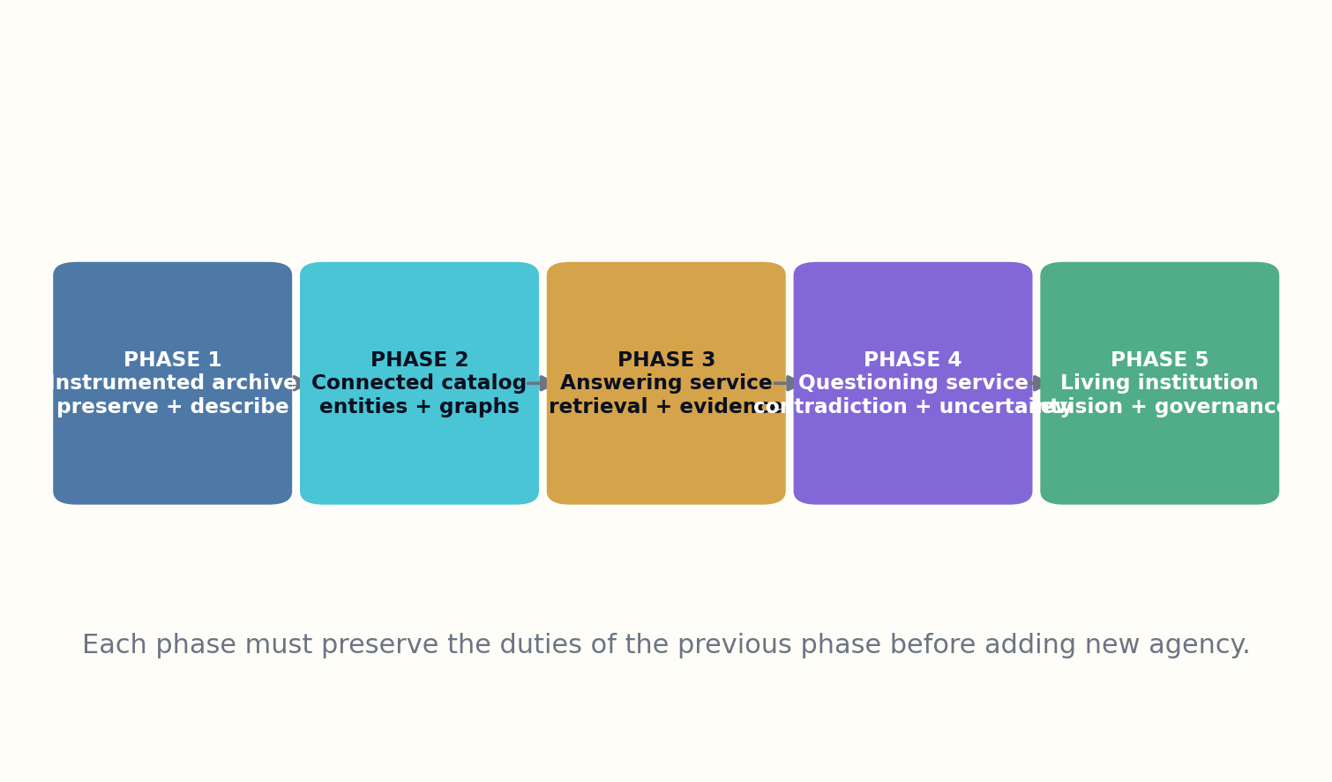
Figure 18. The implementation path adds agency only after preserving the duties of each earlier phase.

HOW THE SYSTEM WORKS
The first pilot should be narrow and observable: a defined collection, a small set of question types, published evidence packets, named librarians, and rigorous error reporting. The objective is to learn where the architecture lies to itself. Rejected answers and failed revisions are valuable research outputs.
Over time, libraries can federate their cognitive services while retaining local governance. Shared standards allow answers, claims, corrections, and editions to travel. Public institutions provide continuity beyond the lifespan of vendors and models. The living library becomes infrastructure for civilization’s relationship with its own memory.

THE INSTITUTIONAL TEST
A library that writes back does not speak last. It answers with evidence, asks what the evidence cannot settle, explains how its understanding formed, and revises without pretending the past never happened. Its intelligence is not the confidence of a machine. It is the disciplined responsiveness of an institution that remembers.
Scale gate S_(n+1) opens only when preservation, access, trust, plurality, and accountability pass at stage n
DESIGN EXERCISE
• Choose a narrow collection for a first cognitive-library pilot.
• Define one audit that must pass before each new phase.
• Write the sentence that determines whether the institution deserves to scale.
Research notes: R1, R2, R21, R28. See Research Notes and Sources.

APPENDIX A
THE COGNITIVE LIBRARY REFERENCE ARCHITECTURE
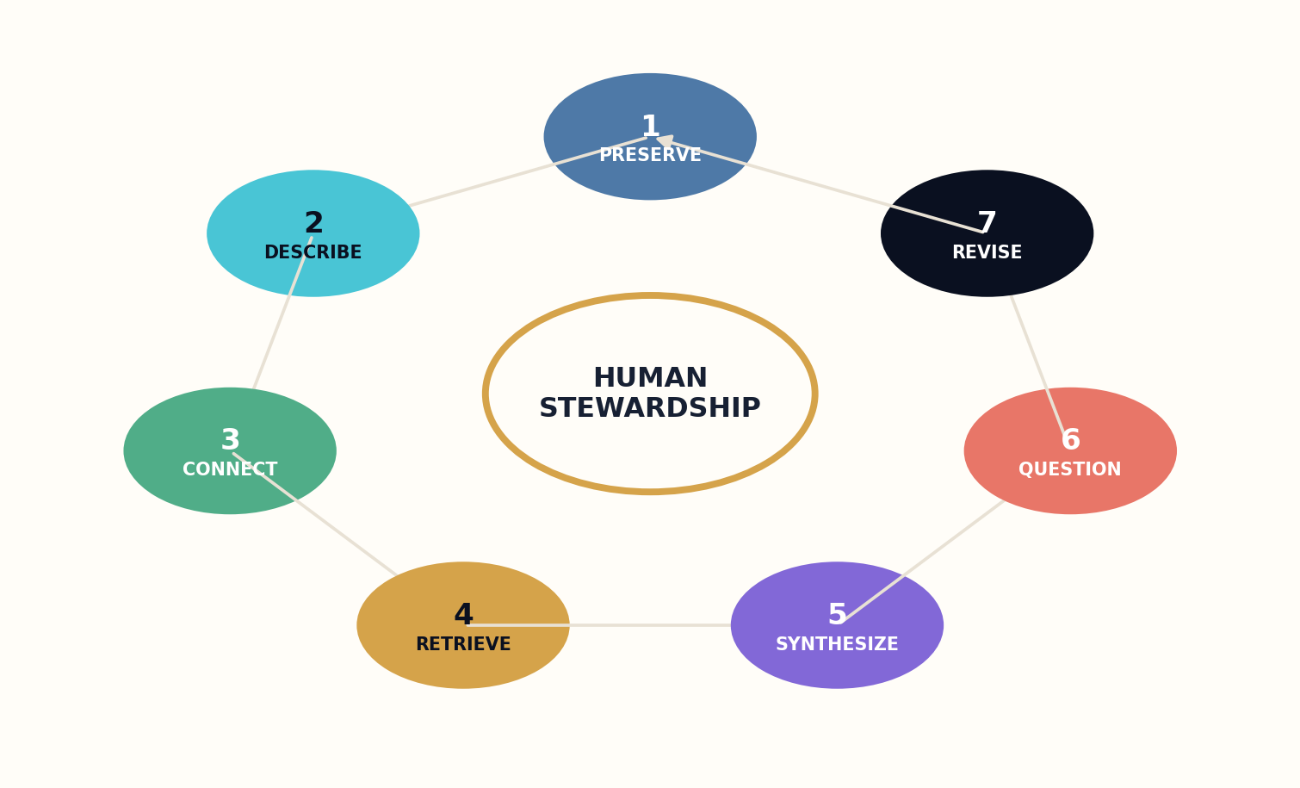
Figure 19. The seven-stage cognitive library, with human stewardship at the constitutional center.

1. Preservation Plane
Immutable source objects, checksums, format migration, collection policy, and preservation copies.

2. Description Plane
Bibliographic records, authority control, entity resolution, temporal metadata, and community vocabularies.

3. Knowledge Plane
Claim graphs, methods, evidence, contradictions, rights, provenance, and dependency links.

4. Retrieval Plane
Lexical search, vector search, graph traversal, temporal filters, source diversity, and stopping rules.

5. Synthesis Plane
Evidence packets, argument maps, explanations, diagrams, lessons, and reader-specific presentation.

6. Questioning Plane
Contradiction search, uncertainty calibration, hypothesis generation, adversarial review, and refusal.

7. Revision Plane
Versioned editions, correction propagation, alerts, audit logs, maintenance policies, and retirement.

Human Stewardship
Librarians, domain experts, communities, educators, creators, auditors, and public governance.

APPENDIX B
CORE DATA OBJECTS AND SCHEMAS

Source Object
• source_id
• checksum
• media_type
• acquisition_event
• rights_record
• preservation_state
• access_policy
• parser_lineage

Entity Object
• entity_id
• type
• labels
• aliases
• temporal_scope
• external_identifiers
• community_assertions
• review_status

Claim Object
• claim_id
• claim_type
• proposition
• scope
• source_span
• method_links
• evidence_links
• counterevidence
• uncertainty
• status

Evidence Packet
• question_id
• research_plan
• supported_claims
• disputed_claims
• methods
• coverage_gaps
• rights
• source_snapshot

Edition Manifest
• edition_id
• semantic_version
• source_snapshot
• graph_snapshot
• models
• human_contributors
• claim_ledger
• change_log
• signature

APPENDIX C
EVALUATION AND AUDIT RUBRICS
PRESERVATION  □ Original object retained  □ Checksum verified  □ Format risk monitored  □ Transformation lineage recorded  □ Access restrictions enforced | ANSWER QUALITY  □ Question fully decomposed  □ Sources appropriate and diverse  □ Claims entailed by citations  □ Counterevidence represented  □ Uncertainty actionable
EXPLANATION  □ Prerequisites correct  □ Mechanism visible  □ Representations appropriate  □ Examples and counterexamples valid  □ Transfer demonstrated | REVISION  □ Trigger detected  □ Dependencies traced  □ Impact classified  □ Prior edition preserved  □ Readers alerted proportionally
GOVERNANCE
□ Authority named
□ Appeal available
□ Privacy minimized
□ Community protocols respected
□ Model changes audited

APPENDIX D
A CONSTITUTION FOR THE LIBRARY THAT WRITES BACK
Article I — Preservation before generation
No cognitive service may compromise the authenticity, durability, or retrievability of the source record.
Article II — Evidence before fluency
A coherent response does not outrank inspectable evidence.
Article III — Intellectual freedom and plural description
The system preserves access to disagreement and represents contested vocabularies without silent erasure.
Article IV — Privacy by necessity
The library collects and retains only the user information required to provide the chosen service.
Article V — Human accountability
High-consequence outputs and institutional policies remain under named human authority.
Article VI — Provenance and rights
Every derivative carries source lineage, permissions, restrictions, and attribution obligations.
Article VII — Revision without historical destruction
Corrections create linked editions and visible status changes rather than silent replacement.
Article VIII — The right to inspect and appeal
Users may inspect evidence, request human review, report errors, and challenge restrictions.
Article IX — Local stewardship
Communities retain authority over culturally sensitive, local, and contributed knowledge.
Article X — The right not to answer
The library may refuse synthesis when evidence, rights, safety, or legitimacy are insufficient.

GLOSSARY
Cognitive library. A governed library system that can preserve, describe, connect, retrieve, synthesize, question, and revise knowledge.
Claim graph. A graph representing propositions, methods, evidence, counterevidence, scope, and revision dependencies.
Contradiction engine. A process that identifies conflicting claims and searches for contextual variables, evidence differences, or genuine unresolved disagreement.
Evidence packet. A bounded research object supplied to a writer or answering model before prose generation.
Living edition. An immutable, citable version of a work linked to later revisions and a current recommended pointer.
Provenance ledger. The inspectable lineage connecting sources, rights, claims, retrieval, models, human edits, and editions.
Query planner. The component that converts a user request into subquestions, source strategy, risk tier, countersearch, and stopping rules.
Reference interview. A librarian-led process for discovering the real information need behind an incomplete or ambiguous request.
Revision propagation. The tracing and repair of downstream works affected by a corrected, retracted, or reinterpreted source.
Semantic pluralism. The preservation of multiple sourced vocabularies or descriptions when one canonical label would erase legitimate difference.

RESEARCH NOTES AND SOURCES
This book distinguishes established practices and published research from proposed architecture. The sources below ground the historical, technical, and governance components. Implementation should use current documentation, applicable law, professional standards, and local institutional policy.
The proposed seven-stage cognitive library and its equations are original design frameworks presented in this volume; they are not claims that a single existing institution currently implements the entire architecture.
R1 Library of Congress, Digital Collections Management Compendium: responsible and trustworthy management of digital collections. https://www.loc.gov/programs/digital-collections-management/about-this-program/
R2 IFLA, Statement on Libraries and Artificial Intelligence, including intellectual freedom, equity, privacy, and AI literacy. https://repository.ifla.org/handle/20.500.14598/1646
R3 Library of Congress, Metadata Enables Access to a Unified Collection. https://www.loc.gov/programs/digital-collections-management/access/metadata-enables-access-to-unified-collection/
R4 Library of Congress, Digital Scholarship Research Guide and computational access to collections. https://guides.loc.gov/digital-scholarship
R5 Library of Congress, Principles of Access for digital collections. https://www.loc.gov/programs/digital-collections-management/access/principles-of-access/
R6 Lewis et al., Retrieval-Augmented Generation for Knowledge-Intensive NLP Tasks, NeurIPS 2020. https://arxiv.org/abs/2005.11401
R7 OCLC, Linked Data: the next evolution of library metadata. https://www.oclc.org/en/linked-data.html
R8 OCLC Research, Linked Data research program and library knowledge infrastructure. https://www.oclc.org/research/areas/data-science/linkeddata.html
R9 OCLC, Linked Data: The Future of Library Cataloging, 2024. https://www.oclc.org/en/news/releases/2024/20240624-linked-data-position-paper.html
R10 OpenAlex, documentation for an open scholarly knowledge graph. https://docs.openalex.org/
R11 Crossref, metadata and relationships among scholarly objects. https://www.crossref.org/documentation/
R12 Crossref Crossmark: current status, corrections, retractions, and updates. https://www.crossref.org/services/crossmark/
R13 Crossref, version control, corrections, and retractions best practices. https://www.crossref.org/documentation/principles-practices/best-practices/versioning/
R14 Lewis et al., RAG paper and explicit non-parametric memory for current, attributable knowledge. https://arxiv.org/abs/2005.11401
R15 Asai et al., Self-RAG: retrieve, generate, and critique through self-reflection, ICLR 2024. https://proceedings.iclr.cc/paper_files/paper/2024/hash/25f7be9694d7b32d5cc670927b8091e1-Abstract-Conference.html
R16 Edge et al., From Local to Global: A Graph RAG Approach to Query-Focused Summarization, 2024. https://arxiv.org/abs/2404.16130
R17 NIST, Artificial Intelligence Risk Management Framework: Generative AI Profile. https://www.nist.gov/publications/artificial-intelligence-risk-management-framework-generative-artificial-intelligence
R18 NIST, Four Principles of Explainable Artificial Intelligence and related AI RMF resources. https://www.nist.gov/itl/ai-risk-management-framework/ai-risk-management-framework-resources
R19 NIST AI Risk Management Framework 1.0: Govern, Map, Measure, and Manage. https://www.nist.gov/publications/artificial-intelligence-risk-management-framework-ai-rmf-10
R20 Crossref, correction and retraction metadata practices as a model for living knowledge. https://www.crossref.org/documentation/register-maintain-records/maintaining-your-metadata/registering-updates/
R21 NIST AI RMF and Generative AI Profile: trustworthiness, transparency, evaluation, and risk management. https://www.nist.gov/itl/ai-risk-management-framework
R22 Edge et al., GraphRAG and corpus-scale sensemaking over connected entities. https://arxiv.org/abs/2404.16130
R23 Asai et al., Self-RAG and explicit critique within retrieval-augmented generation. https://selfrag.github.io/
R24 Research Data Alliance Data Versioning Working Group, Recommendations on Data Versioning, 2024. https://doi.org/10.5281/zenodo.13743876
R25 U.S. Copyright Office, Copyright and Artificial Intelligence reports and guidance. https://www.copyright.gov/ai/
R26 Creative Commons, AI and the Commons. https://creativecommons.org/ai-and-the-commons/
R27 C2PA Specifications for content provenance and authenticity. https://spec.c2pa.org/specifications/
R28 NIST AI RMF profiles and organizational governance of AI risk. https://airc.nist.gov/airmf-resources/airmf/6-sec-profile/
R29 Library of Congress World Digital Library collection and multilingual cultural heritage access. https://www.loc.gov/collections/world-digital-library/about-this-collection/
R30 OCLC Research, Library Linked Data in the Cloud: experiments with new models of resource description. https://www.oclc.org/research/publications/2015/oclcresearch-library-linked-data-in-the-cloud.html

THE LIBRARY WRITES BACK
SO THAT HUMANITY CAN ANSWER BETTER.
GRAYLAN JANULIS

