**UNIT 2 PROJECT---CODE**

SELECT * FROM soccer

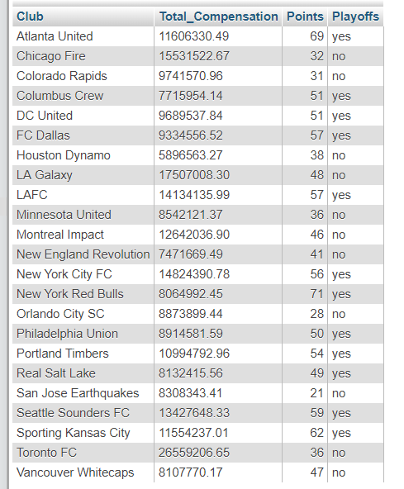

Sources:

<https://mlsplayers.org/resources/salary-guide>

<https://www.mlssoccer.com/standings>

SELECT Club, CASE

WHEN Playoffs = "yes" THEN 1

WHEN Playoffs = "no" THEN 0

END AS x, Playoffs

FROM soccer;

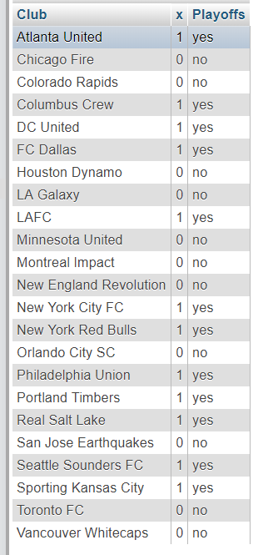

SELECT AVG(CASE

WHEN Playoffs = "yes" THEN 1

WHEN Playoffs = "no" THEN 0

END)*100 AS x

FROM soccer;

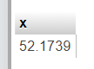

*Over fifty percent of the clubs qualified for the playoffs.*

CREATE TABLE soccer1 AS SELECT Club, Total_Compensation, Points, Playoffs FROM soccer WHERE Playoffs = "Yes";

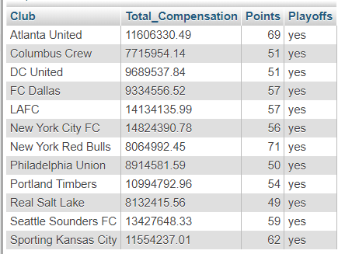

SELECT SUM(Total_Compensation)

FROM soccer1

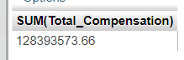

SELECT AVG(Total_Compensation)

FROM soccer1

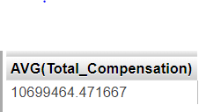

SELECT AVG(Points)

FROM soccer1

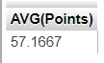

CREATE TABLE soccer2 AS SELECT Club, Total_Compensation, Points, Playoffs FROM soccer WHERE Playoffs = "No";

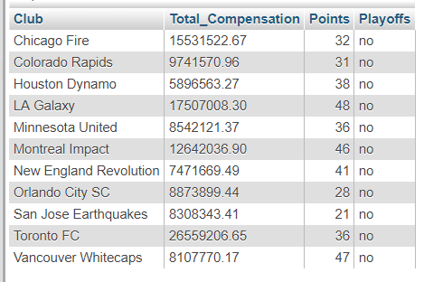

SELECT SUM(Total_Compensation)

FROM soccer2



SELECT AVG(Total_Compensation)

FROM soccer2

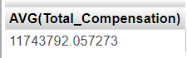

SELECT AVG(Points)

FROM soccer2

