Introduction

The Data Object Model (DOM) is a combination of procedures necessary for reading and writing data from arbitrary sources and the Spectrum Object Model (SOM), which is the data structure that is the primary access point for the data. This document sets out the behavior requirements for the DOM. The DOM is composed of three sub-systems: the Data Resource Broker (DRB), the Data Source Translator (DST) and the Internal Cache (IC). Figure 1 shows the lines of communication between the sub-systems as well as the interactions of the DOM with external entities. The following sections will detail the requirements, stimuli and responses for the different sub-systems along with a functional description of the sub-system.

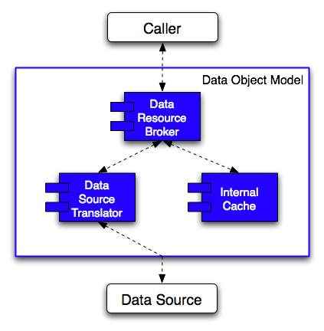
Figure 1: Schematic drawing of the Data Object Model showing the composing modules.

Abbreviations
DOM – Data Object Model
DRB – Data Resource Broker
DST – Data Source Translator
IC – Internal Cache
SOM – Spectrum Object Model

Data Resource Broker

The Data Resource Broker (DRB) is responsible for handling requests from callers about potential data or attributes that are stored in a data source or in the DOM’s internal cache. The DRB interrogates the internal cache via the Internal Cache sub-system for the requested information. If the information is found, it is passed back to the Caller. If the information is not present, the DRB then contacts the Data Source Translator (DST) for the information. The DST retrieves the information and returns it to the DRB, which then passes it back to the caller. Tagged requirements for the DRB are provided in Table 1. Figure 2 shows the interfaces for the DRB. Stimuli and responses for the DRB are given in Table 2 and Table 3 respectively.

Table 1: Requirements for the Data Resource Broker
Tag | Requirement | Trace
 | The DRB is instantiated with a request to open a new data source.
 | The DRB instantiation creates an empty Internal Cache (IC).
 | The DRB responds with a request to open a data source via a DST.
 | If the DRB receives an open data source failure message from the DST, the DRB informs the Caller of the failure and the DRB terminates.
 | If the DRB receives an open data source success message, the DRB makes no response and is ready to receive data requests.
 | Upon the first request for data, the DRB makes the request to the associated DST.
 | If the data request is successful, the DRB returns the data to the caller.
 | A successful data request also causes the DRB to cache that data to the IC.
 | If the data request fails, the DRB informs the Caller of the failure.
 | Subsequent data requests from the Caller are first sent to the IC.
 | If the IC returns the requested data, the DRB forwards the data to the Caller.
 | If the IC cannot find the requested information, the DRB makes the request to the associated DST.
 | If the Caller requests a data source closure, the DRB passes that request onto the associated DST. (Can we have more than one DST?)
 | Upon termination of the DRB, the IC is flushed and the DST is requested to close the data source.
 | If the DRB receives a close data source failure during shutdown, it is ignored. (Could this be a problem for socket or network data sources?)
 | If the DRB is instantiated with the Caller not providing a data source, an empty IC is created but no corresponding DST is created.
 | If the DRB is instantiated with a serialization request, the data is passed to the IC.
 | If the serialization request is successful, the DRB makes no response.
 | If the serialization request fails due to storage limitations, the DRB informs the Caller of the storage failure.

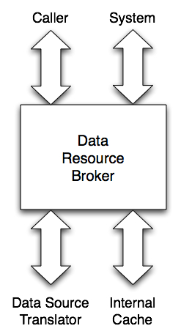
Figure 2: Interfaces for the Data Resource Broker
- Caller – External requests to retrieve stored information (data, attributes etc.).
- Data Source Translator – Receives requests and provides responses on stored information.
- Internal Cache – Receives requests and provides responses on stored information.
- System – Interaction with operating system and handling of system startup and shutdown procedures.

Table 2: Stimuli for the Data Resource Broker
Stimulus | Description | Trace
Instantiate with No Data Source | This is the creation of a DRB with an empty IC and no associated DST.
Instantiate with Input Data Source | This is the creation of a DRB with an empty IC and no associated DST.
Instantiate with Serialize Request | This is the creation of a DRB with a filled IC and no associated DST.
Provide Data Source | This is a request from the Caller to make an associated DST.
Caller Data Request | The Caller makes a data request to the DRB.
IC Data Found | The IC has provided the requested data.
IC Data Not Found | The IC cannot find the requested data.
IC Data Request Failed | The IC failed to process the data request.
DST Data Found | The DST has provided the requested data.
DST Data Not Found | The DST cannot find the requested data.
DST Data Request Failed | The DST failed to process the data request.
Serialization Too Large | The requested serialization to the IC will cause a storage exhaust for the IC.

Table 3: Responses for the Data Resource Broker
Response | Description | Trace
Open Data Source Request | A request sent to the associated DST to open a data source.
Close Data Source Request | A request sent to the associated DST to close its data source.
Send IC Data Request | A data request sent to the IC.
Send DST Data Request | A data request sent to the associated DST.
Send Serialize Request | A serialization request sent to the IC.
Send Cache Request | A request to cache data in the IC.
Data Source Failed to Open | A message to the Caller informing of a failed attempt to open a data source.
Data Source Failed to Close | A message to the Caller informing of a failed attempt to close a data source.
Requested Serialization Too Large | A message to the Caller informing that the requested serialization attempt will cause the IC to storage exhaust.

Data Source Translator

The Data Source Translator (DST) is responsible for receiving data retrieval requests from the DRB and the subsequently retrieving that information from the data source. A fundamental feature of the DST is the ability to translate the data request, which is based on the SOM structure, and turn the request into one that can be understood by the data source that is linked to the DST. If the requested data is present, it is returned to the DRB. If not, an error message is then returned to the DRB. The functioning of the DST presented above is based on the ability of the data source to retain its information. There are classes of data sources that provide a constant stream of information. The DST will have to provide functionality to handle these data source classes in light of DRB requests. Tagged requirements for the DST are provided in Table 4. Figure 3 shows the interfaces for the DST. Stimuli and responses for the DST are given in Table 5 and Table 6 respectively.

Table 4: Requirements for the Data Source Translator
Tag | Requirement | Trace
 | Upon instantiation, the DST creates a handle for a particular type of data source.
 | If the open data source request is performed on an invalid data source, the DST returns a data source open failure to the DRB and terminates.
 | During instantiation, the information from the data source is handled in one of the following manners: read none, read structure, read partial or read all.
 | If the initial data retrieval attempt fails, the DST sends a message back to the DRB informing of the DRB of the failure. The DST then closes its data source and terminates.
 | When the DST receives a data request from the DRB, it attempts to retrieve that data from the data source. The DST will have to translate the request into the data source’s native format.
 | If the retrieval is successful, the DST transmits the data back to the DRB.
 | If the data cannot be found, the DST sends a message to the DRB informing the DRB of the failure.
 | If the data source fails to complete the data request, the DST sends a message to the DRB informing the DRB of the failure.
 | Upon receiving a serialization request, the DST translates the request into the data source’s native formation (if necessary) and transmits the request.
 | If the serialization request is successful, the DST informs the DRB of the success.
 | If the serialization request is unsuccessful, the DST informs the DRB of the failure. This is exclusive of a storage failure.
 | If the serialization request fails due to insufficient storage, the DST informs the DRB of this error.
 | Upon request for a data source closure, the DST destroys the handle in an appropriate manner for the data source type.

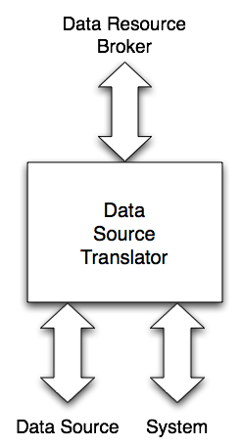
Figure 3: Interfaces for the Data Source Translator
- Data Resource Broker – Requests from and responses to data retrieval.
- Data Source – Provides information based on the translated requests from the DST.
- System – Interaction with operating system and handling of system startup and shutdown procedures.

Table 5: Stimuli for the Data Source Translator
Stimulus | Description | Trace
Open Data Source | Request from the DRB to open a particular data source.
Close Data Source | Request from the DRB to close the associated data source.
Receive Data Request | Request from the DRB to retrieve data from the data source.
Serialize Request | Request from the DRB to store data in the data source.
Data Retrieval Succeeded | The data source has retrieved the requested data.
Data Retrieval Failed | The data source cannot complete the data request. This is exclusive of data not being found.
Data Not Found | The requested data cannot be found in the data source.
Serialization Succeeded | Data source successfully completed the serialization request.
Serialization Failed | Data source cannot complete the serialization request. This is exclusive of a storage exhaust failure.
Serialization Storage Failure | The data source does not or ran out or storage during the processing of the serialization request.

Table 6: Responses for the Data Source Translator
Response | Description | Trace
Open Data Source Succeeded | Message to the DRB if the open request succeeded.
Open Data Source Failed | Message to the DRB if the open request failed.
Close Data Source Succeeded | Message to the DRB if the close request succeeded.
Close Data Source Failed | Message to the DRB if the close request failed.
Initial Data Fetch | The DST makes the initial data retrieval attempt on its data source.
Retrieve Data | The DST transmits the data request from the DRB to the data source.
Transmit Data | The DST has found the requested data and transmits it back to the DRB.
Data Request Failed | Message to the DRB that the DST could not complete the data request. This is exclusive of the data not being found.
Requested Data Not Found | Message to the DRB that the DSTs data source does not contain the requested data.
Serialization Request Succeeded | Message to the DRB that the DSTs data source successfully completed the serialization request.
Serialization Request Failed | Message to the DRB that the DSTs data source could not complete the serialization request. This is exclusive of a storage failure during the serialization attempt.
Serialization Request Storage Failure | Message to the DRB that the DSTs data source could not complete the serialization request due to insufficient storage.

Internal Cache

The Internal Cache (IC) is a system for warehousing information for faster access than that provided by the data source. An example of this would be the IC storing information in memory while the data source is located on disk. Tagged requirements for the IC are provided in Table 7. Figure 4 shows the interfaces for the IC. Stimuli and responses for the IC are given in Table 8 and Table 9 respectively.

Table 7: Requirements for the Internal Cache
Tag | Requirement | Trace
 | Upon instantiation, the IC creates an empty structure.
 | When the IC receives a request for data from the DRB, it searches the internal structure for that data.
 | If the data is found, the IC returns the data to the DRB.
 | If the data is not found, the IC returns a data not found message to the DRB.
 | If the IC receives a data-caching request from the DRB, it first checks to see if there is enough storage for the new data.
 | If there is enough room, the data is cached in the internal structure.
 | If there is not enough room, the amount of cache necessary to purge is calculated.
 | Once the purge size is determined, the IC purges the cache of its oldest data.
 | Once the cache purge is completed, the cache request is fulfilled.
 | If the purge attempt fails, the IC returns a message to the DRB informing it of the failure.
 | Upon termination, the IC flushes the entire cache of its contents and terminates.

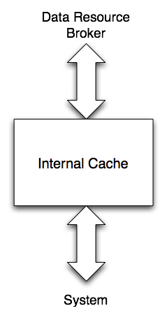
Figure 4: Interfaces for the Internal Cache
- Data Resource Broker – Requests for and responses to data stored in the internal cache.
- System – Interaction with operating system and handling of system startup and shutdown procedures.

Table 8: Stimuli for the Internal Cache
Stimulus | Description | Trace
Instantiate New | Create an IC with an empty internal cache.
Instantiate with Serialization | Create an IC with an internal cache that is filled by the data in the serialization request.
Receive Data Request | The DRB has requested that the IC find a particular block of data.
Data Block OK | The incoming data block will fit within the IC storage limits.
Data Block Too Large | The incoming data block will cause the IC to storage exhaust.

Table 9: Responses for the Internal Cache
Response | Description | Trace
Transmit Data | The IC has found the requested data and is returning it to the DRB.
Data Request Failed | The IC cannot complete the data request. This is exclusive of not finding the data.
Data Not Found | The IC cannot find the requested data in the internal cache.
Cache Data | The IC interacts with the internal cache storage system to install the data in the cache.
Flush Cache | The IC interacts with internal cache storage system to remove part or all of the cache.

