# Association between subjective effort surveys and objective directly-measured workloads in Hispanic migrant farmworkers

### Authors

Ornwipa Thamsuwan, Pablo Palmandez, Kit Galvin, Peter W. Johnson

### Abstract

In North America, Hispanic migrant farmworkers have been exposed to occupational ergonomic risks. It was unknown whether standardized subjective ergonomic assessment tools could yield meaningful results in this population due to cultural differences in the perception of effort and pain. This study investigated whether subjective scales widely used in exercise were associated with objective direct measures such as metabolic load and muscle fatigue in this population.

Twenty-four migrant apple harvesters participated in this study. Borg RPE in Spanish and Omni RPE with pictures of tree fruit harvesters were used for assessing overall effort at four time points during a work shift. Borg CR10 was used for assessing local discomfort at shoulders. To find correlations between objective and subjective overall exertion, we conducted linear regressions of the percentage of heart rate reserve (% HRR) on the Borg RPE and Omni RPE. In terms of local discomfort, the median power frequency (MPF) of trapezius electromyography (EMG) was used for representing muscle fatigue. Then a time-adjusted muscle fatigue was regressed on Borg CR10 increases or decreases from the beginning to the end of the work shift.

When stratifying by the time of measurement, Borg RPE and Omni RPE were significantly correlated to the % HRR, i.e. metabolic load, after the hard work but not after the light work. Therefore, these scales might be useful for certain situations. For the local discomfort, Borg CR10 were not correlated with the MPF of EMG. Thus, the use of such subjective ratings could not replace direct measurement.

## Keywords

Hispanic migrant farmworkers; correlation; Borg; metabolic load; percent of heart rate reserve; muscle fatigue; electromyography

## Relevance to industry

Hispanic migrant agricultural workers are essential in the U.S. food supply chain. While they have been exposed to occupational ergonomic risks, subjective research instruments developed in other settings like cycling exercise and in other population, such as young healthy white adults, may not be applicable to the migrant farmworkers. This research examined the correlations between the subjective scales and the directly-measures data. The results could be used by the practitioners to decide whether to use such scales and how to interpret the outcomes in relation to the actual workloads.

## 1. Introduction

### 1.1 Context of Hispanic migrant farmworkers in North America

In the past several decades, the majority of farmworkers in the United States are Hispanic migrants and more than half of the population do not have authorization to work in the United States (Castillo et al., 2021). Despite being essential to the North American economy, migrant farmworkers’ exposure to the risks of occupational hazard have been negatively affected by language and cultural barriers. Compared to US-born farmworkers, undocumented Hispanic workers had more precarious work, earn less, and more often paid piece rate than hourly (Reid & Schenker, 2016). This situation has led to more exposure to physical and mental stress (Clouser et al., 2018; Panikkar & Barrett, 2021), ultimately leading to work-related musculoskeletal injuries (Cooper et al., 2006; McCurdy et al., 2003). Additionally, this reported problem was affected by increasing age and being female (Shah et al., 2009; McCurdy et al., 2003). Notwithstanding, the research instrument for ergonomic assessment adapted for this population has been lacking.

### 1.2 Objective and subjective measures in ergonomic assessment

Field ergonomic assessment can be done in both objective and subjective manners; in other words, the exposure to occupational ergonomic risk could be evaluated through direct measurement using sensors as well as through participant’s subjective ratings.

Metabolic equivalent (MET), defined as the oxygen consumption of a person and representing a rate at which a person burns energy, has been widely accepted as a measures for the intensity of a physical exercise or work among adults aged 18 to 65 years (Cristi-Montero, 2016; Haskel et al., 2007). Since it is difficult to measure oxygen consumption outside laboratories, numerous studies estimated the MET using other measures that are feasible in the field such as acceleration (Evans et al., 2022; Nakanishi et al., 2018) and heart rate (Caballero et al., 2019; Keytel et al., 2005; Nakanishi et al., 2018). In the occupational health area, a heart-rate-based approach was also developed for determining the cost effectiveness of ergonomic interventions including break strategies, i.e. duration and frequency, as well as the provision of air-conditioning (Bedny et al., 2001). In agricultural field settings, heart rates were used for evaluating work conditions in several activities such as cultivating potatoes (Das et al., 2013), rice (Sahu et al., 2013), wheat (Alka et al., 2014) and apples (Thamsuwan et al., 2019). However, one drawback of this technique is that heart rate varies by age, sex, BMI and fitness (Hiilloskorpi et al., 1999). With this reason, percent heart rate reserve (% HRR), which adjusts for the maximum heart rate and resting heart rate and which has a proven relationship with the oxygen uptake (Cunha et al., 2011), could instead be used as a predictor of MET. In actual farms, % HRR was used for evaluating an assistive device for digging task (Dewi & Komatsuzaki, 2018).

Surface electromyography (EMG) has been used for assessing muscle activity in the field of occupational ergonomics (Hägg et al., 2000; Luttmann et al., 2000). EMG amplitude has a dose-response relationship with a force applied during muscle contraction (Hägg et al., 2000). Also, based on the spectral analysis of an EMG signal, a decrease in EMG mean power frequency (MPF) was proven to be an indicator for muscle fatigue (Luttmann et al., 2000). Surface EMG has already been used for evaluating physical work demand, and for comparing new and traditional tools. In laboratory studies, surface EMG has been used for evaluating the efficacy of emerging technology such as vertical keyboards (van Galen et al., 2007) and touch screen keyboards (Kim et al., 2014, 2013) before the technology was introduced to the market. Nowadays, it is feasible to apply EMG techniques in field settings, which enable the follow up of the effectiveness after the implementation of technology as well as for general ergonomic assessment. In construction, EMG-based muscle fatigue was used in assessing scaffold building activity (Bangaru et al., 2021). In forestry, surface EMG was also used for measuring muscle activity at trapezius of machine operators (Østensvik et al., 2008). In actual agricultural fields, EMG was applied to assess on-farm exposures to biomechanical risk factors (Fethke et al., 2020), and to evaluate the efficacy of a rotary milking parlour as compared to herringbone and parallel ones (Douphrate et al., 2017), mobile orchard platform against ladder uses in the tree fruit industry (Thamsuwan & Johnson, 2022) and potential uses of an exoskeleton or a personal assistive suit in some manual farm tasks (Dewi & Komatsuzaki, 2018; Thamsuwan et al., 2020).

With regards to the subjective measures of effort, fatigue and discomfort, several different scales have been developed and validated. On one hand, Borg RPE (Borg, 1970), which is a perceived exertion scale ranging from 6 to 20, has been widely considered as a psychosomatic indicator of physical activity intensity during work. The Borg RPE was developed in the context of cardiovascular treadmill exercise and intended to be highly correlated with heart rate; that is, the RPE score multiplied by 10 generally represents a person’s actual heart rate in beats per minutes.

On the other hand, Borg CR10 (Borg, 1982) which is anchored at the number from 0 to 10, has been used as a local pain scale. The Borg CR10 has applications in ergonomic; for instance, as a predictor of grip forces during hand tools tasks tested in a laboratory setting (McGorry et al., 2010) and as an indicator of risks to injury among janitors (Schwartz et al., 2019) and nurses (Vieira et al., 2006). One disadvantage of the Borg CR10 is a potential error due to the subjective nature; thus, it is needed to calibrate for the maximal level of exertion to achieve high accuracy (Spielholz, 2006).

Borg RPE and CR10 scales have been translated into several languages (Cabral et al., 2020; Haddad et al., 2013; Leung et al., 2004). While the Borg scales has a verbal description for each numeric value, another commonly-used and validated scale called Omni RPE includes pictorial descriptors in a specific context. Omni RPE is, thus, more generalizable (Lea et al., 2022).

Relationship between subjective and objective measures has been investigated in laboratory studies. A previous study found a significant linear relationship between the EMG MPF of upper trapezius and the Borg CR10 at shoulder elevation endurance tasks (Hummel et al., 2005). Similarly, correlations were found between the EMG MPF of lumbar muscle and the Borg CR10 results during repetitive and prolonged trunk extension tasks (Dedering et al., 1999; Kankaanpaa et al., 1997). Regarding the muscle activity, i.e. the amplitude of the EMG signal, another study (Kuijt-Evers et al., 2007) also found the relationship between the EMG in the percentage of maximum voluntary contraction and the subjective ratings of discomfort (Groenesteijn et al., 2004) in hand tool uses, only in trapezius but not in other muscles.

Despite plenty of laboratory validation of subjective scales, studies on associations between objective and subjective ergonomic measures are lacking in the field settings. It is unclear whether the subjective rating scales validated in the controlled environment could be applied to the ergonomic assessment in the field.

### 1.3 Objectives of this study

The primary objective of this study was to find the relationships between the objective and subjective evaluation of the exertion at the overall level as well as at local body parts in the context of the Hispanic migrant farmworkers in the United States. Specifically, this study aimed to determine 1.) the correlation between metabolic, i.e. cardiovascular, load and the overall RPE scales, and 2.) the correlation between muscle fatigue measured through EMG and the local CR10 scales.

## 2. Methods

### 2.1 Participants

Twenty-four Hispanic male seasonal apple pickers participated in the study. The participants’ ages were on average 28.4 years (range 18-47 years). Their experience as farmworkers harvesting tree fruits in the United States were on average 3.4 years (range 1-14 years). The participants were equally divided into three groups to perform different harvesting methods or tasks: 1.) picking apples at the lower level of the trees up to their reach distance overhead, denoted as “Ground”, 2.) using a ladder to pick apples from the full trees, denoted as “Ladder”, and 3.) picking apples at the upper level of the trees while standing on the semi-automated mobile orchard platform, denoted as “Platform”. All the participants worked in the same schedule from 7:00 to 15:30 with a break during 9:30-10:00.

The protocols for participant recruitment and data collection were approved by the university’s Human Subject’s Division Institutional Review Board. All the participants provided their informed consent.

### 2.2 Data collection

#### 2.2.1 Heart rate monitors

Participants’ heart rate in beats per minute were collected at 1 Hz throughout a full work day using a heart monitor *(Polar RS100CX; Polar Electro Inc., Lake Success, NY)*.

#### 2.2.2 Electromyography

Local muscle activity signal was collected from both left and right trapezius muscles at 1,000 Hz using single-use disposable pre-gelled electrodes (Blue Sensor N; Ambu; Ballerup, Denmark) connected with pre-amplifiers wires to a battery-powered portable data logger (Biomonitor ME6000; Mega Electronics Ltd.; Kuopio, Finland).

#### 2.2.3 Subjective ratings: Borg RPE, Omni RPE and Borg CR10

Borg RPE and Omni RPE were used as subjective measures of overall effort, and Borg CR10 was used as a subjective measure of local discomfort. The Spanish version of Borg RPE and Borg CR10 were previously validated in the field (Thamsuwan et al., 2019). In addition, the Omni RPE with pictures of human wearing an apple bag were included (Figure 1).

The measurement time points of the effort surveys were:

* T0: right before starting the work shift
* T1: after working for 150 minutes since the beginning of the work shift
* T2: after taking a break for 30 minutes, immediately after the 150-minute work period
* T3: at the end of 8-hour work shift

### 2.3 Data processing

#### 2.3.1 Metabolic load: percent of heart rate reserve

Raw heart rate data were filtered using a 5-point moving median to eliminate measurement artifacts. Then the mean of filtered heart rate for each period of interest, i.e. corresponding to the effort survey, were extracted.

The metabolic load was calculated in terms of the percent of heart rate reserve (% HRR) during the work period based on the equations (i), (ii) and (iii) where ${HR}_{max}$ is the maximal heart rate of an individual, ${HR}_{sit}$ is the heart rate measured while the participant was sitting before start working, ${HR}_{work}$ is the heart rate measured while the participant was working, and ${HR}_{rest}$ is the resting heart rate of an individual.

Equation (i) ${HR}_{max}=220-age$

Equation (ii) ${HR}_{rest}= {HR}_{sit}-10$

Equation (iii) $\%HRR=\frac{{HR}_{work}-{HR}_{rest}}{{HR}_{max}-{HR}_{rest}}$

%HRR was square-root transformed to meet the assumption of normality and verified by Shapiro-Wilk test.

#### 2.3.2 Muscle fatigue: EMG median power frequency

Raw EMG signal were filtered with a 20-450 Hz bandpass filter. By converting a time domain signal into a frequency domain, median power frequency of the EMG was calculated for every 10 minutes. Then we conducted a linear regression of MPF on time for each trapezius side and each individual subject based on the equation (iv).

Equation (iv) $MPF=b_{0}+b_{Time}Time$

The slope of the time factor ($b_{Time}$) from the equation (iv), which represented an increase or decrease in MPF over the work period, was used in the analysis to identify the association between muscle fatigue and the changes over time in the subject-reported local discomfort.

#### 2.3.3 Effort survey

The effort surveys including Borg RPE, Omni RPE and Borg CR10 at the specific time point were analyzed in terms of the increase or decrease as compared to the values at the beginning of the work shift.

### 2.4 Statistical analysis

For the overall effort or full body exertion, we calculated a correlation between %HRR and Borg RPE, and a correlation between %HRR and Omni RPE. For the local discomfort or muscle fatigue, we calculated a correlation between muscle fatigue (EMG MPF) and Borg CR10.

Initially, Pearson’s correlations between the subjective and objective measures were calculated. Then we conducted linear regressions to adjust for known confounders; that is, the harvesting method and the time of measurement for the overall exertion, and the harvesting method and the side of trapezius (dominant and non-dominant) for the local discomfort.

As the dataset was fairly small, that is, 24 participants for overall effort and 20 participants for local discomfort due to EMG data lost, we set the level of statistical significance at 0.90. All the statistical analysis was conducted using R programming language.

## 3. Results

### 3.1 Overall effort: % HRR as metabolic load, Borg RPE and Omni RPE

Based on the Shapiro-Wilk test, initial % HRR was not normally distributed (p = 0.013). After the % HRR was square-root transformed, the data became normally distributed (p = 0.48). Figure 2 shows the histograms and the QQ-plots of data before and after the transformation.

The metabolic load, i.e. % HRR, among each group of workers at each time of measurement is shown in Figure 3. In general, % HRR values were between 0.15 and 0.75 after the participants had worked for 90 minutes (T1). Then the % HRR significantly dropped after a 30-minute break (T2) and increased again at the end of the work shift (T3) (p-value < 0.0001). According to Figure 3, the % HRR in the Ladder workers were higher than the %HRR in the Ground and Platform groups at T1 and T3.

The increases in Borg RPE from the beginning of the work shift were greater at the end of the work shift (T3) as compared to the other time (p-value < 0.0001) as shown in Figure 4. However, the increases in Borg RPE over time were not significantly different across the harvesting methods (p-value = 0.83).

The increases in Omni RPE from the beginning of the work shift were also greater at the end of the work shift (T3) as compared to the other time (p-value < 0.0001) as shown in Figure 5. Moreover, at T3, the increases in Omni RPE from the beginning of the shift were significantly smaller in the Ground workers than in the Ladder and Platform groups (p-value = 0.05).

### 3.2 Association between objective metabolic load and subjective overall effort

Without adjusting for neither work period (T1, T2 and T3) nor harvesting method (Ground, Ladder and Platform), the correlation coefficient between the % HRR and the Borg RPE difference was 0.152, with the statistically insignificant p-value of 0.20. Similarly, the correlation coefficient between the % HRR and the Omni RPE difference was 0.169, also with the statistically insignificant p-value of 0.16.

However, when adjusted for the work period and the harvesting method, which had significant effect on the %HRR, the correlation coefficient between the % HRR and the Borg RPE difference became -0.0063, with the p-value of 0.048. In the same way, the correlation coefficient between the % HRR and the Omni RPE difference became -0.0127, with the p-value of 0.027.

With the confounding effect, the analyses were further stratified by the harvesting method and by the work period. On one hand, when the analysis was stratified by the harvesting method and the effect of the work period was adjusted, significant correlations between the % HRR and the Borg RPE difference were found only in the Ground and Ladder groups (p-values = 0.072 and 0.044, respectively), and a significant correlation between the % HRR and the Omni RPE difference was found only in the Ladder group (p-value = 0.078).

On the other hand, when stratified by the work period, i.e. the time point of measurement, Figures 6 and 7 showed the negative correlations between the objective and subjective measures in all time points of measurement. Nevertheless, the correlations between the % HRR and the Borg RPE difference were found statistically significant only at T1 and T3 (both p-values were 0.087). Meanwhile, none of the correlation coefficients between the % HRR and the Omni RPE were statistically significant.

### 3.3 Local discomfort: EMG MPF as muscle fatigue and Borg CR10

The EMG MDF in 10-minute windows of all participants had a bi-modal distribution (Figure 8) due to the difference between dominant and non-dominant muscle sides and the difference across harvesting methods as well as across the time of the day. These differences were adjusted using linear regression. After removing, i.e. adjusting for, the effects of muscle side ($b_{Side}$) and the effects of the participants ($b_{Subject}$) who were different across the harvesting methods, the slope of the time variable ($b_{Time}$) was used for analysis to find correlation between EMG MDF and Borg CR10. Figure 9 shows the distribution of the $b_{Time}$ while the Shapiro-Wilk test indicated that the parameter could be considered as normally distributed (p-value = 0.059).

Muscle fatigue, i.e. the EMG MPF, reduced over time as shown by the negative slope ( $b_{Time}$ = -0.0056) in the regression equation (iv) (p-value < 0.0001). This is in accordance with the results of muscle activity from the previous study (Thamsuwan & Johnson, 2022).

The Borg CR10 difference between the beginning and the end of work shift by each harvesting method is shown in Figure 10. The increases in Borg CR10 from the beginning to the end of the work shift was higher in the Platform group than in the Ground and Ladder groups. According to the Kruskal-Wallis tests for nonparametric data, the harvesting method had a statistically significant effect on the Borg CR10 increase over time (p-value = 0.013) but the side of trapezius did not (p-value = 0.51).

### 3.4 Association between objective muscle fatigue and subjective local discomfort

Regardless of whether we accounted for the muscle side, work period or harvesting method, there was no correlation between the slope $b_{Time}$ in the equation (iv) and the Borg CR10 difference. That is, there was no relationship between the EMG mean power frequency representing muscle fatigue and the Borg CR10 increases or decreases over the work period. Figure 11 shows the scatter plot between the $b_{Time}$ on the y-axis and the Borg CR10 difference between the start and the end of work shift on the x-axis.

## 4. Discussions

### 4.1 Interpretations and implications from negative or no correlation

There were negative significant correlations between the objective and subjective measures of overall effort when the analysis adjusted for the harvesting method and the time of measurement. That is, both Borg RPE and Omni RPE may be used to predict the outcomes of % HRR.

When stratifying by harvesting method, the significance level was still strong only in the Ladder group, but less strong in the Ground and Platform groups, respectively. This might have been due to the fact that the Ladder group had a very physically demanding load, followed by the Ground and the Platform groups. Accordingly, on one hand, the relationship between Borg RPE and % HRR and the one between Omni RPE and % HRR were established when the physical workload was sufficiently demanding. On the other hand, during relatively lighter work, the subjective ratings like Borg RPE and Omni RPE may not be useful for ergonomic assessment.

When stratifying by the time in the work shift, the statistically significant relationship between Borg RPE and % HRR were found at T1 and T3, i.e. after morning and afternoon work sessions, but not at T2, i.e. after the lunch break. This finding is in accordance with the case of stratifying by harvesting method. That is, it might require the farmworkers to perform heavy a task so that the subjective Borg RPE responses could be meaningful. Otherwise, during or after a rest period, Borg RPE was not interpretable in this population and might not be used to assess a recovery from the rest in place of the objective direct measurement.

Additionally, when stratifying by the time in the work shift, the relationship between Omni RPE and % HRR became statistically insignificant. This finding suggested that the Omni RPE with the pictures of apple harvesting may still not be robust. Notwithstanding, it is worth remarking that the reason might be due to the fact that the stratification reduced the sample size and, consequently, there was not enough power to detect a significant correlation in each group.

There was no significant correlation between the objective and subjective measures of local discomfort. In other words, Borg CR10 scales at local body parts, particularly the shoulders, were not representative for the muscle fatigue as directly measured and characterized by EMG.

Despite being translated and adapted to the culture, the subjective effort surveys, namely Omni RPE, Borg RPE and Borg CR10, may not be suitable for ergonomic assessment among Hispanic migrant fruit harvesters, especially when the physical workload were not extreme. Therefore, they could not fully replace the objective directly-measured outcomes like metabolic load or muscle fatigue.

### 4.2 Comparisons to previous studies

This study indicated the unsuitability of subjective scales for ergonomic assessment in fruit harvesting tasks undertaken by the Hispanic migrant workers, as compared to the uses of cardiac measures and the muscle fatigue of trapezius. Particularly, the finding from this study that the subjective scales were more sensitive to heavy workload is relevant to a previous work; that is, while Borg scale could detect a major change in task difficulty, it was found unsuitable to identify minor changes of task difficulty and discomfort, in contrast to the capability of EMG at biceps brachii and triceps brachii (Shafti et al., 2016). On a contrary, Borg CR10 was found to be more sensitive to a light load than EMG MPF did; that is, in a laboratory study using the EMG MPF of trapezius and Borg CR10 during arm abduction, there was a strong negative correlation between the MPF and the CR10 scores at heavy load while the MPF did not change at low load (Öberg et al., 1994). Above all, this study found increases over time in both EMG MPF and Borg CR10; however, we did not address whether the objective measure of muscle fatigue like EMG or the subjective discomfort responses like Borg scales could provide a better ergonomic assessment.

Newly developed subjective rating scales like Omni RPE may be used for certain contexts, in this case, when farmworkers actually performed heavy work but not the light work. This subjective measurement could, thus, be used as a complement of their corresponding objective measurement rather than as standalone tools. Even though a previous study found that the Omni RPE in a pictorial face format was correlated with heart rate and respiratory rate in both men and women (Huang & Chiou, 2013), Omni RPE alone was not distinguishable across different walking and running loads in children whereas the oxygen consumption did (Kung et al., 2020).

### 4.3 Study limitations

A number of systematic biases in this study should be mentioned. Firstly, the presence of researchers in the field might have altered the way the participants worked; thus, the objective directly-measured outcomes on muscle fatigue or metabolic load may be affected. Secondly, the administration of the Borg and Omni questionnaires could have interrupted the workers’ lunch break. It is possible that some workers ended up answering the questions as fast as they could rather than did it attentively.

Moreover, there was a limitation associated with the heart rate measurement. In the ideal situation, a resting heart rate should be measured in a recumbent position. However, in this study, heart rates were measured during a quiet sitting position prior to the work shift, and then the measured values were subtracted by 10 as per the equation (ii) similarly to the previous work (Thamsuwan et al., 2019); in other words, the resting heart rate was obtained by approximation rather than exact measurement.

Furthermore, there were challenges in EMG measurement in the field due to the perspiration of workers and the physical contact between electrodes and the apple bag strap or the ladder. Anomalies in EMG data were detected and removed with a new algorithm to retain the muscle activity signal (Thamsuwan & Johnson, 2022) but there were still some data loss. Future studies should instead find a way to detect the anomalies in real time during the data collection, which could prevent data loss more effectively as compared to logging the data to examine later at the end of the work shift like in this study.

## 5. Conclusion

This study examined whether there was a relationship between subjective and objective measures of overall cardiovascular load and local muscle fatigue among Hispanic migrant farmworkers harvesting apples in North America. Borg RPE and Borg CR10 were translated into Spanish, and Omni RPE with pictures were created for this specific population. The Borg RPE and Omni RPE results were compared to metabolic load derived from heart rate data, which represented overall physical exertion. This study found strong negative correlations between the objective and subjective measures after the workers performed hard work but neither after the light work nor after the break. The Borg CR10, which was expected to indicate local discomfort, was compared to the muscle fatigue as characterized by EMG at trapezius. Unlike the results of the correlations between the RPE’s and the cardiovascular load, there was no significant correlation between the Borg CR10 and the EMG. All things considered, objective direct measures could not be replaced by subjective measures according to this study.

## Acknowledgement

The authors would like to thank all the farmworkers who participated in this study. We also thank to Kit Maria Tchong-French for their support in the research management, as well as Maria Negrete, Katherine Gregersen, and Margaret Hughes for their support in field data collection. This project was funded by the National Institute for Occupational Safety and Health [Cooperative Agreement #4 U 254 OH007544] and the Washington State Medical Aid and Accident Fund.

## Reference

Alka, S., U., S. G., Rajesh, S., & Dinesh, P. (2014). Ergonomic study of farm women during wheat harvesting by improved sickle. *African Journal of Agricultural Research*, *9*(18), 1386–1390. https://doi.org/10.5897/AJAR2013.7956

Bangaru, S. S., Wang, C., Busam, S. A., & Aghazadeh, F. (2021). ANN-based automated scaffold builder activity recognition through wearable EMG and IMU sensors. *Automation in Construction*, *126*, 103653. https://doi.org/10.1016/j.autcon.2021.103653

Bedny, G. Z., Karwowski, W., & Seglin, M. H. (2001). A Heart Rate Evaluation Approach to Determine Cost-Effectiveness an Ergonomics Intervention. *International Journal of Occupational Safety and Ergonomics*, *7*(2), 121–133. https://doi.org/10.1080/10803548.2001.11076481

Borg, G. (1970). Perceived exertion as an indicator of somatic stress. *Scandinavian Journal of Rehabilitation Medicine*, *2*, 92–98. https://doi.org/S/N

Borg, G. A. (1982). Psychophysical bases of perceived exertion. *Medicine and Science in Sports and Exercise*, *14*, 377–381. https://doi.org/10.1249/00005768-198205000-00012

Caballero, Y., Ando, T. J., Nakae, S., Usui, C., Aoyama, T., Nakanishi, M., Nagayoshi, S., Fujiwara, Y., & Tanaka, S. (2019). Simple Prediction of Metabolic Equivalents of Daily Activities Using Heart Rate Monitor without Calibration of Individuals. *International Journal of Environmental Research and Public Health*, *17*(1), 216. https://doi.org/10.3390/ijerph17010216

Cabral, L. L., Nakamura, F. Y., Stefanello, J. M. F., Pessoa, L. C. V., Smirmaul, B. P. C., & Pereira, G. (2020). Initial Validity and Reliability of the Portuguese Borg Rating of Perceived Exertion 6-20 Scale. *Measurement in Physical Education and Exercise Science*, *24*(2), 103–114. https://doi.org/10.1080/1091367X.2019.1710709

Castillo, F., Mora, A. M., Kayser, G. L., Vanos, J., Hyland, C., Yang, A. R., & Eskenazi, B. (2021). Environmental Health Threats to Latino Migrant Farmworkers. *Annual Review of Public Health*, *42*(1), 257–276. https://doi.org/10.1146/annurev-publhealth-012420-105014

Clouser, J. M., Bush, A., Gan, W., & Swanberg, J. (2018). Associations of Work Stress, Supervisor Unfairness, and Supervisor Inability to Speak Spanish with Occupational Injury among Latino Farmworkers. *Journal of Immigrant and Minority Health*, *20*(4), 894–901. https://doi.org/10.1007/s10903-017-0617-1

Cooper, S., Burau, K., Frankowski, R., Shipp, E., Ddeljunco, D., Whitworth, R., Sweeney, A., Macnaughton, N., Wellor, N., & Hanis, C. (2006). A Cohort Study of Injuries in Migrant Farm Worker Families in South Texas. *Annals of Epidemiology*, *16*(4), 313–320. https://doi.org/10.1016/j.annepidem.2005.04.004

Cristi-Montero, C. (2016). Considerations regarding the use of metabolic equivalents when prescribing exercise for health: preventive medicine in practice. *The Physician and Sportsmedicine*, *44*(2), 109–111. https://doi.org/10.1080/00913847.2016.1158624

Cunha, F. A. da, Farinatti, P. de T. V., & Midgley, A. W. (2011). Methodological and practical application issues in exercise prescription using the heart rate reserve and oxygen uptake reserve methods. *Journal of Science and Medicine in Sport*, *14*(1), 46–57. https://doi.org/10.1016/j.jsams.2010.07.008

D. J. Shah, E. M. Shipp, S. P. Cooper, J. C. Huber, D. J. del Junco, A. A. Rene, & J. S. Moore. (2009). Hand Problems in Migrant Farmworkers. *Journal of Agricultural Safety and Health*, *15*(2), 157–169. https://doi.org/10.13031/2013.26802

Das, B., Ghosh, T., & Gangopadhyay, S. (2013). Child Work in Agriculture in West Bengal, India: Assessment of Musculoskeletal Disorders and Occupational Health Problems. *Journal of Occupational Health*, *55*(4), 244–258. https://doi.org/10.1539/joh.12-0185-OA

Dedering, Å., Németh, G., & Harms-Ringdahl, K. (1999). Correlation between electromyographic spectral changes and subjective assessment of lumbar muscle fatigue in subjects without pain from the lower back. *Clinical Biomechanics*, *14*(2), 103–111. https://doi.org/10.1016/S0268-0033(98)00053-9

Dewi, N. S., & Komatsuzaki, M. (2018). On-body personal assist suit for commercial farming: Effect on heart rate, EMG, trunk movements, and user acceptance during digging. *International Journal of Industrial Ergonomics*, *68*, 290–296. https://doi.org/10.1016/j.ergon.2018.08.013

Douphrate, D. I., Fethke, N. B., Nonnenmann, M. W., Rodriguez, A., Hagevoort, R., & Gimeno Ruiz de Porras, D. (2017). Full-shift and task-specific upper extremity muscle activity among US large-herd dairy parlour workers. *Ergonomics*. https://doi.org/10.1080/00140139.2016.1262464

Evans, S. A., James, D. A., Rowlands, D., & Lee, J. B. (2022). Impact of Centre-of-Mass Acceleration on Perceived Exertion, the Metabolic Equivalent and Heart Rate Reserve in Triathlete Spin Cycling: A Pilot Study. *Journal of Human Kinetics*, *81*(1), 41–52. https://doi.org/10.2478/hukin-2022-0004

Fethke, N. B., Schall, M. C., Chen, H., Branch, C. A., & Merlino, L. A. (2020). Biomechanical factors during common agricultural activities: Results of on-farm exposure assessments using direct measurement methods. *Journal of Occupational and Environmental Hygiene*, *17*(2–3), 85–96. https://doi.org/10.1080/15459624.2020.1717502

Groenesteijn, L., Eikhout, S. M., & Vink, P. (2004). One set of pliers for more tasks in installation work: the effects on (dis)comfort and productivity. *Applied Ergonomics*, *35*(5), 485–492. https://doi.org/10.1016/j.apergo.2004.03.010

Haddad, M., Chaouachi, A., Castagna, C., Hue, O., Wong, D. P., Tabben, M., Behm, D. G., & Chamari, K. (2013). Validity and psychometric evaluation of the French version of RPE scale in young fit males when monitoring training loads. *Science & Sports*, *28*(2), e29–e35. https://doi.org/10.1016/j.scispo.2012.07.008

Hägg, G. M., Luttmann, A., & Jäger, M. (2000). Methodologies for evaluating electromyographic field data in ergonomics. *Journal of Electromyography and Kinesiology*, *10*(5), 301–312. https://doi.org/10.1016/S1050-6411(00)00022-5

Haskel, W. L., Lee, I.-M., Pate, R. R., Powell, K. E., Blair, S. N., Franklin, B. A., Macera, C. A., Heath, G. W., Thompson, P. D., & Bauman, A. (2007). Physical Activity and Public Health. *Medicine & Science in Sports & Exercise*, *39*(8), 1423–1434. https://doi.org/10.1249/mss.0b013e3180616b27

Hiilloskorpi, Fogelholm, Laukkanen, Pasanen, Oja, Mänttäri, & Natri. (1999). Factors Affecting the Relation Between Heart Rate and Energy Expenditure During Exercise. *International Journal of Sports Medicine*, *20*(7), 438–443. https://doi.org/10.1055/s-1999-8829

Huang, D.-H., & Chiou, W.-K. (2013). Validation of a facial pictorial rating of perceived exertion scale for evaluating physical tasks. *Journal of Industrial and Production Engineering*, *30*(2), 125–131. https://doi.org/10.1080/21681015.2013.788079

Hummel, A., Läubli, T., Pozzo, M., Schenk, P., Spillmann, S., & Klipstein, A. (2005). Relationship between perceived exertion and mean power frequency of the EMG signal from the upper trapezius muscle during isometric shoulder elevation. *European Journal of Applied Physiology*, *95*(4), 321–326. https://doi.org/10.1007/s00421-005-0014-7

Kankaanpaa, M., Taimela, S., Webber, C. L., Airaksinen, O., & Hanninen, O. (1997). Lumbar paraspinal muscle fatigability in repetitive isoinertial loading: EMG spectral indices, Borg scale and endurance time. *European Journal of Applied Physiology*, *76*(3), 236–242. https://doi.org/10.1007/s004210050242

Keytel, L. R., Goedecke, J. H., Noakes, T. D., Hiiloskorpi, H., Laukkanen, R., van der Merwe, L., & Lambert, E. V. (2005). Prediction of energy expenditure from heart rate monitoring during submaximal exercise. *Journal of Sports Sciences*. https://doi.org/10.1080/02640410470001730089

Kim, J. H., Aulck, L., Thamsuwan, O., Bartha, M. C., & Johnson, P. W. (2014). The effect of key size of touch screen virtual keyboards on productivity, usability, and typing biomechanics. *Human Factors*, *56*(7), 1235–1248. https://doi.org/10.1177/0018720814531784

Kim, J. H., Aulck, L., Thamsuwan, O., Bartha, M. C., & Johnson, P. W. (2013). The effects of virtual keyboard key sizes on typing productivity and physical exposures. *Proceedings of the Human Factors and Ergonomics Society*, 887–891. https://doi.org/10.1177/1541931213571193

Kuijt-Evers, L. F. M., Bosch, T., Huysmans, M. A., de Looze, M. P., & Vink, P. (2007). Association between objective and subjective measurements of comfort and discomfort in hand tools. *Applied Ergonomics*, *38*(5), 643–654. https://doi.org/10.1016/j.apergo.2006.05.004

Kung, S. M., Fink, P. W., Legg, S. J., Ali, A., & Shultz, S. P. (2020). Age-Related Differences in Perceived Exertion While Walking and Running Near the Preferred Transition Speed. *Pediatric Exercise Science*, *32*(4), 227–232. https://doi.org/10.1123/pes.2019-0233

Lea, J. W. D., O’Driscoll, J. M., Hulbert, S., Scales, J., & Wiles, J. D. (2022). Convergent Validity of Ratings of Perceived Exertion During Resistance Exercise in Healthy Participants: A Systematic Review and Meta-Analysis. *Sports Medicine - Open*, *8*(1), 2. https://doi.org/10.1186/s40798-021-00386-8

Leung, R. W., Leung, M.-L., & Chung, P.-K. (2004). Validity and Reliability of a Cantonese-Translated Rating of Perceived Exertion Scale among Hong Kong Adults. *Perceptual and Motor Skills*, *98*(2), 725–735. https://doi.org/10.2466/pms.98.2.725-735

Luttmann, A., Jäger, M., & Laurig, W. (2000). Electromyographical indication of muscular fatigue in occupational field studies. *International Journal of Industrial Ergonomics*, *25*(6), 645–660. https://doi.org/10.1016/S0169-8141(99)00053-0

McCurdy, S. A., Samuels, S. J., Carroll, D. J., Beaumont, J. J., & Morrin, L. A. (2003). Agricultural injury in California migrant Hispanic farm workers. *American Journal of Industrial Medicine*, *44*, 225–235. https://doi.org/10.1002/ajim.10272

McGorry, R. W., Lin, J.-H., Dempsey, P. G., & Casey, J. S. (2010). Accuracy of the Borg CR10 Scale for Estimating Grip Forces Associated with Hand Tool Tasks. *Journal of Occupational and Environmental Hygiene*, *7*(5), 298–306. https://doi.org/10.1080/15459621003711360

Nakanishi, M., Izumi, S., Nagayoshi, S., Kawaguchi, H., Yoshimoto, M., Shiga, T., Ando, T., Nakae, S., Usui, C., Aoyama, T., & Tanaka, S. (2018). Estimating metabolic equivalents for activities in daily life using acceleration and heart rate in wearable devices. *BioMedical Engineering OnLine*, *17*(1), 100. https://doi.org/10.1186/s12938-018-0532-2

Öberg, T., SANDSJö, L., & KADEFORS, R. (1994). Subjective and objective evaluation of shoulder muscle fatigue. *Ergonomics*, *37*(8), 1323–1333. https://doi.org/10.1080/00140139408964911

Østensvik, T., Nilsen, P., & Veiersted, K. B. (2008). Muscle Activity Patterns in the Neck and Upper Extremities Among Machine Operators in Different Forest Vehicles. *International Journal of Forest Engineering*, *19*(2), 11–20. https://doi.org/10.1080/14942119.2008.10702563

Panikkar, B., & Barrett, M.-K. (2021). Precarious Essential Work, Immigrant Dairy Farmworkers, and Occupational Health Experiences in Vermont. *International Journal of Environmental Research and Public Health*, *18*(7), 3675. https://doi.org/10.3390/ijerph18073675

Reid, A., & Schenker, M. B. (2016). Hired farmworkers in the US: Demographics, work organisation, and services. *American Journal of Industrial Medicine*, *59*(8), 644–655. https://doi.org/10.1002/ajim.22613

Sahu, S., Sett, M., & Kjellstrom, T. (2013). Heat Exposure, Cardiovascular Stress and Work Productivity in Rice Harvesters in India: Implications for a Climate Change Future. *Industrial Health*, *51*(4), 424–431. https://doi.org/10.2486/indhealth.2013-0006

Schwartz, A., Gerberich, S. G., Kim, H., Ryan, A. D., Church, T. R., Albin, T. J., McGovern, P. M., Erdman, A. E., Green, D. R., & Arauz, R. F. (2019). Janitor ergonomics and injuries in the safe workload ergonomic exposure project (SWEEP) study. *Applied Ergonomics*, *81*, 102874. https://doi.org/10.1016/j.apergo.2019.102874

Shafti, A., Lazpita, B. U., Elhage, O., Wurdemann, H. A., & Althoefer, K. (2016). Analysis of comfort and ergonomics for clinical work environments. *2016 38th Annual International Conference of the IEEE Engineering in Medicine and Biology Society (EMBC)*, 1894–1897. https://doi.org/10.1109/EMBC.2016.7591091

Spielholz, P. (2006). Calibrating Borg scale ratings of hand force exertion. *Applied Ergonomics*, *37*(5), 615–618. https://doi.org/10.1016/j.apergo.2005.10.001

Thamsuwan, O., Galvin, K., Tchong-French, M., Kim, J. H., & Johnson, P. W. (2019). A feasibility study comparing objective and subjective field-based physical exposure measurements during apple harvesting with ladders and mobile platforms. *Journal of Agromedicine*, *24*(3). https://doi.org/10.1080/1059924X.2019.1593273

Thamsuwan, Ornwipa, Galvin, K., Tchong-French, M., Kim, J. H., & Johnson, P. W. (2019). A feasibility study comparing objective and subjective field-based physical exposure measurements during apple harvesting with ladders and mobile platforms. *Journal of Agromedicine*. https://doi.org/10.1080/1059924X.2019.1593273

Thamsuwan, Ornwipa, & Johnson, P. W. (2022). Machine learning methods for electromyography error detection in field research: An application in full-shift field assessment of shoulder muscle activity in apple harvesting workers. *Applied Ergonomics*, *98*, 103607. https://doi.org/10.1016/j.apergo.2021.103607

Thamsuwan, Ornwipa, Milosavljevic, S., Srinivasan, D., & Trask, C. (2020). Potential exoskeleton uses for reducing low back muscular activity during farm tasks. *American Journal of Industrial Medicine*, *63*(11), 1017–1028. https://doi.org/10.1002/ajim.23180

van Galen, G. P., Liesker, H., & de Haan, A. (2007). Effects of a vertical keyboard design on typing performance, user comfort and muscle tension. *Applied Ergonomics*, *38*(1), 99–107. https://doi.org/10.1016/j.apergo.2005.09.005

Vieira, E. R., Kumar, S., Coury, H. J. C. G., & Narayan, Y. (2006). Low back problems and possible improvements in nursing jobs. *Journal of Advanced Nursing*, *55*(1), 79–89. https://doi.org/10.1111/j.1365-2648.2006.03877.x

Xiao, H., Mccurdy, S. A., Stoecklin-Marois, M. T., Li, C. S., & Schenker, M. B. (2013). Agricultural work and chronic musculoskeletal pain among latino farm workers: The MICASA study. *American Journal of Industrial Medicine*, *56*, 216–225. https://doi.org/10.1002/ajim.22118

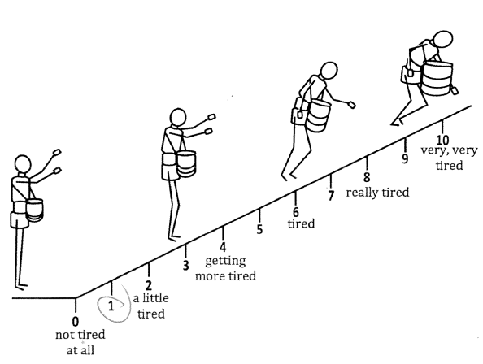

Figure 1. Omni RPE used in this study

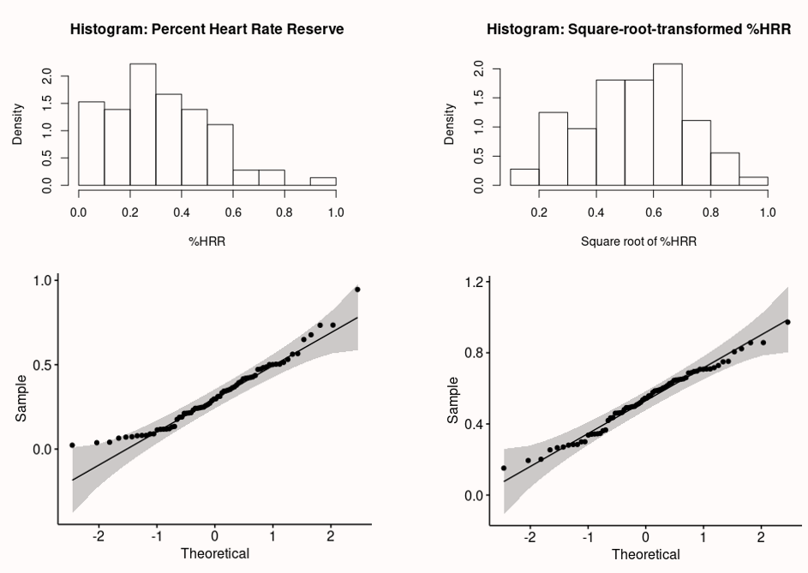

Figure 2. Histograms and Q-Q plots of the %HRR before and after square-root transformed

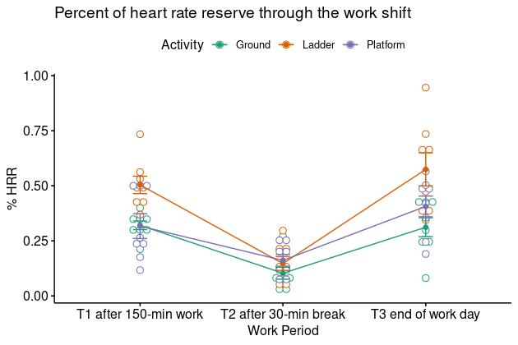

Figure 3. %HRR measured among each group of workers at each work period

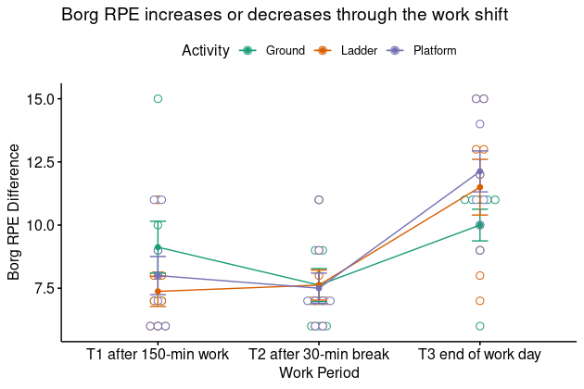

Figure 4. The difference in Borg RPE from the beginning of work reported by each group of workers at each work period

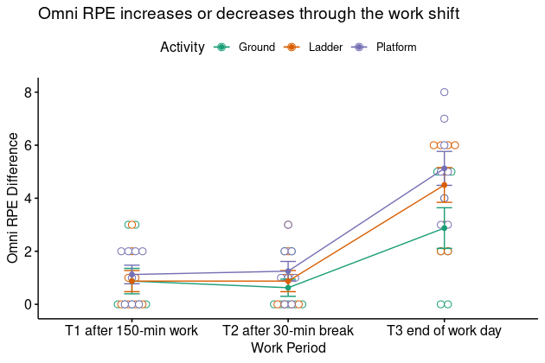

Figure 5. The difference in Omni RPE from the beginning of work reported by each group of workers at each work period

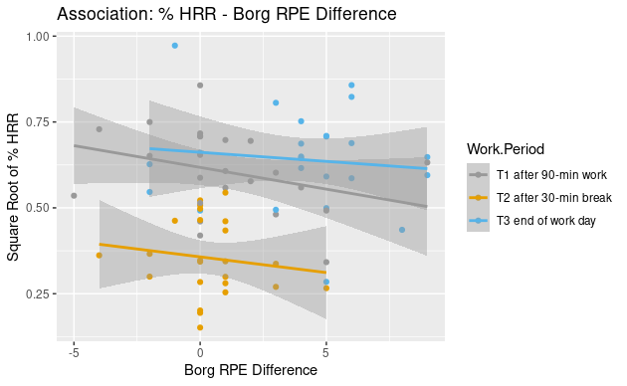

Figure 6. The association between %HRR and Borg RPE difference from the beginning of work shift

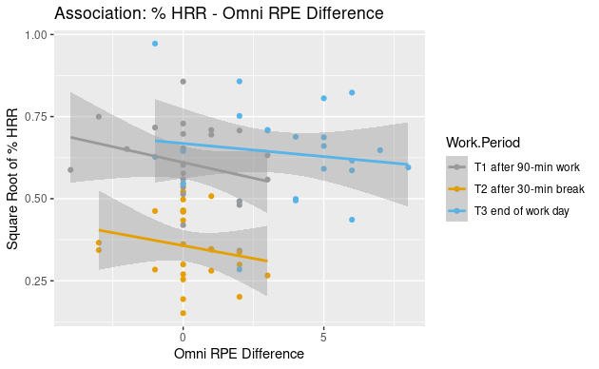

Figure 7. The association between %HRR and Omni RPE difference from the beginning of work shift

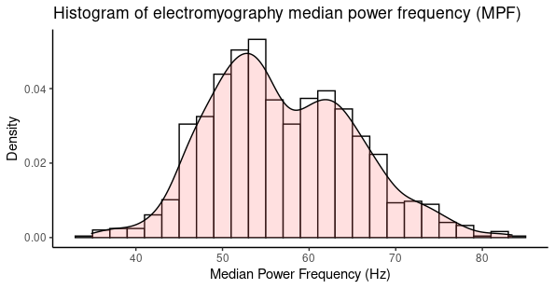

Figure 8. The histogram showing bi-modal distribution of EMG median power frequency

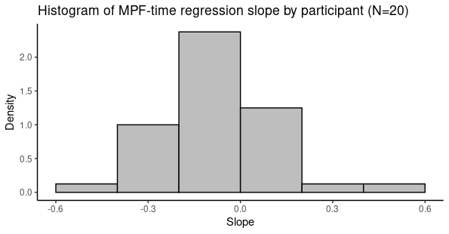

Figure 9. The histogram of the EMG median power frequency regression slope ($b_{Time}$)

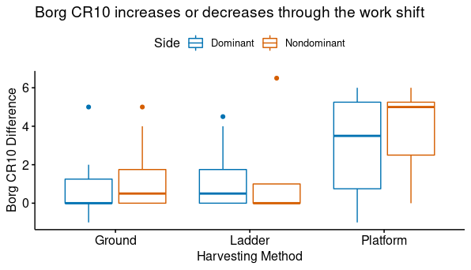

Figure 10. Borg CR10 difference between the beginning and the end of work shift by harvesting method and muscle side

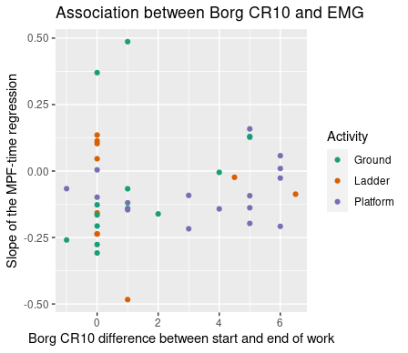

Figure 11. The scatter plot of Borg CR10 difference on x-axis and the $b_{Time}$ on y-axis