# Association between subjective effort surveys and directly-measured physical workloads in Hispanic farmworkers

### Authors

Ornwipa Thamsuwan, Pablo Palmandez, Peter W. Johnson

### Abstract

In North America, Hispanic migrant farmworkers are being exposed to occupational ergonomic risks. Due to cultural differences in the perception and reporting of effort and pain, it was unknown whether standardized subjective ergonomic assessment tools could accurately estimate the directly-measured components of their physical effort. This study investigated whether subjective scales widely used in exercise physiology were associated with direct measures metabolic load and muscle fatigue in this population.

Twenty-four migrant apple harvesters participated in this study. Borg RPE in Spanish and Omni RPE with pictures of tree fruit harvesters were used for assessing overall effort at four time points during a full-day 8-hour work shift. Borg CR10 was used for assessing local discomfort at shoulders. To determine whether there were associations between subjective and direct measures of overall exertion measures, we conducted linear regressions of the percentage of heart rate reserve (% HRR) on the Borg RPE and Omni RPE. In terms of local discomfort, the median power frequency (MPF) of trapezius electromyography (EMG) was used for representing muscle fatigue. Then full-day measurements of muscle fatigue were regressed on Borg CR10 changes from the beginning to the end of the work shift.

Omni RPE were found correlated with the % HRR. Also, Borg RPE were correlated to the % HRR after the break but not after the work. These scales might be useful for certain situations. For the local discomfort, Borg CR10 were not correlated with the MPF of EMG and, therefore, could not replace direct measurement.

## Keywords

correlation; Borg; metabolic load; percent of heart rate reserve; muscle fatigue; electromyography

## Relevance to industry

Hispanic migrant agricultural workers are essential in the North American food supply chain. While they have been exposed to occupational ergonomic risks, subjective research instruments developed for exercise physiology and in other population, such as young healthy white adults, may not be applicable for use in migrant farmworkers. This research examined the correlations between the subjective scales and directly-measured physical measures of effort. The results could be used by practitioners to decide whether to use the less expensive and simpler to use subjective scales and how to interpret the outcomes in relation to the actual workloads.

## 1. Introduction

### 1.1 Context of Hispanic migrant farmworkers in North America

In the past several decades, the majority of farmworkers in the United States are Hispanic migrants and more than half of the population do not have authorization to work in the United States (Castillo et al., 2021). Despite being essential to the North American economy, Despite being essential to the North American economy, language, cultural, immigration status, and educational barriers can can negatively affect the migrant farmworkers’ ability to communicate and/or characterize the exposure to physical workplace hazards. Compared to US-born farmworkers, undocumented Hispanic workers had more precarious work, earn less, and are more often paid piece rate than hourly (Reid & Schenker, 2016). This situation has led to more exposure to physical and mental stress (Clouser et al., 2018; Panikkar & Barrett, 2021), ultimately contributing to work-related musculoskeletal injuries (Cooper et al., 2006; McCurdy et al., 2003). Additionally, these known problems are affected by increasing age and being female (Shah et al., 2009; McCurdy et al., 2003). Notwithstanding, the development and validation of subjective work assessment tools for this population has been lacking.

### 1.2 Direct measurement and subjective self-reported questions in ergonomic assessment

Field ergonomic assessment can be directly-measured with sensors and subjectively participant’s self-reported ratings.

Metabolic equivalent (MET), defined as the oxygen consumption of a person and representing a rate at which a person burns energy, has been widely accepted as a measures for the intensity of a physical exercise or work among adults aged 18 to 65 years (Cristi-Montero, 2016; Haskel et al., 2007). Since it is difficult to measure oxygen consumption outside laboratories, numerous studies estimated the MET using other measures that are feasible in the field such as acceleration (Evans et al., 2022; Nakanishi et al., 2018) and heart rate (Caballero et al., 2019; Keytel et al., 2005; Nakanishi et al., 2018). In occupational health, a heart-rate-based approach was also developed for determining the cost effectiveness of ergonomic interventions including break strategies, i.e. duration and frequency, as well as the provision of air-conditioning (Bedny et al., 2001). In agricultural field settings, heart rates were used for evaluating work conditions in several activities such as cultivating potatoes (Das et al., 2013), rice (Sahu et al., 2013), wheat (Alka et al., 2014) and apples (Thamsuwan et al., 2019). However, one drawback with heart rate-based methods is that heart rate varies by age, sex, BMI and fitness (Hiilloskorpi et al., 1999). For the aforementioned reasons, percent heart rate reserve (% HRR), which adjusts for the maximum heart rate and resting heart rate, and has a strong association with the oxygen uptake (Cunha et al., 2011), has been proposed to be a predictor of MET. On farms, % HRR was used for evaluating an assistive device for digging task (Dewi & Komatsuzaki, 2018).

Surface electromyography (EMG) has been used for assessing muscle activity in the field of occupational ergonomics (Hägg et al., 2000; Luttmann et al., 2000). EMG amplitude has a dose-response relationship with a force applied during muscle contraction (Hägg et al., 2000). Also, based on the spectral analysis of an EMG signal, a decrease in EMG mean power frequency (MPF) has been shown to be associated with muscle fatigue (Luttmann et al., 2000). Surface EMG has already been used for evaluating physical work demand, and for comparing new and traditional harvesting tools. In laboratory studies, surface EMG has been used for evaluating the efficacy of emerging technology such as vertical keyboards (van Galen et al., 2007) and the size of different touch screen keyboards (Kim et al., 2014, 2013). Nowadays, it is feasible to apply EMG techniques in field settings for general ergonomic assessments and the follow up of the effectiveness after the implementation of technology. In construction, EMG-based muscle fatigue was used in assessing scaffold building activity (Bangaru et al., 2021). In forestry, surface EMG was also used for measuring muscle activity at trapezius of machine operators (Østensvik et al., 2008). In different agricultural fields, EMG was used to assess on-farm exposures to biomechanical risk factors (Fethke et al., 2020), evaluate the efficacy of a rotary milking parlour as compared to herringbone and parallel milking parlours (Douphrate et al., 2017), compare the differences between farmworkers using ladders and mobile orchard platform in the tree fruit industry (Thamsuwan & Johnson, 2022), and investigate potential uses of an exoskeleton or a personal assistive suit for selected manual farm tasks (Dewi & Komatsuzaki, 2018; Thamsuwan et al., 2020).

With regards to the subjective measures of effort, fatigue and discomfort, several different scales have been developed and validated. On one hand, Borg RPE (Borg, 1970), which is a perceived exertion scale ranging from 6 to 20, has been widely considered as a psychosomatic indicator of physical activity intensity during work. The Borg RPE was developed in the context of cardiovascular treadmill exercise and intended to be highly correlated with heart rate; that is, the RPE score multiplied by 10 generally represents a person’s actual heart rate in beats per minutes.

On the other hand, Borg CR10 (Borg, 1982) which is anchored at the number from 0 to 10, has been used as a local pain scale. The Borg CR10 has applications in ergonomic assessments; for instance, as a predictor of grip forces during hand tools tasks tested in a laboratory setting (McGorry et al., 2010) and as an indicator of risks to injury among janitors (Schwartz et al., 2019) and nurses (Vieira et al., 2006). One disadvantage of the Borg CR10 is a potential error due to the subjective nature; thus, it is needed to calibrate for the maximal level of exertion to achieve high accuracy (Spielholz, 2006).

Borg RPE and CR10 scales have been translated into several languages (Cabral et al., 2020; Haddad et al., 2013; Leung et al., 2004). While the Borg scales has a verbal description for each numeric value, another commonly-used and validated scale, Omni RPE, includes pictorial descriptors in specific to the context along with anchor words. Thus, the Omni RPE is thought to be more generalizable (Lea et al., 2022).

The relationships between subjectively-reported and direct measures have been investigated in laboratory studies. A previous study found a significant linear relationship between the EMG MPF of upper trapezius and the Borg CR10 at shoulder elevation endurance tasks (Hummel et al., 2005). Similarly, correlations were found between the EMG MPF of lumbar muscle and the Borg CR10 results during repetitive and prolonged trunk extension tasks (Dedering et al., 1999; Kankaanpaa et al., 1997). Regarding the muscle activity, i.e. the amplitude of the EMG signal, another study (Kuijt-Evers et al., 2007) observed that there was a relationship between the EMG in the percentage of maximum voluntary contraction and the subjective ratings of discomfort (Groenesteijn et al., 2004) in hand tool uses, only in trapezius but not in other muscles.

Despite many laboratory validation studies of subjective scales, studies on associations between direct and subjectively-reported ergonomic measures are lacking in the field settings. It is unclear whether the subjective rating scales validated in the controlled environment could be applied to the ergonomic assessment in the field.

### 1.3 Objectives of this study

In the context of Hispanic, both migrant and non-migrant, farmworkers in the North America, the primary objective of this study was to determine whether there are associations between the directly measured, sensor-based and subjective evaluations of overall exertion levels as well as at exertions in local body parts. Specifically, this study aimed to determine 1.) the association between metabolic, i.e. cardiovascular, load and the overall Omni and RPE scales, and 2.) the association between localized muscle fatigue measured through EMG and the local CR-10 scales.

## 2. Methods

### 2.1 Participants

Twenty-four Hispanic male apple pickers participated in the study. The participants’ ages were on average 28.4 years (range 18-47 years). Their experience as farmworkers harvesting tree fruits in the United States were on average 3.4 years (range 1-14 years). The participants were equally divided into three groups based on three different harvesting methods: 1.) picking apples at the lower level of the trees up to their reach distance overhead, denoted as “Ground” workers, 2.) using a ladder to pick apples from the full trees, denoted as “Ladder” workers, and 3.) picking apples at the upper level of the trees while standing on the semi-automated mobile orchard platform, denoted as “Platform” workers. All the participants worked in the same schedule from 7:00 to 15:30 with a break during 9:30-10:00.

The protocols for participant recruitment and data collection were approved by the university’s Human Subject’s Division Institutional Review Board. All the participants provided their informed consent.

### 2.2 Data collection

#### 2.2.1 Heart rate monitors

Participants’ heart rate in beats per minute were collected at 1 Hz throughout a full work day using a heart monitor *(Polar RS100CX; Polar Electro Inc., Lake Success, NY)*.

#### 2.2.2 Electromyography

Local muscle activity signal was collected from both left and right trapezius muscles at 1,000 Hz using single-use disposable 10 mm diameter pre-gelled electrodes (Blue Sensor N; Ambu; Ballerup, Denmark), with a 20 mm inter-electrode spacing. The differential electrode pairs were placed 1-cm distally from the midpoint between the C7 of the spinal column and the acromion, and the ground electrodes were placed on the acromion. The electrodes were connected with pre-amplifiers wires to a battery-powered portable data logger (Biomonitor ME6000; Mega Electronics Ltd.; Kuopio, Finland).

#### 2.2.3 Subjective ratings: Borg RPE, Omni RPE and Borg CR10

Borg RPE and Omni RPE scales were used as subjective measures of overall effort, and Borg CR10 scale was used as a subjective measure of local discomfort. The Spanish version of Borg RPE and Borg CR10 were previously validated in the field (Thamsuwan et al., 2019). In addition, the Omni RPE with pictures of human wearing an apple bag were included (Figure 1). All self-report survey instruments were administered individually to participants by fluent Spanish speaking team members. The participant could view the questions while the team member read them aloud.

The measurement time points of the effort surveys were:

* T0: right before starting the work shift (15-minute heart rate measurement)
* T1: after working for 150 minutes since the beginning of the work shift (10-minute heart rate measurement)
* T2: after taking a break for 30 minutes, immediately after the 150-minute work period (10-minute heart rate measurement)
* T3: at the end of 8-hour work shift (10-minute heart rate measurement)

### 2.3 Data processing

#### 2.3.1 Metabolic load: percent of heart rate reserve

Raw heart rate data were filtered using a 5-point moving median to eliminate measurement artifacts. Then the mean of filtered heart rate for each period of interest, i.e. corresponding to the effort survey, were extracted.

The metabolic load was calculated in terms of the percent of heart rate reserve (% HRR) during the work period based on the equations (i), (ii) and (iii) where ${HR}_{max}$ is the maximal heart rate of an individual, ${HR}_{sit}$ is the heart rate measured while the participant was sitting for 10 minutes before start working, ${HR}_{work}$ is the heart rate measured while the participant was working, and ${HR}_{rest}$ is the resting heart rate of an individual.

Equation (i) ${HR}_{max}=220-age$

Equation (ii) ${HR}_{rest}= {HR}_{sit}-10$

Equation (iii) $\%HRR=\frac{{HR}_{work}-{HR}_{rest}}{{HR}_{max}-{HR}_{rest}}$

% HRR was square-root transformed to meet the assumption of normality and verified by Shapiro-Wilk test.

#### 2.3.2 Muscle fatigue: EMG median power frequency

Raw EMG signal were filtered with a 20-450 Hz bandpass filter. Then errors and artifacts in EMG data were removed using unsupervised learning algorithms (Ornwipa Thamsuwan & Johnson, 2022). By converting a time domain signal into a frequency domain, median power frequency of the EMG was calculated for every 10 minutes. Then we conducted a linear regression of MPF on time for each trapezius side and each individual subject based on the equation (iv).

Equation (iv) $MPF=b_{0}+b_{Time}Time$

The slope of the time factor ($b_{Time}$) from the equation (iv), which represented an increase or decrease in MPF over the work period, was used in the analysis to identify the association between muscle fatigue and the changes over time in the subject-reported local discomfort.

#### 2.3.3 Effort survey

The effort surveys including Borg RPE, Omni RPE and Borg CR10 scales at the specific time point were analyzed in terms of the increase or decrease as compared to the values at the beginning of the work shift (T0).

### 2.4 Statistical analysis

The relationship between direct and self-reported measures were investigated for both overall and local levels. For the overall effort or full body exertion, correlations between % HRR and Borg RPE, and correlations between % HRR and Omni RPE were calculated. For the local discomfort or muscle fatigue, correlations between muscle fatigue (EMG MPF) and Borg CR10 were calculated.

Initially, Pearson’s correlations between the subjective and direct measures were calculated. Then linear regressions were conducted to adjust for known confounders; that is, the harvesting method and the time of measurement for the overall exertion, and the harvesting method and the side of trapezius (dominant and non-dominant) for the local discomfort.

The level of statistical significance was set at 0.95. All the statistical analysis was conducted using R programming language.

## 3. Results

### 3.1 Overall effort: % HRR as metabolic load, Borg RPE and Omni RPE

Based on the Shapiro-Wilk test, initially % HRR data was not normally distributed (p = 0.013). After the % HRR was square-root transformed, the data became normally distributed (p = 0.48). Figure 2 shows the histograms and the QQ-plots of data before and after the transformation.

The metabolic load, i.e. % HRR, among each group of workers at each time of measurement is shown in Figure 3. In general, % HRR values were between 0.15 and 0.75 after the participants had worked for 150 minutes (T1). Then the % HRR significantly dropped after a 30-minute break (T2) and increased again at the end of the work shift (T3) (p-value < 0.0001). Overall, the % HRRs among the Ladder group were higher than the % HRR among the Ground and Platform workers (Tukey HSD p-value = 0.0001 and 0.009, respectively).

As shown in Figure 4, relative to the Borg RPE ratings collected from the beginning of the work shift (T1), there were no difference between the ratings collected at the beginning of the work shift (T1) and after 30 minutes of rest (T2). The Borg RPE ratings collected at end of the work shift (T3) were significantly greater (p-value < 0.0001) than those measured at the beginning of the work shift (T1) and those measured after the 30-minute rest (T2). Nevertheless, the Borg RPE was not significantly different across the harvesting methods (p-value = 0.83).

The Omni RPE from the beginning of the work shift were also greater at the end of the work shift (T3) as compared to the other time (p-value < 0.0001) as shown in Figure 5. Comparing across workers’ groups, the Omni RPE was significantly higher among the Ground workers as compared to the Platform workers (Tukey HSD p-value = 0.04). Moreover, at T3, Omni RPE was significantly smaller in the Ground workers than in the Ladder and Platform groups (p-value = 0.05).

### 3.2 Association between metabolic load and subjective overall effort

Without adjusting for neither work period (T1, T2 and T3) nor harvesting method (Ground, Ladder and Platform), the correlation coefficient between the % HRR and the Borg RPE was insignificant (p-value = 0.23). Similarly, the correlation coefficient between the % HRR and the Omni RPE was positive (p-value = 0.006).

In addition, when adjusted for the work period and the harvesting method, which had significant effect on the % HRR, the regression coefficient between the % HRR and the Borg RPE became negative, with the p-value of 0.054. In the same way, the regression coefficient between the % HRR and the Omni RPE also became negative, with the p-value < 0.0001.

With the confounding effect, the analyses were further stratified by the harvesting method and by the work period. On one hand, when the analysis was stratified by the harvesting method and the effect of the work period was adjusted, correlations between the % HRR and the Borg RPE were no longer significant, meanwhile statistically significant or almost significant correlations between the % HRR and the Omni RPE were found in all the worker groups (p-value = 0.014, 0.015 and 0.086 for Ground, Ladder and Platform groups, respectively) as shown in Figure 7. On the other hand, when stratified by the work period, i.e. the time point of measurement, the correlations between the % HRR and the Borg RPE difference were found statistically significant only at T2 (p-value = 0.0041) as shown in Figure 6. Meanwhile, none of the correlation coefficients between the % HRR and the Omni RPE were statistically significant.

### 3.3 Local discomfort: EMG MPF as muscle fatigue and Borg CR10

The EMG MPF in 10-minute windows of all participants had a bi-modal distribution (Figure 8) due to the difference between dominant and non-dominant muscle sides and the difference across harvesting methods as well as across the time of the day. These differences were adjusted using linear regression. After removing, i.e. adjusting for, the effects of muscle side ($b_{Side}$) and the effects of the participants ($b_{Subject}$) who were different across the harvesting methods, the slope of the time variable ($b_{Time}$) was used for analysis to find correlation between EMG MPF and Borg CR10. Figure 9 shows the distribution of the $b_{Time}$ while the Shapiro-Wilk test indicated that the parameter could be considered as normally distributed (p-value = 0.059).

Muscle fatigue, i.e. the EMG MPF, reduced over time as shown by the negative slope ( $b_{Time}$ = -0.0056) in the regression equation (iv) (p-value < 0.0001). This is in accordance with the results of muscle activity from the previous study (Thamsuwan & Johnson, 2022).

The Borg CR10 difference between the beginning and the end of work shift by each harvesting method is shown in Figure 10. The increases in Borg CR10 from the beginning to the end of the work shift was higher in the Platform group than in the Ground and Ladder groups. According to the Kruskal-Wallis tests for nonparametric data, the harvesting method had a statistically significant effect on the Borg CR10 increase over time (p-value = 0.013) but the side of trapezius did not (p-value = 0.51).

### 3.4 Association between muscle fatigue and subjective local discomfort

Regardless of whether we accounted for the muscle side, work period or harvesting method, there was no correlation between the slope $b_{Time}$ in the equation (iv) and the Borg CR10 difference. That is, there was no relationship between the EMG mean power frequency representing muscle fatigue and the Borg CR10 increases or decreases over the work period. Figure 11 shows the scatter plot between the $b_{Time}$ on the y-axis and the Borg CR10 difference between the start and the end of work shift on the x-axis.

## 4. Discussions

### 4.1 Interpretations and implications from negative or no correlation

There were negative significant correlations between the direct and subjective measures of overall effort when the analysis adjusted for the harvesting method and the time of measurement. That is, both Borg RPE and Omni RPE may be used to predict the outcomes of % HRR.

When stratifying by harvesting method, the significance level was still strong only when using Omni RPE but not for Borg RPE. This phenomenon was evident across all the worker groups. This finding suggested that the Omni RPE with the pictures of apple harvesting may be more useful than the Borg RPE. Notwithstanding, it is worth remarking that the reason might be due to the fact that the stratification reduced the sample size and, consequently, there was not enough power to detect a significant correlation in each group.

When stratifying by the time in the work shift, the statistically significant relationship between Borg RPE and % HRR was found at T2, i.e. after the lunch break, but not at T1 and T3, i.e. after morning and afternoon work sessions. That is, when the effort was relatively light, the subjective Borg RPE responses could be meaningful. Otherwise, for the heavy workload, the use of Borg RPE could not discern the effort levels. In other words, Borg RPE was not interpretable in this population and might not be used to assess a recovery from the rest in place of the direct measurement. Additionally, when stratifying by the time in the work shift, the relationship between Omni RPE and % HRR became statistically insignificant. This finding contradicts with the stratification by harvesting methods. As a results, the Omni RPE with the pictures of apple harvesters may still not be robust.

There was no significant correlation between the direct and subjective measures of local discomfort. In other words, Borg CR10 scales at local body parts, particularly the shoulders, were not representative for the muscle fatigue as directly measured and characterized by EMG.

Despite being translated and adapted to the culture, the subjective effort surveys, namely Omni RPE, Borg RPE and Borg CR10, may not be suitable for ergonomic assessment among Hispanic fruit pickers, especially in this case when the physical workload were extreme. Therefore, they could not fully replace the directly-measured outcomes like metabolic load or muscle fatigue.

### 4.2 Comparisons to previous studies

This study indicated the unsuitability of subjective scales for ergonomic assessment in fruit harvesting tasks undertaken by the Hispanic migrant workers, as compared to the uses of cardiac measures and the muscle fatigue of trapezius. However, the findings from this study that the subjective scales were more sensitive to light workload (T2) is opposite to a previous work; that is, while Borg scale could detect a major change in task difficulty, it was found unsuitable to identify minor changes of task difficulty and discomfort, in contrast to the capability of EMG at biceps brachii and triceps brachii (Shafti et al., 2016). On a contrary, Borg CR10 was found to be more sensitive to a light load than EMG MPF did; that is, in a laboratory study using the EMG MPF of trapezius and Borg CR10 during arm abduction, there was a strong negative correlation between the MPF and the CR10 scores at heavy load while the MPF did not change at low load (Öberg et al., 1994). Above all, even though this study found increases over time in both EMG MPF and Borg CR10, we did not address whether the direct measure of muscle fatigue like EMG or the subjective discomfort responses like Borg scales could provide a better ergonomic assessment.

Newly developed subjective rating scales like Omni RPE may be used for certain contexts. This subjective measurement could be used as a complement of their corresponding direct measurement rather than as standalone tools. Even though a previous study found that the Omni RPE in a pictorial face format was correlated with heart rate and respiratory rate in both men and women (Huang & Chiou, 2013), Omni RPE alone was not distinguishable across different walking and running loads in children whereas the oxygen consumption did (Kung et al., 2020).

### 4.3 Study limitations

A number of systematic biases in this study should be mentioned. Firstly, the presence of researchers in the field might have altered the way the participants worked; thus, the directly-measured outcomes on muscle fatigue or metabolic load may be affected. Secondly, the administration of the Borg and Omni questionnaires could have interrupted the workers’ lunch break. It is possible that some workers could have answered the questions quickly rather than attentively.

Moreover, there was a limitation associated with the heart rate measurement. In the ideal situation, a resting heart rate should be measured in a recumbent position, but this was not possible in the orchard setting. However, in this study, heart rates were measured during a quiet sitting position prior to the work shift, and then the measured values were subtracted by 10 as per the equation (ii) similarly to the previous work (Thamsuwan et al., 2019); in other words, the resting heart rate was obtained by approximation rather than exact measurement.

Furthermore, there were challenges in EMG measurement in the field due to the perspiration of workers and the physical contact between electrodes and the apple bag strap or the ladder. Anomalies in EMG data were detected and removed with a new algorithm to retain the muscle activity signal (Thamsuwan & Johnson, 2022) but there were still some data loss. Future studies should instead find a way to detect the anomalies in real time during the data collection, which could prevent data loss more effectively as compared to logging the data to examine later at the end of the work shift like in this study.

## 5. Conclusion

This study examined whether there was a relationship between subjective and direct measures of overall cardiovascular load and local muscle fatigue among Hispanic migrant farmworkers harvesting apples in North America. Borg RPE and Borg CR10 were translated into Spanish, and Omni RPE with pictures were created for this specific population. The Borg RPE and Omni RPE results were compared to metabolic load derived from heart rate data, which represented overall physical exertion. This study found some strong negative correlations between the direct and subjective measures: % HRR and Borg RPE after the workers took a short break but not after they performed hard work; and % HRR and Omni RPE when stratifying by harvesting methods. The Borg CR10, which was expected to indicate local discomfort, was compared to the muscle fatigue as characterized by EMG at trapezius. Unlike the results of the correlations between the RPE’s and the cardiovascular load, there was no significant correlation between the Borg CR10 and the EMG. All things considered, direct measures could not be replaced by subjective measures according to this study.

## Acknowledgement

The authors would like to thank all the farmworkers who participated in this study. We also thank to Maria Tchong-French for their support in the research management, as well as Maria Negrete, Katherine Gregersen, and Margaret Hughes for their support in field data collection. This project was funded by the National Institute for Occupational Safety and Health [Cooperative Agreement #4 U 254 OH007544] and the Washington State Medical Aid and Accident Fund.

## Reference

Alka, S., U., S. G., Rajesh, S., & Dinesh, P. (2014). Ergonomic study of farm women during wheat harvesting by improved sickle. *African Journal of Agricultural Research*, *9*(18), 1386–1390. https://doi.org/10.5897/AJAR2013.7956

Bangaru, S. S., Wang, C., Busam, S. A., & Aghazadeh, F. (2021). ANN-based automated scaffold builder activity recognition through wearable EMG and IMU sensors. *Automation in Construction*, *126*, 103653. https://doi.org/10.1016/j.autcon.2021.103653

Bedny, G. Z., Karwowski, W., & Seglin, M. H. (2001). A Heart Rate Evaluation Approach to Determine Cost-Effectiveness an Ergonomics Intervention. *International Journal of Occupational Safety and Ergonomics*, *7*(2), 121–133. https://doi.org/10.1080/10803548.2001.11076481

Borg, G. (1970). Perceived exertion as an indicator of somatic stress. *Scandinavian Journal of Rehabilitation Medicine*, *2*, 92–98. https://doi.org/S/N

Borg, G. A. (1982). Psychophysical bases of perceived exertion. *Medicine and Science in Sports and Exercise*, *14*, 377–381. https://doi.org/10.1249/00005768-198205000-00012

Caballero, Y., Ando, T. J., Nakae, S., Usui, C., Aoyama, T., Nakanishi, M., Nagayoshi, S., Fujiwara, Y., & Tanaka, S. (2019). Simple Prediction of Metabolic Equivalents of Daily Activities Using Heart Rate Monitor without Calibration of Individuals. *International Journal of Environmental Research and Public Health*, *17*(1), 216. https://doi.org/10.3390/ijerph17010216

Cabral, L. L., Nakamura, F. Y., Stefanello, J. M. F., Pessoa, L. C. V., Smirmaul, B. P. C., & Pereira, G. (2020). Initial Validity and Reliability of the Portuguese Borg Rating of Perceived Exertion 6-20 Scale. *Measurement in Physical Education and Exercise Science*, *24*(2), 103–114. https://doi.org/10.1080/1091367X.2019.1710709

Castillo, F., Mora, A. M., Kayser, G. L., Vanos, J., Hyland, C., Yang, A. R., & Eskenazi, B. (2021). Environmental Health Threats to Latino Migrant Farmworkers. *Annual Review of Public Health*, *42*(1), 257–276. https://doi.org/10.1146/annurev-publhealth-012420-105014

Clouser, J. M., Bush, A., Gan, W., & Swanberg, J. (2018). Associations of Work Stress, Supervisor Unfairness, and Supervisor Inability to Speak Spanish with Occupational Injury among Latino Farmworkers. *Journal of Immigrant and Minority Health*, *20*(4), 894–901. https://doi.org/10.1007/s10903-017-0617-1

Cooper, S., Burau, K., Frankowski, R., Shipp, E., Ddeljunco, D., Whitworth, R., Sweeney, A., Macnaughton, N., Wellor, N., & Hanis, C. (2006). A Cohort Study of Injuries in Migrant Farm Worker Families in South Texas. *Annals of Epidemiology*, *16*(4), 313–320. https://doi.org/10.1016/j.annepidem.2005.04.004

Cristi-Montero, C. (2016). Considerations regarding the use of metabolic equivalents when prescribing exercise for health: preventive medicine in practice. *The Physician and Sportsmedicine*, *44*(2), 109–111. https://doi.org/10.1080/00913847.2016.1158624

Cunha, F. A. da, Farinatti, P. de T. V., & Midgley, A. W. (2011). Methodological and practical application issues in exercise prescription using the heart rate reserve and oxygen uptake reserve methods. *Journal of Science and Medicine in Sport*, *14*(1), 46–57. https://doi.org/10.1016/j.jsams.2010.07.008

D. J. Shah, E. M. Shipp, S. P. Cooper, J. C. Huber, D. J. del Junco, A. A. Rene, & J. S. Moore. (2009). Hand Problems in Migrant Farmworkers. *Journal of Agricultural Safety and Health*, *15*(2), 157–169. https://doi.org/10.13031/2013.26802

Das, B., Ghosh, T., & Gangopadhyay, S. (2013). Child Work in Agriculture in West Bengal, India: Assessment of Musculoskeletal Disorders and Occupational Health Problems. *Journal of Occupational Health*, *55*(4), 244–258. https://doi.org/10.1539/joh.12-0185-OA

Dedering, Å., Németh, G., & Harms-Ringdahl, K. (1999). Correlation between electromyographic spectral changes and subjective assessment of lumbar muscle fatigue in subjects without pain from the lower back. *Clinical Biomechanics*, *14*(2), 103–111. https://doi.org/10.1016/S0268-0033(98)00053-9

Dewi, N. S., & Komatsuzaki, M. (2018). On-body personal assist suit for commercial farming: Effect on heart rate, EMG, trunk movements, and user acceptance during digging. *International Journal of Industrial Ergonomics*, *68*, 290–296. https://doi.org/10.1016/j.ergon.2018.08.013

Douphrate, D. I., Fethke, N. B., Nonnenmann, M. W., Rodriguez, A., Hagevoort, R., & Gimeno Ruiz de Porras, D. (2017). Full-shift and task-specific upper extremity muscle activity among US large-herd dairy parlour workers. *Ergonomics*. https://doi.org/10.1080/00140139.2016.1262464

Evans, S. A., James, D. A., Rowlands, D., & Lee, J. B. (2022). Impact of Centre-of-Mass Acceleration on Perceived Exertion, the Metabolic Equivalent and Heart Rate Reserve in Triathlete Spin Cycling: A Pilot Study. *Journal of Human Kinetics*, *81*(1), 41–52. https://doi.org/10.2478/hukin-2022-0004

Fethke, N. B., Schall, M. C., Chen, H., Branch, C. A., & Merlino, L. A. (2020). Biomechanical factors during common agricultural activities: Results of on-farm exposure assessments using direct measurement methods. *Journal of Occupational and Environmental Hygiene*, *17*(2–3), 85–96. https://doi.org/10.1080/15459624.2020.1717502

Groenesteijn, L., Eikhout, S. M., & Vink, P. (2004). One set of pliers for more tasks in installation work: the effects on (dis)comfort and productivity. *Applied Ergonomics*, *35*(5), 485–492. https://doi.org/10.1016/j.apergo.2004.03.010

Haddad, M., Chaouachi, A., Castagna, C., Hue, O., Wong, D. P., Tabben, M., Behm, D. G., & Chamari, K. (2013). Validity and psychometric evaluation of the French version of RPE scale in young fit males when monitoring training loads. *Science & Sports*, *28*(2), e29–e35. https://doi.org/10.1016/j.scispo.2012.07.008

Hägg, G. M., Luttmann, A., & Jäger, M. (2000). Methodologies for evaluating electromyographic field data in ergonomics. *Journal of Electromyography and Kinesiology*, *10*(5), 301–312. https://doi.org/10.1016/S1050-6411(00)00022-5

Haskel, W. L., Lee, I.-M., Pate, R. R., Powell, K. E., Blair, S. N., Franklin, B. A., Macera, C. A., Heath, G. W., Thompson, P. D., & Bauman, A. (2007). Physical Activity and Public Health. *Medicine & Science in Sports & Exercise*, *39*(8), 1423–1434. https://doi.org/10.1249/mss.0b013e3180616b27

Hiilloskorpi, Fogelholm, Laukkanen, Pasanen, Oja, Mänttäri, & Natri. (1999). Factors Affecting the Relation Between Heart Rate and Energy Expenditure During Exercise. *International Journal of Sports Medicine*, *20*(7), 438–443. https://doi.org/10.1055/s-1999-8829

Huang, D.-H., & Chiou, W.-K. (2013). Validation of a facial pictorial rating of perceived exertion scale for evaluating physical tasks. *Journal of Industrial and Production Engineering*, *30*(2), 125–131. https://doi.org/10.1080/21681015.2013.788079

Hummel, A., Läubli, T., Pozzo, M., Schenk, P., Spillmann, S., & Klipstein, A. (2005). Relationship between perceived exertion and mean power frequency of the EMG signal from the upper trapezius muscle during isometric shoulder elevation. *European Journal of Applied Physiology*, *95*(4), 321–326. https://doi.org/10.1007/s00421-005-0014-7

Kankaanpaa, M., Taimela, S., Webber, C. L., Airaksinen, O., & Hanninen, O. (1997). Lumbar paraspinal muscle fatigability in repetitive isoinertial loading: EMG spectral indices, Borg scale and endurance time. *European Journal of Applied Physiology*, *76*(3), 236–242. https://doi.org/10.1007/s004210050242

Keytel, L. R., Goedecke, J. H., Noakes, T. D., Hiiloskorpi, H., Laukkanen, R., van der Merwe, L., & Lambert, E. V. (2005). Prediction of energy expenditure from heart rate monitoring during submaximal exercise. *Journal of Sports Sciences*. https://doi.org/10.1080/02640410470001730089

Kim, J. H., Aulck, L., Thamsuwan, O., Bartha, M. C., & Johnson, P. W. (2014). The effect of key size of touch screen virtual keyboards on productivity, usability, and typing biomechanics. *Human Factors*, *56*(7), 1235–1248. https://doi.org/10.1177/0018720814531784

Kim, J. H., Aulck, L., Thamsuwan, O., Bartha, M. C., & Johnson, P. W. (2013). The effects of virtual keyboard key sizes on typing productivity and physical exposures. *Proceedings of the Human Factors and Ergonomics Society*, 887–891. https://doi.org/10.1177/1541931213571193

Kuijt-Evers, L. F. M., Bosch, T., Huysmans, M. A., de Looze, M. P., & Vink, P. (2007). Association between objective and subjective measurements of comfort and discomfort in hand tools. *Applied Ergonomics*, *38*(5), 643–654. https://doi.org/10.1016/j.apergo.2006.05.004

Kung, S. M., Fink, P. W., Legg, S. J., Ali, A., & Shultz, S. P. (2020). Age-Related Differences in Perceived Exertion While Walking and Running Near the Preferred Transition Speed. *Pediatric Exercise Science*, *32*(4), 227–232. https://doi.org/10.1123/pes.2019-0233

Lea, J. W. D., O’Driscoll, J. M., Hulbert, S., Scales, J., & Wiles, J. D. (2022). Convergent Validity of Ratings of Perceived Exertion During Resistance Exercise in Healthy Participants: A Systematic Review and Meta-Analysis. *Sports Medicine - Open*, *8*(1), 2. https://doi.org/10.1186/s40798-021-00386-8

Leung, R. W., Leung, M.-L., & Chung, P.-K. (2004). Validity and Reliability of a Cantonese-Translated Rating of Perceived Exertion Scale among Hong Kong Adults. *Perceptual and Motor Skills*, *98*(2), 725–735. https://doi.org/10.2466/pms.98.2.725-735

Luttmann, A., Jäger, M., & Laurig, W. (2000). Electromyographical indication of muscular fatigue in occupational field studies. *International Journal of Industrial Ergonomics*, *25*(6), 645–660. https://doi.org/10.1016/S0169-8141(99)00053-0

McCurdy, S. A., Samuels, S. J., Carroll, D. J., Beaumont, J. J., & Morrin, L. A. (2003). Agricultural injury in California migrant Hispanic farm workers. *American Journal of Industrial Medicine*, *44*, 225–235. https://doi.org/10.1002/ajim.10272

McGorry, R. W., Lin, J.-H., Dempsey, P. G., & Casey, J. S. (2010). Accuracy of the Borg CR10 Scale for Estimating Grip Forces Associated with Hand Tool Tasks. *Journal of Occupational and Environmental Hygiene*, *7*(5), 298–306. https://doi.org/10.1080/15459621003711360

Nakanishi, M., Izumi, S., Nagayoshi, S., Kawaguchi, H., Yoshimoto, M., Shiga, T., Ando, T., Nakae, S., Usui, C., Aoyama, T., & Tanaka, S. (2018). Estimating metabolic equivalents for activities in daily life using acceleration and heart rate in wearable devices. *BioMedical Engineering OnLine*, *17*(1), 100. https://doi.org/10.1186/s12938-018-0532-2

Öberg, T., SANDSJö, L., & KADEFORS, R. (1994). Subjective and objective evaluation of shoulder muscle fatigue. *Ergonomics*, *37*(8), 1323–1333. https://doi.org/10.1080/00140139408964911

Østensvik, T., Nilsen, P., & Veiersted, K. B. (2008). Muscle Activity Patterns in the Neck and Upper Extremities Among Machine Operators in Different Forest Vehicles. *International Journal of Forest Engineering*, *19*(2), 11–20. https://doi.org/10.1080/14942119.2008.10702563

Panikkar, B., & Barrett, M.-K. (2021). Precarious Essential Work, Immigrant Dairy Farmworkers, and Occupational Health Experiences in Vermont. *International Journal of Environmental Research and Public Health*, *18*(7), 3675. https://doi.org/10.3390/ijerph18073675

Reid, A., & Schenker, M. B. (2016). Hired farmworkers in the US: Demographics, work organisation, and services. *American Journal of Industrial Medicine*, *59*(8), 644–655. https://doi.org/10.1002/ajim.22613

Sahu, S., Sett, M., & Kjellstrom, T. (2013). Heat Exposure, Cardiovascular Stress and Work Productivity in Rice Harvesters in India: Implications for a Climate Change Future. *Industrial Health*, *51*(4), 424–431. https://doi.org/10.2486/indhealth.2013-0006

Schwartz, A., Gerberich, S. G., Kim, H., Ryan, A. D., Church, T. R., Albin, T. J., McGovern, P. M., Erdman, A. E., Green, D. R., & Arauz, R. F. (2019). Janitor ergonomics and injuries in the safe workload ergonomic exposure project (SWEEP) study. *Applied Ergonomics*, *81*, 102874. https://doi.org/10.1016/j.apergo.2019.102874

Shafti, A., Lazpita, B. U., Elhage, O., Wurdemann, H. A., & Althoefer, K. (2016). Analysis of comfort and ergonomics for clinical work environments. *2016 38th Annual International Conference of the IEEE Engineering in Medicine and Biology Society (EMBC)*, 1894–1897. https://doi.org/10.1109/EMBC.2016.7591091

Spielholz, P. (2006). Calibrating Borg scale ratings of hand force exertion. *Applied Ergonomics*, *37*(5), 615–618. https://doi.org/10.1016/j.apergo.2005.10.001

Thamsuwan, O., Galvin, K., Tchong-French, M., Kim, J. H., & Johnson, P. W. (2019). A feasibility study comparing objective and subjective field-based physical exposure measurements during apple harvesting with ladders and mobile platforms. *Journal of Agromedicine*, *24*(3). https://doi.org/10.1080/1059924X.2019.1593273

Thamsuwan, Ornwipa, Galvin, K., Tchong-French, M., Kim, J. H., & Johnson, P. W. (2019). A feasibility study comparing objective and subjective field-based physical exposure measurements during apple harvesting with ladders and mobile platforms. *Journal of Agromedicine*. https://doi.org/10.1080/1059924X.2019.1593273

Thamsuwan, Ornwipa, & Johnson, P. W. (2022). Machine learning methods for electromyography error detection in field research: An application in full-shift field assessment of shoulder muscle activity in apple harvesting workers. *Applied Ergonomics*, *98*, 103607. https://doi.org/10.1016/j.apergo.2021.103607

Thamsuwan, Ornwipa, Milosavljevic, S., Srinivasan, D., & Trask, C. (2020). Potential exoskeleton uses for reducing low back muscular activity during farm tasks. *American Journal of Industrial Medicine*, *63*(11), 1017–1028. https://doi.org/10.1002/ajim.23180

van Galen, G. P., Liesker, H., & de Haan, A. (2007). Effects of a vertical keyboard design on typing performance, user comfort and muscle tension. *Applied Ergonomics*, *38*(1), 99–107. https://doi.org/10.1016/j.apergo.2005.09.005

Vieira, E. R., Kumar, S., Coury, H. J. C. G., & Narayan, Y. (2006). Low back problems and possible improvements in nursing jobs. *Journal of Advanced Nursing*, *55*(1), 79–89. https://doi.org/10.1111/j.1365-2648.2006.03877.x

Xiao, H., Mccurdy, S. A., Stoecklin-Marois, M. T., Li, C. S., & Schenker, M. B. (2013). Agricultural work and chronic musculoskeletal pain among latino farm workers: The MICASA study. *American Journal of Industrial Medicine*, *56*, 216–225. https://doi.org/10.1002/ajim.22118

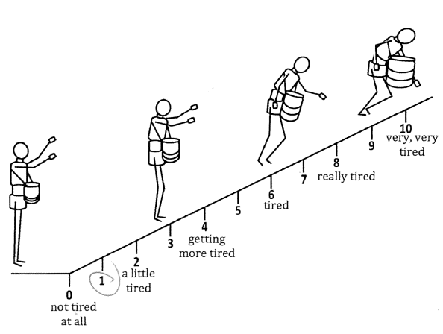

Figure 1. Omni RPE used in this study

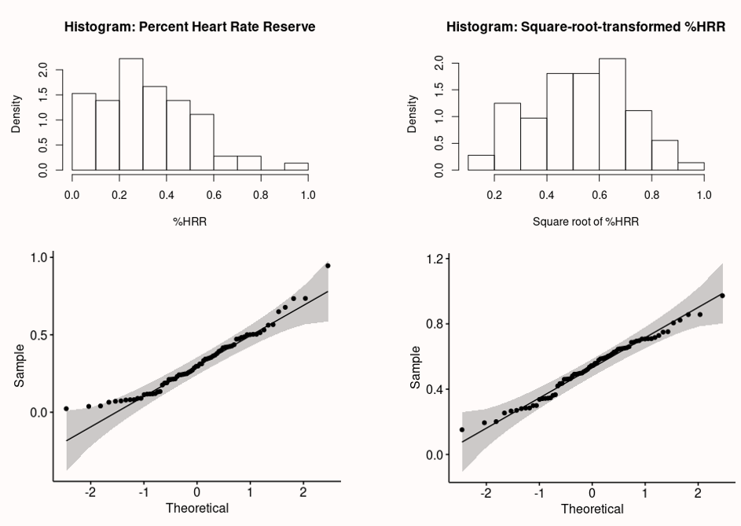

Figure 2. Histograms and Q-Q plots of the %HRR before and after square-root transformed

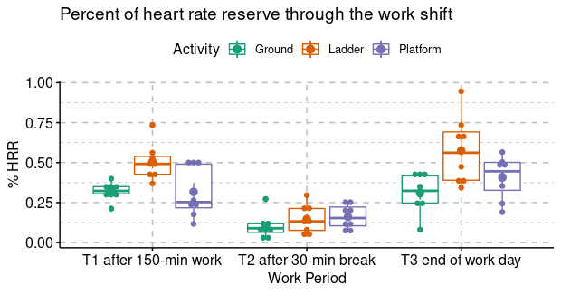

Figure 3. % HRR measured among each group of workers at each work period (n = 8 for each group)

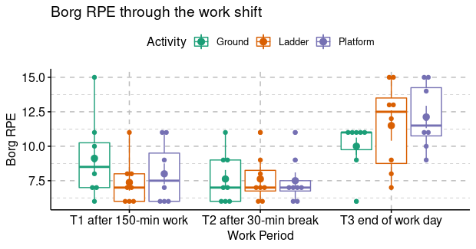

Figure 4. Borg RPE, a measure of overall exertion reported by each group of workers at each work period (n = 8 for each group)

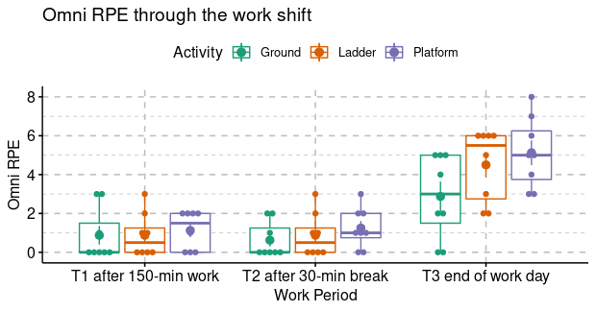

Figure 5. Omni RPE, a measure of overall exertion, reported by each group of workers at each work period (n = 8 for each group)

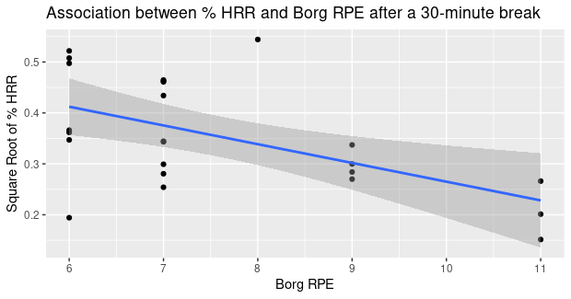

Figure 6. The statistically significant association between % HRR and Borg RPE after a 30-minute break, combining all harvesting methods

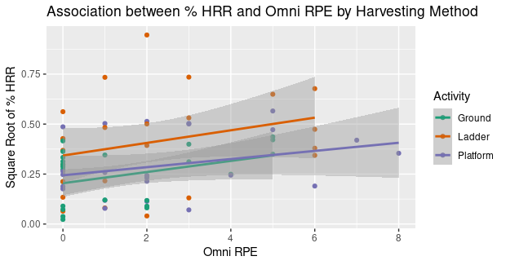

Figure 7. The statistically significant association between % HRR and Omni RPE in all groups when stratifying by harvesting method and combining all time points

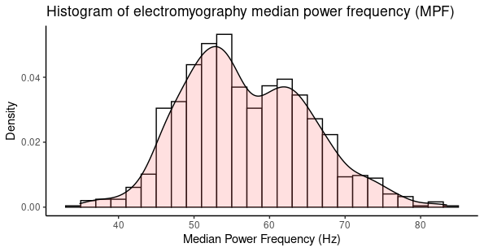

Figure 8. The histogram showing bi-modal distribution of EMG median power frequency

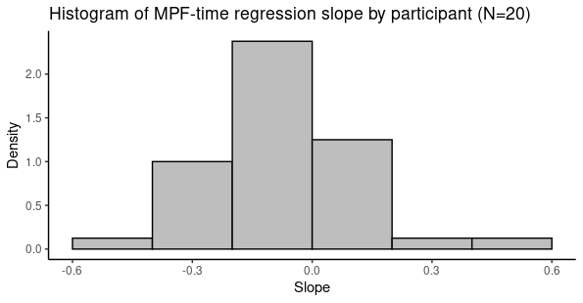

Figure 9. The histogram of the EMG median power frequency regression slope ($b_{Time}$)

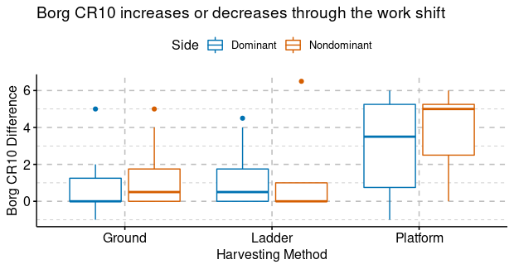

Figure 10. Borg CR10 difference between the beginning and the end of work shift by harvesting method and muscle side

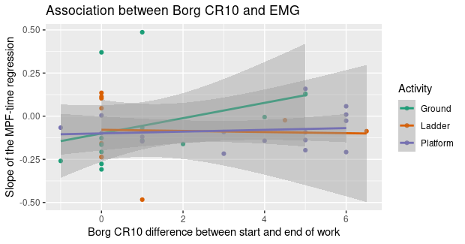

Figure 11. The scatter plot of Borg CR10 difference on x-axis and the $b_{Time}$ on y-axis. All the correlations were nearly zeros and the confidence intervals were large.