**Abstract**

The following report analyses the utilization of scientific code to solve the two-dimensional diffusion equation. The analysis consists in the solution of the differential equation using the explicit and Implicit method. The report indicates all the specifications of the parameters used in the analysis, including the boundary conditions, code language used and specific hardware used to run simulations. The results will evaluate the effects of the number of iterations applied, a study of the grid convergence and the effects of diffusive CFL. The report ultimately concludes with a comparison of the expected results using the theoretical behavior. It was found that with ____,_____,_____ the solution of the two-dimensional diffusion equation is ______,___,_____ respectively. When compared to the expected theoretical behavior it was found that the applied numerical methods had an error of ____,____,___ when using _____,_____,_____. It was also found that the explicit method and the implicit method each had an error of ____ and ___ respectively when compared to the analytical solution. It can therefore be concluded that the ______method is more effective than the ____method especially when using_____.

**Mathematical Statement of Project**

Using computer code and numerical methods, more specifically the explicit and implicit discretization methods, the following two-dimensional diffusion equation is to be solved:

|  |  |
| --- | --- |
|  |  |
|  |  |
| Boundary Conditions: | =0 |
|  |  |

**Discretized version of Equations**

To solve the diffusion equation using computational methods it is necessary to discretize the equations so that they can be translated into a useful code capable of running in MATLAB

**Explicit Method Discretization**

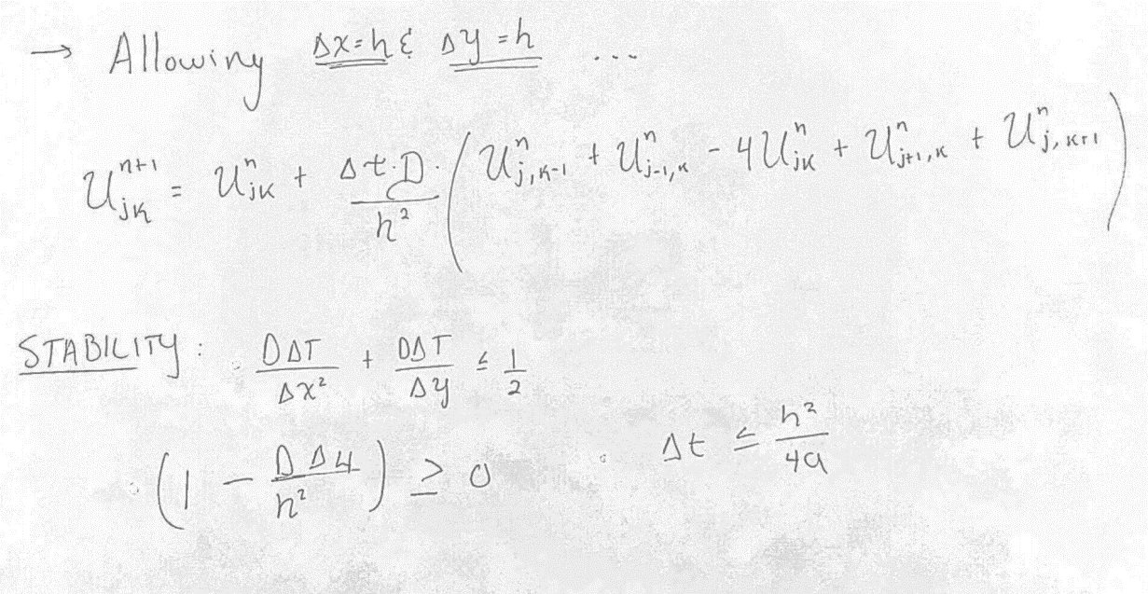

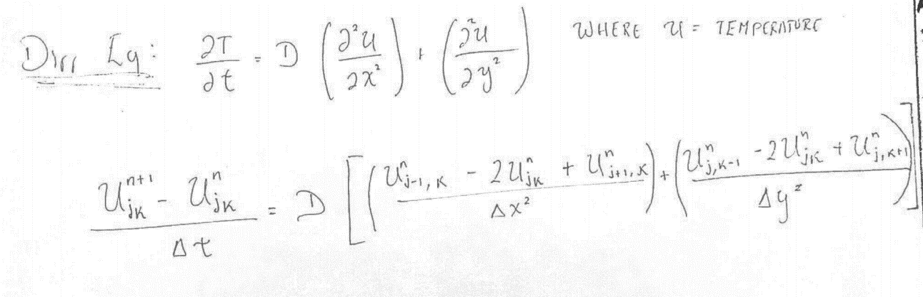

**Implicit Method Discretization**

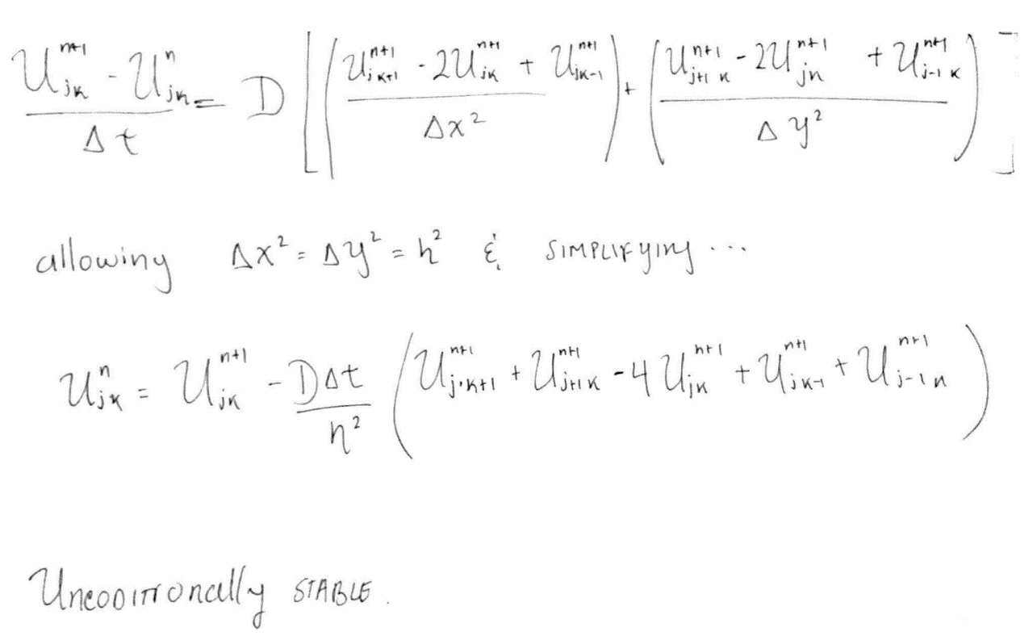

**Description of numerical method and Pseudo Code**

**Technical Specifications of Computer Used**

**Results**

Parameters Used in Simulations

Evaluation of the effect of n (number of points used)

Study of Grid Convergence

Effect of Diffusive CFL

Comparison of Expected theoretical behavior

Order of Spatial accuracy of discretization