Built for goods in motion, not just invoices in a system.
One integration. Every mandate. No new project when the next plant or country goes live.
Trusted by
H&M · IKEA · PUMA · Adidas · Giorgio Armani · Bisleri · Carrefour · Reckitt · PepsiCo · Landmark Group · Joyalukkas · Asics · Majid Al Futtaim · Malabar · LuLu · Dolce Gabbana · Nestle · Decathlon

We speak the language of your existing systems.

Enterprise ERPs  Where your transactions originate.  SAP S/4HANA · SAP ECC · Oracle Fusion · Oracle EBS · Microsoft D365 · Infor · QAD | Plant & Warehouse systems  Where the material actually moves.  MES · WMS · TMS · plant maintenance · barcode and scanner feeds | Trade, channel & middleware  Where the goods cross the border, and the price is settled  Customs brokers · freight forwarders · 3PL · distributor portals · rebate management · EDI · TIBCO

From every plant and every movement to one source of truth.
SELL SIDE & DISPATCH
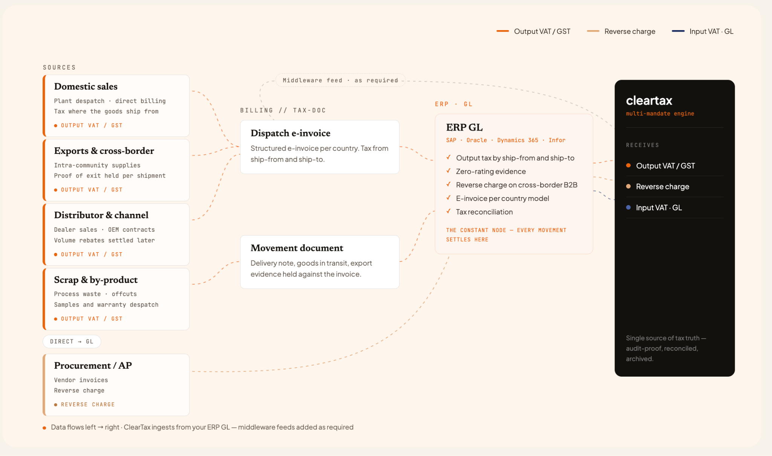
PROCUREMENT, TRANSFERS & GROUP
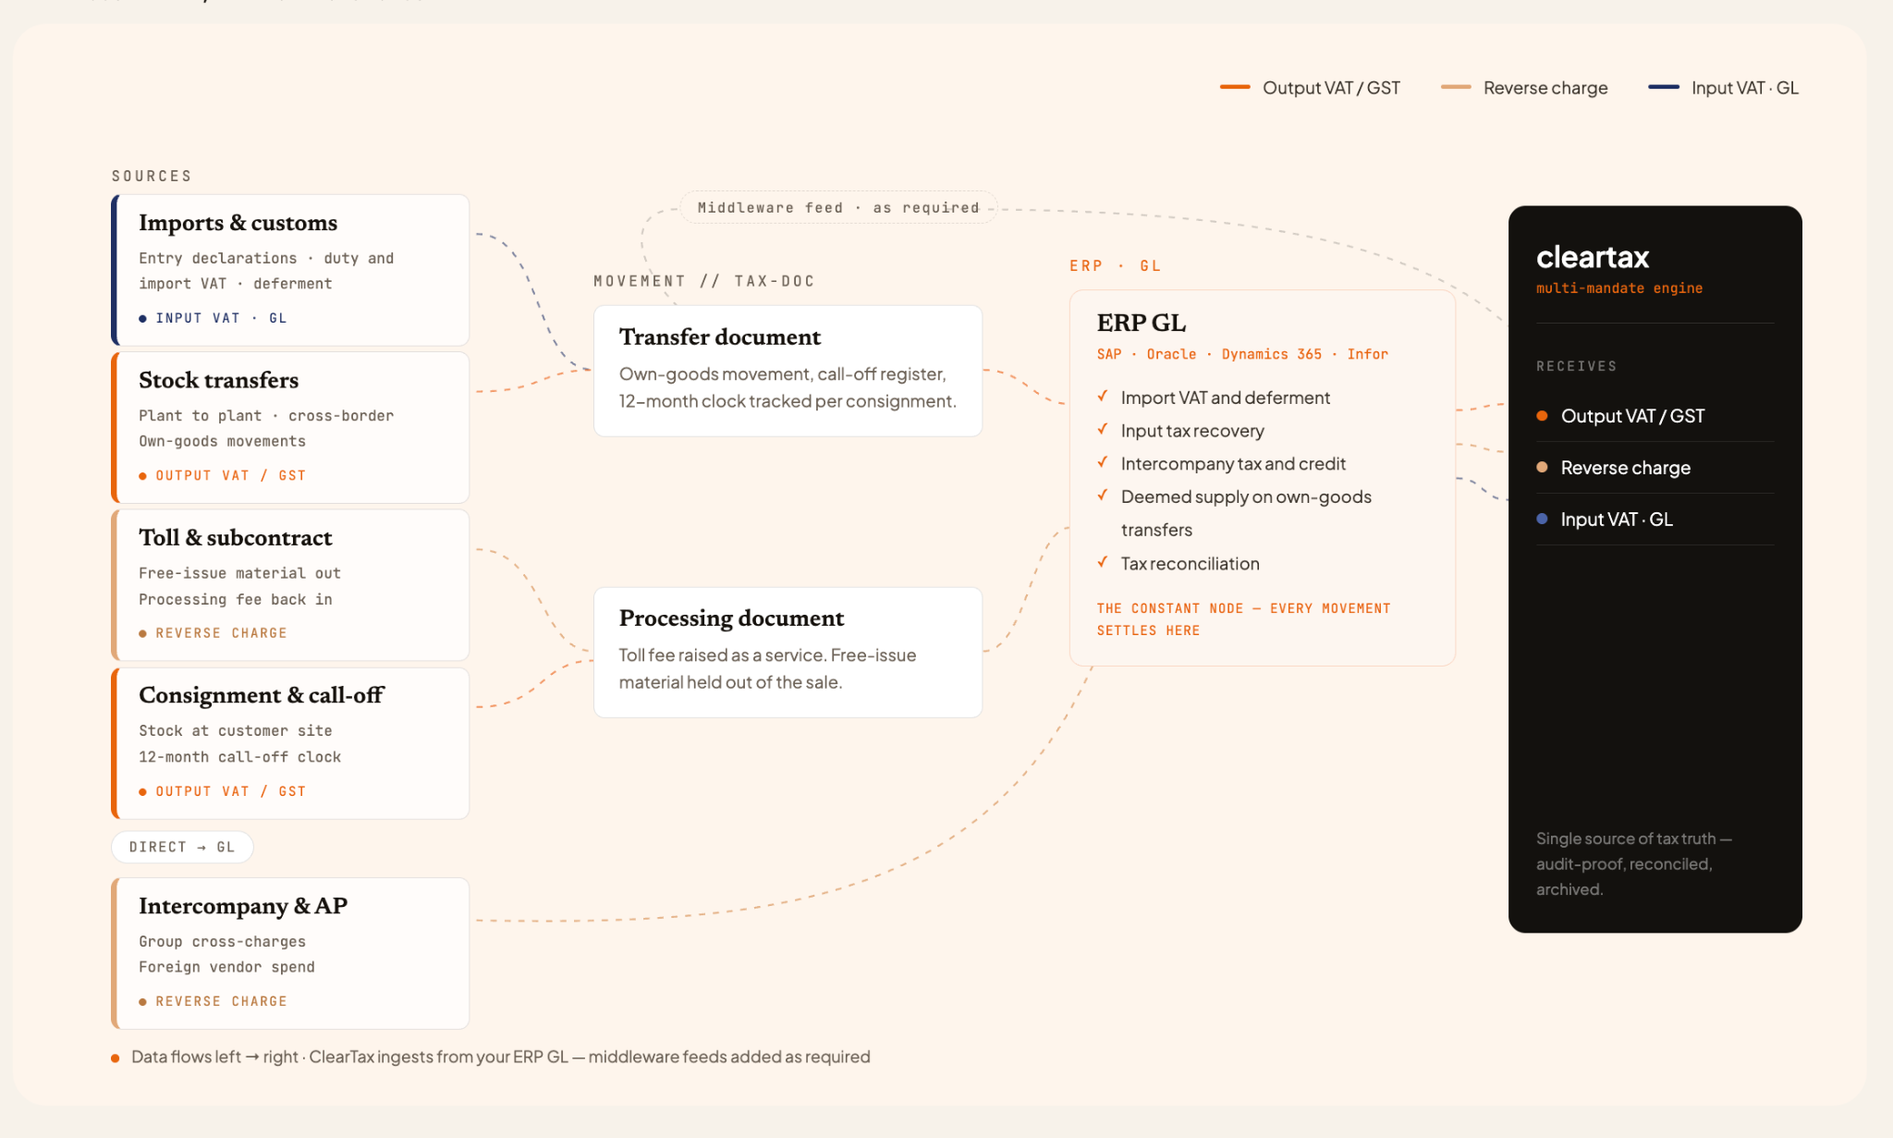

Global experience, mandate after mandate.
ELECTRONICS MANUFACTURING · MALAYSIA · SAP ECC- 500,000 invoices/ year
ClearTax's own SI team built the SAP ECC integration and handles the full volume, around 2,000 documents every working day, submitted to LHDN under appointed intermediary status.
LIGHTING & ELECTRICALS · SAUDI ARABIA · MULTI-ERP - 3 ERPs, one layer
SAP ECC, Oracle EBS and a custom system unified behind a single compliance layer. The estate stayed as it was; no consolidation project was needed to become compliant.

Solving the complexity of making and moving goods.

Moving your own stock across a border must be invoiced  Every transfer of own goods is tracked from dispatch to call-off, with the register entry and the recapitulative report built as the movement happens. The 12-month clock runs per consignment, and stock about to time out is flagged as a deemed acquisition before it becomes one.  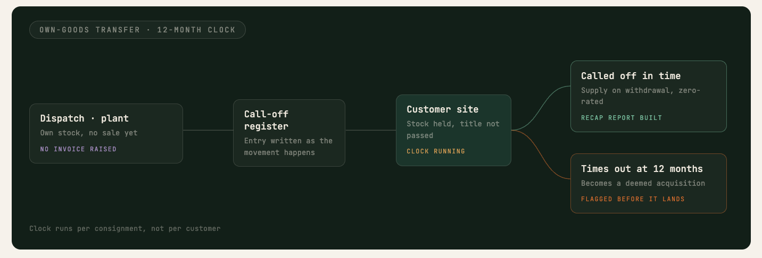 | Three companies, one shipment, and only one leg is zero-rated  The transport leg is assigned once, from who actually arranges the movement, and every document in the chain inherits that decision. Where the simplification does not hold, the registration it triggers surfaces before the goods leave, not after the return is filed.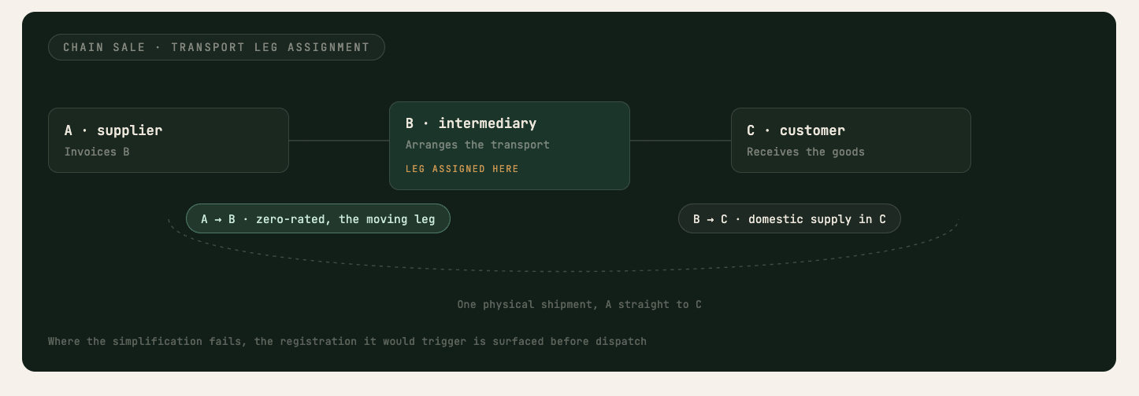
Your ERP books a goods receipt. The tax is on a service.  Toll and subcontract flows are classified at item-category level, so a processing fee is treated as a service and free-issue material stays out of the sale. Ownership is tracked through the conversion, and the country where tax falls due follows the ownership, not the receipt.  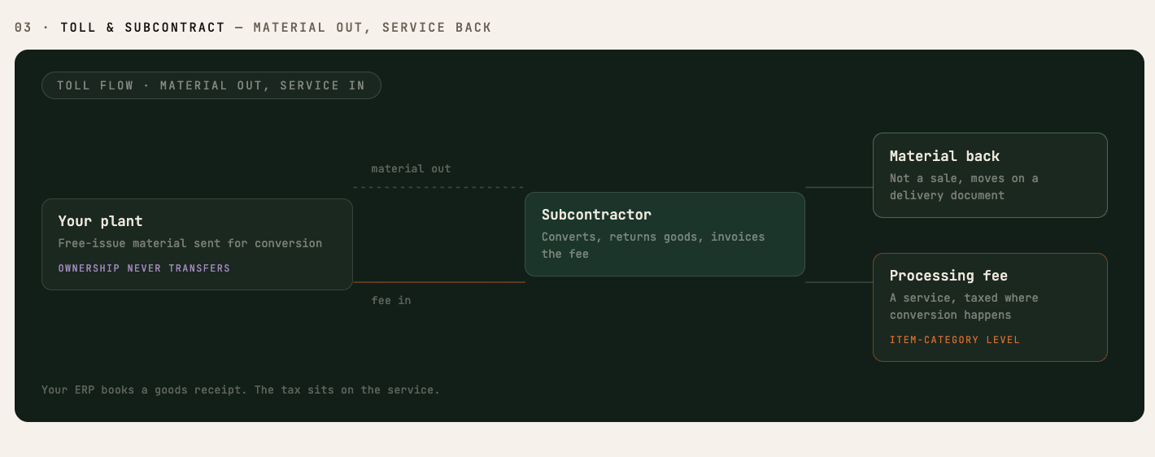 | Shipping something for nothing still needs an invoice  Each zero-value movement is classified when it is raised: warranty replacement, sample, promotional gift, scrap. The ones that are deemed supplies carry output tax on cost. The rest move on the right document with the evidence held against them.  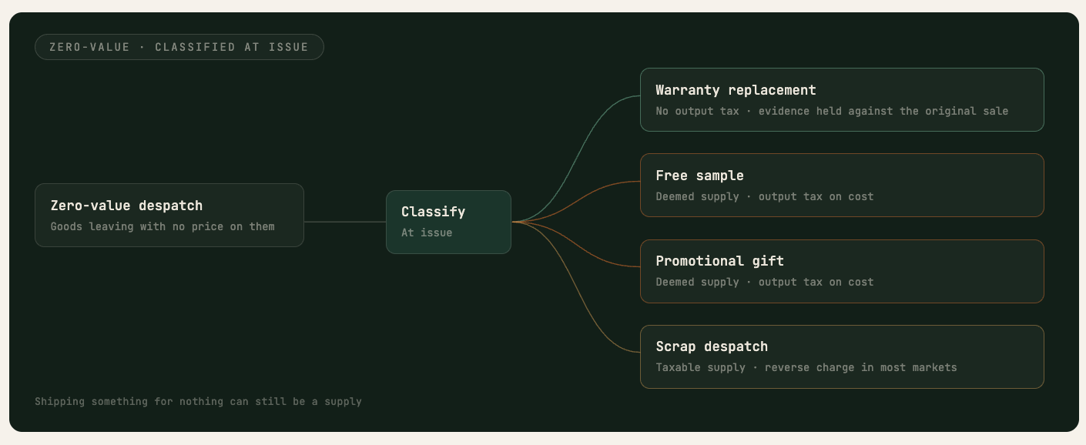
A rebate agreed in March reprices invoices you filed in June  Volume rebates accrue against the invoices they will adjust, then settle as credit notes that reference each one. Domestic and cross-border lines are split before the credit is issued, so the adjustment lands in the right base and the right return.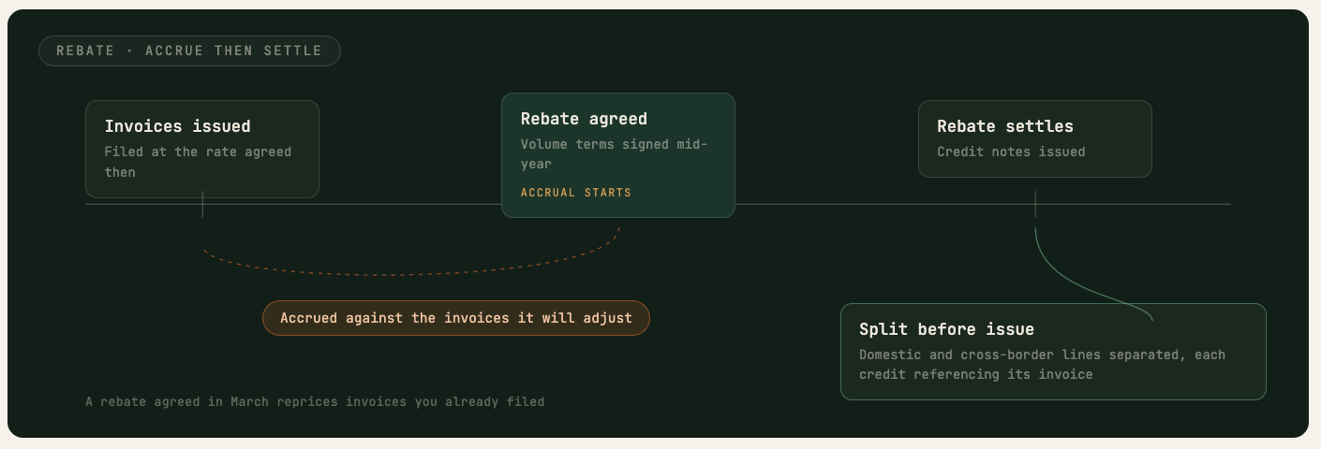 | Ex Works makes the export the buyer’s job and the VAT yours  The Incoterm on the order decides the treatment, not the shipping note. Where the buyer clears the goods, proof of exit is tracked against the invoice, and a shipment still missing evidence is flagged as a domestic sale before the return, not after the audit.  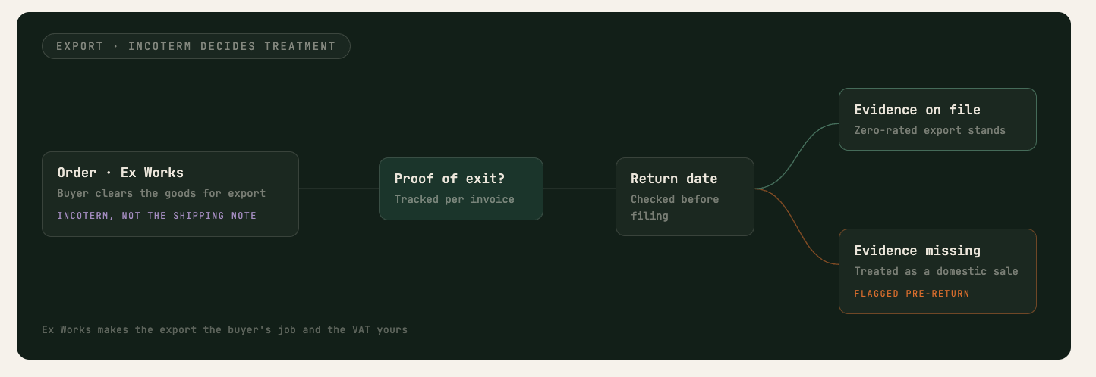

Highest levels of security and audit readiness.
Certifications & compliance
ISO 27001:2022 · SOC 2 Type II · ISO 22301 · GDPR. We do not self-declare security.
Infrastructure & edge protection
WAF and anti-DDoS filter traffic before the VPC. SentinelOne CSPM + DSPM for anomaly detection. Private subnets, no public IPs.
Incident response & audit logs
Every activity logged and traceable via SIEM and EDR. P0 response guaranteed under 24 hours.
Encryption & access identity
AES-256 at rest, TLS 1.2+ in transit. SAML/OIDC SSO, RBAC, no standing access.

