We understand construction billing, not just e-invoicing.
Ready before each mandate. Compliant from day one, in every market.

Trusted by
Standard Chartered · Allianz · BSE · TATA AIG · IDFC · SBI Life · Sun Life · O3 Capital · Edelweiss Gallagher · Indiabulls Home Loans · Exide Life · Hero Fin Corp
We speak the language of your existing stack.

Real Estate ERPs  Where leases, SPVs and off-plan schedules live.  SAP RE-FX · Yardi Voyager · Oracle Fusion · MS Dynamics 365 · MRI Software | Construction Systems  Where interim bills, Bills of Quantities (BOQs) and certification happen.  Procore · Primavera P6 · JD Edwards · SAP PS · COINS ERP | SPV & JV Structures  Where entity boundaries and VAT groups are managed.  Entity register · VAT group map · Grace-period logic · JV boundary rules

From your core systems to one source of truth.

REAL ESTATE DEVELOPMENT & SALES
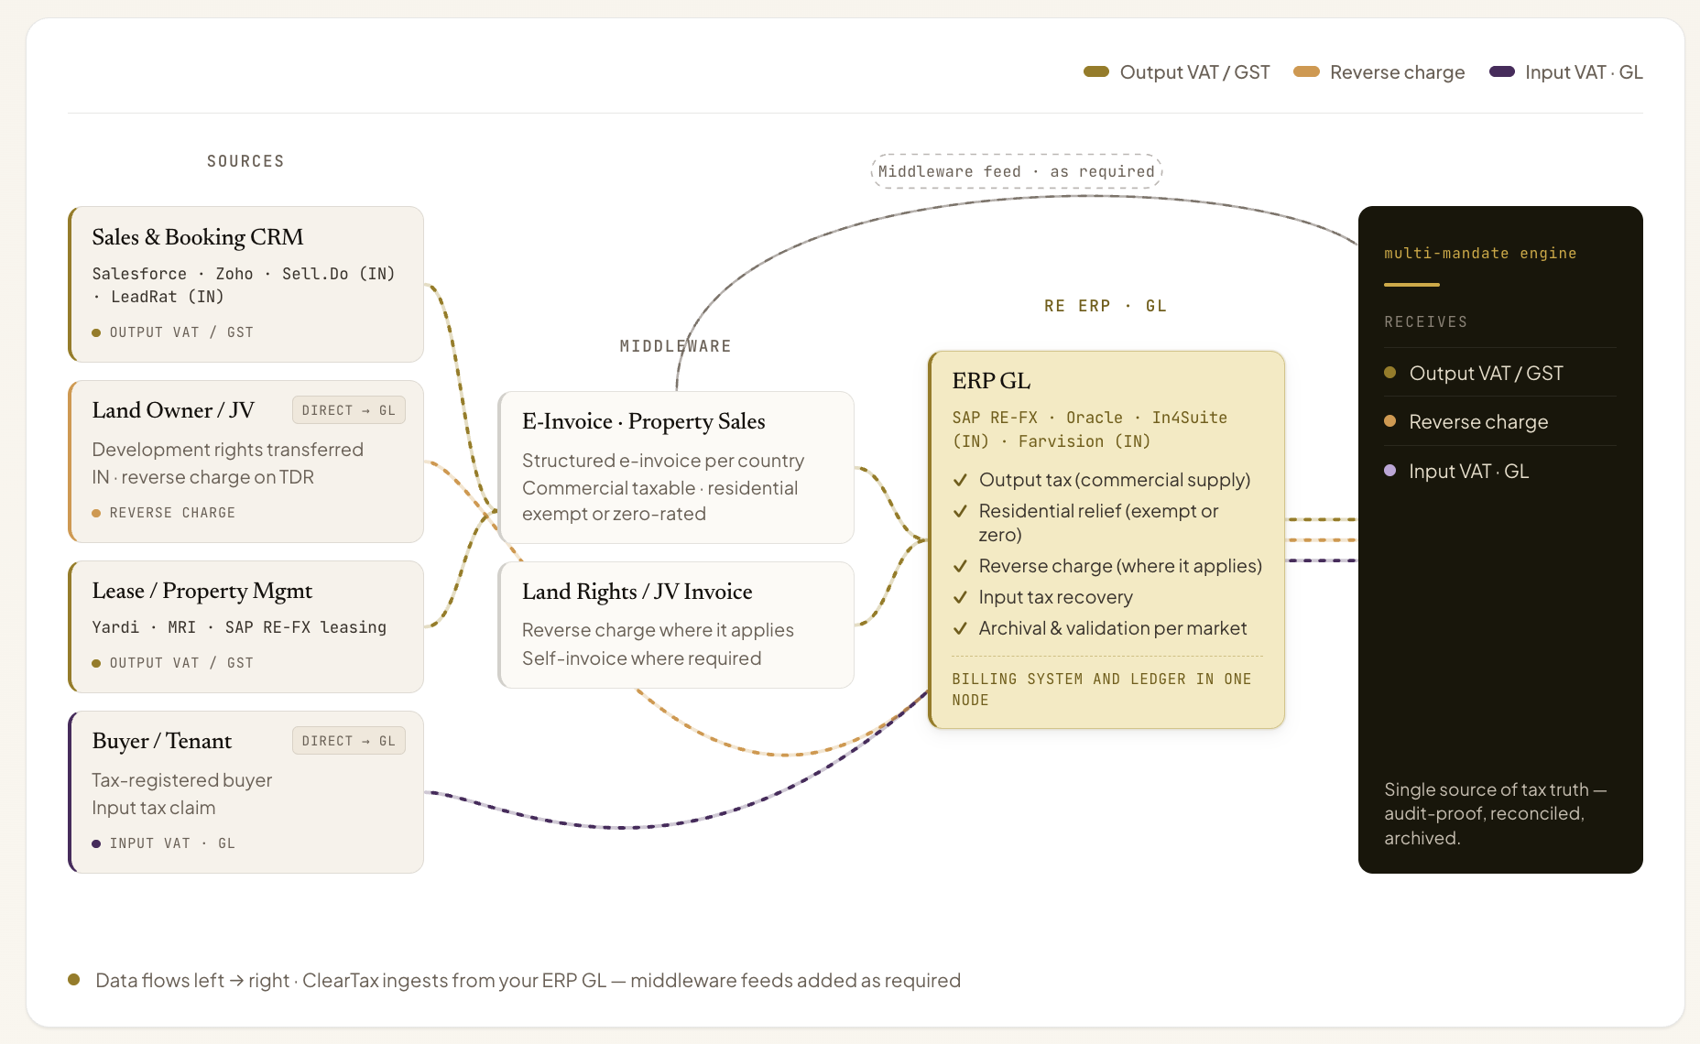

CONSTRUCTION & PROCUREMENT
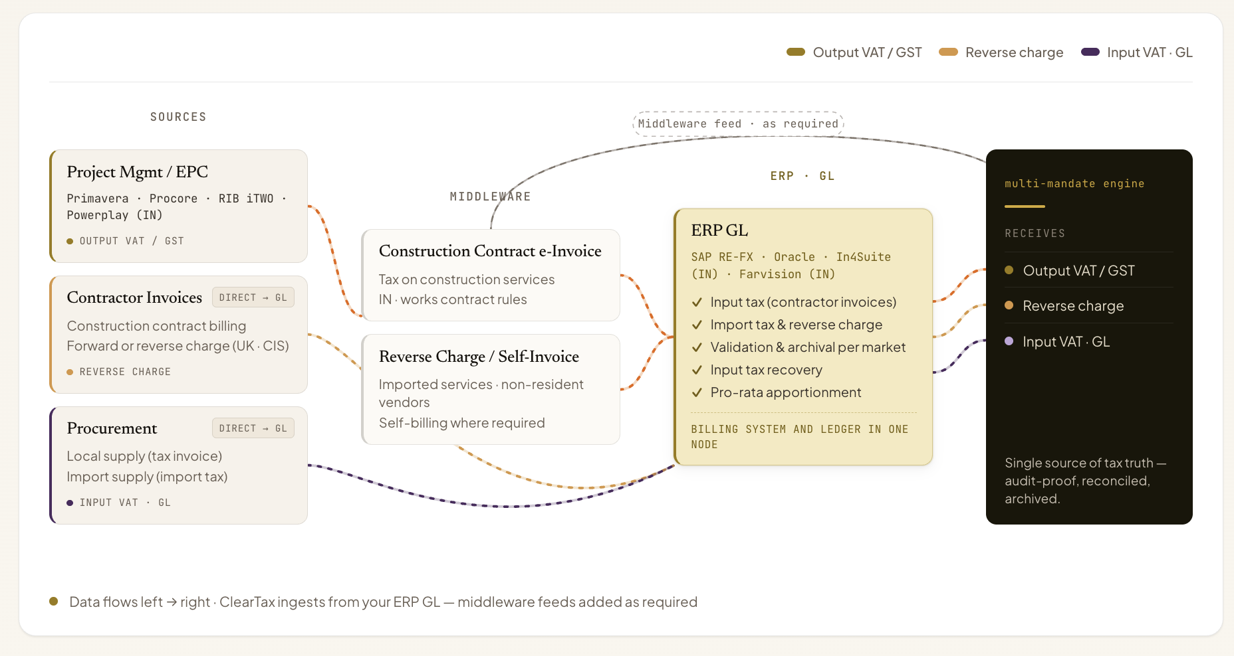
The same challenges. Already solved.

REAL ESTATE · MULTI-ENTITY · 4 BUs
Retention billing, that regime's mandatory Arabic fields and automated PDF generation across 4 business units from one Oracle Fusion integration. Live across all 4 units at once, no phased rollout.
RESIDENTIAL DEVELOPER · TAX-EXEMPT LEASES · B2C fix
Tax-exempt lease invoices for individual tenants with no VAT registration number were generating system-wide rejections. The simplified invoice path resolved them at source.
PROPERTY DEVELOPER · OFF-PLAN & ADVANCES · Mixed invoice splitter
Advance payment invoices with B2B and B2C routing for non-registered buyers. Positive lines issue as tax invoices; negative lines route to credit notes. Zero errors at go-live.
RE + RETAIL · HIGH-VOLUME MIXED PORTFOLIO · 3 streams
Hundreds of thousands of monthly transactions across B2C receipts, B2B invoices and self-billed documents, plus a B2C portal for end-consumers to retrieve their own invoices.

Every compliance edge case, pre-solved.

One property sale can have multiple tax rates on the same invoice  Tax category codes are assigned and validated at line level, never rolled up to the invoice. Exempt lines auto-match to the correct exemption reason at master-data load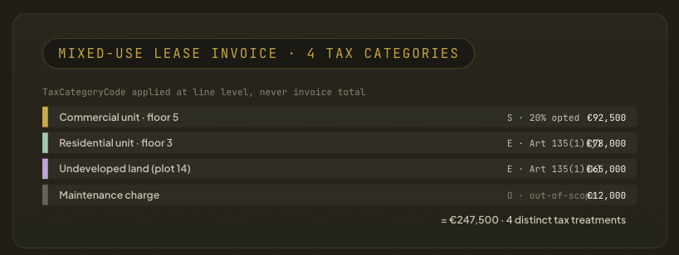 | Off-plan sales are billed in stages, and credit notes are common  Instalment schedules auto-generate a compliant e-invoice at each milestone trigger, with the tax point set to the contractual event. Post-transmission amendment is blocked.  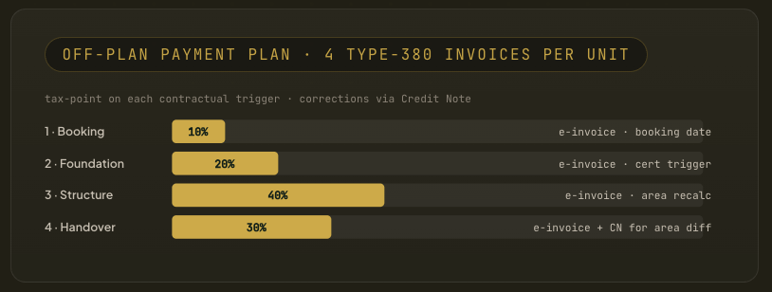
Long-term leases create recurring invoices across every payment cycle  Each periodic invoice generates from the lease master rather than the finance calendar, tagged as a continuous supply with the tax point set to the instalment due date.  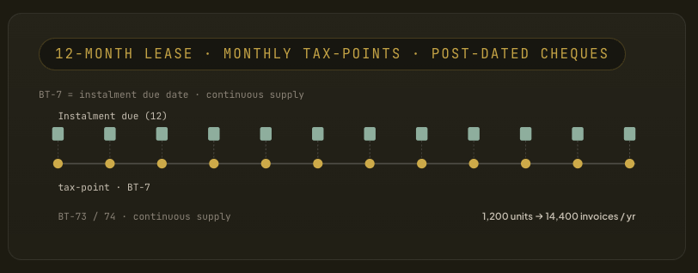 | Transfers between group entities still require valid invoices at arm's length  A live entity register maps every vehicle and joint venture against VAT-group membership, so the engine knows in real time whether a transfer is disregarded or invoiceable.  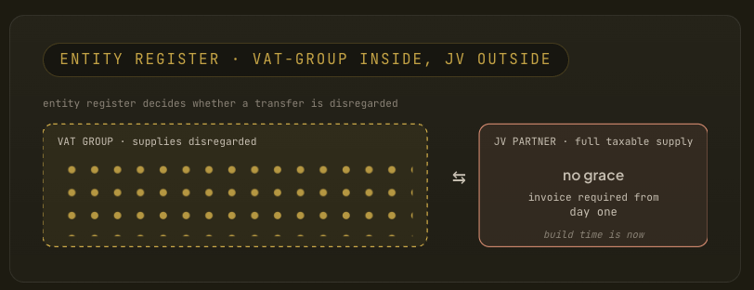
Retention is held back on every invoice but must still appear as a separate line  Retention is structured as a distinct, correctly classified line item on every interim bill, never a bottom-line deduction. Unapproved variations are blocked from invoice generation.  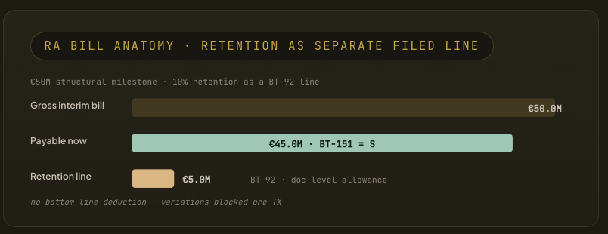 | Property records outlive every other tax document  The archive stores the structured document at line level for the longest window that applies in each market, exportable in open UBL or the original national format at any time.  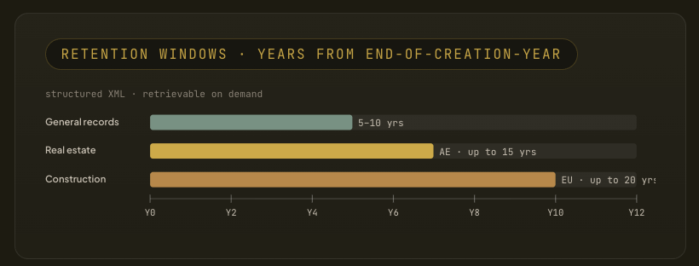

Highest levels of security and audit readiness.

Certifications & compliance
ISO 27001:2022 · SOC 2 Type II · ISO 22301 · GDPR. We do not self-declare security.
Infrastructure & edge protection
WAF and anti-DDoS filter traffic before the VPC. SentinelOne CSPM + DSPM for anomaly detection. Private subnets, no public IPs.
Incident response & audit logs
Every activity logged and traceable via SIEM and EDR. P0 response guaranteed under 24 hours.
Encryption & access identity
AES-256 at rest, TLS 1.2+ in transit. SAML/OIDC SSO, RBAC, no standing access.

