Built for subscriptions, renewals and the invoices they trigger.
Built for how software and professional services actually work: a subscription that renews into a fresh sale every cycle, expenses that pick up tax on the way to your client, and an export that only counts if every condition holds.

Trusted by 6000+
[Customer logo row]
We speak the language of your existing systems.

Finance & billing  Where the invoice is raised.  NetSuite · SAP · Oracle Fusion · Microsoft Dynamics 365 · Sage Intacct · Xero | Subscription engines  Where recurring revenue is priced and charged.  Stripe Billing · Zuora · Chargebee · Recurly · Paddle · in-house metering | PSA, CRM & middleware  Where the engagement and the client record live.  Salesforce · HubSpot · Kantata · Certinia · Workday · Unified API

From every billing channel to one source of truth.

DIRECT & SELF-SERVE
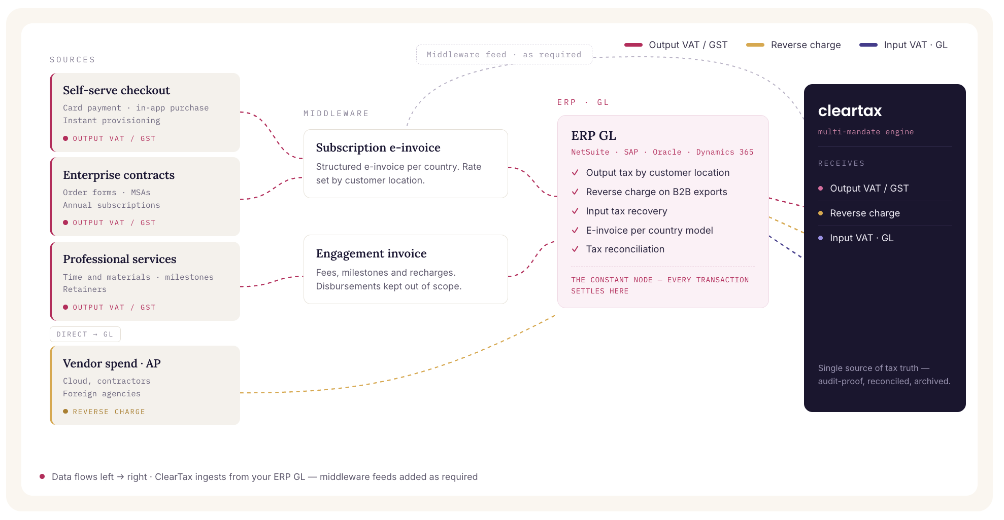
The same challenges. Already solved.

SOFTWARE · SAUDI ARABIA · BUYER PORTAL · Output tuned to the buyer
An software vendor selling into the Kingdom's largest enterprise buyer. Invoices cleared ZATCA but failed the buyer's own portal intake, so PDF/A-3 output was adapted to that specification. Invoices accepted, payment released.
PROFESSIONAL SERVICES · SAUDI ARABIA · MULTI-ENTITY · Nine entities
A Saudi services group spanning driving schools, facilities management, contracting and real estate. 366,415 B2C invoices under Phase 2, with contracted capacity grown from 200,000 to 375,000 per year
SERVICES AT SCALE · MALAYSIA · SAP ECC · Handling 500,000 invoices a year
A global electronics manufacturing enterprise. Clear built the SAP ECC integration end-to-end and handles the full volume — ~2,000 documents a working day — submitting to LHDN as appointed intermediary.

Solving the complexity of selling software and services across borders.

Getting paid in foreign currency does not make it an export  Every invoice is checked against all the export conditions before it goes out, with the contract wording and the payment evidence held against it. Where one fails, it is flagged as a domestic sale before you file, not after a notice lands.  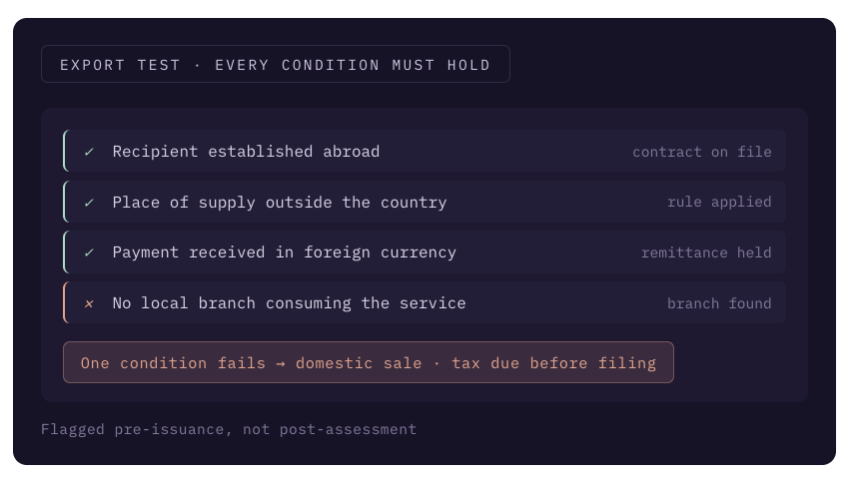 | Every renewal is a new sale with its own deadline  Invoices are raised per period against that period's due date, never as a month-end batch. Mid-term upgrades, downgrades and refunds generate credit notes that link back to the invoice they correct.  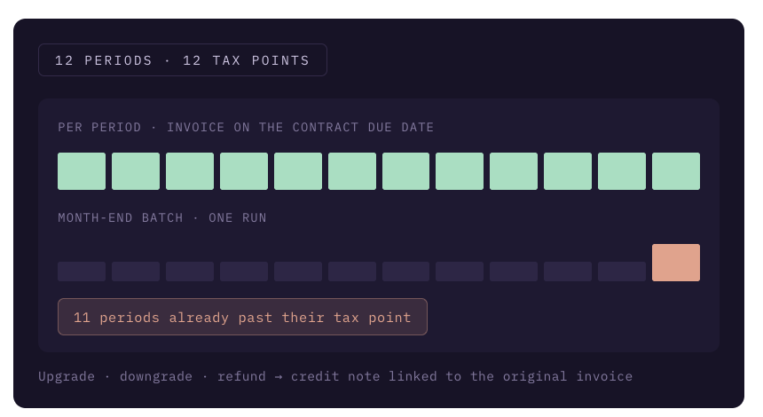
You priced the licence and the setup separately. Tax can still see one sale.  The bundle is decided once on the order form, then applied the same way to every invoice it generates. Elements that belong together carry one rate and one country, instead of drifting apart line by line.  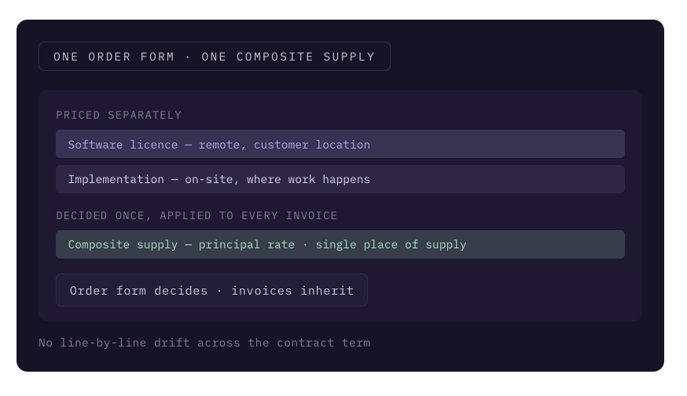 | Billing in stages does not stage the tax  The due date is taken from the contract and tracked per engagement, not per bill. Unbilled time is reconciled against invoices raised, so nothing sits in work-in-progress with tax already owed on it.  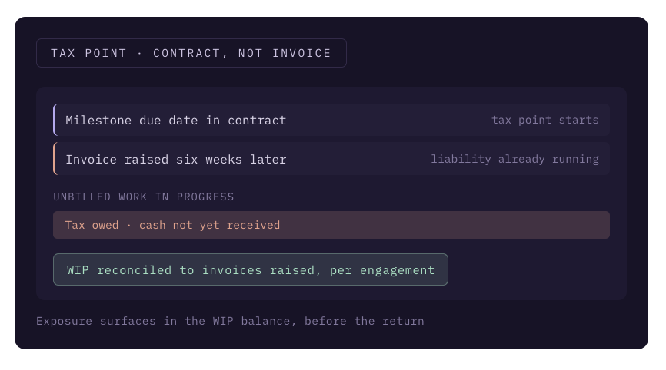
What you pass on to a client is taxed like your fee, not like the receipt  Classify each cost when you book it, not when you draft the bill. Costs that form part of your service take your rate, and the few paid purely on the client's behalf stay off it, with the evidence held.  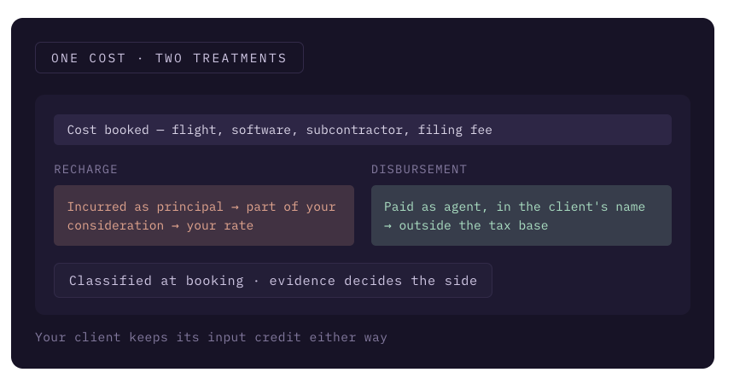 | Your parent company lends you staff. The recharge can be a taxable service.  Every intra-group recharge matches the agreement behind it, and your own document is raised where the arrangement is taxable. Missing agreements show up before the recharge run, not in an assessment years later.  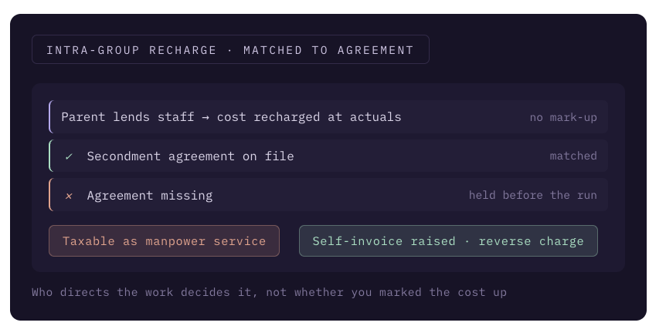

Highest levels of security and audit readiness.

Certifications & compliance
ISO 27001:2022 · SOC 2 Type II · ISO 22301 · GDPR. We do not self-declare security.
Infrastructure & edge protection
WAF and anti-DDoS filter traffic before the VPC. SentinelOne CSPM + DSPM for anomaly detection. Private subnets, no public IPs.
Incident response & audit logs
Every activity logged and traceable via SIEM and EDR. P0 response guaranteed under 24 hours.
Encryption & access identity
AES-256 at rest, TLS 1.2+ in transit. SAML/OIDC SSO, RBAC, no standing access.

