TAX AUTOMATION
AI that understands your business and catches compliance breaks before they cost you
Unlike generic AI, Clarity AI deeply understands your business, and can find gaps that typical data analytics approaches miss
Book a demo

Real-life examples:
AI surfaced $2.31M of duplicated revenue postings a year — worth $121K of overpaid tax annually.
The business had RM349K posted in the ledger against just RM184K actually invoiced.
The difference was not large enough to stand out in an aggregate revenue review.
But when AI matched every e-invoice posting back to the underlying ledger, it found the same invoice being posted twice: 8,397 times.
The duplicates represented just 0.22% of monthly revenue.
Small enough to pass an aggregate review.
But because the tax calculation followed the inflated revenue base, the tax followed the error every cycle.
A tiny accounting discrepancy became a recurring tax cost.
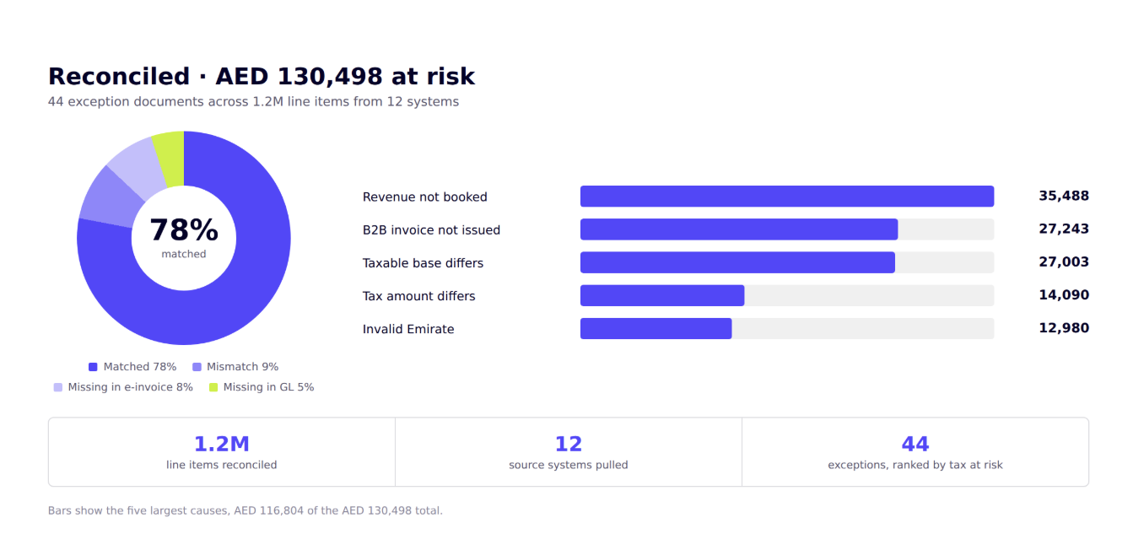
Same question. Two different answers.
 | With generic AI | With Clarity AI
What it reads | The invoice file you upload. It never sees the document that lets the goods move | Transactions, statutory documents and their validity windows, live
What it checks against | Matching three columns checks format, not liability | Every line against the rule that applies in that country
What it carries over | Doesn't know the position you took last year; this return can contradict it | Filing history and the notices each position drew
What comes back | A formatted return, with no view of what was never invoiced at all | Every exception priced by the tax genuinely at risk

Ready to put AI in the hands of your finance team?
Trusted data is the prerequisite. More than four in five finance leaders have hit an AI hallucination, and only one in seven fully trusts an AI answer even after review.
Book a demo

