Built for the front desk and settlements that follow.
Built for how travel and hospitality actually work: a single bill carrying four tax treatments, a contract that decides agent or principal, and a package taxed on the margin rather than the price.

Trusted by
H&M · IKEA · PUMA · Adidas · Giorgio Armani · Bisleri · Carrefour · Reckitt · PepsiCo · Landmark Group · Joyalukkas · Asics · Majid Al Futtaim · Malabar · LuLu · Dolce Gabbana · Nestle · Decathlon
We speak the language of your existing systems.
Enterprise ERPs  Where your transactions originate.  SAP S/4HANA · Oracle Fusion · Microsoft D365 · Oracle EBS · SAP ECC | PMS & booking engines  Where the guest or passenger sees the bill.  Opera · Protel · Mews · Cloudbeds · RMS (PMS) · Hotelkey · Any PMS via REST / SFTP | Distribution & middleware  Where the booking reaches you, and the document leaves.  SynXis · Amadeus · Sabre · M-Files · TIBCO · Unified API

From every booking channel to one source of truth.

DIRECT & DISTRIBUTION
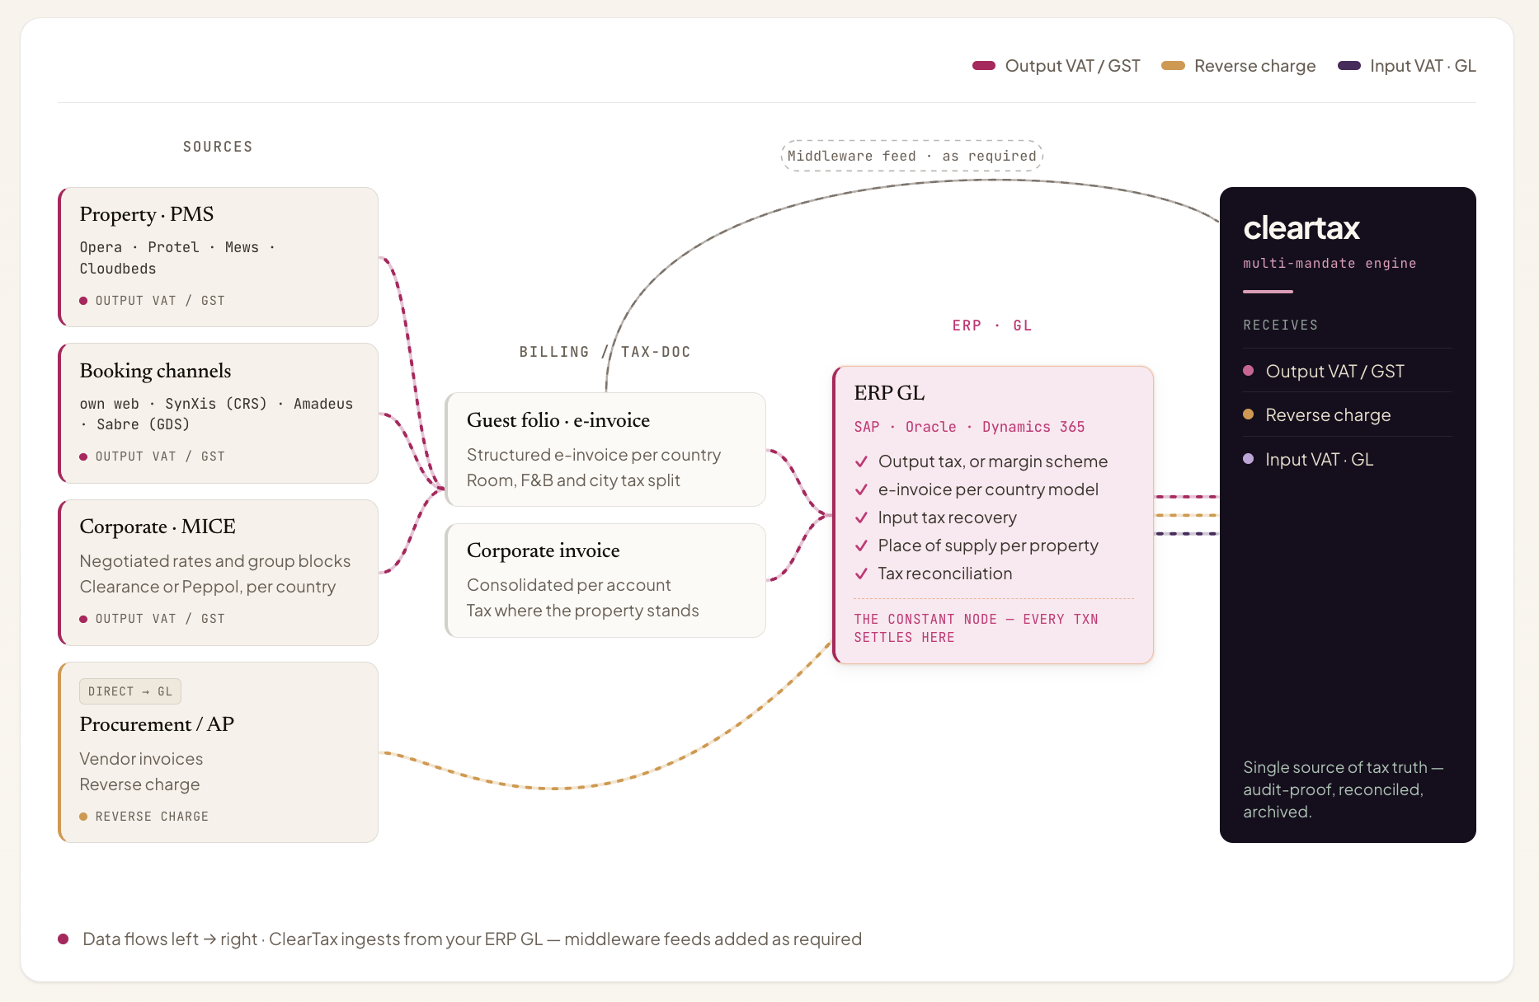
PLATFORMS & OTAS
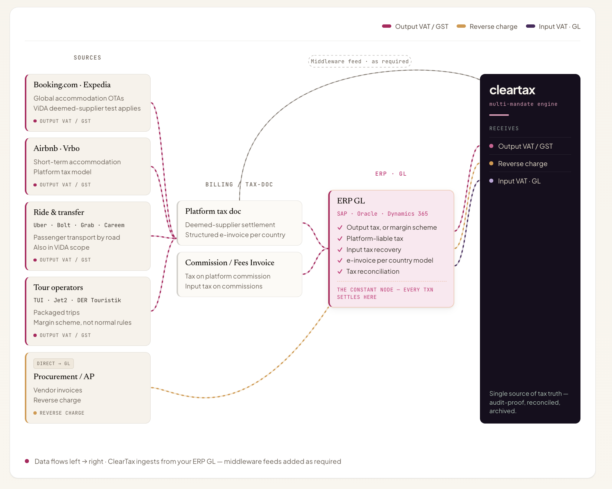
Global experience, mandate after mandate.

HOSPITALITY TECH · BELGIUM · WHITE-LABEL · Multiple PMS
e-Invoicing embedded inside the client's own PMS as a native feature, delivered white-label so they onboard hotel customers and configure VAT themselves.
HOSPITALITY · BELGIUM · AR + AP · ~2,100 invoices/ month
PEPPOL compliance across both AR and AP ahead of Belgium's January 2026 mandate, on one compliance layer over RMS, Oracle ERP and M-Files.
Solving the complexity of travel and hospitality.

Group and corporate accounts need one invoice across thousands of stays  Folio data aggregates into one summary invoice per account per period, with every stay preserved as a distinct line, meeting each country's aggregation rules without losing the audit chain.  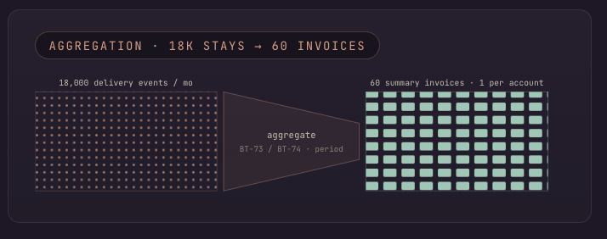 | A single folio can carry four different tax treatments at line level  Every posting code in your PMS is validated against the code list of the country the property sits in, with rate as well as category checked before issuance.  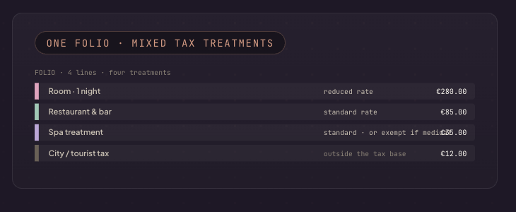
A no-show is taxable on a plane and not taxable in a hotel  Each retained amount is classified by what it actually is: a forfeited deposit, a fare already earned, or a fee that replaces the price, and treated per market and product.  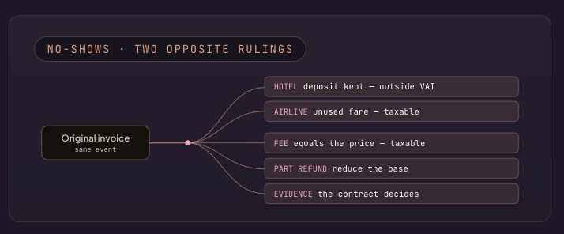 | A package is taxed on your margin, not on what the traveller paid  The margin is computed per departure from actual bought-in cost, the scheme marker applied, and the tax line suppressed on the customer document where the scheme requires it.  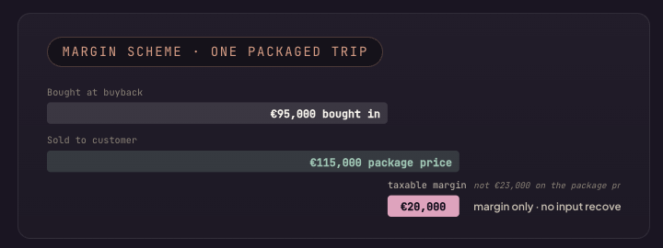
Agent or principal decides your entire tax position before the booking confirms  The determination is held per contract and per supplier, applied at the moment of confirmation, issuing either a commission invoice or a full margin-scheme document. Versioned, so it moves when an agreement is renegotiated.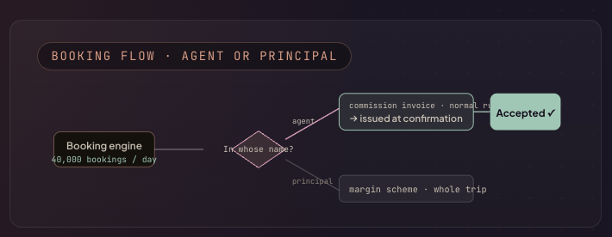 | The international leg is relieved; the domestic one is not  A multi-sector itinerary splits by route at the point of issue. On accommodation, the property register drives the place of supply, so each hotel files where it stands.  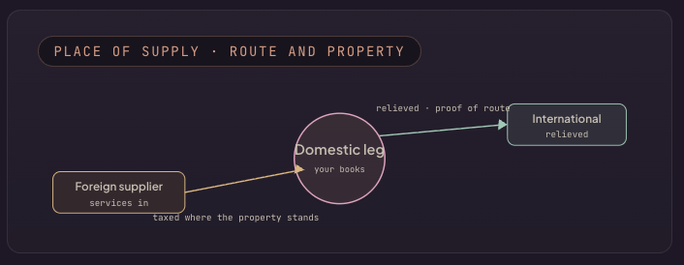

Highest levels of security and audit readiness.

Certifications & compliance
ISO 27001:2022 · SOC 2 Type II · ISO 22301 · GDPR. We do not self-declare security.
Infrastructure & edge protection
WAF and anti-DDoS filter traffic before the VPC. SentinelOne CSPM + DSPM for anomaly detection. Private subnets, no public IPs.
Incident response & audit logs
Every activity logged and traceable via SIEM and EDR. P0 response guaranteed under 24 hours.
Encryption & access identity
AES-256 at rest, TLS 1.2+ in transit. SAML/OIDC SSO, RBAC, no standing access.

