CNN_in_2D:

***"Can you tell by at least some of the images why it failed?"***

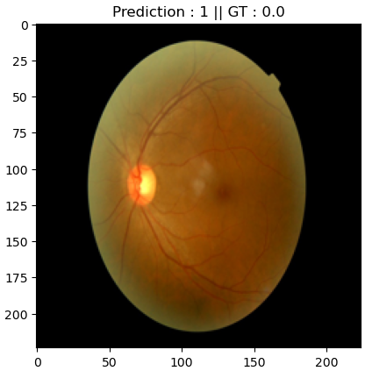It seems that DR is characterized by spots on the retina, caused by capillary damage of eye blood vessels. The model has learned to recognize those patterns which has different color and brightness from their neighborhood. Some of the images there are spots that maybe originate from other source (noise maybe?) that the model confuse with retinal damage pattern. It can be shown in the following example:

***"Let's say that for some reason, you decide that it is more important to never miss any DR patient. This means that we want our false negative number to be 0, even if it make some false positive patient being 1.***

***What can control these rates once the model alreday trained? Change the parmeter that controls these rates and plot the confusion matrix that has minimal FNR."***

The only parameter that we can control after model is trained is the threshold for class score prediction. The model output is continuous number in range [0,1] that represents the score of how likely the model think a sample is positive or negative. In the simple case we divide the two categories in half, setting the threshold at 0.5. If we want to be more cautious, and not to miss any true positive DR patient, we can lower the threshold (as we did, to 0.2), and include less likely patients in the positive predicted DR group. This of course is costing us in higher FP rate.