# Message Board Web Service

# User Guide

## Summery

## web service for a message board. The service should allow users to register, post messages, vote up or down for any message on the board, remove messages, and view all their messages and their corresponding votes

## High level design

## Details Design

Two dockers container runs in a Docker Compose:

**3.1 Cibus Server:** The manager docker. **C# .Net Core 6 VS2022**

* + - Controllers received commands from the client
    - Services validate the data and convert it to specific entity.
    - DAL connect to MySQL data base and get/set/update data in the DB
    - Loggers save exceptions into log file

**3.2 MySQL Data Base**: Database saving all Users and message information.

**Unit Test project:** Run tests and checking functions for services and controllers

## Flow Diagram

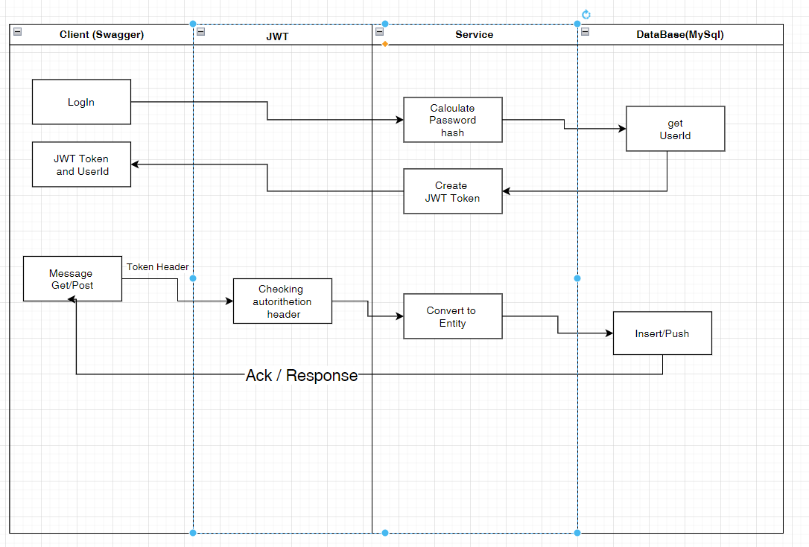

## Class Diagram

The solution is written by VS 2022 C# .Net Core 6.

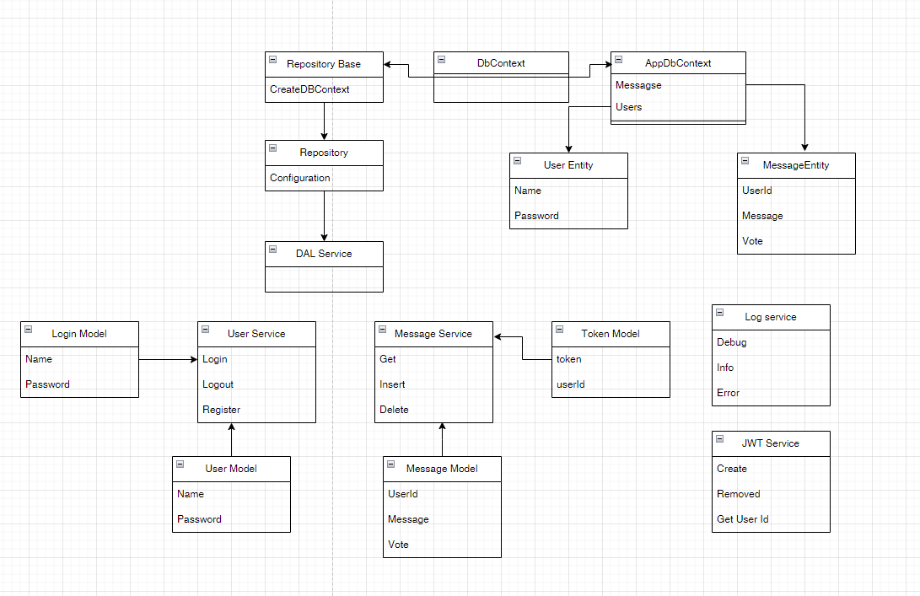

## Data Base diagram

