‏14 אוקטובר 2024

Fireworks HLD

|  |  |  |  |  |
| --- | --- | --- | --- | --- |
| **#** | **תאריך** | **מעדכן** | **מהות השינוי** | **גרסה** |
| 1 | 14/10/2024 | Oron Tamir |  |  |
|  |  |  |  |  |
|  |  |  |  |  |

|  |  |  |
| --- | --- | --- |
| **מפתח** | **מנהל** | **מנהל מוצר** |
|  |  |  |
|  |  |  |
|  |  |  |

Contents

. Summary 2

. Class diagram 3

. Flow. 3

. Screen Shot 3

## Summary

Create a nice fireworks show in all shapes in the Graphics model

## Class diagram

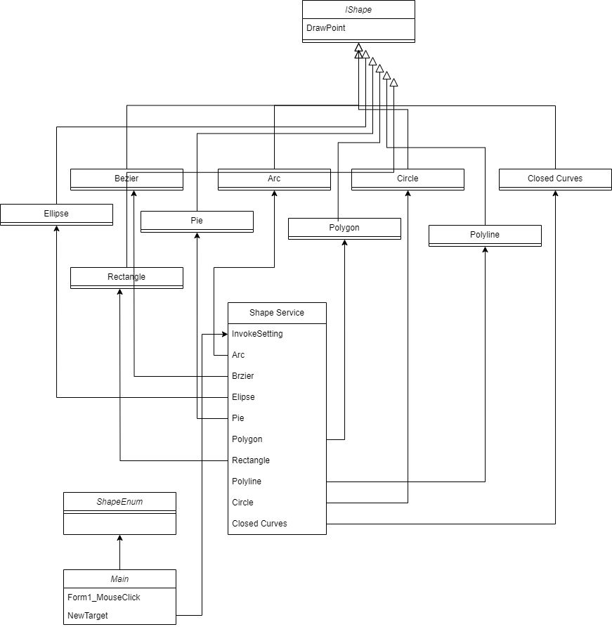

## Flow.

Open the solution: FireWorks.csproj in VS 2022, and run it

## Screen Shot

