User Guide
TA9 Real-Time Document Processing System
Audience | Anyone who wants to use the system: submit documents, follow their processing and read the results. No knowledge of the code is needed
Before you start | The system must be running. Installing and starting it is described in the Installation Guide (docs/installation/TA9-Installation-Guide.docx). The short version is docker compose up --build -d
Three ways to work | Web UI (browser, no tools) · Swagger (browser, every API call) · Postman (ready-made scenarios with built-in checks)

Contents
1. What the system does
1.1 The life of a job
1.2 Limits
2. Choose how to work
3. Working with the Web UI
3.1 Create a job
3.2 Follow a job and read the results
3.3 The jobs list
4. Working with Swagger
4.1 How to send a request
4.2 Create a job
4.3 Check the status and read the results
4.4 Error responses
5. Working with Postman
5.1 Install Postman and import the collection
5.2 The folders
5.3 Send requests one by one
5.4 Run a whole folder automatically
6. Everyday scenarios
7. Questions and problems

1. What the system does
You send a job: a batch of up to 1,000 text documents. The system analyzes every document in the background and keeps you informed while it works. When it finishes, you get these results for each document:
Result | Example
Word count · unique word count | 30 · 8
Five most frequent words | alpha (4), beta (4), delta (4), epsilon (4), eta (4)
SHA-256 of the text | be9a277f0da5…
Characters · lines · average word length · longest word | 172 · 1 · 4.8 · epsilon

When a job ends, a short summary of it is also stored by the Audit Service.

1.1 The life of a job
Status | Meaning
Pending | Accepted and stored; waiting to be handed to the processor
Queued | The processor has accepted it; waiting for a free worker
Processing | Documents are being analyzed; progress (processed / total) moves
Completed | Done. Results are available. If some documents failed, they are marked individually; the job still completes
Failed | The job could not be processed (for example every document failed, or the processor was unreachable for too long). The failure reason is shown
Cancelled | You cancelled it before it finished

A job normally goes Pending → Queued → Processing → Completed, often within a second. Ten jobs of 1,000 documents each take a few seconds.

1.2 Limits
Limit | Value | If exceeded
Documents per job | 1 – 1,000 | 400 Bad Request with the reason
Size of one document | 100 KB (UTF-8) | 400
Document name | required, up to 256 characters | 400
Job name | optional, up to 200 characters | 400
Request size | ~10 MB | 413 / 400

An empty document is allowed: it simply has 0 words.

2. Choose how to work
 | Web UI | Swagger | Postman
Best for | Trying the system, demos, following a job live | Exploring every endpoint and its exact request / response | Running prepared scenarios repeatedly, with automatic checks
Address | http://localhost:4200 | http://localhost:5001/swagger (jobs) · :5003/swagger (audit) · :5002/swagger (processor, internal) | The collection docs/postman/Ta9.postman_collection.json
Install anything? | No, just a browser | No, just a browser | Yes: the Postman app (§5.1)
Live progress | Yes, automatic | No (call GET again) | No (send again)
Covers | Create, list, details, results, cancel, delete, audit | Everything, including internal and health endpoints | Happy path, cancel, validation errors, internal and health

All three use the same API, so you can mix them. For example, create a job in Postman and watch it in the Web UI.

3. Working with the Web UI
Open http://localhost:4200. The top bar has two pages: Jobs and New job. Links to the three Swagger pages are at the bottom.

3.1 Create a job
Click New job (or + New job on the jobs page).
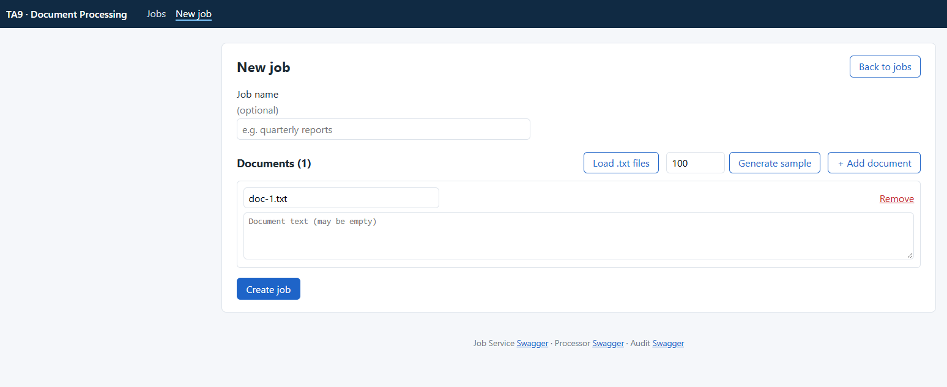
New job page
- Job name (optional): e.g. quarterly reports.
- Add the documents in one of three ways:
  - Type them in. Each document has a name and a text box. + Add document adds another one; Remove deletes one.
  - Load .txt files. Pick one or more text files from your computer. Each file becomes a document with the file's name.
  - Generate sample. Enter a number (up to 1,000) and click Generate sample. The page creates that many sample documents. This is the quickest way to see the system handle a large job.
- Click Create job. The details page of the new job opens at once.
Example with one typed document:
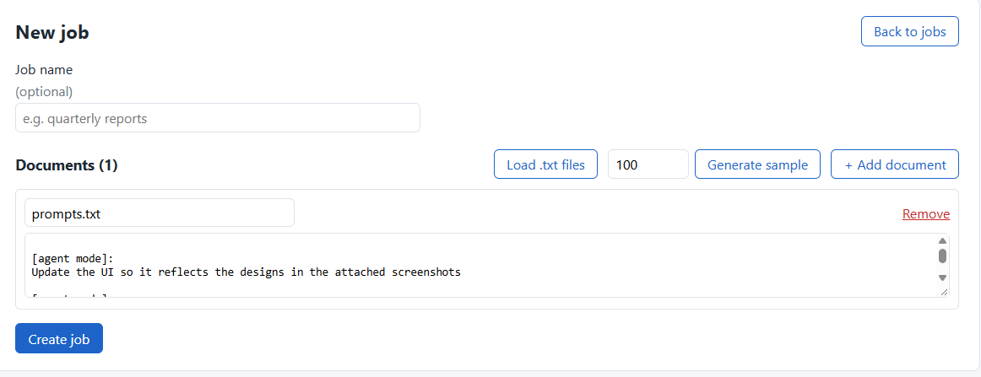
New job with a typed document
If something is wrong, for example no documents or a document over 100 KB, a hint appears and Create job stays disabled. If the server rejects the job, its message is shown in red, including which field is wrong.

3.2 Follow a job and read the results
The details page shows the status, the progress bar, the times and a summary. While the job runs, a green ● live marker shows that the page updates by itself. You don't need to refresh.
When the job is Completed, the Results table lists every document: words, unique words, top five words, characters, lines, longest word and SHA-256. Hover over the shortened hash to see it in full. Large jobs are paged (50 documents per page).
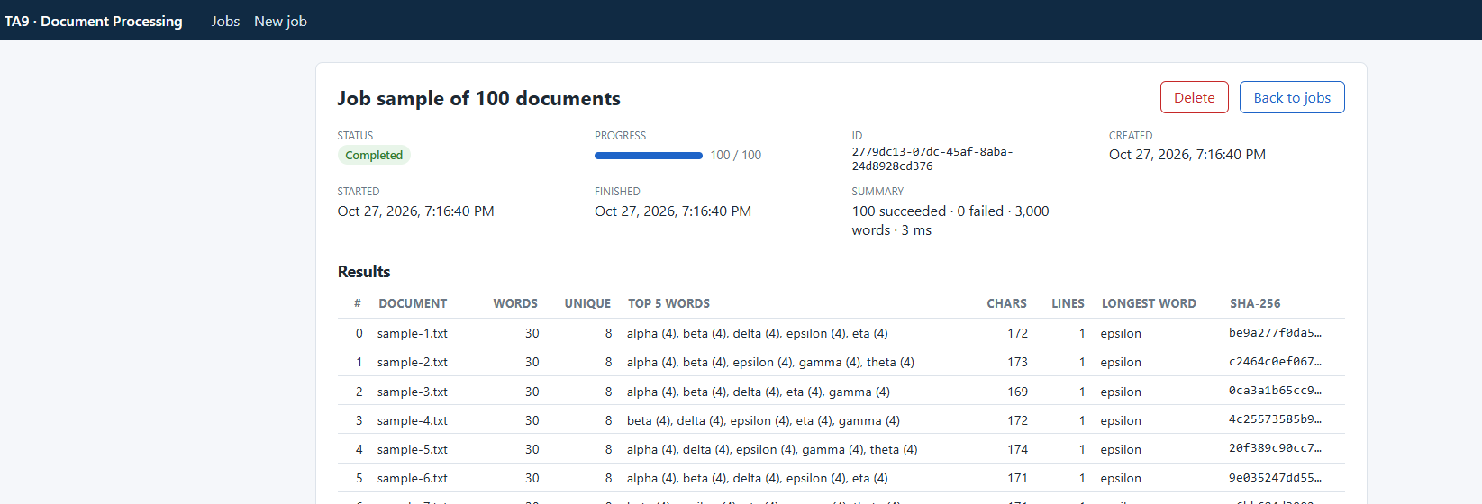
Job details with results
A few seconds after the job ends, the Audit entry appears at the bottom of the page. It is the summary that the Audit Service stored:
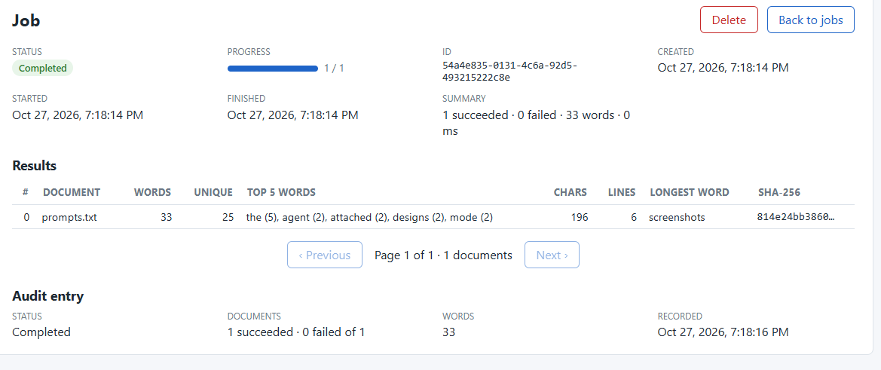
Results and audit entry
Button | When it is shown | What it does
Cancel job | While the job is Pending, Queued or Processing | Stops the job; its status becomes Cancelled
Delete | When the job has ended | Asks for confirmation, then deletes the job and its results
Back to jobs | Always | Returns to the list

3.3 The jobs list
The Jobs page lists all jobs, newest first, with status, progress, total words, creation time and the start of the id. Click a row to open its details.
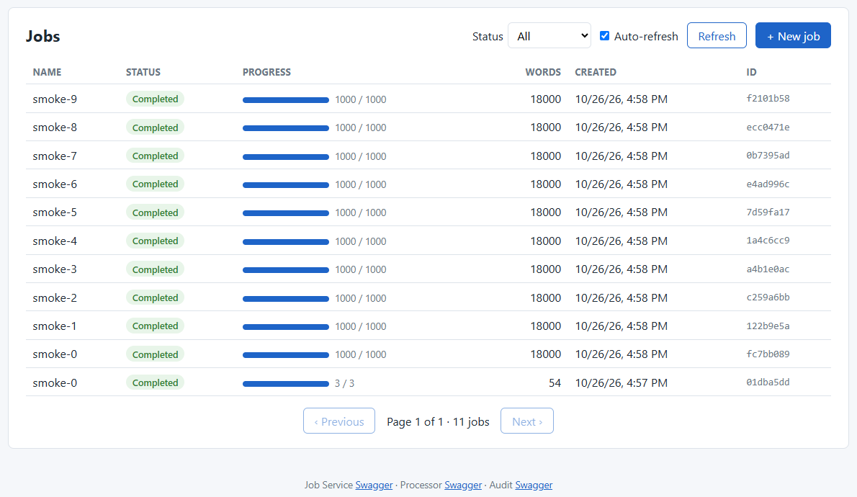
Jobs list
- Status filters the list (e.g. only Completed or only Failed).
- Auto-refresh reloads the list every 3 seconds; Refresh reloads it once.
- Previous / Next page through the list (20 jobs per page).

4. Working with Swagger
Swagger is an interactive page, built into each service, that lists every API call and lets you send it from the browser.
Service | Swagger | Use it for
Job Service | http://localhost:5001/swagger | Everything a user does: create, list, get, results, live status, cancel, delete
Audit Service | http://localhost:5003/swagger | Reading the audit entry of a finished job
Processor Service | http://localhost:5002/swagger | Internal: the Job Service calls it. Useful only to look inside

4.1 How to send a request
- Open http://localhost:5001/swagger.
- Click an operation, for example POST /api/jobs, to expand it.
- Click Try it out.
- Fill in the parameters or the request body.
- Click Execute. Below, under Server response, you see the status code and the response body.

4.2 Create a job
POST /api/jobs, request body:
{
"name": "my first job",
"documents": [
{ "name": "a.txt", "content": "The quick brown fox jumps over the lazy dog. The dog sleeps." },
{ "name": "b.txt", "content": "Hello world, hello again." }
]
}

Expected response: 201 Created, with the new job in status Pending. Copy the id: the next calls need it.
{ "id": "2779dc13-07dc-45af-8aba-24d8928cd376", "name": "my first job", "status": "Pending", "totalDocuments": 2, "processedDocuments": 0, ... }

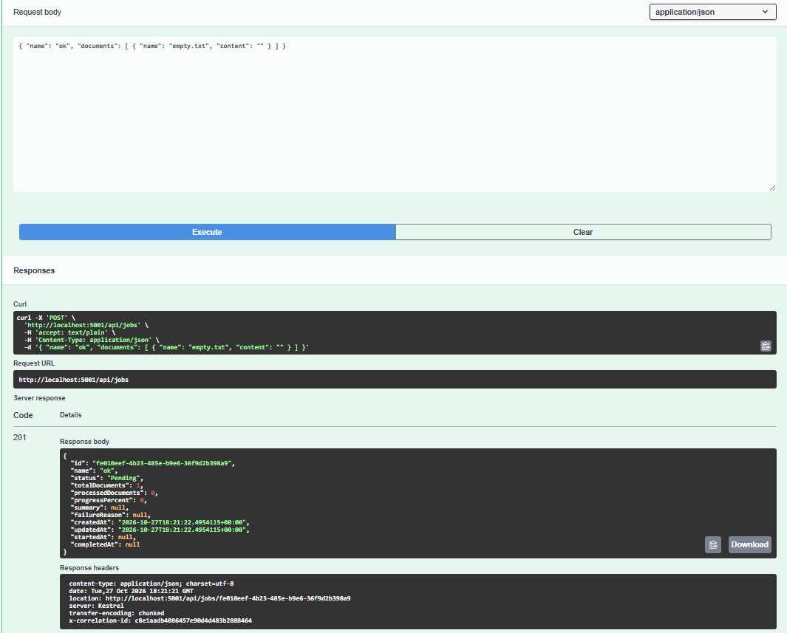
Swagger: POST /api/jobs → 201 Created

4.3 Check the status and read the results
Step | Operation | Parameters | Expected
Status | GET /api/jobs/{id} | id = the copied id | 200, status = Completed (usually within a second); summary filled
Results | GET /api/jobs/{id}/results | id; optional page (1), pageSize (50, max 200) | 200 with items per document. 409 if the job has not completed yet: wait and try again
All jobs | GET /api/jobs | optional status, page, pageSize (max 100) | 200, newest first
Cancel | POST /api/jobs/{id}/cancel | id | 202 with status Cancelled; 409 if it already finished
Delete | DELETE /api/jobs/{id} | id | 204; 409 while the job is still running
Audit entry | GET /api/audit/{jobId} on http://localhost:5003/swagger | jobId | 200 with the summary; 404 for a few seconds after the job ends, until it is recorded

Live status (GET /api/jobs/{id}/events) is a stream that Swagger cannot display well. Use the Web UI, or curl -N http://localhost:5001/api/jobs/<id>/events in a terminal.

4.4 Error responses
Errors come back as standard ProblemDetails JSON (application/problem+json) with a title, a status and, for validation errors, an errors object that lists each field:
{ "title": "One or more validation errors occurred.", "status": 400,
"errors": { "documents": ["At least one document is required."] } }

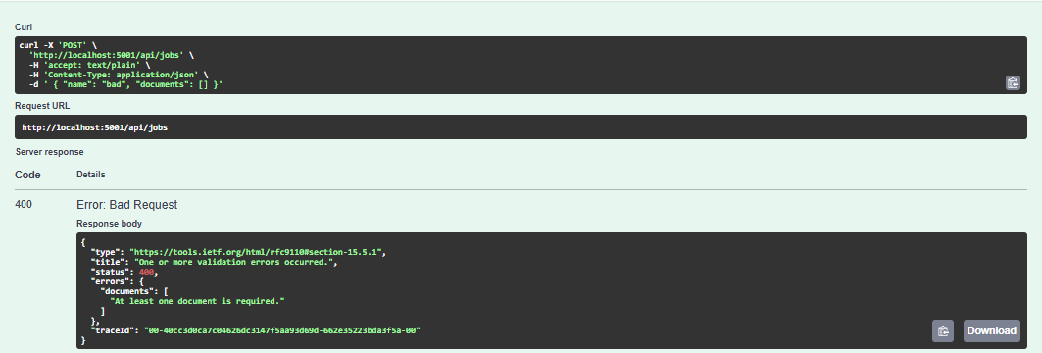
Swagger: a validation error (400) with the field that is wrong
Code | Meaning
400 | The request is invalid; errors says what to fix
404 | No job with this id
409 | Not possible in the job's current state (results before Completed, cancel after it ended, delete while running)
503 | Temporarily unavailable (e.g. the database). Retry later

5. Working with Postman

5.1 Install Postman and import the collection
- Download and install Postman from https://www.postman.com/downloads. Signing in is optional; you can skip it.
- In Postman, click Import (top left), then files, and choose docs/postman/Ta9.postman_collection.json from the repository.
- The collection TA9 Document Processing appears in the left sidebar with four folders.
The addresses are collection variables (jobsUrl = http://localhost:5001, auditUrl = http://localhost:5003, processorUrl = http://localhost:5002). Change them only if you changed the ports. jobId is filled in automatically.

5.2 The folders
Folder | Requests | What it shows
1. Happy path | Create job → Get job → Get results → Stream events → List jobs → List completed → Audit entry → Delete | The full life of a job. Create job saves the new id in {{jobId}} for the rest
2. Cancel | Create large job → Cancel job → Get cancelled job | Cancelling a running job
3. Validation & errors | No documents → 400 · Null content → 400 · Unknown job → 404 | How invalid input is rejected
4. Processor & health (internal) | Processor: known jobs / job status · ready checks of the three services | A look inside, and whether the services are healthy

5.3 Send requests one by one
Open a request in the sidebar and click Send. The response appears in the lower half of the window. The Test Results tab shows the request's built-in checks, for example 201 Created and status is Pending. Within a folder, send the requests from top to bottom.

5.4 Run a whole folder automatically
- Right-click a folder (or the whole collection), then Run.
- In the Collection Runner, keep the order and click Run.
- Each request is sent in turn, and its checks are marked pass or fail.
In folder 1, Get results accepts both 200 and 409: the runner may reach it a moment before the job completes. If you see 409, run that request again.

6. Everyday scenarios
I want to… | Web UI | Swagger / Postman
Analyze my own text files | New job → Load .txt files → Create job | POST /api/jobs with each file's text as content
See the system handle a big load | New job → 1000 → Generate sample → Create; repeat a few times | Or run scripts/smoke-test.ps1 -Jobs 10 -Documents 1000 (Installation Guide §4.3)
Know whether a document failed | Results table: the failed row is red with its error | results.items[].result.status = Failed, plus error
Stop a job I sent by mistake | Details → Cancel job | POST /api/jobs/{id}/cancel
Clean up old jobs | Details → Delete (finished jobs only) | DELETE /api/jobs/{id}
Find all failed jobs | Jobs → Status Failed | GET /api/jobs?status=Failed
See what was recorded for audit | Bottom of the details page | GET http://localhost:5003/api/audit/{jobId}

7. Questions and problems
Question | Answer
The Web UI says "The service cannot be reached" | The services are not running or not healthy: docker compose ps. See Installation Guide §5
A job stays Pending | The processor is not reachable. The system keeps retrying with growing delays, and after 5 failed attempts the job becomes Failed with the reason. See Installation Guide §5.5
GET …/results returns 409 | The job has not completed (yet). Check its status first
The audit entry is missing | It is recorded a few seconds after the job ends. The Web UI keeps checking; in Swagger or Postman, try again
Some documents failed but the job is Completed | By design: one bad document does not discard the others. Look at the failed row's error
A job became Failed | Its failure reason explains why (for example every document failed, or the processor was unavailable for too long)
Can several people use it at once? | Yes. All jobs are visible to everyone; there are no user accounts in this version
Where are the logs? | docker compose logs, and the ta9_logs database. See Installation Guide §5 and the Logging document

For running, stopping and troubleshooting the system itself, see the Installation Guide. For how the system is built, see the High-Level Design (docs/hld/TA9-HLD.docx).

