High-Level Design
TA9 Real-Time Document Processing System
Document | High-Level Design (HLD)
System | TA9 Document Processing (Job Service · Processor Service · Audit Service)
Stack | C# / .NET 8 · ASP.NET Core · MongoDB 7 · Docker Compose
Diagrams | Editable source: diagrams/ta9-hld.drawio (one page per diagram). Open with app.diagrams.net or the VS Code Draw.io Integration extension. PNG renderings are in images
Detailed design | ../design — architecture, API contracts, reliability, decision log (D1–D26)
Topic documents | Concurrency (../concurrency), WebSocket behavior (../websocket), Storage (../storage), Logging & Observability (../logging)

draw.io page | Section
1. Architecture | §3 Architecture diagram
2a / 2b. Class Diagram | §5 Class diagrams
3. Flow Diagram | §6 Flow diagram
4. Job State Machine | §7 Job lifecycle
5a / 5b / 5c. Sequence | §8 Sequence diagrams
6. Deployment | §10 Deployment
7 / 8. Concurrency | §9.1 Concurrency and performance
9. WebSocket — Connection & Outbox | §9.2 Reliability
10. Storage | §5.1 Data model
11. Logging | §9.4 Observability

Contents
1. Purpose and scope
2. Requirements and quality goals
3. Architecture diagram
3.1 Services and responsibilities
3.2 Communication
4. Component design
4.1 Job Service (layers: Api → Application → Domain ← Infrastructure)
4.2 Processor Service
5. Class diagrams
5.1 Data model (MongoDB)
6. Flow diagram
7. Job lifecycle (state machine)
8. Sequence diagrams
8.1 Happy path
8.2 Processor restart mid-job
8.3 WebSocket disconnect, reconnect and replay
9. Non-functional design
9.1 Concurrency and performance
9.2 Reliability
9.3 Scalability (current limits → next step)
9.4 Observability
9.5 Security (POC scope)
10. Deployment
11. Risks, limitations and future work

1. Purpose and scope
The system accepts batches of text documents, analyzes them asynchronously and exposes progress and results in real time. For each document it computes:
- word count
- unique word count
- top-5 words
- SHA-256
- character count, line count, average word length and longest word
In scope: three services communicating over REST, WebSocket and SSE; bounded concurrent processing; failure handling (invalid input, unreachable services, restarts, lost or duplicate events); persistent storage; observability; automated tests; containerized deployment.
Out of scope (by assignment): authentication/authorization, UI, Kubernetes, message brokers, Redis, CI/CD.

2. Requirements and quality goals
Category | Requirement | How the design meets it
Functional | CRUD-style job API, a simple lifecycle, per-document statistics | /api/jobs, state machine Pending → Queued → Processing → Completed | Failed plus Cancelled
Integration | Job Service ↔ Processor over REST and WebSocket/SSE | REST dispatch; processor events over WS with acks; SSE to clients
Performance | ≥ 10 concurrent jobs × up to 1,000 documents; no unbounded parallelism; no blocked threads | Bounded channel (100) + 10 workers × 2 documents in parallel; async I/O; verified by an integration test
Reliability | Invalid input, processor unreachable, WS disconnects, duplicates | Validation (400), persisted retries with backoff, outbox + ack + reconnect, idempotent handlers, reconciler
Storage | Replaceable persistence | Repository interfaces; MongoDB and InMemory implementations selected by configuration
Observability | Meaningful logs for lifecycle, failures and retries (plus: logs in MongoDB and on the console, Debug / Information / Error levels) | One Serilog pipeline: console ≥ Information, MongoDB ta9_logs.logs ≥ Debug (batched, non-blocking, 7-day TTL); Service / CorrelationId / JobId on every record; health checks

3. Architecture diagram
Architecture diagram
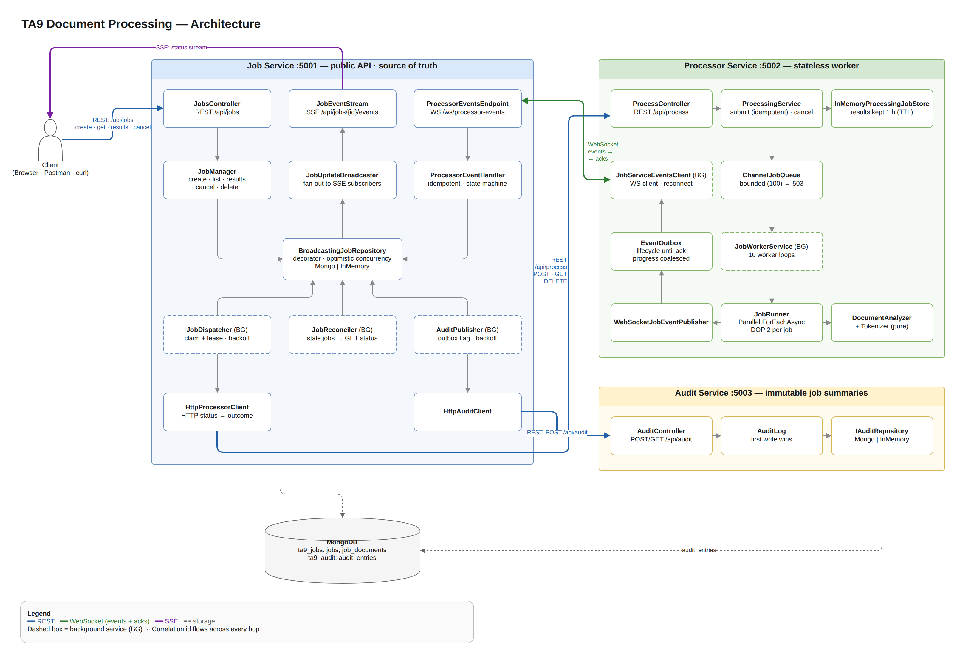
draw.io page 1. Architecture · editable source: docs/hld/diagrams/ta9-hld.drawio

3.1 Services and responsibilities
Service | Responsibility | State | Talks to
Job Service | Public API. Owns the job lifecycle (single source of truth). Dispatches work, applies processor events, streams status (SSE), publishes audit summaries | MongoDB ta9_jobs (jobs, job_documents) | Processor (REST out, WS in), Audit (REST out), clients (REST, SSE)
Processor Service | Stateless worker: accepts work, analyzes documents with bounded concurrency, reports the lifecycle | In memory (finished results kept 1 h for reconciliation) | Job Service (WS client)
Audit Service | Stores immutable summaries of finished jobs | MongoDB ta9_audit (audit_entries) | —
Ta9.Contracts (library) | Shared REST DTOs, WS event envelope and serializer, input limits | — | —
Ta9.ServiceDefaults (library) | Logging pipeline (Serilog → console + batched MongoDB sink), lifecycle / crash logging, correlation id, ProblemDetails, health endpoints, exponential backoff | MongoDB ta9_logs (logs, shared by all services) | MongoDB (logs)

3.2 Communication
From → To | Protocol | Purpose | Delivery semantics
Client → Job Service | REST | Create, list, get, results, cancel, delete | Synchronous; job processing is asynchronous
Job Service → Client | SSE | Live status and progress per job | Snapshot + every change; stream ends at a terminal state
Job Service → Processor | REST | Dispatch (POST, idempotent by jobId), status (GET), cancel (DELETE) | Retries with persisted exponential backoff
Processor → Job Service | WebSocket | JobStarted, JobProgress, JobCompleted, JobFailed, JobCancelled + acks back | Lifecycle: at-least-once (outbox + ack). Progress: best effort
Job Service → Audit | REST | Terminal job summaries | At-least-once (outbox flag); idempotent receiver

4. Component design

4.1 Job Service (layers: Api → Application → Domain ← Infrastructure)
Component | Role
JobsController, JobEventStream, ProcessorEventsEndpoint | HTTP / SSE / WebSocket adapters
JobManager | Use cases: create (documents, then job: commit marker), results, cancel (propagated to the processor), delete (finished jobs only)
JobDispatcher (background) | Atomically claims due Pending jobs with a lease, sends them in bounded parallel batches, applies the outcome (Queued / retry after hint / backoff → Failed / Failed)
ProcessorEventHandler | Applies events and status snapshots through the state machine; results are stored before the status changes
JobReconciler (background) | Safety net for lost events and processor restarts
AuditPublisher (background) | Delivers terminal summaries; the auditPublished flag is the outbox
Job, JobStateMachine | Aggregate with Try* transitions; one transition table for the whole system
IJobRepository + BroadcastingJobRepository | Persistence with optimistic concurrency (Version). A decorator publishes every successful write to SSE subscribers

4.2 Processor Service
Component | Role
ProcessController / ProcessingService | Validate; idempotent submit (known jobId → 200); bounded enqueue (full → 503 + Retry-After); cancel
ChannelJobQueue | Bounded Channel<T>, the backpressure point
JobWorkerService (background) | 10 long-lived worker loops awaiting the channel (no blocked threads)
JobRunner | Parallel.ForEachAsync with DOP 2 per job; per-document failure isolation; throttled progress; cooperative cancellation
DocumentAnalyzer + Tokenizer | Pure, deterministic analysis (Unicode, NFC, case-insensitive; ties broken alphabetically)
EventOutbox + JobServiceEventsClient | Lifecycle events kept until acked and replayed after reconnect or ack timeout; reconnect with backoff and jitter

5. Class diagrams
Class diagram — Job Service
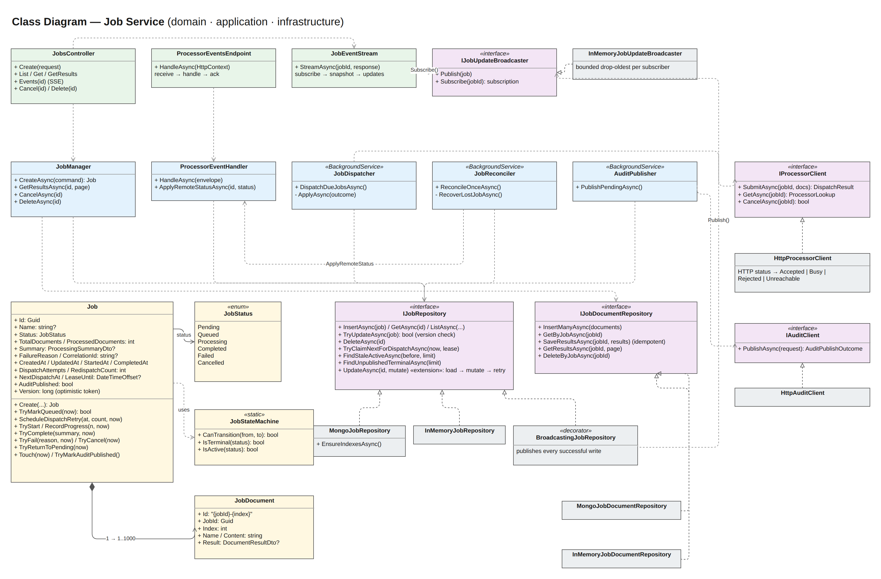
draw.io pages 2a. Class Diagram — Job Service and 2b. Class Diagram — Processor Service · editable source: docs/hld/diagrams/ta9-hld.drawio
Class diagram — Processor Service
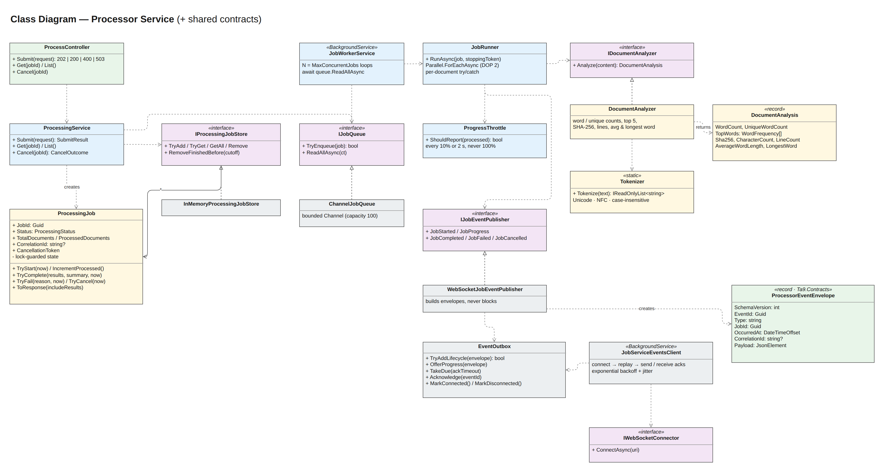
Source: docs/hld/diagrams/ta9-hld.drawio

5.1 Data model (MongoDB)
Collection | Key | Main fields | Indexes
jobs | _id = job id (string GUID) | status, counters, summary, timestamps, dispatch bookkeeping (dispatchAttempts, nextDispatchAt, leaseUntil, redispatchCount), auditPublished, version | {status, nextDispatchAt} (dispatcher) · {status, updatedAt} (reconciler) · {auditPublished, status} (audit) · {createdAt: -1} (listing)
job_documents | _id = "{jobId}-{index}" | jobId, index, name, content, result | {jobId, index} unique
audit_entries | _id = job id | status, counts, total words, failure reason, timestamps, recordedAt | —
ta9_logs.logs | ObjectId | timestamp, level, service, host, message, messageTemplate, sourceContext, correlationId, jobId, exception, properties | TTL {timestamp} 7 days · {jobId, timestamp} · {correlationId, timestamp} · {level, timestamp} · {service, timestamp}

Documents live in a separate collection so that a 1,000-document job never approaches the 16 MB BSON limit and status reads stay small. There are no multi-document transactions. Instead, documents are written before the job (the job is the commit marker) and deleted after it.

6. Flow diagram
Flow diagram
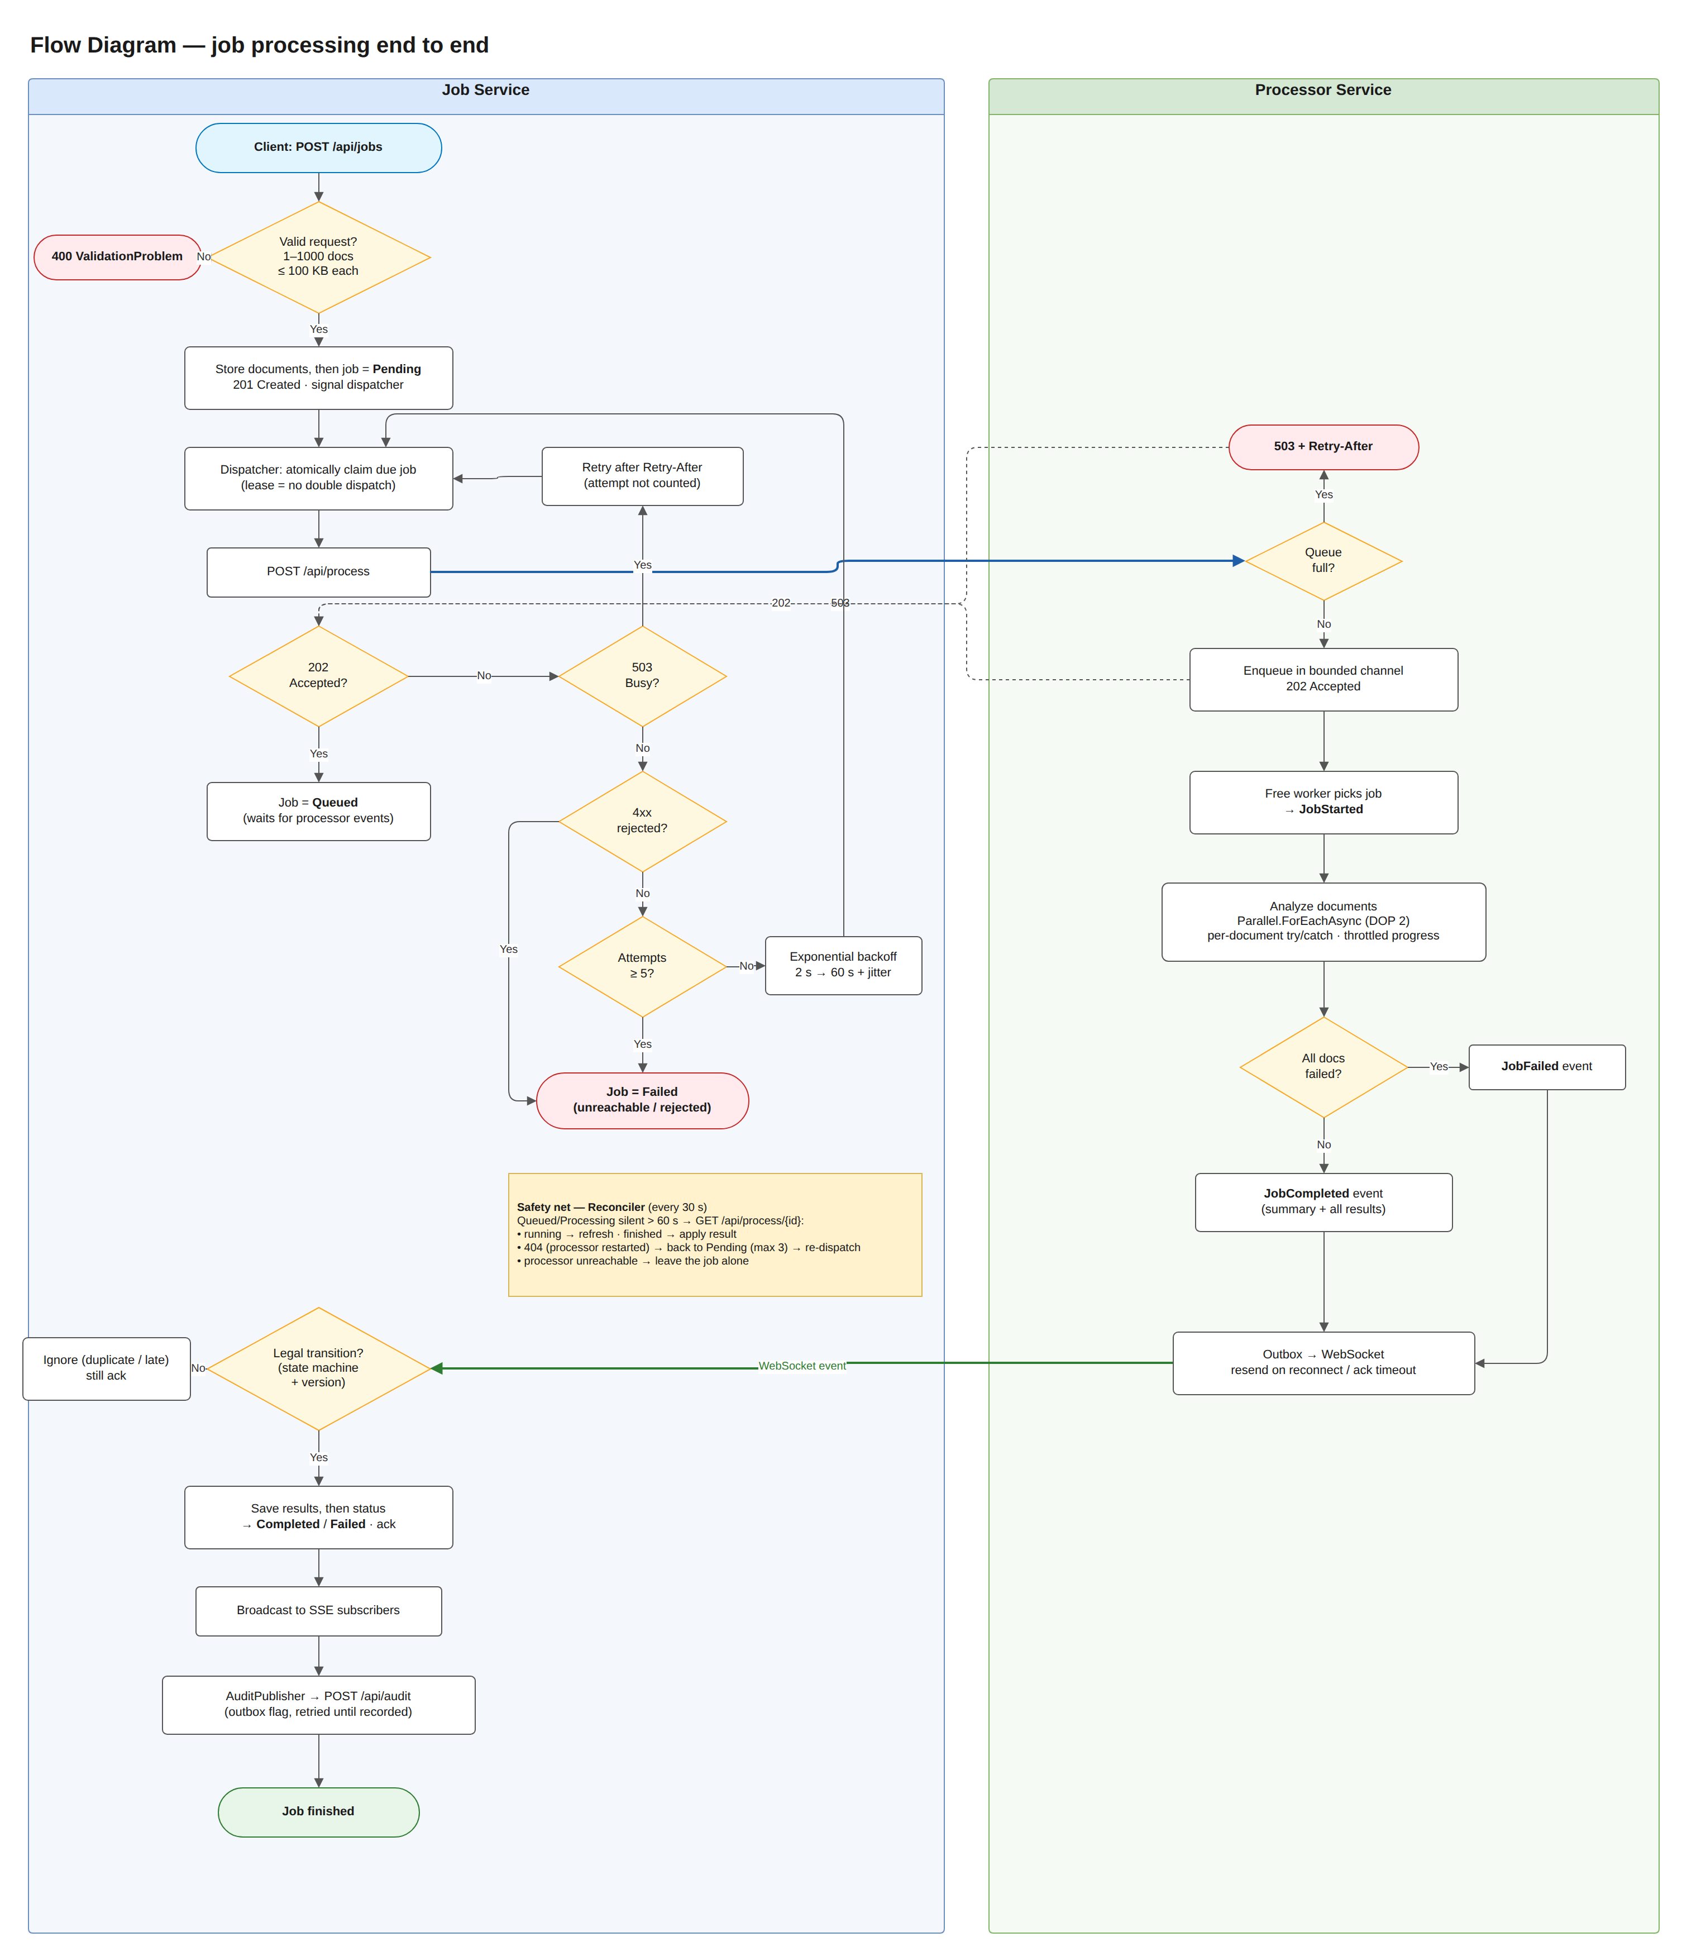
draw.io page 3. Flow Diagram (swim lanes per service) · editable source: docs/hld/diagrams/ta9-hld.drawio
Safety net (reconciler, every 30 s): for Queued/Processing jobs silent for more than 60 s it calls GET /api/process/{id}. Running → refresh progress. Finished → apply the result. 404 (processor restarted) → back to Pending and redispatch (max 3, then Failed). Processor unreachable → leave the job alone.

7. Job lifecycle (state machine)
Job state machine
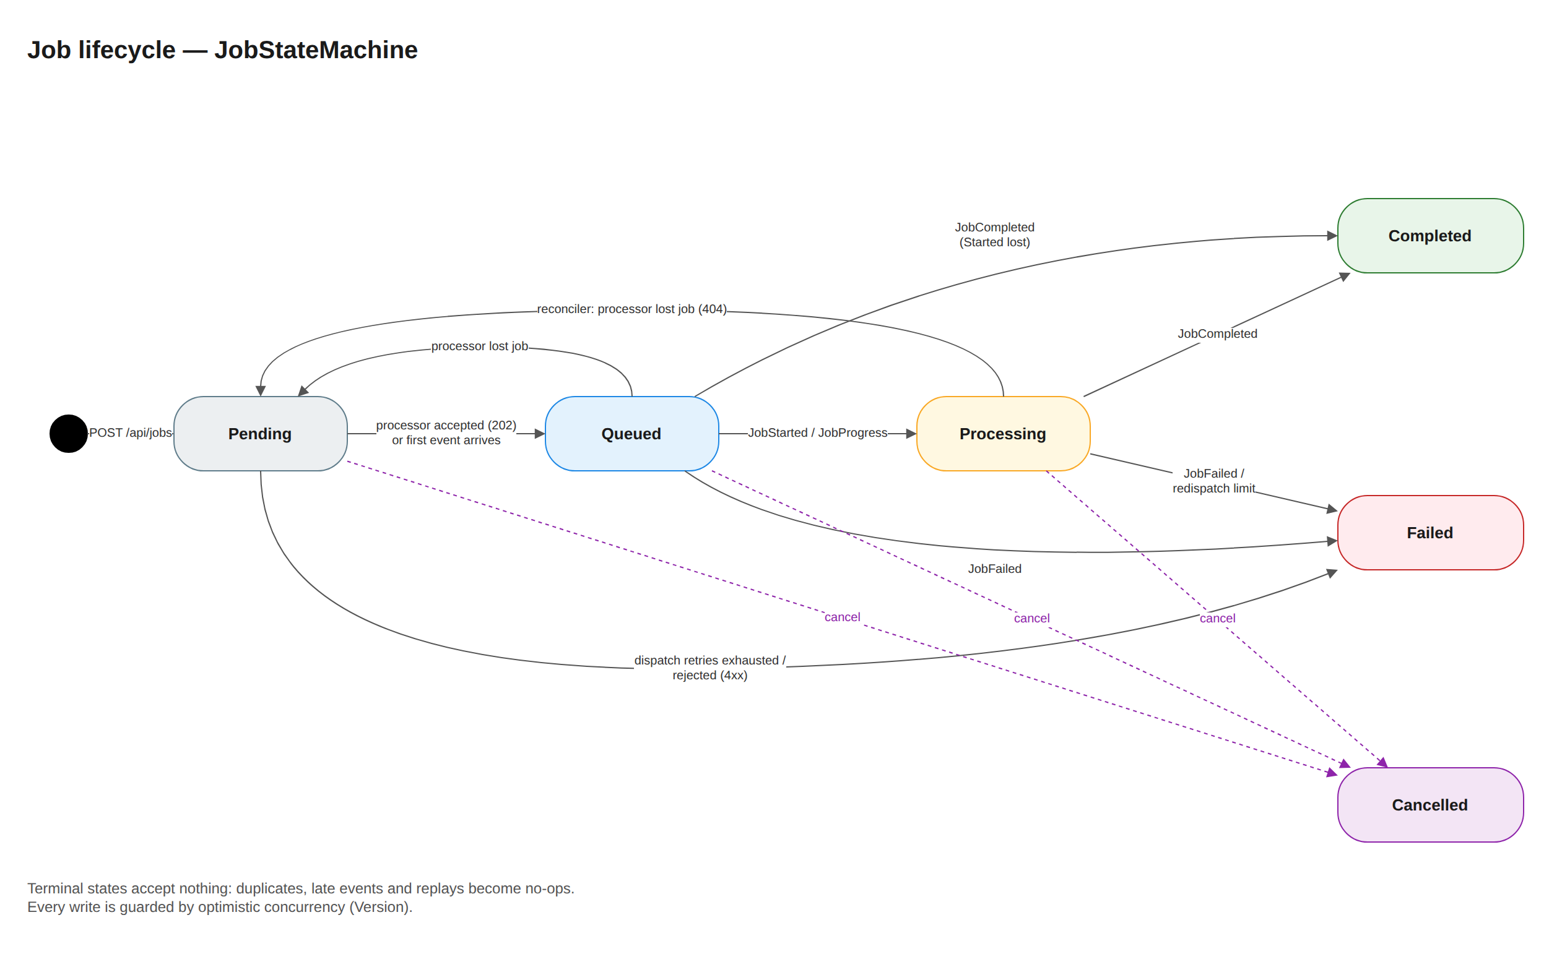
draw.io page 4. Job State Machine · editable source: docs/hld/diagrams/ta9-hld.drawio
Terminal states accept nothing, so duplicates, replays and late events are no-ops. Every write goes through optimistic concurrency (load → mutate → replace if version is unchanged → retry), so the WS handler, dispatcher, reconciler and cancel requests never overwrite each other.

8. Sequence diagrams

8.1 Happy path
Sequence — happy path
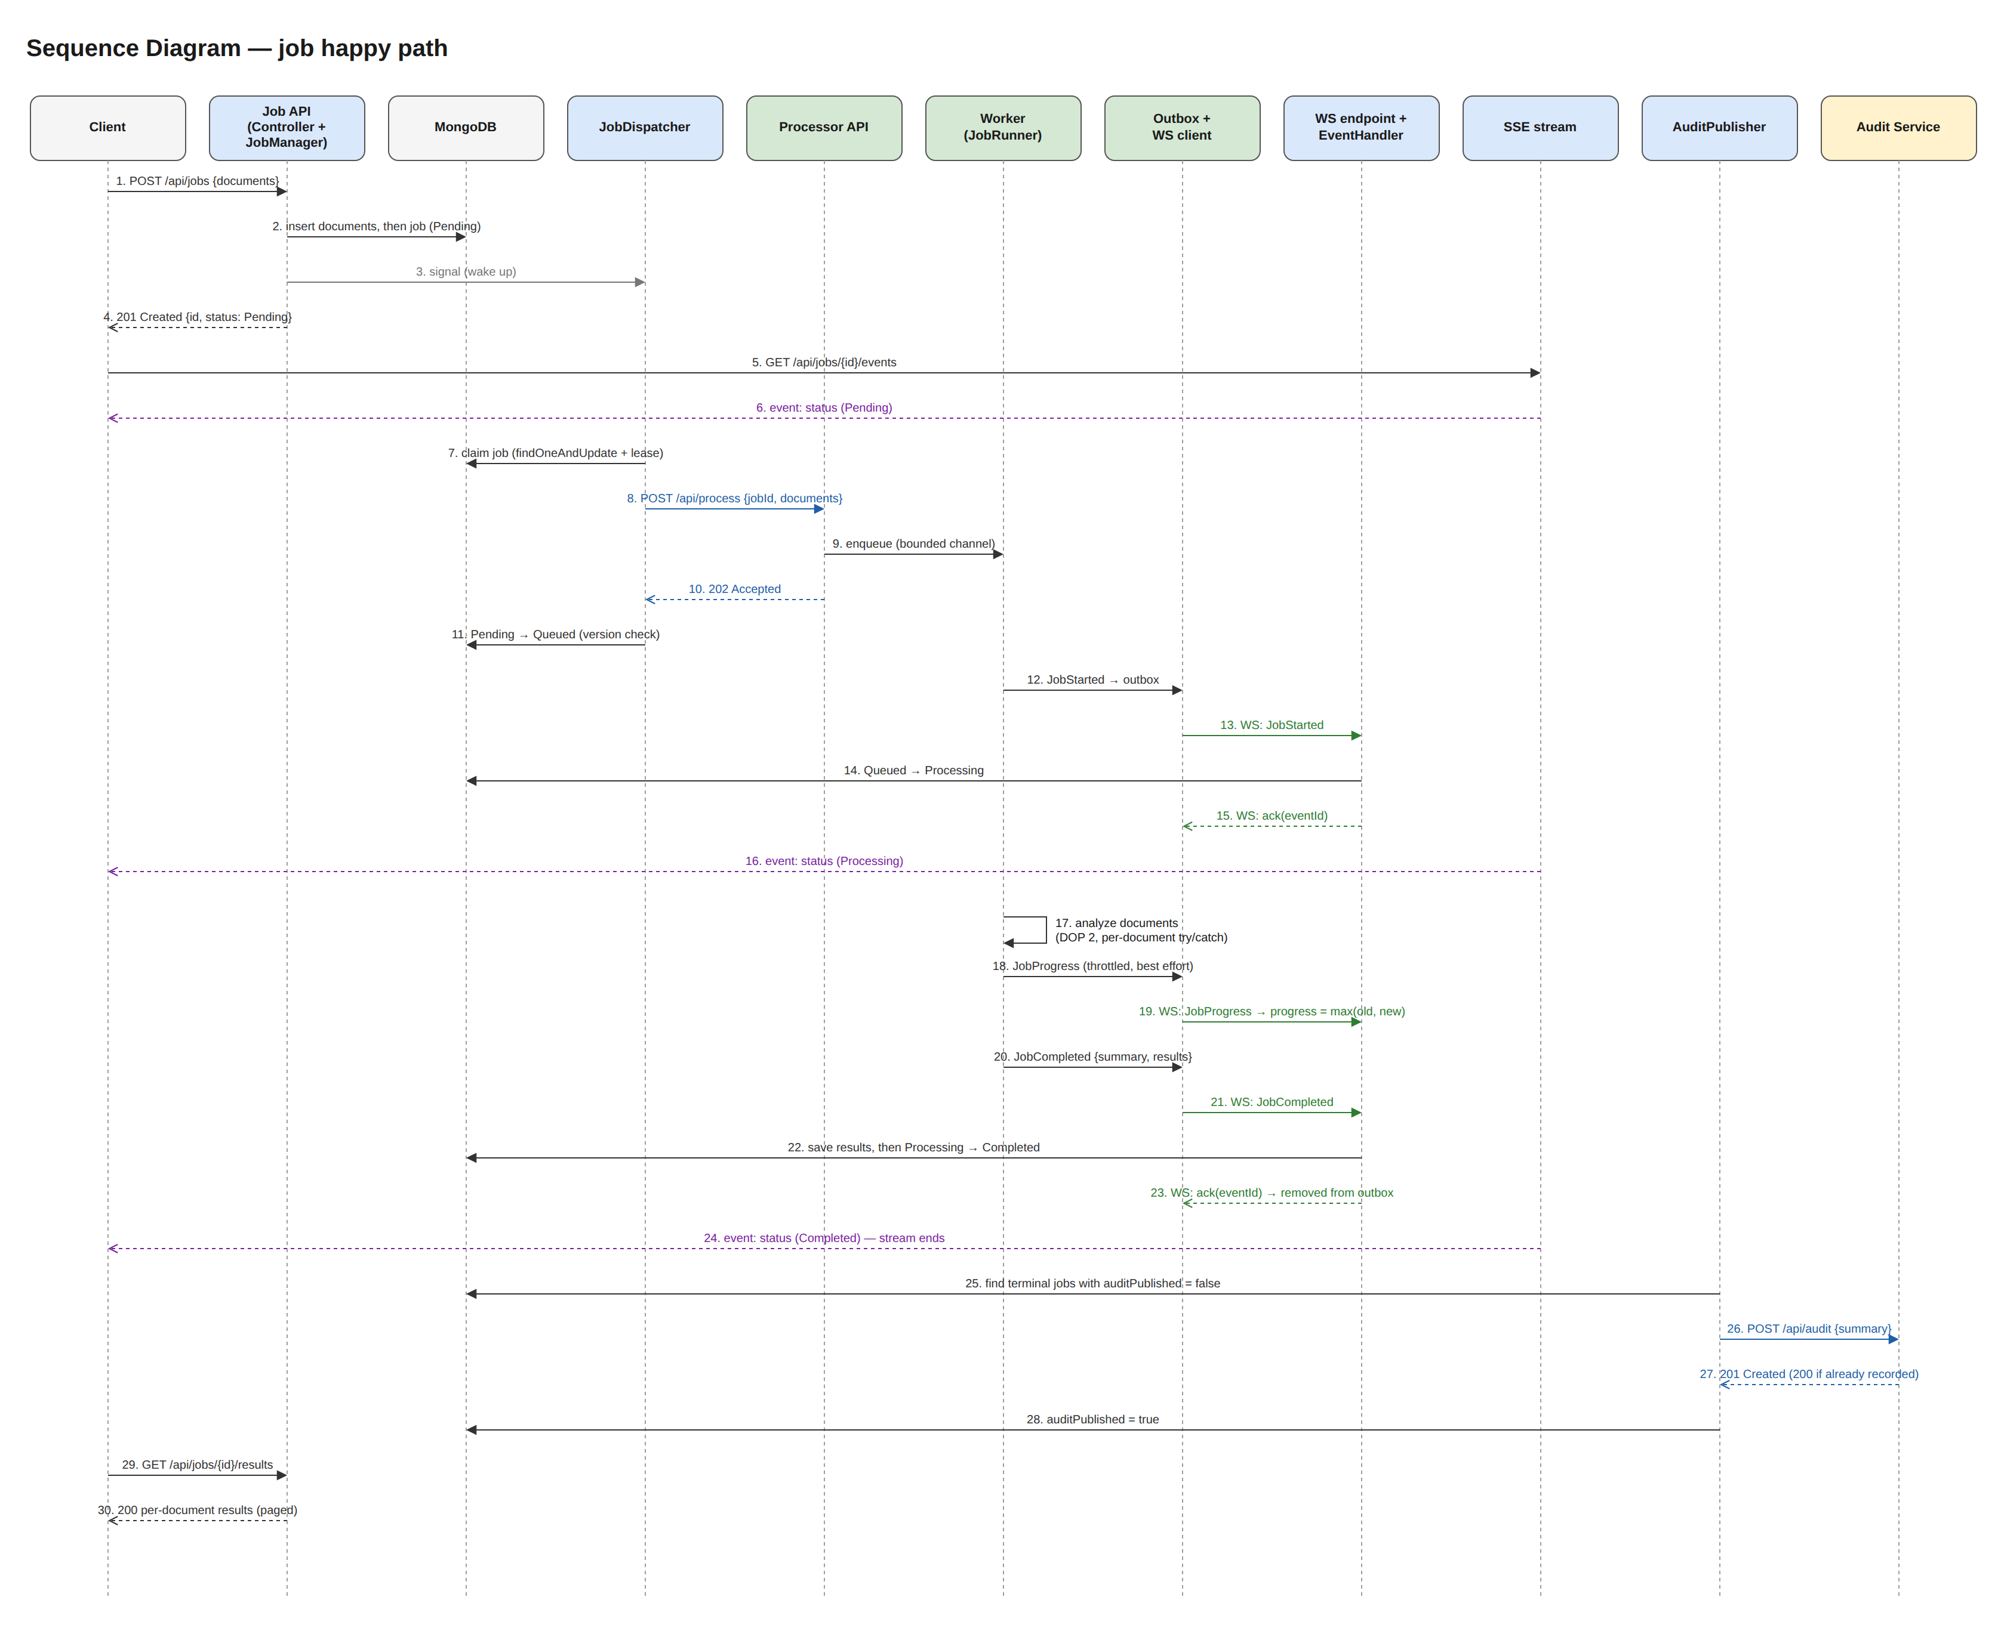
draw.io page 5a. Sequence — Happy Path (30 numbered messages, including SSE and audit) · editable source: docs/hld/diagrams/ta9-hld.drawio

8.2 Processor restart mid-job
Sequence — processor restart
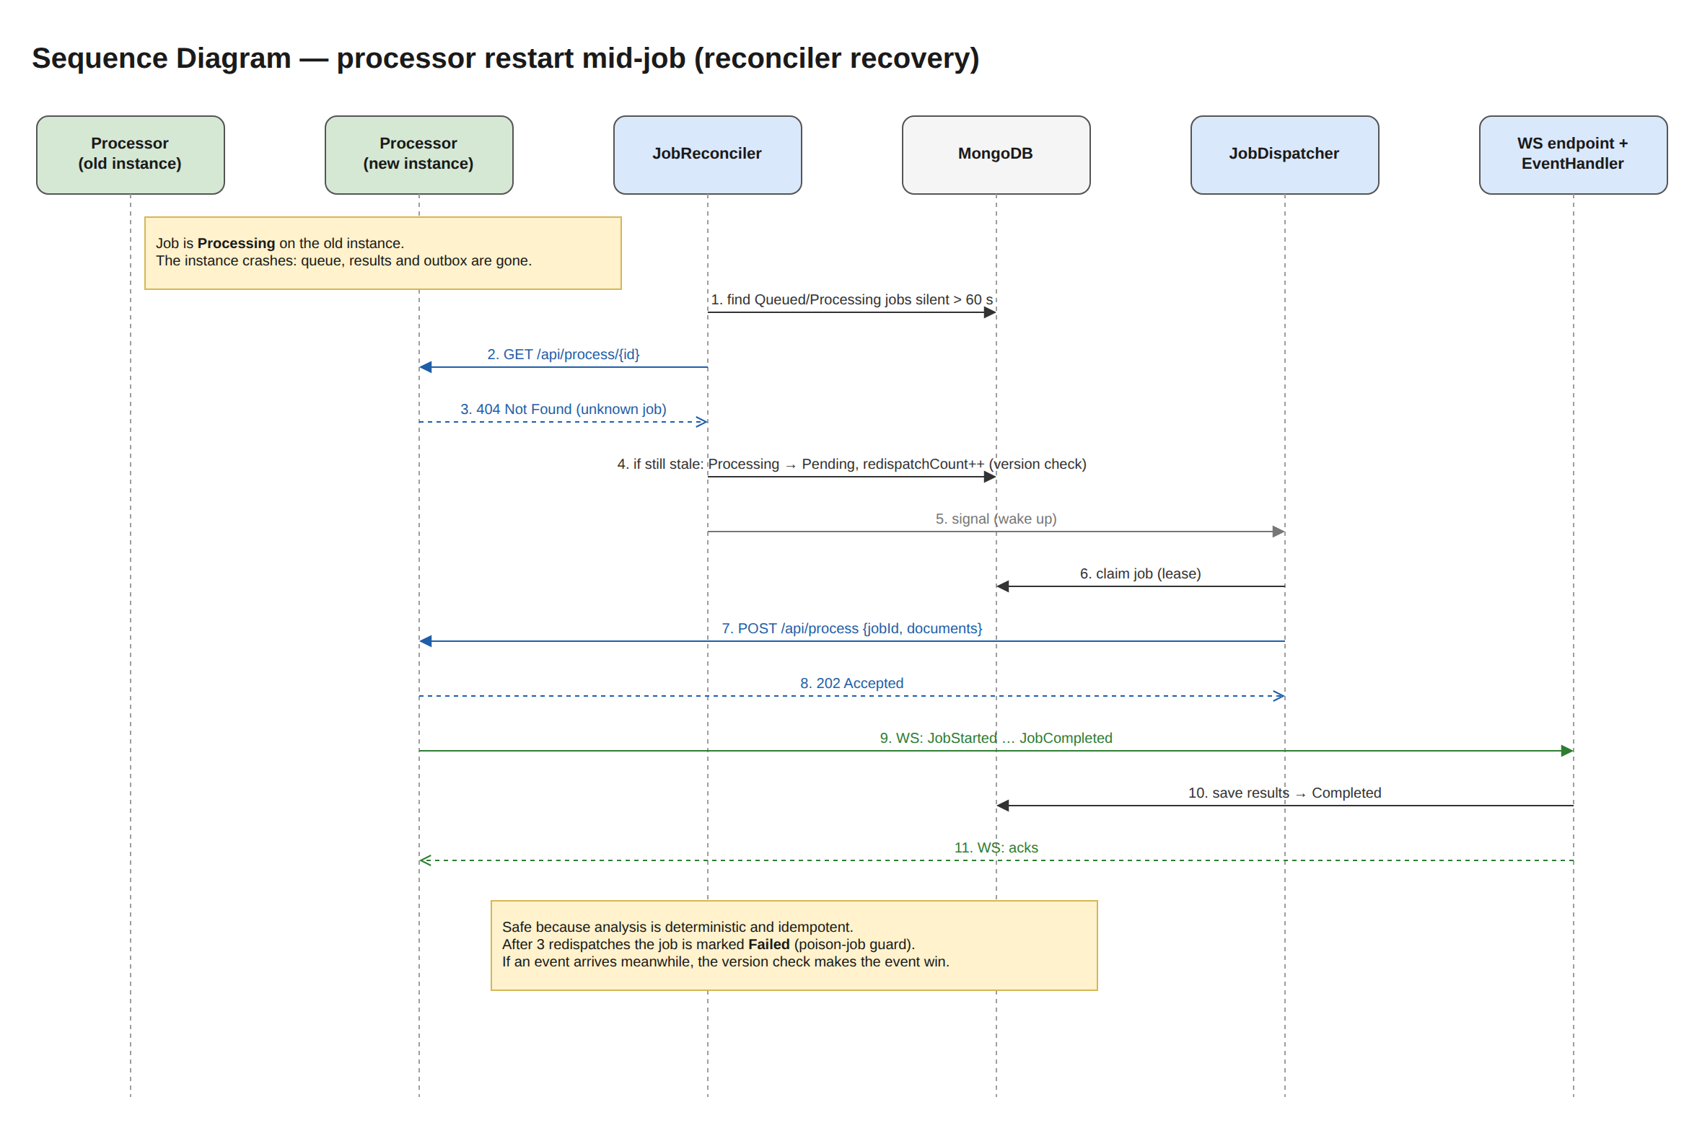
draw.io page 5b. Sequence — Processor Restart · editable source: docs/hld/diagrams/ta9-hld.drawio

8.3 WebSocket disconnect, reconnect and replay
Sequence — WebSocket reconnect
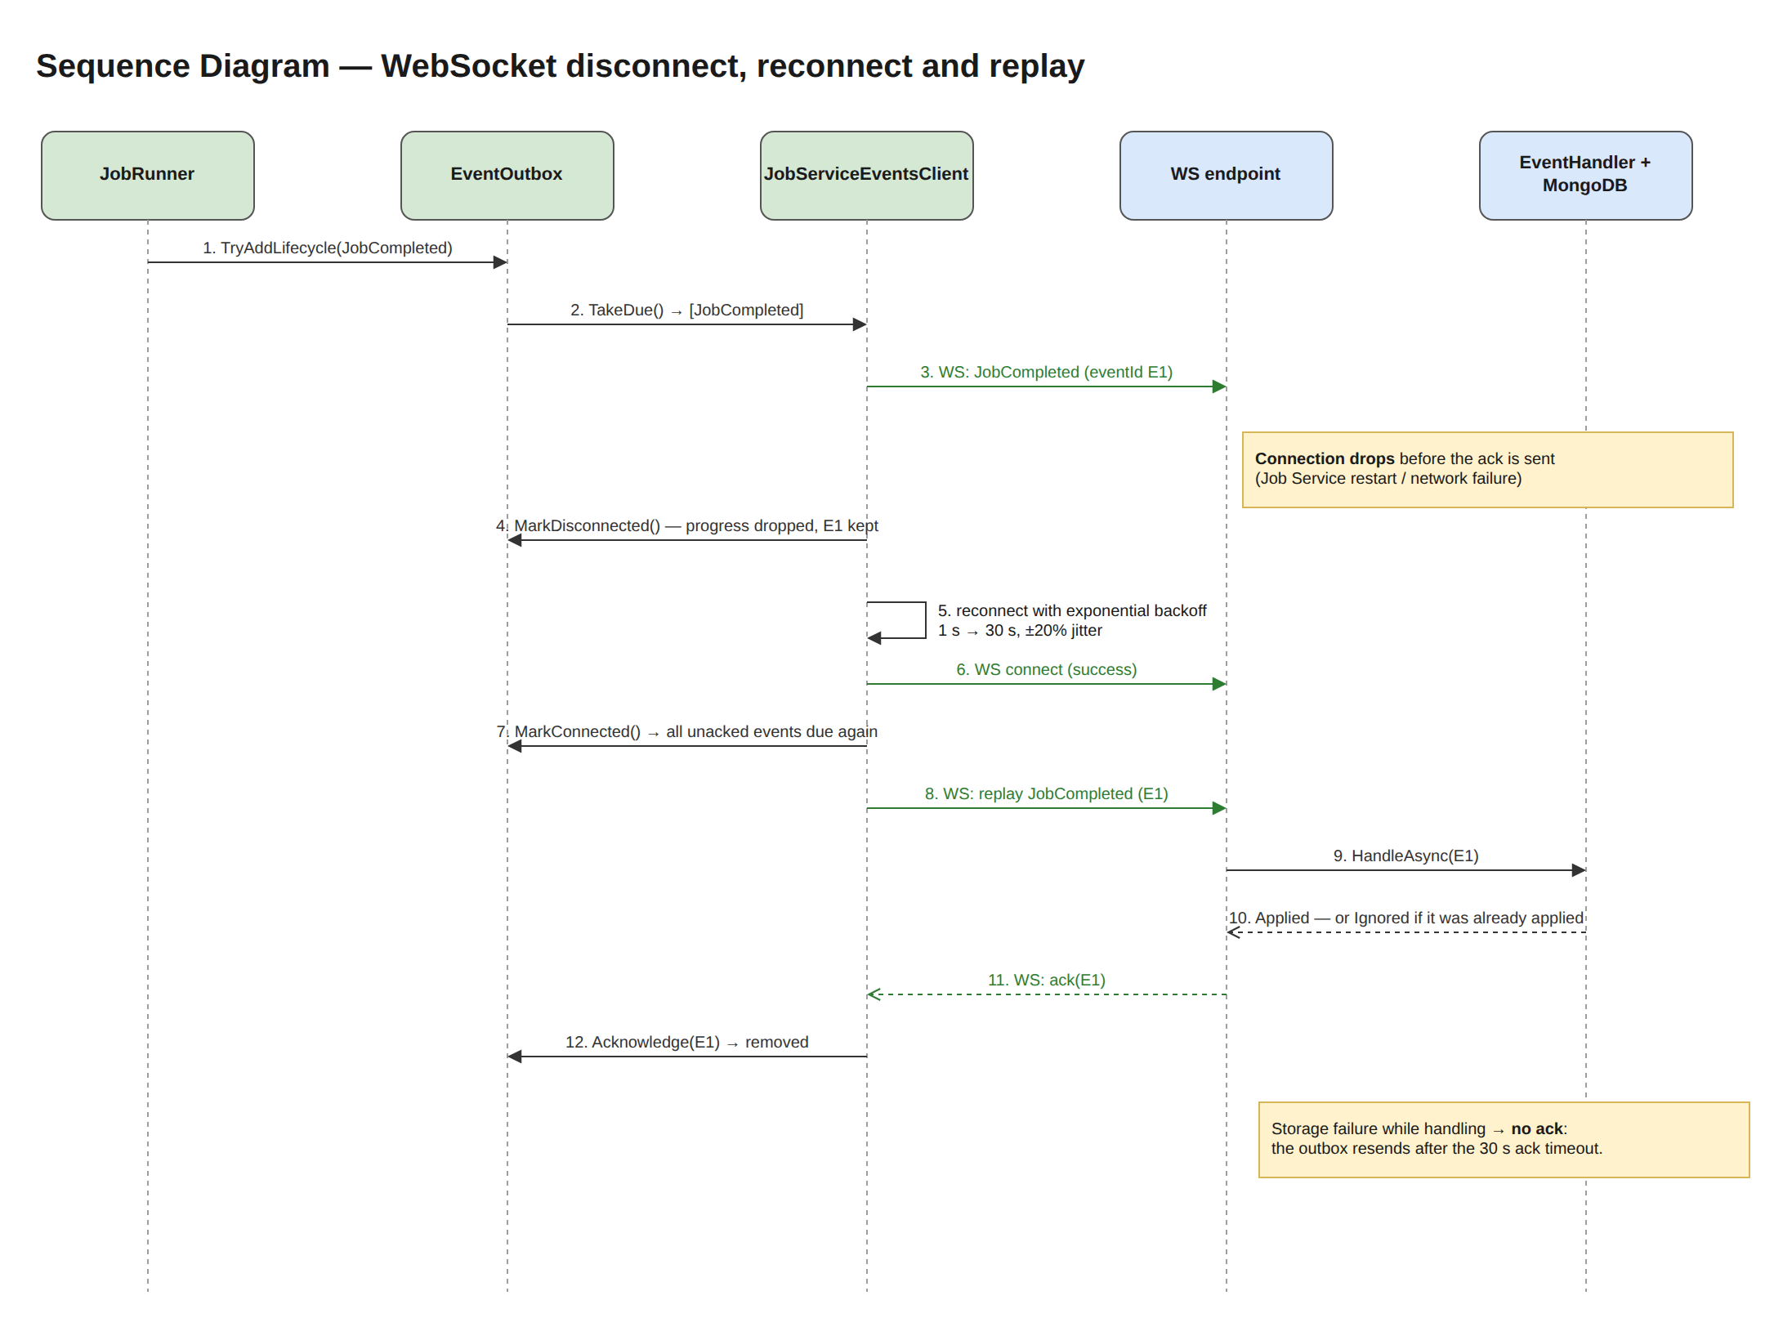
draw.io page 5c. Sequence — WebSocket Reconnect · editable source: docs/hld/diagrams/ta9-hld.drawio

9. Non-functional design

9.1 Concurrency and performance
Full analysis with diagrams, advantages, limitations and alternatives: ../concurrency/CONCURRENCY.md.
- Two explicit bounds: at most 10 concurrent jobs × 2 documents = 20 CPU work items, and at most 100 jobs queued. Above that, 503 + Retry-After backpressure flows back to the dispatcher.
- No blocked threads: workers await the channel and all I/O is async. Only the CPU-bound analysis runs on pool threads.
- Fairness: each job gets its own small parallelism slice, so large jobs never starve small ones.
- Verified: the integration test runs 10 × 1,000 documents end to end and asserts every document is analyzed exactly once with at most 20 concurrent analyses.

9.2 Reliability
Failure | Handling
Invalid input | 400 ProblemDetails with field errors; nothing persisted
Processor unreachable / overloaded | Persisted exponential backoff (5 attempts → Failed); 503 is not counted
WS disconnect | Outbox + ack + reconnect with jitter; readiness Degraded
Duplicate / out-of-order events | State machine, monotonic progress, idempotent result writes
Processor restart | Reconciler redispatch (max 3)
Job Service restart | All state in MongoDB; leases expire; outboxes replay
MongoDB down | 503 (5 s fail-fast); events not acked and therefore resent
Audit down | Jobs unaffected; outbox flag; backoff

9.3 Scalability (current limits → next step)
- The Processor scales horizontally behind a load balancer. The dispatcher only needs one URL, and POST is idempotent.
- The Job Service's dispatch is multi-instance safe (atomic leases). SSE fan-out and WS fan-in are per instance: the next step is Redis pub/sub or a broker.
- At larger scale, a durable broker (RabbitMQ or Kafka) would replace REST dispatch, WS events and the reconciler.

9.4 Observability
Logging & observability
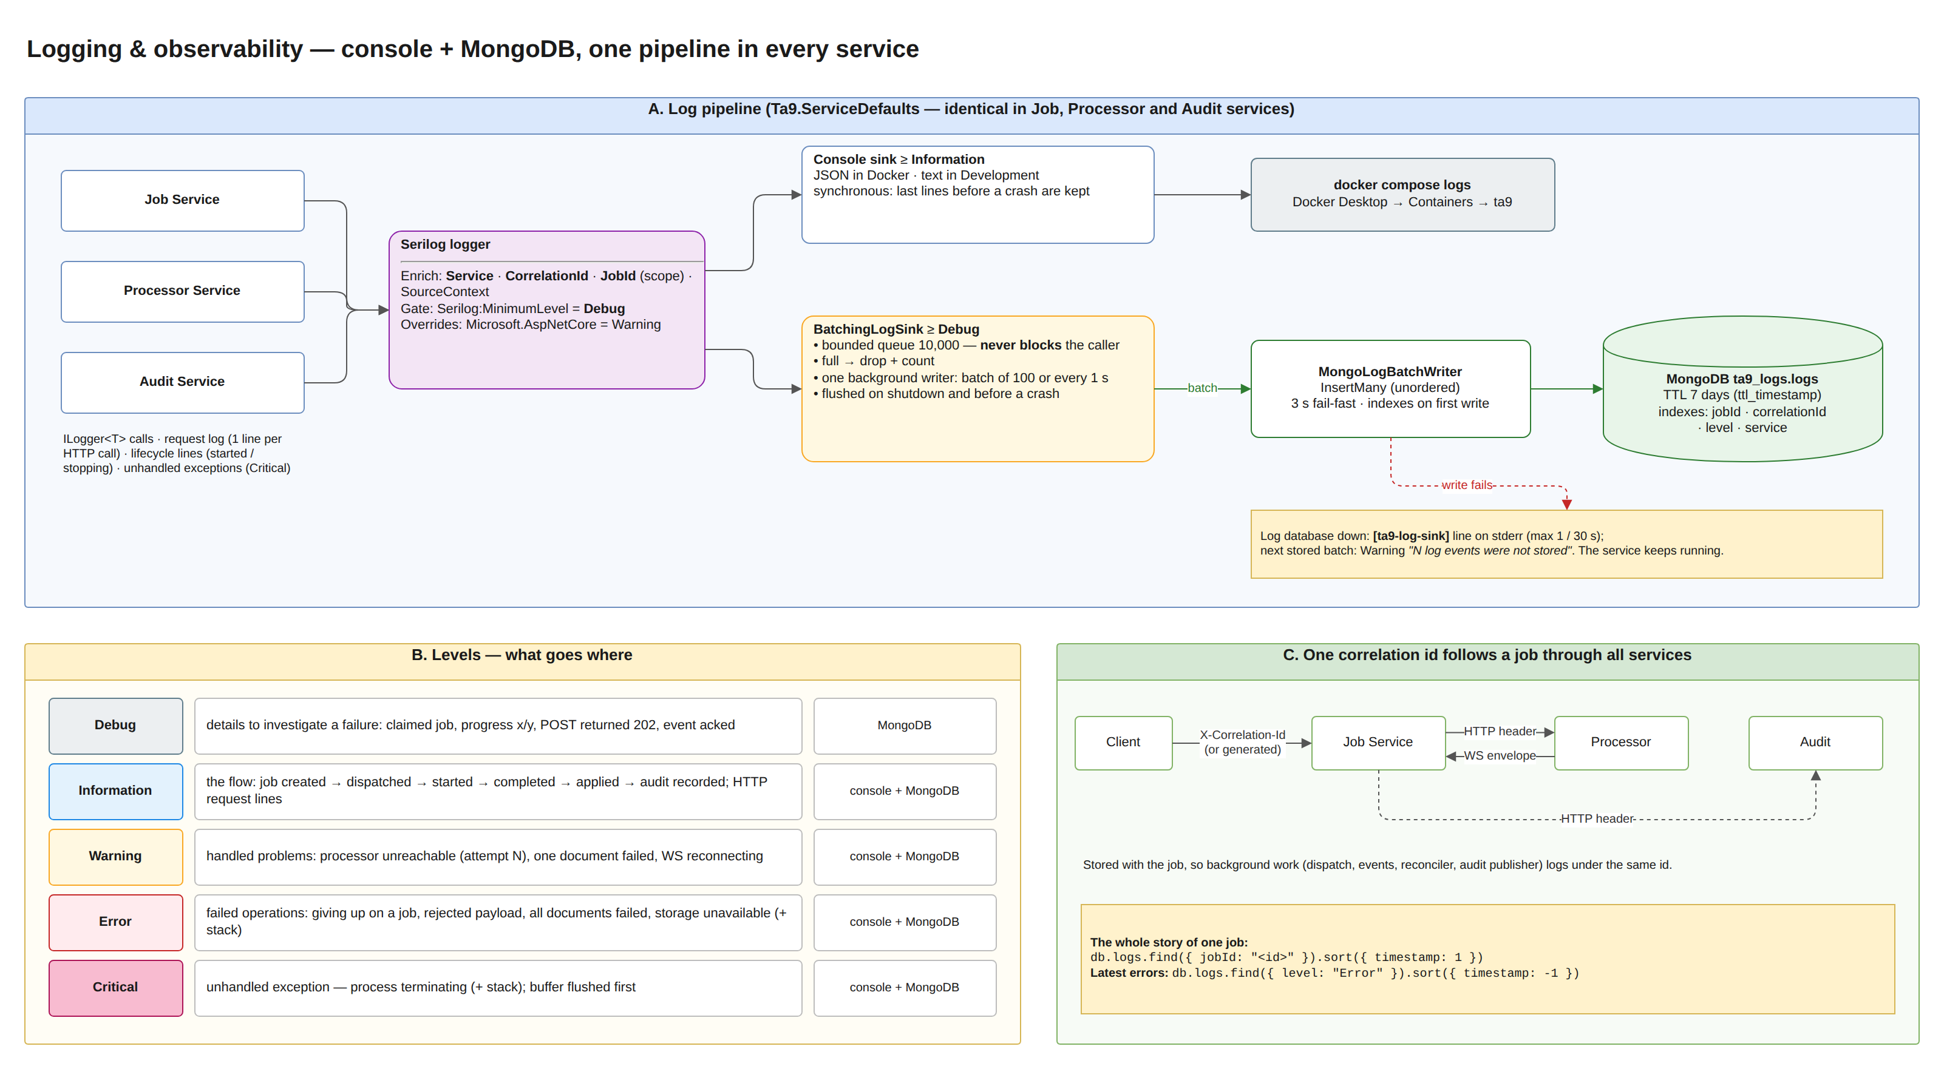
draw.io page 11. Logging*. Full description, alternatives, limitations and tests: ../logging/LOGGING.md. Where to look when something fails: Installation Guide §5. · editable source: docs/hld/diagrams/ta9-hld.drawio
One pipeline, two destinations. AddServiceDefaults configures Serilog identically in the three services:
Destination | Levels | Role | Properties
Console (docker compose logs) | Information and up | Live flow, warnings, errors | Synchronous: the last lines before a crash are always there. JSON in Docker
MongoDB ta9_logs.logs | Debug and up | History for investigating failures, searchable across services | BatchingLogSink: bounded queue (10,000), never blocks, batches of 100 / 1 s, drops counted and reported, flushed on shutdown and crash; 3 s fail-fast writer; 7-day TTL

Levels. Debug = detail (claims, HTTP results, progress, acks); Information = the job flow (created → dispatched → started → completed → applied → audited) and one line per HTTP request; Warning = handled problems (retry, one failed document, WS reconnect); Error = failed operations with the stack trace (giving up, rejected, storage down, all documents failed); Critical = unhandled exception, process terminating. Client errors (4xx) are not Errors.
Correlation. X-Correlation-Id (or a generated id) is stored with the job and restored by every background step. It travels in HTTP headers and in WebSocket envelopes, and a scope adds JobId to every line of job processing. One query, db.logs.find({ jobId }), shows a job's path through all three services.
Health and lifecycle. /health/live and /health/ready (MongoDB; the processor WebSocket link reports Degraded). At startup each service logs where its logs go and Service started … listening on …. Unhandled exceptions are logged as Critical.
Logging never hurts the service. If MongoDB is down, records are dropped and counted, [ta9-log-sink] lines go to stderr (at most one per 30 s), and the console keeps everything.
Next step: OpenTelemetry traces and metrics (queue depth, dispatch latency, outbox size), and a dedicated log platform fed by the console JSON.

9.5 Security (POC scope)
- No authentication, by assignment. Production would add JWT on the public API and mTLS or a shared secret between services.
- Input limits protect the services: 1,000 docs, 100 KB per document, 10 MB per body, 16 MB per WS message.
- Correlation ids are sanitized to prevent log injection.

10. Deployment
Deployment
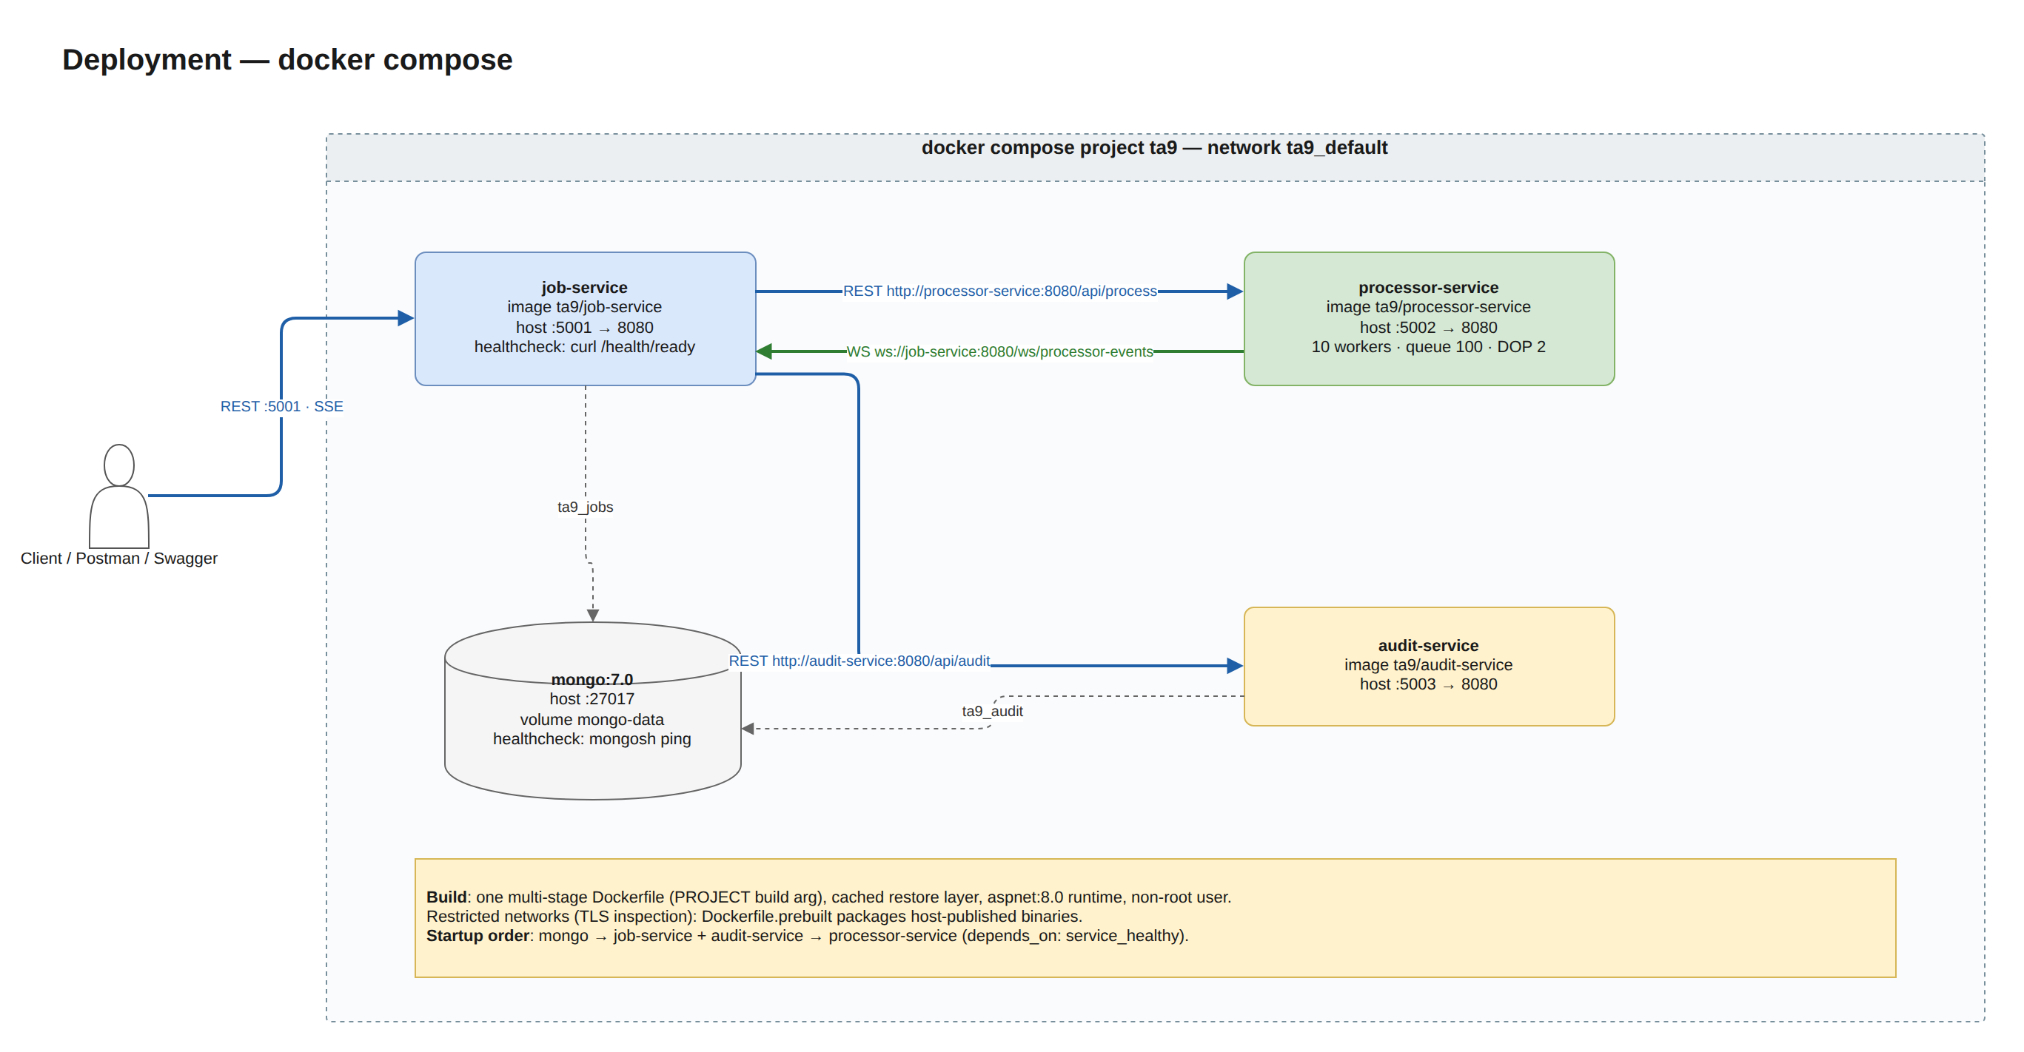
draw.io page 6. Deployment · editable source: docs/hld/diagrams/ta9-hld.drawio
- Images: one multi-stage Dockerfile (PROJECT build arg) with a cached restore layer, the aspnet:8.0 runtime and a non-root user. Dockerfile.prebuilt serves networks with TLS inspection.
- Health checks: curl /health/ready per service. Startup order: Mongo → Job + Audit → Processor.
- Configuration: environment variables override appsettings.json (e.g. Processing__MaxConcurrentJobs, Storage__Provider, Logging__Mongo__MinimumLevel).
- Logs: console → docker compose logs; all services → MongoDB ta9_logs.logs (Logging__Mongo__ConnectionString: mongodb://mongo:27017). Troubleshooting order: docker compose ps → docker compose logs → ta9_logs.logs → /health/ready (Installation Guide §5).

11. Risks, limitations and future work
Risk / limitation | Mitigation today | Future work
Processor state in memory | Reconciler redispatch (≤ ~60 s latency) | Durable broker
Per-instance SSE/WS fan-out | Single Job Service instance | Redis pub/sub
Large JobCompleted messages | 16 MB cap; ~0.5 MB for 1,000 docs | Pull results via REST, or chunk them
No auth / rate limiting | Out of scope | JWT, mTLS, rate limiter
A job deleted before its audit summary is published | Delete is allowed only for finished jobs | Publish before delete
Long processor outage | Jobs left untouched and rechecked | Maximum age before failing
Logs share the MongoDB server with the data | Console keeps everything; losses are counted and reported | Separate log platform, OpenTelemetry

