Concurrency & Performance
TA9 Real-Time Document Processing System
Assignment section | §4 Concurrency & Performance
Requirement | Handle at least 10 jobs concurrently, each with up to 1,000 documents. Avoid unbounded parallel work and avoid blocking threads unnecessarily. Explain the chosen strategy, why, and its limits and trade-offs
Chosen strategy | Bounded producer/consumer with two-level parallelism: a bounded queue with backpressure, a fixed worker pool, a fixed per-job document parallelism, async I/O everywhere; on the Job Service side, optimistic concurrency, atomic leases and bounded fan-out
Diagrams | draw.io pages 7. Concurrency — Processor and 8. Concurrency — Job Service in docs/hld/diagrams/ta9-hld.drawio

Contents
1. The requirement in numbers
2. The chosen method
2.1 Processor Service: where the work happens
2.2 Job Service: many writers, one consistent state
2.3 End-to-end backpressure
2.4 Configuration knobs
3. Why this method: advantages
4. Alternatives considered
5. Limitations and trade-offs
6. Possible improvements for production
7. Tests for this section
7.1 What is verified
7.2 Automated tests
7.3 Manual test

1. The requirement in numbers
Dimension | Required | Designed for (defaults)
Jobs processed at the same time | ≥ 10 | 10 (Processing:MaxConcurrentJobs)
Documents per job | up to 1,000 | up to 1,000 (validated; 400 above)
Jobs accepted while all workers are busy | — | 100 waiting (Processing:QueueCapacity), then 503 + Retry-After
Documents analyzed at the same time | bounded | ≤ 10 × 2 = 20 (MaxConcurrentJobs × DocParallelismPerJob)
Blocked threads while waiting | none | none: workers, HTTP, WebSocket and storage I/O are all async

2. The chosen method

2.1 Processor Service: where the work happens
Concurrency model — Processor Service
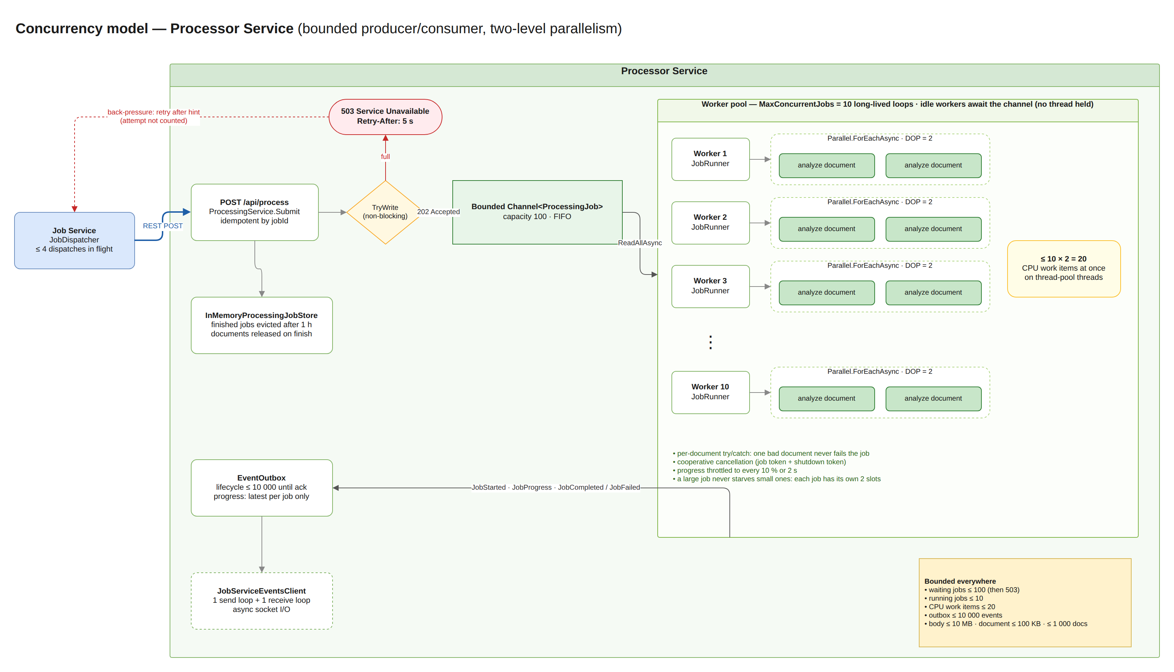
Source: docs/hld/diagrams/ta9-hld.drawio
The processor is a bounded producer/consumer pipeline with two independent limits.
- Admission (producer side). POST /api/process validates the request and calls Channel.Writer.TryWrite on a bounded Channel<ProcessingJob> with capacity 100. TryWrite never blocks. If the channel is full the request returns immediately with 503 Service Unavailable + Retry-After: 5, so overload is pushed back to the caller instead of piling up in memory. Submissions are idempotent by jobId: a retried dispatch returns the existing job (200) instead of queuing it twice.
- Job-level concurrency (consumer side). JobWorkerService starts MaxConcurrentJobs (10) long-lived worker loops. Each loop does await foreach (var job in channel.Reader.ReadAllAsync(...)). An idle worker is a suspended async state machine, not a thread, so 10 idle workers cost no threads at all.
- Document-level concurrency (inside a job). Each worker runs JobRunner, which processes the job's documents with Parallel.ForEachAsync and MaxDegreeOfParallelism = DocParallelismPerJob (2). The analysis itself (tokenize, count, SHA-256) is pure CPU work with no I/O, so it runs on thread-pool threads for a few milliseconds per document.
- The resulting bound: at most 10 jobs × 2 documents = 20 CPU work items run at any moment, whatever the number of submitted jobs or documents.
Surrounding guarantees:
- Failure isolation: each document is analyzed inside its own try/catch, so one failing document is reported as failed and never stops the job. A worker survives any exception thrown by a job.
- Cooperative cancellation: every job has a CancellationToken linked with the host's shutdown token. A cancel request or shutdown stops the job between documents without killing threads.
- Thread-safe job state: ProcessingJob transitions (TryStart, TryComplete, TryCancel, …) run under a short lock that is never held across I/O. The processed-documents counter uses Interlocked.
- Bounded memory: document content is released as soon as a job finishes, finished jobs are evicted after 1 hour, the event outbox holds at most 10,000 lifecycle events, and progress events are coalesced to the latest one per job.
- Throttled progress: progress is reported at most every 10% or every 2 seconds, so 1,000 documents produce about 10 progress events, not 1,000.

2.2 Job Service: many writers, one consistent state
Concurrency control — Job Service
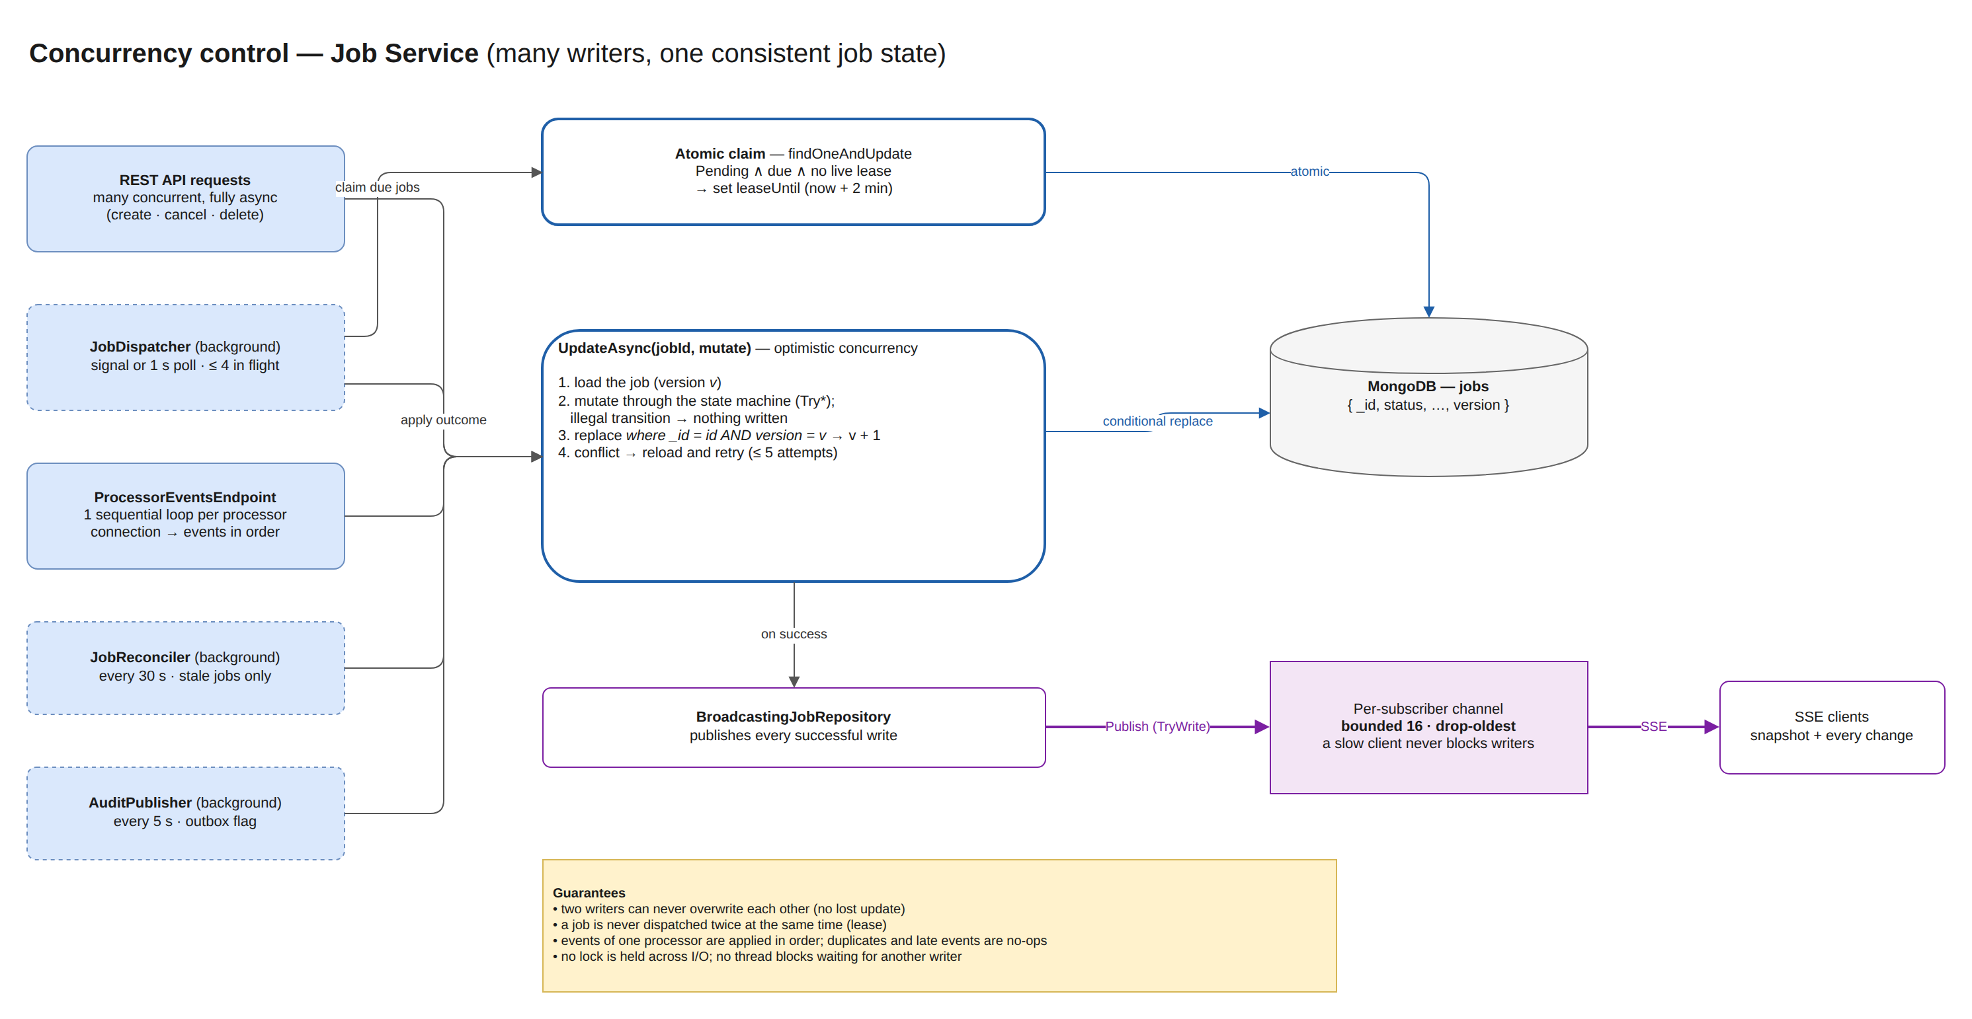
Source: docs/hld/diagrams/ta9-hld.drawio
The Job Service does little CPU work, but many components update the same job concurrently: API requests (cancel, delete), the dispatcher, the WebSocket event handler, the reconciler and the audit publisher. Its concurrency strategy is about correctness under concurrent writers and bounded fan-out.
Mechanism | What it does | Why
Optimistic concurrency (UpdateAsync) | Load the job (version v), mutate it through the state machine, replace it only if the stored version is still v; on conflict reload and retry (up to 5 times) | No lost updates, no locks held across I/O, works across processes and instances
Atomic claim with a lease | The dispatcher claims a due Pending job with one findOneAndUpdate, which sets leaseUntil (2 min) | A job is never dispatched twice at the same time, even with several dispatchers; a crashed dispatch is retried automatically when the lease expires
Bounded dispatch batches | At most MaxParallelDispatches (4) HTTP dispatches in flight; woken immediately by a signal when a job is created, otherwise polls every second | Bounded outbound load; low latency without busy polling
Sequential handling per WebSocket connection | Events from one processor are handled one at a time, in order, and acknowledged only after they are stored | Preserves the sender's order (Started → Progress → Completed) without locks
Persisted retry state | dispatchAttempts, nextDispatchAt and leaseUntil live in the job record | Retries never hold a thread waiting, and survive restarts
Bounded SSE fan-out | Each subscriber has its own channel of 16 snapshots, dropping the oldest when full | A slow client can never block writers or grow memory; it still receives the latest state
Async storage access, fail-fast | All MongoDB calls are async; server selection times out after 5 s | No request thread blocks on an unreachable database; clients get a fast 503

2.3 End-to-end backpressure
- The client gets 201 immediately; work continues in the background.
- The dispatcher sends ≤ 4 jobs at a time.
- When the processor's queue is full it answers 503 + Retry-After. The dispatcher reschedules the job for that time without counting a failed attempt, because this is load, not a fault.
- The processor keeps at most 100 waiting + 10 running jobs and 20 concurrent analyses.
- Results flow back over one WebSocket per processor, with at-least-once delivery and idempotent handling.
The system therefore slows down gracefully under overload instead of failing or exhausting memory.

2.4 Configuration knobs
Setting (environment variable) | Default | Effect
Processing__MaxConcurrentJobs | 10 | Jobs processed at the same time (worker loops)
Processing__DocParallelismPerJob | 2 | Documents analyzed in parallel inside one job
Processing__QueueCapacity | 100 | Jobs accepted while all workers are busy (then 503)
Processing__RetryAfterSeconds | 5 | Back-off hint returned with 503
Dispatch__MaxParallelDispatches | 4 | Concurrent dispatch requests from the Job Service
Dispatch__PollInterval | 1 s | Fallback poll when no new-job signal arrives
Dispatch__LeaseDuration | 2 min | How long a claimed job is invisible to other dispatchers

Sizing rule of thumb: keep MaxConcurrentJobs × DocParallelismPerJob close to the number of CPU cores of the processor host when the analysis dominates, and scale out by running more processor instances.

3. Why this method: advantages
# | Advantage | Explanation
A1 | Explicit, provable bounds | Every resource has a hard ceiling: waiting jobs (100), running jobs (10), CPU work items (20), outbox (10,000), request size (10 MB). Load can never create unbounded tasks, threads or memory. This is exactly the assignment's "avoid unbounded parallel work".
A2 | No blocked threads | Idle workers await the channel, admission uses non-blocking TryWrite, and all HTTP, WebSocket and MongoDB I/O is async. The only threads in use do actual CPU work. The thread pool stays healthy and API latency stays low under load.
A3 | Backpressure instead of collapse | A full queue returns 503 + Retry-After right away. The dispatcher honors it without counting a failure, so overload slows throughput but never fails jobs or exhausts memory.
A4 | Fairness between jobs | Each running job gets its own small parallelism slice, so a 1,000-document job cannot starve a 5-document job. With one global "all documents" pool, a single big job could monopolize every slot.
A5 | Right tool for CPU-bound work | Parallel.ForEachAsync with a fixed degree of parallelism is the idiomatic .NET way to run bounded CPU work: no manual thread management, cancellation built in.
A6 | Simple and standard | Built only on System.Threading.Channels and the TPL, both in-box. No extra framework (TPL Dataflow, Rx, actors), so the code is short, readable and easy to explain and test.
A7 | Tunable without code changes | All limits are configuration values and can be adapted per environment or host size.
A8 | Correct under concurrent writers | Optimistic concurrency plus atomic leases give consistency without locks or distributed locks, and the design already works with more than one Job Service instance at the storage level.
A9 | Testable | The bounds are asserted by tests: an analyzer that measures maximum concurrency verifies ≤ DOP per job (JobRunnerTests), ≤ jobs × DOP overall (JobWorkerServiceTests) and ≤ 20 in the full system with 10 × 1,000 documents (EndToEndTests).

4. Alternatives considered
Alternative | Why it was not chosen
Task.WhenAll over all documents of all jobs | Unbounded: 10 jobs × 1,000 documents = 10,000 concurrent tasks; thread-pool starvation and memory spikes. This is exactly what the assignment forbids.
Task.Run per job, no queue | Unbounded number of running jobs and no backpressure: memory grows with load, and overload turns into timeouts instead of a clear 503.
BlockingCollection + dedicated threads | Each idle consumer blocks a thread, and threads are expensive. Channels give the same producer/consumer semantics asynchronously.
One global SemaphoreSlim(Environment.ProcessorCount) for all documents | Caps CPU work exactly, but adds contention on one semaphore and loses fairness: the first big job can take every slot. It remains an option for a dedicated CPU-limited deployment (see §6).
TPL Dataflow (ActionBlock with BoundedCapacity) | Equivalent semantics, but an extra package and a heavier API for a two-stage pipeline. Channels + Parallel.ForEachAsync express the same bounds more explicitly.
PLINQ AsParallel() | Synchronous and blocking, and parallelism is harder to control and cancel per job.
Message broker (RabbitMQ/Kafka) + horizontal scale | The right next step at larger scale (durable queue, consumer groups), but explicitly out of scope for the assignment and unnecessary for 10 × 1,000.
Pessimistic locks / distributed locks on jobs | Locks held across I/O hurt throughput and need lock-expiry handling. Optimistic concurrency fits the workload: conflicts are rare and cheap to retry.

5. Limitations and trade-offs
# | Limitation | Impact | Mitigation
L1 | CPU oversubscription on small hosts | 20 parallel analyses on a 4-core machine means more runnable work than cores; each document takes slightly longer. Throughput is still correct and fair. | Set MaxConcurrentJobs × DocParallelismPerJob ≈ cores, or add a global CPU limiter (see §6).
L2 | In-memory queue in the processor | Waiting and running jobs are lost if the processor restarts. | The Job Service's reconciler detects the lost jobs (404) and redispatches them; analysis is deterministic, so redoing it is safe. Production would use a durable broker.
L3 | Memory ceiling is high in the worst case | Up to 100 waiting jobs × 10 MB of content is about 1 GB in the extreme case; typical jobs are far smaller. | Lower QueueCapacity, or keep only document references in the queue (fetch content when processing).
L4 | Fixed limits, not adaptive | The same limits apply whether the host is idle or busy with other work. | Expose metrics (queue depth, in-flight work) and tune, or implement adaptive concurrency.
L5 | Dispatch batches have head-of-line blocking | The dispatcher waits for a whole batch (≤ 4) before claiming more; one slow dispatch delays the next batch by up to the HTTP timeout. | Small batches and timeouts keep the effect bounded; a continuous semaphore-based pipeline would remove it.
L6 | Large completion messages | A JobCompleted event for 1,000 documents is about 0.5 MB on the WebSocket (16 MB cap). | Fine for the target size; for bigger jobs stream results or fetch them via REST.
L7 | Per-instance SSE fan-out | Subscribers only see updates written by the same Job Service instance. | Single instance by design; multi-instance needs Redis pub/sub or a broker.
L8 | Performance verified functionally, not benchmarked | Tests prove completion, exactly-once analysis and the concurrency bound, but there is no automated latency/throughput threshold. | scripts/smoke-test.ps1 -Jobs 10 -Documents 1000 measures elapsed time manually; production would add load tests and SLO alerts.

6. Possible improvements for production
- Global CPU limiter (SemaphoreSlim(ProcessorCount)) shared by all jobs, keeping fairness with a small per-job cap.
- Durable queue (RabbitMQ/Kafka) and several processor instances (competing consumers) instead of REST dispatch + in-memory channel.
- Metrics: queue depth, running jobs, in-flight analyses, 503 rate, dispatch latency, outbox size (OpenTelemetry).
- Adaptive concurrency driven by CPU usage or latency.
- Streaming results (or REST pull) for very large jobs, and content by reference instead of inline.
- Continuous dispatch pipeline (semaphore instead of batches) to remove head-of-line blocking.

7. Tests for this section
The complete catalog of the system's tests, with strategy, environment, traceability and results, is the Software Test Description (STD) — docs/testing/TA9-STD.docx (Markdown: docs/testing/STD.md). This chapter lists only the tests that verify §4 Concurrency & Performance. The STD ID column is the identifier of the same test case in the STD, so each test can be looked up there; Theory ×N runs N data rows, ×2 stores runs against InMemory and MongoDB.

7.1 What is verified
Claim in this document | Verified by (STD IDs below)
Documents of one job never exceed DocParallelismPerJob | JobRunnerTests.Never_exceeds_document_parallelism
Total concurrent analyses never exceed MaxConcurrentJobs × DocParallelismPerJob | JobWorkerServiceTests.Processes_many_jobs_with_bounded_total_concurrency; E2E with 10 × 1,000 documents (≤ 20)
The queue is bounded; overload returns 503 + Retry-After and is honored without counting a failure | ChannelJobQueueTests, ProcessingServiceTests, ProcessApiTests, HttpProcessorClientTests, JobDispatcherTests.Busy_processor…
No lost updates between concurrent writers; a job is never dispatched twice at once | JobRepositoryContract (InMemory + MongoDB), JobRepositoryExtensionsTests
Failures, cancellation and shutdown never break the worker pool | JobRunnerTests, JobWorkerServiceTests, ProcessingJobTests
Slow consumers never block producers; per-connection ordering | InMemoryJobUpdateBroadcasterTests, ProcessorEventsEndpointTests
The assignment scenario: 10 concurrent jobs × 1,000 documents | E2E test below and manual MT-03

7.2 Automated tests
STD ID | Test case | Test class | Level | Kind
PS-032 | Never exceeds document parallelism | JobRunnerTests | Unit | Theory ×2
PS-033 | Publishes throttled progress | JobRunnerTests | Unit | Fact
PS-027 | Isolates a failing document | JobRunnerTests | Unit | Fact
PS-030 | Stops when cancelled mid run without reporting completion | JobRunnerTests | Unit | Fact
PS-031 | Abandons job silently on shutdown | JobRunnerTests | Unit | Fact
PS-034 | Processes many jobs with bounded total concurrency | JobWorkerServiceTests | Unit | Fact
PS-035 | A crashing job does not kill the worker | JobWorkerServiceTests | Unit | Fact
PS-036 | Stops cleanly | JobWorkerServiceTests | Unit | Fact
PS-066 | Rejects when capacity is reached | ChannelJobQueueTests | Unit | Fact
PS-067 | Delivers jobs in fifo order and frees capacity | ChannelJobQueueTests | Unit | Fact
PS-058 | Rejects when queue is full and forgets the job | ProcessingServiceTests | Unit | Fact
PS-057 | Resubmitting the same job id is idempotent | ProcessingServiceTests | Unit | Fact
PS-062 | Reports every ten percent but not at completion | ProgressThrottleTests | Unit | Fact
PS-063 | Reports when the interval elapses between steps | ProgressThrottleTests | Unit | Fact
PS-065 | Out of order counts do not produce duplicate reports | ProgressThrottleTests | Unit | Fact
PS-052 | Cancel moves to cancelled and signals the token | ProcessingJobTests | Unit | Fact
PS-053 | Completion after cancel is ignored | ProcessingJobTests | Unit | Fact
PS-051 | Completes only from processing and releases documents | ProcessingJobTests | Unit | Fact
PS-069 | Removes only finished jobs older than cutoff | InMemoryProcessingJobStoreTests | Unit | Fact
PS-099 | Post returns 503 with retry after when queue is full | ProcessApiTests | Component | Fact
PS-095 | Post same job twice returns 200 the second time | ProcessApiTests | Component | Fact
PS-100 | Delete cancels a running job | ProcessApiTests | Component | Fact
JS-017 | Submit 503 is busy with the retry after hint | HttpProcessorClientTests | Unit | Fact
JS-056 | Busy processor delays the job without consuming an attempt | JobDispatcherTests | Unit | Fact
JS-061 | Dispatches in bounded parallel batches | JobDispatcherTests | Unit | Fact
JS-060 | A crashed dispatch is retried after the lease expires | JobDispatcherTests | Unit | Fact
JS-062 | Background loop dispatches new jobs when signalled | JobDispatcherTests | Unit | Fact
JS-037 | Concurrent updates never lose a write | JobRepositoryContract | Contract (InMemory + MongoDB) | Fact · ×2 stores
JS-035 | Update with a stale version is rejected | JobRepositoryContract | Contract (InMemory + MongoDB) | Fact · ×2 stores
JS-042 | Concurrent claims never hand out the same job twice | JobRepositoryContract | Contract (InMemory + MongoDB) | Fact · ×2 stores
JS-039 | Claim leases the due pending job until the lease expires | JobRepositoryContract | Contract (InMemory + MongoDB) | Fact · ×2 stores
JS-084 | Reloads and retries on conflict | JobRepositoryExtensionsTests | Unit | Fact
JS-085 | Gives up after max attempts | JobRepositoryExtensionsTests | Unit | Fact
JS-140 | Events are processed in order per connection | ProcessorEventsEndpointTests | Component | Fact
JS-091 | Slow subscriber keeps the latest snapshots and never blocks the publisher | InMemoryJobUpdateBroadcasterTests | Unit | Fact
E2E-002 | Ten concurrent jobs of 1000 documents complete with bounded parallelism | EndToEndTests | Integration (E2E) | Fact

7.3 Manual test
STD ID | Procedure | Expected result | Status
MT-03 | powershell -ExecutionPolicy Bypass -File .\scripts\smoke-test.ps1 -Jobs 10 -Documents 1000 against the Docker Desktop stack | All 10 jobs Completed, 1,000 / 1,000 documents succeeded each | Passed (2026-10-26)

All automated tests listed here passed in the latest full run (404 / 404).

