WebSocket Disconnect / Reconnect Behavior
TA9 Real-Time Document Processing System
Assignment sections | §3.3 WebSocket Events · §5 Reliability ("For WebSocket disconnections and duplicate events, choose a sensible behavior and document it") · §8 README item "WebSocket disconnect/reconnect behavior"
Link | Processor Service (WebSocket client) → Job Service endpoint ws://<job-service>/ws/processor-events (WebSocket server)
Chosen behavior | At-least-once delivery of lifecycle events (bounded outbox + acknowledgements + automatic reconnect with exponential backoff and jitter) combined with idempotent handling on the receiver, plus a reconciler as a safety net. Progress events are best effort
Diagrams | draw.io pages 9. WebSocket — Connection & Outbox and 5c. Sequence — WebSocket Reconnect in docs/hld/diagrams/ta9-hld.drawio

Contents
1. Context
2. What we implemented
2.1 Processor side: connection management (JobServiceEventsClient)
2.2 Processor side: what is kept and resent (EventOutbox)
2.3 Job Service side: receiving and acknowledging (ProcessorEventsEndpoint)
2.4 Duplicates and ordering: idempotent handling (ProcessorEventHandler)
2.5 Safety net: the reconciler
2.6 Scenario walkthrough
3. Why this approach
3.1 Advantages
3.2 Alternatives considered
4. Limitations
5. Tests for this section
5.1 What is verified
5.2 Automated tests
5.3 Manual test (Docker Desktop) — STD MT-07
6. Configuration

1. Context
The processor reports each job's lifecycle to the Job Service over one persistent WebSocket connection:
Event | Payload | Importance
JobStarted | total documents | lifecycle: must arrive
JobProgress | processed / total documents | informational: may be skipped
JobCompleted | summary + results of every document | lifecycle: must arrive
JobFailed | error code + reason | lifecycle: must arrive
JobCancelled | — | lifecycle: must arrive

Every message is a JSON envelope { schemaVersion, eventId, type, jobId, occurredAt, correlationId, payload }. The Job Service answers each handled event with { "type": "Ack", "eventId": "…" }.
A WebSocket can break at any time: network failure, Job Service restart or deployment, processor restart, or a proxy closing idle connections. A successful SendAsync only means the bytes reached the local TCP buffer; it proves nothing about whether the Job Service received or stored the event. The design must therefore answer three questions: what is resent, when, and what happens when something arrives twice.

2. What we implemented
WebSocket link — connection, outbox and receiver behavior
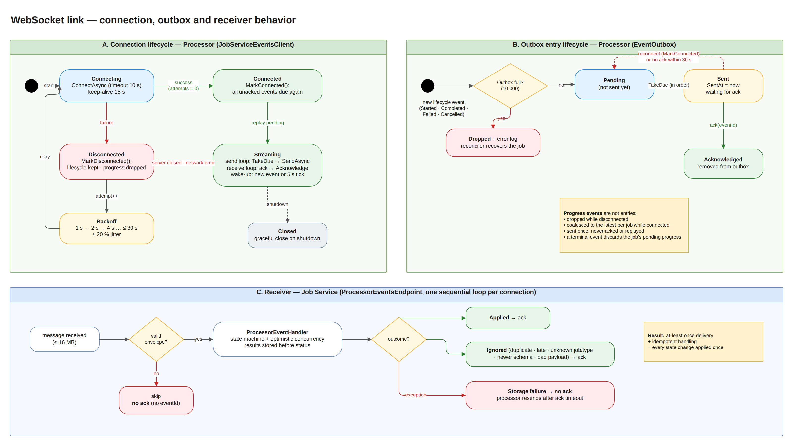
Source: docs/hld/diagrams/ta9-hld.drawio

2.1 Processor side: connection management (JobServiceEventsClient)
A background service keeps exactly one connection open and repairs it when it breaks (diagram part A).
Behavior | Detail
Connect | ClientWebSocket.ConnectAsync with a 10 s timeout; header X-Processor-Id identifies the instance in the Job Service logs
Keep-alive | WebSocket ping every 15 s on both sides, so idle connections are not silently dropped by proxies and dead peers are detected
Two loops per connection | one send loop (the only writer: WebSocket allows one concurrent send) and one receive loop that reads acks. Whichever stops first ends the connection; the other is cancelled, the socket is closed gracefully and then aborted, so no loop can hang
Wake-up | the send loop sleeps until a new event is added to the outbox, or every 5 s to resend events whose ack timed out. No busy polling
Reconnect | on any failure: exponential backoff 1 s → 2 s → 4 s … capped at 30 s, ±20% jitter. The attempt counter resets after a successful connect. The jitter keeps many processors from reconnecting in lockstep (thundering herd)
On (re)connect | MarkConnected() makes every unacknowledged lifecycle event due again: they are replayed in their original order before new events
On disconnect | MarkDisconnected() keeps lifecycle events and drops pending progress (stale by the time the link is back)
Health | /health/ready reports Degraded (HTTP 200) while disconnected: the processor keeps accepting and processing work, and its events are buffered
Shutdown | graceful close of the socket; the background service stops promptly

2.2 Processor side: what is kept and resent (EventOutbox)
Diagram part B.
Event kind | Behavior
Lifecycle (JobStarted, JobCompleted, JobFailed, JobCancelled) | Added to an ordered, bounded outbox (10,000 events). States: Pending → Sent → Acknowledged (removed). A Sent event becomes Pending again on reconnect, or when no ack arrives within 30 s (ack timeout), even without a disconnect
Progress (JobProgress) | Never stored for retry: coalesced to the latest value per job, dropped while disconnected, sent once, never acknowledged. A terminal event discards the job's pending progress
Outbox full | The new lifecycle event is dropped with an error log; the publisher never blocks or throws. The Job Service reconciler recovers the job's state (§2.5)

2.3 Job Service side: receiving and acknowledging (ProcessorEventsEndpoint)
Diagram part C.
Behavior | Detail
One sequential loop per connection | events of one processor are handled one at a time, in the order they were sent, with no locks
Ack after handling | the ack is sent only after the event has been persisted, or deliberately ignored. This is what makes the processor's outbox meaningful
Ignored events are acked too | duplicates, late events, unknown jobs, unknown event types, newer schema versions and malformed payloads can never change state; acking them stops useless resends
Storage failure → no ack | if MongoDB is unavailable the handler throws and the event is not acknowledged; the processor resends it after the ack timeout. The connection stays open
Unreadable message | no eventId to acknowledge → skipped; the connection keeps working
Protection | messages above 16 MB close the connection (MessageTooBig); a JobCompleted for 1,000 documents is about 0.5 MB
Shutdown / client gone | the loop ends on the request-aborted or application-stopping token; the processor reconnects to the next instance

2.4 Duplicates and ordering: idempotent handling (ProcessorEventHandler)
At-least-once delivery means an event can arrive more than once, for example when the ack was lost or the ack timeout fired while the event was being stored. Every event is therefore safe to apply twice:
Mechanism | Effect
Job state machine | only legal transitions are applied: JobStarted after Completed and anything after Cancelled are no-ops
Monotonic progress | processedDocuments = max(current, incoming): an older progress value never moves it backwards
Idempotent results | results are upserted by (jobId, index); a replayed JobCompleted finds the job already terminal and changes nothing
Optimistic concurrency | every write checks the job version, so a replay racing with the dispatcher, reconciler or a cancel can never overwrite a newer state
Pending race | an event for a job still Pending (the processor finished before the dispatcher recorded its 202) first moves it to Queued, then applies
Schema version | an envelope with a newer schemaVersion is acked and ignored (forward compatible)

Result: at-least-once delivery + idempotent handling = every state change is applied exactly once.

2.5 Safety net: the reconciler
The outbox lives in the processor's memory. It cannot survive a processor crash, and it can overflow during a very long outage. The Job Service's reconciler covers both cases. Every 30 s it looks for Queued / Processing jobs with no update for 60 s and asks the processor via GET /api/process/{id}:
- Still running: refresh progress and liveness.
- Finished: apply the result through the same handler.
- Unknown (404, processor restarted): move the job back to Pending and redispatch it (at most 3 times, then Failed).
Lost lifecycle events are therefore recovered within about 60–90 s.

2.6 Scenario walkthrough
Scenario | What happens | Outcome
Short network drop | Processor detects the closed socket, backs off 1 s, reconnects, replays unacked events | No event lost; duplicates ignored
Job Service restart / redeploy | Same as above; the reconnect delay grows up to 30 s while the service is down; processing continues and events accumulate in the outbox | Everything is delivered after restart
Ack lost (event stored, ack not received) | Event is resent on reconnect or after 30 s; handler recognizes it as a duplicate and acks | State unchanged, outbox cleared
MongoDB down while events arrive | Handler throws, no ack; processor resends every 30 s | Applied as soon as MongoDB is back
Processor crash | Outbox and in-flight work are lost; reconciler finds the job missing (404) and redispatches it | Job completes on the restarted processor
Very long outage (outbox full) | New lifecycle events are dropped and logged; the reconciler later pulls each job's status | Jobs converge to the processor's state
Malformed message | Skipped (no eventId) or acked and ignored (bad payload) | Connection keeps working
Out-of-order delivery (e.g. replay after a newer event) | State machine and monotonic progress reject regressions | No state goes backwards

Sequence — WebSocket disconnect, reconnect and replay
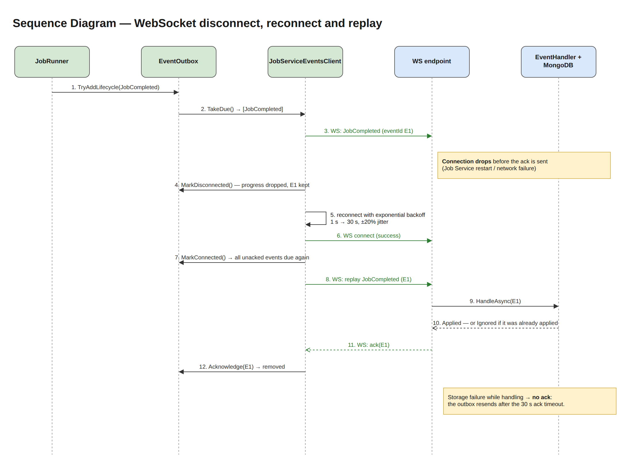
Source: docs/hld/diagrams/ta9-hld.drawio

3. Why this approach

3.1 Advantages
# | Advantage | Explanation
A1 | No lost lifecycle events across disconnects | Acks tell the processor exactly what the Job Service stored; everything else is resent. TCP success alone could not provide this.
A2 | Duplicates are harmless by construction | Idempotency comes from the job state itself (state machine, monotonic progress, upserts, versioning), so no deduplication table or sequence store is needed.
A3 | Survives restarts on either side | Job Service restart → replay from the outbox; processor restart → reconciler. Neither requires manual intervention.
A4 | Ordered, lock-free handling | One sequential loop per connection preserves the sender's order without locking.
A5 | Bounded resources | The outbox is bounded (10,000), progress is coalesced per job, messages are capped at 16 MB, and reconnect delay is capped at 30 s. A long outage cannot exhaust memory or flood the network.
A6 | Graceful degradation | While disconnected the processor keeps working and reports Degraded rather than Unhealthy, so orchestration does not kill or stop routing to a healthy worker.
A7 | No reconnect storms | Exponential backoff with jitter spreads reconnects of many processors.
A8 | Correct under storage outages | "No ack on failure" turns a MongoDB outage into a delay, never into data loss.
A9 | Forward compatible | The schema version in the envelope lets a newer processor talk to an older Job Service without breaking it.
A10 | Simple, dependency-free, testable | Plain ClientWebSocket / ASP.NET Core WebSockets and a small outbox class. Every rule is covered by unit tests and real-WebSocket tests (§5).

3.2 Alternatives considered
Alternative | Why not
Fire-and-forget (send, no ack, no resend) | Events sent just before a disconnect are silently lost; jobs would stay Processing until a timeout.
Reconnect only, rely on the reconciler | Correct but slow: every disconnect would delay status updates by 60–90 s. The outbox makes the common case immediate; the reconciler stays as the rare-case net.
Durable outbox in the processor (database) | Survives processor crashes, but adds a database to a stateless worker and a second source of truth. The reconciler already covers crashes.
Deduplication table by eventId | Extra storage and cleanup; unnecessary because handlers are idempotent by design.
Per-job sequence numbers | Strict ordering per job, but adds sequence tracking on both sides; monotonic progress and the state machine already reject regressions.
SignalR | Automatic reconnect, but no delivery guarantee for messages sent while disconnected, plus an extra protocol and dependency. Acks and replay would still be needed.
Message broker (RabbitMQ/Kafka) | Durable, ordered delivery: the right choice at scale, but explicitly out of scope, and the assignment asks for WebSocket communication.
HTTP callbacks instead of WebSocket | Simpler retries, but one request per event and no persistent channel, which goes against the assignment's WebSocket requirement.

4. Limitations
# | Limitation | Impact | Mitigation / next step
L1 | Outbox is in memory | A processor crash loses its unacknowledged events | Reconciler recovers within ~60–90 s; a durable outbox or broker removes the gap
L2 | Bounded outbox drops when full | After ~10,000 unacked lifecycle events (a very long outage) new events are dropped | Logged as errors; reconciler recovers; capacity is configurable
L3 | Duplicates do reach the receiver | Extra handler work and log lines on replays | Handlers are idempotent; cost is a version check per duplicate
L4 | Progress may be skipped | Clients can miss intermediate progress values during a disconnect | By design: the next progress or the terminal event carries the latest state
L5 | Up to ~30 s added latency after an ack loss | An event whose ack was lost is resent only on reconnect or after the 30 s ack timeout | Ack timeout is configurable; normal operation is unaffected
L6 | One connection per processor, one Job Service instance | All events of a processor flow through one socket into one instance | Multi-instance Job Service would need a load balancer with any-instance handling (already idempotent) or a broker
L7 | No authentication on the WebSocket | Any client that can reach the endpoint could send events | Out of scope by assignment; production: mTLS or a signed token on connect
L8 | Large completion messages | ~0.5 MB per 1,000-document JobCompleted; a replay resends the whole payload | Fine at this scale; for larger jobs send a summary and let the Job Service pull results via REST

5. Tests for this section
The complete catalog of the system's tests, with strategy, environment, traceability and results, is the Software Test Description (STD) — docs/testing/TA9-STD.docx (Markdown: docs/testing/STD.md). This chapter lists only the tests that verify the WebSocket disconnect / reconnect and duplicate-event behavior (§3.3 and §5 of the assignment). The STD ID column is the identifier of the same test case in the STD, so each test can be looked up there; Theory ×N runs N data rows, ×2 stores runs against InMemory and MongoDB. Tests of the other §5 scenarios (invalid input, processor unreachable, storage outage) are traced in the STD under requirements R8, R9 and R14.

5.1 What is verified
Behavior described in this document | Verified by
Lifecycle events are kept until acked, resent after reconnect or ack timeout; progress coalesced/dropped | EventOutboxTests, WebSocketJobEventPublisherTests
Real reconnect over a WebSocket: buffering while unreachable, replay after a drop, resend on ack timeout | JobServiceEventsClientTests (real WebSocket against a fake Job Service)
Reconnect backoff grows exponentially with jitter | ExponentialBackoffTests
The wire contract (envelope, enums, ack) is stable | ProcessorEventSerializerTests
Ack only after handling; duplicates and unknown jobs acked; storage failure not acked; order per connection | ProcessorEventsEndpointTests (real WebSocket against the endpoint)
Duplicates, replays and out-of-order events never change state twice or move it backwards | ProcessorEventHandlerTests
Events lost despite the outbox are recovered by the reconciler | JobReconcilerTests
End to end, including a processor that dies mid-job and a new instance that reconnects | EndToEndTests

5.2 Automated tests
STD ID | Test case | Test class | Level | Kind
PS-078 | Rejects lifecycle events beyond capacity | EventOutboxTests | Unit | Fact
PS-079 | Takes unsent events in order only once | EventOutboxTests | Unit | Fact
PS-080 | Resends events whose ack timed out | EventOutboxTests | Unit | Fact
PS-081 | Acknowledge removes the event | EventOutboxTests | Unit | Fact
PS-082 | Reconnect makes unacknowledged events due again | EventOutboxTests | Unit | Fact
PS-083 | Lifecycle events are buffered while disconnected | EventOutboxTests | Unit | Fact
PS-084 | Progress is dropped while disconnected | EventOutboxTests | Unit | Fact
PS-085 | Progress is coalesced to the latest per job and not kept for ack | EventOutboxTests | Unit | Fact
PS-086 | Terminal event discards pending progress of the job | EventOutboxTests | Unit | Fact
PS-087 | Disconnect discards pending progress | EventOutboxTests | Unit | Fact
PS-088 | Wait for work completes when an event is added | EventOutboxTests | Unit | Fact
PS-089 | Delivers events in order and clears outbox on ack | JobServiceEventsClientTests | Component | Fact
PS-090 | Buffers events until the job service becomes reachable | JobServiceEventsClientTests | Component | Fact
PS-091 | Replays unacknowledged events after reconnect | JobServiceEventsClientTests | Component | Fact
PS-092 | Resends when ack times out without reconnect | JobServiceEventsClientTests | Component | Fact
PS-093 | Sends progress while connected without waiting for ack | JobServiceEventsClientTests | Component | Fact
SD-012 | Grows exponentially up to the cap with jitter | ExponentialBackoffTests | Unit | Theory ×6
SD-013 | Jitter spreads retries | ExponentialBackoffTests | Unit | Fact
PS-070 | Envelope round trips with typed payload | ProcessorEventSerializerTests | Unit | Fact
PS-071 | Uses camel case and string enums on the wire | ProcessorEventSerializerTests | Unit | Fact
PS-072 | Ack round trips | ProcessorEventSerializerTests | Unit | Fact
PS-073 | Non ack messages are ignored | ProcessorEventSerializerTests | Unit | Theory ×3
PS-074 | Lifecycle events are queued with job metadata | WebSocketJobEventPublisherTests | Unit | Fact
PS-075 | Completed event carries summary and results | WebSocketJobEventPublisherTests | Unit | Fact
PS-076 | Progress is dropped while disconnected | WebSocketJobEventPublisherTests | Unit | Fact
PS-077 | Full outbox does not throw | WebSocketJobEventPublisherTests | Unit | Fact
JS-137 | Handled events are acknowledged and applied | ProcessorEventsEndpointTests | Component | Fact
JS-138 | Duplicates and unknown jobs are acknowledged too | ProcessorEventsEndpointTests | Component | Fact
JS-139 | Unreadable message is skipped and the connection keeps working | ProcessorEventsEndpointTests | Component | Fact
JS-140 | Events are processed in order per connection | ProcessorEventsEndpointTests | Component | Fact
JS-141 | Plain http request is rejected | ProcessorEventsEndpointTests | Component | Fact
JS-142 | Event that cannot be stored is not acknowledged | ProcessorEventsEndpointTests | Component | Fact
JS-095 | Started moves a queued job to processing | ProcessorEventHandlerTests | Unit | Fact
JS-096 | Events arriving before the dispatcher recorded the 202 still apply | ProcessorEventHandlerTests | Unit | Fact
JS-097 | Progress is recorded and never goes backwards | ProcessorEventHandlerTests | Unit | Fact
JS-098 | Completed stores results then completes the job | ProcessorEventHandlerTests | Unit | Fact
JS-099 | Replayed completion is ignored | ProcessorEventHandlerTests | Unit | Fact
JS-100 | Late completion of a cancelled job is ignored and stores no results | ProcessorEventHandlerTests | Unit | Fact
JS-101 | Out of order started after completed is ignored | ProcessorEventHandlerTests | Unit | Fact
JS-102 | Failed records code and reason | ProcessorEventHandlerTests | Unit | Fact
JS-103 | Unknown job is ignored | ProcessorEventHandlerTests | Unit | Fact
JS-104 | Unknown event type is ignored | ProcessorEventHandlerTests | Unit | Fact
JS-105 | Newer schema version is ignored | ProcessorEventHandlerTests | Unit | Fact
JS-106 | Malformed payload is ignored not retried | ProcessorEventHandlerTests | Unit | Fact
JS-107 | Storage failure propagates so the event is not acknowledged | ProcessorEventHandlerTests | Unit | Fact
JS-074 | Lost completion event is recovered with results | JobReconcilerTests | Unit | Fact
JS-075 | Lost failure event is recovered | JobReconcilerTests | Unit | Fact
JS-076 | Job lost by a restarted processor is redispatched | JobReconcilerTests | Unit | Fact
JS-077 | Job lost too many times fails | JobReconcilerTests | Unit | Fact
JS-079 | Event arriving during reconciliation wins over redispatch | JobReconcilerTests | Unit | Fact
E2E-001 | Job flows through processor websocket and audit | EndToEndTests | Integration (E2E) | Fact
E2E-004 | Job lost by a processor restart is redispatched and completes | EndToEndTests | Integration (E2E) | Fact

All automated tests listed here passed in the latest full run (404 / 404).

5.3 Manual test (Docker Desktop) — STD MT-07
Step | Command | Expected
1 | Start the stack: docker compose up -d (or scripts/docker-up-prebuilt.ps1) | All containers healthy
2 | Start a long run: powershell -ExecutionPolicy Bypass -File .\scripts\smoke-test.ps1 -Jobs 10 -Documents 1000 | Jobs start processing
3 | docker compose restart job-service while jobs run | —
4 | docker compose logs -f processor-service | Job Service events connection failed (attempt N) with growing delays, then Connected to Job Service events endpoint … N events pending
5 | GET /api/jobs?status=Completed | Every job Completed; nothing lost
6 | curl.exe http://localhost:5002/health/ready during step 3 | Degraded while disconnected, Healthy after reconnect

Status in the STD: Not yet executed.

6. Configuration
Setting (environment variable) | Default | Meaning
JobServiceEvents__Url | ws://localhost:5001/ws/processor-events | Job Service WebSocket endpoint
JobServiceEvents__OutboxCapacity | 10000 | Max lifecycle events waiting for an ack
JobServiceEvents__AckTimeout | 00:00:30 | Resend a sent event if no ack arrives in this time
JobServiceEvents__ResendCheckInterval | 00:00:05 | How often the send loop wakes up to check ack timeouts
JobServiceEvents__ReconnectInitialDelay | 00:00:01 | First reconnect delay
JobServiceEvents__ReconnectMaxDelay | 00:00:30 | Reconnect delay cap
JobServiceEvents__ConnectTimeout | 00:00:10 | Connect attempt timeout
JobServiceEvents__KeepAliveInterval | 00:00:15 | Client ping interval (the server also pings every 15 s)
Reconcile__StaleAfter / Reconcile__Interval | 60 s / 30 s | Safety net for events lost despite the outbox

