CCT College Dublin

Assessment Cover Page

Module Title: | Advanced Data Analytics  Big Data Storage and Processing
Assessment Title: | MSC_DA_BD_ADAv6
Lecturer Name: | David McQuaid  Muhammad Iqbal
Student Full Name: | Orla Kavanagh
Student Number: | sba24195
Assessment Due Date: | 23/05/2025
Date of Submission: | 19/05/2025

Declaration

By submitting this assessment, I confirm that I have read the CCT policy on Academic Misconduct and understand the implications of submitting work that is not my own or does not appropriately reference material taken from a third party or other source. I declare it to be my own work and that all material from third parties has been appropriately referenced. I further confirm that this work has not previously been submitted for assessment by myself or someone else in CCT College Dublin or any other higher education institution.

Index
1. Introduction 2
2. Data Sources and Preprocessing 2
2.1 Twitter Dataset 2
2.2 Stock Price Dataset 3
3. Sentiment Analysis Methodology 3
4. Exploratory Data Analysis (EDA) 3
5. Feature Engineering 4
6. Forecasting Models and Tuning 4
6.1 ARIMA and ARIMAX Models 4
6.2 LSTM Neural Networks 5
6.4 XGBoost Regressor 6
7. Dashboard Design 6
8. Big Data Processing Environment 7
9. NSQL/SQL Performance Benchmarking 8
9.2 Benchmark Results Summary 9
10. Big Data Architecture & System Design 9
10.2 Batch Processing Pipeline (Forecasting Workflow) 10
10.3 Real-Time Analytics Pipeline (Reddit) 10
11. Real-Time Analytics Use Case 11
12. Results and Discussion 11
12.1 Forecast Accuracy and RMSE Comparison 11
12.2 Sentiment Analysis Impact 12
13. Conclusion 12
References 13
Appendices 16

Introduction
This research explores the use of big data technologies and data analytics in the field of financial forecasting using stock price data and social media sentiment for the year 2020. It integrates two basic elements: Big Data Engineering (BD) and Advanced Data Analytics (ADA).
The ADA part involves Twitter data sentiment analysis, exploratory data analysis (EDA), and time series prediction with ARIMA, ARIMAX, LSTM, and XGBoost models on 1-day, 3-day, and 7-day horizons.
The BD part simulates real-time streaming through the API of Reddit, processed in batches using Apache Spark and persisted using MongoDB and Hadoop HDFS. I also compared the performance of YCSB between NoSQL (MongoDB, Redis) and SQL (MySQL) for various workloads.
Forecast outputs were visualized using an interactive dashboard (Section 7). This report encompasses the end-to-end pipeline, all the way from data collection and sentiment analysis to prediction, distributed processing, and visualization.
Along the way, I evaluate classical (ARIMA) and deep learning methods on sparse, noisy real-world data, while demonstrating practical application of distributed systems, storage systems, and stream processing.

Data Sources and Preprocessing

2.1 Twitter Dataset
The Twitter dataset contained ~10,000 tweets from 2020, each linked to a company via stock ticker (e.g., $AAPL). Metadata included Tweet ID, timestamp, and text. This data formed the basis for sentiment analysis, which was forward filled at the daily and weekly aggregations to cover gaps due to sparse and unequal coverage across companies and dates.

Stock Price Dataset
Daily stock data (Open, High, Low, Close, Adjusted Close, Volume) was provided for a number of companies. The analysis focused on closing prices. Of the nine most tweeted companies, five were selected for final modelling: Apple (AAPL), Amazon (AMZN), Tesla (TSLA), Boeing (BA), and Microsoft (MSFT).

Sentiment Analysis Methodology
Sentiment scores were retrieved with VADER, a lexicon-based approach that performs well on brief, informal texts such as tweets (Hutto, 2025). The tweets were pre-processed according to typical natural language processing (NLP) guidelines prior to scoring: conversion to lowercase, tokenization with NLTK, stripping of punctuation, and stopword removal (NLTK, 2025). The cleaned text was written to an additional column and then fed through VADER to generate a compound sentiment score (-1 to +1).
Due to the sporadic rate of tweets across time and companies, raw sentiment scores were aggregated both daily and weekly. This aggregation helped reduce sparsity while also capturing high-level sentiment trends. Weekly scores, in particular, offered greater congruence with stock data during times of low tweet rate.
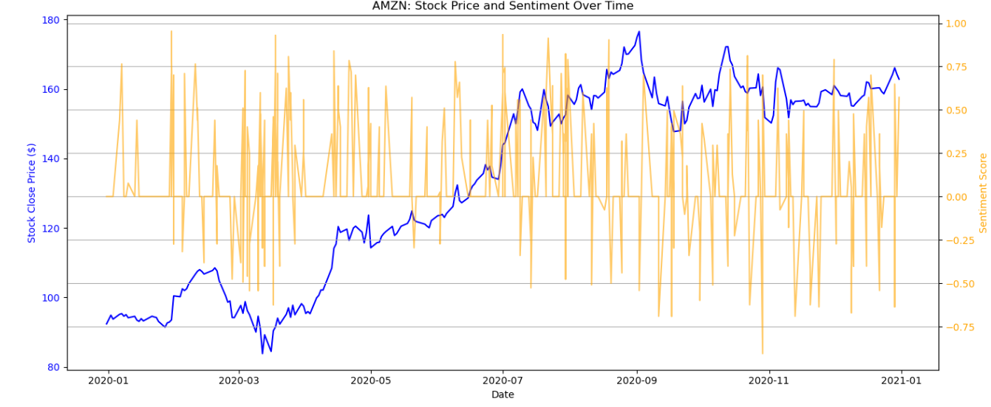
Figure 1: AMZN stock vs daily sentiment.
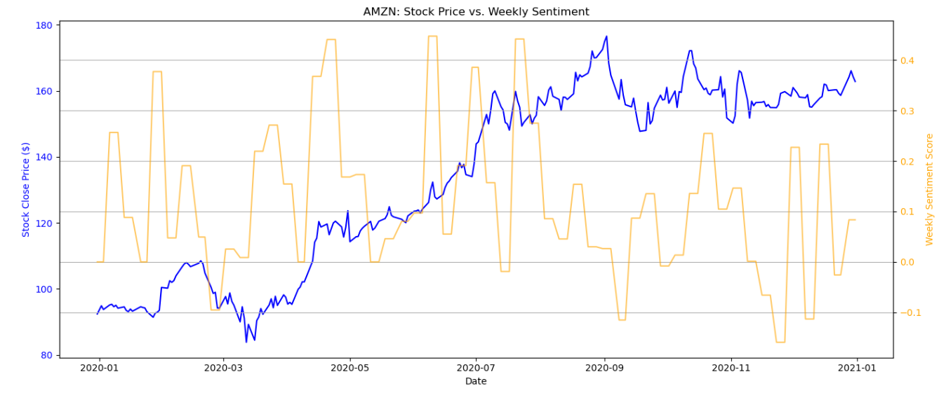
Figure 2: AMZN stock vs weekly sentiment.
As much as VADER has its limitations in detecting nuances like sarcasm or technical financial jargon,(Li et al., 2014) its rule-based architecture was effective for this specific task, delivering a fast and understandable signal. All sentiment scores were built into a merged dataset for use in future models.
Other implementation details, such as feature engineering and alignment, are covered in Section 5.

Exploratory Data Analysis (EDA)
EDA assisted in understanding the nature and limitations of the tweet sentiment and stock price data and inform model construction and preprocessing choices.
To estimate the promise of Twitter sentiment as an exogenous variable, I plotted tweet frequency by company. Apple, Amazon, Tesla, Boeing, and Microsoft had the most tweets, and they are all good candidates for sentiment-driven forecasting. Higher tweet frequency enhances aggregation quality and model input quality.
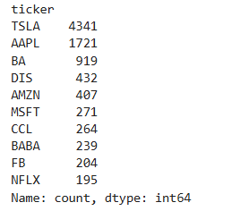
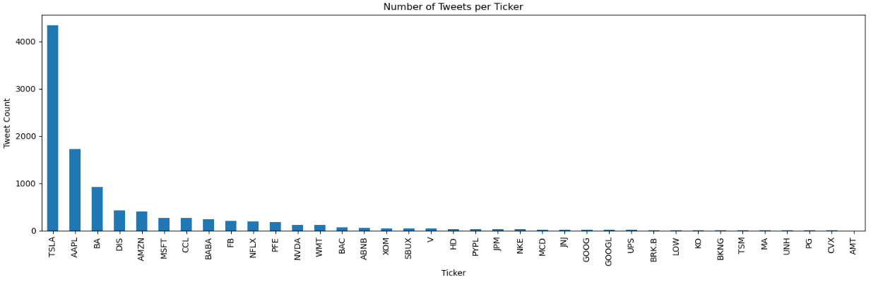
Figure 3: Number of tweets per ticker

Stock price patterns were analysed for trend and volatility detection (Matplotlib documentation, 2025). For example, Boeing experienced high price volatility in 2020 due to market uncertainty from the COVID-19 pandemic, highlighting the need for short-term prediction methods.
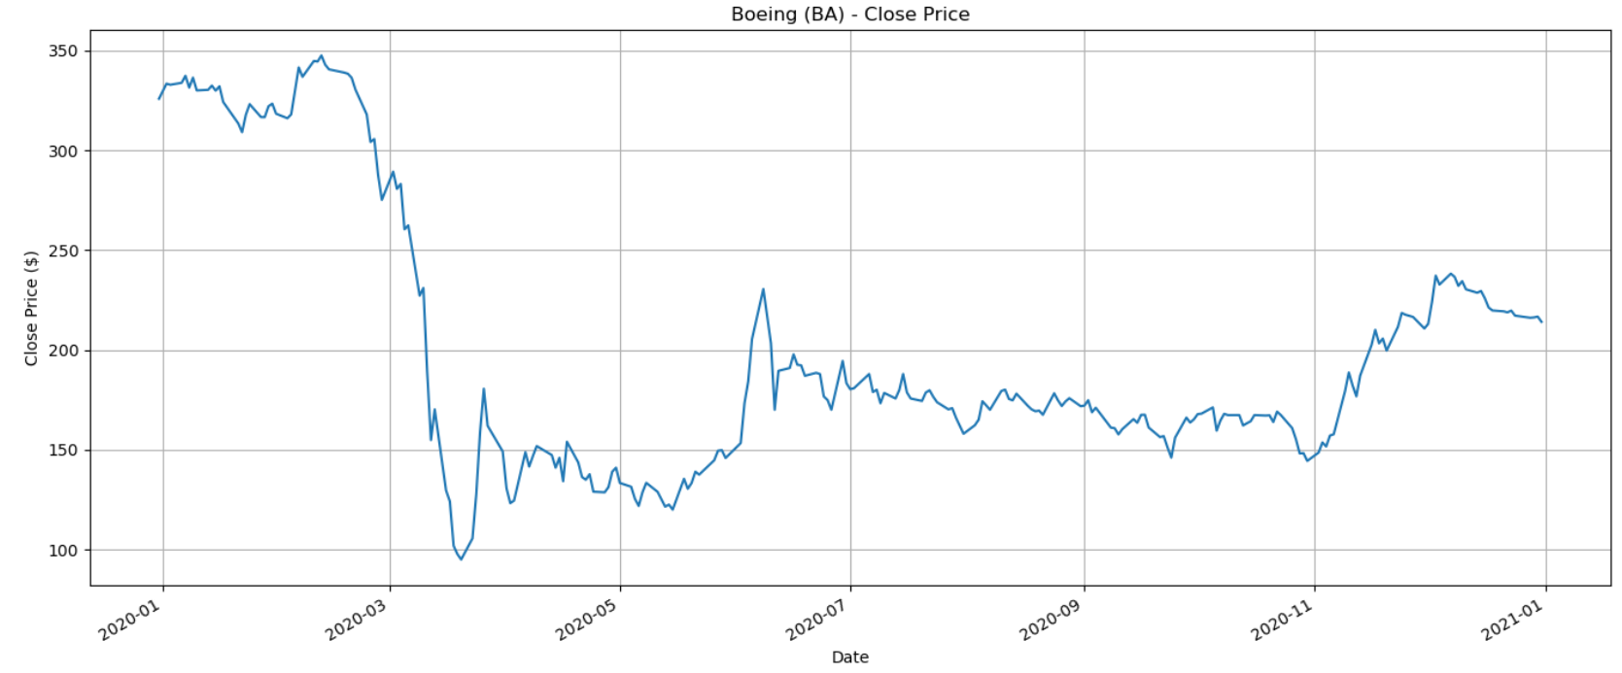
Figure 4: Boeing Stock Close
Discontinuities in tweet coverage over time were an issue. As discussed in Section 3, sentiment sparsity was mitigated using weekly aggregation and forward-filling, allowing integration into models with sequential inputs.
Table 1: Tweet coverage by company
Company | Trading days and tweet overlap | Coverage (approx.)
AMZN | 55 out of 254 trading days | 22%
BA | 54 out of 254 trading days | 21%
Stationarity was verified using the Augmented Dickey-Fuller (ADF) test to determine whether differencing would be required, a step that is required for classical models like ARIMA (Hyndman and Athanasopoulos, 2018).
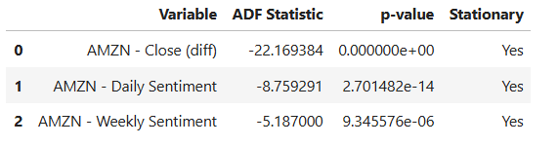
Finally, Granger causality tests identified whether sentiment drove price movement (Box, Jenkins and Reinsel, 2008). Aside from weak causal indications for some tickers (e.g., AMZN, MSFT), the majority of p-values were greater than 0.05. These values instructed which firms used sentiment as an exogenous input for future modelling stages.

Feature Engineering
This phase facilitated data preparation for the time series prediction by converting stock prices and sentiment scores into model-ready formats. Some of the principal steps involved stationarity checking, sentiment data alignment, lag structuring, and input conversion into the specifications of every model.
The aggregated sentiment scores (Section 3) provided day-to-day consistency and were thus applicable for use in models like LSTM and ARIMAX requiring full sequences. Lagging was used wherever Granger tests indicated presence of lagged effects, enabling models to capture temporal association between sentiment and stock direction. Features for model inputs were created from the stationarity and Granger causality findings in Section 4.
Input construction varied between models:
- The ARIMA/ARIMAX models used differenced closing prices and sentiment, where applicable, as exogenous variables.
- LSTM required rolling windows (e.g., 30 days) of scaled prices, optional lagged sentiment, reshaped into 3D tensors.
- XGBoost used tabular inputs with prices lagged and sentiment that needed no scaling since it used a tree-based system.
Each modification was designed to balance theoretical demands (e.g., stationarity and causality) with empirical ones, like data constraints and short time series.

Forecasting Models and Tuning

6.1 ARIMA and ARIMAX Models
To model short-term stock price movements, I used machine learning and classical techniques. I selected ARIMA and ARIMAX for interpretability and simplicity to apply on relatively short financial time series (Box, Jenkins and Reinsel, 2008).
ARIMA models were built following standard steps :
- ADF tests, ACF and PACF plots informed the choice of p and q values; d was derived from the order of differencing.
- The parameters were selected according to statistical information and manual tuning using AIC comparisons.

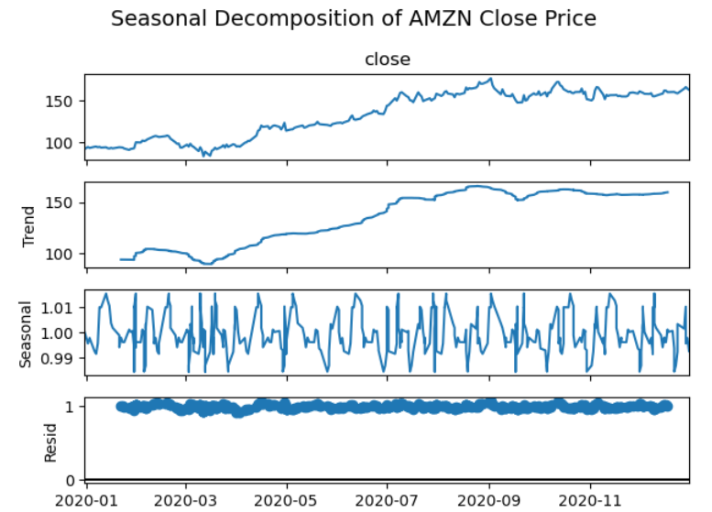  Figure 5 Decomposition or AMZN close | 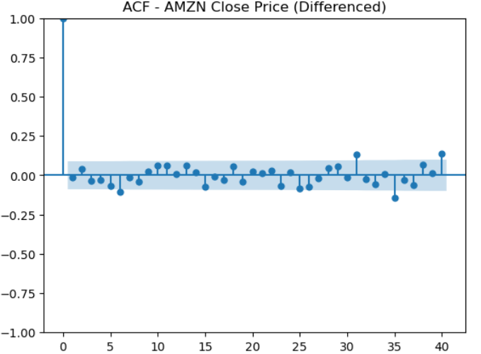  Figure 6 ACF plot AMZN close.  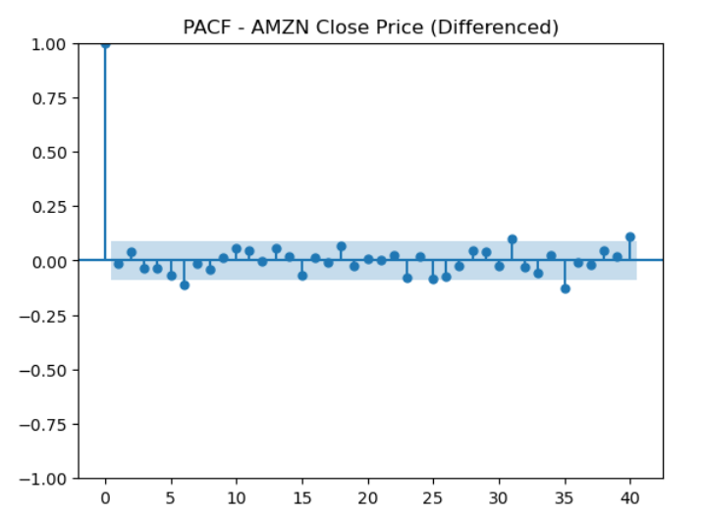  Figure 7 PACF plot Amazon close.

Predictions were generated using the statsmodels library (Josef Perktold et al., 2024) and then saved using a custom function that aligned the predictions with the real trading dates for use in the dashboard.
Where weak causality was found (see Section 5), ARIMAX was tested. This allowed direct comparison with sentiment-full versus sentiment-less models. Generally, performance differences were minimal, possibly due to sparse or noisy sentiment data, but the comparisons were left in for completeness.
Examples:
- BA was modelled using ARIMA alone, as tweet volume was low and causality tests were inconclusive.
- AMZN required differencing and was modelled with ARIMAX using weekly sentiment data.
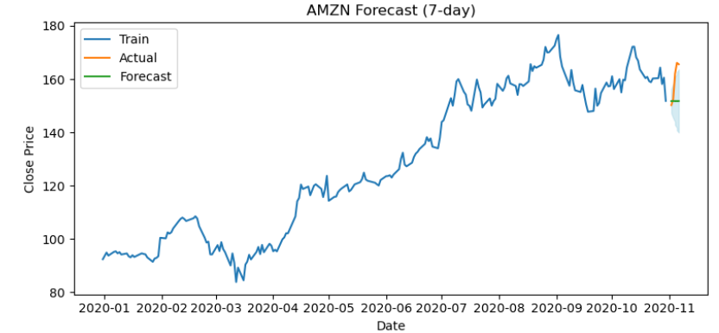
Figure 8 Arimax 7-day AMZN.

Although Granger tests showed minimal statistical backing, sentiment was still included in subsequent LSTM models to investigate possible nonlinear impacts that could not be captured with typical models.

6.2 LSTM Neural Networks
LSTM networks were chosen based on the ability to model nonlinear and sequential stock prices relationships, which is particularly important if sentiment data has lagged or indirect effect (Fischer and Krauss, 2018). LSTMs were trained on AAPL, TSLA, MSFT, and AMZN.
Each model accepted a 30-day moving window of previous closing prices, with optional additional lagged sentiment. The output was a forecast for 1-, 3-, or 7-day horizons. Input features were scaled with MinMaxScaler (closing prices alone), and reshaped into 3D tensors for Keras compatibility (NumPy Documentation, 2025; TensorFlow, 2025; Keras.io).
Model architecture:
- Single-layer LSTM
- Dropout layer (for regularization)
- Dense output layer
- Adam optimizer with MSE loss
To improve accuracy, the AAPL model (1-day prediction) was hyper tuned using KerasTuner. Validation loss was minimised by searching:
- LSTM units: 32–128
- Dropout: 0.1–0.5
- 5 trials, 2 runs per trial, early stopping at 30 epochs.
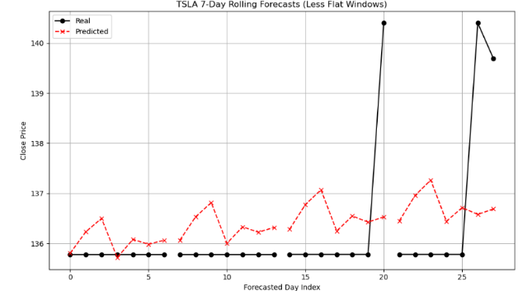
The optimal configuration was retrained on the entire training set (Keras, 2025). The tuned model had lower RMSE than its untuned counterpart and, more importantly, tracked real prices more closely, especially for short time horizons. Its predictions are plotted on the dashboard as lstm_tuned.
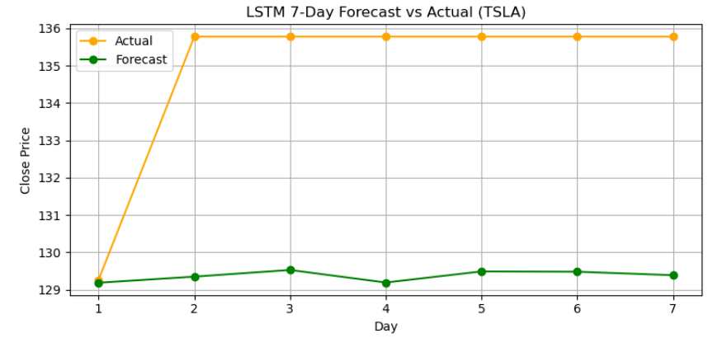
Figure 10: LSTM 7-day single plot.
Figure 9: LSTM 7-day rolling.

6.4 XGBoost Regressor
As a comparison to non-sequential approaches, I trained XGBoost on TSLA with lagged closing prices and sentiment features to predict the next closing price. While tree-based models like XGBoost can be effective at nonlinear relationships without scaled inputs (Jing, Wu and Wang, 2021), the untuned model performed poorly (RMSE ~35.1 vs. LSTM’s ~4.9). As the performance differential was so great, and it appeared that only extensive tuning and additional feature engineering would make a difference, I did not pursue XGBoost further for short-horizon forecasting.
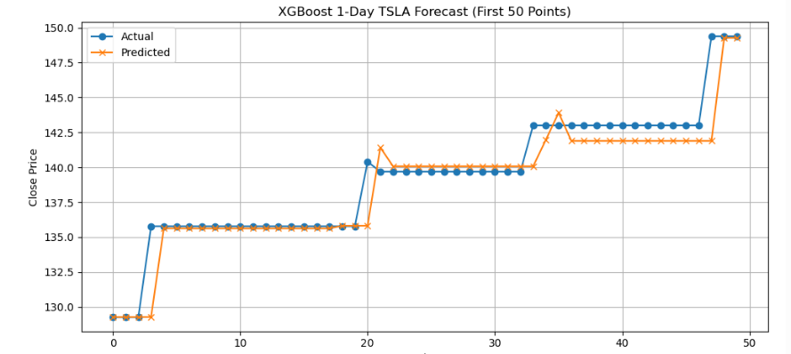
Figure 11: XGBoost appears lags are off, hyper tuning would have helped improve RMSE score before disregarding model.

Table 2: Model Summary
Model | Companies | Sentiment Used? | Tuning
ARIMA | BA, AMZN | No | Manual (ADF, AIC)
ARIMAX | AMZN, MSFT | Yes (weekly) | Manual (ADF, AIC)
LSTM | AAPL, TSLA, MSFT, AMZN | Yes (daily/weekly) | Yes (AAPL tuned)
XGBoost | TSLA | Yes | No
The output of each model was exported and combined into one dashboard to compare across tickers, models, and forecast horizons.

Dashboard Design
The dashboard (see appendix) was built with Streamlit for fast deployment and interactive controls, and Plotly Express for interactive time-series plots (Streamlit documentation, 2025; Plotly, 2025). The data was loaded and joined by Pandas and glob, enabling real-time filtering by user selection (pandas documentation, 2025).
Users are able to select companies (AAPL, AMZN, TSLA, MSFT, BA) and toggle between 1-, 3-, and 7-day forecasts. All of the model forecasts, ARIMA, ARIMAX, LSTM, optimized LSTM, and XGBoost, are shown together by default, but the respective models are toggled on or off via Plotly's legend (Tufte, 2001). Sentiment scores, either daily or weekly aggregated, may also be overlaid on the same plot for visual correlation. An interactive RMSE table is provided to compare models. Outputs are CSV-based and pre-computed; real-time updates would require additional integration.
Design elements reflect Tufte’s principles of clarity, minimalism, and functionality:
Element | Design Choice | Tufte’s Principle(s)
White Background | Clean, distraction-free backdrop for plots. | High Data-Ink Ratio, Chartjunk Elimination
Dropdown Selectors | Reduces cognitive load, allowing user to focus on one company at a time. | Clarity, Minimalism, Functional Interactivity.
Toggles for Models in Legend | Users can do comparative analysis by focusing on specific models or horizons | Comparative Analysis,  Functional Interactivity.
Hover Mode | Users can do side by side comparison by viewing values for all series at a specific date | Precision, Functional Interactivity,  Comparative Analysis.
Optional Sentiment plot | Option check box means it only needs to be displayed if the user is interested | Minimalism, Relevance
RMSE Table with Filters | Allows for quantitative evaluation of forecasting for all models and horizons. | Functional Interactivity,  Analytical Functionality.
Responsive layout | Screen size automatically adjusts as needed. | Functional Design
Alignment of Forecasts and Stock Data | Proper alignment of forecast and actual dates maintains visual accuracy. | Clarity and Accuracy

Big Data Processing Environment
Screenshots demonstrating HDFS uploads, Hive queries, and MongoDB operations are all in the Appendix.
This project utilised Apache Spark for distributed data processing, with data being stored in Hadoop HDFS and MongoDB. The intention was to build a modular pipeline to ingest semi-structured social media data (Reddit) and get it ready for analysis.
Apache Spark was the main processing engine employed, chosen because it is scalable, in-memory optimised, and Python-compatible via PySpark (Spark documentation, 2025). It was used to load Reddit posts (scraped through the PRAW API on r/worldnews), flatten semi-structured JSON, clean and parse timestamps, remove nulls, and apply basic text processing such as tokenization and word frequency.
Processed data was saved to HDFS in CSV form using Spark’s I/O support. HDFS provided a fault-tolerant, distributed storage layer that integrated easily with the Hadoop ecosystem and allowed for persistence of large intermediate datasets.
Although Spark supports MongoDB via connectors, environment-level issues (such as class path conflicts) prevented direct writes. As a workaround, I exported the data as newline-delimited JSON and inserted it into MongoDB using PyMongo. This increased document layout flexibility and ensured the pipeline still functioned.
MongoDB’s schema flexibility suited the varied structure of Reddit posts (MongoDB Docs, 2025) and was chosen for this reason. Subsequent documents could later be queried or visualized as needed.
The toolchain was selected based on practical compatibility and workload requirements. Spark fit batch and near-real-time processing well, and HDFS for fault-tolerant file storage. MongoDB provided flexible document-oriented querying, and Python acted as the glue across data ingestion, cleaning, and storage.
Despite occasional tooling issues (e.g., Spark-Mongo integration), alternative solutions were utilised to make the pipeline robust. This reflects pragmatic knowledge of the limitations of distributed systems in real-world environments.

NSQL/SQL Performance Benchmarking
To benchmark relational and non-relational database performance under varying workloads, I applied the Yahoo! Cloud Serving Benchmark (YCSB) to test MySQL (SQL), MongoDB (document-oriented NoSQL), and Redis (in-memory key-value store). (Cooper et al., 2010; Cooper, 2025)
Three workload profiles were tested:
- Workload A (50% reads, 50% updates),
- Workload B (95% reads, 5% updates),
- Workload C (100% reads).
Each database was tested in the same virtual environment to ensure fairness. Metrics included average, minimum, and percentile latencies, as well as total throughput (operations per second).
Redis consistently outperformed the other systems in both latency and throughput across all workloads. Its in-memory design made it especially effective for read-heavy and real-time use cases (Redis Docs, 2025). For example, on Workload B, Redis showed more than 4,400 operations per second with sub-millisecond latency.
MongoDB offered a good balance of performance and flexibility. It handled mixed and read-heavy workloads more efficiently than MySQL, particularly due to it being schema-less and having less overhead in updates.
MySQL struggled under update-heavy workloads, giving the highest latencies and lowest throughput. While performing well on singular reads, its ACID support and relational paradigm resulted in bottlenecks when dealing with heavier loads (MySQL documentation, 2025).
Hive, HBase, and CouchDB were excluded for the YCSB tests due to persistent compatibility and setup issues within the VM environment.
In conclusion, the benchmarking profiled the trade-offs between relational and NoSQL databases. Redis is ideal for latency-bound workloads, MongoDB provides a middle-ground option that is flexible, and MySQL remains suitable where strict relational integrity is required, but not as good under high-throughput demands.

Benchmark Results Summary
Workload | DBMS | Throughput (ops/sec) | Avg Read Latency (μs) | Avg Update Latency (μs) | Notes
A | Redis | ~4048 | ~180 | ~137 | Fastest overall
A | MongoDB | ~769 | ~726 | ~1,114 | Better than SQL
A | MySQL | ~300 | ~676 | ~4,403 | Update bottleneck
B | Redis | ~4425 | ~127 | ~158 | Read-optimized
B | MongoDB | ~625 | ~1,145 | ~2,800 | Reasonable
B | MySQL | ~250 | ~606 | ~5,110 | Poor update latency
C | Redis | ~4149 | ~131 |  | Best for pure reads
C | MongoDB | ~625 | ~895 |  | Schema-flexible
C | MySQL | ~812 | ~586 |  | Surprisingly decent for reads
More detail in appendices

Big Data Architecture & System Design
This project implemented a modular architecture to support both batch and near-real-time data processing using scalable, distributed technologies. The design focused on flexibility, performance, and fault tolerance.
The batch pipeline (Section 10.2) takes in and cleans Twitter and stock data using PySpark before storing in MongoDB or Hive. ARIMA, ARIMAX, LSTM, and XGBoost forecasting models were trained on the data, and the output saved as CSVs to be integrated with the Streamlit dashboard. MongoDB was a convenient document store, and HDFS offered persistent, distributed storage for larger files. Company-specific data frames were generated after integration to aid model training with cleaner, focused datasets.
The streaming pipeline (Section 10.3) simulated real-time ingestion using Reddit’s API, followed by text cleaning, sentiment analysis, and summarisation. Cleaned outputs were written to MongoDB for querying and to HDFS for saving.
Apache Spark served as the core engine for both batch and streaming in Python. HDFS offered scalable storage, while MongoDB’s schema flexibility supported semi-structured Reddit data. Library support (PRAW, PyMongo, TextBlob, Transformers) enabled data ingestion, storage, and NLP processing.
Overall, the system was flexible and fault tolerant. Components were replaceable or extendable independently, making it practical for production-level big data processing workflows.

10.2 Batch Processing Pipeline (Forecasting Workflow)
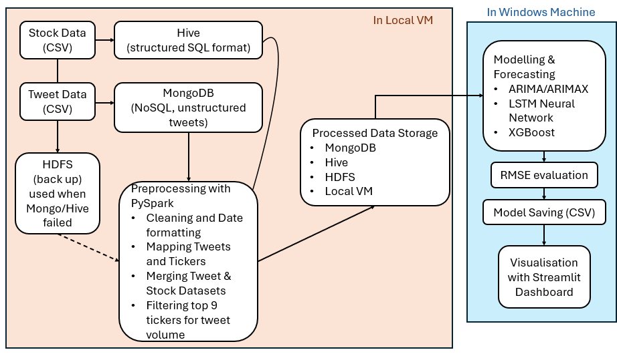

10.3 Real-Time Analytics Pipeline (Reddit)
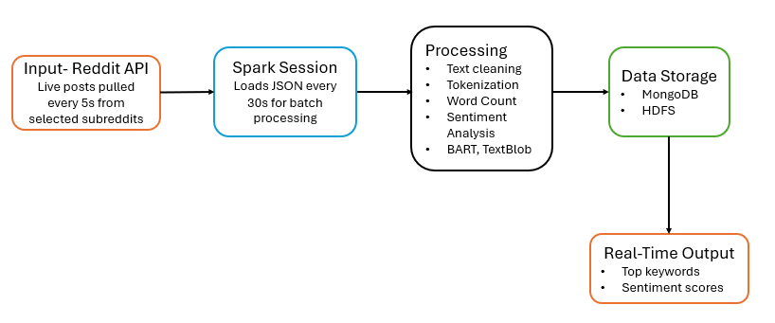

Real-Time Analytics Use Case
To demonstrate practical understanding of real-time analytics, I used a lightweight streaming pipeline that processed Reddit data using Apache Spark and supporting NLP libraries. The application simulated near-real-time ingest, transform, and store social media posts, demonstrating the design of an end-to-end operational streaming architecture.
The Reddit API (implemented via PRAW) was adopted as the data source, polled every five seconds. Posts from the r/worldnews subreddit were collected into 30-second micro-batches in order to mimic streaming ingestion. Subsequent text transformations were executed by park, including sentiment scoring (TextBlob) and summarisation (BART) (NLTK, 2025; TextBlob, 2025; Transformers, 2025).
Each batch of processed data was stored in two locations: MongoDB to enable structured querying and integration into dashboard, and HDFS for historical analysis and archival purposes. Simultaneously, key metrics such as top words, average sentiment, and post summary were displayed live in the console.
This design is very similar to a Kafka-type system for streaming. While real streaming tech like Kafka wasn't being employed due to environmental constraints, the design was made in a way as easy to migrate. Batch logic might be replaced with Spark Structured Streaming and Kafka as a scalable ingestion layer (Kreps, 2011).
The design demonstrated Spark's ability to parallelize text transformation in virtual real time, thanks to MongoDB and HDFS supporting flexible querying and fault-tolerant storage. Console outputs gave plain live feedback, emphasizing key pipeline functionality without a full frontend.
This demonstrated the feasibility of live NLP processing in a distributed framework, establishing key skills in real-time processing, stream simulation, and modular architecture.

Results and Discussion

12.1 Forecast Accuracy and RMSE Comparison
Root Mean Squared Error (RMSE) was used to compare model performance across all companies and time horizons (1-, 3-, 7-day). Results were summarised in the dashboard for ease of comparison.
LSTM models consistently outperformed ARIMA, ARIMAX, and XGBoost across most horizons and tickers. The tuned LSTM for AAPL (1-day forecast) achieved the lowest RMSE, confirming the advantage of deep learning for capturing nonlinear and short-term patterns.
Hyper tuning with KerasTuner produced measurable improvements. In AAPL, RMSE decreased from ~2.13 to ~1.93, and graphical plots showed tighter tracing of actual prices, especially for short horizons.
While ARIMAX models included sentiment as an exogenous input, the improvement over ARIMA was moderate when the exogeneous variable was ignored. For AMZN and MSFT, where Granger causality reported weak causality, the marginal contribution of sentiment was evident but not strong. For tickers with sparse or noisy sentiment data, ARIMA alone often performed comparably.
XGBoost performed poorly, with RMSE over 35 on the 1-day prediction of TSLA. Despite not having hyper tuned the model, its inability to process sequential relationships rendered it unsuitable compared to LSTM, and the performance gap led me not to pursue further analysis using this method.

12.2 Sentiment Analysis Impact
Granger tests showed weak signals of causality for AMZN and MSFT, and therefore some justification existed to include sentiment into some models. Statistical justification was limited, but sentiment did get used in LSTM models because neural networks are capable of uncovering patterns linear methods cannot detect. Coverage gaps likely diminished the impact of sentiment. Aggregation mitigated sparsity but the signal remained noisy and uneven.

Conclusion
This project combined Advanced Data Analytics and Big Data Engineering to look at whether it was feasible to forecast stock price movement using financial data as well as sentiment from social media. By combining classical models, deep learning techniques, and distributed systems, I addressed both the promise and limitations of working with noisy, real-world data.
Among forecasting methods, LSTM networks outshone both ARIMA and XGBoost, especially on short time horizons. This is indicative of the strength of deep learning in the identification of nonlinear, sequential relationships The applicability of sentiment information was constrained by gaps in tweet coverage, even though efforts were made to mitigate this by aggregating and forward-filling (Section 3).
Analytical tools such as ADF tests and Granger causality were used to confirm the structure of the model. While linear methods indicated poor statistical relationships between sentiment and prices, neural networks provided a way to capture more complex, nonlinear patterns.
In the Big Data environment, Apache Spark proved useful for scalable processing of Reddit content, and persistence as well as in-place querying was facilitated by both HDFS and MongoDB. The system design favoured modularity so that each pipeline, batch or streaming, could be tested and extended independently.
Performance benchmarking showed NoSQL systems, such as Redis and MongoDB, were better suited for high throughput as well as semi-structured workloads than MySQL.
The dashboard consolidated model predictions and evaluation metrics in interactive form, leveraging best practices in visual communication (Tufte’s principles).
Future work could begin with expanding the dataset beyond 2020 to increase the generalizability of findings across various market conditions. Model performance can also be improved by implementing rolling forecasts for both the ARIMA and ARIMAX models for more realistic and more robust RMSE evaluation over time. Including auto-ARIMA would also automate model selection and tuning, which can yield better performance without manual configuration. On the deep learning side, further experimentation with LSTM architectures and experimenting with ensemble models can enhance prediction quality. On the systems end, real-time retraining via Kafka and database performance tuning for write-heavy workloads would render it more scalable and production-ready.
Overall, this project demonstrates the practical benefits, and constraints, of integrating statistical rigor with modern scalable tooling to solve a real-world forecasting problem in finance.

References
What is MongoDB? - Database Manual v8.0 - MongoDB Docs (no date). Available at: https://www.mongodb.com/docs/manual/ (Accessed: 16 May 2025).
User Guide — pandas 2.2.3 documentation (no date). Available at: https://pandas.pydata.org/docs/user_guide/index.html (Accessed: 16 May 2025).
Transformers (no date). Available at: https://huggingface.co/docs/transformers/index (Accessed: 16 May 2025).
TextBlob: Simplified Text Processing — TextBlob 0.19.0 documentation (no date). Available at: https://textblob.readthedocs.io/en/dev/ (Accessed: 16 May 2025).
Streamlit documentation (no date). Available at: https://docs.streamlit.io/ (Accessed: 16 May 2025).
Overview - Spark 3.5.5 Documentation (no date). Available at: https://spark.apache.org/docs/latest/ (Accessed: 16 May 2025).
NumPy Documentation (no date). Available at: https://numpy.org/doc/ (Accessed: 16 May 2025).
NLTK Book (no date). Available at: https://www.nltk.org/book/ (Accessed: 16 May 2025).
NLTK :: Natural Language Toolkit (no date). Available at: https://www.nltk.org/ (Accessed: 16 May 2025).
MySQL :: MySQL Documentation (no date). Available at: https://dev.mysql.com/doc/ (Accessed: 16 May 2025).
Matplotlib documentation — Matplotlib 3.10.3 documentation (no date). Available at: https://matplotlib.org/stable/index.html (Accessed: 16 May 2025).
Long Short-Term Memory | MIT Press Journals & Magazine | IEEE Xplore (no date). Available at: https://ieeexplore.ieee.org/abstract/document/6795963 (Accessed: 16 May 2025).
Learning Python, 5th Edition[Book] (no date). Available at: https://www.oreilly.com/library/view/learning-python-5th/9781449355722/ (Accessed: 16 May 2025).
Keras: Deep Learning for humans (no date). Available at: https://keras.io/ (Accessed: 16 May 2025).
Hadoop – Apache Hadoop 3.4.0 (no date). Available at: https://hadoop.apache.org/docs/r3.4.0/index.html (Accessed: 16 May 2025).
Docs (no date) Docs. Available at: https://redis.io/docs/latest/ (Accessed: 17 May 2025).
Data Apps for Production | Plotly (no date). Available at: https://plotly.com/ (Accessed: 16 May 2025).
BigData & Cloud Computing Tutorials | CloudDuggu (no date). Available at: https://www.cloudduggu.com/ (Accessed: 16 May 2025).
API Documentation | TensorFlow v2.16.1 (no date) TensorFlow. Available at: https://www.tensorflow.org/api_docs (Accessed: 16 May 2025).
Apache Hadoop (no date). Available at: https://hadoop.apache.org/ (Accessed: 16 May 2025).
Zaharia, M. et al. (no date) ‘Spark: Cluster Computing with Working Sets’.
Niu, H., Pan, Q. and Xu, K. (2023) ‘Hybrid deep learning models with multi-classification investor sentiment to forecast the prices of China’s leading stocks’, PLOS ONE, 18, p. e0294460. Available at: https://doi.org/10.1371/journal.pone.0294460.
Ma, C. and Yan, S. (2022) ‘Deep learning in the Chinese stock market: The role of technical indicators’, Finance Research Letters, 49, p. 103025. Available at: https://doi.org/10.1016/j.frl.2022.103025.
Tufte, E.R., 2001. The visual display of quantitative information. 2nd ed. Cheshire, CT: Graphics Press.
Li, X. et al. (2014) ‘News impact on stock price return via sentiment analysis’, Knowledge-Based Systems, 69, pp. 14–23. Available at: https://doi.org/10.1016/j.knosys.2014.04.022.
Kreps, J. (2011) ‘Kafka : a Distributed Messaging System for Log Processing’, in. Available at: https://www.semanticscholar.org/paper/Kafka-%3A-a-Distributed-Messaging-System-for-Log-Kreps/ea97f112c165e4da1062c30812a41afca4dab628 (Accessed: 16 May 2025).
Junqué de Fortuny, E. et al. (2014) ‘Evaluating and understanding text-based stock price prediction models’, Information Processing & Management, 50(2), pp. 426–441. Available at: https://doi.org/10.1016/j.ipm.2013.12.002.
Josef Perktold et al. (2024) ‘statsmodels/statsmodels: Release 0.14.2’. Zenodo. Available at: https://doi.org/10.5281/ZENODO.593847.
Jing, N., Wu, Z. and Wang, H. (2021) ‘A hybrid model integrating deep learning with investor sentiment analysis for stock price prediction’, Expert Systems with Applications, 178, p. 115019. Available at: https://doi.org/10.1016/j.eswa.2021.115019.
Hyndman, R.J. and Athanasopoulos, G. (2018) Forecasting: principles and practice. OTexts.
Hutto, C.J. (2025) ‘cjhutto/vaderSentiment’. Available at: https://github.com/cjhutto/vaderSentiment (Accessed: 16 May 2025).
Huang, C.-J. et al. (2010) ‘Realization of a news dissemination agent based on weighted association rules and text mining techniques’, Expert Systems with Applications, 37(9), pp. 6409–6413. Available at: https://doi.org/10.1016/j.eswa.2010.02.078.
Hu, Y. et al. (2015) ‘Application of evolutionary computation for rule discovery in stock algorithmic trading: A literature review’, Applied Soft Computing, 36, pp. 534–551. Available at: https://doi.org/10.1016/j.asoc.2015.07.008.
Fischer, T. and Krauss, C. (2018) ‘Deep learning with long short-term memory networks for financial market predictions’, European Journal of Operational Research, 270(2), pp. 654–669. Available at: https://doi.org/10.1016/j.ejor.2017.11.054.
Cooper, B.F. et al. (2010) ‘Benchmarking cloud serving systems with YCSB’, in Proceedings of the 1st ACM symposium on Cloud computing. New York, NY, USA: Association for Computing Machinery (SoCC ’10), pp. 143–154. Available at: https://doi.org/10.1145/1807128.1807152.
Cooper, B. (2025) ‘brianfrankcooper/YCSB’. Available at: https://github.com/brianfrankcooper/YCSB (Accessed: 16 May 2025).
Chen, J., Yan, S. and Wong, K.-C. (2020) ‘Verbal aggression detection on Twitter comments: convolutional neural network for short-text sentiment analysis’, Neural Computing and Applications, 32(15), pp. 10809–10818. Available at: https://doi.org/10.1007/s00521-018-3442-0.
Chen, H. et al. (2014) ‘Wisdom of Crowds: The Value of Stock Opinions Transmitted Through Social Media’, The Review of Financial Studies, 27(5), pp. 1367–1403. Available at: https://doi.org/10.1093/rfs/hhu001.
Box, G.E.P., Jenkins, G.M. and Reinsel, G.C. (2008) ‘Nonlinear and Long Memory Models’, in Time Series Analysis. John Wiley & Sons, Ltd, pp. 413–436. Available at: https://doi.org/10.1002/9781118619193.ch10.
Box, G.E.P., Jenkins, G.M. and Reinsel, G.C. (2008) ‘Multivariate Time Series Analysis’, in Time Series Analysis. John Wiley & Sons, Ltd, pp. 551–595. Available at: https://doi.org/10.1002/9781118619193.ch14.
Box, G.E.P., Jenkins, G.M. and Reinsel, G.C. (2008) ‘Linear Stationary Models’, in Time Series Analysis. John Wiley & Sons, Ltd, pp. 47–91. Available at: https://doi.org/10.1002/9781118619193.ch3.
Box, G.E.P., Jenkins, G.M. and Reinsel, G.C. (2008) ‘Linear Nonstationary Models’, in Time Series Analysis. John Wiley & Sons, Ltd, pp. 93–136. Available at: https://doi.org/10.1002/9781118619193.ch4.
Box, G.E.P., Jenkins, G.M. and Reinsel, G.C. (2008) ‘Forecasting’, in Time Series Analysis. John Wiley & Sons, Ltd, pp. 137–191. Available at: https://doi.org/10.1002/9781118619193.ch5.
Iqbal, M. (2025) Big Data Storage and Processing Lecture Notes, CCT College Dublin.
McQuaid, D. (2025) Advanced Data Analytics Lecture Notes, CCT College Dublin.

Appendices
Dashboard: https://dashboardappsem2ca2-9glkscdmwpfdtud4xrmwxv.streamlit.app/
Screencast:https://drive.google.com/file/d/1Axg5uyEDIuff0E3fbuOl88tveobV5QES/view?usp=drive_link
Dashboard files (Google drive): https://drive.google.com/drive/folders/1KiZcdtF2lareqWuhd7oqbYIpzCQqqnYi?usp=drive_link
Dashboard screenshots:
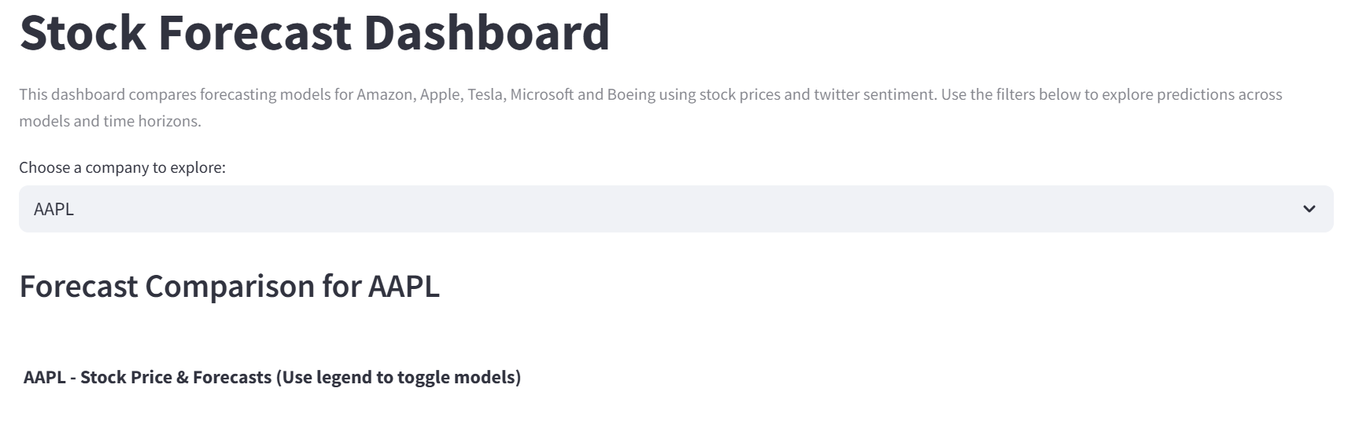 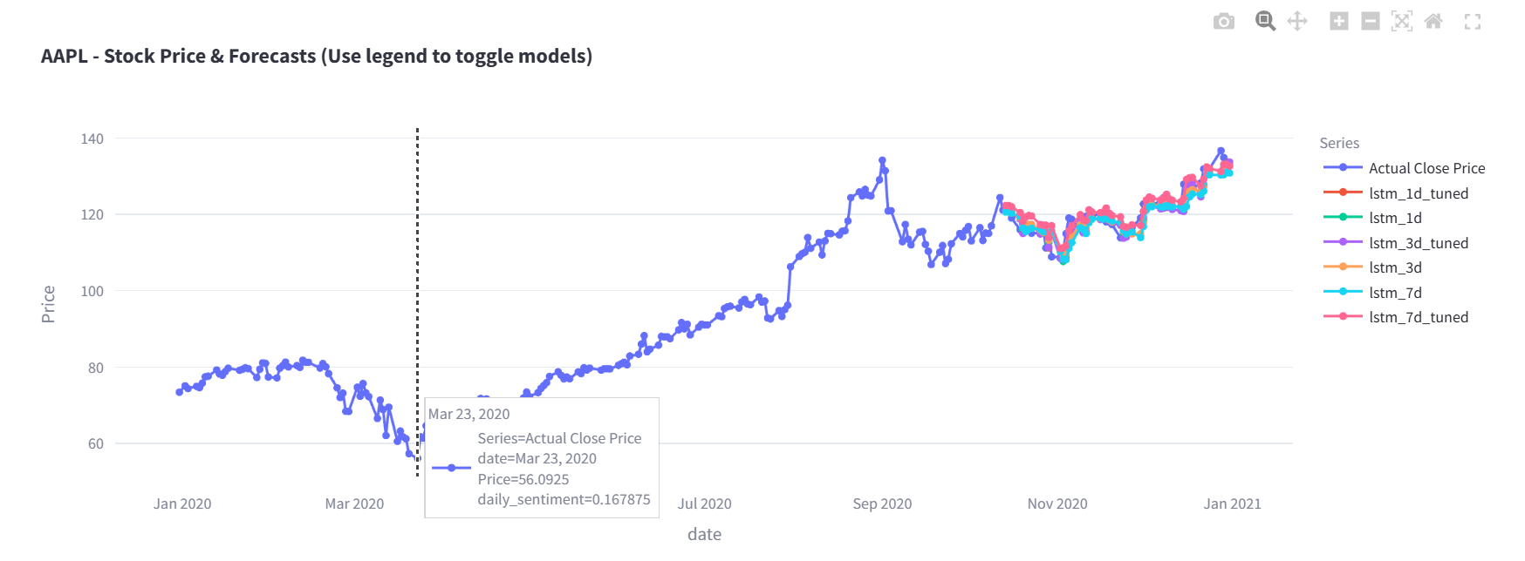
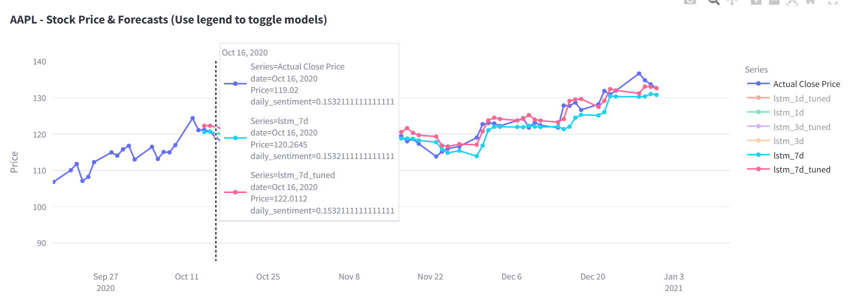
Figure 12: Toggle usage.
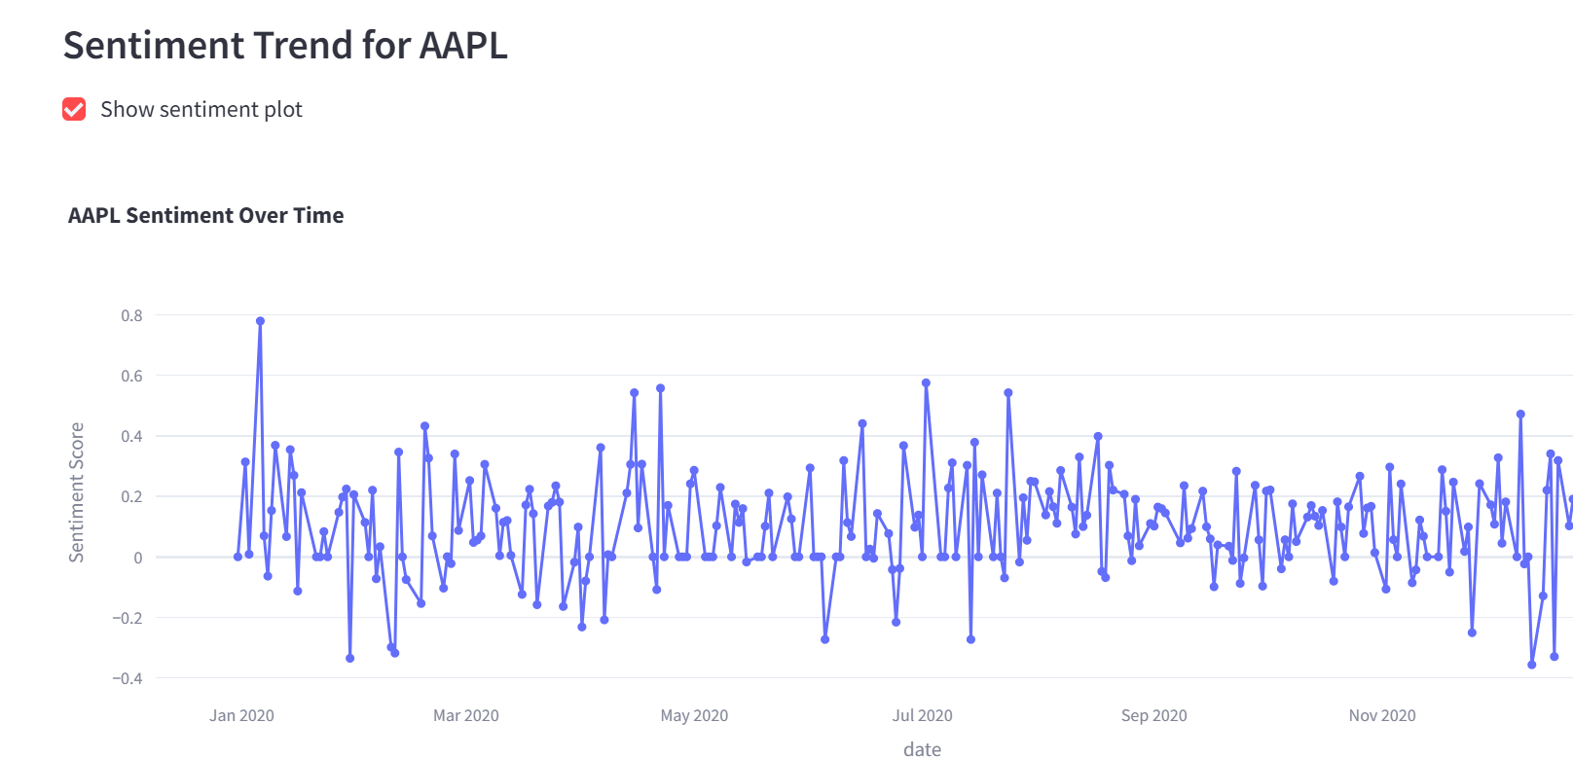 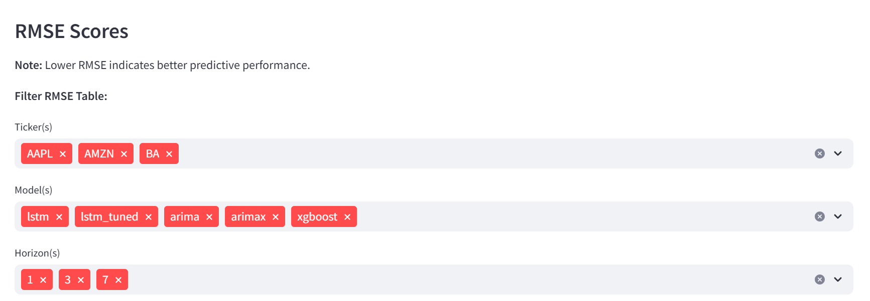
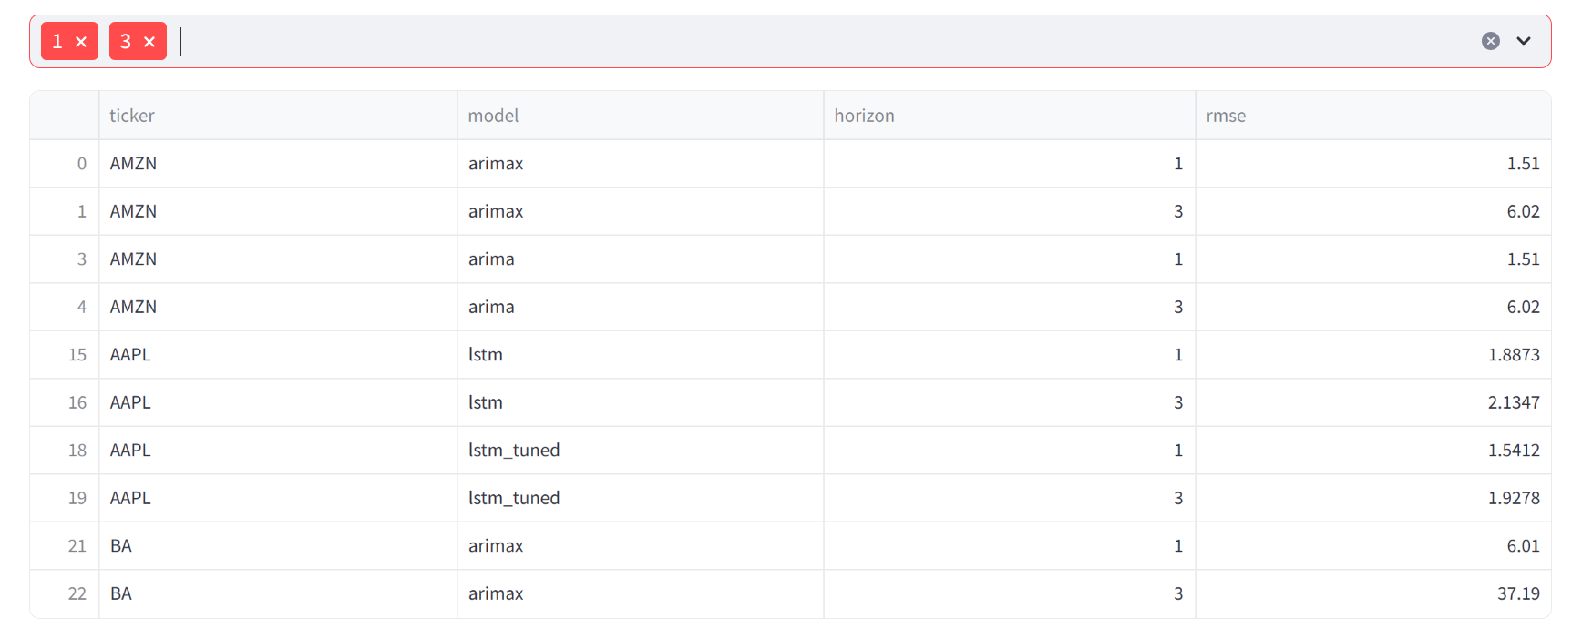

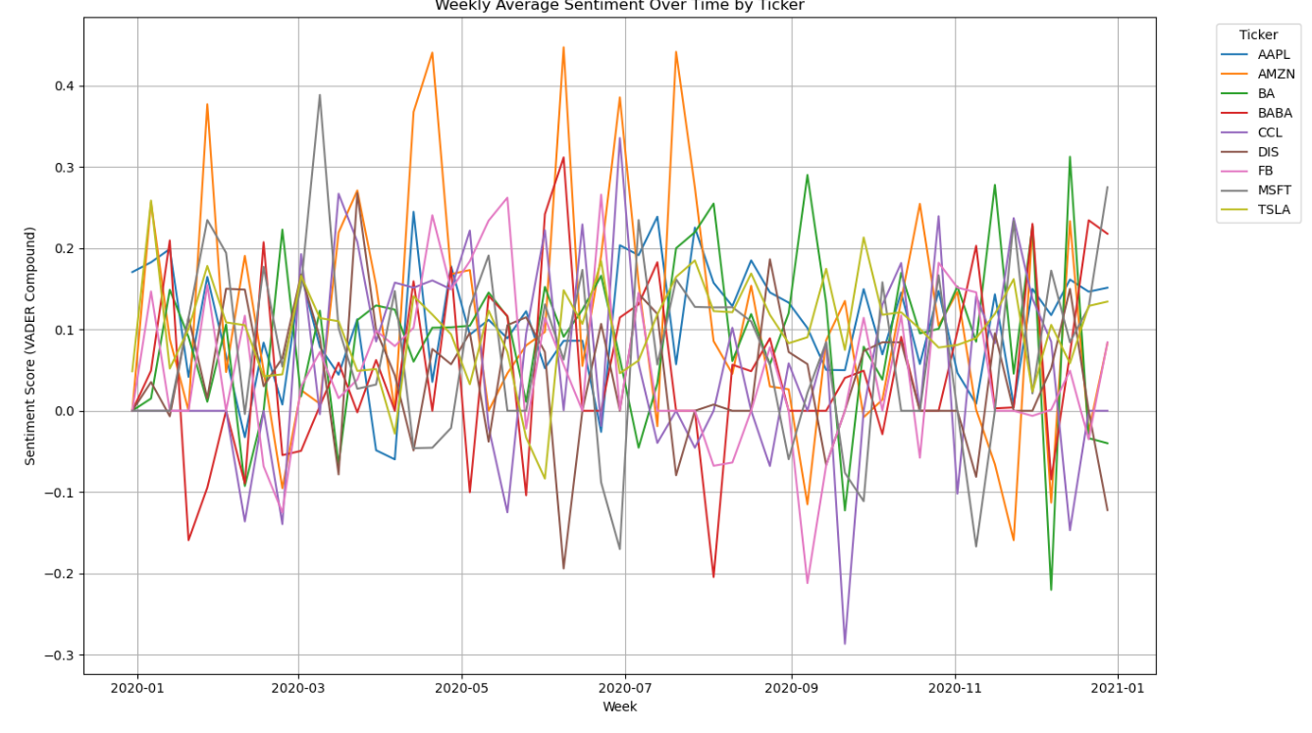  Figure 13 Weekly sentiment by ticker. | 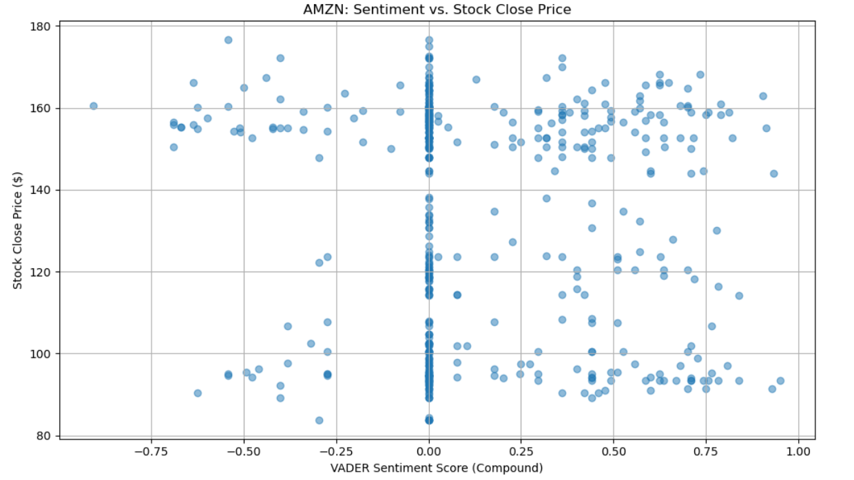  Figure 14 Scatter plot of Close vs daily sentiment
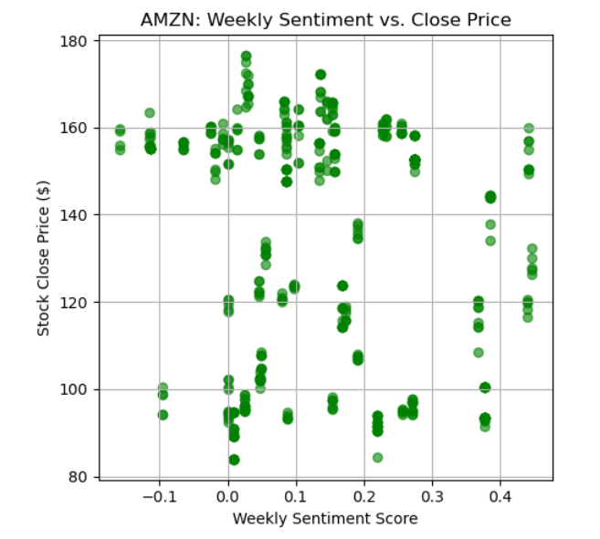  Figure 15 Scatter plot of close vs weekly sentiment | 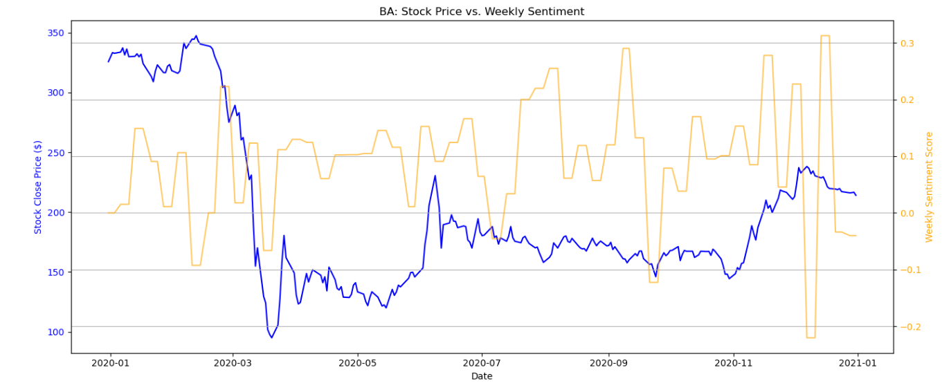  Figure 16 BA stock and weekly sentiment.
Ticker | Stock Differenced | Sentiment Frequency | Best  P-Value | Lag | Causality Likely? | Notes
AMZN | Once | Weekly | 0.0543 | 6 | Weak evidence | Marginal signal (p < 0.10)
BA | No | Weekly | 0.1163 | 1 | No
CCL | No | Weekly | 0.2912 | 1 | No
TSLA | Once | Daily | 0.2100 | 7 | No
AAPL | Once | Daily | 0.2301 | 3 | No
DIS | Once | Daily | 0.1388 | 4 | No
MSFT | Once | Daily | 0.0874 | 9 | Weak evidence | Marginal signal (p < 0.10)

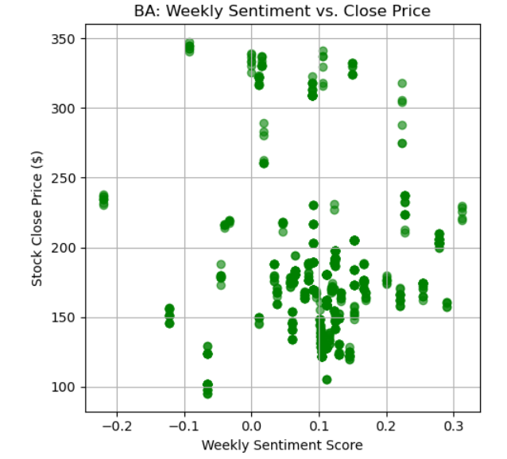  Figure 17 scatter of BA close vs weekly sentiment. | 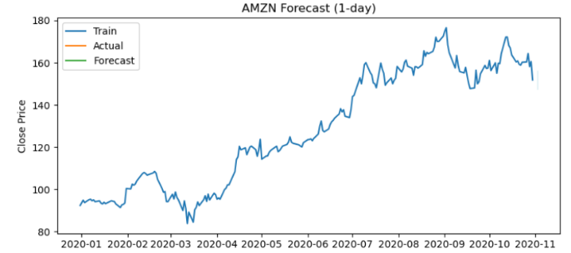  Figure 18 Arimax 1-day forecast.
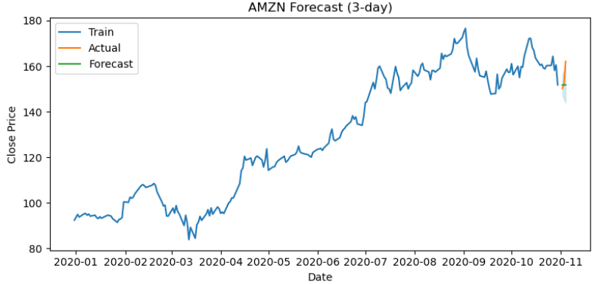  Figure 19 Arimax 3-day AMZN. | 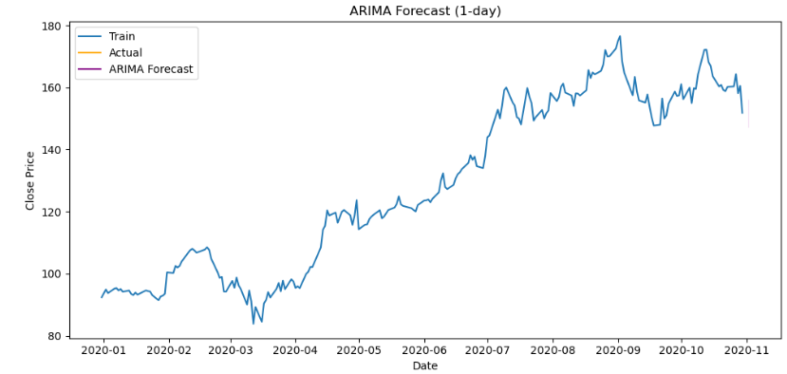  Figure 20 Arima 1 day forecast AMZN.
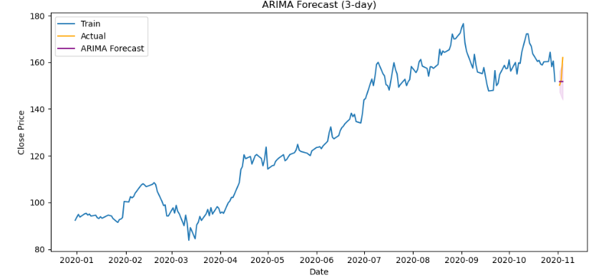  Figure 21 Arima 3 day forecast AMZN. | 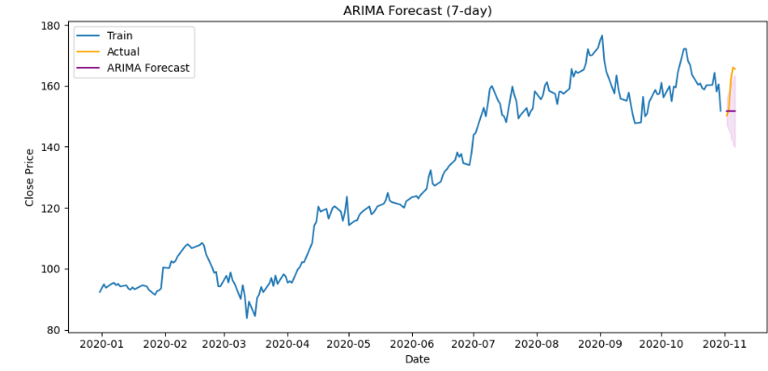  Figure 22 Arima 7-day AMZN.
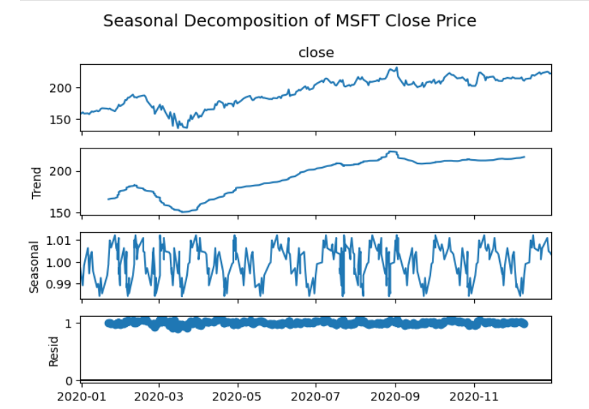  Figure 23 Microsoft decomposition. | 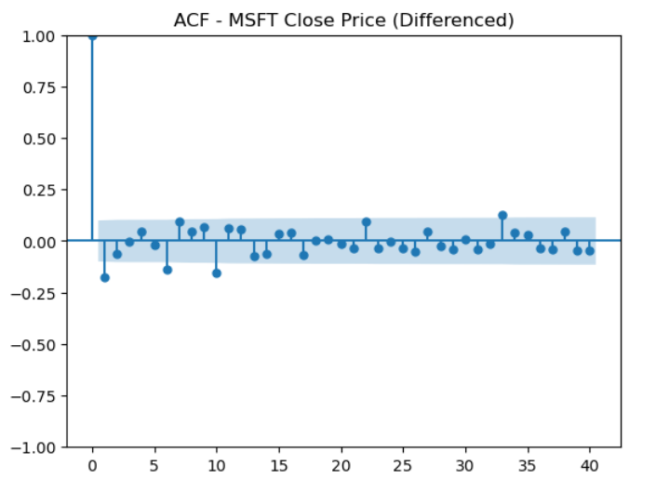  Figure 24 Microsoft ACF plot.

. ADF tests:
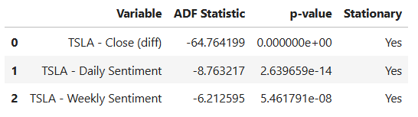 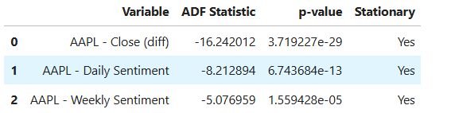 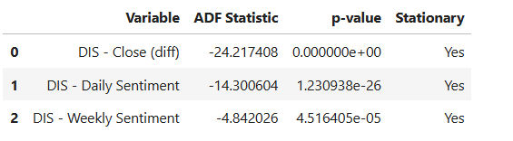 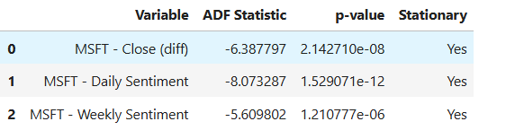
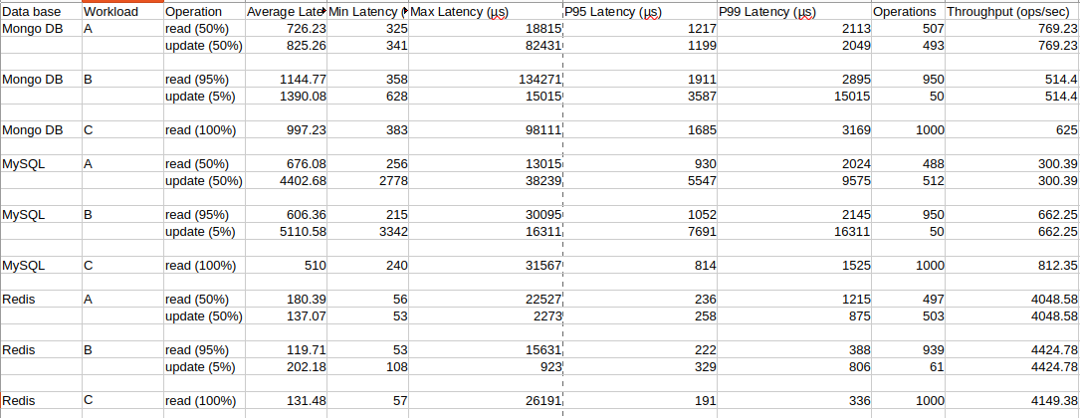
Figure 25: YCSB Metrics
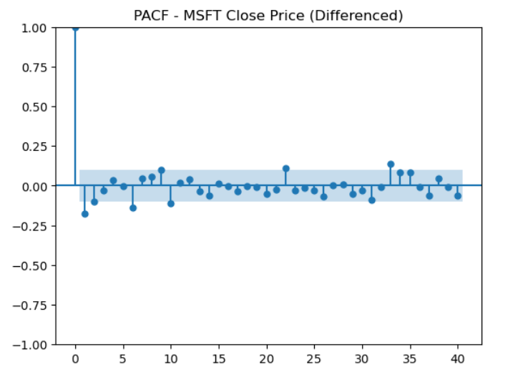  Figure 26 Microsoft PACF plot | 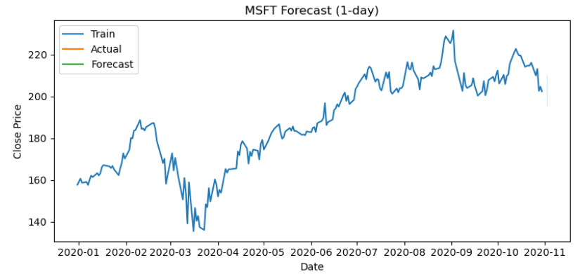  Figure 27 MSFT ARIMAX
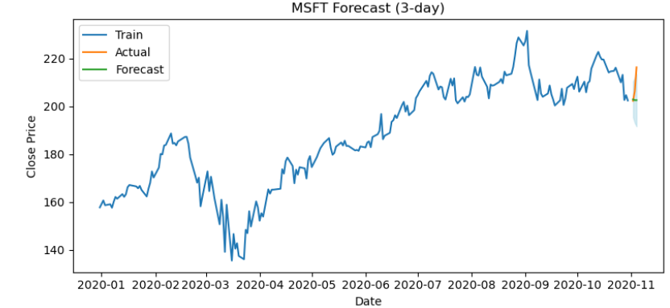  Figure 28 3-day ARIMAX. | 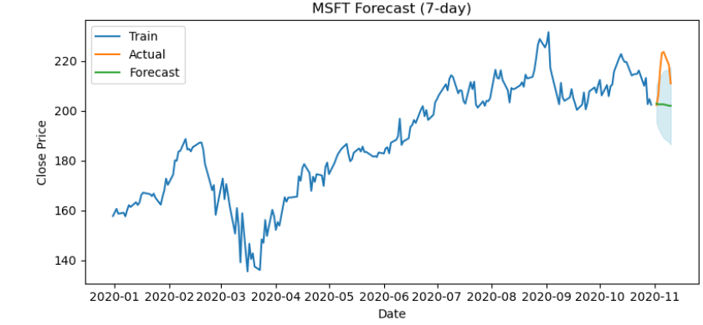  Figure 29 7-day ARIMAX.
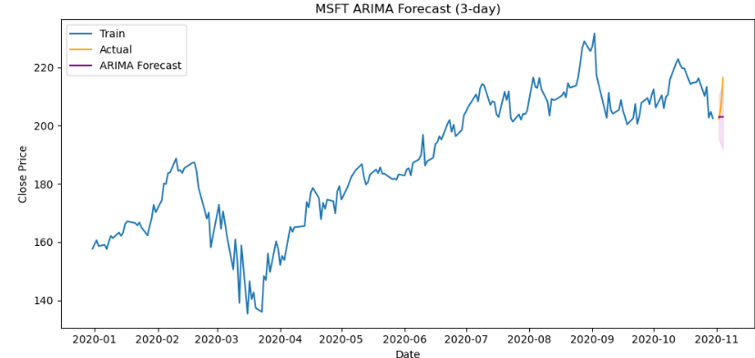  Figure 30 3d ARIMA. | 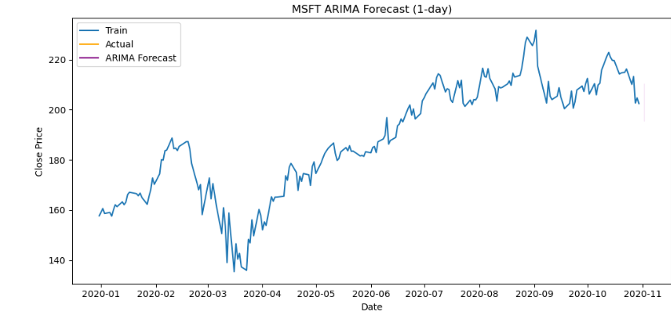  Figure 31 1d ARIMA.
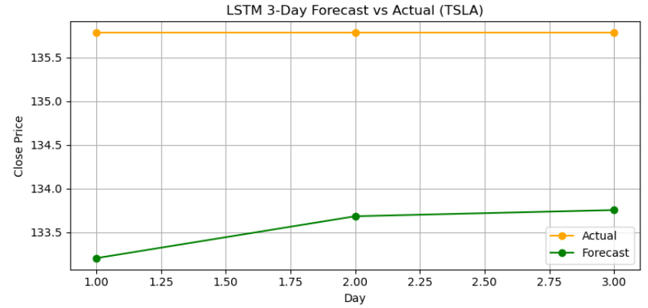  Figure 32 Single plot 3-day LSTM. | 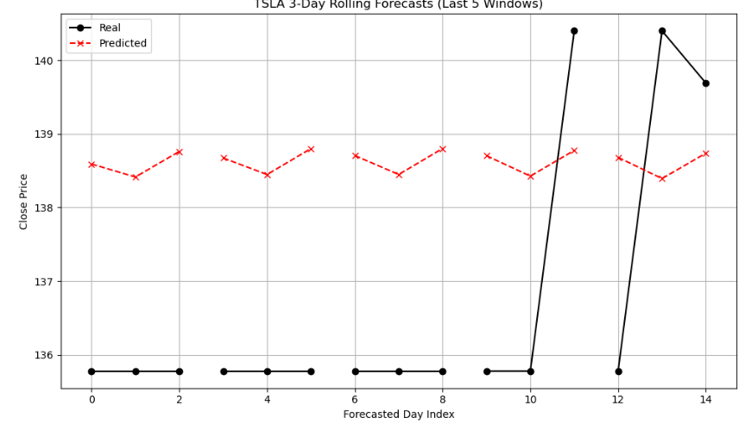  Figure 33 3 days rolling TSLA LSTM

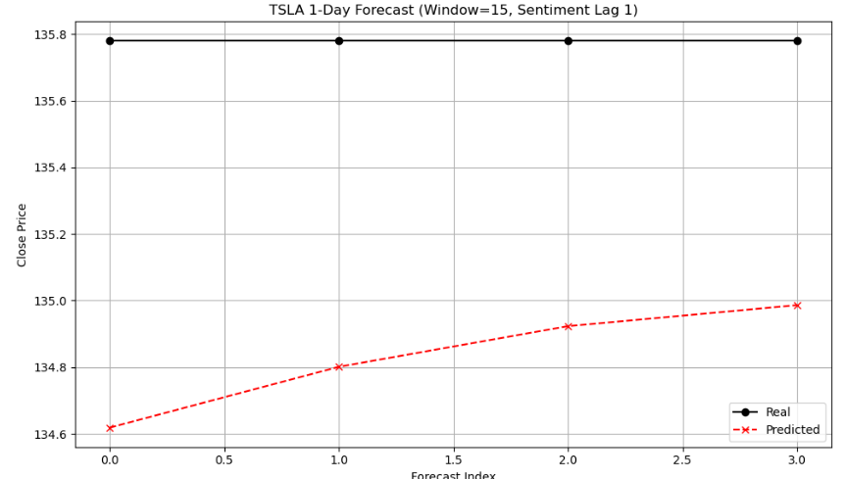  Figure 34 1 day rolling forecast TSLA LSTM | 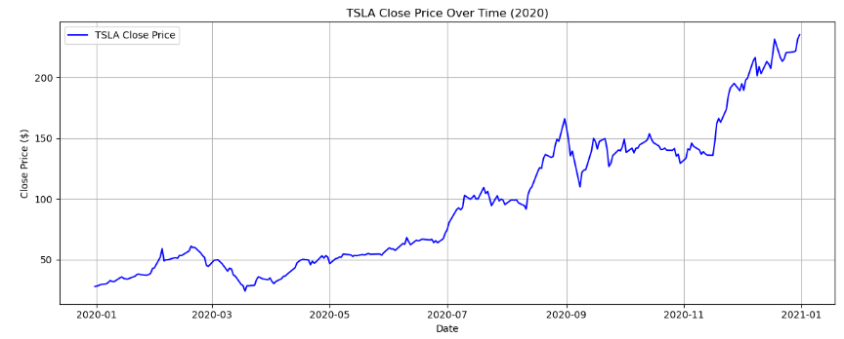  Figure 35 TSLA close.
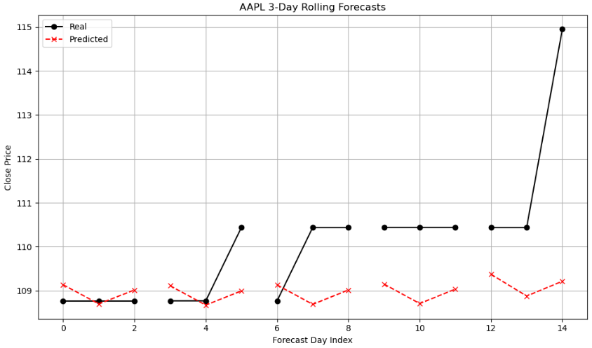  Figure 36 Apple 3-day LSTM rolling. | 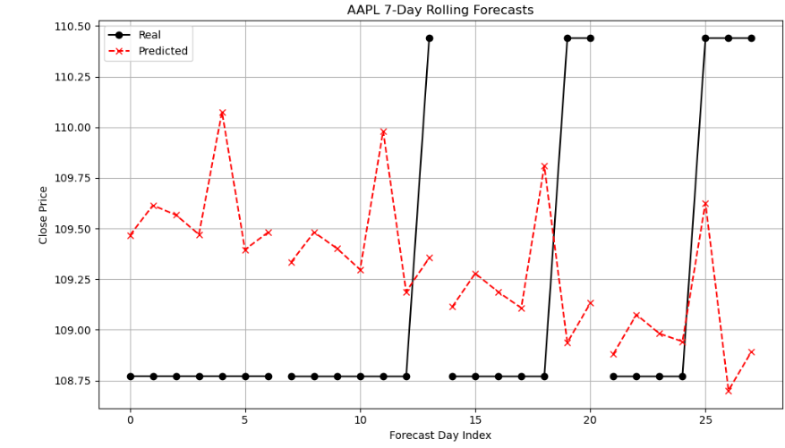  Figure 37 7-day rolling.
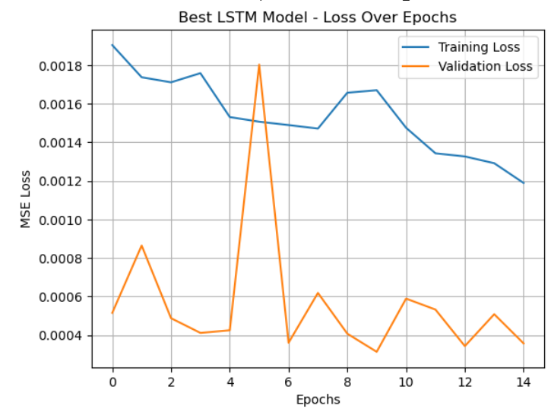  Figure 38 Hyper tuning for LSTM APPL | 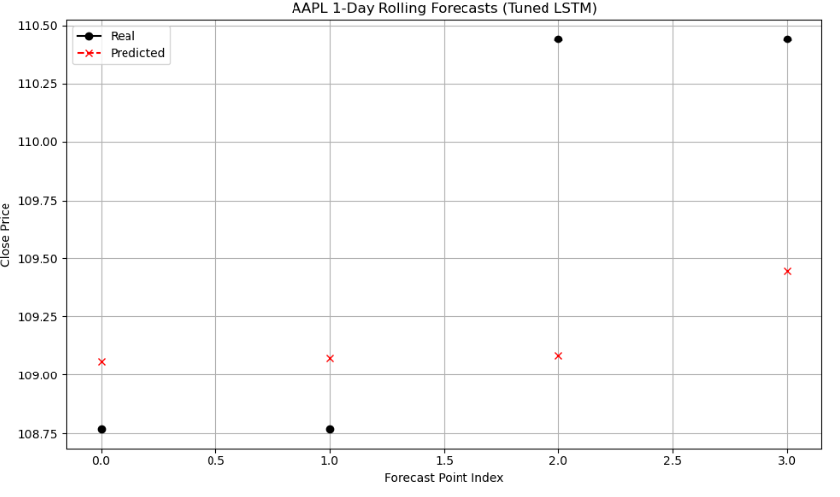  Figure 39 1-day rolling.
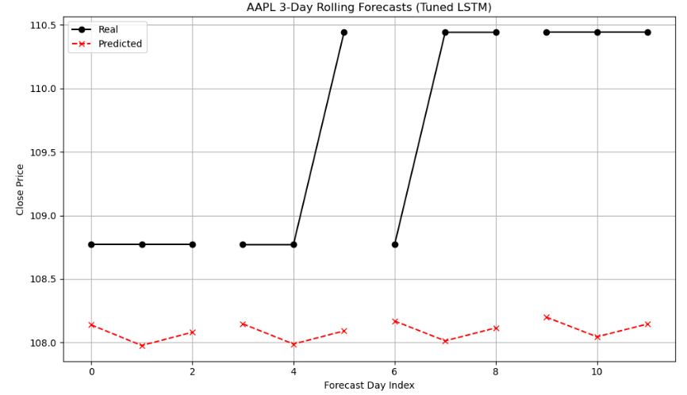  Figure 40 tuned 3-day rolling. | 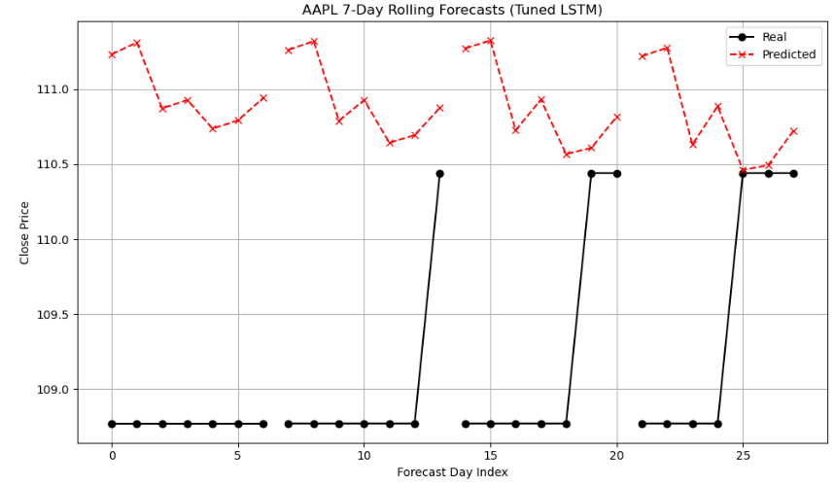  Figure 41 Tuned 7-day rolling.

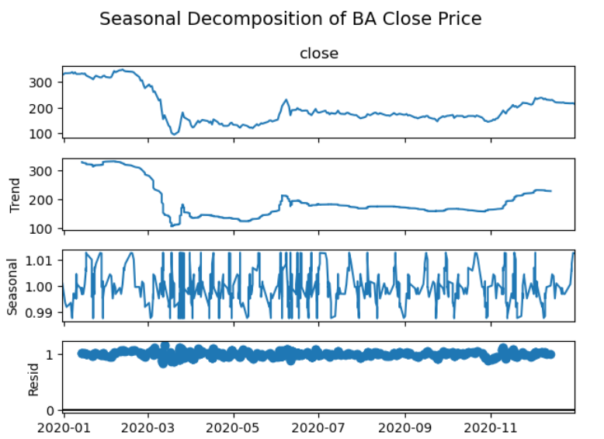  Figure 42 Decomposition for Boeing | 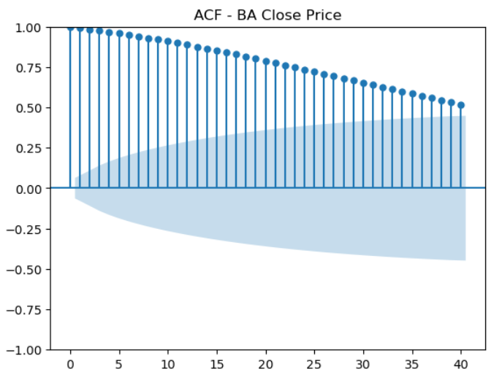  Figure 43 Boeing ACF plot.
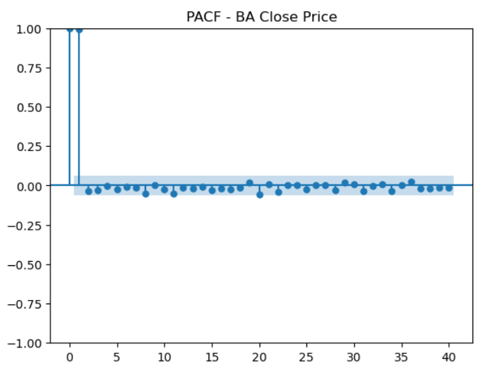  Figure 44 PACF plot Boeing. | 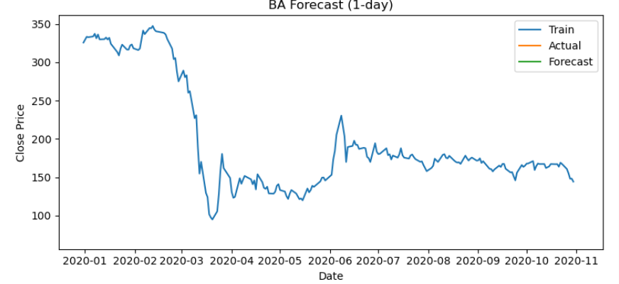  Figure 45 ARIMAX 1 day.
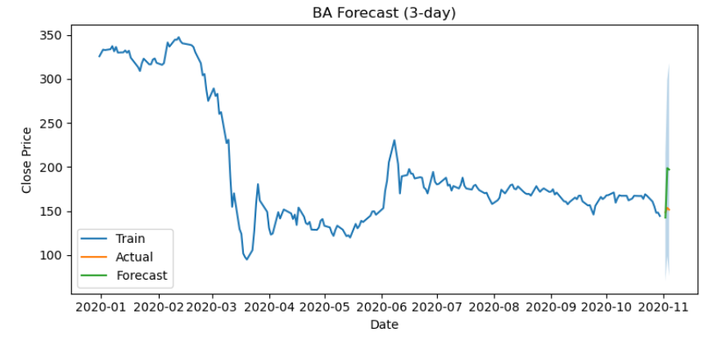  Figure 46 ARIMAX 3 day. | 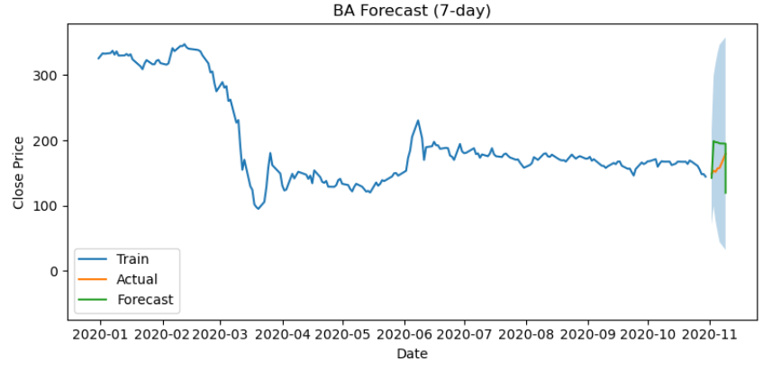  Figure 47 ARIMAX 7 day.
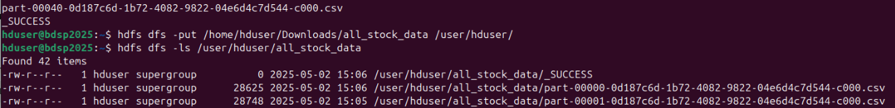
Figure 48 files uploaded to HDFS.
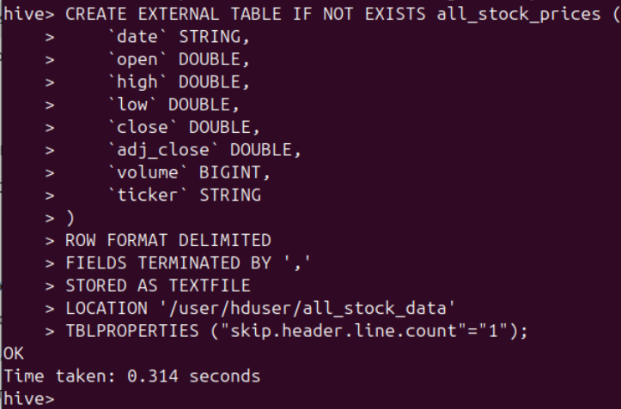
Figure 49 Table created in HIVE.
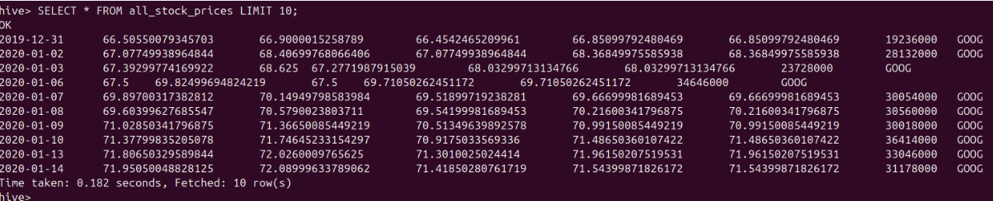
Figure 50 Example of Table created in Hive.
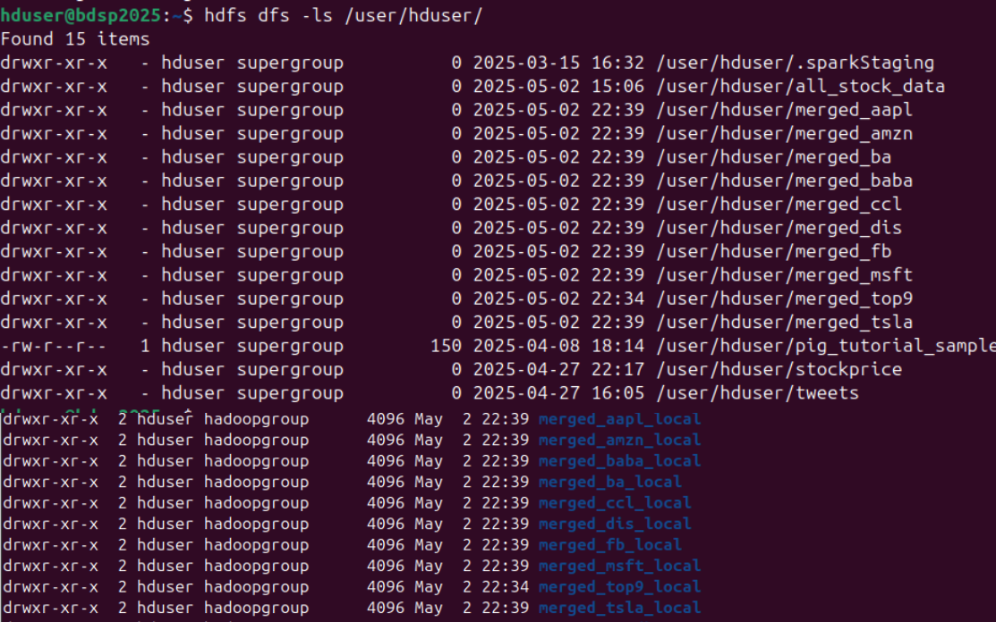
Figure 51 files exported from spark.
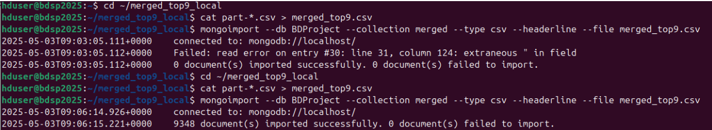
Figure 52 Data added to Mongo successfully.
Figure 53 Temporary file in system ready for reddit posts.
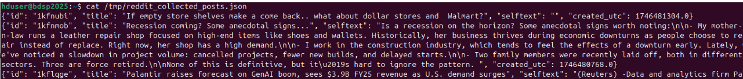
Figure 54: Content of posts.
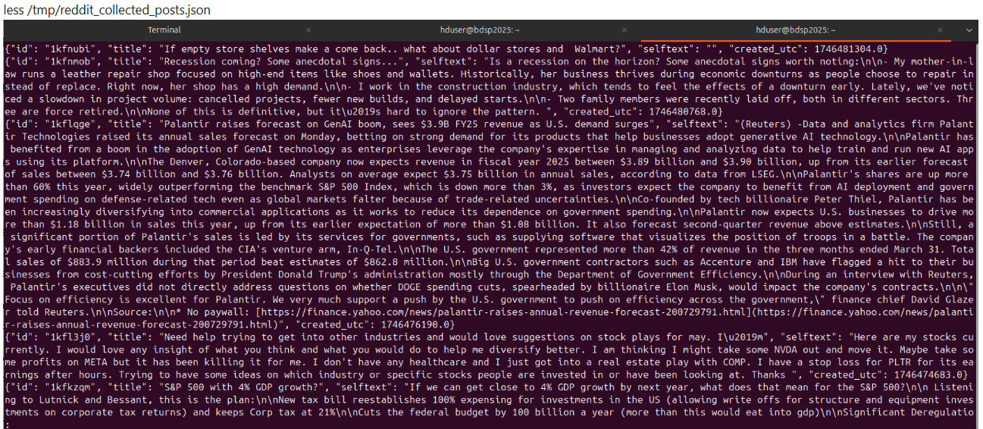
Figure 55: less /temp/reddit_collected_posts.json.
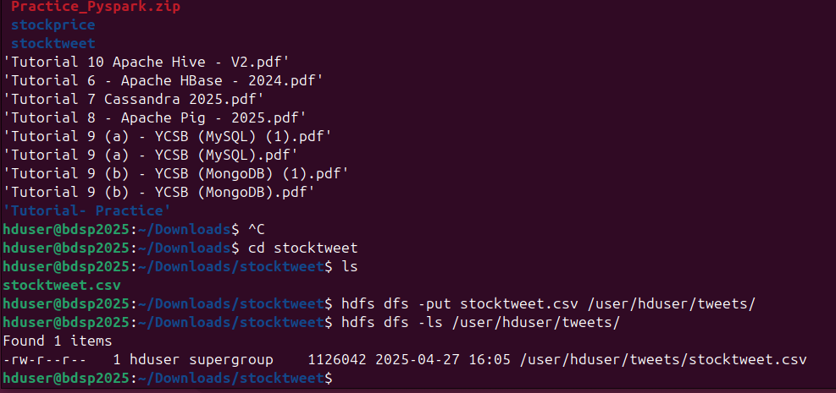
Figure 56: Successfully uploaded stocktweet.csv to HDFS
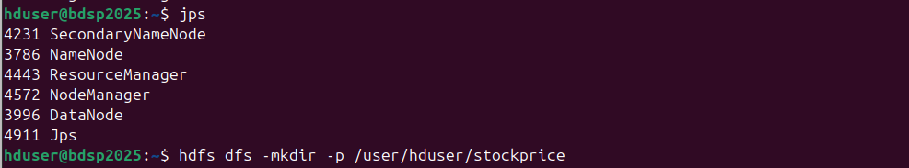
Figure 57: Created HDFS directory /user/hduser/stockprice
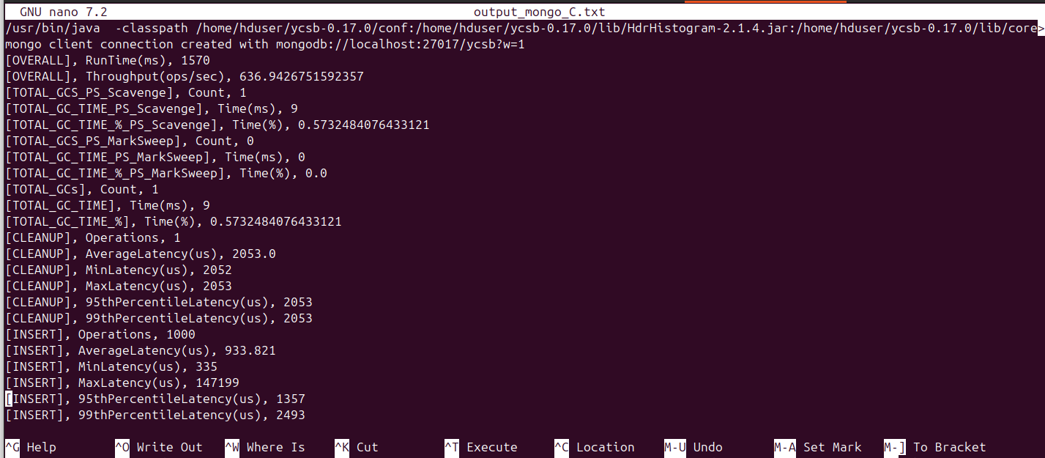
Figure 58: YCSB MongoDB workload C read performance results.
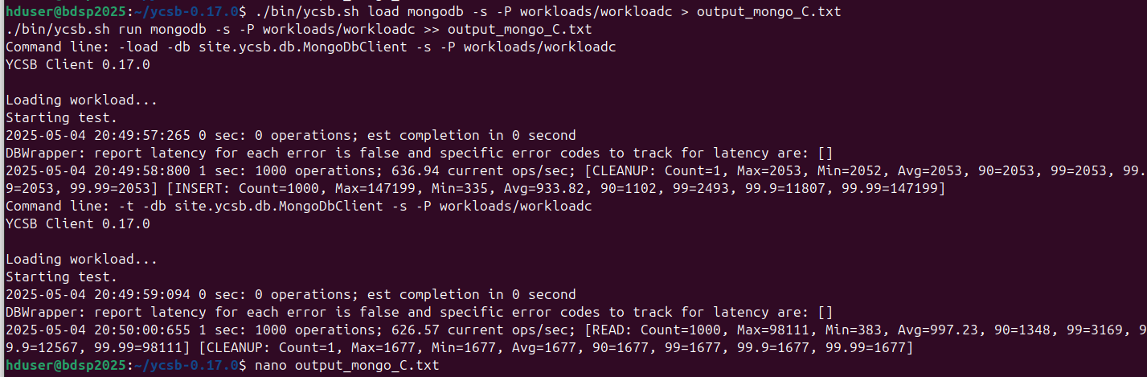
Figure 59: Ran YCSB workload C against MongoDB and saved results to output_mongo_C.txt.
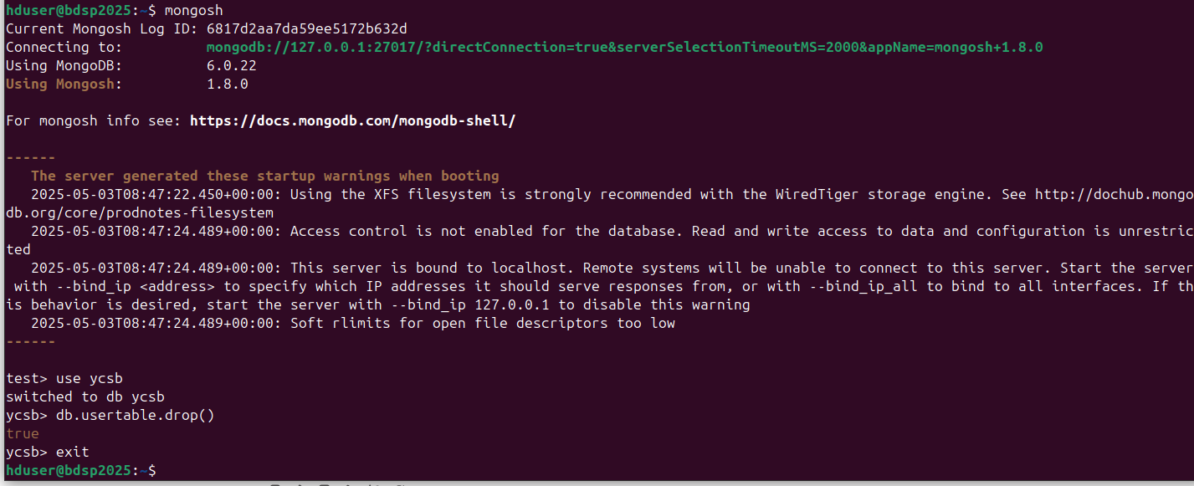
Figure 60: Connected to MongoDB and dropped the usertable from ycsb database.
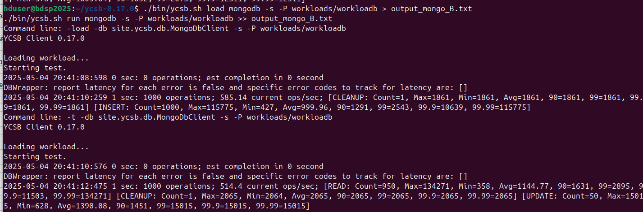
Figure 61: Executed YCSB workload B against MongoDB and logged results to output_mongo_B.txt.
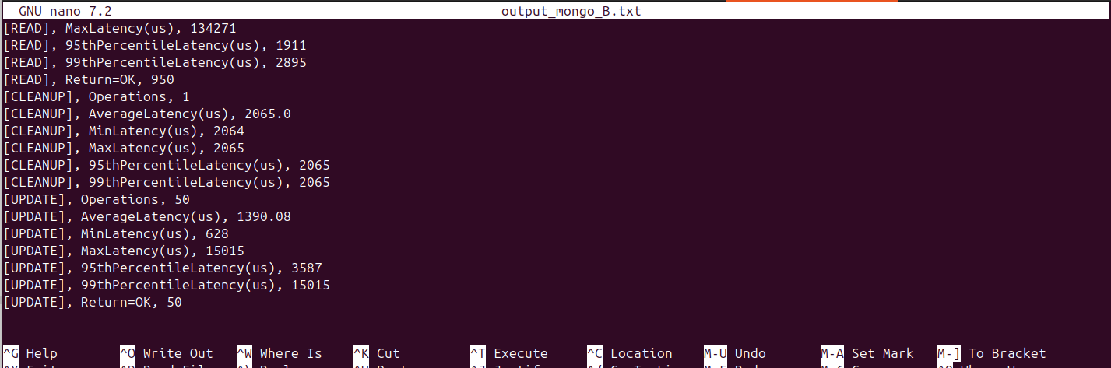
Figure 62: YCSB MongoDB workload B read and update performance metrics.
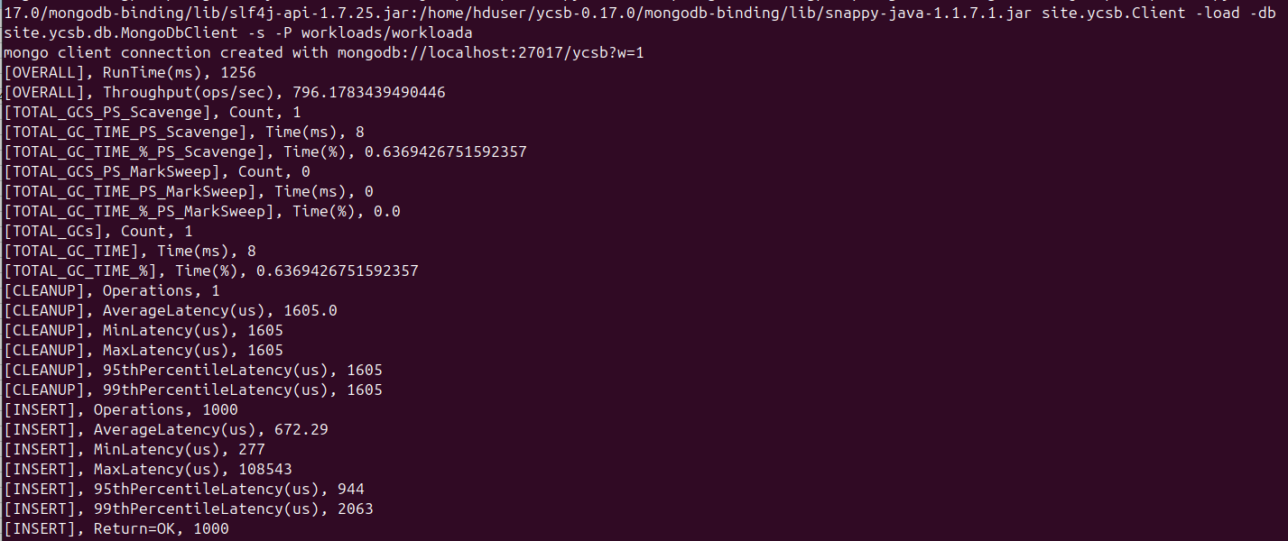
Figure 63: YCSB MongoDB workload A load phase performance summary.
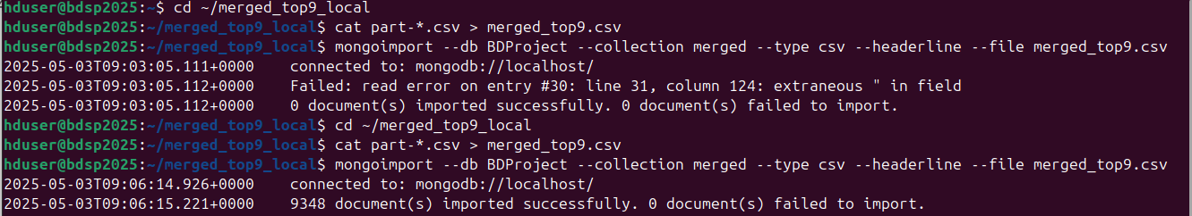
Figure 64: Fixed CSV format issue and successfully imported data into MongoDB.
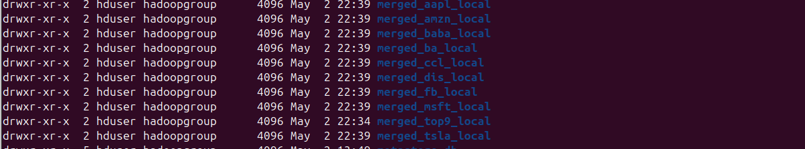
Figure 65: List of merged local directories for individual stock datasets.
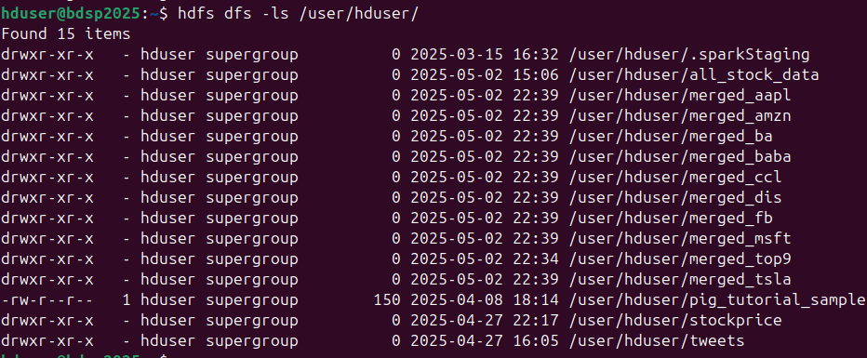
Figure 66: HDFS directory listing showing uploaded stock datasets
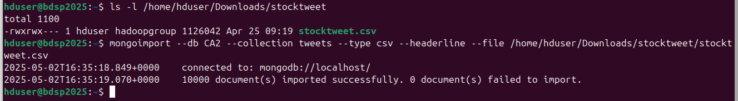
Figure 67: Successfully imported stocktweet.csv into MongoDB CA2 database.
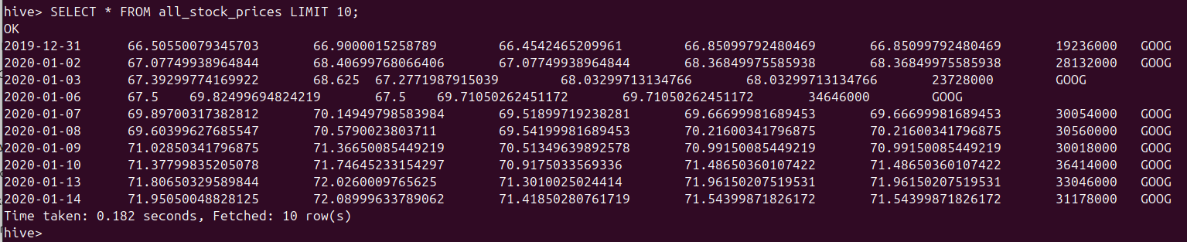
Figure 68: Hive query displaying first 10 rows from all_stock_prices table.
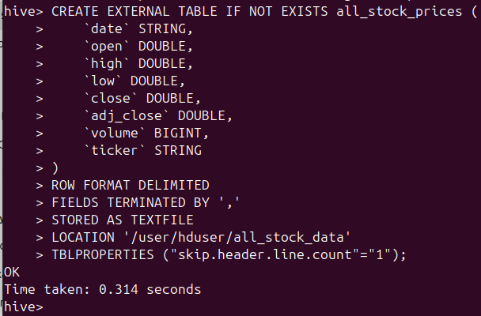
Figure 69: Created external Hive table all_stock_prices pointing to HDFS data.
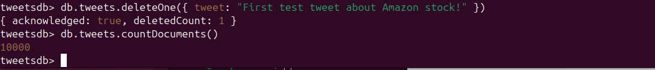
Figure 70: Deleted one tweet document from MongoDB tweets collection.
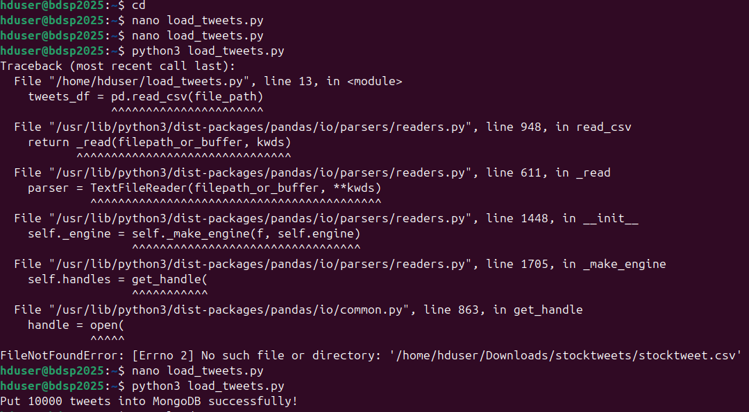
Figure 71: Corrected file path in Python script and loaded tweets into MongoDB.
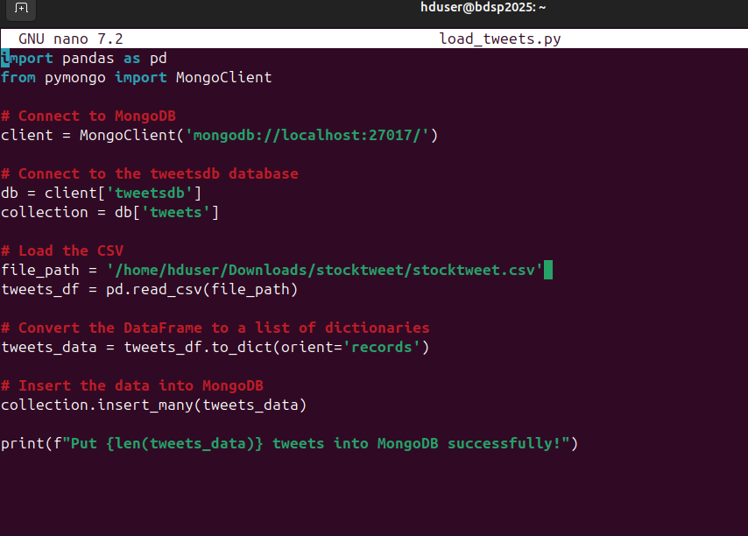
Figure 72: Python script for importing CSV tweet data into MongoDB.
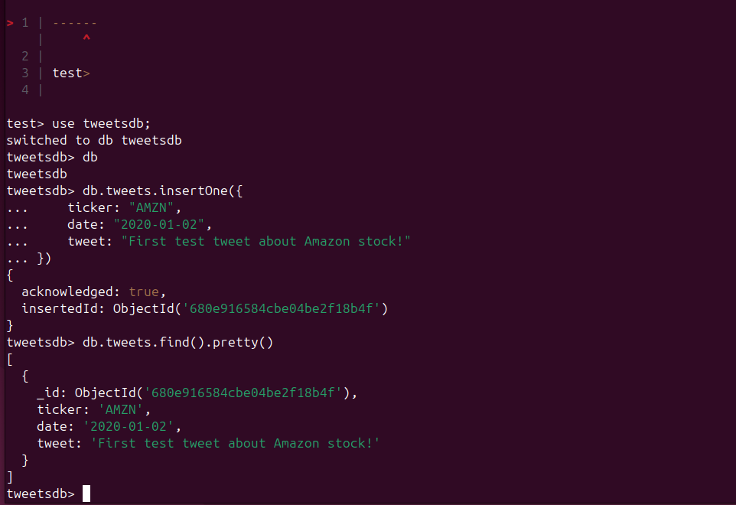
Figure 73: Inserted and verified a test tweet document in MongoDB.
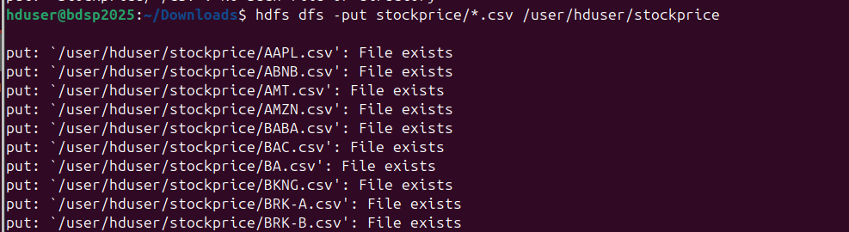
Figure 74: showing all files exist in HDFS
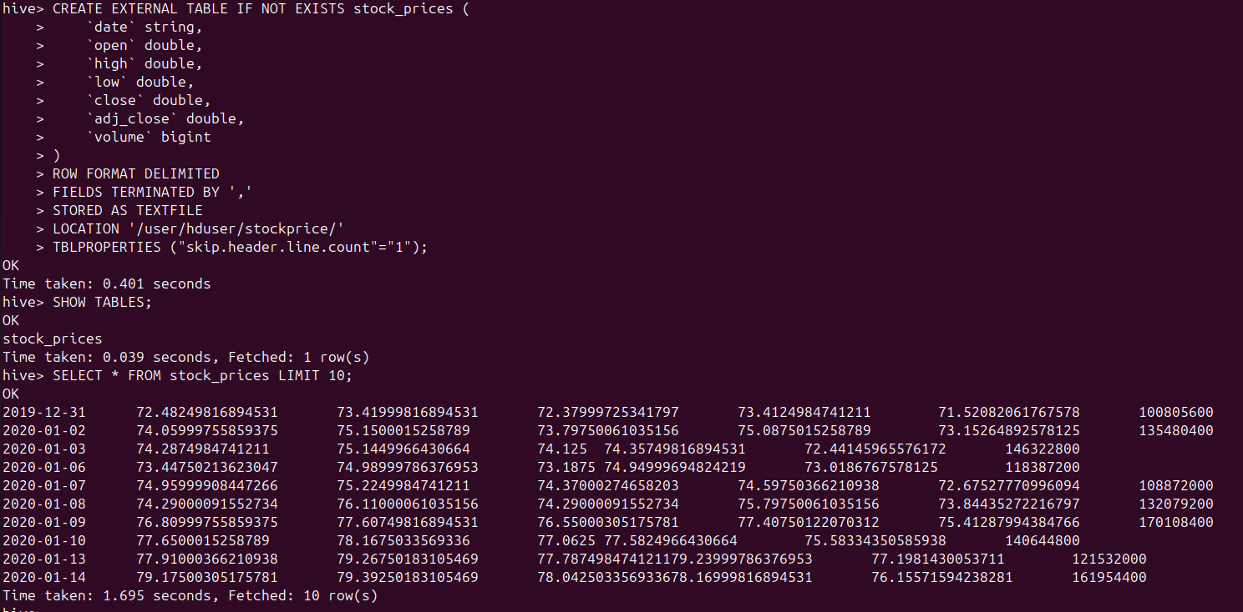
Figure 75: Created and queried Hive table stock_prices from HDFS stock CSVs.
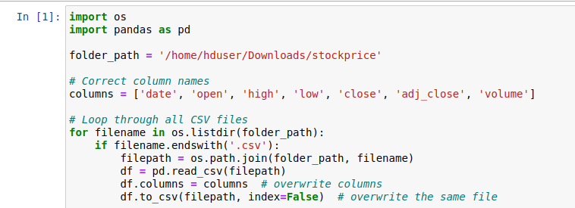
Figure 76: Python script to standardize column names in all stock CSV files.
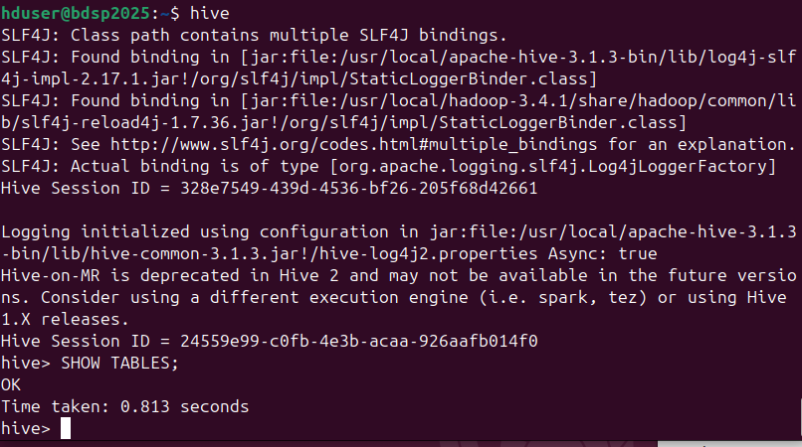
Figure 77: Launched Hive CLI and listed available tables
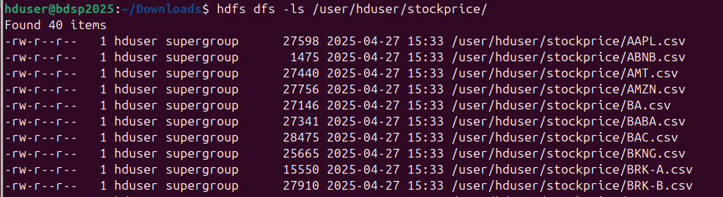
Figure 78: Listed 40 stock CSV files stored in HDFS /user/hduser/stockprice/

