MSC_DA_CA1
Orla Kavanagh

Abstract
This project analyses wheat agriculture in Ireland, comparing it to France and the UK, using Python for data analysis, machine learning, and visualization. Key insights into trends and sentiment dynamics were derived through statistical and predictive modelling. Forum posts were extracted from Forum4Farming.com for sentiment analysis.
Data Acquisition Process
Government and EU Data Sources
All datasets (CSO, FAOSTAT, FADN) were available under the Creative Commons Attribution 4.0 license, allowing free usage with proper attribution.
Sentiment Analysis Data Acquisition
I obtained sentiment analysis data from Forum4Farming.com, a UK and Irish farming community. Finding relevant agricultural data was challenging, but this forum thread on Winter Wheat 2024 contained enough content for analysis. Although I encountered difficulties obtaining data from platforms like Twitter and Reddit, Forum4Farming proved useful.
- Permissions and Licensing: No response was received from my direct request for permission, but the website’s terms and conditions allow for content use under specific conditions. The terms indicate that users grant a non-exclusive, permanent, irrevocable license for content use by the site.
- Robots.txt: There were no restrictions on web scraping, as confirmed by my checks using online tools (e.g., TechnicalSEO, SEOSiteCheckup).
- Data Handling: Efforts to ensure that no personally identifiable information was collected.
Data Processing, Manipulation, and Aggregation from Diverse Sources
Libraries and Techniques for Data Processing
To handle data from multiple sources, I used various libraries and techniques tailored to the specific data formats:
Pandas: The core library for processing CSV and XLSX files. Pandas enables efficient data manipulation through DataFrames, which provide flexibility for analysis and preparation tasks.
- Works well with Seaborn and Matplotlib for visualizations, and scikit-learn for machine learning tasks.
- Enabled easy export cleaned datasets as CSV files for use in Streamlit dashboard, ensuring compatibility and ease of integration.
Key Processing Steps:
- FAOSTAT Data
  - Dropped irrelevant columns using .drop().
  - Analysed categorical data (e.g., "Flag descriptor") with .unique() and .value_counts().
  - Converted data into pivot tables with Year and Area as indices.
- CSO Data:
  - Combined various datasets using concat, ensuring consistent column naming.
  - Adjusted labels for clarity (e.g., renaming "Dublin and Mid East" to "Dublin plus Mid East").
  - Merged datasets on Year, selecting relevant features (e.g., total wheat production).
  - Merged wheat yield and output data by aligning on Year using an inner join, reducing missing data and retaining meaningful matches.
  - Combined similar features (e.g., crop production and yield) which handled NaN values from merging datasets.
- FADN Data:
  - Extracted country-specific data for comparative analysis.
  - Addressed missing UK data post-Brexit by incorporating pre-Brexit data where applicable.
- Forum Data:
Collected unstructured data from forum thread ("Winter Wheat 2024") as follows:
  - Constructed a list of URLs for accessing multiple pages.
  - Parsed HTML with BeautifulSoup to extract comment blocks.
  - Cleaned data using regex, removing irrelevant content such as usernames.
  - Saved processed data to CSV for sentiment analysis.
Library/Technique | Purpose
BeautifulSoup | Parsed HTML and extracted forum comments from multiple pages.
Requests | Sent HTTP requests to fetch raw HTML.
Regular Expressions | Cleaned extracted comments by removing redundant text.
CSV Module | Saved cleaned data in a structured format for analysis.

Optimisation
The following strategies were implemented to enhance the efficiency and performance of the analysis:
Category | Strategy | Details | Trade-offs/Considerations
Resource Optimization | Memory Usage Reduction | Changed float64 to float32 and int64 to int32, reducing memory footprint without accuracy loss. | Slight loss in precision, though no significant impact on outcomes.
 | Use of Pingouin Library | Used Pingouin for hypothesis testing, simplifying code and saving development time. | Limited control over internal processes. Potential for bugs and the need to monitor API updates.
 |  | "This program is provided with NO WARRANTY OF ANY KIND. Pingouin is still under heavy development and there are likely hidden bugs. Always double check the results with another statistical software."
Dataset Optimization | Slicing & Dropping Columns | Removed unnecessary columns to streamline datasets and improve clarity. | Potential loss of data relevant for future analyses.
 | Efficient Data Extraction | Used BeautifulSoup to parse HTML data efficiently, ensuring structured, memory-light datasets. | Initial learning curve and manual handling of HTML inconsistencies.
Code Optimization | Modular Programming | Divided tasks into reusable functions for better readability and maintainability. | Required additional upfront time for implementation.
Data Storage | Efficient Storage with CSV | Chose CSV for compatibility and ease of sharing, suitable for Streamlit integration. | Could explore Parquet or Feather for improved disk space optimization in larger projects.
Model-Specific Optimization | Hyperparameter Tuning | Used GridSearchCV and GCV to optimize machine learning models systematically. | Increased computational cost due to exhaustive search.
 | Dimensionality Reduction | Selected features manually to simplify models and speed up training. | Risk of omitting features that could be relevant for future analysis.
Vectorization | Using Numpy & Pandas | Employed vectorized operations for faster preprocessing and analysis than traditional loops.

Benefits of this optimisation were: faster execution times for preprocessing and analysis tasks; Reduced memory consumption; Increased clarity and maintainability of the codebase.
Exploratory Data Analysis (EDA) and Data Cleaning for Machine Learning
Initial Data Exploration
To begin my analysis, I used several basic commands such as .describe() and .info() to inspect the structure of my datasets. These commands provided a snapshot of the data, including the number of non-null values, data types, and basic statistical metrics like mean, median, and standard deviation. This helped to assess the spread of data (standard deviation) and identify potential skewness or symmetry (comparing mean and median).
To understand the distribution of values in different features, I applied .unique() and .value_counts(). This enabled me to see how different values were distributed across the dataset, allowing me to identify any inconsistencies, anomalies, or irrelevant features.
I also used .head() to quickly check the first few rows of the dataset, confirming that the data slicing and manipulation I had done was effective and that I had set the correct index and headers.
Data Visualization
To further explore the data, I visualized it using various plotting techniques. One of the first visualizations I created was multiplot (cell 35), which allowed me to view several variables at once and gain insights into potential missing data. Additionally, I used line plots with Year on the x-axis to display trends over time. By plotting multiple variables on the same grid, I was able to directly compare their trends (e.g., cell 34).
To assess the symmetry and distribution of the data, I employed box plots (cell 40). Symmetrical distributions in these plots suggested that certain data might be normally distributed, which could be useful for the statistical analysis in later sections. I also used heatmaps to visualize correlations between variables, helping to identify which features were most strongly associated with each other, which could inform feature extraction for machine learning models.
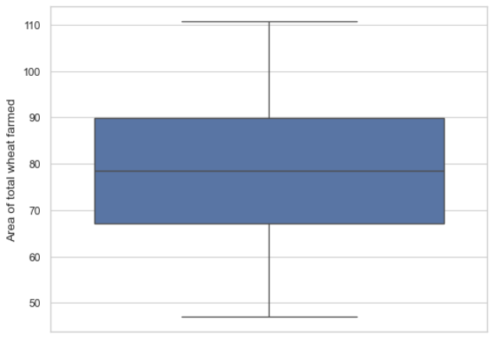 | 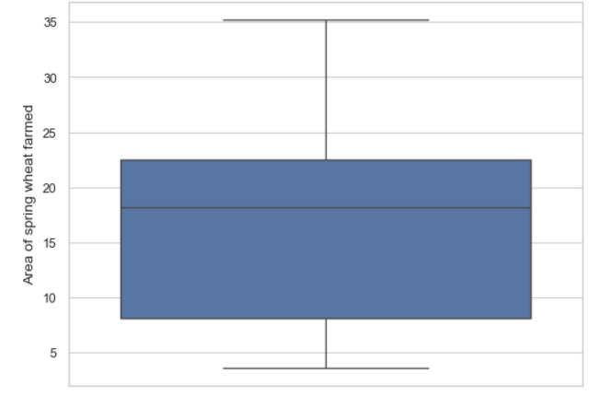 | 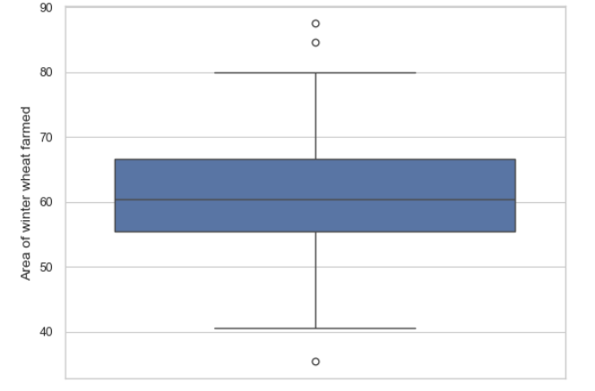

Handling Outliers and Testing for Normality
While performing the exploratory analysis, I identified outliers in the data. I examined these outliers by plotting trend graphs (e.g., cell 44) to determine if they were part of a larger trend or if they should be removed. In cases where the outliers appeared to fit into an overall upward or downward trend, I decided to retain them for further analysis.
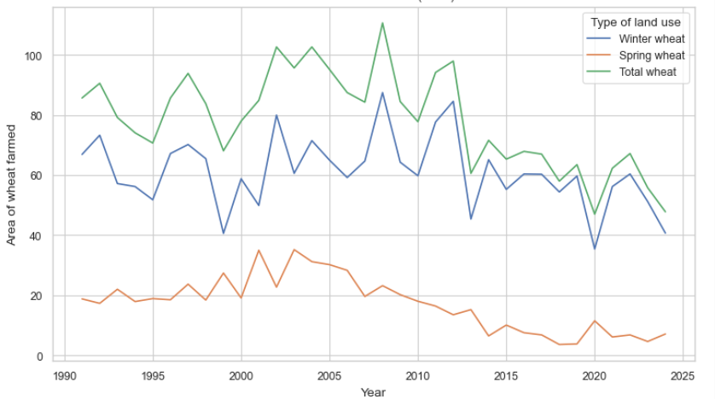 | 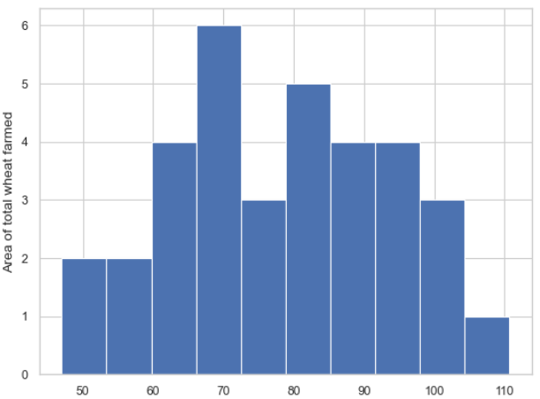 | 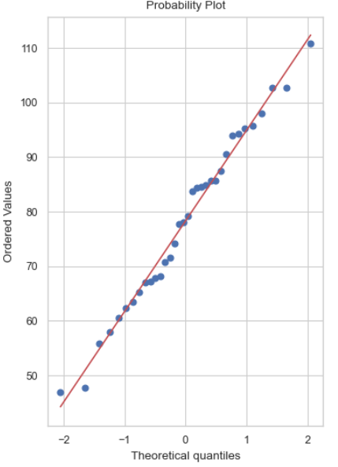

For normality testing, I started by plotting histograms of various features, adjusting the number of bins to better visualize the distribution. For distributions that appeared normal, I confirmed normality using a QQ plot and the Shapiro-Wilk test (which I will explore further in the statistics section). Notably, when I looked at wheat yield data across different countries, I found that data for most wheat types appeared normally distributed, so I kept the outliers in the dataset. (see cells 39-60 for all graphs)
Cost Data
When analysing the cost data, I applied similar methods—using trend lines to assess how cost-related features changed over time. I also performed a multiple box plot to identify features that were likely normally distributed and then investigated them further. (see cells 93 to 122 for all graphs)
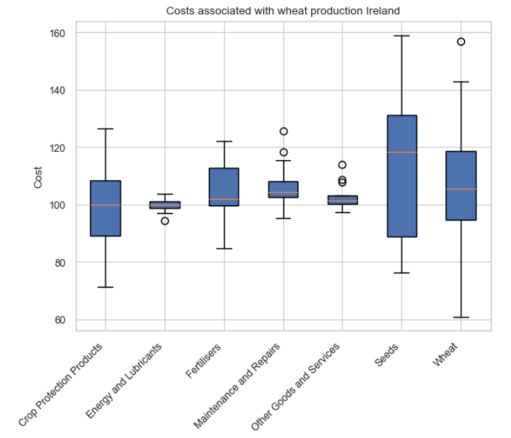 | 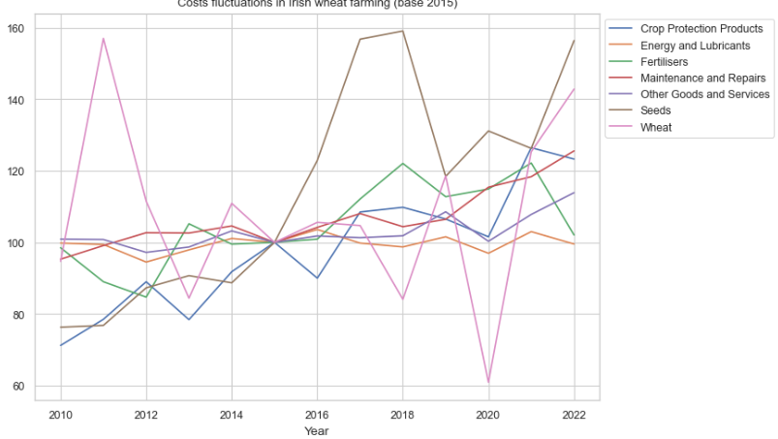
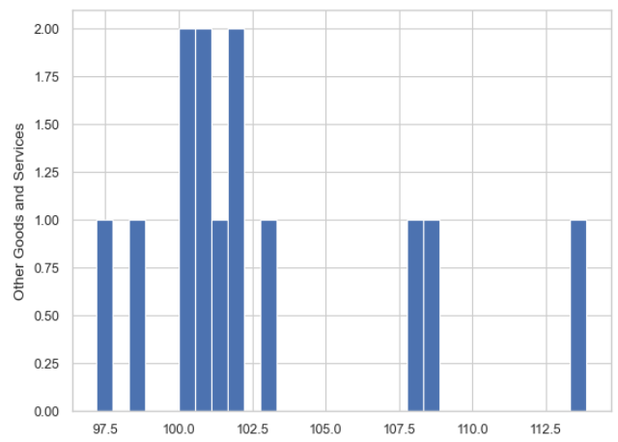 | 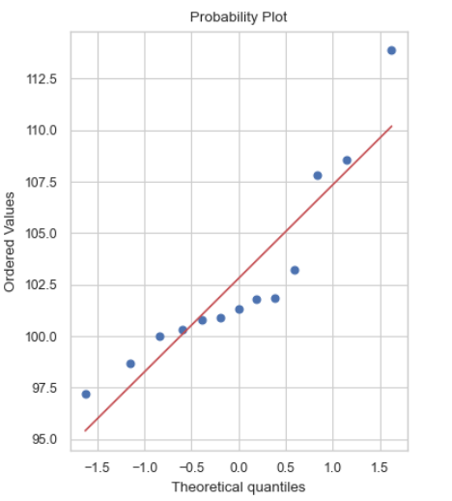

I tested normality in the same way as before but also utilized the pingouin library for faster analysis. This library allowed me to quickly perform the Wilks test statistic, providing a p-value and assessing the normality of the data. This was particularly helpful when working with the fra_irl_uk dataset, which is discussed in the Statistical section, where normally distributed features were chosen for further analysis.
Inferential Statistics and Population Analysis (cells 129-160)
Population Mean Analysis Using Irish Wheat Data
To analyse the population mean values for the Irish Wheat dataset, I began by looking at specific variables such as the mean wheat yields, proportions of winter wheat from the total wheat crop, and wheat as a proportion of all cereals. Additionally, I considered the mean values of different costs, excluding the "Other goods and services" category. For population mean calculations, I utilized the "mean" value from the .describe() table of each dataset and compared it to the sample mean to assess whether the assumed population means were sensible.
Hypothesis Testing for Population Mean
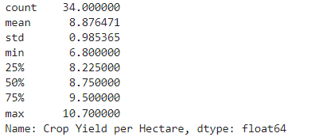
The null hypothesis in each case was that the population mean equalled the mean obtained from the .describe() table. The alternative hypothesis suggested that the sample mean differed significantly from this value. I used t-tests for normally distributed features to validate these hypotheses. For features with smaller sample sizes, such as those in the costs dataset, I relied on t-distributions due to their appropriateness for small datasets.
However, a key limitation in my calculations was that both population and sample estimates were derived from the same dataset. This method risks confirming the population mean simply because it is based on the same data generating the sample. Ideally, a separate sample dataset would provide a more robust validation of population mean estimates.
Focusing on the "Crop Yield per Hectare" feature with 34 data points, I calculated the population mean from the entire dataset and compared it to the average yield from the most recent five years. The intention was to see if focusing on recent data might indicate a change in the mean yield over time.
Using the t-statistic and a two-tailed test, I found no evidence to reject the null hypothesis. This suggested that the mean yield from the most recent five years was not significantly different from the overall population mean.
To calculate the confidence interval for the population mean of wheat yield, I used the Central Limit Theorem (CLT), as the sample size exceeded 30 and the data was approximately normally distributed. With a 95% confidence level, the confidence interval confirmed the validity of using this estimate.
Proportion Analysis of Wheat and Winter Wheat
I calculated a 95% confidence interval for the proportion of wheat relative to total cereals in Ireland. Using the sample proportion (̂p) and standard error formula for proportions, the confidence interval indicated that wheat consistently accounted for less than half of total cereal output. However, the wide interval suggested significant variation in proportions across years.
Similarly, I computed the confidence interval for winter wheat as a proportion of total wheat. The results confirmed that winter wheat comprised the largest share of total wheat production, despite another wide confidence interval, reflecting annual fluctuations.
Cost Dataset Population Analysis
For the costs dataset, I aimed to estimate the population mean for various costs, including "Crop Protection Products," "Energy and Lubricants," "Fertilizers," "Maintenance and Repairs," "Seeds," and "Wheat." Due to the small sample size (14 rows), I used a t-distribution to calculate confidence intervals for these features, which were all normally distributed based on exploratory data analysis.
For "Crop Protection Products," I calculated the sample mean, standard error, and a 95% confidence interval using the t-distribution.
This method was repeated for the remaining features in the dataset (cells 156- 160) . The confidence intervals for these features provided reliable estimates of their population means, despite the small sample size.
Comparison of Countries
I chose to compare Ireland with France and the UK, focusing on three features: Fertilizer cost per farm, yield of wheat, and energy cost per farm.
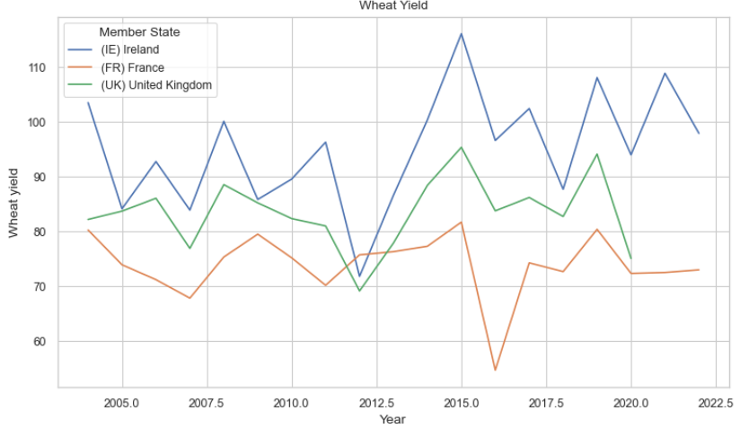 | 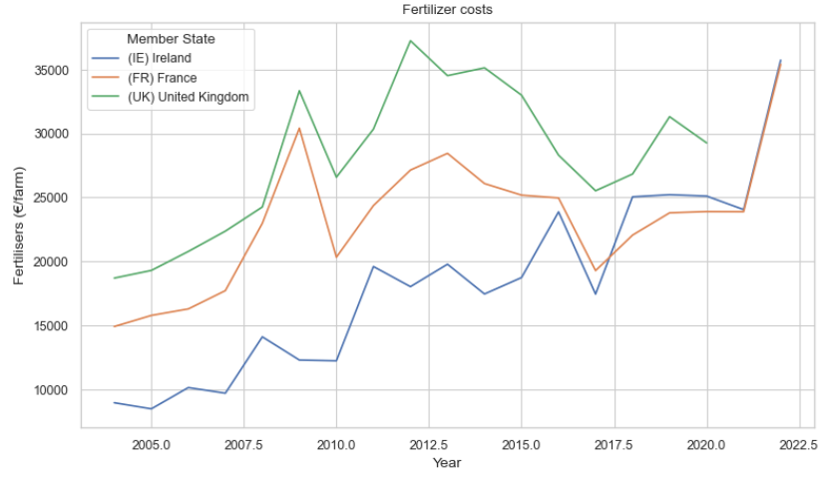
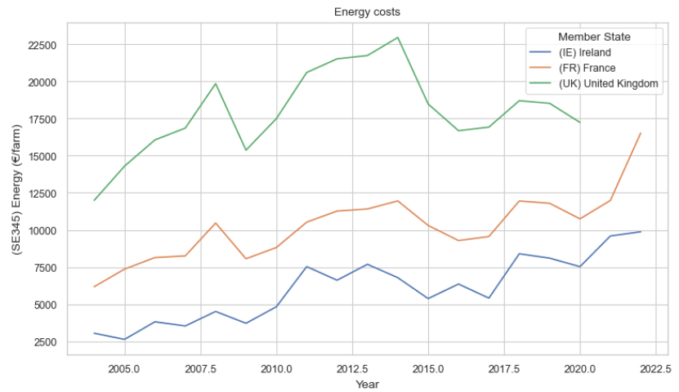
The test I aimed to complete for these features was a one-way ANOVA, to see if there differences between the means of these countries. The assumptions for this test are: Normality, Homogeneity of variances, Independence of observations. Testing for these and then changing paths meant I used many different parametric and non-parametric tests. I made use of the pingouin library to do most of these tests.
To test for normality, I used the Shapiro-Wilk test. The only feature that failed this was France’s wheat yield.
Fertilizers (€/farm) | 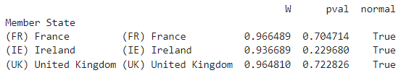
Yield of Wheat (q/ha) | 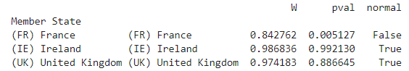
Energy (€/farm) | 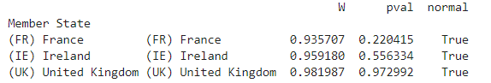

The dataset only had 19 rows; I decided use wheat yield from FAOSTAT dataset. This larger dataset could negate the need for normality by CLT. But normality tests on the new data showed that neither of the countries yield data was normal. A closer examination of the line graph revealed a change in trend between yield from 1960 to 1990, and 1990 to 2020. I decided to focus on data from 1990 onwards, which was normally distributed for each country.
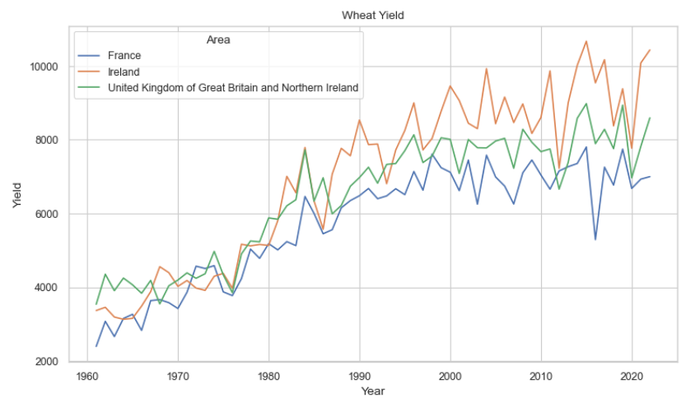
I checked for homogeneity of variances using Levene’s test (cell 183, 201, 221). For the yield data, this test returned a significant result, so ANOVA was not applicable. I opted for Welch’s ANOVA (cell 185), which is robust to unequal variances. The test was significant, suggesting a significant difference between the countries' mean wheat yields, consistent with the trends observed in the line graph. In hindsight this was not a suitable test as the assumption of independence was violated, which I learned when testing with Pearson’s (significant for UK vs Ireland but not France vs Ireland), and Spearman’s (significant for France vs Ireland), after noticing similar trends in their line graphs.
To determine which countries differed from each other, I applied Tukey's HSD (Honestly Significant Difference) test, which requires normally distributed data (cell 187). All assumptions for this test were met, and the results where significant, indicating that the means of each pair of countries were significantly different.
As the data was not independent, I used Friedman’s test and the Wilcoxon signed-rank test(cell 194-196). As expected, the results were significant, confirming the differences in wheat yields between the countries.
Back to energy and fertilizer costs, which were normally distributed. I ran Levene’s test on both which did not indicate significant differences in variances. Next, I tested for independence using Pearson’s correlation (cell 202). This was significant for energy costs and fertiliser costs. The assumption of independence was violated
I decided to conduct a paired t-test, which requires normally distributed differences between pairs of values. To verify this, I calculated the differences between relevant slices of the datasets, graphed histograms of the differences, and checked for normality with a QQ plot and Shapiro-Wilk test (from cell 204).
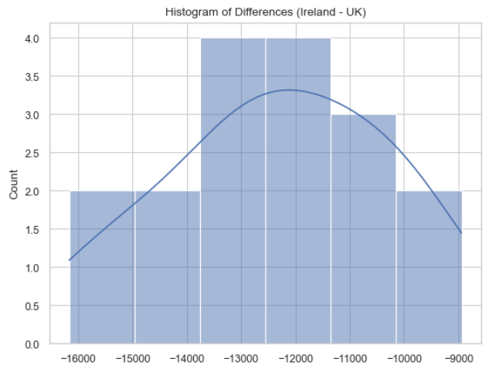 | 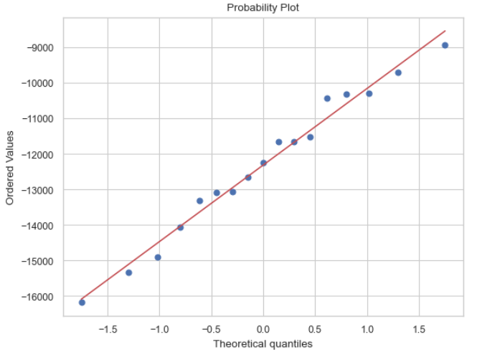

After this analysis a paired ttest was deemed suitable for all but fertilizer costs between France and Ireland as their differences were not Normally distributed. I applied the Wilcoxon signed-rank test on this data, which indicated a statistically significant difference in fertilizer costs between the two countries.
The UK data had no post-Brexit entries which raised a warning when performing paired ttest. I resolved this by adjusting the dataset.(cell 214)
The results of the paired ttests for Ireland and UK fertiliser, Ireland and France energy, and UK and Ireland energy were all significant. Indicating a statistically significant difference between their respective values. The tests comparing UK and Ireland each returned large t-values suggesting a big difference between these countries.
Conclusion: there are substantial differences in wheat yield, energy costs, and fertilizer costs between the countries.
Machine Learning Analysis
To address the challenges posed by the dataset, I explored both unsupervised learning (clustering) and supervised learning (regression and time series prediction). The rationale for choosing these approaches was to group countries with similar wheat-related data for clustering, and to predict key features like fertilizer costs or wheat stock prices for regression and time series models. Various hyperparameter tuning techniques, such as GridSearchCV, and feature engineering methods, including correlation analysis and dimensionality reduction, were employed to improve model performance.
1. Unsupervised Learning: Clustering with K-Means
To group countries based on similar wheat-related features:
- Data Preprocessing: Missing yield values were imputed using the country-specific median to preserve regional patterns. Remaining rows with missing yield values (indicating no yield data) were dropped. A StandardScaler normalized the dataset for improved clustering performance.
- Model Selection: I used K-Means clustering and applied the elbow method to determine the optimal value for number of clusters.
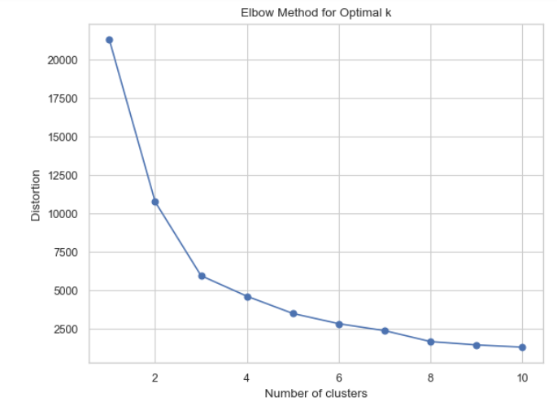
- Visualization: A choropleth map was created with clusters visualized over time, allowing for easy identification of changes in cluster composition year on year.
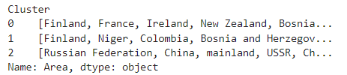
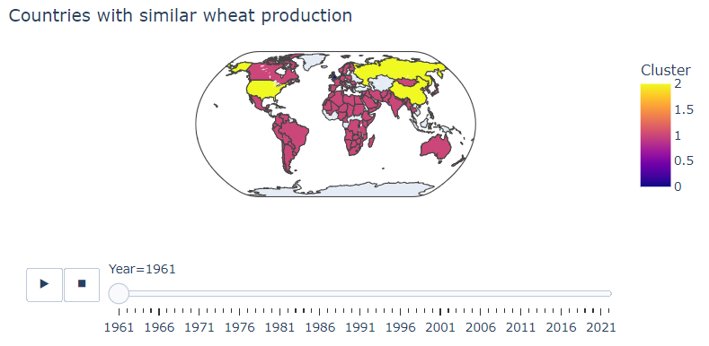
2. Supervised Learning: Regression Models
To predict fertilizer costs, I experimented with multiple regression models, but encountered several challenges:
Data Preparation: Fertilizer cost was chosen as the target variable due to its strong correlation (≥ 0.5) with other features (deduced from .corr() table). Data was scaled using StandardScaler for normalization. A train-test split (70%-30%) was used to ensure adequate training data given the dataset’s size.
Model Selection and Outcomes:
Random Forest Regressor: Despite hyperparameter tuning with GridSearchCV, the model overfitted and performed poorly.
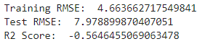
I tried this model again with a different dataset and performed feature selection again on values that correlated well with “Fertilisers”. Using a heatmap to visualise feature correlation
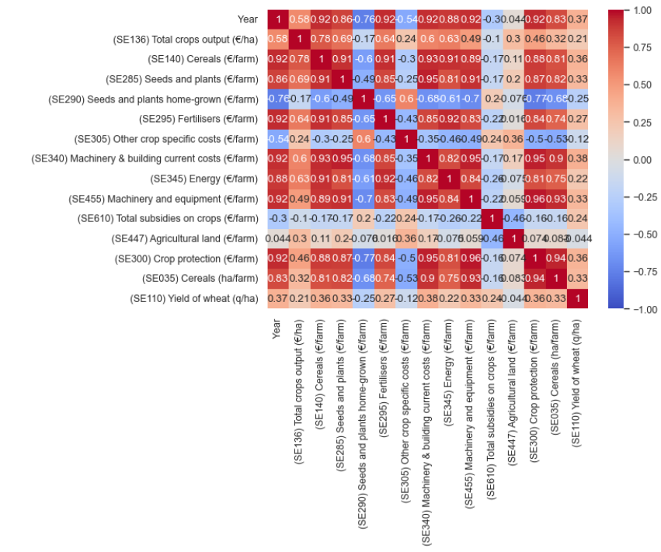
Post- feature selection. Strong correlation only
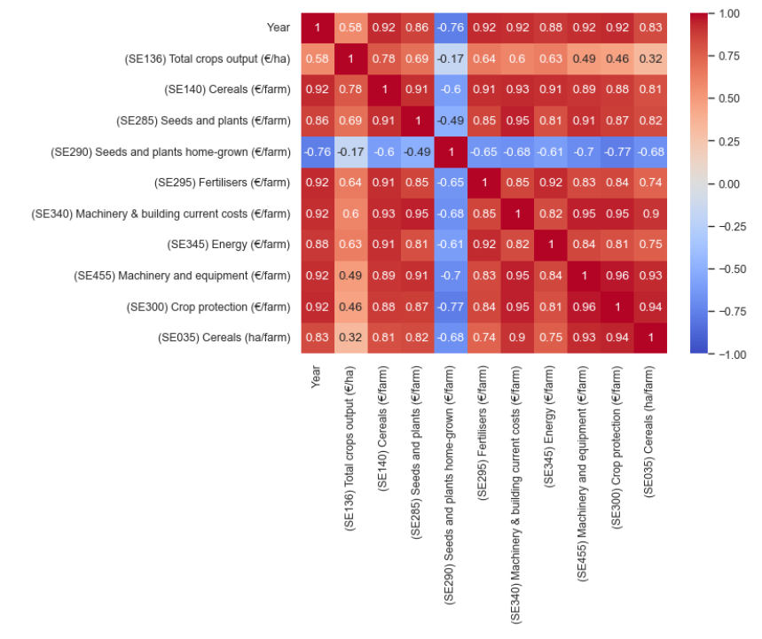

Linear Regression, Decision Trees, k-Nearest Neighbours (k-NN), and Support Vector Machines (SVM): All models failed to deliver satisfactory accuracy, even after feature selection and hyperparameter optimization.
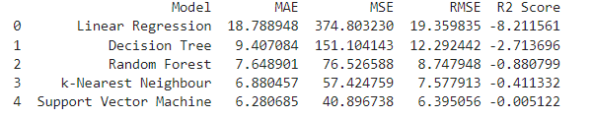
The dataset's small size (13 rows in first instance, 17 in second dataset) likely contributed to the poor performance across regression models. High noise and limited feature correlation impeded effective model training.
3. Exploratory Analysis: LOESS
Given weak linear relationships in the data, I explored LOESS for non-linear regression:
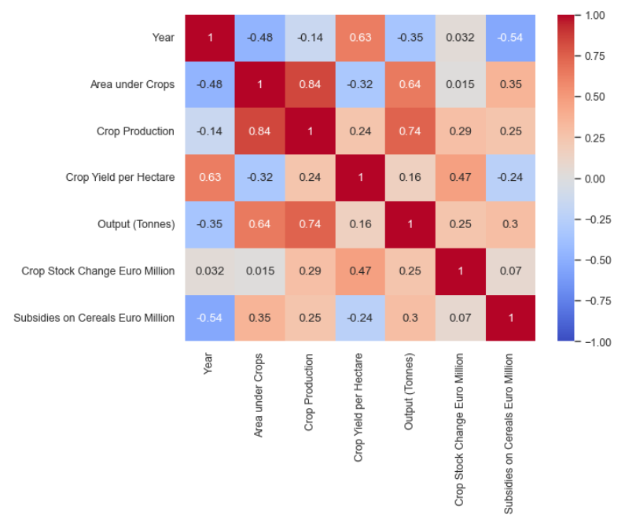
Preprocessing: Missing data was handled, and numeric columns were scaled, excluding the year. The GCV method was used to select the smoothing parameter, frac. GCV value caused overfitting, so code had to be adjusted to encourage higher frac value.
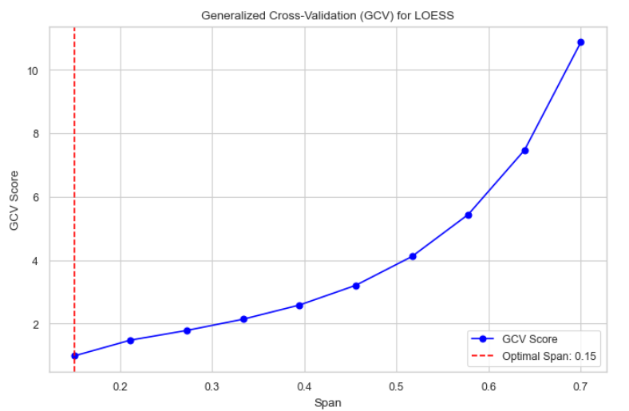
Outcomes: The model struggled with overfitting, particularly when frac values were low. 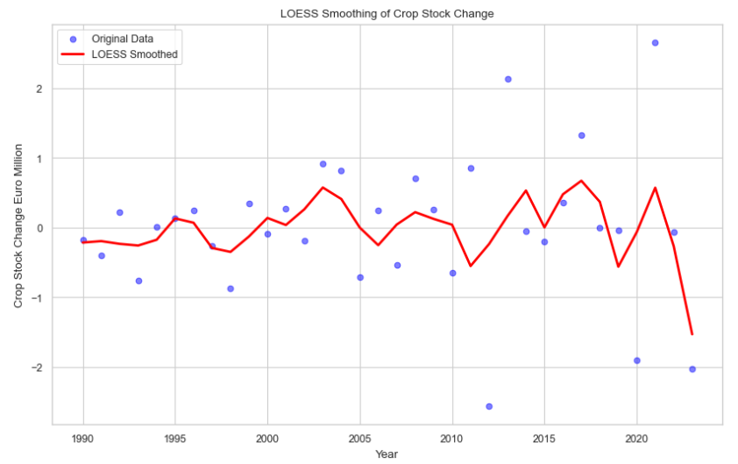 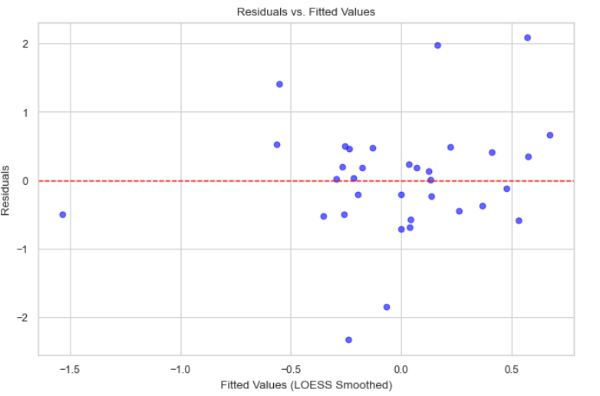
The model captured minimal variability and had limited predictive power, I deemed it unsuitable for the data.
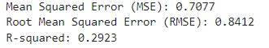 | 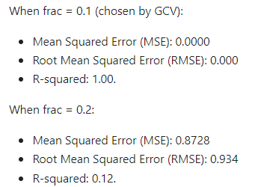

4. Time Series Analysis
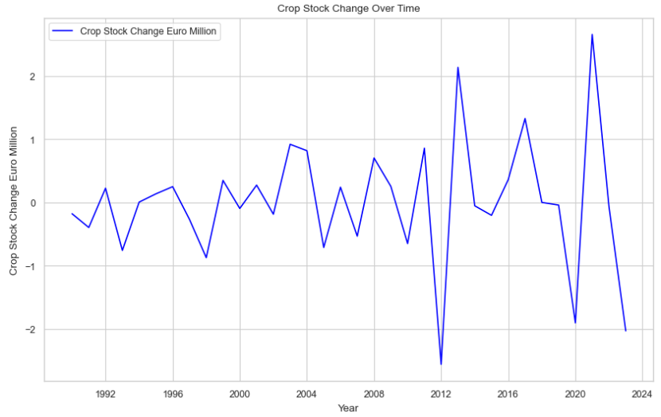
I applied time series models to predict wheat yield in Ireland and crop stock value:
Preprocessing: Missing values were addressed, and the dataset was converted to a time-series format. The ADF test confirmed stationarity (no need for seasonal adjustments).
Modelling: Initial ARIMA models performed poorly with low R² values.
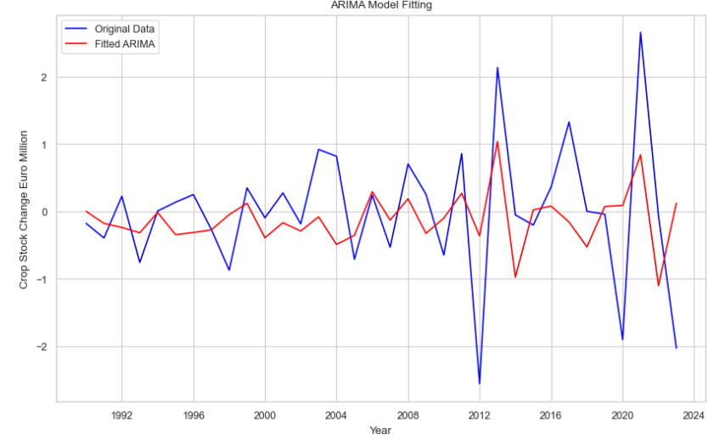 | 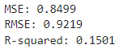

Using auto-ARIMA improved performance by optimizing p, d, and q.
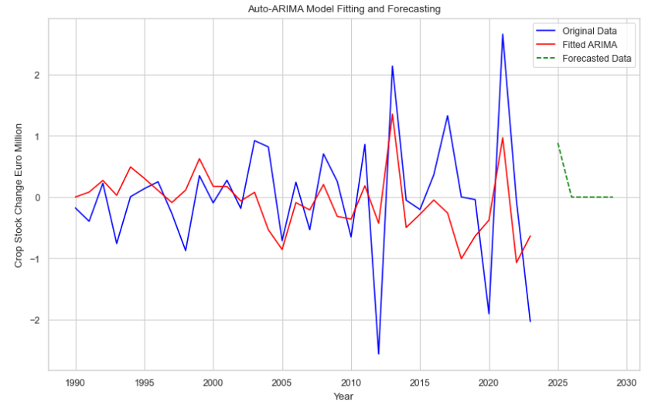 | 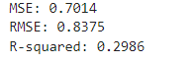

The final model predicted the next five years, though it tended to converge toward the mean after two years. Unscaled RMSE for crop stock predictions was 9.35 million Euros, reflecting significant prediction errors.
I repeated the same process to get predictions for wheat yield per hectare.
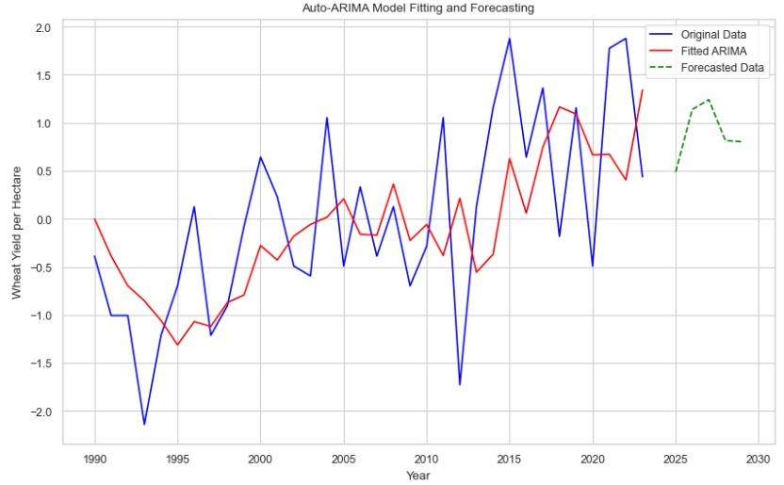 | 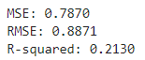
I created a new data frame including the forecasted values, unscaled for visualisation in Streamlit dashboard.
Comparison of Model outcomes:
Model | MAE | MSE | RMSE | R² Score
Linear Regression | 18.79 | 374.80 | 19.36 | -8.21
Decision Tree | 9.41 | 151.10 | 12.29 | -2.71
Random Forest | 7.65 | 76.53 | 8.75 | -0.88
k-Nearest Neighbour | 6.88 | 57.42 | 7.58 | -0.41
Support Vector Machine | 6.28 | 40.90 | 6.40 | -0.01
LOESS | N/A | 0.71 | 0.84 | 0.29
Time Series (Crop) | N/A | 0.70 | 0.84 | 0.30
Time Series (Wheat) | N/A | 0.79 | 0.89 | 0.21
LOESS and Time Series models show relatively better R² scores compared to other models as they are more suited to localized and sequential data. The relatively low R² scores across these models suggest pot the need for additional relevant data to better explain variance.
Text Data Analysis for Sentiment and NLP
Exploratory Data Analysis (EDA)
I conducted basic text statistics on the forum posts related to wheat farming, including word count, character count, and average word length. These statistics revealed patterns, such as whether shorter comments exhibited distinct sentiment patterns compared to longer ones. Additionally, I quantified stop words, special characters, numeric values, and uppercase words to assess the content's meaningfulness and prepare it for analysis.
To ensure data consistency, I handled missing values by removing rows with null entries in the "Thread Content" column. Text standardization involved converting all text to lowercase and removing punctuation using regular expressions. These preprocessing steps ensured clean and consistent data for tokenization and vectorization.
Feature Engineering and Tokenization
As part of feature engineering, I created variables like word count and stop word count, enriching the dataset with deeper insights. Tokenization was performed to split the text into individual words, enabling a granular analysis of vocabulary. Lemmatization was applied to reduce words to their base forms (e.g., "running" to "run"), which minimized redundancy caused by inflected forms.
To represent text numerically, I employed two common techniques:
- Term Frequency-Inverse Document Frequency (TF-IDF): This method highlighted important terms by weighing their frequency within each document relative to their overall occurrence.
- Bag of Words (BoW): I used this approach to create a word count matrix, providing a straightforward representation of term frequencies in the dataset.
These techniques structured the unstructured forum data, preparing it for sentiment analysis and other modelling tasks.
Sentiment Analysis
The analysis focused on supervised sentiment classification to extract the farmers sentiment around issue relating to winter wheat. Two tasks were considered:
- Binary Sentiment Analysis (Positive/Negative) using Logistic Regression.
- Ternary Sentiment Analysis (Negative/Neutral/Positive) to capture nuanced sentiments (after binary proved inaccurate).
Logistic Regression was chosen as the baseline model for its simplicity, interpretability, and effectiveness in text classification. Sentiment scores for each post were calculated using the TextBlob library, with sentiment labels assigned as follows: Binary Analysis: Sentiments >0 were labelled positive, and ≤0 as negative. Ternary Analysis: Sentiments >0.05 were positive, <-0.05 were negative, and the rest neutral.
Model Training and Evaluation
Binary Sentiment Analysis:
Data was split into 70/30 training and testing sets. Logistic Regression trained on bi-grams and stop-word removal yielded moderate accuracy but struggled with positive sentiment detection due to the dataset's neutrality bias. I later repeated this model with all high frequency words removed (not just words that did not effect context, and it yielded the very same results.)
Accuracy: 0.64
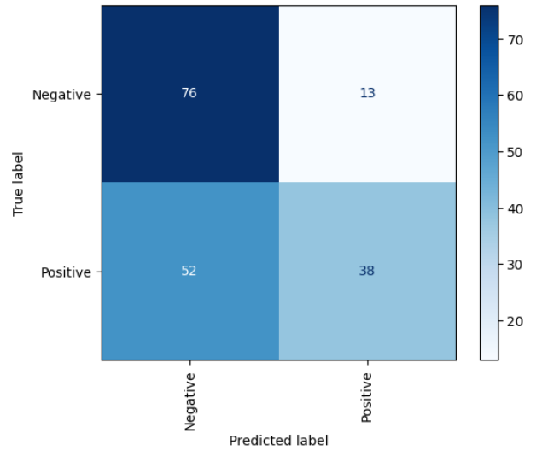  Confusion matrix: Model appears good at identifying negative sentiment, but this is not in line with manual tests. | A lot of sentiment values seemed neutral:  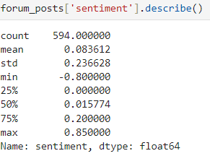

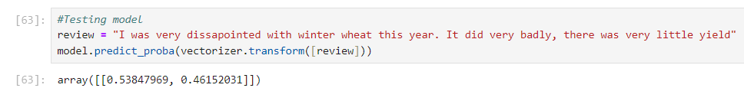
Model incorrectly identified this statement as having a higher probability of being positive. But correctly identified this as being a positive statement:
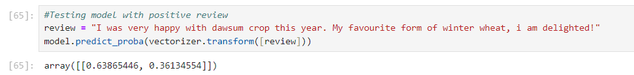
Ternary Sentiment Analysis:
The inclusion of a neutral class slightly improved interpretability but accuracy was worse. Most predictions skewed towards neutrality, reflecting the sentiment distribution in the data. Accuracy: 0.49
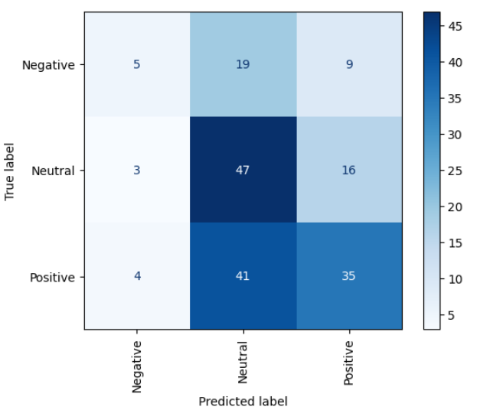

Limitations: High false negatives in binary analysis highlighted the difficulty of identifying subtle sentiments. Ternary analysis introduced interpretability but retained a bias towards neutrality. Logistic Regression’s simplicity limited its ability to capture linguistic nuances in the text.
Additional Sentiment Analysis with VADER and Naive Bayes
VADER: Rule-Based Sentiment Analysis
VADER, a lexicon-based method suitable for short text, was applied to calculate sentiment polarity scores. Compound scores were mapped to positive (≥0.05), negative (≤-0.05), and neutral classes.
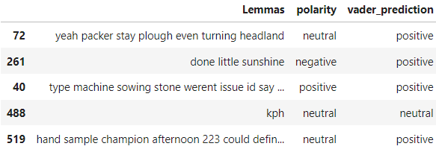While effective for quick sentiment analysis, VADER struggled with ambiguous or complex emotional tones.
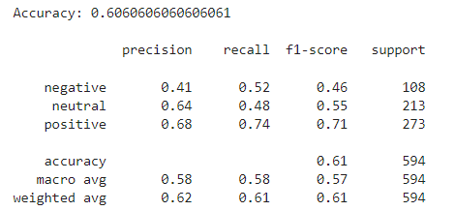
Naive Bayes: Supervised Learning with Bag-of-Words
A Multinomial Naive Bayes classifier was trained using BoW representations. Despite its efficiency, the model achieved low accuracy (49.66%), likely due to class imbalance and feature independence assumptions.
Comparison of Methods
Method | Approach | Accuracy | Strengths | Weaknesses
Logistic Regression | Supervised | 64% (binary)  49% (ternary) | Simple, interpretable | Struggled with class imbalance
VADER | Rule-Based | 60.6% | Effective for short text | Limited handling of ambiguity
Naive Bayes | Supervised | 49.66% | Efficient for large datasets | Poor performance on neutral bias

In addition to all other ML models described above I also briefly looked at Topic Modelling LSA and LDA to explore latent themes in the dataset. Both methods revealed patterns in forum posts by clustering terms into topics.
The text was pre-processed into a document-term matrix (DTM) using Gensim, with 1.02% sparsity typical of text data. This served as the foundation for both models.
LSA used Singular Value Decomposition to reduce dimensionality, creating 7 topics (e.g., Topic 1: "septoria," "varieties," "breeders"). While LSA effectively identified co-occurrence patterns, its linear assumptions may have oversimplified relationships.
LDA modelled each document as a mixture of topics, yielding 7 interpretable topics (e.g., Topic 1: "well," "id," "good"). While more flexible than LSA, LDA's performance depends on careful hyperparameter tuning, which was not performed here.
Visualization and Dashboard Development
Link: Streamlit Dashboard
The visualizations in the dashboard are tailored to the needs and interests of modern Irish farmers. Each visualization uniquely represents features or displays data, either focusing specifically on Ireland or offering a global perspective for broader context. While I considered omitting the final visualization due to its narrower scope (comparing only Ireland, the UK, and France), I deemed the additional features would still be of interest to modern farmers.
Each visualization has been crafted with the user in mind, employing Tufte’s principles (Tufte, 2001) to ensure the dashboard is intuitive, informative, and engaging. Farmers can interact with the dashboard to explore data in a way that aligns with their unique interests and requirements.
All visualisations used the following principles:
- Data Integrity: Ensuring all data is presented truthfully without misrepresentation.
- Audience-Centric Design: Designing with Irish farmers' needs and interests in mind.
- Narrative and Focus: Presenting a logical flow, starting with Ireland-specific data and progressing to broader international comparisons.
- Responsiveness: Leveraging Streamlit for a seamless experience across devices.
- Minimalism and Precision: Avoiding unnecessary elements and ensuring clarity in data presentation.
Visualization Rationales (figures displayed below)
Figure | Rationale | Additional Tufte's Principles
Figure 1 | - White background with light grid for clarity.  - Dropdown menu for feature selection minimizes clutter.  - Line graph to show trends over time, including predicted data.  - Unpredicted features retained for farmer interest. | - Data-Ink Ratio (minimized non-essential elements).  - Chart junk Elimination (every component serves a purpose).  - Precision and Clarity.  - Functionality and Interactivity (customizable by farmers).
Figure 2 | - Highlights cost changes over time.  - Single graph for ease of comparison, with toggle-off feature to reduce crowding. | - Data-Ink Ratio.  - Chart junk Elimination.  - Effective Colour Usage.  - Multivariate and Comparative Analysis.
Figure 3 | - Line graph shows regional value trends over time.  - Toggle-on/off for customizable region comparison.  - Adjusting scale based on selection ensures clarity. | - Data-Ink Ratio.  - Effective Colour Usage.  - Functionality and Interactivity.  - Comparative Analysis.
Figure 4 | - Similar rationale to Figure 3 but focusing on wheat types in Ireland. | - Same principles as Figure 3.
Figure 5 | - Dropdown for feature selection avoids scrolling.  - Choropleth offers a clear, impactful overview.  - Animation shows changes over time.  - Cluster data included for broader insights. | - Data-Ink Ratio.  - Chart junk Elimination.  - Effective Colour Usage.  - Multivariate Analysis.  - Functionality and Interactivity.
Figure 6 | - Line graph for comparing specific countries and features over time.  - Ireland selected by default for relevance and to avoid a blank initial state.  - Countries and features can be toggled on/off. | - Data-Ink Ratio.  - Precision and Clarity.  - Comparative Analysis.
Figure 7 | - Focuses on Ireland, UK, and France with unique features.  - Positioned at the end as it offers a narrower scope.  - Toggle and dropdown for user customization. | - Data-Ink Ratio.  - Chart junk Elimination.  - Functionality and Interactivity.

Figure 1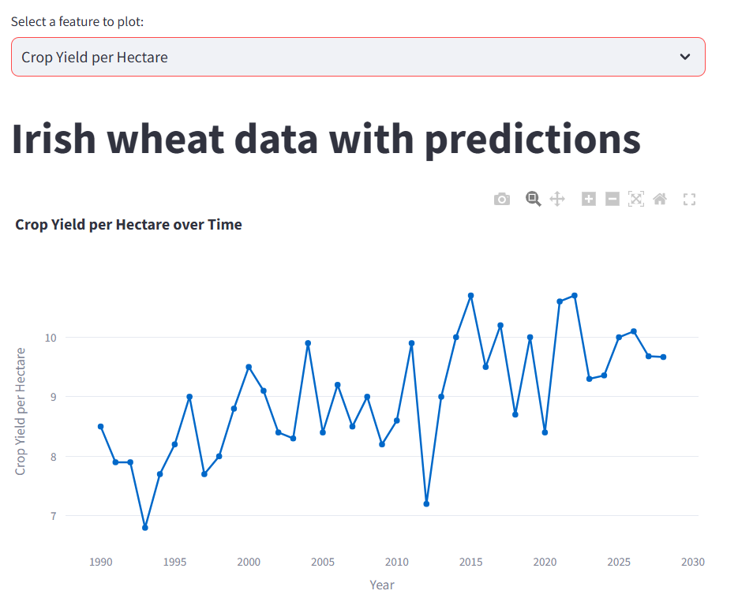 | Figure 2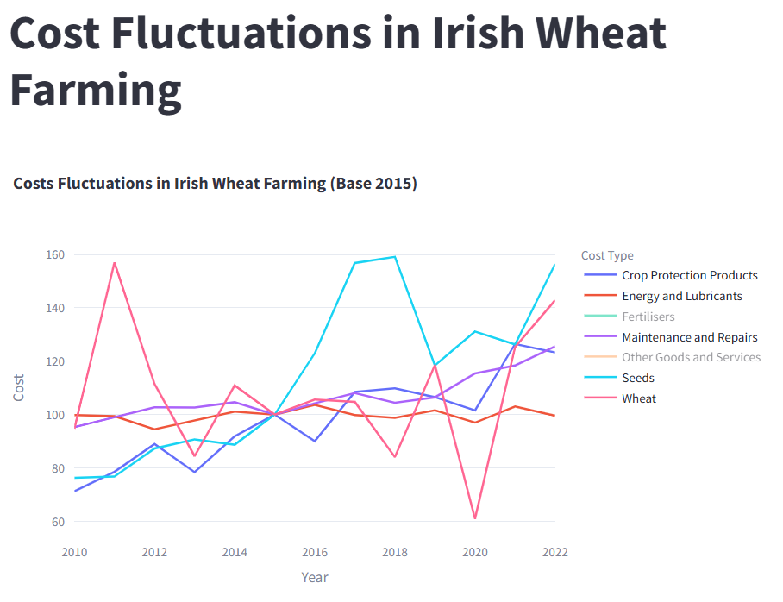
Figure 3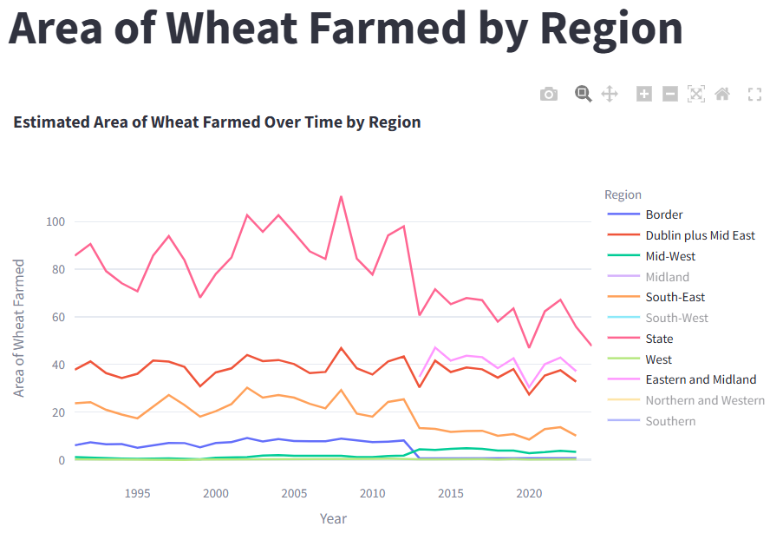 | Figure 4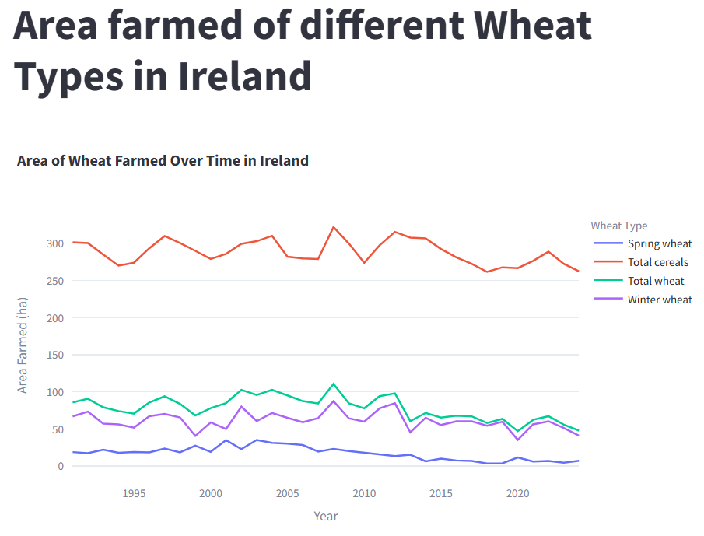
Figure 5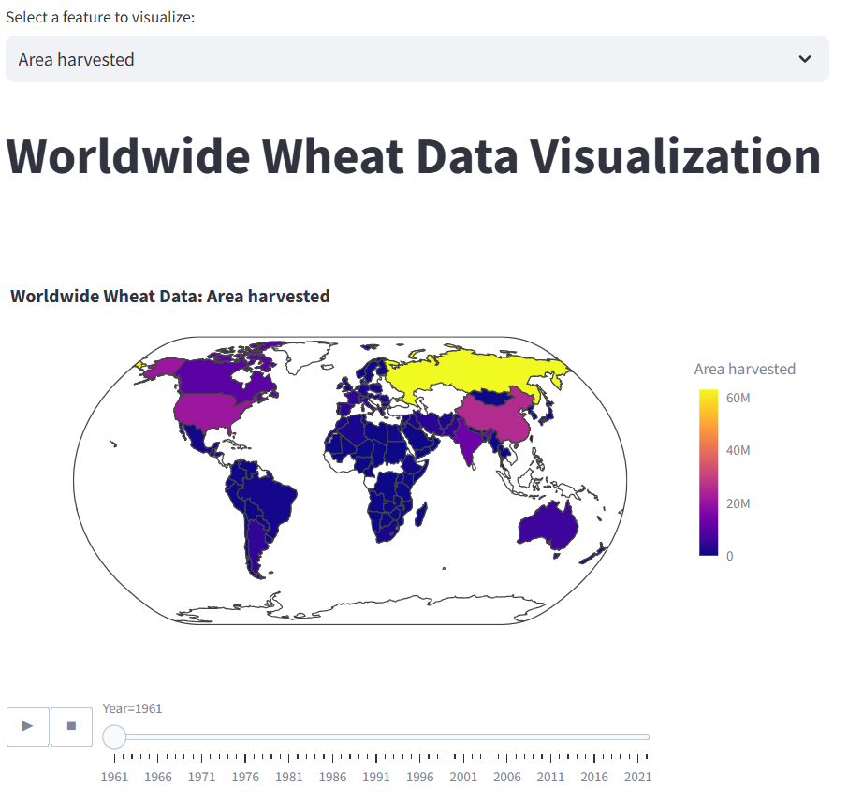 | Figure 6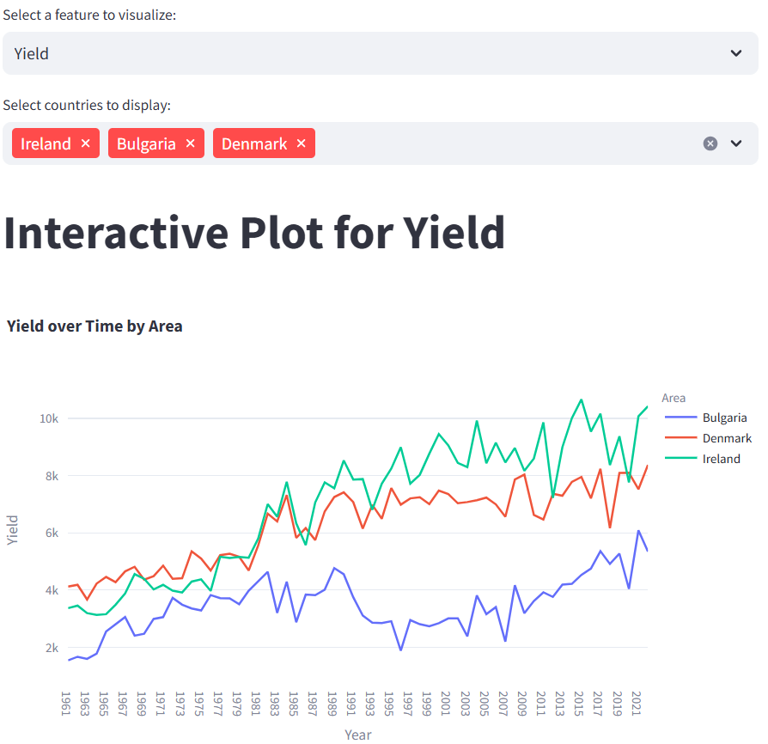
Figure 7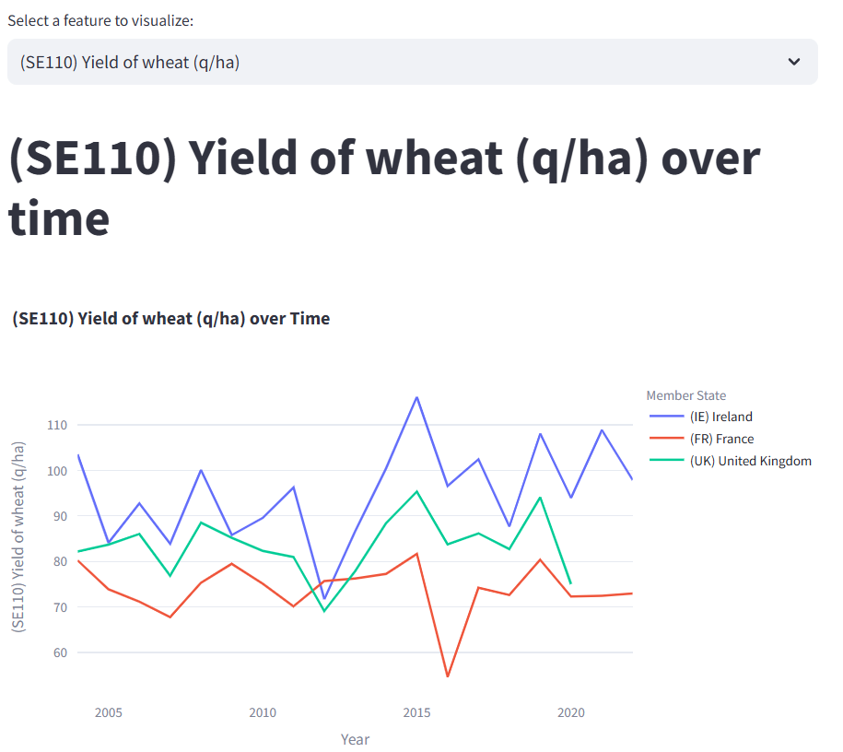

Conclusion
This project successfully met the assignment objectives by analysing wheat agriculture data from Ireland, France, and the UK using Python-based tools. The models and visualizations developed provide meaningful insights into agricultural trends and sentiment, completing the required analysis and fulfilling all project tasks including creation of an interactive dashboard tailored to modern farmers.
Appendices
ChatGPT was used to help with the structural plan of this report. It was also used to help reduce wordcount by suggesting phrasing improvements. Microsoft Word’s editor was used to help improve syntax and style.
Most of the code for this project can be found in the Jupyter notebook “CA2 Wheat”. Text analysis code is in the “Forum” notebook. Code for the dashboard can be found in the file demo.py. Additional visualisations can be found in Jupyter notebook.
Forum: Winter Wheat 2024 | Forum4Farming - Britain & Ireland Farming Forum, Agricultural Discussion Boards. IE & UK
https://seositecheckup.com/seo-audit/www.forum4farming.com
https://technicalseo.com/tools/robots-txt/
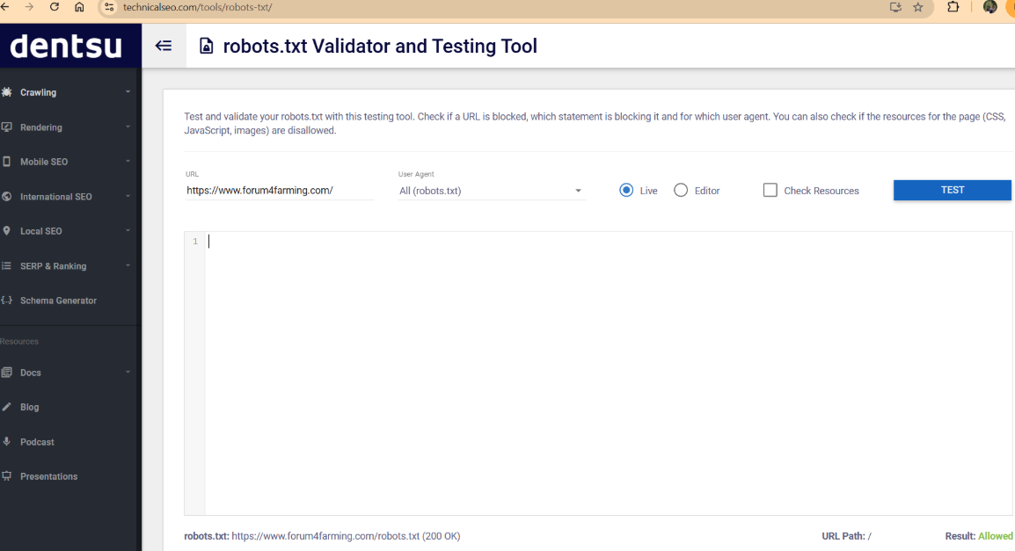
References
Tufte, E.R. (2001) The Visual Display of Quantitative Information. 2nd edn. Graphics Press LLC.
Pandas melt() and unmelt using pivot() function | DigitalOcean. https://www.digitalocean.com/community/tutorials/pandas-melt-unmelt-pivot-function (Accessed: October 15, 2024).
Weiss, N.A. (2017) Introductory Statistics. 10th edn. Pearson Education Limited.
pandas documentation — pandas 2.2.3 documentation. https://pandas.pydata.org/docs/.
Matplotlib documentation — Matplotlib 3.9.2 documentation. https://matplotlib.org/stable/index.html.
seaborn: statistical data visualization — seaborn 0.13.2 documentation. https://seaborn.pydata.org/.
Installation — pingouin 0.5.5 documentation (no date). https://pingouin-stats.org/build/html/index.html (Accessed: November 20, 2024)
pingouin.ttest — pingouin 0.5.5 documentation https://pingouin-stats.org/build/html/generated/pingouin.ttest.html.
re — Regular expression operations (no date). https://docs.python.org/3/library/re.html.
Six Sigma US (2024) Normal probability plot explained. A detailed guide. https://www.6sigma.us/six-sigma-in-focus/normal-probability-plot/ (Accessed: October 31, 2024).
Bajaj, A. (2023) Time series prediction: How is it different from other machine learning? [ML engineer explains]. https://neptune.ai/blog/time-series-prediction-vs-machine-learning (Accessed: October 29, 2024).
7.2.1.3. Anderson-Darling and Shapiro-Wilk tests (no date). https://www.itl.nist.gov/div898/handbook/prc/section2/prc213.htm (Accessed: October 31, 2024).
Kara, M. (2023) 'Time Series, rolling windows - Melih Kara - Medium,' Medium, 12 October. https://medium.com/@karamel.itu/time-series-rolling-windows-5cf9ec500e83
1. Supervised learning. https://scikit-learn.org/stable/supervised_learning.html (Accessed: November 2, 2024).https://medium.com/data-science-at-microsoft/introduction-to-feature-engineering-for-time-series-forecasting-620aa55fcab0
Ruiz, P. (2021) 'ML Approaches for Time series - towards data science,' Medium, 2 November. https://towardsdatascience.com/ml-approaches-for-time-series-4d44722e48fe.
Chapter 8 ARIMA models | Forecasting: Principles and Practice (2nd ed) (2018). https://otexts.com/fpp2/arima.html (Accessed: November 5, 2024).
Statsmodels.tsa.arima.model.ARIMA - Statsmodels 0.15.0 (+518) (2024). https://statsmodels.org/dev/generated/statsmodels.tsa.arima.model.ARIMA.html (Accessed: November 8, 2024).
Hypothesis Testing Fundamentals - p-values (no date). https://campus.datacamp.com/courses/hypothesis-testing-in-python/hypothesis-testing-fundamentals?ex=5.
Understanding a grid search output video | Python (no date). https://campus.datacamp.com/courses/hyperparameter-tuning-in-python/grid-search?ex=8.
auto.arima function - RDocumentation (no date). https://www.rdocumentation.org/packages/forecast/versions/8.23.0/topics/auto.arima
Journal, D. (2024) 'How to check if a website allows web scraping: Expert Tips | Medium,' Medium, 15 November. https://medium.com/@datajournal/check-if-a-website-allows-scraping-77122e9aa4fb.
Text preprocessing, POS tagging and NER - Part-of-speech tagging (no date). https://campus.datacamp.com/courses/feature-engineering-for-nlp-in-python/text-preprocessing-pos-tagging-and-ner?ex=8.
Okamura, S. (2021) 'GridSearchCV for Beginners - towards Data Science,' Medium, 25 December. https://towardsdatascience.com/gridsearchcv-for-beginners-db48a90114ee.
Chen, Y. (2021) 'How to generate an LDA Topic Model for Text Analysis,' Medium, 7 December. https://yanlinc.medium.com/how-to-build-a-lda-topic-model-using-from-text-601cdcbfd3a6.
Dany-Kuznetsov (no date) GitHub - dany-kuznetsov/topic_model_lda_hyper_params_opt: Topic modelling - optimization of model hyper params. Notebooks are examples of using our optimization pipeline for sample data. https://github.com/dany-kuznetsov/topic_model_lda_hyper_params_opt.
How to pivot a dataframe in Pandas? (no date). https://stackoverflow.com/questions/28337117/how-to-pivot-a-dataframe-in-pandas.
Inferential Statistics and Sampling - Confidence intervals and sampling (no date). https://campus.datacamp.com/courses/foundations-of-inference-in-python/inferential-statistics-and-sampling?ex=7.
Confidence interval estimates (no date). https://www.graduatetutor.com/statistics-tutor/confidence-interval-estimates/.
How to read a .xlsx file using the pandas Library in iPython? (no date). https://stackoverflow.com/questions/16888888/how-to-read-a-xlsx-file-using-the-pandas-library-in-ipython.
Bernhardt, K. (no date) Cost of production: How to calculate. https://farms.extension.wisc.edu/articles/breakeven-cost-of-production-how-to-calculate/.
U.S. Army Corps of Engineers (no date). LOESS Notes. Available at: https://www.hec.usace.army.mil/confluence/rasdocs/rasum/files/6.6/139728168/139734527/1/1685717636749/LOESS_notes.pdf
DataCamp (no date). Stemming and Lemmatization in Python. Available at: https://www.datacamp.com/tutorial/stemming-lemmatization-python
DataCamp (no date). Lemmatization Example. Available at: https://www.datacamp.com/datalab/w/ca79eb90-d03f-497b-b031-d7387bad4881#lemmatization-example
DataCamp (no date). What is Topic Modeling?. Available at: https://www.datacamp.com/tutorial/what-is-topic-modeling
Machine Learning Plus (no date). Topic Modeling in Python with Sklearn: Examples. Available at: https://www.machinelearningplus.com/nlp/topic-modeling-python-sklearn-examples/

