2/6/24 Notes

# Variable thresholding for non-uniform background

* If there is systematic variation in the intensities of background pixels, you want to substract the variation
  + Systematic means that variation can be modeled by deterministic function - this is a regression problem
  + There can still be noise, but that noise is added to deterministic results
* Example of variation in background includes lighting: closer background may be more well lit than further away
* There is a tradeoff - the smaller the patches, the smaller the sample size, the larger the error

## Methodology

* Assumption: the object of interest is small relative to the background, so variation of the entire image can be primarily attributed to the background
  + The ratio of foreground to background desired can be empirically determined via checking for error
* Fit a predetermined function (e.g. linear regression) to the pixel intensities in the image
  + The coefficients of the function are determined to minimize some error metric (e.g. sum of square error)
  + He explained how linear regression works via explaining error metric

### Linear regression example (1st order)

1. Fit a function to all the image intensity pixels :
2. Compute :
3. Normalize to the intensity range (e.g. for standard grayscale, 0-255) to
4. Threshold using any thresholding technique (e.g. iterative thresholding)

### Quadratic regression example (2nd order)

Count of coefficients in the model increase exponentially with model order. Higher order can introduce overfitting since now we are fitting for the noise as well. We should strive for balance between accuracy in higher order vs overfitting.

An additional limitation of higher order models is greater computation resources needed.

Typically in computer graphics people don't use anything over cubic regression (3rd order). He decided to write the equation for that which took approximately 32 seconds.

# Enhanced histogram-based thresholding with incorporation of spatial continuity information

A limitation of pixel histogram-based techniques is that we do not consider spatial information.

If there are overlapping distributions (e.g. foreground and background distributions are different), a threshold chosen will misclassify both background and foreground pixels:

We want to enhance histogram-based thresholding with incorporation of spatial continuity information (see image):

1. Select 2 thresholds T1 and T2 - conservative thresholds (see image for example)
2. Using thresholds T1 and T2, classify the pixels into 3 classes / regions:
   * R1 - Confirmed foreground pixel with gray values less than T1
   * R2 - Mixed pixels with gray values between T1 and T2
   * R3 - Confirmed background pixel with gray values greater than T2
3. Visit each pixel in class R2. If the pixel has a neighbor (4-neighbor or 8-neighbor) from class R1, then reassign this pixel to R1
4. Repeat the above step until no more R2 pixels are reassigned
5. Reassign each remaining R2 pixels to R3

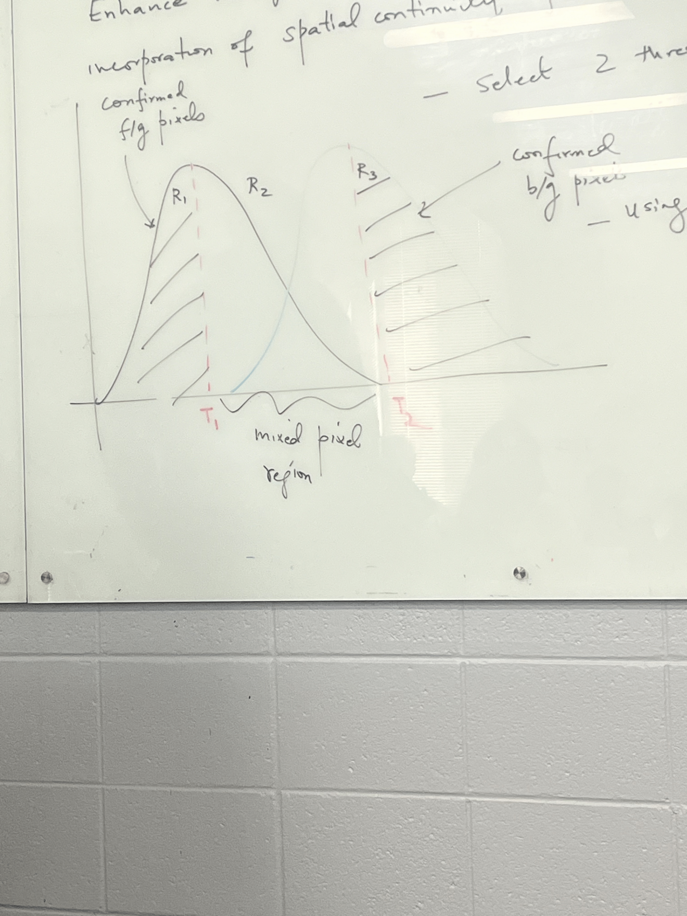

The above uses spatial information: if a pixel we are unsure about is close to the object of interest, we should classify it as part of the object, if it is far away we should not. This reduces likelihood of misclassification when compared to previous histogram-based thresholding methods.

In next classes we'll discuss spatial distributions - so far histograms were spectral distributions.