Question 2-3. SIFT feature extracting and matching

(a) The images are captures

(b,c) Each image separately gave me about 3300-3600 features, by using the peak threshold of 5. By running the matching algorithm I have found 1188 matches, which are indicated on the image below. Each feature is described by it’s location (x,y), scale(σ) and orientation (θ), all of which may be seen on the images (rotation denoted by radius direction).



Between those matches many are outliers, which means they were indicated as matching by their scale and orientation, by their translation (x,y) differs from the translation of the majority of the points. Using methods like RANSAC we can eliminate those. I have indicated the outliers in red rectangles in the image below, there are of course many more which require zoom to identify (or RANSAC to eliminate). Or course matches which also match the major translation vector of the majority of the matches are the inliers. For example, most of the features on my face.

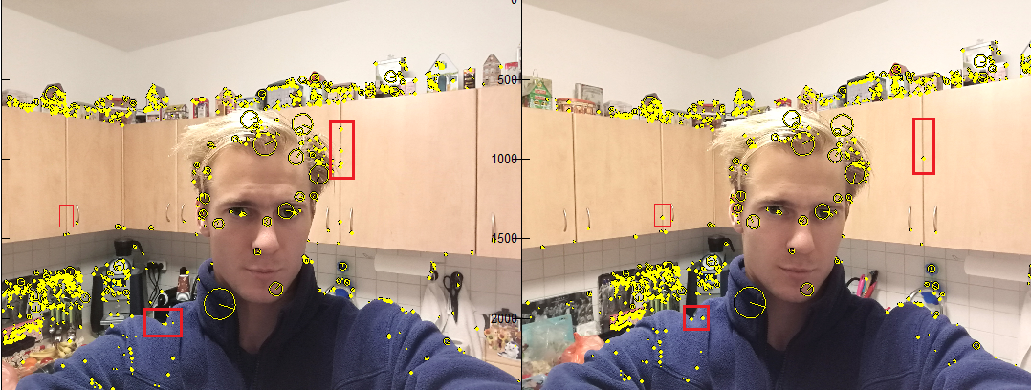

Outliers location